XML Document Exchange
Extensible Markup Language (XML) is an industry standard that enables information-rich data exchange. The introduction of XMLport objects in Microsoft^{â} Business Solutions–Navision^{â} streamlines the import and export of data in XML format.

Key Benefits:
- Facilitates document exchange across different platforms and databases.
- Improves the overall performance of Microsoft Navision when handling XML document exchange.
- Makes it easier for Microsoft Certified Business Solutions Partners to customize XML document exchange in Microsoft Navision.

Key Features:
- Using the XMLport Designer, Microsoft Business Solutions Partners can design objects that map data between Microsoft Navision and a particular XML document.
- XML data can be mapped to C/SIDE tables, fields, and variables.
- Developers can use code to manipulate the XML data during import and export.

The new XMLport objects in Microsoft Navision allow you to easily exchange documents with your business partners. In addition, XMLports improve the overall performance of the solution when handling XML document exchange, and they enable easier customization of data exchange with Microsoft Navision.

Facilitates Document Exchange
Today, nearly all companies expect their business solutions to communicate faster and more efficiently with their supply chain. Information exchange using XML is widespread because it is easy to learn and to use, and because it can work with any platform, in any company.
XMLports are used to create XML documents containing Microsoft Navision data. Once in XML format, this data can easily be sent to and read by another application. For example, an XMLport can be created containing your product catalogue and price list, and this can easily be sent to your business partners regardless of the platform and database they use, just as long as they can read XML documents.
With the introduction of XMLport objects, Microsoft Navision provides a tool for improved document exchange. New XMLports can be created for any documents you want to exchange, for example, a sales quote, a purchase order, a product catalogue, or a price list. The process has been streamlined using XML input/output (I/O) functionality. Whereas previously a large amount of C/AL code had to be written to enable XML document exchange, now XMLport objects can easily be designed, facilitating document exchange across different platforms and databases.
XMLports can also be used to create Microsoft Navision data based on a received XML document. For example, if you receive an XML document containing an updated price list from your supplier, this information can easily be transferred to the relevant place in your Microsoft Navision application.
Seamlessly Transfer Data with the XMLport Designer XMLports are created using the XMLport Designer. With this tool, Microsoft Navision data (for example, the contents of a field) can be placed in specific elements in the XMLport that is being created. Using the XMLport Designer, fields and records in Microsoft Navision can be mapped to elements and attributes in an XML document. This makes it possible to transfer data seamlessly from one format to another.
When working with XML I/O functionality in Microsoft Navision, one or more of the following can be used:
- Encoding: The XMLport Designer is used to generate an XML document that is as well-formed and as generic as possible, utilizing the common format defined in Microsoft Navision. The generating procedures are fast, user-friendly, and proficient in handling errors.
- Decoding: When Microsoft Navision receives external XML documents, they are interpreted quickly and interactively. The XMLport Designer builds a bridge between the documents and the Microsoft Navision database.
- Validation: This is a part of both the encoding and decoding process, ensuring that the XMLport object itself complies with Microsoft Navision data type validation.
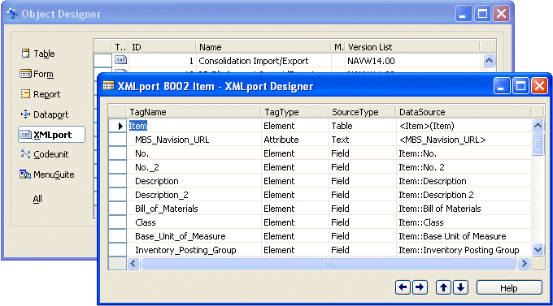

Improve the Overall Performance of Microsoft Navision
Overall, the XML I/O functionality improves the performance of Microsoft Navision when handling XML document exchange. Performance is faster at run time, both when importing and receiving an XML document and when exporting or sending an XML document. This means that you can save time and improve your efficiency when you are exchanging documents with your customers or suppliers.

XMLports and Commerce Gateway
The newly released Microsoft^{â} Business Solutions–Navision^{â} Commerce Gateway uses the new XMLport objects in Microsoft Navision. Commerce Gateway allows the trading of documents with other systems and provides you with predefined document exchange functionality. Because the introduction of XMLports in Microsoft Navision makes it faster for the application to handle XML documents, it also makes Commerce Gateway more efficient. More importantly, by using the new XMLport functionality in Microsoft Navision, Microsoft Certified Business Solutions Partners can now enhance and customize Commerce Gateway more quickly and efficiently.
Other Microsoft Navision Functionality Using XMLports
The following functionality in Microsoft Navision uses the new XMLport objects:
- Intercompany Postings: This is a new functionality within Microsoft Navision that helps customers create and distribute inter-company transactions between multiple Microsoft Navision Solutions and across multiple companies.
- Business Notification: Microsoft^{â} Business Solutions–Navision^{â} Business Notification is functionality within Microsoft Navision that generates e-mail messages to your employees, suppliers, partners, and customers, informing and alerting them of critical business conditions.

Easier Customization
Microsoft Certified Business Solutions Partners have an additional tool to meet the specific needs of your company. They now have an efficient way to customize XML document exchange in Microsoft Navision and get it to you faster. With the XML I/O functionality, partners can simplify the implementation process and the customization of Microsoft Navision XML document exchange.
Receiving and sending XML documents is much faster than before. And creating XMLports doesn’t require a lot of training for partners. It reduces their need to have expert knowledge of XML parsers, such as Document Object Model (DOM) or SAX. It is straightforward and easy to learn the technology. An expert Microsoft Navision user in your company would be able to handle document exchange in Microsoft Navision using the XMLport object. Alternatively, your Microsoft Business Solutions Partner will do it for you.
Microsoft Navision continues to grow as a product and take on more complexity. The introduction of the new XMLport object creates new opportunities when it comes to document exchange. Moreover, it illustrates our commitment to keeping the solution as flexible as possible.

About Microsoft Business Solutions
Microsoft Business Solutions, a division of Microsoft, offers a wide range of integrated, end-to-end business applications and services designed to help small, midmarket, and corporate businesses become more connected with customers, employees, partners, and suppliers. Microsoft Business Solutions' applications optimize strategic business processes across financial management, analytics, human resources management, project management, customer relationship management, field service management, supply chain management, e-commerce, manufacturing, and retail management. The applications are designed to provide insight to help customers achieve business success. More information about Microsoft Business Solutions can be found at www.microsoft.com/BusinessSolutions.

Address:
Microsoft Business Solutions
Frydenlunds Allé 6
2950 Vedbaek
Denmark
Tel +45 45 67 80 00
Fax +45 45 67 80 01
www.microsoft.com/BusinessSolutions

Key Features | Description
XMLport object | - Streamlines the process of handling XML data exchange to and from Microsoft Navision
XMlport Designer | Use the XMLport Designer to:  - Design the objects that will map data between Microsoft Navision and a particular XML document.  - Map records and field elements in Microsoft Navision to elements and attributes in the XML document, to make it possible to transfer data seamlessly in and out of Microsoft Navision.

System Requirements
To obtain the features mentioned in this fact sheet,  the following modules and technologies are required: | Microsoft Business Solutions–Navision 4.0 or later
25.06.04
© 2004 Microsoft Business Solutions ApS, Denmark. All rights reserved. Microsoft, Great Plains, Navision, Visual Studio, and Windows are either registered trademarks or trademarks of Microsoft Corporation, Great Plains Software, Inc., FRx Software Corporation, or Microsoft Business Solutions ApS or their affiliates in the United States and/or other countries. Great Plains Software, Inc., FRx Software Corporation, and Microsoft Business Solutions ApS are subsidiaries of Microsoft Corporation. The names of actual companies and products mentioned herein may be the trademarks of their respective owners. The example companies, organizations, products, domain names, email addresses, logos, people, and events depicted herein are fictitious. No association with any real company, organization, product, domain name, e-mail address, logo, person, or event is intended or should be inferred.

