
Time and Expense For Projects
Time and Expense For Projects

Microsoft Dynamics™ SL

Benefits
- Track project labor and expenses effectively
View and track labor and other expenses with a fully integrated solution that allows you to include labor costs in project profitability calculations. By using Web based capabilities, employees can record labor, travel, and related expenses anytime, anywhere.

- Maintain a smooth workflow
Streamline the collection of labor and
project expenses with timesheets and
expense reports that can be entered
remotely or via the Web, fully validated,
and available for online project manager approval.

- Improve your view into project costs
Track labor and employee expenses
easily on a project-by-project basis, with a complete overview of labor expenses and commitments that allows full drill-down to details.

- Enhance your productivity
Minimize errors and eliminate re-
entry of data with tight integration of information across Microsoft Dynamics SL project accounting and financial management modules.

- Reconcile payroll accurately
Reconcile your payroll precisely
by automatically integrating your timecards with Microsoft Dynamics
SL financial management modules.

Take control of your labor, project, and travel-related expenses. Accurate, timely cost information gives you the precise information you need to increase your productivity and make better, more effective business decisions.

Capture
time information, even from
employees working remotely, with data automatically routed to the appropriate managers.

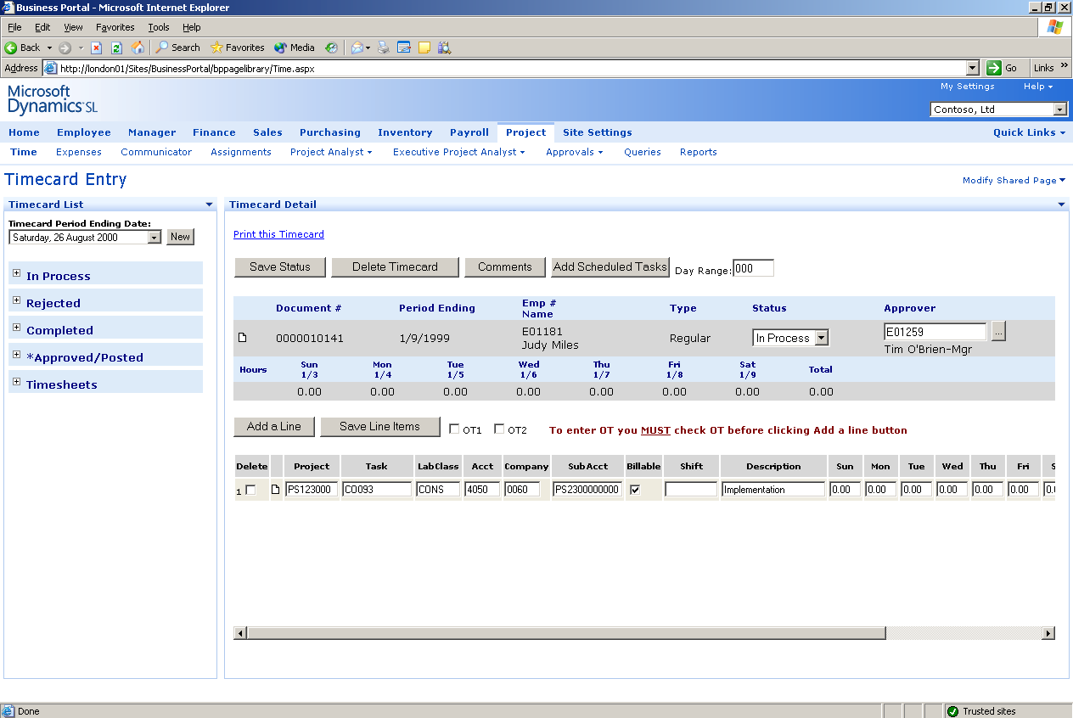

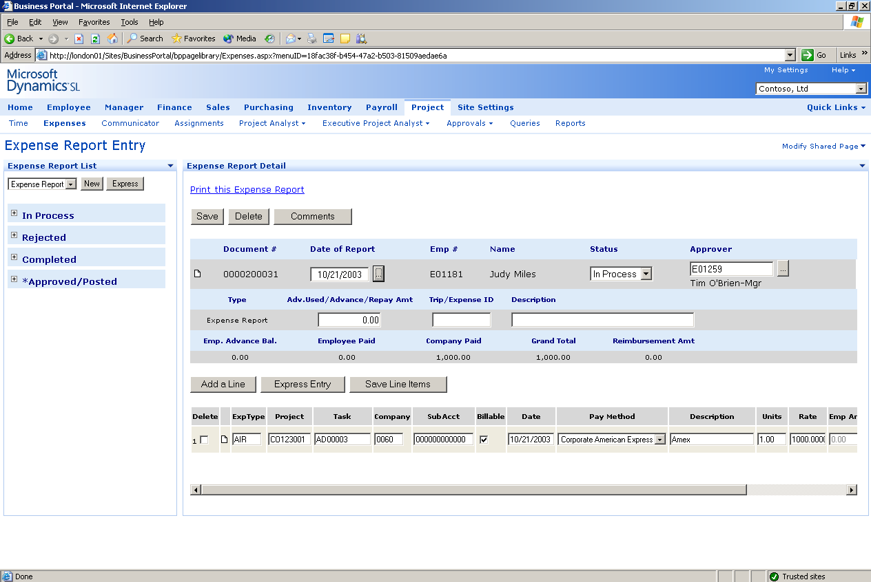

Record travel
and other employee-related project expenses for prompt payment and reimbursement.

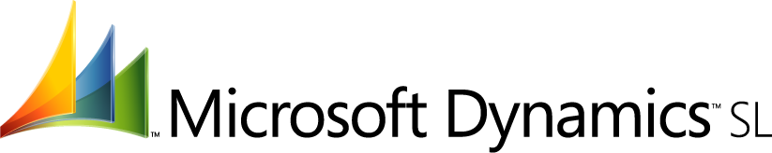

FEATURES

BENEFITS

Intuitive User Interface | Empower employees with timecards and expense reports that are  intuitive and easy to use directly from their Web browser.
Online Timecard Reporting | Enable employees to record their time on a daily basis using electronic  timecards. Labor information flows directly from employees to the  project and accounting tools, and is fully validated at the time of entry  to prevent time entry errors such as charges to incorrect or closed  projects or tasks.
Online Expense Reporting and  Validation | Help ensure that travel and other employee-related project expenses are properly recorded in a timely manner through the convenience of online reporting. Online travel and expense collection minimizes paperwork, shortens the approval process, and provides managers with a clear view of expenses.
Online Timecard and Expense  Review | Automatically route online timecards and expense reports to managers. Once approved, the timecards and expense reports update projects, general ledger, and other integrated Microsoft Dynamics SL modules.
Timecard Management | Streamline your timecard processing with automatic tracking of  timecards to see which employees have timecards missing, in process,  completed but not approved, or approved and posted.
Automated Pay Rates | Set your timecards to automatically calculate certified payroll, prevailing  wages, workers’ compensation, and union pay rates for construction.
Flexible Labor Classifications | Accommodate government, construction, and other complex project and  billing requirements with flexible labor costing methods and labor  classifications. Labor can also be costed and manually adjusted at the  point of entry by using Web Project Time.
Complete Integration | Save time and help ensure that your data is accurate by sharing  information across Microsoft Dynamics SL modules, including payroll,  distribution, and field service management, to provide single-point data  entry.
Timecard/Expense Report Auditing | Capture and store a complete audit trail of all changes to timecards and  expense reports, including change reasons, using the optional audit  utility.
For more information about Microsoft Dynamics™ SL, visit: http://www.microsoft.com/dynamics/sl
This document is for information purposes only.
MICROSOFT MAKES NO WARRANTIES, EXPRESS, IMPLIED, OR STATUTORY, AS TO THE INFORMATION IN THIS DOCUMENT.

© 2005 Microsoft Corporation. All rights reserved.
Microsoft, The Microsoft Dynamics Logo, are either registered trademarks or trademarks of Microsoft Corporation or Microsoft Business Solutions ApS in the United States and/or other countries. Microsoft Business Solutions ApS is a subsidiary of Microsoft Corporation.

