Protecting SQL Server with
System Center Data Protection Manager 2007
Microsoft Corporation
Published: February 2007

Executive Summary
SQL Server™ 2005 already offers a range of data availability technologies, including support for clustering and transaction log replication. Microsoft® System Center Data Protection Manager (DPM) 2007 extends the native SQL Server feature set to provide continuous data protection with byte-level replication and integrity checking, plus full support for disk-to-disk and disk-to-disk-to-tape backup. DPM 2007 offers comprehensive data protection for organizations of all sizes, helping to maintain the business value of your SQL Server infrastructure with enhanced protection making it more available.
The information contained in this document represents the current view of Microsoft Corporation on the issues discussed as of the date of publication. Because Microsoft must respond to changing market conditions, it should not be interpreted to be a commitment on the part of Microsoft, and Microsoft cannot guarantee the accuracy of any information presented after the date of publication.
This White Paper is for informational purposes only. MICROSOFT MAKES NO WARRANTIES, EXPRESS, IMPLIED OR STATUTORY, AS TO THE INFORMATION IN THIS DOCUMENT.
Complying with all applicable copyright laws is the responsibility of the user. Without limiting the rights under copyright, no part of this document may be reproduced, stored in or introduced into a retrieval system, or transmitted in any form or by any means (electronic, mechanical, photocopying, recording, or otherwise), or for any purpose, without the express written permission of Microsoft Corporation.
Microsoft may have patents, patent applications, trademarks, copyrights, or other intellectual property rights covering subject matter in this document. Except as expressly provided in any written license agreement from Microsoft, the furnishing of this document does not give you any license to these patents, trademarks, copyrights, or other intellectual property.

Contents
Contents 3
Protecting Your Critical Business Data 4
The Business Case for Better Protection 4
Technical Obstacles to Effective Data Protection 5
Tape System Efficiency, Robustness, and Cost 5
Network Bandwidth, Latency, and Usage 5
Application Awareness and Support 6
Improving Protection with System Center Data Protection Manager 2007 6
Expanded Protection 6
Application Awareness 7
Seamless Disk- and Tape-Based Recovery 7
Ease of Use and Management 8
Using Microsoft DPM to Protect Microsoft SQL Server 8
Deploying DPM to Protect SQL Servers 9
Installing the DPM Server 9
Allocating Storage on the DPM Server 9
Installing the DPM Agent on SQL Server Computers 10
Creating and Configuring Protection Groups 11
Additional Considerations 13
Creating the Protection Group 13
Recovering SQL Server Databases 16
Recovering a Database to its Original Location 16
Recovering a Renamed Copy of a Database 18
Recovering a Database to a Network Folder 18
Recovering a Copy of the Database to Tape 19
Conclusion 20
Related Links 21

Protecting Your Critical Business Data

Businesses of all sizes increasingly find themselves in a difficult position: they need better protection for their critical data, but they need to get that protection while meeting a host of constraints, including requirements for compliance, auditing, and IT overhead cost reduction. Meeting these challenges begins with understanding the real business case for improved data protection, then identifying the technical obstacles to implementing improved protection.

The Business Case for Better Protection
Magnetic tape has long been the primary means of system backup and recovery. The tape systems in common use today share many of the same basic technologies as the first magnetic wire recording systems invented more than 50 years ago. While tape-based backup systems offer advantages for some recovery goals, tape as a recovery medium is becoming less and less suitable because of five factors that have emerged as trends in data protection and recovery:

- Downtime costs more. As more and more businesses come to depend absolutely on their information systems, the cost of outages and failures continues to increase. Many companies suffer direct financial losses as the result of downtime that degrades their ability to carry out normal business operations, while others incur costs related to lost productivity, missed opportunities, and damaged reputations. As the time pressures on business operations continue to grow, downtime will continue to become increasingly expensive.
- Tape-based restores aren’t always reliable. Microsoft’s own operational experience shows a 17% annual failure rate for its tape devices. Most IT administrators have experienced at least one restore failure during tape-based recovery operations. Tape-based restores require that you have timely access to all the backup media required for a particular restore, that all those media are readable, that the software catalogs managing those tapes are not corrupt, and that the devices needed to read the media are working properly and available.
- Backup and restore windows are shrinking. Traditional IT operations usually call for a defined window of time allocated to backups. However, many organizations are finding that they can no longer afford to have routine designated downtime during which backups must be run. In addition, the amount of time allocated for server and data recovery is shrinking because every minute of downtime is becoming more expensive.
- Branch and remote offices need equal protection. Centralization and consolidation have recently become buzzwords in the IT industry, but the fact remains that a great many businesses have branch or remote offices whose operations and resources cannot be easily or feasibly consolidated. Examples include retailers, financial services companies, and manufacturers. The resources in these branch offices are often as important as the organization’s centralized resources, but branch and remote offices typically don’t receive the same level or quality of data protection because implementing it is expensive and complicated.
- Cost control is driving vendor consolidation. One way that businesses have identified to lower IT costs is to reduce the number of vendors with which they do business. This trend increases the pressure on companies to reduce the complexity and operational cost of their data protection infrastructures by reducing the number of solution vendors in their environments.

The emergence of these trends means that it is now possible to make a strong business case for deploying data protection systems that help meet these business challenges. Of course, there are technical challenges inherent in designing a data protection system that will effectively protect enterprise data while meeting these business needs.

Technical Obstacles to Effective Data Protection
Many of the technical constraints that hamper data protection effectiveness today actually derive from the nature of tape-based backup systems, media and processes. Understanding what these constraints are is a necessary part of designing a system that provides better protection while being responsive to the business requirements described in the preceding section.

Tape System Efficiency, Robustness, and Cost
Tape systems have traditionally offered what seemed like a reasonable trade-off: low media cost (and thus low long-term archival and storage costs) versus limited performance. As a mature technology, tape systems are familiar to most IT professionals and decision makers, and virtually every major operating system and backup solution provides support for tape devices.

However, using tape as the primary backup and recovery mechanism also imposes constraints.
- Tape systems are very slow compared to disk-based solutions, both for backup and recovery operations. This speed gap has widened as disk storage systems have increased in speed and I/O bandwidth. Requirements to back up more data faster often come into direct conflict with the speed limits imposed by tape systems.
- Tape systems include a relatively large number of moving parts; the electromechanical components that physically move the tape are prone to failure at higher rates than solid-state components. The tapes themselves are subject to physical wear and must be stored and maintained in the right environmental conditions to remain usable. This reality is often underappreciated when one is relying on long-term viability of data.
- Tape-based systems don’t provide an effective means of centralizing backup and restore processes. Most tape-based backup solutions require either a hefty allocation of bandwidth between a remote site and the central backup site or a local tape drive at the remote site, which then introduces the problem of how media are managed, cataloged, and stored between the remote and central sites.
- Tape systems have historically been poorly integrated with disk-based backup systems. Companies seeking to combine the high performance and robustness of disk-based backup with the low long-term storage costs of tape solutions have frequently found that combining systems from multiple vendors gives them all the drawbacks of both methods.

In consideration of these constraints, more and more companies are recognizing that tape is not a preferable medium for routine data recovery, but is best served for long-term data retention and archival where disk may not be as practical.

Network Bandwidth, Latency, and Usage
Backup systems operate by making a faithful copy of a set of protected data items. To do this, they must be able to read and copy all the data from the source data items, then transmit the copied data to the location where it will be written to the backup medium. In environments where all backups are done locally, this can be reasonably straightforward. However, the more common case is also more complicated: when it becomes necessary to back up data from one server and ship it to another server to actually perform the backup.

Conventional backup systems operate by making wholesale copies of every bit of the source data. This is initially required for any backup system. However, performing complete copies on a routine basis uses a large amount of network bandwidth to move the copies from the source server to the backup target. This problem is exacerbated in environments with limited available bandwidth, high latencies, or poor network stability.

Application Awareness and Support
Not every application is created equal. Some applications create and process “flat” files that are opened, changed, and then closed (e.g. Microsoft Office documents); these applications are relatively easy to protect by making static copies of their unchanging files. However, the most critical business applications tend to use transactional databases like Microsoft SQL Server or Microsoft Exchange Server. Backing up and restoring data from these databases is significantly more difficult than backing up static files.

Many existing real-time replication or continuous data protection products offer file- or volume-level replication that blindly replicates changes to the underlying disk without awareness of what the applications are actually doing. Microsoft and most other major software vendors provide supported interfaces in their applications for capturing data; for example, Microsoft SQL Server 2005 provides interfaces that can be used to perform online backups, but these APIs are oriented toward capturing transactions, not byte-level changes. SQL Server 2005 also supports Microsoft’s Volume Shadow Copy Service (VSS) for point-in-time copies on the , but VSS itself only provides a way to make a point-in-time copy; the protection software is responsible for requesting the copy and managing it once it’s been made.

Improving Protection with System Center Data Protection Manager 2007
When Microsoft introduced Data Protection Manager 2006 (DPM 2006), it targeted two key problem areas: the need for better backup and restore functionality with disk instead of tape and the need for better methods of centralizing remote and branch office backup. Although DPM 2006 is targeted primarily at protecting file servers and other servers running file-based applications, it’s still possible to use DPM 2006 to help protect SQL Server computers by using SQL Server Enterprise Manager to create a disk-based backup job to effectively dump the changed SQL data to a flat file on disk, and then protecting the resulting file using DPM 2006.

Data Protection Manager (DPM) 2007 adds a high degree of application awareness, including the built-in ability to provide tailored, application-aware protection for SQL Server, Exchange Server, and SharePoint Server. This application awareness is combined with a powerful user interface, complete PowerShell support, and a robust replication and checkpoint system that allows database administrators and IT generalists to perform their own backups and recoveries quickly and successfully.

Expanded Protection
DPM expands the basic data protection capabilities included in SQL Server by adding the ability to provide protection for selected databases with more granular control over your recovery time objective (RTO) and recovery point objective (RPO). Using only the tools provided with Windows Server and SQL Server, it is possible to take periodic full backups, but the frequency of these backups will vary according to the speed of your backup system and the amount of data you need to back up. The frequency at which you can create backups will control both the RPO and the RTO available to you. For example, with nightly tape backup, your RPO or “potential data loss” will be one business day, meaning that any server outage will likely cost up to an entire business day of data (and productivity) that will be unrecoverable. Meanwhile, your RTO, indicating how long it will actually take to recover, will vary according to the amount of data that has to be restored.

By contrast, DPM can provide much more granular protection by combining SQL Server’s transaction log architecture with DPM’s block-level synchronization. After the initial baseline copy of the protected databases are on the DPM server, transaction logs can be continuously synchronized as often as every 15 minutes. DPM’s “express full” backup technology uses the SQL Server VSS writer to identify which database pages have changed on disk. Those pages, and only those pages, are copied to the DPM server, where they are stored as a set of differences from the preceding backup. DPM can maintain up to 512 of these differential backups. If you store one “express full” image per week plus the transaction logs every fifteen minutes in between, you end up with a total of more than 344,000 potential recovery points: 512 weekly images, each one of which has 7 (days) x 24 (hours) x 4 (15-minute) transaction log targets. Each of these recovery points is guaranteed to be consistent and readable by SQL Server, and can be restored directly into the original database, to the same or a different SQL server, or to tape media.

DPM further extends this protection by allowing you to seamlessly intermix disk and tape as recovery media. You can move your online snapshots to offline tape to provide much greater depths of protection; in addition, you can schedule tape-based backup jobs to capture regular full backups to tape to meet your archiving and compliance needs while still preserving your ability to do fine-grained restores at high speed directly from disk.

In addition to directly restoring individual protected databases, you can also use DPM to capture system state data so that you can restore an entire protected server. These restores can use any of the past iterations of data you’ve chosen to capture on the DPM server or on an attached tape system, again giving you excellent granularity for recovery combined with short restore periods and fast restore speeds.

Application Awareness
Many existing backup solutions offer generic backup services that can sometimes be adapted to various applications. Instead of adopting this model, DPM 2007 takes advantage of three fully supported Microsoft technologies to provide continuous data protection specifically for SQL Server:
- The DPM block-based replication engine is used to make the initial copy of a protected database, ensuring a complete and consistent copy is made. DPM’s network transport ensures that the copied data is delivered intact to the DPM server.
- After the initial copy is made, DPM captures “express full” backups using the SQL Server VSS writer, which identifies which blocks have changed in the protected database. Only those blocks (or fragments) are sent to the DPM server for protection. By storing only the differences between individual express full backups, DPM is able to maintain up to 512 shadow copies of the full data set.
- In between express full copy captures, the standard SQL Server transaction logging mechanism is used to offer up-to-the-minute protection. The log files themselves are replicated by DPM; if a recovery is required, the most recent DPM differential backup can be combined with the most recent set of transaction logs to provide rapid recovery to the desired RPO.
Once the administrator chooses which point-in-time recovery point to use for the restore, DPM assembles the necessary data from logs, differential backups, and full backups. This assembly process is completely automatic and doesn’t require the administrator to be an expert in SQL Server database recovery.

Similar protective methods are used to protect Exchange Server and SharePoint Server computers. Because DPM is aware of specific applications, it can tailor its backup behavior and methods to the requirements and usage patterns of specific applications.

Seamless Disk- and Tape-Based Recovery
DPM allows you to combine the best aspects of disk-based and tape-based backup systems. Disk-based backups extremely fast recovery and more flexibility around continuous protection. Tape-based backups are slower, but have lower media acquisition costs. Because you can choose which backups are stored where, you can control how many backup generations you keep on disk versus how many are stored on tape to find the best balance between recovery time, backup depth, and storage utilization. Because DPM provides a seamless view of both disk- and tape-based recovery points, you can easily select the exact data items to restore no matter where they’re located. By using DPM you can combine the ability to quickly recover a short-term snapshot from disk with the ability to go as far back in time as your tape collection permits and recover any arbitrary data that you need. (See Figure

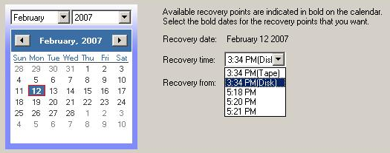
Figure 1: Easy recovery from disk or tape – by date and time

Ease of Use and Management
DPM makes the power of its combined disk- and tape-based backup capabilities available using a familiar, approachable interface. Data Protection Manager is part of System Center, Microsoft’s family of management products that build Microsoft’s product-specific expertise and rich IT knowledge into management tools. DPM provides structured workflows and wizards that walk IT generalists and SQL administrators through a series of straightforward steps: browsing the available SQL servers, instances, and databases, setting recovery goals and retention requirements, and performing restores. DPM handles locating the data, managing the disk-based images and logs, specifying a tape rotation policy, and all the other minutiae of backup and recovery management.

As part of the System Center family, DPM also offers full support for the PowerShell scripting environment, meaning that administrators can easily perform common tasks from the wizard-based DPM interface or from the command line. PowerShell can be used to create scripts that automate frequent operations or to build custom workflows for less-skilled administrators.

DPM works easily with other Microsoft products, including System Center Operations Manager, to give you full visibility into the health and status of the servers you’re protecting and the DPM server that is helping you protect them, as well as System Center Configuration Manager to automatically deploy DPM protection agents on to production servers.

Using Microsoft DPM to Protect Microsoft SQL Server
When used with Microsoft SQL Server, Microsoft System Center Data Protection Manager (DPM) provides data protection and the ability to recover data at the database level. While DPM can provide file-level recovery for data on protected file servers, the various data structures within a database are usually much more interdependent than file data. The DPM protection agent on a computer running SQL Server takes advantage of the VSS capabilities of Windows Server 2003 to take a snapshot of the entire database at once, ensuring that there is always a consistent view of the data. This prevents the possibility of data corruption caused by recovering tables or even specific rows within a table independently of related data needed to properly reconstruct the database.

DPM provides protection for databases on the following versions and editions of Microsoft SQL Server:
- SQL Server 2000 (any edition), with Service Pack 4 installed. Shared disk cluster configurations are supported, as long as all resources are associated with the same network name.
- SQL Server 2005 any edition, with Service Pack 1 installed. Shared disk cluster configurations are supported, as long as all resources are associated with the same network name. Mirrored database servers and SQL Servers performing log shipping are also well supported with DPM.
When a protected cluster node experiences an unplanned failover, DPM will alert the administrator to perform a consistency check of the protected data.

Deploying DPM to Protect SQL Servers
When you are ready to introduce DPM into your production environment, the first major task you need to perform is to install the DPM server. This involves installing and configuring DPM. You can find detailed guidance on this process in Chapter 1, “Installing DPM,” of the Microsoft System Center Data Protection Manager 2007 Deployment Guide.

Before you begin the deployment process, verify that your deployment meets the hardware and configuration requirements outlined in the Deployment Guide.

This section provides instructions for using DPM 2007 to protect SQL Server data. For information on using DPM 2006 to protect SQL Server data, see Knowledge Base article 910401, "How to use Microsoft System Center Data Protection Manager 2006 to help protect a SQL Server database".

Installing the DPM Server
After you verify that your servers meet the prerequisites for their roles, you can install the DPM software on your intended DPM server. You can install directly from the installation media or copy the setup files to a shared network location. Microsoft recommends that you do not install DPM on the system volume, as this configuration can produce complications if you ever need to rebuild your DPM server from tape backups during a disaster recovery scenario.

Allocating Storage on the DPM Server
The next step in deploying DPM is to create the storage pool. The storage pool consists of one or more dynamic disks that are used exclusively by DPM to store replicas, shadow copies, and logs. DPM will use the entire volume and reformat it, so ensure that you have no data on the devices you add. You can use three types of disk storage: direct attached storage (DAS), storage area networks (SAN), or Windows-certified iSCSI devices. You can add RAID volumes to your storage pool, but some common RAID configurations such as RAID 5 are less suitable for use with DPM because of the characteristics of their write performance.

From the DPM management console, use the Management command of the top ribbon bar. Under that, select the Disk sub-tab to add disks to your DPM storage pool. By clicking “Add” on the right-hand task bar, administrators can see any available disks that are usable by DPM. Moving the disk(s) from the left pane to the right pane designates them for DPM usage. (See Figure 2.)

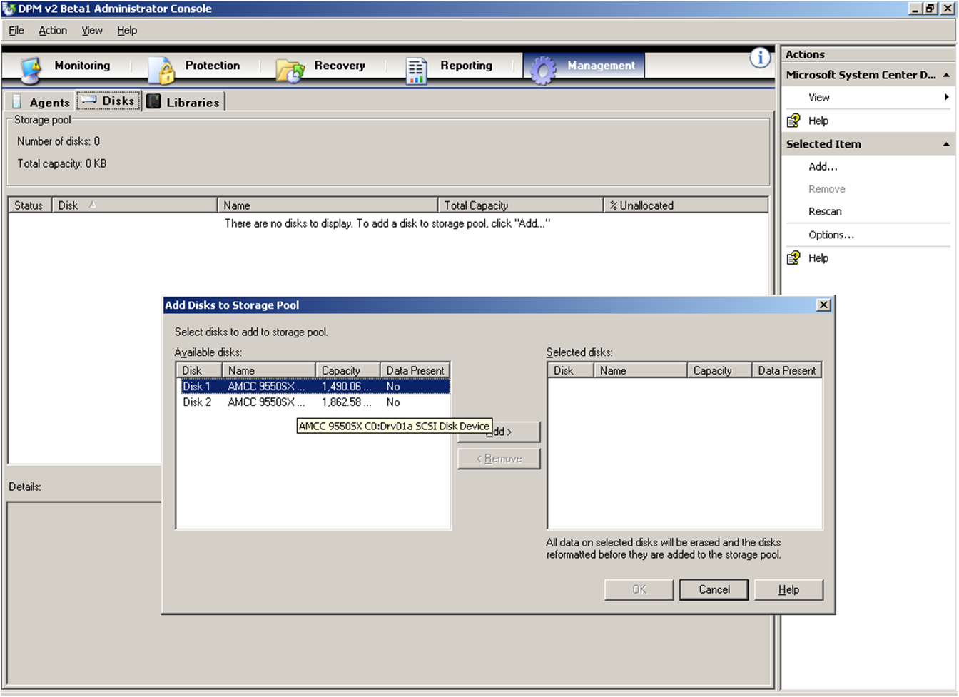
Figure 2: Adding disks to a storage pool

See Chapter 3, "Planning the DPM Server Configurations," of the Microsoft System Center Data Protection Manager 2007 Deployment Guide for more information on storage pool sizing and determining which RAID configurations will be suitable for your DPM server.

Installing the DPM Agent on SQL Server Computers
After installation, DPM will scan Active Directory to find servers that it can protect. Simply choose the servers that you want to protect from the list presented in the DPM “install agents” interface, you will need to deploy the DPM protection agent on the servers to be protected.

See Chapter 5, "Configuring DPM," of the Microsoft System Center Data Protection Manager 2007 Deployment Guide for instructions about installing protection agents. To install the DPM protection agent on a SQL Server computer, do the following:

- Open DPM Administrator Console (Start, All Programs, Microsoft System Center Data Protection Manager), click Management on the navigation bar, and click the Agents tab. In the Actions pane, click Install. The Install Agents Wizard appears.
- The first time you use the wizard, DPM assembles a list of potential servers from Active Directory. The daily auto-discovery process creates a stored list of servers that is used for subsequent installations. Select up to 50 servers and click Add. You can also specify a server by typing its name in the Server name box and clicking Add. When you are finished adding servers, click Next. (See Figure 3.) In the final release of DPM 2007, administrators will also have the option of deploying the DPM agent via Active Directory® group policy, System Center Configuration Manager, or the production server command line.

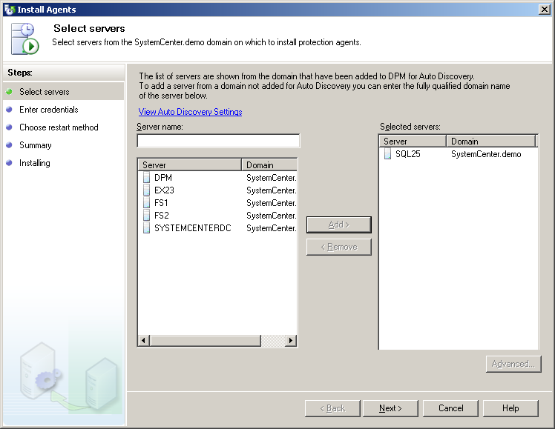
Figure 3: Selecting servers to protect
- Type the user name and password for the domain account to use during the agent installation. This account must be a member of the local administrators group on all selected servers. Click Next.
- Select how you want the selected server to restart when the protection agent is installed and click Next.
- If any of the selected servers are members of a Microsoft Cluster Server (MSCS), you will see an additional screen on which you must select how to restart the clustered servers. In addition, if you choose to install the agent on one node of a cluster, DPM will remind you to install on the other nodes of the cluster to ensure that the protection system does not fail during a clustered server’s failover. DPM will not automatically restart virtual servers in an MSCS cluster. Click Next.
- Review the summary and click Install Agents to proceed with the installation.
- The results of the process appear on the Task tab. You can monitor the installation progress in the Management task area on the Agents tab. If the installation is unsuccessful, you can view the alerts in the Monitoring task area on the Alerts tab.
- After the installation is complete click Close.

See Chapter 5, "Configuring DPM," of the Microsoft System Center Data Protection Manager 2007 Deployment Guide for more information on installing protection agents.

Creating and Configuring Protection Groups
Not all data is created equal, even when it is of the same type, like “SQL databases”. To efficiently make use of your storage and bandwidth, you must design a set of recovery goals that takes into account the nature of each protected data source. To define these goals, you must first determine your desired synchronization frequency, recovery point schedule, and retention range:
- The synchronization frequency determines how often the DPM agent will capture snapshots of your data and transmit the changes to the DPM server. This value reflects how much data you are willing to lose from this data source if there is an outage or disaster. Think of your synchronization frequency as how often you wish incremental backups of your data to happen.
- The recovery point schedule determines how often DPM creates discrete recovery points for the protected data. This schedule is analogous to when you perform full backups of your data.
- The retention range determines how long you need DPM to keep the protected data available for recovery. You may define both short-term and long-term protection policies to control both recovery from disk and from tape. Short-term policies may use either disk or tape, while long-term policies are intended to provide control over your extended tape retention.
  - Defining a “short term to tape” scenario implies using DPM as a traditional tape backup solution, intending to replace one’s existing backup solution.
  - Defining “short term to disk” (only) is often used to provide a robust backup and recovery solution for SQL Server and other workloads via DPM, and then allow a third party heterogeneous “enterprise” tape solution to back up the DPM server for long term compliance.
  - Most DPM users, however, will choose “short term to disk” plus “long term to tape”, enabling a complete solution offering rapid and reliable disk-based protection and recovery, with a seamlessly integrated tape component for long-term retention of data.
DPM uses a protection group to define its protection policies. A protection group is essentially a user-defined policy of “what is to be protected” and “how should the protection be done”, meaning the collection of data sources that share the same desired protection characteristics and configuration options such as disk allocations, replica creation method, and on-the-wire compression. Protection groups can contain data from different types of data sources; you can combine file servers, SQL servers, and Exchange servers in the same protection group. This may be due to multiple servers in a physical office, or perhaps attached to a common project. For example, a consulting or auditing company might protect the Exchange storage group(s) containing the mailboxes for consultants working with a particular client, along with the database(s) pertaining to that client’s project, along with the consultants’ user, work and shared project directories. Afterwards, the protection group provides a complete view of all of the client data, in all formats, along with protection schedules and retention policies.

To plan a protection group, you must make the following decisions:
- Which data sources will belong to the protection group? You do not have to include all databases or instances on a given protected SQL Server computer, and you can mix resources from different servers (including SQL Server databases, Exchange Server storage groups, and file server resources) in the same protection group.
- Which protection method will you use for the protection group? Are you going to use tape, disk, or a combination of both? How much disk space will you need for the disk replicas? Which tape devices will you use?
- How will you create the replicas for the members of the protection group?
When protecting SQL Server computers, DPM automatically sets a configurable schedule to perform express full backups, shared throughout the protection group. However, you can modify the express full backup schedule if any of the protection group members is a SQL Server database with one of the following configurations:
- The database is read-only.
- The database is the primary server in a log shipping pair.
- The data is configured to use the Simple Recovery model.
See Chapter 5, "Configuring DPM," of the Microsoft System Center Data Protection Manager 2007 Deployment Guide for more information on configuring protection groups.

Additional Considerations
As you are designing your DPM protection of your SQL Server databases, you should be aware of the following additional considerations:
- Performance optimizations for slow network links. After you create the protection group, you can configure additional performance settings such as network bandwidth usage throttling for each protected server and on-the-wire compression. The options provide additional performance enhancements that may be critical when deploying DPM to protect resources located over a WAN connection or other slow or congested network links.
- Adding databases to the server. If you create or add new databases on a protected SQL Server computer, these databases will not be automatically added to a DPM protection group. However, these databases can easily be added to an existing protection group without impacting the current protected resources or schedules. Your database creation procedure should be updated to include adding the database to the appropriate protection group.
- Changing database file paths. If you relocate the transaction or database files associated with a database to a new path, protection will no longer succeed and the replica will become inconsistent. You must perform a consistency check, which compares the production data to the DPM replica to ensure that the DPM copy is consistent to the production database. After the check completes successfully, the database will once again be protected.
- Renaming databases. If you rename an existing database is renamed, you must manually remove the old database from the protection group and add the new database to the same (or new) protection group. After you have done this, the database will be synchronized as if it was a new database and new replicas and recovery points will be created. The old protected data and recovery points will not be associated with the database.
- End-user recovery. While end-user recovery is supported for file server data, it is not supported for protected data from SQL Server.

Creating the Protection Group
In order to fully protect your SQL databases with DPM, you must complete the following steps:
- Define the protection group
- Select the data to protect
- Choose a name and protection method (disk, tape or both)
- Select the short-term and long-term protection policies.
- Allocate space for the protection group.
- Specify tape and library details.
- Choose a replica creation method.
The following steps demonstrate how to start the Create New Protection Group Wizard and begin the process of defining a protection group:

- Open the DPM Administrator Console (Start, All Programs, Microsoft System Center Data Protection Manager) and click Protection on the navigation bar. In the Actions pane, click Create.
- The Create New Protection Group Wizard appears. Click Next to continue past the Welcome page.
- Expand the SQL Server nodes to see each of the installed SQL instances and their databases. Select each data source you want to include. Note that you can select multiple kinds of data sources, such as an Exchange storage group, a file server share, and a database within a single protection group. Confirm that your selections appear in the Selected members box, and click Next. (See Figure 4.)

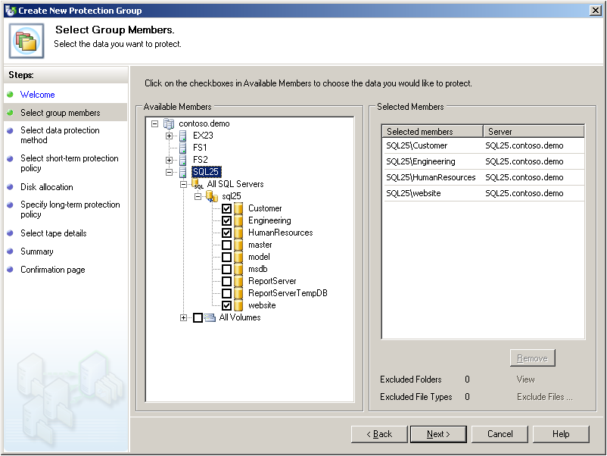
Figure 4: Adding SQL Server data sources to a new protection group
- Accept the default name for the protection group or provide a new name.
- Define your protection policies:
  - If you wish to define the short-term protection for this protection group, select the I want short-term protection using checkbox and select your desired media from the drop-down list.
  - If you wish to define the long-term protection policy for this protection group, select the I want long-term protection using tape checkbox.
  - Click Next.
- If you have configured a short-term protection policy, select the retention duration for data recovery in the Retention range box. In the Synchronization frequency section, select Just before a recovery point to configure DPM to performan an express full backup just before each scheduled recovery point.
- To modify the recovery points for a data source, click Modify next to the desired data source. Select your desired times and days and click OK (see Figure 5). Click Next.

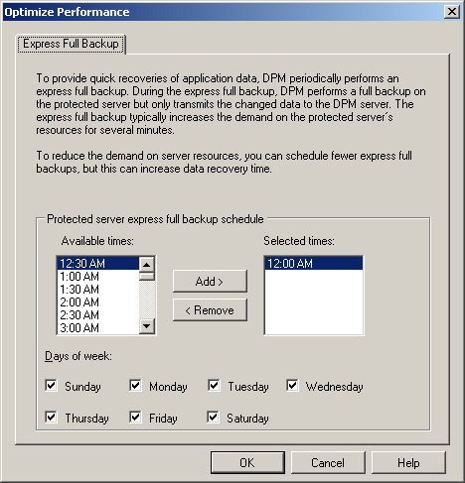
Figure 5: Configuring scheduled recovery points
- DPM will display its recommended disk allocations. The DPM server typically has a significant amount of disk storage for disk-to-disk protection and recovery. This step enables you to allocate how much of that large disk storage pool will be uses to protect these particular data sources. You should allocate the DPM Replica area to slightly larger than how large you expect each data source to grow to in the short term. Sizing the Shadow Copy area will determine how many previous recovery points are available for rapid, disk-based restore. To allocate disk storage, do one of the following:
  - To accept the recommended allocations, click Next.
  - To change a recommended allocation, click Modify, adjust the allocations, click OK, and then click Next.
- If you have configured a long-term protection policy, select the retention duration for data recovery in the Retention range box – this setting may be IT driven, business unit driven, or perhaps mandated from some industry regulation like HIPAA, Sarbanes-Oxley, GLB, etc. In the Frequency of backup box, select your desired backup frequency (daily, weekly, or monthly). Based on these two choices, DPM will determine the appropriate tape rotation scheme (e.g. Grandfather-Father-Son).
- To change the actual tape backup (long-term) schedule, click Modify Day and Time. Do one of the following, then click OK and click Next:
  - In the Weekly section, select the desired backup time from the drop-down list and the desired day to perform the backup.
  - In the Monthly section, select the desired backup time from the drop-down list and the desired day to perform the backup.
  - In the Yearly section, select the desired backup time from the drop-down list and the desired day to perform the backup.
- Select the default media label in the Backup Tape label box and provide a new label name. Select the desired library from the drop-down list in the Backup library box. Select how many drives you want to allocate from the drop-down list in the Drives allocated box.
- If desired, choose the following tape backup options, then click Next:
  - Select the Check backup for data integrity checkbox to verify the data after a backup to tape.
  - Select the Erase tape after recovery range period is over to automatically delete expired data and conserve tape space.
- With all of the protection options now configured, the initial baseline of production data must be sent to the DPM server. Select when you want DPM to replicate your data and click Next:
  - Select Now to replicate the data immediately after the creation of the data group.
  - Select Later to select your desired replication date and time from the drop-down lists.
  - Select Schedule to replicate the data at a future time, perhaps after business hours or over the weekend. [Available with DPM 2007 beta 2 in April 2007]
- Review the summary presented by DPM and click Create Group.
- Review the confirmation page and verify the results of the new protection group creation. Click Close.

Recovering SQL Server Databases
The process of recovering protected SQL Server data with DPM provides several choices:
- Recover a database to its original location – enables an IT Generalist or Disaster Recovery planner to recover the SQL data directly where it was originally hosted without significant SQL experience, by allowing DPM to restore the data directly The result will be a mounted and available SQL database, at the time/point of your choosing.
- Recover a database to an alternate location on the same server – provides a database administrator with previous versions of the database while the user community continues to access the live database. This is particularly useful for ad hoc recoveries of data without affecting the production users. This option is only available for SQL Server 2005.
- Recover database files to an alternate server – delivers the database files to a different server running the DPM agent, and can be useful for testing new applications with production data, auditing databases or disaster recovery preparedness.
- Recover database files to tape – packages the database files to offline tape media, perhaps in support of an audit or simply to store the databases in a vault after a significant milestone like closing the quarterly or annual financials.

Recovering a Database to its Original Location
The following steps demonstrate how to recover a protected database to its original location:
- Open the DPM Administrator Console (Start, All Programs, Microsoft System Center Data Protection Manager) and click Recovery on the navigation bar. Browse to the database you want to recover in the Protected Data box. (See Figure 6.)
- Click any bold date in the calendar to see available recovery points. Select the desired recovery point from the Time menu. Click Recover in the Actions pane to launch the Recovery Wizard.

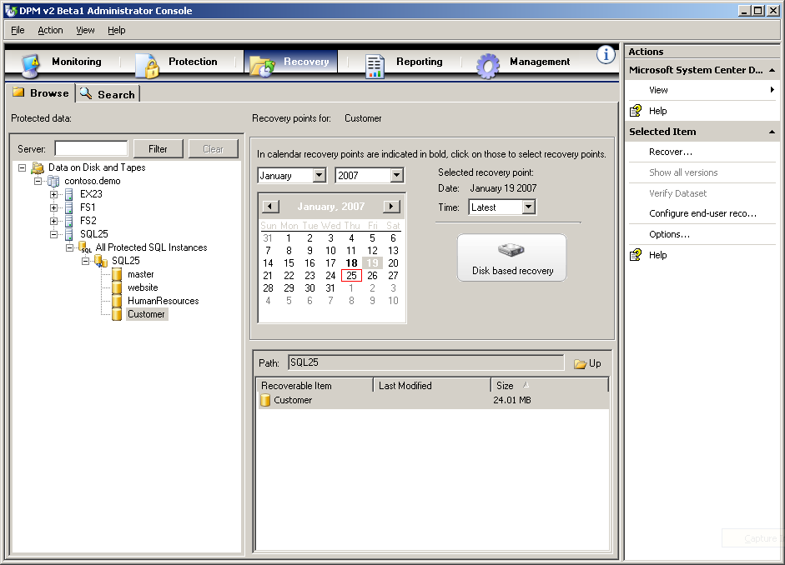
Figure 6: Selecting a database recovery point
- Review the recovery selection and click Next. Select Recovery to original SQL Instance and click Next.
- If you want DPM to send email when the recovery process is finished, select the Send a notification when this recovery completes checkbox and enter one or e-mail addresses. Use a semi-colon (;) to separate multiple e-mail addresses. Click Next.
- Review your selected settings and click Recover. When the recovery is complete, click Close.

Recovering a Renamed Copy of a Database
If you want to recover a protected database to the SQL server and rename it for side-by-side mounting with the original database, it must have been created by SQL Server 2005. It must also be recovered to the original instance of SQL Server, if you have multiple instances running on the same physical server. The following steps demonstrate how to recover a renamed copy of a protected database:
- Open the DPM Administrator Console (Start, All Programs, Microsoft System Center Data Protection Manager) and click Recovery on the navigation bar. Browse to the database you wish to recover in the Protected Data box.
- Click any bold date in the calendar to see available recovery points. Select the desired recovery point from the Time menu. Click Recover in the Actions pane to launch the Recovery Wizard.
- Review the recovery selection and click Next. Select Recovery to original SQL instance after renaming the recovered database and click Next.
- Provide a new name for the recovered database. Specify the location to recover the database files to. Click Next.
- If desired, select the following options:
  - Select whether to use the default security settings option (Inherit security settings of target) or use the security settings of the recovered database files (Use the security of the recovery point version).
  - If you want DPM to send email when the recovery process is finished, select the Send a notification when this recovery completes checkbox and enter one or e-mail addresses. Use a semi-colon (;) to separate multiple e-mail addresses. Click Next.
- Review your selected settings and click Recover. When the recovery is complete, click Close.

Recovering a Database to a Network Folder
If your recovery point was created from an express full backup rather than an incremental synchronization, then you have the option to recover a protected database to a network folder. The following steps demonstrate how to recover a protected database to a network folder:
- Open the DPM Administrator Console (Start, All Programs, Microsoft System Center Data Protection Manager) and click Recovery on the navigation bar. Browse to the database you want to recover in the Protected Data box.
- Click any bold date in the calendar to see available recovery points. Select the desired recovery point from the Time menu. Click Recover in the Actions pane to launch the Recovery Wizard.
- Review the recovery selection and click Next. Select Copy database files and click Next.
- If your selected recovery point was not created by an express full backup, DPM will present you with an additional dialog listing suitable recovery points (Figure 7). Select one and click Next.
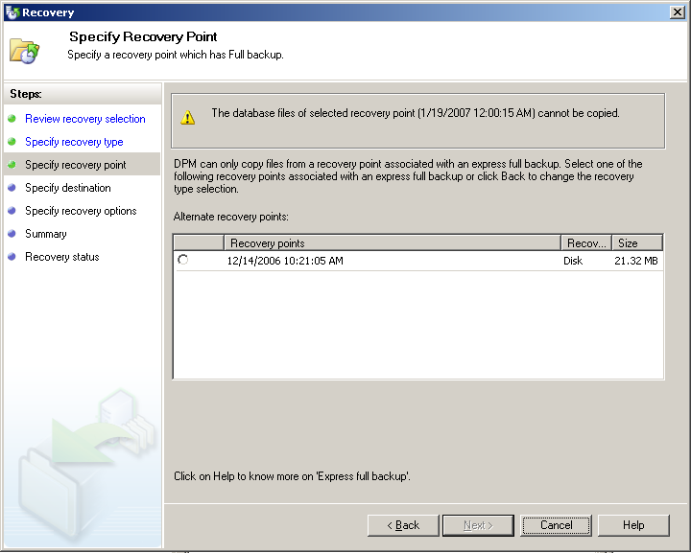
Figure 7: Selecting an alternate recovery point
- Select the destination path to recover the database files to and click Next.
- If desired, select the following options:
  - Select whether to use the default security settings option (Inherit security settings of target) or use the security settings of the recovered database files (Use the security of the recovery point version).
  - If you want DPM to send email when the recovery process is finished, select the Send a notification when this recovery completes checkbox and enter one or e-mail addresses. Use a semi-colon (;) to separate multiple e-mail addresses.
  - Click Next.
- Review your selected settings and click Recover. When the recovery is complete, click Close.

Recovering a Copy of the Database to Tape
If you want to recover a protected database to tape, it must have been created from an express full backup and not an incremental synchronization. The following steps demonstrate how to recover a copy of a protected database to tape:
- Open the DPM Administrator Console (Start, All Programs, Microsoft System Center Data Protection Manager) and click Recovery on the navigation bar. Browse to the database you wish to recover in the Protected Data box.
- Click any bold date in the calendar to see available recovery points. Select the desired recovery point from the Time menu; you must select the most recent recovery point. Click Recover in the Actions pane to launch the Recovery Wizard.
- Review the recovery selection and click Next. Select Copy to tape and click Next.
Note: if your selected recovery point was not created by an express full backup, the Copy to tape option will be unavailable for you to select.
- Select the tape library to use in the Primary library area. If you are recovering from tape and your library has only one drive, you must also select a destination library in the Copy library area:
  - If you are recovering from disk, the data will be copied to a tape in the selected primary library.
  - If you are recovering from a multi-drive tape library in the selected primary library, multiple drives in the library will be used both to read the source tape and write to the destination tape.
  - If you are recovering from a single-drive tape library in the selected primary library, your data will be recovered from the primary library and written to the copy library.
- Enter a new tape label. If desired, select the options to compress or encrypt the data. Click Next.
- If you want DPM to send email when the recovery process is finished, select the Send a notification when this recovery completes checkbox and enter one or e-mail addresses. Use a semi-colon (;) to separate multiple e-mail addresses. Click Next.
- Review your selected settings and click Recover. When the recovery is complete, click Close.

Conclusion
Data Protection Manager 2007 provides seamless, full-featured data protection for your SQL Server databases. By giving you more granular control over how you backup and recover your SQL Server database data, DPM 2007 provides significant improvement to your control over recovery time objective and recovery point objective. DPM’s effortless integration of disk and tape protection technologies gives you confidence and the comfort of knowing that:
- Your protected data can be quickly and reliably backed up from production servers throughout the day without impacting performance.
- Your replicas and recovery points give you multiple options to quickly restore data not just from the most recent backup, but throughout your defined protection period.
- You can flexibly manage recovery locations and options, from restoring to the original location to side-by-side database restores to recovery to arbitrary file locations

Related Links

Microsoft System Center Data Protection Manager (DPM) website
www.microsoft.com/DPM

DPM customer and partner email inquiries
dpmINFO@microsoft.com

“Why Protect SQL Server with DPM” datasheet
http://download.microsoft.com/download/5/1/e/51e28f3b-4626-474a-bf88-070f33886c88/DPM_v2_Datasheet_Protecting_SQL_Server.pdf

“How to Protect SQL Server with DPM” webcast on Microsoft TechNet
http://msevents.microsoft.com/CUI/WebCastEventDetails.aspx?EventID=1032322230

