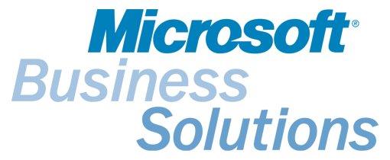

Microsoft
Customer Relationship Management

Training and Certification Frequently Asked Questions

Q. What are the certification requirements
A. Certification for MSCRM requires the following per organization (a minimum of 2 staff to meet the following organizational requirements):
- 1 MSCRM Installation and Configuration certification
- 1 MSCRM Customization certification
- 1 MSCRM Application Professional

Certification exams are administered by VUE testing centers throughout Latin America and the Caribbean. To register for an exam, please go to http://www.pearsonvue.com/mbs/ to register online and find the contact details for the testing center location in your nearest city. Please note: the Microsoft CRM exams are listed near the bottom of the exam listing at this site. Please be sure to scroll down near the bottom where you will find:

US MS-10-159 | Microsoft CRM Professional
US MS-10-184 | Microsoft CRM Installation & Configuration
US MS-10-185 | Microsoft CRM Customization

Attending training courses is not a requirement for presenting the exams, however it will help you significantly in preparing to pass certification exams.

- What certifications does an organization need to qualify for the Microsoft CRM CSA Program?
A minimum of 2 staff to meet the following requirements (total of 3 passed exams, among 2 people):
- 1 MSCRM Installation and Configuration certification
- 1 MSCRM Customization certification
- 1 MSCRM Application Professional

Q. How can I get trained on Microsoft CRM?
A. There is a variety of MSCRM training available, and more to come as the product launches.

Online training
All MSCRM training curriculum is currently available online in English. There are 3 online courses available:
- MSCRM Installation and Configuration
- MSCRM Customization
- MSCRM Application

Course descriptions, costs, and registration are available at:
http://www.microsoft.com/BusinessSolutions/MSCRM/Highlights/mscrmtraining_ecom.mspx .

Classroom training

We are in the process of setting up Classroom training through the CTEC channel in Latin America, as soon as we have a schedule of classes available they will be published.

Q. Where do I take certification exams?
A. Certification exams are administered by VUE testing centers throughout Latin America. To register for an exam, please go to http://www.pearsonvue.com/mbs/ to register online and find the contact details for the testing center location in your nearest city.

Q. Are there any resources available to help me prepare for the certification exams?
A. Yes. Below, please find attached exam preparation guides for each of the certification exams.

Q. What are the exam costs?
A. You can verify with your local testing center the costs of the exams.

