MSlogo_rev_1118

Microsoft Office Access 2007

Table of Contents

Cover is for   
position only

[Overview of Microsoft Office Access 2007 1](#_Toc145291307)

[Start Tracking Quickly 1](#_Toc145291308)

[Create and Adapt Reports to Suit Your Business Needs 2](#_Toc145291309)

[Share Information Effectively 2](#_Toc145291310)

[Manage and Audit Information 3](#_Toc145291311)

[Start Tracking Quickly 5](#_Toc145291312)

[Quickly Get Productive 5](#_Toc145291313)

[Out-of-the-Box Database Solutions 5](#_Toc145291314)

[Quickly Create Tables 6](#_Toc145291315)

[Import or Save a Contact Record as an Office Outlook 2007 Contact 7](#_Toc145291316)

[Work with Multivalue Fields 7](#_Toc145291317)

[Attach Documents and Files to Your Database 8](#_Toc145291318)

[Import and Export Improvements 8](#_Toc145291319)

[Filter and Sort 8](#_Toc145291320)

[Microsoft Office Fluent User Interface 9](#_Toc145291321)

[Improved Navigation 10](#_Toc145291322)

[Rich Text 11](#_Toc145291323)

[Interactive Forms Design 11](#_Toc145291324)

[Create and Adapt Reports to Suit Your Business Needs 13](#_Toc145291325)

[Make Sense of Complexity 13](#_Toc145291326)

[Interactive Report Design Mode Editing 13](#_Toc145291327)

[Filter and Sort Information Easily 13](#_Toc145291328)

[Group Information in Reports 14](#_Toc145291329)

[Share Information Effectively 15](#_Toc145291330)

[Efficient Data Acquisition 15](#_Toc145291331)

[Collect Data Using Office Outlook 2007 15](#_Toc145291332)

[Web Collaboration with Windows SharePoint Services 16](#_Toc145291333)

[Integration with SharePoint Workflow 18](#_Toc145291334)

[Work Offline 18](#_Toc145291335)

[Office Access 2007 Views as SharePoint Views 18](#_Toc145291336)

[E-Mail and RSS Notifications 19](#_Toc145291337)

[Mobile Connectivity 19](#_Toc145291338)

[PDF and XPS Support 19](#_Toc145291339)

[Manage and Audit Information 21](#_Toc145291340)

[Improved Security 21](#_Toc145291341)

[Data Auditing 21](#_Toc145291342)

[Revision History 22](#_Toc145291343)

[Permission Setting 22](#_Toc145291344)

[Recycle Bin 22](#_Toc145291345)

[Summary 24](#_Toc145291346)

[Resources 26](#_Toc145291347)

[System Requirements 27](#_Toc145291348)

# Overview of Microsoft Office Access 2007

Welcome to Microsoft® Office Access 2007, included in the 2007 release of the Microsoft Office system. The Microsoft Office system is an integrated system of programs, servers, and services for information workers. With Office Access 2007, information workers can track and report information with ease, using the Microsoft Office Fluent™ user interface and interactive design capabilities that do not require deep database knowledge or programming skills. Information can be shared through Microsoft Windows® SharePoint® Services lists, which can be audited and backed up easily.

### Start Tracking Quickly

With no coding expertise and very limited database knowledge, any information worker can quickly use Office Access 2007 to organize and track complex information in a structured way.

* **New! Getting Started** experience offers a library of prebuilt database solutions.
* **Improved!** **Field insertion** in a table is as simple as typing a value in a new column in a datasheet.
* **Improved! Data transfer capabilities** enable you to paste a Microsoft Office Excel® spreadsheet table into a new Access table for easy data transfer.
* **New!** **Automatic data type detection in tables** improves schema and table creation.
* **New! Attaching external documents and files** to individual records in the data store enables you to incorporate even more information into your applications.
* **Improved! Importing and exporting information** is easier than ever. You can even save frequently used import and export operations for quick reuse.
* **New!** **The Microsoft Office Fluent User Interface** presents the tools you need, when you need them, in a clear and organized fashion.
* **New!** **The** **Navigation Pane** provides easy access to all object types, including tables, forms, and reports.
* **New!** **Tabbed document window viewing** displays all open objects in the same window for easier navigation.
* **New!** **Interactive form design capabilities** provide a “what you see is what you get” (WYSIWYG) experience. You can modify form layout while viewing the results of your changes in real time.

### Create and Adapt Reports to Suit Your Business Needs

Office Access 2007 helps you make sense of complex information by enabling you to create and edit rich reports that display sorted, filtered, and grouped information in a way that facilitates more informed decision-making in an ever-changing business environment.

* **Improved!** **Rich reports** can be created with one click.
* **New!** **Interactive design capabilities** help you to edit your reports in a true WYSIWYG experience:
  + **Filter** **and** **sort** information more easily.
  + **Grouping** capabilities help you organize information in one or more layers and add subtotals.
  + **Add totals and counts** quickly and easily to any report.
  + **Drag-and-drop editing** helps you add new fields to a report by dragging a field from the field list pane into the position you want.
* **Improved! Title and graphics** **support** enables you to place titles and graphics directly in the report layout and see your changes quickly.
* **Improved!** **Instant text search** helps you find information quickly.
* **Improved!** **PivotTable® dynamic views and chart support** help you analyze across data collections.

### Share Information Effectively

Office Access 2007 makes it easier to collect information from others and to share it more securely on the Internet.

* **New!** **Integration with Microsoft Office Outlook® 2007** helps you use e‑mail to collect or update data in an Access table.
* **New!** **Automatically generate a Microsoft Office InfoPath® 2007 or HTML form** based on the fields in an Access table.
* **Improved!** **Automatic or manual data imports** improve data collection for your tracking.
* **New! Close integration with Windows SharePoint Services** helps you move your application to a SharePoint list where your coworkers can access, edit, or add information and view reports.

### Manage and Audit Information

You can bring new levels of transparency to your data by moving your Office Access 2007 files to a Windows SharePoint Services Web site. At this site, you can audit revision history, recover deleted information, set data access permissions, and back up your information at regular intervals.

* **New!** **Move files with one click** to a Windows SharePoint Services Web site.
* **New!** **Revision history** is available within Office Access 2007 and within SharePoint lists.
* **New!** **Recycle bin for deleted data** helps you recover erroneously deleted data.
* **New!** **Server-side backup** helps you maintain the integrity of your tracking applications.

Office Access 2007 in Action

Jeff Pike is a product marketing engineer at Fabrikam, Inc., a manufacturing company. Jeff’s job is to keep track of the Fabrikam prototypes in pilot tests with early adopter customers around the world. Jeff constantly receives feedback from customers on any part failure, which he promptly submits to the engineers on his team. As more issues arise about part failures, and with more products and customers to track, the spreadsheet that Jeff has long maintained requires increasing amounts of manual intervention. Frequently he finds himself struggling to keep his reports to his manager accurate and up to date.

Office Access 2007 helps Jeff meet these challenges by enabling him to build a powerful tracking application quickly and easily. With Office Access 2007, Jeff can use the product and customer information already stored in various Excel spreadsheets. He can create the tables he needs for a tracking application by simply pasting into Access the information stored in Excel spreadsheets. Office Access 2007 recognizes the data types quickly, and Jeff is well on his way to tracking his prototypes with just a few clicks.

# Start Tracking Quickly

More often, information workers need to track and analyze data in complex ways. Many use spreadsheets to store large amounts of information. But spreadsheets are limited in data tracking and reporting capabilities and do not provide the relational links typical of a database. When you reach the limitations of a spreadsheet, you typically must turn to IT support or specialized resources to build database applications that take you to the next step.

With Office Access 2007, you can track and report the information you need to perform your job. The Office Fluent user interface helps you start working with tracking applications quickly and easily, without requiring deep database experience or programming knowledge.

## Quickly Get Productive

Office Access 2007 provides you with an improved startup experience that enables you to start working with database solutions quickly—even if you have no previous experience with database schemas or programming languages.

### Out-of-the-Box Database Solutions

The new Getting Started screen includes a variety of prebuilt database solutions. You can use these applications right out of the box—or you can treat them like templates and enhance and refine them to accommodate the kind of information you want to track or the way in which you want to track it. These predefined applications can help you track contacts, events, issues, assets, tasks, and more. Other application templates will be available over time, and you can then download them directly from Microsoft Office Online. Many of the packaged applications share a common schema with Windows SharePoint Services lists, which provides a consistent experience when you transfer your application into a SharePoint Web site.

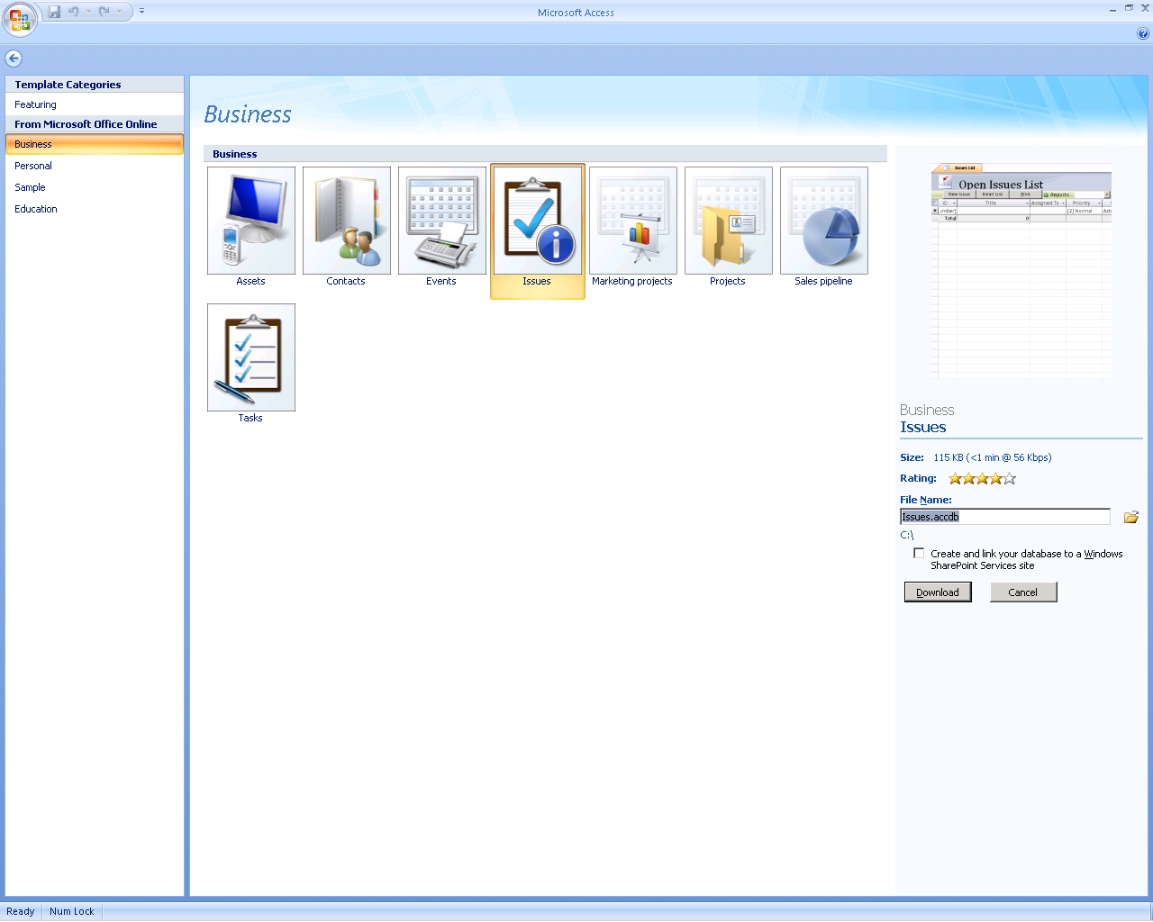

Figure 1: The Getting Started screen offers easy access to a variety of prebuilt applications.

### Quickly Create Tables

Office Access 2007 makes it easier to work directly within a datasheet to create and customize tables. Simply start entering information into a data cell—just as you do now in Excel. When you enter a new value, Office Access 2007 automatically adds a new field and detects the data type (such as date, number, and text). You can even paste Excel tables into a new datasheet, and Office Access 2007 then builds all the fields and recognizes the data types automatically. You can also use the Field Template task pane to insert fields that were predefined for you. You simply drag them into the table.

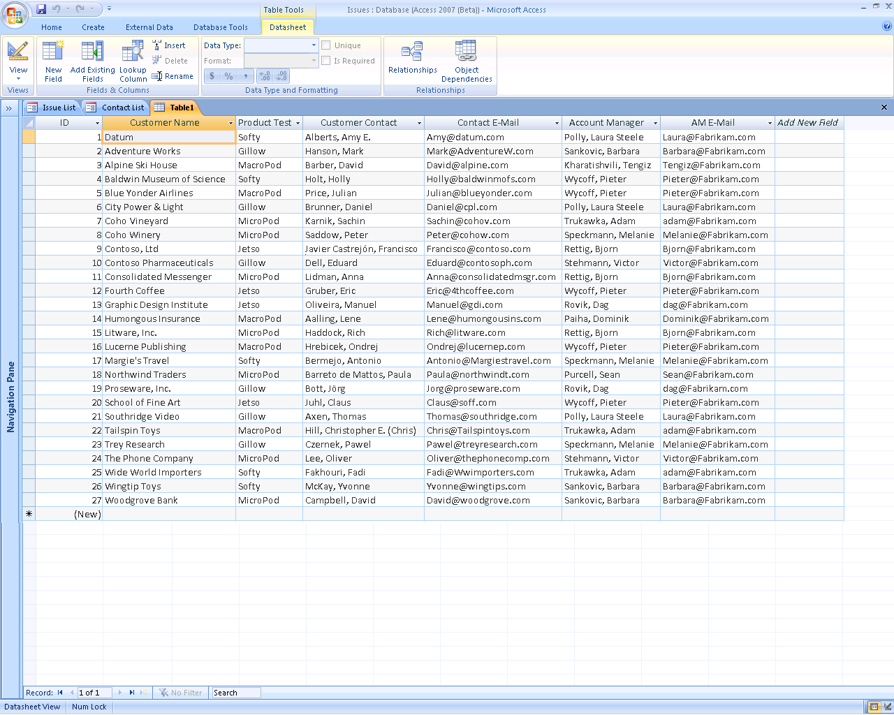

Figure 2: Office Access 2007 makes it easy to paste Excel tables into a new datasheet.

### Import or Save a Contact Record as an Office Outlook 2007 Contact

Office Access 2007 makes it easy to exchange an individual Access contact record with Office Outlook 2007. You can import an Office Outlook 2007 contact record or folder into Office Access 2007. You can also export a contact record from Office Access 2007 and save it as a contact in Office Outlook 2007.

### Work with Multivalue Fields

Office Access 2007 now supports complex data types, so you can create columns that accept more than one value in a cell. For example, if you assign a task to more than one person, you can include both names in the cell. Windows SharePoint Services is compatible with these complex data types to help ensure data symmetry between the local and Web-based data stores.

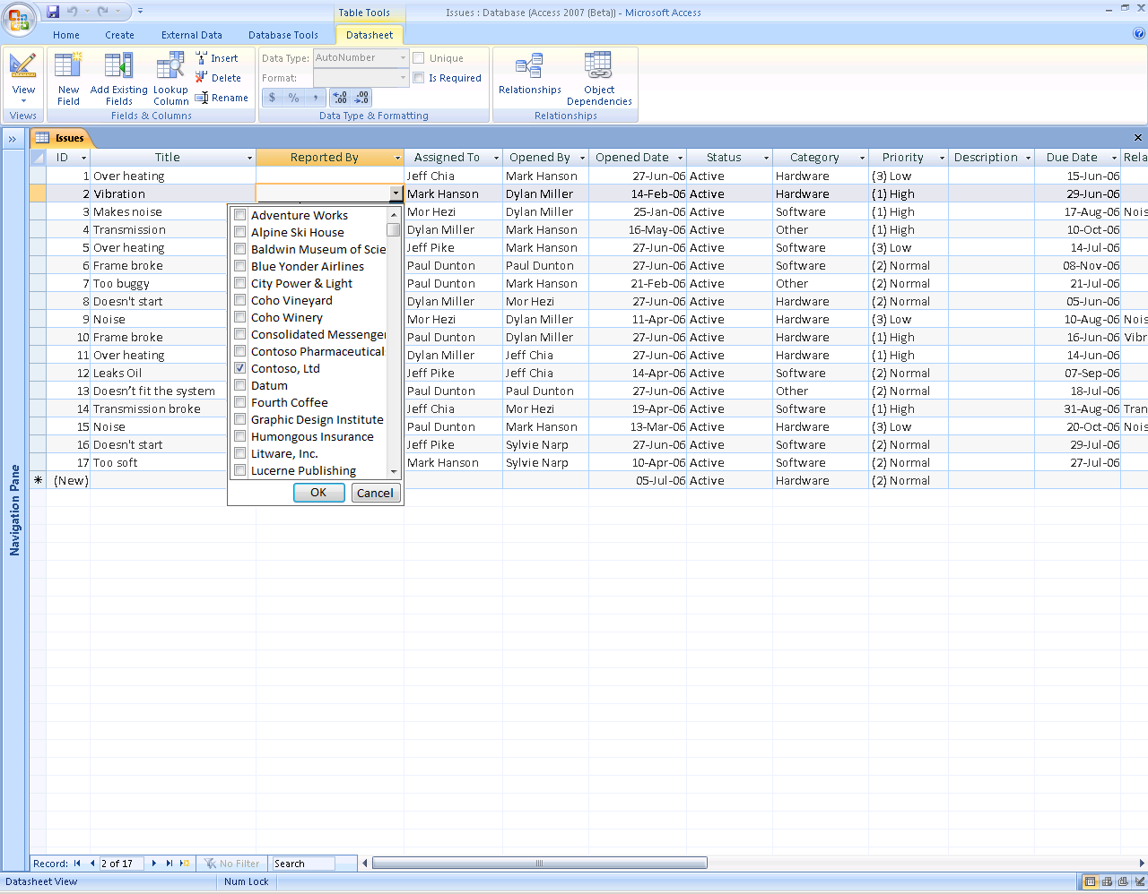

Figure 3: Multivalue fields make it easy to accept more than one value in a cell.

### Attach Documents and Files to Your Database

Your applications can hold information that is more interesting and helpful than ever before. You can attach whole files—such as photos, documents, or spreadsheets—to individual records within the data store for easy reference.

### Import and Export Improvements

New functionality in Office Access 2007 makes it easier to import and export data. The graphical Office Fluent user interface helps you find and select the proper files. You can save an import or export operation and then save the operation so you can reuse it the next time you have to perform the same task.

### Filter and Sort

Office Access 2007 has made it easier to filter data, bringing clarity to business questions. Different filter options are available for text, numbers, and date data types. For example, new filtering options now make it easy to filter a date column for all records in Today, Yesterday, Last Week, Next Month, Future, Past, or any other date. The filtering experience is consistent between Office Excel 2007 and Office Access 2007 so that users do not need to learn a new way to find the information they need.

Office Access 2007 in Action

With Office Access 2007, building a new database has never been easier. When Jeff opens Office Access 2007 to begin building his database, he can choose between several predefined tracking applications. Jeff chooses the “issues” application and imports the contact list of his teammates from Office Outlook 2007. In the datasheet view of his Contacts table, he can quickly and easily delete any unnecessary fields and add any new fields that would be useful.

Next, Jeff needs to add a table to his new database with the list of his early adopter customers. Instead of having to recreate the table in Office Access 2007 or go through a long import wizard, Jeff simply copies the Excel spreadsheet that he has been using and pastes it directly into Office Access 2007, creating a new customer list table. He can add new fields simply by typing in a new column, and Office Access 2007 automatically recognizes the data type.

Finally, Jeff wants to link each issue to the relevant customer who is evaluating the product. He finds it easy to open the issues table and add the customer name field from the recently created customer list table, creating a relationship between the two tables. Jeff takes advantage of the new multivalue field capabilities, too. If an issue has been reported by more than one customer, he can now assign multiple customers to each issue.

## The Microsoft Office Fluent User Interface

Office Access 2007 has been updated with a fresh look that makes it easier to create, modify, and work with tracking applications. The Microsoft Office Fluent user interface, tabbed windows view, a new status bar, new scroll bars, and a new title bar give applications built on Office Access 2007 a very modern look. New features such as the Add New Field column and improved selection capabilities make the Office Access 2007 experience similar to that of Excel.

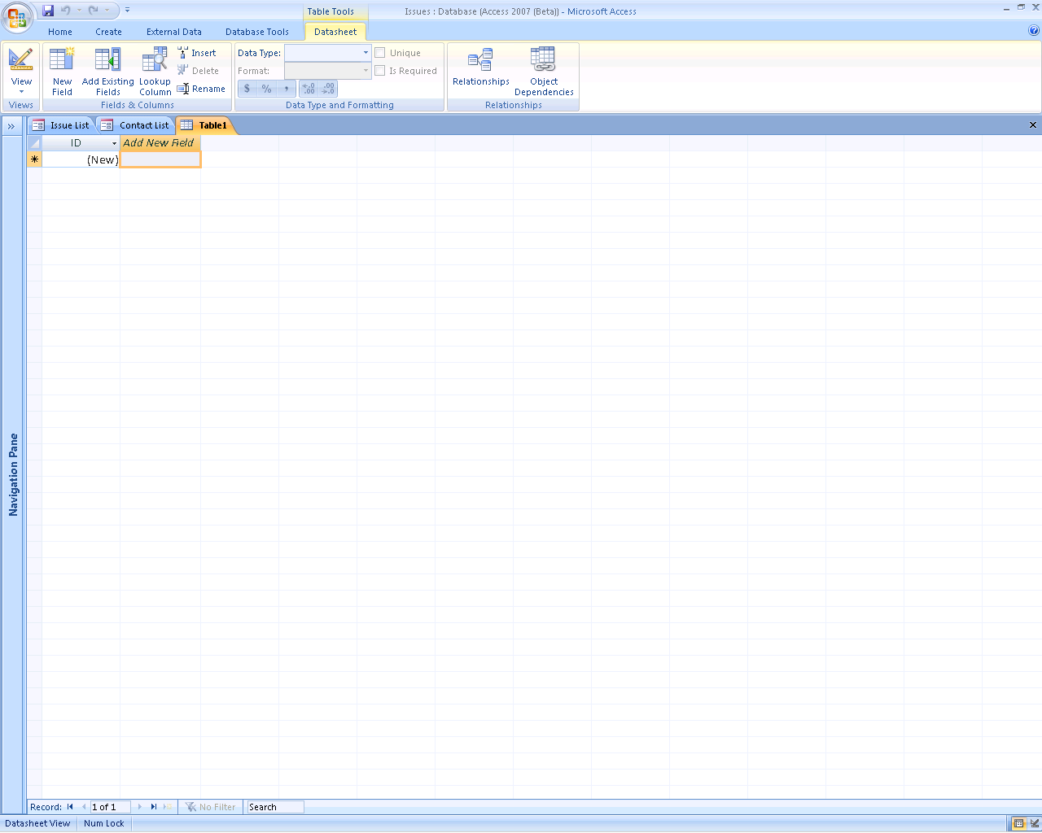

Figure 4: The Office Fluent user interface displays   
only those features that are relevant to the task at hand.

The Office Fluent user interface replaces the old Access menus and toolbars, and most task panes. This Office Fluent user interface is context-sensitive and optimized for efficiency and discoverability. While nearly 1,000 commands are available, the Office Fluent user interface displays only those that are relevant to the task you are performing.

### Improved Navigation

Office Access 2007 provides you with a comprehensive view of tables, forms, queries, and reports with a new Navigation Pane. You can even create custom groups to organize and view all the forms and reports related to a single table.

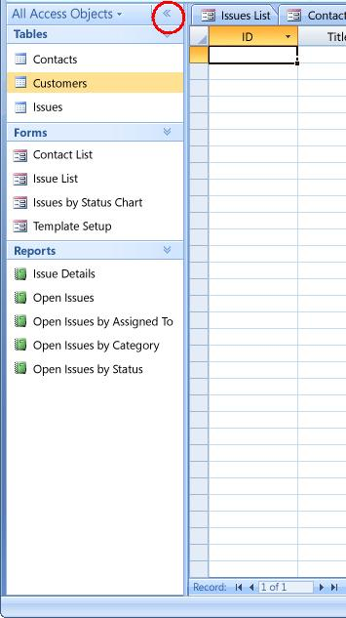 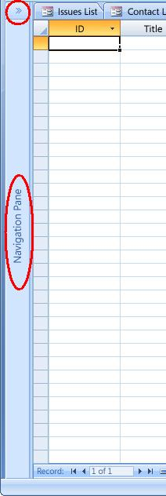

Figure 5: You can open and close the Navigation Pane to see a comprehensive   
view of tables, forms, queries, and reports—even custom groups.

### Rich Text

Office Access 2007 provides Rich Text support for data within tables. It also supports hyperlinks in tables and memo fields.

The Rich Text Format is HTML-based and compatible with the Rich Text data type in Windows SharePoint Services. Formatted data is properly formatted when displayed in any datasheet, form, or report.

## Interactive Forms Design

Office Access 2007 features a WYSIWYG forms design interface. You can design and modify the form layout in real time on the screen—and preview your form as you build it. The WYSIWYG design interface helps you build forms quickly, so you can spend more time doing the work and less on design and formatting issues.

Office Access 2007 in Action

Jeff finds the Office Fluent user interface in Office Access 2007 very intuitive. It displays the tools and options that are immediately relevant to the work he is performing. The navigation pane on the left side of the window groups items logically. He can easily change the pane to group items by type, or add his own custom grouping to display the navigation items in a way that makes the most sense to his work style.

Even when Jeff’s tracking needs change, it is easy to adjust reports and forms. The intuitive interactive design mode provides quick visual feedback about the changes—all without having to rely on external sources that could slow Jeff’s productivity.

# Create and Adapt Reports to Suit Your Business Needs

After you have created a database solution to solve a specific business need, you can use it as a template for other needs. Often, however, each business case requires different fields, forms, or reports. In the past, it has not been easy to modify a database application or its reports—particularly if you have no technical or programming experience. Adapting existing applications has often required submitting a request to IT support or specialized resources, and that request subsequently becomes a bottleneck that prevents quick execution.

In an ever-changing business environment, where every tracking need is different, Office Access 2007 makes it easy to modify an existing database and report structure to meet specific business needs, all without IT support.

## Make Sense of Complexity

Office Access 2007 helps you make sense of your data. You can manage the complexity of your data set more effectively than ever before using filters and groups. And when you need to consolidate information into a report, the WYSIWYG report editor makes it easy for you to design reports that quickly and efficiently present the information that you need.

### Interactive Report Design Mode Editing

New functionality in Office Access 2007 helps you see how data will appear in a report while you are creating it. With the new WYSIWYG interface you can manipulate the report layout directly while browsing the data in the report designer, so you do not need to run the report to see how it looks on the page. This makes it easier to create a great-looking report, and saves you time.

### Filter and Sort Information Easily

Filtering and sorting numbers, dates, and other commonly used data types have become easier in Office Access 2007. You can right-click a column to access a group of common filter options. For example, in a column formatted for dates, right-clicking gives you the option of filtering by year, quarter, or month.

### Group Information in Reports

The grouping user interface in Office Access 2007 is designed to replace the functionality provided through the combination of the Report Wizard and the Grouping Dialog in previous versions of Access. The improved Grouping Pane provides a clear display of data groupings so you can preview changes as you are applying them to reports. You can easily add totals, subtotals, counts, and other elements that help you analyze the data. You can also group the information in one or more layers and add subtotals.

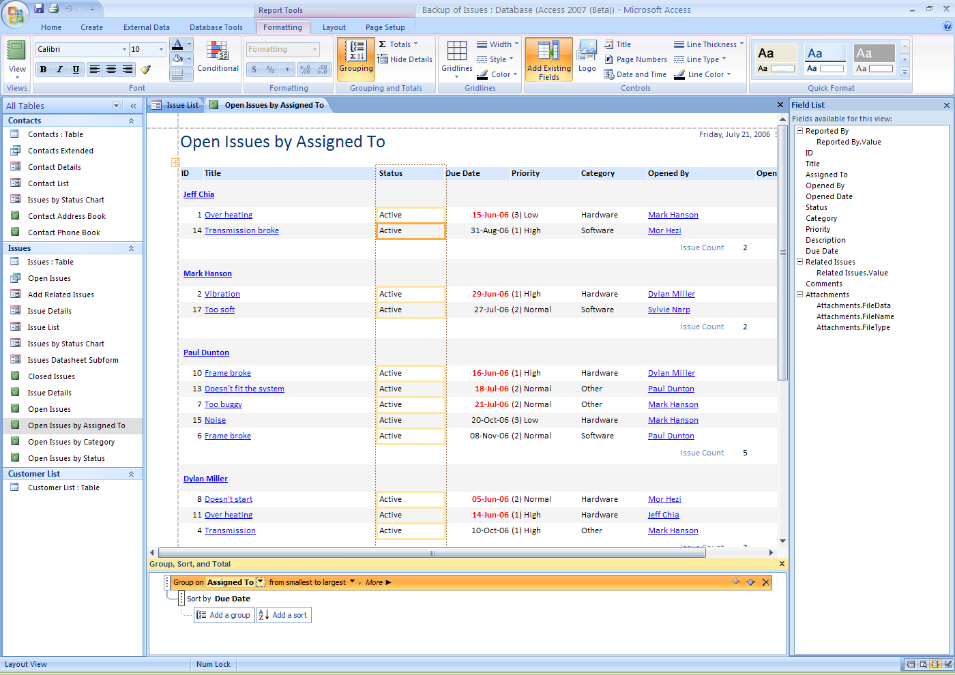

Figure 6: The WYSIWYG report editor makes it easy to group items in your   
reports—and see just what your reports will look like when they run.

# Share Information Effectively

Systems designed to track projects and tasks often rely on input from others—yet enabling other people to interact with a small tracking application running on your desktop has historically presented many challenges. How do you set up your computer to allow secure but remote access? How can others on your team create, manipulate, and run reports? Rarely were there easy answers to these questions—and that compromised productivity for many teams.

Office Access 2007 provides you with the capabilities you need to gather information easily and make it available to others with more security and flexibility. Unlike other versions of Access and similar competing products, Office Access 2007 provides smooth integration with Windows SharePoint Services and Office Outlook 2007.

## Efficient Data Acquisition

Office Access 2007 simplifies the process of collecting information from others.

### Collect Data Using Office Outlook 2007

In Microsoft Office Professional 2007 (and higher suites), Office Access 2007, Office Outlook 2007, and Office InfoPath 2007 work together to help you to collect data using e‑mail. Office Access 2007 builds the data collection form automatically for you in Office InfoPath 2007 or HTML in the body of the e-mail message. You can then send that form to recipients, using e-mail addresses from your Outlook contacts or even from Access.

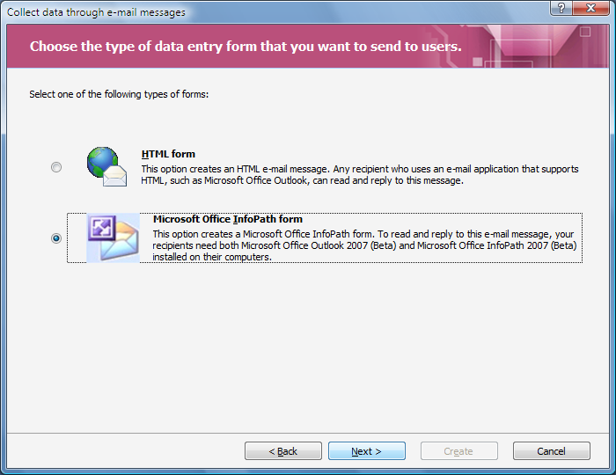

Figure 7: Office Access 2007 makes it easy to collect data using e-mail.

You can select whether you want to collect new information or update existing information. The recipient can fill out the form in the message and return the information you seek. Office Outlook 2007 recognizes the incoming forms and helps you save the data in your Office Access 2007 data store—effectively updating the data in your database quickly without retyping.

## Web Collaboration with Windows SharePoint Services

Web sites based on Windows SharePoint Services provide a place where your team can communicate, share documents, and work together on a project. You can create a separate site for every project on which your team is working. You can contribute to the site by using nothing more than a Web browser. With Office Access 2007, you can work smoothly with the site. You can publish your Access files to libraries or move the application to SharePoint (moving the data and front-end database to the server) where others can interact with it easily through the browser.

You can move your entire Access application to a SharePoint site with just one click. Even reports are available for others to see. The information can then be viewed, updated, or deleted directly on the SharePoint site according to the established permission settings. For a richer experience, you can choose to track the data with the Access client on your computer. The server-based data then is cached on your computer temporarily while the application is open.

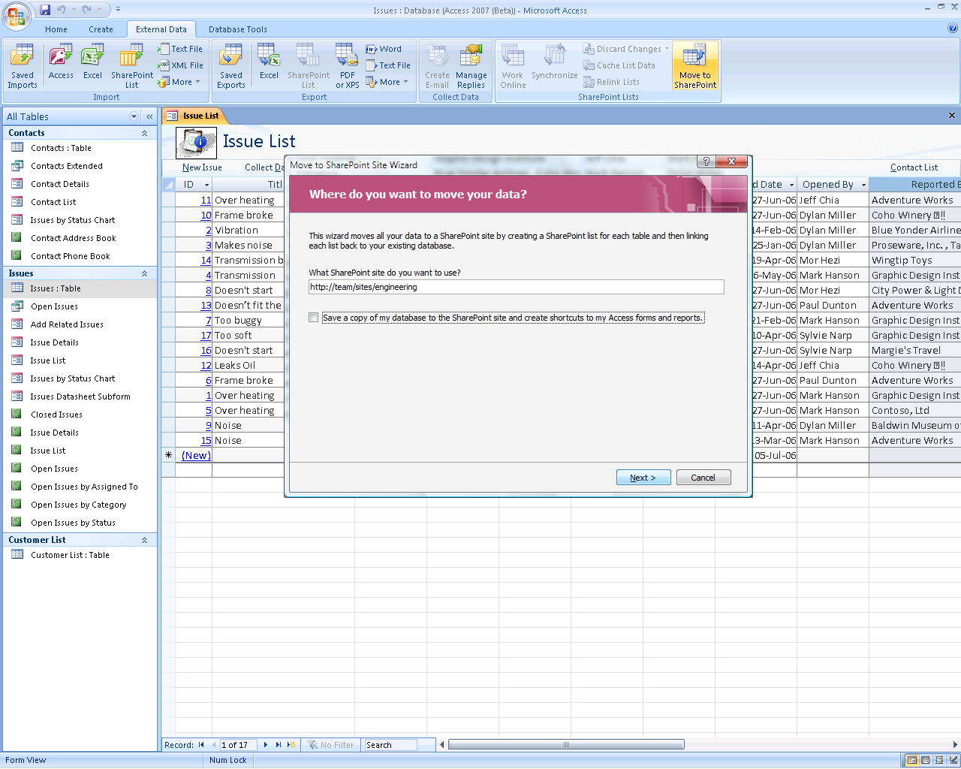

Figure 8: The Move to SharePoint Site Wizard makes it easy to share your Access application.

Office Access 2007 can incorporate SharePoint lists into the database solution you build. You can now open and edit SharePoint lists from within Office Access 2007, and you can link to SharePoint lists just as easily.

### Integration with SharePoint Workflow

Office Access 2007 authors can use business logic created with the SharePoint workflow support to build collaborative workgroup applications. Workflow can be used to automatically assign tasks to other users, report on project status, and help ensure that tasks are completed on time.

### Work Offline

With Office Access 2007, you can also work with Windows SharePoint Services offline. If you are traveling, for example, you can maintain a local copy of a SharePoint list on your laptop computer, where you can edit and query the list as though it were any other table in Office Access 2007. Forms and reports that use the SharePoint list are fully interactive—and Office Access 2007 can later synchronize the local list with the online list when you bring your laptop back online.

### Office Access 2007 Views as SharePoint Views

To extend a Web site built on Windows SharePoint Services technology, you can create and use Office Access 2007 forms, reports, and datasheets as peers to native SharePoint views. Windows SharePoint Services dramatically enhances discoverability and establishes entry points into the data, eliminating the need to launch Access explicitly for these scenarios. Access forms, reports, and datasheets (contained within an Access database on a SharePoint site) appear listed alongside other views in a drop-down list. When you select from this drop-down list, Office Access 2007 is launched on the client and displays the requested Access view. This makes it easy for you to launch a rich Access report on a SharePoint site without first launching Office Access 2007 or knowing the path to the Access database that contains the report.

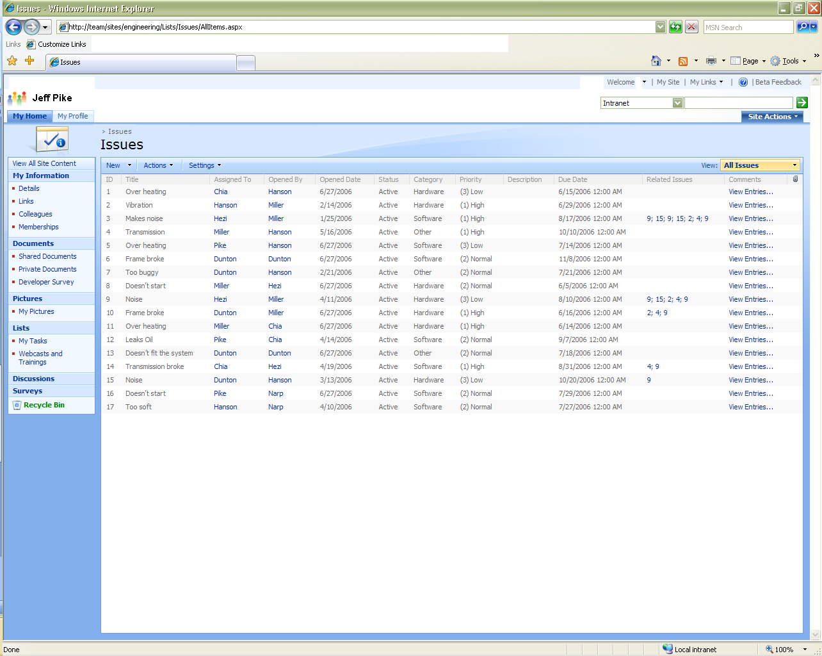

Figure 9: Access lists can appear as SharePoint lists.

### E-Mail and RSS Notifications

Users can subscribe to e-mail notifications when records are added, deleted, or changed. Additionally, using Office Outlook 2007 Really Simple Syndication (RSS) subscriptions, users can subscribe to list feeds.

### Mobile Connectivity

Windows SharePoint Services lists can also be accessed through mobile phones, which help remote users stay current on changing business information.

## PDF and XPS Support

Now with Office Access 2007, you can save a report in a Portable Document Format (PDF) or an XML Paper Specification (XPS) format for printing, posting, and e-mail distribution.[[1]](#footnote-2)\* By saving your report as a PDF or XPS file, you can capture report information in an easily distributed form that retains all your formatting characteristics, yet does not require others to have Access to print or review your report.

Office Access 2007 in Action

Office Access 2007 makes it a lot easier for Jeff to keep his team and his managers up to date on the various pilot projects. After he creates the tracking database, Jeff uses the Move to SharePoint Site Wizard in Office Access 2007 to transfer the data to his team’s SharePoint Web site. Jeff, his teammates, and his managers can now access the data through a Web browser from any location—and they can add and edit records through their browsers. At the same time, each of them can still use the rich client interface of Office Access 2007 to access the data stored on their SharePoint site to filter and build reports.

# Manage and Audit Information

Where does the information you need to track reside? Typically, tracking information for personal projects, and even for many group projects, is on a disk on your computer rather than on a corporate server. Unless you back up and maintain your disks regularly, the information that you need to accomplish your goals is far more susceptible to loss or damage, because it may be outside the systems that your organization’s IT department backs up and maintains. It also poses a problem for your company’s IT professionals, who are personally responsible for ensuring that the company complies with new corporate regulations.

Office Access 2007 makes it much easier for you to meet your information management needs as well as the information management needs of your team and company. Compared to previous versions and comparable solutions, Office Access 2007 gives you better data transparency in a manageable environment.

## Improved Security

To make Office Access 2007 even safer and to maintain consistency with other products in the Microsoft Office system, Office Access 2007 includes new and improved security features. Unified trust decisions are integrated with the Office Trust Center. Trusted locations make it easy to trust all databases in secure folders. Conversely, you can load an Office Access 2007 application with code or macros disabled to provide a safe, “sandbox” experience. Many safe macros are run in sandbox mode.

## Data Auditing

Without requiring IT support, you can easily move data from your local database file to a server with Windows SharePoint Services, which your organization’s IT professionals can manage, secure, and back up according to your organization’s policies.

By running Office Access 2007 on a SharePoint site, you gain new data auditing capabilities.

### Revision History

New functionality enables you to track records and see who created, edited, and deleted records. You can also easily view when the information was modified.

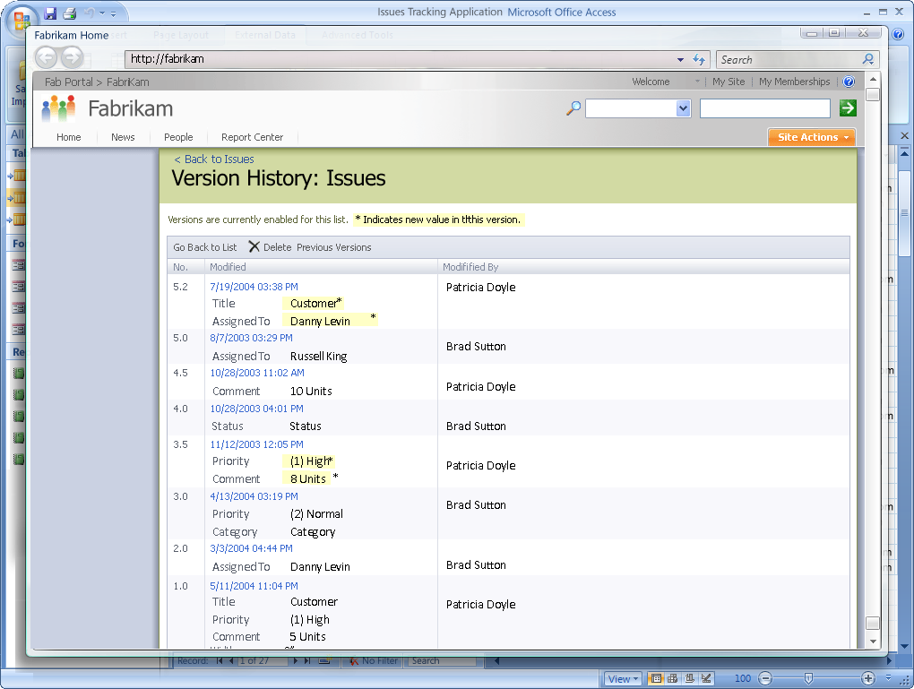

Figure 10: By running Office Access 2007 on a SharePoint site, you gain new data auditing capabilities.

### Permission Setting

Using Windows SharePoint Services, you can manage which users have access to your data. You can assign limited reading permissions or full editing rights.

### Recycle Bin

You can now recover data that was erroneously deleted thanks to the recycle bin feature in Windows SharePoint Services.

Office Access 2007 in Action

By moving the database to a SharePoint Web site on the Fabrikam network, Jeff has increased the security, availability, and transparency of his data. The IT team can automatically back up the corporate servers to reduce the risk of losing critical tracking data. The SharePoint site also provides auditing data and a revision history, so Jeff and his coworkers at Fabrikam can always see who did what and when. And if anyone accidentally deletes critical information, it can be retrieved from the new recycle bin before it is permanently eliminated from the site.

# Summary

Office Access 2007 makes it easy for you and your coworkers to track and report on information. Office Access 2007 empowers you to create and edit database applications quickly and easily, even if you do not possess deep database development knowledge.

Office Access 2007 also makes it easy to start a new project by offering a library of prebuilt database solutions (templates) that support a wide range of common tracking requirements. The Office Fluent user interface and interactive design capabilities eliminate the need for deep database knowledge. At the same time, Office Access 2007 makes it easy to modify a template and to create new fields and tables—so you can adapt your application templates to meet your changing business needs.

After you have created the structure of your application, Office Access 2007 makes it easy to collect the information you want to track. You can capture information using forms that you send and receive via e‑mail or by importing information from external applications. You can share your data on SharePoint lists, while keeping Office Access 2007 as the rich client interface. This contributes to a healthy and transparent ecosystem where data can be routinely audited and backed up.

The tight integration between Office Access 2007 and the Microsoft Office system (including Office Excel 2007, Office Outlook 2007, Office InfoPath 2007, and Windows SharePoint Services) empowers you with new ways to create, maintain, report, and distribute information. These tools move further than ever to break down the barriers that impede the flow of information, helping you get the information you need, in the form you need it, when and where you need it.

Finally, while authoring Office Access 2007 applications is easy for individuals and teams anywhere in an organization, Access remains a powerful database system, and the applications you create can be easily extended. Individuals with more development and programming skills can enhance an Office Access 2007 application with macros or Microsoft Visual Basic® for applications code. Professional developers can even use the tools in the Microsoft Visual Studio® development system to add additional capabilities to an Access application, even turn the application you created for your team into one that the entire organization can use—without having to rewrite the application from scratch. The Access applications you create today can easily grow along with your needs and those of your organization.

# Resources

For more information about Office Access 2007, please visit:

**Office** **Access 2007**

<http://www.microsoft.com/office/access>

# System Requirements

For complete system requirements, visit [www.microsoft.com/office/access](http://www.microsoft.com/office/access).

This document is developed prior to the product’s release to manufacturing, and as such, we cannot guarantee that all details included herein will be exactly as what is found in the shipping product. The information contained in this document represents the current view of Microsoft Corporation on the issues discussed as of the date of publication. Because Microsoft must respond to changing market conditions, this document should not be interpreted to be a commitment on the part of Microsoft, and Microsoft cannot guarantee the accuracy of any information presented after the date of publication. The information represents the product at the time this document was printed and should be used for planning purposes only. Information is subject to change at any time without prior notice.

This document is for informational purposes only. MICROSOFT MAKES NO WARRANTIES, EXPRESS OR IMPLIED, IN THIS DOCUMENT.

© 2006 Microsoft Corporation. All rights reserved. Microsoft, Excel, InfoPath, the Office logo, Outlook, PivotTable, SharePoint, Fluent, Visual Basic, Visual Studio, and Windows are either registered trademarks or trademarks of Microsoft Corporation in the United States and/or other countries. All other trademarks are property of their respective owners.

1. \* You can save as a PDF or XPS file from a 2007 Microsoft Office system program only after you install an add-in. For more information, see [Install and use a PDF or XPS add-in](http://r.office.microsoft.com/r/rlidOOPDFXPSAddin?clid=1033). [↑](#footnote-ref-2)