Published: September 2005
Microsoft Office Live Meeting 2005 Registration User’s Guide



The information contained in this document represents the current view of Microsoft Corporation on the issues discussed as of the date of publication. Because Microsoft must respond to changing market conditions, it should not be interpreted to be a commitment on the part of Microsoft, and Microsoft cannot guarantee the accuracy of any information presented after the date of publication.
This document is for informational purposes only. MICROSOFT MAKES NO WARRANTIES, EXPRESS, IMPLIED OR STATUTORY, AS TO THE INFORMATION IN THIS DOCUMENT.
Complying with all applicable copyright laws is the responsibility of the user. Without limiting the rights under copyright, no part of this document may be reproduced, stored in or introduced into a retrieval system, or transmitted in any form or by any means (electronic, mechanical, photocopying, recording, or otherwise), or for any purpose, without the express written permission of Microsoft Corporation.
Microsoft may have patents, patent applications, trademarks, copyrights, or other intellectual property rights covering subject matter in this document. Except as expressly provided in any written license agreement from Microsoft, the furnishing of this document does not give you any license to these patents, trademarks, copyrights, or other intellectual property.
Unless otherwise noted, the example companies, organizations, products, domain names, e-mail addresses, logos, people, places, and events depicted herein are fictitious, and no association with any real company, organization, product, domain name, email address, logo, person, place, or event is intended or should be inferred.
© 2005 Microsoft Corporation. All rights reserved.
Microsoft, MSN, Outlook, PowerPoint, Visio, and Windows are either registered trademarks or trademarks of Microsoft Corporation in the United States and/or other countries.
All other trademarks are property of their respective owners.

Introduction 1
About This Guide 1
Registration Overview 1
For More Information 3
Getting Started 3
Logging In to Live Meeting Registration 3
The Events Page 4
The Set Up Event Page 6
Creating a basic event 7
Managing Event Information 10
Editing the Event Title and Description 11
Managing Presenters 11
Assigning Branding 12
Managing Meetings on the Event Schedule 14
Reporting on Event Information 17
Managing Registrant Information 18
Setting Up Registrant Information 19
Setting Up Registration Questions 20
Setting Up Entry Questions 23
Managing Registrant Communication 25
Publicizing Event Registration 26
Approving Registrants 26
Managing Notifications 27
Conducting Surveys 30
Appendix: Macros for Notifications and Surveys 34

Introduction
Registration is a feature of Microsoft® Office Live Meeting for setting up large Web conferencing events and managing information about the people who register to attend these events. By using Registration, you can send automatic notifications to registrants, conduct surveys, and create customized profiling questions about attendees.

About This Guide
This guide is for users of Live Meeting who will organize and manage registered events by using Registration. The following concepts are covered in detail:
- Events. What they are, how to create and manage them, and what details you can add or edit to make them effective.
- Registrants. Who attends your events, and what information you can manage about them.
- Presenters. What information you can provide and manage about the people who lead your events.
- Communications. What features you can use to track and notify registrants for your events, including post-event surveys.

Registration Overview
Large events in Live Meeting—training, marketing, or other events—can often present special challenges, especially in managing and learning about the people who attend,: Who are they? How did they learn of the event? What are their goals and expectations for attending? And what did they think of the event after it was over?
Knowing more about event attendees can help you make the event as successful as possible for everybody. In some cases, you might even want to control attendance according to information you learn about registrants in advance.
Registration is a feature of Live Meeting for creating events. An event is an auditorium-style Live Meeting session or group of sessions for which participants must register before they can be admitted. An event features an event registration page where people can register to attend the event. You can design the event registration page to ask specific, detailed questions of each registrant as they register for the event. Optionally, you can manually approve participants’ registration based on their responses.
Each event has an event schedule, made up of one or more meetings (Live Meeting sessions). The meetings can be separate installments of a series of related overall event components, or they can be the multiple instances of the same event that are offered multiple times for attendees’ convenience.
Figure 1. Example event registration page
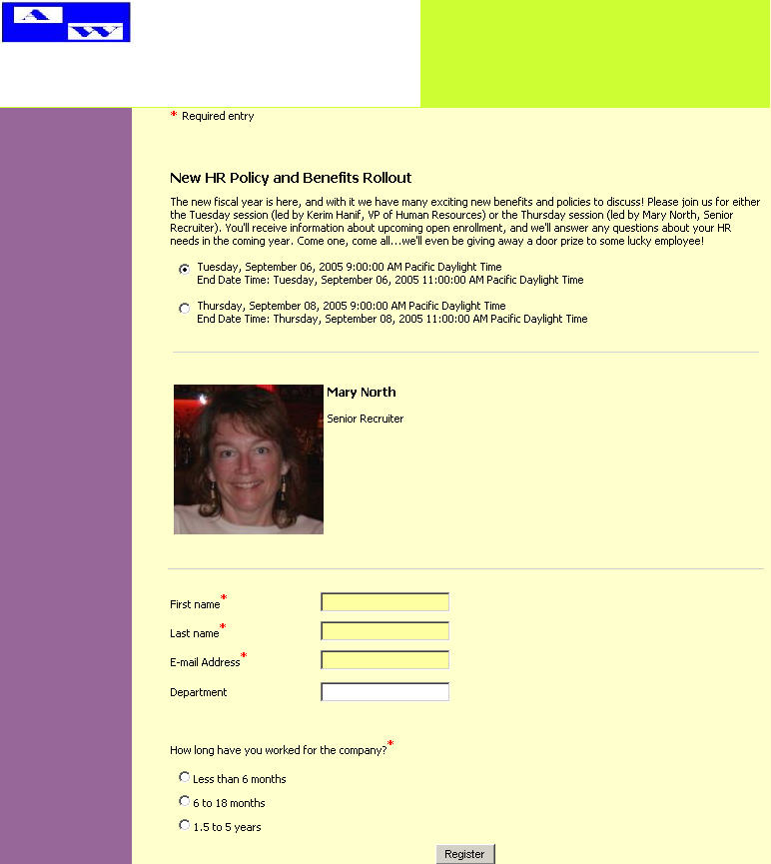

After a registrant is approved, Live Meeting sends the registrant a confirmation e-mail message that contains a link that the registrant can click to join the event at the scheduled time. You can also continue to communicate with registrants before the event by setting up e-mail notifications, meeting entry questionnaires, and follow-up surveys.
Figure 2. Registration workflow
In addition to managing and approving registrants, you can use Registration to create and publish statistical reports about your event. For more information, see “Reporting on Event Information” later in this guide.
For more information about notifications and surveys, see “Managing Registrant Communication” later in this guide. For more information about asking questions of registrants, see “Managing Registrant Information” later in this guide.

For More Information
To learn more about Live Meeting, including training offerings and technical support, visit www.microsoft.com/office/livemeeting/ .

Getting Started
This section describes the basics of getting started with Registration.

Logging In to Live Meeting Registration
To begin using Registration, you must log in. You log in to Registration using a different URL than you use for logging in to your Live Meeting conference center, but your user ID and password are the same. To obtain your organization’s registration URL, contact your Live Meeting administrator.
Figure 3. Registration login page
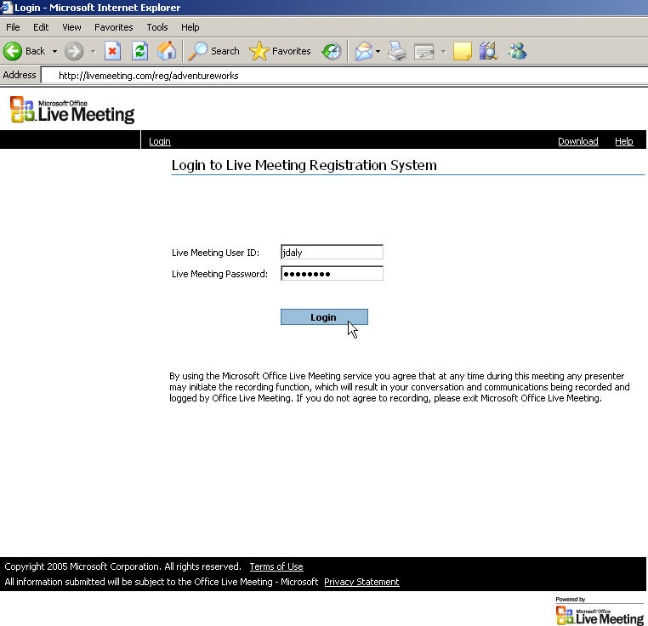

Note
In order to use Registration, you must have a valid Live Meeting account with at least Organizer permissions.
Logging in authenticates you to both the Live Meeting conference center and the registration system. When you use Registration to set up an event, the event is added to the conference center as one or more Live Meeting sessions. You can then use Registration to manage event details, registrant correspondence, and other Registration features.
To log in
In your Internet browser, go to the URL of your organization's Live Meeting registration site.
On the Login to Live Meeting Registration System page, in the User Login box, type your user name. In the Password box, type your password, and then click Login. Your user name and password for the registration site are the same as those for the main Live Meeting site.

The Events Page
After you log in, Registration displays the Events page. On this page, you can do the following:
- Create an event. For more information, see “Creating a Basic Event” later in this guide.
- View the list of registrants pending manual approval for an event. For more information, see “Approving Registrants” later in this guide.
- View reports. For more information, see “Reporting on Event Information” later in this guide.
You can also search for an event and view information about it, as described in this section.
To search for an event
- On the Events page, under Search for an existing event, do one of the following:
- To search for an event by date, click Show all meetings between these dates. In the boxes provided, type the start and end dates for the search in MM/DD/YYYY format, or click the appropriate calendar icon, and then click the date that you want.
- To search for an event by keyword in the event title, click Show meetings, and then click the appropriate option to indicate whether you want to search current and future events, past events, or all events. In the and containing box, type the keyword that you want to search for.
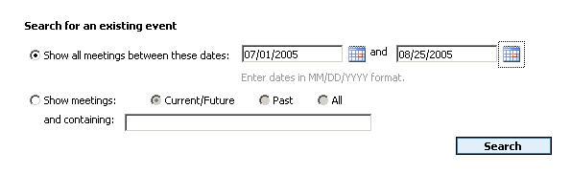
- Click Search.

Note
Only events that you organize are displayed.
To view information about an event
- On the Events page, find the event about which you want to view information. Use the Search feature or Previous/Next links, as needed, to find the event in the list.
- Click the event title.
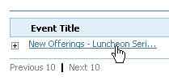

The Set Up Event Page
To create or edit an event, you use the Set Up Event page. On this page, you can do the following:
- Edit the event’s title and optional description. For more information, see “Editing the Event Title and Description” later in this guide.
- Manage the schedule of meetings for the event. For more information, see “Managing Meetings on the Event Schedule” later in this guide.
- Manage the presenter profiles for the event. For more information, see “Managing Presenters” later in this guide.
- Manage the information and questions you set up to gather registrant information. For more information, see “Managing Registrant Information” later in this guide.
- Manage the branding for the event registration page. For more information, see “Assigning Branding” later in this guide.
- Manage notifications and surveys for the event. For more information, see “Managing Registrant Communication” later in this guide.
Figure 4. The Set Up Event page
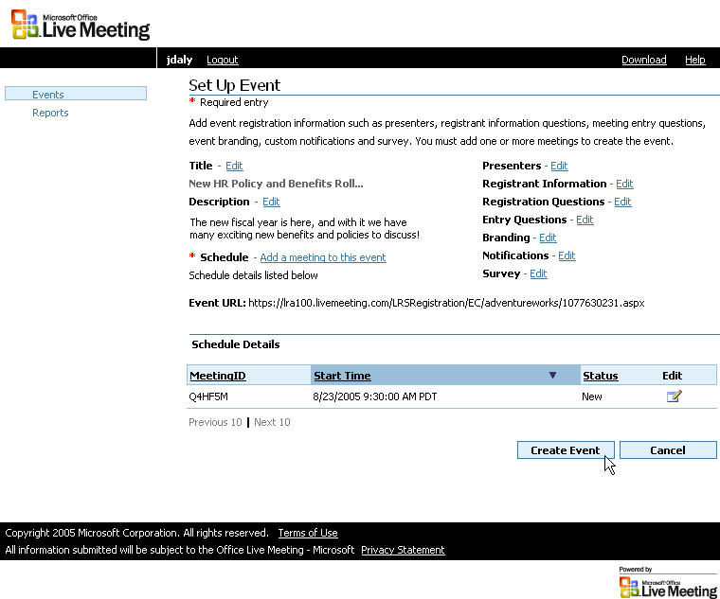
To view the Set Up Event page
- Log in to Live Meeting Registration.
- On the Events page, find the event that you want to set up. Use the Search feature or Previous/Next links as needed to find the event in the list.
- In the row containing the event title, click the icon in the Edit column.
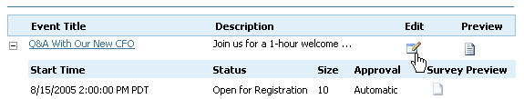

Creating a basic event
This section provides a procedure for getting you up and running quickly with Registration. To create a basic event, you do the following:
- Create an event and give it an event title and description.
- Add a meeting to the event schedule.
- View the event registration page for the new event to verify that everything is correct.
To create a basic event
Note
Only the most basic workflow is described here. For details about organizing and managing events, see the later sections of this guide.
- On the Events page, click Create a new event.
- On the Create a New Event page, type a title and optional description for the event, and then click Next. The title must be unique for all events on the Live Meeting Manager.
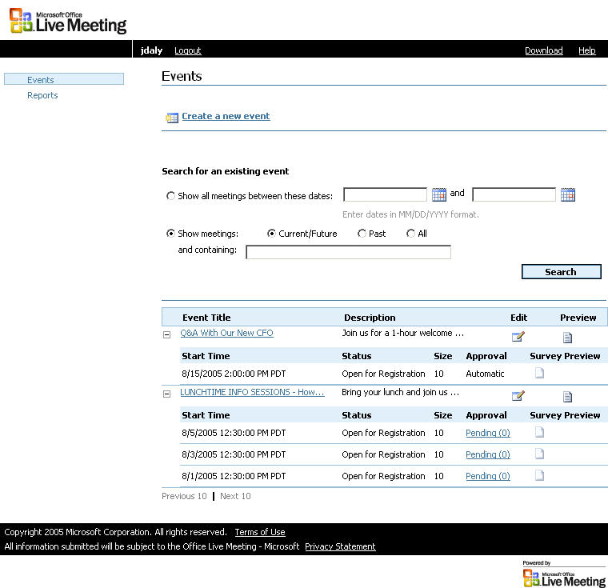
- On the Schedule Meeting page, enter the Start and End time, the time zone for the Start and End time, and the occurrence period for the meeting (one-time or recurring).
- In the Registration Approval list, do one of the following:
- Click Manual if you want to approve or deny each participant's registration manually before sending an automatic e-mail confirmation.
- Click Automatic if you want Live Meeting Registration to approve each participant's registration automatically and then send an e-mail confirmation after they have finished registering.
- If you want to change the meeting options for the meeting, click Meeting Options. Make the changes that you want by using the same steps that you would follow for any Live Meeting session, and then click OK.
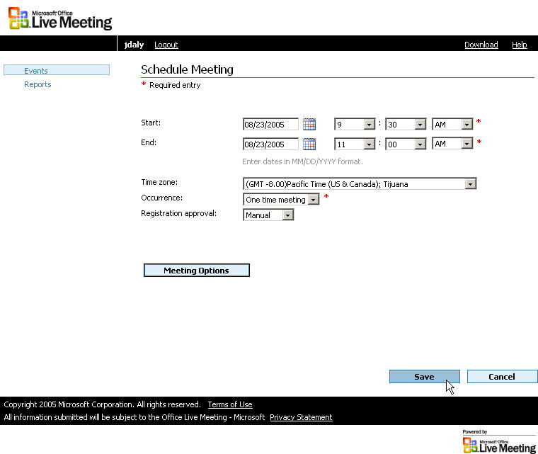
- On the Schedule Meeting page, click Save.
Note
All default meeting options that you have configured by using Live Meeting Manager will apply to meetings that you add to the schedule of a registered event.
- On the Set Up Event page, click Create Event.
- On the Event Details page, click to expand the schedule information.
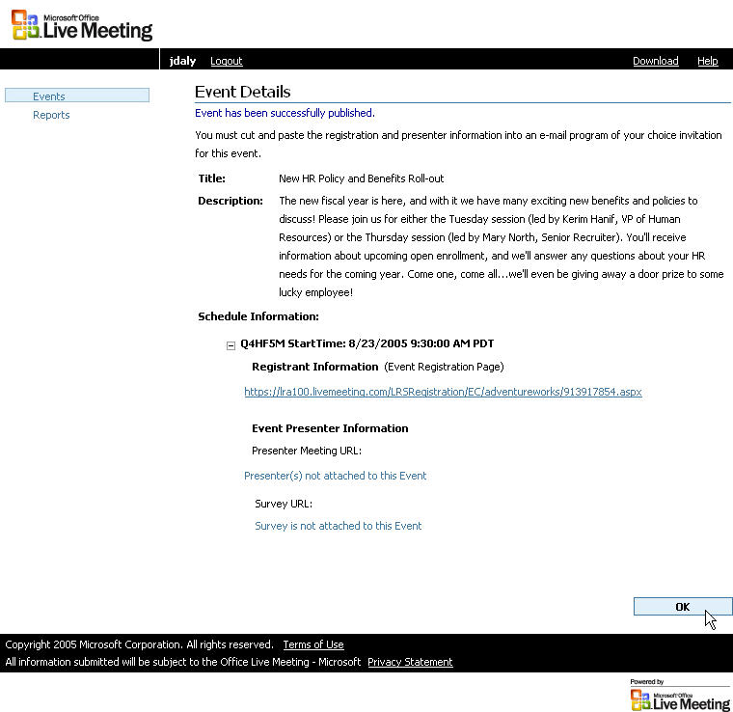
- Click the Registrant Information link to view the event registration page. You can advertise this page to others (for example, by sending the link in a group e-mail message) in order to attract people to register for the event.

Managing Event Information
Event information includes the basics about an event that you organize: its title and description, the presenters who will lead the event, the branding (special identifying graphics) that will be displayed to people who register for the event, and the meetings that you add to and manage on the event schedule.
Typically, you set up all event information at the time that you create an event, before you publicize the event and allow people to register. You can, however, edit the information for an event at any time. You can also run reports to obtain additional information about the event, including registration statistics (pre-event) and participation statistics (post-event).

Editing the Event Title and Description
Note
You can also conduct surveys to learn about feedback from event participants. For more information about surveys, see “Conducting Surveys” later in this guide
The title and optional description that you choose for your event are featured prominently on the event registration page. They are also included in any notifications and surveys that you send that use the title or description macros. For more information about notifications, surveys and macros, see “Managing Registrant Communication” later in this guide.

Note
The title that you provide must be unique. Do not provide a title that has been previously used by you or any other event organizer.
To edit the event title
- On the Set Up Event page, next to Title, click Edit.
- In the Title box, type the event title as you want it to appear.
- Click OK.
To edit the event description
- On the Set Up Event page, next to Description, click Edit.
- In the Description box, type the event description as you want it to appear.
- Click OK.

Managing Presenters
Presenters are the people who will conduct the events that you organize. You can use Registration to create a separate profile for each presenter, which can contain a photo and a description of the presenter. When you assign presenters to an event, registrants can see each presenter’s profile on the event registration page.
A presenter profile can include the following:
- The presenter’s full name and contact data.
- An image of the presenter (optional).
- A description of the presenter (optional). This description can include the presenter’s job title, company history, or any other information that you want to share with registrants.
When you create a presenter profile, Live Meeting retains it in your personal library so that it is available to you if you assign the same presenter to a future event. The presenter profile is also available to other event organizers on your Registration system.
To create a presenter profile
Note
If your event includes multiple presenters at multiple meetings, you can edit the event description to indicate which presenters will lead each meeting.
- On the Set Up Event page, next to Presenters, click Edit.
- On the Presenters page, click Create a new presenter.
- On the Create Presenter page, type the name of the presenter in the Presenter name box.
- To include an optional photo of the presenter, click Browse, and then locate the image file on your computer or network. Click the image file, click Open, and then click Upload Image.
- In the Presenter information text box, type an optional description of the presenter.
Note
Recommended presenter image size is 150x150 pixels.
- On the Create Presenter page, click Save.
- On the Presenters page, click Save.
To edit a presenter profile
- On the Set Up Event page, next to Presenters, click Edit.
- On the Presenters page, next to the presenter profile that you want to edit, click Edit.
- On the Edit Presenter page, update the information about the presenter, and then click Save.
- On the Presenters page, click Save.
To assign a presenter to an event
- On the Set Up Event page, next to Presenters, click Edit.
- On the Presenters page, pick a presenter from the Existing presenters list, and then click Assign Presenter to an Event.
- Click Save.

Assigning Branding
Branding is a term for describing the graphic layout (“look and feel”) of the event registration page for an event. A brand consists of the following optional elements:
- A header background color, used in the header of the event registration page.
- A left column background color, used in the left column of the event registration page.
- A page body background color, used in the main body of the event registration page.
- A brand image (such as a logo) that will appear in the upper left corner of the event registration page.
You set brands on a per-event basis. Your Live Meeting administrator can establish default brands that you can use for your events. You can also use brands created by other Registration users. Alternatively, you can create custom brands for your events, and Live Meeting will retain these brands in your personal library so that you can use them for future events.
To create a brand
Note
All brands that you create in your personal library are also available to other Registration users.
- On the Set Up Event page, next to Branding, click Edit.
- On the Branding page, click Create new brand.
- On the Create Branding page, in the Brand name box, type a name for the new brand.
- To pick the optional header background color, click the Header background color icon. In the Color Picker dialog box, click the color that you want, and then click OK.
- To pick the optional left column background color, click the Left column background color icon. In the Color Picker dialog box, click the color that you want, and then click OK.
- To pick the optional page body background color, click the Page body background color icon. In the Color Picker dialog box, click the color that you want, and then click OK.
- To include an optional branding image, click Browse, and then locate the image file on your computer or network. Click the image file, click Open, and then click Upload Image.
- On the Create Branding page, click Save.
Note
Maximum branding image size is 120 pixels (height) by 600 pixels (width).
- On the Branding page, click Save.
To edit a brand
- On the Set Up Event page, next to Branding, click Edit.
- On the Branding page, next to the brand that you want to edit, click Edit.
- On the Create Branding page, update the information about the brand, and then click Save.
- On the Branding page, click Save.
To assign a brand to an event
- On the Set Up Event page, next to Branding, click Edit.
- On the Branding page, click the option in the Assign column for the brand that you want to assign.
- Click Save.

Managing Meetings on the Event Schedule
Each event has an event schedule, made up of one or more meetings (Live Meeting sessions). The meetings can be separate installments in an event series, or they can be multiple instances of the same event that are offered multiple times for attendees’ convenience.
Each meeting on an event schedule is a separate Live Meeting session. When you add a meeting to an event schedule, it is automatically added to the conference center.
To view all meetings on an event schedule
Note
If your event schedule contains multiple meetings, you cannot assign individual presenters to individual meetings. Optionally, you can edit your event registration page to make it clear which presenters will be leading which sessions and provide a profile for each presenter.
- On the Events page, find the event that you want to set up. Use the Search feature or Previous/Next links, as needed, to find the event in the list.
- In the row containing the event title, click the icon in the Edit column.
- Registration displays the Set Up Event page. The Schedule Details area displays the first ten meetings on the event schedule.
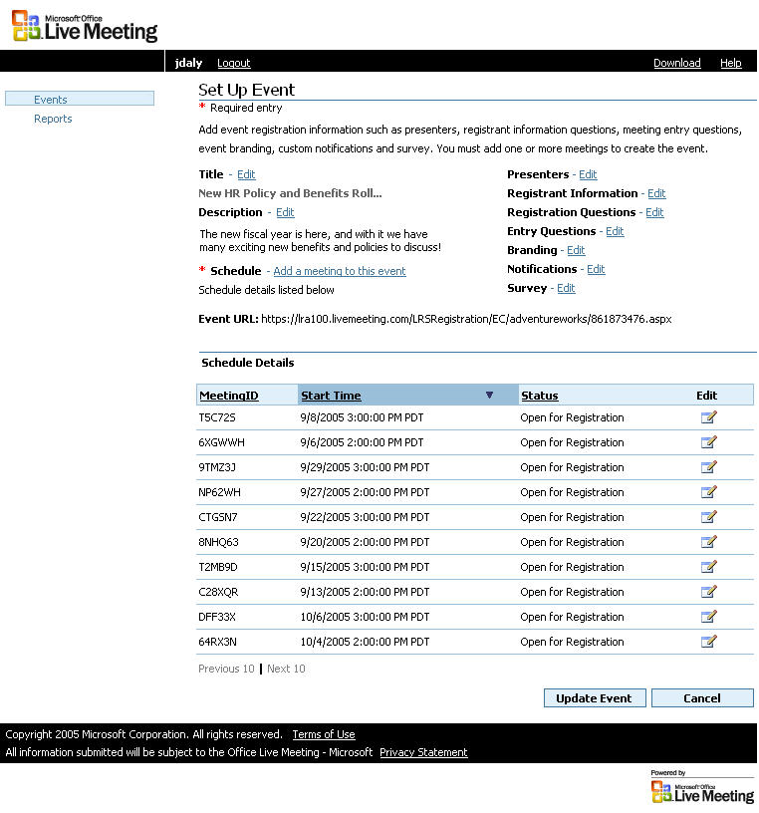
- If the event has more than ten meetings, click Next 10 to view the next ten meetings on the event schedule. Then, click Next 10 again to view the next ten meetings, or click Previous 10 to view the ten previous meetings.
To add a meeting to an event schedule
- On the Set Up Event page for the event to which you want to add a meeting, click Add a meeting to this event.
- On the Schedule Meeting page, specify the Start and End time, the time zone for the Start and End time, and the frequency of the meeting (one time or recurring).
- In the Registration Approval list, do one of the following:
- Click Manual if you want to approve or deny each participant's registration manually before sending an automatic e-mail confirmation.
- Click Automatic if you want Live Meeting Registration to approve each participant's registration automatically and then send an e-mail confirmation once the participant has finished registering.
- To change the meeting options for the meeting, click Meeting Options. Make the changes that you want (using the same steps that you would follow for any Live Meeting session), and then click OK.
- Click Save.
Note
All default meeting options that you have configured by using Live Meeting Manager will apply to meetings that you add to the schedule of a registered event.
- On the Set Up Event page, click Update Event.
To edit a meeting on an event schedule
- On the Set Up Event page for the event, in the Schedule Details area, click the Edit icon next to the meeting that you want to edit.
- On the Update Meeting page, specify the Start and End time, the time zone for the Start and End time, and the frequency of the meeting (one time or recurring).
- In the Registration Approval list, do one of the following:
- Click Manual if you want to approve or deny each participant's registration manually before sending an automatic e-mail confirmation.
- Click Automatic if you want Live Meeting to approve each participant's registration automatically, and send an e-mail confirmation once they have finished registering.
- If you want to change the meeting options for the meeting, click Meeting Options. Make the changes that you want, using the same steps that you would follow for any Live Meeting session, and click OK.
- Click Save.
Note
All default meeting options that you have configured by using Live Meeting Manager will apply to meetings that you add to the schedule of a registered event.
To delete a event
- On the Events page, find the event that you want to delete. Use the Search feature or Previous/Next links, as needed, to find the event in the list.
- In the row that contains the event title, select the Delete check box, and then click Delete Selected.
- In the confirmation dialog box that appears, click OK to delete the event or Cancel to preserve it.
To an delete a meeting
- On the Events page, find the event that you want to delete. Use the Search feature or Previous/Next links, as needed, to find the event in the list.
- In the row that contains the event title, click Edit.
- In the Set up Event page, under Scheduled Meetings, select the Delete check box, and then click Delete Selected.
- In the confirmation dialog box that appears, click OK to delete the meeting or Cancel to preserve it.
Note
When an event or meeting is deleted the registrants do not receive a cancellation notice.

Reporting on Event Information
Reports are a helpful way to get a snapshot of an event, whether the event is in the future or in the past. Reports can contain the following information about an event:
- Meeting size
- Number of registrants and attendees
- Manual or automatic registration approvals granted
- Number of surveys completed
- Conference center information (meeting ID, meeting time, and meeting type)
To search for a report
- In the navigation pane of the ???? window, click Reports.
- On the Reports page, do one of the following:
- To search for an event by date, click Show all meetings between these dates. In the boxes provided, type the start and end dates for the search in MM/DD/YYYY format, or click the appropriate calendar icon, and then click the date that you want.
- To search for an event by keyword in the event title, click Show meetings, and then click the appropriate option to indicate whether you want to search current and future events, past events, or all events. In the and containing box, type the keyword that you want to search for.
- Click Search.
To view a report about an event
- In the left pane, click Reports.
- On the Reports page, find the event for which you want to view a report. Use the Search feature or Previous/Next links as needed to find the event in the list.
- In the row containing the event, click the Reports icon.

To download a report into comma separated value (CSV)
- In the left pane, click Reports.
- On the Reports page, find the event for which you want to view a report. Use the Search feature or Previous/Next links as needed to find the event in the list.
- In the row containing the event, click the Reports icon.
- Click the Download into CSV link. Click Open to open the file, or click Save to save it.

Managing Registrant Information
You can use Registration to learn about the people who attend your events. Registration provides three ways to obtain information about registrants:
- Registrant Information. Demographic and contact data that registrants provide when they register for an event.
- Registration Questions. Questions that registrants answer when they register for an event.
- Entry Questions. Questions that registrants answer immediately prior to joining an event.
When you create registration questions and entry questions, Registration adds them to your personal library so that you can also use them with future events. In this way, you can build highly customized questionnaires for each event that you organize, using both questions from your personal library and new questions that you create.
You can also use Registration to conduct surveys following an event, to obtain feedback from event attendees. For more information, see “Conducting Surveys” later in this guide.

Setting Up Registrant Information
You can collect registrant information, such as demographic and contact data, in a series of fields that you can request or require registrants to complete when they register. These fields appear on the event registration page. You can specify which fields are displayed, as well as which fields are required and which are optional.
You can also alter the display of any registrant information field to gather customized data. For example, if you want to learn the shoe size of each participant, you can type “Shoe Size” in the Alternate Display text box next to one of the custom fields. This revised field will then appear with the other registrant information fields on the event registration page.
To set up the registrant information for an event
- On the Set Up Event page, next to Registrant Information, click Edit.
- For each field listed on the Registrant Information page, do the following:
- To include the information field with the registrant information that you gather for this event, select the corresponding check box.
- To make any field that you select a required field for registrants, select the corresponding check box in the Required Field column.
- If you want to replace the field text (in the Field column) with alternate text that will be displayed to the registrant, type the text that you want to display in the box in the Alternate Display column.
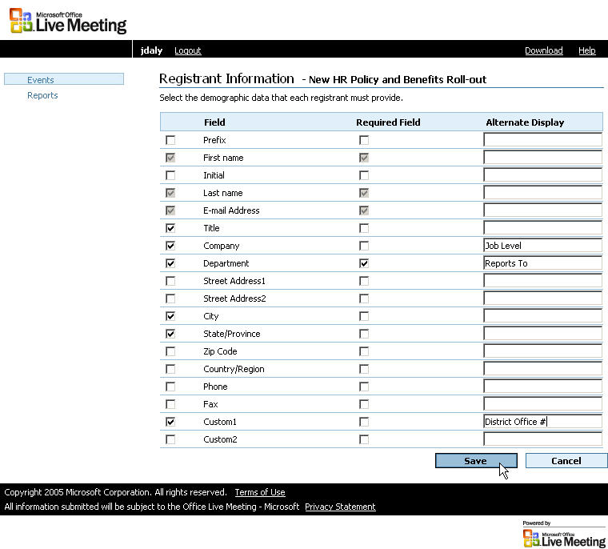
- Click Save.

Setting Up Registration Questions
Registrants respond to registration questions when they register for an event. The questions appear on the event registration page.
To ask registration questions for an event, you add the questions you want from your personal library. You can create questions or add questions that you have previously created.
You can create the following types of registration questions:
- Radio Group. Multiple choice; respondent can choose exactly one response.
- Checkbox group. Multiple choice; respondent can choose multiple responses.
- Single line text. Respondent can type a short response (up to 32 characters).
- Text Area/Comment Box. Respondent types a longer response (no limit).
- Single Select. Multiple choice; respondent can choose one response from a list.
- Multi Select. Multiple choice; respondent can choose multiple responses from a list by holding down the CTRL key.
If you create a multiple choice question, you must also provide answers from which you want respondents to choose. To do this, you type each answer and add it to the Answer List for the question. You can optionally allow respondents to choose an OTHER option and type in a custom response of their own.
When you create a question, you can indicate whether the response is optional or required. Registrants must respond to all required questions before their registration can be approved.
To assign registration questions to an event
- On the Set Up Event page, next to Registration Questions, click Edit.
- On the Registration Questions page, beside a question from the Question list that you want to add, click Assign Question to an Event.
- Click Save.
To create a registration question
- On the Set Up Event page, next to Registration Questions, click Edit.
- On the Registration Questions page, click Create new question.
- On the Create Registration Questions page, in the Question Type list, click the type of question you want to create.
- If you want to make the question a required question, select the This is a required question check box.
- In the Question name box, type the question name as you want it to appear in the Question list on the Registration Questions page.
- In the Display text text box, type the question as you want it to appear to respondents.
- If you chose a multiple choice question type in step 3, type the first answer that you want to make available in the New answer text box, and then click Add to Answer List. Repeat this step for each alternative answer that you want to make available for this question.
- If you chose a multiple choice question type in step 3 and you also want to allow respondents to type a custom answer, select the Include ‘OTHER’ as an answer and provide an input field to enter the custom value check box.
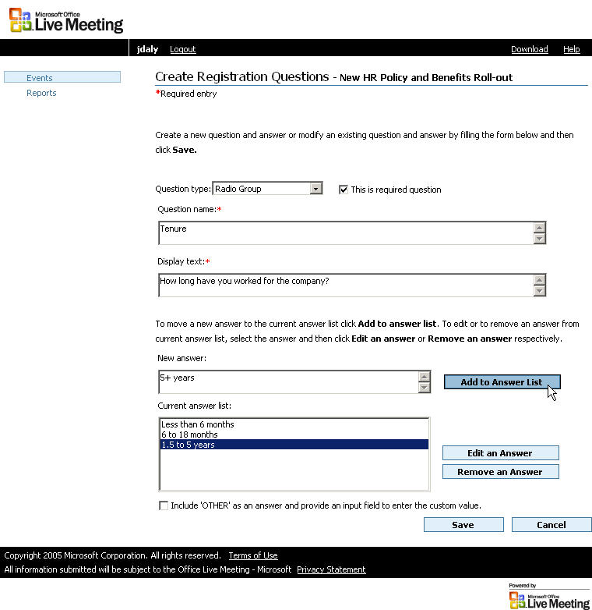
- On the Create Registration Questions page, click Save.
- On the Registration Questions page, click Save.
To edit a registration question
- On the Set Up Event page, next to Registration Questions, click Edit.
Note
A registration question must already be assigned to an event before you can edit it.
- On the Registration Questions page, next to the question that you want to edit, click Edit.
- On the Edit Registration Questions page, provide information about the question (including the answers you will allow), and then click Save.
- On the Registration Questions page, click Save.
To remove a registration question from an event
- On the Set Up Event page, next to Registration Questions, click Edit.
- On the Registration Questions page, next to the question that you want to remove, click the option in the Remove Selected column.
- Click Remove selected.
- Repeat steps 2 and 3 for any additional registration questions that you want to remove from the event.
- Click Save.

Setting Up Entry Questions
Registrants respond to entry questions when they join a meeting that is part of the event schedule. Entry questions appear on a special page that Live Meeting displays immediately following the Join Meeting page for event meetings. To join the event, registrants click the link to join the meeting. After they enter their name and meeting key, they see the Entry Questions page. Once they have answered the questions and clicked OK, the Live Meeting console displays the meeting.
Like registration questions, entry questions are added to an event from your personal library of questions. You create questions for your library or use questions that are already there, and then assign those questions to an event.
You can create the following types of entry questions:
- Radio Group. Multiple choice; respondent can choose exactly one response.
- Checkbox group. Multiple choice; respondent can choose multiple responses.
- Single line text. Respondent can type a short response (up to 32 characters).
- Text Area/Comment Box. Respondent types a longer response (no limit).
- Single Select. Multiple choice; respondent can choose one response from a list.
- Multi Select. Multiple choice; respondent can choose multiple responses from a list by holding down the CTRL key.
If you create a multiple choice question, you must also provide answers from which you want respondents to choose. To do so, you type each answer and add it to the answer list for the question. You can optionally allow respondents to choose an OTHER option and type in a custom response of their own.
When you create a question, you can indicate whether the response is optional or required. Registrants must respond to all required questions before they enter the meeting.
To assign entry questions to an event
- On the Set Up Event page, next to Entry Questions, click Edit.
- On the Entry Questions page, pick a question from the Question list, and then click Assign Question to an Event.
- Click Save.
To create an entry question
- On the Set Up Event page, next to Entry Questions, click Edit.
- On the Entry Questions page, click Create new question.
- On the Create Entry Questions page, from the Question type list, select the type of question that you want to create.
- If you want to make the question a required question, click the This is a required question check box.
- In the Question name text box, type the question name as you want it to appear in the Question list on the Entry Questions page.
- In the Display text box, type the question as you want it to appear to respondents.
- If you chose a multiple choice question type in step 3, type the first answer that you want to make available in the New answer text box, and then click Add to Answer List. Repeat this step for the other answers that you want to make available for this question.
- If you chose a multiple choice question type in step 3, and you also want to allow respondents to type a custom answer, select the Include ‘OTHER’ as an answer and provide an input field to enter the custom value check box.
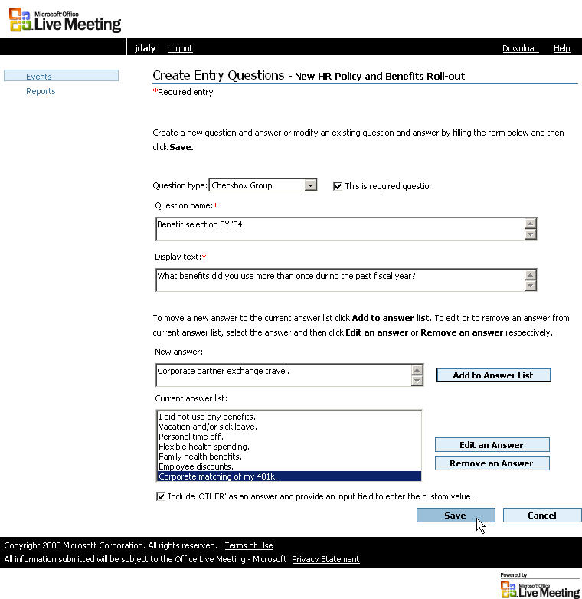
- On the Create Entry Questions page, click Save.
- On the Entry Questions page, click Save.
To edit an entry question
- On the Set Up Event page, next to Entry Questions, click Edit.
Note
An entry question must already be assigned to an event before you can edit it.
- On the Entry Questions page, next to the question that you want to edit, click Edit.
- On the Edit Entry Questions page, provide information about the question, including the answers you will allow, and then click Save.
- On the Entry Questions page, click Save.
To remove an entry question from an event
- On the Set Up Event page, next to Entry Questions, click Edit.
- On the Entry Questions page, next to the question that you want to remove, click the option in the Remove Selected column.
- Click Remove selected.
- Repeat steps 2 and 3 for any additional entry questions that you want to remove from the event.
- Click Save.

Managing Registrant Communication
In addition to gathering profile information about your registrants, Registration provides other methods of communicating with people who participate in your events. These communication methods are crucial for effective management of your events.
You can communicate in the following ways:
- Publicize event registration. You can send an e-mail message to announce the location of your event registration page, so that potential registrants can learn more about the event and register for it.
- Confirmation and Approval Denied notifications. Live Meeting can send e-mail messages notifying people that their registration for an event has been either denied or approved.
- Reminder Notifications. You can instruct Live Meeting to send e-mail messages notifying registered participants of important reminders or other information about the upcoming event.
- Surveys. You can instruct Live Meeting to send surveys to registrants after an event is over, in order to obtain feedback.

Publicizing Event Registration
Inviting people to register for an event is different from using the Live Meeting invitations feature. Typically, when you schedule a Live Meeting session, you specify the people that you want to invite, and Live Meeting sends the invitations on your behalf. With registered events, however, you send a simple e-mail message by using your e-mail program. The message directs potential attendees to your event registration page.
In order for people to register for your event, they must know the URL of your event registration page. Typically, you share this information by sending an e-mail message to the group or groups of people to whom you want to publicize the event. Optionally, you can also publish the URL on a Web page or include it in other kinds of correspondence.
Figure 5. Example of an e-mail message publicizing an event registration page
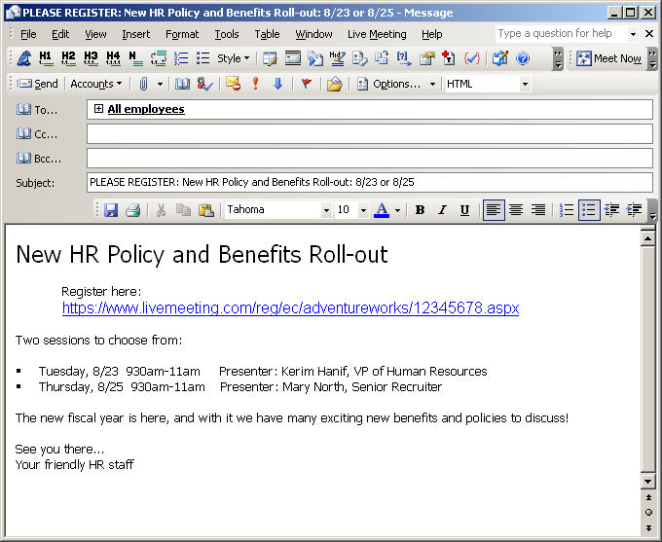

Approving Registrants
When people begin registering for your event, you can approve all registrants automatically, or you can manually approve some and reject others:
- Automatic registration approval. Live Meeting automatically approves each registrant when they click Register on the event registration page, as long as the registrant has provided the required information and answered any required registration questions.
- Manual registration approval. Registrants are added to a Pending list for the event, and you manually approve or deny each registrant on an individual basis.
When a participant’s registration is approved, Live Meeting automatically sends a Confirmation e-mail that contains a Join Meeting link for the registrant to join the event. If you manually deny a registrant, Live Meeting sends an Approval Denied notification. For more information about notifications, see “Managing Notifications” later in this guide.
To manually approve or deny registrants for an event
Note
Registrants register for individual meetings, but you set registration approval on a per-meeting (not per-event) basis. If your event includes multiple meetings on the event schedule, you can specify automatic approval for some meetings and manual approval for others. Registrants receive notifications for each meeting that they register for.
- On the Events page, in the Approve column, click Pending.
- Select the registrants whom you want to approve, and then click Approve.
- Select the registrants whom you want to deny, and then click Reject.
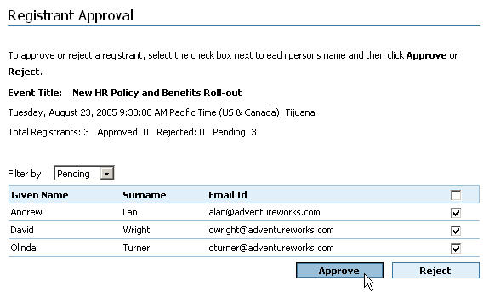
- Click Done.

Managing Notifications
You can use Live Meeting to send e-mail notifications automatically to people who register for your events. You can set up three kinds of notifications:
- Confirmation notifications. Sent to registrants when their registration has been confirmed. These notifications include a Join Meeting link for attending the meeting that the registrant asked to attend.
- Approval Denied notifications. Sent to registrants when their registration has been manually denied.
- Reminder notifications. Sent to confirmed registrants in advance of the event, on a schedule that you specify.
Registration includes one default notification of each type. You can use the default notifications, or you can create custom notifications. When you create a notification, it is available for you to use for a current event or any events that you organize in the future.
Figure 6. Three notification types, and when they are sent by Live Meeting

Note
You can not edit default notifications. If you want to change a default notification, you must first delete it, and then create a new custom notification of the same type
When creating or editing a notification, you can optionally use macros. Macros are variable text segments that you can include in the text of a notification in locations where you want Live Meeting to insert specific information, either about the event or about the registrant. By using macros, you can personalize each notification for each registrant, and you can reuse notifications for multiple events.
To view the list of macros available and a description of each macro, see “Appendix: Macros for Notifications and Surveys.”
To set up a new notification
- On the Set Up Event page, next to Notifications, click Edit.
- On the Notifications page, click Create a new notification.
- On the Create Notification page, provide a name and optional description for the notification in the Notification name and Notification description text boxes.
- In the Notification type list, select the type of notification you are creating.
- If you selected Reminder in step 4, select a number of days in advance of the meeting that you want to send the reminder notification in the Set reminder interval list.
- In the Email address box, type the e-mail address where you want to receive replies to this notification.
- Optionally, in the Display name box, type the name that you want to appear as the sender of the notification.
- In the Subject line box, type the message that you want to appear in the subject line of the reminder. To include a macro, select the macro that you want from the list, click the location in the mail where you want to insert the macro, and then click Insert Macro.
- In the Message body box, type the message that you want to appear in the body of the reminder. To include a macro, select the macro that you want from the list, click the location in the mail where you want to insert the macro, and then click Insert Macro.
- To include standard instructions for attending the meeting with the notification, select the Include attendance instruction check box.
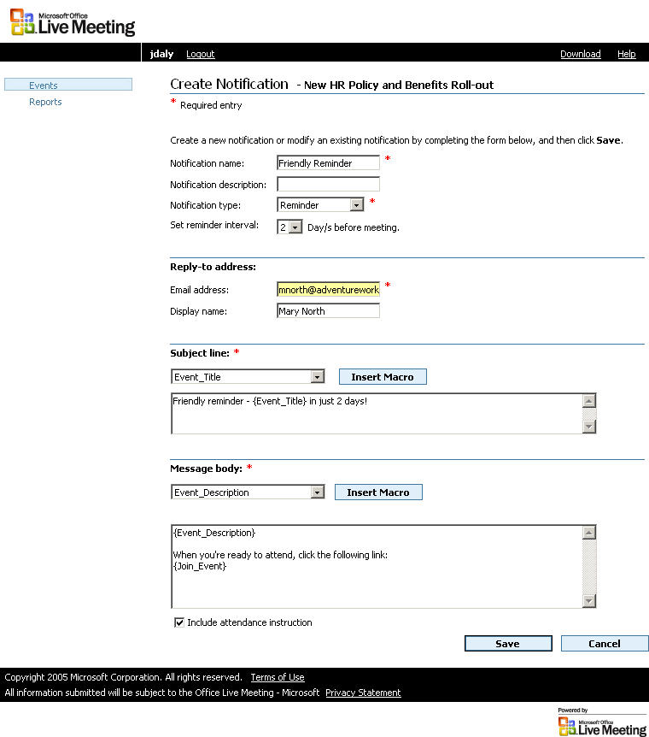
- On the Create Notification page, click Save.
- On the Notifications page, click Save.
To edit a notification
- On the Set Up Event page, next to Notifications, click Edit.
- On the Notifications page, next to the notification that you want to edit, click the Edit icon.
- On the Edit Notification page, update the information about the notification, including the macros that the notification will contain, and then click Save.
- On the Notifications page, click Save.
To assign a notification to an event
- On the Set Up Event page, next to Notifications, click Edit.
- On the Notifications page, from the Existing notification list, select the notification that you want to assign, and then click Assign Notification to an Event.
- Click Save.

Conducting Surveys
After an event, Live Meeting can send a survey to the registrants who attended. Surveys provide a way of receiving specific feedback about an event from the people who participated.
You create surveys using custom survey questions that you store in your personal library. The surveys and questions in your library are available for a current event or for any event that you organize in the future.
You can personalize a survey by using macros to indicate specific information about the registrant or about the event. For more information, see “Managing Notifications” earlier in this guide and “Appendix: Macros for Notifications and Surveys.”
Note
Surveys are conducted by using a separate URL that you can send to registrants by e-mail or display as a Web slide in the Live Meeting console during your event. Survey responses are not anonymous.
Your surveys can include the following types of survey questions:
- Radio Group. Multiple choice; respondent can choose exactly one response.
- Checkbox group. Multiple choice; respondent can choose multiple responses.
- Single line text. Respondent can type a short response (up to 32 characters).
- Text Area/Comment Box. Respondent types a longer response (no limit).
- Single Select. Multiple choice; respondent can choose one response from a list.
- Multi Select. Multiple choice; respondent can choose multiple responses from a list by holding down the CTRL key.
If you create a multiple choice question, you must also provide answers from which you want respondents to choose. To do so, you type each answer and add it to the answer list for the question. You can optionally allow respondents to choose an OTHER option and type in a custom response of their own.
When you create a question, you can indicate whether the response is optional or required. Registrants must respond to all required questions before their survey is accepted.
To set up a new survey
- On the Set Up Event page, next to Survey, click Edit.
- On the Survey page, click Create new survey.
- On the Create Survey page, type a name and description for the new survey in the Survey name and Survey description boxes.
- In the Introductory text box, type the content that you want to appear at the start of the survey e-mail message. To insert a macro as needed, select the macro from the Select Macro list, and then click Insert Macro.
- In the Survey Question list, the first question that you want to appear in the survey.
- Click Add Question.
- Repeat steps 5 and 6 for all questions that you want to appear in the survey.
- In the Closing text and Thank you details text boxes, type the content that you want to appear at the end of the survey e-mail message. To insert a macro as needed, select the macro from the Select Macro list, and then click Insert Macro.
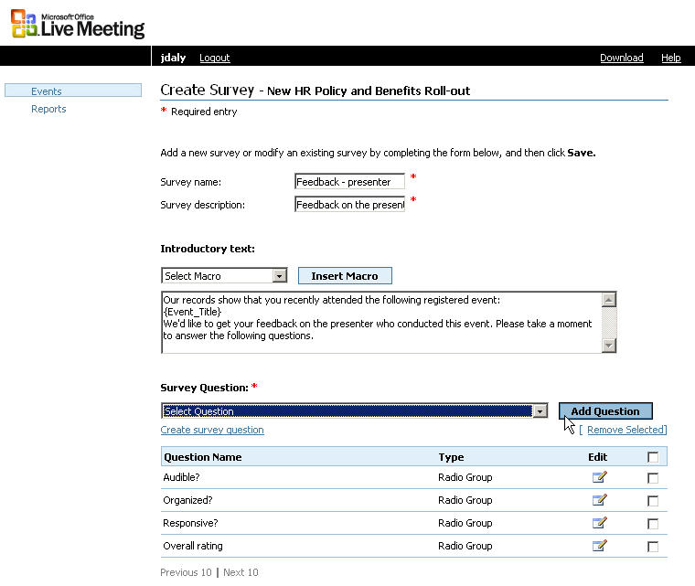
- On the Create Survey page, click Save.
- On the Survey page, click Save.
To create a survey question
- On the Set Up Event page, next to Survey, click Edit.
- On the Survey page, click Create new survey.
- On the Create Survey page, click Create survey question.
- On the Create Survey Questions page, click the type of question from the Question type list: Radio Group, Checkbox group, Single line text, Text Area/Comment Box, Single Select, or Multi Select.
- If you want this question to be a required question in surveys where it appears, select the This is a required question check box.
- In the Question name box, type the question name as you want it to appear in the Survey Question list on the Create Survey page.
- In the Display text box, type the question as you want it to appear to respondents.
- If you chose a multiple choice question type in step 3, type the first answer that you want to make available in the New answer text box, and click Add to Answer List. Repeat this step for the other answers that you want to make available for this question.
- If you chose a multiple choice question type in step 3, and you also want to allow respondents to type a custom answer, select the Include ‘OTHER’ as an answer and provide an input field to enter the custom value check box.
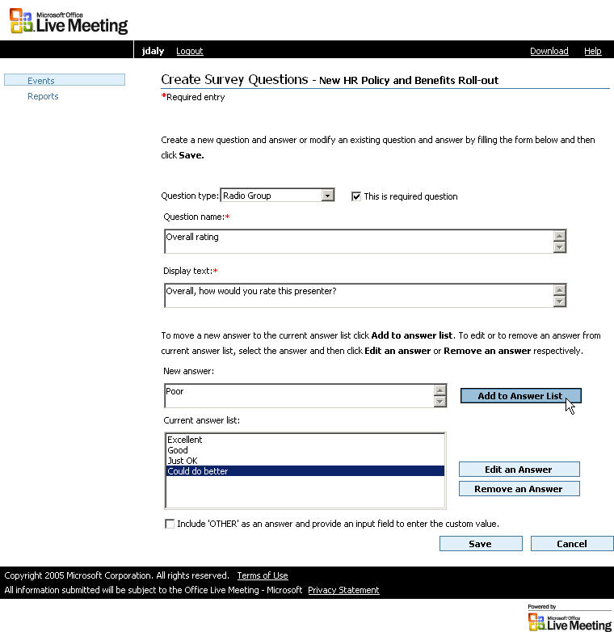
- On the Create Survey Questions page, click Save.
- On the Survey page, click Cancel.
To assign a survey to an event
- On the Set Up Event page, next to Survey, click Edit.
- On the Survey page, in the Survey Name list, click a survey, and then click Assign Survey to an Event.
- Click Save.
To edit a survey
- On the Set Up Event page, next to Survey, click Edit.
- On the Survey page, click the Edit icon next to the survey that you want to edit.
- On the Edit Survey page, update the information about the survey and click Save.
- On the Survey page, click Save.

Appendix: Macros for Notifications and Surveys
The following table lists all macros available for use with Registration. Wherever you insert a macro, the described value will be displayed when the registrant views the notification or survey.
Macro | Description
Account_Admin_Email | E-mail address of the Registration account administrator.
Account_Admin_Name | First and last name of the Registration account administrator.
Attendee_Meeting_Key | Attendee meeting key for the meeting.
City | Registrant’s city.
Company | Registrant’s company or organization.
Country_Region | Registrant’s country or region.
Custom1 | Custom entry field value (registrant information).
Custom2 | Custom entry field value (registrant information).
Department | Registrant’s work department.
Display_Name | Registrant’s name as it appears in the Attendees pane of the meeting.
Email_Address | Registrant’s e-mail address.
Entry_URL | Meeting Entry URL for the meeting.
Event_Description | Event description on the event registration page.
Event_Organizer_Email | E-mail address of the event organizer.
Event_Organizer_Name | First and last name of the event organizer.
Event_Title | Event title from the event registration page.
Fax | Registrant’s fax number.
Given_Name | Registrant’s given name.
Initials | Registrant’s initials.
Leader_Code | Phone bridge leader code (from Audio section of Meeting Details).
Meeting_Duration | Length (in minutes) of meeting.
Meeting_End_Time | End time of the meeting.
Meeting_ID | Meeting ID for the meeting.
Meeting_Start_Time | Start time of the meeting.
Participant_Code | Phone bridge participant code (from Audio section of Meeting Details).
Phone | Registrant’s phone number.
Presenter_Name | First and last name of the presenter for the meeting.
Reply_To_Email | E-mail address to which registrants should reply to notifications.
State_Province | Registrant’s state or province.
Street_Address_1 | Registrant’s street address (first line).
Street_Address_2 | Registrant’s street address (second line).
Surname | Registrant’s surname.
Time_Zone | Time zone of the meeting.
Title | Event title.
Toll_Free_Phone_Number | Toll-free access phone number for the meeting’s phone bridge.
Toll_Phone_Number | Toll-based access phone number for the meeting’s phone bridge.
Zip_Code | Registrant’s postal code.

