

Windows Media Connect:
Device UI Design
Recommendations

Microsoft Corporation
October 2004

Applies to:
Microsoft® Windows Media® Connect
Microsoft Windows Media DRM 10 for Network Devices

Summary: Describes the interactions between network devices (also called digital media receivers) and Windows Media Connect, and suggests how network device designers can best display those interactions to the user.

Legal Notice
The information contained in this document represents the current view of Microsoft Corporation on the issues discussed as of the date of publication. Because Microsoft must respond to changing market conditions, it should not be interpreted to be a commitment on the part of Microsoft, and Microsoft cannot guarantee the accuracy of any information presented after the date of publication.
This White Paper is for informational purposes only. MICROSOFT MAKES NO WARRANTIES, EXPRESS OR IMPLIED, AS TO THE INFORMATION IN THIS DOCUMENT.
Complying with all applicable copyright laws is the responsibility of the user. Without limiting the rights under copyright, no part of this document may be reproduced, stored in or introduced into a retrieval system, or transmitted in any form or by any means (electronic, mechanical, photocopying, recording, or otherwise), or for any purpose, without the express written permission of Microsoft Corporation.
Microsoft may have patents, patent applications, trademarks, copyrights, or other intellectual property rights covering subject matter in this document. Except as expressly provided in any written license agreement from Microsoft, the furnishing of this document does not give you any license to these patents, trademarks, copyrights, or other intellectual property.
© 2004 Microsoft Corporation. All rights reserved.
Microsoft, MS-DOS, Windows, Windows Media, Windows NT, Windows Server, Active Directory, ActiveSync, ActiveX, Direct3D, DirectDraw, DirectInput, DirectMusic, DirectPlay, DirectShow, DirectSound, DirectX, FrontPage, HighMAT, JScript, Microsoft Press, MSN, NetShow, Outlook, PowerPoint, Visual Basic, Visual C++, Visual InterDev, Visual J++, Visual Studio, WebTV, Win32, and Win32s are either registered trademarks or trademarks of Microsoft Corporation in the U.S.A. and/or other countries.
The names of actual companies and products mentioned herein may be the trademarks of their respective owners.

Contents
Introduction 1
Authorization 1
Registration 2
Using UPnP Search to Access Content 3
Using UPnP Browse to Access Content 5
Filtering Unsupported Containers 8
Filtering Unsupported Content 9
Hybrid Browse and Search User Interface 9
For More Information 9

Introduction
When designing network devices that will interact with Windows Media® Connect, network device manufacturers have many choices for how they display information to users. For tasks from authorization to content browsing, the display on a network device can be customized to give network device manufacturers complete control of the user interface. This document describes what information is available to network devices, and provides some of Microsoft's recommendations for displaying that information.

Authorization
For consumer privacy reasons, Microsoft requires that devices be authorized by the user at the computer before the device can access content and associated metadata. Devices should provide a user interface that alerts the users to the need for authorization on the computer. For example, when a user first tries to connect to a computer running Windows Media® Connect, the device can display a message similar to the one in the following illustration.
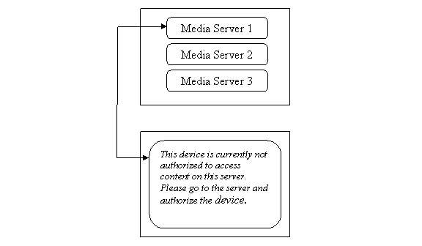
Figure 1. Possible device UI message when authorization fails
Windows Media Connect provides several mechanisms for determining the authorization status of a device. The best mechanism is to use the actions and events supplied in Microsoft's UPnP X_MS_MediaReceiverRegistrar service.
The X_MS_MediaReceiverRegistrar service provides and action called IsAuthorized. This action can be used to determine the authorization status for a device. The IsAuthorized action takes a Unique Device Name (UDN) for Media Renderers or an empty string for Control Points.
An example would be a device that is both a Media Renderer and a Control Point. When powered on, this device searches for servers and checks the authorization status of any computer on the network running Windows Media Connect. To do this the device sends the following action to the server:
IsAuthorized("uuid:00000000-0000-0000-000000000000000")

If the server returns false, either display a message similar to the one in figure 1 or provide some graphical indication such as a lock and key for that server.
Authorization status can change, so it is also useful for devices to subscribe to events from the X_MS_MediaReceiverRegistrar service. Devices will receive AuthorizationGranted and AuthorizationDenied events. Devices can then call IsAuthorized to determine whether the status has changed. The same UI can be used to indicate a change in status

Registration
Registration is another procedure similar to authorization that allows devices to register with Windows Media® Connect. Registration is required before devices can access protected content. Only devices that support Windows Media DRM 10 for Network Devices need to register with Windows Media Connect.
The actual registration of a device is beyond the scope of this document. However, from a UI perspective it might be important to alert a user if a device is capable of receiving DRM content. This might help in troubleshooting problems.
To determine registration status, devices can use the IsValidated action and the associated events, ValidationSucceededUpdateID and ValidationRevokedUpdateID. Devices can provide very simple status like "WMDRM Enabled" for servers. Figure 2 shows an example of a simple DRM status display.
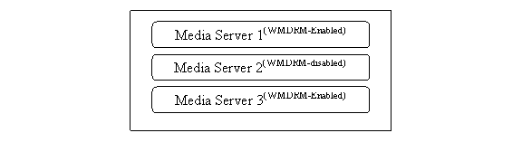
Figure 2. A simple registration status display on a device
To determine the status, devices can do several things. To set the status initially, they should base it on the outcome of the registrations process (not covered here). On power up, devices can use the following action to determine status:
IsValidated("uuid:00000000-0000-0000-000000000000000")

If a device subscribes to the ValidationSucceededUpdateID and ValidationRevokedUpdateID events, it will receive events for change of status. The device can then use the IsValidated action to determine whether the registration status for this device has changed.

Using UPnP Search to Access Content
In general, the UPnP search algorithm should be used with custom UI controls on the device that do not relate to the container hierarchy of the corresponding hierarchy on the UPnP Media Server.
For example, suppose you want a UI that has a button for artists and then a sub-button for each artist that shows all albums for that artist. An example is shown in figure 3.
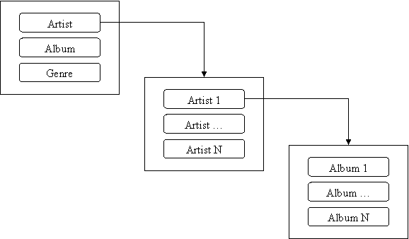
Figure 3. Possible containers under the Artist container
In figure 3, the first window is created by the device. After a consumer selects a button on the first screen, the next two windows are based on UPnP actions.
In figure 3, the user has clicked the Artist button. To make this action display all artists, use the UPnP Search action with the following properties:
Search("0", upnp:class = "object.container.person.musicArtist", "", "*", 0, 0, "")

Depending on memory capabilities of the device and the performance you want, you might want to download the entire artist list at once or request it in some interval like 10 at a time. This is done by using the requested count variable as shown in the following example:
Search("0", upnp:class = "object.container.person.musicArtist", "", "*", 0, 10, "")

The device can now populate the UI with a list of artists. Next, the consumer wants to choose a specific artist. In this example, that action will display a list of albums by the chosen artist. This is done by using the following code:
Search("0", upnp:class = "object.container.album.musicAlbum" and upnp:artist = "Artist 1", "",
"*", 0, 10, "")

This will return all albums for the chosen artist.
The following illustration shows how to use the UI to display all artists for a genre.
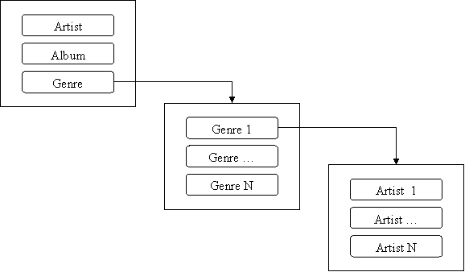
Figure 4. Possible containers under the Genre container
In figure 4, the user has clicked the Genre button. To make this action display all genres, use the UPnP Search action with the following properties:
Search("0", upnp:class = "object.container.genre.musicGenre", "", "*", 0, 0, "")

The device can now populate the UI with a list of genres. Next the consumer wants to choose a specific genre. In this example, that action will display a list of artists for the chosen genre. This is done by using the following code:
Search("0", upnp:class = "object.container.person.musicPerson" and upnp:Genre = "Genre 1", "",
"*", 0, 10, "")

This will return all artists for the chosen genre.

Using UPnP Browse to Access Content
The Browse action is another option for UI. But you should not use Browse if you want broad future compatibility with UPnP Media Servers. The container hierarchy is not standardized by the UPnP Forum, and hence it would be very difficult to create a truly usable UI that would work with all container hierarchies. For this reason Microsoft recommends that you use Browse only if it is filtered specifically for the Microsoft container hierarchy. The following diagram shows the Microsoft container hierarchy with the basic containers of Music, Video, and Pictures followed by some examples of subcontainers.
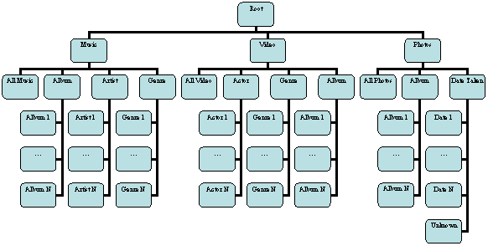
Figure 5. Microsoft container hierarchy for network devices.
The key containers of concern in the Microsoft container hierarchy are Music,Video, Photos, and their immediate subcontainers. These containers can be used when creating a UI. Table 1 describes the containers and lists their IDs.
Table 1. Container names and IDs
Container name | ID | Child type | Description
Root | 0 | object.container | This is the root container of the entire container hierarchy.
Music | 1 | object.container | This container contains all containers and items relating to audio.
Video | 2 | object.container | This container contains all containers and items relating to video.
Pictures | 3 | object.container | This container contains all containers and items relating to pictures.
Music/Album | 7 | object.container.album.musicAlbum | This subcontainer contains album titles for all music items that have album metadata.
Music/Artist | 6 | object.container.person.musicArtist | This subcontainer contains artist names for all music items that have artist metadata.
Music/Genre | 5 | object.container.genre.musicGenre | This subcontainer contains genre information for all music items that have genre metadata.
Music/All Music | 4 | object.item.audioItem  object.item.audioItem.musicTrack | This subcontainer contains all of the music items in the Music container.
Music/Playlists | F | object.container.playlistContainer | This subcontainer contains playlists for all music items.
Video/Actor | A | object.container.album.videoAlbum | This subcontainer contains actor names for all video items that have actor metadata.

Container name | ID | Child type | Description
Video/Album | E | object.container.person.movieActor | This subcontainer contains album titles for all video items that have album metadata.
Vide/All Video | 8 | object.item.videoItem | This subcontainer contains all of the video items in the Video container.
Vide/Genre | 9 | object.container.genre.videoGenre | This subcontainer contains genre information for all video items that have genre metadata.
Pictures/Album | D | object.container.album.photoAlbum | This subcontainer contains album titles for all image items that have album metadata.
Pictures/All Pictures | B | object.item.imageItem.photo  object.item.imageItem | This subcontainer contains all of the image items in the Pictures container.
Pictures/Date Taken | C | object.container.album.photoAlbum | This subcontainer contains the dates pictures were taken for all image items that have date-taken metadata.

Filtering Unsupported Containers
Because the container hierarchy is not standardized, there is a possibility that your device will encounter top-level containers that it does not support. For instance an audio-only device that browses all servers starting at the root will get a return of "music", "video", and "photos". Similar results will be seen with other servers on the market. To prevent showing folders that do not make sense, Microsoft recommends using the <SEARCHCLASS> tag as a means of filtering containers.
In the audio-only example, a device will browse the root container. This will return the following results:
<DIDL-Lite xmlns:dc="http://purl.org/dc/elements/1.1/"
xmlns:upnp="urn:schemas-upnp-org:metadata-1-0/upnp/"
xmlns="urn:schemas-upnp-org:metadata-1-0/DIDL-Lite/">
<container id="1" restricted="true" parentID="0">
<dc:title>Music</dc:title>
<upnp:class>object.container</upnp:class>
<upnp:searchClass includeDerived="false">object.container</upnp:searchClass>
<upnp:searchClass includeDerived="false">object.item</upnp:searchClass>
<upnp:searchClass includeDerived="false">object.item.audioItem</upnp:searchClass>
<upnp:searchClass includeDerived="false">object.item.audioItem.musicTrack</upnp:searchClass>
<upnp:searchClass includeDerived="false">object.container.genre.musicGenre</upnp:searchClass>
<upnp:searchClass includeDerived="false">object.container.person.musicArtist</upnp:searchClass>
<upnp:searchClass includeDerived="false">object.container.album.musicAlbum</upnp:searchClass>
<upnp:searchClass includeDerived="false">object.container.playlistContainer</upnp:searchClass>
</container>
<container id="3" restricted="true" parentID="0">
<dc:title>Pictures</dc:title>
<upnp:class>object.container</upnp:class>
<upnp:searchClass includeDerived="false">object.container</upnp:searchClass>
<upnp:searchClass includeDerived="false">object.item</upnp:searchClass>
<upnp:searchClass includeDerived="false">object.item.imageItem</upnp:searchClass>
<upnp:searchClass includeDerived="false">object.item.imageItem.photo</upnp:searchClass>
<upnp:searchClass includeDerived="false">object.container.album.photoAlbum.dateTaken</upnp:searchClass>
<upnp:searchClass includeDerived="false">object.container.album.photoAlbum</upnp:searchClass>
</container>
<container id="2" restricted="true" parentID="0">
<dc:title>Video</dc:title>
<upnp:class>object.container</upnp:class>
<upnp:searchClass includeDerived="false">object.container</upnp:searchClass>
<upnp:searchClass includeDerived="false">object.item</upnp:searchClass>
<upnp:searchClass includeDerived="false">object.item.videoItem</upnp:searchClass>
<upnp:searchClass includeDerived="false">object.container.genre.movieGenre</upnp:searchClass>
<upnp:searchClass includeDerived="false">object.container.person.movieActor</upnp:searchClass>
<upnp:searchClass includeDerived="false">object.container.album.videoAlbum</upnp:searchClass>
</container></DIDL-Lite>

As you can see from the preceding XML example, each container has an associated set of "search classes" defined. The values between these tags define what can be searched for under a given container. An audio-only device should not show a container unless a search class of the following values is provided:
<upnp:searchClass includeDerived="false">object.item.audioItem</upnp:searchClass>
<upnp:searchClass includeDerived="false">object.item.audioItem.musicTrack</upnp:searchClass>
<upnp:searchClass includeDerived="false">object.container.genre.musicGenre</upnp:searchClass>
<upnp:searchClass includeDerived="false">object.container.person.musicArtist</upnp:searchClass>
<upnp:searchClass includeDerived="false">object.container.album.musicAlbum</upnp:searchClass>

In the preceding example, an audio-only device would be capable of filtering out both the video and photos containers because these containers do not list any audio items under the container.
To get the search class for a particular container or containers, a device must browse with a filter of "*" or "upnp:searchClass". For example:
Browse("0", "BrowseDirectChildren", "upnp:searchClass", 0,10, "")

Filtering Unsupported Content
Devices can use the res@protocolnfo field to filter items. They can also use the extension at the end of URLs.

Hybrid Browse and Search User Interface
A device can use both the Browse and Search actions to create a hybrid UI. For example, if you want to use the container hierarchy for UI, but you want to find an easier way to filter content and containers, you can use code like the following:
Search("0", upnp:class = "object.container" and upnp:searchClass = "object.item.audioItem", "",
"*", 0, 10, "")

Browse("0", "BrowseDirectChildren", "upnp:searchClass", 0,10, "")

For More Information
- For general information about Windows Media® technologies, see the Windows Media Web site (http://www.microsoft.com/windows/windowsmedia/).
- For more information on UPnP Media Renderers, download the MediaRenderer 1.0 specification (http://www.upnp.org/standardizeddcps/documents/MediaRenderer1.0_000.pdf).
- For more information on the UPnP Device Architecture, download the UPnP Device Architecture specification (http://www.upnp.org/resources/documents/CleanUPnPDA101-20031202s.pdf).

