Microsoft Office Outlook Connector 12.0 FAQ

This document is for informational purposes only.  MICROSOFT MAKES NO WARRANTIES, EXPRESS, IMPLIED OR STATUTORY, AS TO THE INFORMATION IN THIS DOCUMENT.

Microsoft may have patents, patent applications, trademarks, copyrights, or other intellectual property rights covering this document or the subject matter included in this document.  The furnishing of this document does not give you any license to these patents, trademarks, copyrights, or other intellectual property.

© 2007 Microsoft Corporation. All rights reserved.

1. **The Outlook Connector doesn’t sync unless I press send/receive in Outlook 2003. Is that expected?**

Yes. Outlook 2003 does not perform a send/receive automatically as Outlook 2007 does. If you use Outlook 2003, either force sync by pressing send/receive, or schedule automatic send/receive in by clicking tools🡪Send/Receive🡪Send/Receive Settings🡪Define Send/Receive Groups.

1. **Why can’t I connect?**

In addition to an internet connection and a copy of Outlook, there is one other requirement for the Outlook Connector. The connector requires accounts to be updated to the new Windows Live Hotmail. You can update an existing account by visiting <http://mail.live.com> and signing in with your Live ID and Password. If there is a green ‘Join Windows Live Hotmail’ button in the upper left, please update and then try connecting with the OLC.

If you still have trouble connecting, try rebooting Outlook. If that still fails, we want to hear from you! Please visit <http://support.microsoft.com/select/default.aspx?target=assistance&prid=10162&gprid=42219> and send us feedback.

Note, if you see a messaging informing you a premium subscription is required to use the connector, please try the steps outlined above and ignore this message. A premium subscription is only required for calendar synchronization (see question 6).

1. **How can I troubleshoot problems?**

In the status toolbar 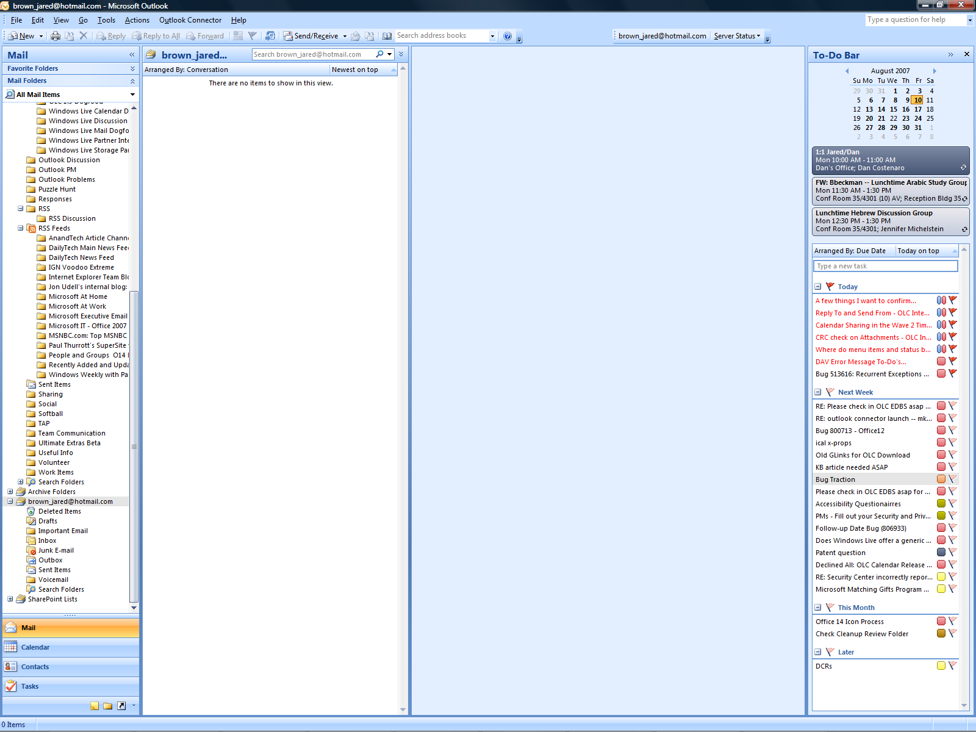click “Server Status” and then “Detailed Report” to see a detailed status report which may include some trouble shooting suggestions if errors are encountered during synchronization.

If the detailed report includes instructions to view the “Sync Issues” folder, follow these steps:

* Click the Go menu in Outlook.
* Click “Folder List”
* In the folder list, under the Windows Live Hotmail account, a Sync Issues folder should be visible.

1. **When I check the detailed status report (in the status toolbar), I see a 4104 error. What should I do?**

If you see 4104 errors, remove the account using the account manager in Outlook

**Outlook 2007:**

* Click the Tools menu.
* Click “Account Settings…”
* Select the Windows Live Hotmail account receiving the 4104 error and click “Remove”

**Outlook 2003:**

* Click the Tools menu.
* Click “E-mail Accounts”
* Select “View or change existing e-mail accounts”, and then click Next.
* Select the Windows Live Hotmail account receiving the 4104 error and click “Remove”
* Click Finish

Then add the account back to Outlook by clicking the Outlook Connector menu and selecting “Add new account…”

Note, do not remove and re-add your Windows Live Hotmail account unless you are unable to synchronize and you receive a 4104 error. Removing and re-adding your account unnecessarily may cause your account to exhaust its pool of synchronization relationships and prevent you from synchronizing for up to 30 days.

1. **Why do more items end up in my Junk Folder in Outlook than on the Hotmail Web UI?**

The Outlook Connector uses Outlook's junk mail filter on top of the Hotmail filter. As a result, more items may be marked as junk in Outlook than on the web.

1. **My status toolbar shows a yellow** [ - Office Medium Size (24x24, 32-bit color)](http://commandbars/update/icons/HighColor/DWSStatusSmallHL.BMP) **icon and I get an error message when creating appointments in my Outlook Connector Calendar.**

While the Outlook Connector is free, it only synchronizes Mail and Contacts at no charge. For Calendar synchronization, a premium subscription is required. You can still use the Outlook Connector calendar in Outlook, however appointments and meetings won't synchronize to the Hotmail calendar.

Premium Subscription services include:

1. MSN Premium: <http://join.msn.com/premium/overview>
2. Office Live Essentials/Premium: <http://office.microsoft.com/en-us/officelive/default.aspx>
3. **Follow-up date for flagged items is sometimes incorrect.**

The follow-up date may be incorrect for flagged items that change on the web or synchronize to another Outlook client with the connector.

1. **Is a mixed language configuration supported (ie: English Outlook + Japanese Outlook Connector)?**

No. We only officially support the Outlook Connector with the same language as the Operating System & Office languages.

1. **Can I sync my Hotmail account if there is no Outlook Connector for my language?**

Yes, as long as the Outlook Connector language and Office languages match your account will sync, even if the account is in another language. No data is altered based on language.

1. **Why don’t my messages get saved to the Hotmail Drafts folder?**

If your Hotmail account is a secondary account in Outlook, authoring mail and saving it as a draft will save the message to the primary account’s ‘Drafts’ folder and not the Hotmail ‘Drafts’ folder, and the draft will not synchronize to the Hotmail web UI.

# For Beta Testers

1. **I beta tested the Outlook Connector as a secondary account in Outlook and upgraded to the non-beta, but flagged items still don’t show up on the To-Do bar and reminders still don’t fire.**

The beta had an issue with flagged items and reminders for secondary accounts. This is fixed in the non-beta release, however beta testers must remove the account in Outlook created with the beta connector and add their Hotmail account to Outlook once the non-beta connector has been installed.