Microsoft® Office InfoPath® 2007

September 2006



Table of Contents

Cover is for   
position only

Overview of Microsoft Office InfoPath 2007 1

Gather Information Efficiently and Reliably 1

Centralize Forms Management and Deployment 1

Streamline Forms-Driven Business Processes 3

Gather Information Efficiently and Reliably 4

Get the Right Information—the First Time 4

Collect Accurate Information Without Writing Code 5

Extend the Reach of Your Business Forms 6

Complete InfoPath Forms Using Web Browsers and Mobile Devices 6

Complete InfoPath Forms Inside Outlook E-Mail Messages 7

Complete Forms Online or Offline 7

The Familiar Microsoft Office System Environment 7

Convert Word Documents and Excel Spreadsheets 8

Automate Information Gathering for Office Access 2007 8

Help Protect Your Forms with Information Rights Management 8

Centralize Forms Management and Control 9

Making Forms More Manageable 9

Use Office SharePoint Server 2007 to Automate Forms-Driven Processes 9

Centralize Control Over Who Can Create and Publish Forms 10

Easily Upgrade Solutions That Are Already in Place 11

Prebuilt Templates and Data Connections Help Make Form Development Safer 11

Simplify Data Access Through an Extensible Single-Sign-On Architecture 12

Streamline Forms-Driven Business Processes 13

Interoperability with Your Existing Systems 13

Microsoft .NET and the Microsoft Windows® SharePoint Services Platform 13

Other Common Line-of-Business Systems and Applications 13

Develop Powerful Solutions with a Host of New Tools 14

Reduce Development Time for Your Forms Solutions 14

Extend InfoPath Forms Solutions Using Visual Studio Tools for Applications 14

Host InfoPath Inside Your Internal Applications 15

Integration with Visual Studio 2005 16

Summary 18

Resources 19

System Requirements 20

# Overview of Microsoft Office InfoPath 2007

Welcome to Microsoft® Office InfoPath® 2007, an information-gathering program included in the 2007 release of the Microsoft Office system. With Office InfoPath 2007, you can create and deploy electronic forms solutions to gather information efficiently and reliably. You can also use the InfoPath Forms Services capabilities in Microsoft Office SharePoint® Server 2007 to extend your business processes beyond your corporate firewall to deliver forms as Microsoft Office Outlook® e-mail messages, Web browser forms, or forms for mobile devices.

## Gather Information Efficiently and Reliably

With Office InfoPath 2007, you can gather information more efficiently using electronic forms. These forms are easy to send to participants, and they help reduce redundant data entry and improve the quality of the data collected.

InfoPath forms solutions help you reach more users by providing an easy form fill-in experience across Web browsers, e-mail messages, and mobile devices.

Office InfoPath 2007 helps you get the right information the first time by providing real-time validation, prepopulated fields, and connections to important sources of information.

Fully integrated with the 2007 Microsoft Office system, Office InfoPath 2007 forms solutions deliver powerful electronic forms capabilities in a familiar package.

## Centralize Forms Management and Deployment

Office InfoPath 2007 and Office SharePoint Server 2007 combine to help centralize the deployment and management of forms throughout your organization.

InfoPath Forms Services, a part of Office SharePoint Server 2007, provides centralized management of electronic forms for the entire organization so you can gain better control over your forms management solution.

Office SharePoint Server 2007 provides a unified portal, forms, and content management solution for your enterprise, enabling you to manage electronic forms in the same context as other critical business functions.

InfoPath Forms Services helps minimize solution downtime by providing easy upgrades, version management, and monitoring tools.

## Streamline Forms-Driven Business Processes

Office InfoPath 2007 uses industry standards and integrates with your current business programs and systems. This helps you automate existing business processes without having to reinvent them.

* InfoPath forms solutions provide an easy way for your organization to gather and present information from your existing line-of-business systems using the familiar Microsoft Office interface.
* Office InfoPath 2007, Office SharePoint Server 2007, and Microsoft BizTalk® Server 2006 combine to deliver a comprehensive solution for optimizing business processes.
* Advanced form design and development tools enable Office InfoPath 2007 to streamline complex processes using dynamic, interactive forms that connect users to the right data.

# Gather Information Efficiently and Reliably

Historically, electronic forms solutions have often been cumbersome to deploy, difficult to learn, and difficult to use. Paper-based forms were also a chore to manage and complete, while Web forms were difficult to design and rarely contained all the functionality an organization needed. Trying to use e-mail or the Web to distribute and collect forms often meant more work for everybody involved.

Office InfoPath 2007 is built to enable organizations to deploy smart, mobile forms that make processes more reliable and efficient. Built-in data validation, connections to external information, deployment over Web browsers, e-mail connections, and many other features make InfoPath a robust solution for optimizing forms-driven processes throughout your organization.

## Get the Right Information—the First Time

InfoPath provides the tools for creating forms quickly and confidently. The WYSIWYG (what you see is what you get) form development environment and the drag-and-drop placement of form controls make layout a straightforward process. You can also use prebuilt template parts that reside in a forms library—simply drag the prebuilt parts into the new form. Prebuilt template parts are especially helpful for maintaining form consistency across larger organizations.

The flexibility of InfoPath forms solutions enables you to consolidate a multiform process down to a single electronic form with which you can gather all of the required information for your processes—in a single pass. Subforms, alternate language forms, and additional or optional information can be easily incorporated into your form solution to help reduce the number of forms your organization is required to design and maintain.

### **Collect Accurate Information Without Writing Code**

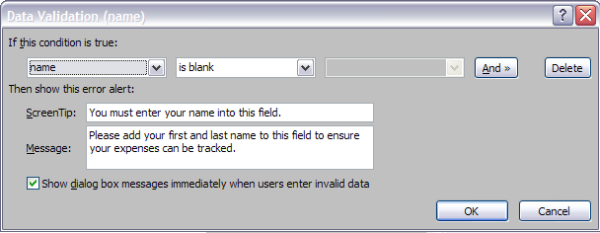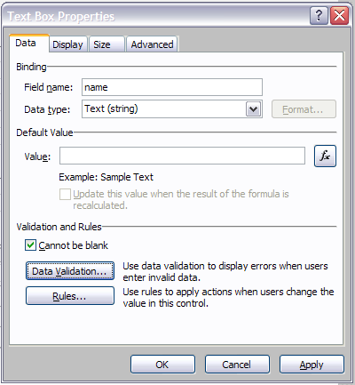The form controls—from radio buttons to fields and drop-down lists—include validation features that provide quick feedback to users when they add information that is incorrectly formatted. ScreenTips explain to users what information is required in any particular part of the form. Rules and conditional formatting can also be used to guide the user experience for completing a form, including the ability to show or hide optional form sections based on information entered. The controls used to create rich, interactive forms are available to a wide variety of users. Validating information entered into the form, establishing required fields, building optional or repeating sections, and many other critical form functions are created through a simple drag-and-drop interface—no code is required.

Figure 1: Validating information within InfoPath forms is as easy as creating simple rules within the user interface.

## Extend the Reach of Your Business Forms

To automate your business processes effectively, you must make the steps easy for your customers. Asking people to submit paper forms or download software to complete electronic forms may make it more difficult for your customers to participate. Instead of limiting the choices users have for completing forms, InfoPath offers many avenues for distributing forms to people inside and outside your firewall.

Using InfoPath Forms Services, you now can enable users to complete forms using a Web browser. For Microsoft Office system users, you can deploy InfoPath forms as Outlook e-mail messages to invite people to complete your forms in the familiar Outlook environment.

### Complete InfoPath Forms Using Web Browsers and Mobile Devices

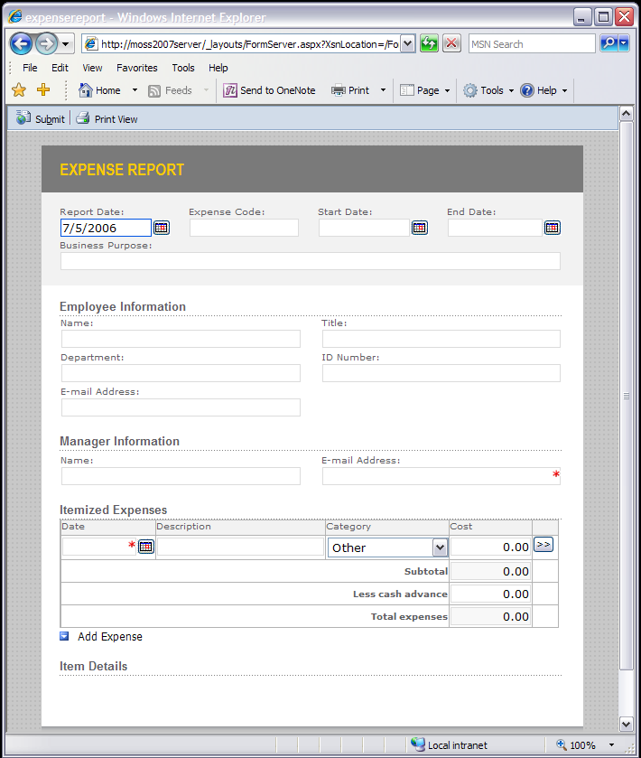With Office InfoPath 2007 and the InfoPath Forms Services capabilities of Office SharePoint Server 2007, you can administer and deploy your business forms beyond the corporate firewall.

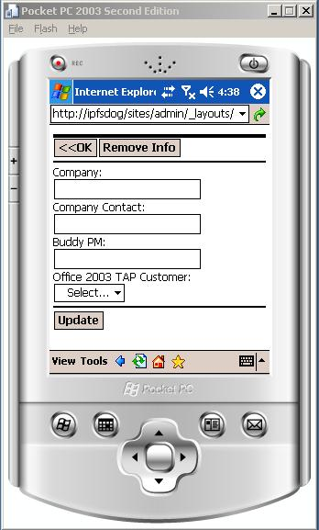InfoPath Forms Services can render InfoPath form templates as browser-based forms that do not require a local installation of InfoPath. In fact, browser forms offered by InfoPath Forms Services require no software download whatsoever. Your external users gain the benefits you have built into your InfoPath forms—including data validation, calculations, and repeating and optional sections—without having to wait for application updates or lengthy downloads.

Figure 2: InfoPath forms can be deployed in a variety of ways, including to Web browsers and mobile devices.

To help ensure the broadest possible reach, your external users can complete Web-enabled InfoPath forms using Microsoft Internet Explorer®, Safari, Netscape, and Mozilla Firefox browsers. Mobile devices with HTML-based browsers can access and complete InfoPath forms as well.

### Complete InfoPath Forms Inside Outlook E-Mail Messages

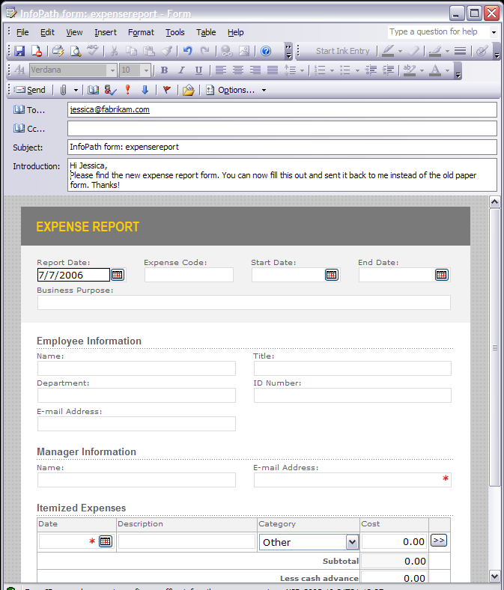Office Outlook 2007 can host InfoPath forms, so organizations can send forms and gather information more efficiently than ever. By deploying InfoPath forms as Outlook e-mail messages, you can enable people throughout your organization to complete forms quickly and easily using the familiar Outlook environment.

Figure 3: InfoPath forms can be deployed as e-mail messages, enabling users to fill out and submit the form simply by replying to the message.

### Complete Forms Online or Offline

Office InfoPath 2007 enhances your ability to work with forms online or offline so you can complete the forms anywhere, anytime. With Office InfoPath 2007, form data such as drop-down lists can be cached on a user’s computer (rather than on a server), so users can work with forms either online or offline. People can take a form along on a laptop or mobile device and complete it whenever it’s convenient—such as on the plane after a business trip.

## The Familiar Microsoft Office System Environment

InfoPath forms solutions are fully integrated with the Microsoft Office system to deliver powerful electronic forms capabilities in a familiar package. Integration with other Microsoft Office programs helps extend the quality of InfoPath forms solutions to other applications, such as Microsoft Office Word, Microsoft Office Excel®, or Microsoft Office PowerPoint®. Outlook is an important vehicle for delivering forms as e-mail messages; even Microsoft Office Access 2007 can be used to collect information by automatically creating InfoPath forms and connecting them to the database for automatic updates.

### Convert Word Documents and Excel Spreadsheets

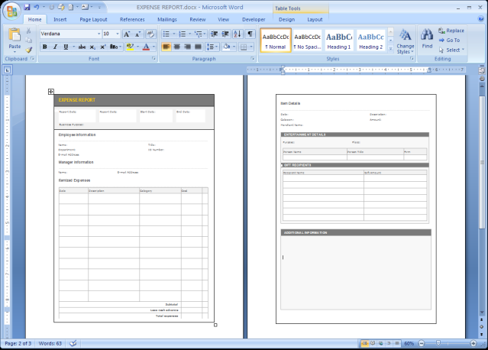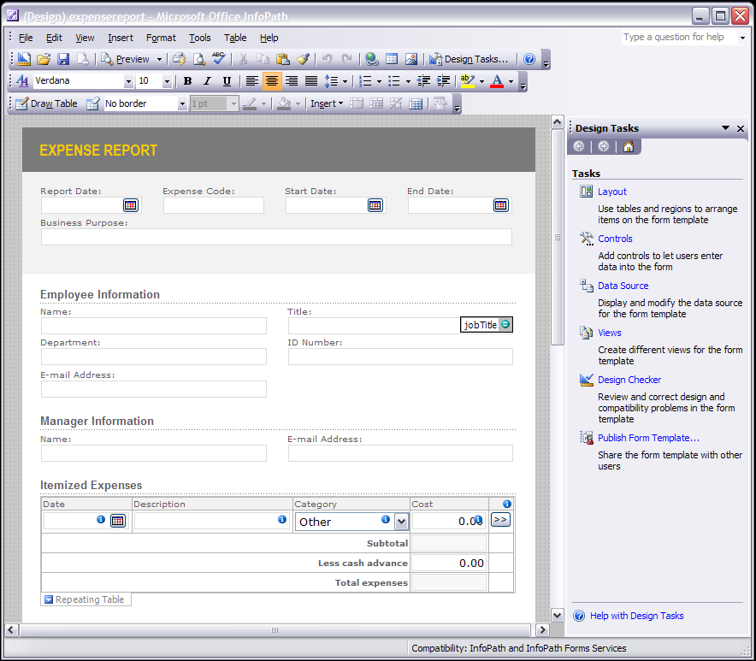Office InfoPath 2007 makes it easy to convert Word documents and Excel spreadsheets into forms, and to build structure into your information-gathering processes. With the Import Wizard, you can import the form, and then the InfoPath Design Checker examines the conversion, identifying each field and table in the form. If the wizard discovers an ambiguous or unsupported element in the form, it flags the element and prompts you to insert   
a proper InfoPath control as a replacement.

Figure 4: Word documents and Excel spreadsheets can be easily and quickly converted to InfoPath form templates.

### Automate Information Gathering for Office Access 2007

Adding Office Access 2007 to the solution extends the power of InfoPath even further. Because Office Access 2007 can automatically generate InfoPath e-mail forms, Access database users can gather information in a few simple steps. The InfoPath form is automatically created at the user’s request, distributed as an e-mail message, and replies received via e-mail update the Access database automatically. This is a great help to those who need to gather and track information in Access, but don’t want to have to surrender their database for editing.

### Help Protect Your Forms with Information Rights Management

You can also control the distribution and use of your electronic forms. By applying information rights management (IRM) properties to form templates, form designers can help prevent others from using or distributing forms inappropriately.

# Centralize Forms Management and Control

InfoPath Forms Services of Microsoft Office SharePoint Server 2007 provides you with a centralized forms solutions repository so you can maintain forms easily. Your administrators centrally control forms access and deployment across the organization, rather than deploying multiple servers to specific departments. Business users can design and deploy forms, but your administrators retain control over who is permitted to publish forms to the server.

With the InfoPath Forms Services technology, your organization can develop and deliver forms-based services more quickly and cost-effectively. Using InfoPath Forms Services, you can easily upgrade forms that are already in place. With side-by-side form upgrades and automatic template version management, your administrators can deploy new versions of forms with no downtime and help ensure everyone is working with the correct version of the form.

## Making Forms More Manageable

InfoPath Forms Services is fully integrated with Office SharePoint Server 2007 to deliver a solution that connects forms-driven business processes to the built-in workflow, records management, single sign-on architecture, and more. Including InfoPath Forms Services within an Office SharePoint Server 2007 deployment helps ensure organizations can centralize the management of electronic forms into the same infrastructure that supports document and Web content management, as well as the organization’s portal solution.

### Use Office SharePoint Server 2007 to Automate Forms-Driven Processes

When combined with Office SharePoint Server 2007, InfoPath forms can be deployed as part of an automated business process, including routing and notification based on information within the form. Information rights management, information management policies, and access rights can be assigned to any form template to help organizations ensure that the appropriate information can travel along with the form.

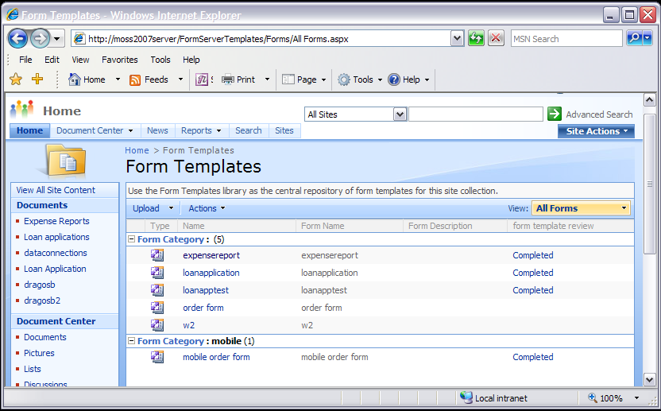

Figure 5: InfoPath Forms Services are integrated with Office SharePoint Server 2007 to provide a comprehensiv**e management solution for elect**ronic forms, documents, Web content, and more.

Because Office InfoPath 2007 and InfoPath Forms Services are fully integrated with the workflow capability of Microsoft Office SharePoint Server 2007, you don’t need anything else to enable workflow for your electronic forms. The same workflow engine used for document reviews, content approvals, and other processes can be used for InfoPath forms, which makes managing business processes much simpler when you use Office SharePoint Server 2007.

### Centralize Control Over W**ho Can Create and Publish Forms**

With the InfoPath Forms Services technology, your organization can develop and deliver forms-based services more quickly and cost-effectively. Business users can design and deploy forms, but your administrators retain control over who is permitted to publish forms to the server, which can prevent the deployment of unwanted code or scripting. This enables IT organizations to provide the design flexibility across the organization without compromising access to mission-critical systems within the company.

### Easily Upgrade Solu**tions That Are Already in Place**

With side-by-side form upgrades, your administrators can deploy new versions of forms with no downtime. Instead of removing a form from the server during working time, potentially stranding large numbers of users, InfoPath Forms Services enables you to update form templates on the fly and helps ensure those who access the form are getting the correct version. Built-in tracking capability within InfoPath templates helps the system know when forms were last updated and helps ensure the data submitted matches the requirements of the latest version.

### **Prebuilt Templates and Data Connections Help Make Form Development Safer**

By offering libraries of prebuilt data connections and template parts, IT organizations can greatly accelerate the development time of sophisticated form solutions. Developers can simply insert entire sections of forms that are frequently used, or apply predefined data connections instead of trying to remember complex connectivity procedures. More important, however, IT organizations that offer a single library of template parts and data connections maintain control over the information that your forms have access to.

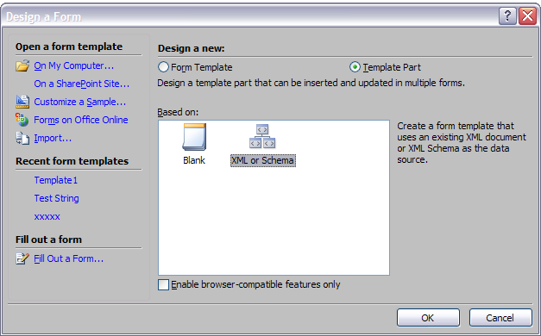

Figure 6: Office InfoPath 2007 can design sections of forms for reuse within other forms.

### Simplify Data Access Through an Extensible Single-Sign-On Architecture

Office SharePoint Server 2007 includes an extensible single-sign-on architecture that is available for your electronic forms,greatly simplifying data source access across the entire organization. Instead of implementing an external, non-integrated solution for authentication, Office SharePoint Server 2007 offers an extensible architecture for managing user access to data connections and systems. This makes complex forms with access to multiple data sources simpler to develop and minimizes IT support headaches.

# Streamline Forms-Driven Business Processes

Office InfoPath 2007 integrates easily with your current business applications and systems using industry standards, helping you automate existing business processes without having to reinvent them. Whether your organization uses Microsoft products everywhere, or a mix of software solutions from many vendors is in place, InfoPath provides an easy way to connect these systems to an easy-to-use electronic form, to gather information and drive business processes to completion.

## Interoperability with Your Existing Systems

### Microsoft .NET and the Microsoft Windows® SharePoint Services Platform

For users of the Microsoft .NET platform, Office InfoPath 2007, Office SharePoint Server 2007, Microsoft SQL Server™ 2005, and BizTalk Server 2006 combine to deliver a comprehensive solution for optimizing distributed business processes. Built on the .NET Framework, InfoPath provides your organization with tools that enable you to build, deploy, and manage electronic forms solutions. Advanced form design capabilities enable Office InfoPath 2007 to streamline complex processes using dynamic, interactive forms that connect users to the right data.

### Other Common Line-of-Business Systems and Applications

Office InfoPath 2007 also offers extensive integration tools and standards support to help ensure organizations can implement InfoPath forms solutions without having to replace their current infrastructure. InfoPath is built from the ground up using XML technologies such as W3C XML Schema, WSDL, UDDI, XPath, and others to help ensure interoperability with virtually any system that supports standards-based integration. For users of SAP, Oracle, Siebel, or other common line-of-business applications, InfoPath and its support for integration standards deliver a valuable tool for connecting users in your organization to the important information stored within your current line-of-business systems.

## Develop Powerful Solutions with a Host of New Tools

The integration between Office InfoPath 2007 and the Microsoft Visual Studio® development environment makes it possible to develop advanced forms solutions using a tightly integrated Visual Studio environment.

InfoPath and InfoPath Forms Services provide a solid platform for users of all skill levels to gather information. Your software developers gain headroom to add advanced business logic and specialized functionality to InfoPath form solutions. Shared data connections simplify your forms solutions development and deployment. Shared form template parts and data connections help speed the form creation process so you can get your solutions up and running more quickly than ever before.

### Reduce Development Time for Your Forms Solutions

With the InfoPath Design Checker, organizations can maintain consistent functionality and appearance across their browser-based and InfoPath client forms. Using the Design Checker, developers can create a single form template for browsers and InfoPath client environments. The Design Checker can disallow InfoPath form controls that are unsupported in the browser environment so form designers can quickly build forms with maximum compatibility.

An organization can also build one or more libraries of template parts. Such libraries help organizations create preconfigured data connections, form layout, XML structure, and other components, so any designer can add them to a form without requiring support from developers or administrators.

Using the InfoPath Logic Inspector, a developer can closely examine the relationships and dependencies that exist within a form. This encourages a more systematic approach to forms development.

### Extend InfoPath Forms Solutions Using Visual Studio Tools for Applications

Visual Studio Tools for Applications (VSTA) is a significantly enhanced .NET Framework–based application customization technology that developers are embedding into their packaged applications. By embedding VSTA into their applications, the developers can build in opportunities for customer interaction and create custom experiences at reduced cost and risk.

Office InfoPath 2007 is designed for smooth integration with VSTA to help ensure InfoPath can interact with other applications that are VSTA-enabled. InfoPath developers can link their forms to other applications—and customize other applications to work directly with InfoPath.

### Host InfoPath Inside Your Internal Applications

Office InfoPath 2007 offers the ability to embed the InfoPath environment—without the user interface—into your custom applications. Developers in your organization can take advantage of the rich InfoPath environment by hosting InfoPath directly within their tools.

Microsoft Office programs will use this powerful new capability. Word, Excel, and PowerPoint will host InfoPath forms for the collection and transmission of document properties and other important metadata. By using the rich InfoPath environment for data capture within these applications, organizations can help ensure users are adding the right information to their documents to improve content tracking and management.

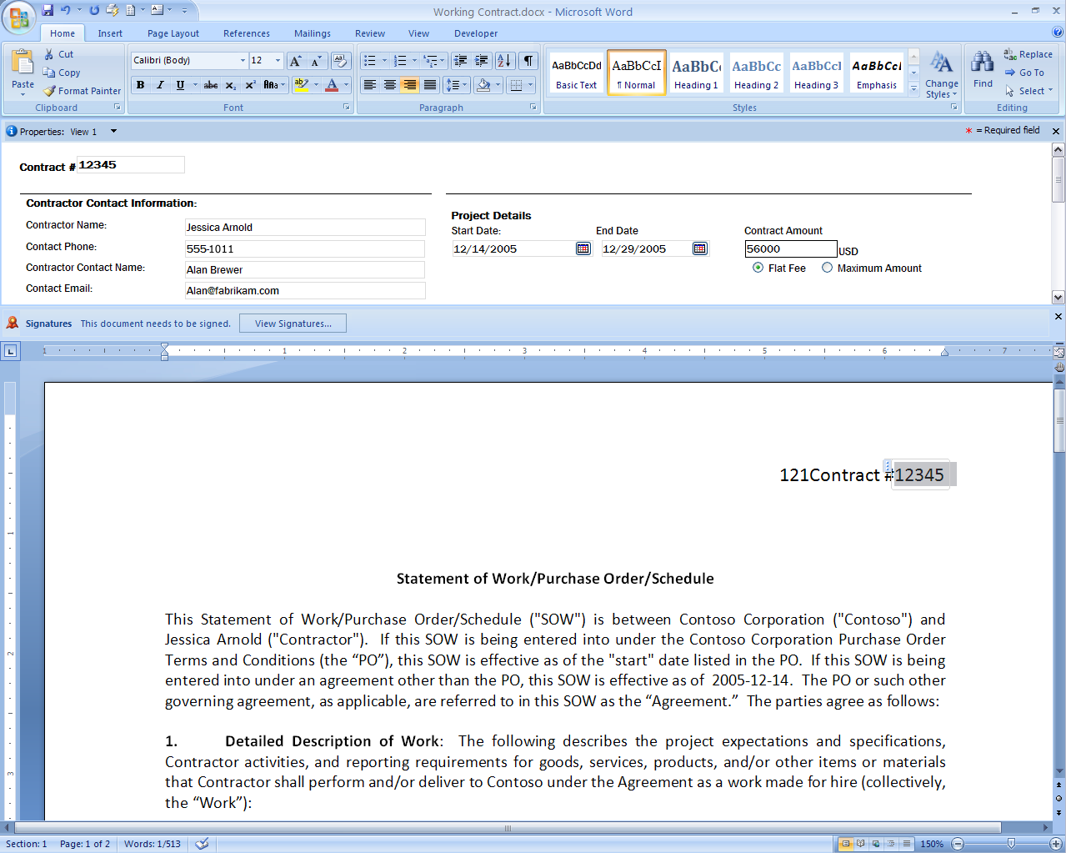

Figure 7: Office Word 2007 can host InfoPath forms to improve the quality of information in documents and help link document information to external sources.

### Integration with Visual Studio 2005

The Office InfoPath 2007 design environment is fully hostable within Visual Studio 2005, enabling developers to build forms and applications in the same integrated development environment.

InfoPath also supports form business logic written in managed code. You can take advantage of the functionality provided by the .NET Framework classes in a form, for example, while continuing to use the built-in, form-specific features of InfoPath such as data validation and conditional formatting. This makes it easy to extend the capabilities of your forms quickly by building on the managed code your developers are already building in the Visual Studio 2005 development environment.

Office InfoPath 2007 has also added support for component object model (COM) add-ins. Form designers can add custom functionality that can be used consistently across forms.

# Summary

Office InfoPath 2007 helps you and your organization gather information more efficiently and effectively than ever. It provides you with the tools you need to create and deploy effective business forms solutions. Office InfoPath 2007 also enables form developers of any skill level to build efficiency and reliability into their data-gathering processes. In concert with InfoPath Forms Services, it can extend your business processes to virtually any user, anywhere—improving collaboration and decision-making to positively impact your business.

Office InfoPath 2007 builds on the powerful information-gathering capabilities of InfoPath 2003. It combines the familiar Microsoft Office system environment with a rich set of tools that enable you to build forms solutions that validate data, integrate into business systems, and guide users through an easy form completion experience. Using InfoPath Forms Services, you can extend your business processes beyond the corporate firewall to provide electronic forms for use in the Microsoft Office system, Web browsers, and mobile devices. Built on industry standards like XML Schema, XSLT, and others, InfoPath provides an easy way to standardize data collection processes across your entire organization*.*

Finally, tight integration between Office InfoPath 2007 and the other programs included in the 2007 release of the Microsoft Office system—including Office Outlook 2007, Office Word 2007, Office Excel 2007, and Office SharePoint Server 2007—offers new ways to capture and consume information. Working together, these tools help break down the barriers that impede the flow of information, so you can get the information you need, in the form you need it, when and where you need it.

# Resources

For more information about Office InfoPath 2007 and the Microsoft Office system, please visit <http://www.microsoft.com/office/infopath>.

# System Requirements

For complete system requirements, please visit <http://www.microsoft.com/office/infopath>.

This document was developed prior to the product’s release to manufacturing, and as such, we cannot guarantee that all details included herein will be exactly as what is found in the shipping product. The information contained in this document represents the current view of Microsoft Corporation on the issues discussed as of the date of publication. Because Microsoft must respond to changing market conditions, this document should not be interpreted to be a commitment on the part of Microsoft, and Microsoft cannot guarantee the accuracy of any information presented after the date of publication. The information represents the product at the time this document was printed and should be used for planning purposes only. Information is subject to change at any time without prior notice.

 This document is for informational purposes only. MICROSOFT MAKES NO WARRANTIES, EXPRESS OR IMPLIED, IN THIS DOCUMENT.

The example companies, organizations, products, domain names, e-mail addresses, logos, people, places, and events depicted herein are fictitious. No association with any real company, organization, product, domain name, e-mail address, logo, person, place, or event is intended or should be inferred.

© 2006 Microsoft Corporation. All rights reserved. Microsoft, BizTalk, Excel, InfoPath, Internet Explorer, the Office logo, Outlook, PowerPoint, SharePoint, Visual Studio, and Windows are either registered trademarks or trademarks of Microsoft Corporation in the United States and/or other countries. All other trademarks are property of their respective owners.