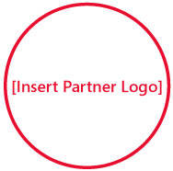C:\Documents and Settings\hkurwa\Desktop\sblogo.jpg

Solutions for Small Business

[Insert Partner Copyright Notice or Trademark Notice]  
[Insert Partner Legal and/or Privacy Information]

So you heard about me from your mom’s doctor’s golfing buddy?

Want to get new customers without it being a hassle? Build on the information you’ve gathered at this event by taking the next step.

**Visit** [**http://mslocalbiz.com**](http://mslocalbiz.com) **to view special offers, access small business resources, and learn about other events in your local area.**

