Microsoft  Technical  Document | Technical White Paper
Developing Flash Applications with the Microsoft MultiPoint SDK Version 1.1: The BeezMath Sample
April 20, 2009

Contents
Introduction 3
Enabling Flash Integration with the MultiPoint SDK 3
Communicating MultiPoint Events from Visual C# to Flash 7
Handling Requests from Flash to Visual C# 9
Summary 10
Appendix A: Scenarios 10
The BeezMath Sample Scenario 10

Disclaimer
This document supports a preliminary release of a software product that may be changed substantially prior to final commercial release, and is the confidential and proprietary information of Microsoft Corporation. It is disclosed pursuant to a non-disclosure agreement between the recipient and Microsoft. This document is provided for informational purposes only and Microsoft makes no warranties, either express or implied, in this document. Information in this document, including URL and other Internet Web site references, is subject to change without notice. The entire risk of the use or the results from the use of this document remains with the user. Unless otherwise noted, the companies, organizations, products, domain names, e-mail addresses, logos, people, places, and events depicted in examples herein are fictitious. No association with any real company, organization, product, domain name, e-mail address, logo, person, place, or event is intended or should be inferred. Complying with all applicable copyright laws is the responsibility of the user. Without limiting the rights under copyright, no part of this document may be reproduced, stored in or introduced into a retrieval system, or transmitted in any form or by any means (electronic, mechanical, photocopying, recording, or otherwise), or for any purpose, without the express written permission of Microsoft Corporation.
Microsoft does not make any representation or warranty regarding specifications in this document or any product or item developed based on these specifications. Microsoft disclaims all express and implied warranties, including but not limited to the implied warranties or merchantability, fitness for a particular purpose and freedom from infringement. Without limiting the generality of the foregoing, Microsoft does not make any warranty of any kind that any item developed based on these specifications, or any portion of a specification, will not infringe any copyright, patent, trade secret or other intellectual property right of any person or entity in any country. It is your responsibility to seek licenses for such intellectual property rights where appropriate. Microsoft shall not be liable for any damages arising out of or in connection with the use of these specifications, including liability for lost profit, business interruption, or any other damages whatsoever. Some states do not allow the exclusion or limitation of liability or consequential or incidental damages; the above limitation may not apply to you.
Microsoft may have patents, patent applications, trademarks, copyrights, or other intellectual property rights covering subject matter in this document. Except as expressly provided in any written license agreement from Microsoft, the furnishing of this document does not give you any license to these patents, trademarks, copyrights, or other intellectual property.
© 2009 Microsoft Corporation. All rights reserved.
Microsoft, MultiPoint, Visual C#, and Windows are trademarks of the Microsoft group of companies.
All other trademarks are property of their respective owners.

Introduction
The Microsoft® MultiPoint™ SDK version 1.1 (MultiPoint) is a development framework that enables developers to build applications where multiple mouse devices can connect to one computer simultaneously. Applications built using MultiPoint can handle mouse clicks from different users independently, and can customize each mouse by assigning it a unique pointer. This technology is intended for use in classroom settings in which teamwork and collaboration are necessary.
This document describes how to use MultiPoint to build Adobe Flash applications that allow multiple mouse devices. You can use the BeezMathSample (discussed below) to expand your knowledge of MultiPoint-Flash integration and help in creating your own original products. This sample is built using the Windows Presentation Foundation (WPF). The Flash game used in the sample was developed using Macromedia Flash Professional version 8. In the BeezMath Sample application, all mouse devices are used to participate in a series of simple math-based games using the full screen. Scenarios for this application are described in Appendix A: Scenarios.
In the three sections of this document, you will learn how to get started building Flash applications that allow multiple mouse devices, how to communicate multiple-pointer events from Visual C#® to Flash, and how to receive requests from Flash to Visual C#.

Enabling Flash Integration with the MultiPoint SDK
When Flash integration is enabled with the MultiPoint SDK, it provides the ability to embed Flash content in a Visual C# application that allows multiple mouse devices.
Flash content is embedded in a user control and hosted in the Windows forms host, which in turn can be placed in a Windows Presentation Foundation (WPF) grid. All multiple-pointer events are captured by a transparent MultiPoint button that is placed on the Windows forms host. The button covers the entire area occupied by the Flash content, thereby providing a transparent, multiple-pointer WPF layer on top of the Flash content.
All MultiPoint events are captured using the Visual C# Windows® application, and communicated to the Flash game using the CallFunction API of the ExternalInterface class provided by the Adobe Shockwave Flash OCX. Requests from the Flash game to the Visual C# Windows application are handled by subscribing to the FlashCall event of the Shockwave Flash OCX.

Architecture Diagram
Existing/New Flash application
Visual C# Windows app

Launches
callFunction
FlashCall
The Visual C# Windows application uses the CallFunction method to communicate the multiple-pointer events to Flash. Requests from Flash are received by subscribing to the FlashCall event.

The BeezMath sample makes use of a generic user control, FlashUserControl. Included as part of the SDK, this control loads the Flash Movie and handles all communication between the Visual C# Windows application and Flash. This user control can be reused for developing other multiple-mouse Flash applications using the MultiPoint SDK. FlashUserControl exposes functions for loading the flash .swf files, providing initialization data to the flash .swf, and communicating multiple-pointer mouse events to the Flash application.
In the BeezMath sample, the main window maintains a static instance of the FlashUserControl:
private static FlashUserControl flashUC = new FlashUserControl();

The FlashUserControl instance creates an instance of the AxShockwaveFlashObjects.AxShockwave class:
private AxShockwaveFlashObjects.AxShockwaveFlash flash;
// The AxShockwave Flash Object
internal AxShockwaveFlashObjects.AxShockwaveFlash Flash
{
get
{
return flash;
}
set
{
flash = value;
}
}

When the main window is loaded, the FlashUserControl is added to a WindowsFormsHost instance that is placed within the application’s main grid. The Flash game’s file name is read from the configuration file and loaded using the LoadMovie method of the FlashUserControl, as shown in the following example:
private void window_Loaded(object sender, RoutedEventArgs e)
{
...
// Create a WindowsFormHost object
WindowsFormsHost host = new WindowsFormsHost();
host.Child = flashUC;
// Determine the Flash file path
System.Reflection.Assembly ass =
System.Reflection.Assembly.GetExecutingAssembly();
string path = ass.CodeBase;
path = path.Substring(0, path.LastIndexOf('/'));
string flashFileName =
ConfigurationManager.AppSettings["FlashFile"].ToString()
// Load the flash game
flashUC.LoadMovie(0, path + "/" + flashFileName);
flashgrid.Children.Add(this.host);
...

To begin the game, an initialization string is constructed by appending the user names and the game number, which was chosen and passed on to the Flash game using the InitializeFlash method of the FlashUserControl:
private void MultiPointEnter_MultiPointClick(object sender,
RoutedEventArgs e)
{
...
string initializeStr = this.P1TB.Text + "|" + this.P2TB.Text + "|" + this.P3TB.Text + "|" + this.P4TB.Text + "^" + level;
flashUC.InitializeFlash(initializeStr);
...

To load the Flash game and pass the initialization data to it, the FlashUserControl uses the LoadMovie and CallFunction methods of the Shockwave Flash OCX:
public void LoadMovie(int layer, string moviePath)
{
this.Flash.LoadMovie(layer, moviePath);
this.Flash.CtlScale = "ExactFit";
this.Flash.Top = 0;
this.Flash.Left = 0;
}

public void InitializeFlash(string dataForInitialization)
{
this.Flash.CallFunction("<invoke name=\"InitializeFlash\" returntype=\"xml\"><arguments><string>" + dataForInitialization + "</string></arguments></invoke>");

}

In the Flash Action Script code, the ExternalInterface class must be imported to receive the data from the Visual C# Windows application:
import flash.external.ExternalInterface;

The InitializeFlash function must be registered to make it available externally. The second argument is null because it is declared on the _root of the timeline.
ExternalInterface.addCallback("InitializeFlash", null, InitializeFlash);
function InitializeFlash (str:String):Void
{
// handle data appropriately
_root.Initialize(str);
}

Communicating MultiPoint Events from Visual C# to Flash
This section covers how to communicate multiple-pointer events from the Visual C# Windows application to Flash, and how these calls can be received and processed in the Flash application.
The MultiPoint Button can recognize the X, Y coordinates of the multiple-pointer event as well as the ID of the cursor (mouse) that clicked on the button. This information is communicated to the Flash content by using the CallFunction method in the ExternalInterface class (recommended for Flash Player 8 and above) or the SetVariable method.
In the BeezMathSample the MultiPointMouseLeftButtonUpEvent is captured by the MultiPointButton and communicated to the Flash game by using the HandleMouseLeftButtonUp method of the FlashUserControl.

private void MultiPointTestButton_MultiPointMouseLeftButtonUpEvent(object sender, RoutedEventArgs e)
{
MultiPointButton mpb = (MultiPointButton)sender;
if (mpb.Content != null)
{
MultiPointMouseEventArgs args = (MultiPointMouseEventArgs)e;
int mouseID = args.DeviceInfo.ID;
Point pos = ((MultiPointMouseDevice)((DeviceInfo) (MultiPointSDK.Instance.MouseDeviceList[mouseID])).DeviceVisual)
.GetPosition();
int x = (int)pos.X;
int y = (int)pos.Y;
flashUC.HandleMouseLeftButtonUp(x, y,
mouseID.ToString(CultureInfo.InvariantCulture));
}
}

The FlashUserControl user control communicates this information to Flash using CallFunction:
public void HandleMouseLeftButtonUp(int coordinateX, int coordinateY, string mouseDeviceInfo)
{
this.Flash.CallFunction("<invoke name=\"HandleMouseLeftButtonUp\" returntype=\"xml\"><arguments><number>" + coordinateX + "</number><number>" + coordinateY + "</number><string>" + mouseDeviceInfo + "</string></arguments></invoke>");
}

Internally, the Flash program uses the coordinates sent by Visual C# to determine the control on which the event was raised (by performing a hit test on its controls or by using any other logic).The Flash program uses this information along, with the MouseID, to handle the event appropriately.
ExternalInterface.addCallback ("HandleMouseLeftButtonUp", null, HandleMouseLeftButtonUp);
function HandleMouseLeftButtonUp(x:String, y:String, m:String):Void
{
// Logic to handle the event
_root.mouseup(x,y,m);
}

Handling Requests from Flash to Visual C#
The Flash application also can send requests to Visual C# applications. Such requests can be handled by subscribing to the FlashCall event or by using the FSCommand function.
For instance, in the BeezMathSample the Flash game sends the Visual C# application a request to Exit the application:
ExternalInterface.call("FlashRequest", “exit”);

In the Visual C# application, this is handled by subscribing to the FlashCall event, as follows:
private void FlashPlayer_FlashCall(object sender, _IShockwaveFlashEvents_FlashCallEvent e)
{
XmlDocument document = new XmlDocument();
document.LoadXml(e.request);
XmlNodeList list = document.GetElementsByTagName("arguments");
if (list != null && list[0] != null)
{
this.HandleRequestFromFlash(list[0].FirstChild.InnerText);
}
}

The HandleRequestFromFlash function handles the request appropriately:
private void HandleRequestFromFlash(string request)
{
switch (request)
{
case "exit":
this.ExitApplication();
break;

default:
break;
}
}

Summary
The MultiPoint SDK enables developers to build innovative applications involving multiple mouse devices connected to a single computer. The ability to integrate with Flash offers a number of additional capabilities on top of what the SDK already offers.
Using the MultiPoint SDK for Flash applications, developers can create new Flash applications with multiple-pointer capabilities. Flash applications now can be enabled to handle multiple-pointer events using the MultiPoint concept. Also, with some amount of code recycling, and modifications to the event-handling logic, it is possible to transform old Flash applications from being inherently single-user to multi-user.
The MultiPoint SDK, along with Flash, can be utilized to create powerful tools for use in education and other fields. You can use MultiPoint and the examples in this paper as a guide to creating your own original Flash applications.

Appendix A: Scenarios
The BeezMath sample is detailed in the following section.

The BeezMath Sample Scenario
Mrs. Adams is a third-grade teacher at an elementary school in a low-income area. The school cannot afford to provide a computer for each child. Mrs. Adams has a classroom of thirty students, each with a wireless mouse device connected to her computer. Her computer display is projected onto a large screen at the front of the classroom.
Today, the class is going to engage in an activity based on the BeezMath sample. The objective is for students to engage in a series of simple math-based exercises targeted at teaching basic fraction concepts in a fun and intuitive manner. The game can be played by a maximum of four players at a time. The users have an option to start from any one of the seven games provided. Users collect points in every game, and points are tallied at the end to determine the winner.

Figure 1: The Option Screen 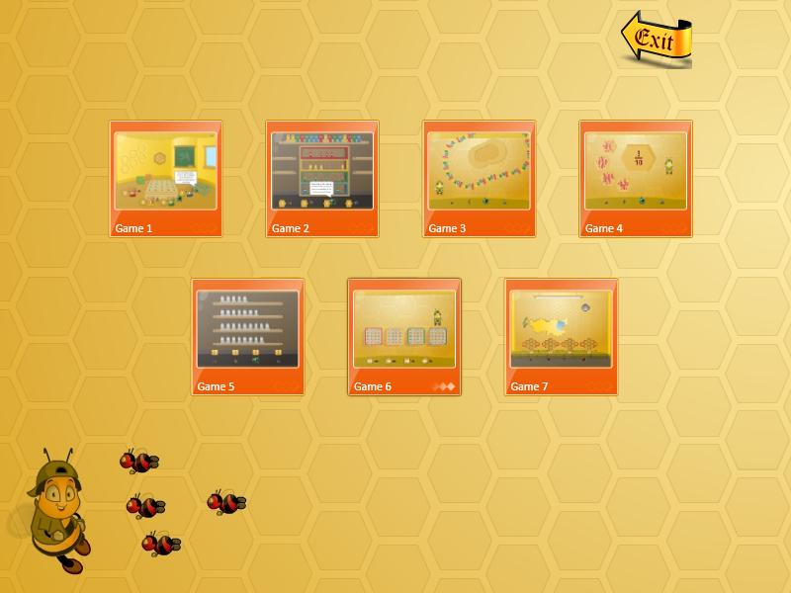

Figure 1 shows the Option screen. The user can choose to start from any of the seven games by clicking on the corresponding image icons. This screen is not MultiPoint enabled; thus, only the system cursor is visible.
Figure 2: The Enter Screen
Figure 2 shows the Enter screen. Each user is assigned a unique cursor; users enter their names in the corresponding text boxes. The Enter and Exit buttons allow users to enter and exit the game. The game can be started only if at least two players enter their names.
Figure 3: Game 1
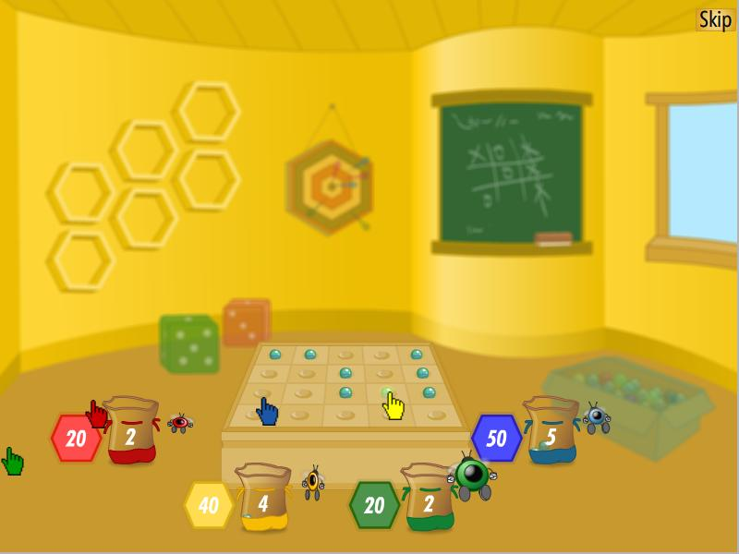
Figure3 shows Game 1. The object of this game is to collect the maximum number of pebbles in the bag by clicking on them. Clicking the Skip button takes the user to the next game.
Figure 4: Game 2
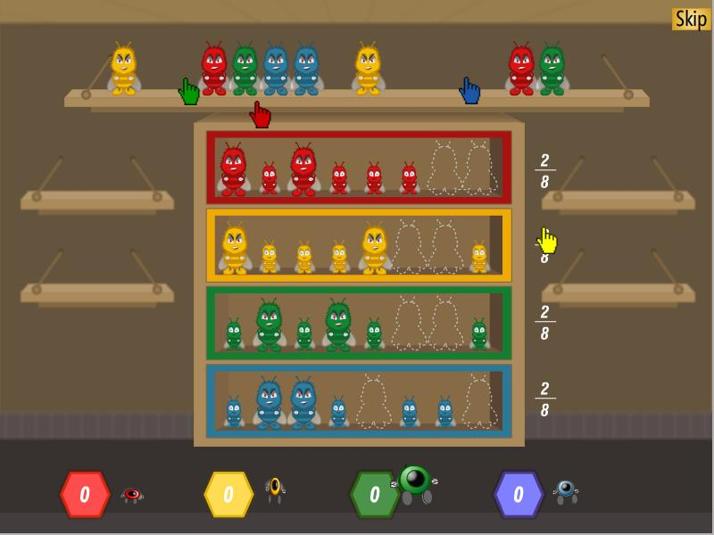
Figure 4 shows Game 2. The object of the game is to put the bumblebees on the topmost shelf into the empty slots on the shelves with the corresponding colors as quickly as possible.

Figure 5: Game 3
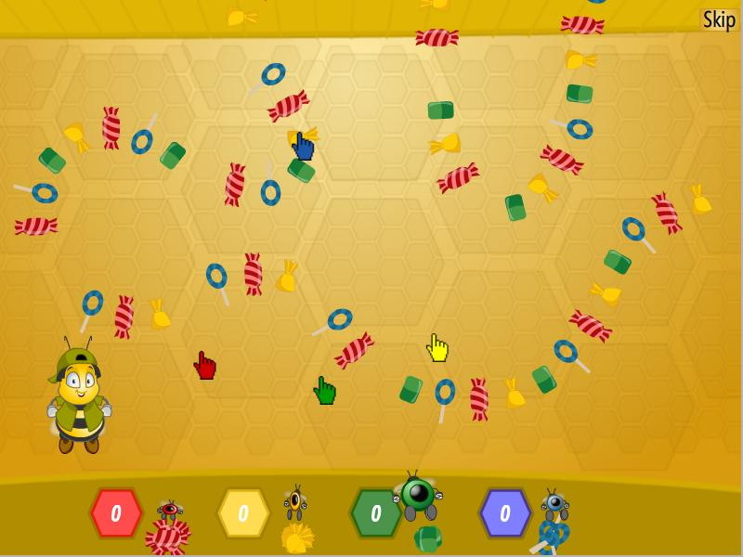
Figure 5 shows Game 3. The object of the game is to collect all of the candies that correspond to the color of the player’s cursor as quickly as possible.

Figure 6: Game 4
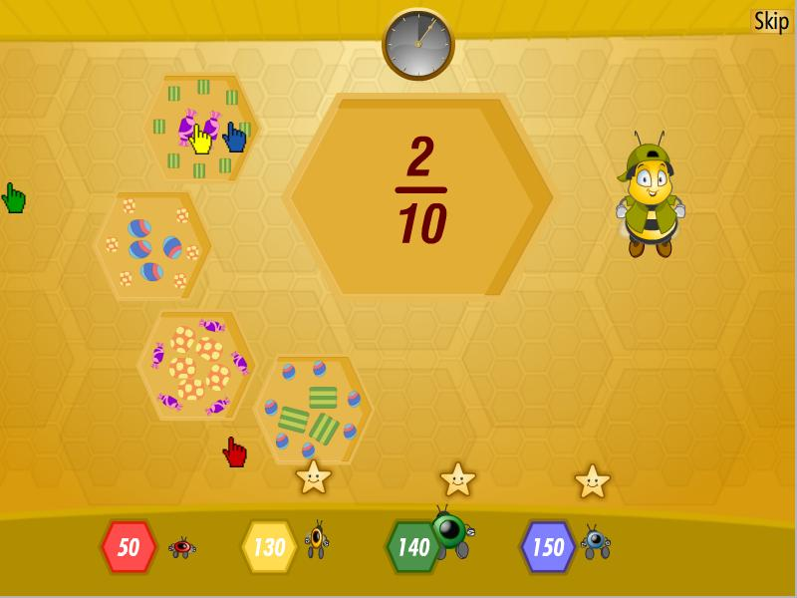
Figure 6 shows Game 4. The object of the game is to correctly identify the set of candies that matches the fraction provided as quickly as possible.
Figure 7: Game 5
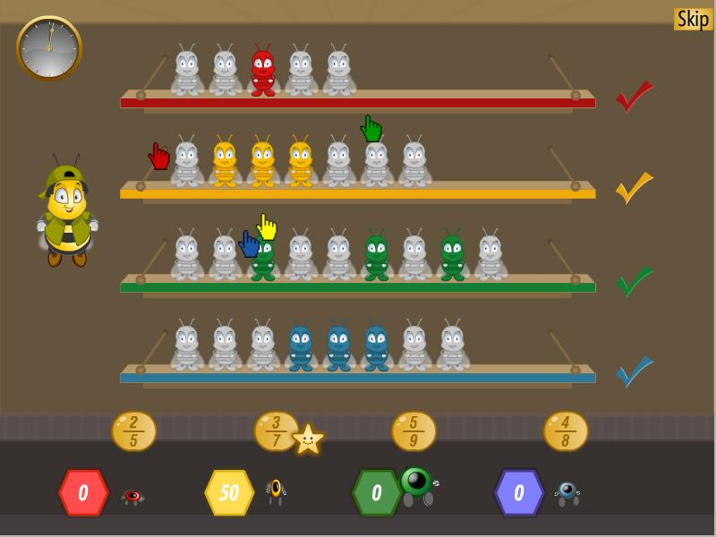
Figure 7 shows Game 5. The object of the game is to choose the fraction of Beez toys on the shelf that correctly matches the fraction in the bubble above the player.
Figure 8: Game 6
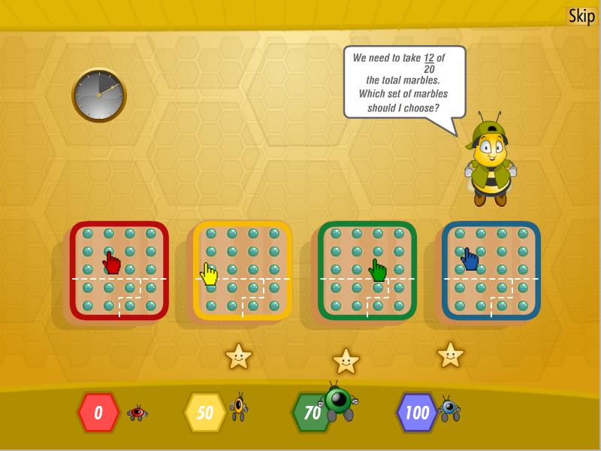

Figure 8 shows Game 6. The object of the game is to choose the set of marbles that correctly corresponds to the number on the player.
Figure 9: Game 7
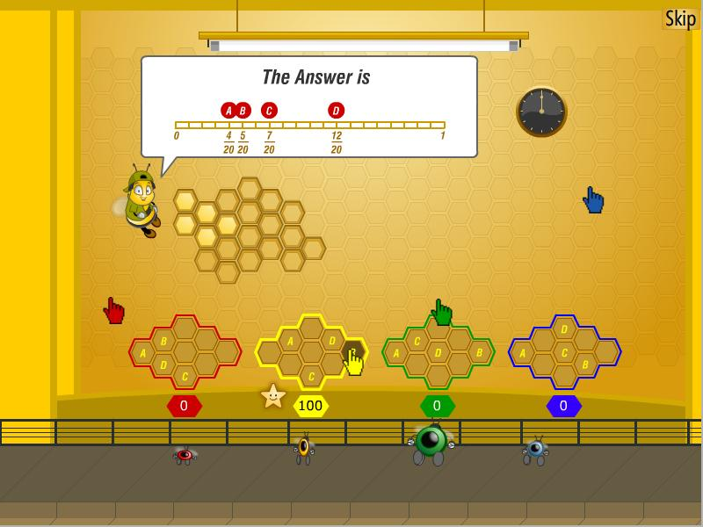
Figure 9 shows Game 7. The object of the game is to determine the fractional representation of the honey-filled cells in the wall. The first player to click the correct option wins.
Figure 10: Score Card Screen
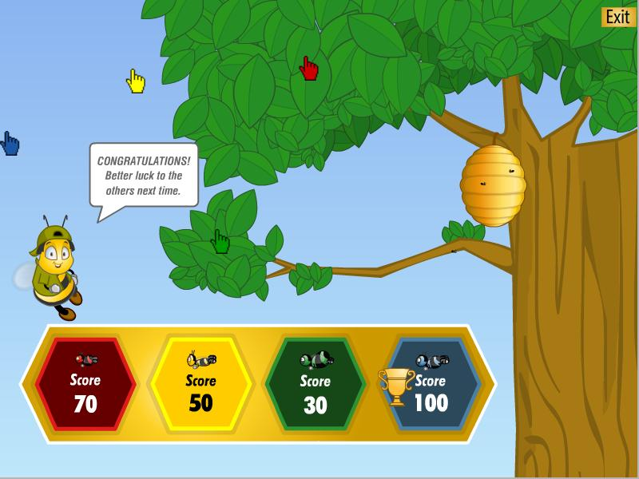

Figure 10 shows the Score Card screen. The points for all players are tallied to determine the winner. Clicking the Exit button exits the game.

For information about Adobe Systems Incorporated and its products that were used in the development of the BeezMath Sample application stated in this paper, please contact Adobe Systems Incorporated directly.

