
MICROSOFT EXCHANGE HOSTED SERVICES
Electronic messaging is mission-critical, but it remains vulnerable to a growing array of threats. Viruses, worms, denial-of-service attacks, spam, the need to satisfy a growing set of government regulations and legal actions all make effective message management increasingly difficult.  Microsoft® Exchange Hosted Services is composed of four distinct services that help organizations do the following: protect against e-mail–borne malware, satisfy retention requirements for compliance, encrypt data to preserve confidentiality, and preserve access to e-mail during and after emergency situations. The services are deployed over the Internet, which helps minimize up-front capital investment, free up IT resources to focus on value-producing initiatives, and mitigate messaging risks before they reach the corporate firewall.  As a component of the Microsoft Exchange solution portfolio, Exchange Hosted Services provide a layer of protection features deployed across a global network of Internet data centers. The services create a security-enhanced message stream to and from your on-premise messaging infrastructure.  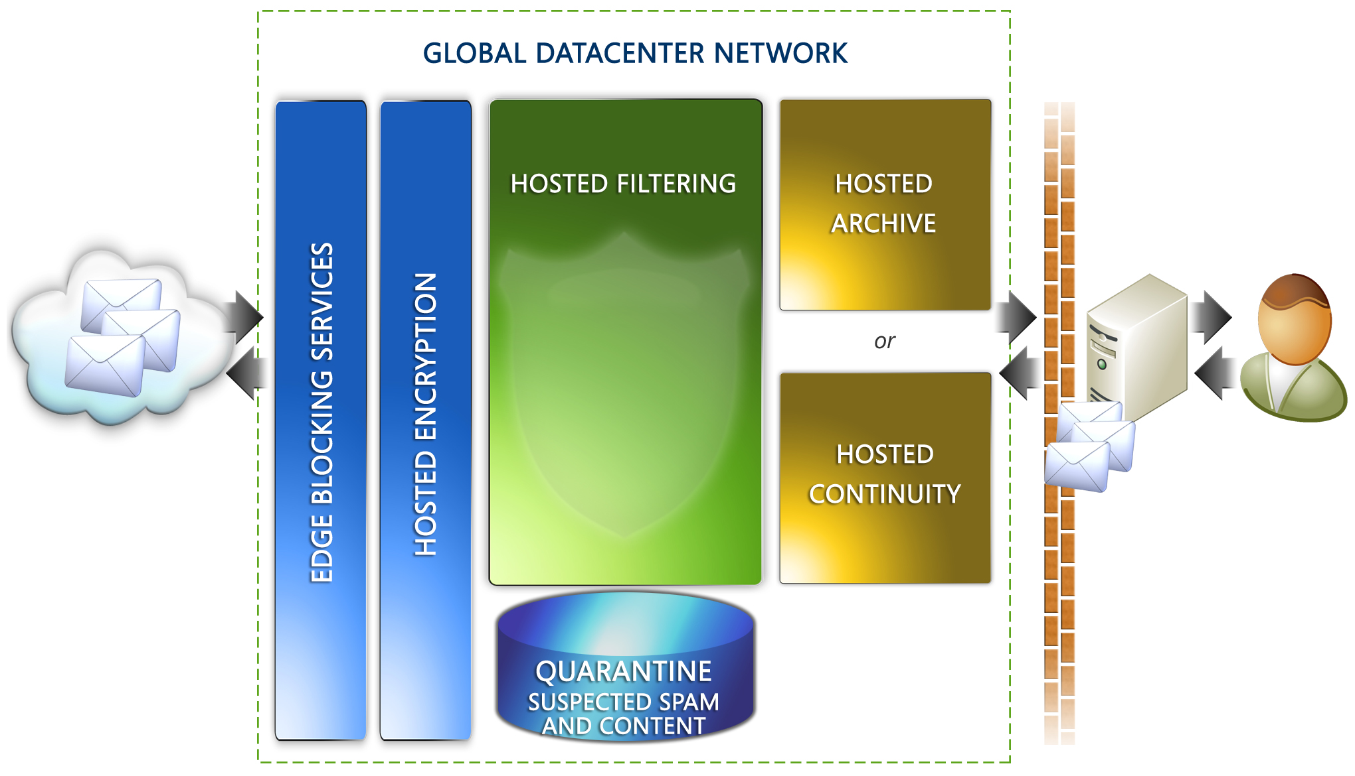  HOW IT WORKS  With just a simple mail exchange (MX) record configuration change, our services can be up and running quickly. There is no hardware to provision; no software to buy, install or configure; and no expensive training required for your IT staff.  Furthermore, there is no need for you to change or modify your existing e-mail infrastructure, or to even install and maintain any new hardware or software. The heart of Exchange Hosted Services is its distributed network of data centers located at key sites along the Internet backbone. Each data center contains fault-tolerant servers that are load-balanced from site to site and from server to server. In the unlikely event that one data center is unavailable, traffic can be easily routed to another data center, minimizing the chances of interruption to the service. And Microsoft algorithms analyze and route message traffic between data centers to help ensure secure and timely delivery.
  LEARN MORE
  microsoft.com/exchange/services
  BENEFITS
  - Multiple real-time antispam and antivirus defenses
  - Help eliminate threats before they reach the corporate firewall
  - Backup e-mail systems for rapid disaster recovery
  - Help satisfy external requirements for e-mail retention and monitoring
  - Assist with internal policy enforcement
  - Respond quickly to e-discovery requests
  - Help eliminate up-front capital investment
  - Help free up administrator time to focus on other projects
NETWORK OVERVIEW  Nine fully redundant, load-balanced data centers located strategically across the globe to help ensure high availability.  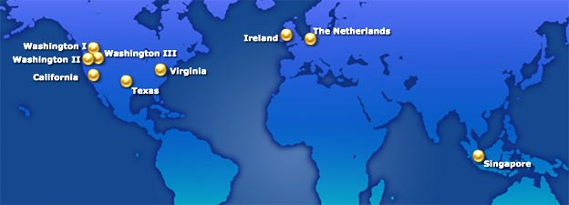  SOLUTIONS OVERVIEW
  Microsoft Exchange  Hosted Filtering  - Active content, connection and policy-based filtering  - Multi-engine spam and virus scanning  - E-mail queuing when server is unavailable  - Low false positive ratios | 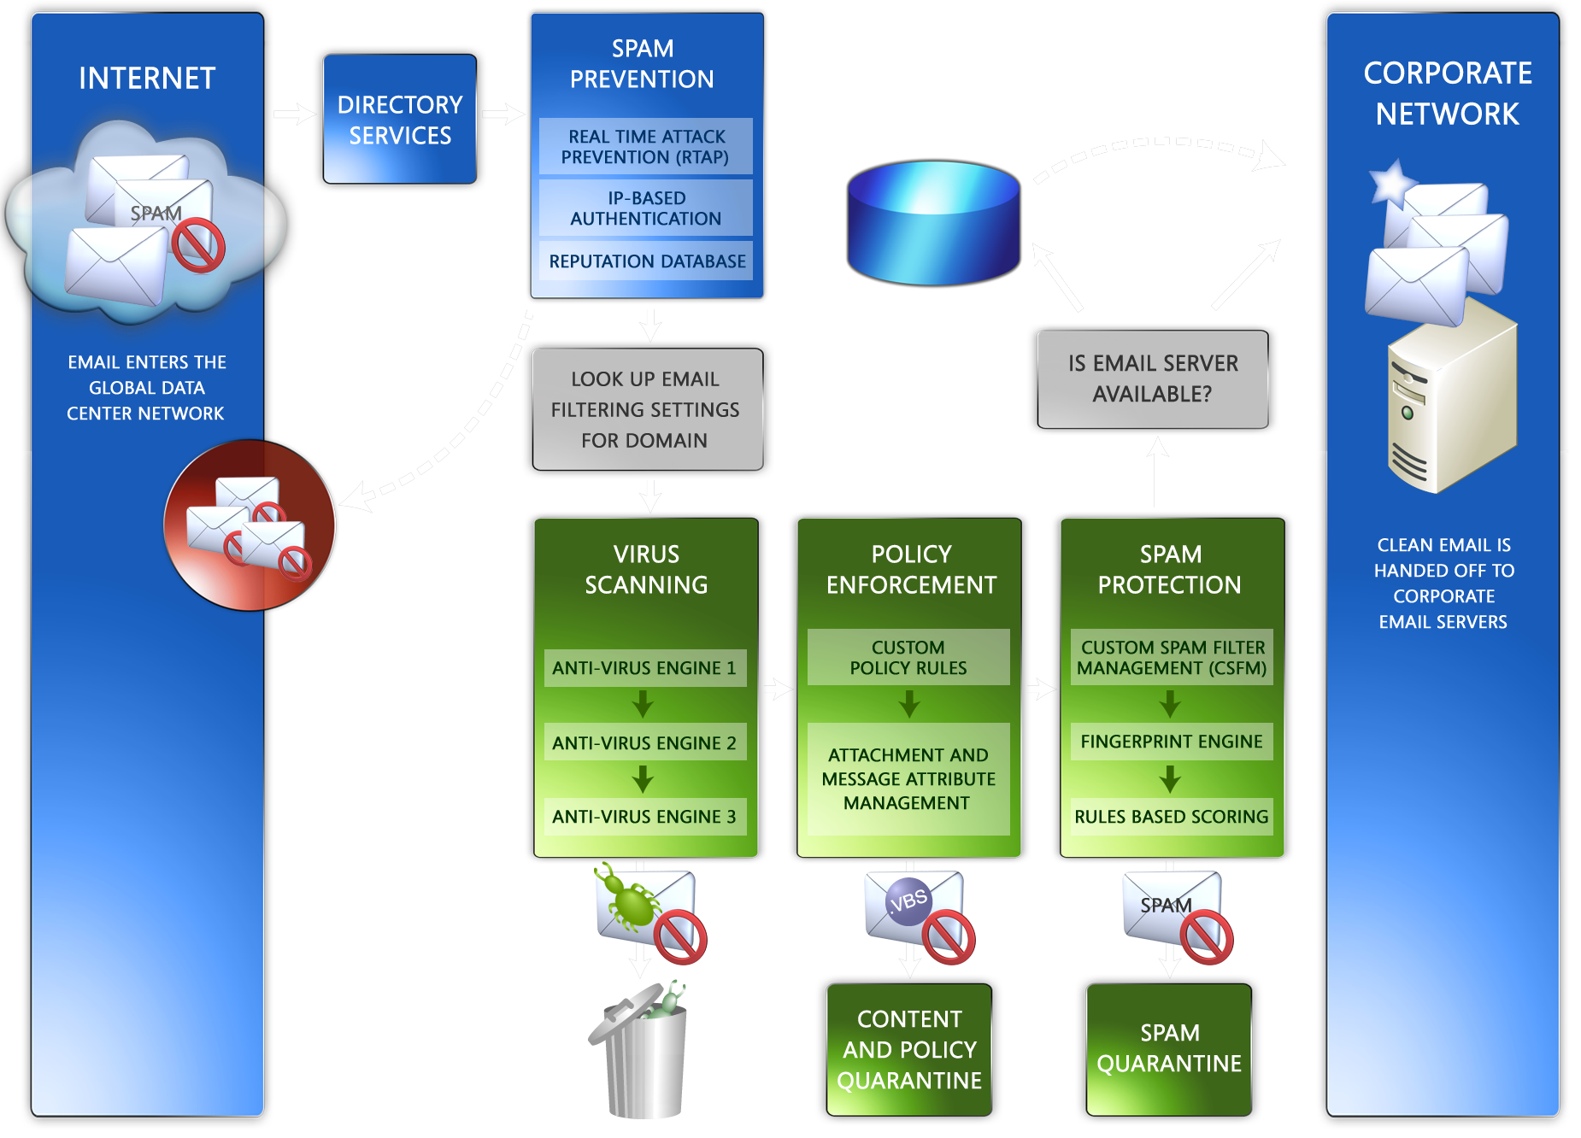
  Microsoft Exchange  Hosted Archive  - Support to help satisfy industry and regulatory retention requirements  - Spam filtering before archival  - Rapid search and retrieval  - Fully functional backup e-mail system | 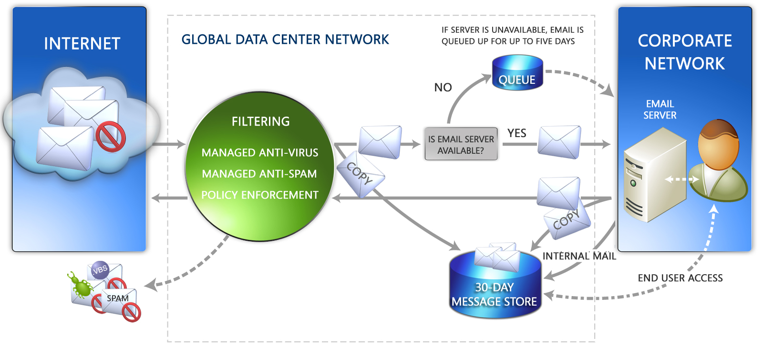
  Microsoft Exchange  Hosted Continuity  - Allows access to e-mail during and after network outages  - 30-day rolling historical archive  - Searchable message store for easy recovery | 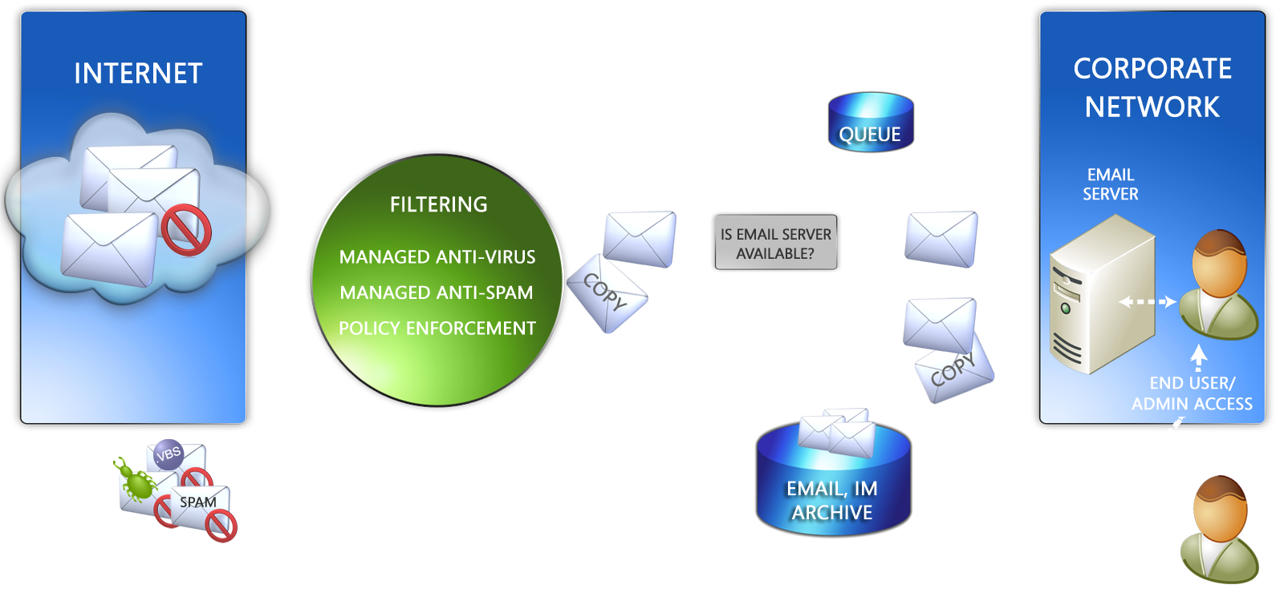
  Microsoft Exchange  Hosted Encryption  - Policy-based encryption from sender to recipient  - Intuitive interface for minimal end user training | 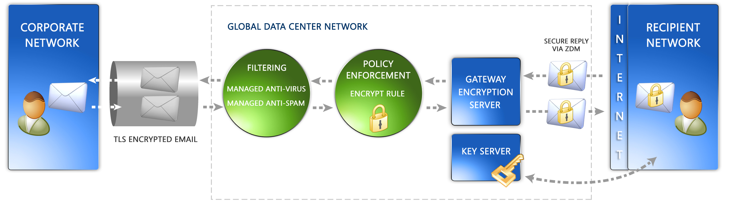
  HOSTED SERVICE BENEFITS
  • Lower total cost of ownership than on-premise solutions
  • Offers a predictable subscription-based payment
  • Simplifies IT environment by minimizing the need to deploy, configure, monitor, and update in-house e-mail security servers and applications
  • Helps increase available bandwidth
  • Helps free up server resources and lower load on CPU
  • Scales to meet the needs of virtually any enterprise
  ANALYST PERSPECTIVE
  “Security, compliance, and business continuity requirements in industries such as healthcare and financial services are placing greater demands on the messaging infrastructure. It’s not enough to handle these challenges with a growing array of stand-alone appliances or point solutions. Managed services are a fundamentally sound method for deploying multiple, integrated services.”
  Michael Osterman,
  President and Founder,
  Osterman Research
  LEARN MORE
  microsoft.com/exchange/services
The information contained in this document represents the current view of Microsoft Corporation on the issues discussed as of the date of publication. This document is for informational purposes only. MICROSOFT MAKES NO WARRANTIES, EXPRESS OR IMPLIED, IN THIS DOCUMENT. © 2006 Microsoft Corporation. All rights reserved. Microsoft is a registered tradmark of Microsoft Corporation in the United States and/or other countries.

