Overview  Country or Region: United States  Industry: Healthcare—Life sciences  Customer Profile  The Scripps Research Institute, based in La Jolla, California, and Jupiter, Florida, is a leading center for basic biomedical science, contributing to the betterment of health and the human condition. It has 3,000 employees.  Business Situation  Crystallography prescreening tests were being processed manually, resulting in slow, error-prone results that inhibited the speed of research and the productivity of researchers.  Solution  The structural biology lab adopted a high-performance computing solution based on Windows® HPC Server 2008 and related Microsoft® technologies.  Benefits  - Speeds research 600 percent, yielding greater insights  - Enables rapid application development  - Boosts IT productivity |  |  | “This is high-performance computing that doesn’t require any specialized tools or training. If you know Windows, you know Windows HPC Server.”  Josh Kunken, System Developer, The Scripps Research Institute
 |  |  | Structural biology researchers at The Scripps Research Institute, a leading biomedical research center, used to process test results manually, inhibiting the pace of their work and limiting the time they could spend thinking creatively about their research. To boost productivity, they adopted a custom high-performance computing (HPC) solution based on Windows® HPC Server 2008. Now, test results are processed 600 percent faster, giving researchers the time they need to analyze their work more thoroughly and to identify more productive research directions. The HPC applications for the solution were created quickly and easily using Microsoft® development tools, and the entire solution life cycle is managed centrally and effectively by a single system developer.
 |  |  | 

Situation
Some of the world’s most important advances in immunology, molecular and cellular biology, chemistry, the neurosciences, and autoimmune and cardiovascular diseases have all come from one place: The Scripps Research Institute, one of the largest private research institutions in North America.
Cherezov and his colleagues refused to wait … to help advance human health.

Among the hundreds of projects being carried out at any time at the institute is one overseen by Dr. Vadim Cherezov: a project to study the structure and function of protein receptors transmitting signals inside the cells of the human body. These receptors are responsible for a variety of physiological activities, such as the increased heart rate and blood pressure that the body experiences when the receptors come into contact with adrenaline. That makes these proteins an ideal object of study when the goal is to understand the effects of pharmaceuticals on humans—and to create new pharmaceuticals to advance the cause of human health.

Although they may be highly important objects of study from a biomedical standpoint, receptors aren’t easy objects of study.

To understand how these receptor molecules function, researchers seek to determine atomic-resolution, three-dimensional structures of the molecules. To achieve this, they assemble individual molecules into crystals and “interrogate” them with powerful x-ray beams generated by synchrotron sources.

Because the membrane receptors are highly dynamic molecules, the research is both complex and time-consuming; it can take years to crystallize a membrane receptor and to obtain useful structural models. For this class of receptors, a breakthrough came when the receptors were genetically engineered and additionally stabilized by inserting them into a lipidic mesophase matrix.

To prescreen dozens of modified receptor constructs and thousands of environmental conditions, the scientists at Scripps Research hit upon the idea of an experiment combining the power of microscopes and lasers. This presented another problem: processing test results had traditionally taken far longer than running the experiments that produced those results. For example, testing and processing a single lab plate with 96 experiments could take a week—and researchers need to conduct tens of thousands of experiments to advance each stage of their research.

Cherezov and his colleagues refused to wait that long to help advance human health. They also wanted to eliminate the human error inevitably associated with manual processing, which could delay the processing of results even more.

Fortunately, they didn’t have to. High-performance computing (HPC) offered a way to take advantage of the massive compute power of distributed computers organized into a single cluster. The institute already had such a cluster running on the Linux operating system. But it wasn’t what the molecular-modeling researchers were looking for.

They identified several challenges in adopting a generic cluster. First, the lab would have to maintain a separate computing infrastructure to support it, driving up the time and money spent on IT management. Second, users would need a separate password authentication and administration system in addition to the single sign-on passwords they use for their existing environment, which is based on the Windows Server® 2008 and Windows Vista® operating systems. Finally, they also anticipated problems if users tried to open 2007 Microsoft® Office files—such as Office Excel® spreadsheets and Office Word documents—on an alternative system.
Finally, the HPC solution that the lab chose for its crystallography work would need to do more than promote IT productivity and facilitate easy use by researchers. It also would have to enable the rapid development of custom HPC applications, so that researchers could take advantage of the power of HPC to further their research.

Solution
The Scripps Research lab found the solution that it was looking for in an HPC solution based on Windows® HPC Server 2008 running on Dell dual-core x64–based computers. The solution also uses custom applications created with Microsoft Visual Studio® Team System 2008 Development Edition and the Microsoft .NET Framework version 3.5; a database running on Microsoft SQL Server® 2008 database management software; Windows Vista; and other Microsoft technologies.
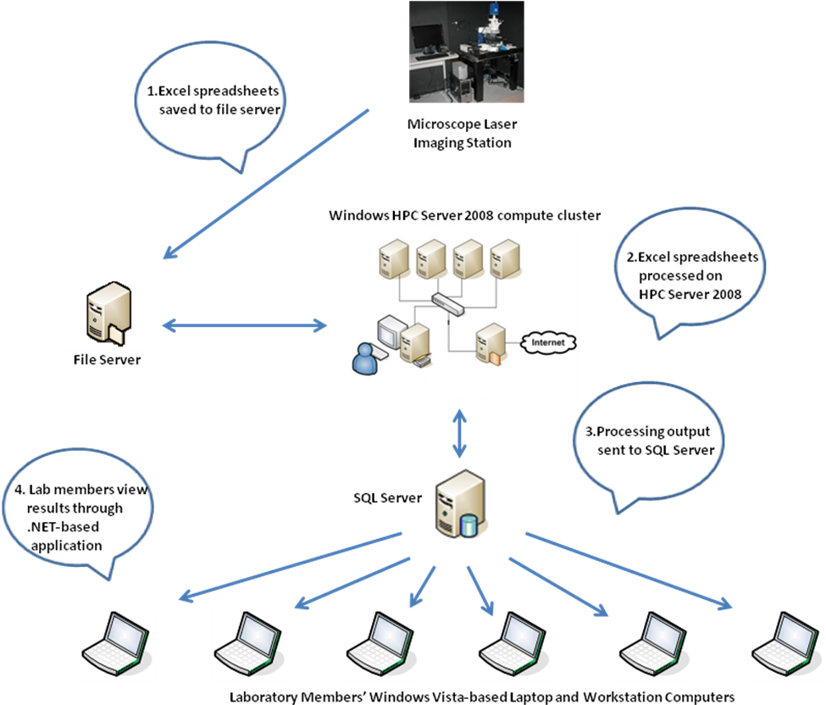
Figure 1. Windows HPC Server 2008 is at the center of a Scripps solution that enables rapid, cost-effective processing of lab results.

The lab’s imaging system takes information from the receptors’ prescreening experiments and stores that information in Office Excel spreadsheets, creating a pair of spreadsheets that record different aspects of the results for each experiment. (See Figure 1.) The spreadsheets are then stored on a file server (step 1). The spreadsheets are no longer processed manually, but rather are forwarded to the HPC cluster for processing (step 2). The results are sent to the SQL Server–based database (step 3), which researchers can query to view and analyze results from their Windows Vista–based computers (step 4).

Researchers can also view and analyze results from their homes or while they’re traveling. Terminal Services, a feature in Windows Server 2008, enables researchers to access and view test results over the Internet through a browser-based version of the solution.

Deploying the HPC Cluster
Josh Kunken, System Developer at The Scripps Research Institute, deployed the cluster by himself in a couple of hours, using the built-in HPC management tools in Windows HPC Server. After imaging the head node, he used the management tools to reflect the same image over the network to the various compute nodes, eliminating the need for him to touch each computer, or even to configure each node separately.
“When we have more time to explore more receptors, we can be more creative in how we pursue our research.”
Dr. Vadim Cherezov, The Scripps Research Institute

User access to each compute node was also automated as a result of the authorizations that Kunken created for the head node. To create user authorization to the cluster, he took advantage of the Active Directory® service that the lab already had in place, so he did not have to maintain separate accounts and user directories for the HPC solution and for other lab infrastructure.

Creating the Applications
Before researchers could take advantage of the HPC cluster, the institute had to create two applications for it. A server-side application processes the spreadsheet data on an hourly basis. A client-side application queries the database and presents the results through streamlined tables, drop-down lists, and intuitive graphs. Researchers can request the processed results of specific experiments, movies recorded by the imaging system that show changes to samples over time, and single frames that show the results of bombarding the samples with laser light.

To create the applications, Kunken used the Microsoft Visual Studio Team System 2008 development system, including the Visual C#® development tool, and the .NET Framework, especially its Windows Communication Foundation and Windows Presentation Foundation components. Windows Communication Foundation provides the infrastructure for the rapid transmission of processed spreadsheet data to SQL Server, while Windows Presentation Foundation provides the components that Kunken used to create the highly responsive and visual user interface.

Benefits
By adopting a custom solution based on Windows HPC Server 2008 and related technologies, the institute has enabled researchers to gain greater insights into their work more quickly, while application development and solution deployment and management are fast, easy, and cost-effective.

Speeds Research 600 Percent, Yielding Greater Insight
The institute has dramatically slashed the time and cost of processing the results of its crystallization prescreening experiments. Single experiments that formerly took more than an hour to complete are now completed in minutes. A series of 96 experiments that previously took three days to complete are now finished overnight—600 percent faster. As a result, crystals that once took years to develop are now developed in a few months.

The greatest benefit of that faster speed is greater insight into the research, according to Cherezov. “When we have more time to explore more receptors, we can be more creative in how we pursue our research,” he says. “We can spend more time analyzing our results because, with Windows HPC Server 2008, we spend less time processing them. And more time for analysis means we can gain greater insight more quickly. We can identify positive avenues of research and achieve greater success in our work.”

An additional benefit of the faster processing of test results is lower cost. The structure-solving process isn’t just time-consuming—it’s expensive. It can cost up to U.S.$10 million to identify a molecular structure that advances the institute’s research.
“We hope that the HPC solution will help to cut our research costs by at least 50 percent.”
Dr. Vadim Cherezov, The Scripps Research Institute

“We hope that the HPC solution will help to cut our research costs by at least 50 percent by reducing the number of protein constructs we have to create, providing the ability to solve twice as many receptor structures in the same period of time,” says Cherezov.

These benefits come both from the greater computing power made possible by Windows HPC Server and from the ease with which institute researchers can take advantage of it. “This is high-performance computing that doesn’t require any specialized tools or training,” says Kunken. “If you know Windows, you know Windows HPC Server.”

Enables Rapid Application Development
With sole responsibility for the technology infrastructure in the crystallography lab, Kunken didn’t have much time to devote to creating applications for the HPC computing environment. Fortunately, he didn’t need much time. Kunken created functional applications in a week, aided by the integration of Windows HPC Server with the Visual Studio Team System 2008 development environment, with which he was already familiar.

Visual Studio Team System provides a comprehensive, parallel-processing development system, with support for standard interfaces and third-party components such as compilers and debugging toolkits.

“Visual Studio features like IntelliSense® make life a lot easier because I don’t have to go to the MSDN® Library to look up how a method or class is referenced or called,” says Kunken. “And one of the beauties of Visual Studio 2008 and .NET Framework components such as Windows Presentation Foundation is the ability to design highly visual user interfaces that look like the end product you’re trying to create. That makes it easier to focus on the business logic of the application.”

And even creating that business logic was simplified, according to Kunken, thanks to .NET Framework components such as Windows Communication Foundation, which provides the “plumbing” or low-level infrastructure for connectivity among application elements.

“The .NET Framework gives you power that you wouldn’t have otherwise,” says Kunken. “Everything communicates and works with everything else, and you can create your application quickly in a modular way.”

Boosts IT Productivity
Kunken says that the HPC-based solution is as cost-effective to deploy and manage as it is to develop applications for. It boosts the productivity of the system developer by dramatically simplifying overall deployment, administration, and management over the entire system lifetime, while helping to ensure interoperability with existing system infrastructure.

“I deployed the compute nodes from the head node without having to touch each machine,” says Kunken. “I deployed my applications just as easily. The HPC Manager in Windows HPC Server monitors the health of every node for me, including the job status on each node. I can see what’s happening on each processor on each node in real time. And the HPC Manager snaps into the Microsoft Management Console I already use with other Microsoft technologies.”

Microsoft Server Product Portfolio
For More Information
For more information about Microsoft products and services, call the Microsoft Sales Information Center at (800) 426-9400. In Canada, call the Microsoft Canada Information Centre at (877) 568-2495. Customers who are deaf or hard-of-hearing can reach Microsoft text telephone (TTY/TDD) services at (800) 892-5234 in the United States or (905) 568-9641 in Canada. Outside the 50 United States and Canada, please contact your local Microsoft subsidiary. To access information using the World Wide Web, go to: www.microsoft.com

For more information about The Scripps Research Institute, call (858) 784-7179 or visit the Web site at:
kuhn.scripps.edu

This case study is for informational purposes only. MICROSOFT MAKES NO WARRANTIES, EXPRESS OR IMPLIED, IN THIS SUMMARY.

Document published September 2008

Software and Services  - Microsoft Server Product Portfolio  - Windows HPC Server 2008  - Windows Server 2008  - Microsoft SQL Server 2008  - Microsoft Office  - Microsoft Office Excel 2007  - Visual Studio  - Microsoft Visual Studio Team System 2008 Development Edition | - Technologies  - Active Directory  - Microsoft .NET Framework 3.5  - Terminal Services  - Windows Vista  Hardware  - PowerEdge SC 1435 computers

For more information about the Microsoft server product portfolio, go to:
www.microsoft.com/servers/default.mspx

