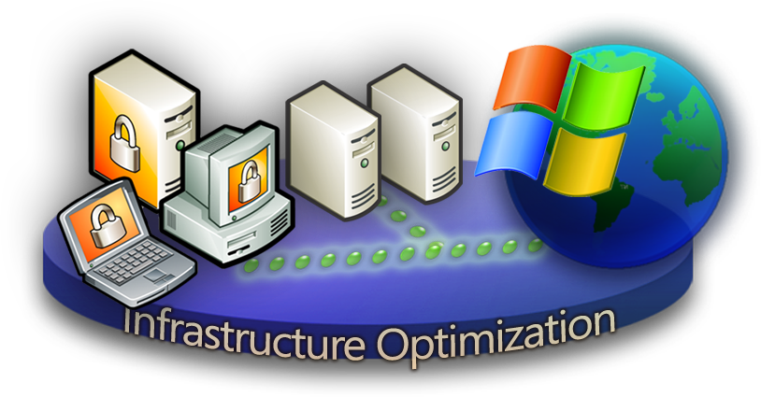

“For most organizations, their IT infrastructure can and should be their greatest strategic asset and business enabler. Unlocking that potential requires alignment between IT and the business as well as a mature infrastructure and an optimised balance between people, process and technology.”

According to Analysts more than 70 percent of a typical IT budget is spent on infrastructure such as servers, operating systems, storage and networking. Add to this the need to refresh and manage desktop and mobile devices and you have a unique set of challenges for IT infrastructure to face.
IT Infrastructure is a strategic asset and the critical foundation upon which software can deliver services and user applications that a business needs in order to operate effectively and succeed. For many organizations growth and rapid developments in new technologies have resulted in data center and desktop infrastructures that are overly complex, inflexible and difficult to manage with built-in costs that are not only high but somewhat fixed regardless of changing business requirements.

Most organizations recognize the importance of an optimized and cost efficient IT infrastructure and have tried to rationalize their infrastructure and increase their operational efficiency through initiatives such as data center consolidation, desktop standardization, implementing IT operational best practices etc. Such initiatives undertaken by IT departments in isolation are not sufficient on their own to deliver the desired and long lasting improvements demanded by the business. In order to achieve a sustained improvement in their IT infrastructure organizations must take a longer term strategic view of I.T. infrastructure maturity and link these capability and maturity improvements to their business needs and overall business strategy.

Infrastructure Optimization Model
The Infrastructure Optimization Model from Microsoft helps customers understand and subsequently improve the current state of their IT infrastructure and what that means in terms of cost, security risk and operational agility. Dramatic cost savings can be realized by moving from an unmanaged environment towards a dynamic environment. Security improves from highly vulnerable in a Basic infrastructure, to dynamically proactive in a more mature infrastructure. IT Infrastructure Management changes from highly manual and reactive to highly automated and proactive. Microsoft and Partners can provide the technologies, processes and procedures to help customers move up through the Infrastructure Optimization Journey. Process moves from fragmented or non-existent to optimized and repeatable. A customer’s ability to use technology to improve their business agility and deliver business value increases as they move from the Basic state up the continuum toward a Dynamic state empowering information workers, managers and supporting new business opportunities.

By working with Microsoft and using this model as a framework, an enterprise can quickly understand the strategic value and business benefits to the organization in moving from a “basic” level of maturity (where the IT infrastructure is generally considered a “cost center”) towards a more “dynamic” use when the business value of the IT infrastructure is clearly understood and the IT infrastructure is viewed as a strategic business asset and business enabler.

Infrastructure Optimization Model – In Action
The Infrastructure Optimization Model from Microsoft has been developed using Industry best practices, Microsoft’s own experiences with its enterprise customers, and is based upon Gartner’s Infrastructure Maturity Model and MIT’s Architecture Maturity Model. A key goal for Microsoft in creating the Infrastructure Optimization Model was to develop a simple way to use a maturity framework that is flexible and can easily be used as the benchmark for technical capability and business value.

The first step in using the model is to evaluate what maturity level you are at in the model. Once the current maturity level has been established, the next step is to use the model to develop a plan on how to progress through each maturity level in order to reach the target level needed for maximum business benefit.

Level 1 Basic
The Basic IT infrastructure is characterized by manual, localized processes, minimal central control, non-existent or un-enforced IT policies and standards regarding security, backup, image management and deployment, compliance, and other common IT standards. There is a general lack of knowledge regarding the details of the infrastructure that is currently in place or which tactics will have the greatest impact to improve upon it. Overall health of applications and services is unknown due to a lack of tools and resources. There is no vehicle for sharing accumulated knowledge across IT. Customers with Basic infrastructure find their environments extremely hard to control, have very high desktop and server management costs, are generally very reactive to security threats and have very little positive impact on the ability of the business to benefit from IT. Generally all patches, software deployments, and services are provided high touch and high cost.

Customers benefit substantially by moving from this type of Basic Infrastructure to a Standardized Infrastructure helping them to dramatically reduce costs through:
- developing standards, policies, and controls with an enforcement strategy
- mitigating security risks by developing a “defense in depth” posture – a layered approach to security at the perimeter, server, desktop and application levels
- automating many manual and time consuming tasks
- adopting “best practices” (ITIL, SANS, etc.)
- aspiring to make IT a strategic asset rather than a burden
Level 2 Standardized
The Standardized infrastructure introduces controls through the use of standards and policies to manage desktops and servers, how machines are introduced to the network, the use of Active Directory® to manage resources, security policies, and access control. Customers in a Standardized state have realized the value of basic standards and some policies yet are still quite reactive. Generally all patches, software deployments and desktop service are provided through medium touch with medium to high cost. However, they have a reasonable inventory of hardware and software and are beginning to manage licenses. Security measures are improved with a locked down perimeter, internal security may still be a risk.

Customers benefit by moving from this Standardized state to a Rationalized state with their infrastructure by gaining substantial control over the infrastructure and having proactive policies and processes that prepare them for the spectrum of circumstances from opportunity to catastrophe. Service Management is a concept and the organization is taking steps to recognize where to implement it. Technology is also beginning to play a much larger role moving toward a Rationalized infrastructure by becoming a business asset and ally rather than a burden.
Level 3 Rationalized
The Rationalized infrastructure is where the costs involved in managing desktops and servers are at their lowest and processes and policies have matured to begin playing a large role in supporting and expanding the business. Security is very pro-active and responding to threats and challenges is rapid and controlled.
The use of Zero touch deployment minimizes cost, time to deploy and technical challenges. The number of images is minimal and the process for managing desktops is very low touch. They have a clear inventory of hardware and software, and only purchase those licenses and computers they need.
Security is extremely pro-active with strict policies and control from desktop to server to firewall to extranet.

Customers benefit on a business level by moving from this Rationalized state to a Dynamic state. The benefits of implementing new or alternative technologies to take on a business challenge or opportunity far outweigh the incremental cost. Service Management is implemented for a few services with the organization taking steps to implement more broadly across IT. Customers contemplating the value of Dynamic state generally are looking for their IT infrastructure to provide business advantage.
Level 4 Dynamic
Customers with a Dynamic infrastructure are fully aware of the strategic value their infrastructure provides in helping them run their business efficiently and staying ahead of competitors. Costs are fully controlled, integration between users and data, desktops and servers, collaboration between users and departments is pervasive and mobile users have nearly on-site levels of service and capabilities regardless of location.
Processes are fully automated, often incorporated into the technology itself allowing IT to be aligned and managed according to the business needs. Additional investments in technology yield specific, rapid, measurable benefits for the business.

The use of self provisioning software and quarantine-like systems for ensuring patch management and compliance with established security policies allows the dynamic organization to automate processes, thus improving reliability, lowering costs and increasing service levels.

Customers benefit from increasing the percentage of their infrastructure that is Dynamic by providing heightened levels of service, competitive and comparative advantage and taking on bigger business challenges. Service Management is implemented for all critical services with service level agreements and operational reviews established.

Want to Know More?

For additional information, see:
http://www.microsoft.com/windowsserversystem/overview/benefits/default.mspx
The information contained in this document represents the current view of Microsoft Corporation on the issues discussed as of the date of publication. Because Microsoft must respond to changing market conditions, it should not be interpreted to be a commitment on the part of Microsoft, and Microsoft cannot guarantee the accuracy of any information presented after the date of publication.
This document is for informational purposes only. MICROSOFT MAKES NO WARRANTIES, EXPRESS OR IMPLIED, IN THIS DOCUMENT.
© 2005 Microsoft Corporation. All rights reserved. Microsoft, Active Directory, the Windows logo, and Windows Server System are either registered trademarks or trademarks of Microsoft Corporation in the United States and/or other countries. The names of actual companies and products mentioned herein may be the trademarks of their respective owners.

