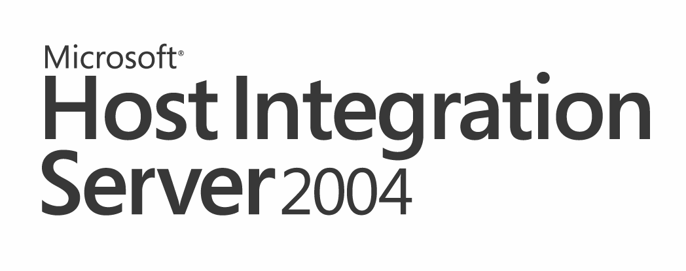

Reviewer Guide
October 2004

For the latest information, please see http://www.microsoft.com/hiserver.

For more information, press only:
Rapid Response Team
Waggener Edstrom
(503) 443-7070
rrt@wagged.com

Abstract
This reviewer guide offers an overview of the integration components provided by Microsoft Host Integration Server 2004. These components enable network, messaging, data, application, and security integration of host-based systems with Microsoft Windows-based and Microsoft .NET Framework-enabled solutions. This document is not a deployment or administration guide for Host Integration Server 2004. Knowledge of host systems and integration strategies is helpful in understanding this information.

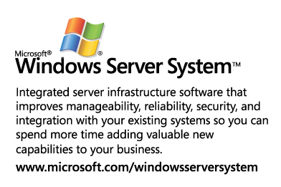

The information contained in this document represents the current view of Microsoft on the issues discussed as of the date of publication. Because Microsoft must respond to changing market conditions, it should not be interpreted to be a commitment on the part of Microsoft, and Microsoft cannot guarantee the accuracy of any information presented after the date of publication.
This reviewer guide is for informational purposes only. MICROSOFT MAKES NO WARRANTIES, EXPRESS OR IMPLIED, IN THIS DOCUMENT.
Complying with all applicable copyright laws is the responsibility of the user. Without limiting the rights under copyright, no part of this document may be reproduced, stored in, or introduced into a retrieval system, or transmitted in any form or by any means (electronic, mechanical, photocopying, recording or otherwise), or for any purpose, without the express written permission of Microsoft.
Microsoft may have patents, patent applications, trademarks, copyrights, or other intellectual property rights covering subject matter in this document. Except as expressly provided in any written license agreement from Microsoft, the furnishing of this document does not give you any license to these patents, trademarks, copyrights or other intellectual property.
© 2004 Microsoft Corp. All rights reserved.
The example companies, organizations, products, domain names, e-mail addresses, logos, people, places, and events depicted herein are fictitious. No association with any real company, organization, product, domain name, e-mail address, logo, person, place, or event is intended or should be inferred.
Microsoft, Windows logo, Windows, Windows Server System, Visual Studio, Active Directory, Win32, Windows Server, Visual C++, Visual C#, Visual Basic, ActiveX, BizTalk and SharePoint and Visual are either registered trademarks or trademarks of Microsoft Corp. in the United States and/or other countries.
The names of actual companies and products mentioned herein may be the trademarks of their respective owners.

Contents

Introduction 1

New Features in Host Integration Server 2004 2

Approaches to Platform Interoperability 4

Network Integration 5
Comprehensive SNA Services 5
Host Environments 6
Session Types 6
Application Programming Interfaces 7
Simplified Desktop Configurations 7
Simplified Host Configurations 8
Flexible Deployment Options 9
SNA Gateway Deployment Models 10
IP-DLC Link Service 12
TN3270 Services 13
Host Print Service 14
Network Service Architecture 15
Server Administration 18
SNA Manager 18

Application Integration 21
Development Projects 21
Administration 22
Mainframe Programs 22
AS/400 Programs 23
Programming Model Improvements 24
Host-Initiated Processing 24

Data Integration 25
ADO.NET and .NET Framework 26
Relational Database Access 26
SQL Server 28
Host Record File Access 30
Host File Transfer 31
AS/400 Data Queue Access 32

Messaging Integration 33
Sending Messages to MQSeries 33
Receiving Messages From MQSeries 34

Security Integration 35
Single Sign-On 35
End-to-End Security Enhancements 36
Flexible Administration Model 36
Auditing 37
Distributed Environment 37
Extensibility 37
Password Synchronization 37
Host-Initiated SSO 38
Configuration Store 38

Installation and Configuration 39
Server Installation 39
Server Configuration 40
Client Installation 41
Client Configuration 42
Supportability 42

“Secure by Deployment” 47
Access to Host Systems 47
Data Encryption 49

Microsoft .NET and Windows Server System 50
Microsoft .NET 50
Developer Tools 51
Windows Server System 51
.NET Experiences 52

Conclusion 53

Introduction
Many organizations run mission-critical server applications on IBM host systems, such as mainframe zSeries and midrange iSeries computers. Yet, organizations use personal computers together with Web-based and Windows-based applications for everyday productivity and line-of-business solutions. Organizations generally find the Web and Windows solutions to be easier to learn and quicker to implement than comparable host-based applications. To preserve their time and capital investments in host technology, organizations must either migrate their host-based resources to the Windows platforms, which can be expensive and time consuming, or integrate their host-based resources with more efficient Windows-based and Web-based solutions. Integrating host-based data and applications with Web-based and Windows-based applications offers significant benefits, including these:
- Preserves investment in currently deployed host and personal computer technology while taking advantage of new architectures and products being offered for the personal computer platform.
- Allows rapid deployment of custom, high-performance solutions, using a choice of Windows-based development tools and leveraging a large pool of qualified developers who do not need to know or learn host programming.
- Lowers administrative resources and reduces hardware expenses, thereby reducing the total cost of ownership (TCO).
Whether organizations want to create data warehouses to improve decision-making, develop Web-based applications that perform transactions using host-based data, or allow users to include archived data in reports, Microsoft Host Integration Server (HIS) 2004 offers integration components that help achieve those goals.
To help its customers achieve these benefits, Microsoft launched Communication Server 1.0 in 1990, specifically to address host integration. Microsoft SNA Server 2.0, which followed in 1992, allowed system administrators to send local area network (LAN) and systems network architecture (SNA) networking traffic across the same network infrastructure.
Since then, Microsoft has continued to improve SNA Server based on customers’ needs, developing it into a complex and feature-rich product. Host Integration Server 2004 builds on the strengths of its predecessor products and offers a range of mature technologies that help organizations solve their host integration challenges.
Today, Microsoft Host Integration Server 2004, which is part of the Microsoft Windows Server System, provides the key enabling technologies that allow enterprises to integrate their mission-critical host applications, data sources, messaging and security systems with new solutions developed using the Microsoft Windows platform.

New Features in Host Integration Server 2004
Integration Approach | Feature | Innovation
All Approaches | Documentation | Improved documentation and samples
All Approaches | Security | Designed under the Trustworthy Computing Initiative  “Secure by Design”  “Secure by Default”  “Secure by Deployment”
Network Integration | SNA Services | IP-DLC Link Service supporting HPR/IP connections to IBM Enterprise Extender
Network Integration | TN3270 Service | Authentication and encryption using Secure Sockets Layer (SSL) and Transport-Level Services (TLS)
Network Integration | SNA Manager | Improved configuration wizards and diagnostics tool
Network Integration | Host Print Service | Support for Arabic Bi-Directional Layout Conversion
Application Integration | Transaction Integrator | Support for .NET Framework and Visual Studio .NET (TI projects)
Application Integration | Transaction Integrator | Support for AS/400 RPG Programs
Application Integration | Transaction Integrator | Host-Initiated Processing
Application Integration | Transaction Integrator | Control of the TCP/IP CICS Transaction Request Message (TRM) for interoperability with CICS using TCP/IP Custom TRMs  WIP support for CICS Enhanced Listener through the ELM (Enhanced Listener Message) programming model  WIP Persistent Connections across an SNA or TCP/IP network
Application Integration | Transaction Integrator | Support for Arabic Bi-Directional Layout Conversion
Security Integration | Enterprise Single Sign-On | Host-Initiated SSO
Security Integration | Enterprise Single Sign-On | Password Synchronization with third-party adapters from Proginet
Data Integration | DB2 Data Providers | Managed Data Provider for DB2
Data Integration | DB2 Data Providers | Improved DRDA AR (DB2 network protocol client)
Data Integration | File System Providers | SQL Server Data Transformation Services access to mainframe VSAM data sets
Data Integration | DB2 Data Providers | Distributed Transactions over TCP/IP  Default Schema  Single Sign-On (SNA and IP)  Client Application Name  Stored Procedure Multiple Results  Default Qualifier (CURRENT SQLID)  UNICODE Data  Long Identifiers  DB2/400 long, mixed-case and special character passwords  APPC AP_SAME and AP_PGM support for already verified DB2 authentication across SNA LU6.2
Data Integration | DB2 Data Providers | Support for Arabic Bi-Directional Layout Conversion
Data Integration |  | UNICODE, Double-Byte and Mixed-Byte character set support when accessing DB2  DB2 data provider support for Simplified Chinese GB18030 code page conversions  DB2 data provider support for Extended UNIX Code pages for use in Japanese, Korean and Simplified Chinese locales
Table 1. New features in Host Integration Server 2004

Approaches to Platform Interoperability
When reviewing platform interoperability products, it is useful to break these up into the five common approaches to integration or layers of technology. Host Integration Server 2004 offers layers of technology, allowing organizations to integrate their host networks, security technologies, messaging, data and applications with new solutions based on Microsoft Windows Server System and Microsoft .NET.
- Network integration components that allow SNA devices and programs to connect efficiently to Windows-based desktops and servers across routable Internet Protocol (IP) networks. With HIS 2004, enterprises can continue to consolidate their network infrastructure, while supporting the same level of SNA-compatible applications and services.
- Security integration components that provide enterprise single sign-on and password synchronization to integrate the IBM mainframe security systems, such as IBM Resource Access Control Facility (RACF) or IBM midrange (OS/400) security system, with Microsoft Windows and Active Directory. This allows administrators and developers to deploy SNA applications on Windows-based desktops and servers, and publish vital host data and applications as XML Web services more securely.
- Messaging integration components that allow enterprises that have standardized on IBM’s cross-platform messaging, WebSphereMQ (MQSeries), to be efficiently integrated with solutions based on Microsoft Message Queuing (MSMQ) technology.
- Data integration components that offer direct access to vital record data stored in IBM host systems, from Windows-based desktop or server-based applications. Host Integration Server 2004 provides a comprehensive set of data providers for accessing vital host sources, including IBM DB2 databases and host file systems. These data providers work with industry standards and popular data access architectures, including the .NET Framework.
- Application integration components that enable enterprise Windows developers to publish and extend business rules in mainframe applications as XML Web services, while allowing host developers to access and update Windows server programs using familiar programming models.
In the following sections of this paper, we will explore these approaches and the methods within each approach in more detail, beginning with networking.

Network Integration
IBM host systems, mainframe zSeries and midrange iSeries computers, are designed to operate within IBM’s Systems Network Architecture. SNA consists of proprietary IBM device types, session types, communications models and application programming interfaces. Host Integration Server 2004 provides enterprise administrators and developers with network services and technologies for efficiently bridging SNA with Windows networking, programming models, and applications.

Comprehensive SNA Services
The most popular method of connecting networks with dissimilar protocols has always been to insert a gateway device that can convert from one protocol to another. Host Integration Server 2004 incorporates the traditional SNA “gateway” services, while offering host print services and a full software development kit (SDK).
SNA-to-PC LAN connectivity sits at the heart of most enterprise integration projects. Microsoft is committed to providing organizations with efficient, flexible SNA gateway options. Host Integration Server 2004 builds on the industry-leading network connectivity features of SNA Server to provide organizations with the greatest number of options for connecting SNA systems and PC-based networks.
Figure 1 Host Integration Server 2004 provides cost-effective network integration for the modern enterprise organization.
Host Integration Server 2004 connects PC-based LANs to IBM zSeries mainframe and iSeries midrange systems. With Host Integration Server 2004, users with desktop operating systems such as Windows XP and Windows 2000 Professional can access resources, data and applications on host computers. HIS 2004 enables this desktop access without requiring any SNA protocols on the desktop computer, branch or WAN networks. HIS 2004 does not require any non-IBM or nonnative software to be installed on the mainframe system to support access by applications emulating the popular SNA device types and logical unit types.

Host Environments
Host Integration Server 2004 offers broad support for common host environments, including these:
- SNA connectivity, 3270 terminal emulation, host print service and SNA programming interfaces to mainframe computers running IBM z/OS, OS/390, MVS, VSE, and VM operating systems.
- SNA connectivity, 5250 terminal emulation, host print service and SNA programming interfaces to midrange computers running IBM OS/400 or IBM AS/400 Advanced 36 System Support Program operating systems.
- Host Integration Server 2004 supports the required SNA host types, including IBM mainframe and midrange systems, Physical Unit (PU) types, and Logical Unit (LU) types as shown in Table 2.
Features | Capabilities
Host Environments | IBM mainframe computers running  z/OS, OS/390, MVS, VSE VM  IBM midrange computers running  OS/400 or IBM AS/400 Advanced 36 System Support Program
PU Types | APPN LEN node and BrNN node, PU2.0, PU2.1, DSPU
LU Types | LU0, LU1, LU2, LU3, LU6.2 TN3270, TN3287, TN3270E, TN5250
Table 2. Host Integration Server 2004 supports a broad range of host computers, PU and LU types.
Host Integration Server 2004 supports an Advanced Peer-to-Peer Network (APPN) by functioning as a Low-Entry Networking (LEN) node or Branch Network Node (BrNN)—when connecting through the new IP-DLC Link Service. This level of APPN support meets the requirements of an effective SNA gateway and allows Host Integration Server 2004 to participate in an APPN environment.

Session Types
Host Integration Server 2004 supports mainframe terminal and printer sessions with LU types 0-3. LU 0 is a device type used mainly in the financial industry to support teller terminals and automatic teller machines. LU types 1 and 3 are used to support printer emulation programs on client and server PCs, including the Host Integration Server 2004 Host Print Service. LU type 2 provides terminal emulation support for client programs such as Attachmate EXTRA!, NetManage RUMBA and the Host Integration Server 2004 3270 Client. LU 6.2 supports Application Program-to-Program Communications (APPC), Common Program for Communications (CPI-C) and Common Service Verbs (CSV). These APIs are what allow client and server-based transaction programs and other processes to communicate with host systems, such as those running under Customer Information Control System (CICS) and Information Management System (IMS). A common example of a transaction-based process would be a magnetic credit card reader at a point-of-sale terminal, such as PC-based cash register, that communicates from a branch store location to the home office through a Host Integration Server 2004 connection. The validation of the card holder’s credit status uses APPC as the API supporting the transaction.
Host Integration Server 2004 supports all AS/400 session types on most popular desktop operating systems using LU type 6.2. Some older-style client emulators use LU type 4 for printer emulation and LU type 7 for terminal emulation. However, Host Integration Server 2004 and most client emulators, such as EXTRA! and RUMBA, support standard 5250 terminal and printer emulation the same as Host Integration Server 2004 does—through LU type 6.2 and APPC.

Application Programming Interfaces
The Host Integration Server 2004 SDK, including online documentation and source code samples, provides the means to build complete APPC, CPI-C, CSV and Logical Unit for Applications (LUA) solutions, as well as add-on products to Host Integration Server 2004 core functionality. Most of these APIs were discussed in the preceding paragraph. LUA is a customizable API that allows one to develop either at a low level in the SNA protocol stack, at the Request User Interface (RUI), or a higher level, at the Session Level Interface. These APIs are used everyday by large institutional organizations building on their legacy of banking and insurance applications, many of which, previous to Host Integration Server 2004, had relied on specialized control unit devices, such as the IBM 4147 financial series controller.
One set of APIs not directly supported by the Host Integration Server 2004 SDK are HLLAPI, EHLLAPI and WinHLLAPI, High Level Language API, Extended HLLAPI and Windows HLLAPI. Generally, these APIs are features of third-party client emulators, such as EXTRA! and RUMBA.
The Host Integration Server 2004 APIs comply with the open standards proposed and published in compliance with the industry-created Windows Open Service Architecture (WOSA) guidelines. This means that on all Windows operating systems, the Host Integration Server 2004 APIs are WOSA versions: WinAPPC, WinCPI-C, and WinCSV. A number of ISVs contributed to the WOSA SNA API standards, among them IBM Corp. and Attachmate Corp.
SNA client emulation vendors support host connectivity through Host Integration Server 2004 by adapting their products to support the Host Integration Server 2004 Function Management Interface (FMI)—sometimes referred to as the Emulator Interface Specification (EIS). The FMI or 3270 EIS API is encapsulated in a piece of Host Integration Server 2004 “client” code that Microsoft licenses to ISVs royalty-free. The emulator talks to this Host Integration Server 2004 client module, which in turn communicates with Host Integration Server 2004 through a client/server connection. When you use a full-featured 3270 emulator (or the Microsoft 3270 Client) with Host Integration Server 2004, you are connecting to the server through the FMI. FMI supports LU types 1-3. When you use a full-featured 5250 emulator (or the Microsoft 5250 Client) with Host Integration Server 2004, you are connecting to the server through APPC.
Through broad API support on the popular personal computer platforms and comprehensive network protocol support, Host Integration Server 2004 effectively integrates personal computer and host systems. Network managers can employ Host Integration Server 2004 to provide enterprise-wide connectivity for disparate systems, with the knowledge that it will work with all required standards and environments.

Simplified Desktop Configurations
Host Integration Server 2004 reduces complexity, increases stability and saves memory by allowing you to use only one protocol on the client workstation. In contrast, when connecting directly, you will need the DLC protocol to connect to the host, and a LAN protocol such as TCP/IP or IPX/SPX to connect to the file/database/mail server.
Host Integration Server 2004 provides easier administration than direct connect solutions. When connecting direct, each desktop must be configured individually with the host's network address, LU name, and so on. Whenever there is a change on the host side, such as the host's network address, all desktops must be reconfigured. With Host Integration Server 2004, there is nothing to configure at the client—all host changes can be tracked centrally by the LAN administrator. Host Integration Server 2004 allows the administrator to create user and group profiles on the server that contain access rights to all Host Integration Server 2004 computers in the subdomain. Host Integration Server 2004 compatible emulators can be configured to connect to a local Host Integration Server 2004 with no configuration other than the choice of LAN protocol. In addition, Host Integration Server 2004 provides users of Windows with simplified logon to resources by automatically validating the user ID and password (using the Enterprise Single Sign-On solution). This optional capability works automatically for IPX/SPX and TCP/IP connections on Win32 operating systems.

Simplified Host Configurations
SNA gateways should allow flexible changes to be made at the gateway as demanded without affecting host configurations. Examples include adding new users to a gateway, assigning priority access to host resources for an existing user, and removing a user’s rights to access host LUs.

Resource Pooling
Host Integration Server 2004 implements a feature called LU pooling. Dependent LU sessions and APPC session pairs can be grouped together into a pool of common resources. LU pooling allows fewer host resources to be shared by multiple users. When new users are added to an organization, these users can be granted access to pooled resources at the gateway, thereby minimizing host changes. Host Integration Server 2004 offers these capabilities, and more, greatly simplifying host configurations.
LU pooling maximizes access to the resources available through 3270, LUA or downstream LUs. A user, LUA application or downstream system using the pool can get LU access as long as one of the pooled LUs is available. Pooling of LUs is handled differently for APPC LUs but provides the same capabilities. LU pooling can provide a variety of benefits. Pools allow groups of intermittent users to use resources efficiently. For example, 10 3270 users who need intermittent access to more sessions may find that a pool of five 3270 LUs is adequate for their needs.
An LU pool can span multiple host connections on a single server, or even multiple Host Integration Server 2004 computers for enterprise-level scalability. The pooled resources can be given a shared name that is then used in a simplified desktop configuration. Multiple users can be granted rights to this LU pool, shared resources, to simplify server configuration, maximize configured resources, and provide for advanced capabilities such as fault tolerance and load balancing.
Using SNA Manager, the administrator can easily assign LU pools to users or groups. This eliminates the time that would be required to assign LUs individually. With Windows UI drag and drop capability, constructing pools and assigning users to them can be done with a few mouse clicks.

On-Demand Connections
On-demand host connections provide the means to support increased user load, or to activate backup connections automatically, by allocating additional host resources when the need arises. This avoids having to maintain ongoing connections to host systems when no traffic requires the open connection. This is especially important in AS/400 environments where the host continually polls peer connections.

Downstream Physical Units
Host Integration Server 2004 can support SNA downstream physical units, such as point-of-sale devices. To the downstream system, there appears to be a direct connection to the host. Host Integration Server 2004 accomplishes this by passing detailed LU information back and forth between downstream systems and the host. Host Integration Server 2004 does require all the usual connection information for the host and downstream connections. Communication through a downstream connection and downstream LU in Host Integration Server 2004 is always controlled by the host.
Although use of a downstream physical unit (DSPU) connection does not provide all the benefits of a regular Host Integration Server 2004 client/server connection, there are still significant benefits to employing Host Integration Server 2004 for DSPU clients:
A full range of client/server transports is supported for DSPU clients: IP-DLC, 802.2/DLC over Token Ring or Ethernet, SDLC, and X.25/QLLC.
Host Integration Server 2004 performs PU concentration instead of PU pass-through. This reduces the network configuration and administration workload as well as the memory consumption at the host.
- DSPU clients can share the Host Integration Server 2004 host connections.
- DSPU clients can be supported along with regular clients, allowing for easy coexistence of various types of clients.
- The DSPU configuration reduces host configuration requirements by concentrating PUs on the SNA gateway computer and passing the LUs to attached DSPUs. LUs from one or more PUs defined on the gateway can be shared with one or more downstream devices. This allows for more economical use of configured resources and alleviates the need to configure each downstream device in host VTAM.

Flexible Deployment Options
Flexibility is an essential goal of most desktop-to-host and client/server solutions. Given the high degree of change in the business world and computing industry, it is important that network managers design new information systems capable of accepting updated software, advanced hardware, and new industry standards as needed.
An efficient SNA gateway is designed to be extensible and can be deployed with flexibility to take advantage of an organization’s current and future networking infrastructure. In this section, we will look at the ways Host Integration Server 2004 provides this required flexibility.
Host Integration Server 2004 supports the required SNA host types, including IBM mainframe and midrange systems, PU types, and LU types as shown in Table 2. IBM midrange support is comprehensive and includes the IBM AS/400, Advanced 36, System/36 and System/38 computers.

Multiple Concurrent Connections
Host Integration Server can support up to 250 concurrent host, peer or DSPU connections. This allows Host Integration Server 2004 to provide flexible access to hierarchical mainframe programs through traditional 3270 terminal emulation and 3287 printer emulation, as well as more modern mainframe advanced peer-to-peer programming for communications programs. Also, this allows Host Integration Server 2004 to offer optional TCP/IP-to-SNA communications to newer midrange AS/400 computer, as well as older SNA-only Advanced 36 System Support Program running in emulation mode on AS/400 computers.

Network Protocols
Typically, Host Integration Server 2004 is connected to the mainframe or midrange system through Token Ring, Ethernet and FDDI adapters that are installed on computers running Windows Server 2003 and Windows 2000 Server, using either 802.2 Data Link Control (DLC) or Internet Protocol-Data Link Control (IP-DLC). Also, Host Integration Server 2004 offers support for Synchronous Data Link Control (SDLC) or X.25 connections over dial-up or leased lines, as well as bus-and-tag or fiber channel connections—through the open SNA Device Interface Specification (SNADIS), supported by a number of independent hardware vendors (IHVs).

SNA Clients
Microsoft has worked to build strong relationships with independent vendors that develop SNA client emulation applications. These vendors offer products that are compatible with Host Integration Server 2004.
Optionally, Microsoft Host Integration Server 2004 includes SNA clients for use with mainframe and midrange AS/400 computers. The Host Integration Server 2004 3720 Client and 5250 Client offer essential functionality for administrators and end users when accessing mainframe or midrange screen logic interface programs.
Client | Features
3270 Client | Emulation of IBM 3178 terminal models 2-5  IND$FILE file transfer to and from TSO, VM/CMS, CICS  Multiple sessions  Copy and paste through the Clipboard  Print screen  Supports collection of IBM NetView RTM data  Multiple international host and PC code pages  Online help
5250 Client | Emulation of IBM 5250 terminals  Multiple sessions  Copy and paste through the Clipboard  Print screen  Graphical toolbar  Multiple international host and PC code pages  Online help
Table 3. Features of the Microsoft 3270 Client and 5250 Client

SNA Gateway Deployment Models
Host Integration Server 2004 supports traditional branch-based and centralized deployment models. In addition, Host Integration Server 2004 offers a new distributed deployment model. The distributed deployment model is the key component of the Microsoft SNA Open Gateway Architecture (SOGA), a scalable framework for SNA enterprise gateways offering multiple options for integrating branch offices through routed internetworks with IBM mainframe and AS/400 computers.
- Branch-based deployment is the traditional way to deploy SNA gateways. SNA gateways are placed in branches and communicate with the host using native SNA protocols, either directly through SDLC leased lines or X.25 network, or through 802.2/DLC, which is tunneled from the branch LAN to the central site LAN by routers, as well as routable SNA over IP (using the new IP-DLC Link Service).
- Centralized deployment has emerged recently as an attractive way to isolate the SNA traffic to the data center. SNA gateways are placed at the data center and connected to the host using native SNA protocols or the new IP-DLC Link Service, offering high-speed gigabyte Ethernet connectivity. The centralized SNA gateways provide split-stack or TN3270E service for local and remote desktops that connect to the gateways using popular LAN protocols.
- Distributed deployment combines the strengths of the branch-based and centralized models by merging the two. Branch-based SNA gateways connect to the host through centralized SNA gateways. The distributed deployment model relies on a capability in Host Integration Server 2004 called the Distributed Link Service, which enables Host Integration Server 2004 computers to be deployed in branch offices, yet allows the branch-based Host Integration Server 2004 computers to connect to centralized Host Integration Server 2004 computers using native TCP/IP or IPX/SPX protocols. The centralized Host Integration Server 2004 computers are connected to the host through IP-DLC Link Service (using high-speed gigabyte Ethernet), direct channel attachment, or a local Token Ring using native SNA protocols.

Branch-Based Deployment
Not all organizations are ready to move to a single interconnected WAN using IP-DLC, Data Link Switching (DLSw), Frame Relay or Asynchronous Transfer Mode (ATM). For example, many organizations have invested in leased SDLC lines or X.25 connections between remote and central sites.
Host Integration Server 2004 supports SDLC and X.25 connections making use of existing SNA infrastructure where appropriate. Given the added complexity and cost, some organizations decide to rely on their existing SDLC and X.25 connections for SNA transactions and reserve their WAN for other protocols supporting non-SNA communications. The advantages of a branch-based deployment include reduction in WAN traffic, availability of multifunction servers in branch offices, and local session management.
More recently, this deployment model relies on the industry-standard SNA over IP, in the form of the HIS 2004 IP-DLC Link Service, which connects branch-based servers to the mainframe through routable IP, while supporting all the existing SNA PU types, LU types and SNA programs.

Centralized Deployment
In a centralized configuration, LU pooling reduces the amount of host connections required and makes better use of host administration time, which would otherwise be spent reconfiguring host PUs and line definitions as required to meet constantly changing needs. In addition, centrally located Host Integration Server 2004 computers are easier to secure and manage by the central IS group. This reduces the need for SNA expertise at the remote site.
Overwhelmingly, organizations are looking at TCP/IP as their single WAN protocol. Host Integration Server 2004 supports this protocol on most client platforms. In Host Integration Server 2004, Microsoft offers support for the industry-standard for SNA over IP when connecting to IBM mainframe computers. This standard is called high-performance routing over IP (HPR/IP) or “Enterprise Extender.” With the new IP-DLC Link Service, centrally deployed Host Integration Server 2004 computers can connect to mainframe z800 and z900 series mainframes across Token Ring or high-speed gigabyte Ethernet using the built-in Enterprise Extender support in OS/390 and z/OS.

Distributed Deployment
The advantages of a distributed approach over a branch-based deployment include elimination of 802.2/DLC time-outs, reduction of required WAN bandwidth and simplification of wide area network management.
Advantages of the distributed approach over the centralized deployment model include improvement of host response times for users at the branch office and support for NetView management of the branch-based Host Integration Server 2004 computers.
The distributed deployment model is composed of branch-based Host Integration Server 2004 computers that connect to the host through multiple centralized Host Integration Server 2004 computers, load-balancing between the central site Host Integration Server 2004 computers at connect time. Should a central site Host Integration Server 2004 computer fail for any reason, the branch-based Host Integration Server 2004 computers automatically establish a new connection through an alternate centralized Host Integration Server 2004 computer providing fault tolerance.
As an additional backup, the branch-based Host Integration Server 2004 computers can use the traditional SNA WAN, such as dial-up SDLC, to connect to the host should the TCP/IP WAN fail.
Because the central site Host Integration Server 2004 computers provide the equivalent of PU pass-through service for the branch-based Host Integration Server 2004 computers, the host operator sees each branch-based Host Integration Server 2004 computer as a single PU and can manage the branches through NetView alerts and RunCmds.

IP-DLC Link Service
Many enterprises consist of distributed branch offices that must connect remote desktop and server computers to centralized IBM mainframe data centers through a wide area network. Typically, the WAN is based on a routable IP network supported by expensive DLSw routers, which encapsulate the IBM proprietary SNA protocols in TCP/IP. This traditional method of integrating SNA with IP allows the data center to operate IBM fixed-functional Front End Processors (FEPs) and cluster controllers to offload the mainframe from handling nonnative network communications.
However, over the past several years, a new industry standard has emerged for integrating SNA devices, networks, and mainframes with modern routed internets, based on commodity routers that do not have to support expensive DLSw functions. IBM calls this solution Enterprise Extender; the industry knows it as SNA over IP, HPR/IP or Cisco SNA-SW.
In Host Integration Server 2004, the core network integration portion of the product has been extended to offer an IP-DLC Link Service to enable Host Integration Server 2004 to participate in an IBM Enterprise Extender environment. Customers can deploy Host Integration Server 2004 in a branch office, in a central location, or even within the data center, directly connected to the mainframe across efficient gigabyte Ethernet.
The Host Integration Server 2004 IP-DLC Link Service requires these host mainframe components:
- IBM Communications Server for OS/390 V6 or later
- IBM OS/390 2R6 (with APAR OW36113) or later
Figure 2 Modern Enterprise Extender network using HIS 2004 IP-DLC Link Service
IP-DLC provides SNA connectivity for applications using dependent and independent sessions over a routable IP network, by offering support for the industry-standard HPR/IP protocol, which IBM calls Enterprise Extender. Using IP-DLC, each SNA packet is transmitted across the IP network as a UDP datagram. The IP-DLC link service is an add-on feature to the existing SNA protocol node. From an application perspective, such as a 3270 emulator or WinAPPC program, there is no change in functionality. However, the SNA network traffic from branch-deployed or centrally deployed Host Integration Server computers can be routed across the IP network directly to an IBM mainframe system running OS/390 V2R10 or higher and using an OSA or OSA Express compatible network adapter.
The Host Integration Server 2004 IP-DLC Link Service allows enterprise IT organizations to realize broad cost savings. IT can retire expensive channel-attached 374x FEPs, move toward a single physical media (gigabyte Ethernet) within the glass room, and replace expensive and complex DLSw routers, while simplifying their overall network infrastructure.
The new IP-DLC Link Service supports the industry-standard SNA over IP routing so that branch-deployed and centrally deployed Host Integration Server 2004 computers can connect directly to IBM mainframes through high-speed IP networks. No longer must enterprises remotely administer branch cluster controllers, use expensive DLSw-capable routers or maintain costly FEPs. With Host Integration Server 2004 enterprises can continue to consolidate their network infrastructure while supporting the same level of SNA-compatible applications and services.

TN3270 Services
Some organizations run the TCP/IP protocol on the host system, and then allow all users running a TN3270 or TN5250 emulator to connect directly to the host computer. In this scenario, the host must process the TCP/IP frames received from the client, translating the TCP/IP into the host’s native SNA protocol. In addition, the host computer may support other TCP/IP-based services, such as FTP file transfer and LPR/LPD printing. Running TCP/IP on a host system may simplify the network but it results in a significant performance penalty. Because of the substantial performance costs to the host of this approach, vendors have produced a number of methods to offload some or all of the TCP/IP-to-SNA protocol conversion required to support TCP/IP client programs. One of the most popular TCP/IP off-load methods is the SNA gateway.
Host Integration Server 2004 offers complete offload of TCP/IP-to-SNA protocol conversion for TN3270 and TN5250 clients, as well as a suite of other server-based services that obviate the need to run TCP/IP on the host computer. The two core services are the TN3270 Service and TN5250 Service.
Host Integration Server 2004 can function as a TCP/IP-to-SNA protocol converter, supporting TN3270 emulators and split-stack SNA clients. The Host Integration Server 2004 TN3270 Service supports all required client-to-mainframe TCP/IP standards, including TN3270, TN3287 and TN3270E.
- TN3270 support. TN3720, which is specified in Request for Comment (RFC) 1576, provides basic LU2 terminal emulation. This basic support allows access to the majority of legacy mainframe applications. However, the TN3270 standard lacks graphics support, access to the SSCP-LU session, full host AID key functionality, and LU1 or LU3 printer emulation. Even without these 3270 session capabilities, organizations and vendors have embraced TN3270.
- TN3270E support. This standard overcomes most of the shortcomings of TN3270, including LU1 and LU3 printing.
- TN3287 support. TN3287 is an interim de facto standard (published in RFC 1646) born out of the need to add printing capabilities to the original TN3270 protocol. The TN3287 protocol adds LU1 and LU3 printer emulation. Organizations that have standardized on TN3287, and invested time and resources configuring clients to use this standard, can seamlessly use the Host Integration Server 2004 TN3287 service.
- Client Emulator Compatibility. Host Integration Server 2004 provides a single TN3270E Service that supports older TN3270 and TN3287 protocols, as well as the latest TN3270E standard. Generally, when a TN emulator first requests a connection to Host Integration Server 2004, it negotiates which functions it supports. TN3270 emulators should be able to negotiate with TN3270E servers, if only to state that they do not support TN3270E. However, some TN3270 emulators are unable to negotiate properly with TN3270E servers, causing the negotiation process to fail. For this reason, the Host Integration Server 2004 TN3270 Service has an option to default to TN3270 mode and not to use TN3270E features. This ensures that no terminal type negotiation failures occur.

Authentication and Encryption
The newly added support for SSL and TLS allow the network administrator using the TN3270 Service to increase the overall security of the enterprise network when accessing mainframe terminal and printer resources, including authentication of access to mainframe sessions and encryption of data between client emulator and TN3270 server.
Although the Microsoft 3270 Client (emulator) does not support SSL or TLS, many third-party software vendors offer 3270 emulators that support this functionality.

Host Print Service
Host Print Service provides server-based 3270 and 5250 printer emulation, allowing mainframe and AS/400 applications to print to any LAN printer supported by Windows Server 2003 or Windows 2000 Server. Organizations no longer need to install, configure, and maintain print emulation sessions on every user’s desktop. Host Print Service enables centralized control and greater sharing of limited print LU resources.

Mainframe Printing
Host Print Service supports mainframe systems through LU1 and LU3 data streams, with pass-through support for Intelligent Printer Data Stream (IPDS). IPDS pass-through support allows users to send mainframe print jobs unchanged to LAN printers without changing the host applications.

AS/400 Printing
The majority of organizations with AS/400 computers and LAN-connected PCs still print to AS/400 system printers. This is because of the difficulty in configuring and unreliability of most current client printer emulation software products. The Host Integration Server 2004 Host Print Service provides an alternative to costly AS/400 system printers, while avoiding the administrative burdens of direct-connect printer emulation solutions.

Administration
Using SNA Manager, the network administrator can manage all Host Print Service computers located anywhere on the network.
Host Print Service allows for most page layout properties to be preset at the Host Integration Server 2004, such as those controlling margins, font typeface and font size. These properties are configured on a per-printer session basis allowing for the highest degree of flexibility.
Host Print Service supports print-to-file with auto-incrementing file names. The Host Integration Server 2004 administrator can configure the file naming scheme to be employed for each printer LU.
Using Printer Definition Files (PDF), the network administrator has a wide degree of control over the printed output. This option provides another means to tailor the print jobs to meet the needs of personal computer users and better use LAN-based printers.
Organizations can avoid the administration and software license costs of installing printer emulation session on each user’s desktop by using Host Print Service.

Network Service Architecture
Host Integration Server 2004 has been designed with a modular architecture, consisting of server and client components.

Server Components
The server components of Host Integration Server 2004 run as services on Windows Server 2003 or Windows 2000 Server, providing network protocol conversion and communications functions. This portion of the Host Integration Server 2004 product contains the core SNA protocol stack and consists of three key components: SnaServer, SnaBase, and SNADMOD.
The SnaBase service starts up before other HIS 2004 services and provides resource location functions for Host Integration Server computers and clients. SnaBase maintains a list of available servers, links, LUs and invokable Transaction Programs (TPs).
The SnaServer component is a Windows service that functions as the core protocol conversion engine of Host Integration Server 2004, providing SNA PU type 2 and 2.1 node emulation. In addition, this component enables administration of the network services by communicating optional levels of status changes with other servers, clients, and host computers. This allows the administration components to report the status of Links, Connections, and Logical Units. The SnaServer service relies on the SnaBase and SNADMOD components.
The SNADMOD component provides client-to-server and server-to-server communications.

Client Components
The client components of Host Integration Server 2004 run on Windows XP Professional and Windows 2000 Professional computers, enabling users to access and integrate Windows desktop productivity applications with vital host resources. The client software includes a number of components, including these:
- The SnaBase runs as either a service or application providing resource location functions for the client. SnaBase maintains a list of available servers, links, LUs and invokable TPs.
- The SNADMOD component provides client-to-server communications.
- The SNA APIs enable enterprise developers and independent software vendors to deploy Windows applications, including 3270 emulators and custom programs (for example, teller or broker applications).

Scalability
One of the common misperceptions about SNA gateways is that they are a bottleneck and reduce overall desktop-to-host performance. An efficient SNA gateway achieves greater levels of performance by scaling to meet peak demand, thus eliminating any potential bottleneck.
There are two methods of scaling: horizontal and vertical.
Horizontal scaling is achieved when you deploy multiple SNA gateways working as a group to share and balance the load to meet demand.
Vertical scaling is achieved when you deploy a single SNA gateway that can operate on increasingly more powerful hardware platforms depending on the need.
Besides scalability, an efficient SNA gateway provides greater performance by taking advantage of the architecture of the underlying operating system. Host Integration Server 2004 can make the most of the potentially greater processing power of computers on which Windows runs than any host computer to which it connects. By offloading communications processing from the host, it frees up the more expensive CPU cycles on the host system. Of course, actual performance can only be accurately assessed by deploying Host Integration Server 2004 in your networking environment.
Feature | Capacity
Host Sessions per SNA Service | 15,000
Users per Server | 8,000
PUs per Server | 250
Concurrent Host Connections per Server | 250
Server per Group (subdomain) | 15
Table 4. Host Integration Server 2004 takes advantage of the underlying operating system to offer high capacity.

Horizontal Scalability
Horizontal scaling is achieved by intelligently deploying two or more SNA gateways in a group. Each server in the group is part of the larger team. The goal of the team is to efficiently provide high-performance connectivity to desktop-based and server-based applications. To achieve high levels of performance, the gateways should evenly distribute the session load across all servers. This automatic load balancing avoids the potential of one server becoming overloaded and slowing down or creating a bottleneck. In addition, the group of servers should be configured so that one member server backs up one or more other servers to provide a high degree of fault tolerance. The concepts of load balancing and fault tolerance operate together to achieve higher performance as well as greater availability and reliability.
Up to 15 Host Integration Server 2004 computers can interoperate simultaneously in a Host Integration Server 2004 subdomain. An indefinite number of Host Integration Server 2004 subdomains can be deployed in any one Windows domain.
Up to 15 Host Integration Server 2004 computers can interoperate together for purposes of load balancing. Through horizontal scaling of Host Integration Server 2004, organizations can balance a larger session load, which results in higher performance.
Up to 15 Host Integration Server 2004 computers can interoperate together for purposes of fault tolerance. With Host Integration Server 2004, there is no need to configure dedicated backup servers. All Host Integration Server 2004 computers can be configured to operate in dual mode as both production and backup servers.

Vertical Scalability
Vertical scaling is accomplished by deploying a single SNA gateway that can scale up to handle increasing loads over time and peak loads when demanded. Vertical scaling can also be used with horizontal scaling.
- Elements of vertical scaling include the SNA gateway software, underlying operating system, and hardware platform.
- Each Host Integration Server 2004 supports up to 8,000 users and a total of up to 15,000 sessions.
- Each Host Integration Server 2004 can support concurrently up to 250 host or downstream connections. In addition, these concurrent connections can be configured using up to the maximum SNA RU size and LAN protocol packet size.
These maximum specifications are achievable because Host Integration Server 2004 uses the Windows operating system, which provides the optimum platform for vertical scaling. Core capabilities of Windows include virtual memory and portability of hardware platforms. This means there is no need for strict adherence of RAM usage formulas because Host Integration Server 2004 is designed to use virtual memory provided by the operating system.

Hot Backup
Hot backup, or fault tolerance, ensures that if one SNA gateway computer should fail, then users can connect through another server automatically. In any organization, an individual gateway can be viewed as a single point of failure. For mission-critical use, Microsoft recommends a minimum of two Host Integration Server 2004 computers to provide fault tolerance. Up to 15 Host Integration Server 2004 computers can be grouped together to provide hot backup and load balancing, allowing sessions to be automatically rerouted to a backup gateway should the primary gateway or host link fail. The hot backup and load balancing features work both for mainframe and AS/400 connections and both for dependent and independent LUs.

Load Balancing
The Host Integration Server 2004 administrator creates pools of resources by collecting LUs from two or more connections, and possibly two or more servers. Using LU pooling, sessions can be distributed to desktops evenly across multiple host connections and multiple servers to balance the load. Load balancing ensures greater reliability by reducing the possibility that any single SNA gateway will be saturated and provides degraded response times. With load balancing and hot backup, the greater the redundancy planned into a deployment, the greater the reliability. The greater the reliability the greater the availability, and more of the organization’s business is transacted in a timely manner.

Server Administration
There are several administrative interfaces available to be used to manage Host Integration Server 2004 resources:
- Microsoft Management Console (MMC)
- Scripting tools
- Windows Management Instrumentation (WMI)-based administration
- Mainframe tools

SNA Manager
MMC is the standard Microsoft tool for assembling individual systems management utilities into customized toolsets that can be used to delegate administrative tasks and responsibilities to individual administrators.
Host Integration Server 2004 provides an SNA Manager MMC snap-in to manage multiple single servers or groups of servers (subdomains). This tool provides flexibility in viewing and managing subdomains, Host Integration Server 2004 computers, host connections, LUs, sessions, users, and groups. SNA Manager integrates the administration of SNA Services, TN3270 Server, TN5250 Server, and Host Print Service into a single interface.
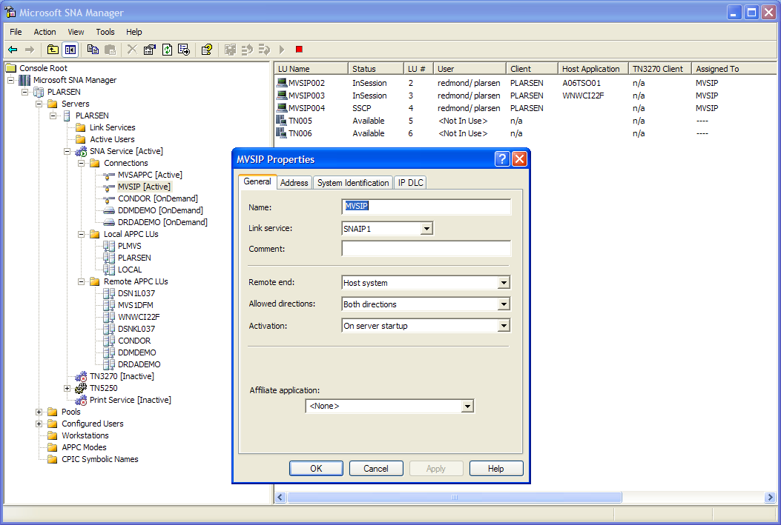
Figure 3 Host Integration Server 2004 offers an MMC-based snap-in for administering server configurations.
Host Integration Server 2004 allows dynamic configuration of connections and resources with no impact on other services running on the Windows computer. Host links are Windows services and can be added without restarting Windows. Other elements of the configuration can be added on the fly without requiring you to restart the core SNA services, including assigning 3270 LUs to users or groups.
SNA manager offers easy-to-use wizards for completing popular configurations, such as 3720 emulation, AS/400 connections, and host security. Simple dialog boxes walk the administrator through the steps necessary to configure these popular features. The dialog boxes help the user to map parameters from the VTAM gen or AS/400 configuration to settings within Host Integration Server 2004. Regardless of whether the administrator has a LAN background or has experience working with host systems, Host Integration Server 2004 is designed to make it easy to configure the PC-to-host connectivity. Automatic configuring of several host parameters also saves time and reduces configuration errors.
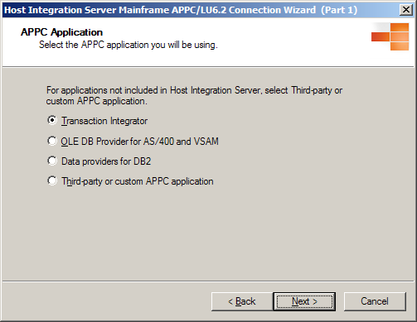
Figure 4 SNA Manager provides helpful wizards to aid the administrator with popular configurations, such as that required for APPC applications.
In addition to the graphical tools provided by SNA Manager, Host Integration Server 2004 provides two command-line utilities, LinkCfg and SNACFG. You can use these command-line interfaces to easily modify a basic offline configuration file without starting the graphical interface, or to store configuration commands in a command file, so that they can be carried out easily in the future. You can also use the SNACFG command-line interface to print out a text version of your configuration.
As an alternative to the GUI-based MMC, Host Integration Server 2004 also comes with command-line utilities that can be used to manage any Host Integration Server 2004 resource. The Windows Scripting Host is a powerful scripting language that is available standard with Windows 2000 Server and Windows Server 2003. The addition of this tool to the Host Integration Server 2004 command-line utilities enables the administrator to create and modify any Host Integration Server 2004 resource from a batch script. Using a combination of the Windows Scripting host and the SNACFG command-line utility, any Host Integration Server 2004 management task can be automated and performed without resorting to the GUI.
Host Integration Server 2004 also supports administration using Microsoft WMI technology. WMI is an automation interface that supports several programming models, including Visual C++, Visual C#, Visual Basic, Visual Basic .NET, ASP and ASP.NET.
Microsoft Host Integration Server 2004 provides enhanced management capabilities for SNA administrators to view and control their Host Integration Server 2004 environment. Using WMI, administrators can build their own tools to monitor, configure, and administer all SNA objects.
In addition to integrating with Windows Server 2003 and Windows 2000 Server management tools, Host Integration Server 2004 also integrates with popular mainframe-based network management tools such as IBM NetView. Windows Server 2003 and Windows 2000 Event Log Alerts can be forwarded up to a mainframe NetView system using the NVAlert component. A NetView operator can also run Host Integration Server 2004 commands using the NVRunCmd command provided by Host Integration Server 2004. In addition, the NetView Response Time Monitor (RTM) can be used to capture information on client response time and forward the data back to NetView.

Application Integration
Host Integration Server 2004 is designed to help build Web services that can be used within a Service-Oriented Architecture (SOA). SOA is an architectural style that promotes simplicity, extensibility, and reuse through the building of loosely coupled applications. SOA redefines an application from a hidden opaque procedure to an orchestrated sequence of events that separates a service’s data from its processes. SOA does not remove an application’s dependencies but it does reduce them. It enables customers to achieve a faster time to value.
Enterprise developers and architects want to move toward an SOA using the .NET Framework, but need to take advantage of existing investments in line-of-business applications running on IBM mainframe and midrange systems. Host Integration Server 2004 Transaction Integrator (TI) (formerly COMTI) allows Windows developers to publish and extend business rules in host mainframe (CICS and IMS) and midrange (AS/400) programs using Visual Studio .NET. Using TI, enterprise developers can efficiently publish XML Web services without knowing SNA networking.
TI is a set of technologies, composed of a development tool, administration tool and runtime components that provide a platform for integrating and extending host applications using Microsoft Visual Studio .NET 2003 and the .NET Framework.

Development Projects
The development experience begins within Visual Studio .NET, where the developer adds a Host Integration Server Project to a Visual Studio solution. Within the Host Integration Server Project, the developer defines a COM or .NET representation of the remote host server program.
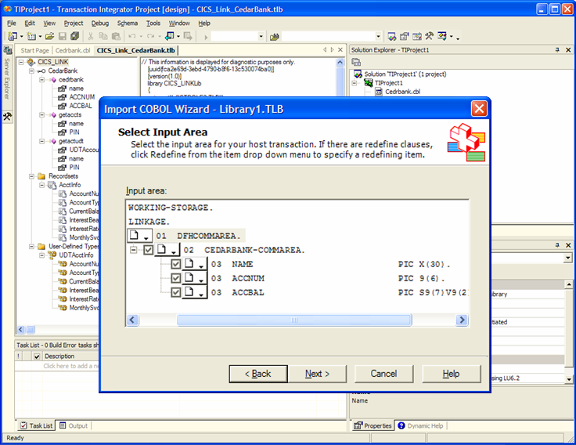
Figure 5 TI Project system within a Visual Studio .NET 2003 solution
Optionally, the developer can create this Windows .NET or COM definition of the host application by using a Host Integration Server COBOL or RPG Import Wizard. When defined, the developer persists the .NET or COM representation of the host program in a .NET assembly or COM+ type library. The next step is to publish this assembly or type library to a runtime context, such as an ASP.NET application or COM+ package using the TI administration tools.

Administration
The new TI Manager tool combines TI Windows-Initiated Processing (WIP) and Host-Initiated Processing (HIP) MMC snap-ins into one view allowing administrators to efficiently define and manage WIP and HIP component applications.
Administrators use the new TI Manager, which combines TI WIP and HIP MMC snap-ins into one view, allowing administrators to efficiently define and manage WIP and HIP component applications.
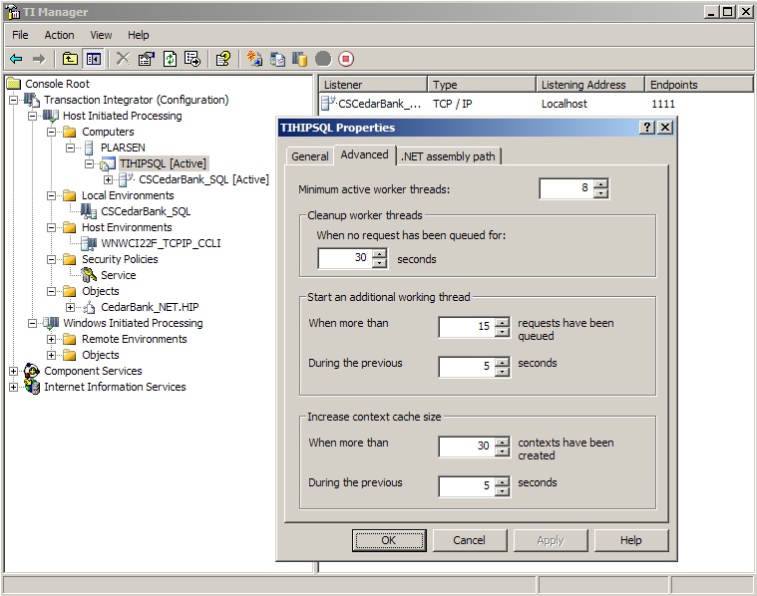
Figure 6 TI Manager snap-in within a Microsoft Management Console window

Mainframe Programs
Transaction Integrator supports popular IBM host programming models for the following transaction environments:
- IBM CICS for MVS V3R3 or later to support an SNA LU6.2 network connection
- IBM CICS Transaction Server for VSE/ESA V2R1 or later to support an SNA LU6.2 network connection
- IBM CICS Transaction Server for OS/390 Version 1 or later to support an SNA LU6.2 or TCP/IP network connection
- IBM CICS Transaction Server for z/OS Version 2 or later to support an SNA LU6.2 or TCP/IP network connection
- IBM CICS Transaction Server for z/OS Version 2 Release 2 or later to support an Enhanced Listener for TCP/IP network connection
- IBM IMS Version 4 to support an SNA LU6.2 network connection
- IBM IMS Version 5 to support an SNA LU6.2 network connection
- IBM IMS Version 6 or later to support reliable 2PC transactions across an SNA LU6.2 network connection
- IBM IMS Version 6 to support an SNA LU6.2 or TCP/IP network connection
- IBM IMS Version 7 to support an SNA LU6.2 or TCP/IP network connection
- IBM IMS Version 8 to support an SNA LU6.2 or TCP/IP network connection

AS/400 Programs
In Host Integration Server 2004, TI has been extended to offer support for AS/400 applications, as well as mainframe CICS and IMS applications, when integrated across a TCP/IP network connection.
Transaction Integrator uses the familiar distributed remote program call (RPC) method to access RPG programs running under IBM OS/400 Version 4 Release 1 or later across a TCP/IP network connection.
Using the new support for AS/400 programs, Windows developers can from within a TI Project import or export RPG source code.
Figure 7 Transaction Integrator publishing an XML Web service to a line-of-business AS/400 RPG program

Programming Model Improvements
TI WIP includes other new features providing the developer with greater flexibility, including the new Client Context that provides an alternative to Explicit Call Back Security, while offering a new option for overriding default values (Remote Environment, Program Name, and Transaction Name). Also, TI WIP offers new programming models, to better match the requirements of today’s CICS and IMS transaction environments:
- Control of the TCP/IP CICS Transaction Request Message (TRM) for interoperability with CICS using TCP/IP Custom TRMs
- WIP support for CICS Enhanced Listener through the Enhanced Listener Message (ELM) programming model
- WIP Persistent Connections across an SNA or TCP/IP network
- TI allows the developer to use Enterprise Single Sign-On for both Windows-Initiated Processing and Host-Initiated Processing scenarios.

Host-Initiated Processing
Transaction Integrator HIP is an innovative new technology that allows a Windows Server computer to function as a peer to IBM mainframe and AS/400 computers. For example, CICS programmers can call into Windows COM+ or .NET server components, just as if they were another CICS transaction program by using familiar programming models such as CICS distributed program link (DPL).
Figure 8 Mainframe CICS COBOL transaction program updating a Microsoft SQL Server database on Windows Server 2003 using Host-Initiated Processing
HIP enables developers to produce asynchronous solutions without using middleware such as MQSeries. For example, many batch processes must return a response to the requester in the form of bulk output such as a finished report. Using TI WIP, Windows clients can request a report that is returned from the host server through HIP later.
Also, HIP allows enterprises to more effectively move portions of their application logic or data onto the more cost-effective Windows Server and SQL Server platforms, while ensuring logical bidirectional application communication.

Data Integration
Host Integration Server 2004 provides access to both structured and nonstructured data stored on IBM mainframe or AS/400 computers. This data can be stored in a database or file system. In addition to data access, the Data Integration layer is also responsible for providing data transfer services between Windows desktop computers and host systems. The Data Integration layer consists of components that make use of existing mainframe and AS/400 software.
The Data Integration layer can be broken down further into the following categories:
- Relational database access
- Record file access
- File transfer
- AS/400 data queue access
All these services make use of IBM host-based products that implement the IBM Distributed Data Management Architecture (DDM). DDM is a framework or methodology for sharing and accessing data between systems. DDM defines the “how to communicate” and leaves it up to individual platform vendors to implement the DDM architecture. IBM currently supports DDM for most IBM platforms, including OS/390 (MVS), AS/400, RS/6000 (AIX) and AS/36. By supporting DDM, application developers are freed from having to write complex communications interfaces for each platform they need to support. Instead, DDM handles this complexity on behalf of the application.
Host Integration Server 2004 offers relational database access by using the Distributed Relational Data Architecture (DRDA) subset of DDM, nonrelational access using the Record Level I/O (RLIO) implementation of DDM, while file transfer and AS/400 data queue access employ a subset of the RLIO protocol.
Figure 9 Microsoft Data Access Architectures and HIS 2004 Data Providers

ADO.NET and .NET Framework
ADO.NET is the strategic application-level interface for providing data access services in the Microsoft .NET platform. You can use ADO.NET to access data sources using the new .NET Framework data providers. In Microsoft Host Integration Server 2004, Microsoft offers a new Microsoft Managed Provider for DB2.
ADO.NET is designed specifically for message-based Web applications while still providing preferable functionality for other application architectures. By supporting loosely coupled access to data, ADO.NET maximizes data sharing by reducing the number of active connections to the database—reducing the possibility of multiple users contending for limited resources on the database server.
ADO.NET provides several ways to access data. If your Web application or XML Web service requires data access from multiple sources, needs to interoperate with other applications (both local and remote), or can benefit from persisting and transmitting cached results, the dataset is an excellent choice. As an alternative, ADO.NET provides data commands and data readers to communicate directly with the data source. Direct database operations using data commands and data readers include running queries and stored procedures, creating database objects, and performing direct updates and deletes using DDL commands.
ADO.NET maximizes data sharing by supporting an XML-based persistence and transmission format for the fundamental object of distributed ADO.NET applications: the dataset. A dataset is a relational data structure that can be read from, written to, or serialized using XML. ADO.NET datasets make it easy to build applications that require loosely coupled data interchange between application tiers and multiple Web sites.
Because datasets are remote as XML, any two components can share data and use XML schemas to define the relational structure of the dataset. And, because the dataset's serialization format is XML, data set objects can easily pass through firewalls without restrictions. In addition to loading data from XML, datasets can be populated with, and hold changes to, data from Microsoft SQL Server, IBM DB2, and other data sources exposed through OLE DB.

Relational Database Access
Much of the operational data stored on mainframe and midrange host computers is accessed through a relational database management system. The most popular database on these host systems is IBM DB2. In the case of the AS/400, DB2 is integrated with the operating system. For mainframe computers, it is common for organizations to deploy multiple instances of IBM DB2.
What these host systems have in common is that data stored in these databases are accessible as relational tables using Structured Query Language (SQL). This allows for efficient and standardized access to the data on the local DB2 system. However, for many years, there was no common means of accessing data across systems on remote DB2 computers. To resolve this problem, IBM devised DRDA and has passed the architecture to The Open Group LLC for publication and future extension.
DRDA offers both Remote Unit of Work (RUW) and Distributed Unit of Work (DUW) access to host data. RUW is used for read-only and simple updating of database tables using SQL statements and stored procedures. DUW is used when updates span multiple DB2 instances or computer systems and supports the two-phase commit (2PC) protocol. The 2PC protocol ensures that changes to multiple databases will either succeed or fail in their entirety. We will talk more about 2PC and transaction management in the section on the Application Layer later in this reviewers guide.

Data Providers for DB2
Host Integration Server 2004 implements access to DB2 through three features:
- Microsoft Managed Provider for DB2
- Microsoft OLE DB Provider for DB2
- Microsoft ODBC Driver for DB2
Host Integration Server 2004 offers a new DB2 network protocol client or DRDA Application Requestor (AR) over which the ODBC, OLE DB, and Managed Provider communicate to the remote DB2 database server. The DRDA AR connects the Microsoft data providers for DB2 to these IBM DB2 databases:
- IBM DB2 V6 and later for OS/390 and z/OS to support an SNA LU6.2 or TCP/IP network connection
- IBM DB2 for OS/400 V5R1 and later to support an SNA LU6.2 or TCP/IP network connection
- IBM DB2 for Universal Database V7.1 and later for Windows and AIX operating systems to support a TCP/IP network connection
The new Microsoft Managed Provider for DB2 is efficiently implemented to run on top of the new Microsoft designed and developed network protocol client for DB2 (DRDA AR).
Figure 10 Microsoft Managed Provider for DB2 publishing an XML Web service to an IBM mainframe DB2 database
The OLE DB Provider for DB2 is also implemented to sit on top of the DRDA AR, and therefore supports the same target DB2 systems and substantially the same DB2 access features (for example, dynamic SQL and stored procedures, 2PC, SNA LU6.2 and TCP/IP network connectivity). Developers can use Visual C or Visual C++ to integrate DB2 data with Web-based and Windows-based applications. Visual Basic and Web developers (using scripting languages such Visual Basic Script) can use the higher-level ActiveX Data Objects (ADO) to develop e-commerce solutions. In addition, DB2 is directly accessible from productivity applications, such as Microsoft Office 2003 using Visual Basic for Applications (VBA) and ADO from within Excel.
The Microsoft ODBC Driver for DB2 provides a flexible way for developers using the ODBC API to create applications that can access DB2 records quickly and efficiently. The driver supports the DRDA Level 3 standard and ODBC 3.x interfaces, and allows application programmers to write Visual C and Visual C++ applications that issue dynamic SQL queries and call DB2 stored procedures.
Based on the new Host Integration Server 2004 DRDA AR network client for DB2, the DB2 data providers offer the following new capabilities:
- DB2 Distributed Transactions (two-phase commit) over TCP/IP
- DB2OLEDB support for multiple result sets on calls to DB2-stored procedures
- Additional DB2 configuration properties such as DBMS Platform (optimize data conversion across platforms), Default Qualifier (simplify SQL syntax), and Quoted Prefix (ensure better support for generic consumers such as SQL Server)
- Support for single sign-on
- Support for DB2/400 long, mixed-case and special character passwords
- APPC AP_SAME and AP_PGM support for already verified DB2 authentication across SNA LU6.2 network connections
- Connection pooling for use with DB2 data providers that is compatible with 2PC DUW scenarios

SQL Server
Many organizations want to improve corporate decision making by centralizing data that is stored in a variety of formats in different places. Database administrators can use Data Transformation Services (DTS), a feature of Microsoft SQL Server 2000 and Microsoft SQL Server 7, to import and export data between multiple heterogeneous sources using the OLE DB Provider for DB2. Using this tool, administrators can create a data warehouse using DB2 data, and integrate most other data sources accessible through an OLE DB provider.
The Distributed Query Processor (DQP), another feature of Microsoft SQL Server, allows users to access data that resides on multiple, distributed databases across multiple servers. Using DQP, SQL Server administrators and developers can create linked server queries that run against multiple back-end data sources with little or no modification. DQP enables application developers to create heterogeneous queries that join tables in SQL Server with tables in DB2. Also, DQP can be used to create SQL Server views over DB2 tables so that developers can write directly to SQL Server and integrate both Windows-based and host-based data in their applications with ease.
Figure 11 BizTalk Server 2004 orchestration of an insurance claims solution, based on an IBM DB2 database, using the Managed Provider for DB2
Globalization is a focus of the HIS 2004 release, including the following enhancements to the data providers for DB2.
- UNICODE, Double-Byte and Mixed-Byte character set support when accessing DB2
- Support for Arabic Bi-Directional Layout Conversion in data providers
- DB2 data provider support for Simplified Chinese GB18030 code page conversions.
- DB2 data provider support for Extended UNIX Code pages for use in Japanese, Korean and Simplified Chinese locales.

Administration
Host Integration Server 2004 offers a new central Data Access Tool for creating and managing connection definitions to DB2 and host file systems and an improved tool for defining the Host Column Descriptions used to access host data sets. Included in this new tool is a DB2 Connect import wizard to define data source definitions for use with Microsoft DB2 data providers.
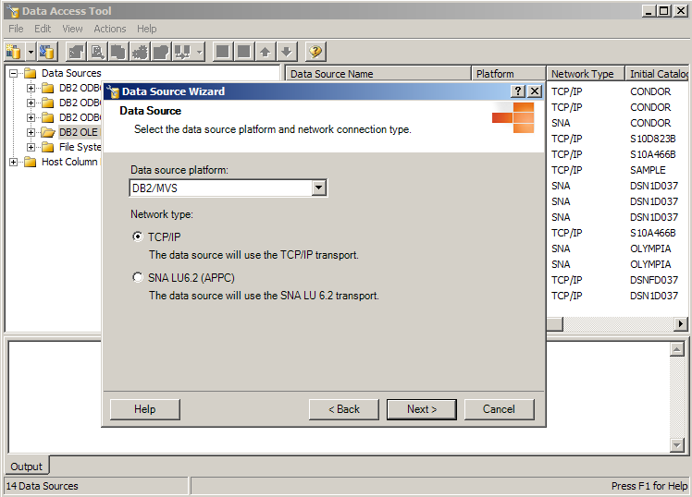
Figure 12 HIS 2004 Data Access Tool

Host Record File Access
Another rich source of legacy information is the large amount of data stored in mainframe VSAM files, Partitioned Datasets and AS/400 files. Host Integration Server 2004 supports the following services for access to nonrelational host data:
- The OLE DB Provider for AS/400 and VSAM
- Relying on the Microsoft designed and developed DDM client, the OLE DB Provider for AS/400 and VSAM can access these host file systems.
- IBM Distributed File Manager (DFM) V1R2 and later to support an SNA LU6.2 network connection (DFM is a component of IBM Data Facility Storage Management Subsystem (DFSMS) for MVS, OS/390 and z/OS)
- IBM OS/400 V5R1 and later to support an SNA LU6.2 or TCP/IP network connection
- IBM AS/400 Advanced 36 SSP (System Support Program) Release 7.5 to support an SNA LU6.2 network connection
Figure 13 Microsoft OLE DB Provider for AS/400 and VSAM publishing an XML Web Service to an IBM mainframe host file system

Host Column Description Files
The OLE DB Provider for AS/400 supports record level access to keyed and nonkeyed physical files with external record descriptions, as well as logical files with external record descriptions. Also, the provider can use an optional Host Column Description (HCD) file to describe the format of the target file, mapping the AS/400 data types to OLE DB data types, allowing the developer to access AS/400 flat data files and source files.
The OLE DB Provider for Virtual Storage Access Method (VSAM), which relies on the HCD files to define the metadata of the target data set or member, provides access to most types of mainframe-based VSAM files.
- Sequential Access Method (SAM) data sets (BSAM and QSAM)
- VSAM data sets (ESDS, KSDS, RRDS, VRRDS, Alternate Indexes to ESDS and KSDS)
- Basic Partitioned Access Method data sets (PDS and PDSE members)
Using Visual Studio, developers can build dynamic Web applications that integrate host nonrelational data sources with Windows data, allowing knowledge workers to publish needed information for use by their organization’s decision-makers.

SQL Server
The Microsoft OLE DB Provider for AS/400 and VSAM in Host Integration Server 2004 has also been improved to provide support for read/write of AS/36 files, support for composite key indexes, and access to VSAM data sets from SQL Server DTS.

Host File Transfer
The Host File Transfer ActiveX Control lets developers move files between a host system and a local Windows-based computer. Host Integration Server 2004 provides this service through a single ActiveX Control. This extends the capability of the client application to perform file transfer operations from a large number of client development environments. Using HCD files, the Host File Transfer can access the same mainframe data set types as the OLE DB Provider for VSAM, yet it is optimized to download or upload the entire contents of the data set or member.
Based on an integrated Microsoft DDM client, the Host File Transfer feature can access these host file systems:
- IBM DFM V1R2 and later to support an SNA LU6.2 network connection (DFM is a component of IBM DFSMS for MVS, OS/390 and z/OS)
- IBM OS/400 V5R1 and later to support an SNA LU6.2 or TCP/IP network connection

AS/400 Data Queue Access
AS/400 Data Queues are used on an AS/400 series computer to send data records between separately executing programs. Multiple AS/400 client programs can send data records to a single server program running on an AS/400 series computer. Alternatively, a single client program can send records to an AS/400 Data Queue, and multiple server programs can extract the records and process the data in parallel. This feature proved so useful in developing AS/400 applications that IBM extended the use of AS/400 Data Queues to computer workstations. Host Integration Server 2004 enables Windows 32-bit applications to access data queues through the AS/400 Data Queue COM Automation Control. Host Integration Server 2004 lets developers access AS/400 data queues from a computer running Windows, so they can move part or all of their AS/400 applications from an AS/400 computer to a personal computer platform and still use the PC-based program to access a remote data queue on the AS/400.
The ActiveX control uses a built-in DDM client that supports extensions to the record-level input/output protocol to access IBM OS/400 V5R1 and later to support an SNA LU6.2 network connection.

Messaging Integration
MSMQ technology enables applications running at different times to communicate across heterogeneous networks and systems that may be temporarily offline. Applications send messages to queues and read messages from queues. MSMQ provides guaranteed message delivery, efficient routing, security, and priority-based messaging. It can be used to implement solutions for both asynchronous and synchronous messaging scenarios.
Some enterprise organizations use IBM WebSphere/MQ (MQSeries) for cross-platform messaging. However, given the developer efficiencies and operating system support for MSMQ on Windows Server 2003, many enterprise developers seek to use MSMQ on Windows while utilizing MQSeries on non-Windows platforms. This creates a requirement for an efficient, easy-to-implement and administer “bridge.”
Microsoft Host Integration Server 2004 offers an MSMQ-to-MQSeries Bridge to satisfy this customer requirement.
Figure 14 Sending messages to MQSeries using the HIS 2004 Bridge

Sending Messages to MQSeries
To send a message from MSMQ to MQSeries, you must define an MSMQ foreign computer representing the MQSeries Queue Manager, and the MQSeries destination queue must already exist.
The messaging process works like this:
- An MSMQ application issues an MSMQ MQCreateQueue() API call to create a foreign queue, located on the foreign computer and representing the MQSeries destination queue. Alternatively, you can create the foreign queue using MSMQ, and in Windows 2000 the foreign queue is a part of Managing Users and Computers.
- The application calls MQOpenQueue() to open the foreign queue.
- The application calls MQSendMessage() to send a message to the foreign queue. MSMQ routes the message and stores it temporarily on an MSMQ connector queue.
- The MSMQ-MQSeries Bridge takes the message from the connector queue and converts the message properties to the MQSeries message structure. MSMQ-MQSeries Bridge routes the message to the MQSeries destination queue.
- An MQSeries application issues an MQSeries MQGET() API call to receive the message from the MQSeries queue.
Figure 15 Receiving messages from MQSeries using the HIS 2004 Bridge

Receiving Messages from MQSeries
The path for sending a message from MQSeries to MSMQ is basically the inverse of MSMQ to MQSeries, with a few differences. You must define appropriate MQSeries aliases, transmission queues and channels for the MSMQ destination queue and/or the MSMQ Server, and the MSMQ destination queue must already exist.
The messaging process works like this:
- An MQSeries application issues an MQOPEN() API call for a remote queue representing the MSMQ destination queue.
- The MQSeries application calls MQPUT() to send a message to the remote queue. MQSeries transmits the message and stores it temporarily on an MQSeries transmission queue located at the MQSeries Queue Manager.
- The MSMQ-MQSeries Bridge takes the message from the transmission queue and converts the message structure to MSMQ message properties. MSMQ-MQSeries Bridge transmits the message to the MSMQ destination queue.
- An MSMQ application issues an MSMQ MQReceiveMessage() API call to receive the message from the MSMQ queue.

Security Integration
A key problem within many enterprise organizations is cross-platform security system integration and management. Typically, mainframe and/or AS/400 applications may also have their own user account and password. After a while users begin to forget theses multiple passwords and begin to write them down and keep them in an insecure place. This defeats the purpose of having passwords. If a user community mishandles IBM mainframe or midrange logon credentials, this situation could compromise vital enterprise computing resources.
The industry-proposed solution is for IT to pursue a Federated Identity Management (IdM) strategy. One component of such a strategy is account mapping for purposes of providing end users and application developers with Single Sign-On (SSO).
An extended implementation of Windows Authentication in Host Integration Server 2004 called Enterprise Single Sign-On (EntSSO) offers administrators the means to efficiently map accounts across Windows Active Directory and IBM systems or applications. This includes 1-to-1 and group-to-1 associations. Based on a secure ticketing mechanism, Host Integration Server 2004 integration components can call EntSSO services to obtain foreign credentials.

Single Sign-On
Host Integration Server 2004 seamlessly integrates Windows-based applications with IBM Mainframe and midrange (AS/400) systems and applications. Host Integration Server 2004 components integrate with SSO services providing end users with a single sign-on experience when accessing non-Windows-based applications on mainframes and AS/400 systems. Similarly, BizTalk Server backend adapters such as SAP, PeopleSoft, Siebel, UNIX, and other adapters are integrated with these SSO services to provide end users with an SSO experience. Front-end BizTalk adapters such as HTTP and SOAP (Web services) adapters of BizTalk Server integrate with SSO to make this possible. Single Sign-On through Enterprise SSO is further available for end users accessing Web parts in SharePoint Portal Server for scenarios where it is integrated with BizTalk Server 2004 through the Web services adapter. This allows portal users to access non-Windows-based applications without being prompted to provide non-Windows credentials, thus enabling an end-to-end EAI solution to the end user with single sign-on. After end users are authenticated in the Windows domain, they do not have to provide further credentials to access disparate backend applications.

IBM Host Systems
Components of Enterprise Single Sign-On work with these host security systems:
- IBM RACF (Resource Access Control Facility) for z/OS, OS/390 and MVS
- Computer Associates eTrust CA-ACF2 Security for z/OS and OS/390
- Computer Associates eTrust CA-Top Secret Security for z/OS and OS/390
- IBM OS/400 V4R2 or later
The password synchronization requires third-party software from Proginet Corp.
EntSSO helps you move toward a Federated Identity Management while improving security of access to host assets. EntSSO helps ensure host credentials are stored securely on the Windows platform, while helping reduce complexity and costs in managing an enterprise security system.

End-to-End Security Enhancements
SSO Services provide a set of security services to store and pass encrypted user credentials across local and network boundaries. The credentials are always stored encrypted in the credential data store. Because the SSO services provide a generic solution, middleware applications and custom adapters do not have to invent their own mechanisms to store credentials securely. End users do not have to remember multiple set of credentials. Instead of using a single account to logon to a backend system, middleware applications can now connect to the backend applications as the individual user who initiated the original request. All access to the credential data store through the SSO services requires the appropriate authority that is defined in the SSO system.
Figure 16 Enterprise Single Sign-On provides the foundations for a Federated Identity Management solution when used with BizTalk Server 2004 and Host Integration Server 2004.

Flexible Administration Model
The administration model relies on Windows group accounts defined in the SSO System. The first and foremost operation concerning administration is to represent the backend platform/application/business within the SSO system. This is referred to as an “affiliate application.” An affiliate application could represent a mainframe or UNIX system as a whole. It could represent SAP running on UNIX, or it could be more granular and can represent a business such as “Pay stub” or “Benefits” on SAP. One or more administrators can be given access to manage just one application alone without having access to any other applications. Each affiliate application has multiple user mappings, for example, users in Active Directory are mapped to their corresponding RACF credentials. Also available are capabilities such as enabling and disabling the entire SSO System, or an Affiliate Application, or, even an individual user mapping.

Auditing
Auditing is critical in a secure environment to track all information. All operations performed on the credential database are audited by the SSO Services. This is accomplished by using event logs and creating audit logs in the database itself. Administrators can set the positive and negative audit level in the SSO System that suits their corporate policies.

Distributed Environment
The SSO Services layer represented in the preceding diagram consists of one or more computers working with a centralized SQL Server database. All changes and updates are made in the centralized database by administration components of SSO. All SSO Servers pick these changes from the centralized database. One SSO Server could be located in Tokyo while the other could be located in Chicago. Because SQL Server is being used, capabilities of SQL Server such as failover clustering and database backup can be leveraged.

Extensibility
SSO Services provide an extensible object model to enable integration of BizTalk Server Adapters with SSO. This allows BizTalk Server ISVs to integrate their adapters with the SSO Services, thereby extending the solution to hundreds of backend applications. Further custom applications can be integrated with these SSO services to achieve single sign-on.

Password Synchronization
Another component of a prudent IdM is password management. EntSSO provides the base infrastructure that, along with third-party software products, provides for a more secure password management solution. This includes both Windows Initiated and Host Initiated password synchronization. Combined with SSO, password synchronization can help enterprise IT move toward Federated Identity Management.
In Host Integration Server 2004, Enterprise SSO has been extended to support one-way and two-way password synchronization. Because the SSO credential database contains user mappings that map Windows Domain\userid to non-Windows userid and non-Windows password, password synchronization allows SSO services to keep the non-Windows password in the credential database synchronized when a user or administrator changes the password. The administrator has three options to configure password sync:
- Non-Windows to Windows Full Password sync. Same password for user on Active Directory and non-Windows system
- Non-Windows to Windows Partial Password sync. Different password for user on Active Directory and non-Windows system
- Windows to non-Windows Full Password sync. Same password for user on Active Directory and non-Windows system
Enterprise SSO provides Password Sync APIs to allow Password Sync adapter vendors to develop password sync adapters that integrate with SSO Services. These password sync adapters can capture user passwords from non-Windows systems and pass them onto the SSO Services, or can receive password changes from SSO Services to make the password change in the user directory on the non-Windows system, or perform both operations.

Host-Initiated SSO
In Host Integration Server 2004, Enterprise SSO has been extended to support host-initiated SSO in addition to the Windows-initiated SSO provided in previous versions. Host-initiated SSO is the opposite of Windows-initiated SSO meaning the end user initiates the request from a non-Windows system (for example, a CICS application on a mainframe) to access a Windows resource (for example, SQL database). Non-Windows users will need to use their corresponding Active Directory account to access Windows resources because Windows resources can be accessed only by Windows-authenticated users. Host Integration Server 2004 enables the SSO request to be initiated from either direction.

Configuration Store
The Enterprise Single Sign-On services can be taken advantage of to store additional information that must be treated securely while making it readily available in a distributed system. For example, BizTalk Server 2004 uses Enterprise Single Sign-On services to store custom configuration information of the adapters. In Host Integration Server 2004, password synchronization adapters developed by third parties store their configuration information in the SSO credential database by using this feature of Enterprise SSO.

Installation and Configuration
The Host Integration Server 2004 product is designed to make it extremely easy to install, configure, manage, and use both the server and client components. This benefit may significantly reduce training and support costs. Host Integration Server 2004 uses the latest in graphical user interface design and usability testing to make the administration tasks as easy as possible.

Server Installation
The Host Integration Server 2004 "server installation” allows the administrator to specify the components that need to be installed and the role the server will play, such as a primary or backup configuration server. The server installation can be performed through several methods:
- Local file system folder
- Network share point
- Unattended installation
- Systems Management Server
The default method for installing Host Integration Server 2004 is from a local file system folder. This type of installation is run on the server, and the installer must respond to all prompts.

Microsoft Windows Installer
The Host Integration Server 2004 setup is based on the Microsoft Windows Installer (MSI) technology and offers the user a familiar Windows graphical setup program that walks the user through the necessary steps to install the product and configure the core services. The Host Integration Server 2004 setup program has been redesigned to provide a user interface similar to other Microsoft business process and integration applications, such as BizTalk Server 2004. The Host Integration Server 2004 setup program installs on top of SNA Server 4.0 and Host Integration Server 2000, automatically upgrading those versions to Host Integration Server 2004.
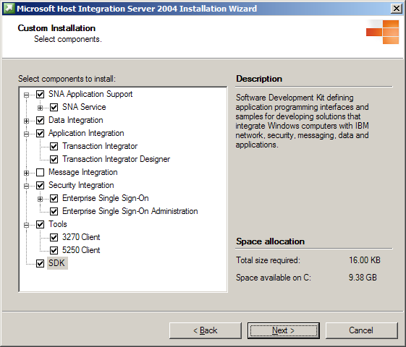
Figure 17 Host Integration Server 2004 offers a Microsoft Windows Installer setup program that allows the administrator to choose the most appropriate features.
Alternatively, the installation files can be located on a network share point. The installer must still answer all the questions during the installation process.
Host Integration Server 2004 also supports an unattended install process. This process uses answer files that remove the need for the installer to be present during the complete installation. Installers still need to be there to start the process, however. This type of install must be done from a network share point or disks because it requires that the installation files be customized. After the process is started, the installer can leave.
With Systems Management Server, the administrator does not have to go to the server to start installation of Host Integration Server 2004. Systems Management Server can be used to push the server installation and configuration to a target server.

Server Configuration
After the server is installed, it must be configured. The configuration process is used to define all the link services, connection types, LUs, and LU pools. It is also used to define users groups and client workstations and allocate resources to them. Resources can be allocated globally to everyone or specifically down to a particular user, group, or even a single workstation. Resource access can also be granted at different levels of granularity such as to a subdomain, a specific server, LU pools, or specific LUs.
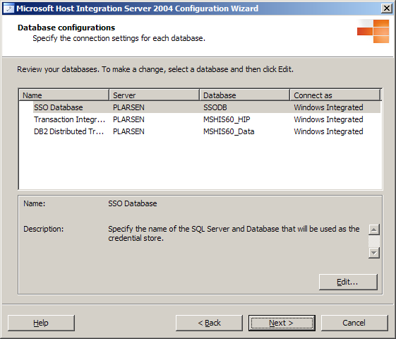
Figure 18 Host Integration Server 2004 Configuration Wizard.

Client Installation
There are three parts to each Host Integration Server 2004 client—not all of which need to be installed. The three parts include the Base client, API support, and features such as the OLE DB providers and 3270 and 5250 clients. Most third-party emulators require only the installation of the Base client.
When installing Host Integration Server 2004 client, the installer can specify the components that need to be installed, select the client/server protocols that the client uses to communicate with the server, and define how the client will locate a server in the network. The methods used to install a client are similar to the ones used to install a server:
- Local file system folder
- Network share point
- Unattended installation
- Systems Management Server
The first two methods are essentially the same. Just as in the case of the Host Integration Server 2004 “server installation,” an answer file can be used to simplify the installation process.

Client Configuration
After the client is installed, it must be configured. This configuration is normally limited to specifying how the client will locate a sponsor server when it connects. Options are to have the client broadcast a request for a sponsor to the entire subdomain, or to direct its request to a specific server or list of servers.
The security mechanism for this access control is based on Windows Server 2003 and Windows 2000 security technologies. User and Groups can be defined and Access Control Lists created for Host Integration Server 2004 resources that will allow or deny these users, groups, or computer systems access.

Supportability
An SNA gateway allows efficient network administration by simplifying configuration, management, and monitoring of desktops, gateways, and host connections. Administration of desktops, gateways, and host links should be possible both locally, from the gateway, and remotely, from any LAN workstation or the host. An effective SNA gateway should also offer administration capabilities that are integrated with the underlying operating system.

Diagnostics
The Microsoft Host Integration Server 2004 Diagnostics tool has been improved to allow the administrator to test and troubleshoot SNA connections and resources from a central location.
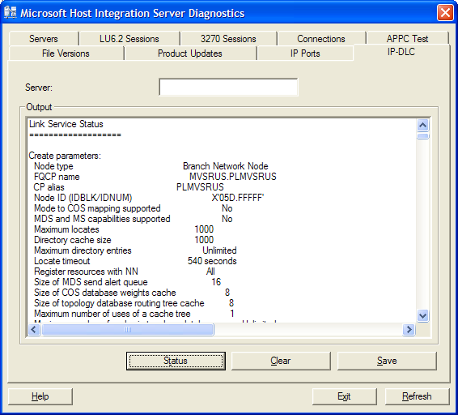
Figure 19 SNA Manager diagnostics tool for testing and troubleshooting network resources

SNA Traces
For extensive troubleshooting capability, Host Integration Server 2004 provides a single Windows-based graphical program for all server tracing needs. The Host Integration Server 2004 trace utility is accessible from the Host Integration Server 2004 computer, or it can be run remotely over all supported LAN protocols.
SNA Trace allows the administrator to quickly collect information about the sequence of events leading up to a problem, and the exact state of the system when the error occurred. It allows you to track the activities of APIs including calls made to an API, communication links, and activity within Host Integration Server 2004. Information collected with SNA Trace can be essential for assisting a Microsoft Product Support Services engineer to solve complex problems. SNA Trace stores a history of the activity you select in trace files. With Host Integration Server 2004, there is no need to stop the server to obtain detailed tracing information with SNA Trace. This allows for uninterrupted use of Host Integration Server 2004 while troubleshooting problems.
In Host Integration Server 2004, the SNA Trace utility has been improved to support Windows events. Optionally, SNA Trace will monitor the Windows Event Log for a specific event ID, at which time SNA Trace stop tracing. This greatly increases the likelihood that you will capture but not overwrite valuable trace data.
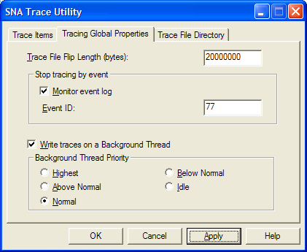
Figure 20 SNA Trace provides the means to monitor key components
This trace information can help LAN administrators improve performance and solve configuration problems. For example, it allows administrators to get the equivalent of a data scope trace of activity on a link that fails to start. Trace reading is possible using the provided SNA Trace Viewer application.

Server Error and Audit Logging
With SNA Manager, you can control the server to which events are logged, set the level of detail to be recorded, and specify which system will receive all pop-up error messages. You can use information from Windows Server 2003 event logs as you test a configuration or diagnose problems. For example, Event Viewer can help you find out about device drivers that did not initialize and reasons for host connection failures, or details of negative responses and sense codes. Event logs are viewed with the Windows Event Viewer.

Windows Utilities
Host Integration Server 2004 takes advantage of utilities that are provided with Windows Server 2003, such as the Windows Command Line facility, User Manager, Event Viewer, Task Manager, Performance Monitor, and Control Panel.
Windows Utility | Description and Benefits
Command Line | The administrator can use simple and familiar Windows command line operations.  Host Integration Server 2004 services can be started and stopped using Windows NET commands.  NetView operators can control remote Host Integration Server 2004 computers from a host NetView console using the NetView NVRunCmd facility.
User Manager | All user and group accounts are managed with the User Manager. The accounts established through the User Manager are also used by Host Integration Server 2004. You need to create an account only once for use by Windows Server 2003 or Host Integration Server 2004.  SNA Manager exposes the common Users and Groups dialog box through which you can specify the users and groups defined in a Windows domain.
Task Manager | Task Manager gives you a simple, quick view of how each application, application component or system process is using CPU and memory resources, as well as a summary of overall CPU and memory usage.  Task Manager allows you to quickly terminate applications and processes that are not responding, thereby improving system performance. Resource usage for specific components and application processes can be viewed in charts and reports.
Event Viewer | All Host Integration Server 2004 events can be sent directly to the central applications log file maintained by the Windows Server 2003 Event Viewer. Multiple Host Integration Server 2004 computers can send their data to a central Windows Server 2003 computer for single-point collection and monitoring.  Host Integration Server 2004 and any Windows events can be forwarded to IBM NetView for viewing by the remote IBM NetView console operator. Using the NetView RunCmd facility, the NetView operator can then act on the Host Integration Server 2004 and Windows events.
Performance Monitor | Host Integration Server 2004 exports server and workstation status information, including NetView RTM data, to Performance Monitor to tune performance or help diagnose difficulties.  Performance Monitor can display a broad range of information, such as server status, CPU usage, host connection status, and session status. The information can be presented in chart format with live updates. In addition, the information can be saved to a log for later analysis or report. Further, the information can be saved as alerts and used for spawning any Windows Server 2003 command line or program when a critical event occurs, such as a lost connection.  Host Integration Server 2004 allows the administrator to specify the times at which the gateway should send RTM data to host NetView and also define the triggers that will cause RTM to register that the host has responded. Host Integration Server 2004 forwards NetView RTM data from clients to host NetView.  Workstation RTM data can be sent to the Windows Server 2003 Performance Monitor for viewing, logging, generating alerts, and so on. Administrators can view any workstation’s response time for any client emulator that supports local RTM. The 3270 Client that comes with Host Integration Server 2004 supports collection of RTM data.
Control Panel | Components of Host Integration Server 2004 can be configured and monitored using the Services and Network Control Panel applets. This is in addition to the configuration and monitoring capabilities provided by SNA Manager.  The services applet controls Windows services. All Host Integration Server 2004 host links and core components are Windows services. Therefore, using the services applet, Host Integration Server 2004 link services, and other components can be started, stopped, paused, and continued. For example, you can stop the NVRunCmd service if you do not want a NetView operator to run commands on the Host Integration Server 2004 computer.  The Network applet displays the bindings for SNA link adapters. From here, the SNA administrator can unbind or rebind some SNA protocols such as DLC. This capability is in addition to SNA Manager’s capability to start, stop and reset host links, or Host Integration Server 2004 install, configure and reconfigure host link adapters.
Table 5. Windows administration utilities augment Host Integration Server 2004 utilities to provide a suite solution for managing subdomain resources.

Documentation and Samples
All Host Integration Server 2004 documentation is available online, making it easier to find the information you need. In addition, online documentation includes SDK sample files for key component technologies.
The HIS 2004 online documentation has been republished in the form of common help topics that can be viewed within the Microsoft Documentation Explorer, which is common to Visual Studio .NET 2003, BizTalk Server 2004 and other products. The HIS 2004 Developer's Guide installs with the core product documentation to help developers use features of the SDK, and includes improved samples.

“Secure by Deployment”
The Trustworthy Computing Initiative means working toward a more secure and reliable computing experience that is both expected and taken for granted. For Microsoft, Trustworthy Computing is also a companywide initiative that is changing how we do business. The goals we set for Trustworthy Computing are designed to deliver a level of trust that people expect from the computing industry: security, privacy, reliability, and business integrity. One key element of the Trustworthy Computing Initiative is deploying Microsoft products in a more secure manner. The administration and runtime components support a new Secure Product Configuration.
Figure 21 Host Integration Server 2004 is tested to be more “secure by deployment,” while offering flexibility of deployment options.
Host Integration Server 2004 is designed to be “secure by default” when installed. The new Configuration Wizard assists the administrator to expose and unlock portions of the product appropriate for their domain. The online documentation offers a new Secure Deployment Guide that discusses security and deployment best practices, including Enterprise Single Sign-On.
The product documentation offers prescriptive guidance for improving security of your systems and key steps to enable access to less-privileged users and groups.

Access to Host Systems
Preventing unauthorized access to host resources is essential to enhancing the security of mission-critical applications and data stored on IBM mainframes and AS/400 computers. SNA gateways can offer an extra layer of flexible security compared to direct-connected workstations. Direct connection allows each desktop user to access the host by simply knowing the applicable host parameters. An effective SNA gateway will take advantage of the underlying operating system to provide this extra security.
Host Integration Server 2004 running on Windows Server 2003 provides additional security for helping prevent unauthorized host access through a number of mechanisms, including requiring security login in the case of Host Integration Server 2004 client/server-aware emulators and hiding the host resource configuration in the case of TN3270 clients. In addition, Host Integration Server 2004 and Windows Server 2003 provide options for monitoring other security issues, such as access to the subdomain configuration file.
However, what raises Host Integration Server 2004 above all other SNA gateway products is its optional Host Security services, including single-sign-on, password synchronization and data encryption. In this chapter, we will look at all these capabilities, which allow Host Integration Server 2004 to provide enhanced secure access to host systems.

Windows Domain Security
Host Integration Server 2004 is designed to run on only one operating system: Windows Server 2003. This enables Microsoft to focus its resources on developing features that fully integrate Host Integration Server 2004 with Windows domain security systems.

An Extra Level of Security
Host Integration Server 2004 resources, including dedicated and pooled LUs, can be configured so that they are available only to individuals or groups identified in the Windows Server 2003 domain security database, for the domain in which Host Integration Server 2004 is deployed. From SNA Manager, the administrator can easily specify which users and groups defined in the domain will be granted access to SNA sessions. The SNA Manager tool displays a simple Add Users and Groups dialog box that accesses the user database from Windows.
On the client side, security features are seamless for Windows clients running popular LAN protocols: TCP/IP and IPX/SPX. The user’s login to Windows provides the user ID and password needed to validate the user for host access through Host Integration Server 2004. This provides users with a simplified login to both the operating system and Host Integration Server 2004.
Users running other operating systems will be challenged by Host Integration Server 2004 to provide a user ID and password. Host Integration Server 2004, working with Windows Server 2003, validates this information against the Windows domain security database and Host Integration Server 2004 configuration. For any type of client, after the client's logon process for one Host Integration Server 2004 has been completed, additional Host Integration Server 2004 computers can provide services without another interactive user logon.

Administrative Permissions
Host Integration Server 2004 provides the means to assign varying levels of secured access to the Host Integration Server 2004 configuration file. The administrative permissions that one can set in SNA Manager are read-only, read/write, full control, and no access. This capability allows organizations to deploy Host Integration Server 2004 to branch offices where partial, but not full, control of SNA gateway administration can be passed over to local personnel.

Windows File System
With the Windows File System (NTFS), system administrators can lock down sensitive Host Integration Server 2004 configuration files with a C2-level security standard, the same level of security required by most United States government agencies. By placing the Host Integration Server 2004 installation on an NTFS drive, the system administrator can take advantage of C2-level security to better protect the host resource definitions listed in the Host Integration Server 2004 configuration file.

Full Audit Tracking
Full audit tracking of access to and changes to the Host Integration Server 2004 configuration is provided through integration with the Windows Event Log. The capability to track all activity that occurs on a server is a requirement for designs that meet C2-level security.

Data Encryption
Most client-to-host communications are unsecured today. For instance, 3270 and 5250 logon IDs and passwords are sent in clear text between the client and the host. However, with Host Integration Server 2004, organizations in the banking, insurance and other security-conscious industries can help safeguard their host communications.
All 3270/5250 emulators and applications written to the Host Integration Server 2004 APIs will automatically benefit from this encryption feature.
- Data encryption is supported on Windows clients.
- Data encryption is also supported in a distributed deployment environment for server-to-server data communications across the Internet and other WANs.
- The encryption keys stay on the server and client so there is no passing of keys between the nodes. The SNA administrator can turn data encryption on or off at the server using the SNA Manager.
- The encryption algorithm is the RC4 stream cipher developed by RSA Data Security Inc. with a key length up to 128 bits. This is the same algorithm used by the Windows RPC Service.
- Encryption and decryption are performed in software on both client and server. Although the CPU cost of encryption on the client is negligible, it is generally not negligible on a server supporting many clients. To manage the allocation of CPU resources, this feature can be selectively enabled on a user-by-user basis.
Data encryption is also supported in the distributed deployment model, allowing for secure server-to-server communications across the Internet, intranets and other WANs. Because the centralized Host Integration Server 2004 computer can be placed next to the host in a secure room, this feature can provide end-to-end encryption of all host communications without placing any additional CPU load on the host.
This feature provides an inexpensive and easy-to-deploy technique for bulk encryption of the entire SNA data stream on the client-to-server portion of the host connection. This is typically the portion of the connection that is exposed on "public" LANs or WANs, such as a corporate intranet or the Internet.
Host access rights tied to the Windows user database and encryption make using Host Integration Server 2004 a highly secure method to access host systems from personal computer networks. These features can be used to augment existing security systems, adding the extra level of security required as more SNA networks are opened up to allow intranet and even Internet access.

Microsoft .NET and Windows Server System
Organizations frequently need to integrate their host systems with Web-based applications. This is why Microsoft offers technologies and products today that developers can use to build and deploy applications for the business Internet, which includes high-traffic e-commerce Web sites, corporate intranets, and enterprise supply chain integration. These key building technologies and products are part of Microsoft .NET and the Microsoft Windows Server System.

Microsoft .NET
Microsoft .NET is a set of software technologies for connecting information, people, systems and devices. This new generation of technology is based on Web services—small building-block applications that can connect to each other and to other, larger applications over the Internet.
.NET is infused into the products that make up the Microsoft platform, providing the capability to quickly and reliably build, host, deploy, and use connected solutions using Web services, all with the protection of industry-standard security technologies.

Smart Clients
For the business world, one of the most exciting promises of the information age is the opportunity to provide employees with access to information and the tools to act on that information whenever and wherever they need to. Today, most business people work on PCs that provide access to information, applications, and resources far beyond the boundaries of their local computer.
There are limits, however. Today's Internet model for information and application distribution assumes access to a network connection, but ubiquitous Web connectivity still lies in the future. And some computing tasks require robust functionality that can only be provided efficiently by "rich" client applications that reside on the local computer.
A challenge arises when your organization requires both the flexibility and immediacy that comes with online access to data and applications, and the full functionality of traditional client software.
"Smart" client application software and operating systems enable PCs and other smart computing devices to act on Web services, allowing anywhere, anytime access to information.

Web Services
Although deceptively simple, XML is turning the way we build and use software inside out. The Web revolutionized how users talk to applications. XML is revolutionizing how applications talk to other applications—or more broadly, how computers talk to other computers—by providing a universal data format that lets data be easily adapted or transformed:
- Web services allow applications to share data.
- Web services are discrete units of code; each handles a limited set of tasks.
- They are based on XML, the universal language of Internet data exchange, and can be called across platforms and operating systems, regardless of programming language.
Microsoft .NET is a set of Microsoft software technologies for connecting your world of information, people, systems and devices through the use of Web services.
Web services allow applications to share data, and—more powerfully—invoke capabilities from other applications without regard to how those applications were built, what operating system or platform they run on, and what devices are used to access them. Although Web services remain independent of each other, they can loosely link themselves into a collaborating group that performs a particular task.
Web services also make it possible for developers to choose between building all pieces of their applications, or consuming (using) Web services created by others. This means that an individual company does not have to supply every piece for a complete solution. The capability to expose (announce and offer) your own Web services creates new revenue streams for your company.
Web services are invoked over the Internet by means of industry-standard protocols including SOAP, XML, and Universal Description, Discovery and Integration (UDDI). They are defined through public standards organizations such as the World Wide Web Consortium (W3C).
SOAP is an XML-based messaging technology standardized by the W3C, which specifies all the necessary rules for locating Web services, integrating them into applications, and communicating between them. UDDI is a public registry, offered at no cost, where one can publish and inquire about Web services.
A key benefit of the emerging Web services architecture is the capability to deliver integrated, interoperable solutions. Helping protect the integrity, confidentiality and security of Web services through the application of a comprehensive security model is critical.
Microsoft Host Integration Server 2004 allows enterprise developers to move toward a Service-Oriented Architecture; by extending their host applications and data to XML-based Web services. This allows enterprises to extend their investments in host systems and more efficiently offer new products and new services to their customers and partners.

Developer Tools
With Microsoft Visual Studio .NET and the Microsoft .NET Framework, developers can develop Web services quickly and integrate them easily with other applications. Most developers can take advantage of existing skills, because the .NET Framework's common language runtime allows you to develop Web services using any modern programming language.
Microsoft Visual Studio .NET and the Microsoft .NET Framework supply a complete solution for developers to build, deploy and run Web services.
These tools help enhance the performance, reliability and security of Web services.
Developers can use a variety of programming environments to create Web services. Microsoft Visual Studio .NET represents the best development environment for .NET-connected software and services.
Visual Studio .NET advances the high-productivity programming languages: Microsoft Visual Basic, which includes new object-oriented programming features; Microsoft Visual C++, which advances Microsoft Windows development and enables you to build .NET-connected applications; and Visual C#, which brings rapid application development (RAD) to the C and Visual C++ developer.

Windows Server System
Microsoft provides the best server infrastructure—the Microsoft Windows Server System—for deploying, managing, and orchestrating Web services.
Windows Server System products, with their built-in security technologies, their support for XML and their capability to quickly scale out to meet increased demands, provide one of the best solutions for hosting and deploying Web services.
The Windows Server System includes the following:
- Microsoft Application Center 2000 to deploy and manage highly available and scalable Web applications.
- Microsoft BizTalk Server 2004 to build XML-based business processes across applications and organizations.
- Microsoft Commerce Server 2002 for quickly building scalable e-commerce solutions.
- Microsoft Content Management Server 2002 to manage content for dynamic e-business Web sites.
- Microsoft Exchange Server 2003 to enable messaging and collaboration anytime, anywhere.
- Microsoft Host Integration Server 2004 for integrating data and applications on host systems.
- Microsoft Internet Security and Acceleration Server 2004 (ISA Server) for SSL-secured and fast Internet connectivity.
- Microsoft Mobile Information Server 2002 to enable application support by handheld devices, such as mobile phones.
- Microsoft Operations Manager 2000 to deliver enterprise-class solutions for operations management.
- Microsoft Project Server 2002 provides an extensible technology platform to develop and deploy best practices for project management across an organization.
- Microsoft SharePoint Portal Server 2001 to find, share and publish business information.
- Microsoft SQL Server 2000 to store, retrieve and analyze structured XML data.
The Windows Server System accelerates the integration of systems, applications and partners using Web services through the servers' deep-level support of XML. This deep support of XML allows enterprises to build on legacy systems instead of ripping and replacing them. For example, Microsoft Host Integration Server 2004 provides simple access to mainframes and Microsoft BizTalk Server offers automatic conversions of existing data formats into XML.

.NET Experiences
Building solutions with .NET technologies allows you to create and connect to an infinite variety of personalized .NET experiences with industry-standard technologies helping protect your security and safety. Individuals can enjoy rich, tailored interactions—.NET experiences—when Web services are pulled together, allowing access to information across the Internet and from stand-alone applications, online or offline.
Using Host Integration Server 2004 with .NET and Windows Server System, organizations can create highly manageable, scalable and reliable distributed applications that use existing host-based resources. Host Integration Server 2004 components and services all work together; share a common programming model, component model and tools, and are designed to work with each other. This allows developers to focus on business problems, not systems integration. By tightly combining many of the common “plumbing” services into the Windows Server 2003 operating system and providing access points for the Microsoft Visual Studio development system to those services, developers can spend more time on building reusable business logic components and less on underlying maintenance code that is common to and necessary for all applications.

Conclusion
Microsoft Host Integration Server 2004 offers significant value to enterprise administrators, architects and developers seeking to efficiently extend investments in IBM host systems through the deployment of Windows server and desktop computers.
To learn more about Microsoft Host Integration Server, visit the Microsoft Windows Server System site at http://www.microsoft.com/hiserver.

