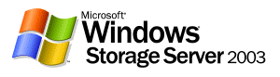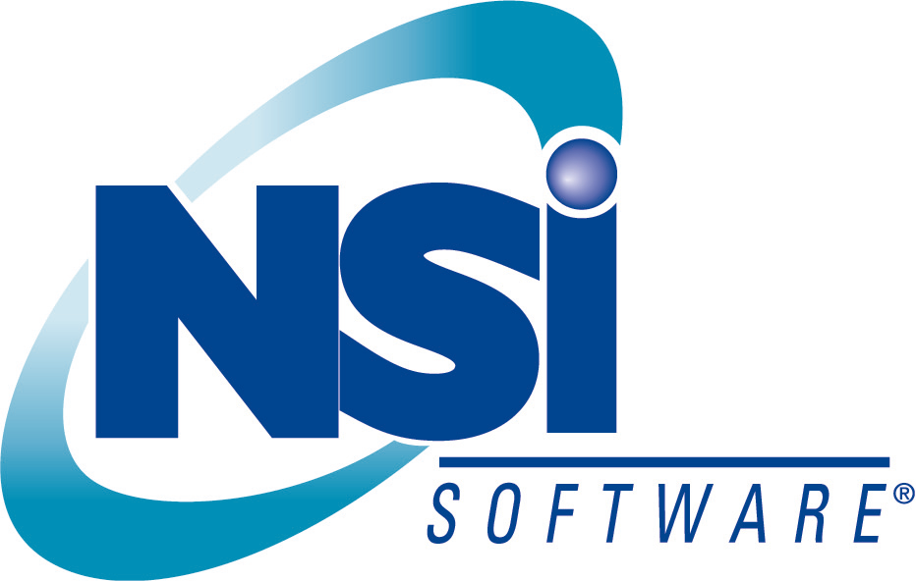

NSI Solutions with Microsoft VSS

Published: March 2004

Abstract
With the introduction of Volume Shadow Copy Service (VSS) in Microsoft Windows Server™ 2003 and Windows® Storage Server 2003 and the strength of NSI Software® Double-Take® you now have the products to achieve your goals of reducing downtime, protecting your critical assets, and reduce time spent on restoring and rebuilding files and servers.

Have you ever felt the frustration of having to spend hours or even days rebuilding files because of inadvertent changes, accidental deletions, or other mishaps?

You spend hours or days creating a document or presentation only to have it get corrupted or you inadvertently overwrite it with undesirable changes. Then you spend the next few hours, or even days, recreating it, hoping that you can remember all that had gone into the original. If you are in IT, how many requests do you get from your end-users for single file restorations? Add to that the worry about server and site failure, and you’ve got quite a stressful life. Wouldn’t it be nice if these issues were a thing of the past? Does the comfort of knowing that users can recover their own files and that your data is well protected against loss and failure seem inconceivable to you? Think how much more productive and stress-free your workday could be knowing that your data was fully protected from these and other means of data loss.
With the introduction of Volume Shadow Copy Service (VSS) in Microsoft Windows Server™ 2003 and Windows® Storage Server 2003 and the strength of NSI Software® Double-Take® you now have the products to achieve your goals of reducing downtime, protecting your critical assets, and reduce time spent on restoring and rebuilding files and servers.
This whitepaper is intended to clarify the strengths of both products and cover some of what they can and can’t do, as well as give you some insight into how you can protect your data, your time, and the time of others, by implementing these two very complimentary best-of-breed data protection solutions. It will also answer the common question of whether VSS can be used in place of Double-Take for your Disaster Recovery and replication needs.
“NSI and Microsoft continue to work together to promote the unique features of their products and provide added value to their customers. Together Double-Take and Volume Shadow Copy Service (VSS) technology enable users to create point-in-time recovery volumes allowing full recovery of files, applications and data. While VSS is a step in the right direction for back up and restore of Windows platforms, particularly for Web and file servers, Double-Take adds full functioning capabilities for disaster recovery and remote availability that VSS is not designed to provide.”

Steve Kenniston
Technology Analyst
Enterprise Storage Group
While we will not cover the technical specifics of these solutions we will discuss the business benefits and high-level functionality and implementation strategies for a few different scenarios. VSS provides a number of different methods and interfaces that allow it to work with VSS-enabled applications such as backup and VSS-enabled hardware-based snapshot and clone technologies. This document will not cover these functions but rather will be focusing on the software snapshot capabilities shipped in Windows Server 2003.
So, does VSS replace Double-Take for Disaster Recovery and replication services? No, it does not. Microsoft clearly states that VSS does not replace backup or replication/disaster recovery solutions . In fact it is quite the contrary. The combination of VSS and Double-Take provides some very complimentary solutions.
VSS native software snapshot support provides points-in-time of volumes for a local server. VSS software snapshots are not “transportable”; meaning the point-in-time volumes can not be created on a remote server nor made accessible from a remote machine at your DR site. Double-Take is the industry-leading local and long distance host-based replication software solution, providing numerous options for your disaster recovery and replication needs.
Read on to better understand the value and differences of these solutions and the complimentary solutions they can offer when combined.

Volume Shadow Copy Service
With the release of Windows Server 2003 and Windows Storage Server 2003, Microsoft has introduced an exciting and valuable infrastructure to it’s already robust operating system; Volume Shadow Copy Service (VSS). VSS provides the ability to create snapshots, or point-in-time (PIT) copies of volumes. These snapshots are images of the data as it looks at a particular instance in time. By maintaining these timely images of data, users and administrators can quickly recover individual files or whole volumes directly from disk as they appeared at the time the snapshot was taken; similar to restore from tape but much faster.
Microsoft has shipped a feature in Windows Server 2003 called "Shadow Copies for Shared Folders" that uses the VSS infrastructure to enable users to restore files on their own, without administrator intervention. By including this feature with its operating systems, Microsoft has dramatically reduced one of the most common and time consuming tasks for both end-users and system administrator: single file recovery. Inadvertent changes, deletions, and corruption are just a few of the reasons files may need to be restored or rebuilt. Recreating files is not only time consuming and inefficient but often results in lost data and incomplete files after the restore or rebuild. Restoring a file from tape can often provide you with a copy of the file as of last night, assuming the backup completed, however this consumes the time of the system administration staff and usually takes at least a day, often longer, to get the file back as tapes may need to be retrieved from offsite retention.
Microsoft now provides a native solution for this with "Shadow Copies for Shared Folders". By taking scheduled periodic snapshots, "Shadow Copies for Shared Folders" allows end-users to recover files on their own, without the need to involve IT or to retrieve and mount a tape. Should a user delete or make undesirable changes to a document they can simply select the file from any desired snapshot and replace it with up to 64 previous versions. They may select one from one hour ago, five hours ago, or maybe a week ago, which is all possible depending on the "Shadow Copies for Shared Folders" configuration settings.
Administrators can configure "Shadow Copies for Shared Folders" to create point-in-time snapshots of particular volumes which users can then access directly should they need to recover a file. The ability to define the frequency of the snapshots allows for "Shadow Copies for Shared Folders" to be customized to meet your specific needs. Not only can "Shadow Copies for Shared Folders" improve file recovery processes, but can also enhance other standard processes, such as backup and archival.
Shadow Copies for Shared Folders provides a ‘self-service’ file recovery mechanism to end-users. Through Windows Explorer, users can easily view the available snapshots and select their file(s) from any point-in-time they choose. The chosen file(s) will then be taken from the selected PIT and copied to their personal folder. "Shadow Copies for Shared Folders" can be configured with up to sixty-four different snapshots for each volume you can ensure the right file is available when needed. Variables such as criticality of the data and the frequency of change to the data should be considered when determining the schedule for snapshots to be taken. By taking an hourly snapshot, for example, users can recover a file from the desired timeframe by themselves, without involving the IT staff and without the need to retrieve and mount any tapes. Plus the biggest benefit is that the file is at most one hour old, whereas with tape the recovery would likely be from the previous day at a minimum, and often times older. However depending on the size of the snapshots, creating them hourly may not allow them to be available for as long as your business requires as older versions are purged once the allocated space for "Shadow Copies for Shared Folders" is used.
Enhanced backup using VSS-aware backup software can greatly enhance the quality of your backups. Backing up the snapshots ensures that there are no open file conflicts which can result in incomplete backups.


Local Server or Filer
running
Windows (Storage)
Server 2003
as of Monday 8AM
VSS Snapshot
as of Monday 10AM
VSS Snapshot
as of Monday Noon
VSS Snapshot
as of Monday 2PM
VSS Snapshot
as of Monday 4PM
VSS Snapshot
Figure 1 – VSS Snapshots

What "Shadow Copies for Shared Folders" Doesn’t Do
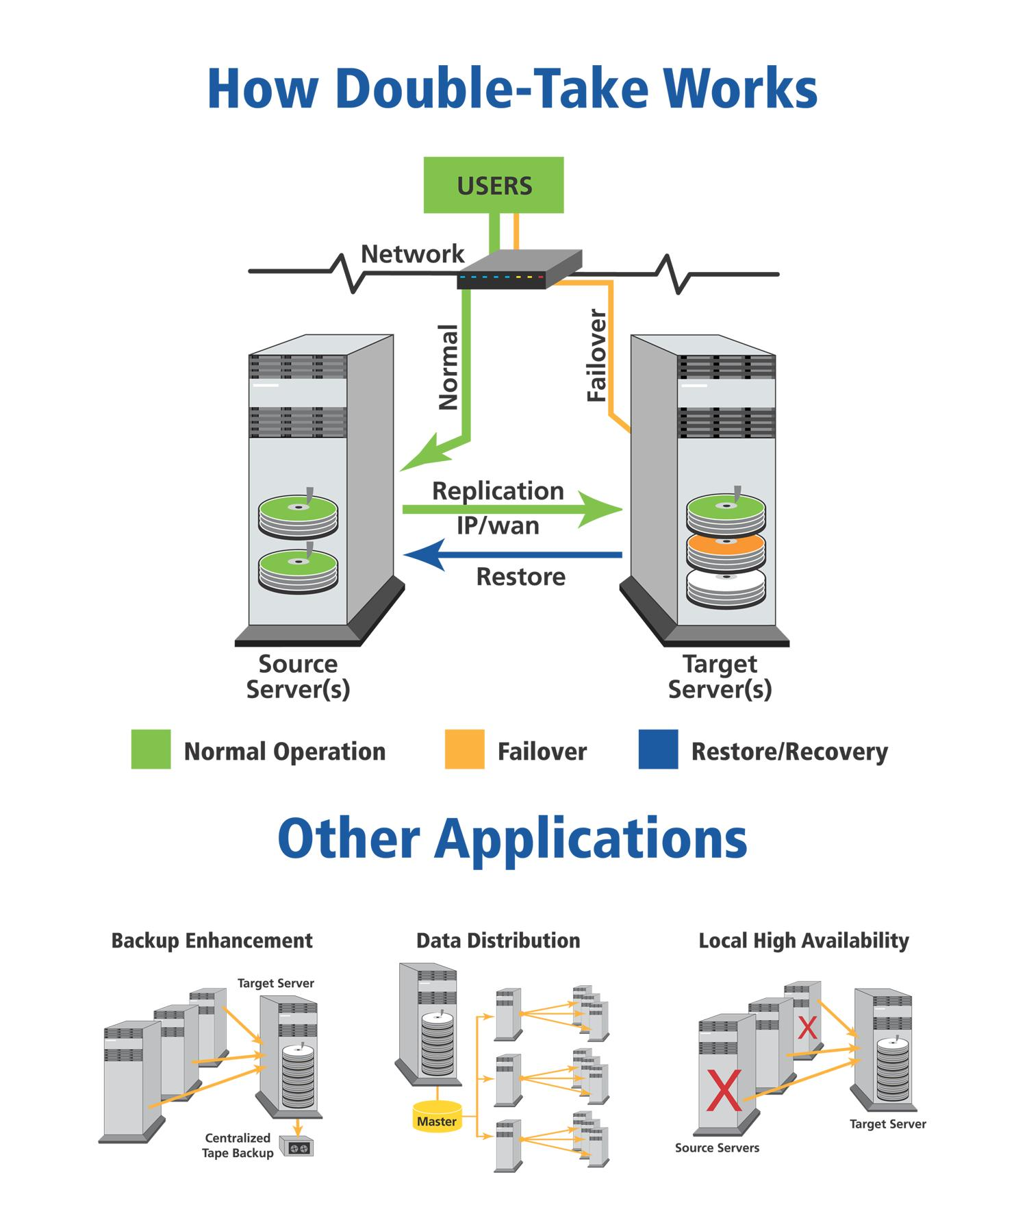
Although "Shadow Copies for Shared Folders" provides an excellent way to recover files, minimize lost work due to deleted files or unwanted changes, what if the disk, server or site were to become unavailable? And what about those files and applications that can’t afford ANY lost data, requiring up-to-the-minute recovery? VSS software snapshots are not available to restore from if the server or disk becomes unavailable as the original source disk must be available and in tact.
Disaster Recovery (DR) is generally considered the ability to recover your data in the event of a local or regional failure. Some regulations require a minimum distance of 200km between the production data and the remote copy. As native VSS software snapshots are not transportable, native VSS software snapshots are not designed to solve DR needs. While having local snapshots allows for a quick recovery of files from different points in time, these snapshots would be unavailable for recovery in the event of a disk, server, or site failure.
NSI Software offers Double-Take, its industry-leading host-based replication software, to provide solutions for disaster recovery and local recovery needs. NSI Software has been protecting file-system-based data since before Windows NT 4 even began shipping. One of the strengths of NSI's replication technology is that it protects files at the byte-level, regardless of the application or physical storage device it is running on. Data changes are captured as they occur and replicated in real-time over existing IP networks to a separate (local or remote) server. This ensures the data on the target, or remote system is as current as the production data.
By using NSI Double-Take software, the data at the local site can be replicated in real-time to a remote site, either across town, to the next state, across the country, or even across the globe, ensuring your data is available should a local or regional failure occur. For enhanced protection or for data distribution, Double-Take can replicate the local data to numerous remote sites simultaneously by implementing a one-to-many configuration. Since Double-Take replicates asynchronously and copies just the byte-level changes, the performance impact to your applications and network is minimal.
Since Double-Take works at the file-system level it can replicate any data, whether they are flat files or database files such as Exchange® or Microsoft SQL Server™. Since most companies critical data resides in some database, this is a critical aspect to consider when implementing your disaster recovery solution. And since Double-Take is hardware independent, you can use it to replicate between any Windows storage device and does not commit you in to a certain vendor’s hardware.
Another aspect to consider is your Recovery Point Objective (RPO). RPO is the amount of data (in days, hours, minutes, and seconds) that your business can afford to lose in the event of a failure. For example, if the server fails at 12:00PM, how far back is acceptable to recover from? One hour, five hours, immediate? Since VSS software snapshots are not available in the case of a server or drive failure, you would still be required to go back to the latest tape backup to rebuild an entire disk. Not only is this a very time-consuming exercise, it may not meet your defined RPO. You will also lose all the previous PIT snapshots so you can no longer recover files from a previous point-in-time.
With Double-Take, the replication process is continuous and real-time resulting in up-to-the-minute recovery. As Double-Take replicates to another disk, it provides the ability to restore the replica once the disk is rebuilt. There is no need to retrieve and mount tapes and apply incremental changes, resulting in a very rapid recovery with minimal or no data loss. For an even faster time to recover, you also have the option of restoring to a different disk or server instead of waiting for the production server to be rebuilt, or even have the target server stand in for the failed server using the built-in failover mechanism in Double-Take which allows for the target server to assume the name and IP address of the production server, allowing for a very rapid return-to-business for your users. In many cases most users are not even aware there was a failure.
So far we’ve discussed snapshots to protect against file corruption and deletion by using "Shadow Copies for Shared Folders", and remote replication for protection from server, site, and regional failures. We now understand some of the value and benefits of "Shadow Copies for Shared Folders" and Double-Take on their own, but what if we combine the value of both products into a single solution?

Protecting the Snapshots
While having multiple copies of files on the local server provides for excellent recoverability should the file become corrupt, have unwanted changes, or be deleted, what protects those software snapshots in the event of a disk or server failure, or a power failure or regional failure? The software snapshots are as vulnerable as the original copies. Should the server or site suffer a failure, the originals AND software snapshots are no longer available. You will be left restoring all your data from the latest tape backup, which as we’ve already discussed is timely and has a poor RPO. For this reason, your data protection solution should include plans to maintain snapshots of the replicated data at the remote sites.
With Double-Take replicating your production data, should a local server failure occur you could simply recover the data from the remote Double-Take replica and rebuild the server to the state it was in when it crashed. However, users would no longer have the ability to restore a file from a previous PIT as all the snapshots were lost with the server failure. To retain PIT recoverability it is important to have the snapshots protected offsite as well as the original data. Since the Shadow Copies for Shared Folder snapshots are not actually full images of the original data, only the changes, it is not possible to replicate the snapshots from production to the target. Instead you would want to replicate the production data to a target server using Double-Take and enable Shadow Copies for Shared Folder snapshots on these replicas. To attain this level of protection the following configuration could be implemented:

- Implement Double-Take to replicate your production data remotely for disaster recovery purposes
- Implement Shadow Copies for Shared Folder snapshots on the local volumes and shares as necessary, providing users with a self-service way to recover their files should they have undesired changes or be accidentally deleted
- Implement "Shadow Copies for Shared Folders" on the remote Double-Take replicas to create point-in-time copies at the remote site
This configuration will provide you with remote up-to-the-minute replicas for recovery from a failure at the local site; local snapshots for quick file restoration; and remote snapshots to maintain your ability to recover files from a previous PIT should the production server fail and lose the local Shadow Copies for Shared Folder snapshots.
Now, should a local failure occur, causing loss of the production data AND the local Shadow Copies for Shared Folder snapshots, you are able to rebuild the server via the Double-Take replicas to the state immediate preceding the failure, and should a user require a file from prior to the failure time, they can still restore it from the Shadow Copies for Shared Folder snapshots on the remote server. Once the local server is rebuilt, "Shadow Copies for Shared Folders" should again be enabled to resume taking local Shadow Copies for Shared Folder snapshots. Should a file be desired from prior to the failure, the remote site will continue to make that data available via the Shadow Copies for Shared Folder snapshots that were taken prior to the production disk failure. From the target server, simply select the files to recover via the Previous Versions client provided by Microsoft (as described above), recover them to the target server, then copy them back to the production server, or anywhere else you desire, using standard Windows copy methods.
Figure 3 below depicts this scenario. "Shadow Copies for Shared Folders" is enabled locally to create snapshots at 8:00am and 12:00 noon for file recoverability, allowing users to restore their own files. Double-Take is replicating the production data (not the snapshots) from the local site to the remote disaster recovery site. "Shadow Copies for Shared Folders" is configured on the remote site to create a weekly snapshot for recovery in the event of a failure at the local site.
Figure 3 - Double-Take and "Shadow Copies for Shared Folders"

Want the benefits of creating software snapshots for data residing on Windows NT and Windows 2000 without having to upgrade to Windows Server 2003? Although this is not natively possible on these operating systems (since VSS is not available) you can still achieve snapshot capabilities without having to upgrade them. Since Double-Take supports both NT and Windows 2000, you can simply configure replication from those servers to a new or existing Windows Server (or Storage Server) 2003 server and enable "Shadow Copies for Shared Folders" on those replicas. Should a file need to be recovered, you can simply restore it from the "Shadow Copies for Shared Folders" snapshot on the target Windows Server 2003 server.
Also note that if you are running Windows Powered NAS you can also achieve the same benefits as with "Shadow Copies for Shared Folders". Although not called "Shadow Copies for Shared Folders", Windows Powered NAS has snapshot capabilities included that can be used in conjunction with Double-Take to provide the same solutions described throughout this document.

Flexibility to meet your needs
As you can see, the specific configuration options are virtually limitless and are able to meet most any business requirements. For example, to improve your recovery process you may want to keep one day worth of hourly software snapshots and a weekly software snapshot, all stored on disk, locally and/or remotely, for immediate availability and recoverability. Just about any other DR and data availability scenarios you require are equally possible and practical with "Shadow Copies for Shared Folders" and Double-Take.
Centralized backup in your plans? Now you can reduce software, hardware, and management costs at regional locations and maintain control and quality from the central data center by replicating that data locally using Double-Take and perform the backup from there. Remember to configure "Shadow Copies for Shared Folders" on the remote office servers to allow users to recover files on their own. For more information on how NSI can help your business meet its data protection goals, please contact us at one of the numbers below.

Together, Microsoft and NSI Software can offer you an even greater level of protection and flexibility. Ensuring that you have the solutions necessary to meet and exceed your service level, business, and regulatory requirements. Microsoft recommends NSI Double-Take as the host-based replication solution for your business continuity and disaster recovery needs. Please see http://www.microsoft.com/windowsserversystem/storage/solutions/businesscontinuity/default.mspx for more information.

The information contained in this document represents the current view of Microsoft Corporation on the issues discussed as of the date of publication. Because Microsoft must respond to changing market conditions, it should not be interpreted to be a commitment on the part of Microsoft, and Microsoft cannot guarantee the accuracy of any information presented after the date of publication.
This white paper is for informational purposes only. MICROSOFT MAKES NO WARRANTIES, EXPRESS OR IMPLIED, IN THIS DOCUMENT.
Complying with all applicable copyright laws is the responsibility of the user. Without limiting the rights under copyright, no part of this document may be reproduced, stored in, or introduced into a retrieval system, or transmitted in any form or by any means (electronic, mechanical, photocopying, recording, or otherwise), or for any purpose, without the express written permission of Microsoft Corporation.
Microsoft may have patents, patent applications, trademarks, copyrights, or other intellectual property rights covering subject matter in this document. Except as expressly provided in any written license agreement from Microsoft, the furnishing of this document does not give you any license to these patents, trademarks, copyrights, or other intellectual property.
© 2001 Microsoft Corporation. All rights reserved.
The example companies, organizations, products, domain names, e-mail addresses, logos, people, places, and events depicted herein are fictitious. No association with any real company, organization, product, domain name, e-mail address, logo, person, place, or event is intended or should be inferred.
Microsoft, Windows Powered, Windows, Exchange, and SQL Server, are either registered trademarks or trademarks of Microsoft Corporation in the United States and/or other countries.

© 2003 NSI Software. All rights reserved.
Double-Take®, GeoCluster® and NSI® are registered trademarks of NSI Software, Inc.. Balance™ is a trademark of NSI Software, Inc. All other trademarks are properties of their respective companies.

‘Introduction to Shadow Copy of Shared Folders’ (http://www.microsoft.com/windowsserver2003/docs/SCR.doc)

