Tips and Tricks for Windows Portable Device Developers
WinHEC 2005 Update - April 19, 2005
Abstract
This paper provides information useful to developers of Windows portable devices (WPD) for the Microsoft® Windows® family of operating systems. It covers the tools available to both application and driver writers when developing WPD solutions.
This information applies for Microsoft Windows Vista™.
Future versions of this preview information will be provided in the Windows Driver Kit (WDK). Preview versions of the WDK are available through the Windows Vista Beta program. For information about the WDK, see http://www.microsoft.com/whdc/driver/wk/default.mspx.
The current version of this paper is maintained on the Web at http://www.microsoft.com/whdc/.
References and resources discussed here are listed at the end of this paper.
Contents
Introduction 3
Diagnostics 3
Built-in Diagnostic Support 3
Turning on the Debug Tracing 3
Obtaining TMF Files 4
Adding Diagnostic Support into a WPD Driver 4
WpdInfo Tool 5
What It Does 5
How to Use It 5
WpdMon Tool 7
What It Does 7
How to Use It 8
Debugging 9
References 9

Disclaimer
This is a preliminary document and may be changed substantially prior to final commercial release of the software described herein.

The information contained in this document represents the current view of Microsoft Corporation on the issues discussed as of the date of publication. Because Microsoft must respond to changing market conditions, it should not be interpreted to be a commitment on the part of Microsoft, and Microsoft cannot guarantee the accuracy of any information presented after the date of publication.

This White Paper is for informational purposes only. MICROSOFT MAKES NO WARRANTIES, EXPRESS, IMPLIED OR STATUTORY, AS TO THE INFORMATION IN THIS DOCUMENT.

Complying with all applicable copyright laws is the responsibility of the user. Without limiting the rights under copyright, no part of this document may be reproduced, stored in or introduced into a retrieval system, or transmitted in any form or by any means (electronic, mechanical, photocopying, recording, or otherwise), or for any purpose, without the express written permission of Microsoft Corporation.

Microsoft may have patents, patent applications, trademarks, copyrights, or other intellectual property rights covering subject matter in this document. Except as expressly provided in any written license agreement from Microsoft, the furnishing of this document does not give you any license to these patents, trademarks, copyrights, or other intellectual property.

Unless otherwise noted, the example companies, organizations, products, domain names, e-mail addresses, logos, people, places and events depicted herein are fictitious, and no association with any real company, organization, product, domain name, email address, logo, person, place or event is intended or should be inferred.

© 2005 Microsoft Corporation. All rights reserved.

Microsoft, Windows, and Windows Vista are either registered trademarks or trademarks of Microsoft Corporation in the United States and/or other countries.

The names of actual companies and products mentioned herein may be the trademarks of their respective owners.

Introduction
The object-based Windows Portable Device Application Programming Interface/Device Driver Interface (API/DDI) enables a new breed of convergent devices, initially focused on smart storage devices such as portable media players, digital still cameras, and mobile phones.
In developing Windows portable device (WPD) solutions for these devices, both application developers and driver writers might need to diagnose various problems, test out newly implemented scenarios, and so on. This paper describes the WPD tools and procedures available to developers for that purpose.

Diagnostics

Built-in Diagnostic Support
All WPD components have adapted Windows software trace preprocessor (WPP). Because WPD uses the WPP software tracing infrastructure, it is beneficial for the reader to be familiar with the WPP information and available tools from MSDN.
Here are some scenarios:
- A user encounters a software problem that involves WPD components. The user turns on debug trace for WPD components and reproduces the scenario. This causes an event trace log (ETL) file to be generated and saved. The user then sends this ETL file along with a description of the problem to the Microsoft support team. The Microsoft development team uses the trace to analyze and pinpoint the issue, without requiring a special (for example, checked) binary.
- Using the same scenario as above, this time the user is a developer who is developing a WPD driver. To know the interaction of the WPD driver with Microsoft WPD components, the developer constructs the trace messages from the raw ETL file to learn the program flow and any special warning or error message.
- An application developer must track a problem with a WPD device. The developer must obtain traces for both the Microsoft WPD components and the vendor’s WPD driver.

Turning on the Debug Tracing
Turning on the trace requires two key values for a target component: the component’s control globally unique identifier (GUID) and the control flag definitions of the target components. Each major WPD component has its unique control GUID, which servers as an identifier. The control flags can be OR’ed and are used to select the types of trace to log. The following tables show this information for WPD components.
Table 1. A list of WPD components and their corresponding control GUIDs

Components: trace providers | Binaries | Control GUIDs
WPD general: Windows Media device manager (WMDM) legacy components | Mswmdm.dll, cewmdm.dll, mspmsnsv.dll, and so on | b809f4ff-3023-473c-971b-ab594429ea57
WPD class installer | Wpd_ci.dll | 45350D79-4497-42f1-BD1B-83587575B91A
WPD Media Transfer Protocol (MTP) drivers | Wpdmtpdr.dll, wpdmtp.dll, wpdmtpus.dll | 97496DDA-C211-4ffe-B1B1-68E6E98EBC38
WPD API | PortableDeviceAPI.dll | C3C5D8AF-2FD5-4500-A8E7-379C2D0BBE2E
WPD Types | PortableDeviceTypes.dll | 58E8F67D-29E9-456C-B23D-C6489E341BB0
WPD service pack: WMDM application compatibility | Wpdsp.dll | 17ABF473-982C-4d0e-B502-3A59D89E71DE
WPD shell extension | WpdShExt.dll | A42C7BD1-5AF3-4b32-9BC6-B85EB31D3F4A

Table 2. A list of standard WPD trace flags

Trace flag bit | Bit | Recommendation for general trace
WPD_TRACE_LEVEL_CRITICAL | 0x00000001 | ON
WPD_TRACE_LEVEL_ERROR | 0x00000002 | ON
WPD_TRACE_LEVEL_WARNING | 0x00000004 | ON
WPD_TRACE_LEVEL_ASSERT | 0x00000008 | OFF
WPD_TRACE_LEVEL_FUNCTRACE | 0x00000010 | OFF
WPD_TRACE_LEVEL_INFORMATION | 0x00000020 | OFF
WPD_TRACE_LEVEL_VERBOSE | 0x00000040 | OFF
Component dependent control flag | Not Defined | OFF

Here are the steps to generate a debug trace:
- Choose one or more target components and add their corresponding control GUIDs into a control trace log (CTL) file. In addition, you should decide what flags you want to set to log the type of traces.
- To configure the trace providers, use a trace control program (Tracelog.exe).
- Create an ETL file by running through a scenario with trace turned on.
- To construct human readable trace messages, use a trace format tool (Tracefmt.exe) with a path to these components’ TMF file.

Here are some tips to help you get started with WPD trace messages. For debugging purposes, the first key word to look for in a trace is “hr.” This usually indicates an error or warning situation. If you must understand the code path, it is helpful to turn on WPD_TRACE_LEVEL_FUNCTRACE bit.

Obtaining TMF Files
TMF files are required to reconstruct human readable trace messages from a raw ETL file. If you have the parallel database (PDB) file, its corresponding TMF files could be extracted with a trace format generating tool such as TracePdb.exe.

Adding Diagnostic Support into a WPD Driver
If you are a WPD driver developer, you might consider adding the same diagnostic support into your driver. You can follow the instructions from MSDN, along with the following recommendations:
- Generate and use a unique control GUID for your component instead of reusing any of the WPD control GUIDs.
- Add your control GUID as a registry in the DDInstall.HW section of your device’s INF file so the control GUID can be discovered programmatically. For example:
; Add WPP Trace Control GUID
HKR,,"WPPTraceGuid",,"{xxxxxxxx-xxxx-xxxx-xxxx-xxxxxxxxxxxx}"
- Document the meaning of each control flag bit.

WpdInfo Tool

What It Does
Application developers and driver writers use the WpdInfo tool to test WPD functionality. Developers can use it to view driver capabilities, verify behavior, and manually test programming scenarios.

How to Use It
WpdInfo is a standalone tool that you can copy to any location and then run.
The following screenshot shows a typical view of the contents of a WPD:
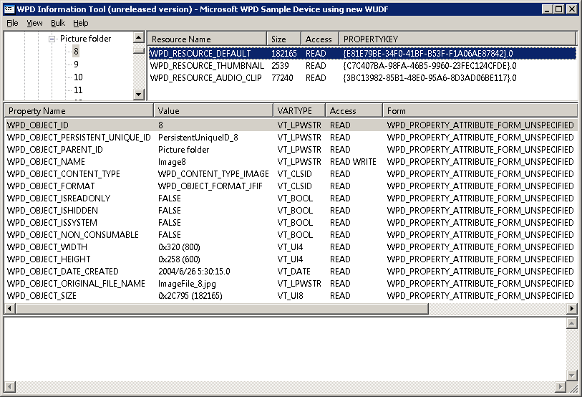
You can use WpdInfo to view the device’s capabilities:
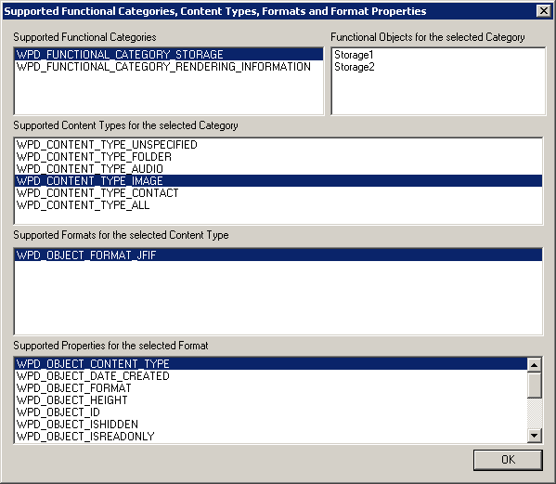
You can use WpdInfo to transfer objects to the device:
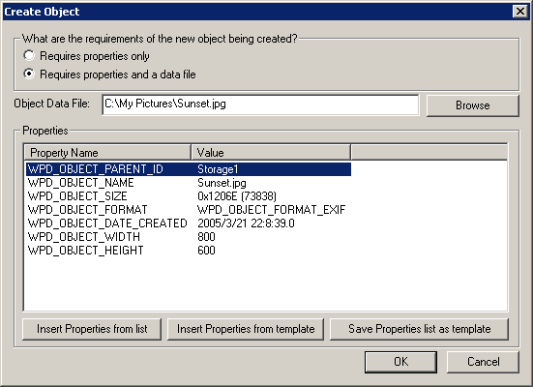
You can use WpdInfo to send any command to the device:
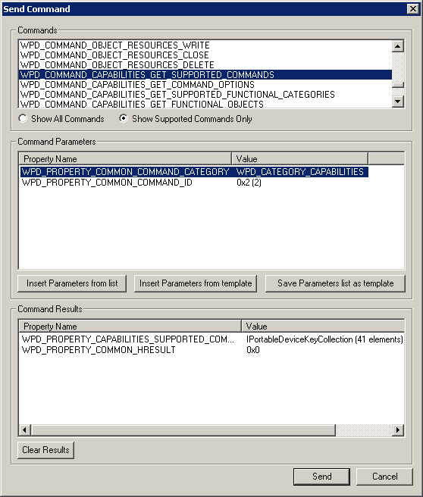
WPdInfo has many other features that are not shown here.
Note that WpdInfo translates most constants from their binary value into the more developer-friendly C++ defined names. Vendors can update the data files used to do this conversion to include their own, so that WpdInfo performs the same translation for custom properties, commands, flags, and so on.

WpdMon Tool

What It Does
WpdMon is an application that is used to analyze the traffic between WPD applications and WPD drivers, or between WPD drivers and their input/output (I/O) stacks.
It also captures PnP arrival and removal notifications to help debug connectivity issues.

How to Use It
WpdMon has two components:
- The WpdMon shim (with no user interface) that intercepts the relevant traffic. You must install this component while no WPD drivers are active on the system; otherwise, a reboot is required.
- The WPDMon application (with user interface) that parses and displays the traffic. This is a standalone application that can simply be copied and run.

The following screenshot shows WpdMon displaying API/DDI traffic:
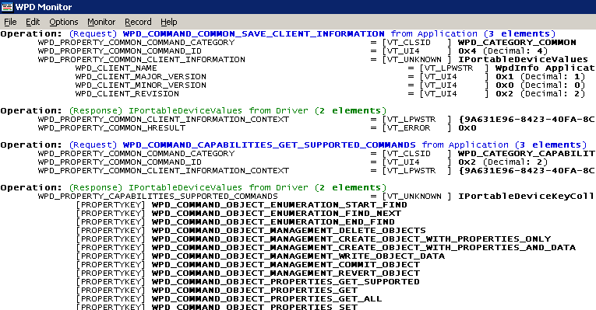
The following screenshot shows captured PnP messages:
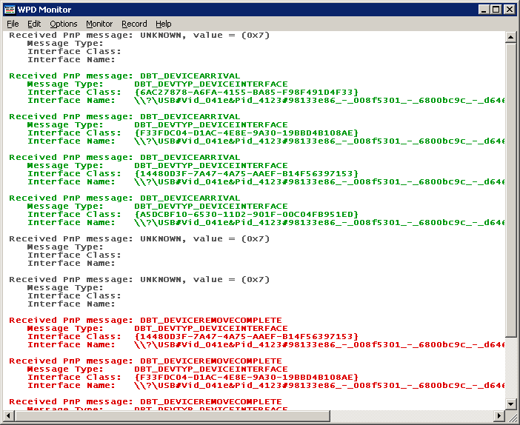
As well as capturing the WPD API traffic, WpdMon also has a plug-in system that facilitates the parsing of vendor-specific messages between the WPD driver and the I/O stack (that is, the I/O send to and from the device).

Debugging
Because the WPD API is in process to the caller, you can debug applications in the usual way by attaching a debugger to the application or by starting the application under a debugger.
WPD drivers are Windows user-mode driver framework (WUDF) drivers and therefore must be debugged differently because they are hosted in the WUDF driver host process. Follow the WUDF guidelines for debugging user-mode drivers.

References
- For more information, send an e-mail to WpdInfo@microsoft.com.
- For an overview of WPD, refer to the white paper titled “Introduction to Windows Portable Device Infrastructure.”
- See “Windows User-mode Driver Framework” from MSDN.
- WPP information and available tools are available from MSDN at http://msdn.microsoft.com/library/default.asp?url=/library/en-us/ddtools/hh/ddtools/st_b1797333-3c08-4e78-8bea-fcee159dfdb5.xml.asp.

