PREfast Step-by-Step
Updated for PREfast Version 2.1
WinHEC 2005 Update - April 19, 2005
Abstract
PREfast is a static analysis tool that detects certain kinds of errors in source code, errors that are not easily found by the typical compiler. This paper introduces PREfast version 2.1 and provides guidelines for interpreting PREfast results and tips for using PREfast during development.
This information applies for the following operating systems:
Microsoft® Windows Vista™
Microsoft Windows Server™ 2003
Microsoft Windows® XP
Microsoft Windows 2000
Future versions of this preview information will be provided in the Windows Driver Development Kit.
The current version of this paper is maintained on the Web at:
http://www.microsoft.com/whdc/DevTools/tools/PREfast_steps.mspx
References and resources discussed here are listed at the end of this paper.
Contents
Introduction 3
Why You Should Use PREfast 3
What PREfast Can Detect 4
Using PREfast 5
Where PREfast Is Installed 5
How to Run PREfast 5
How to Build the PREfast Examples 6
How to Display PREfast Results 7
PREfast Defect Log Viewer 8
PREfast Defect Log Text Output 10
Analyzing PREfast Results 11
Filtering PREfast Results 12
Reducing Noise 13
Examples: Interpreting PREfast Results 14
Example 1: Uninitialized Variables and NULL Pointers 14
Example 2: Implicit Order of Evaluation 15
Example 3: Calling a Function at Incorrect IRQL 15
Example 4: Valid Error Reported in the Wrong Place 16
Example 5: Inferred Purpose Based on Function Characteristics 18
Example 6: Incorrect Enumerated Type 18
PREfast Best Practices 20
Resources 20

Disclaimer
This is a preliminary document and may be changed substantially prior to final commercial release of the software described herein.

The information contained in this document represents the current view of Microsoft Corporation on the issues discussed as of the date of publication. Because Microsoft must respond to changing market conditions, it should not be interpreted to be a commitment on the part of Microsoft, and Microsoft cannot guarantee the accuracy of any information presented after the date of publication.

This White Paper is for informational purposes only. MICROSOFT MAKES NO WARRANTIES, EXPRESS, IMPLIED OR STATUTORY, AS TO THE INFORMATION IN THIS DOCUMENT.

Complying with all applicable copyright laws is the responsibility of the user. Without limiting the rights under copyright, no part of this document may be reproduced, stored in or introduced into a retrieval system, or transmitted in any form or by any means (electronic, mechanical, photocopying, recording, or otherwise), or for any purpose, without the express written permission of Microsoft Corporation.

Microsoft may have patents, patent applications, trademarks, copyrights, or other intellectual property rights covering subject matter in this document. Except as expressly provided in any written license agreement from Microsoft, the furnishing of this document does not give you any license to these patents, trademarks, copyrights, or other intellectual property.

© 2005 Microsoft Corporation. All rights reserved.

Microsoft, Windows, and Windows Server are either registered trademarks or trademarks of Microsoft Corporation in the United States and/or other countries.

The names of actual companies and products mentioned herein may be the trademarks of their respective owners.

Introduction
PREfast is a static analysis tool that can detect certain kinds of errors in source code, errors that are not easily found by the typical compiler or by conventional testing. It simulates execution of all possible code paths on a function-by-function basis, including code paths that are rarely executed during run time. PREfast checks each possible code path against a set of rules that identify potential errors or bad coding practices, and it logs warnings for code that appears to break the rules.
You can use PREfast to analyze both kernel-mode drivers and other kernel-mode components. You can also use PREfast to analyze user-mode drivers by ignoring any kernel-specific warnings. PREfast is licensed only as a driver development tool. You should not use PREfast to test user-mode applications.
PREfast is designed to analyze 32-bit code written for x86 platforms. However, PREfast itself will run on systems with Microsoft Windows-32-bit-on-Windows-64-bit (WOW64) support. You can also use it to analyze 64-bit driver code if the code is compiled for 32 bits, although any code that is excluded through conditional compilation is not visible to PREfast. For PREfast to be able to analyze code, the code needs only to be compiled; it does not need to be linked or run. The code can be written in C or C++.
This paper introduces PREfast version 2.1 and provides instructions for running PREfast, guidelines for interpreting PREfast results, and tips for using PREfast during development. For availability of PREfast version 2.1, see Resources at the end of this paper.
Note
From a user perspective, the major difference between PREfast 2.1 and PREfast 1.5 is that there is only one version of PREfast 2.1 (it is no longer necessary to switch between versions) and the /drivers command line switch is used to enable driver-specific rules. Developers who are familiar with PREfast 1.5 should review "How to Run PREfast" in this paper for details. Other differences for PREfast 2.1 reflect changes in its internal architecture, which result in more efficient operation and reduced noise.

Why You Should Use PREfast
PREfast can be extremely valuable as a kernel-mode development tool because it can find errors that are difficult to test and debug and it can identify assumptions that might not always be valid. You can use PREfast as soon as the program can be compiled, so it can find mistaken assumptions that might propagate through the program. Whether the problem is a simple copy-and-paste error or a complex design flaw that might force a redesign of the program, finding the error early reduces the number of corrections that must be made and allows you to make corrections earlier in the development process, when errors are easier to fix and might have less impact on the development schedule.
Finding such errors during development is much cheaper than trying to find them by testing or having to fix them in the field after your customers discover them in a released product. For example:
- Uninitialized variables can create a number of potentially serious problems that should be corrected. PREfast can identify cases where an uninitialized variable might be used in subsequent code. For example, a variable that is initialized inside a loop remains uninitialized if the loop is executed zero times. If PREfast cannot rule out such a code path, it issues a warning.
- PREfast can detect potentially unprotected float expressions in source code. A kernel-mode driver must protect the floating point state of hardware with appropriate function calls. Failing to do this can cause data corruption and random crashes that are extremely difficult to debug by conventional means.

Notice the phrase "cannot rule out such a code path" rather than "finds such a code path." Because PREfast analyzes code on a function-by-function basis, it has no information about global state or work performed outside the function being analyzed that might affect a given code path. As a result, PREfast issues some warnings that might not represent actual errors in code. These warnings are often referred to as false positives, or "noise."
False positives can still be valuable because they often identify assumptions that the programmer has made. Continuing the example of a variable initialized inside a loop, a programmer with thorough knowledge of the code might know that the loop could not be executed zero times or that the variable is safely initialized by some other function. In this case, the PREfast warning is noise, but it flags the assumption that the variable will always be safely initialized. Even if this assumption is safe, it might be helpful to add an ASSERT to make subsequent programmers aware of the assumption and to take advantage of the notification provided by the checked build, in case the assertion fails.
If the local code doesn't give PREfast any assurance that the code is safe, PREfast behaves as if the code is unsafe. For example, suppose PREfast encounters a code path that dereferences a pointer. Could the pointer ever be NULL? If there is some reason to suspect that it could be—for example, if earlier code tests for NULL, but subsequent code accesses the pointer in an unsafe manner—PREfast issues a warning about dereferencing a NULL pointer. If there is no reason to suspect that the pointer could ever be NULL, then PREfast does not issue a warning.
PREfast does not find every possible error or even all possible instances of the errors it was designed to detect, so code that passes PREfast is not necessarily free of errors. However, PREfast is highly effective at detecting many errors that are difficult to find by other means and usually reports errors in a way that makes them easier to fix. This helps to free your test resources to concentrate on finding and fixing deeper, more significant bugs.

What PREfast Can Detect
PREfast can start detecting potential errors in your code as soon as the code can be compiled. It can detect several significant categories of errors, such as:
- Memory. Potential memory leaks, dereferenced NULL pointers, access to uninitialized memory, excessive use of the kernel-mode stack, and improper use of pool tags.
- Resources. Failure to release resources such as locks, resources that should be held when calling some functions, and resources that should not be held when calling other functions.
- Function usage. Potentially incorrect usage of certain functions, function arguments that appear incorrect, possible argument type mismatches for functions that do not strictly check types, possible use of certain obsolete functions, and function calls at a potentially incorrect IRQL.
- Floating point state. Failure to protect floating point hardware state in a driver and attempting to restore floating point state after saving it at a different IRQL.
- Precedence rules. Code that might not behave as the programmer intended because of the precedence rules of C.
- Kernel-mode coding practices. Coding practices that can cause errors, such as modifying an opaque memory descriptor list (MDL) structure, failing to examine the value of a variable set by a called function, and using C/C++ string manipulation functions rather than the safe string functions defined in Ntstrsafe.h.
- Driver-specific coding practices. Specific operations that are often a source of errors in kernel-mode drivers, such as copying a whole I/O request packet (IRP) without modifying members and saving a pointer to a string or structure argument instead of copying an argument in a DriverEntry routine.

Using PREfast
To run PREfast in a build environment window, you type the word prefast followed by your usual build command. To run PREfast with driver-specific rules, you must use the /drivers switch, as described later in this paper.
PREfast intercepts the build utility's call to the regular cl compiler, cl.exe. The prefast command runs a cl intercept compiler, which analyzes the source code and creates a log file of error and warning messages. PREfast operates separately on each function in the source code. It produces a single combined list for all the files checked in a single run and eliminates duplicate errors and warnings generated by header files. PREfast then calls the regular compiler to produce the usual build output. The resulting object files are the same as those produced by your usual build command.
This section provides a brief introduction to the PREfast command line and PREfast defect log viewer. If you are already familiar with using PREfast, you might prefer to skip this section.
For complete details about using PREfast, see the PREfast online documentation installed with the Microsoft® Windows® DDK.

Where PREfast Is Installed
PREfast is installed with the Windows DDK build environment. You do not need to take any additional steps to install PREfast.
PREfast online documentation is installed with the rest of the Windows DDK online documentation:
- The PREfast online documentation is installed in %winddk%\Help\.
To display this online documentation, click Start, point to All Programs, point to Development Kits, point to Windows DDK , point to Help, point to PREfast, and then click PREfast Documentation.
- Additional PREfast documentation, including specific information about PREfast with driver-specific rules, is installed in the PREfast \Doc directory (%winddk%\bin\x86\prefast\doc\).

How to Run PREfast
To run PREfast in a build environment window, type prefast followed by your usual build command. If you run PREfast on driver source code, be sure to use the /drivers switch to apply driver-specific rules.
PREfast intercepts the call to the cl compiler, analyzes the code to be compiled, and writes the results of the analysis to a log file in XML format. Your code is built as usual—PREfast does not change the source code or the results of the build process.

To run PREfast
1. Open a build environment window.
2. Use the cd command to set the default directory as needed to build your source code.
For example, if you are building a driver, you would set the default directory to one that contains a sources file or a dirs file.
3. Type prefast build followed by any build utility parameters needed to build your code. For example, if you are running PREfast on driver source code:
prefast /drivers build -cZ

PREfast analyzes the code to be compiled and writes results of the analysis to the log file. The default log file, Defects.xml, is written to %winddk%\bin\x86\prefast\. To write the log file to another location, use the /LOG= switch with the prefast command.

How to Build the PREfast Examples
PREfast is installed with a directory of source code examples that contain deliberate errors to trigger various PREfast warnings. You can use the PREfast examples to validate your PREfast installation and to experiment with the PREfast defect log viewer. The \driver subdirectory contains driver source code that illustrates driver-specific rules in more depth.
For comparison with code that triggers warnings, the example code file Bounds-examples.cpp contains a few functions that do not contain errors and so do not trigger any PREfast warnings. Look in the source code for functions with "_ok" in the function name.

To build the PREfast examples
1. Open a build environment window.
2. Make the PREfast Examples directory the default directory.
For example, if C:\DDK is the DDK installation directory and you want to build the examples for PREfast with driver-specific rules, type the following at the command prompt:
cd c:\ddk\bin\x86\prefast\examples

3. Enter a prefast build command such as the following to build the examples:
prefast /drivers build -cZ

The following command window output shows the results of building PREfast examples. The compile errors reflect deliberate errors in the examples.
C:\WINDDK\bin\x86\prefast\examples>prefast /drivers build -cz
-------------------------------------------------------------
Microsoft (R) PREfast Version 2.1.4504 for 80x86.
Copyright (C) Microsoft Corporation. All rights reserved.
-------------------------------------------------------------
BUILD: Adding /Y to COPYCMD so xcopy ops won't hang.
BUILD: Object root set to: ==> objfre_wxp_x86
BUILD: Compile and Link for i386
BUILD: Examining c:\winddk\bin\x86\prefast\examples directory for files to compile.
c:\winddk\bin\x86\prefast\examples
BUILD: Compiling (NoSync) c:\winddk\bin\x86\prefast\examples directory
Compiling - bounds-examples.cpp for i386
Compiling - pft-example1.cpp for i386
Compiling - pft-example2.cpp for i386
Compiling - pft-example3.cpp for i386
Compiling - precedence-examples.cpp for i386
Compiling - hresult-examples.cpp for i386
Compiling - drivers-examples.cpp for i386
Compiling - bounds-examples.cpp for i386
Compiling - pft-example1.cpp for i386
Compiling - pft-example2.cpp for i386
Compiling - pft-example3.cpp for i386
Compiling - precedence-examples.cpp for i386
Compiling - hresult-examples.cpp for i386
Compiling - drivers-examples.cpp for i386
Compiling - generating code... for i386
errors in directory c:\winddk\bin\x86\prefast\examples
pft-example2.cpp(17) : error C4700: local variable 'a' used without having been initialized
pft-example1.cpp(14) : error C4700: local variable 'j' used without having been initialized
Building Library - objfre_wxp_x86\i386\prefastexamples.lib for i386
LIB : error LNK1181: cannot open input file 'objfre_wxp_x86\i386\pft-example1.obj'
BUILD: Done

15 files compiled - 2 Errors
1 library built - 1 Error
Error: The build command 'build' returned status '1'.

-------------------------------------------------------------
Removing duplicate defects from the log...
-------------------------------------------------------------
PREfast reported 41 defects during execution of the command.
-------------------------------------------------------------
Enter PREFAST LIST to list the defect log as text within the console.
Enter PREFAST VIEW to display the defect log user interface.

Note
If you build the PREfast examples without using the /drivers switch, PREfast ignores the driver-specific errors in drivers-examples.cpp and reports only 39 defects.

How to Display PREfast Results
You can display the results of the PREfast analysis in either of two ways:
- To display the contents of the log file in the PREfast defect log viewer, use the prefast view command.
- To list the contents of the log file (which is stored as XML) as text output in the build environment command window, use the prefast list command.

PREfast Defect Log Viewer
The PREfast viewer provides a graphical user interface that you can use to review PREfast output, to filter output so you can show or hide particular messages, and to view annotated source code so you can see the analysis path that produced a given warning.

To display PREfast results in the PREfast defect log viewer
1. Run PREfast on your source code, as described earlier in this section.
2. Enter prefast view.
PREfast displays the PREfast defect log in a Message List screen.

Message List Screen
Figure 1 shows the Message List screen, which lists the results of using PREfast with driver-specific rules to build the examples. The version number at the top of the PREfast Message List screen indicates the version of PREfast that is displaying the log.
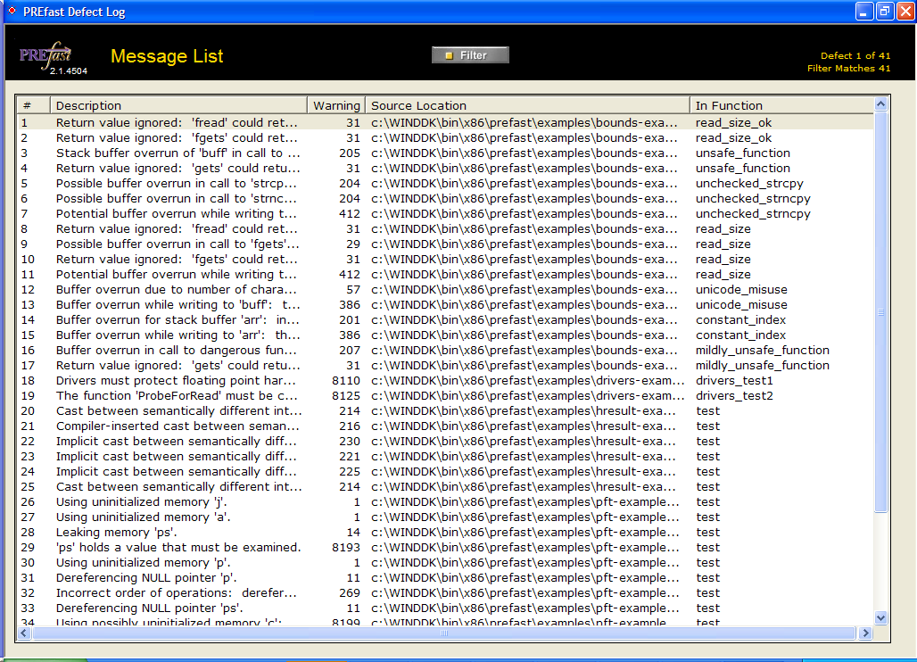
Figure 1. Message List Screen
In the Message List screen, you can:
- Click a column heading (Description, Warning Number, Source Location, or In Function) to sort onscreen messages.
- Double-click a message to open the View Annotated Source screen and display code for that message.
- Click the Filter button to display the filtered view, where you can choose from a list of predefined filters or show and hide individual messages.

View Annotated Source Screen
If you double-click a message in the Message List screen, the View Annotated Source screen appears. The View Annotated Source screen displays annotated source code for the error that triggered that message, with a few lines of code before and after, for context. Figure 2 shows the View Annotated Source screen.
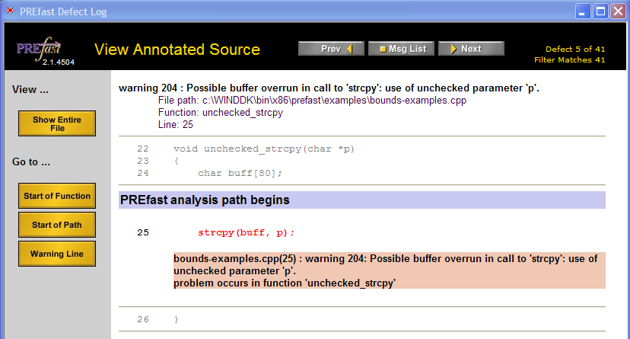
Figure 2. View Annotated Source Screen
In the View Annotated Source screen, you can:
- Click Prev or Next to display annotated source code for other messages, or click Msg List to return to the Message List screen.
- Under View, click Show Entire File to display annotated source code for the entire file that contains the error.
- Under Go to:
- Click Start of Function to go to the beginning of the function.
- Click Start of Path to go to the beginning of the PREfast analysis path.
- Click Warning Line to go to the line that triggered the warning.

Message List Screen in Filter View
If you click Filter on the Message List screen, a list of messages that can be filtered appears above the list of messages that was generated by building your code, as shown in Figure 3.
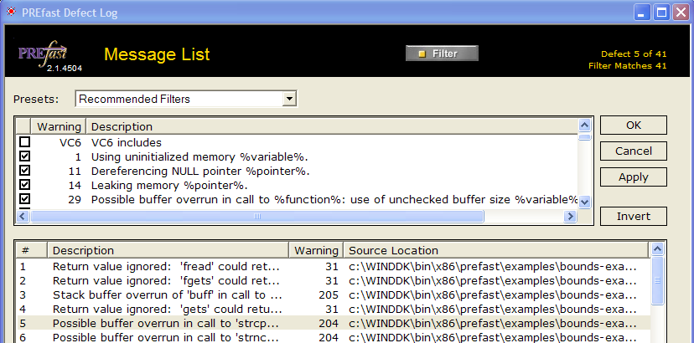
Figure 3. Message List Screen in Filter View
On the Message List screen in filter view, you can:
- Choose from a list of predefined filters in the Presets list box, to show only the messages selected by that filter.
- Clear the check box next to a message or select the message and click Invert to hide that message in the message list for your code.
- Click Apply to update the message list for your code so that it shows only messages that are selected.
- Click the Filter button again to hide filters. The message list for your code continues to show only messages that are selected in filter view.

You can also double-click a message in the message list for your code to display the View Annotated Code screen for that message, just as you can when filters are not visible.

PREfast Defect Log Text Output
You can use the prefast list command to display the contents of the PREfast defect log as text output in the build environment command window. This command is useful if you need only a short list of errors and do not need access to annotated source code (for example, to see the effect of fixing errors found by PREfast in a previous run). The prefast list output consists of the same information that is shown in the PREfast defect log viewer, in a form suitable for pasting into files or bug reports.

To display PREfast results as text output
1. Run PREfast on your source code, as described earlier in this section.
2. At the command prompt, type prefast list.
PREfast displays the message list in the command window.

The following example shows text output for the first few messages from building the PREfast examples by using PREfast with driver-specific rules.
C:\WINDDK\bin\x86\prefast\examples>prefast list
-------------------------------------------------------------
Microsoft (R) PREfast Version 2.1.4504 for 80x86.
Copyright (C) Microsoft Corporation. All rights reserved.
-------------------------------------------------------------
Contents of defect log: c:\winddk\bin\x86\prefast\defects.xml
-------------------------------------------------------------
c:\WINDDK\bin\x86\prefast\examples\bounds-examples.cpp (120): warning 31: Return
value ignored: 'fread' could return unexpected value.
FUNCTION: read_size_ok (116)
PATH:

c:\WINDDK\bin\x86\prefast\examples\bounds-examples.cpp (123): warning 31: Return
value ignored: 'fgets' could return unexpected value.
FUNCTION: read_size_ok (116)
PATH:

c:\WINDDK\bin\x86\prefast\examples\bounds-examples.cpp (15): warning 205: Stack
buffer overrun of 'buff' in call to dangerous function 'gets'.
FUNCTION: unsafe_function (11)
PATH:

c:\WINDDK\bin\x86\prefast\examples\bounds-examples.cpp (15): warning 31: Return
value ignored: 'gets' could return unexpected value.
FUNCTION: unsafe_function (11)
PATH:

Analyzing PREfast Results
PREfast logs every possible error it can find in your source code. As discussed earlier in this paper, some of these errors might be false positives, or "noise." Effective use of PREfast involves balancing noise against legitimate warnings. The goal should be to reduce PREfast results to a manageable list of meaningful warnings, without ignoring warnings that should be fixed.
You can approach this task in two ways:
- Filter PREfast results by hiding certain messages in the PREfast defect log viewer. Hiding individual messages is appropriate when the development team considers the risk associated with the warning to be acceptably low or when the team considers the noise associated with the message to be unacceptably high. It is also appropriate when a product ship cycle permits fixing only the most critical errors.
- Make minor changes to your code to reduce false positives caused by coding style. Although these changes might seem trivial, they can both suppress noise and help reduce ambiguity in your code, which can make it easier for other developers to maintain.

PREfast often reports the same error repeatedly in slightly different contexts. For example, if an uninitialized variable is used more than once, distinct uses of that variable along different paths trigger a PREfast warning. Thus, a single code change might eliminate a number of warnings.
Certain coding constructs can prevent PREfast from fully analyzing a code path. In particular, PREfast treats inline assembler code as if all variables become initialized but the code has no other effect. This behavior suppresses some warnings. If possible, try to avoid inline assembler, not just to make your code easier for PREfast to analyze but to make it more portable to newer architectures that Windows supports. Newer compilers provide many utility functions that can be used instead of inline assembler. If you must use inline assembler, consider placing the code in an __inline function so that PREfast can analyze the rest of the function more effectively.
After you have reduced PREfast results to the set of warnings that are meaningful for your development project, you can focus on fixing genuine problems that will make a difference in your product.
Note
Developers should take full advantage of the compiler's error-checking capabilities by compiling code with the /W4 /WX compiler switch, in addition to using PREfast. PREfast does not enable the /W4 switch, although there is some overlap between errors detected by /W4 and errors detected by PREfast. (Most of these errors are uninitialized variables.)

Filtering PREfast Results
PREfast filtering prevents unwanted messages from appearing in the PREfast defect log viewer. You can filter PREfast results to show only the messages that are meaningful for your development project.
Many developers prefer to start by hiding all but the most critical errors and fixing those, and then running PREfast again and changing the filter to display other, less critical errors. Using the drivers-all filter is a good first step. The drivers-all filter is an updated version of the WINPFT filter (or the equivalent WSPMIN filter) provided in earlier versions of PREfast, with the addition of serious, low-noise rules that apply specifically to drivers. Another useful filter, drivers-only, consists of just the serious, low-noise rules that apply specifically to drivers.
The warnings that pass the drivers-all filter identify particularly serious, low-noise problems in your source code. If you have a limited amount of time to fix errors detected by PREfast, you should concentrate on the warnings that pass drivers-all.
You can also hide individual messages by clearing their check boxes in the Message List screen in filtered view, as described earlier in this paper. For example, certain PREfast warnings that apply to kernel-mode drivers are also triggered by user-mode drivers. If you are testing a user-mode driver, you might want to hide kernel-mode driver messages such as:
Warning 8110: Drivers must protect floating point hardware state. See use of float <expression>
Warning 8111: The IRQL where the floating point state was saved does not match the current IRQL (for this restore operation)
Warning 8146: Kernel mode drivers should use ntstrsafe.h, not strsafe.h

Reducing Noise
In addition to filtering messages, you can also reduce noise in PREfast results. Often minor code changes, such as adding parentheses to expressions to enforce precedence, eliminate a number of false positives. Although the code might be technically correct as written, clarifying the code can help avoid problems later. Code that "confuses" PREfast might also confuse programmers (including you) who must maintain the code.
You can reduce a certain amount of PREfast noise by initializing variables when you declare them, whenever it is possible.
Another common source of noise is making an explicit test for STATUS_SUCCESS. You should replace explicit tests for STATUS_SUCCESS with the NT_SUCCESS macro, as shown in the following code fragment:
status = IoAttachDevice(…);
if (!NT_SUCCESS(res)) {
//handle error
}

When analyzing PREfast results, look for the following common causes of PREfast noise:
- Multiple warnings triggered by a single error, such as multiple uses of the same NULL pointer. Fix these, and then rerun PREfast to produce a shorter message list relatively quickly.
- Warnings that identify assumptions. Make those assumptions explicit with assertions. For example, if PREfast detects potential use of an uninitialized variable that you know is initialized safely elsewhere, add an assertion to confirm that the path in which the variable is left uninitialized is impossible.
- Warnings that identify errors in the use of parentheses or other syntactic misuses where the code might not behave as intended because of the precedence rules of C. Add parentheses or otherwise modify the code to make your intentions explicit.
- Warnings that a slight rearrangement of code can eliminate. For example, if a variable is initialized inside a loop that might be executed zero times, thus leaving the variable uninitialized, consider rewriting the code to initialize the variable outside the loop or restructuring the loop so that it is always executed at least once.

Some noise is unavoidable and might simply have to be ignored. PREfast analyzes code on a function-by-function basis, so it has no information about global state or work performed outside the current function that might affect a given code path. For this reason, PREfast often reports false positives. For example:
- Members of structures or other objects that are not simple variables can mislead the more accurate tests for flow of control.
- Wrapper functions can cause false positives for many kinds of warnings, such as memory leaks, resource leaks, NULL pointer dereferencing, uninitialized memory access, and incorrect argument types.
- A function that has certain characteristics that suggest it is intended for a particular purpose, such as a callback function, causes PREfast to apply additional rules to that function. If PREfast identifies the function incorrectly, it may produce a number of false positives.

If you determine that a PREfast warning is a false positive or simply noise that does not need to be fixed, add comments to your code to document your decision, both for your own benefit and for the benefit of other programmers who might maintain this code in the future.

Examples: Interpreting PREfast Results
This section describes code examples and discusses solutions for common errors that PREfast detects in source code. These are just a few examples of what PREfast can find. For a complete list of warnings, see the PREfast documentation.

Example 1: Uninitialized Variables and NULL Pointers
The test function in %winddk%\bin\x86\prefast\examples\pft-example2.cpp triggers PREfast warnings related to uninitialized variables and NULL pointers. The following code shows the PREfast analysis path for the pointer variable 'p':

12 void test()
13 {
PREfast analysis path begins
14 int *p, a;
15 S *ps, c;
16
17 if (a)
18 {
19 p = &a;
20 }
21 else
22 {
23 ps = (struct S*)malloc(sizeof(struct S));
24 }
25
26 if (p)
27 {
28 ps = &c;
29 }
30
31 *p;
pft-example2.cpp(31) : warning 11: Dereferencing NULL pointer 'p'.
problem occurs in function 'test'
Path includes 8 statements on the following lines:
14 14 15 15 17 23 26 31
32 a = (((ps)))->a;
33
34 return;
35}

In the test function, several variables are declared but not initialized and the function fails to branch appropriately. In this particular code path, the test at line 17 fails because the variable 'a' is not initialized. Line 19 therefore fails to execute, leaving variable 'p' uninitialized.
Although 'p' is tested at line 26, no code handles the case in which the test fails, so execution continues at line 31, which dereferences 'p' and triggers a warning that 'p' could be NULL. The obvious fix for this warning would be to add logic to prevent dereferencing 'p' if it happens to be NULL.
A NULL pointer can also trigger uninitialized variable warnings, as it does for 'p' in the test function.

Example 2: Implicit Order of Evaluation
Code that relies on implicit order of evaluation can contain bugs that are difficult to find. PREfast detects cases where the implicit order of evaluation might produce results that are different from what the programmer intended.
The following code shows a simple example.

4 int unclearIntent(int a, int b, int c)
5 {
6
PREfast analysis path begins
7 if (a & b == c) return 1;
8
abc.cpp(44) : warning 281: Incorrect order of operations: relational operators have higher precedence than bitwise operators.
problem occurs in function 'unclearIntent'
9 return 0;
10 }

According to the rules of operator precedence in C, the expression (a & b == c) is interpreted as (a & (b == c)) because the logical equals operator (==) has higher precedence than bitwise AND (&). Therefore, this function compares 'b' with 'c' and then masks the result with 'a', which tests whether 'a' is even or odd. If this is the intended result, the function is correct as written, but parentheses would help to make the programmer's intention clear (as would a comment in the code).
If the programmer intended to mask 'a' with 'b' and compare the result with 'c', the function is incorrect. Parentheses are required to force evaluation of the expression as ((a & b) == c).

Example 3: Calling a Function at Incorrect IRQL
The IRQL at which a driver routine runs determines which kernel-mode routines it can call and whether it can access paged memory, use kernel-dispatcher objects, or take other actions that might cause a page fault. For example, some routines require that the caller be running at DISPATCH_LEVEL, whereas others cannot be called safely if the caller is running at any IRQL higher than PASSIVE_LEVEL.
It is easy to forget the details about all of the functions that are affected by IRQL in drivers. For example, if your driver sets a flag on the basis of a string and the flag is in a data structure that needs protected access, you might be tempted to write code that resembles the following example. Here, calling ExAcquireFastMutex resets the current IRQL to APC_LEVEL before acquiring the mutex. However, RtlCompareUnicodeString should be called at PASSIVE_LEVEL, so PREfast displays a warning.

11 void IsFlagSet(
12 IN PUNICODE_STRING s)
13 {
PREfast analysis path begins
14 ExAcquireFastMutex(&mutex);
15
16 if (RtlCompareUnicodeString(s, &t, TRUE)) {
IRQL.c(16) : warning 8121: The function RtlCompareUnicodeString is not permitted to be called at the current IRQ level. The current level is too high: The level might have been inferred from the function signature.
problem occurs in function 'IsFlagSet'
Path includes 2 statements on the following lines:
14 16
17 MyGlobal.FlagIsSet = 1;
18 }
19
20 ExReleaseFastMutex(&mutex);
21 }

The solution is to move the RtlCompareUnicodeString call before KeAcquireFastMutex and then to test the result after acquiring the mutex. The corrected code would look like this:
void IsFlagSet(
IN PUNICODE_STRING s)
{
int tmp = 0;
if (RtlCompareUnicodeString(s, &t, true)) {
tmp = 1;
}
ExAcquireFastMutex(&mutex);
if (tmp) {
MyGlobal.FlagIsSet = 1;
}
ExReleaseFastMutex(&mutex);
}

Example 4: Valid Error Reported in the Wrong Place
PREfast often reports a valid error in one location that is actually caused by code in another location. Calling a function at an incorrect IRQL is a good example. When PREfast analyzes a code path, it proceeds as if the programmer intended to change the IRQL. If the IRQL is incorrect for a subsequent function call, PREfast warns about the function call, and not about the earlier change in the IRQL.
For example, assume that function Y is intended to be called at DISPATCH_LEVEL. Function Y calls two functions, KeDelayExecutionThread and KeReleaseSpinLockFromDpcLevel, that have specific IRQL requirements. KeDelayExecutionThread must be called at APC_LEVEL, and KeReleaseSpinLockFromDpcLevel must be called at DISPATCH_LEVEL.
When PREfast starts to analyze function Y, it behaves as if the code should be executing at DISPATCH_LEVEL and issues a warning that KeDelayExecutionThread is being called at an IRQL that is too high, as shown in the following output.

17 void Y(void)
18 //This routine will be always called at DISPATCH_LEVEL
19 {
PREfast analysis path begins
20 LARGE_INTEGER SleepTime;
21 KeAcquireSpinLockAtDpcLevel(&spinLock);
22
23 if(some_condition) {
24 //Driver performs I/O to the hardware and decides
25 //to get a response or check the state.
26
27 KeDelayExecutionThread(KernelMode, FALSE, &SleepTime);
xy.c(27) : warning 8123: The function KeDelayExecutionThread is not permitted to be called at a high IRQ level. Prior function calls are inconsistent with this constraint: It may be that the error is actually in some prior call that limited the range.
problem occurs in function 'Y'
Path includes 4 statements on the following lines:
20 21 23 27
28 }
29 KeReleaseSpinLockFromDpcLevel(&spinLock);
30 }

As PREfast continues to analyze function Y, it now behaves as if the code should be executing at APC_LEVEL because of the call to KeDelayExecutionThread. It then encounters KeReleaseSpinLockFromDpcLevel, which must be called at DISPATCH_LEVEL, and issues a warning that the function is being called at an IRQL that is too low.
xy.c(29) : warning 8122: The function KefReleaseSpinLockFromDpcLevel is not permitted to be called at a low IRQ level. Prior function calls are inconsistent with this constraint: It may be that the error is actually in some prior call that limited the range.
problem occurs in function 'Y'
Path includes 5 statements on the following lines:
20 21 23 27 29
To correct this situation, consider one of the following solutions:
- If the wait time is short (less than a clock tick but more than for a few instructions), call KeStallExecutionProcessor instead of KeDelayExecutionThread. Callers of KeStallExecutionProcessor can be running at any IRQL.
- Queue a timer object with a CustomTimerDpc routine that checks the hardware state.

Example 5: Inferred Purpose Based on Function Characteristics
PREfast identifies certain kinds of functions based on characteristics of the function signature (such as "Callback" or "Cancel" in the function name) and applies additional rules that are specific to that kind of function. When PREfast identifies such a function, it displays an informational message such as:
abc.c(1992) : warning 8101: The Drivers module has inferred that the current function is a Cancel function: This is informational only. No problem has been detected.
problem occurs in function 'IRQLCancel'

PREfast then analyzes the function according to additional rules. In the case of a Cancel routine, one such rule is that the routine must release the cancel spin lock and restore the previous IRQL before exiting. The following example fails to release the cancel spin lock, which causes PREfast to display a warning.

PREfast analysis path begins
1991 IRQLCancel(
abc.c(1991) : warning 8144: Within a cancel routine, at the point of exit, the IRQL found Irp->CancelIrql should be the current IRQL.: The value need not be restored by any specific function, but must be restored before exit. PREfast was unable to determine that it was restored to the required value.
problem occurs in function 'IRQLCancel'
1992 IN PDEVICE_OBJECT DeviceObject,
1993 IN PIRP Irp
1994 )
1995 {
1996 //Cancel some pending operation
1997 }

If PREfast has identified the Cancel function incorrectly, this warning can be ignored. However, if PREfast identified the Cancel function correctly, a solution for this error would be to call IoReleaseCancelSpinLock before returning from the function, as shown in the following code. Ideally, the driver should release the cancel spin lock as soon as possible after entering the function because holding the cancel spin lock slows performance for the entire system.
void
IRQLCancel(
IN PDEVICE_OBJECT DeviceObject,
IN PIRP Irp
)
{
//Cancel some pending operation.
IoReleaseCancelSpinLock(Irp->CancelIrql);
}

Example 6: Incorrect Enumerated Type
The C compiler's type checking is not strict enough to detect an incorrect enumerated type. Unfortunately, using an incorrect enumerated type in driver code can cause problems that are difficult to find and solve. PREfast detects enumerated type mismatches in driver code and issues a warning about each mismatch. PREfast type mismatch warnings vary somewhat according to the function being analyzed, but all PREfast type mismatch warnings identify potential problems that should be investigated and fixed.
For example, a common error when calling the KeWaitXxx routines (KeWaitForSingleObject, KeWaitForMultipleObjects, and KeWaitForMutexObject) is to transpose the WaitReason and WaitMode parameters, which take enumerators of type KWAIT_REASON and KPROCESSOR_MODE, respectively.
The following code fragment shows the PREfast warning for a call to KeWaitForSingleObject in which the WaitReason and WaitMode parameters are transposed.

2784 status = KeWaitForSingleObject(&event,

kewait.c(2784) : warning 8139: The argument 'KernelMode' should exactly match the type 'enum _KWAIT_REASON': Some functions permit limited arithmetic on the argument type, others do not. This usually indicates that an enum formal was not passed a member of the enum, but may be used for other types as well.
problem occurs in function 'PciDrvSendIrpSynchronously'
2785 KernelMode,
2786 Executive,
2787 FALSE,
2788 NULL
2789 );

PREfast issues the same warning for the argument 'Executive' because it is not of type KPROCESSOR_MODE.
The enumerators most commonly passed in a KeWaitXxx call are KWAIT_REASON Executive and KPROCESSOR_MODE KernelMode. Both of these enumerators evaluate to zero, so they are numerically interchangeable. Transposing them in the function call causes a type mismatch for each parameter, but without strict type checking, the mismatch is invisible to the compiler and, if the enumerators are Executive and KernelMode, the mismatch is also invisible to the system.
Problems arise when these parameters are transposed with enumerators that are not numerically interchangeable, such as Executive and UserMode, thus causing the driver to wait in a mode that the programmer did not intend.
This is an example where PREfast is effective in preventing a bug if it is used early in the development process. This coding error is apparently fairly common and, if the values are nonzero, it will show up as a bug at some point in testing. Some variations of this coding error can cause the bug to appear as a bug check in the kernel or in an unrelated driver, making the bug very hard to recognize, let alone actually find in your driver. Using PREfast to detect this bug saves testing and debugging time that would be needed to find the problem, and fixing the bug takes only a moment because the PREfast warning is specific and localized.

PREfast Best Practices
This section summarizes best practices for integrating PREfast into your development cycle:

Setting Policies
- Start running PREfast as soon as you get the first clean compile of each source file.
- Establish a policy for your development team about which PREfast warnings must be fixed, which warnings may be ignored, and which warnings the developer may choose to fix or not fix.
- Establish a policy and comment conventions to record why particular warnings, such as false positives, were not fixed.

Filtering Results
- At a minimum, fix all warnings that pass the drivers-all filter. These are particularly serious, low-noise warnings about errors that can affect system security.
- Filter PREfast results by hiding messages when the development team considers the risk associated with the warning to be acceptably low, when the noise associated with it is high, or when the product ship cycle permits fixing only the most critical errors.

Adopting Coding Practices
- Make minor changes to your code to reduce false positives that are caused by coding style.
- Instead of using inline assembler, use the utility functions provided with newer compilers. If you cannot avoid using inline assembler, consider placing the code in an __inline function so PREfast can analyze the code more effectively.
- Wherever possible, initialize variables when you declare them.
- Identify programming assumptions in comments, and make these assumptions explicit with assertions.
- Use parentheses and other syntax to enforce order of evaluation, rather than relying on the precedence rules of C.
- Use the NT_SUCCESS macro instead of explicit tests for STATUS_SUCCESS.
- Continue to use other driver testing and validation tools, such as Driver Verifier, in addition to PREfast.

Resources
Windows DDK
http://www.microsoft.com/whdc/DevTools/ddk/default.mspx
PREfast version 2.1 is included in the WinHEC 2005 version of the Microsoft Windows Driver Development Kit (WDK).
PREfast documentation in the DDK
Click Start , point to All Programs, point to Development Kits, point to Windows DDK, point to Help, and then click PREfast.
Development Tools and Testing on WHDC
http://www.microsoft.com/whdc/DevTools/default.mspx

