Using the Driver Package Installer (DPInst)
WinHC 2004 Version - April 14, 2004

Abstract
This paper provides information on the Microsoft® Windows® Driver Package Installer (DPInst) version 1.0 for the Microsoft Windows family of operating systems. It describes how driver package providers can use DPInst to simplify and customize the software-first installation of signed driver packages on Microsoft Windows 2000 and later versions.

Contents
Introduction 4
User Experience Provided by the Driver Package Installer 5
Welcome Page 5
EULA Page 6
Installation Page 6
Finish Page 7
How the Driver Package Installer Installs and Updates Driver Packages 7
Locating the INF Files 8
Authenticating the Driver Packages 8
Adding Driver Packages to the Driver Store 9
Installing INF Files 9
Updating Driver Packages on Devices 9
Displaying a Finish Page 10
Adding the Driver Package Installer to an Installation Package 11
Customizing Driver Installation 12
DPInst Descriptor File Example 12
Using a DPInst Descriptor File 13
Specifying the Document Root Element 13
Specifying the Location of a Driver Package 14
Multilanguage Support (Localization) 14
Specifying EULA Text 14
Customizing the Welcome Page 15
Customizing the DPInst EULA Page 17
Customizing the Installation Page 19
Customizing the Finish Page 21
Setting DPInst Configuration Flags 22
DPInst Descriptor File Reference 24
dpinst XML Element 26
search XML Element 26
subDirectory XML Element 27
language XML Element 28
dpinstTitle XML Element 29
welcomeIntro XML Element 30
welcomeTitle XML Element 30
eula XML Element 31
eulaHeaderTitle XML Element 31
eulaNoButton XML Element 32
eulaYesButton XML Element 32
installHeaderTitle XML Element 33
finishText XML Element 34
finishTitle XML Element 34
icon XML Element 35
headerPath XML Element 35
watermarkPath XML Element 36
quietInstall XML Element 37
promptIfDriverIsNotBetter XML Element 37
forceIfDriverIsNotBetter XML Element 38
installAllOrNone XML Element 38
suppressAddRemovePrograms XML Element 39
DPInst Command-Line Switches 40
Driver Support 41
Associating Services and Driver Packages 41
Installing Driver Packages 42
Removing Driver Packages 43
Removing Export Drivers 43
Removing Class Filter Drivers, File System Filter Drivers, File System Drivers, and Kernel Service Drivers 43
Removing Network Drivers 44
Removing Plug and Play Drivers 44
Reversing System Changes 44
Testing and Debugging an Installation Package 45
Known Bugs and Limitations 45
Using the IExpress Wizard to Create a DPInst Installation Package 45
Call to Action and Resources 47

Disclaimer
The information contained in this document represents the current view of Microsoft Corporation on the issues discussed as of the date of publication. Because Microsoft must respond to changing market conditions, it should not be interpreted to be a commitment on the part of Microsoft, and Microsoft cannot guarantee the accuracy of any information presented after the date of publication.

This White Paper is for informational purposes only. MICROSOFT MAKES NO WARRANTIES, EXPRESS, IMPLIED OR STATUTORY, AS TO THE INFORMATION IN THIS DOCUMENT.

Complying with all applicable copyright laws is the responsibility of the user. Without limiting the rights under copyright, no part of this document may be reproduced, stored in or introduced into a retrieval system, or transmitted in any form or by any means (electronic, mechanical, photocopying, recording, or otherwise), or for any purpose, without the express written permission of Microsoft Corporation.

Microsoft may have patents, patent applications, trademarks, copyrights, or other intellectual property rights covering subject matter in this document. Except as expressly provided in any written license agreement from Microsoft, the furnishing of this document does not give you any license to these patents, trademarks, copyrights, or other intellectual property.

© 2004 Microsoft Corporation. All rights reserved.

Microsoft, Windows, and Win32 are either registered trademarks or trademarks of Microsoft Corporation in the United States and/or other countries.

The names of actual companies and products mentioned herein may be the trademarks of their respective owners.
Introduction
This paper provides information on the Microsoft® Windows® Driver Package Installer (DPInst) version 1.0 for the Microsoft Windows family of operating systems. Microsoft Windows 2000 and later versions support DPInst.
DPInst is a component of the Microsoft Windows Driver Install Frameworks (DIFx) that simplifies and customizes the installation of signed driver packages for devices that are not yet installed in a system (commonly known as a software-first installation). DPInst also automatically updates the drivers for any installed devices that are supported by the newly installed driver packages.
By using DPInst, a driver package provider:
- Enhances the user experience by eliminating most of the manual steps that would otherwise be required to install driver packages. All a user has to do is run DPInst and it displays wizard pages that notify the user of the progress of installation and an optional end-user license agreement (EULA) page that gives the user the option to cancel installation. For more information, see “User Experience Provided by the Driver Package Installer” later in this paper.
- Avoids writing a custom installation program to install driver packages and update the installed drivers for supported devices. Driver package providers do not have to change their driver packages to use DPInst. The provider only needs to create an installation package that includes DPInst and one or more signed driver packages. For more information, see “How the Driver Package Installer Installs and Updates Driver Packages” and “Adding the Driver Package Installer to an Installation Package” later in this paper.
DPInst features:
- Driver installation customization. You can customize the text that is displayed on wizard pages, include branding, include an optional EULA, and control whether wizard pages are displayed. For information on customizing installation, see “Customizing Driver Installation” later in this paper.
- Automatic driver package removal. For each driver package that is installed by DPInst, DPInst adds an entry to Add or Remove Programs, in Windows Control Panel, that a user can use to remove the driver package from their system. If the user removes a driver package, the package is removed from the Driver Store, the corresponding INF file is removed from the system INF file directory, and all devices that were previously supported by the package are updated with the next best available driver. For more information on the Driver Store, see "Adding Driver Packages to the Driver Store" later in this paper.
- Installation error logs. DPInst logs high-level messages in the DPInst log file (%windir%\Dpinst.log). The log file is a plain-text file that contains information and error messages, and identifies the driver package that was being installed when an error occurred. For more information on the DPInst log file, see “Testing and Debugging an Installation Package” later in this paper.
DPInst is designed primarily to install Plug and Play device drivers. However, DPInst also supports the installation of other types of drivers. For information about the driver types that DPInst supports, see “Driver Support” later in this paper.
For information on known bugs and limitations, see “Known Bugs and Limitations” later in this paper.
For more information on Driver Install Frameworks, see “Driver Install Frameworks” in the Windows Driver Development Kit (DDK) and go to http://www.microsoft.com/whdc/hwdev/driver/hwuxtools.mspx.
You can obtain the DPInst tool at http://www.microsoft.com/whdc/driver/install/DPInst.mspx.

User Experience Provided by the Driver Package Installer
The Microsoft® Windows® Driver Package Installer (DPInst) eliminates the manual steps that would otherwise be required to install a driver package. The user is not required to know about the details of driver packages and devices, or how to install them manually. If the provider creates a self-extracting executable for a driver installation package that automatically executes the DPInst executable (DPInst.exe), the user only needs to locate the self-extracting executable and run it. For example, if the self-extracting executable is located on a Web page, the user only needs to select the executable and click Open in the File Download dialog box.
By default, when DPInst runs, it displays the following sequence of wizard pages, which are described later in this section:
- A welcome page.
- An optional end-user license agreement (EULA) page that displays EULA text and gives the user the option to cancel the installation.
- An installation page that informs the user that DPInst is installing the driver packages.
- A finish page that informs the user of the results of the installation.

The default wizard pages can be customized. For information about customizing the wizard pages, see “Using a DPInst Descriptor File” later in this paper.
DPInst also supports command-line options that suppress the display of wizard pages during installation. For more information, see “DPInst Command-Line Options” later in this paper.

Welcome Page
Figure 1 is an example of the default welcome page that DPInst displays. The user clicks Next to continue with the installation or Cancel to cancel the installation. The Back button is disabled.
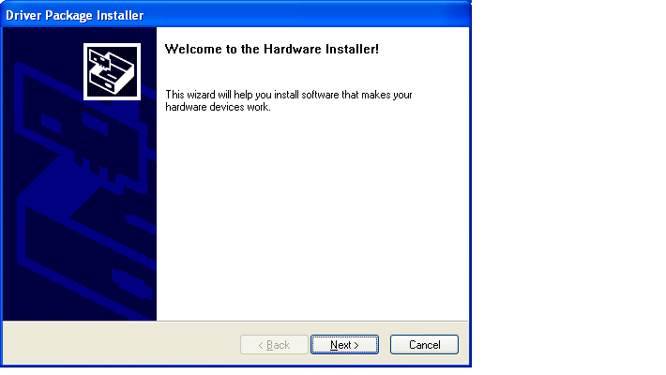
Figure 1. Default welcome page.

EULA Page
DPInst displays a EULA page if a EULA file is specified in the DPInst descriptor file. Figure 2 is an example of the default EULA page. If the user selects I accept this agreement and then clicks Next on the EULA page, DPInst begins the driver package installation. Otherwise, the user must click Back, or select I don't accept this agreement and then click Cancel to cancel the installation.
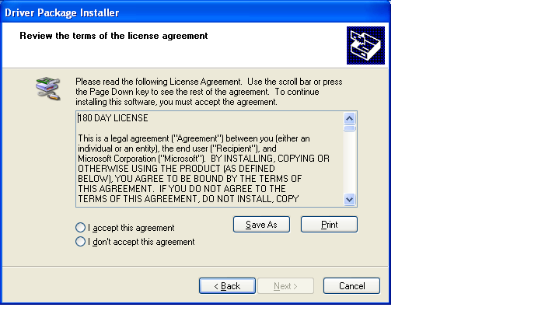
Figure 2. EULA page.

Installation Page
Figure 3 is an example of the default installation page that DPInst displays to inform the user that it is installing the driver packages. The user can click Cancel to cancel the installation. The Back and Next buttons are disabled.
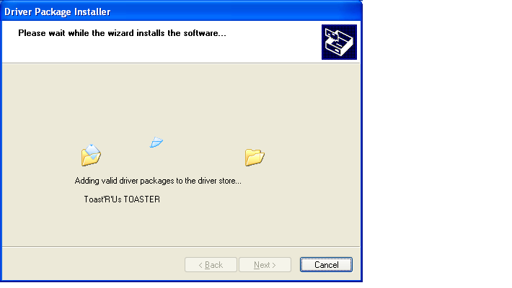
Figure 3. Default installation page.

Finish Page
After installing the driver packages, DPInst displays a finish page that informs the user of the status of the installation. Figure 4 is an example of the default finish page that informs the user that the driver packages were successfully installed. The user clicks Finish to complete the installation. The user can also click Cancel, but this only closes the wizard page—it does not cancel the installation. The Back button is disabled.
For more information on types of information that DPInst displays on the finish page, see “Displaying a Finish Page” later in this paper.
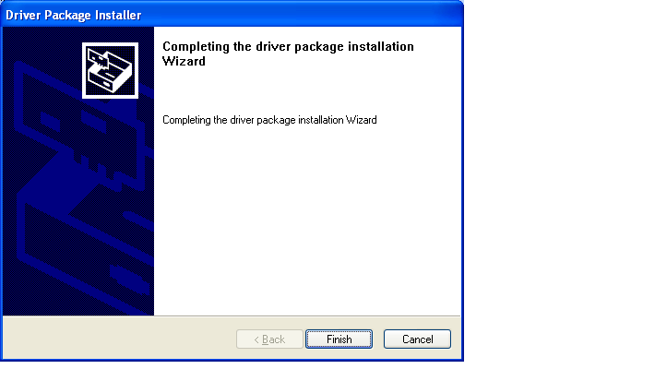
Figure 4. Default finish page.

How the Driver Package Installer Installs and Updates Driver Packages
By default, when the Microsoft® Windows® Driver Package Installer (DPInst) runs, it first displays a welcome page and then displays an end-user license agreement (EULA) page. After the user accepts the licensing agreement on the EULA page, DPInst displays an installation page, and then performs the following initial steps to add driver packages to the Driver Store.
- Locates the INF files.
- Authenticates the driver packages.
- Adds driver packages to the Driver Store.

These three initial installation steps are described later in this paper.
The installation steps that follow adding a driver package to the Driver Store depend on the driver type. For Plug and Play device drivers, DPInst completes the following additional steps to complete the installation of driver packages.
- Installs INF files.
- Updates driver packages on devices.

These two additional installation steps for Plug and Play device drivers are described later in this paper.
After DPInst completes the installation of a driver package, it displays a finish page that informs the user of the status of the installation. For more information, see “Displaying a Finish Page” later in this paper.
If the installation is successful, all of the installation steps are transparent to the user (except, of course, the display of the wizard pages).
For more information about how DPInst installs the driver types that it supports, see “Driver Support” later in this paper.
DPInst supports command-line options that control the display of its wizard pages. For more information, see “DPInst Command-Line Options” later in this paper.
For general information about INF files and driver packages, see “Providing a Driver Package” in the Windows Driver Development Kit (DDK). For specific information about INF files for use with DPInst, see the whitepaper “Requirements for Driver Packages That Are Used with the Driver Install Framework (DIFx) Tools” that is provided with the DPInst tool.

Locating the INF Files
DPInst searches for INF files for driver packages in the following directories:
- By default, DPInst searches the directory where the DPInst executable (DPInst.exe) is located.
- DPInst also searches vendor-specified subdirectories under the directory where DPInst.exe is located. A vendor specifies the subdirectories by using the search and subDirectory XML elements in an optional DPInst descriptor file (DPInst.xml). For more information on XML elements and the DPInst descriptor file, see “Customizing Driver Installation” later in this paper.

Authenticating the Driver Packages
DPInst authenticates each driver package by verifying that it has a Microsoft Windows Hardware Quality Labs (WHQL) signature, an Authenticode signature, or a test signature from Microsoft. For information on driver signing, see “Driver Signing” in the DDK, the white paper on Authenticode signing at http://www.microsoft.com/whdc/hwdev/driver/hwuxtools.mspx, and “Driver Signing for Windows” at http://www.microsoft.com/whdc/hwdev/driver/digitsign.mspx.
If a driver package does not have a valid digital signature, DPInst does not copy the driver package to the Driver Store and it does not install the driver package.
Note
For some device setup classes and some versions of the Microsoft Windows operating system, DPInst might notify the user that an Authenticode-signed package has not been signed by WHQL, and then give the user the option to cancel the installation.

Tip
For testing purposes, DPInst allows the installation of an unsigned driver if a kernel debugger is attached to the system—see “Testing and Debugging an Installation Package” later in this paper.

Adding Driver Packages to the Driver Store
After authenticating the driver packages, DPInst generates a comprehensive list of files that are potentially required for each driver package installation. The list also includes the corresponding INF file and catalog file.
DPInst copies these files to the Driver Store, which is a repository for driver packages that is located on the computer’s hard disk drive and is managed by Microsoft Windows Driver Install Frameworks (DIFx). DPInst and the other DIFx tools use the Driver Store to store and retrieve driver packages. However, pay close attention to the file-copy process:
- An error will not appear if a source file is not present.
- In most circumstances, many INF files reference more files than are actually needed. If a required file is missing from the package, the user is prompted for the location of the missing file.
- Only files that are targeted for the computer architecture are copied. This includes all files for Windows 2000 and later versions. For example, DPInst does not copy files for an Itanium-based system to the Driver Store on an x86 computer.
- DPInst uses compression to minimize the space that is required to save the driver packages in the Driver Store.

Installing INF Files
After DPInst adds a driver package for a Plug and Play device driver to the Driver Store, it calls the SetupCopyOEMInf function to install the INF file for the driver. For information on SetupCopyOEMInf, see the Microsoft Windows Platform SDK.
DPInst installs all INF files into the system INF file directory before it installs any device drivers. This ensures that DPInst setup can automatically install a child device that is enumerated after a parent device is installed (because the child device's INF file is already installed and its driver package is in the Driver Store).

Updating Driver Packages on Devices
After installing the INF file for a Plug and Play device driver in the system INF file directory, DPInst does the following for the INF file:
- Enumerates the hardware ID and compatible IDs that are specified in the INF file, and determines if there is a match to a device that is configured in the system or a match to a nonpresent device.
- If there is a match between the hardware ID or a compatible ID and a device that is configured in the system, DPInst calls the UpdateDriverForPlugAndPlayDevices function using the matching ID and the corresponding INF file. If the new driver is a better match than the currently installed driver for a device, UpdateDriverForPlugAndPlayDevices installs the new driver on the device. For information on this function, see “UpdateDriverForPlugAndPlayDevices” in the Windows Driver Development Kit (DDK).
DPInst also supports users with an option to replace a driver currently installed on a device with a new driver, even if the new driver is not a better match to the device than the driver currently installed on the device. For more information, see “Customizing Driver Selection” later in this paper.
- If there is a match to a nonpresent device, DPInst sets the CONFIGFLAG_REINSTALL configuration flag for the nonpresent device, which causes Setup to update the driver for the device the next time the actual device is plugged into the system. For information on nonpresent devices, see “nonpresent device” in the DDK glossary.

Displaying a Finish Page
After DPInst finishes installing the driver packages, it displays a finish page that informs the user of one of the following installation results.

Installation Succeeded Without Errors
If zero errors occurred and all packages were successfully installed on a device, DPInst displays the following message:
The driver package installation wizard successfully updated the software for your hardware devices!
If zero errors occurred and no packages were installed on devices in the system because none of the driver packages match any of the devices configured in the system, DPInst displays the following:
The driver package installation wizard finished installing the software on your computer, you may insert your device now. Follow the instructions that came with your device on how to insert it into your computer.
If zero errors occurred and no packages were installed on devices in the system because the driver packages already installed on devices in the system are a better match than the driver packages in the installation package, DPInst displays the following message:
The driver package installation wizard did not update any of your software for your hardware devices because it was not better then the software you currently have installed.

Installation Failed Because of Errors
If DPInst did not find any driver packages in the installation package, DPInst displays the following message:
The driver package installation wizard was unable to find any driver packages designed for your machine. Check with the vendor or your site administrator to ensure you have the correct program.
If the user declined to accept the EULA, DPInst displays the following message:
The driver package installation wizard could not install the software for your hardware devices because you declined the end-user license agreement (EULA).
If DPInst cannot find the EULA file defined in the descriptor file (DPInst.xml), DPInst displays the following message:
The driver cannot be installed because it requires the end-user license agreement (EULA) which is missing. Please contact the vendor that provided you this package.
If the installation of all the driver packages fails, DPInst displays the following message, followed by a list of drivers that could not be installed:
Errors were encountered while installing the software for your hardware devices. Please contact the vendor or your site administrator for more information.
If the installation of some, but not all, of the driver packages fails, the message that DPInst displays depends on how the installAllOrNone flag is set. For information on the installAllOrNone flag, see “Setting the installAllOrNone Flag” later in this paper. If the installAllOrNone flag is set to OFF, DPInst displays the following message, followed by a list of all the driver packages that indicates which drivers were installed and which drivers could not be installed.
The driver package installation wizard successfully updated the software for your hardware devices!
Some errors were encountered. Please contact the vendor or your site administrator for more information.
If the installAllOrNone flag is set to ON, DPInst displays the following message, followed by a list of all the driver packages that could not be installed.
Errors were encountered while installing the software for your hardware devices. Please contact the vendor or your site administrator for more information.
Tip
For information on the type of error, check the DPInst log file.

Installation Succeeded—Computer Restart is Required
If the user must restart the computer to complete the installation, DPInst displays the following message:
To complete the installation of the software for hardware devices, you must restart your computer.

Adding the Driver Package Installer to an Installation Package
To create an installation package that uses the Microsoft® Windows® Driver Package Installer (DPInst), do the following:
- Supply driver packages that have a Microsoft Windows Hardware Quality Labs (WHQL) signature, a test signature, or an Authenticode signature. (DPInst will not install unsigned drivers.)
- Locate the driver packages under a single root directory in the installation package. All INF files for driver packages must be either in the root directory or in subdirectories under the root directory. For more information on how DPInst locates INF files, see “Locating the INF Files” earlier in the paper.
- Add the DPInst executable (DPInst.exe) to the root directory that contains all of the driver packages. If you also supply an optional DPInst descriptor file (DPInst.xml), it must also be located in the root directory. You can obtain the DPInst tool at http://www.microsoft.com/whdc/driver/install/DPInst.mspx.
- If you distribute the installation package on a CD-ROM, Microsoft recommends you create an AutoRun-enable installation package. In the AutoRun.inf file for the package, configure the open command to open the DPInst executable on the CD-ROM.
- If you distribute driver packages over the Web, Microsoft recommends that you use the Microsoft IExpress Wizard to create a self-extracting executable for the installation package that automatically executes DPInst.exe after it extracts all the files from the installation package. For information on using IExpress Wizard, see “Using the IExpress Wizard to Create a DPInst Installation Package” later in this paper.

Customizing Driver Installation
You use a Microsoft® Windows® Driver Package Installer (DPInst) descriptor file (DPInst.xml) to do the following:
- Customize the text, icon, and bitmaps that appear on the DPInst wizard pages.
- Specify the location of driver packages in the installation package.
- Set configuration flags that suppress the display of DPInst wizard pages and most other user messages, control certain aspects of driver installation, and suppress adding Add or Remove Programs entries that represent the driver packages that DPInst installs.
For information on DPInst.xml, see “DPInst Descriptor File Example,” “Using a DPInst Descriptor File,” and “DPInst Descriptor File Reference” later in this paper.
You can also use DPInst command-line switches to set the DPInst configuration flags. For more information on the command-line switches, see “DPInst Command-Line Switches” later in this paper.

DPInst Descriptor File Example
A DPInst descriptor file (DPInst.xml) is a XML file that contains the DPInst XML elements that customize a driver installation. The following is an example of a localized DPInst descriptor file for a toaster device. The example includes all the DPInst XML elements that customize the text, icon, and bitmaps that DPInst uses on its wizard pages. For detailed information on all DPInst XML elements, see “DPInst Descriptor File Reference” later in this paper.
Note
The examples of DPInst XML elements in this paper use a bold font style to distinguish between the element tags and the customized XML attributes and data content. This font style is not indicative of the text font style that appears on the wizard pages. DPInst uses the font style and formatting that appears in figure 5 through 12 later in this paper. DPInst does not support customizing the font style or formatting of the wizard text.

<?xml version="1.0" ?>
<dpinst>
<search>
<subDirectory>*</subDirectory>
</search>

<!—English (Standard) -->
<language code="0x0409">
<dpinstTitle>Toaster Device Installer</dpinstTitle>
<welcomeTitle>Welcome to the toaster Installer!</welcomeTitle>
<welcomeIntro>This wizard will walk you through updating the drivers for your Toaster device.</welcomeIntro>
<eulaHeaderTitle>End User License Agreement</eulaHeaderTitle>
<eulaYesButton>I &amp;accept this EULA</eulaYesButton>
<eulaNoButton>I do n&amp;ot accept this EULA</eulaNoButton>
<installHeaderTitle>Installing the software for your Toaster device...</installHeaderTitle>
<finishTitle>Congratulations! You are finished installing your toaster.</finishTitle>
<finishText>Enjoy using your toaster.</finishText>
<eula type="txt" path="Data\Eula409.txt"/>
</language>

<icon>Data\Eula.ico</icon>
<headerPath>Data\Header.bmp</headerPath>
<watermarkPath>Data\Watermark.bmp</watermarkPath>

</dpinst>

Note
The “&amp;” entry in the text of the eulaYesButton XML element and the text of the eulaNoButton XML element indicates that the character following the “&amp;” entry is a keyboard access key. For information on specifying access keys, see “Guidelines for Keyboard User Interface Design” in the Microsoft Windows Platform SDK.

Using a DPInst Descriptor File
The DPInst descriptor file (DPInst.xml) is an optional XML file that you can include with a driver package to customize the installation of driver packages. DPInst.xml must be located in the same directory as the DPInst executable (DPInst.exe) within the installation package. DPInst.xml must be encoded using the UTF-8 standard to support multilingual characters. To create a UTF-8 encoded text file, open Notepad, on the File menu click Save As, and then in the Encoding box, select UTF-8.
For an example of a DPInst descriptor file, see “DPInst Descriptor File Example” earlier in the paper.
For a detailed description of the XML elements in a DPInst descriptor file, see “DPInst Descriptor File Reference” later in this paper.
The following topics describe how to configure a DPInst descriptor file to customize the installation of a driver package.

Specifying the Document Root Element
You must include an XML declaration element in a DPInst descriptor file (DPInst.xml), followed by the dpinst document root XML element that contains all other DPInst-specific elements.
The following example includes the required XML declaration element and the required dpinst XML element. The "..." text indicates that the dpinst element contains zero or more child elements.
<?xml version="1.0" ?>
<dpinst>
...
</dpinst>

Specifying the Location of a Driver Package
By default, DPInst searches for INF files only in the directory where it is located. To direct DPInst to search recursively for vendor-specified subdirectories under the directory in which DPInst is located, include the search and subDirectory elements in a DPInst descriptor file (DPInst.xml). You can specify zero or more individual subdirectories, or specify all subdirectories.
The following example directs DPInst to recursively search the i386 subdirectory.
<search>
<subDirectory>i386</subDirectory>
</search>

The following example directs DPInst to search recursively under the Drivers1 and Drivers2 subdirectories.
<search>
<subDirectory>Drivers1</subDirectory>
<subDirectory>Drivers2</subDirectory>
</search>

The following example uses the "*" wildcard character to direct DPInst to search under all subdirectories under the directory in which DPInst is located.
<search>
<subDirectory>*</subDirectory>
</search>

Multilanguage Support (Localization)
The default language that DPInst uses is the English (Standard) language. DPInst version 1.0 does not support localization for other languages. However, future versions of DPInst will support the use of language XML elements to localize the text, the icon, and the bitmaps that appear on the DPInst wizard pages.
You must use the language element in DPInst version 1.0 to customize the English (Standard) text that appears on the wizard pages. The example of a DPInst.xml file in “DPInst Descriptor File Example” earlier in this paper shows how to use a language element that specifies the English (Standard) language, and customize the text on the wizard pages.

Specifying EULA Text
DPInst supports an end-user license agreement (EULA) that a user must accept before DPInst installs the driver packages that are included in the installation package. DPInst only displays a EULA page if you include a eula element as the child element of a language element. The eula element specifies a text file containing the EULA text that DPInst displays on its EULA page. The EULA file must be a UTF-8 encoded text file. (To create a UTF-8 encoded text file, open Notepad, on the File menu click Save As, and then in the Encoding box, select UTF-8.)
For example, the following example specifies Eula409.txt as a EULA text file that is written with the English (Standard) language. Eula409.txt must be located in the same directory where DPInst.exe is located.
<!—English (Standard) -->
<language code= "0x0409">
<eula type="txt" path="Data\Eula409.txt"/>
<\language>

Customizing the Welcome Page
Figure 5 is an example of the default welcome page in the English (Standard) language. The callouts (for example, "<dpinstTitle>") show the DPInst XML elements that you can use to customize a welcome page.
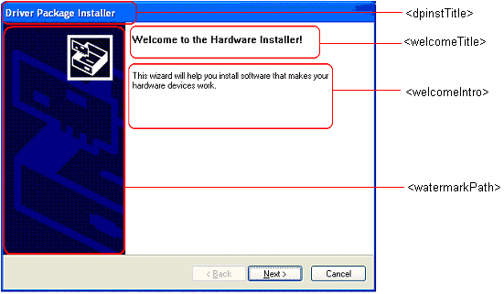
Figure 5. Customizing the welcome page.
Figure 6 is the custom welcome page for the toaster device whose DPInst descriptor file is listed earlier in this paper in “DPInst Descriptor File Example.”
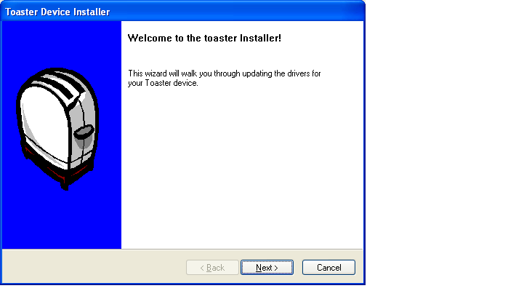
Figure 6. Custom toaster welcome page.
To replace the default bold font-style text in the title bar, include a dpinstTitle XML element. For example, the title bar text in figure 6 was customized by the following dpinstTitle element:
<dpinstTitle>Toaster Device Installer</dpinstTitle>

Note
The title text that is customized by a dpinstTitle XML element is used on the title bar of all the wizard pages.

To replace the default bold font-style text at the top of the welcome message, include a welcomeTitle XML element. For example, the welcome title text in figure 6 was customized by the following welcomeTitle element:
<welcomeTitle>Welcome to the toaster installer!</welcomeTitle>

To replace the default text in the body of the welcome message, include a welcomeIntro XML element. For example, the welcome introduction text in figure 6 was customized by the following welcomeIntro element:
<welcomeIntro>This wizard will walk you through updating the drivers for your Toaster device.</welcomeIntro>

To replace the default watermark bitmap that is displayed on the left side of the welcome page, include a watermarkPath XML element. If you do not specify a path for a replacement watermark bitmap file, the bitmap must be located, by default, in the same directory that contains DPInst.exe. If you specify a path, the path must be relative to the directory that contains DPInst.exe. The following example specifies that the replacement watermark bitmap file, which is shown in bold text, is located in the Data directory, which must be a subdirectory immediately under the directory that contains DPInst.exe.
<watermarkPath>Data\Watermark.bmp</watermarkPath>

Note
The watermark bitmap that is customized by a watermarkPath XML element is also used on the finish page.

For more information on XML elements, see “DPInst Descriptor File Reference” later in this paper.

Customizing the DPInst EULA Page
Figure 7 is an example of the default DPInst EULA page in the English (Standard) language. The callouts (for example, "<eulaHeaderTitle>") indicate the DPInst XML elements that you can use to customize the items on a DPInst EULA page.
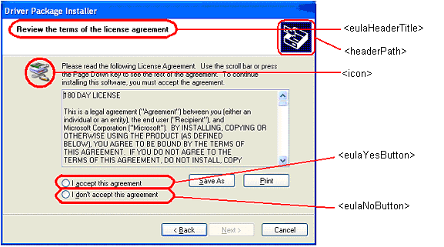
Figure 7. Customizing the EULA page.
Figure 8 is the custom DPInst EULA page for the toaster device whose DPInst descriptor file is listed earlier in this paper in “DPInst Descriptor File Example.”
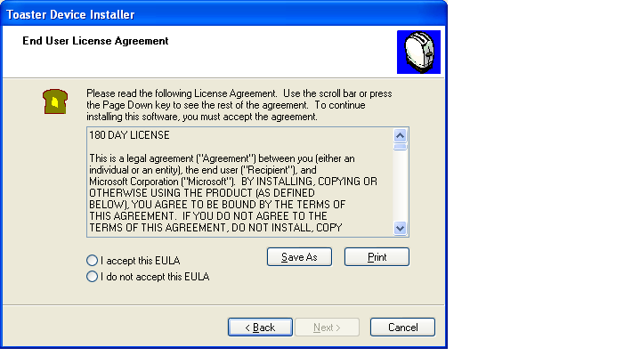
Figure 8. Custom toaster EULA page.
To replace the default bold font-style text for the header title on a EULA page, include a eulaHeaderTitle XML element. For example, the text for the EULA header title in figure 8 was customized by the following eulaHeaderTitle element:
<eulaHeaderTitle>End User License Agreement</eulaHeaderTitle>

To replace the default text that is associated with the acceptance option button on the EULA page, include a eulaYesButton XML element. For example, the text for the EULA acceptance option button in figure 8 was customized by the following eulaYesButton element:
<eulaYesButton>I accept this EULA</eulaYesButton>

To replace the default text that is associated with the do-not-accept option button, include a eulaNoButton XML element. For example, the text for the EULA do-not-accept option button was customized by the following eulaNoButton element:
<eulaNoButton>I do not accept this EULA</eulaNoButton>

To replace the default icon that is displayed on the EULA page, include an icon XML element. DPInst also uses the icon to represent DPInst on the Windows taskbar and desktop, and to represent the Add or Remove Programs entry for a driver package. If you do not specify a path for a replacement icon file, it must be, by default, in the same directory that contains DPInst.exe. If you specify a path, the path must be relative to the directory that contains DPInst.exe. The following example specifies that the replacement icon file for figure 8, which is shown in bold text, is located in the Data directory, which must be a subdirectory immediately under the directory that contains DPInst.exe.
<icon>Data\Eula.ico</icon>

To replace the header bitmap that appears in the upper-right corner of the EULA page, include a headerPath XML element. If you do not specify a path for a replacement header bitmap file, it must be, by default, in the same directory that contains DPInst.exe. If you specify a path, the path must be relative to the directory that contains DPInst.exe. The following example specifies that the replacement header bitmap file for figure 8, which is shown in bold text, is located in the Data directory, which must be a subdirectory immediately under the directory that contains DPInst.exe.
<headerPath>Data\Header.bmp</headerPath>

Note
The header bitmap that is customized by a headerPath XML element is also used on the installation page.

The title bar text “Toaster Device Installer” in figure 8 was customized by a dpinstTitle XML element. A dpinstTitle XML element customizes the title bar text that is shown on all wizard pages, and is discussed earlier in this paper in “Customizing the Welcome Page.”
For information on how to supply the EULA text, see “Specifying EULA Text” earlier in this paper.
For more information on XML elements, see “DPInst Descriptor File Reference” later in this paper.

Customizing the Installation Page
Figure 9 is an example of the default installation page. An installation page includes one XML element that you can customize.
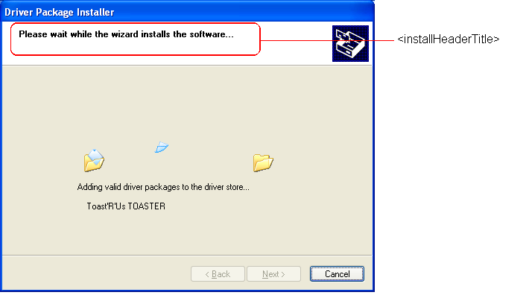
Figure 9. Customizing the installation page,
Figure 10 is the custom installation page for the toaster device whose DPInst descriptor file is listed earlier in this paper in “DPInst Descriptor File Example.”
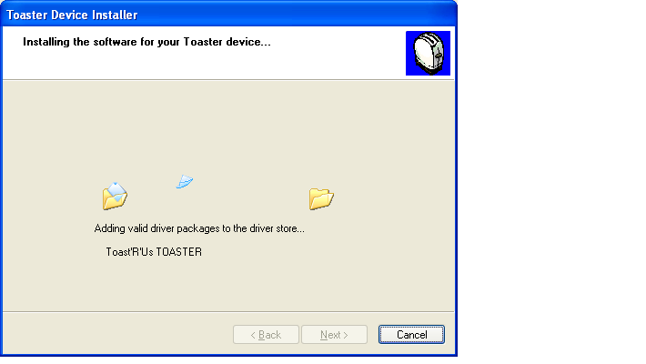
Figure 10. Custom toaster installation page.
To replace the default bold font-style text for the installation header title on an installation page, include an installHeaderTitle XML element. For example, the text for the installation header title in figure 10 was customized by the following installHeaderTitle element:
<installHeaderTitle>Installing the software for your Toaster device...</installHeaderTitle>

The title bar text “Toaster Device Installer” in figure 10 was customized by a dpinstTitle XML element. A dpinstTitle XML element customizes the title bar text that is shown on all wizard pages, and is discussed earlier in this paper in “Customizing the Welcome Page.”
The header bitmap, displayed on the upper-right corner of figure 10 was customized by a headerPath XML element. A headerPath XML element customizes the header bitmap on a DPInst EULA page and an installation page. This element is discussed earlier in this paper in “Customizing the DPInst EULA Page.”
For more information on XML elements, see “DPInst Descriptor File Reference” later in this paper.

Customizing the Finish Page
Figure 11 is an example of the default finish page in the English (Standard) language. The callouts (for example, "<finishTitle>") indicate the DPInst XML elements that you can use to customize items that are specific to a finish page.
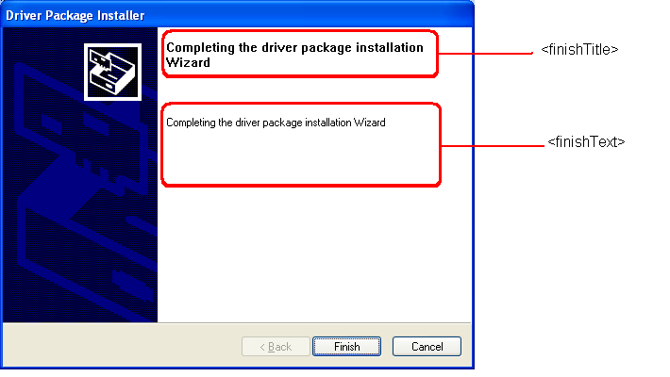
Figure 11. Customizing the finish page
Figure 12 is the custom finish page for the toaster device whose DPInst descriptor file is listed earlier in this paper in “DPInst Descriptor File Example.”
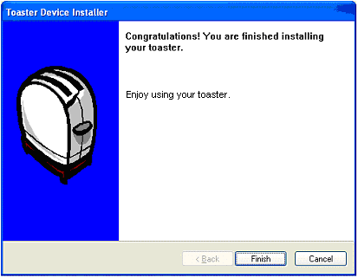
Figure 12. Custom toaster finish page.
To replace the default bold font-style text at the top of the finish page, include a finishTitle XML element. For example, the finish title text in figure 12 was customized by the following finishTitle element:
<finishTitle>Congratulations! You are finished installing your toaster.</finishTitle>

To replace the main text on the finish page, include a finishText XML element. For example, the finish text in figure 6 was customized by the following finishText element:
<finishText>Enjoy using your toaster.</finishText>

The title bar text “Toaster Device Installer” in figure 12 was customized by a dpinstTitle XML element. A dpinstTitle XML element customizes the title bar text that is shown on all wizard pages, and it is described earlier in this paper in “Customizing the Welcome Page.”
The watermark bitmap, displayed on the left side of figure 12 was customized by a watermarkPath XML element. A watermarkPath XML element customizes the watermark that is shown on the welcome and finish pages; this element is described earlier in this paper in “Customizing the Welcome Page.”
For more information on XML elements, see “DPInst Descriptor File Reference” later in this paper.

Setting DPInst Configuration Flags
DPInst supports configuration flags that you can use to:
- Suppress the display of wizard pages and other user messages.
- Display a dialog box that informs the user that a new driver is not a better match to a device than the driver currently installed on the device, and gives the user the option to replace the currently installed driver with the new driver.
- Install driver packages in an installation package only if all drivers in the installation package can be installed.
- Force the installation of a new driver on a device, even if the driver currently installed on a device is a better match for the device than the new driver.
- Suppress the addition of Add or Remove Programs entries that represent the driver packages that DPInst installs.
By default, the configuration flags are set to OFF. In most cases, you set a configuration flag to ON by including a corresponding DPInst XML element in a DPinst.xml file. Alternatively, you can set a configuration flag to ON by using a corresponding command-line switch.
For information about the DPInst XML elements, see “DPInst Descriptor File Reference” later in this paper. For information about the DPInst command-line switches, see “DPInst Command-Line Switches” later in this paper.

Setting the quietInstall Flag
By default, DPInst displays all wizard pages and other user messages that occur during an installation. Set the quietInstall flag to ON to configure DPInst to operate in a quiet-install mode. The quietInstall flag works in combination with the presence of an end-user license agreement (EULA) page and the suppressEulaPage flag in the following way:
- If a DPInst.xml file includes a eula XML element and the suppressEulaPage flag is set to OFF, DPInst displays the wizard pages and other messages whether or not you set the quietInstall flag to ON.
- If a DPInst.xml file does not include a eula XML element or the suppressEulaPage flag is set ON, DPInst operates in a quiet-install mode that suppresses the display of the wizard pages and most user messages, including the dialog box that informs a user that an installed driver is a better match than the one DPInst is installing, and the dialog box that informs a user that a system reboot is required to complete the installation of a driver package.
If DPInst is working in quiet-install mode, you can configure DPInst to install a driver on a device (even if the driver currently installed on the device is a better match than the new driver) by setting the forceIfDriverIsNotBetter flag to ON. The forceIfDriverIsNotBetter flag only works if DPInst is working in quiet-install mode.
The quiet-install mode does not suppress the driver dialog box that informs a user that a driver is unsigned and gives the user the option to cancel the installation.
If a system reboot is required to complete the installation of a driver, DPInst does not display a dialog box that informs the user that a reboot is required. Instead, DPInst returns the Win32® error code ERROR_SUCCESS_REBOOT_REQUIRED upon completion, which causes Windows to inform that user that a reboot is required.
By default, the quietInstall flag is set to OFF. Set the quietInstall flag to ON by including a quietInstall XML element as a child element of a dpinst XML element in a DPInst.xml file, or by using the /q command-line switch.
For more information about the suppressEulaPage flag and the forceIfDriverIsNotBetter flag, see “Setting the suppressEulaPage Flag” and “Setting the forceIfDriverIsNotBetter Flag” later in this paper.

Setting the suppressEulaPage Flag
By default, DPInst always displays a EULA page if one is specified by a eula XML element in a DPInst.xml file. Set the suppressEulaPage flag to ON to suppress the display of a EULA page. If the suppressEulaPage and quietInstall flags are both set to ON, DPInst suppresses the display of all wizard pages, including the EULA page.
DPInst copies the EULA page text to the driver store when the display of a EULA page is suppressed or not suppressed.
By default, the suppressEulaPage flag is set to OFF. Set the suppressEulaPage flag to ON by using a /s command-line switch.
For information about the quietInstall flag, see “Setting the quietInstall Flag” earlier in this paper.

Setting the promptIfDriverIsNotBetter Flag
By default, DPInst installs a new driver on a device only if the match between the new driver and the device is better than the match between the device and the driver currently installed on the device. DPInst does not inform a user that the new driver is not a better match to the device than the driver currently installed on the device. Set the promptIfDriverIsNotBetter flag to ON to configure DPInst to display a dialog box if a new driver is not a better match to a device than the driver currently installed on the device. The dialog box informs the user of this situation and gives the user the option to replace the currently installed driver with the new driver. DPInst does not display this message if the quietInstall flag is set to ON.
By default, the promptIfDriverIsNotBetter flag is set to OFF. Set this flag to ON by including a promptIfDriverIsNotBetter XML element as a child element of a dpinst XML element in a DPInst.xml file, or by using the /p command-line switch.

Setting the forceIfDriverIsNotBetter Flag
By default, DPInst only installs a driver on a device if the new driver is a better match to the device than the driver currently installed on the device. If DPInst is operating in quiet-install mode, you can set the forceIfDriverIsNotBetter flag to ON to force DPInst to install a driver on device even if the driver is not a better match than the driver currently installed on the device.
By default, the forceIfDriverIsNotBetter flag is set to OFF. Set the forceIfDriverIsNotBetter flag to ON by including a forceIfDriverIsNotBetter XML element as a child element of a dpinst XML element in a DPInst.xml file, or by using the /f command-line switch.
For more information about the quiet-install mode, see “Setting the quietInstall Flag” earlier in this paper.

Setting the installAllOrNone Flag
By default, DPInst installs all driver packages in an installation package that can be installed. If some driver packages cannot be installed, DPInst informs the user on the DPInst finish page which driver packages were installed and which drivers could not be installed. Set the installAllOrNone flag to ON to configure DPInst to install drivers in an installation package only if all the drivers in the installation package can be installed.
By default, the installAllOrNone flag is set to OFF. Set the installAllOrNone flag to ON by including a installAllOrNone XML element as a child element of a dpinst XML element in a DPInst.xml file, or by using a /i command-line switch.

Setting the suppressAddRemovePrograms Flag
By default, DPInst adds an Add or Remove Programs entry that represents each driver that it installs. Set the suppressAddRemovePrograms flag to ON to suppress adding Add or Remove Programs entries that represent the driver packages that DPInst installs.
By default, the suppressAddRemovePrograms flag is set to OFF. Set the suppressAddRemovePrograms flag to ON by including a suppressAddRemovePrograms XML element as a child element of a dpinst XML element in a DPInst.xml file, or by using a /sa command-line switch.

DPInst Descriptor File Reference
The DPInst descriptor file (DPInst.xml) is an optional XML file that you can include with a driver package to customize the installation of driver packages. The DPInst descriptor file must be located in the same directory as the DPInst executable (DPInst.exe) within the installation package. The descriptor file must be encoded using the UTF-8 standard, to support multilingual characters.
To create a UTF-8 encoded text file, open Notepad, on the File menu click Save As, and then in the Encoding box, select UTF-8.
The dpinst XML element is the root element in a descriptor file.
The XML elements that direct DPInst to search for INF files are search and subDirectory.
The language XML element is the parent element that localizes child elements that customize the text, the icon, and the bitmaps.
The XML elements that customize the text on a welcome page are dpinstTitle, welcomeIntro, and welcomeTitle.
The XML elements that customize the text on a EULA page are eula, eulaHeaderTitle, eulaNoButton, and eulaYesButton.
The installationHeaderTitle XML element customizes the text on an installation page.
The XML elements that customize the text on a finish page are finishText and finishTitle.
The XML elements that customize icons and bitmaps on the wizard pages are icon, headerPath, and watermarkPath.
The quietInstall XML element sets the quietInstall flag to ON, which configures DPInst to suppress the display of wizard pages and most other user messages.
The promptIfDriverIsNotBetter XML element sets the promptIfDriverIsNotBetter flag to ON, which configures DPInst to display a dialog box if a new driver is not a better match to a device than a driver currently installed on the device. The dialog box informs a user of this situation and provides an option to replace the driver that is currently installed on the device with the new driver.
The forceIfDriverIsNotBetter XML element sets the forceIfDriverIsNotBetter flag to ON, which configures DPInst to install a driver on a device even if the driver currently installed on the device is a better match than the new driver.
The installAllOrNone XML element sets the installAllOrNone flag to ON, which configures DPInst to install drivers only if all the drivers in an installation package can be installed.
The suppressAddRemovePrograms XML element sets the suppressAddRemovePrograms flag to ON, which configures DPInst to suppress the addition of Add or Remove Programs entries that represent the drivers that it installs.

dpinst XML Element
The dpinst element is the root XML element in a DPInst descriptor file that contains the child elements that customize driver installation.
Element Tag
<dpinst>
XML Attributes
None.
Element Information
Parent elements | None permitted.
Child elements | search (zero or more)  language (zero or more)  icon (zero or one)  headerPath (zero or one)  watermarkPath (zero or one)  quietInstall (zero or one)  promptIfDriverIsNotBetter (zero or one)  forceIfDriverIsNotBetter (zero or one)  installAllOrNone (zero or one)  suppressAddRemovePrograms (zero or one)
Data contents | None permitted.
Duplicate child elements | None permitted.

Comments
The following example includes an XML declaration element, followed by a dpinst root document element, which contains zero or more child elements indicated by the text "...".
<?xml version="1.0" ?>
<dpinst>
...
</dpinst>

Note
Because duplicate child elements are not permitted, each search child element of a dpinst element must be unique.

search XML Element
The search XML element directs DPInst to search recursively for INF files in specified subdirectories under the root directory in an installation package that contains DPInst.exe. Subdirectories are specified by one or more subdirectory child elements.
Element Tag
<search>
XML Attributes
None.
Element Information

Parent elements | dpinst
Child elements | subDirectory (zero or more)
Data contents | None permitted.
Duplicate child elements | None permitted.

Comments
The following is an example of a search element that contains one subDirectory element that specifies the subdirectory i386. The text that specifies the custom subdirectory is shown in bold font style:
<search>
<subDirectory>i386</subDirectory>
</search>

For other examples of using a search element that contains subDirectory elements, see “Specifying the Location of a Driver Package” earlier in this paper.
Note
Because duplicate child elements are not permitted, each subDirectory child element of a search element must be unique.

subDirectory XML Element
The subDirectory XML element specifies a subdirectory under the directory in an installation package that contains DPInst.exe. The subDirectory element is a child element of a search element.
Element Tag
<subDirectory>
XML Attributes
None.
Element Information

Parent elements | search
Child elements | None permitted.
Data contents | Specifies one or all subdirectories that are relative to the directory in an installation package that contains DPInst.exe, as follows:  A string that specifies a subdirectory.  The wildcard character "*", which specifies all subdirectories.
Duplicate child elements | None permitted.

Comments
The following is an example of a search element that contains one subDirectory element that specifies the subdirectory i386. The text that specifies the custom subdirectory is shown in bold font style:
<search>
<subDirectory>i386</subDirectory>
</search>

The following is an example of a search element that contains a subDirectory element that specifies all subdirectories. The “*” character that specifies all of the subdirectories is shown in bold font style:
<search>
<subDirectory>*</subDirectory>
</search>

For other examples of using a search element that contains subDirectory elements, see “Specifying the Location of a Driver Package” earlier in this paper.

language XML Element

Note
DPInst version 1.0 supports only the English (Standard) language. However, future versions of DPInst will support localization for many of the commonly used languages that Windows supports. To maintain compatibility with future versions of DPInst, you must also use a language element with DPInst version 1.0 to customize the English (Standard) text that appears on the wizard pages.

The language XML element customizes and localizes text that DPInst displays on its wizard pages. This element can also be used to localize the icon and the bitmaps that DPInst displays on its wizard pages. The icon is also used to represent DPInst on the Windows taskbar, Windows desktop, and the Add or Remove Programs entry for a driver package.
Element Tag
<language>
XML Attributes

Code | Identifies the English (Standard) language. The identifier can be in hexadecimal format (0x409) or decimal format (1033).

Element Information

Parent elements | dpinst
Child elements | eula (zero or one)  dpinstTitle (zero or one)  welcomeTitle (zero or one)  welcomeIntro (zero or one)  eulaHeaderTitle (zero or one)  eulaYesButton (zero or one)  eulaNoButton (zero or one)  installHeaderTitle (zero or one)  finishTitle (zero or one)  finishText (zero or one)
Data contents | None permitted.
Duplicate child elements | None permitted.

Comments
The following is an example of a language element that specifies the English (Standard) language and includes a localized dpinstTitle and welcomeTitle child element.
<language code=”0x0409”>
<dpinstTitle>Toaster Device Installer</dpinstTitle>
<welcomeTitle>Welcome to the toaster Installer!</welcomeTitle>
</language>

To view the default welcome page and a customized welcome page, see “Customizing the Welcome Page” earlier in this paper. If a dpinstTitle element is not specified, DPInst displays the default title bar text that appears on the default welcome page.

dpinstTitle XML Element
The dpinstTitle XML element customizes the bold font-style text that appears on the title bar of all the wizard pages.
Element Tag
<dpinstTitle>
XML Attributes
None.
Element Information

Parent elements | language
Child elements | None permitted.
Data contents | String that customizes the title bar text on all the wizard pages.
Duplicate child elements | None permitted.

Comments
The following example of a dpinstTitle element customizes the title bar text on all the wizard pages. The text that specifies the custom DPInst title is shown in bold font style:
<dpinstTitle>Toaster Device Installer</dpinstTitle>

To view the default welcome page and a customized welcome page, see “Customizing the Welcome Page” earlier in this paper. If a dpinstTitle element is not specified, DPInst displays the default title bar text that appears on the default welcome page.

welcomeIntro XML Element
The welcomeIntro XML element customizes the main text on the welcome page.
Element Tag
<welcomeIntro>
XML Attributes
None.
Element Information

Parent elements | language
Child elements | None permitted.
Data contents | String that customizes the main text on a welcome page.
Duplicate child elements | None permitted.

Comments
The following example of a welcomeIntro element customizes the main text on a welcome page. The text that specifies the custom welcome introduction is shown in bold font style:
<welcomeIntro>This wizard will walk you though updating the drivers for your Toaster device.</welcomeIntro>

To view the default welcome page and a customized welcome page, see “Customizing the Welcome Page” earlier in this paper. If a welcomeIntro element is not specified, DPInst displays the default main text that is shown on the default welcome page.

welcomeTitle XML Element
The welcomeTitle XML element customizes the bold font-style text of the welcome title that appears at the top of the welcome page.
Element Tag
<welcomeTitle>
XML Attributes
None.
Element Information

Parent elements | language
Child elements | None permitted.
Data contents | String that customizes the title text at the top of a welcome page.
Duplicate child elements | None permitted.

Comments
The following example of a welcomeTitle element customizes the title text on a welcome page. The text that specifies the custom welcome title is shown in bold font style:
<welcomeTitle>Welcome to the toaster Installer!</welcomeTitle>

To view the default welcome page and a customized welcome page, see figure 5 and figure 6 in “Customizing the Welcome Page” earlier in this paper. If a welcomeTitle element is not specified, DPInst displays the default welcome title that is shown on the default welcome page.

eula XML Element
The eula XML element is an empty XML element that includes two attributes that specify a EULA text file that contains custom text for the DPInst EULA page.
Element Tag
<eula>
XML Attributes

Type | Specifies the type of vendor-supplied EULA. The value must be set to the string "txt", which indicates a plain-text file.
Path | Specifies a string that identifies the name of the file that contains the text for a DPInst EULA page. The EULA text file must be encoded using UTF-8 encoding. The EULA file must be saved in the same directory that contains DPInst.exe, or a subdirectory under this directory. If the EULA file is in a subdirectory, you must specify a fully qualified file name that is relative to the directory that contains DPInst.exe.

Element Information

Parent elements | language
Child elements | None permitted.
Data contents | None permitted.
Duplicate child elements | None permitted.

Comments
The following is an example of a eula element that specifies the file Data\Eula409.txt that contains custom EULA text. The Eula409.txt file is in the \data directory, which must be a subdirectory relative to the directory in the installation package that contains DPInst.exe. The text that specifies the custom EULA file is shown in bold font style:
<eula type=”txt” path=”Data\Eula409.txt”/>

For another example of using a eula element, see “Specifying EULA Text” earlier in this paper.

eulaHeaderTitle XML Element
The eulaHeaderTitle XML element customizes the bold font-style text of the EULA header title that appears directly below the title bar on a DPInst EULA page.
Element Tag
<eulaHeaderTitle>
XML Attributes
None.
Element Information

Parent elements | language
Child elements | None permitted.
Data contents | String that customizes the title on a DPInst EULA page.
Duplicate child elements | None permitted.

Comments
The following example of a eulaHeaderTitle element customizes the header title of a DPInst EULA page. The text that specifies the custom header title is shown in bold font style:
<eulaHeaderTitle>End User License Agreement</eulaHeaderTitle>

To view the default DPInst EULA page and a custom DPInst EULA page, see figure 7 and figure 8 in “Customizing the DPInst EULA Page” earlier in this paper. If a eulaHeaderTitle element is not specified, DPInst displays the default EULA header title that is shown on the default DPInst EULA page.

eulaNoButton XML Element
The eulaNoButton XML element customizes the text that is associated with the do-not-accept option button on the DPInst EULA page.
Element Tag
<eulaNoButton>
XML Attributes
None.
Element Information

Parent elements | language
Child elements | None permitted.
Data contents | String that customizes the text that is associated with the do-not-accept option button on a DPInst EULA page.
Duplicate child elements | None permitted.

Comments
The following example of a eulaNoButton element customizes the do-not-accept option button text on a DPInst EULA page. The text that specifies the custom do-not-accept option button text is shown in bold font style:
<eulaNoButton>I do not accept this EULA</eulaNoButton>

To view the default DPInst EULA page and a customized EULA page, see figure 7 and figure 8 in “Customizing the DPInst EULA Page” earlier in this paper. If a eulaNoButton element is not specified, DPInst displays the default button text that is shown on the default DPInst EULA page.

eulaYesButton XML Element
The eulaYesButton XML element customizes the text that is associated with the accept option button on the DPInst EULA page.
Element Tag
<eulaYesButton>
XML Attributes
None.
Element Information

Parent elements | language
Child elements | None permitted.
Data contents | String that customizes the text that is associated with the accept option button on a DPInst EULA page.
Duplicate child elements | None permitted.

Comments
The following example of a eulaYesButton element customizes the accept option button text on a DPInst EULA page. The text that specifies the custom accept option button text is shown in bold font style:
<eulaYesButton>I accept this EULA</eulaYesButton>

To view the default DPInst EULA page and a customized EULA page, see figure 7 and figure 8 in “Customizing the DPInst EULA Page” earlier in this paper. If a eulaYesButton element is not specified, DPInst displays the default option button text that is shown on the default DPInst EULA page.

installHeaderTitle XML Element
The installHeaderTitle XML element customizes the bold font-style text of the installation header title that appears on an installation page.
Element Tag
<installHeaderTitle>
XML Attributes
None.
Element Information

Parent elements | language
Child elements | None permitted.
Data contents | String that customizes the title text of an installation page.
Duplicate child elements | None permitted.

Example
The following example of an installHeaderTitle element customizes the title text of an installation page. The text that specifies the custom install header title is shown in bold font style:
<installHeaderTitle>Installing the software for your Toaster device...</installHeaderTitle>

To view the default installation page and a customized installation page, see figure 9 and figure 10 in “Customizing the Installation Page” earlier in this paper. If an installHeaderTitle element is not specified, DPInst displays the default title text that is shown on the default installation page.

finishText XML Element
The finishText XML element customizes the main text that DPInst displays on the finish page.
Element Tag
<finishText>
XML Attributes
None.
Element Information

Parent elements | language
Child elements | None permitted.
Data contents | String that customizes the main text on a finish page.
Duplicate child elements | None permitted.

Comments
The following example of a finishText element customizes the main text on a finish page that DPInst displays for a successful installation. The text that specifies the custom finish text is shown in bold font style:
<finishText>Enjoy using your toaster.</finishText>

If a finishText element is not specified, DPInst displays default finish text that indicates whether the installation was a success or a failure. For more information on the finish page text, see “Displaying a Finish Page” earlier in this paper.
To view the default finish page and a customized finish page, see figure 11 and figure 12 in “Customizing the Finish Page” earlier in this paper.

finishTitle XML Element
The finishTitle XML element customizes the bold font-style text of the finish title that appears at the top of the finish page.
Element Tag
<finishTitle>
XML Attributes
None.
Element Information

Parent elements | language
Child elements | None permitted.
Data contents | String that customizes the title text at the top of a finish page.
Duplicate child elements | None permitted.

Example
The following example of a finishTitle element customizes the title text at the top of a finish page. The text that specifies the custom title text is shown in bold font style:
<finishTitle>Congratulations! You are finished installing your toaster.</finishTitle>

To view the default finish page and a customized finish page, see figure 11 and figure 12 in “Customizing the Finish Page” earlier in this paper. If a finishTitle element is not specified, DPInst displays the default title text that is shown on the default finish page.

icon XML Element
The icon XML element specifies the source file for a custom icon that DPInst displays on the DPInst EULA page. DPInst also uses this icon to represent DPInst on the Windows taskbar and desktop, and to represent the Add or Remove Programs entry for a driver package.
Element Tag
<icon>
XML Attributes
None.
Element Information

Parent elements | dpinst or language
Child elements | None permitted.
Data contents | String that specifies the source file that contains the icon that DPInst displays on a DPInst EULA page. The icon file must be located in the same directory that contains DPInst.exe or a subdirectory under this directory. If the icon file is in a subdirectory, you must specify a fully qualified file name relative to the directory that contains DPInst.exe.
Duplicate child elements | None permitted.

Comments
The following example of an icon element specifies Data\Small.ico as the source of a custom icon that DPInst displays on the DPInst EULA page. The text that specifies the custom icon file is shown in bold font style:
<icon>Data\Small.ico</icon>

If an icon element is not specified, DPInst displays a default icon.
To view the default icon that appears on the default DPInst EULA page, and a customized EULA page, see figure 7 and figure 8 in “Customizing the DPInst EULA Page” earlier in this paper. The position of this icon cannot be changed.

headerPath XML Element
The headerPath XML element specifies the source file name for a custom header bitmap that DPInst displays in the upper-right corner of the DPInst EULA page and DPInst installation page.
Element Tag
<headerPath>
XML Attributes
None.
Element Information

Parent elements | dpinst or language
Child elements | None permitted.
Data contents | String that specifies the file name of the header bitmap that DPInst displays in the upper-right corner of a DPInst EULA and installation page. The header bitmap file must be located in the same directory that contains DPInst.exe, or a subdirectory under this directory. If the header bitmap file is in a subdirectory, you must specify a fully qualified file name that is relative to the directory that contains DPInst.exe.
Duplicate child elements | None permitted.

Comments
The following example of a headerPath element specifies Data\Header.bmp as the header bitmap file that DPInst displays in the upper-right corner of a DPInst EULA page and an installation page. The text that specifies the custom header bitmap file is shown in bold font style:
<headerPath>Data\Header.bmp</headerPath>

If a headerPath element is not specified, DPInst displays a default bitmap.
To view the default header bitmap, the default finish page, and a customized finish page, see “Customizing the Finish Page” earlier in this paper.

watermarkPath XML Element
The watermarkPath element specifies the source file for a custom watermark bitmap that DPInst displays on the left side of the welcome and finish pages.
Element Tag
<watermarkPath>
XML Attributes
None.
Element Information

Parent elements | dpinst or language
Child elements | None permitted.
Data contents | String that specifies the name of the file that contains a watermark bitmap that DPInst displays on the left side of a welcome page and a finish page. The watermark file must be located in the same directory that contains DPInst.exe, or a subdirectory under this directory. If the watermark bitmap file is in a subdirectory, you must specify a fully qualified file name that is relative to the directory that contains DPInst.exe.
Duplicate child elements | None permitted.

Example
The following example of a watermarkPath element specifies Data\Watermark.bmp as the source of the watermark bitmap that DPInst displays on the left side of the welcome and finish pages. The text that specifies the custom watermark bitmap file is shown in bold font style:
<watermarkPath>Data\Watermark.bmp</watermarkPath>

If a watermarkPath element is not specified, DPInst uses a default watermark. To view the default watermark, the default welcome page, the default finish page, a customized welcome page, and a customized finish page, see figure 5 and figure 6 in “Customizing the Welcome Page” and figure 11 and figure 12 in “Customizing the Finish Page” earlier in this paper.

quietInstall XML Element
The quietInstall XML element sets the quietInstall flag to ON, which configures DPInst to suppress the display of wizard pages and most other user messages.
Element Tag
<quietInstall/>
XML Attributes
None.
Element Information

Parent elements | dpinst
Child elements | None permitted.
Data contents | None permitted.
Duplicate child elements | None permitted.

Comments
By default, the quietInstall flag is set to OFF. Set the quietInstall flag to ON by including a quietInstall XML element in a DPInst.xml file, or by using the /q command-line switch. The quietInstall flag works in combination with the presence of a EULA page and the suppressEulaPage flag, as described in “Setting the quietInstall Flag” and “Setting the suppressEulaPage Flag” earlier in this paper.
The following is an example of a quietInstall element.
<quietInstall/>

promptIfDriverIsNotBetter XML Element
The promptIfDriverIsNotBetter XML element sets the promptIfDriverIsNotBetter flag to ON, which configures DPInst to display a dialog box if a new driver is not a better match to a device than a driver currently installed on the device. The dialog box informs a user of this situation and provides an option to replace the driver that is currently installed on the device with the new driver.
Element Tag
<promptIfDriverIsNotBetter>
XML Attributes
None.
Element Information

Parent elements | dpinst
Child elements | None permitted.
Data contents | None permitted.
Duplicate child elements | None permitted.

Comments
By default, the promptIfDriverIsNotBetter flag is set to OFF. Set the promptIfDriverIsNotBetter flag to ON by including a promptIfDriverIsNotBetter XML element in a DPInst.xml file, or by using the /p command-line switch. For information about using this flag, see “Setting the promptIfDriverIsNotBetter Flag” earlier in this paper.
The following is an example of a promptIfDriverIsNotBetter element.
<promptIfDriverIsNotBetter>

forceIfDriverIsNotBetter XML Element
The forceIfDriverIsNotBetter XML element sets the forceIfDriverIsNotBetter flag to ON, which configures DPInst to install a driver on a device even if the driver currently installed on the device is a better match than the new driver.
Element Tag
<forceIfDriverIsNotBetter/>
XML Attributes
None.
Element Information

Parent elements | dpinst
Child elements | None permitted.
Data contents | None permitted.
Duplicate child elements | None permitted.

Comments
By default, the forceIfDriverIsNotBetter flag is set to OFF. Set the forceIfDriverIsNotBetter flag to ON by including a forceIfDriverIsNotBetter XML element in a DPInst.xml file, or by using the /f command-line switch. Setting the forceIfDriverIsNotBetter flag to ON only works if DPInst is operating in quiet-install mode. For information about using this flag, see “Setting the forceIfDriverIsNotBetter Flag” earlier in this paper. For information about quiet-install mode, see “Setting the quietInstall Flag” earlier in this paper.
The following is an example of a forceIfDriverIsNotBetter element:
<forceIfDriverIsNotBetter/>

installAllOrNone XML Element
The installAllOrNone XML element sets the installAllOrNone flag to ON, which configures DPInst to install drivers in a driver package only if all the drivers in the installation package can be installed.
Element Tag
<installAllOrNone>
XML Attributes
None.
Element Information

Parent elements | dpinst
Child elements | None permitted.
Data contents | None permitted.
Duplicate child elements | None permitted.

Comments
By default, the installAllOrNone flag is set to OFF. Set the installAllOrNone flag to ON by including an installAllOrNone XML element in a DPInst.xml file, or by using the /i command-line switch. For information about using this flag, see “Setting the installAllOrNone Flag” earlier in this paper.
The following is an example of an installAllOrNone element.
<installAllOrNone>

suppressAddRemovePrograms XML Element
The suppressAddRemovePrograms XML element sets the suppressAddRemovePrograms flag to ON, which configures DPInst to suppress the addition of Add or Remove Programs entries that represent the drivers that it installs.
Element Tag
<suppressAddRemovePrograms/>
XML Attributes
None.
Element Information

Parent elements | dpinst
Child elements | None permitted.
Data contents | None permitted.
Duplicate child elements | None permitted.

Comments
By default, the suppressAddRemovePrograms flag is set to OFF. Set the suppressAddRemovePrograms flag to ON by including a suppressAddRemovePrograms XML element in a DPInst.xml file, or by using the /sa command-line switch. For information about using this flag, see “Setting the suppressAddRemovePrograms Flag” earlier in this paper.
The following is an example of a suppressAddRemovePrograms element.
<suppressAddRemovePrograms/>

DPInst Command-Line Switches
DPInst supports the following command-line switches that set the DPInst configuration flags that are described earlier in this paper in “Setting DPInst Configuration Flags.”
/q
Sets the quietInstall flag to ON, which suppresses the display of DPInst wizard pages and other user messages. The quietInstall flag works in combination with the presence of a EULA page and the suppressEulaPage flag, as described earlier in this paper in “Setting the quietInstall Flag” and “Setting the suppressEulaPage Flag.”
/s
Sets the suppressEulaPage flag to ON, which configures DPinst to suppress the display of a EULA page. For more information, see “Setting the suppressEulaPage Flag” earlier in this paper.
/p
Sets the promptIfDriverIsNotBetter flag to ON, which configures DPInst to display a dialog box if a new driver is not a better match to a device than a driver currently installed on the device. The dialog box informs a user of this situation and provides an option to replace the driver that is currently installed on the device with the new driver. For more information, see “Setting the promptIfDriverIsNotBetter Flag” earlier in this paper.
/f
Sets the forceIfDriverIsNotBetter flag to ON, which configures DPInst to install a driver on a device even if the driver currently installed on the device is a better match than the new driver. Setting the forceIfDriverIsNotBetter flag to ON only works if DPInst is operating in quiet-install mode. For more information, see “Setting the forceIfDriverIsNotBetter Flag” earlier in this paper.
/i
Sets the installAllOrNone flag to ON, which configures DPInst to install drivers in a driver package only if all the drivers in the installation package can be installed. For more information, see “Setting the installAllOrNone Flag” earlier in this paper.
/sa
Sets the suppressAddRemovePrograms flag to ON, which configures DPInst to suppress the addition of Add or Remove Programs entries that represent the drivers that it installs. For more information, see “Setting the “suppressAddRemovePrograms Flag” earlier in this paper.

Examples
The following command line configures DPInst to operate in quiet-install mode. Quiet-install mode always suppresses the wizard pages and most other user messages:
dpinst.exe /q /s

The following command line suppresses the display of all wizard pages only if a eula element is not included in a DPInst.xml file:
dpinst.exe /q

The following command line only suppresses the display of the EULA page:
dpinst.exe /s

The following command line suppresses the display of all wizard pages, nearly all user messages, and forces the installation of a driver on a device, even if the currently install driver is a better match to the device than the new driver:
dpinst.exe /q /s /f

Driver Support
The Microsoft® Windows® Driver Package Installer (DPInst) supports the following types of drivers:
- File system drivers and file system filter drivers. For information about these types of drivers, see the Windows Installable File System Kit (IFS).
- Class filter drivers, bus drivers, and function drivers for Plug and Play devices. For information about these types of drivers, see “Types of WDM Drivers” in the Microsoft Windows Driver Development Kit (DDK).
- Network drivers for the following device setup classes: Net, NetClient, NetTrans, and NetService. For information about these types of drivers, see “Using the Network Driver Design Guide” in the DDK.
- Drivers that implement a kernel-mode service that is managed by the Service Control Manager (SCM), but is not associated with a device in the device tree. In the remainder of this paper, these drivers are referred to as kernel service drivers. For information about kernel service drivers, see “INF DefaultInstall Section” in the DDK and “Service Control Manager” in the Windows Platform SDK.
- Export drivers that implement a kernel-mode module that is not associated with a SCM-managed service or a device in the device tree. For information about these types of drivers, see “Creating Export Drivers” in the DDK.
DPInst does not support root-enumerated drivers, device filter drivers, or drivers for software-enumerated devices. For information about these types of drivers, see “IoReportDetectedDevice,” “Types of WDM Drivers,” and “Runonce Registry Entries” in the DDK.
For file system drivers, file system filter drivers, class filter drivers, and kernel service drivers, DPInst maintains a service-driver-packages list that associates a service with the driver packages that support the service. DPInst uses this information to update the driver installed for a service when the currently installed driver for a service is removed. For more information, see “Associating Services and Driver Packages” later in this paper.
How DPInst installs and removes a driver package depends on the driver type. For more information, see “Installing Driver Packages” and “Removing Driver Packages” later in this paper.
Finally, for information about how DPInst reverses system changes if a driver package installation or removal fails, see “Reversing System Changes” later in this paper.

Associating Services and Driver Packages
For file system drivers, file system filter drivers, class filter drivers, and kernel service drivers, DPInst manages a service-driver-packages list that associates a service with the driver packages that support the service. When DPInst installs a new driver package for a service, it adds the driver package to the service-driver-packages list and then updates the service with the driver package. When DPInst removes a driver package, DPInst removes the driver package from the service-driver-packages list. When DPInst removes the currently installed driver package for a service, DPInst reinstalls the most recently installed driver package in the service-driver-packages list that it can install.
DPInst does not use a service-driver packages list for export drivers because export drivers implement kernel-mode modules that are not associated with a Service Control Manager (SCM)-managed service or a device in the device tree.
DPInst does not use a service-driver-packages list to determine which driver package to install for a network service. Instead, DPInst uses the INetCfgClassSetup network interface to install and remove driver packages. INetCfgClassSetup uses an internal mechanism to select which driver packages are installed for network services. For more information about INetCfgClassSetup, see “INetCfgClassSetup” in the DDK.
DPInst does not use a service-driver-packages list to determine which driver package to install on a Plug and Play device. Instead, DPInst uses the standard Plug and Play and SetupAPI mechanisms to select and install the best compatible driver on a Plug and Play device. For more information, see “Example PnP Device Installation” and “How Setup Selects Drivers” in the DDK.
For more information about how DPInst installs and removes driver packages, see “Installing Driver Packages” and “Removing Driver Packages” later in this paper.

Installing Driver Packages
DPInst does the following during the installation of a driver:
- Copies the driver package files from the temporary location of the source files to the Driver Store. (The Driver Store is a repository for driver packages that is located on the system disk and is internally managed by DPInst, Microsoft Windows Driver Install Frameworks for Applications (DIFxApp), and other Microsoft Windows Driver Install Frameworks (DIFx) tools).
If the driver is a network driver or a Plug and Play device driver and the driver’s INF file is not already installed in the system INF directory, DPInst copies the driver’s INF file to the system INF file directory. DPInst changes the location of the media source to the location of the driver package files in the Driver Store.
- For class filter drivers, file system drivers, file system filter drivers, and kernel service drivers, DPInst processes the DefaultInstall and DefaultInstall.Services sections in the driver’s INF file to install the driver and the service. For information about these INF file sections, see “INF DefaultInstall.Services Section” and “INF DefaultInstall Section” in the DDK.
After installing a class filter driver, DPInst attempts to stop and restart devices that belong to the corresponding device setup class. When the Plug and Play manager restarts a device in the device setup class, it adds the new class filter driver to the device’s driver stacks. If it is necessary to restart the computer to complete the installation, DPInst prompts the user to restart the computer.
For file system drivers and file system file drivers, DPInst prompts the user to restart the computer. (It is always necessary to restart a computer to complete the installation of these types of drivers.)
For kernel service drivers, DPInst starts the service that is supported by the driver.
- For a network driver, DPInst calls INetCfgClassSetup::Install to install the driver. For more information about INetCfgClassSetup::Install, see “INetCfgClassSetup::Install” in the DDK.
- For Plug and Play device drivers, DPInst installs the driver on devices if the driver is the best compatible driver for the device. DPInst also supports forcing the installation of a new driver on a device even if the driver currently installed on the device is a better match than the new driver. For information about forcing the installation of Plug and Play device drivers, see “Setting the forceIfDriverIsNotBetter flag” earlier in this paper. For information on how Plug and Play selects drivers for a device, see “How Setup Selects Drivers” in the DDK.
- For class filter drivers, file system drivers, file system filter drivers, and kernel service drivers, DPInst adds the driver package to the service-driver-packages list that associates a service with the driver packages that support the service. For more information about these associations, see “Associating Services and Driver Packages” earlier in this paper.
- Adds an Add or Remove Programs entry that can be used to remove the driver package.

Removing Driver Packages
DPInst does not remove a driver package if it is associated with an application that was installed by Microsoft® Windows® Driver Install Frameworks for Applications (DIFxApp). When DIFxApp installs an application that represents a driver package, it creates an association between the application and the driver package. DPInst determines whether a driver package was installed by DIFxApp by checking if such an association exists. For more information about these associations, see “Associating Services, Driver Packages, and Applications” in the “Driver Install Frameworks for Applications (DIFxApp)” white paper that is provided with the DIFxApp tool.
If the driver package is not associated with other applications, how DPInst removes the driver package depends on the type of driver.

Removing Export Drivers
DPInst does the following to remove an export driver package:
- Removes the driver package from the Driver Store.
- Removes the entry that represents the driver package in Add or Remove Programs.

Removing Class Filter Drivers, File System Filter Drivers, File System Drivers, and Kernel Service Drivers
How DPInst removes these driver packages partly depends on the driver type and the status of the driver package. However, in all cases, DPInst performs the following generic-removal operations:
- Removes the driver package from the Driver Store.
- Deletes the corresponding entry for the driver package in Add or Remove Programs.
For a class filter driver, DPInst also removes the service name from the UpperFilters or LowerFilters entry value that is located under the registry key for the corresponding device setup class. DPInst also stops and restarts all devices in the device setup class.
In addition to the generic-removal operations and driver-type-specific operations, DPInst completes the following operations if the driver package is currently installed for the service that it supports:
- If DPInst can reinstall another driver package that DPInst previously installed for the service, DPInst reinstalls the most recently installed driver package that it can install for the service.
- If DPInst cannot reinstall another driver package that DPInst previously installed for the service, DPInst warns the user of this situation and provides an option to retain the service. If the user elects to keep the service, DPInst does not remove the service; otherwise, DPInst removes the service. Whether or not the user elects to retain the service, DPInst removes the driver package from the driver store.
DPInst cannot reinstall a driver package for a service in the following two situations:
- The driver package is the only driver package in the Driver Store that supports the service, and the service was not originally installed by DPInst.
- There are other driver packages in the Driver Store that support the service, but DPInst could not successfully reinstall any of them for the service.

Removing Network Drivers
DPInst does the following to remove a network driver package:
- Removes the driver package INF file from the system INF file directory.
- Calls INetCfgClassSetup::DeInstall to uninstall the driver package. For more information about INetCfgClassSetup::DeInstall, see “INetCfgClassSetup::DeInstall” in the DDK.
- Removes the driver package from the Driver Store.
- Removes the entry that represents the driver package in Add or Remove Programs.

Removing Plug and Play Drivers
DPInst does the following to remove a Plug and Play device driver package:
- Removes the driver package INF file from the system INF file directory.
- Removes the driver from all devices on which it is installed and then, from among all other drivers installed on a computer, installs the best compatible driver for each device. If there is no other compatible driver for a device, DPInst removes the device from the device tree.
- Removes the driver package from the Driver Store.
- Removes the entry that represents the driver package in Add or Remove Programs.

Reversing System Changes
If the installation of a driver package fails, DPInst reverses the system changes it made for that driver package. If the installation of a driver package fails after DPInst installed other driver packages in the same installation package, DPInst also removes the driver packages that it installed before the installation of the driver package failed. The system changes that DPInst can reverse are the system changes that DPInst makes when it removes a driver package. For more information about these system changes, see “Removing Driver Packages” earlier in this paper.
If the DPInst cannot successfully remove a driver package, DPInst reinstalls the driver package and restores the system state that existed before DPInst attempted to remove the driver package.
If a driver package is installed and a subsequent reinstall fails, DPInst does not reverse changes that it makes to the installation of the driver package during the failed reinstall. The net effect is that the state of the driver package installation is unchanged if a reinstall fails.

Testing and Debugging an Installation Package
The Microsoft® Windows® Driver Package Installer (DPInst) provides the following support for testing and debugging installation packages:
Logging installation information and error messages
DPInst logs high-level installation information and error messages in a log file (%windir%\Dpinst.log). The DPInst log file is a plain-text file that you can use to troubleshoot DPInst driver installation.
Installation of unsigned driver packages for testing purposes
If you attach a kernel debugger to the system and set the environment variable _DFX_INSTALL_UNSIGNED_DRIVER to 1, DPInst will install unsigned driver packages. DPInst does not verify that the package is signed and does not check for the presence of a catalog file for the package.

Known Bugs and Limitations
DPInst has the following known bugs and limitations.
Slow signature checking on Windows 2000
Depending on how a driver package was signed, verifying a signature can be slow on Microsoft® Windows® 2000. To speed up signature verification, install the Windows 2000 update that is described in the Knowledge Base article 329433.
While a signature is being verified, DPInst displays a dialog box that informs the user that the signature is being verified by Windows 2000.
Supports only a single distribution disc
If you distribute an installation package on a distribution disc such as a CD-ROM, all the source files for the installation package must be contained on only one distribution disc. DPInst does not prompt the user to insert distribution discs to locate source files.

Using the IExpress Wizard to Create a DPInst Installation Package
Before you run the Microsoft® Windows® IExpress Wizard to create a DPInst installation program, gather the following files:
- DPinst.exe.
- The driver package files.
- A DPInst.xml file. (A DPinst.xml file is required only if you customize how DPInst installs driver packages.)
- A command-line script file. (A command-line script file is required only if the driver package INF files are configured to locate source files in directories other than the directory that contains the INF files. For more information about this requirement, see “Creating a Command-Line Script” later in this paper.)
After you gather the necessary files, run the IExpress Wizard and complete the following sequence of steps (to run the IExpress Wizard, click Run on the Start menu, type IExpress in the command-line box, and then press ENTER):
- On the Welcome to IExpress page, select Create new Self Extraction Directive file, and then click Next.
- On the Package Purpose page, select Extract files and run an installation command, and then click Next.
- On the Package title page, enter the name of the package, and then click Next.
- On the Confirmation prompt page, select No prompt, and then click Next.
- On the License agreement page, select the desired option, and then click Next.
- On the Packaged files page, in the list box, add DPInst.exe, DPInst.xml, and the driver package files. If you need to supply a command-line script file to create a subdirectory structure, add the command-line script file. After adding all the installation files, click Next.
- On the Program to launch page, if you do not need to supply a command-line script file to create a subdirectory structure, enter DPInst.exe in the Install Program box and do not enter anything in the Post Install Command box. If you need to supply a command-line script file to create a subdirectory structure, enter the name of the command-line script file in the Install Program box and enter DPinst.exe in the Post Install Command box. After entering the programs to launch, click Next.
- On the Show Window page, select how the installation program will be displayed, and then click Next.
- On the Finish Message page, select No message, and then click Next.
- On the Package Name and Options page, enter the name of the installation package and the target destination for the package. Also select the desired options, and then click Next.
- On the Configure restart page, select how you want the system to restart after the end of the installation program, and then click Next.
- On the Save Self Extraction Directive page, select the option you want, and then click Next.
- On the Create Package page, click Next. After the wizard informs you that it finished creating the installation program, click Finish.
For more information on the IExpress Wizard, go to http://www.microsoft.com/windows/ieak/techinfo/deploy/60/en/iexpress.htm.

Creating a Command-Line Script
If the driver package INF files are configured to locate source files in subdirectories other than the directory that contains the INF files, you must include a command-line script file that creates the subdirectory structure and copies the files to the subdirectories. This is required because the IExpress Wizard does not maintain the subdirectory structure of the files that you add to the installation program. Instead, the IExpress Wizard treats all files as if they came from the same directory.
INF files are commonly configured to locate binary executable files in subdirectories with names like “i386”, “AMD64”, as well as other possible names. The following example shows the contents of a simple command-line script (a *.cmd file) that creates an i386 subdirectory, and then copies files to the subdirectory.
@md i386
@xcopy /q /y toastva.exe i386\.
@xcopy /q /y tostrcls.dll i386\.
@xcopy /q /y tostrco2.dll i386\.
@xcopy /q /y toaster.sys i386\.

For information on how to configure the installation program to run a simple command-line script of this type before the installation program runs DPInst, see steps 6 and 7 in “Using the IExpress Wizard to Create a DPInst Installation Package” earlier in this paper.

Call to Action and Resources

Call to Action
- For device manufacturers and driver package providers: Use Microsoft® Windows® Driver Package Installer (DPInst) to simplify and customize the software-first installation of signed driver packages on Windows 2000 and later versions.
- If you have questions about DPInst, send an e-mail message to hwux@microsoft.com.

Resources
Microsoft Windows Driver Install Frameworks
http://www.microsoft.com/whdc/hwdev/driver/hwuxtools.mspx
Improving Driver Installation in Windows
http://www.microsoft.com/whdc/hwdev/driver/setup/installtools.mspx
Designed for Microsoft Windows XP Application Specification
http://www.microsoft.com/winlogo/software/downloads.mspx
Microsoft Hardware and Driver Developer Information
http://www.microsoft.com/whdc/hwdev/default.mspx
Microsoft Platform Software Development Kit (SDK)
http://msdn.microsoft.com/downloads/
Microsoft Windows Driver Development Kit (DDK)
http://www.microsoft.com/whdc/ddk/winddk.mspx
Microsoft Windows Logo Program System and Device Requirements
http://www.microsoft.com/whdc/winlogo/downloads.mspx
Microsoft Windows Application Compatibility Toolkit
http://msdn.microsoft.com/compatibility/
Microsoft Windows Hardware Compatibility Test Kit
http://www.microsoft.com/whdc/hwtest/default.mspx

