

FAMILIAR

Microsoft Dynamics

Extending business solutions across the organization

White Paper

Date: May 2007

<http://www.microsoft.com/dynamics>

Contents

Executive Summary 3

Overview 4

Microsoft Dynamics Client for Microsoft Office and SharePoint Server 6

Meeting Business Challenges with Microsoft Dynamics Client for Microsoft Office 8

Meeting Growth Challenges 9

Meeting Customer Challenges 11

Meeting People Challenges 13

Meeting Operational Challenges 15

Extending your Microsoft Dynamics Solutions 17

# Executive Summary

The ability to identify and respond to significant business challenges is a characteristic shared by many top executives. Business challenges can be encountered in all areas of an organization, from controlling costs, improving processes, hiring and retaining the best people, expanding into new markets, or improving customer satisfaction. While there are numerous ways to respond to these challenges, information technology (IT) often plays a vital role in helping to meet the challenges head-on.

Two common areas of IT investment for companies are personal productivity software and business management solutions software. Personal productivity software, such as the Microsoft® Office system, runs on the desktop computers used by many employees, and is used for a wide variety of tasks such as creating documents, planning projects, analyzing information, and communicating and collaborating with others. Business management solutions software is often run from a central location and is used to capture, track, manage, record and report on many of the business events and activities in which the firm is engaged.

Historically, these two areas of IT investment have existed independently of one another, and have had dramatically different deployment and adoption rates. Personal productivity software is distributed and used very widely across organizations, running on the vast majority of desktops. Usage of business management solutions, on the other hand, is more concentrated, as they are typically deployed to just 7% to 8% of desktops[1].

It can be difficult for companies to overcome business challenges when many of their employees are not connected to the information and processes in their business management solution. By using Microsoft Dynamics™ Client for Microsoft® Office and SharePoint® Server to connect Microsoft Dynamics more closely with personal productivity solutions, you can help individuals in your company respond quickly and efficiently to business challenges.

# Overview

Traditionally, the main modules of business management solutions were focused on specific audiences, such as certain roles within finance, sales operations, inventory management, and human resources. Over the last twenty years these modules have evolved into today’s powerful, integrated solutions that manage and control many aspects of a business’ operations. However, while the functionality of these applications has grown considerably, the percentage of people who access them has not.

According to a recent research report by AMR[2], many companies still rely on a core group of “power users” to access their business management solutions. The AMR study found that on average 85% of employees within a company do not have a license to their business management solution. Of the remaining 15% who do have a license, just over half of them have had the business management software deployed to their computers. This means that the vast majority of employees are relying on power users to not only process transactions, but also to extract business information on their behalf. The net result is that all too often valuable information remains locked-up within these business management solutions.

In today’s fast-moving business environment, restricting access to critical business information can limit organizational agility, as well as the ability of companies to make the right decisions based on the best available business insights. A lack of agility can hamper the efforts of senior executives to respond swiftly to significant challenges that are faced by many companies today. These include:

* Growth challenges: Increasing market share; improving margins; responding to competition; introducing new products.
* Customer challenges: Delivering outstanding customer service and support; improving customer satisfaction to earn their repeat business
* People challenges: Ensuring that individual productivity is maximized; recruiting and retaining the best talent available; communicating consistently and broadly across the organization
* Operational challenges: Controlling costs; improving processes; managing information

Two common approaches for executives to manage these challenges include providing employees with the tools to make better-informed decisions, and more closely connecting people with business processes. Both of these approaches require broad employee access to business management solutions.

The diagram on the following page illustrates some examples of roles that could benefit from being more closely connected to their business information.

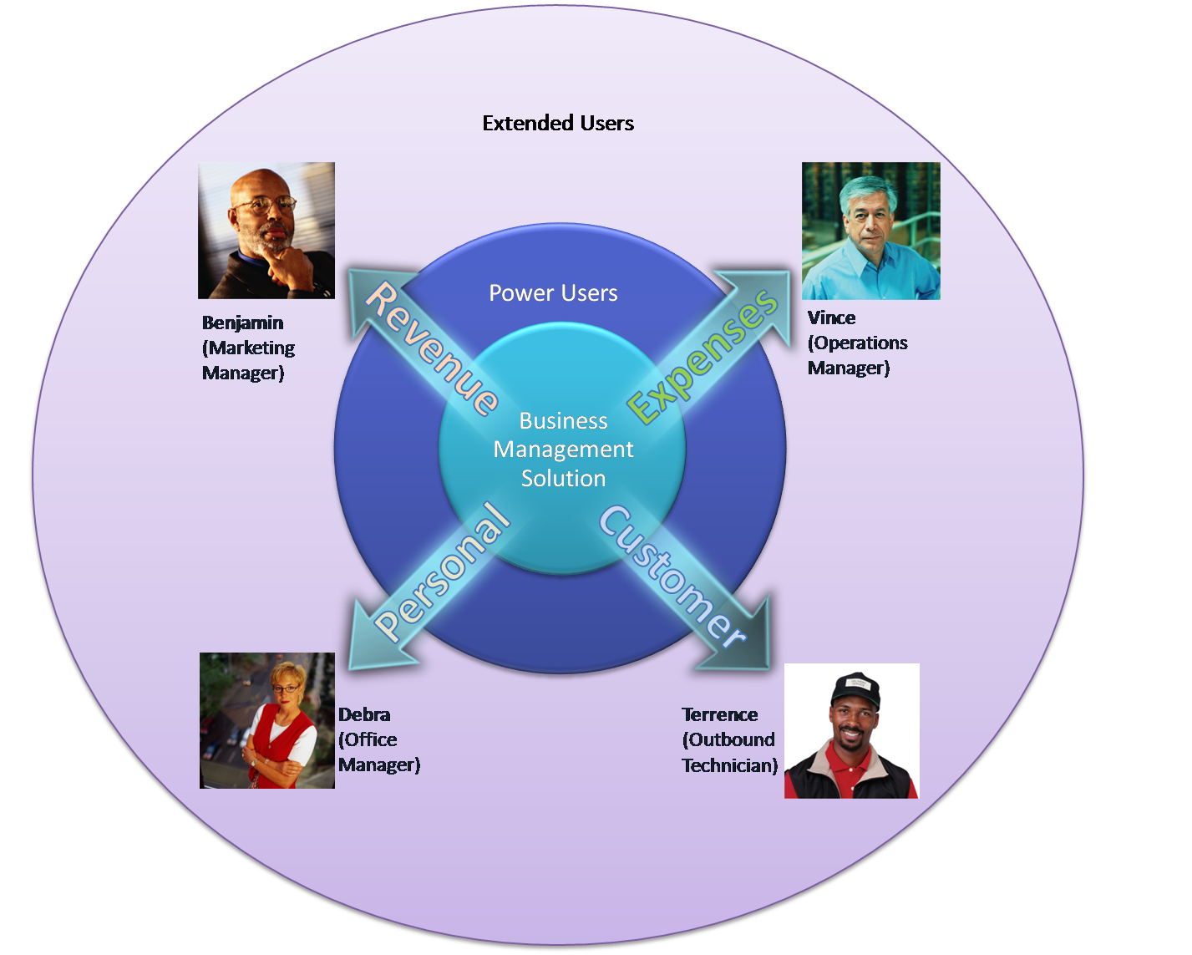

As this diagram shows, there is often a core group of power users who are the primary intermediary between the business management solution and other employees (“Extended Users”) throughout the company. Power users often end up being thought of as gatekeepers: they are the people who control what goes into, and what comes out of, these applications. IT professionals may also be cast as gatekeepers if they are responsible for writing the reports that deliver business information. As the arrows show, business management solutions are the system of record for essential financial data such as revenue and expenses, and also customer information and employees’ own personal records. Also shown are some typical roles that could benefit from accessing this information. However, all too often they are hindered from doing so.

This white paper illustrates ways that Microsoft Dynamics Client for Microsoft Office and SharePoint Server can help your company effectively respond to business challenges by providing employees with easy access to the information they need, and connecting them to processes managed by their business management solution.

# Microsoft Dynamics Client for Microsoft Office and SharePoint Server

Microsoft Dynamics Client for Microsoft Office and SharePoint Server extends the power, insights and process control of Microsoft Dynamics business management solutions to all employees via a number of self service applications. These applications include Office Business Applications that use familiar Microsoft Office system desktop productivity tools such as Microsoft® Office Excel®, Microsoft® Office Outlook® and Microsoft® Office Word. Other applications use Windows® SharePoint® Services or Microsoft® Office SharePoint® Server 2007 technology that provides portals and role-tailored team collaboration sites. The main components of the package are:

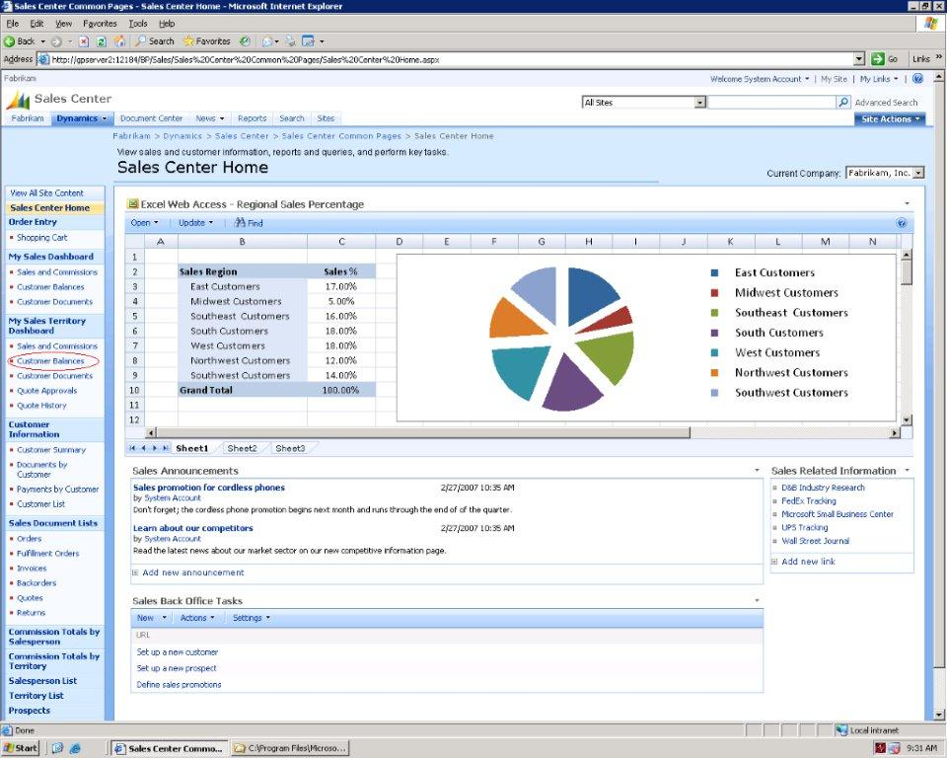

**Microsoft Dynamics Portal** functionality provides role-tailored access to information and processes from a Web browser. Portals integrate seamlessly with Microsoft Dynamics applications, and can be used by employees across the organization.

*Microsoft Dynamics GP Business Portal*

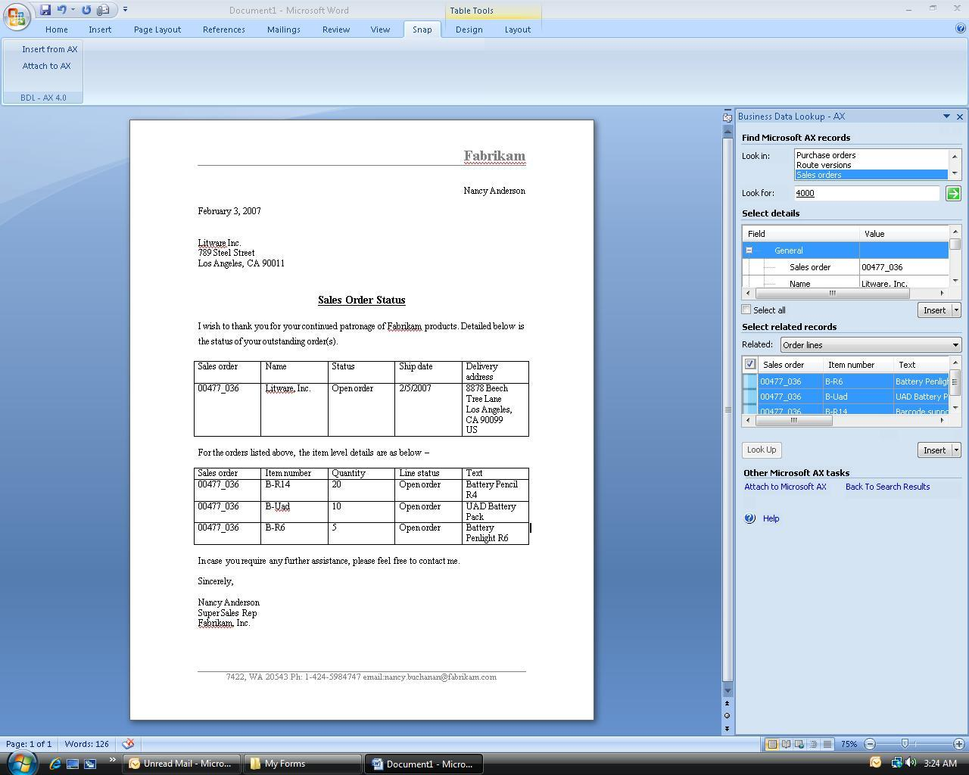

**Microsoft Dynamics Snap[3]** is a collection of Office Business Applications that are built to plug into Microsoft Office system products such as Office Outlook, Office Excel and Office Word. They provide timely and accurate access to Microsoft Dynamics information without having to leave the Microsoft Office system.

*Microsoft Dynamics Snap: Business Data Lookup*

**Microsoft FRx DrillDown Viewer and WebPort[4]**  
are industry-leading, automated financial reporting   
and analysis applications. Executives and managers  
across the organization can use them to make   
decisions based on the financial performance of the company.

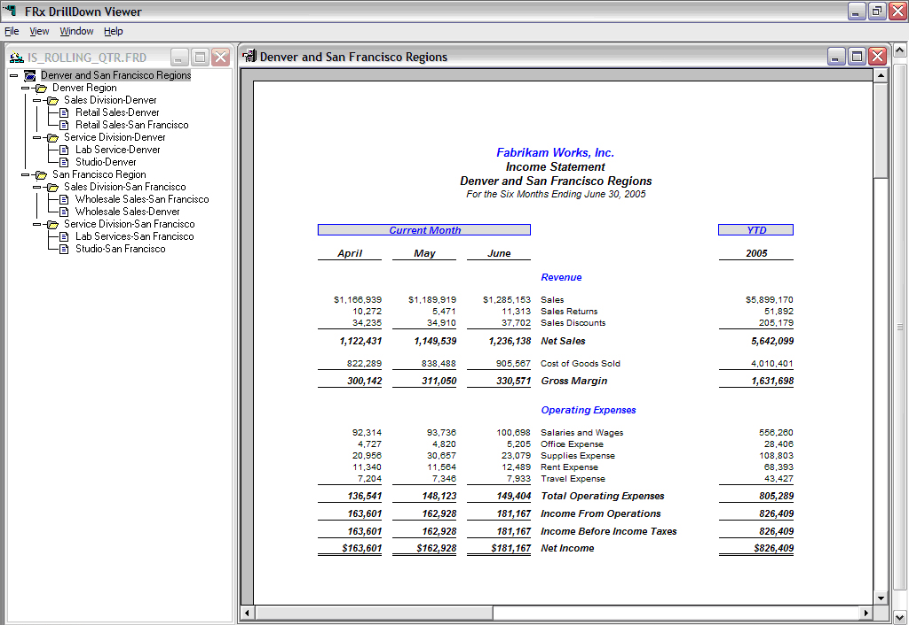

*Microsoft FRx Drilldown Viewer*

Two versions of the package are available. Microsoft Dynamics Client for Microsoft Office and Windows SharePoint Services is the standard version that includes all of the modules listed above. Microsoft Dynamics Client for Microsoft Office and SharePoint Server is the premium version that adds a license to Office SharePoint Server 2007. This provides an integrated suite of server capabilities with comprehensive content management, search, business process management, information-sharing capabilities, and business insights, and has pre-built integration with Microsoft Dynamics products such as Microsoft Dynamics™ GP 10.0. Both versions are priced at a significant discount to the Dynamics full access user license, with the objective of encouraging company-wide deployment.

In addition to using the self-service applications that are included in the Microsoft Dynamics Client for Microsoft Office package, companies can also create their own Office Business Applications (OBA’s) to further extend the information and processes in their business management solution. OBA’s are a new industry wave of composite applications that combine the capabilities of the Microsoft Office system, including client, server, services, and tools, with business management solutions. For employees, this makes it easier for them to continue using the Microsoft Office system products with which they are already comfortable and familiar, while accessing and incorporating up-to-date information from their business management solution.

Together, the self service applications and Office SharePoint Server can be used to help meet the business challenges that are outlined in the following sections.

# Meeting Business Challenges with Microsoft Dynamics Client for Microsoft Office

Microsoft makes significant investments to understand our customers. Over the course of a year we conduct usability and research studies involving 10,000 participants in 43 Microsoft Usability Labs. We also conduct more than 1,700 annual customer site visits where we see people in their own environments and observe their work styles and behaviors.

This research has resulted in the **Microsoft Dynamics Customer Model** that describes how people perform their work within and across organizations. “Personas” from the Customer Model are used in this white paper to identify examples of roles that would benefit from being more connected to their business management solutions.

The following sections describe key business challenges faced by many organizations today and illustrate how the Microsoft Dynamics Client for Microsoft Office can help meet those challenges. The challenges were identified as a result of internal Microsoft research conducted in 2006 that identified recurring themes or issues that were faced by many companies regardless of size, industry or geography.

The research found that senior executives were focused on four primary areas:

* Growth
* Customers
* People
* Operations

In each of these areas, executives are pushing for improvements – growing revenue and market share more quickly; delivering higher levels of customer satisfaction; ensuring that people who work in their companies feel empowered and motivated to do their best work; and improving processes and driving down costs to deliver best-in-class operational performance.

Each of these challenges is examined in more detail, using personas from the Microsoft Dynamics Customer Model to illustrate the information needs of the people who are being asked to respond to the challenges. A consistent theme that emerges is how improved access to business management solutions can enable employees to respond more quickly, and with greater business insights, to improve their organization’s chances of success.

## Meeting Growth Challenges

“How do I grow my business?” is a simple but vital question that business executives have to address. Several possible approaches can be taken, including launching new products, expanding into new geographical markets, acquiring competing or complementary companies, or opening up new distribution channels.



Marketing is most often the department that is charged with growing the business. They are responsible for generating leads, understanding and responding to competitive threats, and effectively positioning the company and its products and services. Within the Microsoft Dynamics Customer Model, Benjamin is the persona that represents an experienced Marketing Manager. One of his primary responsibilities is creating, executing and tracking marketing campaigns that are the source of most leads for the company, which in turn drive revenue growth.

Benjamin spends several hours a day using personal productivity tools to work on campaigns. Some of his activities include:

* Reading and responding to email with people inside and outside his company
* Tracking the cost of marketing campaigns, and evaluating them based on the revenue they generate
* Writing and reviewing new marketing collateral
* Creating presentations for sales representatives and others to deliver

Benjamin uses the Microsoft Office system products such as Office Outlook, Office Excel, Office Word, and Microsoft® Office PowerPoint® to perform these tasks. Having used them for many years, he is very comfortable performing even some of the more advanced tasks such as creating pivot tables to analyze data in Office Excel.

Benjamin does not have access to his company’s business management solutions and as a result he has to ask others to provide much of the information he needs to perform his analysis of marketing campaigns. For example, he asks Phyllis, an Accounting Manager, to run revenue reports against specific product lines and time periods, but these can take several days to produce, and even then he often ends up re-creating the information in Office Excel in order to do additional analysis.

Benjamin also spends several hours per week tracking down the sources of leads, often by speaking directly with sales reps, and then entering this information into a large spreadsheet that he maintains exclusively for this purpose. He uses a separate spreadsheet to record each invoice that he receives from vendors who have worked on his marketing campaigns, covering costs such as collateral, ad fees, agency costs, trade events, and so on. He assigns each invoice to a campaign in his spreadsheet and uses this as a way to track the costs and return on investment of each campaign.

As a result of using these informal channels to produce his data, Benjamin’s analysis is often challenged when he meets with groups from sales and finance. At times, his revenue and profitability numbers for products differ from the “official” reports produced by Finance. Sales managers also challenge the effectiveness of some of his campaigns, as well as which competitors deals are being lost to, as they keep their own separate metrics.

When Benjamin asks for additional funds for his marketing campaigns, he is turned down, as there is little consensus on the ROI achieved by his current campaigns, and Finance executives are reluctant to commit additional funds without a clear view of the revenue that will result from them. Potential revenue growth is therefore held back as a direct result of this lack of funding.

### Meeting Growth Challenges with Microsoft Dynamics Client for Microsoft Office

Benjamin would benefit from having direct access to the financial information stored within his company’s business management solution. It would provide him with real time revenue information that he currently has to get from Phyllis, and he could create it in a format and for the appropriate time periods and products that he needs, thereby avoiding having to re-key and massage the numbers after they are produced.

He could also identify marketing costs from the invoices that are processed by the Accounts Payable (AP) team. This source is more accurate, as it reflects any special terms that the AP department may receive from the vendor such as early payment discounts, which may not always be reflected on the invoice itself. Together, these allow Benjamin to provide a more accurate and realistic analysis of marketing campaigns, based on the actual revenue and cost data that has been recorded within the financial system.

Using Microsoft Dynamics Client for Microsoft Office, Benjamin can perform this analysis. The Custom Report Generator, which is a Microsoft Dynamics Snap application built to plug into Office Excel, displays real-time financial data that is stored in the business management solution. With Microsoft FRx DrillDown Viewer, Benjamin can review expense and revenue detail for a select period and product, going into transaction detail where necessary. FRx brings back real time numbers from Microsoft Dynamics, and makes it easy to analyze them against plan and export them to Office Excel to produce graphs.

Incorporating this business information provides the credibility for Benjamin’s analysis that will help convince executives, especially those in Finance, that he is providing an accurate reflection of the campaign’s results, in turn giving them the additional confidence to agree to an increased marketing budget.

## Meeting Customer Challenges

In a 2006 Microsoft survey of 4,300 business executives in mid-market and enterprise companies, “Improving customer satisfaction” was rated as the most important challenge they face. There are a number of reasons why this is such an important focus. First, satisfied customers are more likely to keep purchasing from your company, rather than looking to competitive offerings. Second, the cost of selling to existing customers is an order of magnitude lower than finding and selling to new customers. Third, satisfied customers can be an excellent reference for your company, and can help persuade potential buyers that they should do business with you.



While business managers see customer satisfaction as extremely important, they also recognize that there are a constant set of challenges to ensuring customers, in particular their most valuable customers, are treated consistently, knowledgably, and professionally by all parts of the organization. This is a particular challenge when so many parts of the organization can come into contact with the customer. Examples of such contacts can include:

* Sales representatives making the initial sale and handling ongoing customer relationships
* Sales order processor taking orders and ensuring they can be fulfilled
* Accounts receivable associates generating sales invoices
* Shipping clerks sending out products
* Service agents visiting the customer to carry out maintenance or repairs
* Support reps receiving customer questions or escalating customer issues

Based on all of these contact points, it can be very challenging to create a unified view of the customer that can be accessed by each of these roles. However, not providing this unified customer view can lead directly to customer satisfaction issues. For example, if the customer has had a number of problems with a product that they purchased, and as a result is delaying paying the invoice until the problems are resolved, it is important that the accounts receivable associate is aware of this, and does not send dunning letters to the customer demanding payment. It is also important that the sales person is aware of any issues, and is up-to-date on what is being done to resolve them, before they visit the customer.

### Meeting Customer Challenges with Microsoft Dynamics Client for Microsoft Office

While the accounts receivable associate and the sales order processor may be power users of the business management solution, other sales and service roles typically do not have access. Their communication, document creation and collaboration normally occur via personal productivity software such as Microsoft Office system. As a result, important customer communications and information is often not shared broadly across the organization, which can directly impact customer satisfaction.

By extending access to the information contained in the business management solution, and allowing each role to update that information based on their customer contacts, a more complete and unified view of the customer can be created and shared by everyone who comes into contact with them. This can reduce the likelihood of the customer receiving disconnected communications from different roles within an organization. It may also lead to higher levels of customer service.

Microsoft Dynamics Client for Microsoft Office includes the Microsoft Dynamics Snap Customer Journal that can download a comprehensive file of customer information to the desktop. Terrence, an Outbound Technical Service persona in the Microsoft Dynamics Customer Model, can use this application to gather customer information before he visits the customer site to perform routine product maintenance. Using the Customer Journal, Terrance can review all support issues, and maybe identify issues that he can address while at the customer’s site. As well as more quickly resolving the issues, Terrence could also save the customer an additional call-out charge. After his customer visit, Terrence can use the same Customer Journal to write-up notes from his visit that he uploads and stores as part of the customer’s ongoing record within his company’s business management solution.

The same Microsoft Dynamics Snap application could also be used by other customer-facing roles such as sales reps, who can easily download a complete history of customer support contacts over the last six months, including the status of any outstanding issues, and take this with them on the road. Armed with this information, sales reps will be much more likely to have a productive and successful customer visit, as they can show that they are tracking issues that are important to the customer, thereby increasing their chances of closing repeat business.

## Meeting People Challenges

Over the last few decades there has been a significant shift in the nature of work. The rise of IT as a driver and enabler of modern businesses has been accompanied by the rise of a new class of worker: the information worker. While information workers were originally the heavy processors and analyzers of information, as IT spread across the organization and applications became less structured and more user-friendly, the tools and practices of information work came to be adopted by more and more roles within the organization. Today, information pervades every aspect of working life, from executive decision-makers to customer-service representatives, skilled professionals like doctors and engineers, and those who work in the call center or the retail bank branch.



With the rise in information work, and information workers, has come an increased focus on the importance of people. People are responsible for making breakthrough discoveries, for providing deep insights into market opportunities, and for cross-group collaboration and communication to deliver products and services. Ensuring that you are hiring, developing, and retaining the best and brightest people, and are making them productive and empowered, is a significant challenge for business leaders today.

Human Resources (HR) is often the department that is charged with responding to people-related challenges. In reality, while HR may set the policies, they have to work closely with managers across all departments to ensure those policies and their supporting business processes are being implemented in a consistent manner.

Luke is a persona used in the Microsoft Dynamics Customer Model to represent the HR Generalist role. As the name implies, HR Generalists have to cover a wide range of HR-related tasks, including benefits, compensation, attendance, performance and training. Depending on company size, while they may not be responsible for performing all of the work in these areas, they are required to know enough about the company’s policies in each area to answer and respond to employee questions. They are also responsible for implementing policies and ensuring they are being followed, such as for vacation and sick leave.

One of the biggest challenges that Luke faces is the constant stream of enquiries, messages, instructions and requests that he receives throughout the day. They come from employees across the organization, cover a diverse set of topics, and arrive via phone, email, instant message, and paper. At certain times of the year, the questions reach a crescendo, in particular during annual benefits open enrollment. From the employees’ perspective, their questions are often important, as they could affect private health insurance coverage for a person’s family, or contributions towards a retirement plan based on the amount of an employer’s match, or eligibility for additional leave under local country laws such as the Family and Medical Leave Act in the USA.

Because these are important questions, employee productivity can be affected if they are not answered promptly and accurately. While waiting for a response from Luke, employees can waste time trying to research answers to these questions themselves, or discussing the issue with colleagues. In some cases, a lack of prompt and satisfactory response can make the difference between a person staying at a company and deciding to leave and pursue other opportunities, based on their belief that they may receive a more compelling benefits or compensation package elsewhere.

### Meeting People Challenges with Microsoft Dynamics Client for Microsoft Office

While Luke has access to the HR-related modules of the business management solution, very few other employees or managers have visibility into this information For example, Debra is the Office Manager persona in the Microsoft Dynamics Customer Model. Debra wants answers to a number of HR-related questions resulting from some recent life event changes. Luke can be an information bottleneck dealing with some of her requests, even though he knows that it is important to respond to employee questions promptly. Luke also knows that the answer is often something that Debra could have found for herself had she been able to access the information.

Using the web-based portal functionality that is part of Microsoft Dynamics Client for Microsoft Office, Debra can access her personal information, such as their benefits, attendance record, and profile. In addition, she can use manager-specific views to retrieve information such as hiring status for her job requisitions.

By using Microsoft Dynamics Client for Microsoft Office to extend access to the business management solution to everyone in the company, employees and managers such as Debra are empowered to review and update their personal information, read about eligibility rules for private health coverage, review the company’s policy on making matching contributions to retirement plans, understand the company’s policy on absence and determine what their available paid time off balances are. At the same time, Luke is freed up to focus on being a more strategic partner to the business units, helping them with their recruitment, development and retention policies.

## Meeting Operational Challenges



Being able to respond to operational challenges can make the difference between being a great company and being a merely good one, between making a profit and breaking even, and between being able to respond to and execute on new opportunities versus being resigned to maintaining the status quo.

Controlling costs, improving processes, and managing information are three typical operational challenges that companies face. With the rise in global competition, there is constant pressure to succeed in all three areas. Costs must be contained if the company is to remain competitive; processes must be improved to incorporate just-in-time inventory or lean manufacturing; information must be captured in real time and made available in easy-to-understand formats for it to be actionable.

One area where all three challenges come together is budgeting. Budgets establish the fiscal discipline that is essential to any company’s long-term future. The process of creating budgets forces managers in each department to review their operations, plan for future spending, justify those plans to senior executives, and gain approval to proceed. Monitoring and reviewing progress against budgets is also an important process, as it provides the opportunity to compare where the business is going against where it was expected to go, and to drill into the reasons for discrepancies. Such a feedback loop can be a valuable learning experience, and can help to re-align resources or re-focus plans to respond to changing conditions. Finally, managing the information that compares budgeted against actual results requires that the organization have efficient, effective IT systems in place to record and update this data promptly, and make it available widely throughout the organization in a format that is both understandable and actionable.

While Finance is often responsible for establishing and monitoring the budgeting process, individual department managers are normally involved in its detailed implementation and are held to account for their spending. For example, Vince is the Operations Manager persona from the Microsoft Dynamics Customer Model. He runs the operations group that includes materials management, quality control and production. Vince is responsible for his department’s budget, and looks at the actual versus budget spending each month.

Vince does not have access to the business management solution, and is sent a report by Finance once a month showing the accounts that he is responsible for in his department. A few days after receiving the report, Vince has to meet with the CFO and CEO to review his spending and justify and explain any overruns. Vince often finds it hard to drill into the details behind some of the numbers, and as a result sends a long list of questions to Finance each month, seeking answers before his meeting. He also speaks to several of his direct reports, to see if they can provide additional insights into the variances. He uses the feedback from Finance and his managers to help explain why some of the variances exist.

Vince’s experience is typical of that of many managers who lack access to their business management solution, and as a result have little visibility into their progress against budgets until after the period has ended and Finance tells them what they have spent. Of course, by this point it is too late to make adjustments for the previous period, and much time is spent reviewing and justifying past behavior rather than focusing on future initiatives that may be required.

### Meeting Operational Challenges with Microsoft Dynamics Client for Microsoft Office

Speed of information access can be vital. It can make the difference between being able to take action to resolve an issue versus being informed that there was an issue in the past, and having to live with its consequences. The quicker that managers can be made aware of issues, the quicker they can respond to them and solve them. By giving managers such as Vince access to budget variances as soon as they occur, they can be alerted to issues and can act upon them immediately. In turn, this allows them to better control their costs, and to proactively manage variances throughout the month, rather than having to respond to issues that are only identified after the month is over.

Microsoft Dynamics Client for Microsoft Office includes FRx DrillDown Viewer that provides Vince with immediate visibility into the budget and actual figures for his department, so that he can identify and resolve spending issues as soon as they arise. The Drilldown viewer provides a summary of the major spending categories, and also allows Vince to drill into transaction detail in areas that warrant additional investigation. Microsoft Dynamics Snap Custom Report Generator is another application included in Microsoft Dynamics Client for Microsoft Office, and in addition to displaying real time financial data, Vince can use it to create budget models and perform “what if” scenarios. The favored scenario for next year’s budget can be submitted directly to the business management solution, all from within Office Excel.

With the access to business management solutions provided by Microsoft Dynamics Client for Microsoft Office, Vince can exercise significantly more control over his department’s spending. For example, he might notice that overtime costs were increasing ahead of budget after the first week’s timesheets are processed. He could then investigate with his managers whether there was a reason for this, and also forecast what the trend will be for the remainder of the month. They can take the proactive decision whether to allow this overtime trend to continue, understanding that there will be an expense overrun at the end of the month, or they can decide to restrict overtime in order to manage this expense more closely. Either way, early and immediate access to this information provides for better cost control and allows managers to act upon issues as they happen.

# Extending your Microsoft Dynamics Solutions

This white paper has shown how extending the power, insights and process control of your business management solution to employees across the company can improve business responsiveness. Many employees currently lack access to these solutions, and yet there are multiple ways in which they could benefit from being more closely connected to them. In the past, complexity and cost have inhibited these connections.

Microsoft Dynamics Client for Microsoft Office directly addresses customer concerns over complexity and cost. The complexity of using business management solutions is significantly reduced by accessing them from within familiar, easy-to-use Microsoft Office system applications such as Office Outlook, Office Word and Office Excel, as well as from popular web browsers. Company-wide deployment of Microsoft Dynamics Client for Microsoft Office is encouraged by pricing that is considerably lower than the cost of the full access user license.

As senior executives come under increasing pressure to respond to business challenges: Grow their business, satisfy customers, empower employees, and improve operational efficiency, Microsoft Dynamics Client for Microsoft Office provides them with the ideal opportunity to extend their business management solutions to all their employees across the organization.

The information contained in this document represents the current view of Microsoft Corporation on the issues discussed as of the date of publication. Because Microsoft must respond to changing market conditions, this document should not be interpreted to be a commitment on the part of Microsoft, and Microsoft cannot guarantee the accuracy of any information presented after the date of publication.

This White Paper is for informational purposes only. MICROSOFT MAKES NO WARRANTIES, EXPRESS, IMPLIED, OR STATUTORY, AS TO THE INFORMATION IN THIS DOCUMENT.

Complying with all applicable copyright laws is the responsibility of the user. Without limiting the rights under copyright, no part of this document may be reproduced, stored in or introduced into a retrieval system, or transmitted in any form or by any means (electronic, mechanical, photocopying, recording, or otherwise), or for any purpose, without the express written permission of Microsoft Corporation.

Microsoft may have patents, patent applications, trademarks, copyrights, or other intellectual property rights covering subject matter in this document. Except as expressly provided in any written license agreement from Microsoft, the furnishing of this document does not give you any license to these patents, trademarks, copyrights, or other intellectual property.

© 2007 Microsoft Corporation. All rights reserved.

Microsoft, the Microsoft Dynamics Logo [list all other trademarked MS product names cited in the document, in alphabetical order. The trademark information that is included is dependent upon the content of the whitepaper. Visit <http://lcaweb/default.htm> to determine what products are trademarked.] BizTalk, Dexterity, FRx, Microsoft Dynamics, SharePoint, Visual Basic, Visual C++, Visual SourceSafe, Visual Studio, Windows, and Windows Server are either registered trademarks or trademarks of Microsoft Corporation, FRx Software Corporation, or Microsoft Business Solutions ApS in the United States and/or other countries. Microsoft Business Solutions ApS and FRx Software Corporation are subsidiaries of Microsoft Corporation.

Microsoft Dynamics is a line of integrated, adaptable business management solutions that enables you and your people to make business decisions with greater confidence. Microsoft Dynamics works like and with familiar Microsoft software, automating and streamlining financial, customer relationship and supply chain processes in a way that helps you drive business success.

U.S. and Canada Toll Free 1-888-477-7989

Worldwide +1-701-281-6500

[www.microsoft.com/dynamics](http://www.microsoft.com/dynamics)



05/07

1. Source: AMR Research Market Analytix: The Enterprise Resource Planning Spending Report,2005–2006
2. Source: AMR Research op. cit.
3. Microsoft Dynamics Snap is currently available as a technical pre-release for Microsoft Dynamics AX. A final version is scheduled to be available by the end of 2007.
4. Microsoft FRx is not available in all countries