
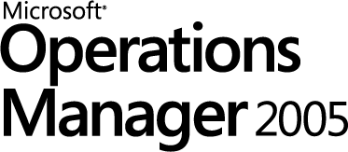
Microsoft Operations Manager 2005
Reviewer's Guide

Microsoft Corporation
Published: August 2004

Abstract
Enterprises’ dependency on their IT solutions for continued growth and success require those solutions to deliver high uptime and scalability. In order to provide these services to their business units, IT managers must have up-to-date and accurate information about the health of their servers and application services as well as performance metrics which would help them plan for future capacity and scalability requirements. Microsoft Operations Manager (MOM) 2005 provides server and application monitoring and performance information in a scalable, security enhanced, and easy-to-deploy manner, helping reduce the complexity IT managers deal with every day.
The information contained in this document represents the current view of Microsoft Corporation on the issues discussed as of the date of publication. Because Microsoft must respond to changing market conditions, it should not be interpreted to be a commitment on the part of Microsoft, and Microsoft cannot guarantee the accuracy of any information presented after the date of publication.
This reviewer’s guide is for informational purposes only. MICROSOFT MAKES NO WARRANTIES, EXPRESS OR IMPLIED, AS TO THE INFORMATION IN THIS DOCUMENT.
Complying with all applicable copyright laws is the responsibility of the user. Without limiting the rights under copyright, no part of this document may be reproduced, stored in or introduced into a retrieval system, or transmitted in any form or by any means (electronic, mechanical, photocopying, recording, or otherwise), or for any purpose, without the express written permission of Microsoft Corporation.
Microsoft may have patents, patent applications, trademarks, copyrights, or other intellectual property rights covering subject matter in this document. Except as expressly provided in any written license agreement from Microsoft, the furnishing of this document does not give you any license to these patents, trademarks, copyrights, or other intellectual property.
© 2004 Microsoft Corporation. All rights reserved.
Microsoft, Active Directory, the Microsoft Internet Explorer logo, Outlook, Visio, Visual Studio, Windows, the Windows logo, the Windows Start logo, Windows NT, Windows Server, Windows Server System and the Windows Server System logo are either registered trademarks or trademarks of Microsoft Corporation in the United States and/or other countries.
The names of actual companies and products mentioned herein may be the trademarks of their respective owners.

Contents
Product Overview 7
MOM 2005 Family 8
MOM Connector Framework 8
MOM 2005 Reporting 8
Dynamic Systems Initiative (DSI) 9
MOM 2005 Development Goals 10
Quick Time to Deployment 10
Ease of Use 10
Trustworthy Computing 10
Ability to Deliver Comprehensive Management Packs for Any Application 10
Microsoft Operations Manager 2005 Themes 11
Identifying Concerns 11
Understanding the Issue 11
Resolving the Issue 11
Concepts 12
MOM 2005 Capabilities for Helping Identify System Issues 14
Operator Console 14
Web Console 15
Server Status Monitoring 16
Relationships 17
Status Context 17
Status Views 17
Rollup and Sorting 18
Nested Groups 18
Scopes 19
Scoped Tasks 19
MOM Capabilities for Helping Understand Issues 20
Diagram Views 20
Alert View 21
Other View Types 22
Performance View 22
Events View 22
Computers and Groups View 22
Administrator Console Home Page 23
Web-based Reporting Server and Database 23
MOM Capabilities for Resolving Issues 26
Operations and Diagnostics 26
Problem Prioritization 26
Problem Visualization and First Level Analysis 26
Diagnostics 26
Remote and Bulk Scripted Corrective Actions 26
Tasks 26
Integration with Trouble Ticketing 27
Maintenance Mode 27
Multi-Pane View 27
Overrides and Hierarchical Management 28
Improved Management Packs 29
Installation Experience 30
MSI-Based Setup 30
Prerequisite Checker 30
Server Discovery 30
MOM Agents 38
Agent Management 38
64-Bit Agent 38
Agentless Monitoring 38
Agent Management and Heartbeat 38
Support for More Topologies 39
Availability and Scale 39
Administrative Partitioning 40
Programmability and Extensibility 41
Scripting Context Object Model 41
WMI Providers and Managed Code 41
SQL Views 42
MOM Connector Framework (MCF) 42
Security Requirements 43
Mutual Authentication 43
Use of Lower-Privileged Accounts 43
Disable Server Side Custom Responses 43
Strong Encryption 44
Out of Process Responses 44
Data Verification 44
New and Improved Features at a Glance 46
Microsoft Operations Manager 2005 Features at a Glance 47
Test-Driving Microsoft Operations Manager 2005 51
Test-drive Overview 51
Test-drive System requirements 51
Full Test-drive System requirements 51
1. Checking MOM 2005 Pre-requisites 53
A. Checking the Pre-Requisites 53
B. Installing MOM 2005 services 54
C. Installing MOM 2005 Reporting 56
D. Importing MOM 2005 Management Packs 57
2. The MOM 2005 Administrator Console 58
A. Deploying MOM Agents 58
B. MOM 2005 Console Overview 59
C. Configuring Management Packs – Computer Groups and Rule Groups 61
D. Configuring Management Pack Tasks 63
E. Configuring Overall MOM Operations 64
3. The MOM 2005 Operator Console 65
A. Overview of the MOM 2005 Operator Console 65
B. Handling a SQL Server Alert 67
4. The MOM 2005 Web Console 69
A. Overview of the MOM 2005 Web Console 69
5. The MOM 2005 Reporting Console 70
A. Transferring Live Data to the Reporting Database 70
B. Walkthrough MOM Reporting 70
6. Shutting Down the Test-drive Image 73
Appendix 1: Supported Operating Systems 74
Appendix 2: Microsoft Operations Manager 2005 System Requirements 79
Appendix 3: Localization 85
Appendix 4: MOM 2005 Component Overview 87
The MOM 2005 Database 89
Configuration Data 89
Operational Data 89
The MOM Management Server 89
Data Access Service (DAS) 89
MOM Server and Local MOM Agent 90
The MOM Agent 90

Product Overview
Systems management is a complex, multifaceted problem, which no one tool or technology can solve. All too often this compels IT managers to use disparate management products to provide status reporting for systems across the enterprise. Poor integration between such tools often leads to reliability and consistency problems, reducing their effectiveness in managing day-to-day operations.
To aid in resolving these problems, Microsoft has developed a two-step approach to management that allows a variety of effective management solutions to be developed, deployed, and integrated. The foundation of this strategy is a suite of core management services incorporated into the base operating system (for example, Windows® Management Instrumentation [WMI] and the Microsoft® Management Console [MMC]). These services provide the necessary instrumentation and interfaces required to enable both the management of Windows and the development of management applications. Using this foundation, Microsoft offers a family of centralized management software applications that use the core technologies to provide enterprise-level IT management services and solutions.
In broad terms, the solutions currently offered by Microsoft for management of server infrastructures falls into two categories: change and configuration management and operations management. Change and configuration management relates to the provisioning and configuration of IT systems, throughout the life cycle of the hardware and software involved. Once a system is in production, operations management provides the real-time event and performance monitoring of servers and applications, enabling administrators to react to and even anticipate critical problems while minimizing the impact to end users and businesses. These two disciplines provide reciprocal and complementary services: Operations management provides advance warning of the need for change and configuration management.
Microsoft offers solutions in both of these areas: Microsoft Systems Management Server (SMS) for change and configuration management and Microsoft Operations Manager (MOM) for operations management. The core management services built into the Windows 2000 Server and Windows Server™ 2003 operating system forms the foundation for all of Microsoft’s management products.

MOM 2005 Family
As the needs of small and medium businesses differ from those of larger organizations, Microsoft recognizes that there must be different versions of MOM focused on each customer segment, as well. MOM 2005 will ship in two versions, MOM 2005 and MOM 2005 Workgroup Edition.

Microsoft Operations Manager 2005
Microsoft Operations Manager (MOM) 2005 delivers extensible and scalable enterprise-class operational management by providing comprehensive event management, proactive monitoring and alerting, reporting and trend analysis, and system and application specific knowledge and tasks to improve the manageability of Windows Server System™ environments.

Microsoft Operations Manager 2005 Workgroup Edition
MOM 2005 Workgroup Edition is designed to provide an enterprise-class operational management experience to smaller Windows Server System environments. Although MOM 2005 Workgroup Edition provides all the capabilities for helping maintain service availability for Windows Server System environments, it does so for up to ten servers only. MOM 2005 Workgroup Edition is designed for environments with a limited number of servers and applications requiring management, or for customers looking to become familiar with MOM 2005. MOM 2005 Workgroup Edition provides a subset of the full MOM 2005 feature set, and can be upgraded to MOM 2005 to receive the additional features available in the full version:

MOM Connector Framework
The MOM Connector Framework (MCF) is a Web service-based technology for connecting Microsoft Operations Manager to third-party management platforms, enabling bi-directional alert forwarding and synchronization.

MOM 2005 Reporting
MOM 2005 reporting provides comprehensive and extensible reports for data collected by MOM 2005 and its Management Packs. MOM 2005 reporting fully utilizes SQL Server™ Reporting Services and includes more than 100 predefined reports on monitored systems, applications, and environments.

Dynamic Systems Initiative (DSI)
The Dynamic Systems Initiative is a Microsoft and partner effort, aimed at delivering cost effective software solutions for managing existing IT environments and to enhance the Windows platform to deliver innovative new development tools, applications, and management solutions that will help to dramatically simplify and automate the design, deployment and operations of distributed, heterogeneous computing systems.

Implementing DSI will result in decreased operating costs, and will help free up valuable IT resources to work on higher-value projects, creating real business value for the enterprise while making computing simpler and more cost-effective for organizations large and small. It is about creating a connection from the design of a system to the operation of that system - on through to the end users utilizing the system. By creating this integrated feedback loop spanning the entire life cycle of a system DSI can help facilitate the ongoing improvement of IT infrastructure with software. It is about helping maximizing people resources, and delivering software that can decrease labor costs across the entire IT life cycle.

Microsoft’s strategy for delivering solutions that support the Dynamic Systems Initiative is to combine a differentiated, long-term vision with a solid product roadmap. In the short term, customers can take a series of practical steps in line with the long-term vision of a drastic reduction in the complexity of their IT infrastructure. The beginning of that product roadmap is Microsoft Windows Server 2003, the Microsoft server platform and the foundation of Microsoft Windows Server System integrated server infrastructure software. Windows Server 2003 provides a foundation on which customers can build ”operationally aware” applications which can describe what is a healthy state and what is not, and offers many improvements in resource management and provisioning, Web and application services, and core server manageability. These improvements are already helping customers to be more productive, deliver more applications, and increase overall efficiency of their Windows Server System environments. For the future, the Windows team has planned a robust set of feature packs in support of the Dynamic Systems Initiative. These feature packs will provide customers with ever-evolving platform improvements in deployment, security and patching, and resource management.

Microsoft Operations Manager (MOM) 2005 is another key component of the Dynamic Systems Initiative, and delivers on the vision by providing improved, comprehensive event and performance management for Windows-based servers and applications. Key features include: ease of use and deployment, an extensive knowledge base and extensions to facilitate integration with heterogeneous environments.

MOM 2005 Development Goals
In developing Microsoft Operations Manager 2005, Microsoft focused on achieving the following goals:

Quick Time to Deployment
- Quick out of the box value in any Windows environment – large or small
- Automated server discovery and agent deployment allows quick time to value
- Easier / Lower cost integration with third party tools

Ease of Use
- Reduce complexity of monitoring with intuitive User Interface (UI)
- Customization of reports through Visual Studio® .NET and SQL Server 2000 Reporting Services
- Better support for operations – Notification, escalation, tracking and documentation of standard operating procedures
- Visualization through the new topological capabilities, and enhanced Analysis provided by the addition of a data warehouse and reporting services
- Automated service discovery and monitoring capabilities

Trustworthy Computing
      - Reliability: MOM 2005 has been designed with security in mind - robust and reliable agents, clean uninstall, and resilient distributed configurations in situations when networks and servers fail.
      - Security: MOM 2005 can improve security in environments where the network may be insecure.
      - Privacy: MOM 2005 provides improved UI filtering facilitating restricted and separate views for IT groups sharing a MOM infrastructure.
      - Manageability: The MOM Management Pack focused explicitly on managing MOM 2005 health and availability has been improved to provide better views, reporting and tasks.

Ability to Deliver Comprehensive Management Packs for Any Application
- A richer Management Pack (MP) authoring environment allows authors to develop Management Packs which reflect the actual health of systems and relationships of components to more rapidly allow operators to understand the cause of an issue
- Richer UI and reports accelerate identification of problems and detection of critical trends
- Shares best practices with users in terms of actionable tasks and diagnostics that promote faster resolution of problems

Microsoft Operations Manager 2005 Themes
MOM 2005 is based on the following themes:

Identifying Concerns
- Allow engineers and operators to avoid spending valuable time on “noise” from unnecessary alerts or unimportant events, by highlighting critical alerts requiring immediate attention
- Provide state and topological views to help engineers and operators to quickly identify the specific point of failure in a business system
- Example: An Exchange administrator can view the state of an Exchange server and determine service availability for multiple mail users at a glance.

Understanding the Issue
- Pre-packaged rules, thresholds, knowledge, tasks reports and more is provided through Management Packs, bringing the knowledge of the subject matter experts directly to the operator or administrator, helping provide better understanding of the event and the recommended response.
- Context-sensitive diagnostics tools, known as “tasks,” assist the operator in troubleshooting problems.
- Personalized and customer-specific knowledge can be added to the MOM 2005 Knowledge Base to share best practices with peers. This will help in resolving future issues quicker.
- Example: An Active Directory® administrator can see a domain controller is under heavy load, causing logon problems across the domain. The administrator can drill down through the alerts to pinpoint the root cause.

Resolving the Issue
- Tasks for resolving known issues are included in the management packs, and variables can be automatically populated based on the content of the fields in an alert. Tasks can be triggered automatically or manually by an operator, reducing the time for resolving outstanding issues and restoring services quickly.
- Resolution statuses can be automatically forwarded to higher-level or lower-level systems such as Enterprise Management Frameworks or Help Desk Systems.

Automated responses to many events are packaged with each Management Pack. These responses can be initiated on a server without the intervention of the engineer, thus saving time.

Example: An operator can create a report in MOM 2005 showing the state and status of server health for messaging and collaboration systems in the company.

Concepts
It is important to understand the following concepts when working with Microsoft Operations Manager 2005.

Consoles
MOM 2005 provides customized consoles tailored to the specific tasks associated with the different roles to be performed - such as the MOM administrator, MOM operator, or application and systems administrator.
- Administration Console
This console, which is an MMC snap-in, provides the MOM administrator the tools to configure and optimize MOM itself, install Management Packs or create rules, configure and deploy agents, and identify user views and security. The MOM Administrator can configure views, which would be used in the Operator Console, for each operator so an Exchange administrator can only work with Exchange Servers
- Operator Console
The Operator Console, which is an application built on .NET, is targeted at the actual IT administrators or operators who provide day-to-day monitoring and administration of IT services. This console provides multiple views into the systems, helping administrators identify alerts, take actions, and resolve those alerts. .
- Web Console
The web console allows operators to be able to obtain access to health information from any computer on the network without requiring a full client. The console allows basic functionality to view and resolve alerts and track system states.

- Reporting Console
The Reporting Console, accessible via a web page, provides access to all published reports. These reports can be made available to executives or systems operators, and can provide insight into capacity planning information, performance against service level agreements, trends in the environment and summaries of open alerts.

Management Packs
Management Packs allow the definition of server or application health using a variety of elements:
Rules are MOM 2005’s basic unit of instruction. Rules can be as simple as detecting the occurrence or absence of a given event or determining whether a performance counter has exceeded a threshold, or as complex as running a series of scripts to perform synthetic transactions that verify server response times and availability.
These rules can create and prioritize alerts, which call attention to conditions that require administrator intervention to prevent potential outages or quickly address issues affecting server performance or availability.
The alerts contain rich knowledge that empower front line and lower level operators or administrators to troubleshoot and address issues quickly, reducing the need for escalating problems to the next level of support.
State monitoring provides a real time view of the condition of line-of-business servers and applications, verifying that the critical services are available and that they are providing end users with good performance. This real-time feedback offers an additional dimension to help operations staff prioritize issues and provide higher overall availability for systems, while working to ensure the lowest overall impact to business applications when a problem occurs.
MOM 2005 also includes tasks, which elevates MOM 2005 capability from observing, detecting and alerting to deeper investigation and issue resolution. Tasks can take specific diagnostic or management actions based upon the role of the server. They are initiated on demand by the administrator and can include sequences that run on the MOM Console, MOM Server or the server experiencing a problem. One example of a task may be flush the DNS cache on a specific DNS server. A second example may be as simple as pinging the server to check connectivity.
Reports leverage the new MOM 2005 data warehouse to expose the rich data store, helping provide useful information to the IT Administrator. The Reporting Console is an easy-to-use web console which can be extended with custom reports using the report writing capabilities of SQL Server 2000 Reporting Services. Visual Studio .NET provides the development environment to create custom reports.
Finally, Management Packs provide the information to MOM 2005’s server discovery capabilities to automatically identify specific roles of servers (e.g. SQL Server, Exchange Server, Domain Controllers, etc.) and deploy the corresponding rules to those servers without any administrative action required.

MOM 2005 also enables the administrators to create their own customized Management Packs for internally-developed applications. This gives an enterprise the ability to leverage its investment in MOM across all of its mission-critical applications. Likewise, third-parties can also create Management Packs for the solutions they produce. MOM 2005 was not designed for Microsoft applications only. The true value is potential to monitor any application an enterprise chooses to use.

MOM Connector Framework
Many organizations have invested in enterprise framework tools which provide a single end-to-end view into the health of their IT infrastructure. As a result, it is important for monitoring tools to have bi-directional communications with those frameworks so the appropriate administrator learns about events and can resolve the issues satisfactorily, while still allowing the event and performance information to aggregate into corporate-wide reports. The MOM Connector Framework facilitates this bi-directional communication by providing the ability to forward alerts and other data to an enterprise framework or other tools in a heterogeneous environment, and receive status messages from those frameworks and tools to resolve alerts as necessary. MCF is based on web services, so it is simple to create connections to various third-party systems.

MOM 2005 Capabilities for Helping Identify System Issues
The operator’s experience is critical for any monitoring solution to be effective. A good percentage of IT management dollars go into training personnel that use management tools. Designing tools with the operator in mind makes them easier to use and problems can be more quickly identified and resolved.
MOM users engage in one of these 3 activities:
- Operations
Role-specific operators handle the day-to-day monitoring and troubleshooting of server issues by viewing events or alerts, taking actions to correct those events, and resolving the alert. An example of an operator is an Exchange Administrator who would be responsible for responding to health issues for Exchange servers.
- Managing MOM 2005
Adding additional Management Packs, configuring specific thresholds, or assigning operators to specific roles fall under the responsibility of the MOM Administrator. The MOM 2005 Administrator Console is the main configuration tool to ensure MOM 2005 is monitoring the correct services.
- Viewing Reports
IT staff, executives, or business application owners rely on the reporting capabilities of MOM 2005 to evaluate trends, performance capacity and planning, and service level agreements.
To help facilitate the job performed by each of these roles, a set of customized consoled focusing on the tasks performed by each of these users are provided.

Operator Console
The Operator Console is designed for operations staff and provides a set of key functions needed by operators:
- Navigation – A Management Pack selector, address bar, forward /back buttons and easy selection of view instances, helping the operator navigate to the item of interests quickly and intuitively
- Scoping – A big challenge with operator consoles are scalability. Providing too many alerts and too much information might lead to operators missing critical alerts. The Operator Console provides quick triangulation capabilities for operators to scope down the alerts to only see a certain type of data for a certain user defined set of machines (e.g. all machines in Europe, Machines in relating to a purchasing application, etc), without requiring pre-defined views to be created.
- Technology-based Filtering – Allows quick navigation to views specific to a technology such as SQL Server or Active Directory.
- Pivoting – Views have three dimensions – View type (e.g. alert, performance, state), scope (e.g. London, Paris) and technology (e.g. SQL Server, Exchange Server). Users are able to pivot through any one of these dimensions while keeping the other two constant.
- Drill Down – Double-clicking on an object allows the user to drill down from computer group to a specific computer to alert views for that computer.
- Context-Sensitive Task Execution – Operators are able to select one or more items in a view and take action on it ( e.g. forwarding an alert to a trouble ticketing system) including executing actions or issuing commands against the real objects represented by the item ( e.g. rebooting a machine)

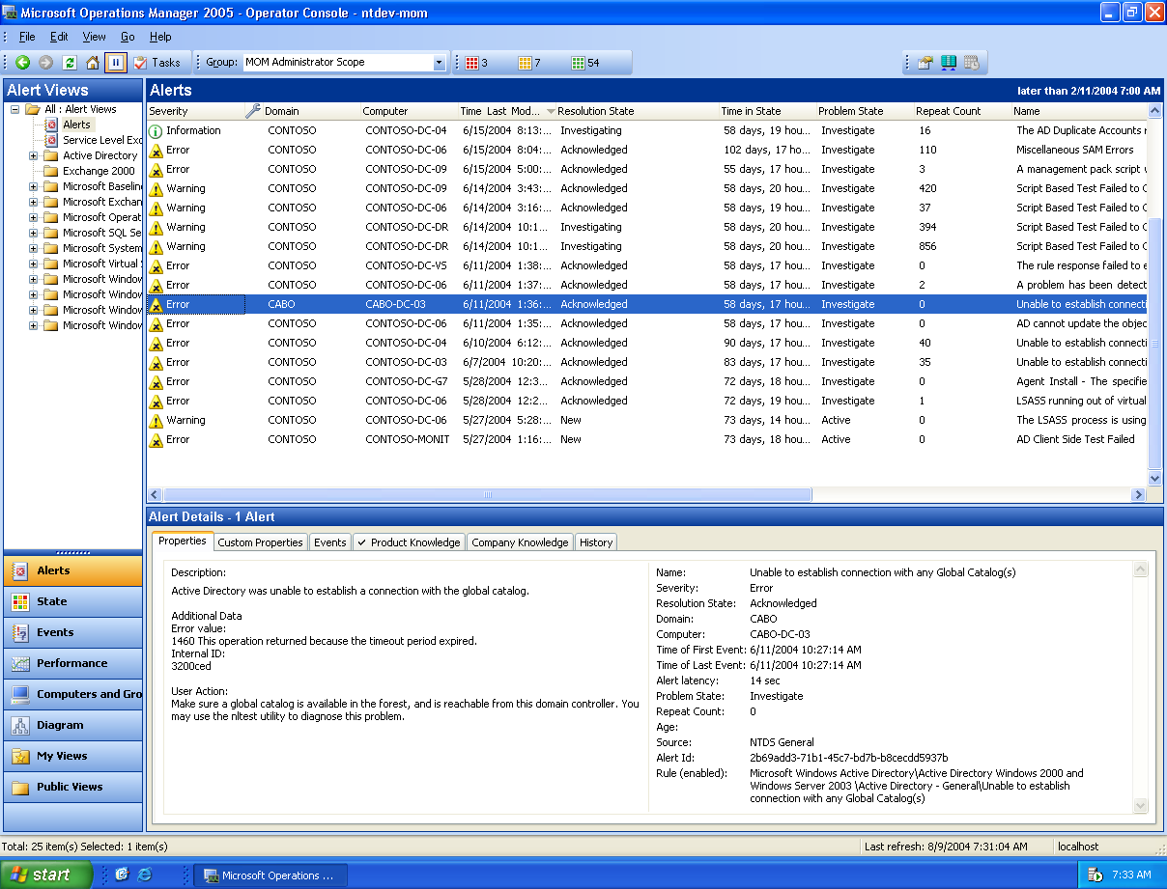
Figure 1. MOM 2005 Operator Console

Web Console
The MOM Web console provides a subset of the Operator Console functionality. Through a web browser a MOM operator can gain access to Alerts, Events, and Company knowledge. This will allow the operator the flexibility to check and modify the status of an alert, update company knowledge, view the status of a computer and receive email notifications with links to a specific problem that needs attention from anywhere on the network.

Figure 2 MOM 2005 Web Console

Server Status Monitoring
While the Alert view is used as a “to do” list for system operators, the State Monitoring View can be used by anyone (including business process owners) who want to know what is running currently, what has failed, and what is in a warning state.
The State View provides the operator with a constantly updated view of the current state of the systems being monitored. As in MOM 2000, an operator could be responsible for a single computer or an entire computer group. With MOM 2005, the State View shows the computer state by rolling up the statuses of all the various roles (e.g. Active Directory, Exchange, IIS etc) the computer is performing. The state of the role may include a rollup of each of its instances if they exist (for example, separate SQL Server instances). This view allows an administrator to rapidly drill down to the root cause of problems.

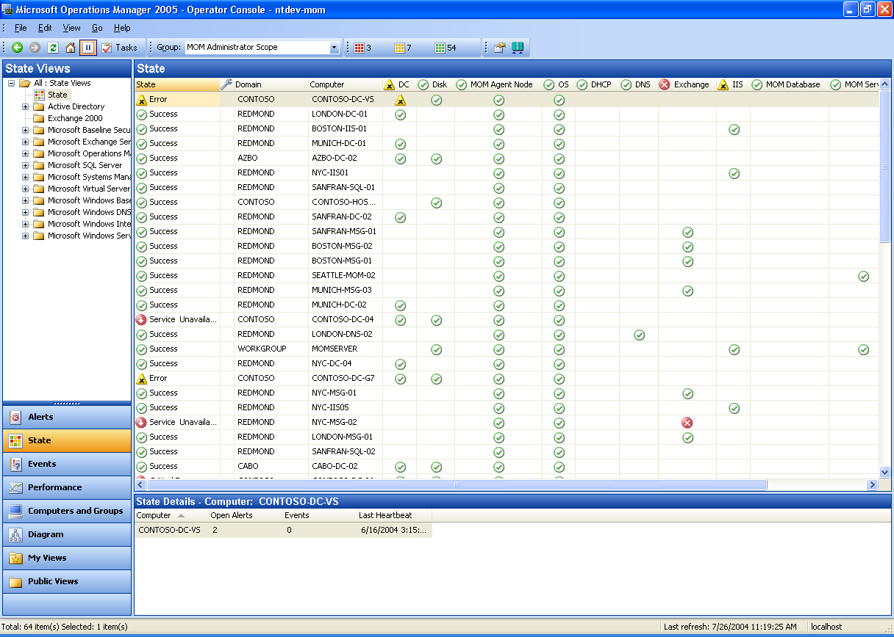
Figure 3: State Monitoring View
MOM 2004 - State Monitoring View
The specific components used to provide state monitoring involved are:

Relationships
MOM 2005 allows the definition of relationship classes. By using these relationships, MOM can help operators understand what a truly healthy system across many technologies would look like - for example, a healthy DNS Server is required for a healthy Active Directory system.

Status Context
Alerts provide the ability to automatically update themselves with a change in status, for example, from a crossed threshold back to a normal state. MOM 2005 extends the ability of response scripts to allow the delivery of status change alerts that can tell MOM to update the status of a certain instance and certain component. MOM uses the alerting subsystem to feed up state change events to the console. For instance, in the figure above, we see that the queues on Exchange instance NYC-MSG-02 are in an unsatisfactory (red) state. This is a result of a rule on the agent which recognized the situation and issued a state alert. The same rule will also issue a “green” alert when that problem is resolved.

Status Views
MOM 2005 allows management pack authors or users to define a status view instance where the user can choose the computers to display, the roles to display and the component status on a per-instance basis of the service role. This allows operators to quickly get a view of all systems and identify which systems, if any, are experiencing issues.

Rollup and Sorting
The concept of status rollup starts from the state of a component. The status of each component is rolled up into and represented all the way up to the status of the computer group. For instance, an alert indicating a bad Exchange queue will be rolled up to reflect a red status for the component representing that queue. The component status (red) is then rolled up to the Exchange instance, which in turn is rolled up to status of the “Exchange” role. The Exchange status then rolls up to the state of the computer, which will continue up to reflect a red state for the computer group. When a computer group shows a red status, an operator could drill down through the entire hierarchy to the individual component – in this case the Exchange queue – to determine which component status is causing an issue with the overall health of the computer group.
It is also easy to sort on specific fields within the view. For example, the operator can view all the similar types of alerts which are potential security breaches, or they can sort on computer name. This helps the operator develop a list of priorities to attend to first.

Nested Groups
In MOM 2000, computer groups were primarily used for targeting. These computer groups were dynamic – their memberships were automatically adjusted based upon the services found or role of each server -- and had the ability to be imported/exported with Management Packs. In MOM 2005, this concept has been extended to a collection of nested groups. The groups may be dynamic or static, user-defined or discovered, and may have one or more parents.
The use of the nested computer groups permeates through MOM 2005. They are used for:
- Rules targeting
- View definition
- Task targeting
- Navigation
- Drill down
- Scoping the view for a user
A typical medium or large organization will have different departments for IT that managed a subset of their whole enterprise – e.g. Print Server Administrators, Web Server Administrators, and Finance Building Administrators. With the computer group features in MOM 2005, this allows an IT Organization to map these departments as computer groups and filter the view of data for these computer groups. As an example, given the following IT organization:

· Central Operations – Ultimately owns all monitoring infrastructure and servers.
- Web Server Administrators – Monitor and manage all web servers in the environment
- SAP Administrators – Monitor and manage all SAP servers.
- LOB Application Administrators – Monitor and manage all other LOB applications

This organization may choose to have the following computer group structure that would allow using console scopes to filter the view of computers in the Operators Console:

· All Servers
- Web Servers – Assign console scope to Web Server Administrators to this computer group.
- SAP Servers – Assign console scope for SAP Administrators to this computer group.
  - SAP Application Servers
  - SAP SQL Servers
- LOB Servers – Assign console scope for LOB Application Administrators to this computer group.
  - LOB Expense Application Servers
  - LOB Business-to-Business Application Servers

An additional benefit is that the operator can use the Diagram View to see all of this graphically. State bubbles up from the child computer groups to the top.

The operator can control the behavior of the state role up, by also using a new computer group feature – State Roll-up Policy. This will allow a business to set business logic such as: “Only show the Web Servers computer group state as red if > 50% of servers in this group and its children are in a red state.”

Scopes
In many environments, groups of computers are assigned to be managed by administrators according to region, by function or by job responsibility. MOM 2005 allows customized views to be created - for example restricting a certain set of users to access and manage only a certain subset of computer groups. Scoping provides a method of isolating operators from seeing and acting on systems for which they are not responsible..

Scoped Tasks
Currently, large organizations are often forced to give operators administrative privileges for every machine they monitor. With MOM 2005, administrators may restrict privileges according to the responsibility assigned to operators. This provides a measure of control over which operators are authorized to execute which type of actions against a certain set of machines. The actions executed against or performed on the agent or server are enacted under a MOM service account, and MOM user is not able to create or override the parameters of a task.

MOM Capabilities for Helping Understand Issues

Diagram Views
Determining the root cause of a widespread problem is difficult when services are distributed and connected in complex configurations. Likewise, when a command or action is executed against a specific node, it is important to understand how that node fits into the environment and what impact the activity would have on nearby or related systems. Operators often have a diagram displayed on the wall to help them visualize the topology of their IT environment; however a static diagram tends to become obsolete rapidly as the IT infrastructure changes. .
MOM 2005 provides operators with a variety of topological views where the existence of nodes and relationships are automatically discovered by MOM MPs. The status of the nodes, navigation to other views and launching of context-sensitive actions can be accessed directly from a topological view, helping the operator navigate quickly to the root cause of the problem and resolution information and tasks for resolving the issue. This ability can potentially cut the resolution time of complex problems from tens of hours to tens of minutes, significantly reducing cost and improving service levels.
An example for Exchange is shown below. Notice that MOM 2005 has the ability to discover and depict memberships of routing groups, relationships between routing groups, roles of servers and status of servers.
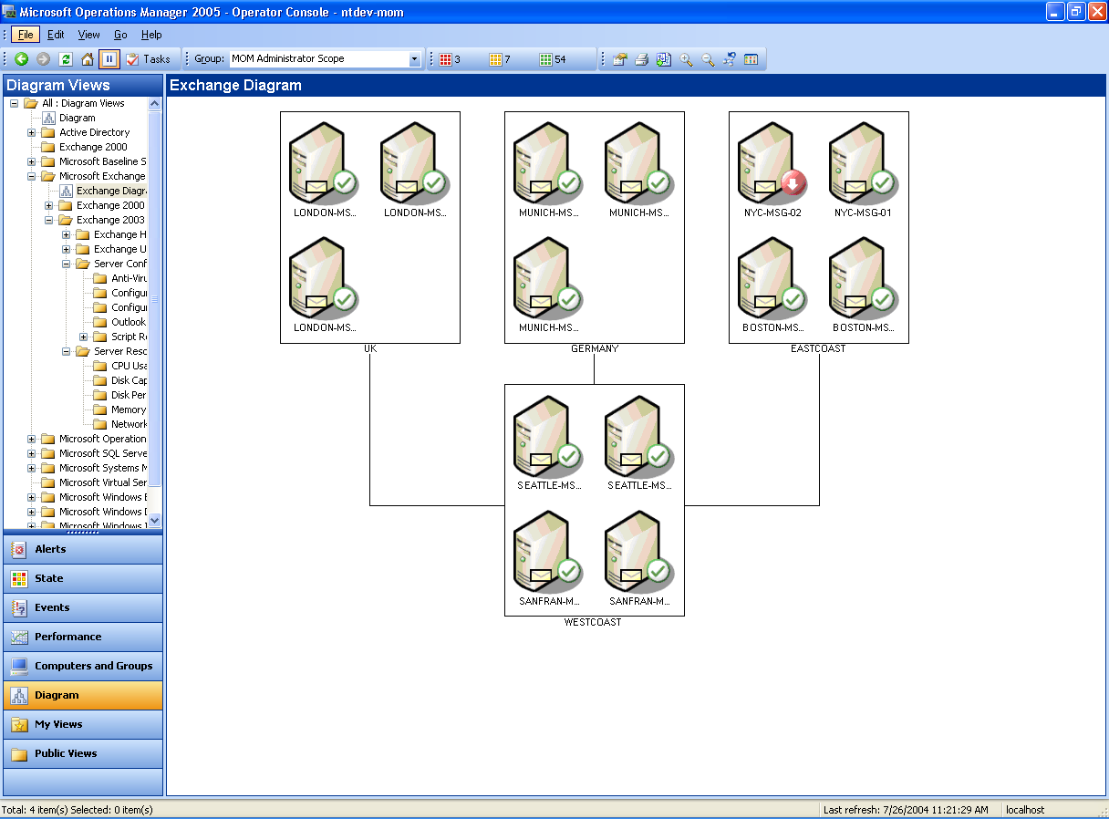
Figure 4: Diagram View
MOM 2004 - Topology View for Exchange Servers

Similarly, below is a diagram view for Active Directory replication:
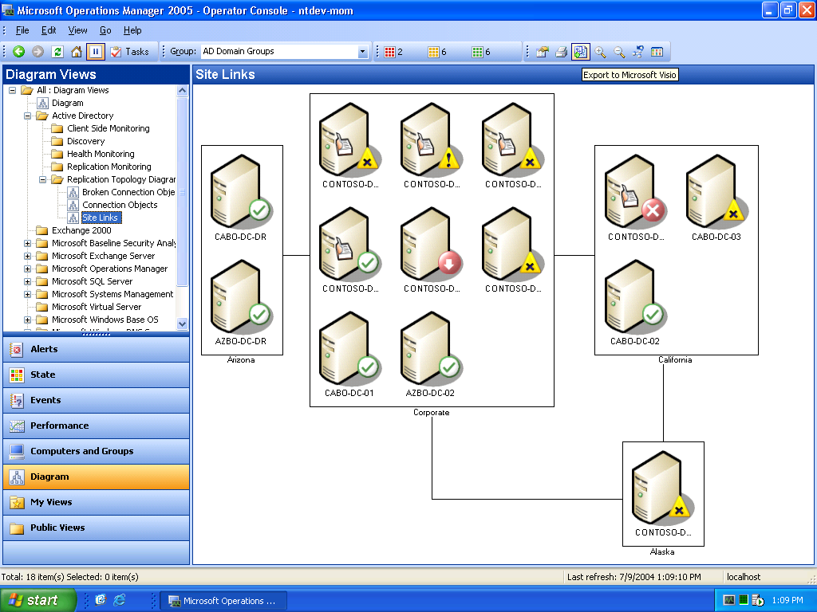
Figure 5: Active Directory Replication Diagram View
MOM 2004 Topology View - Active Directory
MOM 2005 also has a generic topological view that allows users to position computer groups and their descendant groups and computers on a separate surface. MOM 2004 - Generic Topology View Users are able to scan in a background for these views, positioning nodes and groups on the background to produce and maintain views that are more intuitive for their environments. (This includes overlaying servers on a geographic map, as an example.) These diagrams can be exported into Microsoft Visio® or sent to a printer.

Alert View
The main usability improvement made in the MOM 2005 Alert View is the ability to switch from alert to alert and preview details without leaving the main console screen. Descriptions of each alert will appear at the bottom of the console. Users are able to select multiple alerts and act on them as a group, as well as update a specific property for all of them – for instance, one can multi-select alerts and change the resolution state to a value that marks them for forwarding to a trouble-ticketing system.
Operators are able to gather knowledge about the alert history, examine the rule that created the alert, and resolve the alert directly from this view.

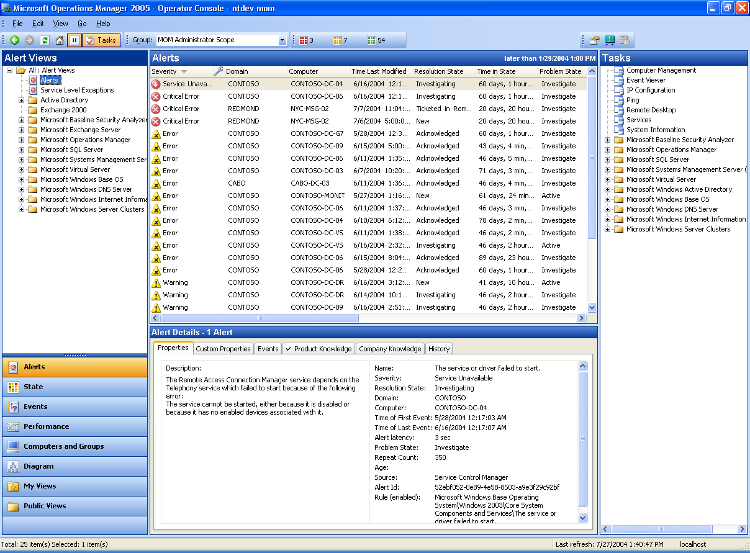MOM 2004 - Custom Background
Figure 6: Alert View

Other View Types
MOM 2005 provides new, easier to use view types for the Operator Console that are backwards compatible to MOM 2000. All views can be authored or imported/exported to or from other MOM instances. The console provides easy switching between views, launch context-sensitive tasks, and drill down to details.MOM 2004 - Alerts Vie

Performance View
The Performance View allows the selection of one or more counters from multiple systems for a period of time as well the selection of different styles of rendering for the resulting data, including tables and graphs.

Events View
The Events View is similar to the Alert View, but also takes advantage of scoping, navigation, and a detailed view, which is also available in the Performance View.

Computers and Groups View
This view shows operators the computer groups a computer belongs to, the processing rule groups that are associated with it, and the associated computer attributes.
The Computer View takes advantage of service discovery to show detailed information of discovered instances on the computer – for instance, to show all the SQL instances on a machine, its authentication mode and connectivity. This can also be a side-by-side view of all instances belonging to multiple computers.
MOM 2005 computer groups are static, dynamic, intersecting, nested and belonging to multiple hierarchies. This makes the computer group view critical to sorting out how systems are grouped, and how this would affect targeting, views, etc.

Administrator Console Home Page
It is imperative that any monitoring solution be easy and intuitive to configure. The tool will not be used if it is difficult to extract useful information. To help new MOM administrators derive value from MOM 2005 immediately, a new home page is provided for the administrator that manages the MOM configuration. The home page, shown in Figure 6, provides access to wizards for some common administrative tasks like discovering nodes, deploying agents, importing management packs, and setting configuration of MOM itself. It is also the launch point for accessing the rules authoring capabilities, advanced configuration and the Operator Console used for day-to-day operations.
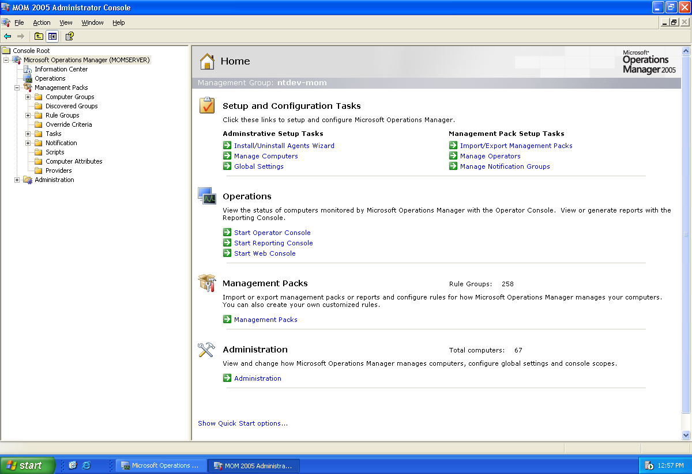
Figure 7: Administrator Console Home PageMOM 2004 - Administrator Console Homepage

Web-based Reporting Server and Database
The Reporting components of MOM 2005 have been redesigned for this release. Reports are written in SQL Server 2000 Reporting Services. A data warehouse has been introduced to isolate the operational database from the reporting queries and also to have a store that can grow more than the limitations of the operational database. At a high-level, operational data and configuration information gets transferred from the MOM database to the MOM data warehouse on a nightly basis. These reports contain queries that execute on the MOM data warehouse. MOM also provides an interface and tools that enable users to import and export reports.

In particular the solution has the following features:
- Long term offline storage and analysis of data
- Web-based reporting
- Dynamic Reports (drill down, sort, chart, etc)
- Easy customization (Visual Studio-based authoring environment)
- Built-in data transformation and management functionality
- Improved database grooming
- Ability to export data to other formats including PDF, Excel, CSV
- Folder- and report-based security
- Publisher – Subscriber Model (users can subscribe for reports of interest)
- Scheduled publishing and delivery
Figure 7 depicts the SQL Server 2000 Reporting Services user interface:

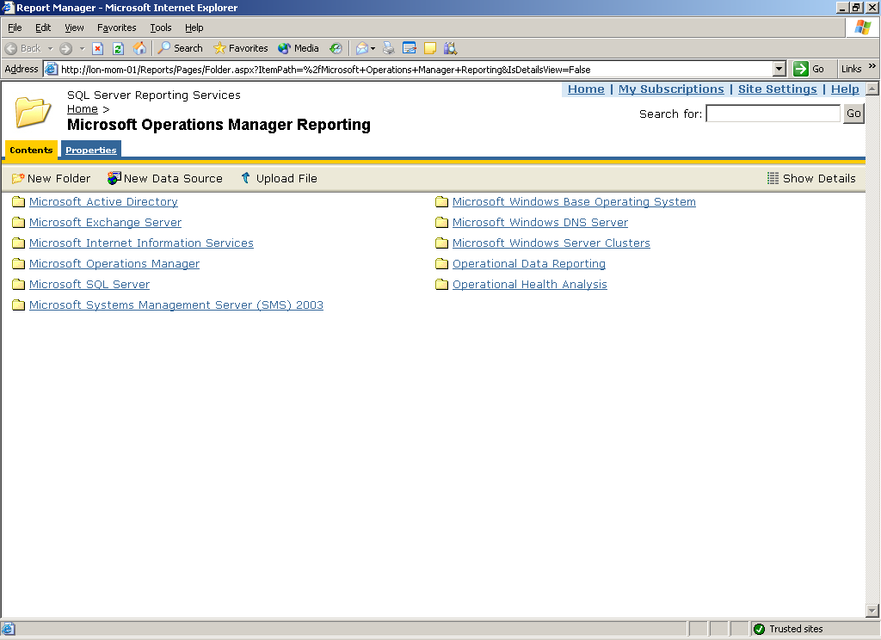
Figure 8: SQL Server 2000 Reporting Services User InterfaceMOM 2004 - Rosetta Reporting UI

Additionally, as shown in Figure 8, some of the other features that can be displayed are:
- Parameterization
- Paging
- Search
- Export in selected format

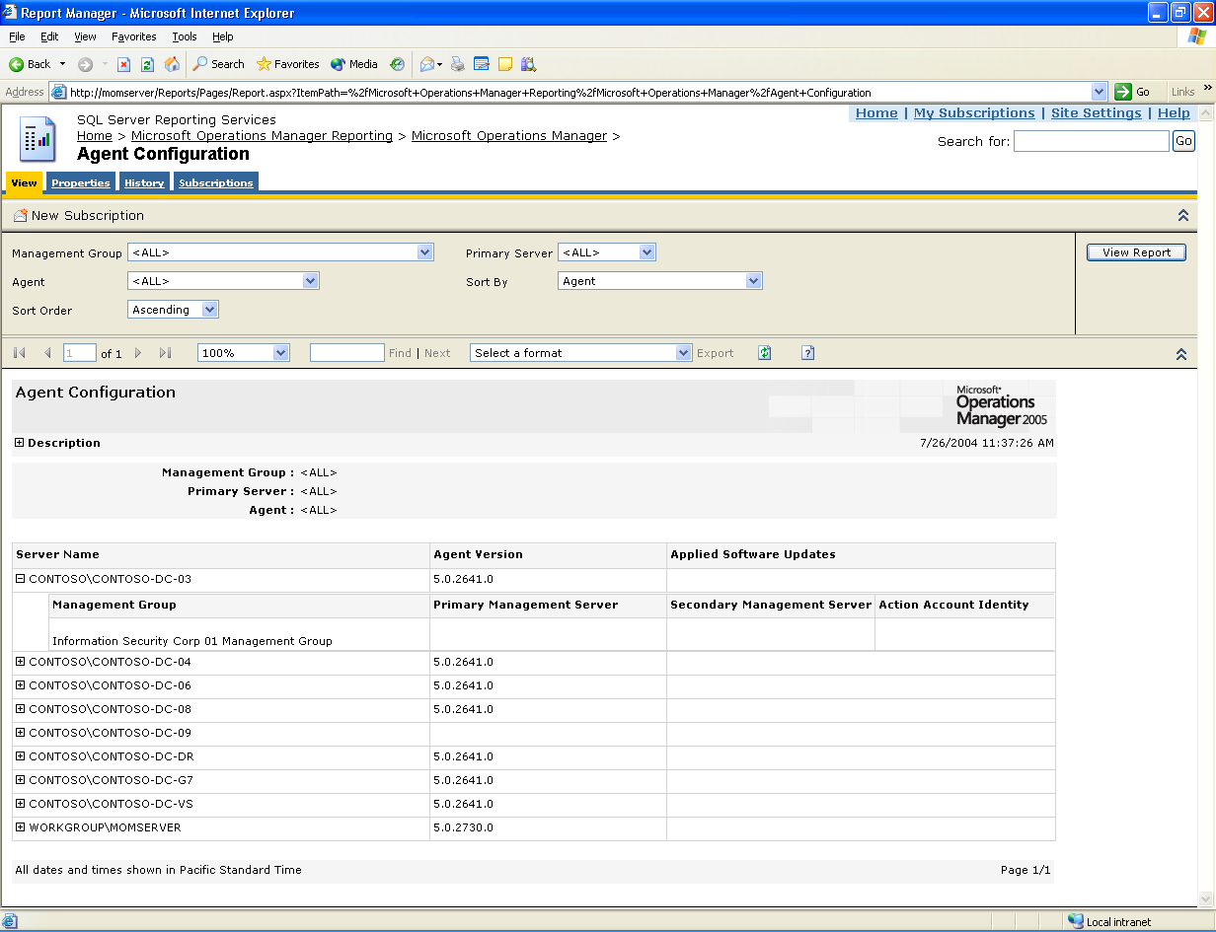
Figure 9: Additional Reporting FeaturesMOM 2004 - Rosetta Report Example

MOM 2005 ships with a set of standard reports for Management Packs to provide out-of-the box value in many categories, including:
- Management Pack Reports providing analysis of deployed MPs by rule attributes
- Capacity and Usage Reports
- Performance, Load and Usage Reports
- Reliability and Availability Reports

MOM Capabilities for Resolving Issues

Operations and Diagnostics
MOM operators perform the following operations as they monitor their environment:

Problem Prioritization
When an operator is faced with a large set of alerts, the operator needs to first prioritize the alerts before acting on them. This decision is based on the severity of the problem, the importance of the services to the business and Service Level Agreement (SLA) of the service, and current status of the server (e.g. is it in test, maintenance mode or in production). MOM 2005 provides easy integration of this information along with a sort function that helps with prioritization by:
- Providing an SLA violation view, including “time in violation” as a sortable column
- Providing Computer Business Criticality as a sortable field in the computer view
- Providing Maintenance Mode as a separate attribute on computers which can be used to filter an alert or state view
- Providing ability to sort by alert severity

Problem Visualization and First Level Analysis
The first-line operator performs extensive analysis to be able to resolve the problem or to route it to the correct specialist. For this, the operator may need to visualize the set of problems in a logical or topological view. The operator may carry out some first-level analysis by pinging the box to check for network connectivity, connecting to the server via Terminal Services or bringing up Service Monitor on that system. MOM 2005 provides context-sensitive tasks and views to provide this without leaving the Operator Console. These Management Pack-specific tasks will often guide the operator on what they should do to resolve a problem.

Diagnostics
The specialist might have created predefined diagnostic scripts for the problem at hand, such as Windows Resource Kit scripts to diagnose Active Directory replication problems. The use of tasks, described below, provides a method of applying context-sensitive diagnostics for specific server roles.

Remote and Bulk Scripted Corrective Actions
Corrective actions might include a remote script to run on one or more related targets; for instance, this may include running a script to delete temporary files or memory dump files to create space.
All these activities are better supported by MOM 2005 by providing the following features:

Tasks
MOM 2005 provides the ability to define, export, import and launch context-sensitive tasks and diagnostics. The tasks can be executed on the Console, the Server or at the Agent.
The tasks obtain the execution context from the managed server selected during the task. .More importantly, a task may also pick up pre-discovered data from the MOM database to optimize targeting instances to operate on. Since these actions may be disruptive, it offers the user the final approval on which set of selected target instances the operation should affect. The tasks may launch a Terminal Server window or a diagnostic tool, while those targeted at the server or agent can execute more automated functions which do not require user interaction. The tasks are shown in the right pane of the Operator Console and are sensitive to the selected management pack. The tasks are provided via the Management Packs for each specific service and provide extra diagnostic value to the operator. For example, the DNS Management Pack includes a task to clear the DNS cache. The Windows Cluster Server Management Pack includes a task to display the cluster properties.
Figure 9 depicts the launching of a ping task:
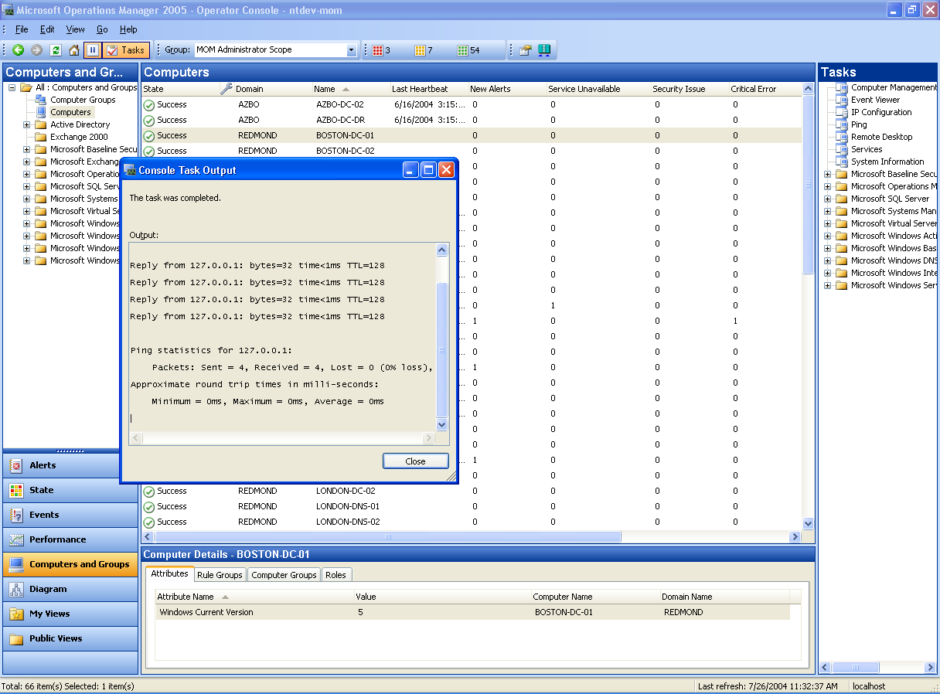
Figure 10: Launching a Ping TaskMOM 2004 - Ping Task

Integration with Trouble Ticketing
MOM 2005, through the use of the .NET Framework, supports the MOM Connector Framework (MCF). The MCF bi-directionally synchronizes applicable MOM alerts with a 3rd-party management system, allowing customers to realize “best of breed” Windows management while preserving existing management investments.
MOM 2005 also allows tracking Trouble Ticket IDs (from other systems) for an alert, making it easier for the operator to resolve all alerts associated with a trouble ticket.

Maintenance Mode
MOM 2005 provides support for placing computers into a maintenance mode. While in this mode, all new incoming alerts for those computers will be automatically set to a “resolved” state and would not be included in any server state calculations. Responses, including any operator notifications, will not be run. This ensures that while the computers are under maintenance, alerts, statuses, and updates do not distract the first-line operator.

Multi-Pane View
Many operators prefer a multi-pane view to watch machine status, new alerts and ticketed alerts at the same time on different panes. This provides functionality similar to inbox, outbox and in-process windows for operators. Some service owners choose to watch several performance views and status on an ongoing basis. MOM 2005 multi-pane views allow these modes of operation. Operator Console navigation applies to the selected pane, as does the Details view.

Overrides and Hierarchical Management
MOM Management Packs provide a set of pre-defined default parameters and thresholds. Administrators have the ability to further customize or refine these defaults to reflect their specific requirements. For instance, the acceptable threshold for free disk space might be different for different groups of SQL Servers based on the type of applications they support.
To facilitate this requirement, MOM 2005 provides a hierarchical management approach where a specific rule can support assigned more than one threshold or parameter based on the different groups of machines. As it is also possible that the same machine can belong to more than one computer group, and therefore have more than one threshold setting for the same situation, precedence as to which setting prevails can be defined in order to help ensure predictable results.
MOM 2005 also allows Management Pack authors and administrators to override the default parameters for a rule for a certain computer or computer group. The overrides can be applied to script parameters and thresholds (and possibly enable/disable the rules themselves). For example, a SQL Server which is identified as a test server should have similar thresholds for memory available as one that is a production server, but the action taken if the threshold is broken may be just an alert instead of paging the SQL administrator. If more than one override applies to a rule, administrators will have the ability to assign a precedence order. This allows a manageable way of customizing monitoring.
Below is a picture of how a rules author sets overrides on a specific rule as it applies to different computer groups or computers:

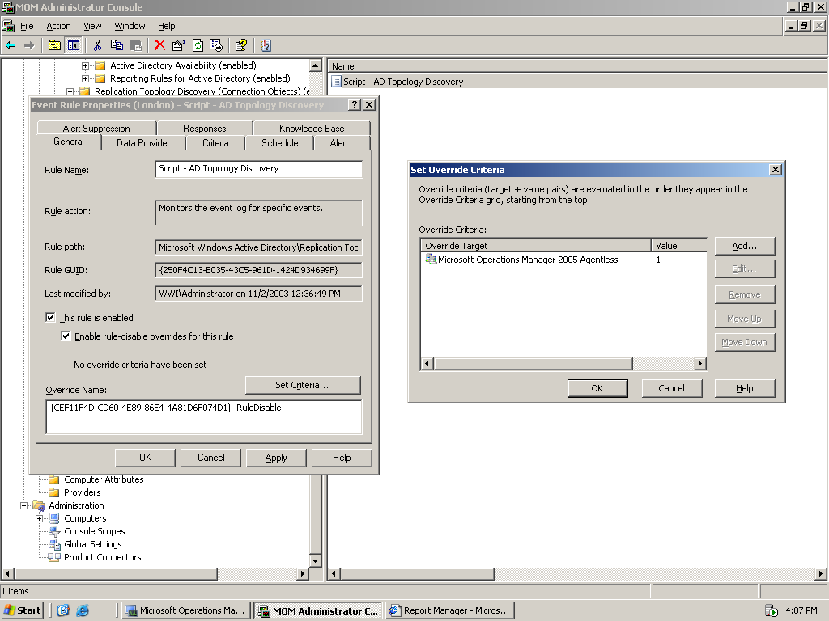
MOM 2004 - Threshold Dialog

Improved Management Packs
MOM 2005 supports the import of management packs from MOM 2000, allowing organizations to leverage their existing investments in MOM. In addition, a rich set of new features allow MP authors to provide an enhanced level of functionality. Some of these new features include:
- Service and Instance Aware Monitoring –MP authors can discover instances of components and tailor their monitoring to provide a richer view of the service
- Service Discovery – Automatic discovery of these components allows for more detailed views, reports and correlation. By having the Management Pack describe the service it was designed to monitor (DHCP, for example) MOM can quickly deploy its rules to all monitored servers running that service with no administrative intervention. As new servers get deployed or an existing server changes roles, MOM is able to automatically identify the changes and dynamically add or remove that server to or from a computer group and manage the services appropriately.
- Cluster Monitoring – In a clustered server environment, MOM 2005 recognizes the concept of the virtual cluster server as well as the physical servers within the cluster. Management Pack authors can leverage this richer ability to instrument servers within a cluster and create appropriate rules. For example, MOM would be able to recognize that a database server has failed over, and a specific task could be written to fail the virtual cluster server back to its original physical server once the reason for failure has been resolved. Support for clustered servers includes:
  - Rules are deployed to the cluster server
  - Event, performance, alert data collected
  - Scripts and responses can be run against the
cluster server
  - The cluster server heartbeats
  - Agents on nodes hosting the cluster server are failover aware
  - Internal failover events are generated which can be leveraged by management pack authors

- New Reports – Greater flexibility in creating reports is provided by the use of SQL Server 2000 Reporting Services.
- Tasks and Diagnostics- Management Pack authors can now prepackage many types of diagnostic of administrative tasks with their MPs.
More information on available Management Packs can be found at http://www.microsoft.com/management/mma/catalog.aspx.

Installation Experience
With the release of MOM 2005, the time, cost, and complexity from the start of deployment planning to receiving value from the product is reduced drastically. The average MOM 2005 customer is able to deploy MOM in a matter of a few hours. To make this possible, investments have been made in many areas including simplified setup, rolling upgrades and support for platforms, languages, topologies, scale, extensibility and security features that enable the customer to negotiate around site-specific issues and roll out MOM 2005 with ease and speed.

MSI-Based Setup
MOM 2005 has a completely revamped setup process for both the management services and the agent based upon MSI. This allows improved support for prerequisite checking, post-install housekeeping, rollbacks and uninstalls.

Prerequisite Checker
MOM 2005 allows customers to make sure that all configuration prerequisites (hardware and software) are satisfied before they begin to install MOM 2005. This helps avoid unnecessary work and aborted installations to fix something which could easily be configured prior to install.

Server Discovery
MOM 2005 also includes a simpler and faster server discovery wizard. Server discovery in MOM 2005 allows importing server lists from the Active Directory, from a file, or from a typed list. It also allows filtering of the list via LDAP queries and name- and domain name-based wild-carding.
The screen shots below provide a view of how server discovery is simplified. A welcome screen points the user to security considerations.
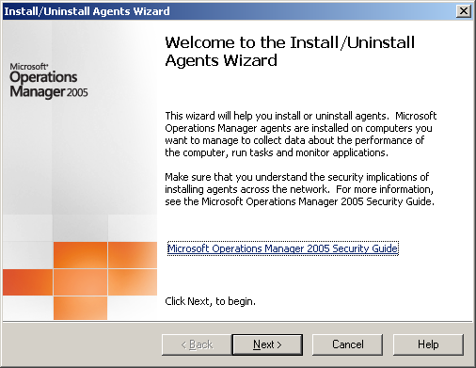
Figure 11: Setup Welcome Screen

The administrator is then asked whether the task should be to install or remove agents from a scope of computers.
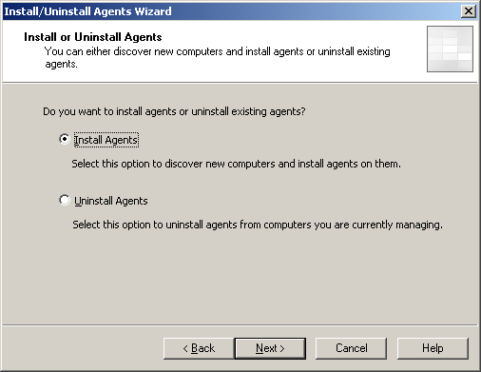
Figure 12: Setup Agent Install

The next screen gives the user a choice of selecting nodes to be managed – named nodes or using automatic search criteria.
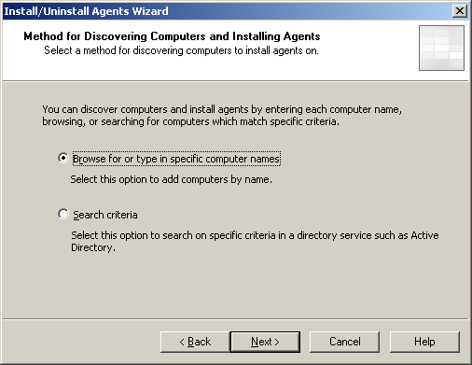
Figure 13: Setup Discovery Methods
The administrator, in the case of using search criteria, is then asked to enter the appropriate criteria. This can include the use of wildcards.
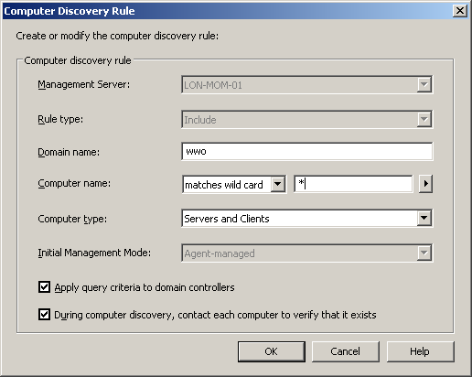
Figure 14: Setup Discovery Rule

In case a search criterion is chosen, since the resulting set can change over time, the user is given an option to continue updating the list on a daily basis on a scheduled time.
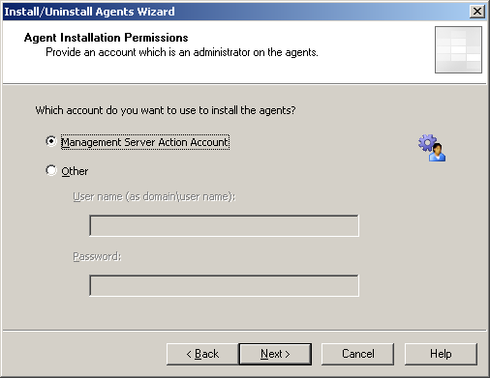
Figure 15: Setup Agent Permissions

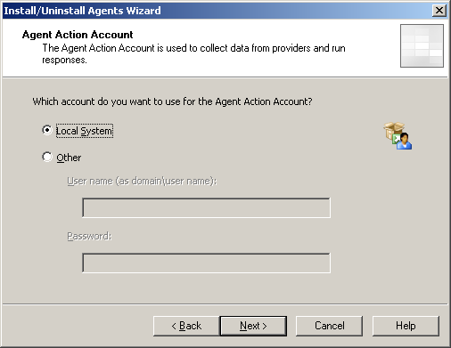
Figure 16: Setup Agent Action Account

The wizard then asks the administrator under which account MOM should use to install the agents, and which account the agent should run under once installed.

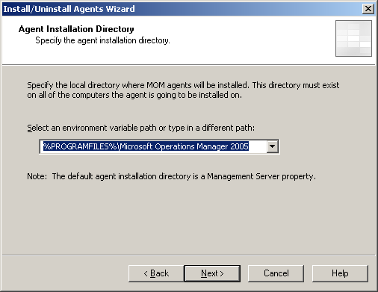
Figure 17: Agent Installation Directory

A local directory path to install the client may also be defined.
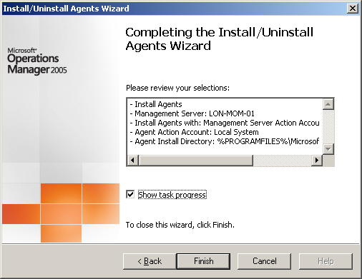
Figure 18: Setup Completion Summary

Finally, the agent will execute using the administrator’s rules.

MOM Agents
The MOM 2005 agent software runs on the managed servers. It can be deployed automatically during server discovery, and includes the rules associated with the running services. The agent is capable of running while its connection with the Management Server is broken and will continue to monitor and take corrective actions until the connection is repaired.

Agent Management
MOM 2000 relied on an Agent Manager component for automated agent management. This component controlled computer discovery, remote collection of attributes, classification into computer groups and agent deployment. Since this worked over RPC, the functionality was not available for managed nodes across firewalls or if the agent manager did not have administrative rights to the managed node. In these situations manual steps were involved.
In MOM 2005, the Agent Manager component has been replaced. Instead, MOM 2005 uses the task infrastructure to offer an extended set of self-management options, including deploying agents, starting/stopping/restarting agents, changing the agent configuration, etc.
In MOM 2000, the agent manager periodically scanned the remote registry for all the agents to keep the computer group classification current. On machines where scanning was not possible for security or network reasons, the administrators were required to manually keep the computer group memberships current for proper rules targeting and views.
In MOM 2005, this responsibility has been transferred to the agents. Agents read the registry locally and report results to the MOM server over the communication channel, eliminating the need for manual administration. In an agentless environment, described below, this operation is still executed remotely.

64-Bit Agent
MOM 2005 supports both Intel IA-64 and AMD-64 platforms as agent managed nodes. For IA-64 there is a special 64-bit agent while the AMD-64 platform uses the standard 32-bit agent in emulation mode.

Agentless Monitoring
MOM 2005 provides support limited monitoring of a reduced set (10 per MOM Server, 60 per Configuration Group) of agentless nodes. This is solution is provide for evaluations, small shops or enterprises where a few exception node owners will not allow agent installation. Agentless monitoring is limited to status monitoring only; it does not support the Application Log providers. Responses not supported include file transfer or any scripts which do not inherently support remote execution.

Agent Management and Heartbeat
MOM 2005 offers improved viewing and reporting of agent configuration and status than MOM 2000. The MOM server is able to maintain a heartbeat with each agent to measure the availability of the managed computer as well as update the agent with new rules it needs to monitor for. This provides MOM the ability to create an alert if a managed computer is not available for a specific amount of time. As an example, the picture below shows machines under management, their management mode, their last heartbeat time, and the MOM server that is primarily responsible for it.
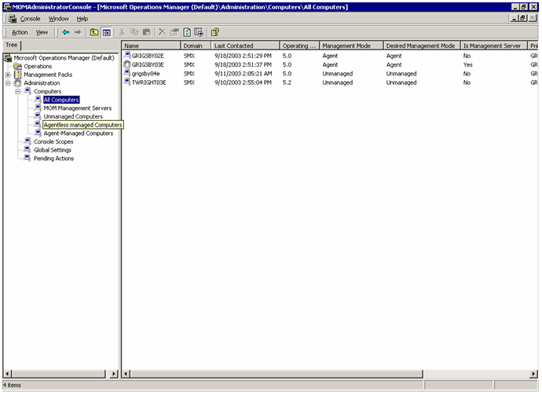
Figure 19: Agent Management and Heartbeat

MOM 2005 also provides the administrator convenient ways to change the agent configuration in bulk.

Support for More Topologies
Many features in MOM 2005 are aimed at making MOM deployable in situations which have complex enterprise requirements.

Availability and Scale
MOM 2005 retains MOM 2000’s ability to install multiple MOM servers per Configuration Group for the purpose of spreading the load as well as to provide failover operation. MOM 2005 also continues to support clustered SQL Servers for failover.
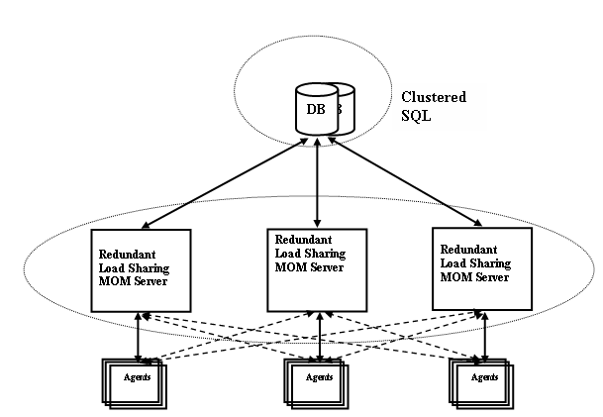
Figure 20: Scaling MOM 2005

Administrative Partitioning
MOM 2000 allowed different groups to share the MOM infrastructure while not sharing an administrative account. This was achieved by having different groups of MOM Management Servers using different Agent Manager accounts. Each group was called a partition. The agents were configured automatically to failover only within a partition.
In MOM 2005, since the Agent Manager component is no longer used, the need to partition MOM Management Servers is relaxed. IT departments can control their capital expenses by sharing a machine between multiple partitions by using different credentials when discovering different communities of servers. There is no ongoing need to have those service accounts in use if all nodes are agent managed.
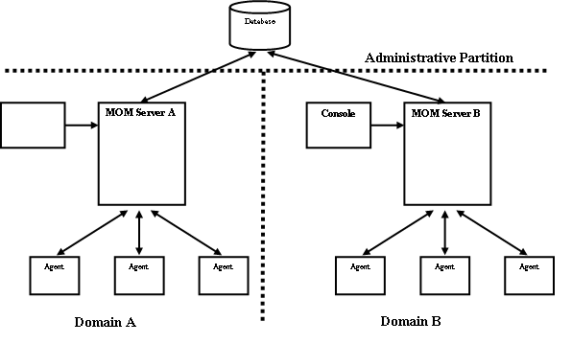
Figure 21: MOM 2005 Partitioning

Programmability and Extensibility
Customers, ISVs and Service Partners require extensibility and programmatic APIs to add value to MOM, to customize for customer topologies and to integrate it into customer environments. In particular they need be able to:
- Develop Management Packs for Applications and Subsystems (e.g. SAP or Cisco Routers)
- Integrate MOM data with a framework or management console (e.g. Tivoli or OpenView)
- Automate some of the MOM configuration functions (e.g. discovery and agent management)
- Automate operations including job scheduling and configuration data collection
- Add subsystems to MOM (e.g. UI, Data warehousing, Reporting or foreign agents)
MOM 2005 allows programmatic access to many different operational and configuration objects through the new .NET framework MOM class library. Operational objects include Alerts, Events, performance data and attributes while configuration objects include computer groups, scopes, overrides and computers. This ability has been extended in MOM 2005 to also support the export of user authored reports, extended attributes, Tasks and class definitions.

Scripting Context Object Model
The runtime-based script responses in MOM 2005 have access to a context by which the data item (event, alert, performance) which triggered the rule is available. The object model allows the creation of new alerts, events or performance samples. In MOM 2005, this has been extended to allow insertion of discovery data items, state alerts and even discovered computers.
MOM 2005 also allows the launching of responses which call managed code. MOM-aware managed code responses are able to access the same context that is available to runtime scripts. For instance, a managed code application which sends a .NET notification can be called as a response to an alert.

WMI Providers and Managed Code
In MOM 2000, access to a selected set of classes was available via WMI provider. This enabled third parties to insert foreign managed nodes and manage computer groups as well as integrate MOM with trouble ticketing or upstream management consoles.
In MOM 2005, the SDK has been extended in the following manner:

Computer Groups
It is possible to create, delete, update or read computer groups programmatically. The properties of the class allow a programmer to include/exclude computers and other computer groups as well as add queries for dynamic groups. A programmer is also able to enable/disable a group and associate it with a Processing Rule Group or override.

Processing Rule Groups
It is possible for a programmer to read the non blob properties of a PRG to create a user interface to navigate to a particular rule and view associated overrides.

Extended Alert Properties
Access (read /write) to the updated alert object including trouble ticket, problem state, Role, instance, and components will be available for alerts. It is also possible to access the rule that generated the alert, and its knowledge.

MOM Configuration
There is now the ability to install MOM 2005 agents programmatically.

Tasks
Programmatic access is provided to target and launch preprogrammed tasks.

Overrides
A rule may include one or more overrides of a type associated with unique targets (computer or computer group). All alerts of a type associated with a rule are ordered. Programmatic access to read, enumerate, create, delete, update, order and reorder these overrides are available via the SDK APIs.

Programming Model
The programming model has changed in MOM 2005 from WMI over DCOM to managed code classes. This further simplifies programmability by taking advantage of .NET features including security, memory management, and programming language independence.

SQL Views
The SQL Views available in MOM 2000 (events, alerts, performance, computer, event-to-alert tables) are available from the MOM 2005 data warehouse. In addition, views are created for computer attributes, extended attributes, instances and associations, as well as all the tables related to rules. This allows high speed bulk read only access.

MOM Connector Framework (MCF)
One major deployment blocker has been inability of MOM 2000 to natively connect with third-party management frameworks and trouble ticketing products. With MOM 2005, Microsoft provides the MOM Connector Framework (MCF), a web service to enable easy development of bidirectional connectors. There are tools available today for MOM, Tivoli TEC, HP OpenView, and Network Node Manager. MOM 2005 ships with MCF integrated into the product. It is also simple to write Product Connectors for integration with other tools and products.

Security Requirements
MOM 2005 is designed with a more secure infrastructure in mind. MOM is installed by default with its most secure configuration. When upgrading from MOM 2000, some of the security options are not enabled for compatibility but can be reconfigured once migration is complete. Mutual authentication is available at setup time if MOM is installed in fully trusted domains. MOM 2005 utilizes Windows security technologies in the following ways to provide a more secure operation:

Mutual Authentication
After the agent is installed, all communication between the server and agent is across a MOM 2005 proprietary channel. This communication in MOM 2000 was encrypted but not authenticated. MOM 2005 utilizes Active Directory-based Windows authentication in either direction to prevent spoofing of agents or servers.
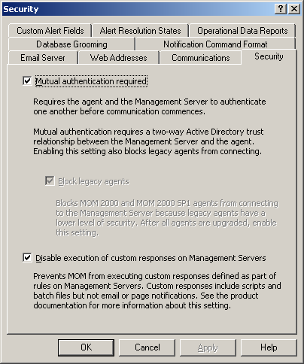
Figure 22: Authentication Configuration

Use of Lower-Privileged Accounts
In MOM 2000, for automated agent management, the Agent Manager service ran with a domain account that had administrative privileges on managed nodes to be able to install/uninstall agents as well as to do registry scans. In MOM 2005, the Agent Manager has been replaced and the same functions (discovery, agent deployment and management) are carried out as server-side tasks.
The dialog box in the previous section shows the configuration to enable mutual authentication and block legacy agents (which did not authenticate). This is designed to prevent a rogue agent from triggering responses on the server.

Disable Server Side Custom Responses
It is possible to write rules which can cause a server-side response. The picture above also provides an option to disable all such actions as a further step towards hardening the MOM server.

Strong Encryption
The option for unencrypted communication is removed in MOM 2005. MOM 2005 takes advantage of Windows encryption, which can be set to FIPS 140 compliant encryption.

Out of Process Responses
MOM 2000 allows admin defined responses run at the server or the managed node under the privileges of the service account. In MOM 2005, the responses are hosted in a separate process. This allows a more reliable operation, since a misbehaving or hung response does not hang the agent. In fact, the agent manages the lifecycle of the response and also kills it if it hangs. The operation is also more secure because a malicious response introduced with an imported management pack cannot take over the agent. Also, when running the agent on sensitive machines, the agent may be run under lower privileges.

The process also runs under local system privileges by default, but can be elevated or lowered to run under different privileges. MOM 2005 supports a range of privileges from the minimum:
- Local ‘Users’ membership
- Local ‘Performance Log Users’ membership
- ‘Manage auditing and security log’ permission
- ‘Allow logon locally’ permission
This gives administrators the flexibility to choose between simple monitoring (which can be achieved with the minimum privileges) and remote administration, which requires administrator-level privileges.

Data Verification
In MOM 2000, data from a managed server might originate from another server. In this situation, the reporting node is called a proxy. This was required to monitor nodes which could not host a MOM agent (e.g. a UNIX or a network box) or to manage a virtual node (e.g. clustering) which could not host a MOM agent. This feature could be exploited by a compromised managed node to spoof data on behalf of another node to generate malicious action (either automatic rule response or by fooling the administrator). MOM 2005 disables this ability by default, only enabling it on nodes that are legitimately chosen to act as a proxy.
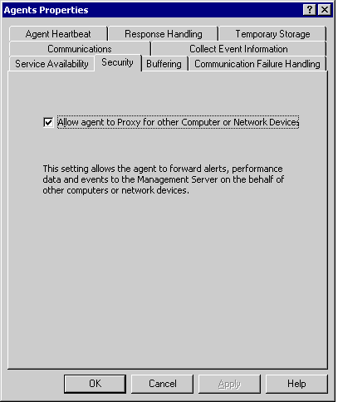
Figure 23: Agent Verification

New and Improved Features at a Glance
Microsoft Operations Manager (MOM) 2005 delivers extensible and scalable enterprise-class operational management by providing comprehensive event management, proactive monitoring and alerting, reporting and trend analysis, and system and application specific knowledge and tasks to improve the manageability of Windows Server System environments. Microsoft Operations Manager 2005 provides:
  - User interfaces optimized for the task at hand, whether it be administration, operations, or reporting
  - Operational knowledge obtained directly from developers and operational staff to help identify, understand, and resolve IT issues
  - Easily extensible architecture to manage custom applications and integrate with third party solutions
Below is a list of what is new and improved in MOM 2005.

Microsoft Operations Manager 2005 Features at a Glance
Feature | New | Improved | Description
User Interfaces
Administrator Console |  | • | The Administrator Console is used for MOM 2005 configuration, server discovery, deployment of agents, creation and maintenance of user privileges and creation, import, and export of Management Packs.
Operator Console | • |  | With MOM 2005 the console functionality has been divided into administration and operations consoles. Alert views and troubleshooting information is now accessible from the Operator console, providing the day-to-day operator with a view into the health of their systems, indications of problems and recommendations to resolve those problems.
Reporting Console |  | • | The Reporting Console allows users to view event, alert, and performance reports from a web browser. The console is based upon SQL Server 2000 Reporting Services and provides subscription services to the operators so they are notified when new reports are published. The reports are structured into folders, and each folder and report may have security privileges associated with it.
Operations
Scalability |  | • | In MOM 2005, several capacity categories have been increased to extend MOM 2005 monitoring capability, including number of managed computers per MOM Server and number of managed servers per console.
Tasks and Diagnostics | • |  | MOM 2005 provides the ability to define, export, import and launch context-sensitive tasks and diagnostics. The tasks can run on the Console, the Server or at the Agent. Such tasks can include pinging a machine, flushing a DNS cache, or removing lingering objects from Active Directory.
Maintenance Mode | • |  | Switching a server into Maintenance Mode provides the ability to stop alerts from being displayed in the Operator Console while a system is being maintained.
Rule Overrides | • |  | Rule Overrides provide the ability to change the default parameters and thresholds for selected computers or groups, and set precedence to prevent potential conflicts caused by multiple overrides.
Auto Alert Resolution | • |  | The agent can automatically update the MOM database when an alert has been resolved without operator intervention.
Instance-Aware Monitoring | • |  | MOM 2005 can recognize and monitor specific instances within a system. For example, it can identify specific databases within SQL Server, not just the SQL Server itself. This provides more granularity for monitoring.
Cluster-Aware Monitoring |  | • | In a clustered server environment, MOM 2005 fully recognizes the concept of the virtual cluster server as well as the physical servers within the cluster. Management Pack authors can leverage this richer ability to instrument servers within a cluster and create appropriate rules for any clustered applications..
Nested Computer Groups | • |  | Logical grouping of computers can be further subdivided to provide management context for similar systems with different monitoring and performance requirements. For example, within the SQL Server 2000 Computer Group there may be a computer group for Payroll and one for Order Fulfillment, each having different rules associated with it.
Views
State View | • |  | The State View provides the operator a real-time, consolidated look at the health of the computers within the managed environment by server role, such as Active Directory Domain Controllers, by highlighting the systems which require attention, and allowing drill-down capabilities to investigate the specific service causing the issue.
Diagram View | • |  | The Diagram View provides operators with a variety of topological views where the existence of servers and relationships as defined by Management Packs. The status of the servers, navigation to other views and launching of context-sensitive actions can be accessed directly from a diagram view, helping the operator navigate quickly to the root cause of the problem.
Alerts View |  | • | The Alerts View provides a detailed list of actionable issues and the current state of those alerts– whether they have been acknowledged, escalated, or resolved, as well as the severity level and whether a Service Level Agreement has been breached.
Events View |  | • | The Events View provides a detailed list of events that have occurred on managed servers, a description of each event, and the source of the problem. The improved layout of the view provides related information in separate panes within the same window for easy access by the operator. Tasks and diagnostics are available from the same view.
Computers and Groups View | • |  | Users can view the computer groups a computer belongs to, the processing rule groups that are associated with it, and the computer attributes.
Security
Reduced Account Privileges |  | • | On Microsoft Windows Server 2003, the MOM Service can run under the Network Service account. This account has lower permissions than the Local System account, and enhances the security of the MOM Service.
Scopes of Operation | • |  | MOM 2005 allows customized views to be created - for example restricting a specific user to access and manage only a certain subset of computer groups. This capability, known as ’scoping’, can be use to isolate users from seeing and acting on each other’s systems
More Secure Agent/Server Communication | • |  | The communication between the MOM 2005 Agent and the Management Server is encrypted and digitally signed by default. The encryption has been enhanced and is based upon a dynamically-created key, rather than a static key. Dynamic keys make it harder to view data that is transferred between MOM components. Mutual Authentication is also enabled by default for authenticated communication between the MOM server and agents.
Deployment
Agentless Monitoring | • |  | MOM 2005 provides monitoring of agentless servers. This functionality is aimed at evaluation situations, smaller environments or for enterprises where agent installation is disabled for a few exception nodes. Agentless monitoring is limited to status monitoring only.
64-bit Agent Support | • |  | MOM 2005 provides management of applications running on 64-bit operating systems based on Intel IA-64 and AMD-64 platforms.
Internationalization | • |  | MOM 2005 operates in multi-language and localized environments, and the consoles and management packs are localized for English, French, German, and Japanese languages.
Server Discovery |  | • | Server discovery in MOM 2005 is wizard-based and allows importing server lists from Active Directory, from a file, or from a typed list. It also allows filtering of the list via LDAP queries, and name- and domain name-based wild-carding.
Reporting
SQL Server 2000 Reporting Services | • |  | MOM 2005 provides scalable and customizable reports by utilizing SQL Server 2000 Reporting Services. Reports can be easily exported to Microsoft Excel, Adobe Acrobat, HTML, TIFF, CSV, or XML file formats.
Report Customization |  | • | Reports can be created and tailored through Visual Studio .NET for both operational data previously available with MOM 2000 and now also historical data with the addition of the SQL Server reporting services with MOM 2005.
Third-Party Interoperability
MOM Connector Framework |  | • | MOM Connector Framework is a web services-based connector enabling bi-directional communication between multiple MOM instances and other third-party management systems to share data and make resolution of problems easier across an enterprise.
Management Pack Authoring |  | • | Third-party ISVs can easily develop their own Management Packs for use by MOM 2005

The next step is to take MOM 2005 for a test drive. The following section provides a detailed walkthrough which describes how to discover the power and features of Microsoft Operations Manager 2005.

Test-Driving Microsoft Operations Manager 2005
This section of the guide provides a series of exercises designed to provide an introduction to the various features of Microsoft Operations Manager (MOM) 2005.

Test-drive Overview
This test-drive of MOM 2005 will use a pre-configured Virtual PC image running under a copy of Microsoft Virtual PC 2004. This image is ready for the installation of MOM 2005 and is bundled with an ISO file containing the MOM 2005 RTM CD image.
During this Test-drive you will cover the following areas of the MOM 2005 product:
- Installation Experience
  - Including installation of MOM Reporting and Management Packs
- Administrator Experience
  - Including configuring Management Packs and Tasks
- Operator Experience
  - Including Operator Console, Web Console and Web Reporting
All one-time server setup and Windows configuration steps have been completed for you, allowing you to focus on those steps an administrator would follow to install and use the product for normal operational tasks. The configuration of this virtual image is identical to one you might build yourself.
The basic requirements for a computer system you will need to run this test-drive are provided below, followed by the steps to walk through each of the feature areas of MOM 2005.

Test-drive System requirements
To use the pre-configured Virtual PC image to complete the MOM 2005 Test-drive, a PC which meets the following systems requirements should be used to host the image. The steps required to set-up and configure Virtual PC 2004 and the Virtual PC image are provided in a README.TXT file with the image. An evaluation copy of the Virtual PC 2004 software is also provided on the image DVD.
- The host system which will be running the Test-drive image under Virtual PC should be Windows 2000, Windows XP or above with a 1GHz processor and at least 500 Mb RAM (1Gb or more strongly recommended).
- At least 4Gb of free disk space will be required – more space if the image is to be run in “non-commit” mode to save the initial image state.
NOTE A: The evaluation version of Virtual PC 2004 supplied with the image will expire 45 days after installation.
NOTE B: The administrator account used in the Virtual PC image is MOMDEMO\mom-admin with the password Password1. You should log into the image with that account for all Test-drive sections below.

Full Test-drive System requirements
If you wish you may also install MOM 2005 separately on your own copy of Windows Server. To follow the steps below you will need to set up and configure a copy of Windows Server 2003 Standard with the following specifications. Detailed steps for this are not provided in this test-drive documentation, but a copy of the MOM 2005 Installation and Upgrade Guide is provided on the Reviewers Test-Drive DVD. This document and others it references provide the steps needed to create a suitable system for the MOM 2005 installation.
To ensure that the step-by-step instructions work correctly when building your own MOM 2005 evaluation system from the ground up, the following basic requirements must be met by the system hosting the installation:
- The host server is running Microsoft Windows 2000 Server or Windows Server 2003 Standard Edition, configured as an Active Directory domain controller of its own forest. In the text below, the domain being managed is “momdemo.net”
- In the text descriptions the server domain controller is called MOMWALK, although any name may be used. The test-drive steps assume an Administrator account named mom-demo has been created on this domain. You should create an account of this name with all Administrative rights for the purposes of the test-drive.
- Microsoft Internet Explorer 6 or later must be installed on the Windows Server.
- Microsoft Internet Information Services must be installed on the Windows Server (available as a standard option under Add/Remove Windows Components).
- Enable IIS and ASP.NET on the domain controller. Install Visual Studio.NET if you wish to author new reports (not required for this walkthrough).
- If Windows Server 2003 is being used as the host OS, then the WebDAV Web Service Extensions must be enabled on the Internet Information Services Manager (accessible from the Administrative Tools menu).
- If Windows 2000 Server is being used as the host OS, then Service Pack 4 must be installed.
- Microsoft SQL Server 2000 must be installed on the host machine, with Service Pack 3 or greater applied.
- The Active Directory must be called MOMDEMO.COM, and the simple directory name should be set to MOMDEMO.
1. Checking MOM 2005 Pre-requisites
The MOM 2005 installation offers a tool to check the configuration of the host machine before proceeding with an installation. This tool simplifies the process of preparing a server to host a MOM 2005 Server and provides instructions for meeting those requirements.
The Pre-requisites tool reports both configuration Errors (which block installation of MOM 2005) and Warnings (which meet minimum requirements but are not optimal).
A. Checking the Pre-Requisites
We will now run the Pre-requisites check for the MOM Server installation, and will resolve an issue with the SQL Configuration which currently blocks the install. We will then confirm that the system will also support the MOM Reporting services by running the checker again.
- On the Virtual PC host computer, launch the image called “MOM 2005 Test-drive”. This will bring up a Virtual PC window in which a server named MOMWALK will boot.
- Once the image has booted, you may force the Virtual PC window full-screen by pressing <Right-ALT>-<ENTER> where <RIGHT-ALT> refers to holding down the <ALT> key to the right of the spacebar
NOTE: When you wish to restore the Window from full-screen simply press <Right-ALT>-<ENTER> again.
- Log into the server MOMWALK using the credentials:
- User: mom-admin
- Password: Password1

NOTE: Instead of pressing <CTRL>-<ALT>-<DELETE> in the Virtual PC to logon you must press <RIGHT-ALT>-<DELETE>.
- On the desktop, double-click the CD-Drive shortcut to “Open” the MOM 2005 setup CD image in the D: drive.
- The MOM 2005 setup launcher appears. The first tab offers three setup choices, including the option to check for MOM Prerequisites. The second tab offers links to MOM 2005 documentation and the third tab allows the CD to be used to install agents manually on servers where automatic agent installation is not an option.
- On the “Setup Tasks” tab, click the Check Prerequisites link.
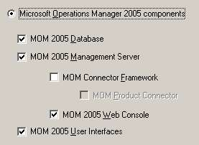
- The “Check Prerequisites” window opens, offering two main options – to check the system for MOM 2005 component requirements or to check for MOM 2005 reporting requirements. For this Test-drive we will install all MOM components on this machine, and so the check boxes should be configured as shown in the figure on the right. These settings will check that the system is able to host the MOM 2005 database, Management Server, Web Console and User Interfaces.
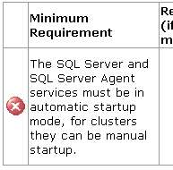
- Press the Check button to initiate the scan of the machine MOMWALK. After a few seconds the results of the check are displayed. Note that one error is reported – this indicates a configuration change which is required before installation may proceed.
- Scrolling down the report window reveals that a “Warning” is also indicated, advising that installation of the MOM Server Components on a Domain Controller is not recommended. This will not prevent installation – it is simply an indication of best practices.
- Close the Prerequisites report window and then double-click on the SQL Monitor icon in the system tray at the bottom right of the screen to open the SQL Server Service Manager.
- In the “Services” drop-down select SQL Server Agent and then select the Auto-start service when OS starts checkbox. Now press the Play button labeled Start/Continue. Now Close the “SQL Server Service Manager” window.
- Re-run the report by pressing the Check button and note that the Error is no longer present. Close the report window.
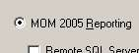
- Repeat this process for the Reporting components by checking the MOM 2005 Reporting Option in the Check Prerequisites dialog and then pressing Check. It will take 20 seconds or so for the report to open, showing that all tests are successful for this component and so MOM Web Reporting can also be supported on this machine.
- Close the report and the Check Prerequisites window.
B. Installing MOM 2005 services
Installation of MOM 2005 is a simple process, and is based on an MSI installation package which simplifies the installation and post-install maintenance of the MOM services. Once the deployment planning has been completed, the MOM 2005 Setup Resources dialog allows an administrator to select and install the required components on the designated machine.
In this section we will install all MOM components onto the virtual system MOMWALK. After the MOM services have been installed, MOM Reporting and several MOM Management Packs will also be installed.
- If the Setup Resources dialog has been closed, re-open it by double-clicking the CD Drive icon which opens the Setup Resources dialog.
- Select the Install Microsoft Operations Manager 2005 link, wait for the Setup wizard to open, and then press Next to move to the “End-user License Agreement” page
- Select to accept the license agreement and press Next then press Next again at the “Registration” page.
- At the “Installation Options” page an operator may choose a Typical (default) or a Custom installation. We will select the Custom installation and press Next.
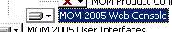
- The “Custom Setup” page shows the Typical options selected by default. The only change we will make is to enable installation of the MOM 2005 Web Console. To do this click on the “X” to the left of the “MOM 2005 Web Console” text and select This component will be installed on the hard disk from the dropdown that appears. Then press Next to invoke a Pre-requisites scan.
- The next page shows that the request to install these components has passed a pre-requisites check, and so the installation may proceed. If one or more pre-requisites had not been met, installation would stop at this point. Press Next to continue.
- The “SQL Server Database Instance” page allows the operator to select which database instance should be used to hold MOM configuration and operations data. In this case only one instance (MOMWALK) is available, so simply press Next to move to the next page.
- The initial size of the MOM 2005 database can be configured on the next page. The default of 1000Mb is larger than needed for this test-drive and so we will reduce it to 300Mb. Type 300 in the “Database Size” field and then press Next. Changing this value will reduce installation time on this Virtual PC image.
- On the next page the operator can select the MOM Group name to be used by this MOM installation. A given organization may use multiple parallel MOM hierarchies to manage computers, each set of MOM servers belongs to a unique MOM Group. This allows (for example) different Operations teams who manage the same systems to own distinct MOM installations for that purpose, without interfering with each other.
- Enter the name MOMGROUP in the Management Group Name box and press Next.
- On the “Management Server Action Account” page, enter the username mom-act and the password Password1. This account is used to gather data remotely, execute automatic responses to events and alerts, and install and uninstall components. Press Next to continue.
- On the “Data Access Server Account” page, enter the username mom-das and the password Password1. This account is used for connections to the MOM database server from all components. Press Next to move on to the next page.
- MOM 2005 offers the ability to report any errors encountered by the installation directly to Microsoft. This option may be enabled on the “MOM Error Reporting” page. Any data captured following a failure is passed through secure channels to Microsoft, where it is held in a controlled access facility. The MOM team use this information solely to improve the MOM 2005 product. We will not enable this feature, as the image has no Internet access. Press Next to continue.
- On the next page we are asked if all computers to be managed are within an Active Directory Domain which is trusted by the current domain (and vice versa). We leave this option enabled as we will only be managing the MOMWALK computer itself, which is the Domain Controller for this domain. Press Next to continue.
- The MOM 2005 installation now has all configuration details needed to install the MOM 2005 server components. Press Install to initiate the installation process. This may take several minutes.
- Once the installation is complete, the final page indicates that MOM 2005 setup was successful, and offers to launch the MOM Administrator console. Press Finish to launch the console and close the setup wizard.
C. Installing MOM 2005 Reporting
MOM 2005 incorporates a powerful web reporting system based on SQL Reporting Services, which have been pre-installed for you on this image. In this section we will add the Reporting Services to this MOM installation. Note that the Web Reports could be hosted on a separate server for load balancing purposes, but for this test-drive they will be added to the MOMWALK machine.
- If the Setup Resources dialog has been closed, re-open it by opening My Computer → D: which opens the dialog.
- Click on the Install MOM 2005 Reporting link and click Next on the Welcome screen.
- Accept the terms of the license on the next page and press Next.
- Press Next at the “Registration Information” page and press Next again on the “Destination Folder” page, accepting the default install location.
- On the “SQL Server Reporting Services Server” page, leave the current machine (MOMWALK) as the SQL Server name and leave auto-detection of the virtual directories enabled. Press Next to re-run the Reporting Pre-requisites Scan.
- As expected, the pre-requisites check passes, so now click Next to move on to the “MOM Database Server Instance” page.
- Since only one instance of SQL Server is installed, enter MOMWALK in the “MOM Database Server” field and click Next.
- On the SQL Server Database Instance page leave the default instance as MOMWALK and press Next to continue.
- On the “Database and Log File Information” page we will reduce the database size from the default setting of 1,000 MB to 300Mb to minimize the disk space used by the test-drive. Enter 300 in the Database Size field and press Next.
- In the “Data Transfer Task Account” page we will supply an account context to be used for scheduled data transfers from the MOM DB to the off-line reporting DB. Enter the following details in the dialog and then press Next to continue:
  - User Name: mom-das
  - Password: Password1
- In the “Reporting User Account” page we will supply an account context to allow the Reporting Services to connect to the MOM Reporting database. Enter the following details in the dialog and then press Next to continue:
  - User Name: mom-das
  - Password: Password1
- On the next page the operator may elect to configure MOM to send weekly operational reports to Microsoft regarding the performance of the MOM product, to allow Microsoft to improve the system design and performance in the future. We will leave this feature at the default, disabled, as this image has no Internet connectivity. Press Next to move to the next page.
- Setup is now ready to install MOM 2005 Reporting. Press Install to initiate the installation process. This will take several minutes to complete, actual time depending on the speed of the host computer.
- At the Final installation page, select the Transfer data from the MOM database now option to copy live data to the off-line reporting database and then press Finish.
D. Importing MOM 2005 Management Packs
In this section we will use the MOM 2005 Administrator Console to import a number of Management Packs, each of which includes hundreds of individual rules designed to monitor and measure system state and performance relating to a specific service or solution.
- The MOM 2005 Administrator console should still be open, with the home page on display. This home page provides the MOM Administrator with the recommended next steps to configure the MOM infrastructure.
- The second bullet on the home page suggests that Management Packs should now be imported. By default after installation MOM 2005 has only one Management Pack loaded – the MOM 2005 Management Pack which carries the rules to monitor and manage the MOM 2005 installation itself. Click on the Import Management Pack link to launch the Management Pack Import/Export Wizard.
- Click Next to reach the Import or Export page. Select Import Management Packs and/or reports and press Next.
- In the “Select a Folder” page, enter or browse to the path D:\ManagementPacks\ to load management packs and reports from the installation CD and then press Next.
- The “Select Management Packs” page allows the administrator to select which Management Packs should be installed, and if an earlier version of that pack is installed, how any customizations or changes should be handled as the new rules are merged into the MOM database. Select all of the lines in the Management Packs listbox, leave the other settings at their defaults and then press Next.
- In the “Select Reports” page, select all lines in the reporting files listbox leaving the “Always warn me about insecure connections” option checked. Press Next to continue.
- On the “Secure Socket Layer Confirmation” dialog that appears press Continue to accept the warning about insecure transfer of user credentials.
- Press Finish to start the import. The Import Status window opens allowing you to monitor the progress of the import process. This process will take several minutes to complete, the actual time depending largely on the speed of the host machine.
- Once the import has completed, press Close to shut down the import status window.
2. The MOM 2005 Administrator Console
The MOM Administrator Console provides an environment in which the staff responsible for deploying and maintaining Microsoft Operations Manager itself may easily change, configure and maintain the system. The console is provided as an MMS snap-in, allowing it to co-reside with other Windows Administration consoles in a single MMC host UI.
The core features of the console UI allow MOM Administrators to deploy and manage agents, define and update computer groups, create role-based Operator console scopes and configure all aspects of the MOM Server operation including Alert customization, communications, security, database grooming and operator notification.
The steps below walk through the Administrator Console, highlighting how a MOM Administrator can reconfigure the MOM Server and agents from this UI, and modify Management Pack rules and Groups.
A. Deploying MOM Agents
Although MOM Agents may be installed manually on target servers, it is much simpler and more efficient to allow the MOM Server to push these agents out automatically across the network. This process can be driven entirely from the MOM Administrator console. The deployment process itself is carried out in the background, but a foreground UI allows an operator to monitor the progress of the deployment as it progresses, and to review the detailed status of the deployment on completion.
In this section we will discover all machines in the directory and attempt to deploy agents to them automatically. Since the demo image has only one machine, the MOMWALK server, and this is already managed by an agent, no actual deployment will take place. Machine accounts will be discovered but as those machines are not on-line, installation will fail.
NOTE: An additional VPC image is available which may be run in parallel with the main MOMWALK image. This image hosts both SQL Server and Systems Management Server 2003. This allows an agent to be deployed and a richer set of views to be demonstrated later in the Test-drive. As execution of two images in parallel requires significantly more memory and disk space on the host machine, this additional image is provided on request only. Please contact the authors of this Guide if you wish to try this option.
- If the MOM Administrator console is not currently open, launch it from the Start Menu under Start → All Programs → Microsoft Operations Manager 2005 → Administrator Console.
- If not already selected, click on the Microsoft Operations Manager (MOMWALK) node to display the Operator Home Page. Once MOM is installed this page provides suggestions and links relating to the next steps in Configuring MOM 2005.
- The first item on the Home Page discusses deploying agents automatically to servers being targeted for management.
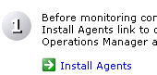
NOTE: In this test-drive only one machine is available – the MOM Server itself, and since this machine is automatically supplied with a MOM agent, no new agents can be deployed. To demonstrate the steps involved however, some Machine accounts have been manually created in the Active Directory. MOM can be configured to deploy agents to servers based on their directory membership so this allows us to simulate the deployment process.
- Click the link named Install Agents. This launches the “Install/Uninstall Agents Wizard”.
- Click Next to move to the “Method for Discovering Computers and Installing Agents” page. This page allows an operator select whether a specific (named) set of machines should be targeted or a query should be built to create a dynamic target set. In both cases the Active Directory is used as the source for machine details.
- Select Search Criteria and press Next to move to the “Computer Discovery Rules” page.
- Click Add… to open the “Create or modify the computer discovery rule” dialog.
- Enter the following details in the named fields to create a dynamic Active Directory query, the result set of which will be targeted for discovery and installation of MOM Agents:
Domain Name: MOMDEMO
Computer Name: “matches wildcard” * (asterisk)
- Deselect the During computer discovery, contact each computer to verify that it exists checkbox. If this box is left checked, the MOM Server will ping any targeted machine before attempting to deploy an agent to it. In the test-drive configuration this would skip the attempt to install.
- Press OK to add the new rule and then press OK on the dialog which warns that a large number of machines may be targeted by this rule.
- Press Next to move to the “Agent Installation Permissions” page. On this page an operator may select the security context in which an agent should be installed. By default the Management Server Action Account (defined during installation) is used. However if the target machines are members of a non-trusted domain, an alternative account may be associated with this installation.
- Leave the default setting and press Next to move to the “Agent Action Account” page. This page allows the operator to select what security context should be used by the installed agents to execute any responses to rules firing. By default the Local System account is used, however an account with lower or higher rights may be required, depending upon the roles of the targeted machines.
- Leave Local System selected and press Next to move to the “Agent Installation Directory” page where the operator may define the folder location where the MOM agent should be installed. By default the agent is installed under Program Files.
- Leave the path unchanged and press Next to move to the final page of the wizard. Leave the “Show Task Progress” box selected so we can monitor the deployment process and then press Finish.
- The “MOM Task Progress” window appears and the background Discovery and Installation processes may be monitored live. Note that although seven new machines are discovered, the attempts to install on each of them fail (as they are not present on the network). In a successful install, a log of each install is provided for debugging purposes.
- Close the progress Window.
B. MOM 2005 Console Overview
The MOM 2005 Console partitions the operator environment into four areas, namely:
- Information
- Operations
- Management Packs
- Administration
The next section provides a brief overview of all four sections and the following sections then drill in the Management Packs and Administration nodes in more detail.
- If the MOM Administrator console is not currently open, launch it from the Start Menu under Start → All Programs → Microsoft Operations Manager 2005 → Administrator Console.
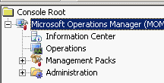
- If the “Microsoft Operations Manager” node in the left pane is not expanded, click the “+” sign to the left to open the tree and show the four sub-nodes in the UI beneath it.
- Click on the Information Center node. This page ensures that MOM Administrators have all of the information they require to manage MOM at their fingertips. Links are provided to a variety of key documents, all of which are hosted on the www.microsoft.com web site, to ensure content is fully up to date at all times.
A link is also provided at the bottom of the page to allow Administrators to provide feedback directly to the MOM 2005 team about the product, to allow future revisions of the product to meet new requirements from real world deployments.
NOTE: The Virtual PC image being used for the test-drive does not have Internet access, and so these links are not available during this walk through the product.
- Click on the Operations node in the left hand pane. The page displayed in the right pane provides links to each of the three additional consoles available for MOM 2005:
Operator Console – is the working environment for first tier IT operators. It offers multiple views onto the status of systems and services allowing operators to examine alerts, events and performance trends, initiate actions and resolve issues.
Reporting Console – The reporting console is a Web UI onto the rich MOM 2005 Reporting system. Over 100 web reports are bundled with MOM 2005 providing a wide range of views onto the system status for operators, managers and business owners.
Web Console – The web console provides a subset of the information available in the Operator Console, but from within a web browser, allowing operators to view current system and server status from any machine with network access without installing the Operator Console.
- Click on the Management Pack node in the left hand pane. In the right hand pane some statistics about the currently loaded sets of management packs are displayed, together with links to the lower level nodes beneath this node. Each of these lower level nodes relates to an area of Management Pack maintenance and configuration.
- Click on the Administration node in the left hand pane. In the right hand pane some overall statistics about the discovered and managed computers in the MOM database are displayed, together with links to the four sub-nodes which provide tools to manage Computers, Console Scopes, Global MOM Settings and Product Connectors.
C. Configuring Management Packs – Computer Groups and Rule Groups
Under the Management Pack node in the MOM 2005 Administrator Console an operator may import, modify and export management packs within MOM 2005. In this section we will explore some of the various sub nodes and drill specifically into the Active Directory Management Pack computer group, changing a script parameter to remove spurious Alerts which would be seen only in this unique Test-drive scenario where we are hosting a single DC.
- If the MOM Administrator console is not currently open, launch it from the Start Menu under Start → All Programs → Microsoft Operations Manager 2005 → Administrator Console.
- If the “Microsoft Operations Manager” node in the left pane is not expanded, click the “+” sign to the left to open the tree and show the four sub-nodes in the UI beneath it.
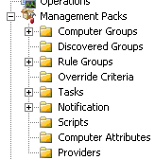
- Expand the “Management Packs” node in the left pane by clicking on the “+” sign to the left of it to open the node sub-tree. This will display nine sub-nodes for management of different Management pack attributes.
- Click on the Computer Groups node. In the right hand pane a list of all Computer Groups defined by the currently installed Management Packs. Each computer groups identifies machines playing a specific role in the network. Management Packs create these groups by defining a set of rules which identify machines meeting the criteria (and therefore performing the role required). Most groups automatically detect such machines based on their configuration, as reported by the MOM agent. Some require manual configuration.
- Locate the “Microsoft Operations Manager 2005 Databases” computer group and double-click it to open the group properties. This property page describes the attributes used to identify machines on the network operating as MOM 2005 Database Servers.
- Click the Search for Computers tab to see the types of computers which may be examined for this role. Note that any Windows Server or Domain Controller is considered a possible target.
- Next click on the Formula tab and review the “Formula for computer group” text box. This describes the registry entries which indicate that a particular computer is currently serving as a MOM 2005 Database Server. Review the contents of the other tabs to understand how the configuration and behavior of a Computer Group may be modified by the MOM Administrator.
- Press Cancel to close the property page, then locate the “Active Directory Client Side Monitoring” group. Double-click to open the property page for the group. The membership of this group must be manually configured by the operator. It is used to identify which machines on the network will be used to remotely test the availability of Active Directory services. For example, in an Exchange Server environment, it is critical that all Exchange Servers have access to AD services. Therefore an Administrator is likely to place Exchange Servers in this group to ensure any loss of AD availability would result in an alert to the operator.
- Click on the Formula tab and note that a formula is not required to identify such a machine.
- Click on the Included Computers tab. This is where an operator may identify the machines which will be used to test AD services on a repeating schedule. We will now add the current server to this group.
Note: In practice, this is not a normal configuration, since this machine is itself a Domain Controller. Normally machines remote from the Domain Controller would be used to probe the service availability.
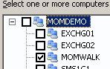
- Click on the Add… button to open the “Add Computer” dialog. Expand the MOMDEMO domain and then check the box next to the MOMWALK server name. Press OK to add the machine to the group.
- Click on the Search for Computers tab and select both the Servers and Domain Controllers check boxes. Press OK to save this change to the Computer Group.
- Click on the Rule Groups node and review the list of currently installed Management Packs.
- In the right hand pane, click on the Microsoft Windows Active Directory link to open the rule group associated with that Management Pack. Review the overview of this management pack displayed in the right hand pane. It includes an introduction to the various sub-groups which may be enabled and the configuration settings required.
- Click on the Active Directory Client Side Monitoring link to move to that sub-rule group. Review the information about this specific rule group, which is responsible for the monitoring of AD services as delivered to remote clients on the network (including Exchange servers). Note the configuration instructions covering how set up a machine to test AD availability, as completed above.
- Click on the “+” sign to the left of the “Active Directory Client Side Monitoring” rule group and then click on the Event Rules node beneath it. Note the 18 event rules which form part of this rule group to monitor AD availability from an AD client.
- Double-click the Script – AD Client GC Availability rule to open its properties.
- Click Data Provider and note that this rule fires on a timer event every 5 minutes, starting at 2 minutes after the hour.
- Click on the Responses tab and note that when the timer period fires, the rule will execute a script called “AD Client GC Availability” on the client. This script will test if the DCs being tested by the client are in sync time-wise, and that a certain number of GCs are visible to the client.
- We will now change the number of GCs required, to prevent spurious Alerts during the test-drive in our single-DC environment. Open the script properties by clicking on the script name in the listbox then pressing Edit to open the “Launch a Script” dialog.
- In the script parameters listbox, note that the “MinimumAvailableGCs” parameter is currently set to 3. An Alerts will be raised if less than 3 GCs are visible to the client. We will reduce this threshold to 1. Double click the MinimumAvailableGCs parameter in the listbox and in the “Value” field of the “Edit Script Parameter” dialog, change the #3 to a 1 and then press OK to close the dialog.
- Press OK to close the “Launch a Script” dialog and then press OK to close the “Event Rule Properties” dialog.
D. Configuring Management Pack Tasks
We will now examine a number of the default tasks installed with the management packs, and will then go on to create two new Tasks which will be used later in the test-drive to trigger operations which occur by default on an 8 hour schedule. By running them manually instead we can reduce the time taken to complete this test-drive process.
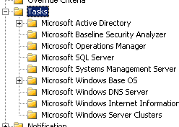
- Expand the “Tasks” node in the left pane by clicking on the “+” sign to the left of it to open the node sub-tree. Note that each Management Pack has installed additional tasks which are specific to that service or function.
- Expand the “Microsoft Windows Base OS” node in the left pane by clicking on the “+” sign to the left of it and click on the “Networking” node beneath it. Note the network specific tools provided for an operator to help diagnose Windows networking problems.
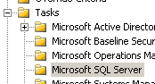
- We will now create two new tasks which we will use from the Operator Console later in the test-drive. Both tasks will be configured to run existing scripts from installed management packs. The first task will be created within the “Microsoft SQL Server” management pack so click on Microsoft SQL Server under the “Tasks” node.
- Right-click on the right-hand pane where the existing tasks are listed and select Create task to launch the “Create Task” wizard.
- Press Next to display the “Task Run and Location Type” page. Tasks may be executed at a number of locations, namely the Operator Console, Management Server, or the target agent. Tasks may also execute a variety of targets including command lines, scripts and managed code.
- Select Agent-managed computer and Script so that the new task will execute a script at the remote agent. Press Next to move to the next page.
- On the “Task Configuration” page we now select which script should be executed. The script we need is for SQL Servers, so in the “Target Role” dropdown select SQL. In the “Script” dropdown, select SQL Server 2000 Service Discovery which is part of the SQL Management Pack then press Next to move to the next page.
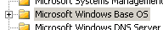
- On the “Task Name and Description” page enter the name Run SQL Service Discovery in the Name text box and then press Finish. This new task will now be available in the Operator Console.
- The second task we will need should be part of the “Microsoft Windows Base OS” management pack.
- Right-click on the right-hand pane where the existing tasks are listed and select Create task to launch the “Create New Task” wizard.
- Press Next to display the “Task Run and Location Type” page. Select Agent-managed computer and Script so that the new task will execute a script at the remote agent and then press Next to move to the next page.
- On the “Task Configuration” page select OS in the “Target Role” dropdown and then select Microsoft Windows Base OS Service Discovery Script in the “Script” dropdown, Press Next to move to the next page.
- On the “Task Name and Description” page enter the name Run OS Service Discovery in the Name text box and then press Finish. This new task will also be available in the Operator Console.
E. Configuring Overall MOM Operations
Under the Administration node in the MOM 2005 Administrator Console operators can configure a variety of global parameters for MOM operations such as managing Computers, Console Scopes, Global MOM Settings and Product Connectors. We will briefly browse through these options.
NOTE: The Product Connectors feature has not been installed in this test-drive since no other systems or products are available to connect with the MOM infrastructure.
- If the MOM Operator console is not currently open, launch it from the Start Menu under Start → All Programs → Microsoft Operations Manager 2005 → Administrator Console.
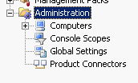
- Expand the “Microsoft Operations Manager” node in the left pane by clicking the “+” sign to the left to open the tree and show the four sub-nodes in the UI beneath it.
- Expand the “Administration” node in the left pane by clicking on the “+” sign to the left of it to open the node sub-tree. This will display four sub-nodes for management of overall MOM operations.
- Click on the Computers node. In the right hand pane a summary of all the computers discovered and managed by MOM is displayed together with links to each of the computer roles or types.
- Expand the Computers node by clicking the “+” sign to the left to open the tree and show the sub-nodes in the UI beneath it and then click on the All Computers node. The current status of agent communication with all computers known to MOM is displayed. Note that only the MOMWALK machine is in communication. Also note that all machines are configured to be Agent-managed, but all but the MOM Server are Unmanaged (since they are off-line and an agent cannot be installed).
- Click on the Console Scopes node. Note that three console scopes are created on MOM installation. A MOM administrator may create additional scopes, customized to specific operator roles. Each scope can be limited to viewing machine and state information for a subset of the machines and services managed by MOM. For example a SQL Administrator scope might only show status information and alerts from SQL Servers managed by MOM, while a Web Administrator scope might display information from Web servers, firewalls and back-end SQL servers associated with a Web-based solution.
- Click on the Global Settings node and then double-click on any of the setting types displayed in the right hand pane.
- Each tab on this dialog allows configuration of a different aspect of global MOM operations. Browse through the tabs to review the various customization and optimization options available to a MOM Administrator.
- Close the dialog by pressing Cancel.
3. The MOM 2005 Operator Console
The MOM Operator Console provides an environment for IT administrators who provide day-to-day monitoring and administration of IT services and components. The console provides multiple views into systems and alerts, allowing them to execute tasks, take actions and diagnose underlying problems. Problems may be tracked through to resolution and longer term trends closely monitored. The MOM Administrator can create customized Consoles for different operator roles, removing extraneous information from an operators view.
The following section walks through the use of the Console, and looks specifically at how SQL alerts are handled by an operator. To demonstrate a typical scenario, a SQL Alert is generated by stopping the SQL agent and a console task is used to restart it.
A. Overview of the MOM 2005 Operator Console
- In the MOM 2005 Administrator Console select the Operations node and then click on the Start Operator Console link in the right hand pane.
- Note the similarity of the multi-pane UI to an Outlook view. This is a familiar format for most operators, and allows them to view multiple aspects of the current state concurrently. The lower left pane is a “Navigation” area which allows the operator to switch between different views on the current system status. We will now take a tour of each of the views available onto the system and service status, specifically looking at the Alerts, States, Events and Performance views.

- In the Navigation pane, click on the Alerts bar to select the “normal” operator view. In this Alert view, the operator can see all currently open alerts in the central top pane. This view is effectively the “inbox” for an operator, displaying the incoming issues which require attention or are currently being addressed.
- Select any of the current Alerts in the top center pane and note that the lower “Alert Detail” pane changes to show the properties of that alert, including a description of the problem.
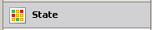
- Click on the Product Knowledge tab to view the information provided to the operator by the relevant product team about the likely causes of this alert and probable next steps to resolution. Companies may add their own organization specific knowledge under the “Company Knowledge” tab providing operators with specific local insight into the problem scenario.
- Click on the State bar in the Navigation pane. Whilst the “Alert” view is used as a “to do” list for operators, the “State” view provides anyone (including business owners) with an overview of the roles being played by each server and the overall status of those roles on each machine.
- Note the column headings in the upper center pane, which list the various roles being monitored. Each installed Management Pack is aggregating the status of individual components and instances into a single overview of the status of a particular service. Although only one machine is listed in this test-drive, normally a line would appear for each server being managed.
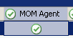
- To view more of the underlying details behind a role status, scroll to the right and click on the check mark under the MOM Agent column heading. Note that in the lower center pane, a more detailed breakdown of the MOM Agent state is provided, including Configuration, Heartbeat, Performance, Queues and WMI, all of which are in a “Success” state.
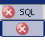
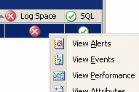
- In the top center pane, click on the red cross beneath the SQL column heading. The top pane tells an operator that the SQL role is in a Critical state. The lower pane now provides more detailed information – by scrolling the lower pane to the right we see that the Log Space is forcing this role into Critical.
- Right-click on the red cross under Log Space and select View Alerts from the menu. The display now changes to show the Alerts which have forced this state change. This is a typical “drill-down” scenario which an operator might use to follow a reported outage or performance degradation through to a root cause.

- Click on the Events bar in the Navigation to change to an event view. The top center pane now displays the full event stream being processed by the MOM server. Normally there are too many events in this view, and so the view can be filtered in a variety of ways including Computer, Computer Group or Management Pack for greater clarity.
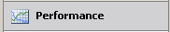
- Click on the Performance bar in the Navigation pane to switch to a view of recorded performance data. By default, the center pane now switches to a mode where the operator can select which counters to display from any number of managed servers. However each Management Pack may also provide pre-created data sets for plotting.
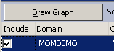
- In the top left pane, Expand the Microsoft Windows Base OS folder then the Performance folder and finally the Processor folder. Click on the % Processor Time/_Total item. The right pane now offers an option to select any number of managed systems to plot for this data set. Check the box for the MOMWALK system and then press Draw Graph. Note the resulting performance data plot.
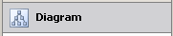
- Click on the Diagram bar in the Navigation pane. Diagram views allow management packs to display relationships and groupings of servers and services. In the test-drive configuration there are few relationships which can be plotted, but in a normal deployment, the AD Management Pack would display layouts of the replication topologies and site to server relationships.
- With this simple single server configuration, only one AD diagram is active. To view it, in the top left pane open up the Active Directory / Replication Topology Diagrams folder and click on the Site Links diagram. The resulting diagram in the center pane shows the relationship between the single DC and the sole AD site link. All topology views can be exported from the console as Visio files, allowing the system and service configuration discovered by MOM 2005 to be printed out or shared with other IT operators, or archived for reference purposes.
- Click on the Alerts bar in the Navigation pane and then select any Alert in the “Alerts” pane with “MOMWALK” in the computer column.
NOTE: We will now execute the tasks we created earlier against this machine. Both tasks used to accelerate the processing of configuration data for the purposes of this test-drive. In a normal MOM deployment this step would not be required as these tasks are automatically executed on a recurring schedule.
- With the MOMWALK server selected, open up the Microsoft SQL Server node in the right-hand “Tasks” pane. Beneath that node, click on the Run SQL Service Discovery to launch the task wizard.
- Press Next all the way through the wizard, accepting the default values for all entries. Finally press Finish to schedule the task for execution. This script will scan the MOMWALK machine for SQL configuration data, identifying instances, services and attributes which will be stored in the MOM database.
- With the MOMWALK server still selected, open up the Microsoft Windows Base OS node in the right-hand “Tasks” pane. Beneath that node, click on the Run OS Service Discovery to launch the task wizard.
- Press Next all the way through the wizard, accepting the default values for all entries. Finally press Finish to schedule the task for execution. This script will scan the MOMWALK machine for hardware and OS configuration data which will be stored in the MOM database.
B. Handling a SQL Server Alert
In this section we will walk through a scenario where an Operator receives an Alert for a SQL Server, uses a Tool to solve the problem and then resolves the active Alert manually within the console. Management Pack rules can also be configured to automatically down-grade an open Alert whern the fault condition is detected as being resolved.
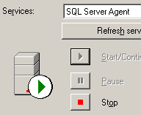
To trigger the failure scenario for our example we will manually stop the SQL Server Agent on the local machine.
- In the System Tray, double click on the SQL Server Service Manager icon to launch the UI.
- In the “Services” drop-down, select SQL Server Agent to view the current state of the agent.
- Press the Stop button to stop the agent, and press Yes in the confirmation message box. This service state change will trigger a failure alert.
- If the MOM Operator console is not currently open, launch it from the Start Menu under Start → All Programs → Microsoft Operations Manager 2005 → Operator Console.
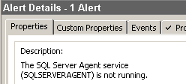
- Select the menu item Go → Home to display the normal Operator view of incoming Alerts. Verify that no displayed alerts relate to the SQL Server Agent.
- After a few minutes a new Critical Alert will appear (actual time will depend on the timing of the rule scheduling and the display refresh period). Click on the new Alert to view its properties in the “Detail” pane. With default settings the system is configured to detect this issues within 2 minutes.
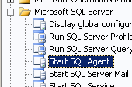
- Once the operator has reviewed the Alert knowledge, the next step is to solve the problem. Clearly the Agent service must be restarted, and the SQL Server Management Pack provides a tool to do this from within the Operator Console.
- In the right hand “Tasks” pane, expand the Microsoft SQL Server folder.
- With the new Alert selected in the center pane, click on the tool icon named Start SQL Agent. This launches the “Launch Task Wizard”.
- Click through the entire wizard without changing any default options. When you press Finish the task will be scheduled to execute on the machine which created the Alert.
- Double click on the SQL Service Manager icon in the system tray again to view the status of the SQL Server Agent. Note that it starts up (as the task has now executed).
- To verify that this was initiated by the MOM Task, click on the Events bar in the Navigation pane. A new “Information” event should have appeared at the top of the “Events” pane. The Properties of this event in the Event Details pane provide details of the successful task execution.
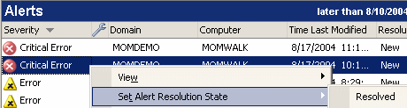
- Press the Alerts bar in the Navigation pane and right-click on the Critical Alert for the “SQL Server Agent”, then select Set Alert Resolution State → Resolved.
- Insert a comment of SQL Server Agent restarted via Task and then press OK. Note that the Alert has now disappeared from the current view, since only active alerts are displayed here (by default). The original Alert, together with any resolution and change history, is still present in the MOM DB for auditing purposes and may be reviewed or reported at any time.
4. The MOM 2005 Web Console
The MOM Web Console provides a web-based client to display computer state, alerts and events on any machine with network access to the MOM Server. This allows an Operator to view critical information, whether or not they are at their main console machine.
A. Overview of the MOM 2005 Web Console
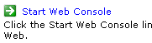
- In the MOM 2005 Administrator Console select the Operations node and then click on the Start Web Console link in the right hand pane.
- When prompted, log in with the credentials
- Username: MOMDEMO\mom-admin
- Password: Password1
- Note that the displayed web page mimics the default Alert view in the Operator Console, showing the currently active Alerts and the detail pane for the selected alert.
- Click on the Computers and Events side menu bars and note how they reflect the same layout and information as the MOM 2005 Operator Console
- Close the web browser window
5. The MOM 2005 Reporting Console
The MOM Web Console provides a web-based client to display computer state, alerts and events on any machine with network access to the MOM Server. This allows an Operator to view critical information, even when far from their main console machine.
A. Transferring Live Data to the Reporting Database
The MOM Reporting system uses an off-line data repository to hold data for reporting. This ensures that reporting tasks will not impact the live database and degrade system performance. By default, the live data is replicated to the off-line repository once a day, during the night. In order to see real reports in the next section, we must first force this replication to happen now.
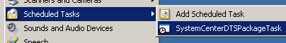
- From the “Start” bar select Start → Control Panel → Scheduled Tasks
- Only one scheduled task is shown – named “SystemCenterDTSPackageTask”.
- Right-click on the SystemCenterDTSPackageTask and click on Run from the context menu which appears. This will force a DTS replication of all live data so far gathered to the reporting database. The process will take about 2 minutes to complete, but no UI will be presented during this time, as the task runs in the background.
B. Walkthrough MOM Reporting
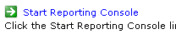
- In the MOM 2005 Administrator Console select the Operations node and then click on the Start Reporting Console link in the right hand pane.
- When prompted, log in with the credentials
- Username: MOMDEMO\mom-admin
- Password: Password1
- Click on the Microsoft Windows Base Operating System link to view the reports and report sub-folders installed by this management pack.
- Click on the Operating System Configuration link. This report displays the basic system configuration for all computers in a specific Computer Group. The required parameter is the Computer Group, which in this test-drive consists of a single machine – the MOMWALK server.
- In the “Computer Group” dropdown list, select Microsoft Operations Manager 2005 Servers and then press the View Report button
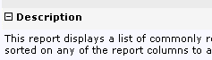
- The reports is displayed. Note the format consists of a report header and the report body, which initially shows one line per system. Press the “+” sign beside the “Description” label to open up the header field. The resulting data fields were added by the report author to describe the report contents. Click the Description “-“ to collapse the header again.
- Click the “+” sign beside the server name to expand the details for the MOMWALK server. Note the richer information available on a per server basis, including the disk drive configuration and BIOS data.
- Click the Properties tab to display the report properties. This page allows an operator to change the behavior of a specific report. Note the side menu bar which offers different categories of settings. On the “General” page the report description may be modified, and a link to another (related) report created.
- Click on the Parameters left-menu option to view the input parameters to the report. An operator may change these defaults, which were created by the report author. Uncheck the Null checkbox and enter Microsoft Operations Manager 2005 Servers in the “CompGroup” Default Value text box and then press Apply.
- Click on the Execution left menu option to view the various options for satisfying each report request. Currently the report is configured to rebuild the full report on each invocation. For performance optimization however, when the reporting server might be busy for extended periods, other options are available. For example the report may be cached on each invocation, and subsequent requests for this report may be served from the cached copy, until the cached entry expires (by default after 30 mins). Alternatively the report may be rebuilt on a regular schedule, and any request would be served with the most recently built copy of the data.
- Click on the Security left-menu item. This report has inherited these security settings from the parent (Management Pack) folder, but an administrator may wish to apply specific security rights to individual or groups of reports. Such changes would be made here.

- Click on the History tab near the top of the page, below the report title and press on the New Snapshot button. The reporting system allows copies of the current report dataset to be kept. Such snapshots may either be taken manually, or configured to be made on a recurring schedule from the “Properties” tab, allowing a historical set of snapshots to be maintained.
- Click on the Subscriptions tab and then click New Subscription. This page allows a user to subscribe for copies of the report to be built and delivered either via e-mail or through a file share. A variety of parameters and formats are available. Click on the Render Format drop-down and note that the results may be provided in HTML (the default) or in a variety of file formats include XML, Excel, CSV, TIFF and PDF.
- At the top of the window click on the Microsoft Windows Base Operating System link to return to the list of reports for this management pack.
- Click on the Disk Performance Analysis link to open that report. In the Computer Group drop-down list, select Microsoft Operations Manager 2005 Servers and press the View Report button.

- Press both sets of “double-up-arrows” in the top right of the resulting page to collapse both the header area and the parameter area of the report. Note the resulting graph of the MOM Server disk performance data.
- Click the “Export” drop-down “Select a format” box and note that this graphical report may be exported in a variety of formats, including HTML, Excel, PDF, TIFF, CSV and XML.
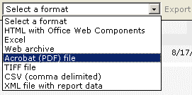
- Close the Internet Explorer window.
6. Shutting Down the Test-drive Image
This concludes the Test-drive of the MOM 2005 product. You may elect to commit the current configuration of this Virtual PC image to disk so you may return to this point in the future to experiment further with MOM 2005. You may also wish to leave the image running for a longer period to allow the gathered data sets to become more complete, allowing more interesting graphs and analyses to be made through the various MOM 2005 UIs.
To commit the changes you have made to the image, close the Virtual PC application by selecting the menu Action → Close… from the menu bar. Note that if you have forced the image full-screen on your host machine, you will need to type <Right-Alt>-<Enter> to display the Virtual PC Menu. In the resulting dialog, in the drop down list of choices, select Shut down Windows Server 2003 and save changes and ensure the Commit changes to the virtual hard disk checkbox is selected. The changes you have made to the base image will then be merged into the hard drive on disk.
Alternatively, if you wish to return the image to it’s initial state, before the MOM 2005 installation and configuration was completed, follow the instructions above to display the “Close” dialog and then select Turn off and delete changes from the drop-down list.

Appendix 1: Supported Operating Systems
The tables in this section outline the supported operating systems, by operating system version, for each MOM 2005 component. There are two tables for each operating system version; each table outlines support for a different set of MOM components.

Support for Microsoft Windows NT®
Table 1.1 Supported Operating Systems in Windows NT (Part 1)
Operating system | Management Server  (32-bit) | MOM database  (32-bit) | MOM Administrator console and Operator console  (32-bit) | Reporting server  (32-bit)
Windows NT 4.0 Server with Service Pack 5 or earlier
Windows NT 4.0 Server with Service Pack 6 and Security Rollups
Windows NT 4.0 Server, Enterprise Edition with latest Service Pack
Windows NT 4.0 Server, Terminal Server Edition with latest Service Pack

= Supported operating system. Setup does not prevent installation.
= Setup prevents installation or upgrade.
Table 1.2 Supported Operating Systems in Windows NT (Part 2)
Operating system | Agent-managed computer  (32-bit) | Agent-managed computer  (64-bit) | Agentless managed computer  (32-bit) | View MOM reports  (32-bit)
Windows NT 4.0 Server with Service Pack 5 or earlier
Windows NT 4.0 Server with Service Pack 6 and security rollups
Windows NT 4.0 Server, Enterprise Edition with latest service pack
Windows NT 4.0 Server, Terminal Server Edition with latest Service Pack

= Supported operating system. Setup does not prevent installation.
= Setup prevents installation or upgrade.

Support for Microsoft Windows 2000
Table 1.3 Supported Operating Systems in Windows 2000 (Part 1)
Operating system | Management Server  (32-bit) | MOM database  (32-bit) | MOM Administrator console and Operator console  (32-bit) | Reporting server  (32-bit)
Windows 2000 Professional with Service Pack 1, Service Pack 2, or Service Pack 3
Windows 2000 Server with Service Pack 1, Service Pack 2, or Service Pack 3
Windows 2000 Advanced Server with Service Pack 1, Service Pack 2, or Service Pack 3
Windows 2000 Datacenter Server with Service Pack 1, Service Pack 2, or Service Pack 3
Windows 2000 Professional with Service Pack 4 or later
Windows 2000 Server with Service Pack 4 or later
Windows 2000 Advanced Server with Service Pack 4 or later
Windows 2000 Datacenter Server with Service Pack 4 or later

= Supported operating system. Setup does not prevent installation.
= Setup prevents installation or upgrade.
Table 1.4 Supported Operating Systems in Windows 2000 (Part 2)
Operating system | Agent-managed computer  (32-bit) | Agent-managed computer  (64-bit) | Agentless managed computer  (32-bit) | View MOM reports  (32-bit)
Windows 2000 Professional with Service Pack 1 or Service Pack 2
Windows 2000 Server with Service Pack 1 or Service Pack 2
Windows 2000 Advanced Server with Service Pack 1 or Service Pack 2
Windows 2000 Datacenter Server with Service Pack 1 or Service Pack 2
Windows 2000 Professional with Service Pack 3
Windows 2000 Server with Service Pack 3
Windows 2000 Advanced Server with Service Pack 3
Windows 2000 Datacenter Server with Service Pack 1, Service Pack 2, or Service Pack 3
Windows 2000 Professional with Service Pack 4 or later
Windows 2000 Server with Service Pack 4 or later
Windows 2000 Advanced Server with Service Pack 4 or later
Windows 2000 Datacenter Server with Service Pack 4 or later

= Supported operating system. Setup does not prevent installation.
= Setup prevents installation or upgrade.

Support for Microsoft Windows XP
Table 1.5 Supported Operating Systems in Windows XP (Part 1)
Operating system | Management Server  (32-bit) | MOM database  (32-bit) | Administrator console and Operator console  (32-bit) | Reporting server  (32-bit)
Windows XP Home Edition with any service pack
Windows XP Media Center Edition with any service pack
Windows XP Tablet PC Edition with any service pack
Windows XP Professional
Windows XP Professional with latest service pack
Windows XP 64-Bit Edition with Service Pack 1 or later
Windows XP 64-Bit Edition Version 2003
Windows XP Embedded (any release)

= Supported operating system. Setup does not prevent installation.
= Setup prevents installation or upgrade.
Table 1.6 Supported Operating Systems in Windows XP (Part 2)
Operating system | Agent-managed computer  (32-bit) | Agent-managed computer  (64-bit) | Agentless managed computer  (32-bit) | View MOM reports  (32-bit)
Windows XP Home Edition with any service pack
Windows XP Media Center Edition with any service pack
Windows XP Tablet PC Edition with any service pack
Windows XP Professional
Windows XP Professional with latest service pack
Windows XP 64-Bit Edition with Service Pack 1 or later
Windows XP 64-Bit Edition Version 2003
Windows XP Embedded (any release)

= Supported operating system. Setup does not prevent installation.
= Setup prevents installation or upgrade.

Support for the Microsoft Windows Server™ 2003 Family
Table 1.7 Supported Operating Systems in the Windows Server 2003 Family (Part 1)
Operating system | Management Server  (32-bit) | MOM database  (32-bit) | Administrator console and Operator console  (32-bit) | Reporting server  (32-bit)
Windows Server 2003, Standard Edition
Windows Server 2003, Enterprise Edition
Windows Server 2003, Datacenter Edition
Small Business Server 2003
Windows Server 2003, Web Edition

= Supported operating system. Setup does not prevent installation.
= Setup prevents installation or upgrade.

Table 1.8 Supported Operating Systems in the Windows Server 2003 Family (Part 2)
Operating system | Agent-managed computer  (32-bit) | Agent-managed computer  (64-bit) | Agentless managed computer  (32-bit) | View MOM reports  (32-bit)
Windows Server 2003, Standard Edition
Windows Server 2003, Enterprise Edition
Windows Server 2003, Datacenter Edition
Small Business Server 2003
Windows Server 2003, Web Edition

= Supported operating system. Setup does not prevent installation.
= Setup prevents installation or upgrade.

Appendix 2: Microsoft Operations Manager 2005 System Requirements
Listed below are the minimum hardware and software requirements for Microsoft Operations Manager 2005 and Microsoft Operations Manager 2005 Workgroup Edition. Multiple server roles can coexist on the same system, however, please ensure that the combined system requirements are met.
Note: Actual requirements can vary based on your system configuration, and the management packs and features you install. For more information about planning and sizing, see the Concept, Planning, and Deployment Guide and the Performance and Sizing Guide.

MOM Management Server Requirements (for each MOM server)

Requirement | MOM 2005 | MOM 2005 Workgroup Edition
Processor | PC with 550 MHz or higher Pentium-compatible
Operating system | Any of the following:  - Microsoft Windows 2000 Server or Advanced Server with Service Pack 4 or later  - Microsoft Windows 2000 Datacenter Server with Service Pack 4 or later  - Microsoft Windows Server 2003 Standard Edition  - Microsoft Windows 2003 Enterprise Edition  - Microsoft Windows Server 2003 Datacenter Edition  - Microsoft Windows Server 2003 Web Edition | Any of the following:  - Microsoft Windows Server 2003 Standard Edition  - Microsoft Windows 2003 Enterprise Edition  - Microsoft Windows Server 2003 Datacenter Edition  - Microsoft Windows Server 2003 Web Edition
Database software | N/A | Any of the following:  - Microsoft SQL Server 2000 Desktop Engine (MSDE)  - Microsoft SQL Server 2000 Standard with the Service Pack 3.0a or later  - Microsoft SQL Server 2000 Enterprise Edition with Service Pack 3.0a or later
Other software | - Microsoft Data Access Components (MDAC) version 2.8 with Service Pack 1 or later  - Microsoft .NET Framework 1.1
Memory | 512 MB of RAM (1 GB or higher recommended)
Hard disk | 5 GB of available hard disk space
Hardware | - CD-ROM drive or DVD-ROM drive  - Keyboard and mouse or compatible pointing device, or hardware that supports console redirection.  - Network Adapter

MOM Database Requirements

Note: A best practice is to use a dedicated computer for the production of MOM 2005 Database.

Requirement | MOM 2005 | MOM 2005 Workgroup Edition
Processor | PC with 550 MHz or higher Pentium-compatible | N/A
Operating system | Any of the following:  - Microsoft Windows 2000 Server with Service Pack 4 or later  - Microsoft Windows 2000 Advanced with Service Pack 4 or later  - Microsoft Windows 2000 Datacenter Server with Service Pack 4 or later  - Microsoft Windows Server 2003 Standard Edition  - Microsoft Windows Server 2003 Enterprise Edition  - Microsoft Windows Server 2003 Datacenter Edition  - Microsoft Windows Server 2003 Web Edition | N/A
Database software | Any of the following:  - Microsoft SQL Server 2000 Standard with the Service Pack 3.0a or later  - Microsoft SQL Server 2000 Enterprise Edition with Service Pack 3.0a or later  - Microsoft SQL Server 2000 Desktop Engine (MSDE) (for evaluation only) | N/A
Memory | 512 MB of RAM (1 GB or higher recommended) | N/A
Hard disk | 5 GB of available hard disk space | N/A
Hardware | - CD-ROM drive or DVD-ROM drive  - Keyboard and mouse or compatible pointing device, or hardware that supports console redirection.  - Network Adapter | N/A

MOM Reporting Server Requirements

Requirement | MOM 2005 | MOM 2005 Workgroup Edition
Processor | PC with 550 MHz or higher Pentium-compatible | N/A
Operating system | Any of the following:  - Microsoft Windows 2000 Server with Service Pack 4 or later  - Microsoft Windows 2000 Advanced Server with Service Pack 4 or later  - Microsoft Windows 2000 Datacenter Server with Service Pack 4 or later  - Microsoft Windows Server 2003 Standard Edition  - Microsoft Windows Server 2003 Enterprise Edition  - Microsoft Windows Server 2003 Datacenter Edition  - Microsoft Windows Server 2003 Web Edition | N/A
Database software | Any of the following:  - Microsoft SQL Server 2000 Standard with the Service Pack 3.0a or later  - Microsoft SQL Server 2000 Enterprise Edition with Service Pack 3.0a or later | N/A
Memory | 512 MB of RAM (1 GB or higher recommended) | N/A
Hard disk | 200 GB of available hard disk space | N/A
Hardware | - CD-ROM drive or DVD-ROM drive  - Keyboard and mouse or compatible pointing device, or hardware that supports console redirection  - Network Adapter | N/A

SQL Server 2000 Reporting Services Server Requirements
Note: MOM 2005 Reporting utilizes SQL Server 2000 Reporting Services - you will need to install and configure SQL Server 2000 Reporting Services to view MOM 2005 Reports

Requirement | MOM 2005 | MOM 2005 Workgroup Edition
Processor | PC with 550 MHz or higher Pentium-compatible | N/A
Operating system | Any of the following:  - Microsoft Windows 2000 Server with Service Pack 4 or later  - Microsoft Windows 2000 Advanced Server with Service Pack 4 or later  - Microsoft Windows 2000 Datacenter Server with Service Pack 4 or later  - Microsoft Windows Server 2003 Standard Edition  - Microsoft Windows Server 2003 Enterprise Edition  - Microsoft Windows Server 2003 Datacenter Edition  - Microsoft Windows Server 2003 Web Edition | N/A
Database software | - Microsoft SQL Server 2000 Standard Edition with Service Pack 3.0a or later  - Microsoft SQL Server 2000 Enterprise Edition with Service Pack 3.0a or later  - Microsoft SQL Server 2000 Reporting Services | N/A
Other software | - Internet Information Services (IIS) Server 6.0 must be installed as part of the Windows Server installation  - Microsoft SQL Server 2000 Reporting Services can render reports in HTML 3.2 and HTML 4.0. To view MOM reports you must have one of the following browsers:  - Microsoft Internet Explorer 6.0 with Service Pack 1  - Microsoft Internet Explorer 5.5 with Service Pack 2  - Microsoft Internet Explorer 5.01 with Service Pack 2  - Netscape 7.0  - Netscape 4.78  - Microsoft Visual Studio .NET 2003, or Integrated Developer Environment 2003 (if you want to customize or create reports)
Memory | 256 MB of RAM (1 GB or higher recommended) | N/A
Hard disk | 10 GB of available hard disk space | N/A
Hardware | - CD-ROM drive or DVD-ROM drive  - Keyboard and mouse or compatible pointing device, or hardware that supports console redirection  - Network Adapter | N/A

Administrator and Operator Console Requirements

Requirement | MOM 2005 | MOM 2005 Workgroup Edition
Processor | PC with 500 MHz or higher Pentium-compatible
Operating system | Any of the following:  - Microsoft Windows 2000 Professional with Service Pack 4 or later  - Microsoft Windows 2000 Server with Service Pack 4 or later  - Microsoft Windows 2000 Advanced Server with Service Pack 4 or later  - Microsoft Windows 2000 Datacenter Server with Service Pack 4 or later  - Microsoft Windows Server 2003 Standard Edition  - Microsoft Windows 2003 Enterprise Edition  - Microsoft Windows 2003 Datacenter Edition  - Microsoft Windows 2003 Web Edition  - Microsoft Windows XP Professional with Service Pack 1 or later
Software | Microsoft .NET Framework 1.1 or later
Memory | 128 MB of RAM (256 MB or higher recommended)
Hard disk | 150 MB of available hard disk space
Monitor resolution | Super VGA (800 x 600) or higher resolution capable of displaying 256 colors (1024 × 768 resolution capable of displaying 24 bit color or higher recommended)
Hardware | - Keyboard and mouse or compatible pointing device, or hardware that supports console redirection  - Network Adapter

Managed Computer Requirements (for each computer)

Requirement | MOM 2005 | MOM 2005 Workgroup Edition
Processor | PC with 200 MHz or higher Pentium-compatible
Operating system | Any of the following:  - Microsoft Windows NT 4.0 Server with Service Pack 6 and the latest security rollup packages (agent-less monitoring only)  - Microsoft Windows NT 4.0 Server Enterprise Edition with Service Pack 6.0 (agent-less monitoring only)  - Microsoft Windows NT 4.0 Server Terminal Server Edition with Service Pack 6.0 (agent-less monitoring only)  - Microsoft Windows 2000 Professional with Service Pack 4 or later  - Microsoft Windows 2000 Server with Service Pack 4 or later  - Microsoft Windows 2000 Advanced Server with Service Pack 4 or later  - Microsoft Windows 2000 Datacenter Server with Service Pack 4 or later  - Microsoft Windows Server 2003 Standard Edition  - Microsoft Windows 2003 Enterprise Edition  - Microsoft Windows 2003 Datacenter Edition  - Microsoft Windows 2003 Web Edition  - Microsoft Windows Small Business Server 2003  - Microsoft Windows XP Professional with Service Pack 1 or later
Memory | 128 MB of RAM (more memory might be necessary depending on which management packs you use)
Hard disk | - The size of the installed agent software is approximately 3 MB. It is recommended that you allocate 100 MB of available hard disk space for agent use (more hard disk space might be necessary depending on which management packs you use)  - 3 MB of additional hard disk space is necessary for each configuration group that a multi-homed agent is added to

Appendix 3: Localization
MOM 2005 is localized in the following ways:
- Localized implementation of MOM itself
- Globalization of MP’s – management pack logic is language-neutral.
- MOM is localized in 4 languages - English, German, Japanese and French. This includes localization of the product, knowledge bases, and product documentation.
- The table below lists the support mix of languages for MOM 2005:

Table 4.1 Supported Languages for a MOM Deployment
OS Where MOM installed | MOM Server | SQL Server (Where MOM DB installed) | Agents to be managed
English | English | English | Multi-Lingual *
Chinese (Simplified) | English | English/Chinese (Simplified) | Chinese (Simplified)
Chinese (Traditional) | English | English/Chinese (Traditional) | Chinese (Traditional)
French | English | English/French | French
German | English | English/German | German
Italian | English | English/Italian | Italian
Japanese | English | English/Japanese | Japanese
Korean | English | English/Korean | Korean
Spanish | English | English/Spanish | Spanish
Brazilian | English | English | Brazilian
Chinese (Hong Kong) | English | English | Chinese (Hong Kong)
Czech | English | English | Czech
Dutch | English | English | Dutch
Hungarian | English | English | Hungarian
Polish | English | English | Polish
Portuguese | English | English | Portuguese

* Multi-Lingual here covers:
5 language versions of Windows 2000 and Windows 2003 Data Center server
9 language versions of Windows 2000 and Windows 2003 advance server
19 language versions of Windows 2000 and Windows 2003 server
25 language versions of Windows XP & Windows 2000 Professional edition

Table 4.2 Supported Agent Languages
OS Where MOM installed | MOM Server | SQL Server (Where MOM DB installed) | Agents to be managed
Japan | Japan | English/Japan | Japan/English
German | German | English/German | German/English
French | French | English/French | French/English

There is no support for Bi-Directional, complex script languages such as Arabic or Hebrew.
There is no MUI release for Microsoft Operation Manager 2005.

Appendix 4: MOM 2005 Component Overview
MOM 2005 uses several components to manage computers and applications and make the appropriate automatic responses to events and configuration changes. This section summarizes these components, their primary responsibilities and their interaction with other components.
The MOM architecture includes the components listed in the following table.
Table 5.3 MOM architecture components
Component | Subcomponent | Description
MOM Agent |  | The runtime component hosted on a managed computer that collects and sends data obtained from the managed computer. MOM Agent also runs locally on the MOM Management Server.
MOM Management Server |  | The Management Server houses the Data Access Server, local agent, WMI APIs, the MCF and the consoles.
 | MOM user interfaces | Administrator console - For configuring all aspects of the MOM environment  Operator console - For viewing and working with operational data.  Web console - For viewing and working with a subset of the operations data.  Reporting console - For viewing and working with reports provided by the MOM Reporting server.
 | Data Access Server (DAS) | A COM+ application that manages access to the MOM Database.
 | MOM Server | The runtime component that manages the MOM Agents that are used to monitor managed computers and funnel aggregated data into the database.
 | MOM WMI provider | A public API that accesses the data stored in the MOM Database.
 | MOM Connector Framework (MCF) | A collection of components that is used to integrate MOM with other management solutions and/or with other MOM installations.
 | Managed Code APIs | A collection of APIs used to extend MOM functionality.
MOM Database |  | A Microsoft SQL Server database that stores configuration and operational data.
MOM Reporting Database |  | An archive of the data stored in the operational database.
MOM Reporting Server |  | A SQL Server service that extracts and presents the data that is accessed via SQL Server Reporting Services.

Figure 5.2 illustrates the relationship between the different parts of a MOM Management Group.
Figure 5.2 MOM Management Group architecture
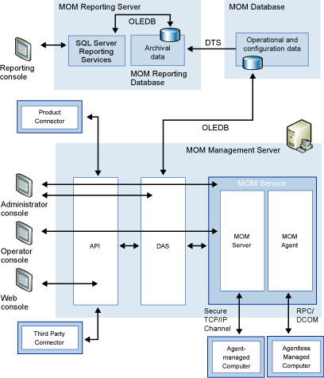@@Alt Text@@

@@Alt Text@@

The MOM 2005 Database
MOM 2005 uses a SQL Server 2000 database to store two types of information: configuration data and operational data.

Configuration Data
The configuration data stored in the database contains the list of rule groups, rules, providers, scripts, computer group definitions, computer attribute definitions, service discovery schema, and view definitions for the MOM user interface. This database also contains the configuration data for the MOM Management Server(s) and the managed computers.

Operational Data
Operational data is the data specified by the Management Packs and collected by the discovery process. Operational data consists of performance data, event data, alerts data, and configuration data.
The MOM Database is accessed by the DAS or by the Reporting database, which uses Data Transformation Services (DTS) jobs to obtain a copy of the operational data.

The MOM Management Server
The MOM Management Server is the to MOM service and the DAS on a single server. The primary components of the runtime are the MOM Server and MOM Agent. The Management Server provides the following services and functions:
  - Uses the DAS to provide data access services for the user interfaces and the MOM runtime.
  - Remotely discovers, installs, uninstalls and manages the lifetime of the MOM Agent by using responses in the MOM Management Server runtime.
  - Uses the Management Server runtime to distribute agent configurations, such as heartbeat intervals, to the MOM Agent.
  - Monitors the availability of managed computers.
  - Receives the operational data submitted by the agents.
  - Processes the operational data submitted by the agents; inserts this data in the MOM Database.
  - Monitors Agentless Managed computers.
  - Self-monitors the Management Server by using an agent that is installed during setup.
Although only one Management Server is required for a management group, the administrator may install additional Management Servers to provide increased availability and scalability. In scenarios where multiple Management Servers are available and configured for failover, the MOM Agents will fail over from their primary Management Server to any other Management Servers that are available in the management group.

Data Access Service (DAS)
The DAS is a server-based COM+ application that is hosted by the DLLHOST process. The DAS exposes a set of DCOM objects and interfaces that control access to the MOM Database. These COM interfaces are associated with COM+ roles, which provide authentication and authorization for identities that access the interfaces.

MOM Server and Local MOM Agent
The MOM Server and the MOM Agent on the Management Server share the same Windows Service that is hosted in the MOMService.exe process.
We use the MOM uses the MOM Agent to self-monitor the Management Server computer. The runtime (local) agent’s responsibilities are exactly the same as those for a remote agent installed on a managed computer. However, there is one key difference between the two agents; in addition to being responsible for self-monitoring; the local agent is responsible for monitoring Agentless Managed computers.
The MOM Server acts as a proxy between the DAS and all the MOM Agents. The MOM Server is responsible for initiating computer discovery, push-installing the agents, sending and receiving configuration data from the agents, consolidating agent data, and writing data to the operational database.
The MOM Server has two internal entry points:
  - The MOM Runtime Object provides a DCOM interface that:
- Submits tasks to run.
- Triggers server engine configuration updates.
- Sends Alert data, Event data, Performance data, and Discovery data to the engine
  - An interface that uses sockets to accept data from the agents.

The MOM Agent
The MOM Agent runs on every computer that is agent-managed. The MOM Agent is hosted by a service in the MOM service process. In typical scenarios the MOM Server automatically installs agents using push installation. However you can manually install agents when your deployment requires this approach. For example, in a scenario where there is communication between domains where there is no trust relationship.
The MOM Agent monitors the local computer according to the engine configuration that it receivers from the management server. When monitoring is enabled, the MOM Agent starts collecting events, performance data, and other possible indicators of problems on a managed computer. If a problem is detected, the MOM Agent generates an alert.
Acting in response to Management Pack rules, the MOM Agent also discovers properties of its host (for example, the version of the local operating system.
At the end of each cycle, the agent sends all this data to the MOM Management Server.
An equally important task for the agent is sending heartbeat messages to the MOM Server to indicate that the remote agent is running and healthy.
Communication between the MOM Agent and the MOM Server is always initiated by the agent. The agent-server communication channel uses the TCP/IP protocol. This channel is secured, mutually authenticated, and encrypted.

Reporting Console is not available with MOM 2005 Workgroup Edition.
MOM 2005 Workgroup Edition is limited to 10 managed servers.
SQL Reporting Services is not available with MOM 2005 Workgroup Edition.
MOM Connector Framework is not available with MOM 2005 Workgroup Edition.

