SQL Server™ 2000 Windows® CE Edition
Version 2.0
Relational Database Management System

Product Evaluation Guide

September 2002

Abstract
This guide highlights the most important new features in Microsoft® SQL Server™ 2000 Windows® CE Edition version 2.0. This software release includes many additional features that are not covered in this guide.

© 2002 Microsoft Corporation. All rights reserved.
The information contained in this document represents the current view of Microsoft Corporation on the issues discussed as of the date of publication. Because Microsoft must respond to changing market conditions, it should not be interpreted to be a commitment on the part of Microsoft, and Microsoft cannot guarantee the accuracy of any information presented after the date of publication.
This Evaluation Guide is for informational purposes only. MICROSOFT MAKES NO WARRANTIES, EXPRESS OR IMPLIED, IN THIS DOCUMENT.
Microsoft, Windows, Visual Studio, MSDN, Visual Basic, Visual C++, Visual C#, .NET, Win32 and ActiveX are either trademarks or registered trademarks of Microsoft Corp. in the United States and/or other countries.
Other product or company names mentioned herein may be the trademarks of their respective owners.
Microsoft Corporation • One Microsoft Way • Redmond, WA 98052-6399 • USA
Microsoft SQL Server 2000 Windows CE Edition Evaluation Guide.

Overview 1
Contents
PRODUCT EVALUATION ASSISTANCE 3
SQL Server CE Design Themes 4
A Familiar Database Platform for Rapid Development 4
Compact yet Capable 5
Flexible Data Access 5
Familiar Database for rapid Development 7
Familiar SQL Server Grammar 7
Familiar, Flexible Development Tools 7
Familiar Data Access Technologies 9
Compact yet Capable 11
Rich Relational Database Functionality 11
Compact Footprint 11
Great Performance and Reliability 11
Embedded Device Support 12
On-Device Data Management 13
Flexible data access 15
Simplifying Connectivity Setup 15
Merge Replication for Complete Access and Synchronization 15
RDA : Easy Access to Back-End SQL Server Data 18
Integration with the .NET Compact Framework 19
Security 19
Internet Standards for Reliability and Security 19
Conclusion 21

Overview

Introduction to the Evaluation Guide
This Evaluation Guide provides an overview of the design themes for Microsoft SQL Server 2000 Windows CE Edition (SQL Server CE) and its many features.
From the client/server environments of 10 years ago to the three-tier, Web-enabled applications of the late 1990s, the enterprise computing environment have seen constant change. The Internet helped unlock the enterprise from the desktop, allowing workers greater flexibility in connecting to business systems from home or the road. Today, enterprise applications have the opportunity to extend beyond desktop or laptop Web browsers to new classes of small, mobile computing devices and appliances. While amazingly capable for their size, these handheld, pocket-sized or embedded devices present new challenges to developers seeking to extend the reach of enterprise applications. Many of the difficulties in extending traditional applications to these devices are obvious, like the smaller screen size compared with laptops and desktops and limited user input options, but there are also less evident factors that make programming these devices challenging. Processing power and available storage are usually significantly less than what is available on larger devices. Similarly, network connectivity may be nonexistent or limited to mechanisms that are typically slower than hard-wired corporate LANs. What is clear, then, is that any system that attempts to extend enterprise applications to such devices must take these limitations into account.
SQL Server CE directly addresses these challenges. It is the compact database for rapidly developing applications that extend enterprise data management capabilities to devices. It has the familiar look of SQL Server, with tools, APIs and SQL grammar that minimize development time. Additionally, the SQL Server CE engine exposes an essential set of relational database features — including an optimizing query processor, support for transactions and assorted data types — while maintaining a compact footprint that preserves precious system resources. Remote Data Access and merge replication, which work over HTTP and support encryption, ensure that data from enterprise SQL Server databases is reliably delivered and that this data can be manipulated offline and synchronized later to the server, making SQL Server CE ideal for mobile and wireless scenarios.

The Microsoft .NET initiative in application development is also helping address challenges in mobile application development. Traditionally, developers needed different software tools to develop for desktop application and mobile applications. It was also very difficult to integrate code written in different languages into a single mobile application. .NET solves these problems by providing the framework to systematically use multiple languages in your application development. The .NET Compact Framework is a subset of the .NET Framework focused specifically on mobile devices. With the new device and mobility features found in Visual Studio .NET, developers can build applications for mobile applications using the same development tools, programming model and development environment as they would building applications for the desktop. SQL Server CE 2.0 supports the .NET Compact Framework.
SQL Server CE is designed to manage data in devices with low memory and any of a host of levels of connectivity to back-end data stores — from no connection to a hard-wired connection to a wireless connection. SQL Server CE is a field-ready product that easily adapts to changing environments while providing robust data storage and security.

Audience

PRODUCT EVALUATION ASSISTANCE
This guide assumes that evaluators are familiar with the basic features of relational database management systems (RDBMS) and have some experience with previous versions of SQL Server. Experience with Windows CE and the Visual Studio® development system is also helpful.

Additional Information
Additional information for those who want to review the new features in SQL Server 2000 Windows CE Edition is available at http://www.microsoft.com/sql/ce/default.asp
You may also download an evaluation copy of SQL Server 2000 from the Microsoft Download Center. Visit the Microsoft Download Center at http://download.microsoft.com.
ActiveSync 3.5 can be downloaded from the Microsoft Download Center.
Microsoft eMbedded Visual Tools can be downloaded from http://www.microsoft.com/mobile/downloads/emvt30.asp.

Information about the Microsoft .NET Compact Framework is available at http://msdn.microsoft.com/vstudio/device/compactfx.asp and
http://www.gotdotnet.com/team/netcf/
As the use of mobile devices becomes integral to the operations of an ever-greater number of organizations, Microsoft has made significant investments to understand the requirements for device-based data management. Consideration of the various scenarios in which data is collected and used has given Microsoft the building blocks to extend the power of SQL Server to the mobile and client device industry.

SQL Server CE
Design Themes
SQL Server CE extends the frontier of data management by delivering the following:
- A familiar database platform for rapid development
- A compact yet capable relational database
- Flexible data access
Customer, developer and partner feedback were key factors in building this product. Over 1000 customers, developers and partners participated in the beta program to test SQL Server CE 2.0 during the early phases of its development. The SQL Server CE Joint Development Program provided the necessary support for selected customers who needed to fast-track SQL Server CE into their enterprise computing production environments. The focus of all these activities was to ensure the product met customer expectations and passed the SQL Server team’s rigorous testing procedures. As a result of the emphases on customer feedback, internal and external product testing and product development quality, the SQL Server CE team is confident that the release of SQL Server CE 2.0 provides the data management capabilities organizations need to extend their enterprises both for native and .NET mobile applications.

A Familiar Database Platform for Rapid Development
Thorough support for application development has long been one of the most critical deciding factors in the success of any database product. Ease of development, rich tools functionality, established and widely used APIs and of course an abundance of developers are key strengths that the development platform for SQL Server CE enjoys.
SQL Server CE is designed to interoperate seamlessly with rest of the SQL Server family. It supports Structured Query Language (SQL) grammar that is upwardly compatible with SQL Server. Developers familiar with server and desktop data access technologies like OLE DB and ADO will find it easy to use OLEDBCE and ADOCE for data access on devices.
The tool sets developers can use with SQL Server CE are the eMbedded Visual Tools for non .NET applications and Visual Studio .NET with the .NET Compact Framework for .NET applications. eMbedded Visual Tools are designed to deliver a complete desktop development environment for creating applications and system components for Windows Powered devices, including the Pocket PC, Pocket PC 2002 and Handheld PC 2000. SQL Server CE, Visual Studio .NET and the .NET Compact Framework take advantage of the Common Language Runtime of the .NET Compact Framework to provide the usage of different .NET programming languages with the greater ability to share code and increase the efficiency in developing mobile applications, utilize web services, and provide broader applicability of applications covering a wide array of devices, such as the Pocket PC 2002 Phone Edition and Windows CE .NET devices.
The consistency of programming languages and familiar environments across server, desktop and device development products ensure that the millions of developers familiar with products like development systems can extend their skills to entirely new areas.

Compact yet Capable
Although devices are advancing rapidly, system resources such as available memory are often scarce, so it is critical that a relational database system be as compact as possible while still exposing essential functionality. SQL Server CE brings the power of a rich database engine into a small memory footprint to support the storage limitations of today’s small devices. The database delivers all of its functionality in approximately 1.5 MB. It also carries with it a robust feature set that database programmers need to develop and extend enterprise applications.
The SQL Server CE database engine makes optimal use of indexes to improve query performance. With the improvements in the new version, SQL Server CE now supports 249 indexes per table, which is the same number of indexes per table supported on SQL Server 2000. Improvements in the query optimizer takes advantage of the improved index support to better optimize joins. Because the product is device-based, the SQL Server CE team balanced its optimizer for speed and efficiency. SQL Server CE also supports direct index seeking through ADOCE and ADO.NET to speed cursor operations. Synchronization speeds are optimized in SQL Server CE via compression and large block transfers. These techniques are best able to deal with connectivity challenges, such as the limited bandwidth characteristic of most current cellular connections.
Embedded device manufacturers also have the option to build SQL Server CE into their custom operating systems. By integrating the SQL Server CE components into the customized image of the operating system they generate, embedded systems integrator can deliver advanced database functionality as part of their custom device offering.

Flexible Data Access
As an extension of the corporate data network, device-based databases must have rich connectivity and data access options that allow data to be processed in a variety of deployment scenarios.
SQL Server CE allows data to be updated autonomously on the device as well as the server. Even if the device is out of range of a wireless network or wired network connections are not available, the SQL Server CE-based application on the device can be used continually, storing and managing the data within the device’s local database. The data can later be synchronized when the device connection to the host SQL Server is re-established. SQL Server CE supports two options for data synchronization — merge replication and Remote Data Access (RDA).
Merge replication is the process of distributing data from a publisher to subscribers, allowing the publisher and subscribers to make updates while connected or disconnected, and then merging the updates between sites when they are reconnected. Data can be synchronized programmatically between publishers and subscribers. In the case that data is updated by more than one entity at a time, a resolver on the server is used to reconcile changes. Administrators have the flexibility of using the default conflict resolution rules or easily creating their own custom rules. For SQL Server CE to act as a merge replication subscriber, SQL Server 2000 is required on the server.
Remote data access provides a simple way for a Windows CE-based application to access SQL Server data located in a remote SQL Server 6.5, SQL Server 7.0, or SQL Server 2000 database. RDA can be used whether a device is continuously connected or intermittently connected to the back-end SQL Server system. Typically, applications use RDA when the backend server cannot be SQL Server 2000 or when customers are not comfortable using replication. Another benefit of RDA is that it can be used without any special configuration of back-end SQL Server databases.
Both merge replication and RDA rely on Internet standards, including HTTP and optional secure sockets layer (SSL). These technologies allow for robust authentication, authorization and encryption without sacrificing the flexibility so critical in many mobile and disconnected environments. HTTP-based communication enables SQL Server CE to work with back-end systems even when they are located behind a firewall or proxy server. Additionally, HTTP-based communication is well suited to wireless transports.

Access to data is controlled by a file-level access control mechanism. The option to use a database password is provided during database creation and requires that the password be passed each time access to the database is requested to provide programmatic security.

Familiar SQL Server Grammar

Familiar Database for rapid Development
SQL Server CE includes SQL grammar that allows applications to query a database and insert, update and delete data to tables in the database. This grammar is upwardly compatible with the SQL grammar of other editions of SQL Server, so, in general, statements that run on SQL Server CE will also run against back-end SQL Server databases.

With support for intrinsic functions, SQL Server CE simplifies mobile application data manipulation. The wide set of functions are consistent with functions provided in the rest of the SQL Server family:
- Aggregate functions to perform calculations on a set of values and return a single value. The supported aggregate functions are AVG, MIN, MAX, COUNT and SUM.
- Date and time functions to perform operations on date and time inputs and return a string, numeric, or date and time value. The support date and time functions are DATEADD, DATEDIFF, DATENAME, DATEPART and GETDATE.
- Mathematical functions to perform calculations based on input values to return numeric values. Examples are ABS, COS, CEILING, DEGREES, LOG, LOG10, POWER, RADIANS, RAND, SIN, SQRT, TAN among many others.
- String Functions to operate on a string value and return a string or numeric value. Examples include LEN, NCHAR, PATINDEX, REPLACE, RTRIM, SPACE, SUBSTRING, and UNICODE among many others.
- System Functions allow operations on values, objects and settings in SQL Server CE. COALESCE, CONVERT, NEWID, DATALENGTH are some examples of system functions developers can use.

Familiar, Flexible Development Tools
The SQL Server CE development model takes advantage of the existing development skills within an organization through the use of development tools familiar to many enterprise developers. With this approach, the time to market for building new device-based applications — or extending existing ones — is shortened drastically.
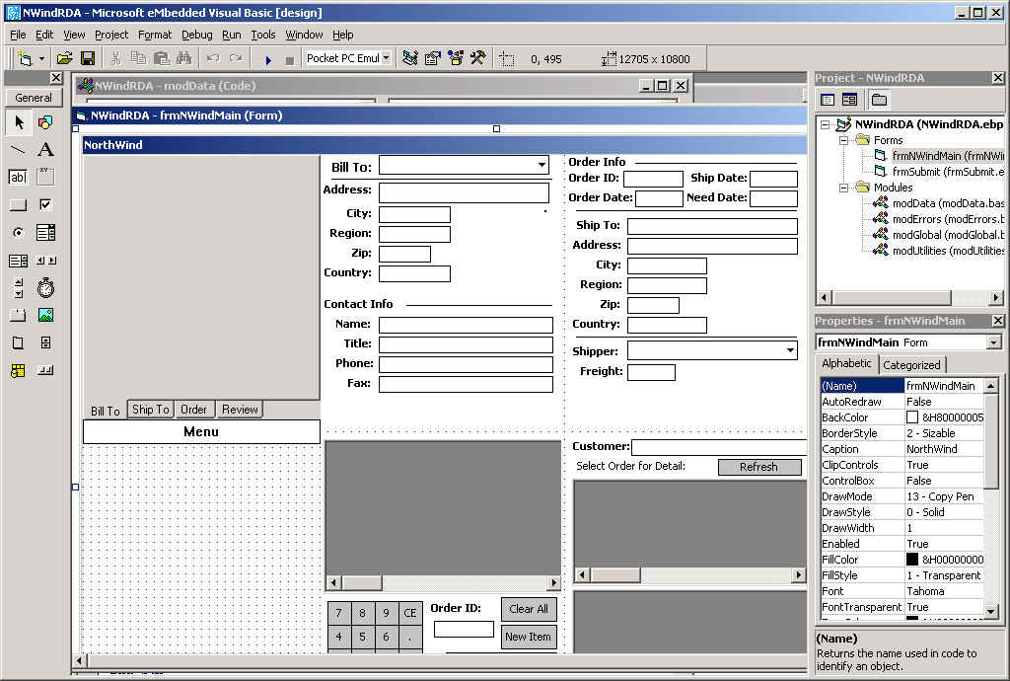
SQL Server CE supports 2 development models for Windows CE-based application development. The eMbedded Visual Tools are Microsoft’s application development platform for native or unmanaged Windows CE-based applications. With either eMbedded Visual Basic 3.0 or eMbedded Visual C++ 3.0, a developer can use his knowledge of Visual Basic or Visual C++ to build Windows CE-based applications. Application developers write their application code using a code editor, form editor and property pane, very similar to those they use with the standard Visual Basic or Visual C++ products. The eMbedded Visual Tools also use an Integrated Development Environment (IDE) similar to that offered in Visual Basic and Visual C++. The IDE, however, is extended with Windows CE-specific tools and features (Figure 1).

Figure 1 –The eMbedded Visual Tools Integrated Development Environment (IDE).
Further aiding the extension of enterprise applications to devices is the close relationship of APIs and object models on those devices to the APIs and object models on server and desktop versions of Windows. Windows Powered devices expose a specialized subset of the Microsoft Win32® API. Additionally, these devices support COM and ActiveX® technologies, so existing component programming skills (and component code itself) can be used on the range of Windows Powered hardware. Libraries like the Microsoft Foundation Classes (MFC) and the Active Template Library (ATL) included with eMbedded Visual C++ simplify Win32 API development and COM component creation. These capabilities are significant for the SQL Server CE developer because SQL Server CE exposes several COM interfaces for direct manipulation of the database engine.
For maximum flexibility, the eMbedded Visual Tools come with software development kits (SDKs) for select devices such as the Handheld PC (H/PC), Palm-size PC (P/PC) and Pocket PC. Newer device SDKs are available for download for the MSDN Downloads website. These SDKs include Windows CE-based device emulators (Figure 2), which provide the look of a physical device from within a PC environment. Developers can create SQL Server CE applications entirely on a PC and test them on the emulator, so no device is required.

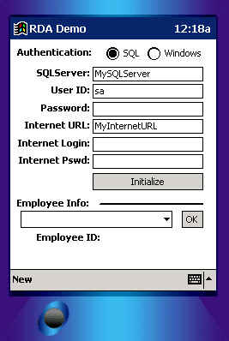
Figure 2 – The Pocket PC emulator running a
SQL Server CE demo entirely from a PC.

The latest mobile development platform from Microsoft is the .NET Compact Framework. Designed to extend the benefits of managed code and XML Web services to mobile devices, the .NET Compact Framework provides a platform and environment that enables secure execution of applications, and an efficient sharing of tools and programming model to maximize varied developer programming skills and existing code.
Developers using Visual Basic .NET or Visual C# .NET to build SQL Server CE applications will be able to share code using a common programming model without sacrificing extensibility for each device platform. The managed code model also provides a secure environment where faulty applications are prevented from crashing the device.

Familiar Data Access Technologies
SQL Server CE supports several data access technologies such as ADO .NET, ADOCE, ADOXCE and OLEDBCE. ADO is Microsoft Corp.’s strategic, high-level interface to all kinds of data. ADO .NET is Microsoft’s evolutionary improvement to ADO. ADO .NET provides the technologies that are used by applications and components that need to access relational data like SQL Server CE and SQL Server 2000, XML Documents, and other data forms.
ADOCE provides consistent, high-performance access to data for developers using eMbedded Visual Basic to program applications for Windows CE. ADOCE is the most widely used interface to create, modify and access SQL Server CE databases. ADOXCE is an extension to the ADOCE objects and programming model that exposes additional objects for creating, modifying, and deleting schema objects. Schema objects are the attributes of the database, such as columns, indexes, tables, and properties.
OLEDB is Microsoft’s strategic low-level data interface technology. OLEDBCE can be used from eMbedded Visual C++ and provides more granular capabilities than ADOCE or ADOXCE when working with SQL Server CE.

Rich Relational Database Functionality

Compact yet Capable
SQL Server CE offers rich relational database functionality in a small memory footprint. Microsoft SQL Server developers will appreciate the robust feature set, which includes the following:
- An upwardly compatible SQL grammar with SQL Server 2000
- A wide range of data types:
  - TINYINT, SMALLINT, INTEGER, BIGINT
  - REAL, NUMERIC, FLOAT
  - BIT, BINARY, VARBINARY, IMAGE
  - UNICODE character data types NATIONAL CHARACTER, NATIONAL CHARACTER VARYING, NTEXT
  - MONEY, DATETIME, UNIQUEIDENTIFIER
- 249 indexes per table, multicolumn indexes
- NULL support
- 128-bit file level encryption for the database file (password protected)
- DDL: Create databases, alter tables, referential integrity, default values
- DML: INSERT, UPDATE, DELETE
- SELECT: UNION, SET Functions (aggregates), INNER/OUTER JOIN, subselect, GROUP BY/HAVING
- Scrollable and forward-only cursors

Parameterized queries allow developers to use placeholders within a query which is supplied values at runtime. This allows applications to run the same SQL statement multiple times, using different sets of values for each execution of the statement without having to recompile the query. Execution times are efficiently minimized, especially for large queries that need to execute multiple times.

Compact Footprint
One of the goals in developing SQL Server CE was to keep the footprint of the database small, without compromising key database features. The database engine occupies approximately 800 KB to 1.3 MB, depending on the target device platform. SQL Server 2000 Windows CE Edition supports databases up to 2 GB, with support for BLOBs of up to 1 GB.

Great Performance and Reliability
SQL Server CE has a number of features to speed the performance of most common user operations. While other editions of SQL Server 2000 may optimize a query for overall multi-user throughput, SQL Server CE optimizes queries to run as quickly as possible. To accomplish this, it employs an efficient cost-based optimizer that provides significant performance gains. B-Tree-based indexes are heavily utilized, both for sorting and predicate evaluation, ensuring the developer that the SQL Server CE engine is providing maximum query performance. In addition to query optimization, SQL Server CE exposes a number of features to enable operations to be run directly against the engine through documented COM and OLEDBCE interfaces, including the ability to manipulate base tables directly (without using the query processor) and the ability to use indexes directly for ordering, seeking or setting ranges. Moreover, because SQL Server CE is implemented as a set of DLLs. Multiple applications running at the same time can share the common set of SQL Server DLLs, saving storage space on the device. With this support, the developer has additionally flexibility to take full advantage of SQL Server CE and optimize performance while minimizing the impact on the device.
While the engine has many impressive performance features, the connectivity solutions provided in SQL Server CE also provide very efficient and effective solutions to transfer data between SQL Server CE and back-end SQL Server databases. Both merge replication and RDA have been optimized to minimize data movement over the communication link, be it a wireless LAN or a cellular phone dialup. This improves application performance over the relatively slow communication links common to many mobile scenarios.

Embedded Device Support
Computing and electronic devices are steadily pervading many facets of our lives and affecting how we interface with society. Electronic books, off-site airline electronic check-in devices, set-top boxes that allow you to interact with TV programs, and self-serve / self-scanning checkout counters in supermarkets, are just some of the ways we see devices with specialized functions making our lives more automated and convenient. These customized devices, called embedded devices, have a lightweight operating system and a lean set of features built into them to do very specific tasks. Businesses rely on these embedded devices to perform with precision and speed. Frequently, the jobs and tasks these devices assist with involve collecting, managing, and transmitting data. Thus, with the complexity and amount of data these embedded devices are responsible for, embedded system manufacturers now require a rich data management environment as a critical complement to the lightweight operating system. Importantly, the data management tools must have a minimal effect on the overall system footprint.
SQL Server CE addresses these challenges, allowing its components to be built as part of a custom Windows CE operating system image for embedded devices. By integrating with Platform Builder, embedded system manufacturers can select SQL Server CE as an integral piece of the tailored operating system image they build for their new devices. Platform Builder is a complete integrated development environment that enables developers to build a new generation of modular Windows CE OS designs that integrate seamlessly with Windows and the Web. When SQL Server CE is installed on the same computer as Platform Builder, it exposes it’s components within the Platform Builder’s integrated development environment (Figure 3). Embedded system developers can now easily select SQL Server CE components and simply drag and drop it into the OS Configuration pane or right click on the SQL Server CE components and select “Add to package”. When the custom operating system is generated and loaded into the Read Only Memory (ROM) of the embedded device, SQL Server CE will be also loaded into the ROM as it is now an integrated part of the custom built operating system image.
Loading SQL Server CE into ROM provides many benefits for embedded systems. As resources are generally limited on these devices, loading SQL Server CE into ROM frees up the RAM storage for user data and applications. Additionally, SQL Server CE will automatically load whenever these devices are reset. (The users however will have to restore their applications and data if they are not located on persistent storage at the time the device was reset.)

SQL Server CE 2.0 supports embedded devices built with Platform Builder 4.1

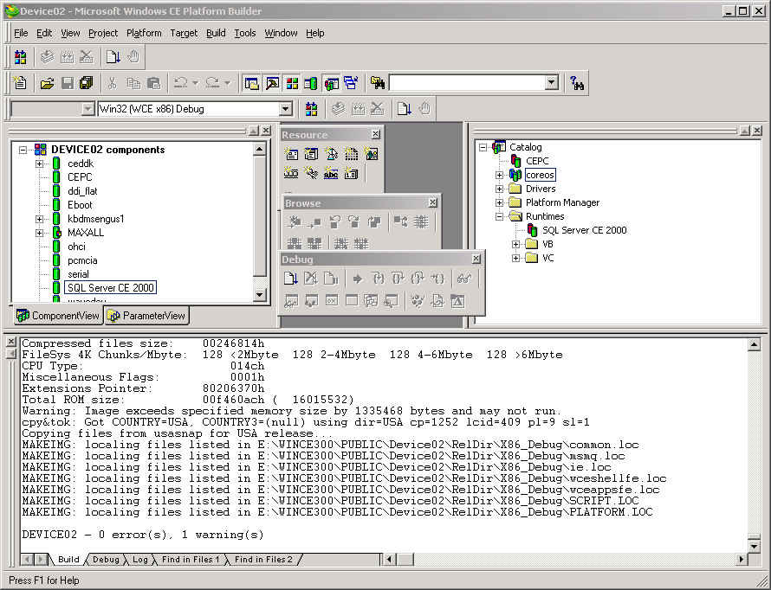

Figure 3 – Platform Builder with SQL Server CE as a selectable component

On-Device Data Management

A tool SQL Server CE provides for on-device data management is the ISQLW tool (Figure 4). With a subset of the functionality of SQL Server’s Query analyzer, ISQLW allows you to execute queries, manage objects and view schemas using an interactive graphical interface. To facilitate executing frequently run queries, you may assign a query to one of 10 function buttons. This allows you to store pre-defined queries and execute them at the touch of a button. This also eliminates having to type the query over and over, which can be difficult if you are tap-typing each letter using the on screen keyboard.

Figure 4 – ISQLW tool provides on device data management
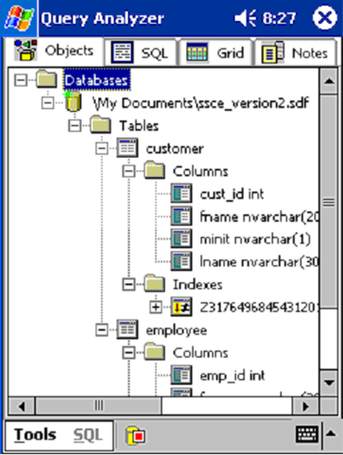
Two main challenges face mobile database application developers as they consider extending their enterprise applications to incorporate data access, modification and synchronization on devices. The first challenge is the connection volatility of mobile devices. Connection states vary from wired or within range of the company’s wireless LAN to disconnected and out of range. The ability to maintain a local database and have the confidence of merging the data modified on the device with back-end stores is a critical requirement. The second challenge is to make the best possible use of the resources on the device. Thus, the ability to limit or filter the data targeted at the device is important. Both of these challenges are addressed by the merge replication and RDA capabilities of SQL Server CE.

Flexible data access

Simplifying Connectivity Setup
SQL Server CE’s new connectivity setup wizard (Figure 5) guides the DBA or developer with a step by step approach in ensuring all configuration settings for data synchronization are correctly implemented. It covers all essential settings, from the creation of virtual directories on the IIS server to establishing data access permissions. The wizard also allows you to set and modify your NTFS permissions.
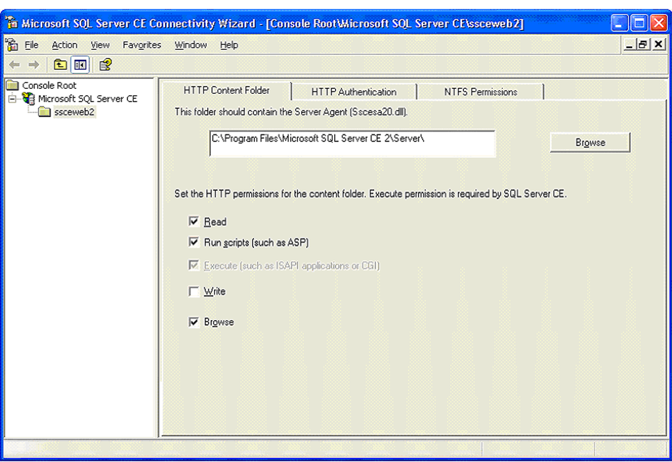
Figure 5 – Connectivity Wizard guides you through the synchronization setup

Merge Replication for Complete Access and Synchronization
Merge replication in SQL Server CE requires Microsoft SQL Server 2000 merge replication on the back-end server. It is ideally suited to portable devices because data can be updated on both the subscriber (the device) and the server (the back-end SQL Server 2000 database) independently and synchronized later when the device is reconnected to the server.
SQL Server CE supports anonymous subscriptions to merge publications. Most administration of the subscription is handled at the subscriber level; limited information about the SQL Server CE-based subscription is stored at the publisher.
A SQL Server CE application can subscribe to a publication using the SQL Server CE Replication Object. When the subscription is created, the initial snapshot is applied to create the subscription database on the device.
Users can modify data in the subscription database once it is transferred to local storage. When reconnected, the data modifications made at the subscriber are sent to the publisher and merged with changes made at the publisher and at any other subscribers. Changes made at the publisher or propagated to the publisher since the last synchronization are sent to the subscriber. Developers will appreciate the capability of SQL Server to provide all this heavy-lifting, such as creating the schema on the device during the initial sync, loading the data, create all the indexes and referential integrity, all using a single line of code, or method call. That very same method call does bi-directional synchronization of all changes on both the device and server. This benefits the developers to focus on their application rather than the intricacies of the sync infrastructure.
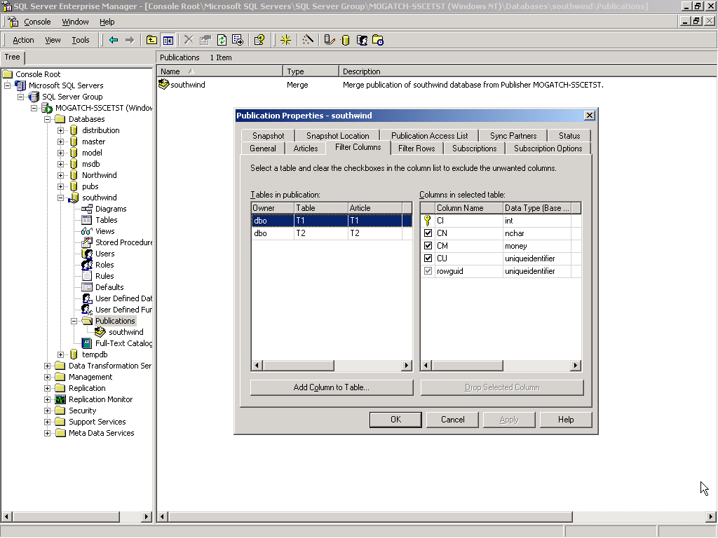
Figure 6 – SQL Server 2000 Enterprise Manager is used to setup publications and filters

Beyond ensuring that data is transferred reliably, it is also important that only the necessary data be replicated to the device. On the backend, SQL Server 2000 controls the exchange of data within tables between the publisher and subscriber through horizontal and vertical filters, allowing the publication of only that data required by the subscriber (Figure 6). Partitions can include specific columns and/or rows. Using filters not only aids the efficiency of replication data transfers, but also provides another level of security, because sensitive data can be filtered out of partitions before being sent to the device.
Consider a company that has distribution offices located across the United States, delivering products to retail outlets. Assuming this company was publishing its inventory and delivery data through merge replication, SQL Server CE could take advantage of dynamic horizontal partitions when the publication is created to download only the data necessary for a particular distribution location. Since the dynamic horizontal partition is created on the backend SQL Server 2000 database, the amount of data that is downloaded can be controlled from a single, centralized location at the company. This same mechanism allows the amount of data downloaded to any device to be controlled from the server, which aids in maintaining the application because changes do not need to be made on the application at the device level, saving the company from potentially having to update 100’s or 1000’s of field-deployed devices.
Another key feature that is available with SQL Server 2000 merge replication publications is ranged IDENTITY columns. Revisiting the distribution scenario described above, consider that delivery people take orders onsite at stores to fill low inventories. Each order requires a unique order number; IDENTITY columns accommodate this need. However, without specific programming logic, the IDENTITY values would occasionally (and unpredictably) conflict when the devices synchronize back to the corporate database. By using a ranged IDENTITY column created at the publication, this problem can be avoided. With ranged IDENTITY columns, the server maintains a range of unique IDENTITY values for each device, removing the burden of having value checking logic on the device while ensuring seamless synchronizations from the subscribing devices to the publication.
If conflicts occur on the back-end server because of conflicting changes to the same data, a component called the Merge Agent will resolve the conflicts using the default or customer conflict resolvers specified during the creation of the publication.
Merge replication is helpful when:
- Multiple subscribers need to update data at various times and propagate those changes to the publisher and to other subscribers.
- Subscribers need to receive data, make changes offline and later synchronize changes with the publisher and other subscribers.
- Control of data is needed at a central location and must be controlled by a database administrator instead of by application logic.

RDA : Easy Access to Back-End SQL Server Data
RDA is a powerful, yet incredibly simple mechanism for updating a remote SQL Server database or to move data back and forth between a back-end SQL Server database and the local SQL Server CE database on the device. Applications can use RDA to access back-end SQL Server databases (SQL Server 6.5 and later) in two ways: by forwarding a SQL Data Manipulation Language statement for execution or by submitting a SQL query that returns a row set. In the latter case, the resulting row set is transmitted to the device where it is stored in a SQL Server CE table. Changes made to this data can be tracked by SQL Server CE and, at the request of the application, updated rows can be sent back and applied to the back-end SQL Server system. RDA can also be used to invoke stored procedures in back-end databases. RDA is able to pull down to the device both the primary key and all additional indices.
Typical applications of RDA include:
- Static Data download. An application running on a Windows CE-based device can pull SQL Server data to a SQL Server CE database. For example, an application might download a company employee directory, product price list or product catalog to the device.
- Data capture and upload. An application running on a Windows CE-based device can capture data that originates from user-entered forms, a GPS system, a bar code reader or something similar. The application can store the captured data in a SQL Server CE database on the device. Periodically, the application can push the captured data from the SQL Server CE database to a back-end SQL Server database.
- Data download, update and upload. An application running on a Windows CE-based device can pull SQL Server data to a SQL Server CE database. The application can then update the SQL Server CE database. Periodically, the application can push the changed data from the SQL Server CE database to a SQL Server database.
- Submitting SQL statements. An application running on a Windows CE-based device can submit SQL statements to be executed on a remote SQL Server database. This is especially useful when the Windows CE-based device is always connected to the network.
Often, these techniques are used in combination. For example, a sales support application might use a data download to "pull" a price list to a Windows CE-based device. The application might use a data capture and upload to capture new orders on the device. These orders might then be "pushed" to a back-end SQL Server. The application might use a data download, update and upload to pull customer information to the device. The customer information could be updated on the device and the resulting changes pushed back to a back-end SQL Server. Finally, the application might submit SQL statements directly to the SQL Server database.

Integration with the .NET Compact Framework
SQL Server CE provides a SQL Server CE Managed Provider which manages data access between applications built with Visual Basic .NET or Visual C# .NET and data residing in SQL Server CE using the Common Language Runtime (CLR) provided with the .NET Compact Framework.
To support the applications using managed code and the .NET Compact Framework, SQL Server CE added the following new namespaces - System.Data.SqlClient and System.Data.SqlServerCe.

Security
SQL Server CE secures your local database by allowing you to set features such as a password and 128-bit encryption. A database password ensures protection against programmatic intrusion into the database. Encryption prevents database files being read as text objects.

Upgrading from 1.x to 2.0
Users of SQL Server CE 2.0 will find that the file format of version 2.0 is compatible with the previous 1.x versions. This provides the migration benefit of simply replacing

Internet Standards for Reliability and Security
RDA and replication communicate with back-end SQL Server databases using Internet standard protocols. Because of the HTTP support in SQL Server CE, RDA and merge replication can locate and connect to databases located behind corporate firewalls or proxy servers. To optimize bandwidth-limited connections, RDA and merge replication rely on compression and large-message-based communications to reduce the amount of data being sent and received via HTTP.
Windows2000 Server’s Internet Information Services (IIS) provides authentication and authorization services for both RDA and merge replication. And both techniques encrypt transmitted data using SSL support in IIS. These Internet protocols also contribute to the reliability of SQL Server CE data access methods. After any communications failure, SQL Server CE attempts to create a new HTTP connection and resume data transmission starting from the last successfully transmitted message buffer.

Microsoft SQL Server 2000 Windows CE Edition was developed with a clear goal of allowing enterprises to extend their applications to a new class of devices and operating environments, leveraging both the .NET development model and the native application development model. It delivers by providing a compact database for rapidly developing applications that extend the frontiers of data management. It has the familiar feel of SQL Server, with tools, APIs and SQL grammar that minimize development time. Additionally, the SQL Server CE engine exposes an essential set of relational database features — including an optimizing query processor, support for transactions and assorted data types — while maintaining a compact footprint that preserves precious system resources. Remote Data Access and merge replication, which work over HTTP and support encryption, ensure that data from enterprise SQL Server databases is reliably delivered and that this data can be manipulated offline and synchronized later to the server, making SQL Server CE ideal for mobile and wireless scenarios.

Conclusion

