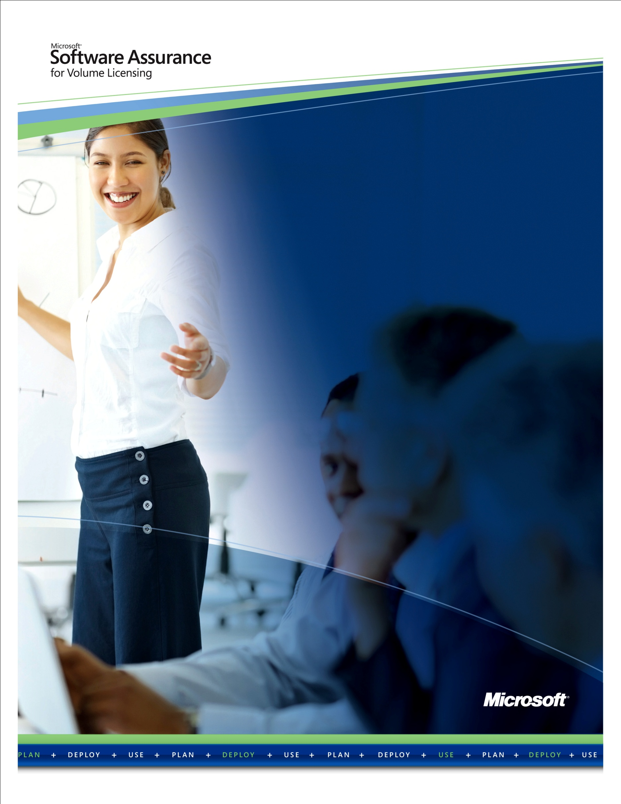Maximize Your Benefits

Practical steps and insider tips for getting  
the most from Software Assurance

Contents

OVERVIEW 3

STEP 1: FAMILIARIZE YOURSELF WITH SOFTWARE ASSURANCE 4

STEP 2: CHECK YOUR BENEFITS 4

STEP 3: BUILD YOUR SOFTWARE ASSURANCE USAGE TEAM 4

STEP 4: DISCUSS PRIORITIES AND ESTABLISH USAGE GOALS 5

STEP 5: BUILD YOUR SOFTWARE ASSURANCE USAGE PLAN 6

STEP 6: FOLLOW THROUGH 11

SOFTWARE ASSURANCE RESOURCES 13

OVERVIEW

Microsoft® Software Assurance for Volume Licensing helps boost productivity across your organization by enabling you to get the most from your Microsoft software. Benefits, including 24x7 support, deployment planning services, end-user and technical training, and the latest software releases and unique technologies, are combined in one cost-effective program. Using these benefits can help your organization improve productivity and help IT efficiently deploy and manage your Microsoft technology.

Informed by Software Assurance customers and industry insiders, this guide offers key steps,   
tips, and practical advice to help you get the most value from your benefits. Use it as a starting point to help you successfully plan, manage, and use the benefits across your organization.

Taking an active role in managing Software Assurance benefits not only helps assure that your organization maximizes these resources, but it can also help you demonstrate your personal, departmental, and organizational impact on business value. By helping manage Software Assurance benefits across your organization, you can show your commitment to your company’s productivity and bottom line.



A key challenge with Software Assurance, however, is that it can be difficult for customers to take advantage of all the tools and benefits that are offered. When SA benefits are underused, customers are potentially leaving cost savings and opportunity for improved return on investment (ROI) on the table.

IDC White Paper sponsored by Microsoft, Maximizing your Microsoft Software Investment, Doc# 219263, July 2009

[Download the full article](http://idcdocserv.com/219263)

STEP 1: FAMILIARIZE YOURSELF WITH SOFTWARE ASSURANCE

Microsoft Software Assurance helps improve end-user productivity with online training and home use licenses that enhance skills and accelerate familiarity with Microsoft software. To help IT staff efficiently manage your Microsoft technology, Software Assurance provides new software releases as they become available, access to unique desktop technologies including Windows® 7 Enterprise and the Microsoft Desktop Optimization Pack (MDOP), 24x7 phone and web support, technical classroom training, and deployment planning services.

* Visit the [Software Assurance Web site](http://www.microsoft.com/softwareassurance) to learn more about Software Assurance, specific benefits, and what they can do for your organization.

STEP 2: CHECK YOUR BENEFITS

Software Assurance benefits vary by Volume Licensing program (such as an Enterprise   
Agreement or Open Value Agreement), and by the number of qualifying licenses you have enrolled   
in Software Assurance.

* Use the resources and tools on the [Software Assurance Web site](http://www.microsoft.com/softwareassurance) to check your   
  organization’s benefits.
* Review the step-by-step instructions presented in the [Software Assurance Quick Start Guide](http://download.microsoft.com/download/5/c/7/5c727885-ec15-4920-818b-4d140ec6c38a/SA_Customer_QuickStartGuide.docx)   
  to learn how to access and use individual benefits.

STEP 3: BUILD YOUR SOFTWARE ASSURANCE USAGE TEAM

A key to setting up your organization for success with Software Assurance is establishing a Software Assurance team to ensure that your benefits are used. Depending on the size of your organization and the scope of your benefits, your team may include individuals with job roles in IT, PC support or helpdesk, human resources, professional development, and procurement.

Identify and Recruit Vested Team Members

To establish your team, identify individuals who have a vested interest in reducing costs for IT, training, or support, and for taking a lead role in identifying unrealized value for your organization.

**Software Assurance team member recommendations for a typical organization:**

|  |  |  |
| --- | --- | --- |
| **Activity** | **SA Benefit** | **Benefit Manager** |
| Deployment | * Packaged Services for Deployment Planning * Home Use Program | * IT Project Manager * HR Manager |
| Training | * Training Vouchers * E-Learning | * IT or HR Manager * IT End-user Support, HR, or Line-of-business Manager |
| Support | * 24x7 Problem Resolution Support * TechNet Benefits through Software Assurance | * IT Support Manager * IT Managers |

STEP 4: DISCUSS PRIORITIES AND ESTABLISH USAGE GOALS

Hold a kick off meeting with your team to review key Software Assurance benefits that map to your organizational priorities and establish Software Assurance usage goals. These goals can be as formal or informal as you like, the idea being to identify the potential value of your Software Assurance benefits, relate this value to key organizational objectives, and agree upon usage goals.

For example, if your organization is looking to conserve cash or preserve credit lines, your Software Assurance plan may include:

* Use no-cost training available through E-Learning and Training Voucher benefits.
* Extend IT resources by utilizing 24x7 Problem Resolution Support incidents, or scheduling deployment planning engagements through Packaged Services.
* Ensure new software upgrades take advantage of the New Product Versions benefit (free upgrades); and/or use latest desktop technologies (MDOP) to streamline deployments and desktop management.
* Offer employee “extras” like the latest Office products for use at home, or the opportunity to build technical skills through online and classroom training available through E-Learning and Training Voucher benefits without impacting staff budgets.
* Take advantage of Software Assurance Spread Payment (delayed) payment option, when renewing your Volume Licensing agreement.

****TIP: To put even more momentum behind end-user training, pair the E-Learning benefit with the [Home Use Program](http://wwwppe/licensing/software-assurance/home-use-program.aspx) and make the latest version of Microsoft Office available to employees for use on their home computer via a low-cost download.

By using the key programs within SA to implement best practices within their IT organization, customers can reduce their operation costs per user by **$292** annually, and break even in 8 months.

*IDC White Paper sponsored by Microsoft, Maximizing your Microsoft Software Investment, Doc# 219263, July 2009

[Download the full article](http://idcdocserv.com/219263)

STEP 5: BUILD YOUR SOFTWARE ASSURANCE USAGE PLAN

Customers who take the time to build a Software Assurance usage plan have greater success using their benefits. Two planning approaches are outlined below. Use one, or a combination of both, to fit your organizational goals.

Strategy 1:

Structure your Software Assurance usage priorities around your Volume Licensing agreement

A simple strategy to help your organization realize the full value of your investment is to manage your Software Assurance benefits across the three-year Volume Licensing agreement term. The following graphic represents a three-year agreement calendar and outlines steps you might take to maximize key deployment, training, and support benefits.

**Software Assurance Benefits Usage Calendar**

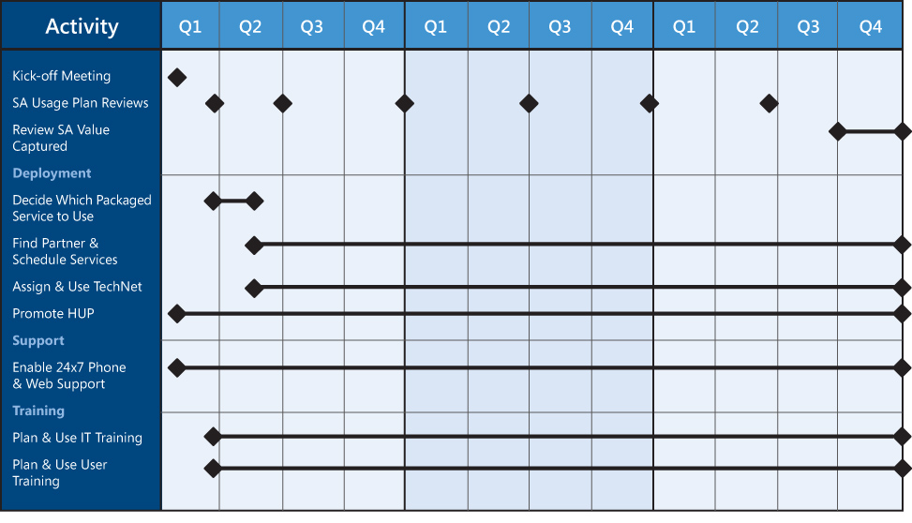

**More planning ideas:**

* Ensure the right people in your organization know about Software Assurance benefits: both individuals who will benefit directly from using the benefits, and business and technical decision makers interested in the return on investment.
* Engage your Software Assurance usage team early in the agreement timeframe to ensure benefits are assigned to appropriate managers.
* Set quarterly meetings to review usage goals and team progress.
* Focus on key deployment, training, and support benefits across the agreement timeframe to help your organization maximize its investment.



TIP:Before your agreement term ends, be sure to reserve any unused IT training days  
 (Training Vouchers) using VLSC. Doing so gives you an additional 180 days to use this benefit.

****TIP:If you are a Microsoft Services Premier Support customer, you may convert your allotted Software Assurance phone support incidents into Premier Problem Resolution Services to extend support from trusted experts you already know.

“In the past, we spent 90 percent of our time reactively. Now with Premier Support, we spend that time to plan for the future.”

Carlos Alcantara, Specialist Manager  
SERASA Experian

[Download the case study](http://www.microsoft.com/casestudies/Case_Study_Detail.aspx?casestudyid=4000005949)

Strategy 2:

Align Software Assurance to your deployment and support plans

While every organization is unique, there is a patterned approach to using Software Assurance to cover key activities surrounding software deployment and use. You can use this approach, illustrated and exemplified below, as a baseline for defining specific plans and actions. This is especially useful if you are planning key software updates or technology upgrades.

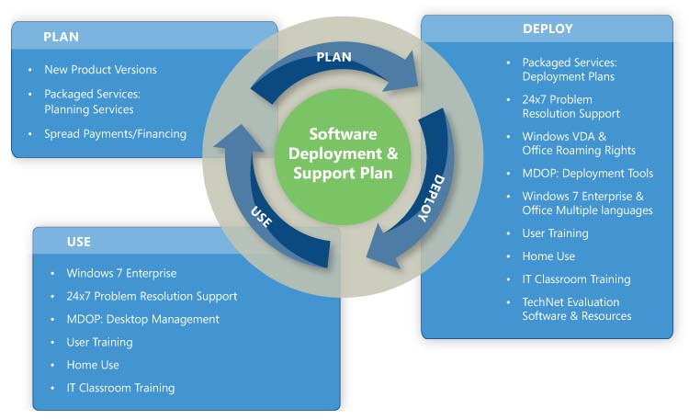

As the chart indicates, Software Assurance offers benefits that support your organization as you plan, deploy, and use Microsoft software. Many of these benefits cross-over and are valuable in multiple phases. For example, as you prepare to deploy new software, you can take advantage of online training (E-Learning) and the Home Use Program to help prepare end-users to be more productive with the new software, AND/OR promote these same benefits so users may become better skilled and more efficient with current software programs.

**More planning ideas:**

* Take advantage of new product versions as soon as they’re released, while benefitting from the ability to spread your Volume Licensing and Software Assurance expenditures across three equal annual payments.
* Focus on how deployment planning can help improve your organization’s deployment timelines and readiness.
* Plan to promote the Home Use Program and training options to ready users, IT, and support for new software versions.
* See how you might use the application deployment and desktop management tools available with Windows 7 Enterprise and the Microsoft Optimized Desktop Pack.
* Understand how Software Assurance supports building and managing virtual desktop environments with App-V and MED-V technologies, in addition to new Windows Virtual Desktop Access and expanded Office Roaming rights.
* Support organizational productivity with end-user and technical training, the Home Use Program, and TechNet Benefits through Software Assurance–all of which can contribute to the more productive use of new software and help lower support costs.

TIP:Make [MDOP](http://wwwppe/licensing/software-assurance/mdop.aspx) part of your Windows 7 deployment plans and use its powerful desktop management tools to speed up application deployments, enhance IT responsiveness,   
and increase user uptime.

“Using Application Virtualization [part of MDOP], we can provide much more responsive service. We can bring new customers on board and update and change applications for existing customers very quickly.”

**Jeron Mehl,** IT Manager

Steinbuch Centre for Computing

[Download the case study](http://www.microsoft.com/casestudies/Case_Study_Detail.aspx?CaseStudyID=4000006508)

**Example:**

Align your Software Assurance usage plan with a Microsoft Exchange Server migration

**Plan**

* Get the latest version of Microsoft Exchange Server software through the New Product Versions benefit.
* Arrange an Exchange Deployment Planning Services (EDPS) engagement to help extend your IT resources, and get expert planning guidance and deployment recommendations.
* Ready IT and support staff with classroom training using Training Vouchers (Courses:Exchange 2007: *3910, 3911, 5047 5049, 5050, 5051, 5053, 5054, 5947, 5095*; Exchange 2010: *10135*; Office Communications Server 2007: *6755*)

**Deploy**

* Use the deployment recommendations stemming from your Exchange Deployment Planning   
  Services engagement.
* Use E-Learning for end-user training (Outlook Course #5261).
* Promote the Home Use Program across your organization to accelerate end-user familiarity with Outlook/Exchange.

**Use**

* Use E-Learning for ongoing end-user training and skill building (Outlook Course #5261).
* Develop and maintain IT and support staff knowledge using Training Vouchers and   
  E-Learning courses.
* Promote the Home Use Program (Outlook for PC or MAC) to help improve skills and productivity with Outlook/Exchange.
* Use 24x7 Problem Resolution Support to resolve issues quickly, and help minimize downtime.
* Utilize Cold Back-ups for Disaster Recovery to help users regain access to critical data and applications following disaster.



TIP: Ready your employees for new software with [self-paced, online training](http://wwwppe/licensing/software-assurance/e-learning.aspx) developed by   
Microsoft experts.

"The engagement proved its value as we saved time and money on the first phase of the Microsoft Office rollout, which was handled solely by the desktop manager."

Shiran Herath

IT Manager, McGrathNicol

[Download the case study](http://www.microsoft.com/casestudies/Case_Study_Detail.aspx?CaseStudyID=4000002289)

STEP 6: FOLLOW THROUGH

Customers who use their Software Assurance benefits and recognize the cost-effectiveness of the program report that success starts with: 1) using benefits early in the agreement timeframe; 2) having a clear plan to maximize Software Assurance value; and 3) revisiting benefit usage periodically throughout their agreement term.

While using Software Assurance may not be a top priority for some in your organization, to maintain focus and capture more value, consider the following actions:

* **Revisit Software Assurance usage periodically**  
  Conduct status meetings or make Software Assurance usage part of the quarterly review process. If utilizing benefits for deployment is your priority, make Software Assurance usage check points part of your overall deployment management process.
* **Document your progress**  
  You can use the [Volume Licensing Service Center (VLSC)](http://www.microsoft.com/licensing/servicecenter) to review your benefits and see how they are being used across your organizations. Refer to the **Check your benefits page** on the [Software Assurance Web site](http://www.microsoft.com/softwareassurance).
* **Develop a planning checklist**Another simple way to track progress is through a usage planning check list. With your team, identify and agree on a few realistic goals and priorities and sketch out your Software Assurance usage plan. Use this table as a starting point to build a checklist to help you track and report how you, your team, or your department is using Software Assurance to bring value to your organization.

**Usage Planning Checklist**

|  |  |  |  |  |  |  |  |  |
| --- | --- | --- | --- | --- | --- | --- | --- | --- |
| **Benefit** | **Description** | | **Plan to Use (Y/N)** | | **Key Actions** | | **Usage** | **Business Value** |
| New Product Versions | Provides new software version releases so you have access to, and own, the latest technology. |  | |  | |  | |  |
| Packaged Planning Services | Provides structured planning services from Microsoft partners  to enable efficient deployments, covering desktop (Office and/or Windows), SharePoint®, Exchange, and Business Value Planning Services. |  | |  | |  | |  | |
| Windows Enterprise and MDOP Technologies | Provides six technologies to help manage PCs and improve application deployments. Includes application virtualization, asset and policy management, and diagnostic tools. |  | |  | |  | |  | |
| 24x7 Problem  Resolution Support | Around-the-clock phone and Web incident support for Microsoft desktop and server products. |  | |  | |  | |  | |
| User Training  (E-Learning) | Offers self-paced interactive training designed for end-users and IT professionals, delivered via Internet or Intranet. |  | |  | |  | |  | |
| IT Training (Training Vouchers) | Provides in-depth technical classroom training for IT professionals and developers. |  | |  | |  | |  | |
| Home Use Program | Provides employees with the latest version of Microsoft Office for their home computer, via a low cost download. |  | |  | |  | |  | |
| Additional Benefits |  |  | |  | |  | |  | |
|  |  |  | |  | |  | |  | |
|  |  |  | |  | |  | |  | |
|  |  |  | |  | | TOTAL | |  | |

SOFTWARE ASSURANCE RESOURCES

Learn more about Software Assurance: [www.microsoft.com/softwareassurance](http://www.microsoft.com/softwareassurance)

See how to **Check Your Benefits**: [www.microsoft.com/licensing/software-assurance/check-your-benefits.aspx](http://www.microsoft.com/licensing/software-assurance/check-your-benefits.aspx)

Get step-by-step instructions for using your benefits with the Software Assurance Quick Start Guide: <http://download.microsoft.com/download/5/c/7/5c727885-ec15-4920-818b-4d140ec6c38a/SA_Customer_QuickStartGuide.docx>

Use the Volume Licensing Service Center to access and manage your benefits: [www.microsoft.com/licensing/servicecenter](http://www.microsoft.com/licensing/servicecenter)

Watch the demos to learn more about registering and assigning Software Assurance benefit managers in the Volume Licensing Service Center: <http://www.microsoft.com/licensing/existing-customers/manage-my-agreements.aspx>, see the how-to demos.

Microsoft provides this material solely for informational purposes. Customers should refer to their agreements for a full understanding of their rights and obligations under Microsoft’s Volume Licensing

programs. Microsoft Software is licensed, not sold. The value and benefit gained through use of Microsoft software and services may vary by customer. Customers with questions about differences between this material and the agreements should contact their reseller or Microsoft account manager. Microsoft does not set final prices or payment terms for licenses acquired through resellers. Final prices and payments terms are determined by agreement between the customer and its reseller. Eligibility for Software Assurance benefits varies by offering and region and is subject to change. The Terms and Conditions of your Volume License Agreement and the Terms and Conditions under which any specific Software Assurance benefits are offered will take precedence in any case of conflict with the information provided here. For eligibility and current program rules, see the [**Microsoft Product List**](http://www.microsoft.com/licensing/productlist/).