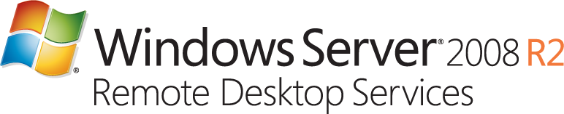

With Windows Server® 2008 R2 Remote Desktop Services (RDS), Microsoft is progressing in its vision to provide the best virtualization platform for accelerating and extending desktop and application deployments from the data center to any device. In addition to the traditional session virtualization scenario (formerly known as “Terminal Services”), Remote Desktop Services is expanding its role to provide an extensible platform for a Virtual Desktop Infrastructure (VDI).

RDS is a cost-effective infrastructure platform for any type of organization, particularly those with a roaming workforce, structured task workers or knowledge workers with a need for flexible desktop or application access, including contractors, offshore workers and office workers that require a free seating environment or have a need to work from home.

|  |  |  |
| --- | --- | --- |
| SOLUTION BENEFITS | | |
| ACCELERATE DESKTOP & APPLICATION DEPLOYMENT | HELP SECURE DATA AND APPLICATIONS | INCREASE REMOTE WORKER EFFICIENCY |
| Remote Desktop Services accelerates and extends the deployment of desktops and applications to a wide array of client devices, helping make your organization more agile and responsive. RDS also enables flexible work scenarios such as hot-desking and work from home. | Remote Desktop Services helps organizations keep critical intellectual property highly secure and helps radically simplify regulatory compliance by removing applications and data from the desktop. | Remote Desktop Services helps simplify remote connectivity, enabling rich applications to be accessed from a web page and seamlessly integrated with a local desktop, improving remote worker efficiency. |

# Key Features of Windows Server 2008 R2 Remote Desktop Services

* + **Full-Fidelity User Experience** significantly improves the user experience of remote users, bringing the experience closer to that enjoyed by users accessing local computing resources. The rich remote user experience in RDS includes multi-monitor support, support for Windows Media® Player redirection, bi-directional audio, as well as enhanced bitmap acceleration for rich media content such as Silverlight.
  + **RD Connection Broker** creates a unified administrator experience for traditional session-based remote desktops and applications (session virtualization or “Terminal Services”), and emerging virtual machine-based remote desktops (VDI).
  + **RemoteApp™** applications appear no different than local applications, performing seamlessly with the new task bar in Windows 7. RemoteApp helps improve the end user experience and reduce training requirements.
  + **RemoteApp and Desktop Connections** simplifies access to a set of resources, such as RemoteApp programs and Remote Desktops that perform seamlessly with Windows 7. These connections are easy to set up and are automatically kept up to date so the user always has access to the latest resources that are being made available.
  + **App-V for RDS** helps solve application compatibility on Remote Desktop Session Hosts and helps consolidate RDSH servers. Microsoft Application Virtualization (App-V) for RDS now supports 64-bit operating systems.
  + **RemoteFX** introduces a new set of remote user experience capabilities that enable a media-rich user environment for virtual desktops, session-based desktops, and remote applications. It can be deployed to a range of thick and thin client devices, enabling cost-effective, local-like access to graphics-intensive applications, and a broad array of user peripherals to improve the productivity of remote users.
  + **Dynamic Memory** (an enhancement to Microsoft Hyper-V™) enables organizations to make the most efficient use of available physical memory by pooling memory on a host machine and dynamically distributing it to virtual machines as needed. Memory is dynamically added or removed based on current workloads without service interruption.
  + **DirectAccess** allows remote workers to securely and seamlessly connect to their work environment as if they were on the corporate network and lets IT administrators continually manage those PCs because they are always reachable, without the use of a VPN, resulting in greater flexibility for remote workers and reduced administration costs.
  + **Managed service accounts (MSAs)** support domain-member services located in perimeter networks (also known as DMZs, demilitarized zones, and screened subnets).
  + **RD Web Access** helpssimplify application and desktop deployment by making those resources available to Windows 7, Windows Vista and Windows XP clients from a web page or a SharePoint portal.
  + **RD Gateway** helps provide a secure connection between internal applications and data to users outside the firewall. It delivers critical applications and data to mobile employees without additional VPN infrastructure.
  + **RD Easy Print** uses the client-side print driver (no server side driver needed) to enable fast and reliable printing to a local or network-attached printer. End users can more productively work from remote locations.
  + **Higher authentication traffic thresholds to domain controllers on high-latency** **networks** allows for finer control of the maximum number of possible concurrent connections to a domain controller, enabling a greater degree of performance tuning for service providers.

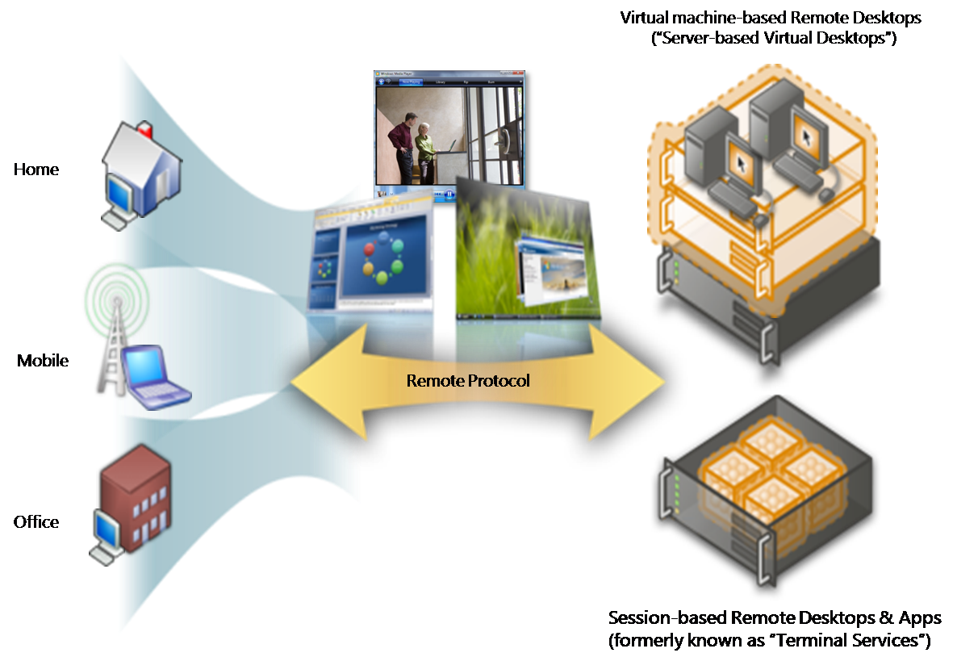

Remote Desktop Services: Rich User Experience for session virtualization (formerly known as Terminal Services) and VDI

|  |  |  |
| --- | --- | --- |
| Key User Scenarios for Remote Desktop Services | |  |
| Task WorkersStructured task workers, such as call center and retail branch employees, often don’t need to access many applications to complete business processes. Sometimes the location is not appropriate for PCs, e.g., a factory floor. Whether the client machine is a legacy desktop, a non-PC desktop, or a thin client, Remote Desktop Services can often provide a better user experience than when installing the application on the machine itself. This type of deployment can extend the reach of Windows applications within the enterprise and is a valuable way to offer access to applications that the user might need only infrequently. | | Contractors and Offshore Workers In an environment where there are complex applications such as Line of Business or customized in-house software, Remote Desktop Services can greatly reduce the burden of having to deliver access to these applications to outsourced firms or partners. The client machines can access the applications they require from a central source, rather than having to have everything installed on their local machine. It is possible to limit access to specific LOB applications, rather than providing access to the full corporate network. |
| Mobile WorkersToday’s employees are often mobile, working from home, hotels or customer sites. With Remote Desktop Services, an organization can enable employee productivity virtually anywhere and increase effective user collaboration without compromising security features. Remote Desktop Services can help offer secure access to desktops and applications from any device and via a low bandwidth connection, as no data are sent over the network. Instead, employees see a consistent set of applications, and can access their own data regardless of location. | | Office Workers Some office workers, such as analysts and lawyers, are connected to the corporate network most of the time, and expect a rich client experience that can handle a broad range of tasks which fall under their responsibility. They use applications such as Office, CRM and ERP Line of Business (LOB) applications, as well as web and project management tools. Many of these users move frequently from one workstation to another and therefore require a free seating environment. Office workers may also have an occasional need to connect to their corporate environment from their home PC. |
|  | |  |
| **For More Information:** | [**http://www.microsoft.com/windowsserver2008/en/us/rds-product-home.aspx**](http://www.microsoft.com/windowsserver2008/en/us/rds-product-home.aspx) | | |
| **Technical Resources:** | [**http://technet.microsoft.com/en-us/library/dd560658(WS.10).aspx**](http://technet.microsoft.com/en-us/library/dd560658(WS.10).aspx) | | |