
Building Investment Banking Pitchbooks Faster Using the Microsoft Office System
Technical Discussion Guide

The information contained in this document represents the current view of Microsoft Corporation on the issues discussed as of the date of publication. Because Microsoft must respond to changing market conditions, it should not be interpreted to be a commitment on the part of Microsoft, and Microsoft cannot guarantee the accuracy of any information presented after the date of publication.
This document is for informational purposes only. MICROSOFT MAKES NO WARRANTIES, EXPRESS OR IMPLIED, AS TO THE INFORMATION IN THIS DOCUMENT.
Complying with all applicable copyright laws is the responsibility of the user. Without limiting the rights under copyright, no part of this document may be reproduced, stored in or introduced into a retrieval system, or transmitted in any form or by any means (electronic, mechanical, photocopying, recording, or otherwise), or for any purpose, without the express written permission of Microsoft Corporation.
Microsoft may have patents, patent applications, trademarks, copyrights, or other intellectual property rights covering subject matter in this document. Except as expressly provided in any written license agreement from Microsoft, the furnishing of this document does not give you any license to these patents, trademarks, copyrights, or other intellectual property.
Unless otherwise noted, the example companies, organizations, products, domain names, e-mail addresses, logos, people, places and events depicted herein are fictitious, and no association with any real company, organization, product, domain name, e-mail address, logo, person, place or event is intended or should be inferred.
© 2005 Microsoft Corporation. All rights reserved.
Microsoft, Active Directory, Excel, PowerPoint, MSDN, SharePoint, Windows, and Windows Server are either registered trademarks or trademarks of Microsoft Corporation in the United States and/or other countries.
All other trademarks are property of their respective owners.

1 Executive Summary 4
Purpose of This Guide 4
2 Business Challenges and Solutions 6
Business Challenges 6
Addressing the Challenges 7
Pitchbook Solutions Using the Microsoft Office System 7
Benefits 8
3 Architectural Overview 10
Solution Architecture 10
Client Tier 10
Middle Tier 11
Data Tier 11
A Pitchbook Solution Example in Action 12
Creating the SharePoint Project Site 12
Searching the Content Library 13
Adding Tombstone Slides to the Pitchbook 14
Saving Slides to the Content Library 15
Modeling and Integrating Data in Excel 16
Assigning Global Variables for Frequently Used Values 17
4 Infrastructure Considerations 19
Software Considerations 19
Scalability and Operations Considerations 20
Windows SharePoint Services Capacity Guidelines 20
Integration with SharePoint Portal Server 21
Security Considerations 21
Digital Rights Management 21
5 Next Steps 23
Resource and Skill Considerations 23
Business Analyst 23
Content Administrator 23
Developer 24
Network Administrator 24
Potential Partner Solutions 24
Solution Showcase for the Microsoft Office System 24
6 Appendix 25
Developer Resources 25
Product Training 25
Security Information 26

1 Executive Summary
Pitchbooks are composite sales documents that investment banks present to prospective clients when trying to secure engagements for securities underwriting, bond refinancing, and other services. The quality and timely preparation of a pitchbook are critical factors in attracting new business opportunities and in responding to a request from a current client. The processes used to compile, approve, and produce a pitchbook, however, can be time-consuming and are often performed manually.
This guide describes an example of a software solution that can be used to automate key steps in the preparation of investment banking pitchbooks. The solution combines features of Microsoft® SharePoint® Products and Technologies, Microsoft Office PowerPoint® 2003, and Microsoft Office Excel® 2003 to help support and manage the work involved in creating a pitchbook.
The example enables users to search a Microsoft Windows® SharePoint Services content library for relevant and approved PowerPoint slides, analyze data for the presentation in Excel, assemble and format a pitchbook, and save new and updated slides to the content library for future use. The content library can be searched and updated while a user works in PowerPoint. Charts and financial data can be added to a pitchbook presentation by running Excel from PowerPoint. A team compiling a pitchbook can also make use of collaborative work features available through a SharePoint site that is set up for a specific pitchbook project and also use the site to post schedules and other project information.
An investment banking pitchbook solution built using the Microsoft Office System can support the preparation of pitchbooks from initial data collection to assembly and generation. It can help an organization respond to opportunities by streamlining preparation time, standardizing the format of a pitchbook, and improving the quality of its content.

Purpose of This Guide
This guide is intended to help decision makers assess and recommend information technology solutions designed to help work teams prepare investment banking pitchbooks. It summarizes challenges faced by businesses that prepare pitchbooks and describes how a Microsoft Office System solution can address those challenges. This guide does not describe the steps required to set up a complete solution.
This guide also covers the following topics:
● The architecture and operations of a sample pitchbook solution
● Issues to consider with respect to scalability, security, and other operational needs
● Resources and skills related to implementing and maintaining a solution
● Additional resources for information about Microsoft products and technologies and partners who develop pitchbook solutions

2 Business Challenges and Solutions
This chapter describes business and workflow challenges that businesses face when preparing investment banking pitchbooks. It explains how a solution built with the Microsoft Office System can address these challenges and highlights the benefits that an Office-based solution provides.

Business Challenges
The contents of an investment banking pitchbook can include information such as the preparing firm's credentials, an industry overview, biographical information about members of the deal team, data about relevant financial products and services, details of the specific deal, market analysis, and financial information about the prospective client. A pitchbook team needs to develop financial models, analyze data, create charts, and compile the information into a presentation, which is often created in PowerPoint. The work takes many hours, and the diverse types of information included in a pitchbook means that a pitchbook author often needs to switch from PowerPoint to a word-processing or spreadsheet application, for example, or to Web sites or file shares to create or find information that needs to be included.
Although investment banking teams need to customize the content of a pitchbook to address the details of a particular business opportunity, teams often lack well-organized access to relevant content that is already available. In addition, individual departments and subsidiaries might follow different processes to create pitchbooks, which makes enforcing company standards and ensuring the consistency of hundreds of projects difficult.
Content in a pitchbook can become out of date in a short period of time. For example, quarterly financial results affect the financial models developed for a presentation and need to be updated. A company's profile and the names and roles of executives change, and modifications and additions to government regulations increase compliance requirements.
Without a content management system in place and with no standardized way to share content from successful pitchbooks throughout the organization, teams use time-consuming processes to search for, re-create, and assemble recurring content. The lack of a centralized repository can lead to undesirable and unnecessary variation in standard pitchbook content, increase the risk of noncompliance with regulatory requirements, and cause incorrect information to appear inadvertently in a published pitchbook. Differing approaches can result in marketing messages that vary from pitchbook to pitchbook and in inconsistent corporate branding that customers might perceive as lacking professionalism.
Pitchbook teams also face challenges related to workflow coordination and file tracking. For example, the latest version of a pitchbook is often reviewed through e-mail or delivered by express services to team members who are geographically dispersed. Hard copies of a pitchbook are routed for approval. Multiple pitchbook versions can delay completion and compromise quality, and lengthy review and approval cycles can delay the delivery of a pitchbook to a client.

Addressing the Challenges
A software solution designed for creating investment banking pitchbooks can automate processes that slow down the assembly of pitchbooks; improve how content is created, managed, and categorized throughout an organization; and support a collaborative workspace. A pitchbook solution can also provide a single user interface that teams work with to compile content, build diagrams, and create presentations.
The implementation of a solution that provides these capabilities can reduce the costs and labor associated with pitchbook creation. A solution can automate creation and inclusion in a presentation of tombstone slides that document prior business deals, enable users to save slides to one or more content libraries, and generate keywords from the information included on a slide so that the material stored in a content library can be effectively searched. A solution can also facilitate information sharing, task management, version control, issue tracking, and scheduling.

Pitchbook Solutions Using the Microsoft Office System
An investment banking pitchbook solution developed with PowerPoint 2003, Excel 2003, SharePoint Products and Technologies, and Web services provides a platform from which to build client pitchbooks. A pitchbook solution developed with the Microsoft Office System can help reduce redundant data entry and eliminate the time teams waste searching for content in data stores that are not integrated.
Support for XML in Office 2003, including technologies such as smart documents and smart tags, facilitates the creation of composite documents by providing access to content repositories and data sources while a document is being assembled. Programmable task panes developed with smart documents or the Microsoft Office Information Bridge Framework, for example, can provide access to context-sensitive resources.
PowerPoint 2003 is one of the Microsoft Office System applications that enables users to make use of resources such as dictionaries, online encyclopedias, and Web sites from the Research task pane. By using Web services and XML, software developers can extend the list of research sources to include information stored in an organization's line-of-business applications or data sources, including content stored in SharePoint sites.
PowerPoint 2003 also supports smart tags that can be linked to and recognize specific terms in a presentation. When a term is recognized, a user can choose from a list of actions associated with the smart tag to insert data, link to a Web page, locate information in a database, and so on.
A SharePoint site can serve as a project workspace that teams use for managing documents, defining user access, and communicating and collaborating as a workgroup. The integration of Windows SharePoint Services with Office 2003 applications enables users to use menu commands and task panes in Office 2003 applications to work with the document storage and collaboration features of Windows SharePoint Services. For example, users can create a document workspace site in Windows SharePoint Services for team reviews. Windows SharePoint Services can also track versions of documents stored on a SharePoint site. Users can view previous versions and the changes that are made as a document is finalized.
Organizations can build Windows SharePoint Services document libraries to store content that they include in pitchbooks. The content library can store pitchbook templates that comply with company guidelines, a catalogue of slides, images, and analytical models. A SharePoint site can also display information to users and serve as the central location at which teams view project announcements, schedules, and task assignments.
SharePoint Portal Server 2003, which includes the features of Windows SharePoint Services, provides additional search capabilities, enabling users to search across SharePoint sites as well as file servers, Web servers, Microsoft Exchange public folders, Lotus Notes, and databases. SharePoint Portal Server also provides the capability to define search scopes that narrow searches based on topics or content sources. SharePoint Portal Server would provide specific advantages to an organization that stores content that it includes in pitchbooks in a variety of data sources.

Benefits
An investment banking pitchbook solution can streamline pitchbook assembly processes across an organization, enabling pitchbook teams to work more effectively with clients and close more deals. Among the benefits of a Microsoft Office-based pitchbook solution are the following:
● Automate processes used to initiate, write, assemble, and update a pitchbook.
● Control versioning and streamline pitchbook aggregation and compilation.
● Perform financial modeling in Excel while working in PowerPoint.
● Gain access to information through a comprehensive search of previous pitchbook slides and other content. Save successful and approved content for reuse in future pitchbooks.
● Improve pitchbook quality by ensuring currency, consistency, and compliance.
● Reinforce corporate identity with consistent branding and messaging across pitchbooks.
● Control pitchbook compliance with the latest industry regulations and company standards.
● Minimize training costs by deploying a solution built with technologies that employees already use and understand.
● Integrate an Office-based solution with back-end or line-of-business systems that are already deployed.
Overall, with an investment banking pitchbook solution developed with the Microsoft Office System, a business can present more accurate and up-to-date content, reduce the time its teams spend on developing pitchbooks and invest this time in customer interactions, submit a greater number of pitchbooks with limited available resources, and ensure that presentations comply with customer standards and government regulations.
A number of partners are available to help build solutions. For more information about partners and investment banking pitchbook solutions, see Chapter 5, "Next Steps," later in this guide.

3 Architectural Overview
This chapter describes an example of an investment banking pitchbook solution. It outlines basic solution architecture and highlights operations that can be performed by the solution.

Solution Architecture
Figure 3.1 shows a basic architecture for a pitchbook solution that can be built with products such as Microsoft Windows Server™ 2003, Microsoft SQL Server™ 2000, SharePoint Products and Technologies, PowerPoint, and Excel. The figure shows client and server components developed within a typical three-tier architecture, including a custom pitchbook application that provides access to content libraries, line-of-business applications, and external data sources.
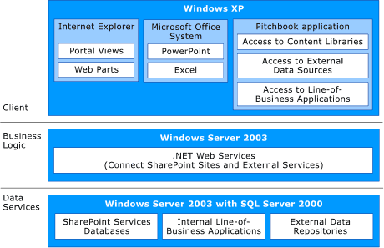
Figure 3.1
Basic architecture of an investment banking pitchbook solution

Client Tier
Client computers run Windows XP and include applications from the Microsoft Office System; in this example, it includes PowerPoint and Excel. A custom pitchbook application that extends the Microsoft Office System can be implemented to provide functionality that supports the specific processes used to build pitchbooks. The operations provided by the pitchbook application can be based on a user's role or authentication credentials through integration with the Microsoft Active Directory® directory service. The application itself can be developed from different technologies, based on the requirements of an organization. For example, the custom application could be built from the Microsoft .NET programmability components, the Information Bridge Framework client, or smart document technology:
● A pitchbook application developed using the .NET Framework could be exposed through PowerPoint to automate interaction with a content library or retrieve external data such as a company's financial information.
● The Information Bridge Framework enables developers to expand the tasks and data collection that can be performed within a single Office application. The Office task pane is customized through metadata defined in the Information Bridge Framework and provides controls with which users can search for, view, and import items from a Windows SharePoint Services content library. The Information Bridge Framework can also be used to connect to external data and services.
● Smart documents solutions tie business logic and custom actions to the contents of a document created in Word 2003 or Excel 2003. Smart documents work with the XML structure of a document to determine where and how to assist users in the preparation of complex documents. Smart documents can also provide access to external data sources and place data in a document or provide contextual help that instructs users how to prepare a document. The information in a smart document can be shared across disparate systems and applications.
Smart tags can also be used in a PowerPoint presentation to make relevant information more accessible when the presentation is being assembled. For example, a user can retrieve information from a variety of internal sources and from back-end systems with a smart tag.

Middle Tier
The middle tier of an investment banking pitchbook solution handles the business logic defined for the solution. This layer can consist of Web services supported by Windows Server 2003 and ASP.NET. Web services implemented through the Microsoft SharePoint Products and Technologies application programming interface (API) interact with the repositories Windows SharePoint Services. Additional Web services provide access to line-of-business data or to external data—such as financial reports or stock quotes—that is exposed by third-party Web services.

Data Tier
The data services layer consists of the content and configuration databases for the SharePoint site, line-of-business data repositories, and external data stores.

A Pitchbook Solution Example in Action
The example of an investment banking pitchbook solution described in this section is an add-in application for PowerPoint developed with the Microsoft .NET Framework. The solution is launched from a custom toolbar in PowerPoint. It depends on a SharePoint site with two default document repositories. One repository stores PowerPoint slides and other content for pitchbooks, and the second is a logo library. These libraries are part of the SQL Server 2000 databases that are created as part of a SharePoint site.
Web services manage the communication between a client computer and the SharePoint site. The solution uses both of the default Web services that are distributed with Windows SharePoint Services in addition to custom Web services.
The solution automates tasks that users perform to search for content and assemble a pitchbook in PowerPoint. In addition, the solution in this example provides assistance in formatting and organizing a presentation. For example, the solution can automate the creation of a table of contents for a presentation.

Creating the SharePoint Project Site
In the pitchbook solution example, a custom Web Part automates the creation of a site from a site template. For a user to create a new client site, the user must have read access to the template library for the site. This site is the central repository for information related to the client account, including supplemental documentation, announcements, task assignments, a list of team members and their status, and completed pitchbook presentations.
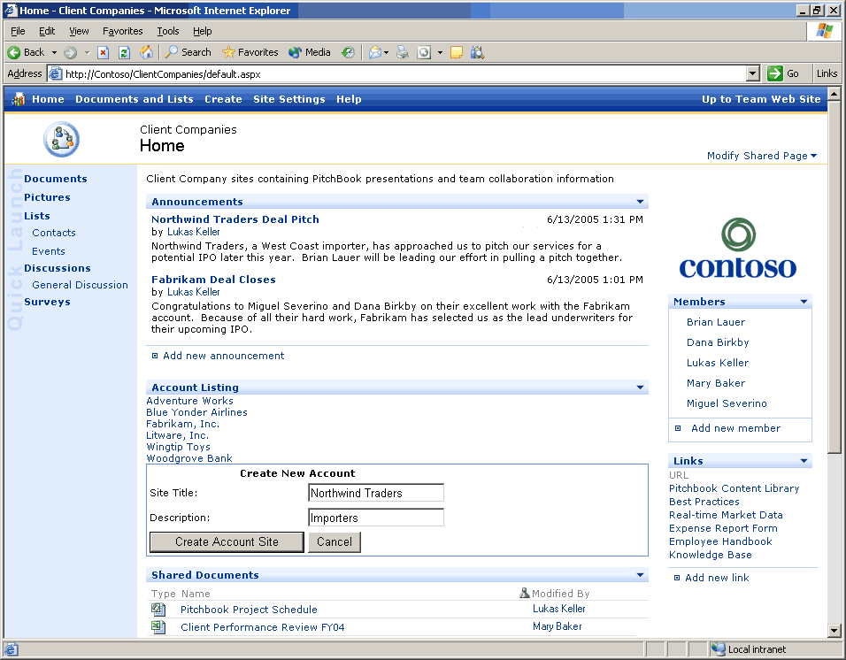
Figure 3.2
A custom Web Part automates the creation of a pitchbook account site from a site template.

Searching the Content Library
After the account site is created, users begin constructing a pitchbook by clicking a link on the site. The link opens an instance of PowerPoint that provides a custom toolbar used to interact with the pitchbook application. The new presentation is based on a template that resides in the Windows SharePoint Services content library, assuring that the template meets standards for branding and other corporate guidelines.
Once the pitchbook application is running, users can search for content stored in a content library. Based on search criteria entered or selected by a user, the solution retrieves slides from the library and displays thumbnail representations for evaluation. A user can edit a slide while using PowerPoint.
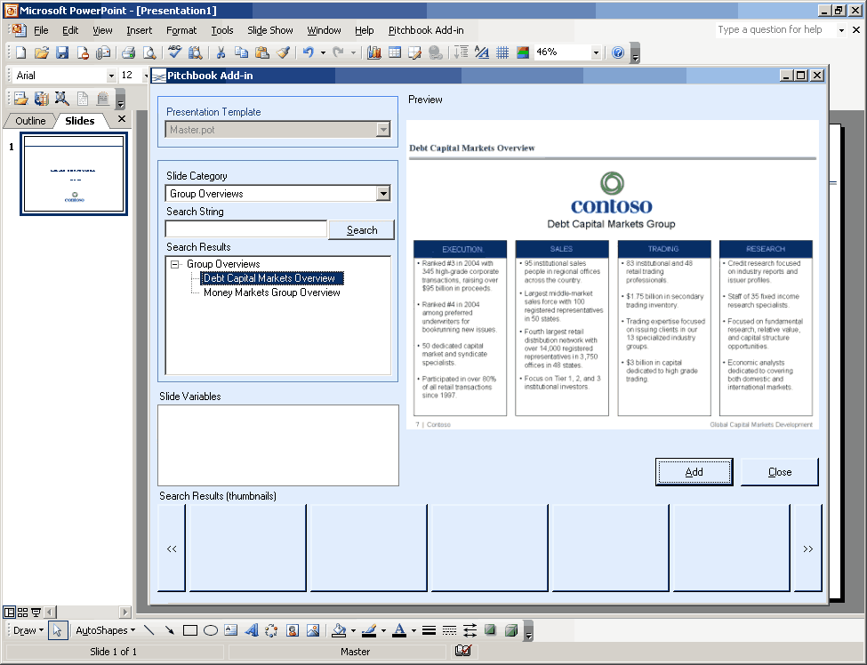
Figure 3.3
Deal teams can quickly and easily search and retrieve approved slides to add to the client pitch.
An organization that implements a pitchbook solution might have hundreds or thousands of files that need to be added to a content library. These documents need to be classified to return precise search results. For example, slides that are saved to a content library need to be named intuitively, tagged with metadata, and associated with a list of relevant keywords.
Many slides will be swapped in and out of different presentations. The formatting of these slides might need to be modified before they are added to the library so that they match the standards defined for company templates.

Adding Tombstone Slides to the Pitchbook
A tombstone slide highlights past success stories with other clients. The preparation of a tombstone slide can require a deal team to hunt around for logos and key bits of information. A pitchbook solution can automate the process of compiling a tombstone slide by storing information in the content library. A user needs only to enter data such as the company name and the amount of the deal and then select an applicable logo from the solution's logo library. The pitchbook application then builds a slide based on the information the team member enters.
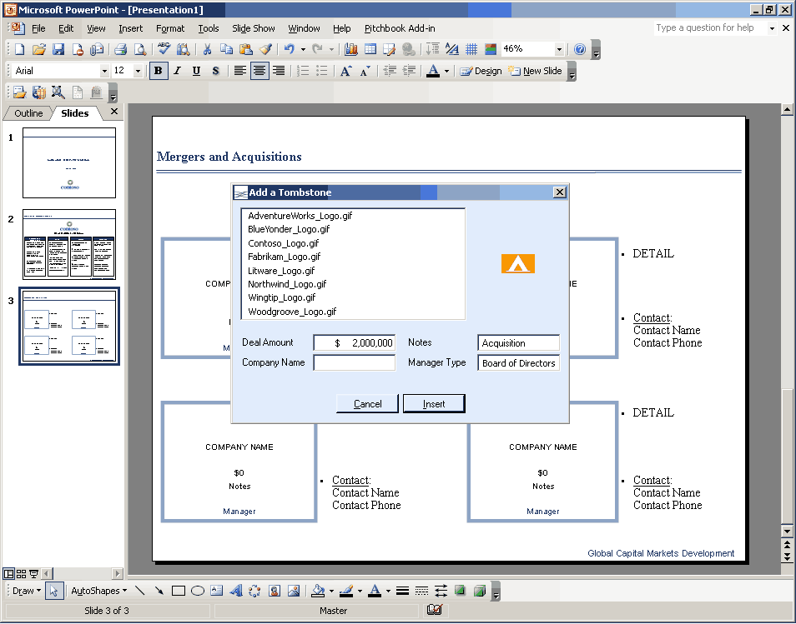
Figure 3.4
A pitchbook solution can automate the creation of tombstone slides, relieving the deal team of manual processes that consume time.

Saving Slides to the Content Library
Working in PowerPoint, a pitchbook team member can save a slide to the solution's content library so that it is available for future use. The solution produces keywords on the basis of information in the slide and associates the keywords with the content to facilitate retrieval of the slide when a user searches the library. A solution could implement a procedure by which a slide is routed for approval before it is saved to the library, an important step in maintaining the quality and status of the content in the library.
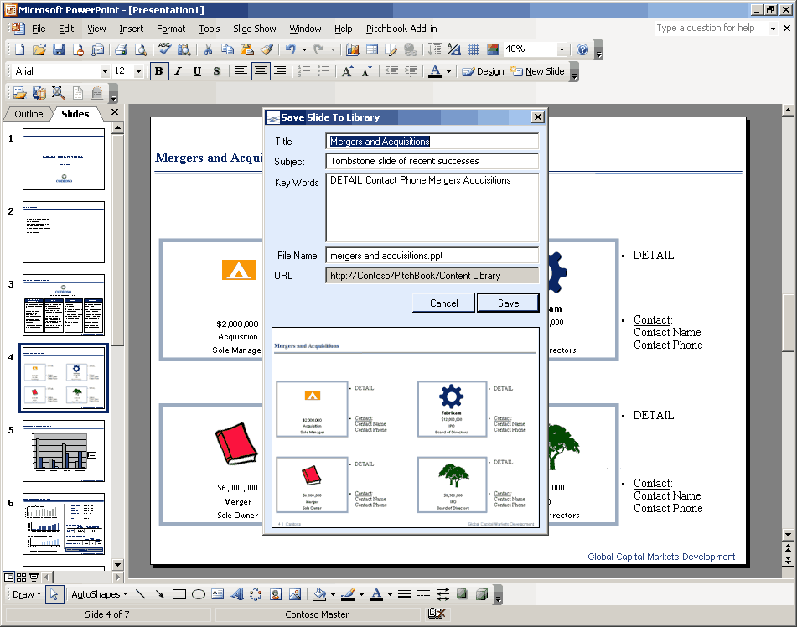
Figure 3.5
A pitchbook solution can automate the process of saving custom slides to the content library.

Modeling and Integrating Data in Excel
While working on a pitchbook in PowerPoint, a user can add a blank chart to the presentation and then use features of Excel to create the chart and to link to financial data sources, for example, so that information remains current. A pitchbook solution could implement a Web service that communicates with financial data services. A user need only enter a company's stock symbol to compile a comparative chart of recent results.
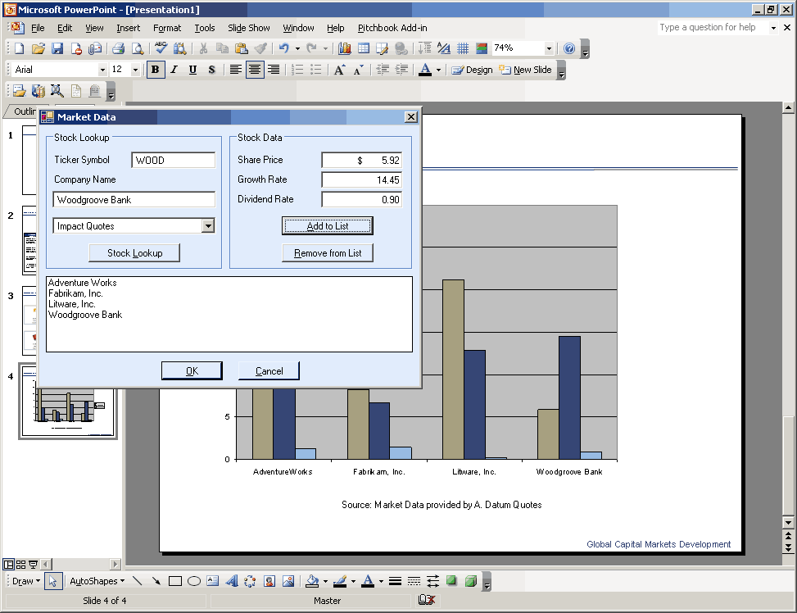

Figure 3.6
Web services integrated with Excel enable deal teams to create custom charts.

Assigning Global Variables for Frequently Used Values
Names of businesses that are cited in pitchbooks and the names of individuals who serve in executive roles can change with some regularity. Searching content libraries for each occurrence of a name that requires updating or correction is time-consuming, but the work must be performed to assure that the content of slides pulled for new pitchbooks is current.
The example of a pitchbook solution described in this section lets a user create a global variable for a role such as CEO and assign a value for that variable. The solution then fills in and updates the value when necessary to ensure consistency and avoid potentially embarrassing mistakes.
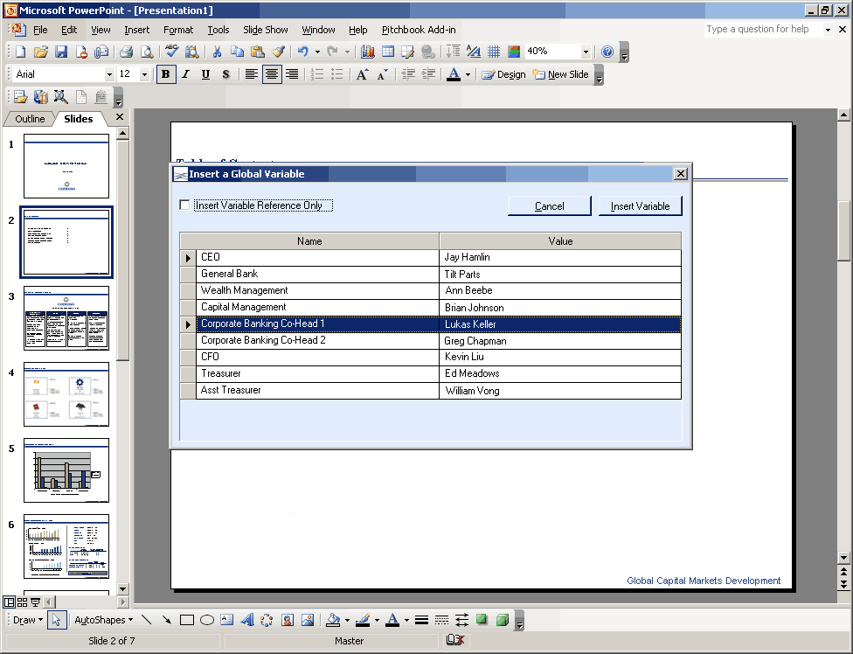
Figure 3.7
The names of executives and companies that are included on multiple slides can be stored and managed through the content library.
The solution example described in this chapter is one approach to using the Microsoft Office System as a platform for an investment banking pitchbook solution. A central SharePoint site provides content libraries and project information. A custom pitchbook application extends the capabilities of PowerPoint 2003 to facilitate the creation of a pitchbook and to help an organization standardize its presentations.

4 Infrastructure Considerations
This chapter identifies topics that an organization should consider with respect to its information technology infrastructure when evaluating the deployment of a pitchbook solution. These topics include which Microsoft software products can be used to build a solution, issues related to the scalability and operations of a solution, and security and digital rights management considerations.

Software Considerations
This section lists the Microsoft products and technologies that can be used to create an investment banking pitchbook solution using the Microsoft Office System.
For client computers, the following products can be used:
● Microsoft Windows XP Professional
http://www.microsoft.com/windowsxp/pro/evaluation/sysreqs.asp
● Microsoft Internet Explorer
http://www.microsoft.com/windows/ie/
● Microsoft Office Professional Enterprise Edition 2003
http://www.microsoft.com/office/prodinfo.mspx
● Microsoft Office PowerPoint 2003
http://www.microsoft.com/office/powerpoint/prodinfo/default.mspx
● Microsoft Office Excel 2003
http://www.microsoft.com/Office/Excel/prodinfo/default.mspx
For server computers, the following products can be used:
● Microsoft Windows Server 2003
http://www.microsoft.com/windowsserver2003/evaluation/sysreqs/default.mspx
● Internet Information Services (IIS) 6.0 with Microsoft ASP.NET
http://www.microsoft.com/windowsserver2003/iis/default.mspx
● Microsoft Windows SharePoint Services
http://www.microsoft.com/windowsserver2003/technologies/sharepoint/default.mspx
● Microsoft SharePoint Portal Server 2003
http://www.microsoft.com/office/sharepoint/prodinfo/default.mspx
● Microsoft SQL Server 2000 SP3a or later
http://www.microsoft.com/sql/
In addition, features of an investment banking pitchbook solution can be based on technologies such as the .NET Framework, the Information Bridge Framework, or smart documents:
● .NET Framework Developer Center
http://msdn.microsoft.com/netframework/programming/
● Office Developer Center: Information Bridge Framework
http://msdn.microsoft.com/office/understanding/ibframework/default.aspx
● Office Developer Center: Smart Tags and Smart Documents
http://msdn.microsoft.com/office/understanding/smarttags/default.aspx

Scalability and Operations Considerations
A Microsoft Office-based solution for investment banking pitchbooks can be implemented on various hardware configurations, whether a single server, two servers, or a large network of clustered servers such as a server farm. For example, a company hosting only a few pitchbook deal sites could run Windows SharePoint Services on a single server, using the same content database for all sites.
For deploying a solution, consider scalability issues such as the following:
● One server: Using a single server reduces the cost of ownership, but this configuration limits the amount of storage and is a factor in future scalability. This approach could be used by a business that wants to build a pilot solution for testing.
● Two servers: Using SQL Server on one server to store data and using a second server to host the investment banking pitchbook account sites provides more options for storage and is a configuration that can be scaled up to include other servers if they are needed in the future.
● Server farm: A server farm is suitable for companies that have a server farm already, those in which clustering is in use, and those that are planning to incorporate a server farm at the same time that they set up a solution. A company that needs the capacity of a server farm would most likely require several content databases in which to store site data for each virtual server.

Windows SharePoint Services Capacity Guidelines
Important issues to consider when evaluating an Office-based solution are the two kinds of capacity guidelines for Windows SharePoint Services: throughput limits and scale limits. This information should be taken into account in planning for hardware purchases and server configuration.

Throughput Limits
Throughput limits are the approximate number of transactions per second that a given server configuration can handle. Throughput limits help determine how many simultaneous users can use a given server resource without negatively affecting performance.

Scale Limits
Scale limits provide a guideline for the approximate number of objects that can be created in a given scope—for example, the number of documents per folder. This guideline helps you determine the server configuration required to host a given number of objects.
For more information about Windows SharePoint Services capacity, see the article “Capacity Planning for Windows SharePoint Services” at:
http://www.microsoft.com/technet/treeview/default.asp?url=/technet/prodtechnol/windowsserver2003/technologies/sharepoint/wssadmin/stsb07.asp

Integration with SharePoint Portal Server
An investment banking pitchbook solution that includes a site built on Windows SharePoint Services can be integrated with an enterprise portal application such as SharePoint Portal Server. SharePoint Portal Server makes available additional features, such as cross-site indexing, enhanced search capabilities, document classification, and others.
SharePoint Portal Server 2003 provides centralized access to multiple systems, including Office applications, business intelligence and project management systems, and line-of-business applications. The portal also features search technology that enables users to search file shares, Web servers, Microsoft Exchange Server public folders, Lotus Notes, and Windows SharePoint Services sites without customization.

Security Considerations
Security concerns for a pitchbook solution such as the example described in this guide are similar to other solutions that make use of a SharePoint site. A user of the solution who needs to save slides to the content library must have permission to contribute to the library. However, when a slide is saved, it is available to other users, which means that organizations might need to restrict permission to add files to the content library to individuals who have been trained in the organization's conventions. Content approval can be enabled for a library so that site administrators and those users who are granted permission to manage lists for the site can accept or reject items.

Digital Rights Management
An investment banking pitchbook often contains sensitive and confidential content. Solutions designed to facilitate the preparation of pitchbooks can make use of technologies that manage and control access to electronic information.
The Microsoft Windows Rights Management Services (RMS) software development kit (SDK) can be used to create applications that enforce terms of use for encrypted digital assets, regardless of the format or content. The RMS SDK provides rights management server functions that handle communication protocols, service discovery, content encryption, rights specification, license publishing, and license acquisition. The RMS client works with the RMS server to provide licenses for publishing and consuming digital content.
For more information about RMS, see "About Rights Management Services SDK," at:
http://msdn.microsoft.com/library/default.asp?url=/library/en-us/rms_sdk/rm/about_rights_management_services_sdk.asp
Access to sensitive financial information and other confidential content can also be restricted by Information Rights Management (IRM), a file-level protection technology that extends RMS to Office 2003 applications (as well as to Internet Explorer). IRM protects documents by enabling users to define how documents and e-mail messages can be accessed and used. After permissions are set, documents and messages travel with the permissions as part of the contents of the file.
In a pitchbook solution, IRM can enable an individual author to create a presentation with restricted permission so that only specific people can access the content. Permission can be restricted on the basis of individual users or by user groups. Group-based permissions require Active Directory.
For more information about IRM, see "Information Rights Management in Microsoft Office 2003" at:
http://www.microsoft.com/technet/prodtechnol/office/office2003/operate/of03irm.mspx
For information about IRM in PowerPoint 2003, see "What's New in Microsoft Office PowerPoint 2003 for Developers," at:
http://msdn.microsoft.com/library/default.asp?url=/library/en-us/odc_pp2003_ta/html/odc_ptwhatsnew2k3.asp

5 Next Steps
This chapter reviews steps that an organization can take if it decides to pursue the implementation of an investment banking pitchbook solution built with the Microsoft Office System. The chapter describes resources and skills required to develop, implement, and maintain a solution and information about Microsoft partners.

Resource and Skill Considerations
An organization that implements a pitchbook solution needs personnel in roles such as business analyst, content administrator, developer, and network administrator. A solution provider or partner might perform the work of some or all of these roles. The following sections highlight functions that are performed by a business analyst and other important roles.

Business Analyst
A business analyst should be familiar with how pitchbook presentations are built and with Microsoft Office PowerPoint. An analyst also needs to know how to work with the basic features of a SharePoint site.
● Functions: Analyzes business processes and defines the rules and behaviors required within the process. Helps determine how the deal sites will be structured. Creates prototypes of PowerPoint templates. Helps define user access requirements and site configuration.
● Skills: Knowledge of organization's pitchbook creation processes. General knowledge of business process analysis procedures.

Content Administrator
A content administrator is responsible for creating, approving, organizing, and maintaining a pitchbook solution's content libraries. An individual in this role must be familiar with how to administer SharePoint sites, have advanced knowledge of PowerPoint, and be familiar with an organization's standards and best practices for creating pitchbooks.
● Functions: Analyzes requirements for content libraries. Defines business rules for including content in a library and for site administration. Helps determine how the deal sites will be structured. Creates PowerPoint templates.
● Skills: Knowledge of organization's pitchbook creation processes. Expert knowledge of PowerPoint. Experience creating and administering SharePoint sites and document libraries.

Developer
A developer who works with an Office-based pitchbook solution should have experience programming with the object models for Office applications. A developer should also be experienced developing templates and site definitions for SharePoint sites and with developing applications with the Microsoft .NET Framework.
● Functions: Implements the business processes defined by the business analyst. Defines required XML schemas. Might design SQL Server databases for storage.
● Skills: Familiarity with Windows Server 2003, SQL Server 2000, the .NET Framework, and XML.

Network Administrator
A network administrator is responsible for setting up a SharePoint site, adding the site templates, managing permissions, and handling installations of the solution. The network administrator might need to troubleshoot issues related to connectivity to corporate networks and access to SharePoint sites.
● Functions: Sets up communication among the components specified by the developer. Deploys Internet Information Services and Windows SharePoint Services as required. Might create and maintain SQL Server databases.
● Skills: Familiarity with Windows Server 2003, SQL Server 2000, SharePoint Products and Technologies, and the .NET Framework.

Potential Partner Solutions
Microsoft industry partners can play an important role in developing a solution that helps a business improve its processes for creating investment banking pitchbooks. A partner can provide subject matter expertise and deployment support, customize a solution by adding Web Parts and other tools, enhance the workflow and security of a solution, and assist in automating the bulk import of content and documents.
You can find more information about partner solutions at:
http://directory.partners.extranet.microsoft.com/

Solution Showcase for the Microsoft Office System
The Solution Showcase for the Microsoft Office System highlights how leading organizations solve business problems using the Microsoft Office System. The Solution Showcase provides information about how Microsoft customers can obtain more value from their investments in the Microsoft Office System.
For more information about the Solution Showcase, see:
http://www.microsoft.com/office/showcase/default.mspx

6 Appendix
The sections that follow list a variety of resources about Microsoft software products. The resources include information about the Microsoft products that can be used to build an investment banking pitchbook solution and links to sites that provide product documentation, technical articles, and training resources.

Developer Resources
For information about products and technologies that can be used to develop an investment banking pitchbook solution, see the following Web sites and articles:
● Microsoft Office Developer Center
http://www.msdn.microsoft.com/office/
● SharePoint Products and Technologies Software Development Kit (SDK)
http://www.microsoft.com/downloads/details.aspx?familyid=AA3E7FE5-DAEE-4D10-980F-789B827967B0&displaylang=en
● Information Bridge Framework technical articles in the MSDN® Library
http://msdn.microsoft.com/library/default.asp?url=/library/en-us/odc_2003_ta/html/odc_landibf03_ta.asp
● Information Bridge Framework 1.0 Solution Development Guide
http://www.microsoft.com/technet/itsolutions/cits/iwp/ibf/soldev/moibf1_sdg_01.mspx
● What's New with Smart Tags in Office 2003
http://msdn.microsoft.com/library/default.asp?url=/library/en-us/dnofftalk/html/office01022003.asp
● What's New in Microsoft Office PowerPoint 2003 for Developers
http://msdn.microsoft.com/office/understanding/powerpoint/techarticles/default.aspx?pull=/library/en-us/odc_pp2003_ta/html/odc_ptwhatsnew2k3.asp
● Smart Tags and Smart Documents
http://msdn.microsoft.com/office/understanding/smarttags/default.aspx

Product Training
For information about product training, see the following Web sites:
● SQL Server Training
http://www.microsoft.com/sql/techinfo/training/
● Windows Server 2003 Training
http://www.microsoft.com/windowsserver2003/techinfo/training/default.mspx
● Windows SharePoint Services Administrator's Guide
http://www.microsoft.com/downloads/details.aspx?FamilyID=a637eff6-8224-4b19-a6a4-3e33fa13d230&displaylang=en

Security Information
For security information, see the following Web sites:
● SharePoint Products and Technologies Security Center: Product and technology guidance that will help you protect your platforms, networks, desktops, and data.
http://www.microsoft.com/technet/security/prodtech/sharept/default.mspx
● Windows SharePoint Services Administrator’s Guide: Guide for installing, configuring, managing, and maintaining Windows SharePoint Services.
http://www.microsoft.com/downloads/details.aspx?FamilyID=a637eff6-8224-4b19-a6a4-3e33fa13d230&DisplayLang=en
● MSDN Security Developer Center: In-depth technical content, community resources, downloads, product information, and more for developers interested in writing secure code and using security APIs.
http://msdn.microsoft.com/library/default.asp?url=/library/en-us/dnanchor/html/securityanchor.asp
● Microsoft Security: Comprehensive and up-to-date information on virus alerts, security bulletins, technical information, and events.
http://www.microsoft.com/security/
● Security Tools on TechNet: Tools to assess vulnerabilities and strengthen security.
http://www.microsoft.com/technet/treeview/default.asp?url=/technet/security/tools/default.asp
● Microsoft Baseline Security Analyzer V1.2: Scans for common incorrect configurations and missed updates.
http://www.microsoft.com/technet/security/tools/mbsahome.mspx
● Microsoft SQL Server 2000 SP3 Security Features and Best Practices: Guide to best practices.
http://www.microsoft.com/technet/prodtechnol/sql/2000/maintain/sp3sec00.mspx
● Windows Server 2003 Security Guide: Provides guidance, tools, and templates that help secure Windows Server 2003 in many environments.
http://www.microsoft.com/technet/security/prodtech/win2003/w2003hg/sgch00.mspx/

