Microsoft® PerformancePoint Services

Monitoring and Analytics: Bringing Business Intelligence to SharePoint

**Microsoft® PerformancePoint Services** **Monitoring and Analytics enables businesses to articulate goals, monitor business activity, identify and analyze issues, collaborate and take action. Now available as part of SharePoint, this will allow users from across the organization to have ready access to business intelligence.**

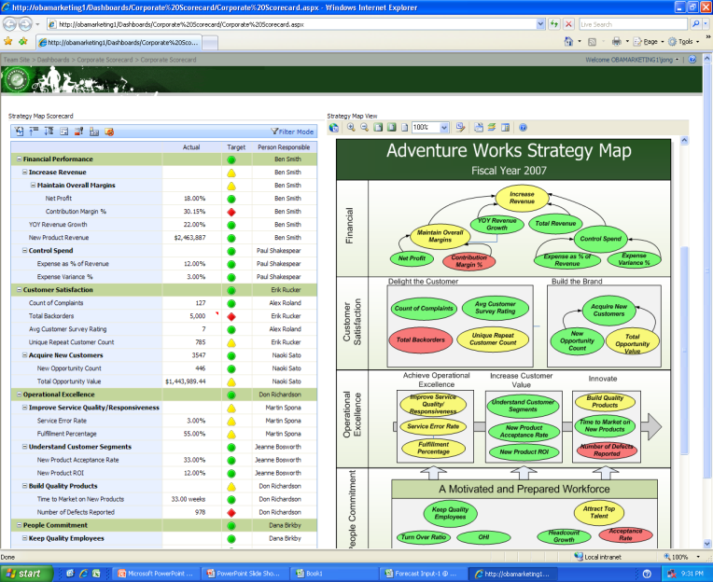

Easily customize the scorecard view by function or role.

Monitoring and Analytics with PerformancePoint Services

Monitoring and measuring performance results are key functions of any successful business. PerformancePoint Services enables business users to define and use scorecards and key performance indicators (KPIs) to drive accountability and alignment across the organization.

Rich visualization and up-to-date performance dashboards and scorecards help business users align their actions with strategic goals. Employees can create analytics that include graphs, key performance indicators (KPIs), and data grids, and use advanced visualization functionalities. These rich capabilities help users rapidly identify trends, opportunities, and even threats to the business hidden within large quantities of data.**Benefits**

PerformancePoint Services helps users:

* Align business activity across the enterprise  
  Businesses benefit when strategy and accountability can be driven across business operations. Finance, operations, HR, marketing, sales, IT, and other groups can all benefit from easy-to-use scorecarding.
* **Gain deep contextual insight**

PerformancePoint Services includes rich drill-down capabilities, personalized scorecards, reports, and analysis tools to combine structured information with unstructured data. Users gain deeper insight, which can help them make better and faster business decisions.

* Enhance the partnership with IT  
  IT staffs spend a lot of time providing business users with information. Because PerformancePoint Services gives business users the functionality to quickly set up their own performance dashboards and scorecards, IT is freed for more critical functions such as meeting security and compliance requirements.
* **Built on the Microsoft Business Intelligence platform**PerformancePoint Services takes advantage of the enterprise-level reliability and security, high performance, and scalability of the Microsoft SQL Server™ 2008 Business Intelligence platform. PerformancePoint Services also makes broad adoption possible by providing robust analytic insights through the familiar and easy-to-use Microsoft Office system environment.

Key Features

Powerful monitoring functionality in PerformancePoint Services includes:

Flexibility and personalization  
PerformancePoint Services empowers users by providing a flexible, end user focused development environment with extensive out-of-the-box functionality for defining and creating scorecards. This makes it easy to visualize strategy and drill down into reports to see lower levels of detail. The user-friendly design, wizards, and familiar Microsoft Office environment empower all users to quickly build, personalize, manage, and use scorecards, while focusing on the business, instead of on the tools.

* **Scalability for broad use**PerformancePoint Services scalability and high performance enable business information to be delivered to a broad number of users. Performance dashboards and scorecards are built to address all types of users, and can be published for both online and offline users.
* **Rich visualization**  
  Rich visualization capabilities including strategy maps, accountability mapping, and Microsoft Office system integration make business information more actionable. They enable users to better understand the context of performance and take appropriate action.

Web-based analysis  
Provide users with analytic functionality out of the box, minimizing help required from IT Staff. More secure access enables the right people to get the right amount of information at the right time.

Guided and contextual analysis   
Provide users with analytic views tied to key performance metrics to give users more contextual information about the performance of those metrics.

Distribution choices  
Analytical views can be shared and managed in SQL Server Report Manager, Microsoft Office SharePoint® Server 2007 Report Center, or distributed in PDF, HTML, or XML format. Users can collaboration with others through Microsoft Office Excel® and PowerPoint®.

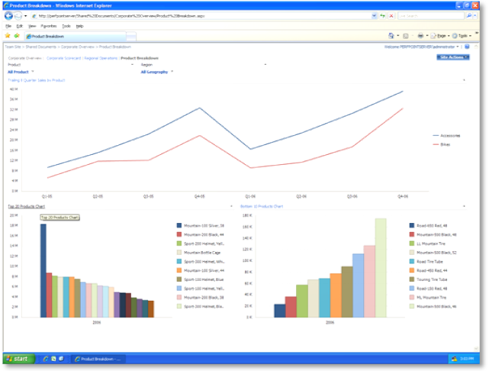

Answering the “why” of business change is easier with PerformancePoint Services.

System Requirements

|  |
| --- |
| PerformancePoint Services is based on the following Microsoft programs and technologies:   * Windows Server® 2003 SP1, Standard Edition, or later * Microsoft Windows SharePoint® Services 3.0/ Microsoft Office SharePoint® Server 2007 * Microsoft Windows® XP Professional SP2, or later * Microsoft Office 2003 SP2, or later * Microsoft SQL Server™ 2005 SP2, Standard Edition, or later * Windows Installer 3.1, or later * Microsoft .NET Framework 2.0 * Microsoft Internet Information Services 6.0 * ASP.NET 2.0 |

For More Information

For more information about Microsoft Office PerformancePoint Services, visit <www.microsoft.com/performancepoint>.

For more information about Microsoft Business Intelligence solutions, visit [www.microsoft.com/BI](http://www.microsoft.com/BI).