

Microsoft® Windows Mobile® 5.0
Reviewers Guide for Smartphones

January 2006

For more information, press only:
Mark Mohammadpour
Weber Shandwick
(503) 552-3734
mmohammadpour@webershandwick.com

Weber Shandwick
usmedteam@webershandwick.com
(425) 452-5400

The information contained in this document represents the current view of Microsoft Corp. on the issues discussed as of the date of publication. Because Microsoft must respond to changing market conditions, this document should not be interpreted to be a commitment on the part of Microsoft, and Microsoft cannot guarantee the accuracy of any information presented after the date of publication. This document is for informational purposes only. MICROSOFT MAKES NO WARRANTIES, EXPRESS OR IMPLIED, IN THIS DOCUMENT.

© 2006 Microsoft Corp. All rights reserved.

Connectivity and synchronization may require separately purchased equipment and/or wireless products (e.g., Wi-Fi card, network software, server hardware, and/or redirector software). Service plans are required for Internet, Wi-Fi and phone access. Features and performance may vary by service provider and are subject to network limitations. See device manufacturer, service provider and/or corporate IT department for details.

Microsoft, the Office logo, Windows Mobile, JScript, Outlook, MSN, Hotmail, ActiveSync, Windows, Windows Media, DirectShow, Direct3D, DirectDraw, Windows CE, Age of Empires and Midtown Madness are either registered trademarks or trademarks of Microsoft Corp. in the United States and/or other countries.
Bluetooth is a trademark owned by the Bluetooth SIG Inc. and any use of such marks by Microsoft Corp. is under license.
The names of actual companies and products mentioned herein may be the trademarks of their respective owners.

Contents
Introduction and Executive Summary 1
Windows Mobile 5.0 1
Full-Feature Chart 5
Getting Started 7
The Home Screen 7
Finding Your Applications 7
Entering Text 8
Additional Text Input Options 9
Inputting Symbols 10
Connecting With Your PC: Microsoft ActiveSync 4.1 10
A Full-Featured Telephone 19
In-Call Features 19
Personalization Options 20
The Quick List 21
Turning on Flight Mode 21
Getting Connected 22
Setting Up a Dial-Up Connection 22
Setting Up Wi-Fi (802.11) 23
Setting Up a Proxy 27
Setting Up a VPN Connection 28
Connecting via Bluetooth Technology 28
Connecting With Infrared (Beam) 29
Browsing the Web 31
Viewing a Web Page 31
The Internet Explorer Menu 31
Outlook Mobile 32
Using Outlook E-Mail 32
Using Outlook Mobile SMS 40
Using Outlook Mobile Calendar 40
Using Outlook Contacts 42
Using Outlook Tasks 45
Synchronizing Outlook Mobile Information 46
Pocket MSN 49
Using MSN Messenger 49
Using MSN Hotmail 51
Entertainment and Multimedia 52
Using Windows Media Player 10 Mobile 52
Playing Games 52
Pictures & Videos 52
Customizing Windows Mobile 5.0 52
Changing the Home Screen 52
Setting a Picture as a Background 52
Changing the Ring Tones on Your Device 52
Adding New Applications to Your Device 52
Removing Programs 52

Introduction and Executive Summary

Welcome to the Microsoft® Windows Mobile® 5.0 Reviewers Guide for Smartphones. This guide discusses the overall vision of this release and what is new since the last release in 2002, offers a full-feature chart, discusses the specific product capabilities and gives basic instructions on how to use the features.

Mobile devices are becoming more widely used. The growing adoption of mobile technology has been reflected in the sales forecasts for Windows Mobile-based devices — in 2008, IDC forecasts that 21 million Windows Mobile Smartphones will ship, an increase of 41 percent from the total forecast previously, due to improvements in platform stability and increased wireless operator uptake.

Just as mobile device usage has become more commonplace, users have become more sophisticated and are demanding more from their devices than before. People want products that help them be more productive while on the go, offer them quick, reliable Internet connectivity for messaging, e-mail and browsing, and give them richer multimedia experiences and the ability to personalize their devices to their liking. The demand for increased mobile capabilities is expected to continue: According to Gartner Inc., by 2008, more than 80 percent of mobile knowledge workers are expected to have access to wireless e-mail.

Windows Mobile 5.0
Windows Mobile is a powerful platform that has been developed to maximize what users can do with their mobile devices. It is continually updated based on extensive research on how mobile devices are actually used, and what people dream of being able to do.

This latest version, Windows Mobile 5.0, is the most significant release of the platform since 2002. Most previous releases contained enhancements that were “under the hood.” This time, in addition to powerful changes behind the scenes, many new features will be obvious to the end user. The overall design goal for this version is to make Windows Mobile easier to use and more intuitive. There are three key supporting design goals: enhancing productivity, providing an outstanding multimedia experience, and providing partners with more options for customization and differentiation. Following is a description of these goals and some of the new features developed in support of them.

Enhanced Productivity When You Are on the Go

Improved connectivity with Wi-Fi. Windows Mobile 5.0 was designed to make connecting to the Internet or work easier than ever, with great flexibility and support for many wireless networks. Depending on your hardware, you can connect wirelessly via Virtual Private Network (VPN), Bluetooth®, infrared technology and your mobile operator’s wireless data network. New in Windows Mobile 5.0 is support for Wi-Fi (802.11) wireless LAN. And now partners have the flexibility to add 3G radio stacks if they want.

Improved mobile Web browsing. Internet Explorer Mobile is a mobile version of the familiar browser for the desktop. It has been redesigned for an improved customer experience with greater flexibility in viewing Internet content.
- Internet Explorer Mobile now supports many more script elements, reducing script errors and allowing more pages to load correctly. The browser includes support for XHTML Basic, CSS, JScript® 5.5, WML 2.0 (XHTML + WML 1.x), Internet Protocol version 6 (IPv6), and Graphics Device Interface (GDI)+ Imaging.
- A new Download Progress Bar shows when the browser is connecting, when it has connected and how much of a Web page has been downloaded. A Resume Download feature continues an interrupted file download from the point of interruption rather than from the beginning of the file.
- Now it is easy to synchronize favorites from Internet Explorer on your desktop with your device for on-the-go access to your most frequently visited Web sites.

Microsoft Office Outlook® Mobile. Many resources were devoted to improvements in Outlook Mobile’s synchronization, user interface, Contacts, Calendar and Tasks. These enhancements represent Microsoft’s ongoing efforts to incorporate key customer feedback into the product, and to enhance the overall synchronization and look and feel with the desktop version of Outlook.
- Account support has been improved. Outlook Mobile supports up to eight accounts, so that in addition to a corporate account via a Microsoft Exchange server, you could have a POP or IMAP account via a public e-mail provider, an MSN® Hotmail® account, and others all coming into your mobile device inbox at once. It is easy to switch back and forth between accounts.
- The new look and feel is closer to the familiar desktop version of Outlook, with support for high- and low-priority e-mail indicators.
- A redesigned message layout with clear separation between header and body helps make the data “glanceable.”
- Actionable e-mail headers allow you to quickly add or open a contact’s information by selecting it. You also now have the ability to dial a contact directly from the e-mail message.
- E-mail attachments have been moved to the header in the top of the message to remove the need for you to scroll to the bottom of the message.
- A completely redesigned Outlook Mobile Contacts application offers an improved user experience. You can easily and quickly communicate with a person from the list and view a summary of Outlook Mobile Contacts with one finger.
- You now have the ability to add pictures to contacts both on the device and from a PC.

ActiveSync® 4.1 support. Microsoft ActiveSync acts as the gateway between your Windows®-based PC and Microsoft Outlook on your Windows Mobile-based phone. The ActiveSync software provides easy transfer of Outlook information as well as pictures, music, videos and applications from your desktop to your phone. In addition to synchronizing with a desktop PC, ActiveSync can synchronize directly with Microsoft Exchange Server 2003, so that you can keep all your e-mail, calendar, notes and contact information updated wirelessly when you are away from your desktop. It can also wirelessly sync with your PC via Bluetooth.

Faster access to e-mail. Windows Mobile 5.0 provides faster access to e-mail, with one-key access to Hotmail and MSN inboxes within Outlook. It also works well with MSN Messenger for instant messaging (IM) with colleagues and friends.

QWERTY keyboard integration. Enhanced QWERTY keyboard integration significantly improves the navigation experience.

Pocket MSN. Pocket MSN is a mobile data service optimized for Windows Mobile that delivers an always-on experience so that you remain available to other online users. It provides one-touch access to MSN Hotmail and MSN Messenger — some of the most used e-mail and IM services in the world — as well as easy access to Web pages designed for mobile users.
- Windows Mobile supports the ability to send and receive Hotmail attachments; the devices can interpret most sound, graphic and text files. Easily set up with a simple wizard, the Hotmail interface makes use of all the great new features of Outlook Mobile that let you easily compose messages offline and schedule sync sessions.
- MSN Messenger offers instant communications with co-workers, friends and family, and includes new features such as these:
- An upgraded contact list displays more contacts and additional information. MSN contacts lists can be shared between a desktop and a mobile device. There is also new support for blocking contacts, adding new contacts, etc. In addition, as soon as you log on from your phone, you have access to all your contacts and can send instant messages.
- An updated user interface more closely resembling the desktop client provides easy navigation.
- If you receive a phone call during an IM conversation, you will not lose your connection because MSN Messenger holds incoming IM messages on its server until you are off the call.

Enhanced security. Windows Mobile 5.0 is compliant with the FIPS 140-2 standard, the U.S. government security requirement for IT products.

A Superior Multimedia Experience

Windows Media® Player 10 Mobile. With Windows Media Player 10 on your Windows XP-based desktop PC, you can easily transfer music, video and picture files to your device.
- Full-Screen-mode video playback. Now you can watch TV shows and other video clips in a full-screen format to maximize the experience.
- All-in-one mobile media player. Enjoy your favorite music, videos and more with broad support for the most popular file formats including Windows Media Audio 9 (WMA) (which includes online music store content), MP3, and Windows Media Video (WMV). Windows Media Player 10 Mobile also adds support for Microsoft DirectShow® technologies, allowing mobile operators and others to add support for more media formats such as 3GPP. You can now access more than 1 million protected digital songs and videos from more than 25 content partners such as Napster LLC, CinemaNow Inc., AOL MusicNow, Movielink LLC, MSN Music and TiVo Inc.
- High-quality audio and video. The high quality of WMA makes for the ultimate listening experience. Windows Mobile 5.0 is now the first mobile device platform to offer audiophile quality with WMA 9 Lossless and WMA 9 Professional. What’s more, advancements in hardware technologies are making QVGA playback possible on QVGA-enhanced mobile devices.
- Refined player design. In addition to an all-new chrome skin, the media library has been improved to allow browsing by popular metadata tags including artist, album and genre. The newly added Queue It Up feature allows you to add music, video, television and entire playlists to the Now Playing list from anywhere in this enhanced media library.
- Album art support. Album art is added automatically by Windows Media Player 10 whenever it is available on the Windows XP-based PC.
- Photo Sync support. Carry your digital photo library with you on a Windows Mobile-based device. Using Photo Sync in Windows Media Player 10 on the desktop, you can easily transfer picture files to the Pictures & Videos album on your Windows Mobile-based device.
- Auto Sync. Windows Media Player 10 Mobile supports intelligent Auto Sync options for automatically transferring the media you want to your Windows Mobile-based device. You can select certain criteria for music, video and picture files to download automatically when the device is connected to the PC. And with Auto Sync, any new music you add to a playlist in Windows Media Player 10 will be seamlessly added to your device.
- Library view. This interface organizes various media on the device into a user-friendly format to help you more easily find your music, videos and playlists.
- Media Center TV sync support. With a Windows Media Center PC, you can synchronize recorded TV content to your Windows Mobile-based device for playback on the go.
- DRM support. Windows Media Player 10 Mobile supports Windows Media Digital Rights Management (DRM) 10 protection of digital media files. DRM support ensures that only music that has been downloaded legally can be played.
- Playlist support. Playlists created with Windows Media Player 10 on the desktop synchronize to Windows Mobile-based devices, delivering a familiar and easy-to-use music experience on your device.
- ActiveSync Wizard. The new ActiveSync Wizard allows you to easily find out how to synchronize music, video and pictures with your Windows Mobile-based device.
- Storage card support. If you have added a storage card, you will be prompted to see if you want Windows Media Player 10 Mobile to search for audio and video files to add to the library.
- Hard drive and USB 2.0 support. Windows Mobile 5.0 adds support for integrated hard drives, enabling you to carry several gigabytes of music or information right on your mobile device. It also provides added support for USB 2.0, which will greatly increase file transfer speeds and synchronization of information between PCs and Windows Mobile-based devices.

Pictures & Videos is a new application for viewing and sharing your pictures and video on Windows Mobile-based devices or stored on removable media. The program offers a one-stop shop to thumbnail views of picture and video files on the device, and also serves as an entry point to quickly access the Camera or Video Recorder application. The Pictures & Videos feature lets you easily view and edit photos with a thumbnail view, and includes options for rotation, brightness/contrast, zoom, crop, and transparency. You can also share your photos, create a slide show or set a picture as wallpaper. Digital camera support is provided, and DCIM directories are recognized.

Games. Windows Mobile 5.0 comes with two popular games: Solitaire and Bubble Breaker. You can visit Web sites where you can purchase and choose from 20,000 commercial applications — everything from games to travel tools and movie clips.

A Highly Customizable Device

For operators and device-makers. With Windows Mobile 5.0, Microsoft has provided many flexible options for operators and device-makers. Partners can add in their own 3G radio stack, and services such as voice over Internet protocol (VoIP). In addition, device-makers and mobile operators now have greater flexibility to customize branded device experiences and can take advantage of extensible menus and new soft keys to build new features, such as push-to-talk, right into the phone dialer.

For developers. Developers can take advantage of a host of new managed code and APIs in addition to a new ARM-based emulator, which enables them to build applications more quickly and add new functionality to applications. The new APIs include Camera Capture, which can integrate camera functionality with third-party applications; State and Notification Broker; Contact Picker; enhanced messaging and Pocket Outlook Object Model; and powerful new graphics APIs for Direct3D®, DirectDraw® and DirectShow.

For end users. There are dozens of ways you can customize the function and look of your Windows Mobile-based device. For instance, now you can take a picture from your phone and easily assign it to a contact for display in the Contacts application. It can also appear in the caller ID window or the e-mail message header when that contact calls or sends e-mail. You can assign a picture on a PC in Outlook and synchronize it over to your device. You can customize ring tones for callers, add applications and change numerous other features to your liking. There are also hundreds of applications available for download that can extend your device’s functionality, letting you do everything from play games to run news, stock and weather updates.

Full-Feature Chart
Feature | Explanation
Applications
Microsoft Office programs for Windows Mobile 5.0 | New and more advanced mobile version of Outlook lets you send e-mail on the go.
Pocket MSN  MSN Messenger  MSN Hotmail | One-touch access to MSN Hotmail and MSN Messenger keeps you connected to your  e-mail, friends and colleagues.
Windows Media Player 10 Mobile  Support for WMA, WMV and MP3 files  Support for Windows Media DRM 10 encrypted files  * Support for pluggable third-party DRM and CODECs  New integrated picture application  Smart lookup technology | Play videos, watch TV shows recorded on your Windows XP Media Center Edition PC and listen to your music on your device. Windows Media Player 10 supports copy-protected files from sites such as MSN Music and Napster and allows for easy navigating of your media library.
Internet Explorer Mobile  Support for HTML, XHTML, CSS, JScript 5.5, WML 2.0, IPv6 and GDI+ Imaging  Default, Desktop, Full-Screen and One-Column viewing modes  New Download Progress Bar | Browse full HTML sites from your device. Take advantage of several viewing modes including Default, Desktop and One-Column, which render all the text on a page into one easily readable column to reduce necessary scrolling. In addition, there is a new progress bar and the ability to save images.
ActiveSync 4.1 | ActiveSync 4.1 provides a variety of advancements including task synchronization, improved error-handling, data compression, and synchronization of your pictures between Outlook Mobile and Outlook on the desktop, and it works well with Windows Media Player.
Connectivity
* Integrated support for Wi-Fi  Zero Configuration setup | Windows Mobile 5.0 software includes Zero Configuration for Wi-Fi, designed to simplify connection with and authentication to 802.11 wireless networks. Zero Configuration is also supported when adding a dial-up modem or Ethernet network card.
Integrated support for Bluetooth  * Support for Bluetooth 2.0  Stereo, Handsfree and Headset profiles.  Bluetooth Wizard | Connect to a variety of Bluetooth devices such as laptops, printers and wireless headsets. Certain devices will support Bluetooth 2.0, a decision made by the device-maker, which will allow for blazingly fast file transfers over Bluetooth.
IR and Bluetooth file transfer | Send files, contacts cards and more with other devices over both Bluetooth and Infrared.
IPSec/L2TP with multiple VPN support | Windows Mobile provides the support for Internet Protocol Security/Layer 2 Tunneling Protocol (IPSec/L2TP), the Microsoft VPN standard for connectivity. Multiple VPNs are supported.
Phone Features
Speakerphone | Set down your device and enjoy Handsfree calls with the integrated speakerphone feature.
Short Message Service (SMS) | Send text messages to friends and co-workers.
Multimedia Message Service (MMS) | Send pictures and video clips to friends’ devices.
Security
FIPS 140-2 Compliant | Windows Mobile 5.0, based on Windows CE 5.0, meets the FIPS-140-2 U.S. government security requirement for IT products.
Wired Equivalent Privacy (WEP) and Wi-Fi Protected Access (WPA) support. | Connect to security-enhanced wireless networks that use WEP and WPA authentication.
Remote API restricted mode support (RAPI) | This enables device-makers to develop devices that will play only RAPI applications.
128-bit encryption strength for Crypto API | This enables independent software vendors and corporate developers to develop additional security for the Windows Mobile platform.
Additional Features
* Support for integrated hard drives | Devices that Windows Mobile partners have built with included hard drives allow for multiple gigabytes of e-mail, multimedia or any data to come with you on your Windows Mobile-based device.
Support for QWERTY keyboards | With the integration of soft keys and support for landscape orientation and QWERTY keyboards, device-makers can create devices with one-handed keyboard navigation so customers can access info without a stylus.
Persistent storage | To help ensure you don’t lose any data on your devices running Windows Mobile 5.0, we’ve included a persistent store feature — even if your battery dies the device stores all your files, applications, settings and device data.
* 3G network support | Windows Mobile 5.0 adds support for 3G networks such as UMTS, and allows for simultaneous use of voice and data.
Multiple e-mail account support | Windows Mobile 5.0 supports up to eight IMAP and POP3 e-mail accounts so you can keep connected to all your e-mail right from one device.
Games: Bubble Breaker and Solitaire | Two classic games allow you to pass time and have fun.

Bold features are new to Windows Mobile 5.0.
* Features may vary depending on the device-maker or operator offering the device.

Getting Started

This section will introduce you to a few of the most useful features in Windows Mobile 5.0.
Before turning on your device, take a moment to become familiar with the keypad. Windows Mobile software for Smartphones does not have a touch-screen interface. All its commands and functions are accessible by hardware controls. Smartphone software is designed for one-handed operation, whereas touch-screen devices require the use of both hands.

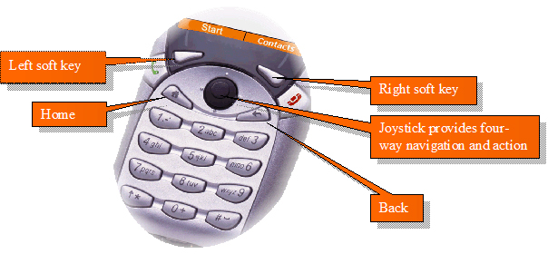

- Left and right soft keys. Located directly below the screen, these keys are used for different functions depending on the context. They perform whatever function is shown above them on the screen.
- Action key. In the center of the navigation pad, the Action key, also referred to as the joystick, allows you to scroll up, down, left or right around the screen. Pressing straight down on it takes action on the selected item.
- Home. This dedicated button always takes you back to the Home Screen.
- Back. This key does the following, depending on the context:
- Takes you back through previous application windows
- Closes the displayed menu
- Clears the text if an edit window is open
- Send and End keys. These keys are on either side of the navigation pad. Send is used to dial a selected number and answer incoming calls. End is used to disconnect.

The Home Screen
When you power up your device, first you will see the Home Screen. It shows icons of the most popular applications you are likely to use. It also displays your current calendar items, tasks and a count of your messages.

Finding Your Applications
Push the left soft key, under the word Start. Your applications will be displayed. (Select More to see ones that did not fit on the screen.) Notice that the Messaging application in the middle is selected. To change the selected application, use the Action key.

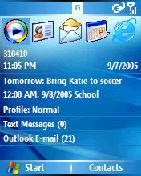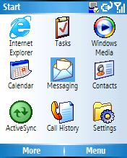

Entering Text
Your Windows Mobile-based device has a standard numerical keypad. Notice that there are also letters next to each number that you will use when inputting text. For example, select the Contacts application. You should see a list of your contacts, if you have any. Select New.

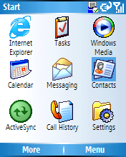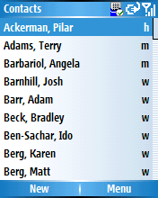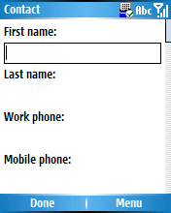

Let’s say you want to enter a contact named “Judy.” To enter the name “Judy,” quickly push the 5 button once, then the 8 button two times, then the 3 button once, and then the 9 button three times. If you make a mistake, press the Back button.

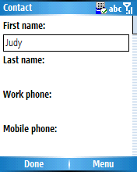

Additional Text Input Options
There are additional input modes that can speed up the process of entering text. Notice the “abc” in the upper-right-hand corner of the screen. That is the current “triple tap” text input mode. You can toggle between modes by pressing the *T9 key on the bottom-left-hand corner of your device. You will see the mode change reflected in the upper-right-hand corner. These are the available text input modes:
- abc. Triple tap — small case (default)
- Abc. Triple tap — sentence case — the first word will be capitalized
- ABC. Triple tap — all capital letters
- t9. Predictive text input — small case
- T9. Predictive text input — sentence case
- T9. Predictive text input — all capital letters
- 123. Number mode
With predictive text mode, you will get a drop-down menu that allows you to select the letter you want. For example, input the name “Judy.” First, toggle to predictive text input mode — sentence case by pressing the *T9 key once. Then press 5. You will see a drop-down menu. Select the letter J. Then press 8. You will see the drop-down menu again. Select the letter u and so on.

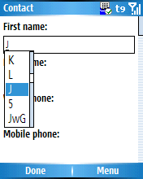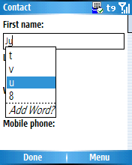

With predictive text input, the software attempts to guess the letter and the word as you are spelling it, and offers the guesses as choices on the drop-down list. It “learns” as it goes along and adds the words and names that you input.

You can also add words or names to your device’s dictionary directly. Let’s say you want to add the name “Bryan.” Use the back arrow to erase any letters you have input so far, then press 2. You will see another drop-down list. Notice the choice for Add Word? at the bottom of the list. Select that. Now you can add a word or name. Notice that the text mode indicator in the upper-right-hand corner has changed back to abc.

From now on, whenever you try to input a letter B by pressing 2, you will be offered the choice “Bryan” on the drop-down menu.

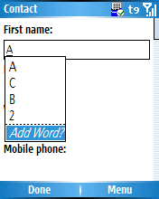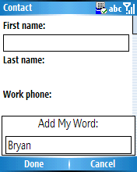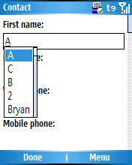

Inputting Symbols
There are a few ways to input symbols. First, you can simply press and hold the # key. A symbol menu will come up.

Otherwise, if you are in predictive text mode, you can press the 1 key. A scrollable drop-down menu with symbols will appear.

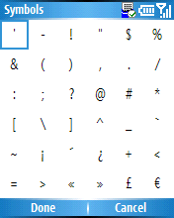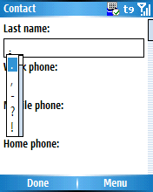

Note: To make a space, press the pound key once. To enter a return, press the Action key.

Connecting With Your PC: Microsoft ActiveSync 4.1
Microsoft ActiveSync 4.1 provides simple synchronization between your desktop and your device.

Please download ActiveSync 4.1 from http://www.microsoft.com/windowsmobile/downloads/activesync41.mspx.

Key capabilities of ActiveSync include the following:
- A Setup Wizard helps you quickly and easily set up your device to synchronize with a PC and/or a server. This helps ensure a more reliable install, upgrade and uninstall experience. In addition, IT managers can deploy desktop ActiveSync as they do all other MSI applications.
- You can easily connect to your PC via Bluetooth technology, so that when the device comes in range of the PC, ActiveSync can automatically initiate synchronization similar to when the device is cradled.
- You can take advantage of the capability for media synchronization in Windows Media Player 10 and ActiveSync.
- Desktop “documents” folder gives you an easy glimpse into the information on your Windows Mobile-based device. In addition, you can drag and drop files to this folder; they are synchronized to your device when it is cradled.

To use ActiveSync, connect your Windows Mobile-based device to your desktop PC via a USB cable or cradle. A new ActiveSync 4.1 Wizard should appear on your desktop to give you step-by-step instructions for synchronizing files and loading applications onto your device.

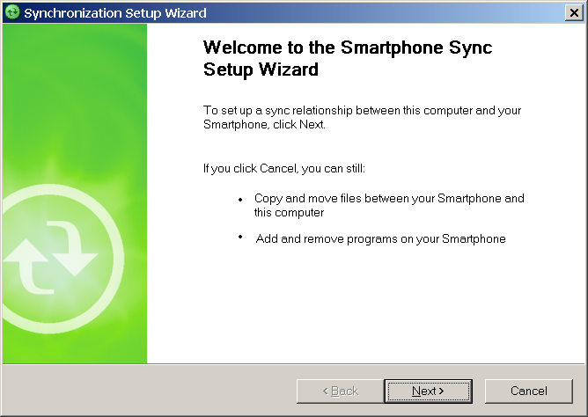

The next step asks you to give your device a distinguishable name.

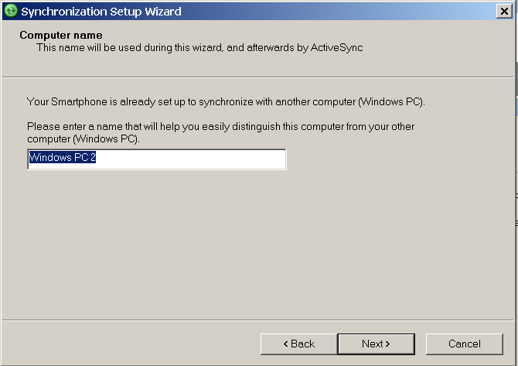

The next step asks if you want to synchronize with a server, and asks for your server address and login credentials available for the next step (from your IT administrator).

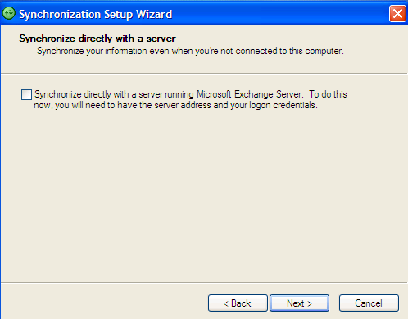

The third step has a spot for server address, user name, password and domain.

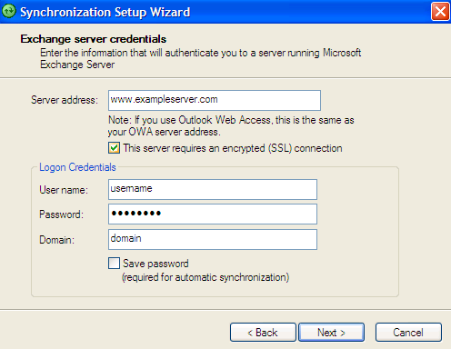

Once you have entered your server settings, ActiveSync will verify and download additional server settings.

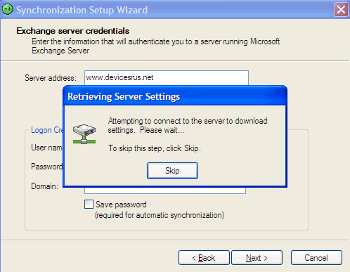

The next step allows you to select the type of data you want to synchronize. This ensures that all your favorite content on your desktop PC is transferred to your device. Check and select for your Contacts, Calendar, E-mail, Tasks, Internet Explorer favorites, Media and Appointments. Based on your device use, you can select whether you want that data synchronized from the server wirelessly or via a USB cable to the PC.

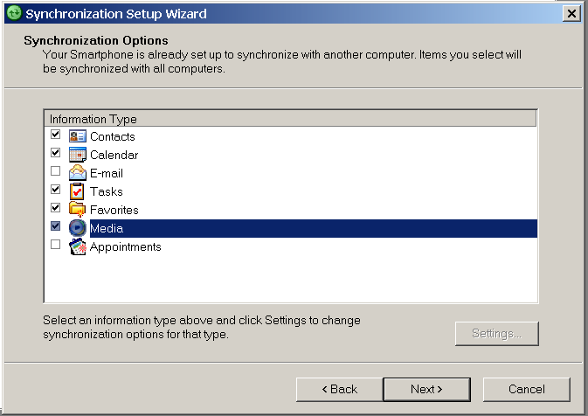

When you are done, you should see the final screen. Select Finish.

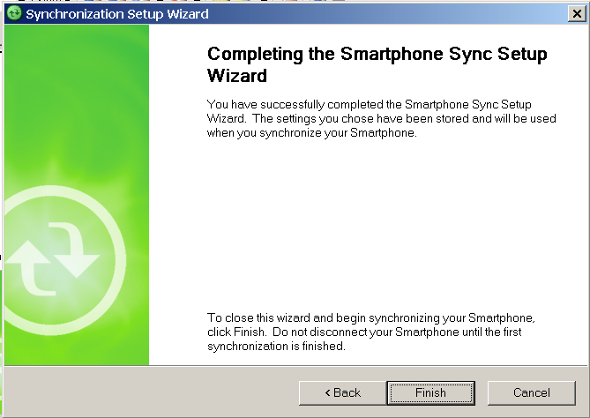

Your desktop and device should begin synchronizing.

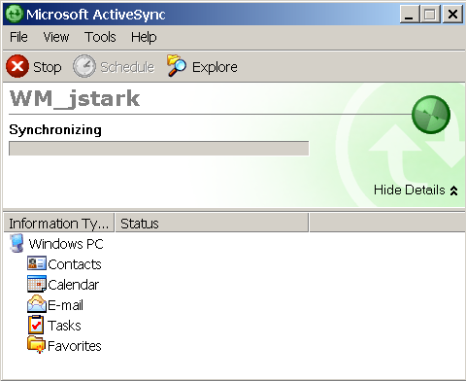

Changing Synchronization Options

You can go back and change your synchronization settings at any time by opening the ActiveSync application on your desktop and selecting Tools > Options.

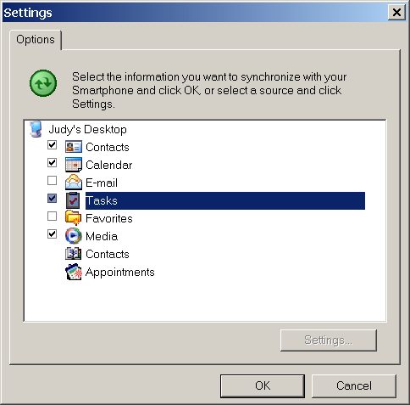

Managing Synchronization Conflicts

You can control how the synchronization handles conflicts between your desktop and Smartphone by opening the ActiveSync application on your desktop and selecting Tools > Options. Then, select your desktop and select Settings.

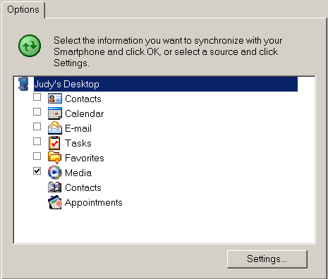

Next to If there is a conflict, select either Replace Item on Device or Replace Item on Desktop.

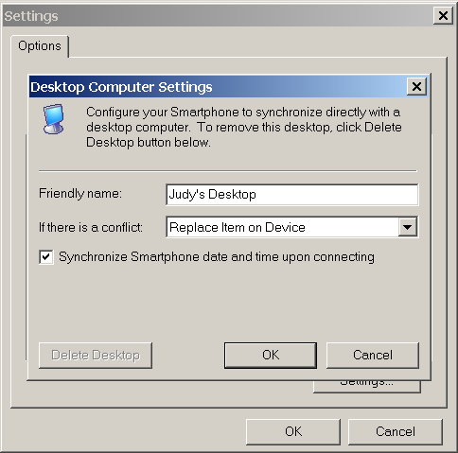

Deleting a Smartphone’s Synchronization Relationship

To delete the relationship of a particular Smartphone with a desktop, disconnect the device from the desktop. Then, open the ActiveSync application on your desktop and select File > Delete Mobile Device.

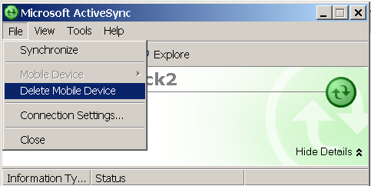

Copying Files From Your Desktop to Your Device

You can drag and drop files from your PC to your phone. First, from your desktop, open up the files on your device. From the Microsoft ActiveSync application, click on Tools > Explore Smartphone. Notice that you have three folders: My Windows Mobile-Based Device, My Pictures and Notes.
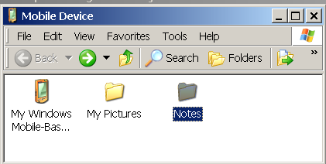
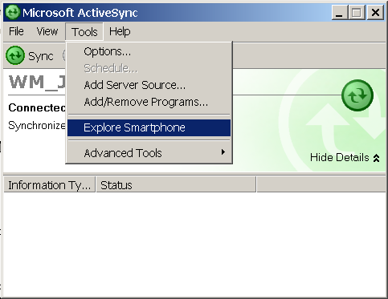
Click on My Windows Mobile-Based Device. You will see a complete list of folders and files.

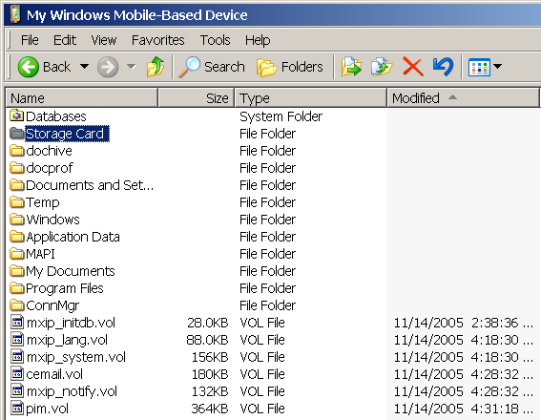

If you have a Storage Card, you will be able to click there and see the files contained in it.

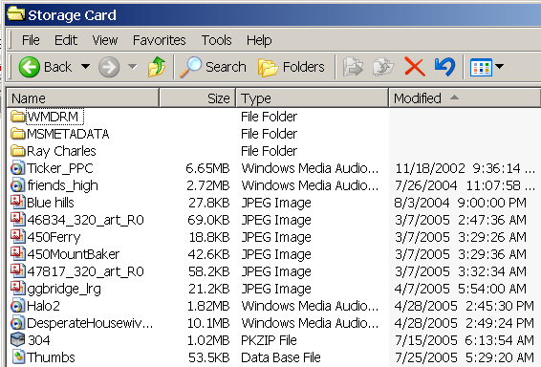

Alternatively, you could view files on your mobile device by viewing them directly with Windows Explorer. Right-click on either My Computer or Start. Click on Explore. Under My Computer, click on Mobile Device.

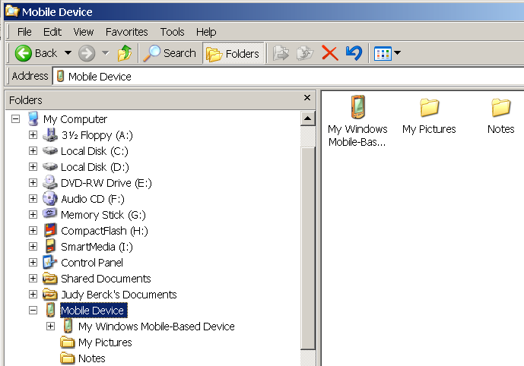

Now open up a window showing files from your desktop. Right-click on either My Computer or Start. Click on Explore. Browse to the file you want to copy. Either copy and paste, or drag and drop the file into a folder on your device.

Note: Although you can copy virtually any kind of file to your device (as long as you have room for it), you cannot view all types. For example, you could copy a Microsoft Word document to your device, but you would not be able to view it. You would, however, be able to copy it back to a desktop.
A Full-Featured Telephone

There are several ways to make a phone call with your device.

- Keypad dial. From the Home Screen, you can simply dial a number using the keypad. Press the Send button on the left side of the keypad. (Notice how easy this is to do with one hand.) You can also call by pressing Menu > Call.
After you have stored contacts into your phone, you will notice that as you dial a new phone number from the Home Screen, contact names appear below the number. This Smartdial feature makes it even faster to call someone in your Contacts list.
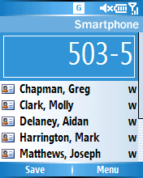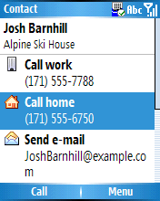
- Dial from Contacts. You can initiate a call by simply selecting the phone number of the person you want to call from the Contacts application. Instead of scrolling through the Contacts list, you can simply enter the first few letters of a name to locate the person you want to call.
- Dial by Call History. Your Smartphone stores information about all voice calls made to and from the device in the call history. You can access the call history from the Home Screen by pressing the green Send button on the left of your device. From there, you can select a recently dialed number.
- Dial from E-mail. If you receive e-mail from someone that is already listed in your Contacts list and you want to call them, you can select or highlight their name in the message’s header and then press the Call button.

In-Call Features
While in a call, you can conference in friends or colleagues, place a call on hold, or mute the call by simply pressing Menu. You can also add a number to Contacts, or even bring up your Calendar entries for the day.
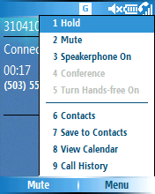
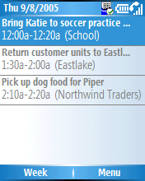

Personalization Options

With a Windows Mobile-based Smartphone, you can personalize your device’s sounds, ring tones and volumes, color schemes, images, Web favorites, and much more. You can also turn on Flight Mode.

From the Home Screen, select Start > Settings. You can either navigate to your choice or simply press the number.

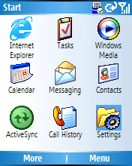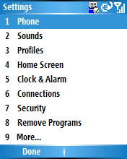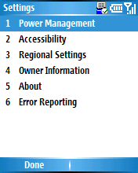
- Phone. These options let you take advantage of telephone services including call barring, call forwarding, call waiting, caller ID and other related features.
- Sounds. In addition to nearly 30 built-in sounds, users can personalize their Windows Mobile-based Smartphone with their own WMA and WAV files. In addition to setting ring tones, users can select different sounds for reminders, new-message notifications and alarms.
- Profiles. Windows Mobile software supports eight profiles for specific situations, such as being in a meeting, in a car or outdoors. You can easily toggle between several profiles, including the following, as your environment changes:
  - Normal
  - Silent — vibrate mode
  - Meeting — all sounds muted
  - Outdoor — ring tones changed to high volume
  - Automatic — based on information in your calendar, Windows Mobile software will automatically mute your phone during meetings and then turn the sounds back on when you are available
  - Headset
  - Car
  - Speaker phone — higher volume activated for use in conference calls or in the car
  - Home Screen. You can adjust your Home Screen’s layout, color scheme, background image and time out number of minutes.
  - Clock & Alarm. You can set the date and time as well as set an alarm. You set the alarm tone in Sounds, above.
  - Connections. See section below.
  - Security. These settings help you control access to your device, and set and change passwords.

The Quick List
You can quickly access your profiles and other options by displaying your Quick List. To display the Quick List, press the power key once, quickly.

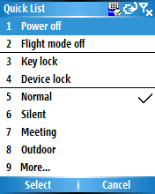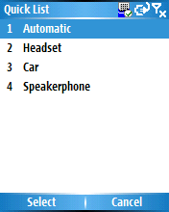

Turning on Flight Mode
In Flight Mode, your phone’s wireless connections are disabled, but you can still read e-mail, listen to music or play games. From your Quick List, select Flight Mode.

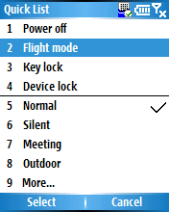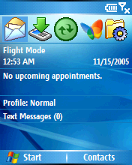

Getting Connected

If your service provider supports it, you may be able to automatically connect to the Internet just by turning on your phone. Windows Mobile software supports seven connection types: Beam (Infrared), Bluetooth, Dial-up, GPRS, Proxy, VPN and Wi-Fi.
Here are some of the connection options available. The actual options available to you will depend on which kinds of connections your device supports.

To access your connections, select Start > Settings > Connections.

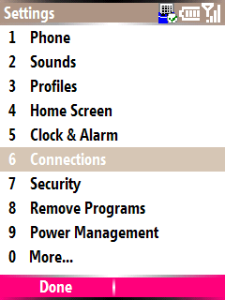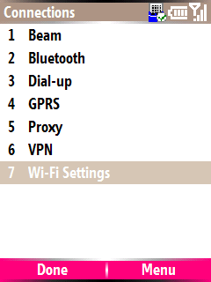

Setting Up a Dial-Up Connection
Imagine you are away from your desktop and you need to configure a dial-up connection to the home office. Select Start >Settings >Connections > Dial-up. Select Menu > Add.

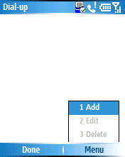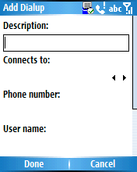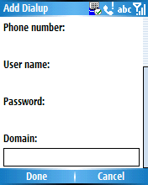

Give the connection a meaningful description. Choose where it connects to from the drop-down list. Enter a phone number, user name, password and domain information (if provided by your ISP or network administrator). Select Done when finished.

Enter a User Name and Password and Domain. Under the Advanced option, leave the default options for each tab (General, Port Settings, TCP/IP and Servers), and then select Finish.

Setting Up Wi-Fi (802.11)
Some phones now have Wi-Fi capabilities, a new feature enabled by Windows Mobile 5.0. Windows Mobile 5.0 software includes integrated zero-configuration support for Wi-Fi. This means that if your device is Wi-Fi capable, it will automatically sense a Wi-Fi network when it comes in range of one. It will prompt you with a simple notification message saying that a wireless network is available, and request a WEP key if one is required.

You can choose to connect or not; your choice is stored in Connection Manager until it is manually changed. If you chose to connect, the next time the device is within range of the same Wi-Fi network, Windows Mobile software will automatically connect you without alerting or distracting you. You do, however, need to turn on Wi-Fi so that your device knows to search for Wi-Fi networks.

Turning on Wi-Fi

If your device supports Wi-Fi, you can turn it on from your Quick List. Press the power key once, quickly. Select Turn on Wi-Fi.

You can also turn on Wi-Fi by selecting Start > Settings > Connections > Wi-Fi Settings > Wi-Fi and then selecting Menu > Turn on Wi-Fi.

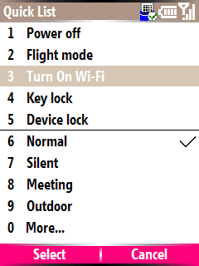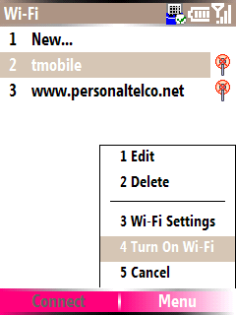

Once Wi-Fi is turned on, your device will automatically detect available networks and notify you when it finds one. When your device is connected to a Wi-Fi network, you will see an icon at the top of the screen of a tower with a circle around it.

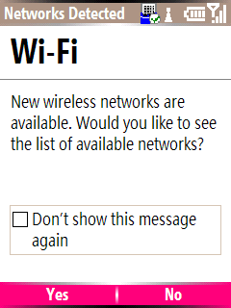

Viewing the Available Networks

You can see which Wi-Fi networks are available for you to use by selecting Start > Settings > Connections > Wi-Fi Settings > Wi Fi.

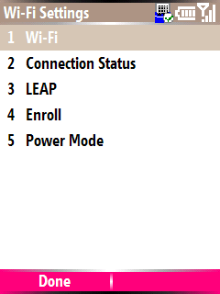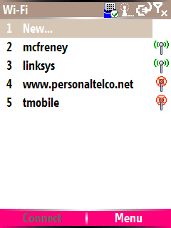

You can see the status of your current Wi-Fi network connection by selecting Start > Settings > Connections > Wi-Fi Settings > Connection Status. Scroll down to see the Signal Strength indicator at the bottom.

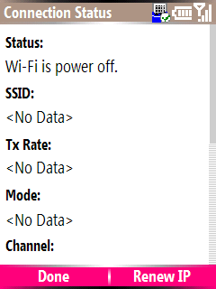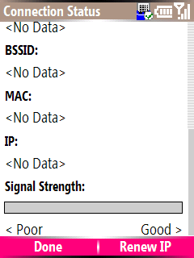

Editing a Wi-Fi Connection’s Security Settings

Some Wi-Fi networks have additional security protections for authentication and data encryption and may require entering a key. To edit security settings for a Wi-Fi network, select Start > Settings > Connections > Wi-Fi Settings > Wi-Fi. Select a network. Select Menu. From the menu, select Network Key.

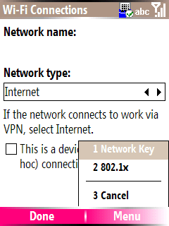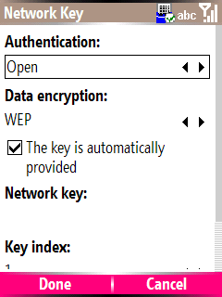

Under the Authentication pull-down menu, you can select Open, Shared, WPA or WPA - PSK. Under the Data Encryption pull-down menu, you can select WEP, TKIP or Disabled. If you have a network key to enter, uncheck the box marked The key is automatically provided. Enter the key next to Network key.

Setting Up a New Wi-Fi Connection
If you want to manually enter a network’s settings rather than let Windows Mobile 5.0 automatically detect the network, select Start > Settings > Connections > Wi-Fi Settings > Wi Fi. Select New. Enter the settings. If you need to enter security settings, select Menu.

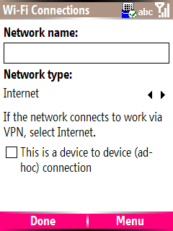

Network Notification Options

You can change the network notification options by selecting Start > Settings > Connections > Wi-Fi Settings > Wi Fi. Select Menu > Wi-Fi Settings.

  - The options for Networks to access are All available, Only device-to-device and Only access points.
  - The options for Available network notification are On or Off.

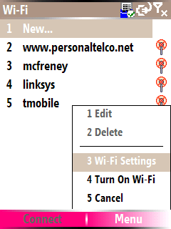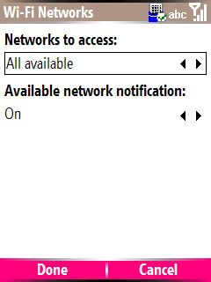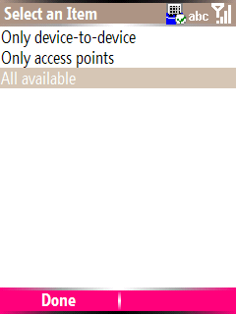

Using Lightweight Extensible Authentication Protocol (LEAP)

Microsoft Window Mobile 5.0 supports LEAP, a form of authentication that is proprietary to Cisco Systems Inc. To use it, select Start > Settings > Connections > Wi-Fi Settings > LEAP.

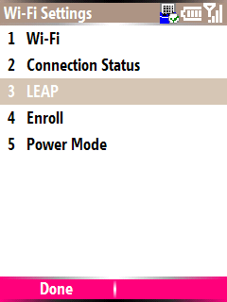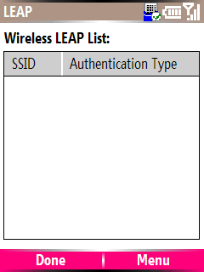

To create a new LEAP connection, select Menu > New. Enter the settings. Select Done.

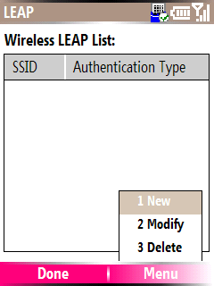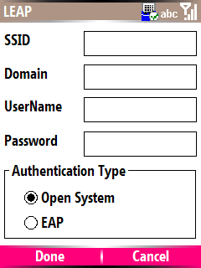

Certificate Enrollment

Windows Mobile 5.0 supports certificate enrollment, enabling access to networks that support PEAP and TLS. To use it, select Start > Settings > Connections > Wi-Fi Settings > Enroll. Enter the Server name, Username and Password (if required).

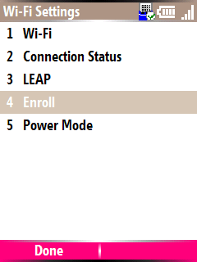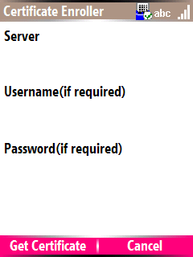

Changing Power Settings

You can edit the power settings for Wi-Fi connections. Select Start > Settings > Connections > Wi-Fi Settings > Power Mode.

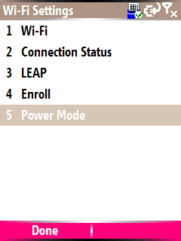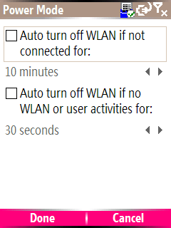

Setting Up a Proxy
To set Proxy Settings, select Start > Settings > Connections > Proxy. Select Menu > Add. Enter a description, where the proxy connects from, where it connects to, and the proxy name in the form name:port.

Then, use your Active key to scroll down to the next set of options. Enter the proxy type (HTTP, WAP, SOCKS4 or SOCKS5), your User name, and Password. Select Done when finished.

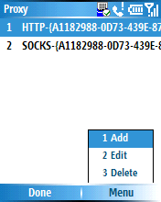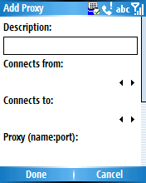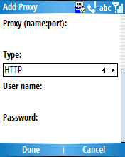

Setting Up a VPN Connection
To set up a VPN connection, select Start > Settings > Connections > VPN. Select Menu > Add. Enter a description, the VPN type (either IPSEC/L2TP or PPTP), the server address, and where it connects from (Work, The Internet, WAP Network or Secure WAP Network).

Then, use your Active key to scroll down to the next set of options. Enter where the VPN connection connects to, and your User name, Password and domain information. Indicate the IPSec authentication type (Certificate or Pre-Shared Key) and enter the IPSec Pre-Shared Key if there is one. Select Done.

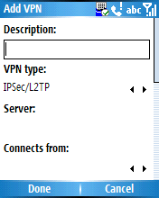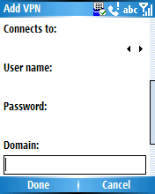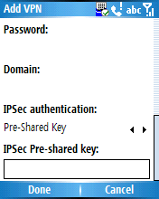

Connecting via Bluetooth Technology
The Connection Manager is designed to make “partnerships” between the Smartphone and other Bluetooth-enabled devices, such as laptops. By default, Bluetooth is turned off on new devices. Once you turn on the Bluetooth feature, Windows Mobile will automatically scan for other Bluetooth devices.

Turn on Bluetooth by selecting Start > Settings > Connections > Bluetooth. Select Off, On or Discoverable. If you select Discoverable, your device will be visible to other Bluetooth-enabled devices.

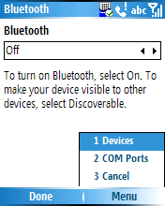

To establish a new partnership with another device, select Menu > Devices. Select Menu > New to search for Bluetooth-enabled devices. Select a device to modify its settings. If a device is found, you can add it by following the Next command.

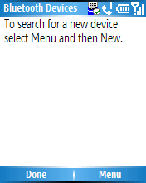
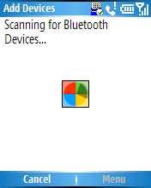

Connecting With Infrared (Beam)
To turn your Infrared receiving on or off, access the Infrared controls by selecting Start > Settings > Connections > Beam. Check the box Receive incoming beams. Select Done.

When this box is checked, you can line up the infrared port on your device with that of another device, such as a laptop, and your device will automatically receive data when it is sent. Before the transfer is complete, your device will prompt you if you want to accept the file being sent.

Beaming files from your device to another device is just as easy. When viewing a contact, document, image or other file you want to send, there is generally a Beam option listed under Menu.

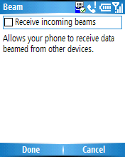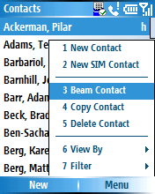

Browsing the Web

Viewing a Web Page
To view a Web page, first connect to the Internet. Then access Internet Explorer Mobile by selecting Start > Internet Explorer. You will see your Favorites.

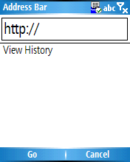
To view a Web page, choose a favorite, or else select Menu. Enter a Web address in the address bar. Select Go.
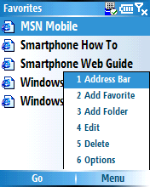
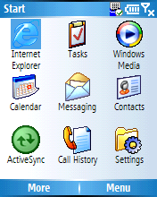

The Internet Explorer Menu
Many of Internet Explorer Mobile’s features can be accessed by selecting the Menu button at the bottom of the Favorites screen. In addition to viewing the Address Bar, the menu also lets you add a Favorite or a Folder, and edit your Favorites.

You can also access other important options, including General, Connections and Memory:
- General. This option lets you turn sounds on and off, allow cookies and set security settings.
- Connections. This option lets you choose to automatically detect settings and to select your network (The Internet, Work, WAP Network or Secure WAP Network).
- Memory. This lets you allocate numbers of bytes to Temporary Files, Cookies and History.

To access these options, select Start > Internet Explorer > Menu > Options.
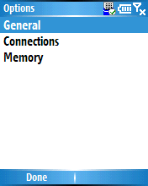

Outlook Mobile

Microsoft Outlook Mobile consists of the following:
- Outlook Mobile Messaging (e-mail and SMS)
- Outlook Mobile Calendar
- Outlook Mobile Contacts
- Outlook Mobile Tasks

Using Outlook E-Mail
Outlook E-mail lets you access your e-mail wirelessly, so that you can be up to date. You can access Outlook E-mail by selecting Start > Messaging. You should see your Text Messaging and Outlook E-mail inboxes. (If you have a Hotmail account set up, you will see it listed here as well.) Select Outlook E-mail. You will see the messages in your inbox.



Viewing Your Messages and Options

Select a message to read it. Then, select Menu. Here you will be able to choose Delete, Reply, Folders, Switch Accounts and other options.

If you want to view messages in a different inbox instead of your Outlook E-mail inbox, you can switch to your Outlook E-mail inbox by selecting Menu > Switch Accounts.

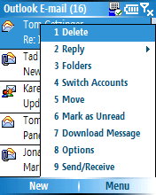

Setting Up Your E-Mail Accounts

If you are synchronizing your device with a desktop PC using Outlook, e-mail from your desktop PC will be synchronized to your device automatically (assuming you selected that option during synchronization setup).

In addition to synchronizing e-mail with your desktop PC, you can also set your Windows Mobile-based device to wirelessly synchronize with your Hotmail account, up to eight POP3 e-mail accounts, and even corporate e-mail accessed over a VPN server connection, all at the same time. You can control synchronization schedules for different accounts and even configure your device to send and receive
e-mails as they arrive.

In addition, Microsoft recently announced a Messaging and Security Feature Pack for Windows Mobile 5.0 devices, giving them support for Microsoft’s new direct push technology embedded in Exchange Server 2003 with Service Pack 2. This feature pack will be available for free to device-maker partners, mobile operators and enterprises looking to deploy devices. The Messaging and Security Feature Pack builds in support for direct push e-mail provisioning, new management and provisioning features, and wireless access to contacts stored on company Exchange Servers.

POP3 or IMAP Accounts
To set up a POP3 or IMAP4 account, first establish a wireless network connection or cradle the device. From Outlook, select Menu > Options. Then select New Account.

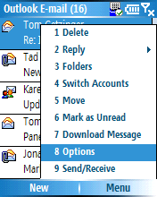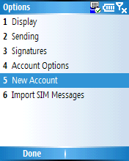

You will see the first of several e-mail setup screens. Enter your name and an e-mail address. Then select Next. Outlook will attempt to obtain e-mail settings for the address. You can skip this step and enter settings manually.

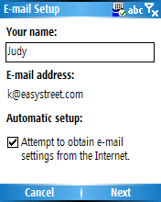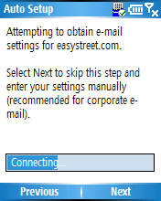
Enter your User name, Password and Domain (if necessary). Select Next. Enter Server type (POP3 or IMAP4), Account name, and Network (The Internet, Work, WAP Network or Secure WAP Network). Select Next. Follow the additional screens for Incoming Server and Outgoing Server information.

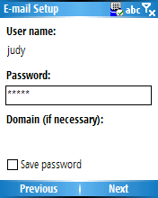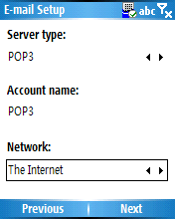

VPN or Proxy Accounts
If your account is accessed using a VPN or a Proxy, select Start > Settings > Connections. Choose VPN or Proxy. Contact your ISP or network administrator for the settings information.

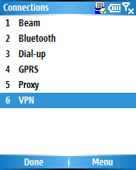

Creating a Message

Create a new message by selecting Start > Messaging. You will see Text Messages and Outlook E-mail listed. If you have a Hotmail account, it will also be listed here. Select the account. Select New.

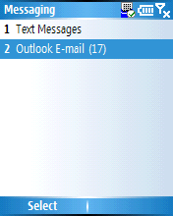
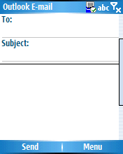

In the To: line, type in a new address (or more than one, separating them with a semicolon). Scroll up to find the Cc and Bcc fields.

Alternatively, you can select recipients from your Contact list by selecting the word To, Cc or Bcc in the heading. Your Contact list should appear. (You can also access contacts by selecting Menu > Add Recipient.) Select the contact to whom you want to send the e-mail. Fill in the Subject line, and the message. When you are finished, select Send.

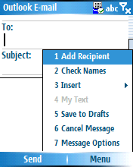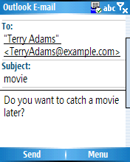

Sending and Receiving Messages

Because you are not necessarily connected to the Internet when you use Outlook, messages are not automatically sent out but are moved to your Outbox folder. To send out the messages in your Outbox, connect to the Internet and select Menu > Send/Receive. Do the same to receive messages.

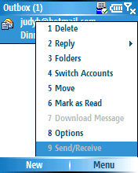

If you are working offline, e-mail messages are moved to the Outbox folder and will be sent the next time you connect. You can view the Outbox folder by selecting Menu > Folders.

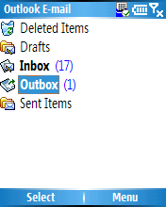

New Message Options

With a new message open, select Menu. Here you can add a recipient, check names or insert attachments. You can also set the message priority, security and language options. To do so, select Menu > Message Options.

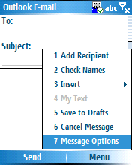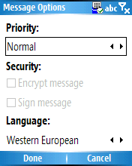

Saving Sent Messages

By default, to help conserve memory, messages you send are not saved on your device. If you want to keep copies of sent messages, from Messaging select Menu > Options > Sending. Select the check box Save copies of sent items.

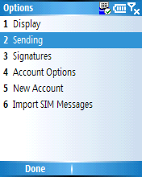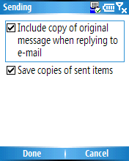

Note: If your account is an Outlook E-mail or IMAP4 account, you must also select the Sent Items folder for synchronization. To do this, select Menu > Folders > Sent Items. With the Sent Items folder selected, select Menu > Manage Folders. Select Sync.

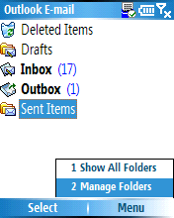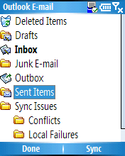

Adding an Attachment to a Message

With a new message open, select Menu > Insert. Choose either Picture or Voice Note. You will see a list of objects in the active folder (you can change folders by selecting the black arrow to the right of the folder name). Choose one of the objects. You will see it attached in the e-mail header.

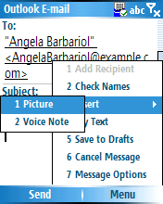
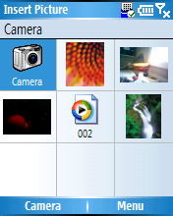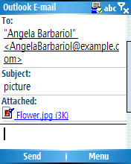

Recording a Voice Note

Adding a Voice Note is a handy way to respond to a message without typing anything — simply record a message and send it as an attachment. To record a Voice Note, select Start > More > Voice Notes. You will see a list of your Voice Notes, if any.

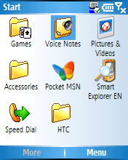

Select Record. When you are done recording, select Stop. You will see the Voice Note in your list. You can rename or delete it by selecting Menu > Rename or Menu > Delete.


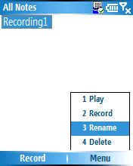

Synchronizing Folders

To choose which of your Outlook folders are synchronized when you connect with your desktop, from within Outlook select Menu > Folders. Select Menu > Manage Folders. Scroll down the list to a folder. If it can be synced, the word Sync will be displayed. Select that to sync it. Note: If you have an Exchange Server you can sync from your phone.

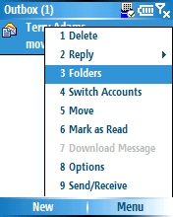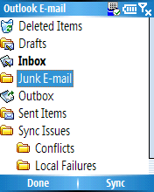

If you do not see all your folders, select Menu > Folders. Then select Menu > Show All Folders.

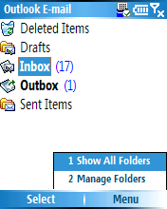

Message Options

You have flexibility in many aspects of your messaging. From your Inbox, select Menu > Options.
Here you will be able to change your Display, Sending, Signatures, Account Options and other features.

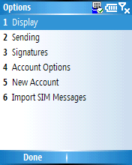

Using Outlook Mobile SMS
You can create text messages (SMS) as easily as creating an e-mail. Select Start > Messaging. Select Text Messages. Select New. Choose a contact by either typing it in directly, by selecting Menu > Add Recipient, or by selecting To:, which will bring up your contact list. When you are finished, select Send.

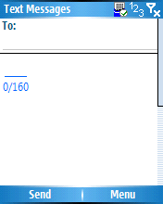

You can request Delivery Notification by selecting Menu > Message Options. Select Request message delivery notification. Select Done.

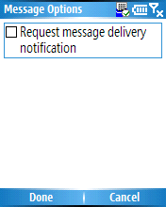

Using Outlook Mobile Calendar
To open your Outlook Calendar, select Start > Calendar. You will see the current day’s entries displayed according to the view in use. To see a skeleton of the week’s appointments, select Week. Use the right and left keys on the Action key to navigate to a different date or week.

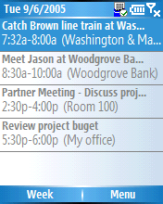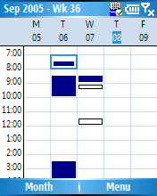

To view a particular appointment, navigate to it with the up and down keys, and select it with the Action key. To edit the appointment, select Edit. Scroll down to see all the options.

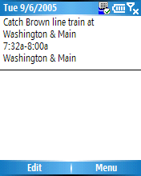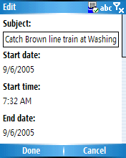

Adding an Appointment

From any screen in Calendar, push Menu. Select New Appointment. Scroll down to see all the options. Push Done when finished.

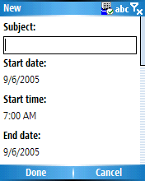

Changing Calendar Views

Calendar has five available views: Agenda, Week and Month. You can change views by pushing Menu and selecting one, or by choosing the view offered by the left soft key.

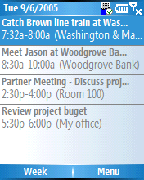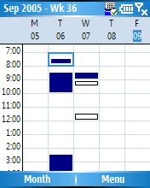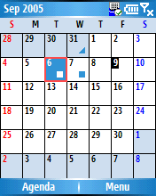

Setting Reminders and Changing Calendar Options

You can change how your calendar views are displayed and set reminders by selecting Menu > Options. To change the reminder sound, select Start > Settings > Sounds > Reminders.

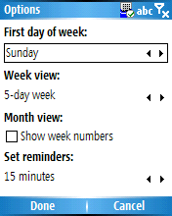

Using Outlook Contacts

How to Add a Contact

Open Contacts by selecting Start > Contacts, or by selecting Contacts at the bottom right of the Home Screen. Select New at the bottom of the screen. The contact information options should appear. Enter in the information. Do not forget to scroll all the way down to see all your information options. When you are finished, select Done.

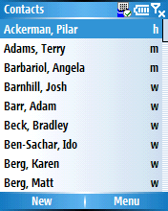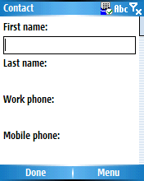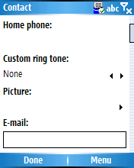

Note: If someone who is not already listed in your contacts calls you or sends you a message, you can create a contact entry for them from Call History, or directly from the message by selecting Menu > Save to Contacts.

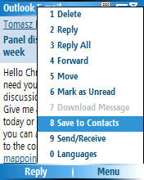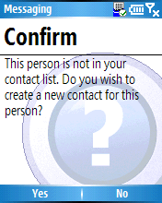

How to Call or Send an E-Mail or Text Message to a Contact

It is easy to call or send an e-mail or text message directly from your contact list. Select Start > Contacts. Select the contact. Select the call location or address. Notice that the bottom-left soft-key command changes depending on the function to Call, SMS or E-mail. Press the bottom-left soft key.

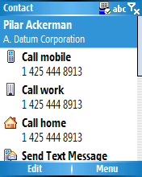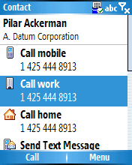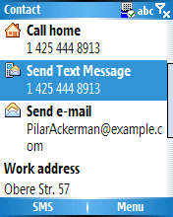

How to Assign a Photo to a Contact

Choose a contact. Select one of the numbers, then select Menu > Edit. The contact information options should appear. Scroll down to the Picture field, and then press the Action key to the right. A list of pictures in your My Pictures folder will appear. Choose one (you can change it later). Choose Select.

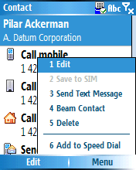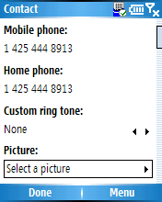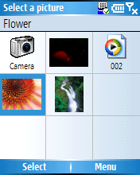

Now, when you open up that contact, the picture will appear next to it.

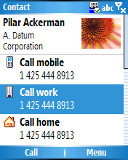
Note: You can also choose Camera from the Select a picture screen and take a picture (if your device has this capability). This picture will be added to the contact.

How to Assign a Ring Tone to a Contact

Choose a contact. Select one of the numbers, then select Menu > Edit. The contact information options should appear. Scroll down until you see the Custom ring tone field. Press the Action key to the right. The ring tone options should appear. Choose one. Select Done.
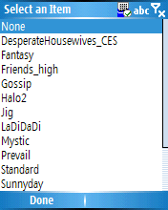

Contact Options

You can access additional options from your contact list by pressing Menu.

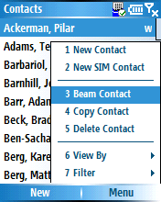

Using Outlook Tasks
To open your Outlook Tasks, select Start > Tasks. You will see your task list. To enter a new task, press the Action key down arrow. You will see the cursor appear in the task bar and the text mode symbol appear in the upper-right-hand corner.



Enter the task description. Press the Action key to save. You will see the task listed next to a check box. To mark a task complete, select Complete. To uncheck the box, select Activate.

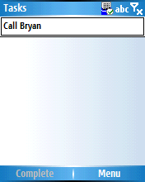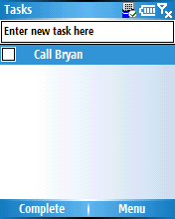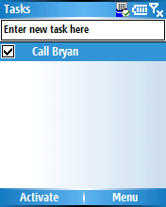

Task Options

You can beam a task, delete a task, sort your tasks or filter your tasks by selecting Menu.

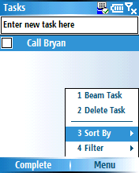

Synchronizing Outlook Mobile Information

Synchronizing Calendar, Contacts and Tasks

Calendar appointments, contacts, favorites and tasks stored on your device can be synchronized with similar items on your PC or Exchange Server. The items entered on one computer are copied to the other during synchronization.

Open the ActiveSync application on your desktop. Select Tools > Options. Select the items you want to synchronize. If Settings are available for that item, select Settings (otherwise it will be grayed out).

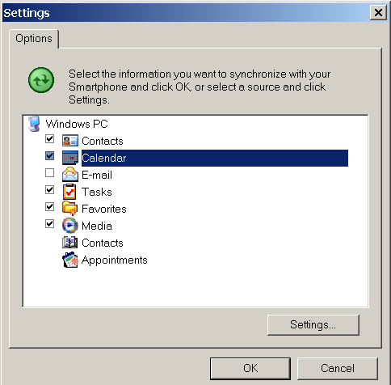

Synchronizing E-Mail Messages

The manner in which you download messages depends on the type of account you have. To send and receive e-mail for an Outlook E-mail account, you will synchronize through ActiveSync on your desktop PC as above or to an Exchange Server. To send and receive e-mail messages for an e-mail account that you have with an ISP (POP3 or IMAP) or that you access using a VPN server connection, you will download messages through a remote e-mail server.

Receiving Attachments and Other Synchronization Options

The default sync settings are these:
- From the last three days only
- The first 0.5 KB of each new message
- No syncing of file attachments

You can change these settings. Any changes you make on the device will be synchronized to your PC or server wirelessly or when cradled.

To receive attachments on your phone, open the ActiveSync application on your desktop. Select Tools > Options. Select the E-mail folder, then select Settings. Check the box Include file attachments.
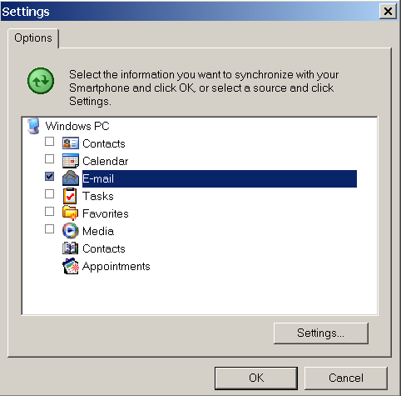
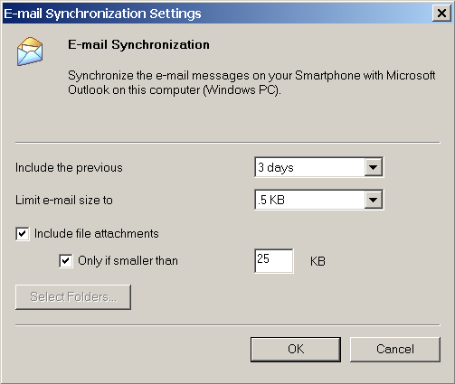

Pocket MSN

Using MSN Messenger
With MSN Messenger, you can send instant messages to your contacts’ mobile devices or computers.

Note: You need a Microsoft .NET Passport and MSN Messenger account to use this feature. Visit http://www.msn.com to obtain them.

To access MSN Messenger, first connect to the Internet. Then select Start > Pocket MSN. Select MSN Messenger.

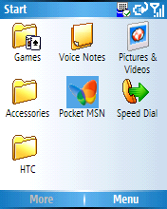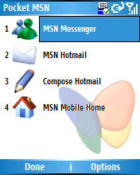

Select Sign in. Enter your e-mail address and password. Once you are signed in, you will see a list of which contacts are online and not online; you only have to do this once — your device remembers your credentials, making it very easy to stay connected.

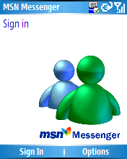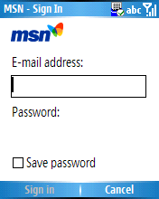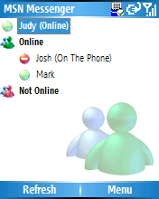

Sending a Message

Click on the contact to whom you want to send a message. Enter your message in the text entry area at the bottom of the screen and select Send. Alternatively, you can select Menu > Send Message.

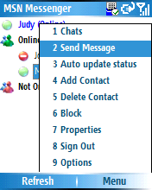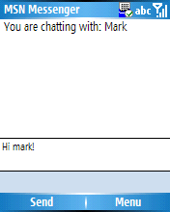

To enter common text, you can select Menu > My Text and choose from the options.

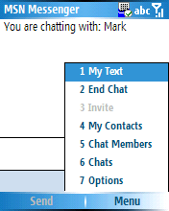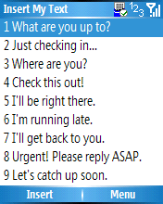

Chats

To see who is already chatting, or to switch between chats, select Menu > Chats.

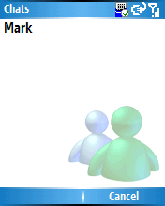

Changing Your Display Name

To change your display name, from MSN Messenger select Menu > Options. Enter your display name. Select OK.

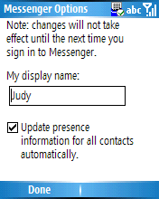

Adding and Deleting Contacts

To add a contact, from MSN Messenger, select Menu > Add a Contact. Add the Sign-in Name and select Next. The name will be added to your list.

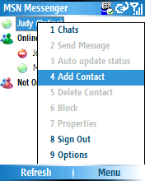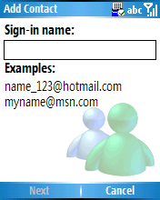

To delete a contact, select and hold on the contact’s name, and then select Delete Contact from the pop-up menu.

Using MSN Hotmail
With MSN Hotmail on your device, you have access to your Hotmail Inbox even when you are mobile. In addition to Hotmail you can also view your messages offline when not connected. You also get all the great advantages of Outlook Mobile Messaging to manage your Hotmail account on the go.

To open MSN Hotmail, select Start > Pocket MSN. Select MSN Hotmail. You will see your Hotmail inbox. Alternatively, you can select Start > Messaging > Hotmail.

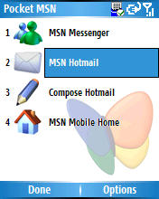

To synchronize your Hotmail Inbox so you see your latest messages, select Menu > Send/Receive.

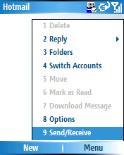

Creating and Sending Hotmail Messages

You create and send messages using Hotmail by selecting Start > Pocket MSN > Compose Hotmail. Alternatively, from within Hotmail, you can select New. You can add a recipient by selecting Menu > Add Recipient, or simply type one in.

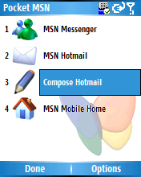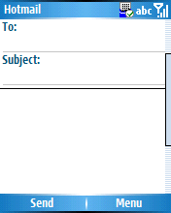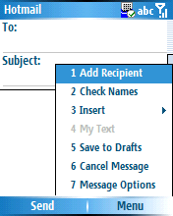

You can change message options, such as message priority, security settings and language, by selecting Menu > Message Options.

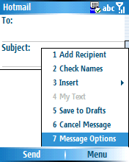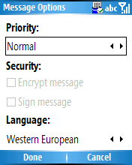

When you are ready to send the message, select Send. This puts the message into your Outbox. To send out the message, select Menu > Send/Receive.

Changing Your Hotmail Options

You can access many of your Hotmail options by selecting Start > MSN Hotmail > Menu > Options.

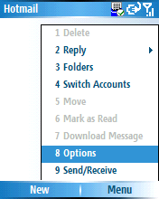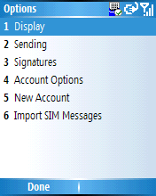

For instance, you can set your Send options to include a copy of the original message when replying to
e-mail, or to save all copies of sent items. Select Sending. Check or uncheck the boxes you want, then select Done.

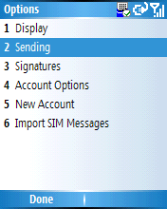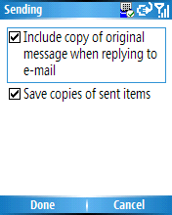

Viewing Your Hotmail Folders

To view your Inbox, Outbox, Deleted Items, Drafts and Sent Items folders, select Menu > Folders.

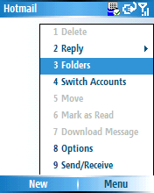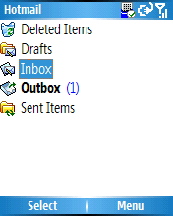

Entertainment and Multimedia

Windows Mobile 5.0 for your Smartphone includes entertainment and multimedia programs such as Windows Media Player 10 Mobile, Games, and Pictures & Videos. The particular programs installed depend on your particular device.

Using Windows Media Player 10 Mobile
Synchronizing files and playing media on your mobile device has never been easier. To view a list of devices that have Windows Media Player 10 Mobile installed, visit http://www.microsoft.com/windows/windowsmedia/player/windowsmobile/default.aspx.

Getting Content From Your Desktop Onto Your Device

To get media onto your device, you can take advantage of the built-in synchronization capability of Windows Media Player 10 Mobile. Built-in synchronization allows you to synchronize your PC’s media files with your mobile device on demand. You can even synchronize content without pushing a button via the intelligent Auto Sync functionality in Windows Media Player. Windows Media Player can scan your PC for media and add it to your media library. Content that you add to your media library from your PC is then readily available to synchronize to your Windows Mobile-based device.

Note: To take full advantage of Windows Media Player 10 Mobile, you will need to install the PC version onto your computer first. You can do so by visiting Microsoft’s Web site at http://www.microsoft.com/windows/windowsmedia/player/download/download.aspx.

Once you have installed Windows Media Player 10 Mobile on your PC, you will also need to set it up to synchronize. To do so, from Windows Media Player 10 Mobile on your desktop, select File > CDs and Devices > Synchronize. Select the Sync tab, and then connect your mobile device to your PC.

If you have a multimedia card inserted in your device, you will be prompted with the Device Setup menu and asked to choose either automatic or manual synchronization. Windows Media Player 10 sets the default synch method to automatic if it sees that your storage card or hard drive is 512 MB or larger. If your storage capacity is smaller then 512 MB, the default is set to manual.

If you have not set up your storage card, when you synchronize with ActiveSync, you will receive a message asking if you want to set up a partnership with your storage card. Select Yes. The Windows Media Player application should appear.
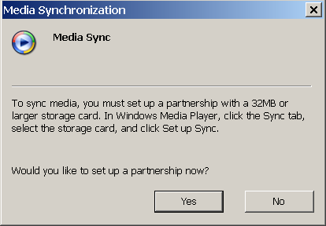

Finally, you will also need to make sure that your device is set up to synchronize your media files. To do so, open your desktop ActiveSync application. Select Tools > Options. Check the Media file if it is unchecked.
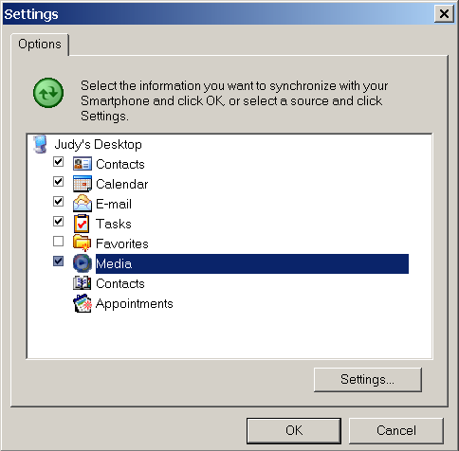

Automatic Synchronization

If you have 512 MB or more storage on your device or storage card, try the Auto Sync feature. Windows Media Player 10 will scan the music on your PC and sync songs based on the following rules until your storage card is full:
- Music rated at 5 stars
- Music added in the past month
- Music rated 4 stars or 5 stars
- Music played in the last month
- Music played the most
- All music

You also have the ability to customize the priorities and playlists for Auto Sync. Customization can be done by selecting Sync Settings and choosing the items you want to include. Each time your mobile device is synced to your PC while Windows Media Player 10 is active, Windows Media Player will make updates to your device’s media library automatically based on your preferences.

Note: If your device has less than 32 MB of usable memory, whether system memory or storage card memory, you will not be given the option to Auto Sync.

Manual Synchronization

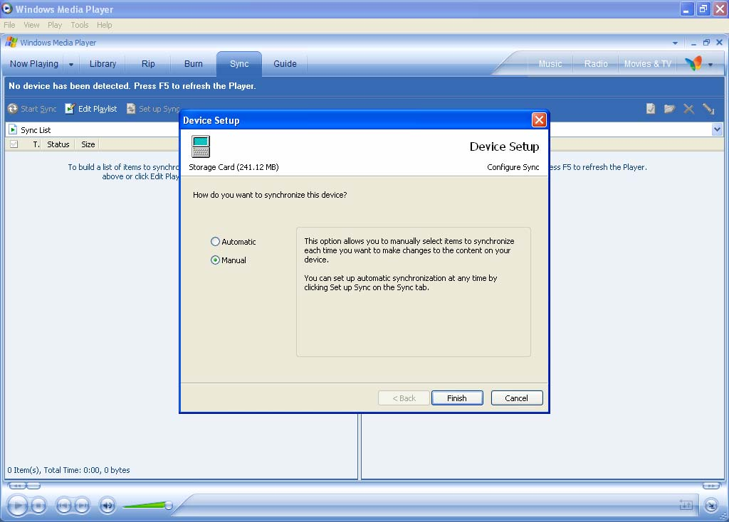
Notice that your device name is listed on the right side of Windows Media Player. Below the device name are folders that reside on your device. By using the four icons above your device name, you can add folders, delete files, format multimedia cards in your device or view the properties of selected files. To switch from your device memory to your multimedia card, select on the icon depicting your device name, and then select Storage Card. The contents of your card are now listed.

Select the pull-down arrow just below the Start Sync icon. The selections in this pull-down menu represent the many ways you can sort and sync your media: by track, album, artist, genre, recently played songs, top-ranked songs and more. When you have selected the tracks you want to sync, select the Start Sync button to begin syncing the content to your Windows Mobile-based device.

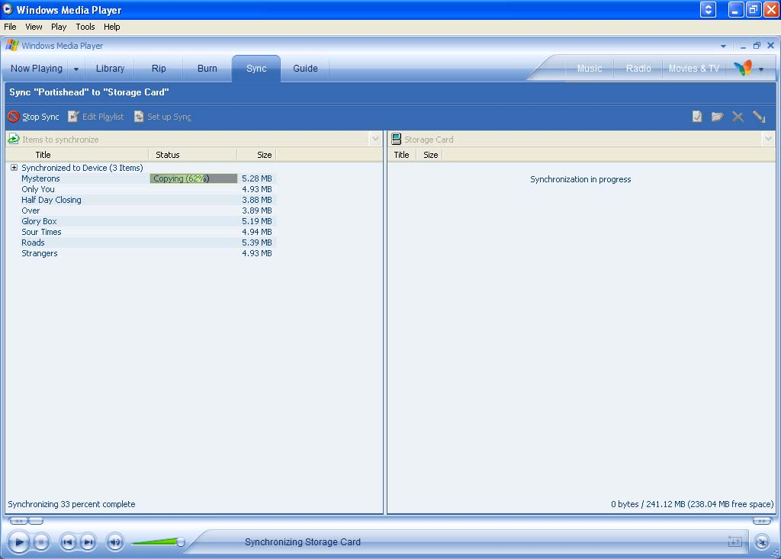

The status section denotes if the song is ready to sync or is currently syncing. It will also indicate that Songs may not fit… if you do not have adequate storage space on your card.

Starting Windows Media on Your Smartphone

To start Windows Media Player 10 on your Pocket PC, select Start > Windows Media. You’ll see your Now Playing screen. To access your media library, select Menu > Library.

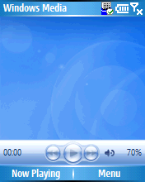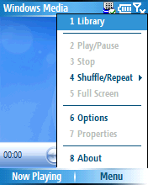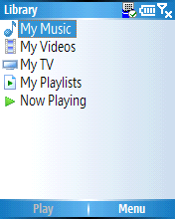
From here you can navigate to the five areas of content: My Music, My Videos, My TV, My Playlists and Now Playing. From your Library you can launch music, video and TV shows that you’ve previously stored on your device’s storage card.

Updating Your Library After Syncing Over Content

It’s easy to update your mobile device media library after syncing content. Select Start > Windows Media > Menu > Library. From the library screen, select Menu > Library. Press the right Action key. You’ll see options for My Device or Storage Card. Choose Storage Card.

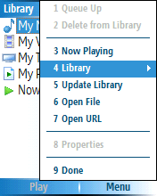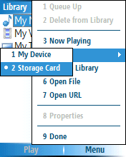

Then choose Menu > Update Library. Windows Media will search for new files and add them to the library. Use the Update Library function each time you sync over new content.

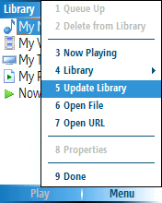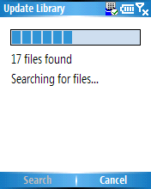

Playing Media on Your Device

Now you are ready to play media on your mobile device. From the Library screen, select My Music. Notice that you can sort by All Music, Artist, Album or Genre. Select the track you want to hear, then select Play. You can view the properties of what’s playing by selecting Menu > Properties.

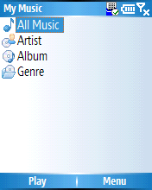

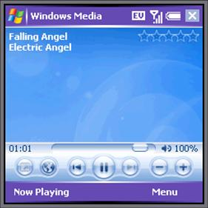

Playing Video Content

Playing your video content is just as easy as playing your music. From the Library page, select My Videos, and choose either All Video or Genre to sort through your collection. Select a video you want to view. You should be able to see and hear the video.

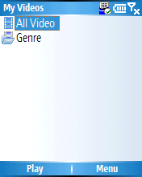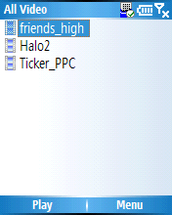
Full-Screen Mode

In Full-Screen landscape mode you use more screen real estate to watch video. To use this feature, start your video, select Menu, and then select Full Screen. Depending on video size, compression and format, certain videos can be played utilizing the entire screen. Those that aren’t rendered to fit the screen will have a black border.

To return to the standard mode, press the Action key.

To stop the video, select Menu > Stop.

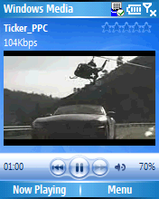

Using My TV

With a Windows XP Media Center Edition or a Windows XP-based computer with Windows Media Player 10, you can easily synchronize TV content using Windows Media Player 10.

From the library, select My TV. Select a television program. Select Play.



Queuing Up Your Media

You can queue up other songs or videos to form a playlist. From the media library, highlight a song, artist, album, genre, playlist or the All Music selection. Select the Menu button and select Queue Up. When you return to the Now Playing list, you will see that all the content under the selected item has been added to the end of the queue. You can reorganize the order of the Now Playing list however you want by selecting Menu.

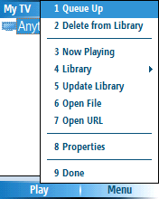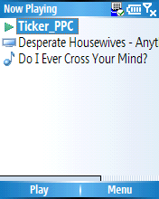

Things to Keep in Mind When Playing Media
- The Action key is your main control. You can customize it based on your personal preferences.
- Press the Action key straight in to play or pause media.
- Press it once to the right or left to go to the next song or start the song over.
- Hold it down to the right or left to go to the next or preceding media file.
- Press it up or down to control the volume.
- Press the # key to mute or turn on the volume.
- If you have synced an album with album art from your PC to your mobile device through Windows Media Player 10, the artwork will appear when music from the album is played.
- If you receive a call while listening to or watching media on your mobile device, the device will automatically pause and mute the media so you can take the call.
- Selecting Menu brings up a variety of selections, such as Shuffle/Repeat, which lets you listen to your music in a random-play mode. Note that the Options section is accessed from the menu.

Windows Media Options

Pressing Menu > Options brings up a number of ways you can customize your Windows Media experience.

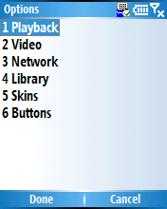

- Playback. You can show time as Elapsed or Remaining. You can pause playback while using another program or resume playback after a phone call.
- Video. You can play video in Full-Screen Never, Only when oversized or Always modes. You can scale video to fit the window.
- Network. You can set your Internet Connection Speed and Protocol.
- Library. You can start the Windows Media Player on the Library screen.
- Skins. You can search for new skins.
- Buttons. You can assign or reset buttons.

Playing Games
To play games on your mobile device, select Start > More > Games. Both Bubble Breaker and Solitaire come with your device, but any other games you install will also appear in this game folder. There are thousands of titles available for purchase including popular games such as “Age of Empires®,” “Lemonade Tycoon,” “Midtown Madness®” and “Myst.”
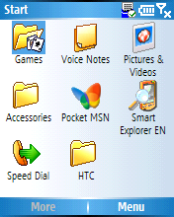
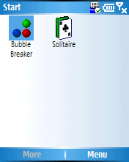

Pictures & Videos
To use Pictures & Videos, select Start > More > Pictures & Videos.

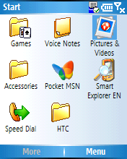

The default view in Pictures & Videos displays thumbnail images to quickly sort picture and video files on the device and storage card. The menu offers you many options to edit or share images. To use it, select a picture. Then select Menu.

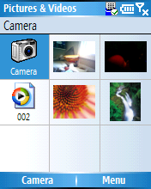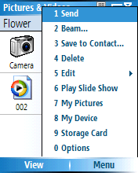

Editing a Picture

To rotate a picture, open one up by selecting it with the Action Key. Select Menu > Edit. Then select Menu > Rotate.

Note: From this menu, you can also use a picture as your Home Screen.

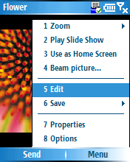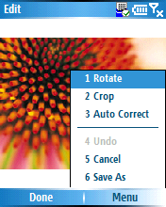

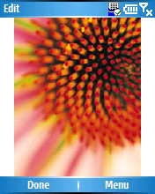

To crop a picture, select Menu > Crop. Use the Action key to position the first corner. Select Next. Use the Action key to position the second corner. Select Finish.

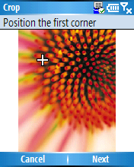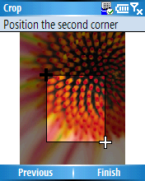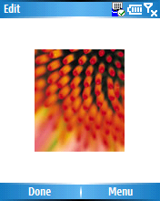

Picture & Videos Options

You can access Picture & Videos Options by selecting Menu when a picture is open and then selecting Options.

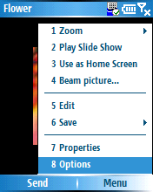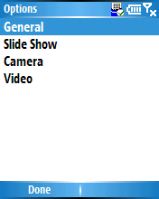

- General. This option lets you specify the picture size when sending pictures in e-mail (original size, Large (640 x 480), Medium (320 x 240), or Small (160 x 120)). It also lets you change rotation direction.
- Slide Show. This option lets you optimize slide shows for viewing.
- Camera. This option lets you specify where you save files (main memory or storage card) and choose other options.
- Video. This option lets you include audio when recording video files, and set a time limit for videos.

Customizing Windows Mobile 5.0

Changing the Home Screen
The Home Screen that appears when you turn on your Windows Mobile-based Smartphone shows you all your calendar items, active tasks and unread messages. You can customize this screen by selecting Start > Settings > Home screen. Here, you can change your home screen layout, color scheme, background image and time-out options.

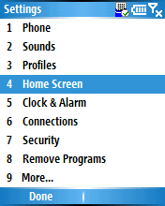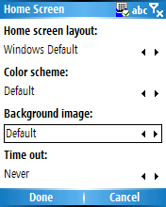

Setting a Picture as a Background
To set a picture as a background, select Start > Settings > Home screen. Scroll down to Background image. You’ll see a list of the images available on your device. Select one. Select Done.

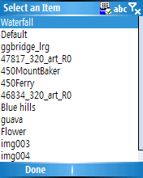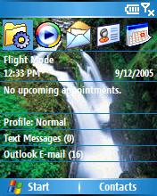

Changing the Ring Tones on Your Device
With Windows Mobile 5.0 you can assign individual ring tones to each of your friends, business associates or other contacts.

To do so, from the Home Screen select Contacts. Select the contact from the list to whom you’d like to assign a ring tone. Select Menu > Edit.

Scroll down the edit options to Custom ring tone and select it. Then select the ring tone you want to use from the scroll-down menu. Select Done.

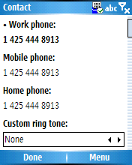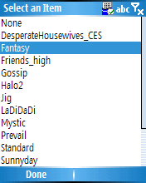

If you want to add your own ring tone to the list, Windows Mobile 5.0 supports a variety of ring tones formats including WAV, WMA and MP3. If you have a song or sound you want to add to your ring tone collection, connect your device to the PC. Open up ActiveSync on your desktop. Click on Tools > Explore Smartphone. Click on My Windows-Based Device >Application Data. You’ll see a folder named Sounds.
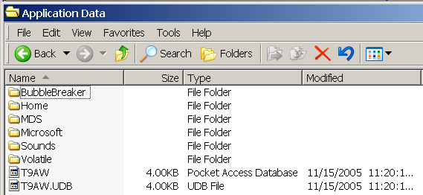

Now, from your desktop, right-click on My Computer or Start > Explorer. Browse to the file you want to add. Copy and paste or drag and drop the file into your device’s Sounds folder. The next time you synchronize using ActiveSync, the file will be added to your ring tones.

Adding New Applications to Your Device
ActiveSync makes it easy to add one of the many programs available (more than 18,000 applications from productivity to entertainment) for Windows Mobile 5.0 to your Smartphone. Download the application to your desktop (or insert the CD). Make sure your device is connected to your PC and synchronized via ActiveSync. Run the new application’s setup program. When it finishes, you should receive a notification to check your mobile device screen to see if additional steps are necessary.

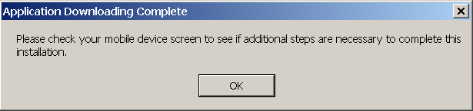

Follow the instructions on your device screen. You should see an Installation Wizard. You will be asked to choose a location to install the application. Choose Storage Card (if there is one). Select Install.

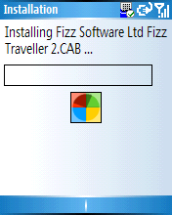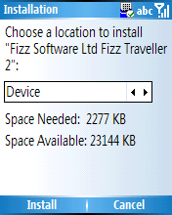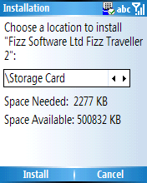
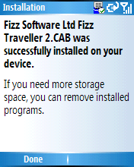

The application icon should now appear on the device’s Start menu, and you should be able to run the program.

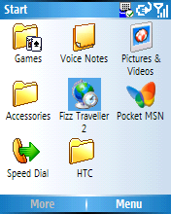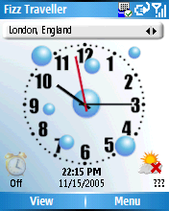

Removing Programs
You can only remove programs that you’ve already installed. Programs that come with your device cannot be removed.

Select Start > Settings > Remove Programs. Select the program you want to remove, and select Done.

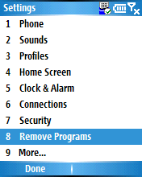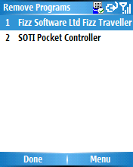

There are many more ways to customize your device. Here are a few more:

- Change the sounds: Start > Settings > Sounds.

- Change the Power Management settings: Start > Settings > More > Power Management.

- Change the Owner Information: Start > Settings > More > Owner Information.

#########

IDC report, “Worldwide Mobile Phone 2005–2009 Forecast and Analysis,” May 2005

