Step-by-Step Guide to Securing Windows XP Professional in Small and Medium Businesses

Overview
With the over-growing theat of malicious code -- such as worms, virus, and hacker threats -- it is critical that all customers take immediate action to help lock-down their desktop and laptop systems. This guide explains how to implement the security measures recommended in the Windows XP Security Guide in a small or medium business environment without an Active Directory deployment. These recommendations help ensure that your desktop and laptop systems running Windows XP Professional SP1 are more secure from the majority of current security threats, while ensuring that users can continue to be efficient and productive on their computers. In addition to the advanced step-by-step guidance in this document, you will also find information on the top security recommendations that Microsoft is making to all customers, from the home to the enterprise. These include:

1. Use a firewall, like the Internet Connection Firewall already in Windows XP
2. Use Microsoft Windows Update to get and keep your PC up-to-date
3. Install antivirus software and ensure it’s up-to-date
This guide provides step–by–step deployment guidance and troubleshooting advice for information technology (IT) professionals and system administrators in a small to medium sized organization.
For more information on the particular settings that are applied by following this guidance, and their potential impact, please refer to the complete Windows XP Security Guide at: http://go.microsoft.com/fwlink/?LinkId=14839. To create customized security templates based on the specific needs of your organization, refer to the Threats and Countermeasures Guide at: http://go.microsoft.com/fwlink/?LinkId=15159.

Who Should Read this Guide
Read this guide if you are planning to deploy Windows XP, or if you are currently administering a number of computers running Windows XP Professional and are looking to implement a base level of security and protect your desktops and laptops with a minimal impact on end users.
This guide is written for the average small or medium business administrator who may not have extensive training on Microsoft products but is looking for a quick, step–by–step guide to securing Windows XP in their organization.
This guide does not address the wide variety of needs and configurations that may be required in a large corporation. Additionally, it may not fully address the specific security needs of some organizations. For additional security options and customization information, please refer to the Windows XP Security Guide.

What to Expect
As with any security recommendations, this guidance strives to find the right balance between enhanced security and usability. The recommendations provided here will work successfully for Windows XP Professional deployments in a wide variety of environments. However, there are several key points that you should note before implementing these recommendations.
This guide should not be used to secure Windows XP desktops or laptops that are members of a domain. A domain is a networked set of computers that share a common account database and can be managed as a group. Additionally, this guide should not be used for computers running Windows XP Home Edition.
This step-by-step guide is focused on organizations that manage individual user accounts on each Windows XP Professional computer. In organizations where all users share a common username and password, or organizations where users have multiple accounts on different computers that use the same password, additional steps must be taken prior to using this guidance. Such practices are not secure and the steps recommended in this guide will not work in these environments.

Connectivity to Windows 98 and Windows NT
Using the recommendations in this guidance, your Windows XP desktops and laptops will be capable of communicating more securely with other computers running Windows XP, Windows 2000, and Windows Server 2003. However, Windows XP desktops and laptops may have difficulty sharing files, folders, or printers with Windows 98 or Windows NT 4.0 systems. Windows 98 and Windows NT 4.0 are older technologies that are more difficult to secure against today's security threats.
The use of Windows XP, Windows 2000 and Windows Server 2003 provide small and medium businesses with a security solution that helps safeguard your important business documents from the threat of viruses and attackers while providing you with the most reliable Microsoft desktop to date. Windows XP Professional is the most reliable Windows operating system yet–much more reliable than Windows 98 SE. Only Windows XP, Windows 2000, and Windows Server 2003 include the new security features and functions utilized in this guide. For additional reasons to consider upgrading Windows 98 and NT clients to Windows XP, see: http://microsoft.com/windowsxp/pro/evaluation/whyupgrade/sorgtop10.asp.
For information regarding how to secure Windows XP systems that are members of a domain, or that need to communicate with Windows NT 4.0 workstations and servers or Windows 98 clients, please refer to the complete Windows XP Security Guide.

Changes to Password Requirements
After implementing this guidance, your users will be required to maintain a complex password of at least 8 characters, and must change that password every 42 days.
In addition to changing passwords frequently, the most productive security change that you can implement is encouraging your users to choose strong passwords. Weak passwords are one of the greatest security risks in any organization. Help your users by explaining that they can use "pass phrases" instead of passwords. Using an easy to remember phrase that includes numbers, capital and lowercase letters, and spaces or symbols is much more secure than a single word.

Running Programs as a Local User
A common issue in many organizations is the prevalence of users that run their laptop or desktop with administrative credentials. All of the user's accounts should be members of the Users group. Users should not be allowed to log in routinely with accounts that are members of the Administrators group. By enforcing this change, users will not be able to install unapproved software that may contain viruses or other types of potentially dangerous code.
Implementing this requirement may be challenging, but using Windows XP Professional with logo certified applications makes this easier. Applications that are not logo certified may not run correctly for users without administrative privileges. For a list of logo certified applications, look for software labeled "Designed for Windows XP" in the Windows Catalog at http://www.microsoft.com/windows/catalog/.
An administrator must implement the recommendations in this guide but the settings provide the necessary functionality to allow the laptop or desktop to be run by someone who is not a member of the Administrators group on a day–to–day basis. Once the security settings recommended in this guide are implemented, they apply to all users logging onto the desktop or laptop, including the Local Administrator.

Securing your Laptops and Desktops
This section provides you step–by–step instruction for downloading and installing the password and security templates provided with the Windows XP Security Guide, and other key steps to help you secure your Windows XP systems. The first step you take is to download the security templates to your Windows XP client. The next step is to import the password and security policies. Finally, you apply these policies to your desktop or laptop computer.

Downloading the Windows XP Security Templates
A security template is a file that represents a recommended security configuration. Security templates are applied to a system by importing them on the desktop or laptop. This section shows you how to download the pre-built security templates, which are detailed in the Windows XP Security Guide, to secure your desktop and laptop systems.
◆ To download the Security Templates:
- Log in to the Windows XP Client with an account that has administrative rights.
- Open a Web browser and navigate to http://go.microsoft.com/fwlink/?LinkId=14840.
- On the bottom of the page, in the Files in this Download section, select the Windows_XP_Security_Guide.exe.
- In the File Download window, click Save.
- When prompted for a location, select the Desktop, and click Save.
- In the Download Complete window, click Open.
- In the WinZip Self-Extractor window, click Browse.
- Select My Documents and click OK.
- In the WinZip Self-Extractor window, click Unzip.
- After all files have finished extracting click OK.
- In the WinZip Self-Extractor window, click Close.

Importing the Security Templates
After you have downloaded and extracted the security templates, use the Microsoft Management Console (MMC) snap–in for the Security Configuration and Analysis tool to apply these policies on the stand–alone machine.

Importing the Password Policy
This security template enforces the requirement that users of the system choose complex passwords that are greater than 8 characters in length. Additionally, it requires them to change their password every 42 days. The policy monitors for failed attempts to log in to the computer. If 50 failed login attempts occur within 30 minutes, the account is locked for 30 minutes, or until an administrator manually unlocks it.
You will use the SA Enterprise Account.inf file that is included with the Windows XP Security Guide to perform this task.
◆ To import the recommended password policy:
- On the Start menu, click Run, type mmc, and then click OK.
- On the File menu, click Add/Remove Snap–in.
- Click Add on the Stand–alone tab in the Add/Remove snap–in properties box.
- Select Security Configuration and Analysis and then click Add.
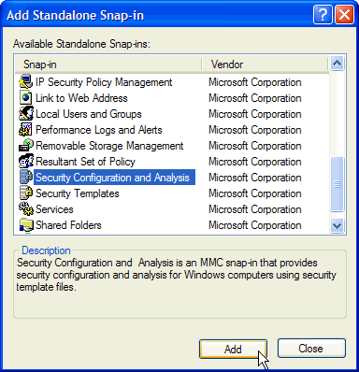

- Click Close, and then click OK.
- Under Console Root, right–click the Security Configuration and Analysis item and then click Open Database.
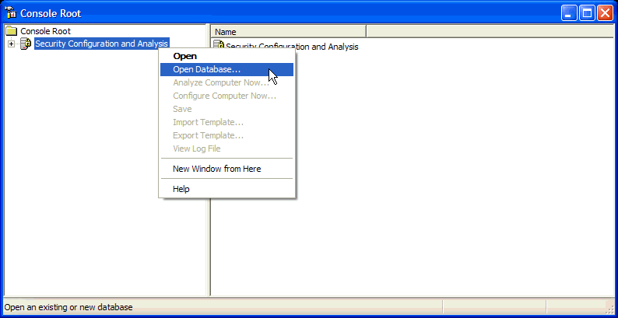

- Type a new database name (Windows XP Security Guide.sdb), and then click Open.
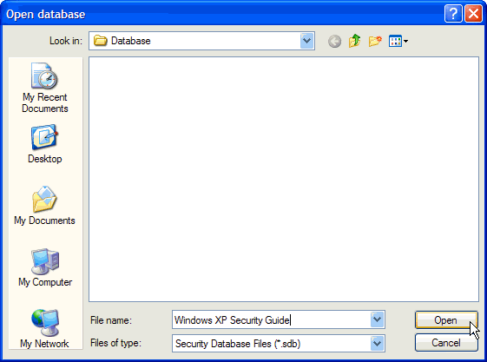

- In the Import Template window, navigate to \My Documents\Windows XP Security Guide\Tools and Templates\Security Guide\Stand Alone Clients\.
- Select the SA Enterprise Account.inf security template, and click Open.

Note: If you do not see the SA Enterprise Account.inf file, you may have saved it to a different location. You may need to extract the files from the Windows_XP_Security_Guide.exe self-extracting file again.

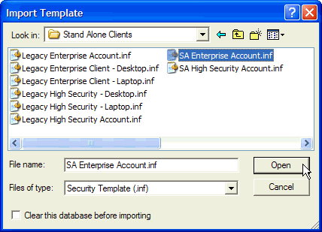

You have now successfully imported the security policy. Do not close out of the Security Configuration and Analysis snap-in yet. Now, you must import the security policy before applying these changes to the system.

Importing the Security Policy
The next step to securing your computer is to configure many of the built–in security settings. While this seems like a daunting task, step–by–step instructions for using the Enterprise Client - Desktop.inf file that is included with the Windows XP Security Guide are provided below to perform this task.
This policy will configure settings that ensure only valid users can connect to the computer, only administrators can backup and restore files on the computer, and that only administrators can add new drivers to the system.
◆ To import the recommended security policy:
- Right–click the Security Configuration and Analysis scope item and then click Import Template.
- In the Import Template window, navigate to \My Documents\Windows XP Security Guide\Tools and Templates\Security Guide\Security Templates.
- Select the Enterprise Client–Desktop.inf security template, and click Open.

Note: If you are configuring a laptop, select the Enterprise Client–Laptop.inf security template instead of the Enterprise Client–Desktop.inf file.

Important: Do not select the High Security templates unless you have read the Windows XP Security Guide and understand the impact they may have on usability.

- Right–click the Security Configuration and Analysis scope item, and then click Configure Computer Now.
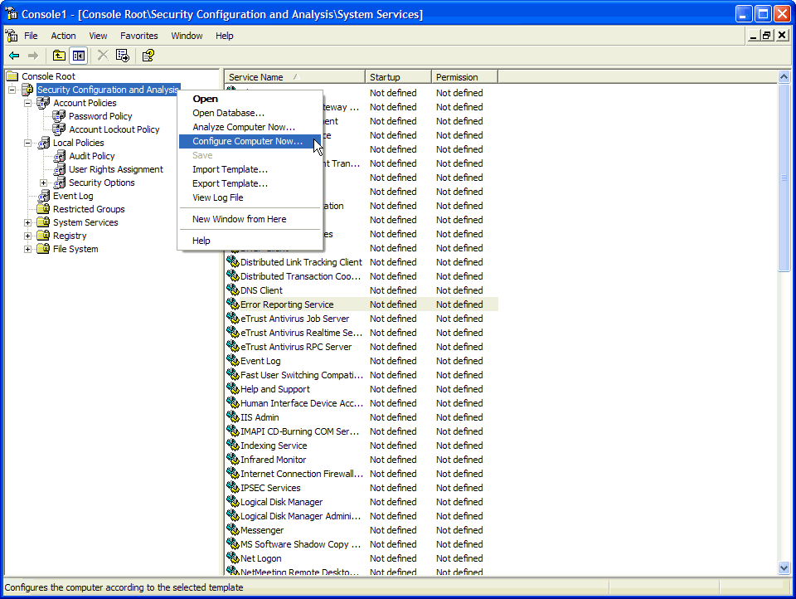

- In the Configure System dialog box, accept the default name of the log file by clicking OK.
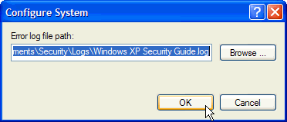

Completing the Process
You are now ready to apply the password and security settings to your desktop or laptop. To ensure they are applied, use the gpupdate.exe command.
◆ To run gpupdate:
1. On the Start menu, click Run, type cmd, and then click OK.
2. Type gpupdate.exe /force and press ENTER.
3. When you are prompted with "OK to Reboot?", type Y and then press ENTER.

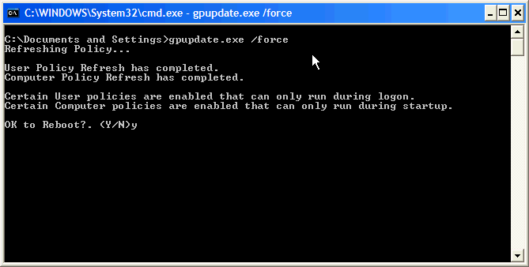

After the system restarts, the password and security policies are successfully applied. After pressing Control + Alt + Delete to log in, you should see the "It is an offense to continue without proper authorization" dialog box. Click OK and log in as normal.
If you have trouble, refer to the Troubleshooting section below.

Additional Recommendations
Implementing the recommended security templates is a great start to securing your desktop or laptop. In addition, there are several other security measures that you should consider taking, including:
● Converting your file system to NTFS
● Using the Internet Connection Firewall
● Using antivirus software
● Keeping up-to-date on security patches

These topics are discussed further in the sections below.

Converting your File Systems to NTFS
A file system is the way that directories and files are organized on the computer. During the Windows XP setup process, computers could either be configured to use the FAT32 or NTFS file system.
FAT32 is an older technology utilized by previous versions of Windows. The NTFS file system is faster and more secure than previous file systems. For optimal performance and security of the operating system, you should use NTFS on all file system partitions on your machine.
◆ To check the file system type on your machine:
- On the Start menu, click My Computer
- Right click on the drive letter you want to check and select Properties from the menu.
- The File System type should be NTFS. If it is not, you can use the convert.exe utility to convert from FAT16 or FAT32 to NTFS.
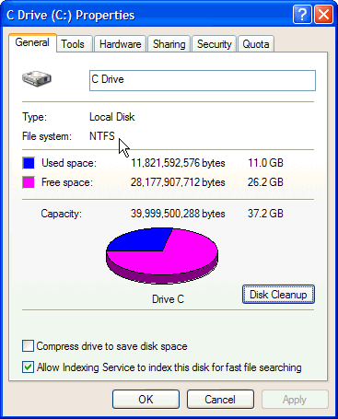

Repeat this process for all disks on the computer. Even if the file system was configured as FAT32 when the operating system was installed, it can be easily converted to NTFS to provide additional security.
To convert the file system to NTFS, take note of the name of the disk otherwise known as the volume label (C Drive in the preceding example) and complete the following steps.
◆ To Convert the File System to NTFS
  - On the Start menu, click Run, type cmd, and then click OK.
  - In the command prompt, type the following, where drive letter is the drive you want to convert:
Convert drive letter: /fs:ntfs
  - You will be prompted to enter the current volume label for the drive. Enter the volume label that was identified earlier. Press ENTER.
  - When the conversion is complete, exit the command prompt by typing EXIT.

Note: If you are attempting to convert the drive where the Operating System is installed, you may be prompted to schedule the conversion to occur the next time the system is restarted. If this occurs, type Y and reboot the computer.

Using the Internet Connection Firewall
An Internet firewall can help prevent outsiders from getting to your computer through the Internet. Firewalls come in two forms, software or hardware, and they provide a protective boundary that helps screen out unwanted Internet invaders.
A firewall can screen for malicious Internet traffic such as hackers, worms, and certain types of viruses before they can cause problems on your system. In addition, firewalls can help keep your computer from participating in attacks on others without your knowledge. Using a firewall is especially important if you are always connected to the Internet, such as when you have a broadband cable or digital subscriber line (DSL or ADSL) connection.
The Microsoft Internet Connection Firewall (ICF) is a feature included in Windows XP to help protect a your system or network connection to the Internet. ICF is easily enabled if the Windows XP Network Setup Wizard detects that your system is directly connected to the Internet.
◆ To enable the Internet Connection Firewall:
- On the Start menu, click Control Panel
- In the Control Panel, double click Networking and Internet Connections, and then click Network Connections.
- Right–click the connection on which you would like to enable ICF and click properties.
- On the Advanced tab, click the box to select the option to Protect my computer or network by limiting or preventing access to this computer from the Internet.
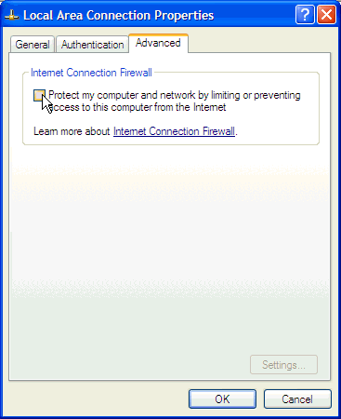

- Click OK.
These changes will take effect immediately and protect your network connection against many types of attacks. While ICF is very powerful, and it is highly recommended that you enable it, ICF is not a replacement for a true firewall. A firewall is a combination of software and hardware that is used to protect the primary internet connection of an organization. For more information on protecting your network with a firewall, see: http://www.microsoft.com/ISAServer/.

Using Antivirus Software
An antivirus software program will help protect your computer against most viruses, worms, Trojan horses, and other malicious code. Many new computers come with antivirus software already installed. However, antivirus software requires a subscription to stay up to date. If you don't have a current subscription for these updates, your computer is likely to be vulnerable to new threats. Computer viruses are programs that are loaded on to your system without your knowledge or approval. Viruses and other forms of malicious software have been around for years. Today's viruses can replicate themselves and use the Internet and e-mail applications to spread across the world within hours.
Antivirus software continually scans your computer for viruses and helps detect and remove them. Installing antivirus software only solves part of the problem - keeping the antivirus signature files up to date is critical to maintain a secure desktop or laptop.
User education regarding safe email practices is another critical step in preventing virus attacks. Users should not open an email or take action on an email attachment unless they are expecting the file. All email attachments should be scanned with the antivirus software prior to its execution.
For a list of the Software vendors that provide antivirus software compatible with Windows XP, refer to the following TechNet article: http://support.microsoft.com:80/support/kb/articles/Q49/5/00.ASP.

Keeping Up-to-Date with Security Patches
Your Windows XP operating system includes the Automatic Updates feature which can automatically download the latest Microsoft security updates while your computer is on and connected to the Internet. To get the most out of Automatic Updates, run a Windows Update scan on your computer first.
- Click Start, click All Programs, and then click Windows Update.
- Follow the directions on your screen. Windows Update will scan your machine and give you a pre-selected list of critical updates.
Tip: To reduce download times, run Windows Update when you will not be using your computer for other tasks. Your download times will vary depending on how long it has been since you last updated, the number and size of files being downloaded, and your modem speed. Slower modems may take several hours to download all recommended updates the first time you use Windows Update.
- Install the updates.
Tip: Some updates have prerequisites; therefore, you may be asked to install certain updates and then reboot your machine. Be sure to go back to Windows Update after rebooting to check for any additional downloads. You may need to do this several times.
Now that your Windows XP is up to date, establish a regular maintenance schedule with Automatic Updates.
◆ To configure your machine for automatic updates:
- On the Start menu, click Control Panel.
- Double-click System.
- Click the Automatic Updates tab, and then click to select the check box labeled: Keep my Computer up to date. With this setting enabled, Windows Update software may be automatically updated prior to applying any other updates.
- Select the option for Automatically download the updates, and install them on the schedule that I specify.
- Select the day and time for the updates to occur.
- Click OK to close the System Properties window.
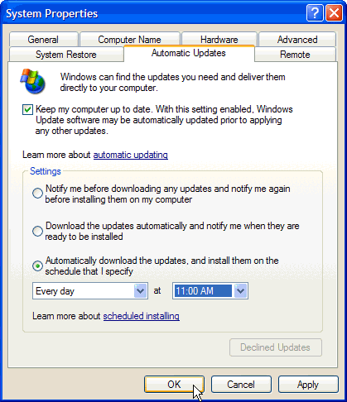

Once you enable Automatic Update, a message will appear above the Task Bar, notifying you when new patches, fixes, and updates are available for download. On your indicated schedule, the new updates are automatically applied to the computer.

Troubleshooting
When troubleshooting these recommendations, you may encounter error messages or, in severe cases, applications that do not work after the policies have been applied. This section provides you with several of the common error messages you may encounter, as well as information on returning the security configuration of the machine to a default state.

Common Error Messages
The following error messages may appear during the application of these policies.

Winzip Self-Extractor: Could not create…
When you attempt to extract the Windows XP Security Guide, you may receive an error message that says, "Could not create "<Path Name>/Windows XP Security Guide"– unzip operation cancelled." This message likely means that the account you are using does not have access to the path you have chosen. To correct this, log out and then log back in with an account that has administrative rights on the laptop or desktop.

Security Configuration and Analysis snap-in: Access is denied. Import Failed
This message may occur during the use of the Security Configuration and Analysis snap-in. It is usually an indication that the person performing the import of the template does not have administrative rights. Please ensure that the account you are using to apply the security templates has administrative permissions on the client.

Security Configuration and Analysis snap-in: An unknown error occurred…
When attempting to open an existing database with the Security Configuration and Analysis snap-in, you may receive the following error: "An unknown error occurred when attempting to open the database." This means the database may be configured with read only permissions. To resolve this, either create a new database by specifying a different name, or remove the read only permissions on the existing database.
If this error occurs when creating a new database, ensure that you are attempting to create the database in a location where you have adequate permissions to create new files.

Dialog Box: It is an offense to continue…
This is a generic, customizable statement used to deter unauthorized users from using your computer. Your legal advisor should approve this message for use on all of your desktop and laptop computers. For detailed information on how to modify this setting, please refer to page 61 of the Windows XP Security Guide.

NTFS Conversion: Convert cannot gain exclusive access…
When trying to convert a FAT16 or FAT32 partition to NTFS, you may receive the following message: "Convert cannot gain exclusive access to the drive letter drive, so it cannot convert it now. Would you like to schedule it to be converted the next time the system restarts? <Y/N>."
This issue occurs when the volume that you are attempting to convert is in use, for example, if the drive that you want to convert is the same drive on which Windows XP is running. To resolve this behavior, type Y at the command prompt. The volume or drive is converted to NTFS the next time you start your computer.

Returning to the Default Settings
If you encounter problems after the security templates have been applied, you can reset the security settings back to the operating system defaults.
◆ To restore the default security settings:
- On the Start menu, click Run, type cmd, and then click OK.
2. Type "secedit /configure /cfg %windir%\repair\secsetup.inf /db secsetup.sdb /verbose" (without the quotation marks), and then press ENTER.

This process may take several minutes to complete. After completion, you receive a message that states: "Task is completed. Some files in the configuration are not found on this system so security cannot be set/queried. It's ok to ignore." This is the expected behavior.

More Information
The following information sources were the latest available on topics closely related to securing Windows XP Professional at the time this guide was released to the public.
For more information on the Windows XP Security Guide, see:
http://go.microsoft.com/fwlink/?LinkID=14839.
For more information on methods to help protect your PC, see:
http://www.microsoft.com/security/protect/default.asp
For more information on the Threats and Countermeasures: Security Settings in Windows Server 2003 and Windows XP, see:
http://go.microsoft.com/fwlink/?LinkID=15159.
For more information on the Security Configuration Manager, see:
http://www.microsoft.com/technet/treeview/default.asp?url=/technet/prodtechnol/
windowsserver2003/proddocs/entserver/scm_analyze.asp.
For information on the Administrative Templates for Windows XP, see the following TechNet article:
http://www.microsoft.com/technet/treeview/default.asp?url=/technet/prodtechnol/
winxppro/proddocs/ADMinAD.asp.
For more information on Windows Automatic Updates, see the following TechNet article:
http://support.microsoft.com/default.aspx?scid=kb;EN-US;306525.
For more information on Internet Connection Firewall, see the following TechNet article:
http://support.microsoft.com/?kbid=283673.
For more information on upgrading to Windows XP:
http://microsoft.com/windowsxp/pro/howtobuy/upgrading/default.asp.

