Microsoft Office PowerPoint 2007

September 2006



Table of Contents

Cover is for   
position only

Overview of Microsoft Office PowerPoint 2007 1

Create Dynamic Presentations 1

Easily Share Presentations 2

Manage Presentations Efficiently 2

Create Dynamic Presentations 4

Microsoft Office Fluent User Interface 4

Custom Slide Layouts 5

SmartArt Diagrams 6

Graphics Effects 8

Rich Text and Typography 9

New Table and Chart Formatting 9

PowerPoint Themes and Office Styles 11

Easily Share Your Presentations 12

PowerPoint Slide Libraries 13

Increased Transparency Using the PowerPoint XML Formats 15

New Ways of Sharing and Collaborating 16

Save Office PowerPoint 2007 Presentations in New File Formats 16

Create a Review or Approval Workflow 17

Organize and Access Your Presentations 17

Collaborate on a Presentation Using Microsoft Office Groove 2007 17

New Options for Presenting to an Audience 19

Create a Custom Slide Show 19

Get More Setup Options 19

Provide Multiple Monitor View 19

Manage Presentations Efficiently 20

Finishing and Securing Your Presentation 20

Help Protect Your Private Information with the Document Inspector 20

Apply a Digital Signature 21

Information Rights Management 23

Manage and Keep Your Content Safer with Office SharePoint Server 2007 23

Records Management 23

Information Management Policies 23

Summary 24

Resources 25

System Requirements 26

# Overview of Microsoft Office PowerPoint 2007

Welcome to Microsoft® Office PowerPoint® 2007 presentation graphics program, included in the 2007 Microsoft Office system. Office PowerPoint 2007 gives you a powerful solution for all your presentation needs by making it easier to create impressive and dynamic presentations quickly. As a result, you save time formatting and creating content, so you can focus on the things that matter most.

Office PowerPoint 2007 offers many new and improved features. This document provides an overview that highlights these exciting features. It also gives you a close look at Office PowerPoint 2007 in action and provides guidance on specific features that demonstrate its new capabilities.

### Create Dynamic Presentations

Office PowerPoint 2007 makes it easier than ever to create dynamic and professional-looking presentations. The Microsoft Office Fluent™ user interface exposes features like never before, making tasks and options more accessible. Plus, new features—like in-the-box workflow and hierarchy graphics, PowerPoint Themes, custom layout support, and improved text effects and shape manipulation—help you to create more effective presentations.

* **New! The Microsoft Office Fluent user interface** makes it easier to create professional-looking presentations and boosts productivity.
* **New! Custom layouts** help you quickly create the precise layout you envision without being confined to one of the prepackaged standard layouts.
* **New! SmartArt™ graphics and other shape effects** give you the ability to add   
  3-D effects, glow, shadowing, and other powerful visuals to your presentation elements.
* **New! SmartArt diagram tools** help you create professional diagrams and flow models.
* **New! Rich text and typography effects** boost the impact of your design.
* **New! PowerPoint Themes** help you apply a consistent look to every graphic, font, and table color in an Office PowerPoint 2007 presentation with a single click.
* **New! Office Styles** help ensure a consistent appearance when you create Microsoft Office Word 2007 documents, Microsoft Office Excel® 2007 spreadsheets, and Office PowerPoint 2007 presentations.

### Easily Share Presentations

With the new Office PowerPoint 2007 features, you can easily share and reuse information with coworkers and peers.

* **New! PowerPoint Slide Libraries** help you publish and share slides and layouts while easily accessing content from other presentations.
* **New! PowerPoint XML Formats** are more compact, so you can share presentations more effectively.
* **New! Save as PDF or XPS functionality** gives you the ability to share your presentations with customers or clients on other platforms.[1]*
* **New! Initiate and simplify the review and approval workflow process** directly fromOfficePowerPoint 2007 by using Microsoft Office SharePoint® Server 2007.

### Manage Presentations Efficiently

Office PowerPoint 2007 can provide more effective ways to manage content. As a result, it is now easier to help ensure consistency across your company and comply with regulations.

* **New! Managed document repositories** can be accessed from within Office PowerPoint 2007, so you have greater control over presentation versions.
* **New! Digital signatures** enable you to apply a digital signature to Office PowerPoint 2007 presentations, so others can verify the content has not changed since it was published.
* **New! Document Inspector** helps ensure private data stays that way by helping you detect and remove unwanted comments, personal information, and hidden text.

Office PowerPoint 2007 in Action

Mark Hassall is the Director of Sales for Fabrikam, Corp., a manufacturing company. Mark oversees geographically dispersed members of the sales force. His team uses Office PowerPoint 2007 to create sales presentations, financial updates, and industry overview materials.

# Create Dynamic Presentations

Creating professional-looking presentations is easier than ever. Office PowerPoint 2007 has the Office Fluent user interface that makes developing presentations more intuitive and much faster. It also offers new and improved features such as new graphics capabilities and effects, PowerPoint Themes, and enhanced typography formatting tools. As a result, you can create great-looking, dynamic presentations in a fraction of the time you used to spend.

## The Microsoft Office Fluent User Interface

In previous releases, some features of PowerPoint were embedded in the toolbar layers. Users sometimes spent a lot of time searching for the tools and features they needed to complete the task at hand.

Like Office Word 2007, Office Excel 2007, and Microsoft Office Access 2007, Office PowerPoint 2007 features the Office Fluent user interface. The Office Fluent user interface makes it easier for you to produce your best work more quickly. Features that were once embedded in the toolbar are now more exposed. The Office Fluent user interface is complemented by the fact that the interface also organizes and presents PowerPoint contextual menus according to what you are doing.

Office PowerPoint 2007 recognizes the functionality you are currently using and then presents the tools within the Office Fluent user interface to satisfy your specific task needs. You do not have to navigate complex menus or open toolbars to make a small format change or change a drawing. The right tools are available when you need them.

Drop-down galleries easily present formatting options, graphic choices, layouts, and more. Live previews show you exactly what your changes will look like before you click or commit to anything.

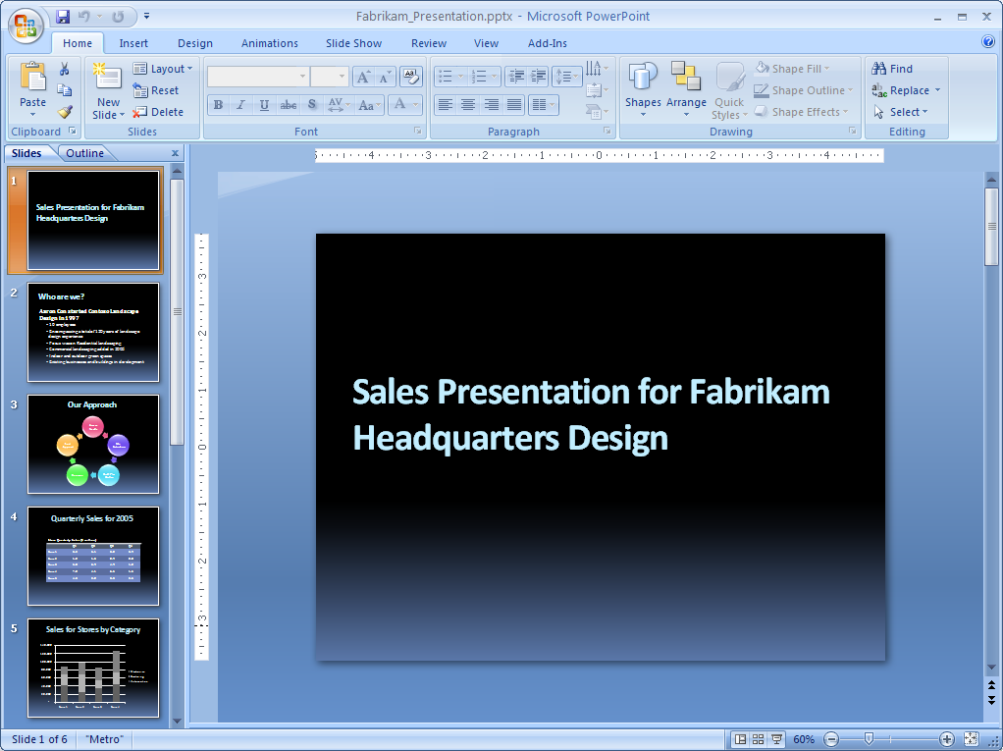

Figure 1: The Office Fluent user interface in Office PowerPoint 2007 presents features in a more intuitive manner.

Office PowerPoint 2007 in Action

Mark and his employees find the Office Fluent user interface in Office PowerPoint 2007 easy to use. No matter what task Mark performs—whether adding a chart or modifying a graphic—the tools he needs to work with that particular feature appear automatically. As a result, he can create presentations much more quickly.

## Custom Slide Layouts

With Custom Slide Layouts, you can create the type of layout you need when you need it so you are never confined to prepackaged layouts. This gives you the flexibility to create layouts that contain multiple elements—and you can even have multiple slide master sets with custom layouts for different slide topics. In addition, you always have the option of saving your layout for future use.

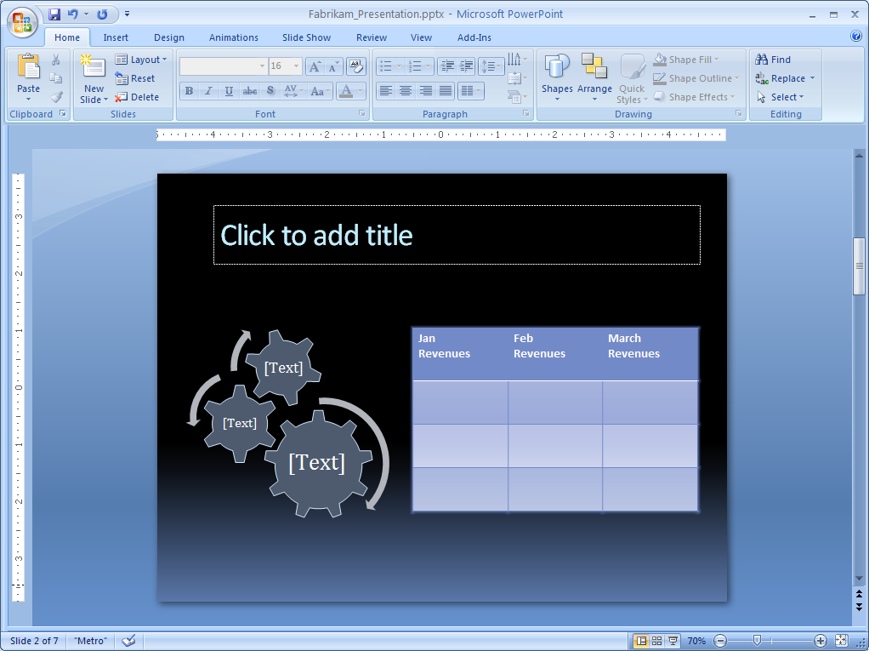

Figure 2: Custom Slide Layouts in Office PowerPoint 2007 help you customize your presentations quickly and easily.

Office PowerPoint 2007 in Action

Mark and his employees must use a company-approved layout for sales presentations to help ensure that all company presentations look the same and that clients consistently receive high-quality materials and information from Fabrikam, Corp. Using Office PowerPoint 2007, Mark can create and save a custom presentation layout.

## SmartArt Diagrams

Office PowerPoint 2007 features new powerful tools that help you create professional-looking presentations. Using SmartArt graphics, you can now add stunning visual effects to your diagrams and charts, including 3-D objects, shading, reflections, glows, and more.

These new graphical capabilities help you easily create diagrams from scratch, but also change an already determined set of bullet points into an appealing and effective diagram. All of the SmartArt diagrams are dynamic and can be adapted to your needs, so you are not confined to static and unmanageable graphics. These new diagramming capabilities are complemented by updated effects, presented in contextual menus as you work with the diagram.

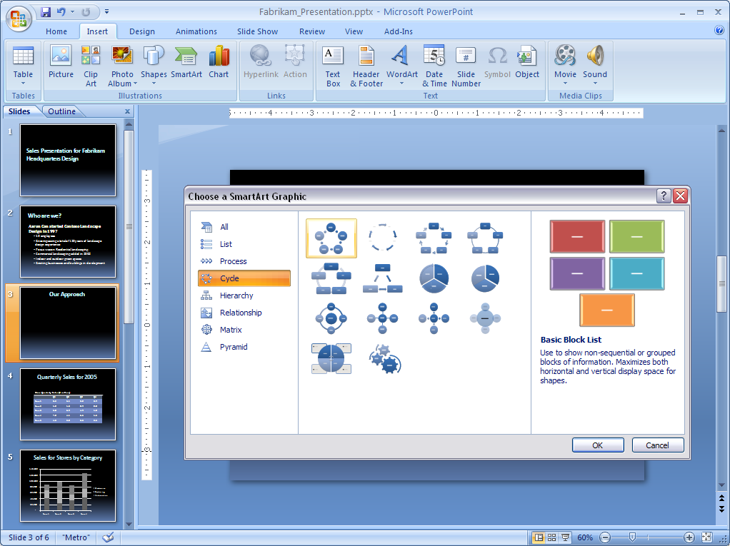

Figure 3: Out-of-the-box diagramming options in Office PowerPoint 2007 help you get started quickly.

Office PowerPoint 2007 in Action

In the past, Mark hired a professional designer to create his Office PowerPoint diagrams and charts. However, when Mark received the diagrams back from the designer, they were saved as images, so he could not edit the text or images. Now, with SmartArt diagrams, creating a diagram in an Office PowerPoint 2007 presentation is a snap. Plus, Mark can edit and modify them as he needs.

## Graphics Effects

With improved SmartArt graphics effects, you can add impact to existing graphics or easily modify new graphics in your presentations. Effects that were previously most accessible to graphic designers are now put in your hands through the style galleries presented in the contextual menus. Whatever option you choose, you can rest assured that the effects you add to all your graphical elements look professional and are easy to work with. Specific graphic features include:

* New effects like 3-D, shadow, glow, warp, bevel, and more.
* Improvements in drawing alignment, selection, and direct manipulation of objects.

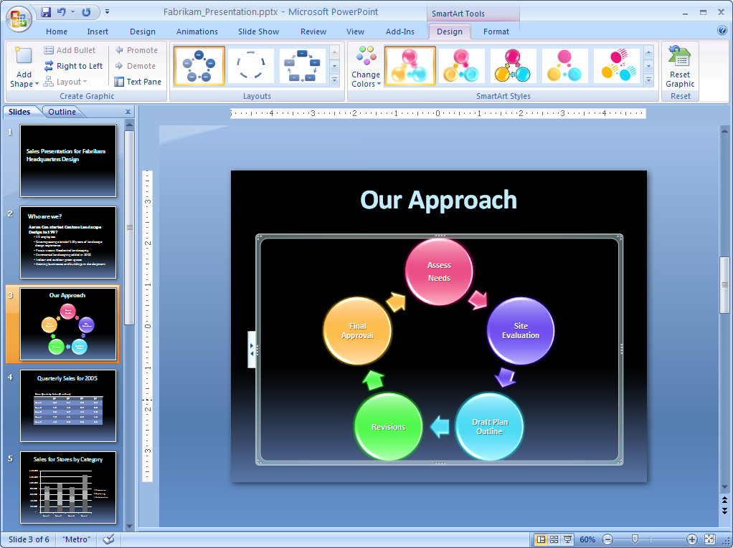

Figure 4: Use the new diagramming and effects capabilities in PowerPoint to add impact to your presentations.

## Rich Text and Typography

Crisp text is a hallmark of professional design, and Office PowerPoint 2007 brings rich typography directly to your computer. Whether or not you are an advanced PowerPoint user, you can create professional-looking presentations with a wide range of features that include:

* Text wrapping within a shape.
* Text in columns or running vertically down the slide.
* Paragraph-level rulers.
* The ability to select discontinuous text.

Using Quick Styles, you can change how your presentations look with a single click of the mouse. You can modify fonts, colors, effects, and other elements by choosing a different format. Simply select the text you want to change and then choose the style you want from the style gallery.

Office PowerPoint 2007 also has new character styles to provide you with more choices. You can choose from all the standard styles of previous releases of PowerPoint as well as:

* All caps or small caps.
* Strikethrough or double strikethrough.
* Double or color underline.
* Fills, lines, shadows, glow, and 3-D effects on text.
* Highlighting.

## New Table and Chart Formatting

The way PowerPoint tables and charts work has been redesigned to make them much easier to manipulate and edit. The contextual menus and Office Fluent user interface give you easy-to-find options to edit your tables and charts. Additionally, the style galleries present all the effects and formatting tools you need to create professional-looking tables and charts. This new functionality works so that cutting and pasting data, charts, and tables from Office Excel 2007 works even more smoothly than previously, helping to ensure that your presentations have the same look as your spreadsheets.

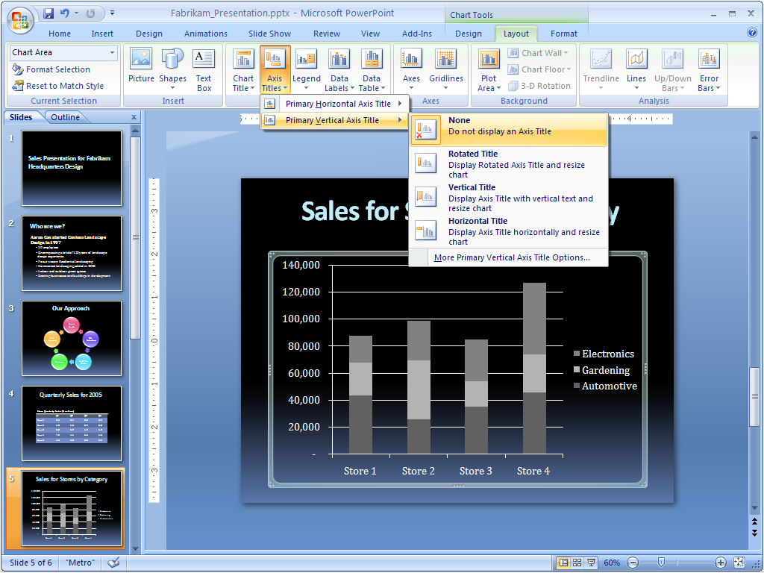

Figure 5: Easily modify your chart data using contextual menus.

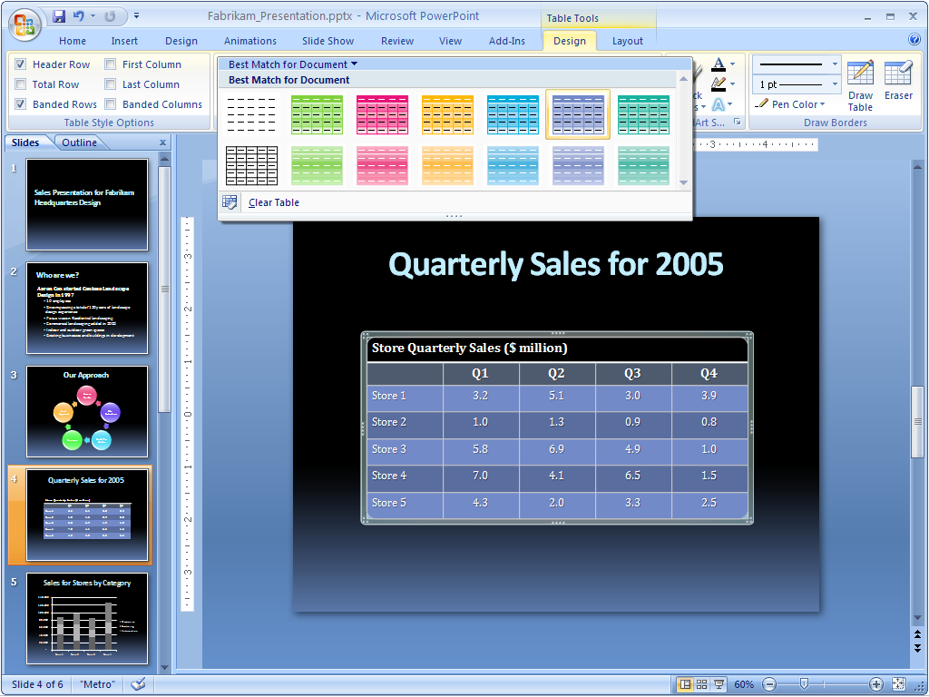  
Figure 6: Easily modify the look of your table using style galleries.

Office PowerPoint 2007 in Action

With the new contextual menus and formatting capabilities available in Office PowerPoint 2007, creating consistent, powerful presentations is simple. Now Mark can easily format his charts and tables in Office PowerPoint 2007 using improved styles and effects.

## PowerPoint Themes and Office Styles

PowerPoint comes with new, out-of-the-box themes, layouts, and styles that give you a wide range of options when formatting presentations. In the past, formatting a presentation could take time as you chose color or style options for your tables, charts, and graphics to match one another. PowerPoint Themes simplify the process of creating presentations. Simply select the theme you want, and Office PowerPoint 2007 does the rest. With one click, the background, text, graphics, charts, and tables all change to reflect the theme you have selected, helping ensure that all elements in your presentation complement one another.

This same process also works even if you have already selected a theme. After a theme has been applied to your presentation, the style and formatting galleries change to adapt to that particular theme. As a result, any new diagrams or graphics you insert into the presentation will automatically match your existing theme.

With Office Styles, you can choose to apply the same color scheme to your presentations that you use in your documents and spreadsheets. With a consistent color scheme, all your materials can look consistent and professional.

**Office PowerPoint 2007 in Action**Mark can now add a theme to presentations that have already been created. With one click he can apply a consistent appearance to all presentation elements like tables, diagrams, text, and background. Mark finds that PowerPoint Themes are a great way to format and finalize presentations so that they present a uniform and professional appearance.

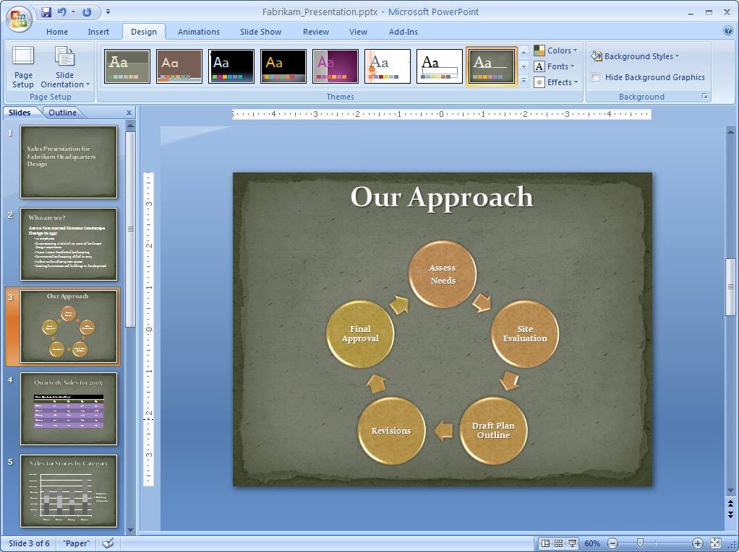

Figure 7: Help ensure your presentation is consistently formatted and has a professional look by using PowerPoint Themes.

# Easily Share Your Presentations

The exponential growth in electronic data has increased the drain on local and server storage. In previous releases of PowerPoint, large file sizes made it difficult to share content or send presentations through e-mail. Moreover, presentations could not be reliably shared with users on different platforms.

New features in Office PowerPoint 2007 now make it easy to share and reuse presentations. PowerPoint Slide Libraries simplify sharing presentations and the content within them, while a shift to the PowerPoint XML Format reduces file size. You can also save presentations as a Portable Document Format (PDF) or as an XML Paper Specification (XPS) file, giving you even more sharing options for effectively collaborating on your work.

## PowerPoint Slide Libraries

Using Office PowerPoint 2007 with Office SharePoint Server 2007 provides you with even richer capabilities for sharing presentations through PowerPoint Slide Libraries. This new feature gives you one centralized storage area for all your personal or team presentations. In fact, you can publish presentations directly to a PowerPoint Slide Library from Office PowerPoint 2007. Because the sites have the same look as Microsoft Windows® SharePoint Services sites you are already accustomed to, it is easy to navigate the site and repurpose the information stored there.

PowerPoint Slide Libraries also reduce the need to re-create content because you can easily repurpose existing content stored in a PowerPoint Slide Library. This way, if you or your teammates have created a presentation and you need one or two slides, it is easy to insert this content into your presentation without ever having to leave PowerPoint. In this respect, PowerPoint Slide Libraries remove many of the inefficiencies associated with trying to repurpose content while managing multiple presentations stored in different locations.

Additionally, you can even create new presentations from an existing slide set. After you enter the PowerPoint Slide Library, you can select individual slides to send to PowerPoint so that you can easily create a new presentation without any unnecessary steps. PowerPoint Slide Libraries offer the added advantage of helping ensure that your content is up-to-date because you can choose to link slides in your presentation to the server version. If the server version changes, you are automatically prompted to update your slides. This is very similar to how storing documents in Microsoft Office SharePoint Portal Server 2003 document libraries works today.

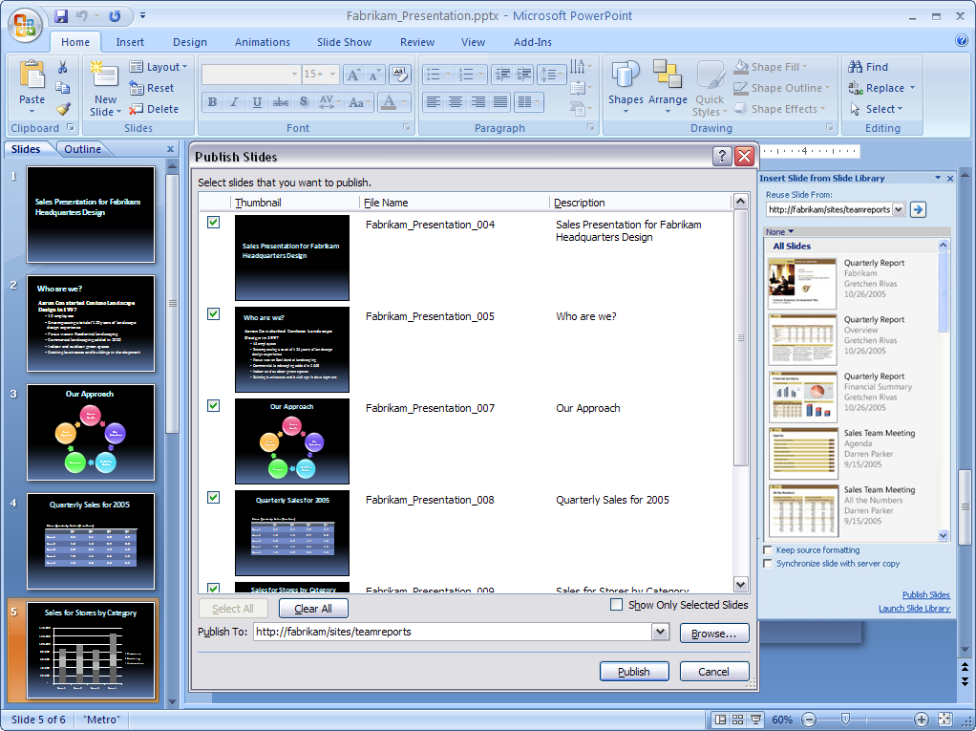

Figure 8: Easily choose which slides you want to publish to your team’s PowerPoint Slide Library.

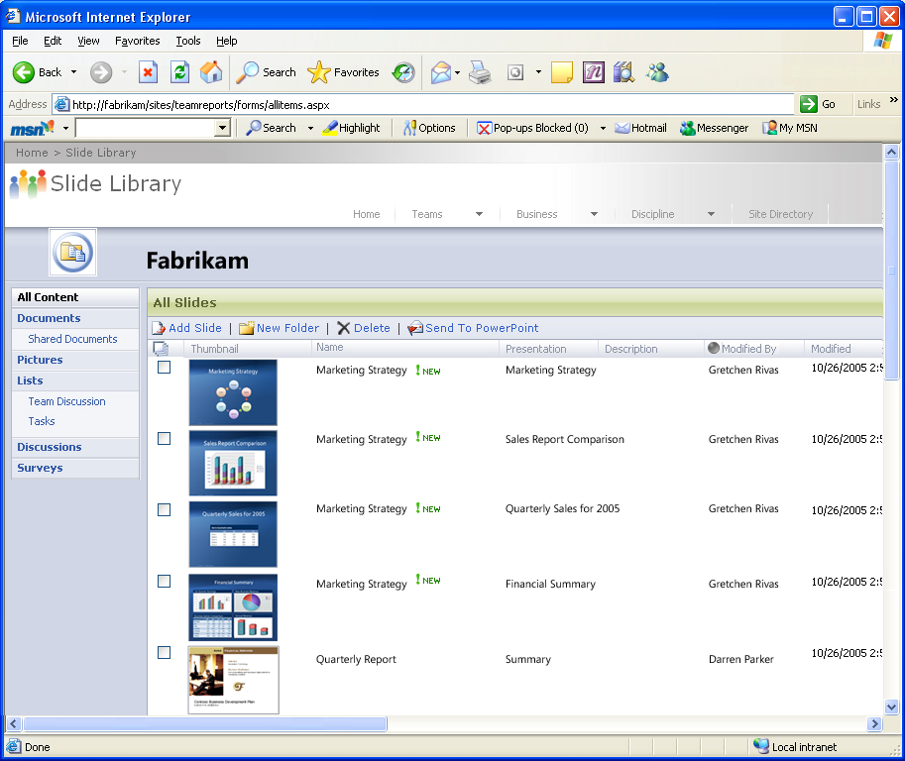

Figure 9: Use a PowerPoint Slide Library to share and help ensure your information is up-to-date.

## Increased Transparency Using the PowerPoint XML Formats

Companies are storing more information online, and unfortunately, large presentation files increase the drain on local and server storage. As a result, many companies are hindered from actively sharing their presentations to reuse content and collaborate more effectively. The new PowerPoint XML Formats help solve this issue while providing many other benefits.

PowerPoint XML Formats are a published file format specification intended to provide an open, transparent environment that makes it possible for any technology provider to integrate PowerPoint presentations or other Microsoft Office system documents into their solutions.

PowerPoint XML Formats are a compact, robust file format. Because the file formats are compressed, they yield substantially smaller file sizes, reducing storage and bandwidth requirements. Segmented data storage within the file formats greatly aids the recovery of corrupt documents, because the corruption of any part of the document does not prohibit the remainder of the document from being opened.

PowerPoint XML Formats represent a new level of transparency and openness for PowerPoint. You now have the benefits of connectivity and integration built directly into your presentations and delivered in a package that is more compact, efficient, and stable than ever before.

Office PowerPoint 2007 in Action

Mark encourages his sales force to share and repurpose information. Every time a team member creates a new PowerPoint presentation, he stores it in a team PowerPoint Slide Library for others to view and use. If Mark creates a presentation using some of his teammates’ content, he can also choose to synchronize his slides with the version located in the PowerPoint Slide Library. This way, Mark is confident that he is working with the most up-to-date information.

## New Ways of Sharing and Collaborating

Whether you need to share presentations with people who do not use Office PowerPoint 2007, create approval and review workflows, or collaborate with others online, Office PowerPoint 2007 offers new ways to share and collaborate.

### Save Office PowerPoint 2007 Presentations in New File Formats

Sometimes you may need to save your PowerPoint presentation in a “fixed” file format so that other people who may not have PowerPoint can view it. PowerPoint now supports saving your document as a PDF or as an XPS file. Now you can post your presentations on the Internet or share them with others knowing that they can view them regardless of the type of computer or applications they are using.

### Create a Review or Approval Workflow

After creating presentations, you may send them in an e-mail message to colleagues to gather feedback. When you need to get feedback quickly, you want to route the document to the right people without having to deal with complicated interfaces or cumbersome tools. Now you can take advantage of the review or approval workflows available from Office PowerPoint 2007 and Office SharePoint Server 2007.

To initiate a review or approval process, simply select the appropriate SharePoint workflow from within Office PowerPoint. The workflow creates a task for participants and sends an e-mail message notifying them that they have a new document to review. After they open the document and complete the review, participants can indicate its status on a workflow completion form.

### Organize and Access Your Presentations

For companies who have a great number of mobile or remote workers, storing presentations in SharePoint document libraries and then connecting them to the Microsoft Office Outlook® 2007 messaging and collaboration client is an excellent option. By connecting data to Office Outlook 2007, you can easily manage your information and work with it offline. Then, when you are back at the office, it is easy for you to tell which documents have changed so that you can synchronize your files with the versions on the SharePoint site.

### Collaborate on a Presentation Using Microsoft Office Groove 2007

Microsoft Office Groove® 2007 is a new addition to the Microsoft Office system that helps team members set up collaborative workspaces. Virtual team members can complete projects on time and within budget by making it easier to share information and work together with enhanced security. Office Groove 2007 keeps everyone up-to-date and helps them work together effortlessly anywhere, online or offline, with colleagues, partners, and customers.

With Office Groove 2007, you can easily co-review your presentation in real time. Simply set up a Groove workspace so that you can present and view your presentation collaboratively with others. This way, you can update materials quickly and easily with others.

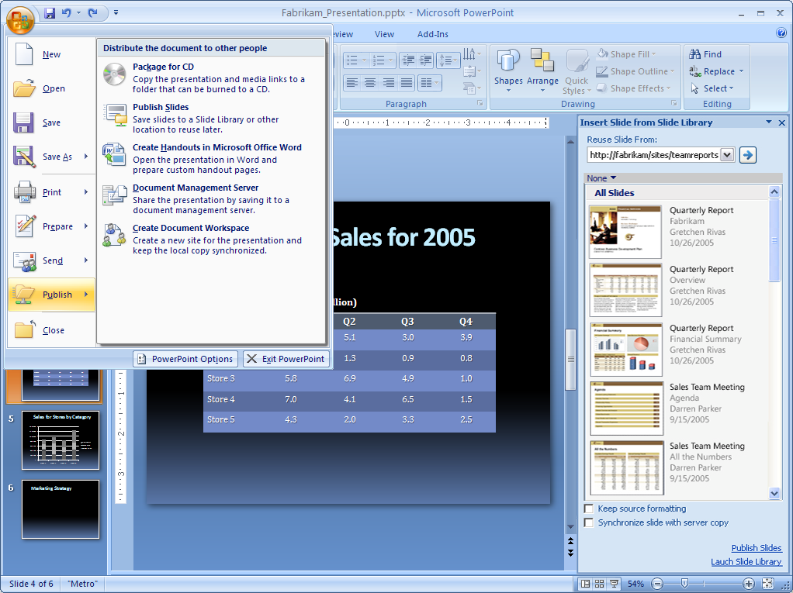

Figure 10: PowerPoint makes it easy for you to share your presentation in a multitude of ways.

Office PowerPoint 2007 in Action

Mark’s team often saves presentations as PDFs. This is particularly helpful when they send a presentation to a prospective client because they know the recipient can open the file, no matter what programs they might be using.

## New Options for Presenting to an Audience

The Office Fluent user interface in Office PowerPoint 2007 makes it easy to find features that help present and tailor each presentation based on how you need to use it. You can create custom presentations based on existing materials, use exciting new features to make your presentations more compelling, and set up different views so that the presenter has one view and participants another.

### Create a Custom Slide Show

Create custom slide shows based on existing presentations. This feature helps you present exactly what you need—without having to skip slides or fast forward through the presentation. You can also save your custom slide show for later use.

### Get More Setup Options

With more setup options, you can create compelling presentations quickly and easily. Set up your slide show with advanced options like rehearsed timings, setting a presentation on a continuous loop, and determining which slides in a presentation to show.

### Provide Multiple Monitor View

With the Office Fluent user interface, it is easy to locate and start using Presenter View, which uses multiple monitors to provide one view for the presenter and another for the audience. The presenter has insight into upcoming slides, timing, and speaker notes, while the audience only sees the full view of the slide.

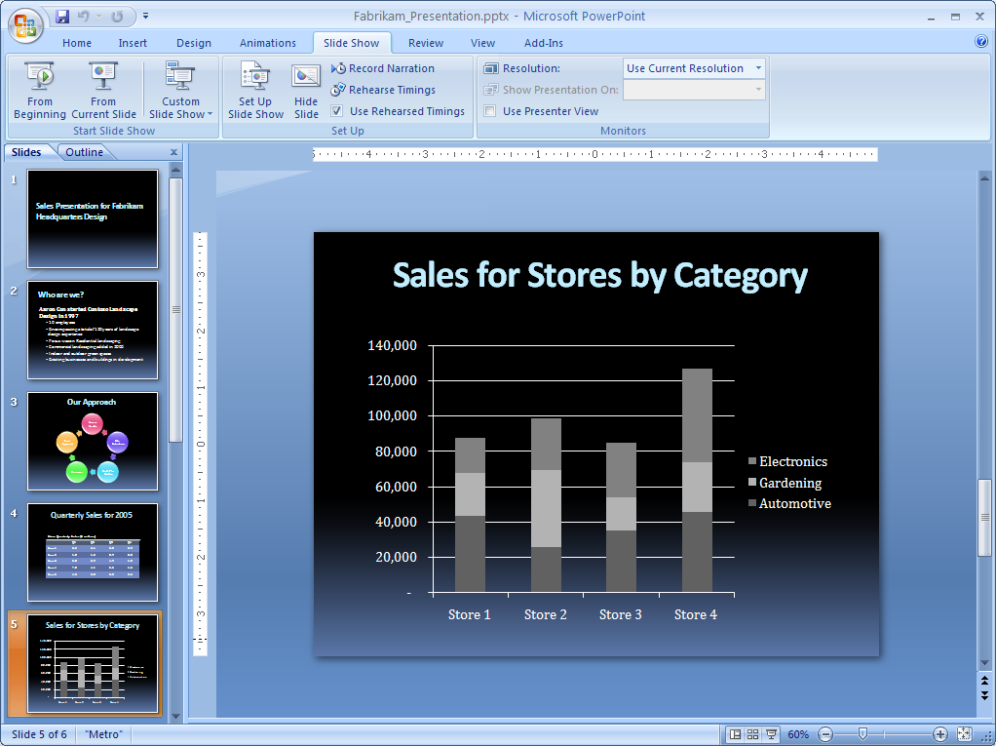

Figure 11: Use the Slide Show tab on the Office Fluent user interface to explore your advanced setup options.

# Manage Presentations Efficiently

Companies are increasingly challenged by compliance regulations. Although many have started using electronic business and document management processes, it can be difficult to start managing and auditing electronic business records.

When a presentation has been completed and is ready to be shared, you need to be confident that it is not inadvertently shared with people who should not see it. You should also be confident that your presentation does not include unintentional content or editing marks that call out words that the recipient’s dictionary does not recognize. Furthermore, you should be able to restrict access to the content within your presentations that may include potentially sensitive information that may come to light after they have been publicly distributed. Finally, you may also need to indicate that your presentation is the document of record that indicates an official company policy or procedure for a given topic.

Using Office PowerPoint 2007, there are many more ways for users to help protect and manage their information.

## Finishing and Securing Your Presentation

Sometimes you may not want to show who authored a presentation, or you need to make sure that all comments have been removed. Also, you might need to help protect your intellectual property by limiting who can modify a presentation. With a number of new security features in Office PowerPoint 2007, you can help ensure that your presentation is safely managed after it leaves your hands.

### Help Protect Your Private Information with the Document Inspector

The new Document Inspector feature scans your presentation and gives you the opportunity to choose whether or not you want to remove personally identifiable information, comments, and tracked changes. It can also search for and remove hidden text. For people who want to inspect their PowerPoint presentations for specific types of information, the Document Inspector is designed so that organizations with specialized needs can develop these custom modules. For example, a pharmaceutical company might want to examine all outbound documents to help ensure that they do not contain patient names.

### Apply a Digital Signature

Documents like contracts or formal notices often require someone’s signature. Traditionally, these documents include a line for each signature and are printed so that they can be signed. In today’s world of document management, these signed pieces of paper are then scanned to create a digital record of the signature. Although this method of signing is tried and true, it can be time-consuming and cumbersome as the paper is sent from person to person.

Office PowerPoint 2007 introduces the ability to insert asignature line into documents. This signature line looks like a typical signature placeholder in a document, but it works differently. When the signature line is inserted, the author is asked for information about the intended signer and is given an opportunity to provide instructions for that person. The recipient sees the signature line and a notification that his or her signature is requested.

The signed document includes an image of the signature, so it looks similar to a page that has been printed and signed. However, the difference is that a digital certificate is used to provide a record of exactly what was signed. With this technology, the signature can be verified in the future. This feature can then also be used with the Signature Collection workflow in Office SharePoint Server 2007 to notify recipients and track the progress of each signer.

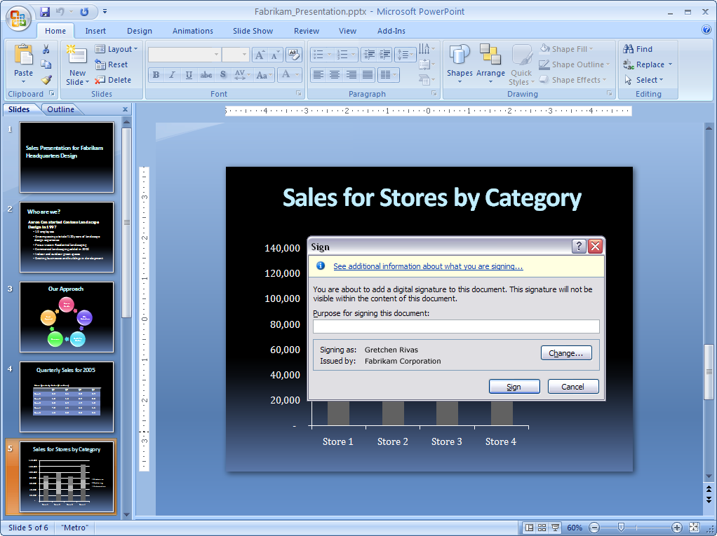

Figure 12: Certify content by adding a digital signature to your file.

Office PowerPoint 2007 in Action

When members of the sales force are finished creating a presentation, they use several features in Office PowerPoint 2007 to help protect their content. First, they use the Document Inspector to remove all information that identifies who created the document and make sure no comments or hidden text remain in the final document. This is a particularly important feature for Fabrikam, Corp., because it ensures no proprietary information is included in presentations. Team members can then apply a digital signature to verify the content of the document.

## Information Rights Management

You may need to control who can access company information, especially if you create presentations with highly confidential information. By using the Microsoft Office system with the Windows Rights Management Services of Microsoft Windows Server® 2003, you can assign permissions that prevent others from copying, printing, or editing your presentation.

## Manage and Keep Your Content Safer with Office SharePoint Server 2007

It can be extremely challenging to implement consistent information management policies across an organization that has a wide range of sites. To solve this issue, Office SharePoint Server 2007 empowers policy decision-makers—such as IT staff, records managers, or compliance officers—to define site policies that users can apply without worrying about the specific details. Each site policy can include any number of settings, like expiration, labeling or auditing. As a result, you can add an extra layer of security to your presentations by designating access to them. For example, if you only want to allow a certain department access to presentations, you can easily define it to require the right credentials.

### Records Management

Office SharePoint Server 2007 provides a managed document repository built on Windows SharePoint Services to store the document record or the master document. You can upload presentations to the records repository directly from Office PowerPoint 2007. As a result, you have greater control over each of your presentations.

### Information Management Policies

When using Office SharePoint Server 2007, information management policies provide controls that consistently enforce the labeling, auditing, and expiration of presentations. You can configure policies for a specific storage location or content type. For example, organizations can help ensure that all presentations are stored the same way by setting the expiration dates on common criteria, such as the end of the fiscal year.

Office SharePoint Server 2007 supports a set of information management policies that can be defined for an entire site or a specific list, library, or content type. You can also create a policy statement that informs users how the content is governed. For PowerPoint presentations, this policy statement is embedded in the presentation. For instance, the policy statement might indicate that a document will expire after a certain period of time or that it is sensitive information that should not be communicated outside the company. It can even provide a contact name if the recipient needs more information.

# Summary

Office PowerPoint 2007 provides many enhancements and new capabilities over previous versions. With an emphasis on more professional presentations that are easier to create, Office PowerPoint 2007 puts the power of design into your hands. The result is that you can create more effective, professional-looking presentations quickly and easily.

With Office PowerPoint 2007, you can share and reuse information so that you do not waste time re-creating presentations or working with information that is out of date. With Office PowerPoint 2007, you get the tools you need to easily format and create high-impact presentations. As a result, it is easier for you—and everyone in your company—to create professional-looking presentations more quickly.

# Resources

For more information about Office PowerPoint 2007, please visit

<http://www.microsoft.com/office/powerpoint>.

# System Requirements

For complete system requirements, visit <http://www.microsoft.com/office/powerpoint>.

This document is developed prior to the product’s release to manufacturing, and as such, we cannot guarantee that all details included herein will be exactly as what is found in the shipped product. The information contained in this document represents the current view of Microsoft Corporation on the issues discussed as of the date of publication. Because Microsoft must respond to changing market conditions, this document should not be interpreted to be a commitment on the part of Microsoft, and Microsoft cannot guarantee the accuracy of any information presented after the date of publication. The information represents the product at the time this document was printed and should be used for planning purposes only. Information is subject to change at any time without prior notice.

This document is for informational purposes only. MICROSOFT MAKES NO WARRANTIES, EXPRESS OR IMPLIED, IN THIS DOCUMENT.

© 2006 Microsoft Corporation. All rights reserved.

Microsoft, Excel, Groove, the Office logo, Outlook, PowerPoint, SharePoint, SmartArt, Windows, and Windows Server are either registered trademarks or trademarks of Microsoft Corporation in the United States and/or other countries. All other trademarks are property of their respective owners.

1. * You can save as a PDF or XPS file from a 2007 Microsoft Office system program only after you install an add-in. For more information, see [Install and use a PDF or XPS add-in](http://r.office.microsoft.com/r/rlidOOPDFXPSAddin?clid=1033).