“The drive to upgrade came from our employees. They were familiar with the benefits of using Office Outlook and wanted to use it in their everyday work.”
Customer: Dnevnik
Web Site: www.dnevnik.si
Number of Employees: 350
Country or Region: Slovenia
Industry: Publishing and printing
Partner: Alarix

Customer Profile
Dnevnik has more than 50 years’ experience of publishing in Slovenia. It employs 350 people to create a range of print and electronic magazines and newspapers.

Software and Services
- Microsoft Server Product Portfolio
- Microsoft Exchange Server 2007
- Windows Server 2008 Standard
- Microsoft Office
- Microsoft Office Outlook 2007

For more information about other Microsoft customer successes, please visit: www.microsoft.com/resources/casestudies
Igor Dolenc, IT Manager, Dnevnik
Slovenia-based publishing company Dnevnik wanted to upgrade its existing open-source messaging system. By engaging with Microsoft Gold Certified Partner Alarix, it deployed Microsoft® Exchange Server 2007 and Microsoft Office Outlook® 2007 messaging and collaboration client. Company employees now benefit from greater efficiency, collaboration, and data security, and make use of improved remote working features.

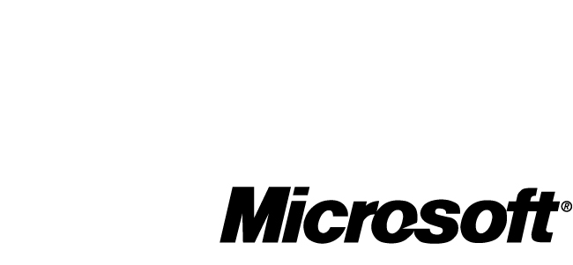

Business Needs
Established in 1951, Dnevnik is a Slovenia-based newspaper publisher that employs 350 people to create print and electronic publications, which are read daily by thousands of people in the country. Its main publication is the Dnevnik, a daily newspaper selling more than 150,000 copies a day. The company produces additional supplements, magazines, and Web sites, extending its circulation to advertisers.

Dnevnik mainly comprises journalists and managerial staff who use business technology to write and publish stories, manage production, and collaborate effectively. One of the most important tools is the employees’ use of e-mail to share documents and keep up to date with current

events. The company used Postfix—an open-source mail transfer agent that runs on the UNIX operating system—as its e-mail system. Deployed on a single server, employees had to access their messages using the Post Office Protocol 3 (POP3) with different e-mail clients.

This solution presented a number of challenges. Mobile users found it difficult to access their messages from outside the office using POP3 and the different e-mail clients. In addition, the system was difficult to manage. For example, user accounts in the messaging environment had to be controlled separately, which wasted the administrators’ valuable time. Plus, the solution didn’t provide full protection for data.
Dnevnik needed a new messaging solution that was more reliable and capable than its existing system. It had to offer centralised e-mail archives and increase security for users accessing e-mail outside the network. The company also wanted to give employees a greater number of ways to access e-mail, such as through a mobile phone.

Igor Dolenc, IT Manager at Dnevnik, says: “We wanted to create a more productive environment that simplified system maintenance, supported mobile e-mail access, and achieved a high return on investment.”

Solution
In 2008, Dnevnik worked with systems integration specialist Alarix to find a replacement messaging system. Alarix proposed that the organisation migrate from a mixed client base to a unified user environment on Office Outlook 2007. So Dnevnik replaced the Postfix e-mail system with Exchange Server 2007, running on the Windows Server® 2008 Standard operating system. All company desktop clients were replaced with Office Outlook 2007, which employees use to manage personal information, such as e-mail, contacts, tasks, calendars, and RSS feeds.

Administrators use the Standby Continuous Replication (SCR) function to replicate information from the production server to a second server running in stand-by mode. If the first server fails, the second server activates, ensuring that important messages reach their destination.

To improve security, Dnevnik implemented a feature to block certain attachments, including malicious programs and potential viruses. This approach prevents high-risk content from reaching end users. IT employees deployed certificates to secure access to the Exchange Server so personnel can safely use e-mail even if not connected to the company network.

Tadej Verk, Technical Manager at Alarix, says: “During the implementation, we had to ensure the existing e-mail system operated without interruptions, which meant it had to be running during the deployment and activation of the servers. This was
done by forwarding e-mail from the existing server to the Exchange servers and then removing the POP3 accounts from the Postfix server.”

Benefits
By deploying Office Outlook 2007 and Exchange Server 2007, Dnevnik has not only increased employee efficiency and collaboration, but also simplified administrative tasks. Dolenc says: “The drive to upgrade came from our employees. They were familiar with the benefits of using Office Outlook and wanted to use it in their everyday work.”

- Increases employee efficiency. Office Outlook 2007 provides users with a unified interface, which combines all personal information—e-mail, contacts, calendars, and tasks—in one place. Now, employees can efficiently manage this information, resulting in better performance and work satisfaction.
- Improves remote working. By deploying Office Outlook 2007 and Exchange Server 2007, the company enhanced the mobility of its users. With Microsoft Office Outlook Web Access, they can open their e-mail accounts through a Web browser. Also, employees can use various mobile devices and telephones to access their messages and other data.
- Enhances functionality. “Users save time by previewing e-mail attachments,” says Dolenc. “They can view Word, Excel, PowerPoint, and Adobe Acrobat files without needing to download additional software, helping them work more productively.”
- Boosts collaboration. Employees can now view their colleagues’ shared calendars, coordinate their time more effectively, and easily exchange information and collaborate.
- Simplifies administration. The Active Directory® service and Exchange Server 2007 integrate with each other so that users can enter their network username and password to connect to the e-mail server. Administrators no longer have to maintain two separate directories for usernames and access rights.
- Strengthens security. E-mail messages are no longer located on individual computers, but are archived centrally on the servers, reducing data loss and replication. The system also features an offline mode so employees can access e-mail messages even if the server or Internet connection fails.

