Windows Azure
Customer Solution Case Study
 |  |  |   Firm Uses Internet Service Bus to Enable Smart Grid for Dynamic Energy Savings

Overview  Country or Region: United States  Industry: Utilities  Customer Profile  Invensys Operations Management provides automation control solutions to companies in the manufacturing and infrastructure industries. Based in Plano, Texas, the company has 9,000 employees.  Business Situation  Smaller electric utilities want to participate in a U.S. energy-saving initiative called smart grid, which requires a cost-effective, scalable, secure way to share pricing data with customers.  Solution  Invensys used The Service Bus and Access Control Service features, part of the Windows Azure™ platform, to build the Smart Grid Pilot, demonstrating Internet-scale communications.  Benefits  - Immediate implementation of smart grid applications  - Richer, real-time information  - Massive scalability  - Faster, low-cost development |  |  | “The Service Bus provides the security, interoperability, and performance required for large-scale smart grid applications, at a significantly lower cost than building data centers.”  David Hardin, Staff Engineer, Invensys Operations Management
 |  |  | Invensys Operations Management is out to make it easier and less expensive for small electric utilities in the United States to participate in smart grid, an energy modernization program supported by the U.S. government. Utilities need a high-performance, low-cost way to distribute real-time pricing data to customers so that they can make smarter consumption decisions. Invensys responded by creating a smart grid communications platform using The Service Bus and Access Control Service, both part of the Windows Azure™ platform. The resulting platform enables utilities to immediately embrace smart grid services at affordable prices. Such services will help utility customers save money by using energy more wisely. Invensys developed its pilot solution in just three months as part of a plan to realize increased revenues from selling smart grid–compliant products and services.
 |  |  | 

Situation
What if homeowners had their electric meter posted on their kitchen wall, instead of on the side of their house, with a running total of how much electricity every device was using and how much it was costing? They might make smarter usage decisions. What if industrial businesses had the same electrical usage data flowing to them in real time, complete with pricing information, so that they could dynamically monitor and adjust electricity consumption? Even better, what if their electrical devices had smart controls that would turn off, cut back on energy usage, or load-balance when electrical prices were highest?
“Everything else we interact with is on a pricing basis—the more expensive something is, the less we are inclined to use.”
David Hardin, Staff Engineer, Invensys Operations Management

This is the idea behind smart grid, an electricity conservation and distribution concept that has been discussed in the utility industry for years. The concept finally gained traction when the United States Congress passed a law in 2007 that includes provisions for smart grid technology, including smart energy metering and distribution; dynamic optimization of grid operations; and standards for communication and interoperability of appliances, equipment, and electrical infrastructure. The bill’s ultimate goal is to protect national security by maximizing use of domestic energy sources and reducing dependence on foreign energy.

There are multiple technical challenges in bringing smart grid to fruition. Utilities need to upgrade and expand the nation’s electrical infrastructure to reliably and securely deliver power from a variety of energy sources, including not only coal, water, and oil, but also wind and solar power.

They also need to figure out how to deliver constantly changing pricing data in near real time to huge numbers of customers over a broad geographic area using a wide variety of existing network infrastructures.

The U.S. government is creating and mandating standard formats for electricity pricing data as it moves through a lengthy supply chain from regional transmission operators to aggregators for retail markets, to local utilities, and finally to residential, commercial, and industrial customers. However, there has been no common, scalable, and affordable communications infrastructure for communicating this data up and down the supply chain.

“Everything else we interact with is on a pricing basis—the more expensive something is, the less we are inclined to use,” says David Hardin, Staff Engineer at Invensys Operations Management, a manufacturer of process control devices used in smart grid applications. “The trick is getting prices to people in near real time so that they can adjust their usage patterns.”

Invensys Operations Management is working hard to make smart grid a reality. The company is a leading provider of automation and information technology, systems, software, services, and consulting for the global manufacturing and infrastructure industries. Headquartered in Plano, Texas, its solutions are used by more than 40,000 customers around the world in more than 200,000 plants and facilities. The company has approximately 9,000 employees and is a division of London-based Invensys, which makes industrial and railway control systems.

Invensys already provided many electric utilities with process-control and automation products and services, and it wanted to help smaller utilities better monitor the health of their power grid and participate in the smart grid initiative. Of the 3,100 utilities in the United States, the largest have modern data centers, but the vast majority does not. They are municipal utilities or cooperatives that do not have the compute resources to manage smart grid services.

“Making smart grid a reality has required that utilities have a significant computational capacity to receive, calculate, and rebroadcast pricing data to its constituents,” Hardin says. “We wanted to help these smaller utilities participate in smart grid right away without waiting for years or making large capital investments.”

Solution
As a Microsoft® Global Independent Software Vendor, Invensys learned from Microsoft in 2008 about the Windows Azure™ platform, a “cloud” services platform hosted in Microsoft data centers that provides development, computing, storage, and communications services for creating scalable, pay-as-you-go Internet services.

Enterprise Service Bus at Internet Scale
Invensys was immediately captivated by the Service Bus feature as a mechanism for solving the data communications challenges involved in smart grid. “We evaluated Amazon EC2 and Google cloud products, but no one had anything comparable to the Service Bus,” Hardin says. “The Service Bus has the functionality, interoperability, and scalability required to provide a communications infrastructure that can be used for large-scale smart grid applications. The Service Bus and Access Control Service are services that do not exist in other cloud offerings.”
“The Service Bus is essentially an enterprise service bus in the Internet. It can be accessed widely and securely, paid for as used, and expanded as needed.”
David Hardin, Staff Engineer, Invensys Operations Management

The Service Bus makes it easy to connect applications over the Internet. Services that register on the Service Bus can easily be discovered and accessed across virtually any network topology.

Access Control Service provides authorization services for applications connecting over the Internet. It provides an easy way to control Web applications and services while integrating with standards-based identity providers. Authorization decisions can be pulled out of the application and placed in a set of rules that can transform incoming security claims into claims that applications understand.

The concept of service bus middleware—integrating application services using service-oriented architectural patterns—has been around the utility industry for years. Utilities are widely adopting enterprise service buses as they upgrade their information technology infrastructures to integrate newer smart grid functionality. Enterprise service buses provide the messaging “glue” that permits a service to find and efficiently use other services through a directory or registry structure.

While enterprise service buses provide both pull and push data transfer with low latency, along with integrated access security, they have only been practical within a private network that interconnects systems within a protected corporate boundary. Smart grid requires a communications infrastructure that can deliver high-performance notifications on a global scale.

The Service Bus precisely fits the bill. “The Service Bus is essentially an enterprise service bus in the Internet,” Hardin says. “It can be accessed widely and securely, paid for as used, and expanded as needed.”

Architectural Details
Invensys used the Service Bus and Access Control Service and worked closely with the Microsoft Developer and Platform Evangelism group, to create a communications platform for building smart grid–compatible products. Development time was just three months.

The Windows® Communication Foundation–based event-relay channel enables publish and subscribe connectivity through a directory structure based on URLs. This technology, coupled with Access Control Service, provides a scalable infrastructure that can technically support the secure delivery of dynamic pricing information, down to five-minute pricing updates, from the wholesale markets to consumers on a massive scale.

“The Service Bus solves some very important problems,” Hardin says. “Usually with a notification technology, you have to worry about getting around inbound ports that are guarded by firewalls. Also, for some IP [Internet protocol] addresses, you have to use network address translation stations to get to devices. These barriers make it difficult to send messages from one machine to another. The Service Bus solved these problems for us because we can send messages without worrying about closed inbound ports.”
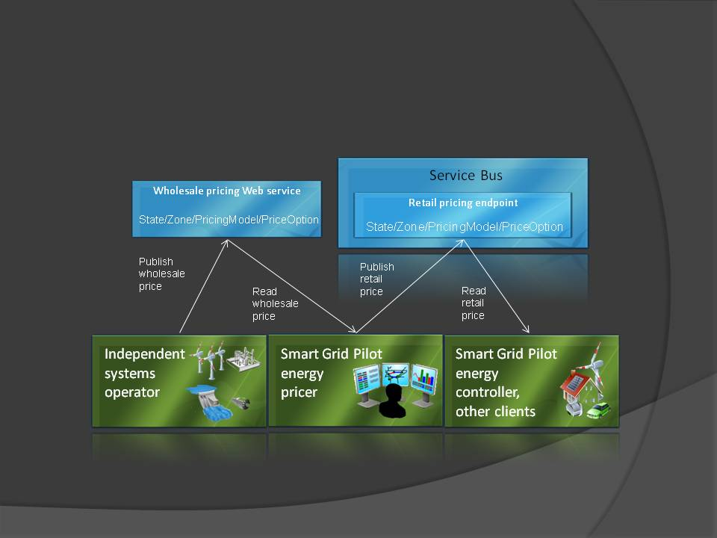

Invensys used the Microsoft Silverlight™ browser plug-in to create a graphical user interface for interacting with the smart grid application. Client applications and utilities exchange pricing and usage data over the Service Bus, and the Silverlight-based application displays the data graphically.

Usage Scenarios
In its Smart Grid Pilot, Invensys demonstrated several usage scenarios (Figure 1). In one, an electric utility sends real-time electrical pricing data to customers in different geographic areas and pricing zones every five minutes. A client application running in a home or business receives the pricing information through the Service Bus. The consumer can respond to the pricing data by turning off certain appliances during expensive, high-demand periods. Local utilities could create business intelligence applications and reports on the pricing and usage information flowing to them in real time and better plan for reallocation of power supply, new energy sources, or new facilities.
Figure 1. The Invensys Smart Grid Pilot architecture uses the Service Bus to move energy-pricing data through the supply chain from markets to utilities to consumer and residential devices.

In another scenario, a consumer on vacation could log on to a home energy portal, powered by Silverlight and hosted on the Windows Azure platform, and notice that he left his air conditioner on. He can remotely turn off the unit over the Web. Once the instruction is delivered over the Service Bus, the consumer immediately sees his cost savings calculated from forecasted electricity prices.

In an industrial scenario, factory operators could save a great deal of money by shifting equipment usage times to lower-priced power times. For example, an automaker could decide to swap its sheet-metal stamping shift for a sheet-metal assembly shift to save electricity.

Benefits
Using the Service Bus and Access Control Service, Invensys Operations Management was able to quickly create the Smart Grid Pilot, which demonstrates the feasibility and affordability of offering smart grid services to smaller utilities. The utilities do not need to build their own data center infrastructures to support smart grid traffic, and their customers receive rich, real-time information with which to develop smart energy consumption habits.
“The Service Bus has massive scalability at very reasonable costs and can elastically scale up or down as need demands.”
David Hardin, Staff Engineer, Invensys Operations Management

Immediate, Cost-Effective Implementation of Smart Grid
“The Service Bus provides the security, interoperability, and performance required for large-scale smart grid applications, at a significantly lower cost than building data centers,” Hardin says. “It can provide a valuable vehicle for expediting the implementation of smart grid technologies by providing a mechanism for making pricing and demand-response information available to the large population of consumers that has Internet access.”

Hardin notes that the power industry tends to be very conservative, and the power grid is its biggest, most valuable asset. “We are presenting our Service Bus–based solution as an easy, low-cost way for small utilities to move forward with power-saving technologies without huge data center investments,” he says.

Richer, Real-Time Information
The Invensys communications platform gives utilities an effective way to impact the energy consumption habits of thousands of customers. Some utilities today use wireless radios to send simple signals to home and business devices, instructing those devices to cut back the thermostat or air conditioning.

“Using the Invensys Smart Grid Pilot platform, utilities can send much richer information that enables them to dynamically adjust usage based on ever-changing energy prices,” Hardin says. “We want to move into a collaborative, market-driven environment where utilities send richer information that enables consumers to react more intelligently. Conversely, utilities receive real-time customer data that will help them implement variable-load metering. With real-time usage information, utilities could change prices based on the changing availability of power on the grid.”

Massive Scalability
Using the Service Bus as their communications highway, utilities using the Invensys solution can easily scale their smart grid infrastructure to keep pace with need. “The Service Bus has massive scalability at very reasonable costs and can elastically scale up or down as need demands,” Hardin says. “There’s no physical on-premises infrastructure to deploy or depreciate, and a utility can bump up capacity on demand, paying only for the communications traffic that they use.”

Invensys has calculated that the cost of using the Service Bus to serve 100,000 customers should cost utility companies roughly U.S.$18,930 a year and $189,300 a year to serve 1 million customers. This compares favorably with the cost of building and supporting a high-availability data center. For comparative purposes, small data centers cost from $500,000 to several million dollars, with annual maintenance adding another 50 percent.
Faster Development, Lower Costs
Invensys says that using the Service Bus and Access Control Service not only lowered its development costs, but made the project possible in the first place. “Without the Service Bus, we might not even have tackled this project,” Hardin says. “Building an Internet-based service bus with this capability and performance would have been a monumental development challenge and expense costing hundreds of thousands of dollars.”

New Revenue Potential
As the smart grid market develops, Invensys will be able to sell process automation systems, real-time information systems, and integration devices that enable utilities to connect with smart devices at customer locations and move pricing information up and down the supply chain.

“Selling smart grid–compliant products will open up a brand new market for smart grid–enabled automation systems,” Hardin says. “We don’t have exact market size estimates yet, but we know that it will be significant.”

Windows Azure Platform
For More Information
For more information about Microsoft products and services, call the Microsoft Sales Information Center at (800) 426-9400. In Canada, call the Microsoft Canada Information Centre at (877) 568-2495. Customers in the United States and Canada who are deaf or hard-of-hearing can reach Microsoft text telephone (TTY/TDD) services at (800) 892-5234. Outside the 50 United States and Canada, please contact your local Microsoft subsidiary. To access information using the World Wide Web, go to:
www.microsoft.com

For more information about Invensys Operations Management products and services, visit the Web site at: www.invensys.com

This case study is for informational purposes only. MICROSOFT MAKES NO WARRANTIES, EXPRESS OR IMPLIED, IN THIS SUMMARY.

Document published November 2009

Software and Services  - Windows Azure Platform  - Windows Azure  - Access Control Service  - Service Bus | - Technologies  - Microsoft Silverlight  - Windows Communication Foundation

The Windows Azure platform provides an excellent foundation for expanding online product and service offerings. The main components include:
- Windows Azure. Windows Azure is the development, service hosting, and service management environment for the Windows Azure platform. Windows Azure provides developers with on-demand compute and storage to host, scale, and manage Web applications on the Internet through Microsoft data centers. In addition, Windows Azure serves developers’ connectivity needs through the following services.
- The Service Bus connects services and applications across network boundaries to help developers build distributed applications.
- The Access Control Service provides federated, claims-based access control for REST Web services.
- Microsoft SQL Azure. Microsoft SQL Azure offers the first cloud-based relational and self-managed database service built on Microsoft SQL Server 2008 technologies.

To learn more about the Windows Azure platform, visit:
www.windowsazure.com

