

Microsoft Windows XP Embedded

Developer Resource Kit

Componentizing Windows XP Professional for embedded systems developers
Author/Editor: Mark Chamberlain
Published: November 2008
Applies To: Microsoft Windows XP Embedded, up to and including Update Rollup 1.0.
This document does not include features that are unique to Windows Embedded Standard 2009 (WES 2009).

Copyright
The information contained in this document represents the current view of Microsoft Corporation on the issues discussed as of the date of publication. Because Microsoft must respond to changing market conditions, it should not be interpreted to be a commitment on the part of Microsoft, and Microsoft cannot guarantee the accuracy of any information presented after the date of publication.
This white paper is for informational purposes only. MICROSOFT MAKES NO WARRANTIES, EXPRESS OR IMPLIED, AS TO THE INFORMATION IN THIS DOCUMENT.
Complying with all applicable copyright laws is the responsibility of the user. Without limiting the rights under copyright, no part of this document may be reproduced, stored in or introduced into a retrieval system, or transmitted in any form or by any means (electronic, mechanical, photocopying, recording, or otherwise), or for any purpose, without the express written permission of Microsoft Corporation.
Microsoft may have patents, patent applications, trademarks, copyrights, or other intellectual property rights covering subject matter in this document. Except as expressly provided in any written license agreement from Microsoft, the furnishing of this document does not give you any license to these patents, trademarks, copyrights, or other intellectual property.
The example companies, organizations, products, people and events depicted herein are fictitious. No association with any real company, organization, product, person or event is intended or should be inferred.
© 2006-2008 Microsoft Corporation. All rights reserved.
Microsoft, Active Directory, BizTalk, MSDN, Visual SourceSafe, Visual Basic, Visual C#, Visual Studio, Windows, Windows NT and Windows XP are either registered trademarks or trademarks of Microsoft Corporation in the United States and/or other countries.
The names of actual companies and products mentioned herein may be the trademarks of their respective owners.

Disclaimers
This document contains information adapted from many sources, including MSDN®, and third-party developers. No functional guarantees are stipulated regarding suggestions offered in this document. There is no guarantee that a particular tip will function in every run-time scenario. Each Windows XP Embedded run-time image consists of a specific subset of Windows XP Professional components chosen by each developer to accommodate specific product requirements. The developer is ultimately responsible for creating and deploying the test plan that is appropriate to the product. The developer is strongly advised to fully test any tips used from this document. These tests should be based upon the developer’s unique product requirements and operational environment.
Microsoft provides third-party contact information to help you find technical support. This contact information may change without notice. Microsoft does not guarantee the accuracy of this third-party contact information.
The third-party products that this article discusses are manufactured by companies that are independent of Microsoft. Microsoft makes no warranty, implied or otherwise, regarding the performance or reliability of these products.

Chapter 1. Using this Document 1
Target audience 1
Operating system version 2
About the author 2
Well deserved credit 2
Chapter 2. Overview and Evaluation 4
Introduction 4
Evaluating Windows XP Embedded 4
On-line tutorial 4
Additional tutorials 4
Case studies 4
Supported target device processors 5
Supported development platforms 5
Microsoft Support Lifecycle considerations 5
Licensing considerations 5
Microsoft support 6
Features unique to Windows XP Embedded 7
XP Embedded product releases 7
Product comparison 9
Comparison with Windows XP Professional 9
Comparison with Windows XP Embedded for Point of Service (WEPOS) 9
Comparison with Windows NT Embedded 9
Chapter 3. Development Guide 10
Introduction 10
Installing Windows XP Embedded 10
How to obtain Windows XP Embedded 10
Problems installing Windows XP Embedded Studio 10
How to upgrade your database to the licensed version 11
Developing your XP Embedded Device 12
Introduction 12
Development Master Checklist 14
Quality Assurance Checklist 17
Introduction to the XPE SP2 Component Manifest 17
Development Environment Audit 21
Functional Audit 22
Serviceability Audit 24
Security Audit 26
API Audit 27
Reliability Audit 27
Image Footprint Reduction 28
Testing and Deployment considerations 30
Configuring the User Interface (shell) 30
Different Shells for Different Users 30
Multiple user accounts 30
Enabling the context-sensitive Help 31
Removing the Windows splash screen after the Power On Self Test (POST) 31
How to replace the boot screen with one of your own. 31
How to disable "Windows is starting up" and "Windows is shutting down" type messages 31
How to Customize the Welcome Screen behavior 31
Disabling the "Turn Off Computer" button on the Logon screen 32
Removing System and Application popups and Balloon tips 32
Adding "Manage" functionality when building a configuration 32
Enabling the classic Start menu 32
Automatically start applications or a custom shell upon startup 32
Removing the "Windows XP Embedded Evaluation" text in the shell 33
How to enable context menus for "right-click" functionality in the runtime 33
Changing the system font 33
Disabling the Ctrl+Alt+Del keyboard combination 33
Avoiding the Ctrl+Alt+Del splash screen 33
Creating shortcut resources 34
Centering the search pane in an Explorer file browser window 34
How to hide the shell task bar. 34
Managing User Profiles and user settings 35
How to hide the mouse pointer 35
Configuring Internet Explorer as a full screen shell 35
Configuring Components 35
Automatic Logon 35
Bluetooth 35
.NET Framework 1.1 35
.NET Framework 2.0 35
.NET Framework 3.0 36
File System 36
IIS 36
Internet Protocol Version 6 (IPV6) 36
MSDTC and Cloning 37
Network Command Shell 38
NTFS encrypted file system support 38
Security Template components 38
Windows Firewall/Internet Connection Sharing (ICS) 38
Fine tuning 38
Hot plugging and hot swapping 39
How to identify the computer name 39
How to identify IP settings 39
Licensing issues when you install Office on a runtime 39
Applying locale settings to a run-time image 40
Adding Japanese, Korean, or Chinese IME components 40
Using Component Designer to create a Service Resource for a component 40
Moving Event Viewer logs to an unprotected volume 40
Using Windows XP Embedded to boot to a USB device 41
Runtimes and Antivirus Software 41
Netset tool 42
How to set the Time Zone offline in Target Designer 42
Where to turn on paging file support 43
How to move or rename your paging file in your runtime 43
How to clear the paging file 43
Using SQL Server with Windows XP Embedded 45
Initiating System Shutdown 45
Bootvis system boot performance analysis tool 45
First Boot Agent 45
Duplicating images to many Compact Flash and Flash Module devices in a production environment 46
Where to find a list of Microsoft Certified Hardware products 46
Does Microsoft support installation of Microsoft SQL Desktop Engine (MSDE) into my XP Embedded image? 46
How can I edit the Registry of my XP Embedded image, before FBA has run? 46
Where can I find useful utility programs for use when developing an XP Embedded Image? 47
How to apply a static IP address to the runtime 47
Multilingual User Interface (MUI) 47
More information about supported Languages and Locales 48
Using Development Tools 49
Target Analyzer 49
Target Designer 50
Component Designer 51
Creating driver components 54
Installing third party driver and applications after FBA completes 55
Installing a third party driver via rundll32 56
Chapter 4. Embedded Enabling Features 58
Introduction 58
BootPrep 58
Using BootPrep to prepare a storage device 58
USB Boot 59
Device Update Agent 60
Setting a registry key with Device Update Agent 60
How to judge whether a previous DUA command was successful or failed 61
The Enhanced Write Filter 62
Comparison between RAM and Disk-based Enhanced Write Filter (EWF) 62
Deployment considerations 62
The Enhanced Write Filter and Hibernation 62
EWF Applications 62
EWF Functional Modes; defined 63
Mixing EWF-RAM and EWF-DISK 64
Deployment considerations 65
Runtime maintenance considerations 66
Installation and Implementation 66
Setup procedure for EWF-DISK or EWF-RAM 67
Setup procedure for EWF-RAM-REG 72
Preparing storage media for EWF 76
An alternative to RAM EWF using SDI 80
File Based Write Filter (FBWF) 80
Registry Filter 80
Developing an image bootable from a CDROM 82
Background 82
Booting from an El Torito formatted CDROM 82
Booting from an SDI file 108
Command-Line Tool 110
Remote Boot 110
Remote boot applications 110
Accessing hard disk volumes on a Remote Boot client 111
Using Remote Boot as a means of servicing devices that are booted by using Compact Flash 111
Maximizing performance of Remote Boot clients 112
RAM boot and WinPE 112
RAM boot using SDI 112
How to stop a computer or laptop from booting from the network (PXE) and to load normally 112
Third-party TFTP server offering 112
Remote Boot Services health checking 112
Use the kernel debugger on the target system for troubleshooting Remote Boot problems 112
Diagnostics messages 112
System cloning / Fbreseal 114
Chapter 5. Troubleshooting 115
Introduction 115
Help from the embedded community 115
Design tools 116
Target Designer Development 116
Component development 116
Embedded image deployment 117
Licensing 118
Common issues 118
Boot Time Errors 130
First Boot Agent 134
Embedded Enabling Features (EEF) 136
Enhanced Write Filter 136
Use EWF Manager to monitor and troubleshoot EWF 140
El Torito 141
Device Update Agent 141
Remote Boot 142
SDI 143
System Cloning Tool and FBRESEAL 143
System Cloning Tool modifies the wrong disk volume 143
Cryptographic Service problems 143
Component troubleshooting 144
What to do if you are having trouble finding components 144
(SP1) Missing CLSID key may prevent COM+ application from running 144
Administration support tools 144
Application Compatibility Core 144
Application Verifier 145
ATI Rage Mobility 145
Automatic Logon 145
Background Intelligent Transfer Service 145
Client for Microsoft Networks 146
Client Services for NetWare 146
CMD – Windows Command Processor 146
Command Shell 146
Explorer Shell 146
Device Manager 147
Disk Management Services 147
Display Control Panel 147
DOS Windows on Windows Support 148
Error Reporting 149
Event Logging 149
Hardware Abstraction Layer 149
Help and Support Services 150
Home Gateway 150
Home Gateway & Kiosk/Gaming Console 150
HyperTerminal 150
Images and Media 150
IMAPI – CD Burning 150
(SP1) Internet Connection Wizard 150
Internet Connection Sharing Discover and Control Client 151
Internet Explorer Kiosk Mode 151
IME Prototype 151
Internet Explorer 151
Map Network Drives/Network Places Wizard 152
Message Queueing (MSMQ) 152
Microsoft Management Console (MMC) 152
MIDI 152
Minlogon 152
.NET Framework 153
Net.exe Utility 154
NetBIOS Driver 154
NetMeeting 154
Network Configuration 155
Oledb Provider for Internet Publishing 156
Performance Monitor 156
Regional and language options 157
Remote Access (RAS) 157
Remote Assistance Channel 157
Remote Registry Service 157
Search Assistant User Interface 157
Serial Input Support 158
Security Shell Extension 158
(SP1) SMTP Server 158
Software Installation Group Policy MMC Snap-in 158
System Event Notification Service 158
TCP/IP Netstat Command 159
Telnet Server 159
Terminal Server Remote Desktop 159
Terminal Services 159
Terminal Services Web Control Extension 159
Volume Shadow Copy service 160
Windows Media Player 8.0 160
Windows Movie Maker 160
Windows Picture and Fax Viewer 160
Windows Security Configuration Editor Client Engine 160
Windows XP Explorer User Interface 160
Multilingual User Interface Pack 162
Miscellaneous 163
Boot time performance 164
A walk-through of the windows boot process 164
Tips for optimizing boot performance 165
EWF and boot optimization 165
Bootvis system boot performance monitoring tool 166
Debugging 166
System memory dump files are not saved when you have EWF enabled on your boot drive 166
Post mortem debugging does not work when using the .NET Framework 2.0 component 166
General XP Debugging Tips, Tools and Techniques 167
Kernel mode debugging overview 167
Chapter 6. Servicing 169
Introduction 169
Servicing Methods 169
Objective 169
Image ownership considerations 169
Device deployment and servicing options 171
Flowchart 173
Servicing strategy 175
Delivery methods 180
Deploying Microsoft security updates 181
Where to get updates 181
Security updates strategy 181
Back up your Component Database 184
Obtaining, Installing and Managing Component Updates 185
Microsoft support policy 185
Licensing considerations 185
Deployment techniques 186
Device Update Agent (DUA) 186
Using custom batch files, scripts or programs 188
Systems Management Server (SMS) 189
System Center Configuration Manager (SCCM) 189
Windows System Update Server Version 2.0 (WSUS) 190
Remote Procedure Calls (RPC) 190
Remote management 192
Windows Preinstallation Environment deployment alternative 194
Creating a derivative Windows Preinstallation Environment CD 194
Configuring Windows Server 2003 with Remote Install Services to boot WinPE Images. 197
Using Windows Deployment Server to deploy XP Embedded runtime images 198
Security considerations 199
Assessing your security risk 199
Mitigating your security risks 200
Building in Windows Security 200
Securing the network 201
Securing physical media by using Enhanced Write Filter 202
Protection from computer viruses 202
Servicing checklist 203
Using Image Difference Engine (ImageDiff) 203
Common servicing questions 204
When replacing critical system binaries do I need to disable Windows File Protection first? 204
How can I identify Operating System version, Service Pack level, and specific XP Embedded platform? 205
Can I run a single XPe target image on multiple hardware devices? 207
What is the relationship between XP Pro Security Update releases and XP Embedded Security Update releases? 207
Can I use Windows XP desktop Updates (hot fixes) in a deployed XP Embedded runtime? 208
How do I identify the hot fixes installed in my runtime? 209
How do I obtain and configure Licensing Runtime PIDs? 209
Servicing-related Microsoft Corporation on-line resources 209
Third party tools and resources 211
Glossary 211
ADDENDA 212
Addenda 1. Table of built-in Windows XP utilities 212
Addenda 2. General Microsoft resources 216
Addenda 3. Third-party resources 216
Addenda 4. Useful keyboard shortcuts 218
Addenda 5. XP Embedded Troubleshooter 219

Chapter 1. Using this Document

Target audience
The target audience is the Windows XP Embedded developer, henceforth abbreviated as “developer”. The developer is typically associated with the OEM (Original Equipment Manufacturer) who develops and/or integrates Windows XP Embedded target hardware. The developer uses Windows XP Embedded SP2 development tools, such as Target Designer, in order to develop Windows XP Embedded images that are custom tailored for the OEM hardware.
The purpose of this document is to help guide the developer through the complete process of evaluating, choosing, designing, installing, developing, debugging, testing, shipping and servicing an effective, reliable and secure Windows XP Embedded device.

Searching
You can use the Find feature of Microsoft Word (<Ctrl key> + F) to scan these documents to find topics that you are specifically interested in.

Hyperlink convenience
This document contains many hyperlinks. An example of a hyperlink (henceforth abbreviated as "link") is this: Microsoft Corporation.
Click on it while depressing the <ctrl> key, to activate the link. A link will take you to:
- A web site, or
- A specific section in this document.
If the link takes your focus to a different section in this document, note that you can always browse back to the original section that contained the link that you clicked on, by holding the <Alt> key down and then pressing the <left arrow> key.
In order to link to a web site, the computer that you use to view this document must also be connected to the internet.
If a web site link fails to work because it has been renamed since the publication of this document, it is frequently possible to find the renamed link by conducting an internet search using the link's textual title.
For example, if the following web site link no longer works:
Windows XP Embedded Tutorials
Use your favorite search engine to search for the following (quotes included):
"Windows XP Embedded Tutorials"
If the above attempt fails, try it again without quotes.

This document is organized into the following chapters.
Chapter | Description
Chapter 1. Using this Document | (this chapter)
Chapter 2. Overview and Evaluation | Helps you understand Windows XP Embedded in order to determine its suitability to your product design.
Chapter 3. Development Guide | Walks you through the entire development process, with the goal of producing a complete and highly reliable XP Embedded image, in the least time.
Chapter 4. Embedded Enabling Features | Describes all the tools and features that are unique to Windows XP Embedded (and not available in Windows XP Professional)
Chapter 5. Troubleshooting | Contains common problems and solutions associated with Windows XP Embedded
Chapter 6. Servicing | Helps you determine the best way to service and maintain your XP embedded device image, and then discusses how to configure and deploy your image for servicing.

Operating system version
Unless otherwise indicated in this document, the term Windows XP Embedded refers to the Update Rollup 1.0 version, which indicates that all of these updates are present:
- Windows XP Embedded SP2
- Feature Pack 2007
- Update Rollup 1.0
Please note that Windows XP Embedded SP1 reached end of life and is no longer formally supported. Security updates are no longer provided and Developer Support cases are treated as "best effort only".

About the author
Mark Chamberlain is Microsoft's principal support escalation engineer for Windows XP Embedded, .NET Micro Framework and Robotics Studio. Mark's passion is embedded systems, software and electronics technology, with 31 years of embedded systems architecture and development experience. Hobbies include radio controlled and robotic aircraft (particularly flying wings), electronics, carpentry, photography and the general study of science and technology innovation.
Mark lives with his wonderful wife Teri, in Woodinville, Washington, USA.
Formal education: BSEE and MSEE (with focus on computing), University of Washington.

Well deserved credit
Special thanks to Lynda Allen in the Windows XP Embedded product team, who reviewed the entire Kit and provided helpful and valuable feedback.

Chapter 2. Overview and Evaluation

Introduction
This section will help you understand Windows XP Embedded to determine its suitability to your product design.

Evaluating Windows XP Embedded
This section provides links to information that can help you evaluate Windows XP Embedded. You can identify the requirements of your project, and then determine how Windows XP Embedded can best fulfill those requirements.
Windows Embedded Developer Center is an excellent place to get started:
Learn Microsoft Windows XP Embedded
MSDN contains a lot of information about XP Embedded starting here. Scan the table of contents for specific topics.
Windows XP Embedded
The following Windows Embedded XP Team Blog article lists many commonly used links to resources on the net, to help you get started:
You need help? Here it is!
Use the following link to review a list of free Windows XP Embedded downloads. This link was created by performing an Advanced Search at http://www.microsoft.com/downloads:
Windows XP Embedded Downloads

On-line tutorial
Tutorial: Building and Deploying a Run-Time Image

Additional tutorials
Windows XP Embedded Tutorials
The content at the following link was written during the SP1 timeframe but remains useful for SP2 developers:
Microsoft Windows Embedded Studio Development Tools for Windows XP Embedded
A preview of the development process:
Development Process

Case studies
Microsoft Windows XP Embedded Case Studies

Supported target device processors
Windows XP Embedded target devices support the same Intel Pentium-compatible (586 or higher) processors that are compatible with Windows XP Professional. Intel 286, Intel 386, and Intel 486 class processors are not supported. Officially, the low limit for supported processors is the Pentium II (233) MHz.
Native 64 bit processor mode is not supported.
The easiest way to validate a processor and its motherboard for Windows XP Embedded is to confirm that Windows XP Professional (x86) installs and works in the target platform.
A specific requirement of the processor is that it must support the following machine instructions:
- CPUID
- CMPXCHG8B

Supported development platforms
You can install Windows Embedded Studio Tools on Windows XP Professional or Windows Vista operating system platforms. However, additional steps are required if installing into Windows Vista (32 or 64 bit Editions):
Installing Update Rollup 1.0 for Windows XP Embedded on Windows Vista
It can be more convenient to install the tools on Windows XP Professional because XP Embedded is based on XP Pro binaries and hence you can use the XP Pro platform to compare features, functionality and binaries with your built XP Embedded image.

Microsoft Support Lifecycle considerations
It is important that you install and use the latest version of Windows XP Embedded, in order to maximize the image lifecycle support offered by Microsoft.
For information about product lifecycle support, visit the following Microsoft Web site:
Microsoft Support Lifecycle
Once you have obtained licensed tools through an Authorized Microsoft Distributor, the Distributor will provide you with access to the OEM Secure web site which contains Product Support Lifecycle articles.

Licensing considerations
For general licensing information for Windows XP Embedded, visit the following Microsoft Web site:
How to Buy Windows Embedded Operating Systems
Windows XP Embedded does not use product activation. Product activation is a feature of Windows XP for desktop systems.
However, the Windows XP Embedded run-time image is associated with specific attributes of the motherboard hardware. This means that after the image has completed First Boot Agent (FBA) on a specific motherboard, attempts to copy the post-FBA image to different motherboard hardware may fail.

Microsoft support
Windows Embedded Support Services
Windows XP Embedded Service Pack 2 Support

Features unique to Windows XP Embedded

XP Embedded product releases
You install the various Windows XP Embedded Tools product releases on the development computer that you have designated for creating and managing XP Embedded images.
The releases are listed below in chronological order.
These feature upgrades must be installed into your development system in the order shown. The features are cumulative, for example you must install Windows XP Embedded with Service Pack 2 before you can install Feature Pack 2007.
Installing all the available releases is strongly recommended even if you do not use the special features offered in the latest releases, because the releases also include the latest Security Updates.
In between releases you can obtain Security Updates at the OEM Secure web site. You obtain access to this site by contacting your Microsoft Authorized Embedded Distributors.
Deploying Microsoft security updates

Windows XP Embedded with Service Pack 2
This is currently the minimum version that is formally supported.
Introducing Windows XP Embedded with Service Pack 2

Windows XP Embedded Feature Pack 2007
MSDN: Windows XP Embedded SP2 Feature Pack 2007- What's new
Sean Liming - What's new in Feature Pack 2007 for XP Embedded
Windows for Devices - Key enhancements in Windows XPe SP2 FP2007
Feature Summary
1. New embedded enabling features (EEF):
- File-based write filter
- Registry filter
- Native USB boot capability
- Enhancements to the Enhanced Write Filter (EWF) and Hibernate Once Resume Many (HORM) functions for instant on
- Message Box Default Reply component
- Several requested bug fixes to tools such as the Target Designer, CMI, Import Framework, and SLX/XML usability
- A New command line tool (XPECMD or XPe Console) that replicates Target Designer and allows builds to be implemented in scripts

2. Component updates
- Footprint reduction (Working with Re-factored components in FP2007 - Part 1)
- Upgrades to configurable component settings in TD
- New macro components

3. All security updates for XPe-SP2 have been rolled up to the Feature Pack repository

Windows XP Embedded Update Rollup 1.0
MSDN: Update Rollup 1.0 for Windows XP Embedded
Windows Embedded Blog - Update Rollup 1.0 for Windows XP Embedded (was Feature Pack 2008)
Feature Summary
1. New components
- Internet Explorer 7
- Windows Media Player 11
- Remote Desktop Protocol 6.0
- .NET Framework 3.0 Setup
- User Mode Driver Framework
- Enhancements to USB Boot 2.0
- Enhancements to File-Based Write Filter

2. All security updates for XPe-SP2 have been rolled up to the Update Rollup 1.0 repository

Product comparison

Comparison with Windows XP Professional
Differences between Windows XP Embedded and Windows XP Professional
At the tutorial site here, download and launch the Windows XP Embedded Product Overview video which compares XP Embedded with Windows XP and Windows CE.

Comparison with Windows XP Embedded for Point of Service (WEPOS)
Windows Embedded for Point of Service is a version of Windows XP with Service Pack 2 optimized for retail point of service (POS) devices. The Windows Embedded for Point of Service platform is easy to use, includes technologies that enable present and future retail scenarios, and provides low lifecycle costs.
Windows Embedded for Point of Service
Which Windows Embedded Product is Right for Me?

Additional features currently supported by WEPOS but not supported by Windows XP Embedded:
- Windows Update
- WEPOS specific device drivers with Plug and Play functionality for retail device peripherals.
- POS-specific API support

Comparison with Windows NT Embedded
The following white paper compares Windows XP Embedded SP1 features against Windows NT Embedded. Note that it does not include Windows XP Embedded SP2 features.
Comparison of Windows XP Embedded and Windows NT Embedded
The following resource also is useful for comparing NT Embedded with XP Embedded.
Microsoft Windows XP Embedded Frequently Asked Questions

Chapter 3. Development Guide

Introduction
This chapter walks you through the entire development process, with the goal of producing a complete and highly reliable XP Embedded image, in the least time.

Installing Windows XP Embedded

How to obtain Windows XP Embedded
To obtain Windows XP Embedded, visit the following Microsoft Web sites:
- For general information:
How to Buy Windows Embedded Operating Systems
- To order or download the evaluation versions:
Windows XP Embedded Downloads and Updates
- To download the evaluation version, use the links below. Note that in order to install SP2, you must install SP1 first. The first link below includes a tool that automatically downloads both SP1 and SP2:
Microsoft Windows XP Embedded, SP2 Update Evaluation Edition
Then install the following two updates in the order listed below. By doing so, not only do you gain benefit of additional product features but also your built images will automatically contain the newer Security Updates:
Microsoft Windows XP Embedded Service Pack 2 Feature Pack 2007 Evaluation
Update Rollup 1.0 for Windows XP Embedded Evaluation Edition
We highly recommend you follow this procedure when installing SP2 or upgrading to SP2:
Installing Windows XP Embedded with Service Pack 2
It can be useful when troubleshooting failed installations.
Then install Feature Pack 2007 and Update Rollup 1.0.
- For a list of all available free downloads related to Windows XP Embedded, proceed to the Microsoft download site (www.microsoft.com/downloads ) and click on Advanced Search. Choose Product/Technology = Windows XP Embedded, and sort results by Release Date.

Problems installing Windows XP Embedded Studio
Use the following checklist if you are having problems installing the tools.
1. Back up any of your custom design files that may be present in the C:\Windows Embedded Data folder and C:\Windows Embedded Images folder
2. Remove any existing third party antivirus software, and third party software that performs system monitoring activity. These applications can interfere with Target Designer's ability to process script files.
3. Uninstall existing XPE Tools using Control Panel -> Add or Remove Programs.
4. Uninstall SQL Server component(s) using Control Panel ->Add or Remove Programs.
5. Reboot.
6. Delete the following folders:
- C:\Windows Embedded Data
- C:\Program Files\Windows Embedded
- C:\Program Files\Microsoft SQL Server
7. Use Registry Editor (regedit) to delete the following sections of the registry:
- [HKLM\Software\Microsoft\Microsoft SQL Server]
- [HKLM\Software\Microsoft\Microsoft SQL Native Client]
8. Reboot.
9. Verify that all traces of XPE and SQL have been removed.
10. Follow this procedure, which installs both XPE SP1 and SP2:
- Installing Windows XP Embedded with Service Pack 2
11. Run the tools to verify that they are basically working.
12. Install Feature Pack 2007 and then Update Rollup 1.0. By doing so, not only do you gain benefit of additional product features but also your built images will automatically contain the newer Security Updates.
If you are installing the Evaluation version of XPE, you can obtain the updates from these links, in the order shown:
Microsoft Windows XP Embedded Service Pack 2 Feature Pack 2007 Evaluation
Update Rollup 1.0 for Windows XP Embedded Evaluation Edition

If you are installing the Licensed version of the Tools (i.e. the first CD you install, for SP1, is the licensed version) you should obtain all your updates from the OEM Secure website. You obtain access to this site through your Authorized License Distributor.

Additional considerations:
- If you plan to install the tools in Vista, the following blog contains special considerations owing to the User Account Control (UAC) feature:
Running Embedded Studio Tools on Vista
- If you have another computer that contains XP Professional it might make sense to also do a parallel installation of XPE Tools on it, to help identify whether the OS in your main computer is in an unusual state or is corrupted.

How to upgrade your database to the licensed version
The evaluation copy of the Windows XP Embedded tools produces an evaluation image. This is a fully running image that expires approximately 90 to 180 days after your image is first created using First Boot Agent. If you build using the release version, this expiration limitation is removed.
If you have decided to use Windows XP Embedded and want to create the images for your final target devices, you need a release version of the tools, and you must purchase a run-time license. To find local distributors, visit the following Microsoft Web site:
How to Buy Windows Embedded Operating Systems
- You must completely uninstall the Evaluation version of Windows XP Embedded. If you created custom components, make sure you back those up before uninstalling.
- Completely install the retail (licensed) version of Windows XP Embedded; both tools and database, and security updates. The evaluation version of XP Embedded does not offer a field for you to enter the product ID for the deployed runtime images.
Deploying Microsoft security updates
- Run Target Designer, and then open your configuration. Open the Settings node in the root (top-most) component of your configuration.
- Select the following setting: Run-time Image Licensing - Product Identification Key (PID).
- Enter your run-time image license PID, for example: JAS8A-9A8AS-8ASDA-124A9-8A9AA. This is the number obtained from one of the license stickers you receive. It is not the PID that was used to install Windows Embedded Studio. You only need to use the number from one of your stickers. This way, you can use a single image for mass device deployment.
- If a built image fails to register as a licensed copy, try a different PID and/or contact the license distributor to obtain a working PID.
- Note that you cannot change the PID associated with a deployed image after it has been built and deployed. You can only change the PID by modifying it using the Target Designer application, and then rebuild the image.

Developing your XP Embedded Device

Introduction
Many on-line resources are available, offering development advice. For example:
Installing Windows XP Embedded with Service Pack 2
Release Notes for Windows XP Embedded with Service Pack 2
Development Process
Building and deploying XP Embedded Images
Configuring a Windows XP Embedded Thin Client
Dual-Booting Tips for XP Embedded
Building a Diskless Automation Controller Using Windows XP Embedded
Rapid Prototyping with Windows XP Embedded (using Virtual PC)
Developing an Embedded Run-Time Image from Start to Finish
Tutorial: Building and Deploying a Run-Time Image

The following master checklist was developed in part from these resources.

Development Master Checklist
NOTE: For a more comprehensive list, see Quality Assurance Checklist.
☑ | Item
 | Create a design requirements checklist
 | Create a master image build checklist
 | Create a test requirements checklist
 | In order to ensure you are working with a stable hardware platform, ensure that your hardware accepts Windows XP Professional as the operating system. Also match the operating system version against the version of Windows XP Embedded that you are using. For example, if you plan to use Windows XP Embedded Service Pack 2 (SP2), you should first install and test Windows XP Professional SP2.
Boot Windows XP Professional on the target device, then Run Target Analyzer Probe (TAP) on the booted device. TAP inspects the registry to identify all hardware devices that were detected during Windows XP Professional Setup.
The above step is important in order to ensure that Target Analyzer Probe obtains a complete hardware component list that can be 100% successfully processed when the TAP output (.PMQ) file is imported into Target Designer. Note that your finished XPE OS image will be specifically tailored for use only with your specific hardware (motherboard).
Save the resulting .PMQ file, for later importing into Target Designer or Component Designer.
Note regarding footprint reduction:
In order to produce a fully functioning device in the shortest time, the first time you build your image do not worry about minimizing the size of the image.
Footprint minimization should occur after proving that your (non-minimized) image is 100% functional. To minimize footprint, rebuild the image from scratch, using a minimal set of hardware components. This way, if any problems develop while building the minimal configuration, you will know the problems are due to inadvertent removal of necessary components. For more details, refer to the Image Footprint Reduction section.
 | Develop, debug and test your custom user software and device drivers using XP Professional. Consider componentizing them for XP Embedded only after getting everything working in XP Professional.
Import the .PMQ file one of two ways:
- Import the .PMQ into a component using Component Designer. Name and save the component, and then you can select it later when you run Target Designer.
- Import it directly into a runtime configuration using Target Designer.
 | For testing purposes, consider including selected development / tool components (such as Regedit) that are listed in Addenda 1. Table of built-in Windows XP utilities. Also consider which of these components will be useful or necessary when the image needs to be serviced after it has been deployed.
 | Choose Minlogon vs. Windows Logon. Minlogon offers a smaller image footprint and faster boot time however it is not recommended for most installations because you cannot create User accounts; all processes must run at the System/machine account level. This imposes functional restrictions for all components or applications that require or are dependent on user accounts.
 | Choose file system (FAT, NTFS, UDFS, CDFS). You can include all of them, with a fairly small impact on footprint.
 | Implement Per-component review and selection using "XPE SP2 Component Manifest.XLS"
 | Cloning – set cmiResealPhase to 0 if you plan to modify the image before resealing.
 | Determine whether you need to use EWF-RAM, EWF-DISK, EWF-RAM-REG or HORM. Review Chapter 4. Embedded Enabling Features
 | If you intend to boot from USB media, include USB Boot 2.0 Update and USB Boot Mass Storage Device Update (or later versions). Include these components ONLY if booting from USB. Remove them if booting from IDE or SATA because USB Boot always marks the first enumerated USB Storage device as fixed type, so the device cannot be safely removed once installed (resulting in corrupted or lost data on the first detected USB Storage device).
 | Edit User interface core component settings.
 | If desired, develop and configure a Custom shell, but consider initial testing using the default Explorer shell.
If you desire generic detection of device classes consider including the Generic Device Driver Support component:
Adding Generic Device Driver Support for Device Classes
Consider adding the Safe Mode Support component, for F8 functionality at boot time:
Adding Safe Mode Support
Prepare your target hard disk
- Make sure that the partition is active (use fdisk or run Diskmgmt.msc on an XP Pro system to verify or change this).
- Make sure that the boot partition (usually drive C, or the first partition on the first hard disk drive) has a valid Windows XP boot sector. For example, the Windows XP Disk Management tool (diskmgmt.msc) will automatically accomplish this when it is formatted.
- Copy your built design files to the target device drive.
- Make sure that the boot partition has the necessary Windows XP boot files (these are NTLDR, Ntdetect.com, and Boot.ini).
- Make sure that the Boot.ini file has the proper Advanced Risc Computing (ARC) path pointing to the location of the system files.
- Make sure that the system files are where you said they would be in the form they need to be (see the Settings section in the topmost node in your Target design)
 | If you cannot use Windows XP Professional to format your boot drive, and you must use MS-DOS to format it, you can put a valid Windows XP boot sector on your boot drive by using the Bootprep.exe utility that is included with Windows XP Embedded. Bootprep.exe is located in the Program Files\Windows Embedded\Utilities folder.
Make sure that the system files have the proper components to support booting. The easiest way to ensure this is to use Tap.exe to discover the hardware on your computer. However, if you have to run Ta.exe, or are adding components manually, you may be missing crucial components. The list of necessary components varies from computer to computer, but the minimum that you need are:
- A BIOS component (Standard PC, for example—found under Hardware\Devices\Computers in the left pane of Target Designer)
- An integrated drive electronics (IDE) controller (specific to your hardware)
- The Primary IDE Channel and Secondary IDE Channel components
- The Disk Drive component
Also make sure that you configure the target drive properties to point to the proper locations. Click the configuration, located at the top node in the Configuration Editor tree, and then click Advanced in the Details pane. There are four properties to set:
cmiTargetBootDrive The system boot location (usually the C drive)
cmiTargetWinDir The Windows folder location
cmiTargetProgramFiles The Program Files folder location
cmiTargetDocsAndSettings The Documents and Setting folder location
If you do not set these properties properly before you build your image, you will have problems booting and problems during the First Boot Agent (FBA) sequence. Inspect the \WINDOWS\FBA\FBALOG.TXT file if you have problems with FBA.
If you are booting from one partition (for example, from drive C) but running the system from another partition (for example, from drive D), your run-time image on the development computer will have a DriveD folder that contains the system files, while the root contains the necessary boot files. Make sure that the contents of these folders are copied to the correct drives.
Fine tune the image user settings if needed. Information in the following link may assist:
Technet: Windows XP
Ensure your database contains all QFEs that have been published. First make sure you have installed the latest update package (Update Rollup 1.0 as of this writing). Next, download and install the latest Security Updates found on the OEM Secure web site (ECE). For access to this site, contact the License distributor that you used to obtain your licensed product and runtime keys.
Deploying Microsoft security updates
 | If device is attached to a network that is not completely secure, include the Windows Firewall/Internet Connection Sharing (ICS) component and then edit its settings to block ports etc.
Add antivirus software if necessary; particularly if the device is connected to an unsecure network.
Runtimes and Antivirus Software
 | Review Chapter 6. Servicing to ensure your image is designed with built-in Security and Serviceability. Run a sample image update test, to confirm that your update mechanisms work.
 | Implement final QA

Quality Assurance Checklist
This chapter is divided into the following QA task categories:
Development environment audit.
To help you maintain an appropriate development environment for developing your XPe image.
Functional audit.
To ensure that your XPe image contains all the functionality it needs to fulfill the needs of your limited functionality runtime.
Serviceability audit.
To ensure that your image is serviceable after it has been deployed to the end user. This includes having in place a fully-tested process for updating the image or applying hotfixes.
Security audit.
To produce a secure solution, based on considerations such as the environment in which your device will be deployed.
Reliability audit.
To eliminate or reduce potential points of hardware or software failure. This includes but is not limited to prevention or elimination of software bugs.
Image footprint reduction.
To offer guidelines regarding building configuration files and satisfying dependencies, in order to produce the smallest footprint possible.

The steps above can offer a reduction in development time thereby resulting in reduced development cost and quicker production deployment.

Introduction to the XPE SP2 Component Manifest
This chapter makes reference to a companion Excel spreadsheet, named
"XPE SP2 Component Manifest.XLS".
This spreadsheet contains a list of all feature-type components found in Windows XP Embedded Service Pack 2, along with columns that you can sort in order to group components by various categories.
The Component Audit spreadsheet enables you to improve your component choice decisions.
For example, if you want to group all the Debugging/Development type components together, in order to make it easier to pick and choose components that are useful during image development, follow these steps:
Using Excel, open "XPE SP2 Component Manifest.XLS"
Choose Data->Sort
In the Sort by field within the Sort dialog, choose Debug / Development tools, and turn on the button to indicate your data range has a Header row.
Click OK to perform the Sort operation
Note that all the Debug / Development Tools related items will be grouped together at the beginning of the spread sheet. Pick and choose those components that you wish to use for development.

Here is a summary description of the columns contained within "XPE SP2 Component Manifest.XLS":
COLUMN NAME | DESCRIPTION
Component Name | This is the formal component name as observed in Target Designer
Purpose | A short description of the component name.
Unique customizable component settings | If the component can be customized using Target Designer, this column contains a brief description of the customization options. Sort by this column if you wish to identify and review all the customizable components in your Target Design.
Macro Component | An “X” indicates the component is a Macro component, i.e. a component that contains only component dependencies. Macro components are a convenient means of specifying an arbitrary group of components to be included in your build.
Networking | An “X” indicates the component is a networking related component. Sort by this column to group together networking components. This can be useful when performing a security audit.  Additional MSDN resources:  Comparing TCP and SMB connections for Windows XP Embedded-based devices  Working with Netsh in Windows XP Embedded
Graphics and Multimedia | An “X” indicates the component is related to Graphics and Multimedia.
User Interface (UI) | An “X” indicates the component is related to the user interface. Sort by this column to help you review the user interface options available.
Printing / Imaging | An “X” indicates the component is related to printing or imaging. Sort by this column to help you review printing related components.
Security | An “X” indicates the component is related to security. The component may relate to “surface attack area”, i.e. potential attack vulnerabilities. Most commonly, network related components fall under this category. The component may relate to security enhancement, such as the Windows Firewall. Sort by this column to review all the security related components.
Windows Platform (API) | An “X” indicates the component is related to the Windows Platform Application Programmer Interface (API). Sort by this column to help identify components related to the Platform API. You can choose exactly those components that you need, in order to fulfill the requirements of your specific XP Embedded runtime application.
Storage | An “X” indicates the component is related to storage technology. Note that Windows XP Embedded target devices are typically configured to use one of the following storage technologies as the boot device: Conventional hard disk, flash IDE storage devices, CD-ROM (via El Torito CD), and Remote Boot. Remote Boot is a means of booting a diskless system, as it uses a portion of system memory to serve as the system boot storage device.
Language | An “X” indicates the component is related to language, internationalization or MUI functionality. Note that you also may need to install corresponding MUI packs in order to achieve full functionality of these components. Sort by this column in order to review and choose Language related components.  Additional MSDN resources:  Windows XP Embedded Language Support Overview  Language Support  Adding Multiple Language Support in a Windows XP Embedded Image
App Compatibility | An “X” indicates the component is related to Application Compatibility. Application Compatibility refers to the ability of the operating system to remain compatible with legacy applications. You may need to include certain Application Compatibility components if you intend to use older applications that were originally developed for use in earlier operating system versions.
Embedded Enabling (EEF) | An “X” indicates the component is a feature that is unique to Windows XP Embedded, i.e. not available in conventional Windows XP Professional. Sort by this column to review these components to determine which ones are useful to you.
WMI / Instrumentation | An “X” indicates the component is related to Windows Management Instrumentation, or other instrumentation such as Event Tracing, system monitoring tools, etc.
Debug / Development Tools | An “X” indicates the component is related to debugging and/or development. Sort by this column to review and choose all the development and debugging tool features. When it is time to produce a production image, you can review these components to identify which ones should not be included for the production image.
Service (executable name) | If the component is part of a Windows Service, this column contains the name of the service, and, in parentheses, the corresponding binary DLL or EXE of the service. Sort by this column to pick and choose Windows Services. After you deploy your image, you can run the Services control panel applet (services.msc) to confirm that the services are installed, and you can inspect the status of each service.

Development Environment Audit

Objective
To help you configure and maintain an appropriate development environment for developing your XPe image.

Audit checklist
For suggestions regarding the configuration of your development system, review these on-line resources:
Installing Windows XP Embedded with Service Pack 2
Release Notes for Windows XP Embedded Service Pack 2 Feature Pack 2007
Development Process
Building and deploying XP Embedded Images
Configuring a Windows XP Embedded Thin Client
Dual-Booting Tips for XP Embedded
Building a Diskless Automation Controller Using Windows XP Embedded
Rapid Prototyping with Windows XP Embedded
Developing an Embedded Run-Time Image from Start to Finish
Tutorial: Building and Deploying a Run-Time Image
Establish and deploy a regiment of regularly backing up your Target Designer development system, in particular the following:
- Component database or databases (your repository folders and *.MDF, *.LDF)
- Configuration files (.SLX)
- Custom components (.SLD) that you created and manage.
If you are maintaining and servicing XPe images that were developed using SP1 as well as SP2, do not install SP2 on top of your SP1 database; instead establish two separate databases, one for SP1 and one for SP2.
For more information:
Installing Windows XP Embedded with Service Pack 2
If your development systems are part of a corporate network, ensure that your SQL Server database and your folders are adequately protected, by configuring them with restricted permissions.
If you do not intend to share your Component Database for use with other developers in your company who use Target Designer, configure SQL Server so that it does not accept network clients, using the svrnetcn.exe tool to disable all network services.
Become familiar with third party tools to facilitate Windows XP Embedded development:
Third-Party Tools for Windows XP Embedded
Review the Component Help system:
Finding Information in Help

Functional Audit

Objective
Ensure that your XPe image contains all the functionality it needs to fulfill the needs of your limited functionality runtime.

Audit checklist
If using Minlogon instead of Winlogon, review these resources:
Introduction to Minlogon
Review these links to establish their applicability to your project. Then use the applicable ideas.
Development Process
Design a Run-time Image
Building and deploying XP Embedded Images
Configuring a Windows XP Embedded Thin Client
Dual-Booting Tips for XP Embedded
Building a Diskless Automation Controller Using Windows XP Embedded
Rapid Prototyping with Windows XP Embedded (using Virtual PC)
Developing an Embedded Run-Time Image from Start to Finish
Tutorial: Building and Deploying a Run-Time Image
Finding information in Help
Review and choose Embedded Enabling Features (EEFs) – these are components that are only available in Windows XP Embedded.
Embedded Enabling Features
Chapter 4. Embedded Enabling Features
If considering using the Enhanced Write Filter (EWF) component, review the EWF section in Chapter 4. Embedded Enabling Features, as well as these on-line MSDN resources:
Programmatically Dismounting Volumes
Dismounting Volumes in a Hibernate Once/Resume Many Configuration
Controlling EWF by Using the EWF APIs
Using CompactFlash (CF) with the Enhanced Write Filter (EWF)
Configuring the CompactFlash Device
Using the Enhanced Write Filter (EWF) in Windows XP Embedded
Configuring the User Interface (shell)
Review this on-line MSDN resources regarding user interface shell options:
Different Shells for Different Users
Within Excel, use the Data->Sort feature to sort the spreadsheet by the column titled “Unique customizable component settings”. For each component that is in your build that contains customizable settings, review each setting to ensure that it is correctly set for your production image.
Finish developing all custom components that you need.
Creating custom components for Windows XP Embedded
Author Components and Customize Shells
Tutorial: Creating a Custom Component
How to Componentize an Application
Component Designer: Pulling It All Together
Review this set of blog articles, walking you through every basic step to componentize WinAmp:
Componentizing Apps (Winamp project)
Finish developing all custom driver components that you need.
Review this content: Creating Driver Components
If you have further problems componentizing a third party driver or application, particularly if the driver or application is being installed via a third party installer package, follow these steps.
Use an installation monitoring tool found here Third party installation monitoring tools to determine what binaries and what registry entries have been added to your image by the driver installer program. Run the driver installer on an XP Professional SP2 system (not your XPe SP2 system) via while running the installation monitoring tool which monitors all files and registry keys added to the image.
Analyze each file that is being installed by the installer, using the DEPENDS.EXE tool (available in the Windows SDK or a version can be found here: http://www.dependencywalker.com/ - this site is also not formally endorsed by Microsoft). Verify that the binary dependencies required by the driver binaries are included in your XPe image.
If further analysis is needed, you can monitor file access using FILEMON and monitor registry access using REGMON. These third party tools are available at this site:
Windows Sysinternals
Ensure that the status of your custom component(s) is “Released”.
Ensure that any custom components are backed up (along with your component database and repositories).

Serviceability Audit

Objective
Ensure that your image is serviceable after it has been deployed to the end user. This includes having in place a fully-tested process for updating the image or applying hotfixes.

Background
You, as the OEM, must maintain 100% “ownership” of your deployed XP Embedded (XPe) image. Every XPe image is a “sub-platform” of Windows XP Pro. As such, it has been custom tailored to fulfill exactly one target device scenario. In contrast, Windows XP Professional serves as an operating system platform designed to accommodate any third party application that adheres to MSDN XP Platform development guidelines.
Please review Chapter 6. Servicing for details.

Licensing considerations
Windows XPe cannot be used on a PC as a Windows XP Professional replacement. To be clearer, XP Embedded can only be licensed to run line-of-business applications on fixed function devices. You can have an unlimited number of applications running locally, if the line-of-business application requires them locally. For example, a device that has a retail management application may have a local spreadsheet for the store manager to create daily reports. Running Microsoft Office is usually outside the scope of this definition.

Serviceability Audit checklist
Most Important
Review Chapter 6. Servicing
Planning Ahead
Think about servicing when you design your devices. Servicing should not be an afterthought. Will your devices be able to connect to the Internet and communicate with a server? Will your devices use modem access? How many servers do you need to handle the load of servicing?
Servicing Experience
Invest the time required to design a clear and consistent user experience for servicing. For example, a set top box periodically downloads a program guide. It can also download updates, which simplifies its design and makes the user experience clear and consistent.
Testing Your Servicing Solution
Test your servicing solution thoroughly so that you are sure that it works correctly. By the time you have deployed your devices in the field, it is too late to fix major bugs. If you thoroughly plan your testing and then test against your plan, you can potentially save time and money. Include scalability testing (tests that ensure that servicing scenarios work the same way, regardless of the number of devices) and corner cases (tests that introduce small deviations in sets of devices).
Having a Back-Up Plan
Make sure that you create a back-up plan in case your primary servicing solution fails. If you typically service devices by using a broadband connection, you might want to be able to dial up by using a modem, also. You might want to be able to service devices through a CD-ROM or a universal serial bus (USB) storage device, and plan to replace media and devices in case of failures.
Ensure image contains the Servicing tools you need
Include useful maintenance tools in your image such as Registry Editor, Administration Support Tools, Misc. Command Line Tools, Net.exe Utility, etc. See Addenda 1. Table of built-in Windows XP utilities.

For additional information
Comparison of Servicing Solutions
Supporting Windows XP Embedded-based Devices
Servicing Windows XP Embedded with Service Pack 2
Manage and service a run-time image
Building Serviceable Devices

Security Audit

Objective
To produce a secure solution, based on considerations such as the environment in which your device will be deployed.

Select components carefully, in order to minimize surface exposure area
- You can optimize the security of your image by including only those components that you need to support your embedded limited functionality runtime application.
- Consider removing components that may contain feature functionality that carry a possible risk of exposing the system to viruses or malicious intruders.
- Consider adding components that serve as security protection or security control.
- Since malicious intruders commonly use the network as the principal access conduit, you should also review all Network related components when conducting a Security review.

Security audit checklist
Most important
Review and deploy the section named Security Considerations in Chapter 6. Servicing
Within Excel, use the Data->Sort feature to sort the spreadsheet by the column titled “Security”. Review those components related to security. Pick and choose those security related components that are applicable to your image.
Administrator Account component: Depending on your device scenario, consider specifying a secure password (cmiUserPassword). Also consider using the User Account component to add one or more user accounts with restricted user access settings.
In order to reduce surface attack area, i.e. reduce exposure to malicious intruder software, consider excluding components from your configuration that are not required for your configuration to function – especially components that are networking or UI related.
Consider including in your consideration, all components that enhance or support system security, such as Windows Firewall/Internet Connection Sharing.
Consider the inclusion of Antivirus software.
Runtimes and Antivirus Software
Design the image so it can be updated with Microsoft security updates. Develop a servicing strategy for accomplishing this.
Deploying Microsoft security updates

MSDN Links
Security Considerations for Windows XP Embedded Developers
Add Security Features to a Run-Time Image
Creating a Component for the Custom Security Template
Microsoft Security Home Page

API Audit
You should review components that typically contain APIs (Application Program Interfaces) which are intended for public use.

Audit checklist
Within Excel, use the Data->Sort feature to sort the spreadsheet by the column titled “API”. Then review those specific components.
In order to minimize image footprint and increase image security, consider deleting components in your image, exposing APIs that are not required by your runtime image.

Reliability Audit

Objective
To eliminate or reduce potential points of hardware or software failure. This includes but is not limited to prevention or elimination of software bugs.

Audit checklist
Ensure you use SP2 or greater for all new development!
List of fixes included in Windows XP Service Pack 2
Windows XP Embedded with Service Pack 1 Reliability
(written in the SP1 time frame but relevant for SP2)
Building a Reliable Windows XP Embedded Platform
Ensure you have in place a test procedure that covers all known code paths for your (limited functionality) runtime, and that you perform a complete test pass before deployment.

Image Footprint Reduction

Objective
This section offers guidelines regarding building configuration files and satisfying dependencies, in order to produce the smallest possible footprint.
In order to produce a fully functioning device in the shortest time, the first time you build your image you should not worry about minimizing the size of the image.
Footprint minimization should occur after proving that your (non-minimized) image is 100% functional. To minimize footprint, rebuild the image from scratch, using a minimal set of hardware components. This way, if any problems develop while building the minimal configuration, you will know the problems are due to inadvertent removal of necessary components.
Ultimately if you want to minimize image footprint, you should build from scratch with the set of known components you need. This is because whenever you add a component to your configuration, all its dependency requirements get pulled in, but when you remove that component later, its dependency requirements are not typically removed at the same time, causing image bloat.
Rebuilding the image from scratch will help ensure that you do not have unnecessary components that were introduced while you were developing, experimenting and testing your original configuration.
Make sure you can view file, registry, and other resources of the components in your .slx file by navigating to and then enabling the option. In Target Designer, click View on the toolbar, and then click to select the Resources check box. You may also need to lower the default visibility in Target Designer to 100 to see most of the components in your database and in your .slx configuration.

Dependency analysis
You can start with a known set of components that you need, then turn automatic dependency resolution off (a Target Designer option). You will see task items for every dependency resolution issue. This will let you see who is dependent on Outlook for example. The Macro components (those components that are shown in bold) are nothing but components containing lists of dependency needs. You might want to review what macro components you are using because they can bloat your footprint quickly. After completing Dependency Checker, you can delete or disable the macro component, because it will already have done its job of pulling in its list of dependent components.

Analyzing the size of the components in your runtime
Review the Build.log file that is generated when you build your image. The footprints of each component are given at the end of the log. Inspect the largest components first and determine whether they may be deleted from your runtime.

Audit checklist
Review this MSDN content:
Footprint
Delete unneeded hardware components (originally obtained via TAP) in order to reduce the total disk and memory “footprint”. If you used Tap.exe to generate the hardware configuration, see the Disabling Software Enumerated Devices Picked up by TAP.exe tip. The hardware configuration list generated by Tap.exe and imported into your design can have a significant impact on your footprint if you are not careful.
Rebuild a new configuration using the reduced hardware component configuration.
Add only the feature components that you know your image requires.
Do not attempt to minimize footprint by failing to let Target Designer resolve all the component dependencies. This is likely to result in a non-functioning device, or even worse, feature failure that is discovered only after the device has been deployed.
Disable paging file support. If you have enough RAM to support the services you expect the user to run, you may not need the paging file. Note that paging file is disabled by default.
Consider removing the Indexing Service component.
Typically, you can safely remove the Indexing Service component to reduce footprint.
The Indexing Service component installs the "Fast Find" indexing that the Windows XP Professional Search functionality uses. This service is not enabled by default in Windows XP Professional and in Windows XP Embedded, so in many cases, it can safely be removed with little to no impact in most runtime images.
The Indexing Service component itself adds approximately 15 MB to most runtime images, so you reduce the overall run-time footprint if you do not need this service.
Convert the partition on your target embedded device to NTFS, and then compress the volume (the compression feature requires NTFS file system). This can reduce the footprint by up to 40 percent. This requires that you add the NTFS component to the runtime.
Review the Additional Footprint Links below.

Additional Footprint Links
Footprint
Finding and eradicating big footprint
Support WebCast: Microsoft Windows XP Embedded: Reducing the footprint
Footprint Reduction: Remove Indexing Service
Tips for Reducing Footprint Size of a Windows XP Embedded Runtime
File Sharing vs Footprint
Winlogon vs. Minlogon
Adding MMC without the Overhead of IE
Using BOOTPREP
Kaspersky Anti Virus sample component for XPe

Testing and Deployment considerations
One thing that customers may consider when choosing between different hardware vendors is whether the hardware itself is WHQL certified for XP (not XPe specifically). In other words, any 3rd party drivers for the motherboard and add-on peripherals were certified by WHQL as fully compatible with XP.
Microsoft currently does not have a certification program for XP Embedded images. The developer of the XPe OEM image has complete control over what goes into the image; the XP Embedded database offers high granularity in this regard.
Microsoft offers guidelines through documentation with the kit, as well as on line, but this information is not all integrated into one location.
Because every XPe image that an OEM develops is essentially a unique, limited functionality runtime platform, it is impossible for Microsoft to test every possible platform because there are over 10,000 components. The number of possible platforms is on the order of 2 to the 10,000th power according to combination theory. Instead, it is the responsibility of the image developer to fully test (100% code coverage) the limited platform against their unique “limited functionality runtime” that the OEM is deploying as their principal application, to ensure that the limited XPe platform supports their application.
XPe’s Target Designer does perform a dependency check which automatically adds components as needed to help ensure that all inter-component dependencies are satisfied. This is the most that our tools do to help ensure image integrity.
Microsoft does strongly emphasize that the OEM develop a plan to keep the image up to date regarding security patches.

Configuring the User Interface (shell)
Windows XP Embedded provides the following shells:
- Explorer shell
- Task Manager shell
- Command shell
Choose the Explorer shell if you want to enable the standard Windows shell experience. Command shell is usually reserved for a minimal configuration, and usually used with the MinLogon.
The following links offer more information:
Creating a Windows XP Embedded Shell

Different Shells for Different Users

Multiple user accounts
- To set up users in addition to the Administrator Account in a runtime, add the User Account component.
- Set the group, password, and user name by clicking the Advanced button for the component in Target Designer.
- Type the user name in the cmiUserName field. Type the password in the cmiUserPassword field.
- To assign the user group, use the appropriate value to modify the cmiUserGroup field:
1 = Administrators
2 = Power users
3 = Users
4 = Guests
You can add multiple users in this manner.

Enabling the context-sensitive Help
To enable context-sensitive Help, add the Primitive: Winhlp32 component.
Note that by default, help files are not included in XP Embedded images, in order to minimize image footprint size. Details:
Other Settings

Removing the Windows splash screen after the Power On Self Test (POST)
To remove the Windows splash screen, use the /noguiboot option in your Boot.ini file. This option removes the Windows XP Embedded splash screen. The monitor screen remains blank until the shell loads or until the user is prompted to log on to the system.
An example of this option in an Advanced Risc Computing (ARC) path in a Boot.ini file is similar to the following:
multi(0)disk(0)rdisk(1)partition(1)\WINDOWS="Windows XP Embedded" /fastdetect /noguiboot

How to replace the boot screen with one of your own.
Use the boot.ini /bootlogo switch to modify the boot at start up.
multi(0)disk(0)rdisk(0)partition(1)\WINDOWS="Microsoft Windows XP Embedded" /NOGUIBOOT /bootlogo
Create a bitmap image file, named boot.bmp and copy it to the \WINDOWS folder. This file must be a 640 x 480 file, with 16 colors (4 bit color, not 16 bit color).

How to disable "Windows is starting up" and "Windows is shutting down" type messages
[HKEY_LOCAL_MACHINE\SOFTWARE\Microsoft\Windows\CurrentVersion\Policies\System]
"DisableStatusMessages"= dword:00000001
For more information:
DisableStatusMessages

How to Customize the Welcome Screen behavior
HKEY_LOCAL_MACHINE\SOFTWARE\Microsoft\Windows NT\ CurrentVersion\Winlogon
- Value Name: LogonType
- Data Type: REG_DWORD (DWORD Value)
- Value Data: 0=Classic mode, 1=Welcome screen.
Create a new DWORD value, or modify the existing value, called 'LogonType' and edit the value. Reboot.

Disabling the "Turn Off Computer" button on the Logon screen
To disable the Turn Off Computer button on the Logon screen, set the following registry key to the appropriate value:
HKEY_LOCAL_MACHINE\SOFTWARE\Microsoft\Windows NT\CurrentVersion\Winlogon
Value: ShutdownWithoutLogon
Type: REG_SZ (String Value)
Data: (0 = disabled, 1 = enabled)

Removing System and Application popups and Balloon tips
How to Get Rid of System and Application Popup Messages

Adding "Manage" functionality when building a configuration
In Windows XP Professional, when you click Start, and then right-click My Computer, one of the options on the context menu is Manage. Manage functionality offers one way of opening the Microsoft Management Console (MMC). You can add the following registry keys to a configuration in Target Designer to add manage functionality to a Windows XP Embedded runtime:
HKEY_CLASSES_ROOT\CLSID\{20D04FE0-3AEA-1069-A2D8-08002B30309D}\shell\Manage
Default type: REG_EXPAND_SZ
Default value: @%windir%\system32\mycomp.dll,-400
Key: Suppression Policy
Type: REG_DWORD
Value: 0x4000003c(1073741884)
HKEY_CLASSES_ROOT\CLSID\{20D04FE0-3AEA-1069-A2D8-08002B30309D}\shell\Manage\command
Default type: REG_EXPAND_SZ
Default value: %windir%\system32\mmc.exe /s %windir%\system32\compmgmt.msc

Enabling the classic Start menu
To enable the classic Start menu, you must create a REG_DWORD subkey named NoSimpleStartMenu for the following registry key:
HKEY_CURRENT_USER\Software\Microsoft\Windows\CurrentVersion\Policies\Explorer
Set the value of the NoSimpleStartMenu subkey to 1.

Automatically start applications or a custom shell upon startup
You can set the following registry values directly if you want applications to start automatically at startup, or if you want a custom shell:
A definition of the Run keys in the Windows XP registry
- HKEY_LOCAL_MACHINE\SOFTWARE\Microsoft\Windows\CurrentVersion\Run
- HKEY_LOCAL_MACHINE\SOFTWARE\Microsoft\Windows\CurrentVersion\RunOnce
- HKEY_LOCAL_MACHINE\SOFTWARE\Microsoft\Windows\CurrentVersion\RunOnceEx
- HKEY_LOCAL_MACHINE\SOFTWARE\Microsoft\Windows NT\CurrentVersion\Winlogon
"Userinit"
- HKEY_LOCAL_MACHINE\SOFTWARE\Microsoft\Windows NT\CurrentVersion\Winlogon "Shell"
MSDN contains the required information about these keys. For additional information, visit the following Microsoft Web site, and search on the registry key:
http://msdn.microsoft.com/
If you have the Explorer shell component, you can also set up "Startup" items.
If you install the Command Prompt component, you can run your applications from a batch file that is automatically started by the shell from command-line arguments.
For information about launching a script via Group Policy Object, see the Scripts section in this on-line TechNet content:
Step-by-Step Guide to Understanding the Group Policy Feature Set

Removing the "Windows XP Embedded Evaluation" text in the shell
This text is not displayed after you configure the runtime with a production PID.

How to enable context menus for "right-click" functionality in the runtime
Context menus are disabled (unchecked) by default. To enable them, you must change the configurable settings in the User Interface Core component. There are two check boxes related to context menus that you can modify:
- Show context menu on Shell folders
- Show context menu on Task bar

Changing the system font
To change the system font, change the FONTS.FON value in the following registry key:
HKEY_LOCAL_MACHINE\SOFTWARE\Microsoft\Windows NT\CurrentVersion\GRE_Initialize
Inspect this key in a Windows XP Professional computer to see exactly how it is configured in the registry. For additional information, see the following article in the Microsoft Knowledge Base:
How to Change to System Font

Disabling the Ctrl+Alt+Del keyboard combination
You can use the GINASTUB sample, found in the Platform SDK, as a basis for modifying the behavior of the Ctrl+Alt+Del keyboard combination or another logon procedure. For additional information, search on GINASTUB at the following Web site:
www.xpefiles.com
Additional links:
Winlogon and GINA
Gina Sample: Graphical Identification and Authentication DLL
Customizing Winlogon

Avoiding the Ctrl+Alt+Del splash screen
Instead of creating your GINA, change the value of the following registry key:
HKLM\Software\Microsoft\Windows\CurrentVersion\policies\system\DisableCAD
Set this value to 1 and the "Log on to Windows" dialog box will be suppressed.

Creating shortcut resources
To create a basic shortcut resource in Component Designer, use the following procedure. These resources also create a folder for you if you specify a folder. For example, for a Microsoft game, you can make it create the Microsoft Games folder for the Start menu.
- Right-click the resources area for your component, and then click Shortcut.
- Fill in the Name field. This example uses the following:
"Shortcut(819):"%SystemDrive%\Documents and Settings\All Users\Start Menu\Programs\Sideshow","Sideshow.lnk"
- Fill in the Description field with whatever it is you are linking to. This example uses "Begins Sideshow".
- Fill in the DstName field with the file name of the link. This example uses "Sideshow.lnk".
- Fill in the DstPath field with the location that this link file points to. This example uses %SystemDrive%\Documents and Settings\All Users\Start Menu\Programs\Sideshow. This places the .lnk file in the Sideshow folder.
- Fill in the TargetPath field with the path to the program that you are linking to. Be sure to add the .exe file extension in the path. This example uses "%ProgramFiles%\Sideshow\Sideshow.exe".
- Fill in the WorkingDir field with the path to the folder where the program is located. Do not include the .exe file name in the path for this variable. This example uses "%ProgramFiles%\Sideshow".

Centering the search pane in an Explorer file browser window
If the search pane is not centered correctly, it may be caused by an animated character. Windows XP Embedded may not be able to render the animated character. To work around this problem and center the pane, choose Change preferences on the search pane, and then click Without an animated screen character.

How to hide the shell task bar.
1. If your program is set for full screen, it can hide the task bar. In the Taskbar and Start Menu Properties (right click on the task bar) uncheck "Keep the taskbar on top of other windows" and uncheck "Lock the taskbar". Since the mouse will never be able to hover over the taskbar because it is hidden, the taskbar can never appear. This might be the easiest solution.
2. You can make your application the shell application, so explorer.exe, the owner of the taskbar, never runs at all. Configure your application so the user has no means of minimizing or shrinking it. Review these links for more information:
Creating a Windows XP Embedded Shell
Different Shells for Different Users
Explorer Shell

Managing User Profiles and user settings
Windows XP

How to hide the mouse pointer
Here are several methods.
If writing a C# application, do it this way:
Cursor.Hide();
This will hide the cursor whenever the mouse is over your application.
If you replace explorer.exe with your own (shell) app, you have complete control.
Another way is to have your application move the mouse pointer off-screen.

Configuring Internet Explorer as a full screen shell
How to use Kiosk Mode in Microsoft Internet Explorer (KB154780)
Internet Explorer as the shell (in Kiosk Mode)

Configuring Components
A description of every feature component can be found in the "XPE SP2 Component Manifest.XLS" spreadsheet. Use the spreadsheet to help pick and choose the components needed for your device.
This section contains additional component-specific tips and tricks. For debugging component problems, refer to the Troubleshooting document.

Automatic Logon
Use the Automatic Logon component to automatically log on the user every time the system boots. This component has configurable settings allowing you to enter the default domain name, user name, and password. Keep in mind that if the user changes these values later in the runtime, the Autologon feature will fail.

Bluetooth
Bluetooth Support in Microsoft Windows XP Embedded with Service Pack 2

.NET Framework 1.1
The .NET Framework 1.1 component is included in Windows XP Embedded SP2.
To obtain the .NET Framework 1.1 for Windows XP Embedded SP1, visit the Microsoft Download Center:
Update for Windows XP Embedded with SP1 (831558)

.NET Framework 2.0
The .NET Framework 2.0 component is available as a component or you can install it using its Installer after your XPe image has completed FBA.
Please refer to the following companion document:
Installing_DotNet_Framework.doc

.NET Framework 3.0
The .NET Framework 3.0 feature is a component. However, as with several other Update Rollup 1.0 features, the feature itself actually is installed via an installer application (dotnetfx3.exe) near the end of FBA. The .NET Framework 3.0 component contains a list of prerequisite dependencies i.e. a list of components that must also be installed for the feature to install and function, along with the dotnetfx3.exe installer. The Settings page contains a checkbox that you must check if you want to "Install .NET Framework 3.0 XP-Pro Install Package during FBA". When you do so, an FBA Generic Command is preconfigured to run the installer at FBA phase 11000. Otherwise you need to make provisions for running dotnetfx3.exe as a post-FBA step.

File System
For an overview of FAT, HPFS, and NTFS File Systems, see the following article in the Microsoft Knowledge Base:
Overview of FAT, HPFS, and NTFS File Systems

IIS
See MSDTC

Internet Protocol Version 6 (IPV6)
For the IPV6 network stack, service and utilities, include these components:
TCP/IP Version 6
TCP/IP Version 6 Service
TCP/IP Version 6 Utilities
Refer to the corresponding XPe component help in Target Designer for more information.
One way to install the IPV6 protocol stack, is to run 'ipv6 install' after FBA has completed. However there is a preferred way to install the stack, via Netsh. To include netsh.exe in your design, add the Network Command Shell component. For more information regarding its use with IPv6:
Using the Netsh command-line tool to configure the IPv6 protocol instead of using the IPv6.exe utility
Migrating IPv6.exe Commands to Netsh Command
Utilities unique to IPV6 are ipsec6.exe, ipv6.exe, and ping6.exe.
Since XPe is a componentized representation of XP Pro, you can use MSDN content describing IPV6:
IPv6
How to install and uninstall IPv6
IPv6 Guide for Windows Sockets Applications
IPv6 Transition Technologies White Paper (principally applies to Windows Server 2008 and Vista but it is a good description of the technology in general).
In order to have a better understanding of the mapping of IPv6 features to versions of Windows XP or Server, refer to this link:
Microsoft's Objectives for IP Version 6

MSDTC and Cloning
MSDTC and/or IIS may fail after an image has completed the cloning process.
The cloning process (whose internal process name is sysprep, a mechanism that was inherited from XP Professional sysprep) uses the MINIOC.INF file to notify various services that are sensitive to system identity changes, when cloning is about to begin (SysprepBeforeExecute) so they can prepare themselves for the system identity change (SID). After sysprep completes, it then notifies the services listed in the (SysprepInitExecute) section of MINIOC.INF so they can reinitialize themselves.
Here is a typical MINIOC.INF:
[SysprepInitExecute]
msdtcprx.dll,SysPrepDtcReinstall
catsrvut.dll,SysprepComplus
scecli.dll,SceSysPrep
setup\iis.dll,SysPrepRestore
setup\tsoc.dll,SysPrepRestore
[SysprepBeforeExecute]
setup\msmqocm.dll,SysprepDeleteQmId
setup\iis.dll,SysPrepBackup
setup\tsoc.dll,SysPrepBackup
These services may fail to start back up again after Sysprep completes.
There are potentially several things that could cause these services to fail, here is
a list:
1. By far, the most common problem occurs when FBRESEAL is run more than once
against the image. The OEM should carefully review the entire process to ensure
that this does not happen. When you include the System Cloning Tool component in
your configuration, by default it will run FBRESEAL automatically when FBA
finishes. Then when the OEM runs FBRESEAL to prepare for deployment, this is the
same as running it twice. To prevent this, go into the Advanced Settings of the
System Cloning Tool settings and change cmiResealPhase from 12000, to 0.
2. If you have any custom applications that use or rely on MSDTC (or IIS), it is
possible they are preventing MSDTC (or IIS) from re-initializing itself, and the solution is
to ensure they are not running when cloning occurs.
If you have a custom designed or third party service that has a static dependency on ole32.dll, iphlpapi.dll and/or secur32.dll, it can interfere with stopping or starting of MSDTC. Try ensuring that your service is stopped before cloning starts up.
Interestingly, the service only has to reference the above as static link-time DLLs, and not actually call into them.
Workaround 1:
Stop any of your custom services that have static dependencies on
ole32.dll, iphlpapi.dll and secur32.dll (use the depends.exe tool to identify these
dependencies). Restart the services after cloning completes.
Workaround 2:
Issue the following commands after cloning completes, in order to
restart MSDTC and IIS. Use RunOnceEx and/or configure it to run after the shell has fully launched.
msdtc -install -a
msdtc -resetlog
iisreset /restart

Network Command Shell
For information about working with the network command shell (Netsh.exe), visit the following Microsoft Web site:
Working with Netsh in Windows XP Embedded
For information about using command-line options with Netsh.exe, see the following article in the Microsoft Knowledge Base:
How to Use the Netsh.exe Tool and Command-Line Switches

NTFS encrypted file system support
You can encrypt the contents of a folder or individual files in your runtime by adding the NTFS component and the NTFS Format/Tools component to your configuration.

Security Template components
The following link describes how to create a custom security component for the Microsoft Management Console (MMC) Snap-in interface.
How to Create a Custom Security Template
For additional information, see the following article in the Microsoft Knowledge Base:
How to add custom registry settings to Security Configuration Editor

Windows Firewall/Internet Connection Sharing (ICS)
This SP2 component is perhaps the single most important network security related feature. Click on the following links for more information:
How to Configure Windows Firewall in Windows XP Embedded with Service Pack 2
843090 Description of the Windows Firewall feature in Windows XP Service Pack 2
875357 Troubleshooting Windows Firewall settings in Windows XP Service Pack 2

Fine tuning
This section provides more information about components that contain configurable features, and discusses some known feature issues.

Hot plugging and hot swapping
For hot plugging and hot swapping detection, make sure the PnP (User Mode) component is included in your runtime build.
Plug and Play Driver considerations
If you want to prevent the Add New Hardware wizard from appearing, remove the Add Hardware Control Panel component. If dependency check complains about a missing dependency when this component is not included, there is a good chance this warning can be ignored.
Alternately, try this registry key, in order to suppress the hardware arrival dialog.
HKEY_LOCAL_MACHINE\System\CurrentControlSet\Services\PlugPlay\Parameters
Value name: SuppressUI
Type: REG_DWORD
Value: 0x1

If you do not want the user to be able to install new devices, set up the user as a non-Administrator. A small pop up will still appear for a non-admin user and asks the user to provide an admin password if installation is desired. With the above reg key, the small authentication pop up won’t appear.
You can avoid the Found new hardware dialog box if you pre-install the device drivers for a device on the target embedded device before a device is installed and the driver package is digitally signed. This is called "Software First" device installation. The other way is called "Hardware First" device installation, where the device is plugged in first, causing the Found new hardware dialog box to appear asking the user to provide the drivers. It appears only if the system does not have in-box drivers for the device, or if drivers exist but they are not digitally signed. There is no supported way to disable this dialog box.
The windows\Setupapi.log file can be very useful in discovering device driver Plug and Play events.
For additional information, visit the following Microsoft Web site:
Troubleshooting Device Installation with the SetupAPI Log File

How to identify the computer name
Include the Net.exe Utility component. Use the following command:
Net config workstation

How to identify IP settings
Include the TCP/IP Utilities component. Use the following command:
Ipconfig /all

Licensing issues when you install Office on a runtime
It is generally not acceptable or applicable to install Microsoft Office in a Windows XP Embedded runtime.
Windows XP Embedded can be licensed for use for line-of-business applications only. The number of other applications that can be used is unlimited, as long as they are required for use as part of the specific OEM embedded role or application. If you have a scenario that requires Microsoft Office, you should use either Windows XP Home or Windows XP Professional to fulfill the licensing and functional requirements of Microsoft Office.

Applying locale settings to a run-time image
To ensure that locale settings are applied to a run-time image, you must use Target Designer to amend the Extra Files section of the root component in your configuration. Add the Winnls.dll file. Alternately, include the Dos Windows on Windows Support component.

Adding Japanese, Korean, or Chinese IME components
Input Method Editor (IME) components are not automatically added to your run-time image if you choose Japanese, Korean, or Chinese as your default input language. To enable the appropriate IME functionality, you must manually add the IME components that you want.

Using Component Designer to create a Service Resource for a component
Refer to the following Microsoft Knowledge Base article when you create a service resource for a component:
How to Create a Windows Service Using Sc.exe
This article describes how to use the Sc.exe tool to create a service. However, you can transfer Sc.exe and its command-line arguments into Component Designer. The following list describes the Sc.exe Start property and the Type property, and what they translate to in Component Designer.
Type
1 | Kernel (Driver)
2 | Filesys (File system Driver)
16 | Own
32 | Share
288 | Interactive

Start
2 | Automatic
3 | Manual
4 | Disabled

Moving Event Viewer logs to an unprotected volume
This tip is applicable to Enhanced Write Filter (EWF-RAM) users. To move Event Viewer logs to a volume unprotected by EWF, modify the following three registry keys as shown in the following example. The example uses drive D as the unprotected volume.
HKEY_LOCAL_MACHINE\SYSTEM\CurrentControlSet\Services\EventLog\Application
File=D:\\AppEvent.evt
HKEY_LOCAL_MACHINE\SYSTEM\CurrentControlSet\Services\EventLog\Security
File=D:\\SecEvent.evt
HKEY_LOCAL_MACHINE\SYSTEM\CurrentControlSet\Services\EventLog\System
File=D:\\SysEvent.evt

Using Windows XP Embedded to boot to a USB device
Feature Pack 2007 introduced formal USB Boot Support. However, install Update Rollup 1.0 in order to use the latest USB Boot binaries that accommodate the standby/resume power state.
Prior to FP2007 you may be able to use Windows XP Embedded to boot to a USB device if the BIOS of the embedded device supports booting to a USB device. Specifically, the operating system loader requires that the USB device appear to be an IDE device. Contact M-systems Inc. for more details.

Runtimes and Antivirus Software
The Etrust antivirus tool has been successfully installed and used in Windows XP Embedded runtimes. For additional information, visit the following Web site:
CA home page (search for XP Embedded)
Also check this out:
Kaspersky Anti Virus sample component for XPe
Check these links:
Sygate Security Agent
http://blogs.msdn.com/embedded/archive/2005/08/06/448602.aspx
http://blogs.msdn.com/embedded/archive/2005/03/23/401377.aspx
Windows XP Embedded Security
It may be difficult to keep antivirus software updated on a runtime. It is common for systems to perform a remote boot from the store master controller, which can lock down the boot image on the master server and make it read-only. Then, each remote boot pulls down the master image.
One possibility is to store the antivirus software in RAM or on the EWF partition.
Another option is to eliminate the need for the antivirus software by removing or disabling components or hardware that would enable infection.
Other considerations:
- Is the Windows Firewall/Internet Connection Sharing (ICS) component installed and enabled? You can fine tune its Settings.
- What applications are installed and used? For example, what e-mail clients, scripting engines, browsers, and so on are installed and used?
- If you had antivirus software, would you be able to update it on a very regular basis? Outdated antivirus signatures are only slightly better than none at all.
- Are you using EWF to write protect your media?
- Are these systems exposed to the Internet or on an isolated subnet?
- You can use FBWF to set the anti-virus signatures folder as an exception so it is updated even when FBWF is enabled.
Check with antivirus companies to determine whether they are creating components of their software for Windows XP Embedded.

Netset tool
Netset.exe is a standalone utility that you can use to add, remove, or change the network configuration of a client computer that has Windows already installed on it. For additional information, view the following article in the Microsoft Knowledge Base:
Description of the Netset.exe tool from the Windows 2000 Resource Kit

How to set the Time Zone offline in Target Designer
You may notice that all your runtimes default to the Coordinated Universal Time (Greenwich Mean Time) time zone. This behavior occurs because registry keys are populated by the NLS: Time Zones component. If you prefer the time zone to be set to some other location, use one of the following procedures:
- To create a component to own these new keys, set your new component Build Order for these registry keys to "1001" so that the registry keys overwrite the default UTC time zone that is added by the NLS: Time Zones component.
- To enter this information directly into Target Designer:
- Go to the NLS: Time Zones component in Target Designer, click its Registry node to view the registry keys, and then disable each of the values that are listed at the end of this procedure.
- At the top of your configuration in the center pane of Target Designer, click the Extra Registry Data node, and then type the appropriate registry data. The following example is for Pacific Standard Time.
Add the time zone information that you require to your configuration with Target Designer by including the correct registry values listed here:
HKEY_LOCAL_MACHINE\SYSTEM\CurrentControlSet\Control\TimeZoneInformation
"ActiveTimeBias"=DWORD:000001a4
"Bias"=DWORD:000001e0
"DaylightBias"=DWORD:ffffffc4
"DaylightName"="Pacific Daylight Time"
"DaylightStart"=HEX:00,00,04,00,01,00,02,00,00,00,00,00,00,00,00,00
"StandardBias"=DWORD:00000000
"StandardName"="Pacific Standard Time"
"StandardStart"=HEX:00,00,0a,00,05,00,02,00,00,00,00,00,00,00,00,00
You can also view this key in your full version of Windows XP.

Where to turn on paging file support
By default there is no paging file in an Windows XP Embedded runtime. You can add support for this by checking the configurable settings in your HAL component. Common HAL component names are Standard PC component, ACPI Uniprocessor, Advanced Configuration Power Interface, etc.

How to move or rename your paging file in your runtime
Occasionally, you may want to rename the paging file from Pagefile.sys to Newfilename.sys, where Newfilename is the name you want to give to the renamed file.
Or, you may want to move the paging file to another partition that is not protected by EWF.
To rename or move the paging file, make the appropriate changes to the following registry key:
HKEY_LOCAL_MACHINE\SYSTEM\CurrentControlSet\Control\Session Manager\Memory Management
Value: PagingFiles
Type: REG_MULT_SZ
Data: C:\pagefile.sys 150 500
In that Data field, you can adjust the name of the paging file, its location, and its minimum and maximum values.
For example, if you decide that you want the paging file to reside on drive D, to be called "Oldpagefile.sys", have a minimum value of 3 MB, and a maximum value of 2 GB, the Data field of the key would look similar to the following:
Data: D:\oldpagefile.sys 3 2000
You can make these changes from within the runtime itself if you have the registry tools installed. Or you can load the System hive offline with Regedit.exe from a full build of Windows, make your changes, and then unload the hive.

How to clear the paging file
See this Support article:
How to Clear the Windows Paging File at Shutdown (KB 314834)
The registry key that is referenced in the above article can be found in the Session Manager (Windows subsystem) component.

Make your runtime behave as if it is installed on drive C even though it is installed on another partition
You can remap the assignment of drive letters to partitions. The Extra Registry Data from Target Designer, enables you to assign drive letters for every volume on the target device. For example, on the target device, from a full build of Windows XP, export the following registry keys to a .reg file:
HKEY_LOCAL_MACHINE\System\MountedDevices
In Target Designer, click Import on the File menu to load registry values from that REG file. Those keys will appear in the center pane in the "Extra Registry Data" node.
Remove any imported keys that begin with
HKEY_LOCAL_MACHINE\SYSTEM\MountedDevices\??\Volume{guid}
For example:
HKEY_LOCAL_MACHINE\SYSTEM\MountedDevices\??\Volume{99a4d6c3-bc54-11d6-81af-fd310b342a24}
Reassign drive letters in registry key names than begin with \DosDevices\. For example, if you want to place the runtime on the G: partition but make the runtime think and behave as if it were on the C: partition, change the registry key setting from \DosDevices\G: to \DosDevices\C:.
Folder settings in Target Designer will all point to drive C. For example:
C:\Windows
C:\Program Files
C:\Documents and Settings
However, the boot Advanced Risc Computing (ARC) path should point to the true location of the runtime.
Insight to boot process:
During the boot, Windows mounts and assigns drive letters according to following order:
- First it uses letters for volumes that have reserved positions saved within entries in the following registry key:
HKEY_LOCAL_MACHINE\System\MountedDevices\\DosDevices
- Then it tries to find new volumes that do not have matching IDs in both the Volume, and the DosDevice key groups. If the volume that matches this criteria is found, Windows XP Embedded assigns the first available drive letter to it, and creates both Volume and DosDevice keys for it.
Insight to volume ID:
The volume ID is a binary value that is 12 or more bytes long. It is unique for every partition on a disk, and is always the same for all installed Windows XP Embedded-based operating systems. The first 4 bytes are disk IDs and are the same as the value that you obtain when you use the DiskPart utility.
The last 8 bytes represent partitions offset on disk. For removable devices, there is a more complex algorithm for creating the volume ID, but it is unique for every device.
Applications:
Easy deployment of a pre-FBA image to a remote hard drive that has Windows XP installed on drive C. This application allows you to use drive C for your Windows XP Embedded image without bothering about the drive letter order that will be assigned.
To enable RAMDrive. When you make a System Deployment Image (SDI), you need to have Windows XP Embedded installed on drive C for Windows RAM Disk Driver (RAMDrive) to work.
Testing. In test scenarios, you can have more than one working Windows XP Embedded environment that differ in some settings. For example, you can test application behavior on drive D while you have MinLogon and Windows Logon builds that you want to boot from drive C.

Using SQL Server with Windows XP Embedded
SQL Server can be run on an Windows XP Embedded runtime under the following conditions:
SQL Server is the only application that is running locally on the embedded device.
There are less than or equal to ten concurrent server message block (SMB) connections to the Windows XP Embedded computer.

Initiating System Shutdown
You can run Shutdown.exe from a command shell to shut down a system that uses WinLogon. Shutdown.exe is owned by the Misc. Command Line Tools component.
The APIs for quitting Windows (for example ExitWindowsEx) are specifically tailored to allow you to shut down, power off, or restart the computer. Another choice is InitiateSystemShutdown[Ex], which has a little more flexibility, including a dialog box with the shutdown information.
If you use the MinLogon component, and you want to shut down your computer by means of the power button, you can write a Windows 32-bit program that responds to the WM_POWERBROADCAST message by calling the ExitWindowsEx API.
You typically should not use the Xpepm.exe and Xpepm.dll binary files to initiate a system shutdown. These binary files offer power management features and were originally intended for use in “kernel only” configuration run times. Unfortunately, Xpepm.exe does not fully prepare the system for shut down before it initiates standby or hibernates, in the case of images that use Minlogon or Windows Logon. For example, updates to the registry may fail to be written back from internal system cache memory to your hard disk before the system shuts down. For the safest and most orderly shutdown, use either the ExitWindowsEx API or the InitiateSystemShudown[Ex] API instead.

Bootvis system boot performance analysis tool
The Bootvis system boot performance analysis tool is useful for analyzing system performance, not for increasing performance. More information about the Bootvis boot-time performance analysis tool is available at the following Web site:
BootVis.exe Tool for System Manufacturers

First Boot Agent
First Boot Agent (FBA) is the Windows XP Embedded equivalent to Windows XP Professional Setup. It updates the embedded runtime with required information that can only be determined dynamically, such as Plug and Play configuration, dynamic COM server registration, and so on.
For more information:
First Boot Agent
First Boot Agent: Not Just a Pretty Face

Duplicating images to many Compact Flash and Flash Module devices in a production environment
To duplicate images to many Compact Flash and Flash Module devices in a production environment, consider using a CF Card Duplicator.

Where to find a list of Microsoft Certified Hardware products
From a Windows XP system, Choose Start -> All Programs -> Windows Catalog. This will take you to http://www.windowsmarketplace.com , where Microsoft lists all hardware and software that meet Microsoft's quality and compatibility standards and have earned the Microsoft Windows XP logo (after passing through the WHQL tests).

Does Microsoft support installation of Microsoft SQL Desktop Engine (MSDE) into my XP Embedded image?
While MSDE in XP embedded runtimes is not supported by Microsoft, some developers have installed it into their runtimes. The product group has not componentized and tested it for use with XPe.

How can I edit the Registry of my XP Embedded image, before FBA has run?
You can off-line view and edit the pre-FBA registry hives in your Windows XP Embedded image, using your development computer. The registry hive files are located in the \WINDOWS\system32\config folder in your XP Embedded image.
Files with the .SAV extension are pre-FBA. Once FBA completes, the files are saved without the .SAV extension:
DEFAULT.SAV
SOFTWARE.SAV
SYSTEM.SAV
DEFAULT
SAM
SECURITY
SYSTEM
Procedure:
Build your image but do not run FBA yet. Perform an off-line registry hive edit (in windows\system32\config\system.sav) using regedit. The following steps show how to edit the system.sav branch of the registry (which corresponds to HKEY_LOCAL_MACHINE/SYSTEM).
- Run Regedit
- Click on HKEY_LOCAL_MACHINE
- Choose File->Load Hive
- Select this file found in your XP Embedded image: windows\system32\config\system.sav
- Choose an arbitrary name for the temporary hive path. For our example we will use FOO.
- Make any desired changes to the hive branches, using RegEdit
- Click on the FOO key, then use File->Unload Hive in order to unload the registry hive from Regedit
- Let your modified XPe image boot, in order to FBA the modified image.

Note that each time you need to rebuild your image, you will need to repeat the above process.

Where can I find useful utility programs for use when developing an XP Embedded Image?
Review the list of utilities in XPe components, listed in Addenda 1. Table of built-in Windows XP utilities. Alternately, open the "XPE SP2 Component Manifest.XLS" companion spreadsheet, and Data->Sort by Debug / Development tools.
Over 71 Windows XP Professional utility programs may be found in the Support folder in the Windows XP Professional SP2 CDROM. Follow the installation instructions.
Windows XP Service Pack 2 Support Tools offers these utilities:
Ipseccmd.exe
Httpcfg.exe
Replmon.exe
Iadstools.dll
Extract.exe
Bitsadmin.exe
Netdom.exe
See Windows Sysinternals for useful development and debugging tools (Filemon, Regmon, Process Explorer, Process Monitor etc.)

How to apply a static IP address to the runtime
To apply a static IP address to your runtime, set a batch file or script to run during RunOnce. Use the following commands to have Netsh.exe configure the IP for you. You must also add the Network Command Shell, Network Command Shell Interface Context, and IP Router Monitor Library components.
A typical batch file/script follows:
netsh interface ip set address name="Local Area Connection" source=static addr=192.168.1.10 255.255.255.0 192.168.1.1 1
netsh interface ip set dns name="Local Area Connection" static 192.168.1.2 primary
netsh interface ip add dns name="Local Area Connection" 192.168.1.3 index=2
netsh interface ip add dns name="Local Area Connection" 192.168.1.4 index=3

Multilingual User Interface (MUI)
Useful related online links follow:
Multilingual User Interface Pack
Installing Windows XP Embedded with Service Pack 2
Hodge Podge Lodge: Remote Debugging, Localization, and Globalization in Windows XP Embedded
Comparing Windows XP Professional Multilingual Options
How to Add Multiple Language Support to a Run-Time Image
Adding Multiple Language Support in a Windows XP Embedded Image (XP Embedded SP1)
Windows XP Embedded Language Support Overview (XP Embedded SP2)
Language Support (Update Rollup 1.0)
List of available languages:
Language | Abbreviation
Arabic | ARA
Chinese – Simplified | CHS
Chinese – Traditional | CHH
Czech | CS
Danish | DA
Dutch | NL
English | EN
Finnish | FI
French | FR
German | GER
Greek | EL
Hebrew | HEB
Hungarian | HU
Italian | IT
Japanese | JPN
Korean | KOR
Norwegian | NO
Polish | PL
Portuguese | PT
Russia | RU
Spanish | ES
Swedish | SV
Turkish | TR

More information about supported Languages and Locales
Windows XP Embedded does not support all the languages and locales that are supported by Windows XP Professional. You can use the links below for comparison purposes.
This FAQ shows all the languages supported by Windows XP Professional.
Frequently Asked Questions - Windows XP Home and Professional Editions
This page shows the locales supported by Windows XP Professional:
Windows XP/Server 2003 - List of Locale IDs, Input Locale, and Language Collection

Using Development Tools
This section contains helpful tips and tricks for Windows XP Embedded tools. For an overview of Microsoft Windows Embedded Studio development tools for Windows XP Embedded, visit the following Microsoft Web site:
Microsoft Windows Embedded Studio Development Tools for Windows XP Embedded

Target Analyzer
See also:
Hardware Detection with Target Analyzer
The Target Analyzer tool has two versions:
- Ta.exe is an MS-DOS® (16-bit real mode)-based application that enables you to obtain a list of hardware devices as reported by BIOS.
- Tap.exe requires a Windows XP or a Windows Preinstallation Environment (WinPE) (32-bit protected mode) operating system. It inspects the hardware section of the registry to obtain a list of all hardware devices that have ever been installed in the system.
For best results, install XP Professional on your target device and then run TAP.EXE.
The Target Analyzer tool provides various levels of hardware detection, depending on the operating system that is running on the device. In a 16-bit environment, Ta.exe produces limited results. Ta.exe can only make an assumption regarding the hardware abstraction layer (HAL) and CPU types. The following table shows the hardware device types that Ta.exe and Tap.exe can detect. Tap.exe can be restricted or unrestricted.

Device type | Ta.exe running in MS-DOS | Tap.exe running in WinPE | Tap.exe running in Windows XP Professional
Plug and Play BIOS | X | X | X
PCI | X | X | X
ACPI (presence) | X | X | X
ACPI (devices) |  |  | X
USB (presence) | X | X | X
USB (devices) |  |  | X
1394 (presence) | X | X | X
1394 (devices) |  |  | X
SCSI (presence) | X | X | X
SCSI (devices) |  |  | X
PCMCIA (presence) | X | X | X
PCMCIA (devices.) |  |  | X
DiskOnChip | X | X | X
ISA (presence) | X | X | X
ISA (devices) |  |  | Some/Maybe
HAL | Best guess | X | X
CPU (driver) | Best guess | X | X
IDE (presence) | X | X | X
IDE (devices) |  |  | X
GKW (other) |  |  | X
Software enumerated devices |  |  | X

Note If you removed a device from your system, you must also remove the component corresponding to the device in Component Designer and/or Target Designer.

Disabling software-enumerated devices recorded by Tap.exe
One potential disadvantage to using Tap.exe is that you get every device listed in the registry. This includes devices that used to be installed but have since been removed (such as an old video card you may have upgraded from) and also includes software-enumerated devices. For example, many configurations will show WAN Miniport and RAS Async components. These are listed in the registry of your computer, but may not be needed for standard networking features to function properly in your runtime. Disabling or deleting them can greatly reduce your footprint. To get the benefit, you must remove them from the configuration before you ever run through the check dependency phase. Alternately, install a fresh instance of XP Pro on your device.

Target Designer

On-line content
Target Designer Guide

General information

The difference between the build type "debug" and "release" in Target Designer
Debug builds are not supported. Building a debug runtime will result in errors because not all files will be in the runtime. For example, NTLDR will be missing.
Only retail builds are supported because only the retail binary files were added to the repositories that shipped with the product.

How to allow multiple users to have access to a Windows XP Embedded database:
The Embedded suite creates predefined database roles on your development computer that you can assign to SQL Server users. These roles are WES_Reader, Wes_Importer and WES_Admin. You can see these predefined roles in Enterprise Manager. For additional information, visit the following Microsoft Web site:
Database Roles

Altering the Default Settings of a Component
You cannot alter all components but some components have settings that you can configure in Target Designer to modify the default properties of the component before you build your runtime. For example, in your configuration, examine the settings for your display driver component. You will see that you have the ability pre-select the run-time resolution, refresh rate, and color depth.

Common Target Designer Errors

Filters in Target Designer causing a CMI error
If you are using a complex filter, you may receive the following error message:
The CMI encountered the following error: 0x80042335 (-2147212491)
A database error occurred within the CMI.
To resolve this issue, add the following registry key:
HKEY_LOCAL_MACHINE\Software\Microsoft\Windows Embedded\CMI\DBCmdTimeout
You can then create the DBCmdTimeout DWORD value type, and set the value to 300, which is 5 minutes. If the error occurs again, or if you are using a more complex filter algorithm, you may need to increase the DBCmdTimeout value.

Configuration error when you try to create a new configuration
When you click New on the File menu, and then try to type a configuration name, you may receive the following error message:
Configuration Management Error Code=0x8002801d
To resolve this problem, upgrade your development computer to Windows Script 5.6. You can install this upgrade from the following Microsoft Web site:
Windows Script 5.6 for Windows XP and Windows 2000

Component Designer
This section contains tips, tricks, and techniques for creating your own components.

On-line content
Component Designer Guide

General information
When you create a new component, you need to put all the files into one flat folder. You cannot have a directory structure in a repository; it must all come from the root of the folder. If there are file name collisions, rename one of the files in the repository, and then change the Source Name property of the file resource in the component.

Using XPECMD to analyze components in the database
FP2007 introduced a new version of CMI Explorer, named Console Application for Windows XP Embedded, or XPECMD for short. Use this tool to report information about pre-existing components. This includes file resources, registry resources and component dependencies.
See Command-Line Tool.
The following blog describes this feature in more detail:
Console Application for Windows XP Embedded

Creating custom components
Review these links:
Creating custom components for Windows XP Embedded
How to Componentize an Application
Component Designer: Pulling It All Together

Review this set of blog articles, walking you through every basic step to componentize WinAmp:
Componentizing Apps (Winamp project)
Componentizing the app means creating a component with Component Designer that owns all the file and reg and custom action resources, then determining all of the application dependencies on windows features so that the application can be installed offline via Target Designer.
With that basic definition, you should know that not all OEMs “componentize” their apps and drivers. They instead will identify the windows components they depend on for both their application installer and application to function, add those components to the runtime and after setup the OEM installs the drivers and apps from the desktop.
Benefits of componentizing the app/drivers to install offline:
- Componentizing reduces the level of involvement in tweaking the builds post setup.
- Footprint may be reduced, because post-FBA installation may introduce temporary files and servicing status files that can bloat the image size.
Additional componentization resources are available:
Windows Embedded Newsgroups
The XP Embedded team blog
MVP sites have lots of componentized drivers and helper components from the community
www.xpefiles.com
http://www.seanliming.com/
the Microsoft XPe site: http://msdn.microsoft.com/embedded/windowsxpembedded
Depending on the level of knowledge of the developer and familiarity with the tools and component building process and the complexity of the app, it may take anywhere from a couple of hours to a couple of days to fully determine the dependencies. In some cases, you may get a vast majority of the dependencies in that period, only to later identify non intuitive dependencies during testing, for instance a missing font or code page.

What is a macro component?
A macro component is simply a component that has only component dependencies—no binary or registry dependencies are listed within that component. If you create your own macro components in Component Designer, use the Macro Component check box. When you import the resulting component into your database, the display name will be bold to indicate that it is a macro component.
Also if you import your TAP.EXE output (devices.pmq) into Component Designer (File->Import) this will produce a macro component that contains a list of hardware components derived from your devices.pmq.
For more information:
Automating the Build Process Using Macro Components and Prototyping
Using Macro Components to Ensure Application Compatibility

How to create shortcut resources in your System Level Definition (SLD) file
One confusing aspect of componentizing an application for Windows XP Embedded has been how to create your own shortcut resources offline. This section provides the steps necessary to create a shortcut offline that will be propagated to the runtime by Target Designer. For this example, a shortcut to the Start Menu for a fictional Flight Simulator program called "XYZ" is created.
Note that there is one component in the database that generates all the standard shortcuts to the Start Menu that are normally installed by default in a full version of Windows XP Professional. That component is called "Standard Start Menu Shortcuts." Adding this component to your runtime generates links to 51 different files even if those associated files do not exist in your runtime. From Target Designer, you can simply disable any resources within the "Standard Start Menu Shortcuts" to prevent it from generating broken links.
- Go to the resources area for your component, right-click within the area, and then click Add->Shortcut from the shortcut menu.
- Type the shortcut name in the Name field. For this example,
- FlightSim XYZ
- Fill in the Description field with whatever it is that is being linked to. For this example:
- FlightSim XYZ - realistic Flight Simulator
- Type the link the DstName field. For this example:
- Flightsim.lnk (This is the actual link's filename.)
- Fill in the DstPath field with the location this link file is headed to. If the folder does not exist, Target Designer will create the folder for you. For this example:
- %SystemDrive%\Documents and Settings\All Users\Start Menu\Programs\Flight Simulator\
- Fill in the TargetPath field with the path to the program that you are linking to. Be sure to add the .exe file extension in the path. For this example:
- %ProgramFiles%\FlightSim XYZ\Flight.exe
- Fill in the WorkingDir field with the path to the folder where the program is located. Do not include the .exe file extension in the path for this variable. For this example:
- %ProgramFiles%\FlightSim XYZ
In addition, you can fill in the Arguments field with any arguments that are normally in the shortcut. Some arguments may start with a minus (-) sign, for example, -AnyArgumentHere, while other arguments do not. Please consult the shortcuts that are normally created with the given program.
For additional information about component creation, review the following:
Creating Custom Components

Creating driver components

How to create third-party driver components
The Windows Embedded suite of tools allows you to easily create your own third-party driver components. The first step is to download the driver to a full version of Windows XP so that you can see all the file resources that the driver uses. In your working folder, create two folders. Name one "Rep." This is where you will place all the driver files that you identified. Name the other one "SLD." This is where your component will reside.
To create the driver component itself:
- Start Component Designer and import the driver’s INF file. Make sure you select *.inf file type in the Files of type list. In the INF Processing Options box, click the default radio button, Automatic.
- The import procedure populates the Component Designer nodes with all the necessary files, resources, and registry keys. There may also be multiple components, one for each version of the driver. If you receive error messages, see the following Microsoft Web site:
I've Componentized a Driver and I Get Errors
- Create a package object. To do so, right-click the Packages node, click Add Package, and then fill out an appropriate name and description.
- Create a repository object.
Right-click the Repositories node, click Add Repository, and then fill out an appropriate name and description.
Set the Source Path to the repository files. To do so, click the Browse button, and then navigate to the Rep subfolder that you created in your working folder, in order to add the relative path to your component's repository (your working folder contains your .SLX component definitions). If the name of the folder is Rep, the repository Source Path indicated should be “.\Rep”.
- For each component in the SLD, set a reference to the repository object. To do so, click the Repositories… button, and then browse to the repository object that you created.
- For each component in the SLD, add the package object as a group member. Expand each component, right-click Group Memberships, expand to the package object that you created, and then add it.
- For each component in the SLD, mark it as Released. Right click on the component and then choose Release (consider holding off on this step until the component has been tested).
- Save the SLD to your working folder, and use Database Manager to import the SLD into your database for inclusion in a runtime configuration. Make sure that the Copy repository files to repository check box is selected.
If your driver uses a self-extracting executable, it may be helpful to use a tool to track where all the driver files are extracted to, when the setup installer is launched in a conventional XP Pro system. These tools essentially snapshot the state of the system before and after the installer launches, and then compares the differences between the snapshots, reporting file and registry differences.
Third party installation monitoring tools
Filemon, Regmon and/or Process Monitor may also be helpful in monitoring changes made to files and registry keys when the driver is installed. You can obtain them from the following Web site:
Windows Sysinternals (for FileMon, RegMon, Process Monitor, Process Explorer etc.)

Installing third party driver and applications after FBA completes
Instead of creating a component, you can install drivers and applications after FBA completes.
In some cases, a third party driver installer application may fail to install in XP Embedded, while the same driver installer works in XP Professional. You can try the following steps which configure your XPe image to appear as if it is XP Professional, in order to allow an installer to function.
This same technique may be needed when installing Microsoft Desktop QFEs (QFEs that are designed for installation into a Windows XP Professional system).
1. In Windows XP Embedded, the code that performs driver signing verification has been modified. The following registry key is unique to XP Embedded:
[HKEY_LOCAL_MACHINE\SOFTWARE\Microsoft\Windows\CurrentVersion\Setup]
"MinimizeFootprint"
This key is used in SetupApi and was designed to accommodate reduced embedded footprint scenarios. When it exists, it disables many of the driver validation steps that are normally performed in XP Pro, while at the same time allowing a reduced footprint because crypto is not needed etc.
- .PNF files are not generated, which are rather large files which might be a footprint problem in XP embedded.
- Driver signing is completely disabled.
With Driver signing disabled, crypto API is not called, so the developer can keep the Crypto API out of the image (here are the Crypto related components: Core Certificate Services, Cryptographic Network Services, Cryptographic Service Providers, FBA:Crypto, Kernel Mode Crypto Driver for RSA, Smart Card Cryptographic Service Providers, Certificate User Interface Services).
Some developers have needed to restore Driver signing verification functionality for certain application or driver installers to function.
If you discover that you need to disable MinimizeFootprint in order to install a third party driver or application:
- Verify that the Crypto components listed above are included.
- Ensure that your image contains the FBA: Driver Signing component. This component contains catalog files which contains, among other things, default paths used when installing device drivers.
- Completely delete, or rename the MinimizeFootprint key.
- Reboot and then install your app.
- Restore the MinimizeFootprint key and then reboot your computer. The Windows XP Embedded Test team has NOT tested XP Embedded with this flag turned off (removed).
It is possible that if you keep MinimizeFootprint disabled, your image may be missing some of the above functionality (the components listed above) required to perform driver signing etc, which could cause random compatibility problems if not present.

2. The following steps restore the ability to automatically detect all the in the box drivers supplied by XP Pro. Please note that this should be a temporary step to enable your installer to function. If you want to support this functionality permanently in your XPe device, use the following component instead, which componentizes driver.cab etc: Generic Device Driver Support, and then pick and choose which device driver class you wish to support via its Settings.
- Create a Windows\Driver Cache\i386 folder on the XPe machine
- Copy driver.cab and sp1.cab and/or sp2.cab files (from an XP Pro SP2 machine) to the above folder.
- Also copy drvindex.inf to Windows\inf on the XPe machine. During driver installation, the system first checks drvindex.inf to make sure that the files it needs do actually exist in the driver.cab and sp2.cab files.
- Remove or rename the MinimizeFootprint registry key (and reboot)

Installing a third party driver via rundll32
You can install an application or driver by directly using setupapi and rundll32:
rundll32 setupapi.dll,InstallHinfSection DefaultInstall 132 c:\Windows\inf\myInfFile.inf
(Substitute the actual name of the DefaultInstall section and the full path for the inf file in the previous command. No spaces should be removed or added in between)
It may be necessary to include the following components in the design:
- Primitive: Rundll32
- Primitive: Setupapi
- PnP (User-mode)
- Primitive: Umpnpmgr
- PnP (Kernel-mode)
- FBA: PnP
- Add Hardware Control Panel

For more information:
InstallHinfSection Function
Setup API

Chapter 4. Embedded Enabling Features

Introduction
This chapter contains supplemental information regarding Windows XP Embedded’s Embedded Enabling Features (EEFs) which are tools and features that are unique to Windows XP Embedded and not included in Windows XP Professional.
You should begin by reviewing the foundation documentation on-line; click on this link:
Embedded Enabling Features

BootPrep
First review the on-line documentation by clicking on this link:
BootPrep
The principal intent of the BootPrep tool is to change the Master Boot Record (MBR) from an MS-DOS FAT16 format into a format that is recognized by Windows XP or Windows XP Embedded.
The BootPrep tool only works when you run it from MS-DOS, and is only required if you are starting with a storage device that cannot be recognized as configurable by Windows XP.
The Bootprep tool is a command-line tool to create media that can boot into Windows XP Embedded. First, you must prepare the media by using MS-DOS tools such as FORMAT and FDISK to prepare the MBR and at least one partition. The BootPrep tool prepares your media, the active partition of which has been formatted and made bootable with FAT16, BIGDOS FAT 16, or FAT32 for booting into Windows Embedded. The program replaces the partition boot sector code that normally boots into MS-DOS by loading Io.sys and Msdos.sys with the code that loads NTLDR.

Using BootPrep to prepare a storage device
To use the BootPrep tool to prepare a storage device, the BIOS must be able to recognize the flash disk as an AT (Active Disk) disk. If this is the case, the hard disk can be treated like any other hard disk drive. To be properly recognized, your storage device must connect to your computer as an IDE device.
- Plug in the hard disk drive that you want to prepare so that it is the primary partition.
- Boot to a floppy disk that contains MS-DOS, fdisk, Bootprep.exe, and format.
- Run fdisk, and delete everything.
- Create a primary partition of the appropriate size, for example 500 MB.
- Mark that partition as active.
- Quit fdisk, and then reboot the embedded device. Boot to the same floppy disk that you used in step 2.
- Run format to format the partition that you created in step 4.
- Run the following command to create a Master Boot Record (MBR):
fdisk /mbr
- Run Bootprep.exe to create a partition sector, for example:
bootprep.exe /dC
where C is the drive.

USB Boot
In order to obtain the latest version of USB Boot, install Update Rollup 1.0 or later. Update Rollup 1.0 added Power Management standby capability to USB Boot.
Links:
MSDN: Booting from USB Devices
MSDN: Booting XPe from USB
MSDN: XPe Component: USB Boot 2.0
Troubleshooting USB Boot in Feature Pack 2007
If you intend to boot from USB media, include USB Boot 2.0 Update and USB Boot Mass Storage Device Update (or later versions). Include these components ONLY if booting from USB. Remove them if booting from IDE or SATA because USB Boot always marks the first enumerated USB Storage device as fixed type, so the device cannot be safely removed once installed (resulting in corrupted or lost data on the first detected USB Storage device).

Device Update Agent
Please refer to the Servicing document for more information about this EEF.
The on-line documentation launching point for DUA:
Device Update Agent
A document describing how to prepare QFEs for use with DUA:
Applying QFEs with Windows XP Embedded Device Update Agent
This link includes a DUA video tutorial.
Windows XP Embedded Tutorials
The following “power toy” (DUA ScriptGen) eliminates some of the burden of authoring DUAScripts:
DUAScriptGen User's Guide

Setting a registry key with Device Update Agent
The Device Update Agent documentation indicates that the size parameter for defining or setting a registry key or value is optional, depending on the command that it applies to. The command reference should really be as follows:
11, [ErrorMode], hKey, [ExpandMode], Key, [ExpandMode], ValueName, Type, [Size,] Value
A size parameter is only needed for the following value types:
DAREG_NONE
DAREG_BINARY
DAREG_LINK
DAREG_RESOURCE_LIST
DAREG_MULTI_SZ

For value types that do not require a size, leave out the parameter entirely. DUA looks at the type, and determines if the next parameter should be the size or the value. In the command you included in your Device Update script, DUA sees that the type is REGSZ, and expects the next parameter to be the value. Because the next value is specified as a null string, DUA assumes that this is the value that you want to set and moves on. This is why the command shows as a success. DUA ignores anything beyond the last parameter.
So you will find that this command sets an empty string:
REGSETVALUE,,HKEY_LOCAL_MACHINE,,SYSTEM\CurrentControlSet\SampleKey,,SampleValue,DAREG_SZ,,Hello World
Whereas this command actually sets the value:
REGSETVALUE,,HKEY_LOCAL_MACHINE,,SYSTEM\CurrentControlSet\SampleKey,,SampleValue,DAREG_SZ,Hello World

How to judge whether a previous DUA command was successful or failed
For the purpose of debugging, you can add a value in the registry under DUA config:
Key Name: HKEY_LOCAL_MACHINE\SYSTEM\CurrentControlSet\Services\DUAgent\Parameters\Config
Value Name: ‘Logging’
Value: 1
Type: DWORD
This will log both successes and failures to the event log.

The Enhanced Write Filter
When considering the Enhanced Write Filter component, first review these on-line MSDN resources:
Enhanced Write Filter
Controlling EWF by Using the EWF APIs
Using CompactFlash (CF) with the Enhanced Write Filter (EWF)
Using the Enhanced Write Filter (EWF) in Windows XP Embedded
How to use Enhanced Write Filter (EWF) on removable media
Dismounting Volumes in a Hibernate Once/Resume Many Configuration
Building and Deploying Windows XP Embedded Images
Enhanced Write Filter API
Configuring a Hard Drive with Diskpart and Windows PE
Hibernation and EWF
What Is the Typical Amount of RAM Required for RAM-based EWF?

The Enhanced Write Filter (EWF) is an Embedded Enabling Feature (EEF) included as a part of Windows XP Embedded. EWF provides a means of protecting a volume from disk writes.

Comparison between RAM and Disk-based Enhanced Write Filter (EWF)
RAM: After you reboot, all changes are gone. Changes can be committed back to the protected volume only if you are using Windows XP Embedded Service Pack 1 or 2.
Disk: After you reboot, all changes still exist. Changes can be committed to the protected partition. The disk-based EWF has the ability to have different levels of changes. The partition can be restored to different levels of changes or back to original.

Deployment considerations
Be sure to use the Enhanced Write Filter (EWF) version of NT Loader (EWF NTLDR) if you are using EWF to maintain disk-based overlays to protect your system volume.

The Enhanced Write Filter and Hibernation
The Enhanced Write Filter (EWF) does not allow hibernation if hiberfil.sys resides on a protected volume. If the hibernation file is not on a protected volume, EWF functions as expected.

EWF Applications
Included here are common EWF usage scenarios.

Conversion of read-only storage so it appears to be writable
Converting read-only storage media such as flash media, CD-ROMs and write-protected hard disks, into read/write media, allows you to use read-only storage media as the system boot device for Windows XP Embedded. This is particularly helpful with respect to extending the life of write-wear-limited storage devices such as devices that use flash memory.
A volume that resides on read-only media can be “converted” into a read-write media because EWF copies sectors that have been modified into a special data cache referred to as an overlay. The overlay can reside in system memory, or it can reside in writable storage, within a specially prepared storage partition called the “EWF partition”.

Establishment and maintenance of disk volume state snapshot checkpoints
If the volume being protected is located on writable media, and the overlay resides in the EWF partition (also located on writable media), EWF offers the ability to (1) revert to an arbitrary restore point, and/or (2) to “commit” (i.e. collapse) the disk changes contained in all overlays, back to the original volume being protected.
You can protect a maximum of 9 volumes. Each volume can have a maximum of 9 overlay snapshot levels.

Using EWF to limit writes to flash by batching the writes
If you want changes persisted yet do not want to shorten the write lifetime of the flash, if desired you can use EWFMGR c: –commit followed by a reboot, to persist all the current session changes in one batched write operation.

Protecting the device against surprise power removal
You can use EWF-RAM to protect disk drive content against any corruption such as that caused by surprise power loss. The system always boots up in the exact same state as prior reboot(s).
EWF-DISK is not as useful as EWF-RAM in protecting the disk against surprise power removal. The current overlay risks getting corrupted, so you risk not being able to boot up to a functional operating system after surprise power removal. If you do manage to boot up successfully, you can then use EWFMGR to revert to the prior overlay level in order to eliminate the corruption.
For more information:
Disk sectors corrupted after surprise power loss

EWF Functional Modes; defined
Throughout this document the following terms are used to reference the three basic functional modes of EWF:

EWF-DISK mode
In this implementation, modified disk sectors are redirected to disk overlay in a (required) EWF partition. This protects data on a disk from being altered or corrupted.
Media must be capable of being configurable with more than one partition, i.e. it cannot be marked as a removable media type. This is required to accommodate the EWF partition where EWF stores its cached sectors.
After reboot, changes still exist (in the EWF partition). Changes can be committed to the protected partition. EWF has the ability to maintain up to 9 overlay layers per protected volume, depending on the number of checkpoints established. When a checkpoint is created, this (1) snapshots the current state, persisting it in an overlay level, and (2) starts a new overlay level. The protected drive can be restored to different levels of changes or it can be restored to its original state. You can use the commit command to cause all overlays to collapse (write) themselves back into the original volume. This action results in all the overlays being deleted after all their contents have been copied back into the protected volume. Note that the commit command collapses ALL existing overlays; you cannot perform a selective commit down to a particular overlay level.
Be sure to use the EWF version of NT Loader if you are using EWF to protect the system boot volume.

EWF-RAM mode
In this implementation, modified disk sectors are redirected to a volatile RAM overlay in system memory. An EWF partition is required, but contains no overlays; it is only used to retain EWF state information.
Only one RAM overlay per protected volume is allowed.
Media must be capable of being configured with more than one partition, i.e. it cannot be marked as a removable media type.
After rebooting all changes are gone. Changes can be committed to the protected volume only if using Windows XP Embedded Service Pack 1 or greater.
Since the volume always boots up in the exact same data configuration state as the prior boot, this is sometimes referred to as “stateless” operation.

(SP2 or later) EWF-RAM configured to boot from a Hibernation File
You can use EWF-RAM combined with a hibernation file, to improve the boot time of a system. Resuming the system from a hibernation file is typically faster than normal system startup. More information about this feature is available at MSDN online:
Hibernation and EWF

Mixing EWF-RAM and EWF-DISK
It is possible to configure EWF to simultaneously support both EWF-RAM and EWF-DISK when multiple volumes are being protected.
A minimum requirement is that the target device must support multi-partitioned media (i.e. the media is flagged as fixed type), hence allowing a configuration EWF partition to exist.
However, to save on RAM requirements, consider this alternative deployment:
Use only DISK overlays
Set up a small service that runs on startup and issues a restore
(rundll32 ewfdll.dll EwfMgrRestore) on the partition that you don’t want persisted. This allows a partition to be “stateless” without requiring lots of RAM. Another advantage to this method is it supports paging to the non persistent volume, which means you can use a page file if desired.

EWF-RAM-REG mode
This implementation uses volatile RAM overlay in system memory, similar to EWF-RAM mode. The key difference is that there is no EWF partition; EWF configuration information is maintained in the registry instead.
This mode is commonly used for media that is flagged as Removable type and hence only allows the creation of a single partition within the media; an example of such media is Compact Flash (CF). Some CF vendors, such as SanDisk, offer a tool that allows you to change their media to Fixed type, thus allowing multiple partitions; meaning you can use EWF-RAM instead if desired.
EWF management functionality is reduced when EWF configuration information is maintained in the registry; the only functions available are:
EWFMGR <drive>:
EWFMGR <drive>: -commitanddisable
EWFMGR <drive>: -enable
EWFMGR <drive>: -commit
The command EWFMGR <drive>: - disable without a corresponding –commit will not work because the “disable” state is maintained in the registry; since the registry is not committed it will never be saved before the next boot.
If you attempt to type the command EWFMGR by itself it will report an error because there is no EWF partition. This is normal and expected.
Media can be marked as either removable or fixed type; only one partition is required.
As with EWF_RAM mode, only one RAM overlay per protected volume is allowed.
El Torito CD-ROM uses the EWF-RAM-REG technique; however, the implementation for El Torito is not included in this document; refer to a separate document for details.

Deployment considerations

Functional mode vs. Storage Media selection chart
Use the following chart to help you identify which EWF Functional modes are appropriate for your application, depending on the type of storage media used:
 | ACCEPTABLE STORAGE MEDIA
EWF Functional Mode | Conventional Read-write, i.e. media that is not considered write wear sensitive | Read/Write but is write-wear limited (such as Flash) | Read-only  Such as ROM or write-protected media) | Read-only per El Torito  CD-ROM Specification
EWF-DISK | ✓
EWF-RAM | ✓ | ✓
EWF-RAM-REG | ✓ | ✓ | ✓ | ✓

Note that there is another way to boot from read-only or write-limited storage media, using SDI. See the following section in this document: “An alternative to RAM EWF using SDI”.

Runtime maintenance considerations
EWF can affect the method(s) that you use to service and update field-deployed runtime images.
Consider the following maintenance scenarios. In each case, the objective is to be able to update a protected volume with your desired changes. This involves disabling EWF, making the changes, and re-enabling EWF.

Updating an EWF-DISK protected volume
- Run EWFMGR C: -disable then reboot.
- Make any required changes to your runtime images. This may require an additional reboot, if updating system components or other locked components.
- Run EWFMGR C: –enable then reboot.

Updating an EWF-RAM protected volume
- Run EWFMGR C: -disable then reboot (alternatively, reboot, and then immediately run EWFMGR C: -commitanddisable -live).
- Make any required changes to your runtime images. This may require an additional reboot, if updating system components or other locked components.
- Run EWFMGR C: –enable then reboot.

Updating an EWF-RAM-REG protected volume
- Reboot (to ensure RAM overlay will be set in its initial post-boot state).
- Run EWFMGR C: -commitanddisable then reboot (alternatively, run EWFMGR C: -commitanddisable -live without needing to reboot).
- Make any required changes to your runtime images. This may require an additional reboot, if updating system components or other locked components.
- Run EWFMGR C: –enable then reboot.

Installation and Implementation

Target System Requirements
If deploying a RAM based overlay, ensure that you have sufficient system memory to accommodate normal operating system memory needs, as well as additional memory to accommodate the RAM-based overlay. Consider limiting the size of the protected volume, thereby placing a ceiling on the maximum amount of RAM that can be consumed by the RAM-based overlay. You should configure the protected volume’s unused disk space so that it runs out of space before system memory is entirely consumed.
If deploying a DISK based overlay, the EWF partition should be large enough to accommodate the worst case disk write scenarios. For example, if you deploy a single 250MB protected volume that is configured with 100MB of free space, and you anticipate that up to 30MB out of the preexisting 250MB of program or data files will be modified in the future, then the EWF partition should be 100MB+30MB = 130MB in size. This will prevent overlay space from being filled up before free sector space is fully consumed. The EWF partition size never needs to be any larger than the sum of the total capacity(s) of the protected drive(s).

XP Embedded Database prerequisites
Minimum requirement: use the Windows XP Embedded Service Pack 2 or greater.
Recommended:
- Feature Pack 2007
- Update Rollup 1.0

Setup procedure for EWF-DISK or EWF-RAM
See also:
MSDN: EWF Disk Mode
MSDN: EWF RAM Mode
Use this procedure if you plan to deploy an EWF partition on the media being protected. Note that the setup procedure for EWF-RAM-REG, which uses registry entries instead of an EWF partition in order to persist EWF state, is described later.
If you wish to deploy Hibernate Once / Resume Many (HORM), you should follow the steps below, and then study the SP2 documentation on this subject, in order to learn how to enable HORM. You can also read about on MSDN:
Hibernation and EWF
1. Using Target Designer, include the following components in your runtime image, along with all other components you require for your specific runtime image:
- EWF Manager Console application
- EWF NTLDR (if EWF-DISK; otherwise you can use conventional NTLDR).
- Enhanced Write Filter
- Enhanced Write Filter API (EWF API)
- Registry Editor (usually required when troubleshooting)

(Optional) System Cloning Tool
If you are planning to use the System Cloning tool in order to generate a unique computer id (SID) for each deployed runtime, be sure to also include the System Cloning Tool and then set its Advanced Property of cmiResealPhase to zero (0). This setting disables automatic FBA cloning deployment, which allows you the opportunity to make custom changes to the image before the cloning step. You must manually activate the cloning tool using FBRESEAL.EXE at a later step. If you included the Automatic Logon component in your image, note that you must configure FBRESEAL so it does not overwrite the automatic logon information. To retain the settings you specified in the Automatic Logon component, set the extended property "cmiRemoveAutoLogon" in the System Cloning Tool to FALSE.
2. Edit the Enhanced Write Filter component settings, depending on whether you are configuring EWF for RAM or DISK overlay:

EWF Volume Configuration | (Typical EWF-RAM Overlay Configuration) | (Typical EWF-DISK Overlay Configuration)
Number of Protected Volumes | 1 | At least 1
Maximum Number of Overlay Levels | 1 | At least 1
EWF Partition Size in Kbytes | 0 (will auto configure 32KB) | Large enough to accommodate all volumes and overlays.
Disable Background Disk Defragmentation | Checked | Checked
Enable Hibernate-Once-Resume-Many Mode (HORM) | Checked if HORM is desired | Un-checked
Protected Volume #1 (configure the entries below for each protected volume)
Start EWF Enabled | No (because you typically need to make custom modifications after FBA completes; start it later manually via EWFMGR) | No (because you typically need to make custom modifications after FBA completes; start it later manually via EWFMGR)
Enable Lazy Write | No | No
Disk Number | 0 | 0
Partition Number | 1 | 1
Overlay Type | RAM | DISK
Optimization Option | Optimal Performance | Optimal Performance

3. Choose the file system to be used in the volume you intend to protect.
The FAT file system consumes less overhead than NTFS, particularly when used with smaller volumes such as seen in flash devices. Note that FAT does not support NTFS features such as file encryption, and security features such as file permission control.
4. Implement the suggestions here: EWF Performance Considerations.
5. From Target Designer, run Check Dependencies (F5) and resolve all dependency issues.
6. Check for the following issue:
Page file support
If your configuration has Page File enabled, the page file should be located on a volume that is not protected. By default there is no pagefile in an XP Embedded runtime. You can add support for this by checking the configurable settings in your HAL component. Examples of the HAL component are "Standard PC" component, "ACPI Uniprocessor", "Advanced Configuration Power Interface", etc.
Adjust the following registry key to relocate or rename the page file:
HKLM\SYSTEM\CurrentControlSet\Control\Session Manager\Memory Management
Name: PagingFiles
Type: REG_MULT_SZ
Data: C:\pagefile.sys 150 500
Within that Data field you can adjust the NAME of the pagefile, its LOCATION and its MINIMUM & MAXIMUM values.
Note however that the pagefile must be on the System volume, for kernel dumpfiles to work.
7. From Target Designer, run Build Target Image (F7) and resolve any build issues.
8. Partition the media that you plan to run FBA on. For details, refer to the section titled Preparing storage media for EWF.
9. Copy the runtime image to the volume within the target media that you plan to use to run FBA.
10. Boot the device and allow FBA to complete. This typically requires several (automatic) reboots.
11. Inspect the file \windows\fba\FBALOG.TXT. Ensure that the EWF partition was created successfully.
If you used the kernel debugger (Windbg) and you configured for EWF-DISK, you would see output similar to the following on the second boot. This is similar to that which is seen in FBALOG.TXT except it contains a bit more information, particularly if installation fails:

14:43:29 PM - ConfigureEwf() Start.
ConfigureEwf() Start.
14:43:29 PM - Getting EWF config parameters from registry.
Getting EWF config parameters from registry.
14:43:30 PM - Non El Torito disk configuration.
Non El Torito disk configuration.
14:43:30 PM - EWF Partition Size = 32000 (KBytes), Levels = 1, Volumes = 1.
EWF Partition Size = 32000 (KBytes), Levels = 1, Volumes = 1.
14:43:30 PM - Protected Volume Config #0 :
Protected Volume Config #0 :
14:43:30 PM - Disk= 0,Part= 1,DiskType= IDE,Type= Disk.
Disk= 0,Part= 1,DiskType= IDE,Type= Disk.
14:43:30 PM - Enable= Disabled, Optimize= 0, LazyWrite= N.
Enable= Disabled, Optimize= 0, LazyWrite= N.
14:43:30 PM - Found 2 Hard Disks.
Found 2 Hard Disks.
14:43:31 PM - Deleting EWF Partition #3, disk#=0, type=69
Deleting EWF Partition #3, disk#=0, type=69
14:43:31 PM - Disk #0 layout info:
Disk #0 layout info:
14:43:31 PM - PRIMARY partition,start=0x0000000000007e00, len=0x000000007d040000, type= 7
PRIMARY partition,start=0x0000000000007e00, len=0x000000007d040000, type= 7
14:43:31 PM - PRIMARY partition,start=0x000000007d047e00, len=0x000000005da3fe00, type= 7
PRIMARY partition,start=0x000000007d047e00, len=0x000000005da3fe00, type= 7
14:43:31 PM - FREE partition,start=0x00000000daa87c00, len=0x00000000263d9c00, type= 0
FREE partition,start=0x00000000daa87c00, len=0x00000000263d9c00, type= 0
14:43:32 PM - Allocating EWF in PRIMARY partition, start=0x00000000daa87c00, len=0x0000000001f41000.
Allocating EWF in PRIMARY partition, start=0x00000000daa87c00, len=0x0000000001f41000.
14:43:32 PM - Created EWF partition on Disk = 0, partition = 3,size = 0x0000000001f41000 .Created EWF partition on Disk = 0, partition = 3,size = 0x0000000001f41000 .
14:43:33 PM - ewfOpen.
ewfOpen.
14:43:33 PM - EWF Volume Config on Disk#0, Partition#3:
EWF Volume Config on Disk#0, Partition#3:
14:43:33 PM - Segments = 499, Max Volumes = 1, Max Levels = 1
Segments = 499, Max Volumes = 1, Max Levels = 1
14:43:33 PM - ewfAdd.
ewfAdd.
14:43:33 PM - Protected Volume Config on Disk0\Partition1 :
Protected Volume Config on Disk0\Partition1 :
14:43:33 PM - Type = DISK, State= DISABLED.
Type = DISK, State= DISABLED.
14:43:34 PM - ewfClose
ewfClose
14:43:34 PM - ConfigureEwf() End, status = 0x0.
ConfigureEwf() End, status = 0x0.
14:43:35 PM - [CallEntryPointThread] C:\WINDOWS\system32\ewfdll.dll, ConfigureEwf

12. At this point the image is booted up and operational, with EWF disabled. Make any additional custom modifications to the operating system such as registry tweaks, patches, etc.
13. Enable EWF (without rebooting).
14. If you took the earlier step of including the System Cloning Tool in your configuration, and you have set its Advanced property of cmiResealPhase to 0, you reseal the image at this step (if testing; if ready to mass deploy the image, run FBRESEAL only after you have thoroughly tested the image for deployment)
Run FBRESEAL along with its optional command-line arguments; refer to
FIX: Windows XP Embedded system cloning may reset runtime information
for argument details.
15. Shut down your system and do NOT re-boot up on the XPe image; instead, save this XPe image as your Master image.
16. Partition and format the target media. The media type must be “fixed” type, in order to accommodate two or more partitions on the media. If you are using Compact Flash, refer to a discussion later in this article, describing how to change CF media type.
See also Preparing storage media for EWF for details.
17. Copy your master XPe image to the target media. You may need to use imaging tools such as Ghost to copy the EWF Partition (if used).
18. Boot up the image on the intended target device, allowing the System Cloning Tool to execute in order to uniquely identify the computer (if System Cloning Tool is used).
19. If your partition copying tool was not capable of copying the EWF Partition (partition type 0x45), you can have it created automatically, using the following technique:
19.1. Make sure there is no EWF partition on the target clone; use FDISK or run DISKMGMT.MSC from XP Pro, for example, to test this.
19.2. Generate a new EWF partition after cloning, onto the target clone, with the following command line script:
"rundll32 ewfdll.dll ConfigureEwf"
Note that if the kernel debugger is running when you execute this, you will see something like this on your kernel debugger application (such as WinDbg):
ConfigureEwf() Start.
Getting EWF config parameters from registry.
Non El Torito disk configuration.
EWF Partition Size = 32000 (KBytes), Levels = 1, Volumes = 1.
Protected Volume Config #0 :
Disk= 0,Part= 1,DiskType= IDE,Type= Disk.
Enable= Disabled, Optimize= 0, LazyWrite= N.
Found 2 Hard Disks.
Disk #0 layout info:
PRIMARY partition,start=0x0000000000007e00, len=0x000000007d040000, type= 7
PRIMARY partition,start=0x000000007d047e00, len=0x000000005da3fe00, type= 7
FREE partition,start=0x00000000daa87c00, len=0x00000000263d9c00, type= 0
Allocating EWF in PRIMARY partition, start=0x00000000daa87c00, len=0x0000000001f41000.
Created EWF partition on Disk = 0, partition = 3,size = 0x0000000001f41000 .
ewfOpen.
EWF Volume Config on Disk#0, Partition#3:
Segments = 499, Max Volumes = 1, Max Levels = 1
ewfAdd.
Protected Volume Config on Disk0\Partition1 :
Type = DISK, State= DISABLED.
ewfClose
ConfigureEwf() End, status = 0x0.

20. Make any per-clone-unique custom modifications, such as registry tweaks, files that have no component owner, files unique to the particular clone, machine name, etc.
21. An additional reboot may be necessary in order to allow some components, such as IIS, Microsoft Distributed Transaction Coordinator (MSDTC) and Terminal Services, to resynchronize with the new computer ID (SID). Some customers have observed occasional failure of these services during or after the cloning phase. This may occur owing to the timing of the various services that are starting up. The workaround for this is to either minimize the number of services that are started during the cloning process, and/or start the SID-sensitive services after cloning completes, via script that is launched via the RunOnce section of the registry.
22. Repeat steps 16-21 for each desired image copy.

Setup procedure for EWF-RAM-REG
See also:
MSDN: EWF RAM Reg Mode
Use EWF-RAM-REG if you require RAM overlay and do not or cannot use an EWF partition on the media being protected. For example, CF media that are marked as “removable” type will only accommodate a single partition, thus preventing you from including both a volume partition and an EWF partition.
With EWF-RAM-REG, the EWF settings are stored in the registry. Although it avoids the problem of partitioning the flash media to accommodate more than one partition, it does impose a few restrictions on your configuration. One restriction on this type of configuration is that there can only be one protected volume. There is no way for EWF-RAM-REG to protect multiple volumes. If you need to protect multiple volumes, you will need to find a way to configure your flash media with more than one partition, and use EWF-RAM or EWF-DISK. Another restriction is that the "disable" command cannot be used. This is because the EWF settings are stored only in the registry, which is write-protected by EWF. Instead, you need to use the "commit and disable" command. This ensures that the “disable” registry state change gets persisted to real storage before the system reboots.
The basic difference between this procedure and the standard procedure (EWF-DISK or EWF-RAM) follows:
- Build your image as you normally would, using Target Designer.
- In the Enhanced Write Filter settings, uncheck "Start EWF Enabled", and select Overlay type as RAM (Reg).
- Build the image, run First Boot Agent (FBA), enable EWF and then optionally run FBRESEAL if using the System Cloning Tool.

Procedure
1. Using Target Designer, include the following components in your runtime image, along with all other components you require for your specific runtime image:
- EWF Manager Console application
- EWF NTLDR
- Enhanced Write Filter
- Enhanced Write Filter API (EWF API)
- Registry Editor (enables you to manually activate EWF via registry change, at a later step)
- (Optional) System Cloning Tool
If you are planning to use the System Cloning tool in order to generate a unique computer id (SID) for each deployed runtime, be sure to also include the System Cloning Tool and then set its Advanced Property of cmiResealPhase to zero (0). This setting disables automatic FBA cloning deployment, which allows you the opportunity to make custom changes to the image before the cloning step. You must manually activate the cloning tool using FBRESEAL.EXE at a later step. If you included the Automatic Logon component in your image, note that you must configure FBRESEAL so it does not overwrite the automatic logon information. To retain the settings you specified in the Automatic Logon component, set the extended property "cmiRemoveAutoLogon" in the System Cloning Tool to FALSE.

2. Edit the Enhanced Write Filter component settings:
EWF Volume Configuration | (EWF-RAM-REG Configuration)
Maximum Number of Protected Volumes | 1
Maximum Number of Overlay Levels | 1
EWF Partition Size in Kbytes | 0 ( will always auto configure to 32KB if all EWF protected volumes are set to RAM )
Disable Background Disk Defragmentation | Checked
Enable Hibernate-Once-Resume-Many Mode (HORM) | Checked if HORM is desired
Protected Volume #1 (note that EWF-RAM-REG supports only one volume)
Start EWF Enabled | No
Enable Lazy Write | No
Disk Number | 0
Partition Number | 1
Overlay Type | RAM
Optimization Option | Optimal Performance

3. Disable the FBA DLL/COM Registration step of the Enhanced Write Filter component. This is under the Resource settings of the component:
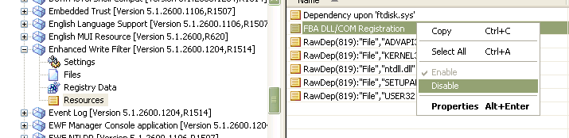
Disabling FBA DLL/COM Registration
If this step is not executed, EWF will attempt to create the EWF partition (and fail). If EWF is accidentally started as enabled, EWF will prevent you from making permanent changes to the runtime image, because EWF will prevent the data from being written to the underlying volume.
4. Choose the file system to be used in the volume you intend to protect.
FAT offers less overhead than NTFS, particularly when used with smaller volumes such as seen in flash devices. Note that FAT does not support NTFS features such as file encryption and security features such as file permission control.
5. From Target Designer, run Check Dependencies (F5) and resolve all dependency issues.
6. Check for the following issue:
Page file support
If your configuration has Page File enabled, the page file should be located on a volume that is not protected. By default there is no pagefile in an XP Embedded runtime. You can add support for this by checking the configurable settings in your HAL component. Your HAL will be "Standard PC" component, "ACPI Uniprocessor", "Advanced Configuration Power Interface", etc.
Adjust the following registry key to relocate or rename the page file:
HKLM\SYSTEM\CurrentControlSet\Control\Session Manager\Memory Management
Name: PagingFiles
Type: REG_MULT_SZ
Data: C:\pagefile.sys 150 500
Within that Data field you can adjust the NAME of the pagefile, its LOCATION and its MINIMUM & MAXIMUM values.
7. From Target Designer, run Build Target Image (F7) and resolve any build issues.
8. Partition the target media that you plan to run FBA on. For details, refer to the section titled Preparing storage media for EWF.
9. Copy the runtime image to volume within the target media that you plan to use to run FBA.
10. Boot the device and allow FBA to complete
11. Inspect windows\FBA\FBALOG.TXT. It should not report any reference to configuring an EWF partition, since it was disabled.
12. At this point the image is booted up and operational. Make any additional custom modifications to the operating system such as registry tweaks, patches, etc.
13. Enabling EWF
At this point, you have built and configured your runtime image exactly the way you want it. The next step is to enable EWF on the boot volume. Because the step for doing this during FBA was disabled in the EWF component, EWF must be manually configured via the registry.
First, verify that the following entries are present on your device:
[HKEY_LOCAL_MACHINE\SYSTEM\CurrentControlSet\Services\ewf]
"ErrorControl"=dword:00000001
"Group"="System Bus Extender"
"Start"=dword:00000000
"Type"=dword:00000001

[HKEY_LOCAL_MACHINE\SYSTEM\CurrentControlSet\Control\Class\{71A27CDD-812A-11D0-BEC7-08002BE2092F}]
"UpperFilters"="Ewf"

Then, add the following entries to your device:
Key Name:
HKEY_LOCAL_MACHINE\SYSTEM\CurrentControlSet\Services\ewf\Parameters\Protected\Volume0
Name: Enabled
Type: REG_DWORD
Value: 0
Name: Type
Type: REG_DWORD
Value: 0x00000001 (1)
Name: ArcName
Type: REG_SZ
Value: multi(0)disk(0)rdisk(0)partition(1)
Note The entry ArcName is the boot Arc path volume that you want to protect. Change the boot Arc path to protect a different volume on the system.
Key Name:
HKEY_LOCAL_MACHINE\SYSTEM\CurrentControlSet\Control\Class\{71A27CDD-812A-11D0-BEC7-08002BE2092F}
Name: UpperFilters
Type: REG_MULTI_SZ
Value: EWF
Note This key may already exist with the value of volsnap. If the value of this key is volsnap, add EWF to the value. EWF must be on a new line. For example:
Value: volsnap
EWF

These changes can be made by any of the following techniques:
- Create a new component containing these registry keys, and add it to your configuration
- Add the registry keys as Extra Registry Data in the root component of your configuration
- Import a REG file using RegEdit
Edit the registry offline using RegEdit (as it ships with your computer) on another computer. The final entry, "ArcName", should reflect the ArcName for the partition you wish to protect.
14. If you took the earlier step of including the System Cloning Tool in your configuration, and you have set its Advanced property of cmiResealPhase to 0, you reseal the image at this step.
Run FBRESEAL along with its optional command-line arguments; refer to
FBRESEAL Commands.
15. Shut down your system and do NOT re-boot up on the XPe image; instead, save this XPe image as your Master image.
16. Partition and format the target media. The media type may be either removable or fixed. Removable media will only accommodate one partition. See also Preparing storage media for EWF for details.
17. Copy your master XPe image to the target media. Note that since you are using EWF-RAM-REG, there is no need to copy the EWF partition.
18. Reboot the target media in its target hardware. This step lets the System Cloning Tool complete its cloning operation, creating a unique SID for the XPe device.
19. Make any per-clone-unique custom modifications, such as registry tweaks, files that have no component owner, files unique to the particular clone, machine name, etc.
20. A second reboot may be necessary in order to allow some components, such as IIS and Terminal Services, to resynchronize with the new computer ID.
21. Repeat steps 16-20 for each desired image copy.

Preparing storage media for EWF
The first time you run FBA, you can run it on the storage device you intend to use. Or, you can run it on a storage device other than your final chosen device. For example you can run FBA on a conventional hard drive, then copy the post-FBA image to your final CF storage device. However, the CF device must appear as the same IDE drive letter in order to work, and it must be formatted and prepared properly.
Three Microsoft tools are available for preparing your storage media:
Windows XP Disk Management utility (diskmgmt.msc)
This is the preferred tool, and is included in standard Windows XP. Some compact flash (CF) devices may fail if you attempt to repartition them with this tool. This is because they report the incorrect disk geometry information to the operating system. For such devices, use WinPE/DISKPART or MS-DOS/FDISK instead.
WinPE (Windows XP Preinstallation Environment) & DISKPART
You can boot from CD1 of Windows XP Embedded, and use the DISKPART tool to partition your media.
MS-DOS, Fdisk, Format & Bootprep
If the media does not allow itself to be partitioned using the above tools, you can partition the media by booting to MS-DOS, using MS-DOS tools, and as a last step use the Windows XP Embedded Bootprep tool to modify the boot sector so that media can boot to Windows XP Embedded. Bootprep is typically only required when using older and smaller capacity disk drives with unusual disk geometries. Bootprep.exe is a command-line tool to create media that can boot into Windows XP Embedded. Specifically, Bootprep changes the Master Boot Record (MBR) from an MS-DOS format into a format recognized by Windows XP or Windows XP Embedded.
First, you must prepare the media by using MS-DOS tools such as FORMAT and FDISK to prepare the MBR (Master Boot Record) and at least one partition. Prepare your media, the active partition of which has been formatted and made bootable with either FAT16, BIGDOS FAT 16, or FAT32 for booting into Windows Embedded. Run Bootprep to replace the partition boot sector code that would normally boot into DOS by loading IO.SYS and MSDOS.SYS with the code that loads NTLDR.
This tool only works when run from MS-DOS, and is only required if you are starting with a storage device that cannot be recognized as configurable by Windows XP.
If your target device uses multiple physical storage media, please note that when the EWF partition is being created (for example via “rundll32 ewfdll.dll ConfigureEwf”), EWF searches all disk volumes, starting with the lowest physical device number, for the first piece of unallocated disk space that will accommodate the size of your EWF partition. If you have two disk drives, and both have unallocated disk space, the EWF partition will choose the first one. If you require that the EWF partition reside on the second disk, it is important that you do not leave any free disk space on the first disk.
Also keep your drive letter mapping as simple as possible. Windows XP allows you to remap the drive letters to arbitrary partitions; if you do so, this might confuse the EWF initialization process.
You should abide to the following rules and constrictions, when partitioning and formatting your disk(s):
- When preparing the partition for the first time, set up no more than 1 primary partition on the target disk media, because there is a known issue during the EWF initialization process when it creates the EWF partition. The symptom is an intermittent failure to open the EWF partition after it is created (see the end of your FBA log for details). After the EWF partition is created successfully, you can add primary partitions to the disk afterwards if required. If you require additional logical drives, instead of creating multiple primary partitions you can create an extended partition that consumes remaining disk space and contains the desired logical drives. Leave enough free sectors in the extended partition to accommodate the EWF partition.
- Unallocated disk space should be less than 4GB.
- Do not fragment unallocated space. Configure all unallocated space so that it is always at the end of the physical disk.
- When formatting, specify the file system(s) to match the file system(s) that you included in your Target Designer configuration. If you format a partition for NTFS, but your configuration contains only the FAT file system, FBA will fail.
- If your disk contains an extended partition, EWF will always attempt to create the EWF partition in the free space within the extended partition. In this case, if the physical disk also has unallocated space, this space is always ignored and never used. So you must ensure there is enough free space in the extended partition to accept the EWF partition. Another requirement is that the extended partition must be the last partition on the physical disk; there must not be a physical partition located after an extended partition.

Preparing flash-based storage media
One of the benefits of using Microsoft® Windows® XP Embedded is the ability to create devices that boot to Compact Flash™ (CF). There are many advantages to using CF, most notably creating solid-state devices. These devices are usually more reliable as they have no moving parts. The downside of using CF is that it has a limit to the number of times one can write to a storage location. Over time, the CF media will fail. The Enhanced Write Filter (EWF) provides a way of protecting the underlying volume from writes. This avoids wearing out the media but imposes the restriction of running protected volumes as stateless. This article will describe a means for building a Windows XP Embedded image and deploying it to CF with EWF enabled.
Storage devices that are marked by the IDE controller as “Removable” are allowed to contain only one partition.
Most Compact Flash (CF) storage devices are marked as removable. However, there are software utilities available from some CF vendors that can mark the vendor’s media as non-removable; this enables you to configure the media with more than one partition. Where possible, it is usually better to mark the media as non-removable, which enables you to reserve unallocated space on the media to accommodate an “EWF partition”, in addition to the volume being protected. An EWF partition provides better support for disabling and storing persistent data. If you cannot mark the media as non-removable, you cannot install an EWF partition. When this happens, RAM-based EWF can still be configured by persisting key information in the registry instead of the EWF partition. This is referred to as EWF-RAM-REG.
If your target embedded device uses Compact Flash instead of hard disk as the storage device, you typically include the Enhanced Write Filter (EWF) with a RAM-based overlay, in order to protect the operating system from any changes. This is an effective means of prolonging or indefinitely extending the life of the CF by reducing or eliminating write cycles to the CF.
For a truly “stateless” system, all your mass storage is protected in this way. Each time you shut down and reboot your system, it will revert to the same system state as the prior boot (and all previous boots).
If you want to protect the system volume but still want to be able to save information so it is retained when the system reboots, you need to set up an additional partition that is not EWF protected. Here are some examples of how this can be accomplished using CF:
- Configure a single CF storage device that contains multiple partitions. The only way you can include more than one partition in a CF storage device is that it must first be flagged as a “fixed” type storage device. By default, most CF storage devices are flagged as “removable”. SanDisk and some other CF device manufacturers supply a utility that allow you to change this flag to “fixed” type, to enable multiple partitions on one CF.
- Configure more than one CF storage device in your design. Set up one of them as EWF protected (usually the system volume), and the other as unprotected.

How to initialize CF media for Windows XP Embedded
There are two ways to accomplish this. The technique chosen depends on whether the CF media can be marked as “non-removable” (i.e. fixed disk type) using a program tool supplied by the CF media vendor.
Use the following procedure if you are able to mark the CF media as “non-removable”.
- Insert the CF media into an IDE->CF adapter installed into your computer as the primary IDE device (you cannot use a USB->CF adapter for this step).
- Run the manufacturer’s utility to mark the CF media as “non-removable”. For example, if you are using SanDisk CF, boot up from a floppy disk using MS-DOS and then run this tool:
NDCFWCHG /P /F
Consider checking with the CF vendor for more information about their default factory settings and their recommendations.
- Boot up into Windows XP Professional with the CF media installed into the IDE->CF adapter (do not use a USB adapter as it typically reports the CF as being removable even when it is marked as non-removable).
- Run the Disk Management tool (DISKMGMT.MSC).
- Right click on the disk to obtain the context menu, then select Delete Partition from the menu. Perform any partitioning activity as required. Use right-click again to create a Primary Partition. If you want more than one partition, create an Extended Partition, then populate the Extended Partition with one or more Logical Drive(s).
- Mark the first partition as Active (again, use the right-click context menu).
- Let First Boot Agent complete in a standard IDE drive on your target embedded hardware. Be sure EWF was initialized as disabled to ensure all changes are persisted.
- Copy your (post-FBA) embedded image to the CF device
- Deploy the CF in your target embedded hardware.

Use the following procedure if you are unable to mark the CF media as “non-removable”, i.e. it can only appear as a removable disk type.
- Insert the CF media into an IDE->CF adapter installed into your computer as the primary IDE device (you cannot use a USB->CF adapter for this step).
- Prepare a floppy disk to contain MS-DOS (version 6.22 or later preferred but not required), FDISK and FORMAT. Locate the BOOTPREP.EXE tool, on the computer where you installed the Windows XP Embedded Tools, in folder Program Files\Windows Embedded\Utilities\ and copy BOOTPREP.EXE to the prepared floppy disk.
- Use FDISK to format the flash as a single partition. Since the CF is marked as removable, you cannot create more than one partition.
- Use FDISK to mark the partition as the Active partition
- Run the BOOTPREP tool. Refer to the System Design Guide documentation in Microsoft Windows Embedded Studio for usage details.
- You can format the CF partition using MS-DOS, or you may boot the computer into Windows XP and then format the CF using the DISKMGMT.MSC tool.
- Let First Boot Agent complete in a standard IDE drive on your target embedded hardware. Be sure EWF was initialized as disabled to ensure all changes are persisted.
- When booted into Windows XP, copy your embedded image to the CF device.
- Deploy the CF in your target embedded hardware.

If you have difficulty formatting the flash device using DISKMGMT.MSC, you may need to use the MS-DOS FORMAT utility (and BootPrep), or the manufacturer’s formatting utility, because sometimes Windows reports the wrong drive geometry to FDISK for flash drives.
Consider using a CF Card Duplicator when mass deploying.

An alternative to RAM EWF using SDI
You can configure a boot volume so that it copies itself into a Ram Disk, then the system boots directly from the Ram Disk. Refer to this section:
Booting from an SDI file

File Based Write Filter (FBWF)
Link to main on-line content:
File-Based Write Filter

Note: Do not apply both EWF and FBWF to the same volume. If both are included in a design, they should be applied to different volumes.
FBWF and EWF

Free disk space display options
If Update Rollup 1.0 is installed, you can configure FBWF to display either actual disk size or virtual disk size.
FBWF Disk Size Display Modes
You can turn on virtual size display mode in Designer component settings, or via fbwfmgr after the image has built:
To have explorer and dir display actual sizes:
- fbwfmgr /setsizedisplay 0
- reboot
For virtual sizes, use a value of 1 in step 1 above.
Use virtual size display mode if you wish to place emphasis on the limited free space available for FBWF file cache area. If this area runs out of space the system will likely crash. When virtual size is chosen, system low disk notifications will pop up when this critical area is almost out of space.

Registry Filter
This component is only used in conjunction with either Enhanced Write Filter (EWF-RAM) or File Based Write filter (but not both at once).
Its purpose is to ensure that two specific registry keys are persisted across system boots (normally FBWF or EWF prevents all registry keys from being persisted across boots).
Persisted keys:
- Enable TSCAL persistence
Used to enable a Server to properly keep track of Terminal Services Client Access Licensing
- Enable Domain Secret Key persistence
For XPe devices connected to a domain server, this key needs to persist for the server to manage participation of clients on its domain.
Some users have inspected the registry keys owned by the Registry Filter component, and then added their own entries, in order to persist additional keys of their own. This is not guaranteed to work for all registry keys. For example:
- Some registry keys are dynamically created by the operating system during the boot process (such as HKEY_CURRENT_USER and HKEY_CURRENT_CONFIG). These keys cannot be persisted across boots owing to their nature.
- Some registry keys are read or written by the operating system at early boot phases, before the Registry Filter service has had a chance to start up. Registry Filter will only work for registry keys that are used for the first time after the Registry Filter service has loaded and fully initialized.
- Aside from the two documented registry keys that are supported, there is no published list that specifies the registry keys that will persist correctly when Registry Filter is used.
Links:
MSDN: Registry Filter
MSDN: XPe Component: Registry Filter

Developing an image bootable from a CDROM

Background
This article has been superseded by later documentation. There is a macro component named El Torito CD Support that facilitates the process. Please use the following on-line link as the principal source of documentation:
Bootable CD-ROM
The documentation below may be useful as a walk through that can help you to better understand the whole process in greater detail.

Booting from an El Torito formatted CDROM
El Torito is the name of a standard for formatting bootable CD-ROM media. Use the Windows XP Embedded El Torito component to enable a CD-ROM to manifest itself as the XPe system volume.
Since CD-ROM is read-only storage, EWF is included in the configuration, in order to convert the system volume from read-only to read/write. All writes are diverted to the EWF RAM overlay (RAM-based disk sectors are dynamically allocated from system memory). This data is lost the next time the system is rebooted. As a result, the system contents are “stateless” across reboots; the system always reboots in the same state as any prior reboot.

The differences between SETUPLDR CDROM boot and El Torito (NTLDR) Boot
SETUPLDR
On WinPE and normal OS install CDs, the loader (setupldr) is written to specifically boot from CD and thus no El Torito HDD emulation is required.
El Torito (using NTLDR):
The HD2ISO tool used in the following XP Embedded walkthrough, in order to create an ISO image, is hardcoded to produce type 4 (HDD Emulation) CD boot images.
The boot loader is NTLDR. NTLDR expects to see a hard drive with an MBR on sector 0. In this case the CDROM must emulate a hard disk drive and hence El Torito HDD emulation is required (and the BIOS has to support El Torito).

Development environment

System requirements
The following are necessary to get started:
- Windows Embedded tools and database.
- A CD Burner.
- A minimum of 2 blank CDR media.
- A hard drive containing a partition that is boot prepped with a total capacity no larger than a CD (650MB).

Because you will deploy a RAM-based EWF overlay, ensure that you have sufficient system memory to accommodate normal operating system memory needs as well as additional memory to accommodate the RAM-based overlay. Consider limiting the size of the protected volume, thereby placing a ceiling on the maximum amount of RAM that can be consumed by the RAM-based overlay. You should configure the protected volume’s unused disk space so that it runs out of space before system memory is entirely consumed.

Development Platform Description
Windows XP Embedded supports booting and executing from CD ROM. The requirements for running the XP Embedded operating system from CD ROM are as follows:
- A BIOS which supports the El-Torito specification
- El Torito component included with the XP Embedded build
- The XP Embedded build must use the Enhanced Write Filter when running from CD since the CD is a read only format.
For more information on the El Torito Specification, see the Web page:
http://www.phoenix.com/NR/rdonlyres/98D3219C-9CC9-4DF5-B496-A286D893E36A/0/specscdrom.pdf

El Torito creation process

Process overview
Creating a bootable CD ROM consists of building an XP Embedded operating system, and then converting it to a CD image file.
The following process outlines building an XP Embedded system, and then deploying the system on CD ROM.
1. Create an XP Embedded configuration, which includes all desired functionality:
Include the El Torito and Enhanced Write Filter components.
Configure the EWF to use RAM overlay
Clear the Start EWF Enabled check box.
Run dependency check and resolve all errors.
2. Build the image and copy the image along with the etprep.exe tool to the Target Machine Drive C:. The drive will need to be accessible by both the XP Pro OS on the target as well as the development system. Do not boot the new image if you have not generated a preliminary El Torito CD, but proceed to step 3. If you have a preliminary El Torito CD in the CDR drive, proceed to step 4.
3. If you have not generated a preliminary CD with El Torito format yet, then run the HD2ISO program from the target XP Pro system and convert the image on the C drive to an ISO file on the target system. Place the ISO image on the development system, and burn a CD with this image. Place this CD in the CDROM drive on the target system.
4. With the preliminary El Torito CD in the drive, boot the XP Embedded operating system from the C: drive on the target system. After FBA has run, boot the XP Embedded operating system on the target device and check the Windows\FBA\FBAlog.txt to see if the EWF was properly initialized.
5. From the C: drive, execute the El Torito preparation tool: etprep.exe. This tool configures the Enhanced Write filter for an El Torito disk, as well as swap drive letters so the El Torito CD will appear as the C: drive. Re-boot back into XP Pro, and verify the changes to the drive letters by examining the system hive on the EL Torito image with regedit.
6. Convert this image to an ISO image using the hd2iso utility. In order to do this, the development machine must have access to the volume which contains the operating system. The hd2iso utility will convert the volume into an ISO CD ROM image file. Transfer this image to the development system, and burn the final image to CD ROM. Place the final CD in the CDR drive of the target. Make any changes to the setup for booting from CD and boot the target. Then test the functionality of your CD.

General flowchart

See flowchart on the next page.

Required components in your configuration
The following table shows which components to include in Bootable CD Rom XP Embedded build:

Component name | Where to find it? | Function
Enhanced Write Filter | Software/System/System Services/Base | Enhanced Write Filter (EWF) is an upper filter in storage device driver stack that redirects disk writes to a volatile (RAM) or non-volatile (Disk) storage
El Torito CD | /Software/System/System Services/Base | El Torito component definition
EWF Manager Console application | /Software/System/Storage & File Systems/Applications | Enhanced Write management application
EWF NTLDR | /Software/System/System Services/Base | Special version of NTLDR that works with EWF
Optional but useful components
Disk Management Command line utility | /Software/System/Storage & File Systems/Applications | Contains Diskpart.exe
FAT/NTFS Common Format/Tools Files | /Software/System/Storage & File Systems/Applications | Contains Format.com, autochk.exe, autofmt.exe, chkdsk.exe, label.exe, recover.exe, chkntfs.exe
Registry Editor | /Software/System/User Interface/Shells/Windows Shell | Use this to inspect registry settings, particularly useful when troubleshooting!

You can optionally include the following:
Enhanced Write Filter API (include this if you wish to programmatically control EWF)
System Cloning Tool
If you are planning to use the System Cloning tool in order to generate a unique computer id (SID) for each deployed runtime, be sure to also include the System Cloning Tool and then set its Advanced Property of cmiResealPhase to zero (0). This setting disables automatic FBA cloning deployment, which allows you the opportunity to make custom changes to the image before the cloning step. You must manually activate the cloning tool using FBRESEAL at a later step. If you included the Automatic Logon component in your image, note that you must configure FBRESEAL so it does not overwrite the automatic logon information. To retain the settings you specified in the Automatic Logon component, set the extended property "cmiRemoveAutoLogon" in the System Cloning Tool to FALSE.

Step by step procedure

Purpose
This chapter explains step by step how to create a bootable Windows XP Embedded CD ROM.

Prerequisites
1. Prepare your first target Hard Disk by accomplishing the following steps.
- Boot a DOS floppy which has FDISK, FORMAT, and BIGFDISK.
- Run FDISK (Answer NO to large disk support). Delete all partitions and disks.
- Create a Primary DOS partition, size: 640MB (643).
- Set this partition active and re-boot the floppy.
- Run FDISK (Answer YES to large disk support).
- Create an extended partition of at least 3.0 GB.
- Create a logical disk drive in the extended partition with size LESS THAN the partition size. There must be at least 10MB of unused space INSIDE the extended partition.
- Leave the rest of the disk free. Exit fdisk and re-boot. You should now have C: =640MB, D: =3000MB.
- Format C: (This will be FAT 16 and will hold the El Torito image).
- Format D: (This will be FAT32 and will hold the XP Pro installation).
- Insert XP Pro CD and Boot from the CD. (Remove floppy disk).
- Install XP Pro on the Second (D:) partition. Leave file system intact.
- When installed, XP should be bootable. Connect to the network, join a domain, rename the computer, and install ETrust and any other fixes you think of.
- Go to Windowsupdate.com and install all other critical updates.
- Copy the hd2iso.exe program from your development system to the XP Pro partition on your target system.
- Modify the boot.ini file on the C: drive to allow booting either from the C (El Torito) drive or the D (XP Pro) drive. A modified boot.ini should look like this:
[boot loader]
- timeout=30
- default=multi(0)disk(0)rdisk(0)partition(1)\WINDOWS
- [operating systems]
- multi(0)disk(0)rdisk(0)partition(1)\WINDOWS="Windows XP Embedded" /fastdetect
- multi(0)disk(0)rdisk(0)partition(2)\WINDOWS="Windows XP Professional" /fastdetect
- C:\="Microsoft Windows"

Step 1: Create an XP Embedded configuration
Open Microsoft Target Designer
File menu → New
Select target device component (ex: GX150) and add it to image
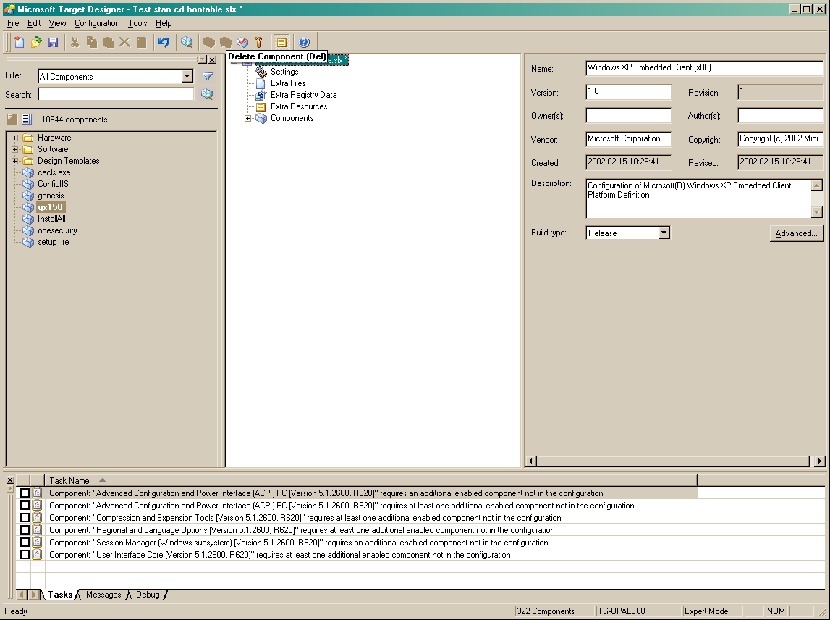
Check dependencies (F5 keystroke).
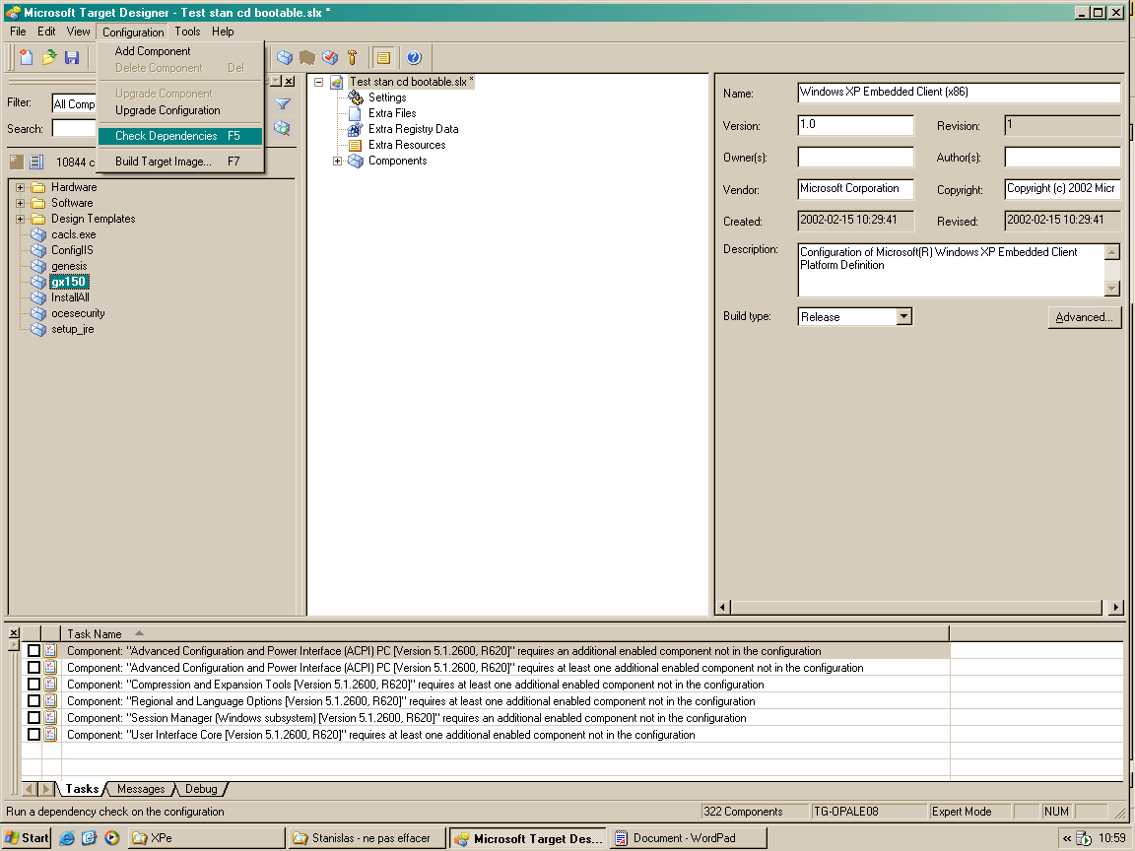
Give necessary information for each task:
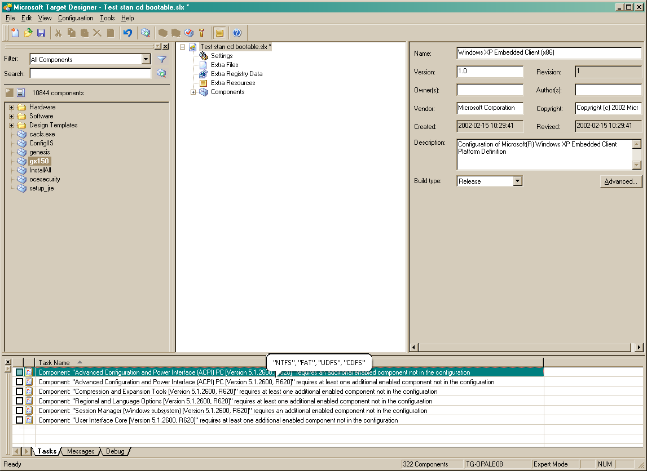
Double click on the first task
Select EWF NTLDR
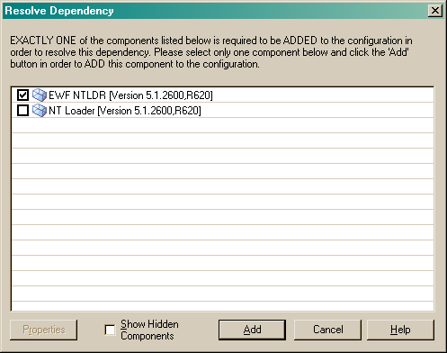
Click Add
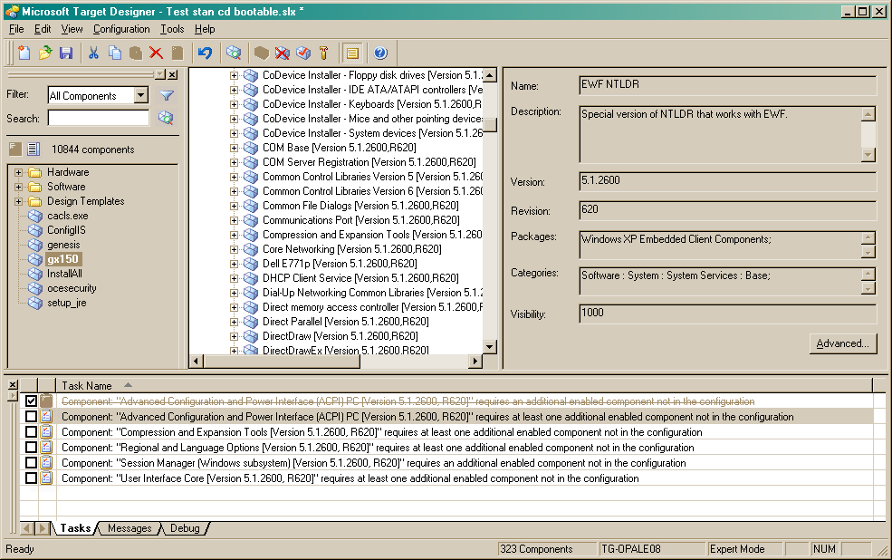

Double click on the second line.
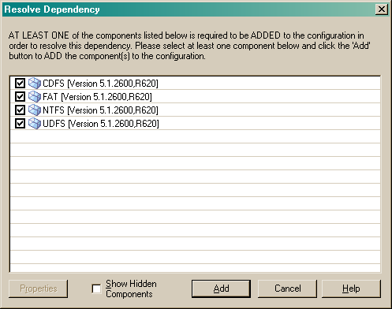
Select all components and then click Add
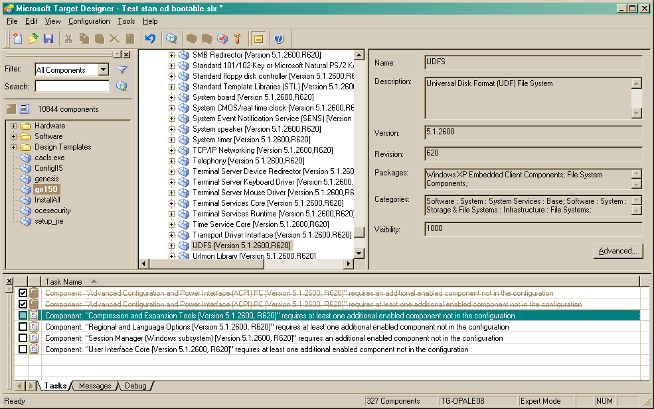
Double click on the third line.
Select all components and then click Add

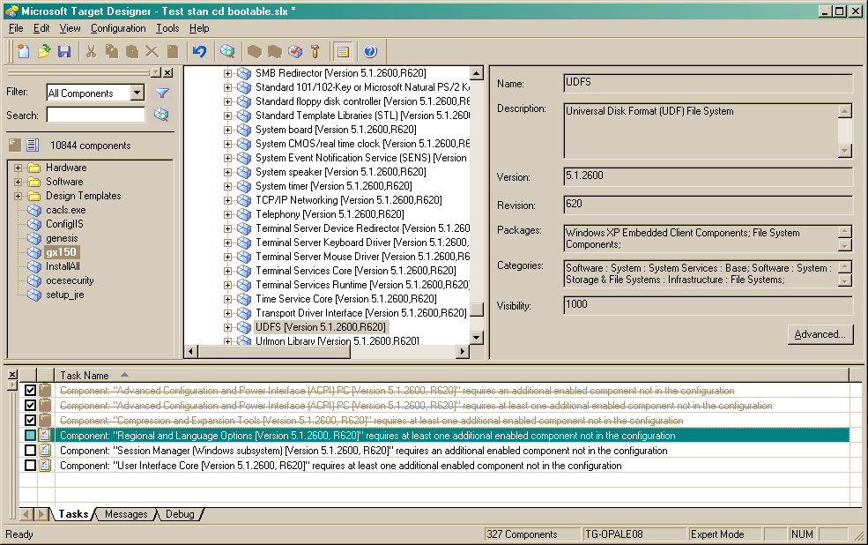
Double click on the fourth line.
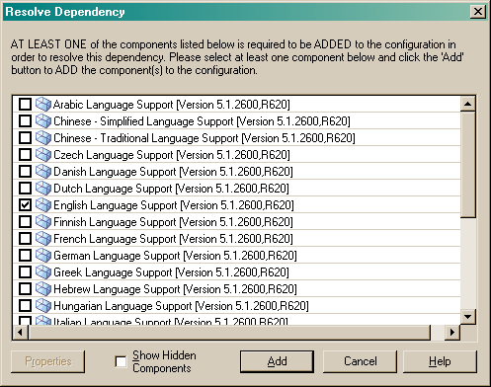
Select English Language Support and click Add.
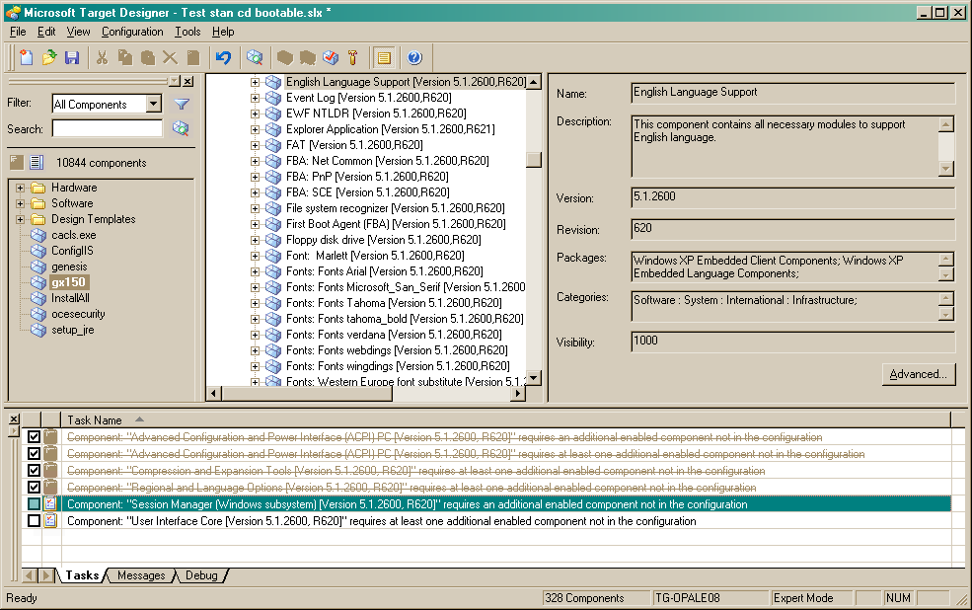
Double click on the fifth line.
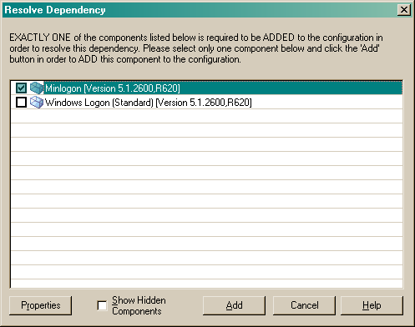
Check Minlogon and click Add.
Note: You can choose another Session manager like Winlogon, this example just create a simple “text interface”.
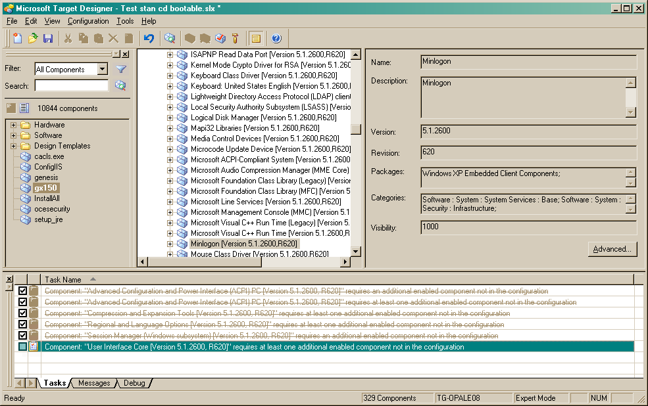
Double click on the last line
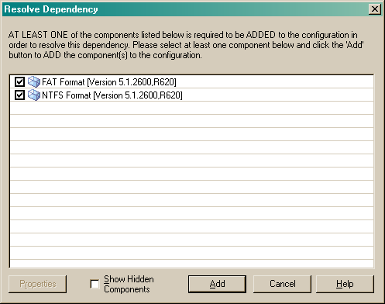

Select both components.
Include the following components in your configuration:

- El Torito CD This component has one configurable setting. The default value for disk signature is 0x4F544C45 (1330924613 Decimal). You do not need to change the default value.
- Enhanced Write Filter Edit the configuration settings for this component and clear the Start EWF Enabled check box. Make sure the overlay type is set to RAM. Leave the default values for all other settings. The target disk volume that is being protected by EWF must be set to Disk Number equals 0, Partition Number equals 1.
- EWF Management Console application
- EWF NTLDR
To do this, perform the following actions:
Add Enhanced Write Filter to image
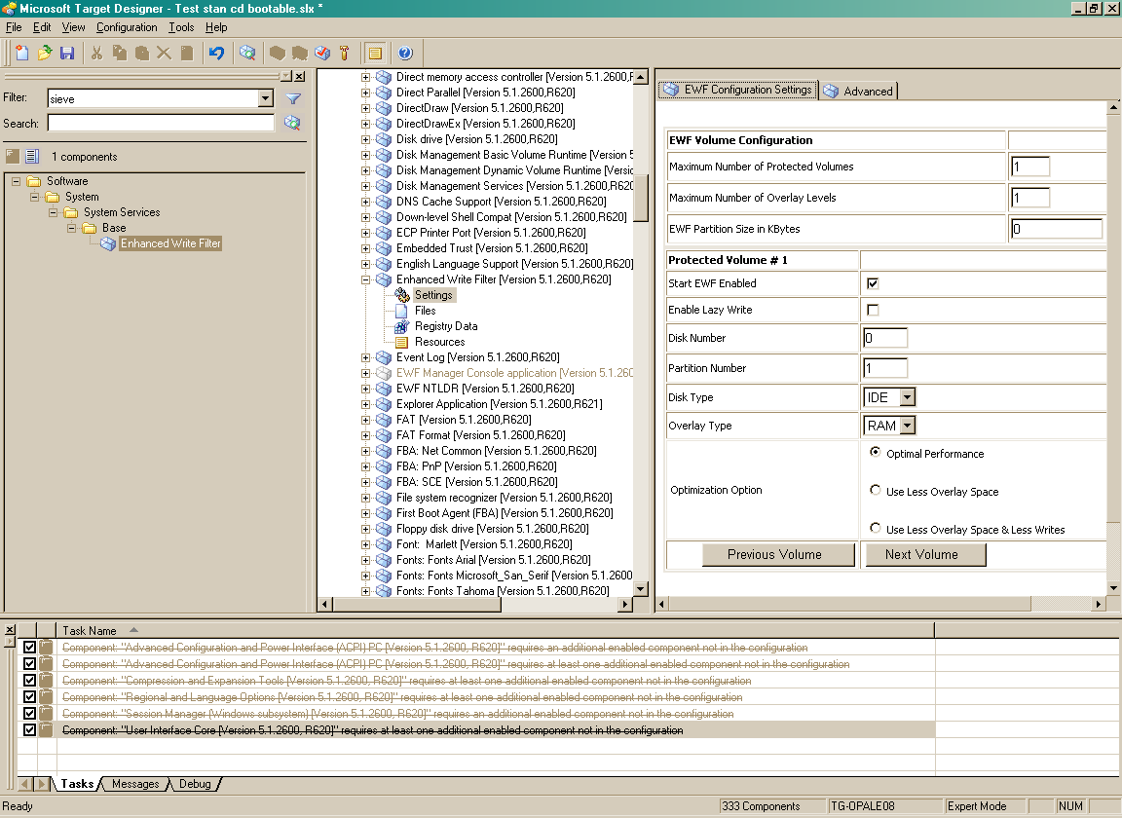

Settings default to the values shown above. Verify the following items:
- Start EWF Enabled is UNCHECKED.
- Disk Number is 0 (Default).
- Partition Number is 1 (Default).
- Disk type is IDE (Default).
- Overlay type is RAM overlay (Default).
- Since this is a RAM overlay, you can set EWF Partition Size in KB to anything you wish, since it has no effect. Best to leave the default value of 0 (Default).
Add El Torito CD to image:

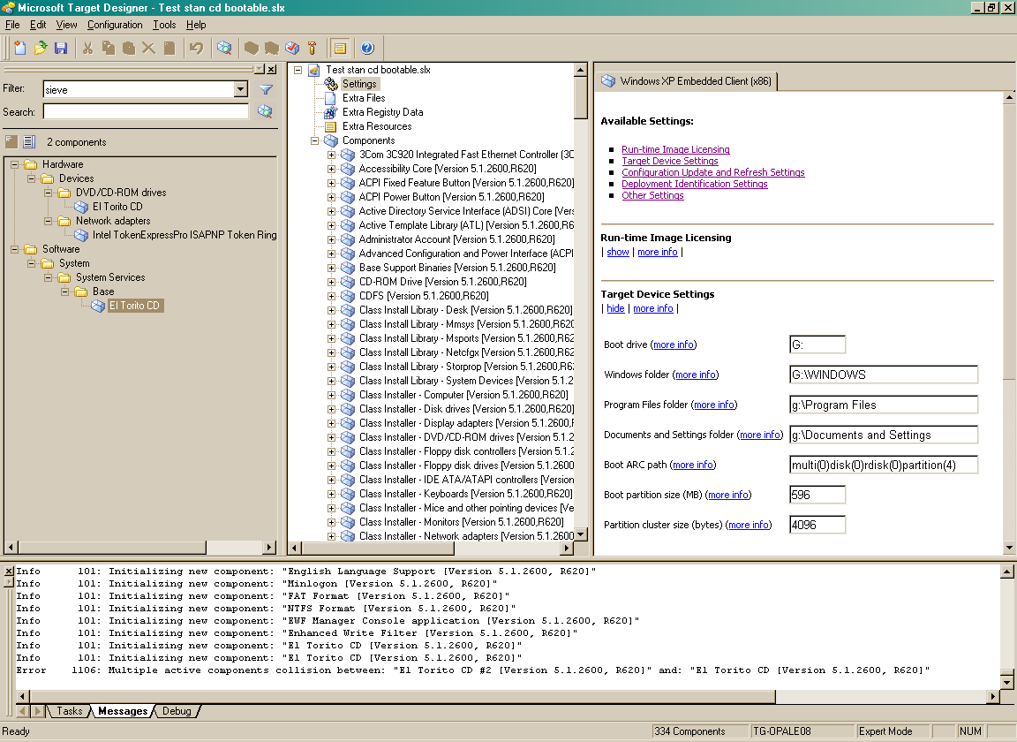

Add EWF Management Console application to image
Add EWF NTLDR to image
Depending on your needs, you can also add the following useful components:
- Disk Management Command line utility.
- FAT/NTFS Common Format/Tools Files.
- Registry Editor.
- Power Management Application
- Beep Driver
- System Cloning Tool

/////For information only/////
If you wish to optimize system boot performance using the above service, you might consider a variation of the above. In this case, do not modify the EnableAutoLayout registry key initially. Let FBA complete, with EWF disabled, and then run a test pass that exercises the functionality of your runtime image. Perform several reboots during this time, and keep track of how long it takes to boot up. Once boot time has been optimized by the background disk defragmentation service, set the EnableAutoLayout key to 0 as described above.

You should not enable the system memory Page File. This is a configurable setting in the PC component, which manifests as one of the following components
- Standard PC (HAL.DLL)
- ACPI Multiprocessor PC (HALMACPI.DLL)
- ACPI Uniprocessor PC (HALAACPI.DLL)
- Advanced Configuration and Power Interface (ACPI) PC (HALACPI.DLL)

Possible issue: EWF missing PnP (user-mode)
Currently when building a runtime with EWF, the PnP (user-mode) component is not always coming into the runtime as needed. The workaround is to manually add this component.
Check dependencies (F5 keystroke).
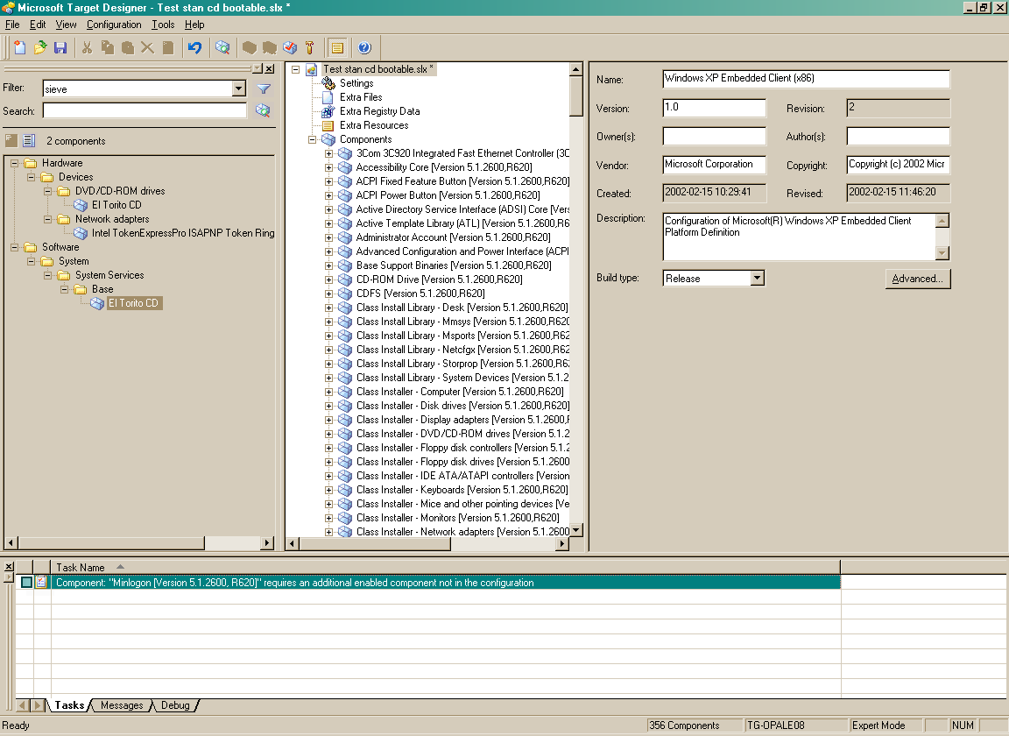
Double click on the task.
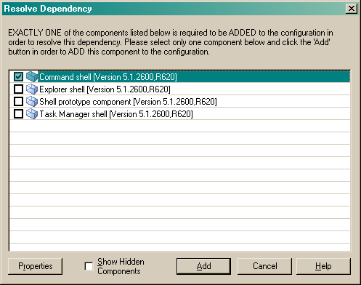
Choose Explorer shell.
Check dependencies (F5)
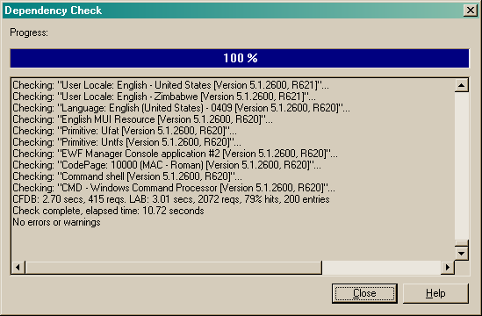
Click Close.
Build the XPe image (F7)
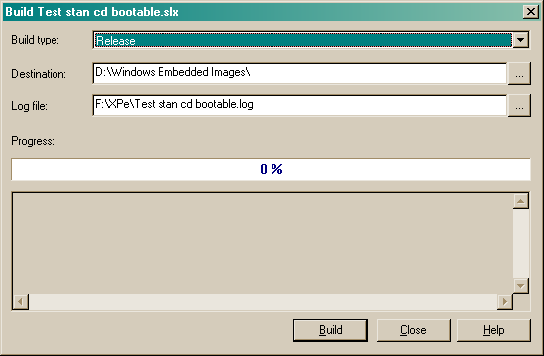
When build is done, click Close.

Step 2: Transfer built image to target device.
Transfer built image to the FAT-16 boot partition on the target device (C:).
///// Do NOT copy the boot.ini from the image on the dev machine. It will overwrite your boot.ini if you do this. /////
///// Do NOT REBOOT the image if you have not built the FIRST CD (Preliminary CD) yet. Go to step 3 /////
If you have already built or you have a Preliminary CD, proceed to Step 4 below.

Step 3: Convert run-time image to ISO format before FBA runs to generate the Preliminary CD.

Overview
Convert your run-time image into an ISO-9660 image file using the El Torito CD Image Preparation tool (Hd2iso.exe) which should be on your XP Pro partition.
The El Torito CD Image Preparation tool creates a bootable CD image from a partition on a physical disk. It converts the hard disk partition image to an ISO-9660/El Torito-compliant image file that can be burned to a CD using a commercial CD-burning application.
Step by step
You should already be booted on XP Professional on Target Device
Execute hd2iso.exe (that you have copied previously from your development station and that is present most of the time under \program files\Windows Embedded\utilities).
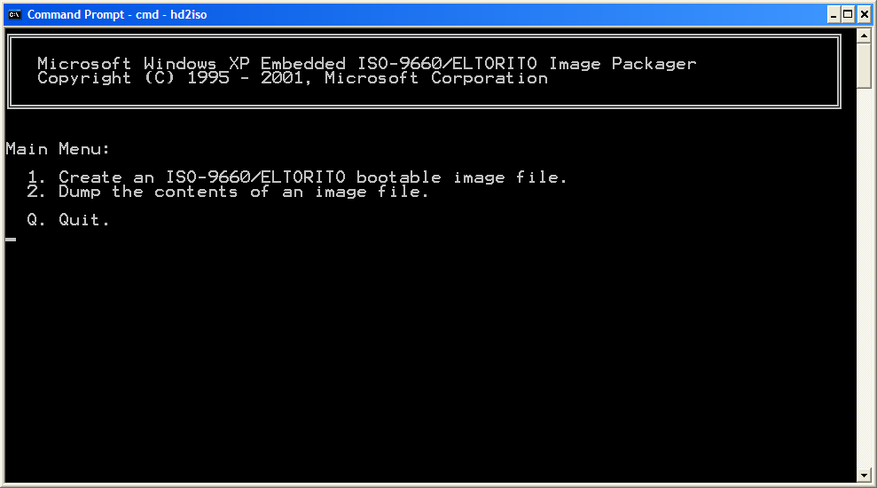
Press 1.
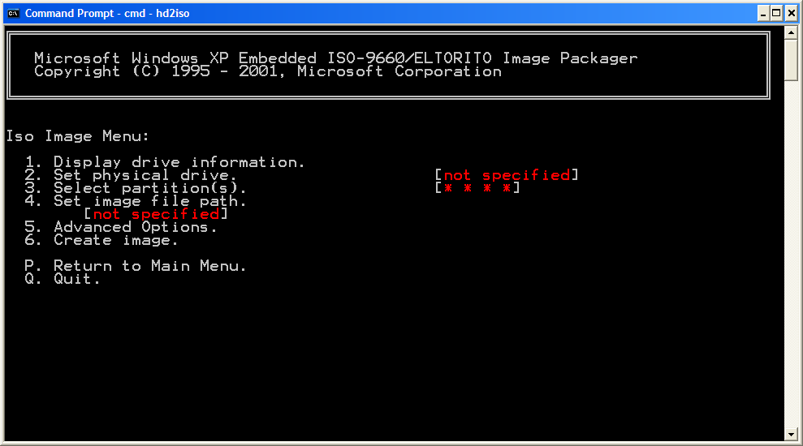
Press 2.
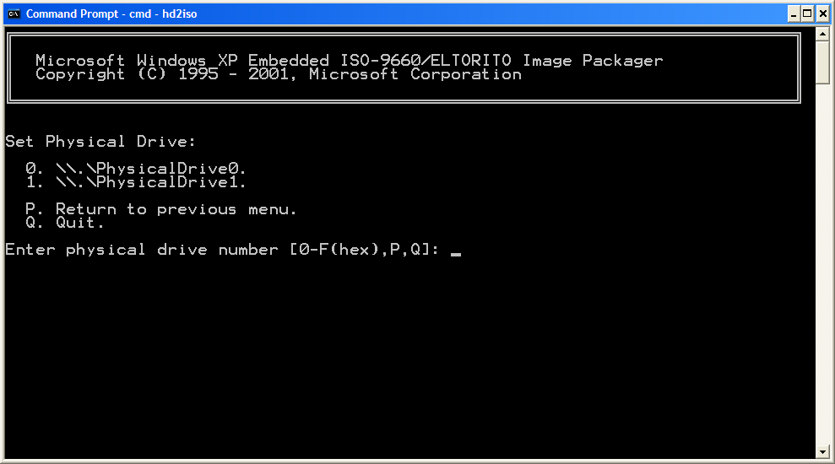
Press 0.
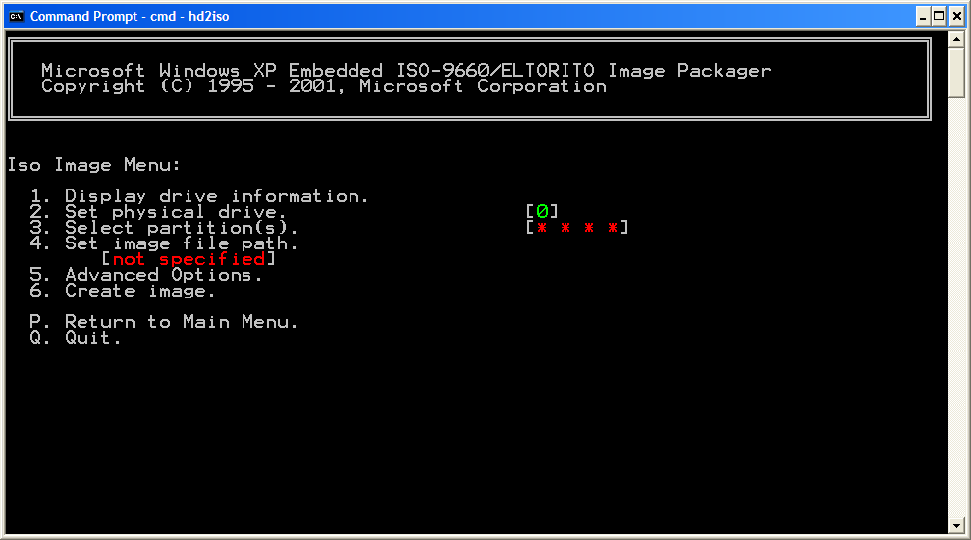
Press 3.
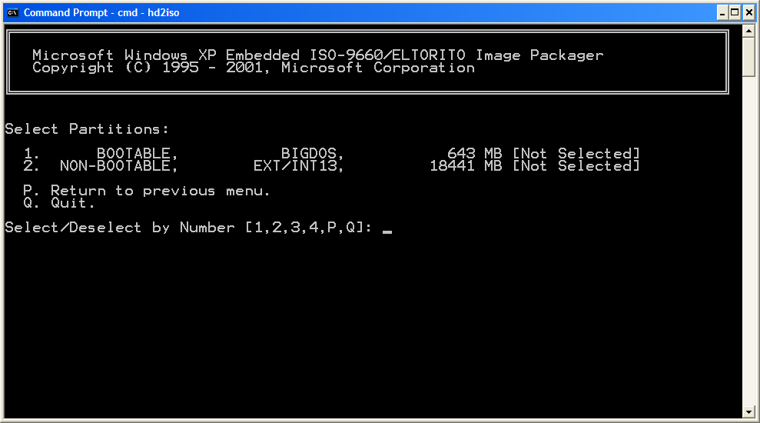
Press 1.
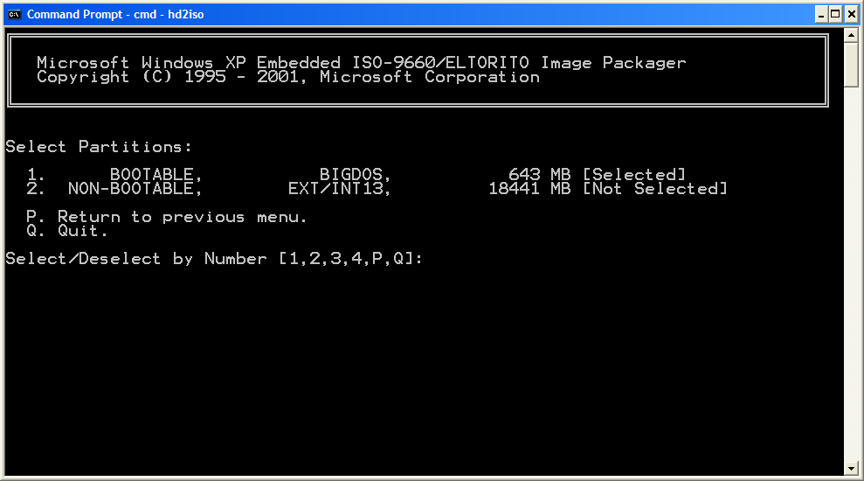
Press P.
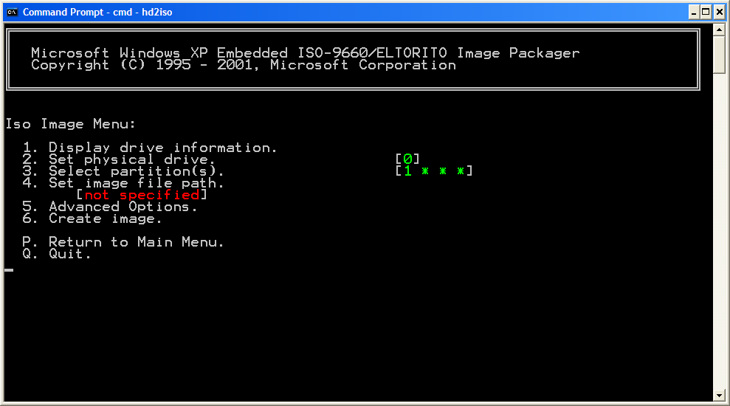
Press 4.
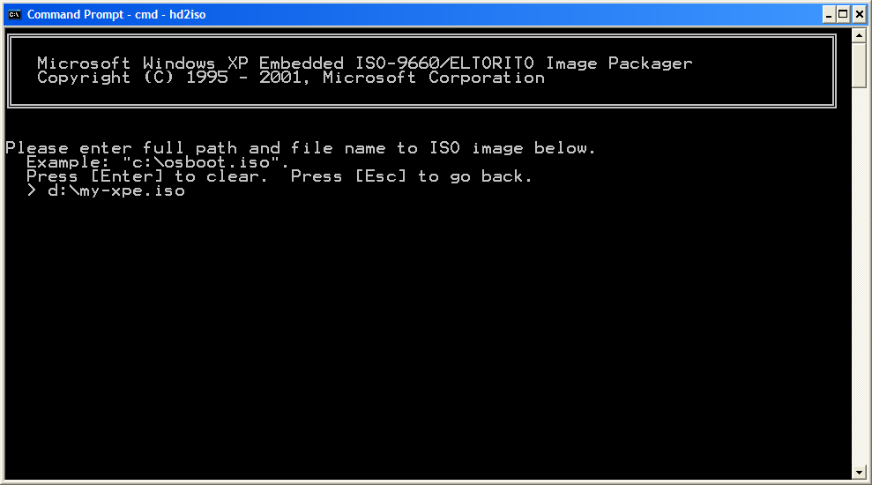
Enter full path and name file to ISO image and press Return.
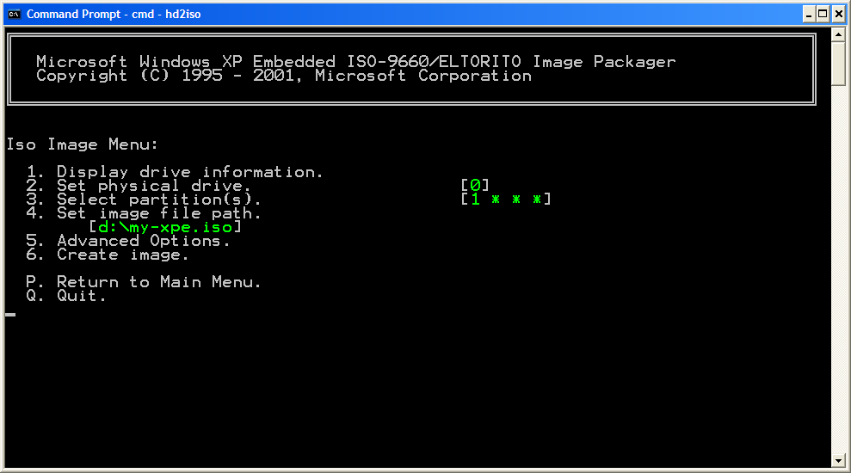
Press 6.
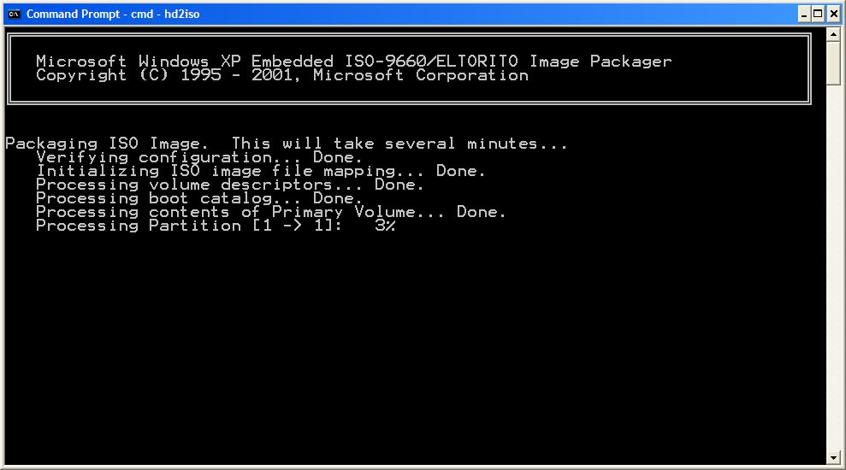

When ISO file is done, press a key and Q to quit HD2ISO.
Copy or move the .iso file to your development station where the CD burning hardware and software reside.
Burn the pre-FBA image produced by the El Torito CD Image Preparation tool onto a CD using commercial CD burning software that is ISO-9660 compliant.
The following example was done using ROXIO software:
With the Roxio software installed on your machine where the cd burner is located, go to the ISO file generated in the above steps and double click it.
The Roxio software will prompt you to insert a blank disk, etc.
Step 4: Run FBA and validate the status of EWF
On Target Device, enter BIOS setup and configure Boot Sequence to start first with hard disk.
On target device, insert the Preliminary CD into the CD ROM drive, and then boot the XPe run-time image located on the 650 MB hard disk partition.
/////NOTE: You must have an El Torito CD in the drive when you run FBA, so that it is discovered as such by the FBA software/////.
The Eltorito.sys driver will detect, report, and set up the new disk volume during the Plug and Play enumeration phase in FBA.
Allow your target system to run FBA. With EWF, FBA will usually reboot the system twice before it has completed its process and you can view the shell.
Log on to your target system XPe (the default in the boot.ini file), and validate the status of EWF using Ewfmgr.exe from a command shell.
C:\windows\system32\ewfmgr
Volume Size 32256
Segments 0
Segment Size 0
Free segments 0
Max Levels 1
Max Protected Volumes 1
Protected Volumes 1
Overlay volume percent full -1.#J

Protected volumes
Device Name "\Device\HarddiskVolume1" [C:]

Verify the status for Protected Volume Configuration by typing ewfmgr c:. The EWF Manager Console application will display the status of the protected volume as shown in the following code:
Protected Volume Configuration
Type RAM
State DISABLED
Boot Command NO_CMD
Param1 0
Param2 0
Persistent Data ""
Volume ID C7 A9 1A EA 00 7E 00 00 00 00 00 00 00 00 00 00
Device Name "\Device\HarddiskVolume1" [C:]
Max Levels 1
Clump Size 512
Current Level 1

Memory used for data 0 bytes
Memory used for mapping 0 bytes

Now, check fbalog.txt
Go to c:\windows\fba
Notepad fbalog.txt
The FBA log should contain EWF information at the end of the log file as shown in the following example:
ConfigureEwf() Start.
Getting EWF config parameters from registry.
EWF Partition Size = 0 (KBytes), Levels = 1, Volumes = 1.
Protected Volume Config #0 :
Disk= 0,Part= 1,DiskType= IDE,Type= RAM.
Enable= Disabled, Optimize= 0, LazyWrite= N.
Found 2 Hard Disks.
Searching for El Torito disk.
Disk0 signature = 0x499602D2.
Disk1 signature = 0x4F544C45.
Disk1 is an ElTorito disk.
Disk #0 layeout info:
PRIMARY partition,start=0x00000001966dfa00, len=0x0000000025429800, type= 6
Created EWF partition on Disk = 1, partition = 1,size = 0x0000000000007e00 .
Saving EWF configuration to registry:
Protected Volume ArcName = multi(0)disk(0)rdisk(0)partition(1).
ewfOpen.
EWF Volume Config on Disk#1, Partition#1:
Segments = 0, Max Volumes = 1, Max Levels = 1
ewfAdd.
Protected Volume Config on Disk0\Partition1 :
Type = RAM, State= DISABLED.
ewfClose
ConfigureEwf() End, status = 0x0.

If the status in the configureEwf() End statement is not equal to zero, look for error messages in the EWF log section and go back over the partitioning and setup steps previously described.
Check the disk configuration and verify that target device contains the El Torito CD in addition to the original disks from which you booted the target device. If not, read the FBA log file and be sure that the El Torito CD drive was listed in Plug and Play by searching for the Eltorito\eltoritodiskdevice string
Diskpart
Diskpart> List volume

Volume Ltr Label Fs Type Size Status Info
-------- --- ----------- ---- ------ ------ ------ ----
Volume 0 E Windows XP CDfs CD Rom 643 Mb
…
…
Volume X C NTFS partition 643 Mo Heathly System

Step 5: Running Etprep.exe
Before you can burn your updated run-time image onto a CD, you must run the Etprep.exe tool. Make sure to reboot your system immediately after etprep.exe has finished.
To run Etprep.exe:

- Your system should still be booted on the embedded partition. Open a command prompt, navigate to the windows\system32 subdirectory, and then type the following command:
etprep /all

- If the operation is successful, the following text will be displayed.
Deleted EWFpartitions = 1.
Swapped ElTorito volume drive F: with Boot volume C: .
Since the system reboots immediately after running etprep, you may not be able to see these statements.

- The EWF partition on the disk has been deleted, and the boot drive letter has been reassigned to the El Torito CD, which will become the boot volume when you boot your target system from CD ROM. The partition you are currently booted from may no longer be bootable after running Etprep.exe because the drive letters have changed. Be sure that you are ready to burn the final CD before completing this step.

Step 6: Finalize image, burn and boot the run-time image from an El Torito CD
Restart your system on your safe build (XP Professional).
The following steps 2-3 are optional, and can be useful for troubleshooting.
Check if ETPREP /All command has been executed with success: run Regedit and highlight HKEY_LOCAL_MACHINE is left pane. File Menu → Load Hive. Go to c:\windows\system32\config and open SYSTEM file. Give a name (ex: SYSTEM XPe).

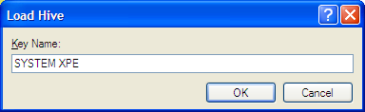

In left pane of regedit, go to HKEY_LOCAL_MACHINE \SYSTEM XPe\MountedDevices. There, you will see some objects with volume IDs in the form "\??\Volume{[guid]}". Ignore these entirely. Below them will be some values with the form "\DosDevices\C:". There should be a new drive letter listed there whose binary data starts with 45 4C 54 4F... (converted from hex to ASCII, this spells “ELTO”. This is the new "drive" reported by the Eltorito driver and represents the emulated hard disk image on the CD. If the ETPREP tool successfully “swapped” the drive letters, you should see this:

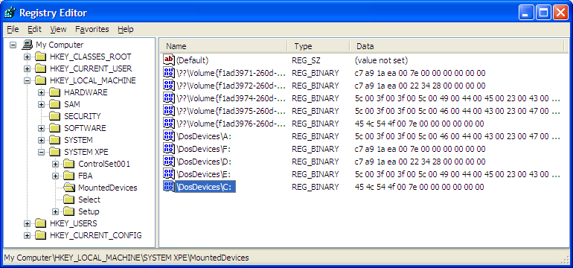

If the tool did not correctly execute, the drive assignment will look something like the following, and you will need to manually swap the binary data of this new drive with the binary data of the \DosDevices\C: drive (assuming C: is the original source partition).

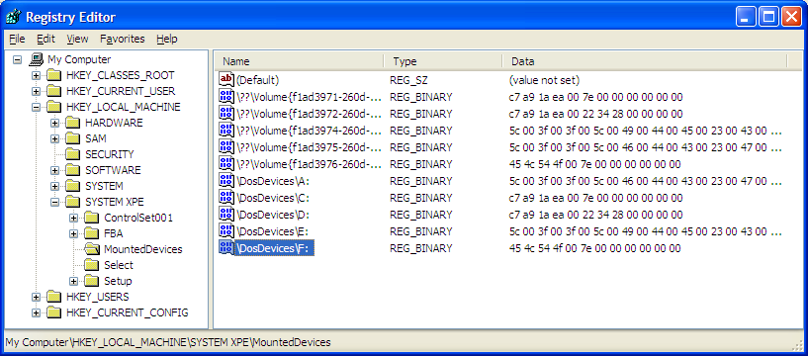

Make sure that there is nothing else you need to do with the embedded image before you reboot to your safe build to burn the final El Torito master CD.
When finished, you must “unload” the hive. Select the hive (SYSTEM XPe), then choose File->Unload Hive.
Finally, close the Registry Editor program.
- Run HD2ISO for the second time (same process as in step 3) and burn the final .ISO image.
- Insert the CD that contains your run-time image in the CD ROM drive on your target device.
- If you have a hard drive installed, in the BIOS configuration menu on your target system, verify that the CD is configured as first boot device, and that your target system will attempt to boot from CD first.
- Allow your target system to reboot. The system should boot from the El Torito CD.
- Log on to your target system, open a command prompt, and then type ewfmgr c: to confirm that the RAM-based EWF is running. The EWF Manager Console application component should report the amount of system memory used. This number should grow as your target system is running various applications.

Troubleshooting
If having problems:
- Use kernel debugger to get additional data during boot.
- Ensure the target Embedded partition is Marked As Active (in Computer Management / Storage / Disk Management)
- After FBA completes, inspect %windir%\FBA\FBALOG.TXT). Confirm the “Created ewf partition on… “ message. Also a later message should indicate “Protected Volume Config on … Type=RAM, State= Disabled”.
- After FBA completes, this registry entry should exist: ControlSet\Enum\ElTorito. EWF should indicate it is disabled.
- If still having trouble consider creating an El Torito build designed to boot up on a stock PC (instead of your unique hardware or CF storage) to ensure you are following the basic procedure correctly.
- The free space for the EWF partition cannot be larger than 2GB
NOTE: If you are using an extended partition, EWF will attempt to use free space within the extended partition. If there is no free space in the extended partition, EWF will fail (even if there remains free unpartitioned space available on the disk).
Usage notes:
- Any applications included on the El Torito image should be designed to minimize disk writes, since each new disk write consumes available system memory until the next boot.
- After creating your image, you cannot repartition the disk in any way wherein the offset of any boot partition changes, and you cannot add new boot storage devices. However, you CAN add non-boot type devices to an El Torito image.
- El Torito cannot be used to create a bootable DVD:

Common problems and solutions
You see a never-ending FBA reboot loop. | The main cause of this is not clearing the “Start EWF Enabled” check box in the EWF component settings.  Before starting FBA, ensure any old EWF (type 45) partitions are first deleted, using Disk Manager (diskmgmt.msc) or the WinPE Diskpart utility.  Also make sure your drive letter mapping is correct. This information is configurable in the root component of your configuration, in Target Designer.
The EWFMGR command with no parameters reports “NO EWF PARTITION” | There is no EWF partition. This is a normal condition if deploying EWF-RAM-REG. You can, however, get the status of the EWF RAM-based volume if you include the drive letter, e.g. EWFMGR C:
A window appears on the desktop stating:  “Delayed Write Failed. Windows was unable to save all data for the file…” | The most probable cause of this is if you run out of free overlay space.  For RAM-based EWF, ensure you are using Windows XP Embedded Service Pack 2 or later. Otherwise, the total memory available for RAM overlay is limited to 256MB.  Ensure you have a large enough overlay (RAM) to accommodate the worst case disk write scenarios. Increase the amount of physical memory until you get the “running out of disk space” warning instead of the delayed write failure. This way, when you start running out of normal disk space (on the CD = 650 MB), the operating system can warn about “disk space” instead of failing.  Consider setting the following check box: “Use Less Overlay Space & Less Writes”  Your application should minimize disk writes. Make sure you have no page file and that hibernate is DISABLED.  Make sure the background disk defragmentation service is turned off, as described elsewhere in this document.
The FBA log reports that ewfOpen returned an Invalid Handle | Usually, the partitioning described earlier in this document is not correct. The program must find free space either at the end of the first Primary partition with no other primary or extended partitions, or at the end of the logical drive in the extended partition (i.e. Logical drive does not use the WHOLE extended partition).
The FBA log reports that it is unable to create the EWF partition | There are no free sectors available to create the EWF partition. Note that even with EWF-RAM an EWF partition is always created temporarily with a minimum size of 32KB.
Fatal Error 0xC000021A occurred when booting the El Torito image | This blue screen fatal error may occur (WINLOGON_FATAL_ERROR) if you did not leave the intermediate El Torito CD in the CD-ROM drive when the ETPREP tool was used, in preparation for creating the final El Torito CD.

Sample FBALOG.TXT
This excerpt from the FBA log lists only the portion where EWF and El Torito are being configured.
11:04:26 AM - [FBADoReboot] Exiting process...
11:05:22 AM - ConfigureEwf() Start.
11:05:22 AM - Getting EWF config parameters from registry.
11:05:22 AM - EWF Partition Size = 65536 (KBytes), Levels = 1, Volumes = 1.
11:05:22 AM - Protected Volume Config #0 :
11:05:22 AM - Disk= 0,Part= 1,DiskType= IDE,Type= RAM.
11:05:22 AM - Enable= Disabled, Optimize= 0, LazyWrite= N.
11:05:22 AM - Found 3 Hard Disks.
11:05:22 AM - Searching for El Torito disk.
11:05:22 AM - Disk0 signature = 0xEA1AA9C7.
11:05:22 AM - Disk1 is raw.
11:05:22 AM - Disk2 signature = 0x4F544C45.
11:05:22 AM - Disk2 is an ElTorito disk.
11:05:22 AM - Checking Start value in System\CurrentControlSet\Services\redbook key.
11:05:22 AM - Resetting Start value.
11:05:22 AM - Checking Start value in System\CurrentControlSet\Services\Imapi key.
11:05:22 AM - Disk #0 layout info:
11:05:22 AM - PRIMARY partition,start=0x0000000000007e00, len=0x0000000028332600, type= 6
11:05:22 AM - EXTENDED partition,start=0x000000002833a400, len=0x00000004809cde00, type= 15
11:05:22 AM - LOGICAL partition,start=0x000000002833a400, len=0x00000001770d7a00, type= 11
11:05:22 AM - EXTENDED_FREE partition,start=0x000000019f411e00, len=0x00000003098f6400, type= 0
11:05:22 AM - FREE partition,start=0x00000004a8d08200, len=0x00000000007d8200, type= 0
11:05:22 AM - Allocating EWF in LOGICAL partition, start=0x000000019f411e00, len=0x000000000000fc00.
11:05:22 AM - Created EWF partition on Disk = 0, partition = 3,size = 0x0000000000007e00 .
11:05:22 AM - Saving EWF configuration to registry:
11:05:22 AM - Protected Volume ArcName = multi(0)disk(0)rdisk(0)partition(1).
11:05:22 AM - ewfOpen.
11:05:22 AM - EWF Volume Config on Disk#0, Partition#3:
11:05:22 AM - Segments = 0, Max Volumes = 1, Max Levels = 1
11:05:22 AM - ewfAdd.
11:05:23 AM - Protected Volume Config on Disk0\Partition1 :
11:05:23 AM - Type = RAM, State= DISABLED.
11:05:23 AM - ewfClose
11:05:23 AM - ConfigureEwf() End, status = 0x0.
11:05:23 AM - [CallEntryPointThread] C:\WINDOWS\system32\ewfdll.dll, ConfigureEwf
11:05:23 AM - [FBASetProgressText] Resetting Setup Flag...
11:05:24 AM - [FBADoReboot] Sleeping...
11:05:34 AM - [FBADoReboot] Rebooting system...
11:06:30 AM - [FBALaunch] cmd /c c:\windows\system32\end-cd-script.cmd

Booting from an SDI file
As an alternative to El Torito, you can prepare an SDI image on a CDROM that copies itself into a RAM Disk and then boots from the RAM Disk. Since the RAM Disk is writable, this approach does not require EWF. The boot media is effectively protected since it is only read during the copy phase, and is never written to.
The Windows XP Embedded Remote Boot feature also uses RAM Disk, except it obtains the volume image from a server on the network.
As a prerequisite, please study the section in the Remote Boot document that describes how to create an SDI image.
Create your image in accordance with the procedure in the Remote Boot documentation, including the “Windows RAM Disk Driver”.
Let your embedded image complete FBA successfully.
Prepare the SDI using SDI Manager (SDIMGR.WSF), thereby creating an SDI image that is compatible with Remote Boot. The SDI should only have the PART blob, which contains the post FBA volume image. Let’s call this JUSTPART.SDI. This SDI image will need to be able to fit onto CDROM, typically <650MB:
sdimgr /new justpart.sdi
sdimgr justpart.sdi /readpart:i:

Use SDI Manager to determine the offset of the PART blob. Typically it’s 4096 if the PART blob is the first in the SDI. You'll use this offset with the /RDIMAGEOFFSET switch.
Copy the following files from your original image to a bootable FAT (not NTFS) partition on the hard disk. Do not use the NTLDR from the Remote Boot downloads directory. If desired, the partition may actually be located on an SDI drive, so you do not need to install a physical disk for this step.
NTLDR
JUSTPART.SDI
BOOT.INI
NTDETECT.COM

Edit BOOT.INI to add this entry in the [operating systems] section:
ramdisk(0)\windows="Windows XP Embedded from RAM" /fastdetect /rdpath=multi(0)disk(0)rdisk(0)partition(1)\JUSTPART.SDI /rdimageoffset=4096
NOTE: All the above text must appear as a single line in the BOOT.INI text file.
Use HD2ISO to create an ISO image file of the post-FBA hard disk (or SDI drive). Use a CDROM burning software utility to transfer the ISO image to your target CDROM media.
The prepared media, upon power up, will automatically copy its ISO image to RAMDISK and subsequently boot from RAMDISK. Note that EWF is not required since RAMDISK is a writable “medium”.
Command-Line Tool
This feature was originally called CMI Explorer (CMIEXP) and Console Application for Windows XP Embedded (XPECon) but its latest rendition is the Windows XP Embedded Command-Line Tool, and is started by launching XPECMD (XPECMD.WSF).
For the latest on-line content:
Command-Line Tool Guide
Be advised that the following old links refer to the older names of this tool:
What's new: XPECMD
Console Application for Windows XP Embedded
TDLite (CMIExplorer)

Remote Boot
First click on the following links to review the on-line MSDN documentation:
Remote Boot
Deploying Windows XP Embedded Remote Boot
Configuring the Remote Boot Service using Remote Boot Manager
Installing the Remote Boot Server
Creating a Remote Boot Image
Preparing a Remote Boot Image for Deployment
Starting and Stopping Remote Boot Services
Configuring DHCP for Remote Boot Services
Using a Boot.ini File in a Remote Boot Environment
Remote Boot Response Time

Remote boot applications
When deploying Remote Boot, you typically use a secure, dedicated private network to connect a Remote Boot server to one or more client devices. Servicing of images is convenient, since all the images are maintained on the server.
Here are some typical applications:
A Remote Boot server is used to serve runtime images to a network of client Point of Sale (POS) terminals in a retail department store. When the POS terminal is powered up or reset, the server automatically downloads the specific runtime image for that terminal. The POS terminal subsequently boots up off of that image.
A Remote Boot server in a factory manufacturing floor is used to deploy runtime images to assorted embedded devices used throughout the factory.
Thin client (minimal hardware), diskless PCs are connected to a Remote Boot server, in a home environment, serving as remote terminals. When the diskless PC powers up, it downloads its embedded runtime image from the server into its system memory. The image contains a Windows XP Embedded runtime that includes little more than a Windows Terminal Services Client (MSTSC) and networking functionality. After the diskless PC completes booting from the image, it launches MSTSC, which connects to the server. This approach enables multiple users throughout the household to share the Windows operating system located on the server, while requiring very little hardware on the terminal side.
You also can deploy Remote Boot on client computers that already contain a hard disk as a boot device. When the client computer boots up from the network, the RAM disk that is created will appear as drive C: The original boot disk is typically assigned the next drive letter (D:). This offers the capability of using Remote Boot to service and/or update runtime images contained in the hard drive of each networked embedded device.

Accessing hard disk volumes on a Remote Boot client
When you boot off a RAMDisk, RAMDisk will mask your underlying hard disk's first partition. RAMDisk always assigns itself drive C. This allows you to boot from the same image regardless of how many drives you have on the embedded device.
- Inspect the following registry key of your target image:
HKEY_LOCAL_MACHINE\SYSTEM\MountedDevices
- Free up \DosDevices\C: for use by RAMDisk by renaming\DosDevices\D: to \DosDevices\E:, \DosDevices\C: to \DosDevices\D:, and so on.
If the signature matches, drive D will be assigned to the drive that was drive C, and so on.

Using Remote Boot as a means of servicing devices that are booted by using Compact Flash
If you want to use the Remote Boot server to deploy a Windows XP Embedded image onto a Sandisk Compact Flash storage device (or any IDE storage device marked as Fixed type), on the target embedded device, and the Compact Flash storage device is set as fixed media and not as removable, the deploying image may not install the Compact Flash storage device, with error code 39. Consequently, the deploying image cannot copy the final image to the Compact Flash storage device.
This behavior occurs because the disk driver, Disk.sys, is automatically loaded when the system boots, and it remains loaded in memory even when no disk drives, including Compact Flash, exist on the embedded device. This condition causes the problem because when you install the Compact Flash storage device or the disk drive, the system tries to load the Disk.sys driver for the Compact Flash storage device or drive. However, because this driver still exists in memory with a null driver object, the installation process fails with error code 39.
To work around this problem, delete the disk driver entry from the following registry key:
HKEY_LOCAL_MACHINE\SYSTEM\CurrentControlSet\Control\CriticalDeviceDatabase\gendisk
This prevents the disk driver from loading at boot time and allows the image to boot off of a RAMDisk. Delete this registry key in the post-FBA image or alternatively run an FBA command at the end of the FBA process that deletes the key.
See also:
You cannot see the local disk drives after you start a Window XP Embedded image by using Remote Boot Server (KB943838)

Maximizing performance of Remote Boot clients
The following factors affect performance:
- Size of the image: smaller is better.
- Network bandwidth: faster is better.
- Number of devices that are booting simultaneously. Booting more embedded devices than your bandwidth can carry will clog your network.
There is a size limit on the image itself: 500 MB.

RAM boot and WinPE
Boot into RAM with Windows PE

RAM boot using SDI
The following MSDN article is intended for developers who want to deploy their own programmatic means of copying and executing a real mode image using PXE in order to boot from the network:
RAM Boot Using SDI in Windows XP Embedded with Service Pack 1

How to stop a computer or laptop from booting from the network (PXE) and to load normally
You need to change the setting in the BIOS. Disable the LAN boot or change the boot order.

Third-party TFTP server offering
Here is an external link to a TFTP server supplied by 3Com.
http://support.3com.com/software/utilities_for_windows_32_bit.htm

Remote Boot Services health checking
You can verify that the Remote Boot Service and Trivial File Transfer Protocol services are installed and started in the Remote Boot Server; use the Service Manager to confirm this. A shortcut to launch the Services Manager is to type services.msc in the Start>Run dialog box.

Use the kernel debugger on the target system for troubleshooting Remote Boot problems
If you wish to debug a network booted client device using the kernel debugger, add the appropriate kernel debugger switches to the Boot Parameters field in the Remote Boot Service Manager’s Policy List (or add this information to the boot.ini file, if used). An example follows:
/debug /debugport=com1 /baudrate=57600

Diagnostics messages
If you have a problem with remote boot, a diagnostic message may appear on the client console video display during client boot. The table below identifies each message and corresponding corrective action.

Message on client display | Corrective action
Windows could not start due to an error while booting from a RAMDISK. Windows failed to open the RAMDISK image | This indicates that the RBSPXE server was unable to locate the file on the server, i.e. the specified image file name is incorrect or the image file was not copied into the designated TFTP downloads path. Ensure that the file is named correctly and is present in the TFTP downloads path.
NTLDR: Fatal Error 21 reading BOOT.INI | Indicates BOOT.INI was not found in the designated folder in the PXE Boot Images folder. Remote Boot Manager will attempt to use the BOOT.INI file from the Boot Images folder if either:  The Remote Boot Manager was not provided with an Boot Image name in the Device Policy List, or  The PXE client physical address is not included in the Device Policy List and the check box named “Use default settings to boot unspecified clients” is checked.  If you wish to create and use your own BOOT.INI, copy your BOOT.INI to the folder containing your Boot Images.
Windows could not start because the following file is missing or corrupt:  <Windows root>\system32\hal.dll.  Please re-install a copy of the above file. | This message can occur if you used the /rdpath=… parameter in either boot.ini or in the Boot Parameters field of the Remote Boot Service Manager’s Policy List, and you specified an SDI image without including the following required switch in the boot parameters: /rdimageoffset=4096.  If you use the /rdpath=... parameter you must also add /rdimageoffset=4096 to the boot parameters.
Windows could not start because of a computer disk hardware configuration problem.  Could not read from the selected boot disk. Check boot path and disk hardware.  Please check the Windows documentation about hardware disk configuration and your hardware reference manuals for additional information. | This message can occur if you did not specify an image name (either in the Device Policy List or in a manually created BOOT.INI file).
TFTP download failed | Appearing on the PXE Client screen at the beginning PXE boot phase, this can indicate that the NTLDR file does not exist on the right place on the server or it has been renamed so it contains a file extension. Ensure that NTLDR is present and has not been renamed.

System cloning / Fbreseal
First click on this link to review the on-line MSDN documentation:
Mass Deployment

Cloning the runtime to multiple target devices
Windows XP Embedded includes the System Cloning tool component. If you add this component to the configuration, by default it adds steps to the First Boot Agent (FBA). After the system completes FBA phases 0 through 8,500, the system reboots on your master system and enters the "Reseal" phases 8,501 through 12,000. After the Reseal phase, you must shut down the system and copy this image to disk. Propagate this image to the multiple cloned embedded devices. The next time this image boots, the cloning phase begins, and the computer's security ID (SID) from the master device is replaced with a unique SID.
Note that the procedure above offers no point in time when you can manually update the image and/or test the image prior to resealing.
If you want to hold off reseal completion from occurring at the end of FBA, edit the System Cloning Tool component so its Advanced parameter cmiResealPhase is set to 0. Then use the FBRESEAL command after you have finished manual updates and testing, when you are ready to perform reseal completion. Then you can mass duplicate your image. See the Cloning topic under System Design Guide, Design Considerations in the Windows XP Embedded Help files for more information.
Note Refer to the Windows XP Embedded Help files topics on the special settings that are required if you need FBA to process anything after cloning. Refer to the FBA Generic Command topic.
The System Cloning tool that is included in Windows XP Embedded does not support cloning an image more than one time. After you use the System Cloning tool to reseal an image, the Fbreseal.exe and Setupcl.exe core files are deleted from the image the next time the cloned client starts up. This behavior is by design to prevent end users from accidentally starting Fbreseal.exe in the deployed run-time image and changing the current configuration of the client image.
Cloning an image more than one time with the System Cloning tool can lead to data loss and image corruption of user settings, Internet Information Services and database settings, domain memberships, and local and group policies.

Chapter 5. Troubleshooting

Introduction

Target Audience and Purpose
This document contains common problems and solutions.
You can use Addenda 5. XP Embedded Troubleshooter as a general purpose troubleshooting starting point, as it contains references to the tips provided in this chapter, as well as references to other chapters and external links.
If you are troubleshooting issues that are specifically related to Service Pack 1, the following document, available on-line, can be useful.
The Windows XP Embedded SP1 Resource Guide
IMPORTANT NOTE: Windows XP Embedded Service Pack 1 (SP1) reached end of life and is no longer formally supported. Security updates are no longer provided and Developer Support cases are treated as "best effort only".

Help from the embedded community
Many embedded customers (mostly from the newsgroups) provide their SLDs back to the community on that site.
Discussions in Windows XP Embedded
Google Groups - microsoft.public.windowsxp.embedded
Windows Embedded Newsgroups
The XP Embedded team blog

An excellent resource to take advantage of is the following Web site:
www.xpefiles.com

Design tools

Target Designer Development

Filters in Target Designer causing a CMI error
If you are using a complex filter, you may receive the following error message:

The CMI encountered the following error:
0x80042335 (-2147212491)
A database error occurred within the CMI.

To resolve this issue, add the following registry key:
HKEY_LOCAL_MACHINE\Software\Microsoft\Windows Embedded\CMI\DBCmdTimeout
You can then create the DBCmdTimeout DWORD value type, and set the value to 300, which is 5 minutes. If the error occurs again, or if you are using a more complex filter algorithm, you may need to increase the DBCmdTimeout value.

Configuration error when you try to create a new configuration
When you click New on the File menu, and then try to type a configuration name, you may receive the following error message:
Configuration Management Error Code=0x8002801d
To resolve this problem, upgrade your development computer to Windows Script 5.6 for Windows XP:
Windows Script 5.6 for Windows XP and Windows 2000

Component development

Component development, debugging and testing tools
For links to useful debugging tools, refer to the following Addenda:
- Addenda 2. Microsoft resources
- Addenda 3. Third-party resources

Problem re-importing a component
If you add a custom component to the component database, and attempt to later update this component (re-import it), you may get an error when you trying to re-import it. This behavior may occur because the repository share is read-only. To resolve this problem, do one of the following:
- Change the permissions, and then push the permissions through to all the folders in the share to prevent this problem from occurring in the future with other component repositories. Before doing this however, make sure you are not using Simple File Sharing which does not provide full visibility of all properties. In File explorer, click Tools->Folder Options... Click on the View tab. At the bottom of the Advanced Settings list, make sure the following is not checked: Use simple file sharing. Then click on the button labeled Apply to All Folders. Now you can set permissions for which users can share the Repositories folder etc.
- In Explorer, delete your old custom repository manually. To discover the relationship between the name of a repository and its folder name, run Component Database Manager and click on the Repository tab. An example of a repository folder is {FA42B463-6457-41E5-93B2-2F21BA2D28D7}. Then re-import the .sld file.
- When you import the new .sld file, if the new .sld file involves no changes to the files in the repository, click to clear the Copy files to repository check box when you click the Import button.
For additional information, visit the following Microsoft Web site:
Hodge Podge Lodge: Remote Debugging, Localization, and Globalization in Windows XP Embedded

Driver Component Debugging
First please reference Chapter 3. Development Guide regarding development and debugging driver components.
For an overview of Microsoft debugging tools for Windows, visit the following Microsoft Web site:
Debugging Tools for Windows - Overview
For information about verbose debug tracing, see the following article in the Microsoft Knowledge Base:
How to enable verbose debug tracing in various drivers and subsystems
If you use a serial port for communication with a serial device, you may encounter false serial mouse detections. For a registry remedy, see the following article in the Microsoft Knowledge Base:
Serial Device May Be Detected as a Serial Mouse in Windows 2000
For information about the null modem cable technique for kernel debugging, see the following article in the Microsoft Knowledge Base:
How to set up a remote debug session using a null modem cable
To obtain checked binary files for Windows XP Professional visit the following Microsoft Web sites:
Windows XP Service Pack 2 Checked Build Network Installation Package
If you are having difficulties componentizing an audio driver, check this link:
I am having problems componentizing my third-party audio driver

Embedded image deployment
This section includes troubleshooting tips and workarounds for known issues.
The following tips are from the original release of Windows XP Embedded SP1, but many are still relevant to SP2 and beyond.
Microsoft Windows XP Embedded Technical Frequently Asked Questions

Licensing

Licensing issues when you install Office on a runtime
It is generally not acceptable or applicable to install Microsoft Office in a Windows XP Embedded runtime. Windows XP Embedded is designed for creating "limited functionality runtime devices".
Windows XP Embedded can be licensed for use for line-of-business applications only. The number of other applications that can be used is unlimited, as long as they are required for use as part of the specific OEM embedded role or application. If you have a scenario that requires Microsoft Office, you can use either Windows XP Home or Windows XP Professional to fulfill the licensing and functional requirements of Microsoft Office.

Common issues

ActiveX controls fail to load in Internet Explorer
You may observe a problem with ActiveX controls after applying Windows XP Embedded October 2005 Security Updates
Microsoft Security Bulletin MS05-052
The above update references the following fix:
ActiveX controls may not load as expected in Internet Explorer due to defense in depth changes introduced in cumulative security update 896688 (MS05-052)
If the indicated registry keys are not present in your image, apply the registry key additions.

Your design reports CMI Error 0x800A01C9 (or other CMI errors)
CMI error code 0x800a01c9 (The index specified does not reference an existing item in the collection) can happen when:
- Upgrading a pre-existing image using Configuration->Upgrade Configuration
- Building a new design and you choose primitive level components that are end of life, Prototype, or otherwise obsolete.
1. If creating an initial design, start by choosing macros found in the Design Templates branch in Target Designer, and/or top level feature components such as those listed in the companion spreadsheet "XPE SP2 Component Manifest.XLS". If you manually include low level components such as components whose name starts with "Primitive" you might inadvertently include end of life or prototype components that are not compatible with the current database version level.
2. Remove Prototype components from your image. It is possible that you manually included one or more Prototype components in your old SP1 image. Prototype components are not intended to be used in a configuration, they serve as abstract base prototype components for building real components. Target Designer makes some of these prototype components visible and hence selectable by the developer. Search for and delete any components that contain the word Prototype.
3. Make sure your database is at the same version level or higher, than the design you are attempting to load, and all the latest security updates (for components) are installed. Otherwise you may get errors relating to (newer) components not being found by Target Designer.
4. This error can occur when upgrading an SLX that contains any of the components that have been marked as “End of life” in SP2. This problem has been reported with both "MSN Explorer" and WMP 8.0 components.
The following list of components have been marked as End of Life for SP2. Please delete these components from your SP1 SLX before attempting to upgrade to SP2 or later.

Common Control Libraries Policy 6 [6.0.0.0] [R101514] | Common Control Libraries Version 6 [1.0.0.0] [R101509] | Common Control Libraries Version 6 [6.0.2800.1515] [R101906]
DirectShow Indeo4 [R100624] | DirectShow Indeo5 [R100624] | DirectShow Indeo5Audio [R100624]
Electronic Program Guide Database [R100625] | GDI+ Policy XPSP1 [R101509] | GDI+ XPSP1 [R101510]
ICM: DiamondTron Monitor G18 D50 [R100622] | ICM: DiamondTron Monitor G18 D65 [R100622] | ICM: DiamondTron Monitor G18 D93 [R100622]
ICM: DiamondTron Monitor G22 D50 [R100622] | ICM: DiamondTron Monitor G22 D65 [R100622] | ICM: DiamondTron Monitor G22 D93 [R100622]
ICM: Generic Monitor Adobe1998RGB D65 WP 2.2 Gamma [R100622] | ICM: Generic Monitor AppleRGB D65 WP 1.8 Gamma [R100622] | ICM: Hitachi Monitor G18 D50 [R100622]
ICM: Hitachi Monitor G18 D65 [R100622] | ICM: Hitachi Monitor G18 D93 [R100622] | ICM: Hitachi Monitor G22 D50 [R100622]
ICM: Hitachi Monitor G22 D65 [R100622] | ICM: Hitachi Monitor G22 D93 [R100622] | ICM: NEC Multisync Monitor G18 D50 [R100622]
ICM: NEC Multisync Monitor G18 D65 [R100622] | ICM: NEC Multisync Monitor G18 D93 [R100622] | ICM: NEC Multisync Monitor G22 D50 [R100622]
ICM: NEC Multisync Monitor G22 D65 [R100622] | ICM: NEC Multisync Monitor G22 D93 [R100622] | ICM: Trinitron Monitor G18 D50 [R100622]
ICM: Trinitron Monitor G18 D65 [R100622] | ICM: Trinitron Monitor G18 D93 [R100622] | ICM: Trinitron Monitor G22 D50 [R100622]
ICM: Trinitron Monitor G22 D65 [R100622] | ICM: Trinitron Monitor G22 D93 [R100622] | Legacy: 001 MB Page File [R100001]
Legacy: 002 MB Page File [R100001] | Legacy: 004 MB Page File [R100001] | Legacy: 008 MB Page File [R100001]
Legacy: 016 MB Page File [R100001] | Legacy: 032 MB Page File [R100001] | Legacy: 064 MB Page File [R100001]
Legacy: 128 MB Page File [R100001] | Legacy: 256 MB Page File [R100001] | Legacy: 3Com Etherlink III (3C509) [R100001]
Legacy: 3Com Etherlink III (3C509) <2> [R100001] | Legacy: 3Com Etherlink III PCI (3C590) [R100001] | Legacy: 3Com Fast EtherLink XL (3C900) [R100001]
Legacy: 3Com Fast EtherLink XL (3C905) [R100001] | Legacy: 3Com Fast EtherLink XL NIC (3C905B-TX) [R100001] | Legacy: 3Com Fast EtherLink XL NIC (3C905B-TX) <2> [R100001]
Legacy: 486c HAL [R100001] | Legacy: 512 MB Page File [R100001] | Legacy: ACL Editor [R100001]
Legacy: Adaptec AHA-154X Plug and Play [R100001] | Legacy: Adaptec AHA-154X/AHA-164X [R100001] | Legacy: Adaptec AHA-294X/AHA-394X or AIC-78XX PCI [R100001]
Legacy: Add Printer Wizard [R100001] | Legacy: aha154x [R100001] | Legacy: aic78xx [R100001]
Legacy: Alerter [R100001] | Legacy: AMD PCNET ISA/VESA [R100001] | Legacy: AMDPCN [R100001]
Legacy: APIC HAL [R100001] | Legacy: AppleTalk [R100001] | Legacy: Arial Font [R100001]
Legacy: ASP [R100001] | Legacy: AST HAL [R100001] | Legacy: AT Command [R100001]
Legacy: ATI [R100001] | Legacy: ATI Graphics Adapter [R100001] | Legacy: AutoCheck [R100001]
Legacy: Automatic Logon [R100001] | Legacy: Buslogic [R100001] | Legacy: BusLogic Multimaster PCI SCSI Host Adapters [R100001]
Legacy: Calculator [R100001] | Legacy: Cbus HAL [R100001] | Legacy: Cbusm HAL [R100001]
Legacy: CDFS [R100001] | Legacy: Character Map [R100001] | Legacy: Chat [R100001]
Legacy: Chips [R100001] | Legacy: Chips Video Accelerator [R100001] | Legacy: Cirrus [R100001]
Legacy: Cirrus Logic 5465 Graphics Adapter [R100001] | Legacy: Cirrus Logic Graphics Adapter [R100001] | Legacy: CL546x [R100001]
Legacy: ClipBook Viewer [R100001] | Legacy: Clock [R100001] | Legacy: COM1 [R100001]
Legacy: COM2 [R100001] | Legacy: COM3 [R100001] | Legacy: COM4 [R100001]
Legacy: Command Shell [R100001] | Legacy: Compaq Netelligent 10 or 10/100 PCI [R100001] | Legacy: Compaq Netelligent 10/100 TX Embedded UTP [R100001]
Legacy: Computer Browser [R100001] | Legacy: Console Administration Common [R100001] | Legacy: Copy File Command (XCOPY.EXE) [R100001]
Legacy: Courier Font [R100001] | Legacy: CpqNF3 [R100001] | Legacy: Cryptography Core [R100001]
Legacy: DC21X4 [R100001] | Legacy: DCOM [R100001] | Legacy: DEC PCI Fast Ethernet DECchip 21142 [R100001]
Legacy: DEC PCI Fast Ethernet DECchip 21143 [R100001] | Legacy: Default Page File [R100001] | Legacy: Device Settings [R100001]
Legacy: DHCP Client [R100001] | Legacy: DHCP Server [R100001] | Legacy: Dial-Up Networking Serial Cable between 2 PCs [R100001]
Legacy: Digi DataFire Driver [R100001] | Legacy: Digi DataFire PCI 1 S/T ISDN Adapter [R100001] | Legacy: Digi DataFire PCI 1 S/T ISDN Adapter <2> [R100001]
Legacy: Disk Administrator [R100001] | Legacy: DiskOnChip As Disk [R100001] | Legacy: Display Common [R100001]
Legacy: DNS Server [R100001] | Legacy: Domain Participation [R100001] | Legacy: E100B [R100001]
Legacy: E100BNT [R100001] | Legacy: EIDE CD-ROM [R100001] | Legacy: EIDE Disk [R100001]
Legacy: EIDE SCSI Adapter [R100001] | Legacy: EIDE SCSI Driver [R100001] | Legacy: El Torito CD As Disk [R100001]
Legacy: El59X [R100001] | Legacy: EL90x [R100001] | Legacy: Elnk3 [R100001]
Legacy: English (US) Input Locale [R100001] | Legacy: Event Logging [R100001] | Legacy: Event Viewer [R100001]
Legacy: Explorer [R100001] | Legacy: Explorer Links [R100001] | Legacy: Explorer Shell [R100001]
Legacy: FAT [R100001] | Legacy: Fault Tolerance [R100001] | Legacy: File ACL Command (CACLS.EXE) [R100001]
Legacy: File and Print Services for NetWare [R100001] | Legacy: File Attribute Command (ATTRIB.EXE) [R100001] | Legacy: FTP Performance Counters [R100001]
Legacy: Graphical Remote Administration [R100001] | Legacy: HP LaserJet 6L [R100001] | Legacy: HP LaserJet 6L - Shared [R100001]
Legacy: Hyper Terminal [R100001] | Legacy: IDE Disk [R100001] | Legacy: IEEPRO [R100001]
Legacy: IIS 3.0 [R100001] | Legacy: Intel EtherExpress PRO (E100B) [R100001] | Legacy: Intel EtherExpress PRO (E100BNT) [R100001]
Legacy: Intel EtherExpress PRO (IEEPRO) [R100001] | Legacy: Internet Service Manager [R100001] | Legacy: IPX/SPX [R100001]
Legacy: Kernel TSP [R100001] | Legacy: Keyboard Drivers Common [R100001] | Legacy: Keyboard Locale Common [R100001]
Legacy: LAN Manager Server [R100001] | Legacy: LAN Manager Workstation [R100001] | Legacy: Logitech PS/2 Mouse [R100001]
Legacy: Logon Screen Saver [R100001] | Legacy: LPT1 [R100001] | Legacy: LPT2 [R100001]
Legacy: Lucida Console Font [R100001] | Legacy: Lucida Unicode Font [R100001] | Legacy: Manual Shell [R100001]
Legacy: Matrox Graphics Adapter [R100001] | Legacy: Matrox Millenium Graphics Adapter [R100001] | Legacy: MCA HAL [R100001]
Legacy: Messenger [R100001] | Legacy: MGA [R100001] | Legacy: MGA64 [R100001]
Legacy: Microsoft PS/2 Mouse [R100001] | Legacy: Minimal OS [R100001] | Legacy: MMC [R100001]
Legacy: Modem Console Administration [R100001] | Legacy: Modern Font [R100001] | Legacy: Mouse Common [R100001]
Legacy: MPS HAL [R100001] | Legacy: MPSM HAL [R100001] | Legacy: MS Sans Serif Font [R100001]
Legacy: N100 [R100001] | Legacy: NCR HAL [R100001] | Legacy: NE2000 [R100001]
Legacy: Net Command (NET.EXE) [R100001] | Legacy: NetBEUI [R100001] | Legacy: NetBIOS [R100001]
Legacy: NetDDE [R100001] | Legacy: Network Common [R100001] | Legacy: No Page File [R100001]
Legacy: Notepad [R100001] | Legacy: Novell NE2000 Compatible Adapter [R100001] | Legacy: NT LM Security Support Provider [R100001]
Legacy: NTFS [R100001] | Legacy: NULL [R100001] | Legacy: Null Keyboard Driver [R100001]
Legacy: Null Mouse [R100001] | Legacy: NullVGA [R100001] | Legacy: Object Packager [R100001]
Legacy: ODBC Access Driver [R100001] | Legacy: ODBC Core [R100001] | Legacy: ODBC Jet Support [R100001]
Legacy: ODBC SQL Server Driver [R100001] | Legacy: OLE/COM [R100001] | Legacy: Olivetti HAL [R100001]
Legacy: Paint [R100001] | Legacy: Parallel Ports Common [R100001] | Legacy: PC/AT Keyboard Driver (101/102-Key) [R100001]
Legacy: Performance Counters [R100001] | Legacy: Performance Monitor [R100001] | Legacy: Phone Dialer [R100001]
Legacy: PPTP [R100001] | Legacy: Primary Domain Controller [R100001] | Legacy: Printer Common [R100001]
Legacy: Quick View [R100001] | Legacy: RAS Client [R100001] | Legacy: Realtek RTL8029 PCI Adapter [R100001]
Legacy: Registry Editor [R100001] | Legacy: Roman Font [R100001] | Legacy: RPC [R100001]
Legacy: RRAS [R100001] | Legacy: RTL8029 [R100001] | Legacy: S3 [R100001]
Legacy: S3 Graphics Adapter [R100001] | Legacy: SAP Agent [R100001] | Legacy: Scheduler [R100001]
Legacy: Script Font [R100001] | Legacy: SCSI CD-ROM [R100001] | Legacy: SCSI Common [R100001]
Legacy: SCSI Disk [R100001] | Legacy: Serial Console Administration [R100001] | Legacy: Serial Mouse [R100001]
Legacy: Serial Ports Common [R100001] | Legacy: Server System [R100001] | Legacy: Service Settings [R100001]
Legacy: Services for Macintosh [R100001] | Legacy: Shutdown Utility [R100001] | Legacy: Simple TCP Services [R100001]
Legacy: SIS Graphics Adapter [R100001] | Legacy: SiSV [R100001] | Legacy: SMC EZ Card PCI 10 Adapter [R100001]
Legacy: SMC LAN9000/91C94/91C100 Ethernet Adapter [R100001] | Legacy: SMC1208 [R100001] | Legacy: SMC9xxx [R100001]
Legacy: SNMP [R100001] | Legacy: Sportster 28.8Kbps Internal Modem [R100001] | Legacy: Sportster 56Kbps External Modem with X2 [R100001]
Legacy: Standard 28.8Kbps Modem [R100001] | Legacy: Standard Accessibility [R100001] | Legacy: Standard Floppy Disk [R100001]
Legacy: Standard HAL [R100001] | Legacy: Standard OS [R100001] | Legacy: Symbol Font [R100001]
Legacy: System Cloning [R100001] | Legacy: System Message Interception [R100001] | Legacy: SystemPro HAL [R100001]
Legacy: TAPI 2.1 [R100001] | Legacy: Task Manager [R100001] | Legacy: Task Manager Shell [R100001]
Legacy: TCP/IP [R100001] | Legacy: TCP/IP Printing [R100001] | Legacy: TCP/IP Utilities [R100001]
Legacy: TD Completeness [R100001] | Legacy: Telnet Server [R100001] | Legacy: Tgiul40 [R100001]
Legacy: Time Zone Settings [R100001] | Legacy: Times Font [R100001] | Legacy: Trident Video Accelerator [R100001]
Legacy: Unimodem [R100001] | Legacy: US Keyboard Layout [R100001] | Legacy: User Manager [R100001]
Legacy: User Manager for Domains [R100001] | Legacy: VGA [R100001] | Legacy: Virtual Memory Common [R100001]
Legacy: Windows NT Command Prompt [R100001] | Legacy: Windows NT Diagnostics [R100001] | Legacy: Windows NT Help Engine [R100001]
Legacy: Wingdings Font [R100001] | Legacy: Winmodem 56Kbps Modem [R100001] | Legacy: WINS Server [R100001]
Legacy: WinSock [R100001] | Legacy: WMI [R100001] | Legacy: Wordpad [R100001]
Legacy: Workgroup Participation [R100001] | Legacy: Workstation System [R100001] | Legacy: Write Filter [R100001]
Legacy: WWW Performance Counters [R100001] | Legacy: Wyse HAL [R100001] | MSN Explorer [R102078]
RTC User Agent Library [R101509] | TAPI Audio, Video and RTP Filters [R101509] | Time Shifting / Digital Video Recording [R100625]
Windows Firewall/Internet Connection Sharing [R102097] | Windows Media Player 8.0 [R101902] | Windows Media Player Skins [R101903]
Windows Update Web Access Component [R102090]

Other CMI Errors encountered.
If CMI errors start occurring after applying an SP2 Security update package to the database, remove all security packages except the very latest one. There is a known problem with the February 2005 and June 2005 Security Rollups.

The Memory.dmp dump file is never created when the system stops
You may want to use the Memory.dmp file to troubleshoot issues with your applications and the runtime. However, when the computer runs a bug check, you receive indications that the Memory.dmp file is being saved to disk, but when you restart the computer, the file is not there.
This behavior occurs because the default log file path is "%SystemRoot%\Memory.dmp". You have to change this to a path similar to "C:\Windows\Memory.dmp".
You can change the path either in the System item in Control Panel, or you can modify the registry at the following location:
HKEY_LOCAL_MACHINE\System\ControlSet001\Control\CrashControl\DumpFile
If you modify the run-time image while it is not running (that is, when it is offline), use Regedit to open and edit the System.sav hive.
Additional dump file considerations:
- Set the memory.dmp path to a hard path such as c:\memory.dmp
- Make the registry change to enable crashing via keyboard, KB 244139
Windows feature allows a Memory.dmp file to be generated with the keyboard
- Set it for a complete memory dump (if you want a minidump, you must also include the Save Dump component in your build)
- Ensure the pagefile is at least as big as the amount of your system memory
- Ensure you have enough free disk space to accommodate the memory.dmp file
- Ensure the pagefile is located on your system volume, then reboot
- To configure Dr. Watson, run drwtsn32.exe.
A related link:
How to disable Dr. Watson for Windows

You cannot set HI resolution mode for ATI RAGE video adapters
This problem affects ATI Rage Mobility Pro Video Adapter Components that have the following descriptions:
- ATI 3D RAGE LT PRO
- ATI RAGE Mobility
- ATI RAGE Mobility-L
- ATI RAGE Mobility-P
- ATI RAGE Mobility-M
- ATI RAGE Mobility-M1

If you are using an ATI Rage Mobility Pro video adapter in your run-time configuration, you may find that the ATI Hotkey Poller Service entry that comes with the ATI Rage Mobility Pro drivers does not start correctly in the run-time image. This causes the video adapter to be installed incorrectly after the run-time image is complete.
To resolve this problem, you must first disable the ATI Hotkey Poller service entry in the component. To do this:
- Select the ATI Rage Mobility Pro instance found in your configuration (in the center pane of Target Designer).
- Ensure that the [View -> Resources] check box is selected in the main Target Designer menu.
- Expand the tree under the ATI Rage Mobility Pro Instance.
- Select the expanded tree on [Resources].
- In the right pane, find the ATI Hotkey Poller service data entry.
- Right-click the ATI Hotkey Poller service data entry, and then click Disable. If a dialog box opens, click Continue.
After you disable the ATI Hotkey Poller service data entry, during the initial boot of the run-time image the ATI Hotkey Poller will be enumerated and start appropriately. You can then use the full functionality of the ATI Rage Mobility Driver in your run-time configuration.

Unsigned device drivers are not installed on run-time images
OEM developers trying to install unsigned drivers should contact the hardware vendor to determine if updated signed drivers are available. Otherwise, you can use the Sigverif.exe tool that is included in Windows Millennium, Windows 2000, and Windows XP Professional to detect unsigned drivers and files. Sigverif.exe allows you to scan either specific folders or the entire system for unsigned files. Then Sigverif.exe produces a report of its findings. You can also change the value of the following registry key
HKEY_LOCAL_MACHINE\SOFTWARE\Microsoft\Driver Signing\Policy
to hex:00 so that unsigned drivers will install.

Some Start menu shortcuts are not provided
Links to features, such as Activate Windows, Tour of Windows XP, Imaging, System Information, and CD Player do not operate as these features are not included in Windows XP Embedded.

You must add a missing registry key to properly configure video drivers
A registry key is required to enable some NVidia and other multi-head video cards to be configured correctly and to function correctly. Add the following key (with no value other than the default value) to the registry:
HKEY_LOCAL_MACHINE\System\CurrentControlSet\Control\GraphicsDrivers\UseNewKey

Managing printers
The Print UI wizard calls into printui.dll, which uses the Win32 spooler APIs, which in turn call into the spooler service. You can also directly use the rundll32 interface of printui.dll to automate or script print management. First make sure the "Print Spooler" service is running.
Another printer management method is to use prnmngr.vbs script that ships with XP to add/delete/list/etc local printers. This script can be added to your XPe image by adding the Print Administration Scripts component in Target Designer. Note that this script uses WMI to manage the printers (specifically WMI Scripting, WMI Win32 Provider, WMI Core and WMI Tools). You also need the CMD - Windows Command Processor and Windows Script Engines components to be able to run scripts on the XPe device.
Run cscript prnmngr.vbs in a command window to see the usage.

Dialogs and Fonts do not appear correctly, some dialogs may be distorted
This may be due to missing one or more system fonts. Try adding the MS Sans Serif font.

USB Printer support not working
To enable USB printer support, add the Primitive:Win32spl component.
The Add Printer Wizard will not work unless the Unidrv.hlp file and all printer-specific .hlp files are present.
Note To reduce the run-time footprint, you must adjust your global settings to include Help files, and then clear the Help inclusion option for all unwanted Help in the configuration.

Clicking the "Print" toolbar button in Internet Explorer and other programs opens the "Print" dialog box even though you have already set a default printer
To resolve this issue, modify the "Extra Registry Data" branch in your Target Design as follows:
- Add the following registry key. Click to select the Key only check box because you only need a key and not a value:
Root: HKEY_LOCAL_MACHINE
Key Name: SOFTWARE\Microsoft\Windows NT\CurrentVersion\IniFileMapping\win.ini\Windows
- Add the following value as extra registry data (leave value name empty) to the key you created in step 1:
Root: HKEY_LOCAL_MACHINE
Key Name: SOFTWARE\Microsoft\Windows NT\CurrentVersion\IniFileMapping\win.ini\Windows
Type: REG_SZ
Value: USR:Software\Microsoft\Windows NT\CurrentVersion\Windows

Setting video resolution offline does not always work.
This behavior can be caused by either of the following conditions:
- Lack of Plug and Play components in the configuration.
- A color depth setting that the drivers will not accept.
To resolve this issue, do one of the following:
- Ensure that PnP(User), PnP(Kernel), FBA: PnP, and Plug and Play Software Enumerator are in the configuration.
- Set the color depth for a lower setting. For example, if you are trying to set a 32-bit color depth and the screen resolution after FBA is incorrect, set it for 16-bit or set the Component Management Interface (CMI) property, cmiColorQuality, to 24 (the 24-bit equivalent) if the hardware and driver set supports this color depth.

Run-time images do not report drivers as being driver-signed
This is a known issue.

You need a file to enable desktop shortcuts to MS-DOS programs
By default, desktop shortcuts to MS-DOS programs are not supported. To resolve this issue, add the Apps.inf file to your image. The Apps.inf file is located in the repository to the Windows\Inf folder. The Apps.inf file allows you to create shortcuts to MS-DOS programs. Shortcuts to MS-DOS programs will have a generic icon instead of the MS-DOS icon.

Desktop Cleanup tool not available in Windows XP Embedded
This is a known issue. The Desktop Cleanup tool is not configurable and may not run in Windows XP Embedded. In Windows XP, there are configuration items located in the "Customize Desktop" window that are invoked from the Desktop tab of the Display properties.

The resolution or color depth do not appear correctly or the refresh rate does not appear in the Configuration UI in Target Designer
You can adjust the display adapter attributes in your video driver component. To do so, use the Extended Properties instead of the Settings user interface. To open the Extended Properties, click the Advanced button that is located in the left pane of Target Designer. However, you must set these adapter attributes to a value that is also accepted in the Settings user interface configuration list. If you change the following display adapter attributes to a value that is not normally accepted in the Settings configuration list, a Target Designer script error may occur when the runtime is built. This rule applies to the following extended properties:
- cmiScreenResolution
- cmiColorQuality
- cmiScreenRefresh

When you boot your Windows XP Embedded runtime for the first time, you receive an error message
The first time you boot your Windows XP Embedded runtime, you receive the following error message:
A problem is preventing Windows from accurately checking the license for this computer.
This behavior usually indicates that you did not correctly set the partition size in Target Designer. It is important that the Windows XP Embedded tools and First Boot Agent (FBA) know the destination partition size. If the true partition size is very different from your property settings in Target Designer, you will receive this error message. To verify or modify the partition size setting in Target Designer:
- Open your configuration in Target Designer.
- Click the Settings node. The Settings node is located near the top in the root of this configuration.
- Click Target Device Settings in the list of links in the configuration user interface in the right pane.
- Under Target Device Settings, click Show to reveal the detailed target configuration settings.
- Locate the Boot Partition size (MB) setting. The default value is 1024 MB. This setting assumes that your destination partition will be approximately 1 GB in size.
- Change this setting to indicate what the target device partition size will be when you deploy the runtime. Set the target device partition size as closely as possible. While the setting does not need to be exactly the same as the target device partition size, it must not differ too much from the actual partition size.
Note You can ignore the Partition cluster size setting. It does not affect your runtime's functionality. Target Designer uses the Partition cluster size setting to estimate the runtime's footprint during the check dependency and build phases. Changing this value to match the destination partition cluster size simply makes the footprint estimates more accurate.

Important If you did change the Boot partition size (MB) value, you must run check dependency again before you rebuild the runtime. Otherwise, the runtime will continue to fail.

Windows XP Embedded cannot print to some Windows-based printers.
Windows XP Embedded cannot print to other computers that are sharing out printers and that run on the following operating systems:
- Windows 95
- Windows 98
- Windows 98 Second Edition
- Windows Millennium Edition
- Windows NT 4.0 Alpha printer

This is a known issue. The problem occurs because the call to the InfGetDependentFilesAndICMFiles function fails because the GetPrinterDriverDirectory function fails. The GetPrinterDriverDirectory function fails on a Windows XP Embedded system because some keys and values are missing from the registry. This causes an "invalid environment" error message. The missing keys and values are:
Keys:
SYSTEM\CurrentControlSet\Control\Print\Environments\Windows NT Alpha_AXP
SYSTEM\CurrentControlSet\Control\Print\Environments\Windows NT Alpha_AXP\Print Processors
SYSTEM\CurrentControlSet\Control\Print\Environments\Windows NT Alpha_AXP\Drivers
Values:
HKEY_LOCAL_MACHINE\System\CurrentControlSet\Control\Print\Environments\Windows NT Alpha_AXP\Directory
Type: REG_SZ
Data: W32ALPHA
To resolve the problem:
- Add the following registry keys and values as a registry resources in the Printer_Common_2.sld file:
Keys:
SYSTEM\CurrentControlSet\Control\Print\Environments
SYSTEM\CurrentControlSet\Control\Print\Environments\Windows NT Alpha_AXP
SYSTEM\CurrentControlSet\Control\Print\Environments\Windows NT x86
SYSTEM\CurrentControlSet\Control\Print\Environments\Windows IA64
SYSTEM\CurrentControlSet\Control\Print\Environments\Windows 4.0
SYSTEM\CurrentControlSet\Control\Print\Environments\Windows NT Alpha_AXP\Print Processors
SYSTEM\CurrentControlSet\Control\Print\Environments\Windows NT Alpha_AXP\Drivers
SYSTEM\CurrentControlSet\Control\Print\Environments\Windows NT x86\Print Processors
SYSTEM\CurrentControlSet\Control\Print\Environments\Windows NT x86\Drivers
SYSTEM\CurrentControlSet\Control\Print\Environments\Windows IA64\Print Processors
SYSTEM\CurrentControlSet\Control\Print\Environments\Windows IA64\Drivers
SYSTEM\CurrentControlSet\Control\Print\Environments\Windows 4.0\Print Processors
SYSTEM\CurrentControlSet\Control\Print\Environments\Windows 4.0\Drivers
Values:
HKEY_LOCAL_MACHINE\System\CurrentControlSet\Control\Print\Environments\Windows NT Alpha_AXP\Directory
Type: REG_SZ
Data: W32ALPHA
HKEY_LOCAL_MACHINE\System\CurrentControlSet\Control\Print\Environments\Windows NT x86\Directory
Type: REG_SZ
Data: W32X86
HKEY_LOCAL_MACHINE\System\CurrentControlSet\Control\Print\Environments\Windows IA64\Directory
Type: REG_SZ
Data: IA64
HKEY_LOCAL_MACHINE\System\CurrentControlSet\Control\Print\Environments\Windows 4.0\Directory
Type: REG_SZ
Data: WIN40
- Remove the following registry keys and values from the registry resources that are defined in the following .sld files:
- Client_Printing.sld
- Local_Printing.sld
- Server_Printing.cld
These keys and values will be moved in Printer_Common_2.sld because Printer_Common_2.sld is common for all printing components. Therefore, you do not need to have them defined in three .sld files.
Keys:
SYSTEM\CurrentControlSet\Control\Print\Environments\Windows NT x86\Print Processors
SYSTEM\CurrentControlSet\Control\Print\Environments\Windows NT x86\Drivers
SYSTEM\CurrentControlSet\Control\Print\Environments\Windows NT x86
SYSTEM\CurrentControlSet\Control\Print\Environments\Windows IA64\Print Processors
SYSTEM\CurrentControlSet\Control\Print\Environments\Windows IA64\Drivers
SYSTEM\CurrentControlSet\Control\Print\Environments\Windows IA64
SYSTEM\CurrentControlSet\Control\Print\Environments\Windows 4.0\Print Processors
SYSTEM\CurrentControlSet\Control\Print\Environments\Windows 4.0\Drivers
SYSTEM\CurrentControlSet\Control\Print\Environments\Windows 4.0
SYSTEM\CurrentControlSet\Control\Print\Environments
Values:
HKEY_LOCAL_MACHINE\System\CurrentControlSet\Control\Print\Environments\Windows NT x86\Directory
Type: REG_SZ
Data: W32X86
HKEY_LOCAL_MACHINE\System\CurrentControlSet\Control\Print\Environments\Windows IA64\Directory
Type: REG_SZ
Data: IA64
HKEY_LOCAL_MACHINE\System\CurrentControlSet\Control\Print\Environments\Windows 4.0\Directory
Type: REG_SZ
Data: WIN40

Bootvis.exe causing error on boot, "Failed to initialize symbols."
The full error message is:
Failed to initialize symbols. Check environment variable _NT_SYMBOL_PATH
A workaround for this issue is to add Dbghelp.dll to the %windir%\System32 folder, or to add the Primitive: Dbghelp component. The Dbghelp.dll file is located in the repository.

Cannot analyze performance using Bootvis.exe in embedded device
You can use the Bootvis.exe tool to analyze the boot time (startup) performance of a Windows XP Embedded device. However, when you try to do so, you may receive the following error message:

Timeout while waiting for schedule service to start
followed by a second message:

Failed to defrag the system. Please defrag the disk manually.
To resolve this problem, include the Task Scheduler component in your configuration.

MUI Keyboard changes may not always take effect
In your Multilingual User Interface Pack (MUI) runtime, when you switch keyboards in the Text and Service list of Regional tool in Control Panel, after you log off and then log back on, the keyboard change does not take effect
This is a known bug. Your runtime requires registry keys that are located in the IME Prototype component. This component owns some registry keys that should belong in the Keyboard components.
To work around this problem:
- Temporarily add the IME Prototype component to your configuration and expand it. If this component is not visible in Target Designer, use the Tools->Options dialog box, and change the Visibility setting to 100 on the Advanced tab.
- Click the Registry Data node.
- Scroll up so that you can see the Extra Registry Settings at the top of the configuration, in the root component of your configuration.
- Copy the following keys from the IME Prototype component to the Extra Registry Settings area. Only copy the eight subkeys of the following key:
- HKEY_LOCAL_MACHINE\SOFTWARE\Microsoft\Windows NT\CurrentVersion\IniFileMapping\KeyboardLayout.ini
- Remove the IME Prototype component.
Note The Run registry key for Ctfmon.exe is the only key in the IME Prototype component that you do not need. Leave this key in the IME prototype component.

Boot Time Errors

The target Windows XP Embedded system hangs or produces a blue screen upon first boot
This behavior may occur if critical boot hardware components are missing from the build. This can happen if you used Ta.exe instead of Tap.exe to obtain your initial list of the boot hardware. To use Tap.exe, you must first install the full Windows XP Professional operating system into your target runtime. Tap.exe takes advantage of the Plug-and-Play processes that Windows XP uses to fully detect hardware buses and devices.
Note that to install Windows XP Professional, you will minimally require a keyboard and a standard display device with a minimum resolution of 640 x 480 pixels. You can remove these devices later if your final design does not require them.
If Windows XP Professional fails to install on the target hardware, it is likely that the target hardware does not meet the minimal requirements of Windows XP Embedded.

You receive an "NTLDR missing" error message before you receive the operating system selection screen
To resolve this problem, ensure that the NTLDR file is located in the root of the active partition of the hard disk drive. Also NTDETECT.COM and BOOT.INI must be located there.

You receive a "HAL.DLL not found" error message after you receive the operating system selection screen
If this situation occurs, the Boot.ini file may be incorrect. Ensure that the Windows directory name field is correctly filled out to point to the embedded image. For example, in your Boot.ini file, your Advanced Risc Computing (ARC) path may look similar to the following if it were going to the master hard disk drive on the primary IDE channel:
multi(0)disk(0)rdisk(1)partition(1)\WINDOWS="Windows XP Embedded" /fastdetect
The partition would be the first on the hard disk drive, and Windows is the proper Windows folder name.

You receive a "Computer disk hardware configuration" error message after you receive the operating system selection screen
If this situation occurs, the Boot.ini file may be incorrect. Ensure that the rdisk() and partition() fields are correctly filled out to point to the embedded image. For example, in your Boot.ini file, your Advanced Risc Computing (ARC) path may look similar to the following if it were going to the master hard disk drive on the primary IDE channel:
multi(0)disk(0)rdisk(1)partition(1)\WINDOWS="Windows XP Embedded" /fastdetect
The partition would be the first on the hard disk drive, and Windows is the proper Windows folder name.

How to avoid receiving a "Missing pci.sys" error message or avoid missing other critical boot devices during initial boot of the runtime
During the initial boot into your Windows XP Embedded runtime, if you receive a "Missing pci.sys" error message that prevents First Boot Agent (FBA) from starting, your configuration is missing at least one critical boot device. This error also occurs if you are missing other critical boot files such as an Integrated Drive Electronics (IDE) Controller driver. Note that this does not apply to any error messages regarding a missing Hal.dll file or a missing Kernel, which would usually indicate that the ARC path in your Boot.ini file is incorrect.
This error can occur for several reasons. The most common causes are:
- You used Ta.exe to collect the hardware information on your embedded device but the basic input/output system (BIOS) on the target device returned device information that could not be found in the dependency database when you imported the Devices.pmq file.
- The generic Peripheral Component Interconnect (PCI) bus component or the PCI bus component for your particular chip set has been disabled or deleted.
- Your device requires a driver that is not in the database.

Resolution
- Avoid using Ta.exe to collect hardware information on your embedded device.
Do not confuse Ta.exe with Tap.exe. Ta.exe is designed to be used in real mode and it queries the BIOS for the hardware information. If the BIOS returns incorrect VenDev IDs or returns no ID at all for a particular device, you may have incorrect information in the PMQ or you may be missing critical information all together. In that case, you should already have an intimate knowledge of the hardware your specific embedded device will be supporting, so you should be able to easily gather the information on the devices that your BIOS missed.
One workaround for the BIOS issue is to use Tap.exe. However, you should only run Tap.exe from Windows XP Professional, which means that you must first install a full build of Windows on the target embedded device and experiment with it. From that build of Windows, run Tap.exe. This tool will parse the ENUM key in your registry to gather the hardware information that is populated by Setup and by Plug and Play.
- The generic PCI bus component has been disabled or deleted.
To determine if a PCI bus component has been disabled or deleted, check your configuration to see if you have inadvertently disabled any critical boot devices such as PCI Bus or IDE Controllers.
- Your device requires a driver that is not in the database.
If you are missing third-party drivers in the database, it usually means that the driver you are using is not included in the full Windows XP Professional product (XP Embedded obtains all of its Device driver components from the drivers that are supplied in Windows XP Professional). Therefore, the driver will be missing in your dependency database. However, the Windows XP Embedded tools suite includes tools such as Component Designer that you can use to create components for these third-party drivers so you can import them into your database and add them to your configuration.
Your resulting Devices.pmq file will contain all the hardware necessary to start the device, and it will be operational as long as your configuration satisfies all of the hardware dependencies.
The downside to using Tap.exe is that there are many more devices listed in the PMQ that you will probably not need. For example, there will be software enumerated devices such as RAS Async, or the Terminal Server redirectors that are not real devices. Therefore, if you do not know whether or not you need them, it is more than likely that you can disable or remove these devices in your configuration to reduce your footprint. Do this before you run Check Dependencies (F5) in Target Designer.
Another downside to using Tap.exe is that it will also pick up device information for hardware that used to be installed on the embedded device but has since been removed or replaced. For example, if you plug in a Web camera, install the drivers, remove the Web camera from the system, and then run Tap.exe, Tap.exe will still pick up the Web camera device ID and add it to the PMQ. This behavior occurs because the camera device information is still in the registry from which Tap.exe collects the hardware data. When you import that PMQ into Target Designer, it will show the Web camera device in the default configuration. If you no longer use the Web camera, you should disable it in the configuration before you run dependency checks for the first time. If you neglect to disable a device that you have removed or replaced, you will bring in superfluous drivers and their dependencies, and increase your run-time footprint.

How to avoid the "Stop Error 6B" error during the initial boot of the runtime
If your runtime stops responding and displays a blue screen with debugging information the first time that you boot into it, and you receive a bug check code 6B, you left out a necessary file system component. For example, if you have satisfied your file system component requirement in Target Designer by adding the file allocation table (FAT) component, but the destination partition has NTFS, you will receive this error. You will also see this error if you only added NTFS, but your system required FAT. There are four file system components in the database: FAT, NTFS, CDFS (for CDs), and UDFS (for DVDs). If you want, you can add all four components. They will not conflict with each other.
Note: The FAT component is for FAT16 and FAT32.

How to avoid the "Stop Error 7B" error during the initial boot of the runtime
If your runtime stops responding and displays a blue screen with debugging information the first time that you boot into it, and you receive a bug check code 7B, you left out a critical boot device. This boot device could include one of the following components: a disk drive, an Integrated Drive Electronics (IDE) controller, a primary IDE channel, a secondary IDE channel, a PCI bus, or another boot device.
The two most common causes are:
- You have built the hardware configuration yourself without using the tools to query the target embedded system for its devices.
- You used Ta.exe in the BIOS on the target device but it returned information that could not be found in the database. This means you could have missed a critical device in the configuration process. If you know the specific component or one that is compatible, such as a generic driver that is in the database, try adding one of these components into your configuration, and build the runtime again.
Try one of the following solutions:
- Use Tap.exe instead of Ta.exe. Using Tap can be virtually foolproof and it will determine all devices necessary. You should only run Tap from Windows XP Pro. Tap will query the registry to identify the correct devices that Windows Setup determined would be best for that embedded device. Another downside to Tap is that it will pull in any devices that it used to install in that device but were subsequently removed, as well as pull in some software enumerated devices into your configuration that you may not want or need. If this happens, delete the unnecessary component from your configuration.
- The second solution would be to examine device manager in a safe build successfully installed on the target embedded device. For instance, if you already have Windows XP or Windows 2000 installed, open device manager and identify the critical device listed in Device Manager that is missing from your configuration in Target Designer. Then locate the device with the same display name in Target Designer and add it to your configuration.

The embedded device skips the operating system selection menu
To resolve this problem, ensure that the Boot.ini file is located in the root of the active partition of the hard disk drive.

The embedded device reboots after you select an operating system
To resolve this problem, ensure that the Ntdetect.com file is located in the root of the active partition of the hard disk drive.
Ensure that you are using the correct core PC component (Standard PC, Advanced Configuration and Power Interface (ACPI) PC, and so on) in your configuration. If you are not sure which to choose, first try Standard PC.

A blue screen occurs, displaying Bugcheck 74 "BAD_SYSTEM_CONFIG_INFO", STOP: 0x00000074
This error is from the boot files and indicates that the existing boot files cannot load the kernel. This issue usually occurs when you are dual booting, Windows 2000 is installed, and you forget to update the Windows 2000 boot files with the Windows XP Service Pack 2 or later OS versions. The Windows XP boot files are backwards compatible with Windows 2000, but the Windows 2000 files cannot load the new kernels.
To resolve this problem, overwrite the NTLDR and Ntdetect.com files on drive C with the versions that are generated by the runtime. You will still be able to boot back to the safe build of Windows 2000.

CScript fails to run, registry entries of user profiles are deleted, and/or you cannot create desktop shortcuts
Inspect Target Device Settings, located in the Settings section of your configuration’s root component. Ensure that the drive letters (i.e. C:, D: ) are set to upper case instead of lower case. Some applications that inspect environment variables appear to be case sensitive.

First Boot Agent
First Boot Agent (FBA) is the Windows XP Embedded equivalent to Windows Setup. It updates the embedded runtime with required information that can only be determined dynamically, such as Plug and Play configuration, dynamic COM server registration, and so on.

Troubleshoot First Boot Agent errors yourself
FBA creates a log that you can use for troubleshooting. The log is located in the runtime at:
\%windir%\Fba\Fbalog.txt
Note that %windir% is usually the Windows folder.
The log lists every binary registered, protocols bound to the NIC, PnP devices found, and so on. Errors are also listed here and much more.
If you have the kernel debugger connected, all this information is also reported to the debugger, while FBA is running.

Exception errors during First Boot Agent
Two main causes of exception errors that occur during FBA are either:
- You specified the wrong destination partition in Target Designer. To resolve this problem, specify the appropriate destination partition (see the "First Boot Agent reboots repeatedly" section for information about how to do this).
- You ran out of memory during FBA. To resolve this problem, add more RAM to the target embedded device or add paging file support. You can disable the page file after FBA completes.

First Boot Agent (FBA) reboots repeatedly
If FBA restarts repeatedly, it is likely that you built the runtime for the wrong partition. Target Designer defaults to drive C. You need to change the destination partition on the target embedded device. Check the beginning of the Fbalog.txt file located at %windows%\Fba\Fbalog.txt. If you see errors that say "invalid path," this is the problem. You need to change the destination partition.
To change the destination partition:
- In Target Designer, click Settings in the center pane.
- Click Target Device Settings. Your boot drive is probably correctly set to drive C, but the Windows folder, Program Files folder, and Docs and Settings folder probably need to have their drive letter changed from C to the correct drive letter. The correct drive letter for these folders is indicated in Real Mode (for example, running MS-DOS, then launching FDISK to view drive letter assignments). The correct drive letter is not always the same drive letter that is assigned by Windows.
Note that if you have a complex arrangement of disk volumes and drive letter assignment, there is increased risk of failure during FBA due to the way drive letters are assigned to volumes during early boot phases. For best results, disconnect all volumes that are not relevant to FBA, before starting FBA.

What to check if FBA generates an exception error and you receive a virtual memory error during FBA
If this situation occurs, your runtime has loaded more services and registered more binary files than you have physical RAM for on the target embedded device. To resolve this problem:
- Reduce the number of features in the runtime by disabling or deleting components from your configuration.
- In Target Designer, add paging file support to the configuration (paging can be turned off after FBA completes).
- Add more RAM to the target embedded device.

FBA Log Indicates "Invalid Path" Errors
If your FBA log has "Invalid Path" statements in it, this is because you built the runtime for the wrong destination partition for the target embedded device. In Target Designer, you need to inform the tools which partition the runtime will be located in. Otherwise, FBA may wind up trying to process and register binary files located on your Safe Build on a different partition and ultimately generate an exception error.

You receive exit code 0x4a020 from Snetcfg.exe in the FBA log
Exit code 0x4a020 in your FBA log indicates a harmless error. It means the network protocol was already installed, and FBA was trying to initialize it again.

Display device settings are different after FBA
Not all display devices support all the configurable settings in Target Designer. If a setting is not supported, FBA reverts to the lowest common denominator (e.g. setting: 640 x 480, 16-bit color).
To resolve this problem, reconfigure the display device settings in Target Designer to one that is supported by the particular device.

Embedded Enabling Features (EEF)
Embedded Enabling Features are specifically developed to facilitate or support Window XP Embedded development.

Enhanced Write Filter

Common questions

When setting up EWF-DISK, is there a way to use all the remaining unallocated space on a disk for the EWF partition without having to supply a specific size?
No, you must specify the size.

When using EWF, should I use a page file in my runtime?
If you deploy a page file, it should not be resident on the volume that is protected using EWF.

How large should I make the EWF partition if using EWF-DISK mode?
For each overlay level you plan to have, you should make space in the EWF partition, keeping in mind the reserved space should be no larger than the size of the volume it is protecting.

What happens when I defragment a protected volume with EWF enabled?
This rapidly consumes overlay sectors in the EWF partition, and there is no benefit in running a defragmenter when EWF is enabled. You should disable EWF before defragmenting a volume.

Which filesystem should I use, FAT32 or NTFS?
FAT32 requires less file system overhead and may be slightly faster. NTFS offers file system security, file compression and encryption, but requires more file system overhead.

I want to protect the boot volume using EWF-RAM or EWF-RAM-REG, but still want to be able to store some persistent data that is not lost when the system is rebooted.
Set up a new volume that is not protected by EWF. This volume may be either on the same physical disk, or on a separate disk.

Common problems and solutions

Growing EWF files when using EWF-RAM
The developer will need to test their device in the anticipated scenarios by the customers, monitor system memory consumption, and decide whether it is acceptable. If not acceptable, then developer will need to do one or more of the following:
- eliminate the source of growing files
- increase system memory
- choose to not use EWF-RAM

Your actual system requirements will depend on your specific scenario.
However, there is a distinction between free disk space and in-use disk space, in the EWF protected volume, that the EWF-RAM developer should keep in mind:
1. Growing files, or newly created files, consume free disk space, and cause EWF-RAM to consume system memory. The maximum that can be consumed is the amount of free disk space in the volume. If the initial free disk space is kept limited in size, then the user will receive a warning from the operating system (your system is low in free disk space etc.) before the system can crash because it runs out of system memory.
2. Modifications to in-use disk space also causes EWF-RAM to consume system memory, because some fraction of in-use space will get modified by the developer’s limited functionality runtime. This consumption is bounded, so over time all the sectors that can be modified, become modified, and then no further system memory consumption caused by modification of in-use disk space will occur.
Assuming the developer configured enough system memory to accommodate (2) above, then the only issue remaining is that of growing or newly created files. Note that the choice of XPe OS components intimately affects this. For example, Internet Explorer maintains a cache of recently used web pages. This cache should be set in Internet Options so it is limited in size.
Here is a summary of things customer can do to reduce memory consumption on their devices instead of looking at solutions like relocating file system metadata files which might not be even the major contributor to the increase of memory consumption on their devices:
- Log files and changing data files should be placed on an unprotected partition.
- Follow the guidelines in the XPe SP2 doc on how to improve EWF performance:
EWF Performance Considerations
- Relocate user profiles to the unprotected partition.
- Re-consider using EWF on their devices. If EWF is absolutely needed, consider using disk-based EWF.
- Investigate the memory consumption increase as it might be caused by other app (theirs or 3rd party) or modules in the OS.
- Use a pagefile on the unprotected partition, which will improve the system memory management performance.
- Use regmon to find out who’s writing to the registry hives.
- Use filemon to find out what files are being accessed.

You see a never-ending FBA reboot loop.
Before starting FBA, ensure any old EWF (type 45) partitions are first deleted, using Disk Manager (diskmgmt.msc) or the WinPE Diskpart utility.
Make sure your drive letter mapping is correct in Target Device Settings. This information is configurable in the root component of your configuration, under Settings. If your XP Embedded device boot volume is on drive D:, your Settings should be as follows:
Boot Drive: C:
Windows Folder: D:\WINDOWS
Program Files Folder: D:\Program Files
Documents and Settings Folder: D:\Documents and Settings

The EWFMGR command with no parameters reports “NO EWF PARTITION”
There is no EWF partition. This is a normal condition if deploying EWF-RAM-REG. You can, however, get the status of the EWF RAM-based volume if you include the drive letter, e.g. EWFMGR C:

A window appears on the desktop stating: “Delayed Write Failed. Windows was unable to save all data for the file…”
The most probable cause of this is that you have run out of free overlay space.
For RAM-based EWF, ensure you are using Windows XP Embedded Service Pack 2 or greater. Otherwise, the total memory available for RAM overlay is limited to 256MB.
Ensure you have a large enough overlay (RAM or DISK) to accommodate the worst case disk write scenarios. This way, when you start running out of normal disk space, the operating system can act correctly on this condition.
Consider setting the following check box: “Use Less Overlay Space & Less Writes”
Your application should minimize disk writes.
Make sure the background disk defragmentation service is turned off.

The FBA log reports that it is unable to create the EWF partition
There are no free sectors available to create the EWF partition. Note that even with EWF-RAM an EWF partition is always created; with a minimum size of 32KB.

Disk sectors corrupted after surprise power loss
There are many facets to this issue, and the root cause can be one or more hardware and/or software sources, regardless of whether EWF is used.
The most important consideration is that surprise power removal from a system that does not receive an early indicator of pending power loss (such as a signal from the power supply that can interrupt the processor as an advance warning) will typically result in file system corruption if there is cached write data that either has not yet been written to disk, or is in the process of being physically written to the disk.
If your target device contains an ACPI-compliant BIOS, you can configure the XP Power Options Properties (Start->Run Powercfg.cpl) set to Shutdown, so that when you push the power button on the device, the operating system performs an orderly operating system shutdown (the choices are Shutdown, Stand by, Hibernate, Do nothing, or Ask me what to do). Using Shutdown will guarantee that all pending disk data gets properly persisted to disk.
The following discussion explains what happens if power loss occurs while data is being written to disk.
Pending write data is cached by the operating system, 3rd party device drivers, and the storage device itself. How long it takes for the operating system and device driver to write the cached data to be written to the storage device is adjustable, but in any case it remains a statistical issue because there will always be a slice of time where power loss within that time slice will result in failure to commit the data to the disk.
The disk drive hardware itself is a peripheral that contains a data cache. If the disk itself is unable to flush its internal pending writes, then the failure will occur, regardless of the choice of operating system.
If the motherboard itself does not assert a RESET signal when the power supply voltage falls below a level at which operation can become unpredictable, this can result in execution of random code, which might cause a stray write to the storage disk to occur. The same can occur in any peripheral device that contains a microcontroller that runs a program (such as a CF IDE storage device, or the IDE controller that talks to the CF device)
Some CF media incorporate built in “write wear leveling” use an internal algorithm to balance sector writes across all sectors, in order to maximize the life of the CF device (Flash memory is reliable to approximately 100,000 to 1,000,000 write cycles per sector). If the power loss occurs while the CF itself is performing sector balancing, this could corrupt the CF.
Note that due to the nature of surprise power loss, no operating system can guarantee 100% recovery, if the storage device is writable and actively being written to, unless the operating system receives a power loss interrupt with enough advance warning to flush pending writes to physical disk. Of course, the operating system must have software to act on that interrupt as well; this can be accomplished using a custom device driver.
The Enhanced Write Feature greatly reduces failures due to loss of pending write data because once EWF is activated, it prevents the operating system from performing physical writes to the disk (all changes go to system memory, consuming memory in the process). However you would need another disk volume that is not protected by EWF, in order to log your data that persists.
In order to analyze this problem further, it is necessary to discover more about the nature of the data corruption within the storage device. If you cannot read the failing storage device using Windows Explorer, use a sector editor to compare a device that is functional against a device that is corrupted. Here is a public search link for “disk sector editor”:
Live search for Disk Sector Editor
The next step is to analyze the differences.
If whole sectors are not getting written to the disk, this is likely due to a failure to flush pending write data to disk.
If sectors are partially corrupted, this could be due to random code execution or hardware behaving erratically due to low system voltage.
If you cannot read the CF at all with a sector editor (and cannot even format the device), then the CF likely contains internally corrupted mapping tables due to power loss during a critical time when the CF was completing remapping operations in the course of writing data.
Actionables:
- Protect the operating system volume using EWF. Place your log data on a second volume. Consider placing the log data on a second physical CF media device to reduce the chance of corrupting the operating system volume. This way the physical CF media for the operating system volume never gets written to. Note that EWF will not protect you from the hardware performing random code execution during power loss (and the operating system has no control over this either).
- Use an Uninterruptible Power Supply (UPS) device, and possibly software that automatically performs an orderly shut down when power loss occurs.
- Try other CF devices and motherboards that may be more forgiving when power loss occurs. Specifically, hardware that generates a reset signal before power drops below dangerous levels, and peripherals that reset themselves properly when the reset signal occurs.
- If you can modify the hardware design, configure the boot device as read only in hardware, and then use EWF-RAM on the boot device.

Use EWF Manager to monitor and troubleshoot EWF
The EWF Manager Application is a console utility used to manage EWF on the device. It allows you to control EWF operation. You can check the EWF status by issuing the following command:
Ewfmgr C: (where C: is your protected volume)
EWF manager displays a result similar to the following:
Protected Volume Configuration
Type RAM
State ENABLED
Volume ID BB E6 0E BC 00 64 15 00 05 00 00 00 00 00 00 00
Device Name "\Device\HarddiskVolume1" [C:]
Max Levels 1
Clump Size 512
Current Level 1

Memory used for data 2624000 bytes
Memory used for mapping 4096 bytes
If you attempt to run EWFMGR without specifying any arguments, you will receive an error. The message will indicate that it was unable to locate the EWF volume. Also, all non-status commands take effect on the next reboot. Remember that by using the registry to configure EWF, the filter can only be disabled by performing a CommitandDisable operation.

EWF Security updates
This XP Embedded SP2 update addresses an issue with the file EWFAPI.LIB as shipped with Windows XP Embedded with Service Pack 2:
Windows XP Embedded SP2 Update: Enhanced Write Filter (EWF) API Replacement Library

(SP1) The Enhanced Write Filter is missing PnP (user-mode)
When you build an SP1 runtime with the Enhanced Write Filter (EWF), the PnP (user-mode) component does not always become automatically included in the runtime. This behavior is due to Dependency Check. To work around this problem you must add this component manually.

El Torito
Useful links:
How to use Enhanced Write Filter (EWF) on removable media

Troubleshooting
- Use kernel debugger to get additional data during boot.
- Ensure that the target embedded partition is marked as active. To do so, run Diskmgmt.msc from a command prompt, and then right-click the drive to identify whether it is marked as active.
- After FBA completes, inspect the %windir%\Fba\Fbalog.txt file. Confirm that the file contains the following messages:
- Created ewf partition on… "
- Protected Volume Config on … Type=RAM, State= Disabled
- After FBA completes, the following registry entry should exist:
- ControlSet\Enum\ElTorito
- EWF should indicate it is disabled (run EWFMGR C:).
- If you are still having trouble, consider creating an El Torito build that is designed to boot up on a stock computer instead of on your unique hardware or Compact Flash storage to ensure that you are following the basic procedure correctly.
- The free space for the EWF partition cannot be larger than 2 GB.

Usage notes
Design any applications that you include on the El Torito image to minimize write operations to the disk, because each new write operation consumes available system memory until the next boot.
After you create your image, you cannot repartition the disk in any way that changes the offset of any boot partition, and you cannot add new boot storage devices. However, you can add non-boot type devices to an El Torito image.
El Torito cannot be used to create a bootable DVD.

Error 0xC000021A occurs when you start the El Torito image
You may receive blue screen error 0xC000021A when you try to start the El Torito image. This behavior occurs if you do not leave the intermediate El Torito CD in the CD-ROM drive when you use the ETPREP tool in preparation for creating the final El Torito CD.

Device Update Agent
Video tutorials for XPe, including a DUA tutorial:
Windows XP Embedded Tutorials
In the above web site, choose the following video tutorial for DUA that's 36min long (there's another at the bottom of that page as well):
- Device Update Agent for Windows XP Embedded
- Windows XP Embedded - Advanced
For the online docs, here's the launching point for DUA:
Device Update Agent
Also review the team blog:
Windows XP Embedded Team
There's a power toy (DUA ScriptGen) that eliminates some of the burden of authoring the DUScripts:
Aaron Stebner's WebLog

Setting a registry key with Device Update Agent (REGSETVALUE)
Correction to the Device Update Agent documentation
The Device Update Agent documentation indicates that the size parameter for defining or setting a registry key or value is optional, depending on the command that it applies to. The command reference should really be as follows:
11, [ErrorMode], hKey, [ExpandMode], Key, [ExpandMode], ValueName, Type, [Size,] Value
A size parameter is only needed for the following value types:
- DAREG_NONE
- DAREG_BINARY
- DAREG_LINK
- DAREG_RESOURCE_LIST
- DAREG_MULTI_SZ

For value types that do not require a size, leave out the parameter entirely. DUA looks at the type, and determines if the next parameter should be the size or the value. In the command you included in your Device Update script, DUA sees that the type is REGSZ, and expects the next parameter to be the value. Because the next value is specified as a null string, DUA assumes that this is the value that you want to set and moves on. This is why the command shows as a success. DUA ignores anything beyond the last parameter.
So you will find that this command sets an empty string:
REGSETVALUE,,HKEY_LOCAL_MACHINE,,SYSTEM\CurrentControlSet\SampleKey,,SampleValue,DAREG_SZ,,Hello World
Whereas this command actually sets the value:
REGSETVALUE,,HKEY_LOCAL_MACHINE,,SYSTEM\CurrentControlSet\SampleKey,,SampleValue,DAREG_SZ,Hello World

Remote Boot
The original version of Remote Boot worked with Windows Server 2000. For Windows Server 2003, you need to apply the following update:
Security Update for Windows XP Embedded with SP1 (Q820683)

SDI

I get the error message D:\XPe\SDIMGR.WSF(2294, 4) SDIAUT.SDIFile.1: Access is denied, when I try to run writedisk with SDI
You receive an access denied error message when some other application is accessing the volume in the SDI file.
To resolve this problem:
- Close all other applications that are accessing the SDI volume.
- Make sure that no application is using the disk that you want to write to.
- If you are trying to access the SDI file through a share, make sure that the network share that has the SDI file on is shared out with write permissions to the user you are connecting with through Net.exe.

System Cloning Tool and FBRESEAL

The fbreseal –keepall option turns off the System Cloning tool advanced property cmiGenerateComputerName
The fbreseal –keepall option is documented as having the same effect as using the following command line switches:
fbreseal -autologon -keepdomain -keepnet -keepuser –keepmounted
However, it also has the effect of disabling the random computer name feature (effectively setting the cmiGenerateComputerName to a value of 0).
If you need the random computer name feature, use the following workaround:
- In the Settings of the System Cloning tool, make sure that Generate New Computer Name is checked.
- Instead of using fbreseal –keepall, use the following command:
fbreseal -autologon -keepdomain -keepnet -keepuser –keepmounted
- For additional information, see the following article in the Microsoft Knowledge Base:
FIX: Windows XP Embedded system cloning may reset runtime information

System Cloning Tool modifies the wrong disk volume
The first boot after the “Reseal complete” Message Box appears causes SysPrep to establish the image as unique. However, If the resealed XP Embedded target system volume is located on drive D and drive C contains Windows XP Professional, the SysPrep process that is used to clone the device may change the state of Windows XP Professional on drive C. For example the MountedDevices section of the registry on drive C may have the mounted drive letters C and D mapped in reverse (swapped). To avoid this situation, if cloning a device, avoid multiple operating systems on the embedded device during the resealing phase, and/or install your XP Embedded image on drive C:.

Cryptographic Service problems
You get errors attempting to apply an XP update to an XP Embedded runtime image, and you have already installed the Desktop QFE support fix, Q824706 found in the OEM secure web site.
“Setup could not verify the integrity of the file Update.inf. Make sure the Cryptographic service is running on this computer.”
Try implementing the instructions contained at these links:
You cannot install some updates or programs

Component troubleshooting
This section contains component-specific tips and tricks, as well as information about error messages and exceptions.
Apply the tips listed below, only if your device experiences the symptoms indicated, because a subsequent Service Pack or update may have already remedied the problem.
Review the Release Notes.htm file on the CD-ROM first. In particular, review the Components section for possible components issues. If you are building SP2 images, use the Release Notes on the SP2 CD.

What to do if you are having trouble finding components
If you know the name or partial display name of the component, you can search Target Designer for this component. Do not forget that if the visibility of the component is less than your current setting (default is 1000), some components will be hidden from you. Simply reduce your visibility (for instance to 200), and you will see additional components.
Use the companion Excel spreadsheet (XPE SP2 Component Manifest.XLS), to assist in choosing and picking components.
If you do not know the name of the component but you do know a file name that is part of a feature that you want, you can use Filter Manager in Target Designer to locate the component that owns that binary.

(SP1) Missing CLSID key may prevent COM+ application from running
If you have problems with your COM+ application, ensure that the following registry key is in your image:
HKEY_CLASSES_ROOT\CLSID\CLSID
(Default) = {0000031A-0000-0000-C000-000000000046}
Type: REG_SZ

Administration support tools
(SP1) In Windows XP Embedded, you cannot right-click My Computer in the Start menu, and then click Manage. Instead, to open Computer Management, add the Administration Support Tools component to a configuration, and then run Compmgmt.msc.

Application Compatibility Core
Event Viewer reports "Error Application Popup EventID 877: Description: Database open failed".
This is a bug where Drvmain.sdb is not owned by any component, it should be owned by the App Compat Core component and the file should be copied to %systemroot%\AppPatch folder.
The Drvmain.sdb file is the "bad driver database" so when a driver is loaded, Plug-and-Play checks this database, and blocks any drivers flagged as such. Even though the error appears to be harmless, to resolve this problem, manually copy this file to the AppPatch folder.

Application Verifier
The Application Verifier component file resource, Verifier.dll, has an undeclared raw dependency on Dbghelp.dll. Dbghelp.dll is owned by the Primitive: Dbghelp component. Manually add Primitive:Dbghelp to your configuration, which will ensure that Dbghelp.dll is included in your configuration.

ATI Rage Mobility
If you are using an ATI Rage Mobility Pro or RADEON 9000 video adapter in a configuration, you will find that the ATI Hotkey Poller Service entry that accompanies the ATI Rage Mobility Pro drivers may not start properly in the run-time image. This causes the video adapter to be incorrectly installed after the run-time image is complete. To properly use the service that is supplied in the .inf files for this video adapter, you must first disable the ATI Hotkey Poller service entry in the component resources. During the initial boot of the run-time image, the ATI Hotkey Poller is then installed and started correctly. This allows you to use the full functionality of the ATI Rage Mobility Driver in the run-time image.

Automatic Logon

The Automatic Logon component does not properly log on to the domain after the runtime starts
This behavior occurs because the Automatic Logon component does not bring in the Domain Participation support component after you set the option to have the runtime log on to the domain. Include Domain Participation in your design.

Automatic logon fails when the System Cloning Tool component is included
By default, the System Cloning Tool overwrites the following information:
- AutoLogonUser
- AutoLogonPassword
- AutoLogonDomain

If you use the System Cloning Tool component, make sure that you apply the following hotfix for it to your database first:
Windows XP Embedded - Auto-Logon Information Not Retained When Using System Cloning (Q322200)
To retain the settings in the Automatic Logon component, set the cmiRemoveAutoLogon extended property in the System Cloning Tool to FALSE.

Background Intelligent Transfer Service
The Background Intelligent Transfer Service (BITS) does not start because of some incorrect settings. To resolve this problem:
- Change the service log on setting to Log on As Local System Account.
- In the registry, change the BITS service ImagePath key to:
%SystemRoot%\system32\svchost.exe -k netsvcs

Client for Microsoft Networks
In the "Client for Microsoft Networks Properties" UI, under the RPC Service tab, you'll find that the "Name service provider" field is initially empty. Closing this UI using the OK button will cause Explorer to AV (access violation) or the UI might just hang.
Include the "RPC Named Service" component in your XP embedded build and deploy a new image.
See this article (KB 883104) for details:
The Name service provider field is empty on the RPC Service tab in the Client for Microsoft Networks Properties dialog box

Client Services for NetWare
If you experience difficulties installing and configuring Client Services for NetWare on Windows XP Embedded images, you may need to copy .inf files before booting your run-time image or running First Boot Agent (FBA). Copy the files to DIRID %17%. By default, DIRID %17% is the Windows\Inf folder. The following list shows the .inf files you can copy from the repository:
- Netnwcli.inf
- Netnwlnk.inf
- Netnovel.inf
- Netmgr.inf
- Netnm.inf

CMD – Windows Command Processor
If the Null device (NUL) in Cmd.exe does not work, add the Null Device Driver component.

Command Shell

Command shell runtimes may not be able to use the Image Viewer toolbar in Internet Explorer
Run-time images that include the command shell in Internet Explorer may generate the following error message when you try to use the Image Viewer toolbar to view images.
Windows cannot find "/idlist, :2712:1964,D:\Documents"
To resolve this issue, add the Explorer Shell component.

Explorer Shell

Disabling the taskbar "always on top" feature
- Start Regedit.
- Find the following registry key:
HKEY_CURRENT_USER\Software\Microsoft\Windows\CurrentVersion\Explorer\StuckRects2
- Double-click the Settings property, and then change the value after the four FFs to 00 (disable) or 02 (enable), as shown in the following example:
(Disable) HKEY_CURRENT_USER\Software\Microsoft\Windows\CurrentVersion\Explorer\StuckRects2
"Settings"=hex:28,00,00,00,ff,ff,ff,ff,00,00,00,00,03,00,00,00,3e,00,00,00,1e,00,00,00,fe,ff,ff,ff,e4,02,00,00,02,04,00,00,02,03,00,00
(Enable)
HKEY_CURRENT_USER\Software\Microsoft\Windows\CurrentVersion\Explorer\StuckRects2
"Settings"=hex:28,00,00,00,ff,ff,ff,ff,02,00,00,00,03,00,00,00,3e,00,00,00,1e,00,00,00,fe,ff,ff,ff,e4,02,00,00,02,04,00,00,02,03,00,00
- Restart the computer by running the Down.exe utility with the /R /Q /F options. You can obtain Down.exe from the following Web site:
http://www.losoft.de/download/ls-tools.zip
The right hand nibble (four bits) of the 02 contains two other Taskbar and Start menu properties as shown below:
0010
| | | |
| | | +----- Auto hide (0 = disable, 1 = enable)
| | +------- Always on top (0 = disable, 1 = enable)
| +--------- Unknown
+----------- Show clock (0 = enable, 1 = disable)

Device Manager
When you open the COM port properties in Device Manager, and then click Advanced on the Port Settings tab, you may receive the following error message:
You must have write privileges in the registry for this device in order to modify the devices advanced settings.
This behavior occurs because there are three missing registry subkeys from the following registry key:
HKEY_LOCAL_MACHINE\system\currentcontrolset\enum\acpi\pnp0501\2
The missing keys are:
- RxFIFO
- TxFIFO
- ForceFifoEnable

Disk Management Services
The Disk Management Services component has an undeclared dependency on the PnP (User Mode) component.

Display Control Panel

Common problems

The default Windows XP Visual Style does not work in Windows XP Embedded
If you add the Windows XP Visual Style component to a configuration, also add the Display Control Panel component.

You cannot select or configure screen savers
If you add the Screen Savers component, you must also add the Display Control Panel component or the Screen Saver selection dialog box is not available in the runtime.

Screen saver does not start after the timeout period has elapsed
To resolve this problem, add the following registry key:
HKEY_CURRENT_USER\Control Panel\Desktop
Name: SCRNSAVE.EXE
Type: REG_SZ
Data: %windir%\System32\xxxxxxxx.scr

Where xxxxxxxxx.scr is the name of your chosen screen saver. By default, screen saver files are stored in the Windows\System32 folder.
Deploying this onto a finished runtime image should be easy: just create a .reg file to do so. Here is what to put into the file:
Windows Registry Editor Version 5.00
[HKEY_CURRENT_USER\Control Panel\Desktop] "SCRNSAVE.EXE"="%windir%\\system32\\<your_screen_saver_name>"
The above registry configuration is owned by the DOS Windows on Windows Support component.
If the footprint of the DOS Windows on Windows component is not too high for you, you can simply include it. Note that this component has a visibility of 200, so you need to set your minimum visibility to a value of 200 or less. To do so, in Target Designer, click Tools->Options, click the Advanced tab, and then set your minimum visibility to a value of 200 or less.
Otherwise, you can create a new component that declares the registry entry as its own.

How to disable Control Panel icons (while in the runtime and from Target Designer)
There is a registry key that performs this function if the control panel icon is created from a .cpl file. Simply add the name of the .cpl file to a REG_SZ value name (the actual value name is the .cpl file name), and this value name has no value information located within it. Add this key at the following key:
HKEY_LOCAL_MACHINE\SOFTWARE\Microsoft\Windows\CurrentVersion\Control Panel\don’t load
If you need to do this offline in Target Designer, just add the value name or names to the "Extra Registry Data" at the top of the configuration.

DOS Windows on Windows Support
When you try to run a 16-bit application, you may receive the following error message:
16 bit Windows Subsystem
An installable Virtual Device Driver failed Dll initialization. Choose "Close" to terminate the application.
This behavior occurs because earlier applications, such as 16-bit applications, require the DOS Windows on Windows Support component. To resolve this problem, include the DOS Windows on Windows Support component. You must reduce your visibility in Target Designer to 200 or less to see the component.

Error Reporting
If you add the Error Reporting component to a configuration, add the Terminal Services macro component.

Event Logging
In Windows XP Embedded the errors in the Event log may not be detailed. To get more detailed Event log information, copy the following registry keys and their subkeys and values from the registry on a Windows XP Professional computer, to the registry in your embedded runtime, and then restart the runtime:
HKEY_LOCAL_MACHINE\SYSTEM\CurrentControlSet\Services\Eventlog\System
HKEY_LOCAL_MACHINE\SYSTEM\CurrentControlSet\Services\Eventlog\Application

Message resource DLLs referenced in the above key paths may also be missing from the XP Embedded image. You may need to manually copy those across as well.

Hardware Abstraction Layer
When you start your runtime, if your screen appears black with an underline non-blinking cursor in the upper left corner, it is possible that you chose the wrong Hardware Abstraction Layer (HAL).
One component that contains Hal.dll is included in your runtime. It can manifest as any of the following components. The file name in parentheses is the source name. In all cases, the file is renamed Hal.dll in the runtime image. You must know these source names if you intend to use the kernel debugger and replace Hal.dll with its checked build equivalent source name.
- Standard PC (Hal.dll)
- ACPI Multiprocessor PC (Halmacpi.dll)
- ACPI Uniprocessor PC (Halaacpi.dll)
- Advanced Configuration and Power Interface (ACPI) PC (Halacpi.dll)
- Compaq SystemPro Multiprocessor or 100% Compatible (Halsp.dll)
- MPS Multiprocessor PC (Halmps.dll)
- MPS Uniprocessor PC (Halapic.dll)

If you are not sure which component to select, start with Standard PC.
If you are using a multiprocessor system, Windows XP Embedded has the same processor support as Windows XP Professional, which is a maximum physical processor limit of two and a maximum logical processor limit of four (two physical processors, each supporting two logical processors).
You can modify the following settings in the advanced properties of the HAL component:
- Paging file enabling, initial size, and maximum size
- Registered owner (OEM)
- Registered organization (OEM)
- Computer name
- Workgroup
- Hibernation enabling

Help and Support Services
Some .chm files require the Help and Support Services component. If you use one of these files and do not add the Help and Support Services component to your configuration, you may receive script error messages.

Home Gateway
The Home Gateway macro component contains a Config UI option for the IIS Technologies component. However, IIS is not used for the scenario. This is a known issue. To work around this problem, click to clear the Config UI check box.

Home Gateway & Kiosk/Gaming Console
The Home Gateway and Kiosk/Gaming macro components do not contain the Dialer Application component that you need to dial a phone number. You must manually add this component, or you must use a third-party application to enable this feature.

HyperTerminal
HyperTerminal requires additional components. If you add the HyperTerminal component to a configuration, you must add the TAPI 2.2 Client component. You may also add the Phone and Modem Control Panel component.

Images and Media
If User Account pictures are not visible in the Friendly Logon User Interface, add the Images and Media component. This component allows the pictures to show up for the users instead of the default chess piece.

IMAPI – CD Burning
To burn a CD, add the IMAPI - CD Burning component. This component enables you to burn CDs in the Windows Explorer window as well as in Windows Media Player.

(SP1) Internet Connection Wizard
When you enable firewall support in the Internet Connection Wizard, you may receive the following error message:
Class Not Installed
This behavior occurs because the Internet Connection Wizard has an undeclared dependency on the Internet Connection Sharing and Firewall component.
To resolve this problem, do either of the following:
- Manually add the (SP1) Internet Connection Sharing and Firewall component to your configuration (NOTE: In SP2 and later, this component has been replaced with Windows Firewall/Internet Connection Sharing (ICS) )
- Click to clear the Turn on Firewall check box when you configure your system with the Internet Connection Wizard, if you do not require the firewall feature.

Internet Connection Sharing Discover and Control Client
Within the Internet Connection Discovery Client, the Internet Connection Sharing server's settings may not be visible. This behavior may occur because the Internet Connection Sharing Discover and Control Client has a missing dependency on Hnetcfg.dll. To resolve this problem, manually add the (SP1) Internet Connection Sharing and Firewall component to your runtime.

Internet Explorer Kiosk Mode
A useful “kiosk mode” is built into Internet Explorer. This feature makes Internet Explorer fill the entire screen, and removes the URL field, if you want a turnkey kiosk with tighter control over where the user is allowed to browse. See these links for details:
How to use Kiosk Mode in Microsoft Internet Explorer (KB154780)
IE as the shell (in Kiosk Mode)

IME Prototype
The keyboard input locale is not saved when you log on and off the runtime or restart the runtime.
To resolve this problem, ensure that the IME Prototype component is in the runtime. The IME Prototype component owns the registry keys that are needed for this process.

Internet Explorer

The My Pictures folder does not load properly in the Command Shell
Internet Explorer supports an Image toolbar with four buttons, one of which opens the My Pictures folder. If you click the button that opens the My Pictures folder when Internet Explorer is not running, an error occurs, and Internet Explorer is started. To avoid this issue, disable the Internet Explorer component property called Enable Picture Toolbar while you are using Command Shell components.

The custom home page does not load properly in the runtime
To enable the custom home page to load properly in your runtime, you must specify the protocol in the cmiIEHomePage field of the Internet Explorer component Advanced settings. Alternatively, you can use the component’s Settings user interface, and set the Home Page URL field to your homepage. Here is an example of the format that you need in order to specify a working URL:
http://www.microsoft.com

The custom online support page does not load properly in the runtime
To enable the custom online support page to load properly in your runtime, you must specify the protocol in the cmiIEHelpPage field of Internet Explorer Advanced settings. Alternatively, you can use the component’s Settings user interface, and set the Online Support URL field to your homepage. When you set the value, specify the complete URL, here is an example::
http://www.microsoft.com

The custom search page does not load properly in the runtime
To enable the custom search page to load properly in your runtime, you must specify the protocol in the cmiIESearchPage field of Internet Explorer Advanced settings. Alternatively, you can use the Config UI and set the Search Page URL field to your homepage. When you set the value, specify the complete URL, here is an example::
http://www.microsoft.com

Map Network Drives/Network Places Wizard
It may appear that Map Network Drive/Network Places Wizard component has missing dependencies. However, this is not the case. Some components require the selection of other components that have a visibility as low as 100. To view these additional components, you must lower the visibility in Target Designer to 100, and keep the visibility set to 100 throughout the life of the configuration. This is also true for any other development system that will host these configurations.
The Map Network Drive/Network Places Wizard component requires you to manually add these components:
- Primitive: MPRUI
- Msxml Libraries

Message Queueing (MSMQ)
You need to register a DLL for the Message Queuing (MSMQ) COM Library component and the Message Queueing (MSMQ) DCOM Library component after you install the runtime.
To enable full functionality support of both components, register the Mqoa.dll file by creating a First Boot Agent COM/DLL Registration resource or by running the following command at a command prompt:
regsvr32.exe mqoa.dll
Failure to register Mqoa.dll will result in failure of applications using IDispatch, such as Microsoft Visual Basic® Scripting Edition (VBScript) programming language and Active Server Pages (ASP).

Microsoft Management Console (MMC)
If you add the Microsoft Management Console (MMC) component to a configuration, you must also add the MSXML 3.1 component.

MIDI
MIDI may not work in your runtime. The progress bar may show that MIDI is playing, but there is no audio.
To resolve this problem, add the Roland Sound Canvas Sound Set component. The visibility for this component is 200.
The file resource that enables MIDI is Gm.dls, which is licensed by Microsoft from Roland Corporation. Additionally, the component is a part of the DirectMusic Core dependency chain.

Minlogon
For an introduction to Minlogon, visit the following Microsoft Web site:
Introduction to MinLogon
If you cannot create a static connection to a share using the MinLogon component coupled with the Command Shell in your runtime, include the following component, which is missing from the Net.exe Utility component:
- Network Command Shell Interface Context

.NET Framework
The .NET Framework development tools, Regasm and Gacutil, may not work or may stop responding when your runtime uses the Minlogon component instead of Windows Logon.
The .NET Framework has an undeclared dependency on some components that are normally included with WinLogon.
Regasm.exe and Gacutil.exe throw exception errors when they are run from within the runtime. To resolve this problem, use Windows Logon instead of Minlogon.

Problem Installing .NET Framework 1.1 update from the Embedded OEM secure web site
When trying to install the Desktop run-time (non-componentized) version of .NET framework update, MS05-004 (887219) that you obtain from the Embedded OEM secure site (which incidentally are exactly the same as the XP Pro updates) on an XPe runtime, the installation fails with ERROR_PATCH_TARGET_NOT_FOUND. This error indicates that the patch is inapplicable to the product. This problem is applicable to all versions and service packs of the .NET framework.
This occurs because the .NET Framework component is installed on XPe as an optional component using the Optional Component Manager (OCM). This is equivalent to the one installed by default on Windows Server 2003 for .NET 1.1 framework and "Tablet PC / Media Center" for .NET 1.0 framework. However the version of .NET framework updates that you install onto XP Pro (and which we post on the OEM secure site for XPe customers) is the MSI version and that expects the .NET framework to have been installed as an MSI package (as is the case for .NET framework on XP Pro) and not as an optional component.
Use the following workaround to enable installation of the "Tablet PC / Media Center" or Windows Server 2003 .NET framework security updates onto XPe runtimes:
1. Figure out the exact version of the .NET Framework you have (major and minor version plus service pack). If you are using the .NET 1.0 component we shipped, it will be 1.0 SP2. If you are using the .NET 1.1 component we shipped, it will be 1.1. If you are using the .NET 1.1 component in the value-add folder of XPe SP2, it will be 1.1 SP1
2. Click on this search result:
http://www.microsoft.com/downloads/results.aspx?freetext=security_patch&productID=C9C8FCFB-BFF3-40CA-B59D-216F6850000A&DisplayLang=en
and locate the hotfix that matches the version of the .NET Framework you have. You will need to choose the version that is specifically marked for "Tablet PC / Media Center" (for 1.0 hotfixes) or "Windows Server 2003" (for 1.1 hotfixes)
3. Download the exe for the hotfix from the download center
4. Extract the exe to a local folder by running <name of exe> /x:<folder>
5. If you have a service pack of 1.0 or 1.1 installed you will need to add an additional registry value that the update package is checking for as a prerequisite (so if you only have the 1.1 component we shipped you can skip this). You need to add HKLM\Software\Microsoft\Updates\.NETFramework\1.1\SP1, DWORD Installed=1. Note that this key name should be changed as needed to 1.0 or to a different service pack level if there is a higher .NET Framework SP installed.
6. Go to the folder that you extracted the .NET Framework hotfix to in step 4 above and open each of the update*.inf files in the update folder. There is a [Version] section at the top that you will need to update the following values for:
NtBuildToUpdate=2600
NtMinorVersionToUpdate=1
MinNtServicePackVersion=###
MaxNtServicePackVersion=###
ThisServicePackVersion=###

The values of Min, Max and This for service pack should match the CSDVersion value in your registry at HKLM\System\CurrentControlSet\Control\Windows. For XP Embedded SP2 this value should be 512 for example.
7. Now you can run update.exe from the update folder on your embedded device (assuming your embedded device has desktop QFE installer support (or includes the dependencies update.exe needs to run correctly)

.NET Framework 2.0
Refer to the companion document, Installing_DotNet_Framework.doc for information about this topic.

Net.exe Utility
To obtain the net use command functionality, install the Net.exe Utility component.
When you use the net use command to connect to a network share that uses a drive letter, for example: net use f: \\servername\sharename, you may receive the following error message:
System error 126 has occurred.
To resolve this problem, add the Network Command Shell Interface Context component.

NetBIOS Driver
To make sure that the NetBIOS Driver component works properly in a configuration, also add the PnP (User-mode) component.

NetMeeting

Common problems

NetMeeting does not receive or transmit audio or video
NetMeeting® has an undeclared dependency on the Quality of Service RSVP component. For NetMeeting to function properly, you must add the Quality of Service RSVP component.

After you install the 331042 hotfix for Headless Support, the NetMeeting Shared Files icon is unavailable
If you require NetMeeting and you install the 331042 hotfix for Headless Support, you must remove the following registry keys from the SYSTEM.SAV hive file after you create the run-time image but before you run First Boot Agent (FBA). To do so:
Run Regedit on a Windows XP Professional-based computer.
Load SYSTEM.SAV as a hive (name it "myhive" if you want).
Edit the corresponding myhive branch, and then unload it.
HKEY_LOCAL_MACHINE\System\CurrentControlSet\Services\mnmdd\Enum\0 - REG_SZ - "Root\\LEGACY_MNMDD\\0000"
HKEY_LOCAL_MACHINE\System\CurrentControlSet\Services\mnmdd\Enum\Count - REG_DWORD - 1
HKEY_LOCAL_MACHINE\System\CurrentControlSet\Services\mnmdd\Enum\NextInstance - REG_DWORD - 1

Some functions of Netsh.exe may not work
The Netsh.exe application has some undeclared dependencies. To gain all functionality of Netsh.exe, you may need to add the following components:
- Network Command Shell
- Network Command Shell Interface Context
- IP Router Monitor Library

Network Configuration
To see your network connections, make sure that the Network Configuration component is included in the runtime. Also make sure that the hardware for connectivity is in the runtime.

The IPX/SPX protocol on Windows XP Embedded does not start automatically on start up
There are three ways to resolve this problem.

Method 1
In Target Designer, add a First Boot Agent (FBA) generic command with the following parameters under the resources of the root component. Leave the other parameters set to their default.
Arguments: -v -l %17%\netnwlnk.inf -c p -I MS_NWIPX
FilePath: %11%\snetcfg.exe
Phase: 5600

Method 2
At a command prompt on your runtime, run the following command:
snetcfg -v -l %windir%\inf\netnwlnk.inf -c p -I MS_NWIPX

Method 3
Manually add the NWLink IPX/SPX/NetBios Compatible Transport Protocol to your Local Area Connection properties in the network properties of your runtime.

Oledb Provider for Internet Publishing
If you add the Oledb Provider for Internet Publishing component in a configuration, you must run regsvr32 from Program Files\Common Files\System\OLE DB\Msdaipp.dll at run time.

Performance Monitor
Performance Monitor depends on Microsoft Management Console (MMC), and MMC depends on Internet Explorer. This unusual dependency can affect your run-time footprint.

Microsoft SQL Server Desktop Engine (MSDE) SQL counters are not available
By default, the SQL counters are not available in Performance Monitor in the runtime. To add and monitor SQL counters:
- Add the following components to the runtime:
- Performance Monitor
- Performance Counter Configuration
- CMD - Windows Command Processor
- Net.exe Utility
- In Target Designer, view the registry keys for the Performance Counter Configuration component, and disable the following registry key:
HKEY_LOCAL_MACHINE\SOFTWARE\Microsoft\Windows NT\CurrentVersion\Perflib\009
- After you start the runtime, run the following commands from a command prompt:
unlodctr mssqlserver
lodctr sqlctr.ini
net stop mssqlserver
net start mssqlserver

Performance Monitor does not show some counters without a paging file
Performance Monitor has a dependency on the presence of a paging file. Without the paging file, you will be missing counters for the following:
- Cache
- Memory
- Objects
- Processor
- System
To work around this problem, add paging file support for a paging file of at least 2 MB. Set the minimum to 2 MB and set the maximum to 2 MB.

Regional and language options
In the Geographical Location list for the Regional and Language Options component, Australia is not an option. To work around this problem:
- In Target Designer, add the English Language Support component.
- Add the Regional and Language Options component.
- Click the Advanced button for the Regional and Language Options component.
- Click the Add button, and then add the following values:
Name: cmiLangGeoLocation_500
Format: String
Value: Australia;12
Note that 500 is just a high number. This value must be higher than the highest cmiLangGeoLocation variable.
- Right-click the Regional and Language Options component, and then click Disable.
- Right-click the Regional and Language Options component, and then click Enable.

Remote Access (RAS)
RAS depends on Jet Database.

Remote Assistance Channel
Remote assistance is not enabled by default. The following registry value enables Remote Assistance.
HKEY_LOCAL_MACHINE\SOFTWARE\Microsoft\Remote Desktop\Policies\fAllowToGetHelp
This value is overwritten by the Terminal Services core component while First Boot Agent (FBA) is running. To enable Remote Assistance, you must use Target Designer to manually set the Remote Assistance registry value to 1 before you build your run-time image.

Remote Registry Service
The Remote Registry component has the following dependency issues:
- If you add the Remote Registry component to a configuration, you must also add the RPC Remote over Named Pipes component.
- Desktop Wallpaper preview does not function unless you add the Windows Picture and Fax Viewer component.

Search Assistant User Interface
The Search Assistant User Interface component requires additional components. If you add the Search Assistant components, make sure that the Msxml3.1 component and the Internet Explorer component and its dependencies are included in the runtime.

Serial Input Support
The Serial Input Support component requires an additional component. If you add the Serial Input Support component to a configuration, you must also add the Accessibility Control Panel component.

Security Shell Extension
You may not see all the security policies in Local Security Settings. This behavior occurs because the Sceregvl.inf resource file is not associated with a Windows XP Embedded component (this issue has since been corrected and it is part of the Security Shell Extension component).
To resolve this problem, recreate the owning component. Basically, it contains three resources: a file resource, an FBA DLL Registration, and some dependencies.
The file resource is Sceregvl.inf. Place it in the %17% folder (\Windows\Inf). It is already in the Windows XP Embedded repository, but is not owned by any component.
The FBA DLL Registration goes as follows:
FilePath | %11%\rshx32.dll
DLLInstall | FALSE
DLLRegister | TRUE
Flags | 0
Phase | 4500
Reboot | FALSE
Start | 1
Timeout | 0
Type | 2
Leave everything else as is.
The dependencies are two components: the Security Shell Extension component, and the Windows Security Configuration Editor Client Engine component.
Import the new component that you create to your database, include it in your configuration, check the dependencies, and then rebuild your runtime.

(SP1) SMTP Server
The SMTP Server component contains the pre-SP1 version of SMTP.
The quickest solution is to obtain the SP1 (or later) version of SMTP and update the binary, either in your image or in your repository.

Software Installation Group Policy MMC Snap-in
The Software Installation Group Policy MMC snap-in component has a missing dependency. If you add the Software Installation Group Policy MMC snap-in component to a configuration, you must also add the NLS: Time Zones component.

System Event Notification Service

Windows XP Embedded is missing a required registry key
Add the following registry key to your runtime image:
HKEY_LOCAL_MACHINE\SYSTEM\CurrentControlSet\Services\SENS\Parameters\
Key: ServiceDll
Value: %SystemRoot%\system32\sens.dll

TCP/IP Netstat Command
The netstat -r command does not work properly unless you manually add the Route.exe file to your configuration (found in TCP/IP Utilities component). Netstat has been subsequently componentized into TCP/IP Netstat Command.

Telnet Server
A telnet server on a Windows XP Embedded runtime fails when users connect to it, with the following error message:
Failure in initializing the telnet session. Shell process may not have been launched.
The Telnet Server component has an undeclared dependency on the Windows Logon component. This error occurs when you are using the MinLogon component.
To resolve this problem, replace the MinLogon component with the Windows Logon component.

Terminal Server Remote Desktop
To enable the Remote Desktop client to connect to a Windows XP Embedded Terminal Server at high color (24-bit), add the following registry key:
HKEY_LOCAL_MACHINE\SYSTEM\CurrentControlSet\Control\Terminal Server\WinStations\RDP-Tcp
Change the default value from 3 to 4 in the Terminal Server Remote Desktop component.

Terminal Services
By design, you cannot automatically log the local user of an Windows XP Embedded runtime back on after a Terminal Service connection has ended.
This is because of security reasons. To work around this behavior:
- Add the Automatic Logon component, and then add the local user account information for the user account that you want to log on automatically each time that you restart the computer.
- After the Terminal Services session has ended, restart the computer.
The computer should log back on to the terminal server after you restart it because of the Automatic Logon component.

Terminal Services Web Control Extension
The Terminal Services Web Control Extension component requires you to manually add the Terminal Services Web Control Core component.
Some components require the selection of other components that have a visibility as low as 100. To view these additional components, you must lower the visibility in Target Designer to 100, and keep the visibility set to 100 throughout the life of the configuration. This is also true for any other development system that will host these configurations.

Volume Shadow Copy service
The Volume Shadow Copy service does not require the Indexing Service component, even though it expresses a dependency on it. If desired you can disable Indexing Service.

Windows Media Player 8.0
Note: As of the time of this writing, the latest available componentized version is Windows Media Player 11.
Microsoft Windows Media Player® 8.0 cannot play .avi files that use the Indeo3 codec. Windows Media Player 8.0 components lack playback support for .avi files that use the Indeo 3 codec. If this capability is required, perform the following steps to resolve the issue:
- Add the Ir32_32.dll file to the Windows\System32 folder.
- Add the following REG_SZ values to the HKEY_LOCAL_MACHINE\SOFTWARE\Microsoft\Windows NT\CurrentVersion\Drivers32 registry key:
vidc.iv31=ir32_32.dll
vidc.iv32=ir32_32.dll

Windows Movie Maker

Common problems

Movie Maker does not record video properly
If you add the Windows Movie Maker component to a configuration and want to use video recording features, add the DirectX 8 (or newer) Macro component.

You get a "File not found" error message when you try to use the Movie Maker Help
When you try to use the Movie Maker Help, you receive an error message that states that the Help file cannot be found. This behavior occurs because the Help file is located in the MUI\1033 folder instead of the MUI\0409 folder. To resolve this problem, move the Help file to the MUI\0409 folder.

Windows Picture and Fax Viewer
User account pictures in the Users program in Control Panel will not appear unless you add the Windows Picture and Fax Viewer component.

Windows Security Configuration Editor Client Engine
See the "Security Shell Extension" component section.

Windows XP Explorer User Interface
When you add the Windows XP Explorer User Interface component to a configuration, a dependency check may reveal that it contains a dependency on at least one format utility. You can disregard this dependency.

Video resolution problems
In Target Designer, you can preset the desktop display settings for your runtime. To configure the display settings offline:
- In Target Designer, locate your particular display adapter component in your configuration, for this example, "NVIDIA GeForce4 MX 440."
- Expand the component, and then click the Settings node under it.
- The following configurable settings are displayed in the right pane of Target Designer:
  - Resolution
  - Refresh Rate
  - Color Depth
- Select the settings you want the runtime to be in. FBA will use these settings to configure the runtime as you want. Rerun the check dependency process, and then build the runtime.
The default settings in the Config UI are general settings; they may not be appropriate for your particular adapter. If your adapter requires an uncommon setting (such as a refresh rate of 47Hz), it may not be offered in the list.
However, you can still force the Config UI to take your uncommon settings. So if your adapter supports a value that is not offered in the list, click the video adapter component name in the Config UI, and then click Advanced. Type the value that your adapter requires.
Note If you return to the Config UI for the display adapter, the unsupported setting will still not appear in the list. In fact, the list will be blank. This is normal. However, do not click that list. Doing so generates a VB script error from Target Designer. This is a known bug.
A common problem is booting into the runtime and seeing that the default resolution settings are not configured as you had set them offline. You may notice near the end of your FBA log (located in the runtime in the Windows\Fba\Fbalog.txt file) entries similar to the following example:
12:43:43 PM - [FBAChangeDisplaySettings] Settings: [640, 480, 16, 60]
12:43:43 PM - [FBAChangeDisplaySettings] Settings not found!
This "settings not found" is a generic warning that FBA was unable to automatically configure the video adapter for the settings specified in the configurable UI of your video adapter. This issue may be caused by any of the following reasons:
- You are missing the PNP (User-mode) component in your configuration. The PNP (User-mode) component is required for FBA to configure the video adapter. Also be careful that you did not inadvertently disable the FBA: PnP component or the PNP (Kernel-mode) component. Both of these components have a visibility of 200, so you must reduce your visibility level to see them.
- You may have specified a setting that is not supported by the adapter (could be refresh rate, color depth, or resolution). If the driver for your adapter does not accept the setting as being valid, it will fail at this point as well.
- In rare cases, a monitor may require its specific component driver to be added to the configuration instead of using the generic Default Monitor component that appears to work with a majority of monitors.
- If you created the video driver components yourself, it is possible that there is a missing dependency in your driver package. This condition forces the operating system to use the VGASave driver in place of your driver. You can verify if this is the case by several methods:
- If you have the Device Manager component in your configuration, you can check to see if your display adapter is installed correctly or not.
- If you have the Display Control Panel component in your configuration, you can click the Advanced button on the Settings tab. This will show you whether the system is using VGASave or using your driver. VGASave simply indicates there was a bigger problem with your component and that the inability to reconfigure the settings is just a symptom of that failure.
If you created the video driver components yourself and you are not sure if the driver was set up correctly in FBA, check your Fbalog file, and browse the entries in the PNP phase near the top quarter of the log. Locate the Ven/Dev ID for your video adapter, and see if there are any errors related to it when FBA-PnP is attempting to set it up. If there are errors, these may indicate a missing dependency in your driver package. There are other tip articles on the Windows XP Embedded Web site that explain how to troubleshoot issues like this.

Multilingual User Interface Pack
This section provides troubleshooting tips for Multilingual User Interface Packs (MUI).

You get an error when you import a MUI SLD and you cannot import it
These MUI .sld files contain a common repository object called Console Repository. If this object had already been imported, the import may not work because you do not have permission to perform actions such as deleting or re-importing with this repository object in the repository share. Be sure that your account has full control access (including delete permission) to the repository root to which you are copying repository files.

In the Start menu, the accessories are in English
Some Start menu items will always appear in English in the runtime.

You cannot switch between MUI and English in the runtime
If you add multiple language support components that have corresponding MUI resources imported into the database, you can use Regional and Language Options in Control Panel at run time to switch the users default UI language.
However, you must add the following registry key before you can switch to the English language:
HKEY_LOCAL_MACHINE\SYSTEM\ControlSet001\Control\Nls\MUILanguages
Name: 0409
Type: (REG_SZ) 1

All user accounts have the same icon on the Friendly Logon UI in your Multilingual User Interface Pack runtimes
Not all Multilingual User Interface Packs (MUIs) exhibit this behavior, but if this behavior occurs in your runtime, use the following workaround:
- Add the Images and Media component.
- In Target Designer, add the English Language Support component and the International Control Panel component to your configuration.
- Using the Extra Registry Data node in Target Designer, add the following registry resource to your configuration:
HKEY_LOCAL_MACHINE\SYSTEM\ControlSet001\Control\Nls\MUILanguages
Name: 0409
Type: REG_SZ
Data: 1

- Use the Settings node in the Regional and Language Options component in Target Designer to set default UI language to English.
- Run a dependency check, and then build your runtime.
- Reboot your runtime, and then perform First Boot Agent (FBA) in English.
- At run time, use the International Control Panel to switch to the original UI language of your choice.

Japanese font in command window is too small or appears corrupted
If the command window is reduced in size, the Japanese font may be shrunken to the point where the Kanji characters appear corrupted.
To resolve this problem, maximize the window (Alt+Enter), or manually increase the size of the window.
This behavior is not a problem on systems that use the command prompt (Cmd.exe) as the shell because by default, the command prompt window is in full screen mode.

Enabling high contrast
In non-English languages, if you use the Accessibility item in Control Panel to enable high contrast, it does not work. Use the Accessibility Wizard to enable high contrast instead.

Miscellaneous

Inbound network connections limit
Since XP Embedded is a derivative of XP Professional, XP Embedded inherits the 10 incoming connections limit as in XP Pro.
Inbound connections limit in Windows XP
If working with HTTP connections, a workaround is to develop your own HTTP server.
HTTP Server Sample Application

Boot time performance
The purpose of this article is to describe the general boot process of Windows XP Embedded, and describe boot time features as well as troubleshooting tips, techniques and tools.
Click on the following link to review a Microsoft White Paper describing the fast system startup mechanisms built into Windows XP (and hence Windows XP Embedded):
Fast System Startup for PCs Running Windows XP

A walk-through of the windows boot process
The following is an outline of the Windows XP boot process which Windows XP Embedded inherits.
- BIOS performs its Power On Self Test (POST).
- BIOS loads the Master Boot Record (MBR) into memory, and launches the code contained within (in real mode)
- The MBR boot code effectively results in the loading and launching of NTDETECT.COM and NTLDR. NTLDR loads and executes all of the critical boot devices. During this time the screen is blank.
- During the boot, Windows mounts and assigns drive letters according to following order:
- First it uses letters for volumes that have reserved positions saved within entries in HKLM\System\MountedDevices\\DosDevices
- Then it tries to find new volumes that don't have matching ID in both Volume, and DosDevice key groups. If the volume that matches this criteria is found, XPe assign the first available letter and creates both Volume and DosDevice keys for it.
- Next, Windows XP loads the rest of the operating system while the progress bar appears. Note that if you add the /NOGUIBOOT option to the boot.ini file, you will get a black screen instead of the Windows Embedded GUI with progress bar, until the shell loads, or until the user logon prompt appears.
Example: In your boot.ini your ARC path would look something like this-
multi(0)disk(0)rdisk(1)partition(1)\WINDOWS="Windows XP Embedded" /fastdetect /noguiboot
See also the /bootlogo option discussed here:
How to replace the boot screen with one of your own
The order of deployment of kernel mode and user mode objects frequently depends on the Plug and Play boot order and hence the exact load order varies.
You can inspect the setupapi.log found in the windows folder, for more information about Plug & Play activity.
During this window of time, the Windows XP Prefetcher can improve the overall boot time loading.
- The prefetcher uses adaptive algorithms which progressively improve boot time performance. For an XP Embedded runtime, it is recommended that you boot the runtime, run the applications associated with the runtime, and then shutdown the system. Repeat this several times, until the boot time has stabilized to a minimum. Then mass deploy the runtime.
- The Windows XP prefetcher self optimizes based on idle time delays and other events such as:
- has an optimization ever happened,
- is there anything to do,
- has it been done in the past 3 days.

- If you clean install a machine, never let it idle and time the first or second boot, it will seem slow. However, if you take that same machine and let it sit idle after a couple boots, it will self optimize based on idle time timeouts. The optimize feature in bootvis simply triggers the same idle time events to happen without waiting for the timeout so that in a lab environment a solid repro can be built of a fully optimized system. There is nothing special about the optimization triggered by bootvis vs. what happens based on idle time. Further it is important to note that Windows XP is always self optimizing, it is not a one time event to do based on a utility.
- If you are using the Enhanced Write Filter (EWF) RAM-based overlay to protect your system volume, be sure EWF is disabled throughout this procedure, otherwise your reboots will have no effect on the prefetcher’s progressive performance because all information is lost each time the system is shut down.
- Once all of the above has completed, the shell is launched.
- Minlogon: a minimum command shell is launched, along with LSASS and the Service Control Manager (SCM).
- Windows Logon: the Windows shell is launched which is a superset of Minlogon.
- Custom: a developer-specified customer shell is launched.

Tips for optimizing boot performance
- The fastest boot performance can generally be obtained using HORM:
Hibernation and EWF
- Ensure that Prefetching is turned on (for more information, search for EnableAutoLayout in Chapter 4. Embedded Enabling Features), then use and reboot the system until the prefetcher has automatically optimized the boot time.
- Use Minlogon instead of Windows Logon. This will affect some system functionality such as user authentication. The following QFE (SP1 only) contains a version of Minlogon that supports (rapid) suspend, hibernate and resume:
Update for Windows XP Embedded with SP1 (833642)
- Check out Venturecom’s (www.vci.com) ReadyOn technology for fast boot capability.

EWF and boot optimization
If you are protecting your system drive with EWF, do not immediately enable EWF. Boot the system a number of times, until the boot time becomes optimally reduced by the Prefetch feature of Windows XP. Then enable EWF.

Bootvis system boot performance monitoring tool

Bootvis.exe usage issues
If you see this message "Failed to initialize symbols. Check environment variable _NT_SYMBOL_PATH", a workaround for this is to add dbghelp.dll to %windir%\system32 or add the Primitive: Dbghelp component. The file is located in the repository.

Unable to optimize using bootvis.exe from Embedded
You are likely missing the component Task Scheduler. The full error message is "timeout while waiting for schedule service to start" and after that the user will receive "Failed to defrag the system. Please defrag the disk manually before starting trace".

Debugging

System memory dump files are not saved when you have EWF enabled on your boot drive
To have a memory dump file saved when the system crashes, you need to have a paging file on the boot volume. Without a paging file on the boot volume, the system cannot save a dump file. Because EWF is protecting the boot volume from writes, the dump file feature will not work properly. A work around is to disable EWF, reboot, and then configure a page file. For general information about paging files, see the following article in the Microsoft Knowledge Base:
How to configure paging files for optimization and recovery in Windows XP

Post mortem debugging does not work when using the .NET Framework 2.0 component
In order to post mortem debug .NET Framework applications, cut and paste the following registry entries into a .REG file and then import it into the XPe device using RegEdit. The example below assumes the target debugger is columbo.exe.
Windows Registry Editor Version 5.00

[HKEY_LOCAL_MACHINE\SOFTWARE\Microsoft\Windows NT\CurrentVersion\AeDebug]
"Auto"="1"
"Debugger"="\"C:\\WINDOWS\\system32\\columbo.exe\" -p %ld -e %ld"
@="mnmsrvc"

[HKEY_LOCAL_MACHINE\SOFTWARE\Microsoft\.NETFramework]
"DbgManagedDebugger"="\"C:\\WINDOWS\\system32\\columbo.exe\" -p %ld -e %ld"
"DbgJITDebugLaunchSetting"=dword:00000002

[HKEY_LOCAL_MACHINE\SOFTWARE\Microsoft\.NETFramework\policy\Standards]

[HKEY_LOCAL_MACHINE\SOFTWARE\Microsoft\.NETFramework\policy\Standards\Standard CLI 2002]
"v2.0.50727"=dword:00004095

[HKEY_LOCAL_MACHINE\SOFTWARE\Microsoft\.NETFramework\policy\Standards\Standard CLI 2005]
"v2.0.50727"=dword:00004095

[HKEY_LOCAL_MACHINE\SOFTWARE\Microsoft\.NETFramework\policy\Standards\v1.0.0]
"v2.0.50727"=dword:00050727

[HKEY_LOCAL_MACHINE\SOFTWARE\Microsoft\.NETFramework\policy\Upgrades]
"2.0.50727"="1.0.0-2.0.50727"

[HKEY_LOCAL_MACHINE\SOFTWARE\Microsoft\.NETFramework\policy\v2.0]
"50727"="50727-50727"

[HKEY_LOCAL_MACHINE\SOFTWARE\Microsoft\.NETFramework\v2.0.50727]

[HKEY_LOCAL_MACHINE\SOFTWARE\Microsoft\.NETFramework\v2.0.50727\NGenService]

[HKEY_LOCAL_MACHINE\SOFTWARE\Microsoft\.NETFramework\v2.0.50727\NGenService\ListenedState]

[HKEY_LOCAL_MACHINE\SOFTWARE\Microsoft\.NETFramework\v2.0.50727\NGenService\Roots

General XP Debugging Tips, Tools and Techniques
MSDN Visual Studio: Debugging in Visual Studio
MSDN Visual Studio: Remote Debugging Setup
Kernel debugging: Debugging Tools for Windows - Overview
Kernel debugging: Huge list of links to KB Articles on Driver Development and Debugging

For a list of debugging related components, Data->Sort the "XPE SP2 Component Manifest.XLS" spreadsheet by the column named Debug / Development Tools.

Creating Dump Files in XP Embedded
Consider including the following components to facilitate debugging:
Disk Dump Drivers (contains diskdump.sys, used for SCSI or SATA storage devices)
Dr. Watson Debugger
Save Dump (for writing minidumps on a system crash, not need for a kernel or complete memory dump).
Safe Mode Support (adds F8 functionality when system boots).

Kernel mode debugging overview

Varieties of Kernel-Mode Dump Files
- Complete Memory Dump
This file contains all the physical memory for the machine at the time of the fault.
- Kernel Memory Dump
This file contains all the memory in use by the kernel at the time of the crash.
- Small Memory Dump (“Minidump”)
This file contains bug check information, list of loaded drivers, the PRCB, EPROCESS, ETHREAD, and kernel-mode stack for the process and thread that failed.
This is sent to Microsoft if you allow it (Online Crash Analysis).

Creating a Kernel-Mode Dump File
To enable Kernel-Mode Dump File Creation:
Control Panel | System | Advanced | Startup and Recovery
The paging file on the boot partition must be large enough to hold a temporary copy of the dump file.

Forcing the Creation of a Kernel-Mode Dump File
Creating a Kernel-Mode Dump File from the Debugger
.crash (Force system crash)
.dump (Generate dump file with more options than .crash; also does not crash system)

Creating a Kernel-Mode Dump File from the Keyboard
1. Use Regedit to set:
HKLM\Sys\CurrentCS\Services\i8042prt\Parameters Value: CrashOnCtrlScroll equal to REG_DWORD 0x1
2. To engage crash, use this sequence on the keyboard:
<Right CTRL>+<Scroll Lock>+<Scroll Lock>

Opening a Kernel-Mode Dump File
- Start WinDbg
- Open the dump file
- Resolve any symbol problems
- Use !analyze -v
- Automatically interprets bug check code and parameters
- For more details on a bug check, see the debugger documentation under “Bug Checks (Blue Screens)” → “Bug Check Code Reference”
- You can inspect the stack trace given in the !analyze -v output for clues in module names and routine names.

Collecting Information from a Kernel Mode Dump
.bugcheck displays bug check code and parameters
!process 0 0 lists all processes with their image names
!process displays information about a specified (or current) process
!thread displays information about a specified (or current) thread
!drivers displays list of each driver loaded
!locks displays kernel eresource locks
!vm displays a summary of memory use on the target computer
!pool displays information about suspected pool address
!timer displays the system timer list
!errlog displays the contents of any pending error log entries

For more information, refer to the debugger documentation.

Chapter 6. Servicing

Introduction
This chapter includes techniques that the OEM can leverage to update and/or service their deployed images. It also contains suggestions regarding Security Updates.
In order to maintain the content integrity of your target device media, any changes made by the end user must be closely supervised and/or specifically approved by the OEM. This ensures that the OEM retains full control of the device media content.

Servicing Methods

Objective
You, as the OEM, must maintain 100% “ownership” of your deployed Windows XP Embedded image. As stated in Microsoft’s OEM Client License Agreement (CLA), you are solely responsible for end user support.
If your end user needs service of any kind regarding your deployed device, they must contact you for support. Microsoft Technical Support cannot support your customer because only you have the knowledge of what your product has been designed to do.
You should ensure that your image is serviceable after it has been deployed to the end user. This includes having in place a fully-tested process for updating the image or applying hotfixes.
The update mechanisms for Windows XP Embedded images are different than the mechanisms used to update Windows XP Professional.
A common method that is used to update Windows XP Professional is to connect to the Internet and browse to www.windowsupdate.com. From there, the user is prompted to pick and choose the desired updates. This mechanism does not work for Windows XP Embedded. The following blog link explains further.
Why can't I use Windows Update with XPe?
Windows XP Embedded images are directly managed and maintained by the OEM who created the image. There are two fundamental update approaches.
Componentized update.
Update the Windows XP Embedded Component Database with updated components, and then rebuild your image using the updated database and Target Designer.
Run-time update.
Directly update the image that is already deployed (do not update the Component Database and then update and deploy a new image).

Image ownership considerations
Every XPe image is a “sub-platform” of Windows XP Pro. As such, it has been custom tailored to fulfill exactly one target device scenario; as defined by you, the OEM. In contrast, Windows XP Professional serves as an operating system platform designed to accommodate any third party application that adheres to MSDN XP Platform development guidelines.
Any attempt for an end user to add a third party application to a Windows XP Embedded device, such as something an end user might find on the web, has a good chance of failing, because some XP operating system component that the application requires might be missing.
It is critical (and required) that you, as the OEM, fully specify the anticipated usage by the end user, and fully test those scenarios. This is typically the main application for the device (the “limited runtime scenario”). You must test, in advance, any new applications that you (the OEM) deem that the end user is allowed to install, today or at a later time. This testing is required to ensure that their XPe O/S sub-platform fulfills all the requirements of the application.
Thus you are 100% responsible for defining the functional specification of the XPe device. Further, any modifications to the XPe image must be performed by you so you can follow up with complete functionality tests (regression testing) before releasing the updated image.
Consider the situation where an end user decides to add applications or security updates to the XPe device, and suppose this causes the functionality of the device to fail.
Now you have the situation where multiple “owners” have made changes to the image. Would you, being the OEM, feel obliged to debug this? Probably not. So the customer goes to Microsoft support. Microsoft doesn’t own the image, and Microsoft does not own the set of tests used by the OEM to ensure that the image meets the OEM spec. So there isn’t a whole lot Microsoft can do without becoming yet another “owner” of the image, blurring the issue even further.
In contrast, Microsoft is necessarily the “owner” of all Microsoft’s supported full desktop platforms, such as XP Home and XP Professional.
For Windows XP Embedded, you, being the OEM developer of the device, are the “owner”. All management of the image must go through the OEM. Microsoft is available to assist in supporting the XPe OEM. Microsoft is happy to assist the end user too, as long as the OEM works with Microsoft and retains true ownership of the XPe OS image. The OEM is responsible for deploying any subsequent updates and conducting the appropriate regression testing of that image.
Since the XP Embedded image is a sub-platform, sometimes security updates appear that are not applicable to that image (for example, because it may be an update for some component that is not present), and hence there is some risk that installing such an update will cause the image to fail.
Only the OEM has the unique XPe configuration file information required to make such decisions.

Device deployment and servicing options
The following chart lists the most common hardware scenarios and possible servicing methods.
The boot partition of an XP Embedded device may be serviced either online or offline. Online servicing refers to servicing the image while the device is currently running and using the partition as the live system volume. Offline servicing refers to a process that involves booting up to an alternate operating system partition, which allows you free access to the runtime boot partition volume, because it is offline. Offline servicing offers the ability to replace the entire partition image.
Device scenario | Update mechanism | Offline servicing method  (minor modifications or complete replacement of image) | Online servicing method (only minor modifications of image are possible)
Fixed disk boot device with one partition  network connectivity | Network via Remote Boot | Boot to Ramdisk using Remote Boot. Then service the image located on the fixed disk. | After booting to RamDisk, use scripts to update or replace the image on the fixed disk.
Fixed disk boot device with one partition  network connectivity | Network via Device Update Agent | Not applicable | Push DUA script file to the device via networking, or use DUA’s HTTP mechanism.
Fixed disk boot device with one partition  removable storage device | Inserting removable storage media as a secondary device (floppy, CDROM, USB storage device etc.) | Not applicable | Insert storage media and then launch the scripts contained within, to update the live image.
Fixed disk boot device(s) containing two or more bootable partitions.  Network connectivity | Network | Via network, edit BOOT.INI to change boot partition. Reboot from the alternate partition, and then service the primary partition. Switch back when done. | Use the offline method, or use DUA or command scripts deployed via removable storage media, that take into account the fact that the image being updated is live (reg.exe, inuse.exe etc.)
Fixed disk boot device(s) containing two or more bootable partitions.  Removable storage device | Inserting removable storage media (floppy, CDROM, USB storage device etc.) | Via command files, data files etc. found in removable storage media, edit BOOT.INI to change boot partition. Reboot from the alternate partition, and then service the primary partition. Switch back when done. | Use the offline method, or use DUA or command scripts deployed via removable storage media, that take into account the fact that the image being updated is live (reg.exe, inuse.exe etc.)
Fixed disk boot device(s) containing one partition  CD-ROM device; used to boot an El Torito maintenance image | Inserting El Torito CDROM boot device, then rebooting to the CDROM drive. | Via command files, data files etc. found in an XP Embedded image on the CDROM that you designed for maintaining your image. | Use the offline method, or use DUA or command scripts deployed via removable storage media, that take into account the fact that the image being updated is live (reg.exe, inuse.exe etc.)
Boot media can be physically removed | Physical replacement | Physically swap out the media, to replace the old image with the new image. | Not applicable
Remote Boot (diskless system) | Remote Boot Server | Update the SDI image found on the Remote Boot Server | Not applicable
El Torito (diskless system) | Physical replacement of CDROM media | Physical replacement of CDROM media | Not applicable
Fixed disk containing one partition  SUS Client | SUS or WSUS client | Not applicable | SUS or WSUS offer the ability to manage incremental image updates from a central server location.
Fixed disk containing one partition  SMS or SCCM Client | SMS or SCCM client | Not applicable | SMS offers the ability to Manage incremental image updates from a central server location.
Booting to Ramdisk from a storage device (including USB storage) | Update the SDI file via network or via transport of media. | Update the SDI image found on the storage device | Update the SDI image found on the storage device
USB Boot | Booting from an inserted USB storage device that is used for servicing the fixed storage device. | Insert a USB storage media and then reboot the device. This will cause booting from a USB media servicing image that is in turn used for servicing the fixed storage media. | Not applicable.

If your boot device is Flash storage media and you are using EWF-RAM to protect the device from excessive writes and/or to ensure that the system is “stateless” across reboots, EWF must be disabled before servicing the image, and then re-enabled after servicing it.
SCCM 2007 Prereq Macro is Fully Tested with CTP!
Macro Pre-Requisite Component for SCCM Client is Now Available

Flowchart
The following flowchart outlines the major choices you need to make when deploying or updating your device image. Note that SP1 is no longer formally supported and you should only apply the SP1 portion of the flowchart if you are using it to maintain updates to deployed XPe SP1 devices.
The rest of this document explores your deployment options in more detail.

Servicing strategy
Consider the major servicing strategy categories:

1. Replace the entire runtime image
If you choose this strategy, you must replace the runtime image on a device with a new image that incorporates an update. For certain devices, such as those that start from a CD-ROM or a network-hosted image (Remote Boot), this is the only servicing strategy available. You deliver updates either by distributing a CD that contains the new image, or by refreshing the network image. You can implement updates by restarting the device.
You can replace a whole runtime image by replacing the physical boot media.
Alternatively, you can reformat existing boot media, and copy across a new image of the operating system.
In order to replace an entire image, it is necessary to set it into the “off-line” state, meaning you must boot the system up on an alternative boot volume, with a separate copy of an operating system (WinPE, DOS, Windows XP Pro, an XPe image used for servicing purposes, etc.).
You can use the SDI feature of Windows XP Embedded to package your replacement disk volume image into a convenient file form, making it easier to package and deploy.
Here are some implementation scenarios.
“Ping-pong” hard disk image update method
Configure your hard disk with two partitions of identical size, both configured to be bootable. Configure the boot.ini file so that the system initially boots up on the first partition (containing your current embedded image). When a new image becomes available, your custom image update agent receives an SDI file, and deploys it into the second partition. Once the new image is successfully copied to the second partition, the boot.ini file is modified to indicate that the second partition is the boot partition, and the system is rebooted. When a future update arrives, you deploy it to the first partition, then modify boot.ini so it will subsequently boot from the first partition, and so on.
Dedicated servicing partition method
Use method (1) above, except dedicate one partition to contain an operating system dedicated to servicing the other. Boot into the servicing partition whenever you wish to update the normally live partition.
You can edit BOOT.INI regardless of whether it is located on an on-line or offline partition. Any changes to BOOT.INI will be observed by the boot loader the next time the system is restarted.
If you choose this strategy, you must replace the runtime image on a device with a new image that incorporates an update. For certain devices, such as those that start from a CD-ROM or a network-hosted image (Remote Boot), this is the only servicing strategy available. You deliver updates either by distributing a CD that contains the new image, or by refreshing the network image. You can implement updates by restarting the device.

Advantages and disadvantages to replacing the entire runtime image follow.

Advantages (replacing the entire runtime image)

Image is tested and managed in a 100% known state.
- When you replace a whole runtime image you ensure that all dependencies have been satisfied and you can more effectively test and manage the completed image before deployment.

Simplified image management.
- You update your Target Designer database with the latest Windows XP Embedded hotfixes, then rebuild your image using the new components (from Target Designer, choose Configuration->Upgrade Configuration, and then rebuild.) You do not need to do any additional work to rebuild the runtime image and deploy it to the device. The runtime image will contain the updated files and registry keys. No need to create and test an update package for every discrete update. All updates occur in the Target Designer database which is easier to maintain, secure and back up. You know exactly what is being deployed for each target device, compared to many incremental updates where there is a greater potential for error.

Useful when there are many image updates.
- If you are adding a major application or an update rollup to the image, it frequently makes more sense to replace the entire image.

No need to deploy Device Update Agent.
- This is a tool that is specifically designed to update individual files and registry entries.

Disadvantages (replacing the entire runtime image)

Might require significant network resources.
- The large size of some runtime images might require a lot of network bandwidth.

Requires new or reformatted boot media.
- Typically, you must replace or reformat the boot media. This requirement might create a problem for CompactFlash-based devices, which are approximately one third the size of a PC Card, or for devices with traditional hard disks.

Might require significant human resources.
- Because the entire runtime image is replaced, a new runtime image must be generated. This might require significant development and test efforts.
- Entire runtime image replacement is the only viable strategy for devices that start from read-only media, including:
  - "El Torito" CD-ROMs. (El Torito is the standard for creating bootable CD-ROMs on the Intel platform). For more information about El Torito, see "El Torito" in the Microsoft Windows XP Embedded documentation, available online via this link:
Bootable CD-ROM
  - Network-based images from Remote Boot servers.
For more information about the Remote Boot service:
Remote Boot Overview
Deploying Windows XP Embedded Remote Boot

2. Incrementally update files or the registry (or both) automatically
Typically, an update involves selective modification or addition of files and registry keys. A Microsoft update for Windows XP Embedded contains package file and registry key updates together with an installer application to form a servicing package. These servicing packages can be applied automatically or manually to a device or set of devices.
If you choose this strategy, you must run an agent on the embedded device that replaces files or registry keys, or both. Typically, you must have a server that can host the updates, and you must perform some tasks manually to create and serve the scripts. Proprietary servicing systems, including Device Update Agent (DUA) in Windows XP Embedded, fall into this category. You deliver updates by putting the appropriate scripts and files on a network server that a device can access. These scripts and files then implement the updates.

Advantages (incremental automatic updating)

Offers a single package format.

Offers centralized delivery through automatic servicing.

Offers small servicing packages.
- All updates for a particular Microsoft technology work in the same way, regardless of their contents, which might be operating system updates, application patches, or new device drivers.
- By enabling servicing clients on the device, a single central server can be used to provide a delivery mechanism for all Windows XP Embedded devices with a single update.
- A typical servicing package consists of the files to update and a script containing registry key updates and instructions on where to copy the files. The payload can be compressed, reducing network load during delivery and time to service.

Disadvantages (incremental automatic updating)

Requires a server in order to automate.
- In order to properly service a device automatically, a server is required to manage the delivery process.

Might require custom-made servicing packages.
- In order to deliver an update, a servicing package must be created. Due to the variety of network architectures and device configurations, servicing packages sometimes must be custom crafted by you or your customer to suit a particular environment.

Might require different implementation methods for different technologies.
- Updates to non-Microsoft or custom applications might be packaged by using Microsoft Windows® Installer or other technologies, while operating system updates are packaged using a special update installer. Device drivers might or might not use an installer. This variety challenges you to make sure that all the necessary implementation methods are supported by your devices.

3. Incrementally update files or the registry (or both) manually
If you choose this strategy, your service personnel must manually update devices one by one. While this strategy is the most labor-expensive of the three servicing strategies, it can allow you flexibility in delivering and implementing updates. In some cases you may need to manually implement updates.

Advantages (incremental manual updating)

Most customizable option
- Manually updating a device allows you to customize the update procedure for each specific device, taking into account the operating environment of the device, user and application data stored on the device, and any special requirements to update the device.

Disadvantages (incremental manual updating)

Requires touching each device
- In order to manually update a device, someone must visit each device individually and perform the procedures on each.

Manual updates are prone to user error
Performing the same steps over and over for a set of devices can lead to errors during the process, which can lead to device failure.

Very costly to implement
Depending on the location of the devices and the personnel involved, manually updating each device can be very costly in terms of man-hours, resources consumed, and device downtime. Any errors during updating may repairs up to replacement of the device, which adds to the total cost of servicing.

4. Replace the runtime image on a Remote Boot server
With Remote Boot, the image is maintained on a server and the remote client devices each copy the image from the server to the client into a RamDisk, and then boot themselves up. You deliver an update by simply replacing the image on the server with a new image.
If you are deploying Remote Boot, then any updates need to occur on the SDI run time image file located on the local server. In this case it usually makes sense to rebuild the entire image.
However it is possible to deploy updates only to the SDI image file. This allows you to patch/update the SDI incrementally locally without resending the entire image out.

Here is the overall process for updating an SDI file.
- Create an empty virtual drive
- Extract the partition data from the production SDI image and load it into the virtual drive
- Make the desired file changes on the image that is loaded on the virtual drive
- Write back the whole virtual drive, replacing the old partition data (blob) in the production SDI image

A detailed example follows.
- Use SDILoader to create a blank disk (H:) large enough to hold the partition to be extracted from your final disk image E:\FOOBAR.SDI
- Extract the partition from the final disk image partition using sdimgr /writepart:H: E:\FOOBAR.SDI /yes
- Make your required production image changes to H:
- Delete the partition in the final disk image using sdimgr /delete:PART E:\FOOBAR.SDI
- Write out the H: drive with all your changes using sdimgr /readpart:H: E:\FOOBAR.SDI /yes

5. Using the USB Boot feature: Physically replace the USB device
USB Boot is a feature that became available with Feature Pack 2007, but you should upgrade to Update Rollup 1.0 in order to use the latest USB Boot update which supports standby and resume.
USB Boot is convenient from a servicing standpoint because you can update the whole image by unplugging the old image and replacing it with a new one. USB storage devices can be physically small and hence easy to mass distribute.

6. Using the USB Boot feature: Create an image for servicing purposes that boots from the target device USB port and then updates the fixed storage media.
In this scenario, your target device has a fixed IDE or SATA device that serves as the normal boot device. When you need to service the device image, you reboot the device using a USB storage device that you pre-configured for servicing the device. After boot completes, the IDE or SATA drive can be serviced at the file level or it can be completely replaced, using a script and new replacement image contained in the USB boot (servicing-only) image.
Note that you must include the USB Boot components in the servicing image, but do NOT include the USB Boot components in the normal run time image, because in normal operation, the boot device boots via IDE or SATA.

Delivery methods
Delivery refers to how updates reach a device. Delivery strategies include pull methods, in which a device initiates the update process by requesting an update, and push methods, in which a server initiates the update process by delivering an update to a device. Regardless of the method you choose, you can use both Microsoft and non-Microsoft solutions to put it in place. Typically, you must build support for both delivery and implementation into your devices before you deploy them.
The following table lists various update delivery methods available:
Update Delivery method | Summary
Network – Device Update Agent (DUA) Push | DUA is included with Microsoft Windows XP Embedded. You typically copy an update package (*.DUP) to the target device using a network share connection. DUA then senses the arrival of this file, and subsequently processes it then deletes it.
Network – DUA Pull | DUA looks for the presence of an update package on a server. When it appears, it processes it.
Network – file share | You develop software that uses a network share connection between a target device and your device update server, in order to update the target device.
Network – other | Other network-based mechanisms include Remote Procedure Calls (RPC), Telnet, SUS, SMS, Remote Registry, Remote systems management, etc.
Removable storage media - Diskette | If the update is small enough (<1.44 MB) you can use diskette media
Removable storage media - CDROM | This 650+ MB media can be used to deploy entire image updates, or incremental updates.
Removable storage media – Compact Flash | Compact Flash is commonly used in XP Embedded devices as the primary boot device (when used with EWF). The easiest way to update these devices is to simply replace the media with an update.
Removable storage media – USB or other | This could include USB Disk on Key or similar convenient removable storage media. The USB Boot option is now available so you can create a servicing image that boots via USB and then updates the fixed disk in the device via automated script.
Manual instructions (a documented procedure) | This is perhaps the most expensive update option as it requires manual (human) activity to deploy updates.

Deploying Microsoft security updates
As an OEM developer, part of your device image servicing plan includes keeping your Windows XP Embedded target devices current with the latest software updates, obtainable from Microsoft, device manufacturers, your own company and third party companies.

Where to get updates
The OEM obtains the latest updates via an OEM Secure web site. Obtain access to this site through Microsoft Authorized Embedded Distributors.
A point of confusion is that some older security updates are available on the public download site. However, security updates from approximately Feb 2006 onwards are not available on the public site. You need to use the OEM Secure web site.
You can find the publicly available security updates (as well optional updates) using this procedure:
- Browse to http://www.microsoft.com/downloads
- Click on Advanced Search.
- Set Product/Technology to Windows XP Embedded
- Set Sort Results by: Release Date

Security updates strategy
Microsoft periodically issues minor releases. Each minor release after the original product release is called a Service Pack. Service packs bundle feature updates as well as security updates that were previously released.
Software updates can occur in between Service Packs. For XP Embedded, only the updates related to security are suppled by Microsoft for updates to your component database. You obtain these updates from the OEM secure web site. The updates are cumulative, therefore you only need to obtain the very latest update package, and then execute that package on the computer that contains your component database.
Typically, when Microsoft deploys a new Service Pack, all the updates that were released during the prior release are rolled up into the new release.
Here is a brief history of Windows XP Embedded releases:
- The original major release of Windows XP Embedded, released in November 2001, is also referred to as the “Gold” release.
- Windows XP Embedded Service Pack 1 (SP1) was released in the fall of 2002.
- Windows XP Embedded Service Pack 2 (SP2) was released in December 2004.
- Windows XP Embedded Feature Pack 2007 was released in October 2006.
- Windows XP Embedded Update Rollup 1.0 was released in May 2007.
For the purposes of this document, each of the following is considered to be an “update":
- a hotfix. A single cumulative package composed of one or more files used to address a problem in a product. Hotfixes address a specific customer situation and may not be distributed outside the customer organization. The terms QFE, patch, and update have been used in the past as synonyms for hotfix.
- a security update (or security bulletin). A broadly released fix for a product-specific, security-related vulnerability. Security vulnerabilities are rated based on their severity, which is indicated in the Microsoft security bulletin as critical, important, moderate, or low.
- an update rollup. A tested, cumulative set of hotfixes, security updates, critical updates, and updates packaged together for easy deployment. A rollup frequently targets a specific area, such as security, or component of a product, such as Microsoft Internet Information Services (IIS).
Two types of security vulnerabilities that are addressed by updates are bugs in your operating system and bugs in your applications. Bugs in the Windows XP Embedded operating system can potentially compromise the security of your devices and their data.
Microsoft recognizes different levels of security updates for its operating systems. For more information about these levels, see the "Microsoft Security Response Center Security Bulletin Severity Rating System" on the Microsoft TechNet Web site by clicking on this link:
Microsoft Security Response Center Security Bulletin Severity Rating System (Revised, November 2002)
Note that some operating system updates released by Microsoft might include new functionality that is required for your devices to work correctly, but have no security impact. You must also fix bugs in the applications that run on your embedded devices, for security reasons. Like operating system updates, application updates can range from those that address simple "fit and finish" bugs, to more serious functionality bugs, or critical security bugs that require your immediate attention. Application updates can also consist of upgrades that offer new features.
The OEM Secure web site provides monthly CD images containing the desired updates. Click on the Download Center link to locate these.
There are two distinct types of update mechanisms:
Updating the XP Embedded Component Database
Use this technique when you wish to rebuild an existing XP Embedded design image (SLX) that incorporates the latest updates. To update already-deployed devices you will need to replace the entire image in the deployed device.
- In the Windows folder of the monthly CD image, you will find update installer programs that you run in your development system containing your Windows Embedded Database. Running the installer will result in updating your Component Database.
- Start Target Designer and load your design.
- Any components in your design that require updating will have modified icon that looks like a blue dot with an upward pointing arrow inside it.
- From the menu, choose Configuration->Upgrade Configuration.
- Run dependency checker, fix any issues, and build your new image, run FBA, etc.
Updating XP Embedded runtime images after they have been deployed
Use this technique to update devices that are already deployed in the field.
- In the DQI folder of the monthly CD image you will find "Desktop QFE Installer" runtime updates. In most cases these are the same runtime updates that are available for updating the desktop XP Professional operating system.
- Create a deployment mechanism that packages these updates (executable installer packages) and causes them to execute in the desired target devices. This mechanism could be a script or batch file.
Regardless of where you get updates, installing them on your devices running Microsoft Windows XP Embedded in a uniform and scalable manner is becoming increasingly important to your success as an OEM. A solid servicing strategy is a kind of preventive medicine because it saves you a significant amount of time and money that you would otherwise spend to react to a security compromise. This document provides general guidelines on how to create a servicing strategy. Note that these concepts do not pertain to all devices.

Back up your Component Database
Before updating your Component Database, you should perform a backup, so you can revert to a previous version in the event that your device tests fail after applying updates.

Procedure for backing up the SQL database and repositories
- Stop the SQL Server by right clicking on the SQL Server icon in the task bar, and choosing the Stop function.
- Browse to the Windows Embedded Data folder.
- Copy the following files to a backup folder: MantisSQLDB_Data.MDF, and MantisSQLDB_log.LDF.
- Copy the Windows Embedded Data\Repositories folder (and all its contents) to a backup folder.
- Restart the SQL Server by right clicking on the SQL Server icon in the task bar, and choosing the Start function.

Procedure for restoring the SQL database and repositories
- Stop the SQL Server by right clicking on the SQL Server icon in the task bar, and choosing the Stop function.
- Copy the following files from your backup folder to the Windows Embedded Data folder. MantisSQLDB_Data.MDF, MantisSQLDB_log.LDF.
- Copy the repository files from your backup repository folder to the Windows Embedded Data\Repositories folder.
- Restart the SQL Server by right clicking on the SQL Server icon in the task bar, and choosing the Start function.
Another way to restore the SQL database is to remove an update package using Database Manager. However, if the database is corrupted, Database Manager may be unable to perform this function. This is why it is important to use the above file backup procedure as a safety measure.

Procedure for removing an update package using Database Manager
- Close all tools in all computers that access the component database, such as Target Designer and Component Designer. This is necessary because in order to delete a package you must run Component Database Manager in exclusive mode.
- Run Component Database Manager found in Microsoft Windows Embedded Studio
- Click on the Package tab.
- Within the Available packages windows, click on a package that you wish to remove.
- Click on the Delete Package button.
- Repeat steps 3 and 4 until you have deleted all the packages of interest

Obtaining, Installing and Managing Component Updates
It is important to make sure that your Windows XP Embedded SP2 component database is maintained, keeping it completely up-to-date with the latest SP2 (and newer) security update rollups. Click on the following link for more information:
Deploying Microsoft security updates
This chapter describes how to update your component database. After you update your component database, you must perform the following to update your designs:
- Open your XPe image configuration (design) using Target Designer
- Choose Configuration->Upgrade Configuration to force Target Designer to update your image to use the latest updates
- Run Configuration->Check Dependencies to ensure that any new dependencies get added to the design.
- Rebuild your image.
The above should certainly be done towards the end of your XPe runtime image development cycle, just before you run a complete functional test pass.

Microsoft support policy
Microsoft Corporation’s support policy is such that we typically only fully support versions of products for 12 months after subsequent SP releases.
This means for example we officially stopped supporting XPe RTM in the Fall of 2003, 12 months after the availability of SP1.
This holds true whether the customer has paid for extended/custom support or not.
Therefore, you should plan to deploy upgrades as they arrive, and then deploy updates until the next upgrade arrives.
It is important that you install and use the latest version of Windows XP Embedded, in order to maximize the image lifecycle support offered by Microsoft.
For information about product lifecycle support, visit the following Microsoft Web site:
Microsoft Support Lifecycle

Licensing considerations
XPe can not be used on a PC as an XP Pro replacement. To be clearer, XP Embedded can only be licensed to run line-of-business applications on fixed function devices. We do however have it written in our licensing that you can have an unlimited number of applications running locally, if the line-of-business application requires them locally. For example, a device that has a retail management application may have a local spreadsheet for the store manager to create daily reports. Running Microsoft Office is usually outside the scope of this definition, as most customers cannot technically justify running Office locally.

Deployment techniques

Device Update Agent (DUA)
DUA is a lightweight solution for delivering scripts from a server to a client device running Windows XP Embedded.
General information about DUA is available here:
Device Update Agent
DUA scripts are compiled files that make it possible for you to copy, move, and delete files; update registry keys; and manage a device in other ways such as restarting it, copying files to it while it is in use, and running arbitrary files on it. For more information about the DUA scripting language, click on this link:
Device Update Script
Because DUA scripts can copy files and make changes to the registry, delivering a DUA script that contains file and registry changes can implement the updates automatically. Information about file and registry changes required to apply a Windows XP Embedded update is provided with each update that Microsoft publishes. You must obtain file and registry information for non-Microsoft updates from the appropriate company.
You can deliver DUA scripts to a device manually or automatically. If you choose to deliver the scripts automatically, you must use a server to host the script. The device can then pull the script from the server on a schedule that you set, or the server can push the script to the device when the script is ready. See this link for details:
Applying QFEs with Windows XP Embedded Device Update Agent

DUA Script generator powertool
Aaron Stebner and Mike Hall developed a tool to make the creation of DUA Script Files simpler. A preview version of this tool is available on the web:
Support for this version of the tool is handled through the web logs (blogs).
DUAScriptGen User’s Guide

Using DUA to install Componentized XP Embedded updates
This method is for updating images which have been deployed. It uses the Device Update Agent to apply the file and registry changes to an image which is running and which can download the update package.
1. Download from the secure OEM web site, all of the componentized updates of interest.
2. For each update from one of the embedded sites, locate the Additional Info file which is alongside the componentized update on the web site, or included in the componentized update executable. For the ones which are included, open the update executable with winzip (do not execute it).
3. Extract the Additional Info file and the other system files and put the system files in a directory (Q835732\RESULT in this example).
4. Open the Additional Info file and look over the files and registry entries. Note if there are any files which need to be executed in the update. If there are, then the process for generating the DUA script will be modified by adding the executable in the form of EXECUTEPROCESS in the script.
5. Generate a DUA script by executing the DUAScriptGen.exe program contained with these instructions. Configure the program by entering the options as follows:
- Poll Share Location: Checked
- Location to poll: C:\DUA\CmdFiles (Same as the setting in your DUA component in Target Designer).
- Local Dua Folder: C:\DUA\working
- Next Dua Script: C:\DUA\CmdFiles\CmdFile01.DUP (set this to 02, 03, or leave it at 01)
- Reboot at the end of script: Checked
6. Click on the "Convert QFE to DUA" button and complete the location of the Additional Info rtf file. The file references and registry entries will be loaded into the tool.
7. Click on "Generate Script" and complete the location of the DUS file to be generated. Name this file with the Update number (Q835732.DUS in this example).
8. Click on "Execute Compiler" and the program will generate a Q835732.DUP file in a directory 'DUA_Files".
9. Place the DUP file and all of the extracted files from the Update in a directory (Q835732\RESULT in this example). Download these files to the image to a directory referenced by the DUA component settings (C:\DUA\CmdFiles in this example). Rename the DUP file according to the configuration of DUA component on your image (CmdFile01.dup in this example).
10. When the DUA service polls the location it will see the script file and execute it. If the reboot is executed at the end it will reboot the image. When the DUA Agent finishes the script it will delete the script file so that it is not repeatedly executed on each poll.

Known issues
Some users have reported having problems setting the registry key with Device Update Agent.
Referring to the Device Update Agent documentation, the size parameter is optional, depending on the command that it applies to. The command reference should really be as follows:
11, [ErrorMode], hKey, [ExpandMode], Key, [ExpandMode], ValueName, Type, [Size,] Value
A size parameter is only needed for DAREG_NONE, DAREG_BINARY, DAREG_LINK, DAREG_RESOURCE_LIST, DAREG_MULTI_SZ. For value types that do not require a size - you should leave out the parameter entirely. DUA will look at the type and based on this information determine if the next parameter should be the size or the value. In the command you included DUA sees that the type is REGSZ and expects the next parameter to be the value. Since the next value is specified as a null string - DUA assumes this is the value you want to set and moves on (this is why the command shows as a success). It ignores anything beyond the last parameter. So you will find that this command sets an empty string:
REGSETVALUE,,HKEY_LOCAL_MACHINE,,SYSTEM\CurrentControlSet\SampleKey,,SampleValue,DAREG_SZ,,Hello World
Whereas this command actually sets the value:
REGSETVALUE,,HKEY_LOCAL_MACHINE,,SYSTEM\CurrentControlSet\SampleKey,,SampleValue,DAREG_SZ,Hello World

Using custom batch files, scripts or programs
Your solution is likely to require some degree of custom software development. At a minimum, you will likely develop custom .CMD or script files, to partially or fully automate the process.

Considerations when updating the image off-line
If the files that need to be updated are in use by the operating system that the device is running, you may need to take the device offline and then copy files to it. In this case, you can update registry keys by directly loading and modifying the files which contain the registry (the hive files) while the device image is not on-line; see the following link for more details:
Registry Hives
You can view and edit the pre-FBA registry hives in your Windows XP Embedded image off-line, using your development computer. The registry hive files are located in the \WINDOWS\system32\config folder in your XP Embedded image.
Files with the .SAV extension are pre-FBA. Once FBA completes, the files are saved without the .SAV extension:
DEFAULT.SAV
SOFTWARE.SAV
SYSTEM.SAV
DEFAULT
SAM
SECURITY
SYSTEM
Procedure:
- Build your image but do not run FBA yet. Perform an off-line registry hive edit (in windows\system32\config\system.sav) using regedit. The following steps show how to edit the system.sav branch of the registry (which corresponds to HKEY_LOCAL_MACHINE/SYSTEM).
- Run Regedit
- Click on HKEY_LOCAL_MACHINE
- Choose File->Load Hive
- Select this file found in your XP Embedded image: windows\system32\config\system.sav
- Choose an arbitrary name for the temporary hive path. For our example we will use FOO.
- Make any desired changes to the hive branches, using RegEdit
- Click on the FOO key, then use File->Unload Hive in order to unload the registry hive from Regedit
- Let your modified XPe image boot, in order to run through FBA on the modified image.

Considerations when updating the image on-line
You can develop a command or batch file to deploy updates to an on-line image.
1. The REG.EXE tool, found in the Misc. Command Line Tools component, is a command-line interface to the operating system registry, which allows the user to read from and write to the system registry on remote systems as well as on the target system.
2. Use the INUSE.exe tool when you wish to update binaries that are currently in use by the operating system. INUSE works by setting parameters in the registry that get launched at an early time in the subsequent boot, before the operating system has a chance to use the binary. Click on the following link for details.
How to replace currently locked files with Inuse.exe
3. This tool may be useful when installing runtime updates:
How to install multiple hotfixes to allow a single reboot (Q296861)

Systems Management Server (SMS)
SMS can be used for all kind of updates deployment, security updates, updates for applications and drivers, deploying software and even OS deployment (OSD). However, OSD is not currently supported on XPe.
Features:
- Microsoft Systems Management Server (SMS). SMS is a complete network management solution for enterprises. A component of Windows XP Embedded makes it possible for SMS to manage devices. For more information about SMS Server:
SMS 2003 Product Information: Overview
Microsoft Systems Management Server 2003

- SMS Scripting. SMS provides a method of packaging custom updates for the devices that are managed by SMS.
The SMS team has provided the Advanced Client in the form of an Embedded component. This component plugs into XP Embedded Component database and Target designer for building images with it.
Systems Management Server 2003 Advanced Client for Windows XP Embedded
Currently only software update is supported with this (meaning you can push patches/updates to clients). Patch management (meaning figure out what XPe clients have what patches installed and install missing patches) in XPe using SMS is currently not supported; consider System Update Server (SUS) instead, described later in this document.
This article contains more information about SMS, comparing it with other deployment methods.
Supporting Windows XP Embedded-based Devices

System Center Configuration Manager (SCCM)
SCCM is the successor to Systems Management Server (SMS).
SCCM 2007 Prereq Macro is Fully Tested with CTP!
Macro Pre-Requisite Component for SCCM Client is Now Available

Windows System Update Server Version 2.0 (WSUS)
WSUS is the successor to SUS.
WSUS can be used to push all the security updates that Microsoft publishes via Microsoft Updates which include security updates for Windows, Office, SQL and other Microsoft products.
These are the components needed in your XPe image to consume updates from a WSUS (SUS 2.0) server:
- Windows Update Agent
- Windows Update for Device Drivers
See this link for information about SUS:
Using SUS with Windows XP Embedded Service Pack 2
An online training video that includes a SUS tutorial is available at the following online web site:
Windows XP Embedded Tutorials
Within the above page, locate this section, and play the corresponding video:
Windows XP Embedded with SP2 Security Feature Enhancements
SUS uses Windows Update technology, which works well for security updates.
NOTE: The WSUS client components in the XPe SP2 database can connect to either a SUS 1.0 server or a WSUS 2.0 server.
The Windows Update Agent for SUS 1.0 Servers component can be used if the Enterprise is still using SUS 1.0 servers and have not upgraded to WSUS 2.0.

Remote Procedure Calls (RPC)
If you have applications that utilize Remote Procedure Calls (RPC), you might need to include multiple RPC components in your configuration. If an RPC function is called, but the RPC component exposing that function is not installed, the function call fails.
The following table shows the available RPC components.

Component | Description
RPC Local Support | Facilitates local RPC using the ncalrpc and ncacn_np protocol sequences, and provides support for dynamic endpoint resolution.  RPCs using the ncalrp protocol can enhance security for remote procedure calls without the need for additional RPC components.
RPC Remote | Facilitates local and remote RPC calls using the ncacn_ip_tcp, ncacn_http, and ncadg_ip_udp protocol sequences. This component provides the following client and server RPC functionality:  - ncacn_ip_tcp  - ncadg_ip_udp  - ncacn_http, which requires an RPC proxy computer  Secure RPCs are not facilitated by the RPC Remote component. At least one RPC Secure component is required to make secure RPCs, such as Secure RPC over Kerberos, Secure RPC over Negotiate, Secure RPC over NTLM, or Secure RPC over SSL.  The RPC Remote component includes the functionality provided in the RPC Local Support component. Therefore, if you include RPC Remote in a configuration you do not need to include the RPC Local Support component.
RPC Authorization Support | Exposes the RpcGetAuthorizationContextForClient and RpcFreeAuthorizationContext functions. The RPC Authorization Support component provides no other RPC functionality, and is necessary only to obtain the RPC capabilities exposed by the specified functions.
RPC HTTP CIS Server | Provides the RPC proxy necessary to make RPC HTTP calls, and is also required by CIS. To successfully complete an RPC over HTTP RPC, the following components must be installed: the RPC Remote component must be installed on the client, the RPC HTTP CIS Server component must be installed on the proxy machine, and the RPC Remote component must be installed on the server.
RPC Named Service | Provides RPC named service functionality, such as the RPC Locator. The RPC Named Service component exposes all RpcNsxxx RPC functions.  The RPC Named Service component includes RPC Locator service functionality, which runs on the local machine and on the domain controller. The RPC Named Service component is typically used by applications using the auto_handle attribute.
RPC Remote over Named Pipes | Facilitates remote procedure calls using the ncacn_np protocol sequence. RPC over Named Pipes to a server on the same computer requires the RPC Local Support component.
RPC Remote over SPX | Facilitates RPCs over SPX to servers residing on the local computer or a remote computer The RPC Remote over SPX component includes both client and server support, and includes support for SPX name resolution.
Secure RPC over Kerberos | Facilitates RPCs using the Kerberos Security Support Provider Interface (SSPI) for authentication and privacy protection.
Secure RPC over Negotiate | Facilitates RPCs using the Negotiate Provider Interface SSPI for authentication and privacy protection. This component is not required to make non-secured RPCs. Other Secure RPC components provide different SSPI capabilities for RPC; developers generally include one or more Secure RPC components to secure RPCs.
Secure RPC over NTLM | Facilitates RPCs using the Windows NT Challenge/Response (NTLM) SSPI for authentication and privacy protection.
Secure RPC over SSL | Facilitates making remote procedure calls using the SChannel SSPI for authentication and privacy protection. This component is not required to make non-secured RPCs. Other Secure RPC components provide different SSPI capabilities for RPC; developers generally include one or more Secure RPC components to secure RPCs.

Remote management
In some cases, you cannot gain physical access to your device once it has been deployed. Windows XP Embedded provides a comprehensive set of component features to help you to connect via networking to a remote target device, and then remotely administer the device.
Component name | Description
TCP/IP Networking with File Sharing and Client for MS Networks | Enables network functionality. You also must configure your Administrator Account component and machine name, to enable remote administration tools to work. The machine name is found in your PC component (which is named Standard PC, ACPI Multiprocessor PC, or similar)
Terminal Services | Remote Desktop. Use your local workstation to take control of the console of a remote device (run MSTSC.EXE on your workstation)
Remote Registry Service | Allows your local workstation to locally use RegEdit to edit the registry of your remote device.
Telnet Server | Allows your local workstation to connect to the remote device using Telnet. This gives you a remote command prompt so you can deploy updates on the remote device.
Microsoft Management Console (MMC) | You can use MMC on your local workstation to manage a remote device.
Net.exe Utility | This is a command line tool that controls users, groups, services and network connections.
IIS FTP Server | File Transfer Protocol (FTP) server, you can use to copy files to or from the remote device.
WMI … | WMI Windows Management Instrumentation enables you to collect and manage information about the embedded device.
Simple Network Management Protocol (SNMI) | The SNMP agent monitors network traffic, and retrieves and updates local management information based on the requests from the SNMP manager.
RPC | Refer to the section in this document titled “Remote Procedure Calls”
Message Box and Balloon Pop-Up Interception | This is not a component, rather it is an Embedded Enabling Feature (EEF) that addresses how you can force the system to automatically reply to each system-generated MessageBox. This can be useful when remotely managing a device. See also:  Message Box and Balloon Pop-Up Interception

Windows Preinstallation Environment deployment alternative
More information about Windows Preinstallation Environment is available in the Windows XP Professional OEM Preinstallation Kit (OPK).

Deploying images using Windows Preinstallation Environment
A copy of Windows Preinstallation Environment (WinPe) is included on Disk 1 of Windows XP Embedded to help in your deployment. On that disc there is a partitioning program called Diskpart.exe that you can use to partition a drive instead of booting up an MS-DOS disk and running fdisk. Diskpart.exe can create NTFS bootable drives directly, which removes the need for the bootprep process. The following procedure is a simple walk-through that demonstrates how to make a 600-MB FAT partition that is suitable for El Torito or other image deployment. For this example, one primary partition is created on the first hard disk drive.
Important We recommend that you use MS-DOS or your manufacturer's utilities to format flash because Windows may report the wrong drive geometry to Fdisk for flash drives.
- Set the BIOS to boot to the CD-ROM before the hard disk drive.
- Boot off of the first Windows XP Embedded disk (WinPE).
- Run Diskpart.exe, and then issue the following commands:
select disk 0
create primary partition size=600
select partition 1
active
quit
- Reboot the embedded device, and then boot Windows Preinstallation Environment again.
- Format the drive. This example requires FAT, so the command is:
format c:/FS:FAT
- Deploy your runtime.
WinPE contains network drivers so you can easily map a network share if your device has a network interface

Creating a derivative Windows Preinstallation Environment CD
This section contains two methods for creating a derivative Windows Preinstallation Environment CD.

Method 1
Note The Windows XP Professional OEM Preinstall Kit (OPK) contains the OSCDIMG utility referenced below.
To make a Windows Preinstallation Environment boot CD:
- Make a temporary folder, X:\Winpe, where X: is the drive you want to use for the temporary folder.
- From the Windows XP Embedded CD, disk 1, copy the following files and folders to the X:\Winpe folder:
- The entire I386 folder
- The entire XPe folder
- The Winbom.ini, Win51, and Win51ip files
- If you need custom network driver files:
- Copy the custom .inf file to the X:\Winpe\I386\Inf folder.
- Copy the custom .sys file to the X:\Winpe\I386\System32\Drivers folder.
- If you need network support, append the following section to the X:\Winpe\Winbom.ini file:
[WinPE.Net]
IPConfig = DHCP
StartNet = Yes
- Delete the X:\Winpe\I386\Bootfix.bin file if you always want to boot from the CD and do not want to receive the prompt: "Hit any key to boot from CD."
- Create an ISO file from the temporary X:\Winpe folder:
oscdimg -bx:\etfsboot.com x:\winpe x:\image.iso
Note Copy the Etfsboot.com file from the Winpe folder of the Windows Preinstallation Environment 1.1 OEM (OPK) CD to drive X.
- Create the CD from the ISO file.
This CD should now boot and connect to the network.

Method 2
Based on information from the newsgroup and using readily available tools, here are the steps to create a Windows Preinstallation Environment boot CD using (mostly) the Windows Preinstallation Environment folder on the Windows XP Embedded CD, disk 1. The CD ISO image is created and burned onto the CD-ROM by using the following programs found in the NU2.NU Build CD-ROM (BCD) package: mkisofs and cdrecord.

Requirements
- Windows XP Embedded CD, disk 1
- Windows XP Professional installation CD
Download the latest version of BCD from http://www.nu2.nu/bcd.
Download the latest version of Bart's Boot Image Extractor (BBIE) from http://www.nu2.nu/bbie.

Procedure
- Make a temporary folder, C:\BuildWinPE, where C can be any drive and BuildWinPE can be any folder name.
- Extract the Bcd111.zip file with folders to C:\BuildWinPE. A Bin folder will be created in the process.
- Extract the file in the Bbie10.zip file into the Bin folder that was created in step 2.
- Copy the Wnaspi32.dll file to the C:\BuildWinPe\Bin folder.
- Insert the Windows XP installation CD into drive Z: (where Z is your CD drive).
- At a command prompt, type the following commands. Note that "winpebootsect.bin" is case sensitive in a later step.
CD C:\BuildWinPE
MK cds
MK cds\WinPE
MK cds\WinPE\Files
CD cds\WinPE\Files
..\..\..\Bin\bbie z:
rename image1.bin winpebootsect.bin
- Remove the Windows XP installation disk.
- Insert the Windows XP Embedded CD, disk 1.
- At a command prompt, type the following commands:
copy z:\Win51*
Xcopy Z:\I386 I386 /S
Xcopy Z:\XPe XPe
cd ..
- If you need custom network driver files, use the following commands:
copy custom inf file to C:\BuildWinPE\cds\WinPE\files\i386\inf
copy custom sys file to C:\BuildWinPE\cds\WinPE\files\i386\system32\drivers
- If you need network support, append the following section to the C:\BuildWinPE\Cds\WinPE\Files\I386\Winbom.ini file:
[WinPE.Net]
IPConfig = DHCP
StartNet = Yes
- Delete the C:\BuildWinPE\Cds\WinPE\Files\I386\Bootfix.bin file if you always want to boot from a CD and do not want to receive the prompt: "Hit any key to boot from CD."
- Create and copy the following lines into the Bcd.cfg file in the C:\BuildWinPe\Cds\WinPe folder.
mkisofsargs -N -l -no-iso-translate -relaxed-filenames
#case must match that on the file when copied in previous steps !
bootfile Winpebootsect.bin
system WinPE
application embeddedXP
- At a command prompt, type bcd –b winpe to create the ISO in the "%temp%\BCD.iso" file or type bcd WinPE to create and burn a Windows Preinstallation Environment CD.
The CD should boot Windows Preinstallation Environment, and connect to the network.
Configuring Windows Server 2003 with Remote Install Services to boot WinPE Images.
In theory, you can use a derivative of the following technique to deploy images.
This document assumes that a Windows 2003 Server has not been preconfigured for RIS, and does not have any existing images installed. If RIS is configured and additional images are being added, skip to step 6.
- Ensure that Remote Install Services is installed on the Server
- How To Use Remote Installation Service to Install Windows Server 2003 on Remote Computers
(see Install Windows Server 2003 RIS).
- Apply all current critical hotfixes to server (e.g. www.windowsupdate.com).
- Stop the BINL service:
NET STOP BINLSVC
- Apply hotfix Q823658 to the server.
- The operating system image you selected does not contain the necessary drivers for your network adapter" error message during the text-mode part of Setup when you deploy an operating system image by using RIS
At the time of this document the version will be 5.2.3790.111. This version or better is required.
- Start the BINL service:
NET START BINLSVC
- Add a Windows XP Pro SP1a image to the RIS share:
How To Use Remote Installation Service to Install Windows Server 2003 on Remote Computers
See the Set Up RIS section.
- Navigate to the RIS install share where you installed the image in step#6 using Explorer. For example: D:\RemoteInstall\Setup\English\Images\<image_folder>
- Overwrite the i386 directory in the <image_folder> with the i386 directory from the WinPE CD that you want to use to boot client machines. Note: the version of WinPE you’re adding into this directory must match the version of the OS that you installed via RIS (e.g. SP1 Pro OS and SP1 WinPE).
- Obtain hotfix Q811419:
You Cannot Use the Same WinPE Image for Both Uniprocessor and Multiprocessor-Based Computers
This hotfix allows a single WinPE image to boot on single or multi-processor machines (including HyperThreaded-enabled).
Extract the contents of this hotfix package to a temp folder…do not install the hotfix on the server as that will do no good. The hotfix can be extracted using the /X switch.
- Copy the files from the hotfix temp folder as follows:
EXTRA.INF → <image_folder>\i386 directory
KB814199.CAT → <image_folder>\i386 directory
SETUPLDR.BIN → <image_folder>\i386 directory
SETUPLDR.EXE → <image_folder>\i386 directory
SETUPLDR.EXE → <image_folder>\i386\Templates
IP\LAYOUT.INF → <image_folder>\i386 directory
- Very Important: Delete the <image_folder>\i386\Templates\NTLDR file and then rename the <image_folder>\i386\Templates\SETUPLDR.EXE to NTLDR.
If you don’t do this, then the client will fail to boot correctly.
- Copy the following files in the <image_folder>\i386 directory as follows:
<image_folder>\i386\NTOSKRNL.EXE → <image_folder>\i386\System32
<image_folder>\i386\NTKRNLMP.EXE → <image_folder>\i386\System32
- Stop the BINL service (net stop binlsvc).
- Copy any 3rd-party netcard drivers that exist in your WinPE image which will be used to boot the client computers as follows:
<image_folder>\i386\INF\<inf_file> → <image_folder>\i386
<image_folder>\i386\System32\Drivers\<driver_file> → <image_folder>\i386
In addition you may also have to copy any .DLL, .EXEs or other support files related to the driver into the <image_folder>\i386 directory otherwise the client may not boot. Look at the driver’s .INF file and search for the [SourceDisksFiles] section. This section will list all the files that the INF expects to be able to find. Copy all files listed to the <image_folder>\i386 folder to be safe.
- Very Important: Delete all the .PNF (precompiled INF files) from the <image_folder>\i386 directory:
DEL <image_folder>\i386\*.PNF
If the .PNF files are not deleted before restarting the BINL service, RIS won’t acknowledge any changes to existing INFs that may exist (say for example, if you overwrote an existing driver INF with a newer one).
- Restart the BINL service (net start binlsvc)
The server is now ready to accept WinPE boot clients.

Using Windows Deployment Server to deploy XP Embedded runtime images
Refer to Brad Combs' article at XPeFiles.com:
HowTo: Using Windows Deployment Server to deploy XP Embedded runtime images

Security considerations
Please be sure to review the following on-line content:
Common Criteria Certification: Microsoft Windows Platform Products
Best Practices for Security
Security Considerations for Windows XP Embedded Developers
Updating your devices frequently can be expensive; however, servicing can prevent even more expensive security compromises. This section provides general guidelines on how to reduce the risk of a security compromise.

Assessing your security risk
Some factors to consider when you assess your potential security risk are as follows:
Network environment. Devices that are connected to a network might be vulnerable to network-based attacks, especially if these devices have unrestricted access to the Internet. You help to mitigate this risk by connecting your devices to a corporate network, or—even better—by restricting both incoming and outgoing Internet traffic. For more information about technologies that can help you to mitigate the risk of exposure to network-based attacks, see "Building in Windows Security" and "Securing the Network" later in this document.
Physical environment. Any kind of direct physical access to your devices by a malicious user—a user who intentionally accesses a system with the intent to cause harm to the system or to use it in an unauthorized manner—presents an obvious risk. For more information about technologies that can help you to reduce this risk, see "Securing physical media" later in this document.
Data storage. Because embedded systems run operating systems that have a small footprint, it is best not to store critical data on them. Instead, store critical data on a different computer, a server that is connected to the network, or on embedded devices whose operating systems have a larger footprint. Limit the amount of data that you store on a device running Windows XP Embedded so that the device works normally and achieves your performance goals.

A number of security-related factors are taken into account during the design of an embedded operating system, including:
Footprint. The larger the footprint of the embedded operating system, the more surface area that is vulnerable to attack. It is recommended that you choose an operating system that has the smallest footprint possible and can still meet your needs. Devices running operating systems that have small footprints also tend to perform faster due to the small size of the media that they use, and the small number of files that they must process, load, and catalog.
Services and features. The more services and features that you enable on a device, the more surface area that is vulnerable to attack. Again, the minimum set of features and functionality that meets your needs is recommended.
Built-in security features. You can use Windows Firewall (formerly called Internet Connection Sharing and Firewall), Winlogon, Group Policy, and Access Control Lists (ACLs) to secure computers running Windows XP and also devices running Windows XP Embedded. In Windows-based systems, an ACL is a list of access control entries that apply to an entire object, a set of the object's properties, or an individual property of an object, and that define the access granted to one or more security principals.

Mitigating your security risks
Ways that you can help mitigate security risks to your devices include the following:
- Building small images. Devices with small footprints have less surface area exposed to attack. For more information about building these devices, refer to the Image Footprint Reduction section.
- Managing non-essential services. Services are processes that run in the background on Windows XP Embedded. Some services are unnecessary on certain devices and should not be built into the operating system, or should be turned off or disabled. You can also configure services to start either automatically or manually. You can configure a service to start manually, or to be managed by the device itself, if the service must be installed on the device but poses potential security vulnerability. For more information about managing base services in Windows XP Embedded, click on this link: Services.
- Using Windows Firewall/Internet Connection Sharing (formerly Internet Connection Sharing and Firewall). Windows XP Embedded includes Windows Firewall, a feature that can help protect your devices from network-based attacks. For more information about this technology, click on this link: Windows Firewall.

Building in Windows Security
Security features in Windows XP Embedded can help reduce potential data loss or compromise by either communicating directly with a device, or by communicating with a device over the network. Windows XP Embedded offers two distinct logon base components, with distinct security models:
The Minlogon component, which is unique to Windows XP Embedded, provides faster boot times and a smaller operating system footprint at the expense of built-in security features. There are no users on a device that use the Minlogon component: Programs run in the Local System context, which provides all users with complete control over the operating system. Security features such as Group Policy settings (for more information on Group Policy, see the Group Policy link below), logon rights, and ACLs are not necessary in this context, because there are no users. For more information about this technology, click on this link:
Introduction to Minlogon
The Windows Logon (Standard) component, also referred to as the Winlogon, component embodies the same standard logon mechanism as used in Windows XP Professional. Devices that use Winlogon are somewhat larger and slower to boot than devices that use Minlogon; however, Winlogon uses the full spectrum of Windows security features. Security features such as Group Policy settings, user logon rights, and ACLs are implemented in this context. For more information about Winlogon, click on this link:
Responsibilities of Winlogon
Here are additional security considerations:
Microsoft Active Directory® directory service. Active Directory provides a centralized, distributed computing infrastructure with built-in security. Devices running Windows XP Embedded can participate in an Active Directory infrastructure by including the appropriate Active Directory components. For more information about this technology:
Active Directory Domain Services
Group Policy. If your devices run the Winlogon service, you can manage users and security groups by configuring Group Policy settings in Windows XP and Windows XP Embedded. For more information about Group Policy:
About Group Policy
Credential management APIs (Application Programming Interfaces). Windows XP and Windows XP Embedded provide the APIs that you need to implement custom credentials management applications. You can use these applications to manage user credentials instead of relying on users to type their user names and passwords.
Smart cards. Windows XP Embedded supports smart cards, including integrated Smart Card security management and Smart Card reader device support. For more information about this technology:
The Smart Card Cryptographic Service Provider Cookbook.

Securing the network
You can use the following technologies in Windows XP and Windows XP Embedded to help protect your devices from network-based attacks.
Windows Firewall (formerly Internet Connection Sharing and Firewall ). The Windows Firewall is a port-based firewall service that blocks incoming traffic to your device on specific ports. Windows XP Embedded contains a Windows Firewall component that implements this functionality. For more information about this technology:
Windows Firewall.
Internet Protocol security (IPSec). The IP Security Tools and User Interface component provides IPSec policy management and diagnostic capabilities. The Microsoft Management Console (MMC) snap-in for the IP Security Policies allows you to configure and view both locally based and Active Directory-based IPSec policies. The MMC snap-in for IP Security Monitor displays the details about the active IPSec policy and security state. The ipseccmd commands for IPSec provide an alternative to the console-based management and diagnostic capabilities provided by the IP Security Policies and IP Security Monitor snap-ins. Ipseccmd is a scripting utility that you can use to configure IPSec policies and to display details about the state of the active IPSec policy through the command line. For more information about this technology:
How To: Use IPSec for Filtering Ports and Authentication
Kerberos. The Kerberos protocol defines how client computers communicate with a network authentication service. Client computers get tickets from the Kerberos Key Distribution Center (KDC), and then present these tickets to servers to establish connections with them. Kerberos tickets are the network credentials of client computers. For more information about this technology:
Microsoft Kerberos.

Securing physical media by using Enhanced Write Filter
Protecting the physical storage media of your devices is critical to avoiding data corruption from outside sources and computer viruses. Windows XP Embedded provides the Enhanced Write Filter (EWF) component to help protect your physical storage media.
EWF helps to protect the contents of a volume on the physical media by redirecting all writes to a different storage location, called an overlay. Used in this context, an overlay is similar to a transparency overlay on an overhead projector. Any change made to the overlay affects the picture as seen in the aggregate, but if the overlay is removed, the underlying picture remains unchanged. EWF can protect one or more bootable and non-bootable disk volumes, including but not limited to hard drives, flash ROMs, and CDs formatted in the El Torito format.
EWF presents a servicing challenge, however. To service the underlying operating system or application that EWF helps to protect, you must first disable EWF. This challenge is reduced by the availability of the EWF API, which provides programmatic control of EWF from inside your own applications. Find more information about EWF here: Chapter 4. Embedded Enabling Features.

Protection from computer viruses
Third party antivirus sources are available:
Windows XP Embedded Security
Runtimes and Antivirus Software

Servicing checklist
The following tips can help you to successfully complete servicing tasks, and can help make these tasks less time consuming and costly.
Planning Ahead
Think about servicing when you design your devices. Servicing should not be an afterthought. Will your devices be able to connect to the Internet and communicate with a server? Will your devices use modem access? How many servers do you need to handle the load of servicing?
Servicing Experience
Invest the time required to design a clear and consistent user experience for servicing. For example, a set top box periodically downloads a program guide. It can also download updates, which simplifies its design and makes the user experience clear and consistent.
Testing Your Servicing Solution
Test your servicing solution thoroughly so that you are sure that it works correctly. By the time you have deployed your devices in the field, it is too late to fix major bugs. If you thoroughly plan your testing and then test against your plan, you can potentially save time and money. Include scalability testing (tests that ensure that servicing scenarios work the same way, regardless of the number of devices) and corner cases (tests that introduce small deviations in sets of devices).
Have a Back-Up Plan
Make sure that you create a back-up plan in case your primary servicing solution fails. If you typically service devices by using a broadband connection, you might want to be able to dial up by using a modem, also. You might want to be able to service devices through a CD-ROM or a USB storage device, and plan to replace media and devices in case of failures.
Include components that facilitate Servicing
Consider including Device Update Agent (DUA) in your configuration, and edit its parameters. Even if you plan to update the entire image in bulk, you may find requirements in the future to make small changes.
Include useful maintenance tools in your image such as Registry Editor, Administration Support Tools, Misc. Command Line Tools, Net.exe Utility, etc. (See Addenda 1. Table of built-in Windows XP utilities for a complete list)
Perform a Security audit
Review the Security section in this document.

Using Image Difference Engine (ImageDiff)
Microsoft Windows XP Embedded Image Difference Engine (ImageDiff) is available on the OEM Secure web site (Where to get updates).
ImageDiff can be useful for comparing two XP Embedded images in order to identify the effects of specific targeted changes to an image.
For example it can be useful to observe the changes made to an image when an application, driver, or set of service packs are added.
However, using ImageDiff to perform large scale updates to deployed devices, such as upgrading from SP1 to SP2 is not formally supported. This is mainly because once an XP Embedded device is deployed, its contents and settings change over time, ultimately becoming significantly different than the original master image from which it derived.
Attempts to apply ImageDiff to perform a whole image update to an image that no longer matches the original master image is likely to render the image non-bootable or cause other functionality problems.
Here is a sampling of scenarios that can cause problems.
- Many system components use dynamically generated GUIDs (a GUID is a representation of a large random number) to represent system resources. Examples are the NIC and wireless LAN interfaces; GUIDs are generated when a new network connection is made. Those GUIDS will be different on even identically cloned images. This may break any preset TCP/IP and other settings for the NICs.
- Every image has a unique computer Security ID (SID). This is a requirement if the devices are to be networked; which applies to the majority of today's devices. Even two identical cloned images will have different computer SIDs. Even if you don’t run fbreseal, the act of running through FBA generates a random SID. All local users accounts internally are represented by SIDs that derive directly from the computer SID. If you compare two identical cloned images that were installed using the same pre-FBA image, both will have different sets of local users. Although you will see a “George” user on both images, internally those are two different user accounts. This will definitely cause issues with system components and customer’s apps that are tied to specific user account (for example, some of those store a hash of the user SID and password and uses it to authenticate access). Examples: Task scheduler, EFS, IIS, etc.
- Registry branches CurrentControlSet (holds critical system-wide config info needed to boot the system) and \Hardware Profiles\Current (system config variations of the base settings) are aliases to ControlSet001 (or 002, etc.) and \Hardware Profiles\001 (or 002, etc). Those may be different even on two identically cloned machine. Copying these branches from one machine to another will likely cause hardware problems, confuse the status of services and drivers, and more seriously cause boot issues and bluescreens.
- Commonly there are hundreds of customizations (desktop look and feel, fonts, service/hardware configuration, …a very long list) that an OEM or end user tweaks on a deployed image. Applying a whole image diff derived from another image will likely cause loss or corruption of many of these customizations.
- ImageDiff is a simple image differencing tool. ImageDiff has no knowledge of interdependencies between registry entries, i.e. knowing which registry setting combinations are valid. Therefore it is possible to inadvertently apply a set of registry settings that are not valid and/or have never been formally tested. Note that direct modification to system OS registry entries (bypassing APIs intended for that purpose) is commonly not supported.

Common servicing questions

When replacing critical system binaries do I need to disable Windows File Protection first?
No, because Windows File Protection is permanently disabled in Windows XP Embedded. Your servicing mechanism does not need to take any special steps. However if a binary that you need to replace is currently in use, you will need to either (1) rename the old in-use binary and then copy in the new one, or (2) use the inuse.exe utility to cause the binary to be replaced on the next boot:
How to replace currently locked files with Inuse.exe

How can I identify Operating System version, Service Pack level, and specific XP Embedded platform?

Method 1. Using the GetVersionEx() Function
To find out whether the OS is fundamentally one of the XP Embedded platform versions use the GetVersionEx() function.
The OSVERSIONINFOEX structure reports XPe devices with a value of VER_SUITE_EMBEDDEDNT.
If finer granularity is required, here are additional options.

Method 2. Using the IsOS() API
This API approach is the preferred method because registry structures may change in future versions.
Refer to the API info found at MSDN on-line:
IsOS Function
Use the IsOS() Function to distinguish between the various OS versions:
// WEPOS is based on Embedded and therefore needs to be detected before Embedded
if (IsOS(OS_WEPOS))
{
// WEPOS
}
// Windows Fundamentals for Legacy PCs (WinFLP / EIGER) can be based on Embedded and therefore needs to be detected before Embedded
else if (IsOS(OS_FUNDAMENTALS))
{
// WinFLP
}
else if (IsOS(OS_EMBEDDED))
{
// Generic Embedded XP;
}
else if (IsOS(OS_WES))
{
// Windows Embedded Standard
}
// need to come before OS_PERSONAL since Windows XP Starter Edition is based on personal
else if (IsOS(OS_STARTER))
{
// XP Starter
}
else if (IsOS(OS_PERSONAL))
{
// XP Home
}
else if (IsOS(OS_MEDIACENTER))
{
// XP Media Center Edition
}
else if (IsOS(OS_TABLETPC))
{
// XP Tablet Edition
}
else
{
// XP Professional;
}

Here are the definitions:
#define OS_EMBEDDED 13 // Embedded Windows Edition
#define OS_PERSONAL 19 // Home Edition
#define OS_TABLETPC 33 // TabletPC
#define OS_MEDIACENTER 35 // XP Media Center Edition
#define OS_STARTER 38 // Windows XP Starter Edition
#define OS_WEPOS 43 // Windows Embedded for Point of Service
#define OS_FUNDAMENTALS 44 // Windows Fundamentals for Legacy PCs (WinFLP / Eiger)
#define OS_WES 45 // Windows Embedded Standard

Method 3. Using the GetSystemMetrics Function.
Using the GetSystemMetrics function the following information can be retrieved.
GetSystemMetrics Function
- SM_WEPOS (0x2003) indicates WePOS.
- SM_Fundamentals (0x2004) indicates Windows Fundamentals for Legacy PCs (WinFlp)
See also the following KB article to determine if Windows Fundamentals is installed:
How to identify a Windows Fundamentals for Legacy PCs-based computer

Method 4. Registry inspection
Here are the registry settings for the various OS types and versions.
 | Registry References (see legend for associated registry key)
OS | ProductSuite | MajorVersion | XpeVersionInfo | WeposVersionInfo
XPe SP1 | EmbeddedNT | 0x100 (Note 1) | n/a | n/a
XPe SP2 | EmbeddedNT | 0x200 | n/a | n/a
XPe FP2007 | EmbeddedNT | 0x200 | FP2007 | n/a
XPe UR1.0 | EmbeddedNT | 0x200 | Update Rollup 1.0 | n/a
XPe SP3 | EmbeddedNT | 0x300 | SP3 | n/a
Windows Embedded Standard | EmbeddedNT | 0x300 | Windows Embedded Standard 2009 | n/a
WEPOS 1.0 | EmbeddedNT | 0x200 | n/a | 1.0.0
WEPOS 1.1 | EmbeddedNT | 0x200 | n/a | 1.1.0
XP Pro SP1 | (empty string) | 0x100 | n/a | n/a
XP Pro SP2 | (empty string) | 0x200 | n/a | n/a
XP Pro SP3 | (empty string) | 0x300 | n/a | n/a

Note 1: This field may be blank owing to a bug in the original release of XPe SP1. The OEM can add the value 0x100 in order to enable XPe SP1 Runtime Desktop QFE Installer updates to work correctly.
n/a = Not Applicable
Registry References legend:
Label | Registry key and value path
ProductSuite | HKLM\SYSTEM\CurrentControlSet\Control\ProductOptions\ProductSuite
MajorVersion | HKLM\SYSTEM\CurrentControlSet\Control\Windows\CSDVersion
XpeVersionInfo | HKLM\SYSTEM\CurrentControlSet\Control\WindowsEmbedded\ProductVersion
WeposVersionInfo | HKLM\Software\Microsoft\WEPOS\Version

Note that WINVER or MSINFO32 report the Service Pack version based on the CSDVersion section of the registry above.

Can I run a single XPe target image on multiple hardware devices?
Yes, this is possible and is a common question by OEMs when they want to support multiple HW configs for their customers yet have the same features and functionality across all the devices they market.
The caveat to this is that all the devices must use the same HAL. If the devices require different HALs then all bets are off. Otherwise, you can import multiple PMQs into the same config within TD when creating the runtime.
Also, since there is no driver.cab in XPe, all devices you expect to be attached to the device need to be added to the configuration before deploying the runtime, unless they want the ability to "Add New Hardware" from the desktop. If you want the driver.cab functionality, include the Generic Device Driver Support component, then pick and choose which device classes you need within this component.
Finally please note that you need to run First Boot Agent exactly once on each unique hardware platform, and then you will likely need to maintain one post-FBA master image for each supported hardware platform.

What is the relationship between XP Pro Security Update releases and XP Embedded Security Update releases?
All applicable XP Pro security bulletins are made available for XPe in the XPE Security Update CD package, available on the OEM Secure web site. There are two types of update:
- an update to the XPe SQL component database used by Target Designer; found in the \Windows folder
- a Desktop QFE Installer runtime version; found in the \DQI folder, that you use to update a finished, properly prepared and deployed runtime.
Note that there is a time delay between the release of the XP Pro update and the XPe version – this is due to the extra engineering we have to do to get the XPe version ready for release. This delay is usually one business week.
One thing to keep in mind when comparing XP Pro to XPe is that there are cases where a security update available for XPe is not applicable to a given device. For example, devices that do not include Internet Explorer would not be affected by the IE update (or the vulnerability it fixed) that was released earlier this week. In this case, the XPe device is more secure than a similar XP Pro device, simply because the reduced footprint means less surface area for attack.

Can I use Windows XP desktop Updates (hot fixes) in a deployed XP Embedded runtime?
For testing purposes, you may be able to apply hot fix packages intended for Windows XP Professional, executing them directly in a running Windows XP Embedded system. In other words, installing them the same way as you would a DQI runtime update. For production deployment, use the corresponding XP Embedded Update fixes which update your component database. Then rebuild and deploy your updated runtime using the updated database.
Warning: When deploying hot fixes in this way, you must ensure that the intended target component(s) of each hot fix are also completely included in the runtime image. Since an XP Embedded image contains a subset of the components that constitute the Windows XP desktop operating system, it is possible that a Windows XP Desktop Update may contain file updates for files that are not already present in your XPe runtime image. In this case, you might not get the updated version because some updates will only copy files that pre-exist on the target.
1. Use Target Designer to create your runtime image.
2. Deploy your image on your embedded system target. Let FBA complete.
3. On your embedded system target, run the tool services.msc in order to confirm that the Cryptographic Services is installed and is started. Cryptographics Services is required in order to deploy some XP Professional hot fixes.
4. Finally, install and run each of the desired XP Professional hot fixes on the embedded runtime.
5. After installing the hot fixes in this way, a good validation is to compare between an XPe computer and a desktop XP Pro computer using the same update package to make sure you are getting everything.
Caveats
- The installer may fail when it attempts to update a binary that it expects to exist on the image but is not there.
- The copied binaries may not correctly implement the update because of dependencies they have on components that may be missing in the image.
Regarding the overwriting of system files, when you configure a DUA script you can specify the need to copy the file after the subsequent reboot. This is something you need to set up yourself.
You can also write a batch file, using the inuse.exe tool available on MSDN, or programmatically via movefileex(). These mechanisms perform the copy on the subsequent reboot.

How do I identify the hot fixes installed in my runtime?
If you run any recent desktop update with the -l switch (that's a lower-case "L"), you will list all the hot fixes (updates) installed.
See also the following registry key where sub keys identify each hot fix in your runtime image: HKLM\Software\Microsoft\Windows NT\CurrentVersion\Hotfix

How do I obtain and configure Licensing Runtime PIDs?
You obtain your runtime PIDs from a licensed distributor, one per deployed XP Embedded device.
Note that these PIDs not the same as the PID associated with the XP Embedded Tools Suite.
One runtime PID should be used for all the target devices no matter how many of these devices they’re deploying as long as (1) enough licenses (i.e. Certificate of Authenticity (COA) stickers) are obtained and (2) all these devices belong to the same category (e.g. POS, Thin client, etc). An OEM can pick a PID number on any of the COA stickers and use it as the runtime PID for his XPe image. If the OEM does not have any stickers yet, then the OEM needs to contact the Microsoft Authorized Embedded Distributors.
More info at:
Licensing a Run-time Image

Servicing-related Microsoft Corporation on-line resources
Windows XP Embedded Team Blog site
Supporting Windows XP Embedded-based Devices
Servicing Windows XP Embedded SP2
Deploy a Run-Time Image
Manage and service a run-time image
Building Serviceable Devices
Using SUS with Windows XP Embedded Service Pack 2
Bootable CD-ROM
Microsoft Security Site
Microsoft Support Lifecycle
Microsoft Systems Management Server 2003
SMS 2003 SP1 Advanced Client for Windows XP Embedded
SMS 2003 Advanced Client pre-requisites macro component for Windows XP Embedded
Managing Windows XP Embedded Systems with SMS 2003 sp3
Deploying a Windows XP Embedded Runtime

Third party tools and resources
Sean Liming’s XPe Center
The XPe Files
WindowsForDevices.com

Glossary
Componentized update | An update that is applied to the Windows XP Embedded component database. In order to use newly installed componentized updates, you must use Target Designer to rebuild your run-time image.
Desktop update | This is an update that was designed for deployment into a Windows platform operating system. This mechanism is inherited by XP Embedded.  As contrasted against an (XPe) Componentized update, which is an update to the Windows XP Embedded component database used by Target Designer, a desktop (a.k.a. run-time) update is directly applied to a specific already-deployed XP Embedded runtime image. While many XP Pro desktop updates are identical to XPe desktop updates there are exceptions. You obtain your updates from the OEM Secure web site for both technical and licensing reasons.
DUA | Device Update Agent
EWF | Enhanced Write Filter
Hotfix | A single cumulative package composed of one or more files used to address a problem in a product. Hotfixes address a specific customer situation and may not be distributed outside the customer organization.
OEM | Original Equipment Manufacturer
Patch | See Update.
Run-time update | See Desktop update
Security Update | A broadly released fix for a product-specific, security-related vulnerability. Security vulnerabilities are rated based on their severity, which is indicated in the Microsoft security bulletin as critical, important, moderate, or low.
Update | This term is used to refer to any system update (Hotfix, QFE or Patch).
Update rollup | A tested, cumulative set of hotfixes, security updates, critical updates, and updates packaged together for easy deployment. A rollup generally targets a specific area, such as security, or component of a product, such as Microsoft Internet Information Services (IIS).
Desktop QFE Installer (DQI) | The infrastructure in the image that enables Desktop updates to correctly update the operating system in deployed XPe runtimes.

ADDENDA

Addenda 1. Table of built-in Windows XP utilities
This table lists the relationship between Windows XP utilities and the Windows XP Embedded components that own these utilities.
To start these utilities click Start, click Run, and then type the utility name in the Run dialog box. You can also start these utilities from a command prompt.
Utility | Description | Windows XP Embedded component
Access.cpl | Accessibility options | Accessibility Control Panel
Append.exe | MS-DOS utility | Dos Windows on Windows Support
Appwiz.cpl | Add or Remove Programs | Add/Remove Programs Control Panel
Cacls.exe | Display or modify Access Control Lists (ACLs) of files | In FP2007, use Primitive:cacls.exe.  Prior to FP2007, the ACL inspection utility, CACLS.EXE, is found in the XP Embedded Repository but no component owns it. You can copy it to the Windows\system folder of your embedded image for testing purposes.
Certmgr.msc | Certificates Manager | Certificate MMC Snap-In
Ciadv.msc | Indexing service | Indexing Service
Cmd.exe | System command prompt | CMD - Windows Command Processor
Command.com | MS-DOS shell | Dos Windows on Windows Support
Compmgmt.msc | Computer Management | Administration Support Tools
Dcomcnfg.exe | Component Services | COM+ Services
Debug.exe | MS-DOS utility | Dos Windows on Windows Support
Desk.cpl | Display Properties | Class Install Library - Desk
Devmgmt.msc | Device Management | Device Manager
Dfrg.msc | Disk Defragmenter | Disk Defragmenter Core
Diskmgmt.msc | Disk Management | Disk Management MMC Snap-In
Diskpart.exe | Disk Management via command line | Disk Management Command Line Utilities
Dosx.exe | MS-DOS utility | Dos Windows on Windows Support
Drwatson.exe | MS-DOS utility | Dos Windows on Windows Support
Edit.com | MS-DOS utility | Dos Windows on Windows Support
Edlin.exe | MS-DOS utility | Dos Windows on Windows Support
Eventvwr.msc  Eventvwr.exe | Event Viewer | Administration Support Tools
Exe2bin.exe | MS-DOS utility | Dos Windows on Windows Support
Explorer.exe | Windows File Explorer | Explorer Application
Fastopen.exe | MS-DOS utility | Dos Windows on Windows Support
Finger.exe | Report user information via finger service | TCP/IP Utilities
Forcedos.exe | MS-DOS utility | Dos Windows on Windows Support
Fsmgmt.msc | File System management | Administration Support Tools
Gdi.exe | MS-DOS utility | Dos Windows on Windows Support
Gpedit.msc | Group Policy Editor | Group Policy Core Administration MMC Snap-In
Graftabl.com | MS-DOS utility | Dos Windows on Windows Support
Graphics.com | MS-DOS utility | Dos Windows on Windows Support
Hdwwiz.cpl | Add Hardware Wizard | Add Hardware Control Panel
Hostname.exe | Report computer name | TCP/IP Utilities
Iis.msc | Internet Information Service Management | IIS Internet Manager
Inetcpl.cpl | Internet Properties | Pre FP2007: Internet Explorer  FP2007: Primitive:inetcpl.cpl
Intl.cpl | Regional and Language Options | International Control Panel
Ipconfig | Windows IP Configuration | TCP/IP Utilities
Joy.cpl | Game Controllers | DirectInput
Kb16.com | MS-DOS utility | Dos Windows on Windows Support
Loadfix.com | MS-DOS utility | Dos Windows on Windows Support
Lusrmgr.msc | Local Users and Groups | Users Control Panel
Main.cpl | Mouse properties | Keyboard & Mouse Control Panel
Mem.exe | MS-DOS utility | Dos Windows on Windows Support
Mmc.exe | Microsoft Management Console | Microsoft Management Console
Mmsys.cpl | Sounds and Audio Devices Properties | Primitive: MMSYS
Mrinfo.exe | Multicast Router info (see Q225158) | TCP/IP Utilities
Mscdexnt.exe | MS-DOS utility | Dos Windows on Windows Support
Mstsc.exe | Remote Desktop (Terminal Services Client) | Terminal Server Client
Ncpa.cpl | Network connections | Netshell
Net.exe | Console based network management tool | Net.exe Utility
Notepad.exe | Notepad editor tool | Windows Accessories
Nslfunc.exe | MS-DOS utility | Dos Windows on Windows Support
Ntmsmgr.msc | Removable Storage manager | Removable Storage MMC Snap-In
Ntmsoprq.msc | Removable Storage Operator Requests | Removable Storage MMC Snap-In
Ntvdm.exe | MS-DOS utility | Dos Windows on Windows Support
Nusrmgr.cpl | User Accounts | Users Control Panel
Nwc.cpl | Client Services for NetWare | Client Services for NetWare
Odbccp32.cpl | ODBC Data Source Administrator | Microsoft Data Access Components (MDAC)
Pentnt.exe | Identify whether processor chip has floating point division error problem. | Misc. Command Line Tools
Perfmon.msc | Performance Monitor | Performance Monitor
Ping.exe | IP ping test tool | TCP/IP Utilities
Powercfg.cpl | Power Options Properties | Power Meter Control Panel
Rcp.exe | Remote copy service | TCP/IP Utilities
Redir.exe | MS-DOS utility | Dos Windows on Windows Support
Reg.exe | Console based registry maintenance tool | Misc. Command Line Tools
Regedit.exe  Regedt32.exe | Registry Editor | Registry Editor
Rexec.exe | Run commands via remote REXEC service | TCP/IP Utilities
Route.exe | Manipulates network routing tables | TCP/IP Utilities
Rsh.exe | Run commands via remote RSH service | TCP/IP Utilities
Rsop.msc | Resultant Set of Policy | Group Policy Core Administration MMC Snap-In
Secpol.msc | Local Security Settings | Security Settings Editor
Services.msc  Services.exe | System services | Administration Support Tools
Setver.exe | Sets the version number that MS-DOS reports to a program | Dos Windows on Windows Support
Share.exe | MS-DOS utility | Dos Windows on Windows Support
Shutdown.exe | Shuts down the system | Misc. Command Line Tools
Sysdm.cpl | System Properties | System Control Panel
Sysedit.exe | MS-DOS utility | Dos Windows on Windows Support
Taskmgr.exe | Windows Task Manager | Task Manager
Telephon.cpl | Phone and Modem Options | Phone and Modem Control Panel
Timedate.cpl | Date and Time Properties | Date/Time Control Panel
Tracert.exe | IP trace routing | TCP/IP Utilities
User.exe | MS-DOS utility | Dos Windows on Windows Support
Win.com | MS-DOS utility | Dos Windows on Windows Support
Winhelp.exe | MS-DOS utility | Dos Windows on Windows Support
Winspool.exe | MS-DOS utility | Dos Windows on Windows Support
Wmimgmt.msc | Windows Management Infrastructure | WMI Tools
Wowdeb.exe | MS-DOS utility | Dos Windows on Windows Support
Wowexec.exe | MS-DOS utility | Dos Windows on Windows Support

Addenda 2. General Microsoft resources
Windows Sysinternals (for FileMon, RegMon, Process Monitor, Process Explorer etc.)
Windows XP Embedded Team Blog
Windows XP Embedded Documentation at MSDN on-line
Microsoft Debugging Tools for Windows
Technet contains useful setting configuration information that is also applicable to XP Embedded devices which are componentized versions of Windows XP Professional:
Microsoft Technet
Alphabetical listing of links to most XP Pro resource kits:
Windows Resource Kits - Web Resources

Addenda 3. Third-party resources

Third party web sites
Third-Party Tools for Windows XP Embedded
XPEFILES: Windows XP Embedded Resource Center
Sean Liming’s XPe Center
Windows For Devices
Hard Real-Time with VenturCom RTX on Microsoft Windows XP and Windows XP Embedded
Managing a Real-Time Hardware Interface with INtime® and Windows XP Embedded
Real-Time Operating Systems: INtime Architecture
Windows Embedded Developers Interest Group
Dependency Walker

Third party installation monitoring tools
These tools are useful for discovering changes in the operating system due to installing an application, or for detecting what happens under the hood when any OS configuration change is made:
PC Magazine InCtrl5
Ashampoo Uninstaller Suite

Books
Windows XP Embedded Advanced, Sean Liming. ISBN 0929392779.

Newsgroups
Welcome to MSDN Discussion Groups -Search for “XPe” or “xp embedded”
Use Google Groups to search the Windows XP Embedded newsgroups. Include the following terms in your searches: XPe or XP Embedded.

Addenda 4. Useful keyboard shortcuts
Listed below are keyboard shortcuts that are useful when testing an XP Embedded Runtime. They are listed roughly in order of usefulness.

[MS-Key]+R | Display the Run Dialog Box
[MS-Key]+[BREAK] | Open the System Properties Control Panel
[MS-Key]+E | Open Windows Explorer
[MS-Key]+F | Find a file or folder
[MS-Key]+[CNTL]+F | Find a computer
[MS-Key]+[F1] | Start Windows Help
[MS-Key]+[TAB] | Activate open programs listed in the taskbar, in order
[MS-Key]+M | Minimize all dialog boxes with the minimize buttons
[MS-Key]+[SHIFT]+M | Maximize all dialog boxes that were minimized using the [MS-Key]+M shortcut
[MS-Key] | Open the start menu same as [CNTL]+[ESC]
[MS-Key]+L | Lock
[MS-Key]+D | Show desktop
[MS-Key]+U | Utility manager

Addenda 5. XP Embedded Troubleshooter
Search this table by subject and/or issue.
Tip: After you have clicked on a hyperlink reference found in this table, you can return to this table using the following keystroke combination:
- Hold down the <Alt> key and then press the <left arrow> key.
Subject Type | Issue | Hyperlinks / Strategies / Solutions
Component | Device Driver componentizing | Creating driver components
Component | Bug in componentized security update | Deploying Microsoft security updates  1. Make sure all the very latest updates have been installed in your component database from the OEM Secure web site (obtain access through your license distributor).  2. Contact Microsoft Support
Component | Componentizing an application (your application or a third party's) | Creating custom components
Component | EEF; EWF with HORM | Hibernation and EWF
Component | EEF; EWF or FBWF and Registry Filter (domain joining or Remote Desktop TSCAL license issue) | Registry Filter
Component | EEF; SDI | System Deployment Image  Booting from an SDI file  RAM boot using SDI  SDI
Component | Event Viewer; messages incomplete or cryptic | Event Logging  Incomplete Event log messages are typically due to missing Event Log registry keys
Component | Missing; preventing an OEM or third party app from running correctly | Creating custom components  Dependency Walker  PC Magazine InCtrl5  Filemon  Regmon  If your application runs in XP Pro but not XPe, then one or more components may be missing in the XPe design, that your application depends on. Use Inctrl5, Dependency Walker, FileMon, RegMon etc. as needed to analyze missing binaries and registry entries. Use these tools to monitor your application in both XP Pro and XPe.
Component | Searching for components | Search for the component by name in this document.  Search the companion spreadsheet "XPE SP2 Component Manifest.XLS".  Search by component name in Target Designer's leftmost pane.
Component | WMI | Search the companion spreadsheet "XPE SP2 Component Manifest.XLS" for all components containing "WMI" or sort on its WMI column.
Component | WMI; Performance Counters do not work | Some performance counters such as processor related counters require that the pagefile be turned on in order to work. Choose one of three options:  1. Turn on pagefile support in your Processor component and rebuild the image.  2. Build image with pagefile turned off and then after image has completed FBA, enable perfos.dll using EXCTRLST.EXE (a tool that comes with the Support Tools on the XP Pro CD)  3. Apply the following hotfix: KB884558
Device driver | Programmatic starting, stopping and disabling | 1. Use the Devcon.exe tool, compile the source code available in the Windows Driver Kit.  2. Or obtain Devcon.exe here: KB311212
End user | End user Wishes to enhance an OEM device image (such as a Wyse or HP thin client device) | Image ownership considerations  End users need to contact the OEM (Wyse or HP) for advice regarding allowed image modifications. Thin clients are still "limited functionality runtime devices" per licensing agreement.
FBA | blue screen / hangs | Troubleshoot First Boot Agent errors yourself
FBA | continuous rebooting | First Boot Agent (FBA) reboots repeatedly
FBA | Fails with error messages | Troubleshoot First Boot Agent errors yourself
Feature | Looking for a specific component feature functionality or availability | Search for desired components by keyword or category, in the "XPE SP2 Component Manifest.XLS" spreadsheet.
Feature | Hard fail OS problem; Hard failure, likely due to XPe component not functioning / component bug | Development Master Checklist  A necessary component is probably missing.  1. Use development procedures to ensure that critical boot devices are properly set up  2. Search for desired components by keyword or category, in the "XPE SP2 Component Manifest.XLS" spreadsheet.
Feature | Intermittent OS problem; Intermittent feature functionality (likely an XP Pro issue) | Intermittent issues are typically not caused by missing XPe components. If possible, see if the issue can reproduce in a full XP Pro environment. In any event, treat the issue as an XP Pro type troubleshooting issue, not XP Embedded.
Feature | Minlogon vs. Windows Logon tradeoffs | Winlogon vs. Minlogon  Introduction to Minlogon  Also search this document for "Minlogon".
Getting started | Differences between Operating System (OS) platforms and versions | How can I identify Operating System version, Service Pack level, and specific XP Embedded platform?  Chapter 2. Overview and Evaluation
Headless design | Developing and/or servicing a device that uses no video and/or keyboard and/or mouse | Headless System  Headless Device Video Driver Processing
Disk image | Footprint (disk image size) reduction | Image Footprint Reduction
Disk image | Servicing issues or questions | Chapter 6. Servicing
Disk image | Storage media preparation (initializing and formatting) | Preparing storage media for EWF  BootPrep
Disk image | Surprise power loss / image / hard disk corruption | Disk sectors corrupted after surprise power loss
Disk image | Cloning and FBRESEAL problems including machine ident/uniqueness | MSDTC and Cloning  System Cloning Tool and FBRESEAL  System cloning / Fbreseal
Disk image | Image upgrade; CMI errors and/or the design will no longer load. | Your design reports CMI Error 0x800A01C9 (or other CMI errors)  Other CMI Errors encountered
Disk image | Design fails to boot | When you boot your Windows XP Embedded runtime for the first time, you receive an error message  The target Windows XP Embedded system hangs or produces a blue screen upon first boot  You receive an "NTLDR missing" error message before you receive the operating system selection screen  You receive a "HAL.DLL not found" error message after you receive the operating system selection screen  You receive a "Computer disk hardware configuration" error message after you receive the operating system selection screen  How to avoid receiving a "Missing pci.sys" error message or avoid missing other critical boot devices during initial boot of the runtime  How to avoid the "Stop Error 6B" error during the initial boot of the runtime  How to avoid the "Stop Error 7B" error during the initial boot of the runtime  The embedded device skips the operating system selection menu  The embedded device reboots after you select an operating system  A blue screen occurs, displaying Bugcheck 74 "BAD_SYSTEM_CONFIG_INFO", STOP: 0x00000074
License | Run time license does not work | How do I obtain and configure Licensing PIDs?  How to upgrade your database to the licensed version
License | Upgrading from eval to licensed | How to upgrade your database to the licensed version
NT Embedded | (Windows NT Embedded is no longer formally supported) | -
Package | MUI or Language Support questions or issues | Multilingual User Interface (MUI)  Multilingual User Interface Pack  MUI Keyboard changes may not always take effect
Performance | Boot time optimizing | Boot time performance  The fastest boot performance can generally be obtained using HORM:  Hibernation and EWF  Minlogin can also shorten the boot time, however User Account functionality is lost which causes many other features that depend on User Accounts, crypto etc. will no longer function:  Winlogon vs. Minlogon  Introduction to Minlogon
Performance | Run time optimizing | Boot time performance  EWF Performance Considerations  Maximizing performance of Remote Boot clients  Growing EWF files when using EWF-RAM
Performance | Real time performance questions | Whether XPe can accommodate your specific real time performance needs depends on many factors. Worst case latency depends on the latency of the slowest device drivers installed in the system. If quicker response time or more accurate I/O timing is needed, consider third party tools (search the internet using these search terms: "xp embedded" "real time") and/or consider implementing custom hardware with a dedicated microcontroller as a buffering liaison between XPe and the real world.
Post-FBA configuration | 3rd party Anti-virus | Runtimes and Antivirus Software
Post-FBA configuration | OS Feature settings customization | Development Master Checklist  Quality Assurance Checklist
Servicing | Configuring an image for debuggability, including crash dump (dump files) capability, and configuring an image with necessary debug tools. | Debugging  Introduction to the XPE SP2 Component Manifest  Component development, debugging and testing tools  Hodge Podge Lodge: Remote Debugging, Localization, and Globalization in Windows XP Embedded  How to judge whether a previous DUA command was successful or failed
Servicing | Deploying SCCM (SMS) or WSUS (SUS) | Device deployment and servicing options  Systems Management Server (SMS)  Managing Windows XP Embedded Systems with SMS 2003 sp3  Windows System Update Server Version 2.0 (WSUS)  Using SUS with Windows XP Embedded Service Pack 2
Servicing | QFE or Hotfix Request - XP Pro feature specific | Can I use Windows XP desktop Updates (hot fixes) in a deployed XP Embedded runtime?  You can typically download hotfixes directly from the web. For example:  Availability of Windows XP COM+ Hotfix Rollup Package 9
Tools Installation | Problem installing tools and/or database | Problems installing Windows XP Embedded Studio  Release Notes for Windows XP Embedded with Service Pack 2
Tools | ImageDiff | Using Image Difference Engine (ImageDiff)
Tools | Learning and using Component Designer | Component Designer
Tools | Learning and using Target Designer | Target Designer
Tools | SQL Server; Cannot connect to component database | Administering a Shared Database  Note that XP Embedded accommodates Target Designer and Component Designer running on a different computer than where the Component Database resides. For each computer, edit the Component Database Manager's Database server location in order to reference the computer that contains the Component Database. If only one computer is used, the default Database server location is the name of the computer.
Tools | Target Analyzer (TAP) | Target Analyzer
Tools | Target Design file (.slx) will not load (CMI errors) | Your design reports CMI Error 0x800A01C9 (or other CMI errors)  Other CMI Errors encountered
Tools | Target Designer; one or more components have a round blue up-arrow icon associated with it. | From Target Designer use Configuration->Upgrade Configuration to ensure that the design gets updated with the latest components. Then run Dependency Checker and save the updated design.
Tools | Target Designer; Dependency check fails with errors | This can happen if the design (.SLX) version is out of sync with the Component Database version.  1. If you have made updates to the Component Database, your design (.SLX) is old and needs updating. From Target Designer use Configuration->Upgrade Configuration to ensure that the design gets updated with the latest components. Then run Dependency Checker.  2. If the version of the component database is older than the version of the design (.SLX) or is missing components that are referenced in the design, upgrade the component database to the latest Service Pack and then install the latest Security Updates from the OEM Secure web site. Install your custom components that are referenced in the design. Then try loading your design.  If the above does not apply, the component database is likely corrupted; reinstall.
Tools | WinPE | Deploying images using Windows Preinstallation Environment  RAM boot and WinPE  RAM boot using SDI
XP Pro inherited | Service; creating, starting, stopping and disabling | Using Component Designer to create a Service Resource for a component  How to create a Windows service by using Sc.exe  Controlling a Service using SC
Feature | Shell / UI configuration | Configuring the User Interface (shell)
End user | An end user of an XPe device has questions or problems. | OEM is responsible for end user support.  Chapter 6. Servicing
License | Requesting an OEM Redistribution license for an XPe feature intended for end users | The OEM (XPe image developer) should work with their Microsoft Technical Account Manager regarding licensing issues.

Storage media must be writable in order to be able to change the state of the EWF settings in the EWF partition. The answer in this checkbox is YES if it is acceptable to perform limited writes to the EWF partition, located on the same flash media as the protected volume.
Before running FBA, you must physically connect the disk device corresponding to the alternate boot device, to your embedded device. Otherwise the image deployed to Ramdisk will not see the disk drive. A workaround is to delete the disk driver entry in the critical device database (HKEY_LOCAL_MACHINE\RemoteBoot\ControlSetxxx\Control\CriticalDeviceDatabase\gendisk)
Click on this link for more information: Using SUS with Windows XP Embedded Service Pack 2
Click on these links for more information: SMS 2003 SP1 Advanced Client for Windows XP Embedded SMS 2003 Advanced Client pre-requisites macro component for Windows XP Embedded Managing Windows XP Embedded Systems with SMS 2003 sp3 SCCM 2007 Prereq Macro is Fully Tested with CTP! Macro Pre-Requisite Component for SCCM Client is Now Available

