Microsoft® Business Solutions−Axapta®
Balanced Scorecard
Microsoft Business Solutions−Axapta Balanced Scorecard enables you to monitor and optimize your business performance based on Key Performance Indicators (KPIs).

Key Benefits:
- Track performance and measure fulfillment of business goals
- Obtain real-time overviews of KPIs that will allow you to take immediate action
Evaluate overall business performance according to your strategic plan

Key Features:
- Support of focus groups
- Normalized score function
- Manual adjustment of measurements
Graphical presentation of KPIs
Setting your goals is one thing, but reaching them is quite another. And staying on target with your business goals requires constant monitoring and attention. With Microsoft Business Solutions−Axapta, you can track your performance and identify the necessary steps for reaching your goals.
Keeping your entire business on the right path can be a complex affair. But there is nothing complex about Microsoft Axapta Balanced Scorecard. The overall strategies and goals you set for your business as a whole can be broken down and defined for each organizational unit – right down to the individual employee. Once the measurable targets are entered in Microsoft Axapta, following the progress is simple.
Microsoft Axapta Balanced Scorecard gives top managers the full overview of their business. From financial and operational measures to customer satisfaction, internal processes and the organization’s overall growth. Operational and often intangible measures are the drivers of future financial performance.

Powerful functions for reporting and statistical analysis
Microsoft Axapta Balanced Scorecard provides you with a number of functions for status reporting and statistical analysis, giving you the possibility of more in-depth analysis views. Your KPIs can be analyzed periodically, and the design of these analyses is in your own hands. Arrange the view as you like it: postings, budgets, maximum, minimum, sums, averages or budget rejections.
With a graphic analysis, it becomes obvious if your business is on track to meet your targets. Color schemes, measurement intervals and fluctuation interpretations are configured for each goal area and set up according to your preferred view.

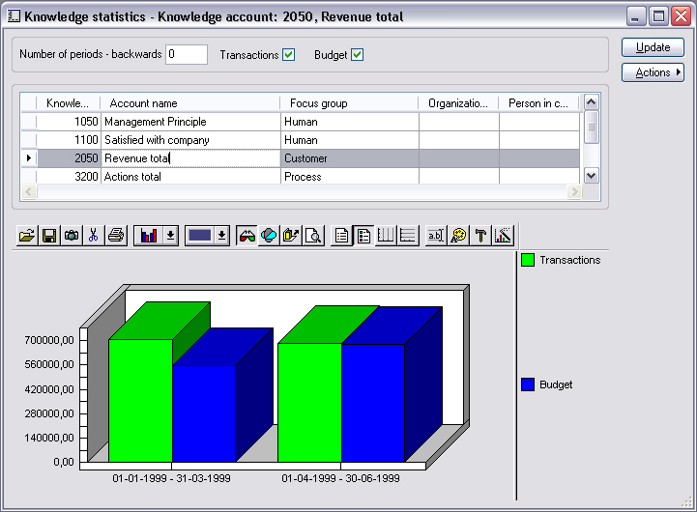
Knowledge statistics

Transactions
Your business overview is always reliable with Microsoft Axapta Balanced Scorecard because the module is transaction-based. All automatic and manual measurements are recorded as transactions within periods. The periods coincide with the indicators’ period profile. As a result, your budget and the actual numbers in the form of transactions can be compared online and in real-time.

Monitoring performance
Tracking progress and performance is not only of interest to management. With access to this information, any employee can monitor their own, as well as the organization’s targets and performance. The navigation is simple, and it is possible to highlight the measures and results that are of relevance. Cockpits that visualize the measures are fully configurable to your specific preferences and provide an optimal overview in one single screen view.
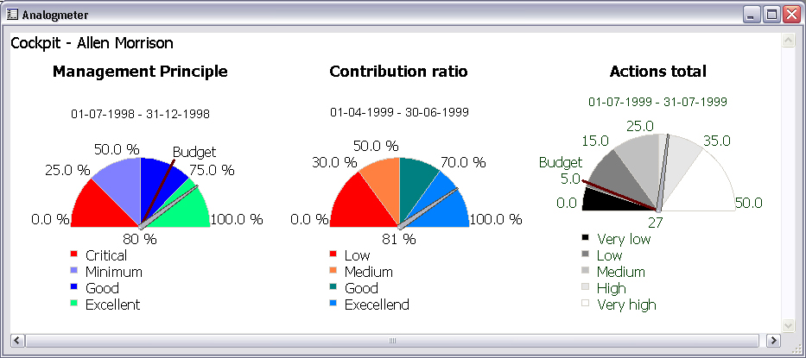
Analog meter cockpit view for progress tracking

Support for external measurement data
If you have data stored in several systems, how can you be sure that all the vital information is considered and included in your reports? The Data link function makes it possible to measure data from a source other than Microsoft Axapta. This allows you to work with information from the respective IT systems used throughout the entire organization in a goal-oriented and balanced way.

Contact your partner
To learn more about Microsoft Axapta, contact your local Microsoft Certified Business Solutions Partner. They have the expertise necessary to meet your specific business needs.

About Microsoft Business Solutions
Microsoft Business Solutions, a division of Microsoft, offers a wide range of integrated, end-to-end business applications and services designed to help small, midmarket and corporate businesses become more connected with customers, employees, partners and suppliers. Microsoft Business Solutions' applications optimize strategic business processes across financial management, analytics, human resources management, project management, customer relationship management, field service management, supply chain management, e-commerce, manufacturing and retail management. The applications are designed to provide insight to help customers achieve business success. More information about Microsoft Business Solutions can be found at www.microsoft.com/BusinessSolutions.

Address:
Microsoft Business Solutions
Frydenlunds Allé 6
2950 Vedbaek
Denmark
Tel +45 45 67 80 00
Fax +45 45 67 80 01
www.microsoft.com/BusinessSolutions

Key Features | Description
Easy to Use | - Intuitive layout and structure  - User-adjustable menus, forms and reports  - User-adjustable layout of main tables and journals  - Windows commands incl. ‘copy and paste’ from and to Microsoft Axapta  - Direct access to main tables from journals  - Advanced sorting and filter options  - Built-in user help including an integrated manual  - Option to mail and fax directly from Microsoft Axapta  - Application can be run in different languages
Knowledge Account Plan | - Create a structure and overview of your Balanced Scorecard  - Set up Key Performance Indicators (KPIs)  - Break down KPIs  - Compare KPI target to actual KPI results  - Support focus groups  - Link KPIs to strategic plan and organizational units via Microsoft Axapta HRM I
Measurements | - Measurement definition wizard  - Definition of approval procedures for manual update of KPI measurements  - Link to external databases to specify KPI measurements
Calculations | - Normalized score function  - Define and consistency-control your methods/formulas
Periodic Measurements | - Indicate periods for automatic measurements  - Manually adjust measurements  - Simulate KPI periods
Reporting and Statistical Analysis | - Graphical presentation of KPIs  - Measurement intervals and fluctuation interpretations  - Setup of analog meter

System Requirements
To obtain all of the features mentioned in this fact sheet,  the following modules and technologies are required: | To obtain all of the features mentioned in this fact sheet, the following modules and technologies are required:  - Microsoft Business Solutions–Axapta 3.0  - Microsoft Business Solutions–Axapta Balanced Scorecard
Type
© 2003 Microsoft Business Solutions ApS, Denmark. All rights reserved. Microsoft, Great Plains, Navision, FRx, *list other trademarks mentioned are either registered trademarks or trademarks of Microsoft Corporation, Great Plains Software, Inc., FRx Software Corporation, or Microsoft Business Solutions ApS or their affiliates in the United States and/or other countries. Great Plains Software, Inc., FRx Software Corporation, and Microsoft Business Solutions ApS are subsidiaries of Microsoft Corporation. The names of actual companies and products mentioned herein may be the trademarks of their respective owners. The example companies, organizations, products, domain names, email addresses, logos, people and events depicted herein are fictitious. No association with any real company, organization, product, domain name, e-mail address, logo, person, or event is intended or should be inferred.

