Microsoft® Business Solutions−Axapta®
Web Tools
Microsoft Business Solutions−Axapta Web Tools are used to create Web applications to provide browser access to Microsoft Axapta.

Key Benefits:
- Out-of-the box Microsoft Axapta Web Tools, Business Connector, and standard Web applications included on the product CD
- Integrated approach using the same business logic and data as Microsoft Axapta
- Part of the Microsoft Axapta development environment Morphx
With Microsoft Business Solutions−Axapta Web Tools, developers can create Web applications based on online data and the same business logic as that in the ordinary Microsoft Windows interface of Microsoft Axapta.
Microsoft Axapta Web Tools are all based on the same principles and concepts as the existing MorphX Development Suite. So, for developers already familiar with MorphX, it is easy to start developing Web applications with Microsoft Axapta Web Tools.
With Microsoft Axapta Web tools, you can develop Microsoft Axapta Web applications for several different devices. Users can access Microsoft Axapta from their desktop browser, a handheld PC or a Pocket PC for direct access to current data.

The integrated approach
The integrated approach means that with one database, one application, one source code, and one toolbox, you can still have multiple interfaces to Microsoft Axapta – through Microsoft Windows, the Web, desktop browsers, Pocket PC browsers, or XML. However you choose to give access to Microsoft Axapta, developing the application requires the same approach.
Browser-based access to Microsoft Axapta gives users simple and quick access to the data they need, on-line from Microsoft Axapta so it is always updated and accurate. Changes made over the Web or in the Microsoft Windows interface are immediately communicated to the database.

The Application Object Tree
The Application Object Tree (AOT) is Microsoft Axapta’s development environment. In the AOT, the developer can create new application objects by using “drag n’ drop” and setting properties. To make the developer's job easier and faster, the system has auto settings for all application object properties.
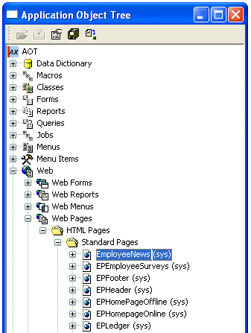
The Application Object Tree

Web Projects
The Web Projects in Microsoft Axapta are simply a Web version of the standard AOT projects. The developer can here group the relevant AOT elements and create either a private or a shared project, depending on whether the project should be available to all users or only to the user who created it.
You can create a new Web application by creating a new project of the type ‘Web Project’. Or you can choose to use one of the existing WebApps as a template for a new WebApp by using the duplicate function.

Web AOT elements (menus, forms & reports)
Web menus have their own branch in the AOT. They are easily created by using the “drag ‘n drop” function.
The Web forms are the primary interaction element between users and Web applications. Through the Web forms users create, modify and delete data directly in the Microsoft Axapta database. And the updated data is available to other users immediately once the modifications are communicated to the database.
Web reports are created in the same way as normal Microsoft Axapta reports, but they have their own Web report node in the AOT. You also have the possibility to show reports graphically in three different ways and to generate PDF reports. This feature makes it quick to generate, for example, a quotation in a Web application, turn it into a PDF report and e-mail it to the customer for approval.

Web pages
The Web application’s Web pages will be loaded and saved in the AOT. Web pages have their own node in the AOT. It is easy to keep the overview of Web pages in different languages, as language-specific pages are displayed as sub-nodes to the ‘neutral’ language Web page.
With Microsoft Axapta, you can tailor Web pages to different interfaces. When creating Web pages to be accessed by a PDA, a line will show you the boundaries of what can be seen on the PDA screen and which parts the user will need to scroll to view.
The WholePage property on Web pages allows a Web page to take up the entire browser window when opened. This is especially useful for larger Web sites where there is a need for a different design structure on a number of pages.

Style sheet editor
The Style sheet editor is used to create a set of styles for the HTML tags and classes used on Web pages. The layout information is separated from the content itself, meaning that you control the layout style from one place and the content from another. This means you can change the font and color for a headline in the style sheet editor and the change will immediately be implemented throughout all the Web pages of the Web site.
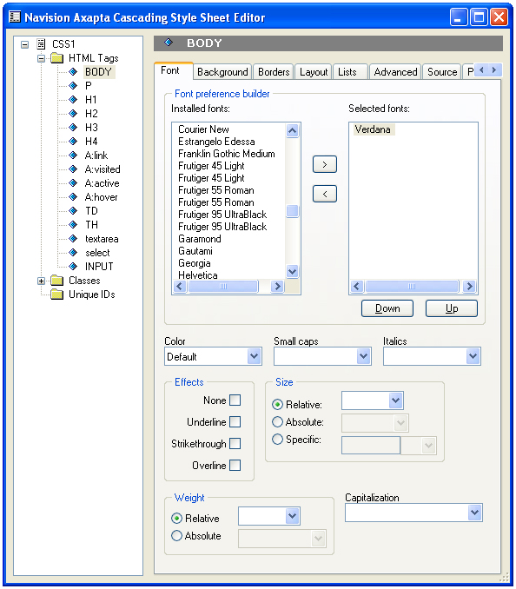
The Style sheet editor

Web files
The Web branch in the AOT contains both server files and client files. The server files are used to establish the connection between the Web server and Microsoft Axapta through the Business Connector. The files are copied to the server when a Web site is deployed. Client files contain Java scripts that are run in the users’ browser.

Weblets
A Weblet is a class that generates content for Web applications in HTML code. Microsoft Axapta provides you with a number of standard Weblets to simplify setting up your Web application with as little coding as possible. For example, the Outlook Weblet will let you display items from an employee’s calendar in Microsoft Outlook. Other Weblets such as News Weblet and Discussion Weblet let you display news or discussion forums based on information already stored in Microsoft Axapta. With the Web Panel Weblet, users are able to set up their own Web page and choose which elements to display where. Users can create their own Weblets to include customized functionality and content in Web applications

The Web page editor
The Web page editor in Microsoft Axapta is the primary design tool for structuring your Web page. Typically, a Web page is structured using an HTML table where you can drag and drop items such as images, AOT elements, and Weblets into the various cells of the table.
In Microsoft Axapta, every application area has a corresponding template for a web page layout with suggestions for menus and content areas. You can choose to use these templates, but with the editor, it is just as simple to modify them or to create your own design.
By using the Include Weblet, you can include one Web page on other Web pages. This is useful when a large number of Web pages have common content. You can maintain the common content on one single Web page, and any changes made to that page are immediately reflected in all the Web pages on which it is included.

Search on the Website
In the Microsoft Axapta Web application, you can help users quickly locate needed data by setting up a search function. With Advanced Crawler technology, you select the tables and fields to be indexed for the search function.

Security
Letting users access Microsoft Axapta through various interfaces outside your enterprise increases the importance of securing the information in your database and keeping control over who can access the business logic. Web Apps use the same security system as the normal Microsoft Axapta application.
Setting up user groups controls which data and functionality users within the group can access. Microsoft Axapta gives you pre-defined user roles that enable users to enter different parts of the system in accordance to their job responsibilities. These roles are split into three internal and two external roles, the internal roles being employee, sales and consultant role, and the external roles being customer and vendor.
Transactions such as completing a purchase are made by secure socket layer technology, where the data sent between the browser and the Web server is encrypted.

Web site wizard & Web user wizard
Setting up your site or creating Web users is simple with the wizards available in Microsoft Axapta. The Web site wizard will lead you step-by-step through the deployment of your Web application, asking you to enter information such as server name and Microsoft Axapta configuration to be used for the WebApp.
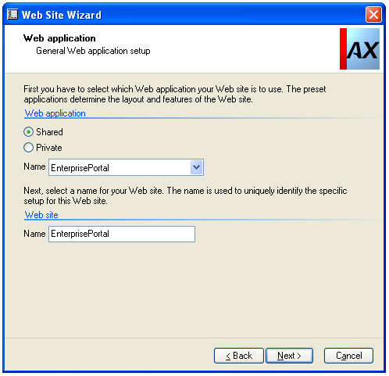
The Web site wizard
The Web user wizard will guide you through setting up a web user, assigning a role and language for the user and giving the user a Web login and password. It is also here that you specify which Web sites the user can access.

Contact your partner
To learn more about Microsoft Axapta, contact your local Microsoft Certified Business Solutions Partner. They have the expertise necessary to meet your specific business needs.

About Microsoft Business Solutions
Microsoft Business Solutions, a division of Microsoft, offers a wide range of integrated, end-to-end business applications and services designed to help small, midmarket and corporate businesses become more connected with customers, employees, partners and suppliers. Microsoft Business Solutions' applications optimize strategic business processes across financial management, analytics, human resources management, project management, customer relationship management, field service management, supply chain management, e-commerce, manufacturing and retail management. The applications are designed to provide insight to help customers achieve business success. More information about Microsoft Business Solutions can be found at www.microsoft.com/BusinessSolutions.

Address:
Microsoft Business Solutions
Frydenlunds Allé 6
2950 Vedbaek
Denmark
Tel +45 45 67 80 00
Fax +45 45 67 80 01
www.microsoft.com/BusinessSolutions
Key Features | Description
Easy to use | - Intuitive layout and structure  - User-adjustable menus, forms and reports  - User-adjustable layout of main tables and journals  - Windows commands incl. ‘copy and paste’ from and to Microsoft Axapta  - Direct access to main tables from journals  - Advanced sorting and filter options  - Built-in user help including an integrated manual  - Option to mail and fax directly from Microsoft Axapta  - Application can be run in different languages
Deployment | - Guided deployment of Web sites using the Web site wizard  - Set up the Microsoft Axapta Business Connector directly from the Microsoft Axapta Configuration Utility
Security | - Secure Sockets Layer support for secure transactions  - The Business Connector can connect from the Web server through a firewall to the AOS so the database and application are protected behind firewalls  - User access to functionality is handled through the security key system
Development and design tools | - Quick learning for experienced MorphX developers as the WebApps are a natural part of MorphX  - The Application Objects of a Web Application are developed and maintained in a Web Project  - Drag and drop AOT elements to Web projects  - Built-in Web page editor: Handle static as well as dynamic content from the AOT  - Apply style sheets and images to Web pages from the AOT's Resources node
Multilanguage support | - Web pages, labels, and the on-line Help can be created in all the required languages  - Each user can set the preferred language for the Web site
Multiple information sources | - Support for MS Digital Dashboards WebParts, enabling content from a wide range of sources, for example MS Outlook, MSN Business News, etc. to be included in WebApps  - I-Frames can be used to integrate content from the network as well as from the Web

System Requirements
To obtain all of the features mentioned in this fact sheet,  the following modules and technologies are required: | - Microsoft Business Solutions−Axapta 3.0  - Microsoft Business Solutions−Axapta Windows MorphX Development Suite  - Microsoft Business Solutions−Axapta Enterprise Portal Framework  - Microsoft Business Solutions−Axapta Web MorphX Development Suite  - Microsoft Internet Information Server
16.04.2003
© 2003 Microsoft Business Solutions ApS, Denmark. All rights reserved. Microsoft, Great Plains, Navision, FRx, *list other trademarks mentioned are either registered trademarks or trademarks of Microsoft Corporation, Great Plains Software, Inc., FRx Software Corporation, or Microsoft Business Solutions ApS or their affiliates in the United States and/or other countries. Great Plains Software, Inc., FRx Software Corporation, and Microsoft Business Solutions ApS are subsidiaries of Microsoft Corporation. The names of actual companies and products mentioned herein may be the trademarks of their respective owners. The example companies, organizations, products, domain names, email addresses, logos, people and events depicted herein are fictitious. No association with any real company, organization, product, domain name, e-mail address, logo, person, or event is intended or should be inferred.

