Microsoft® Business Solutions−Axapta®
Sales Management
Microsoft Business Solutions−Axapta Sales Management enables sales managers to manage and monitor the activities of their entire sales organization, individual sales representatives and sales teams.

Key Benefits:
- Manage and monitor the sales activities of single sales representatives, teams, or the entire sales organization
- Define sales targets for individuals and teams

Key Features:
- Sales Target window
- Graphical displays show sales wins and sales quotations
- Sales Statistics Management window
- Graphical integration to external products
Microsoft Business Solutions−Axapta Sales Management is closely integrated with the Sales Force Automation module to provide for efficient collaboration between sales and marketing managers and their respective sales and marketing teams.

Establish and Monitor Sales Targets
The Sales Target window is used to establish and monitor sales targets for each member of a sales unit. After you have assigned your individual sales staff to the different sales units, you can browse the visual sales unit “tree” to inspect, define and modify the sales target for each salesperson. Sales targets are defined for each year. The yearly totals can be split into quarterly targets that can be represented in graphical charts showing actual sales and quotations compared with sales targets for individuals or sales teams.

Analyze Sales Data
The Management Statistics window in the Sales Management module enables sales managers to monitor and analyze sales data. This provides assistance to executives and salespeople when monitoring the sales process.

Establish and Maintain a Sales Pipeline
The Management Statistics window presents sales statistics in a graphical format that shows forecasts, actual sales and sales activities. This forms the basis for pipeline and opportunity management. The Management Statistics window provides a number of different ways to view sales management graphs.
Two different parameters are provided: Perspective and Category. Perspective defines whether the graph shows data for a given salesperson, sales unit or company. Category defines what type of data to present. There are six categories:

Sales and Quotations
For better and faster visibility of sales and quotes, the Sales Management module allows users to display five different

types of graphs illustrating sales opportunities, probabilities, and actual sales versus target.
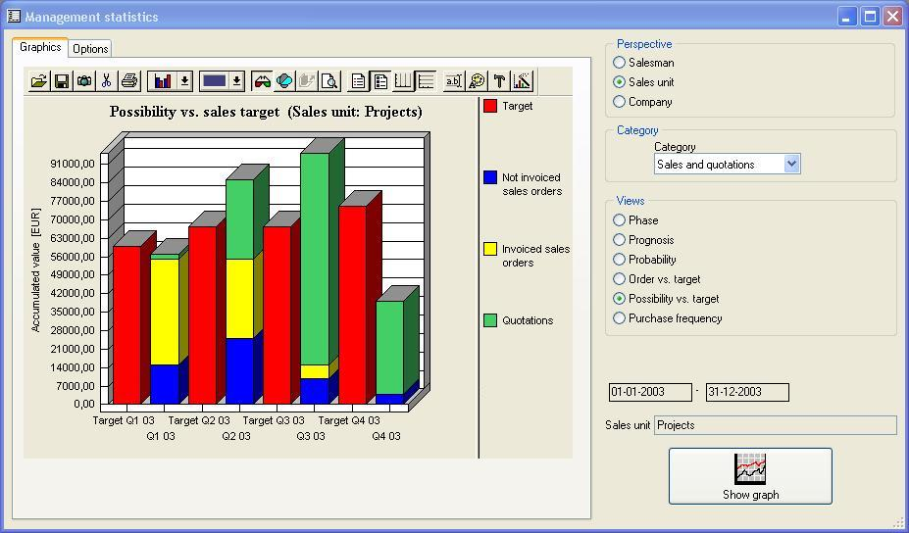
The Sales Management module contains a graphical tool for establishing and maintaining a sales pipeline.

Monitoring Responsibility for Specific Actions
The transaction log contains information about specific changes made to selected tables in the system. It provides four different graphs providing, for example, statistics of new customers, prospects, quotations and sales orders within a given time frame, or an activity-level report displaying all sales activities for an individual salesperson, sales unit and company in a selected time period.

Business Relations
Get a precise picture of financial performance of both individual and group of existing and potential customers, a customer top ten list as well as growth in customer and lead generation.

Products
Create lists of the sales pattern of what personnel is selling which products, by single item or group of items.

Campaign
Evaluate your campaigns in respect to ROI, response frequency and status, and identify how your marketing staff is performing.

Telemarketing
See how your callers are succeeding in relation to the number of successful calls and the resulting sales from your telemarketing efforts.
To display the desired graph, you simply select the perspective, category and view. Active fields change depending on which graph you select.

Generate Sales Reports
The Sales Management module makes it easy to generate reports representing sales activities. You get the tools to analyze and report on sales, quotations and sales force activities. This allows you to perform opportunity management and pipeline analysis and to measure sales forecasts against sales targets. It also provides activity level analysis.
The Sales Management reporting tools in Microsoft Axapta are based on information about sales activities, sales orders, quotations and modifications made to selected tables. You can define sales targets for each salesperson and sales unit, and view graphs of sales and forecasts versus targets.

Contact Your Partner
To learn more about Microsoft Axapta, contact your local Microsoft Certified Business Solutions Partner. They have the expertise to meet your specific business needs.

About Microsoft Business Solutions
Microsoft Business Solutions, a division of Microsoft, offers a wide range of integrated, end-to-end business applications and services designed to help small, midmarket and corporate businesses become better connected with customers, employees, partners and suppliers. Applications from Microsoft Business Solutions optimize strategic business processes across financial management, analytics, human resources management, project management, customer relationship management, field service management, supply chain management, e-commerce, manufacturing and retail management. The applications are designed to provide insight to help customers achieve business success. More information about Microsoft Business Solutions can be found at www.microsoft.com/BusinessSolutions.

Address:
Microsoft Business Solutions Aps
Frydenlunds Allé 6
2950 Vedbaek
Denmark
Tel +45 45 67 80 00
Fax +45 45 67 80 01
www.microsoft.com/BusinessSolutions

Key Features | Description
Easy to Use | - Intuitive layout and structure  - User-adjustable menus, forms and reports  - User-adjustable layout of main tables and journals  - Windows commands incl. ‘copy and paste’ to and from Microsoft Axapta  - Advanced sorting and filter options  - Built-in user help including an integrated manual  - Option to e-mail, phone and fax directly from Microsoft Axapta  - Application can be run in different languages
Sales Target | - Define sales targets for individuals and teams  - Build and maintain a sales pipeline  - Generate sales forecasts
Management Statistics | - Manage and monitor activities for sales teams  - Track status of sales activities, including pending sales quotations  - Track progress and activities of specific sales people  - Display sales data graphically  - Generate reports for sales quotations as well as activities for salespeople and sales units and at company level

System Requirements
To obtain all of the features mentioned in this fact sheet,  the following modules and technologies are required: | - Microsoft Business Solutions−Axapta 3.0  - Microsoft Business Solutions−Axapta Trade Series  - Microsoft Business Solutions−Axapta Sales Force Automation  - Microsoft Business Solutions−Axapta Sales Management
16.04.2003
© 2003 Microsoft Business Solutions ApS, Denmark. All rights reserved. Microsoft, Great Plains, Navision, FRx, Axapta, are either registered trademarks or trademarks of Microsoft Corporation, Great Plains Software, Inc., FRx Software Corporation, or Microsoft Business Solutions ApS or their affiliates in the United States and/or other countries. Great Plains Software, Inc., FRx Software Corporation, and Microsoft Business Solutions ApS are subsidiaries of Microsoft Corporation. The names of actual companies and products mentioned herein may be the trademarks of their respective owners. The example companies, organizations, products, domain names, email addresses, logos, people and events depicted herein are fictitious. No association with any real company, organization, product, domain name, e-mail address, logo, person, or event is intended or should be inferred.

