Microsoft® Business Solutions−Axapta® Questionnaire
Microsoft Business Solutions−Axapta Questionnaire is a powerful tool for designing, constructing and analyzing surveys, which also turns raw data into useful information.

Key Benefits:
- Easy design and execution of questionnaires
- Deploy questionnaires via corporate intranets and websites
- Turn raw data into useful information through analysis

Key Features:
- Simple step-by-step approach to questionnaire design
- Integrated with the Web
- Flexible analytical tools
The Microsoft Business Solutions−Axapta Questionnaire module allows you to design effective questionnaires quickly and simply without any technical experience. Business managers, human resources personnel and administrative personnel can design and implement basic questionnaires in a matter of minutes. The Questionnaire module supports Web integration, so questionnaires can be deployed via a corporate intranet as well as public websites.
Individual questions can be accompanied by instructions to advise the user. They can also be designed to handle multiple choice answers as well as free-text answers. Questions can be delivered sequentially or randomly. Rich media such as pictures, audio and video can also be used to accompany questions.

Support for scheduling the questionnaire process
It is easy to schedule, or plan, questionnaires for a range of audiences including employees, customers and job applicants. For example, you can design a survey for participants on a particular course by searching in the course table of your database. The planning functionality also offers easy administration of mail correspondence with target groups inside and outside your organization.

Multiple uses
The Questionnaire module can be used for a range of activities including customer or employee-satisfaction surveys, job development dialog, ethical and environmental measurements and management and staff testing.

Store all your data in one place
The Questionnaire module allows you to store your knowledge from surveys in the same system that you store your daily business interaction knowledge. This simplifies retrieval and reduces transaction costs. You no longer have to search through a number of spreadsheets or data conversions from other survey systems.
As the questionnaire module is an integral part of Microsoft Axapta the system provides extensive help with finding and addressing target audiences for questionnaires, as long as they are already listed in the system. Customers, vendors, participants in courses, your own employees and job applicants can be selected from your system. You don’t have to pick out specific contact people or course participants but you can search everybody who has ‘Quality Assurance Manager’ as their job title, for example.
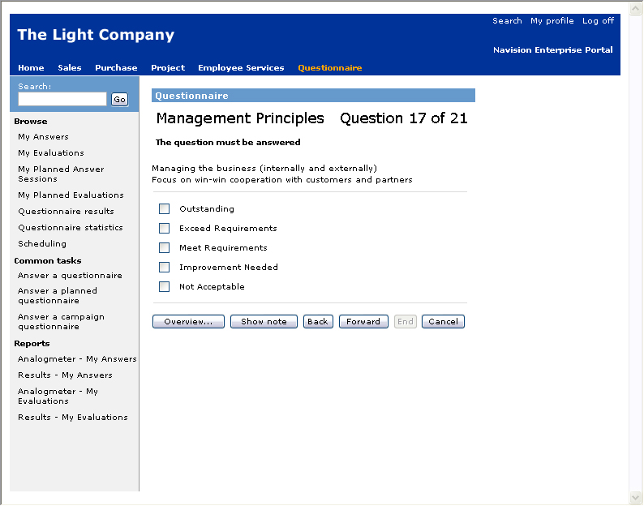
Design effective questionnaires quickly and simply

Analysis of results
Analysis is mandatory for large volume evaluations so the Questionnaire module supports a large number of statistical tools such as calculation and graphical functions, including Pivot Graphics.
You can make a calculation on any data set in a questionnaire, anywhere in a response hierarchy. There is demographic support for all employees, via the Microsoft Business Solutions–Axapta Human Resource (HRM) module, so that you can cross-reference employee groups across organizational dimensions such as gender, age, length of employment in company, working place, role, salary level, and so on.
For respondents outside of your organization, demographic data can be cross-tabbed with respondent master data from the Microsoft Business Solutions–Axapta Sales and Marketing module. The information in Microsoft Axapta is also integrated with Microsoft Excel, which allows for even greater analysis.

Compare new data with earlier results
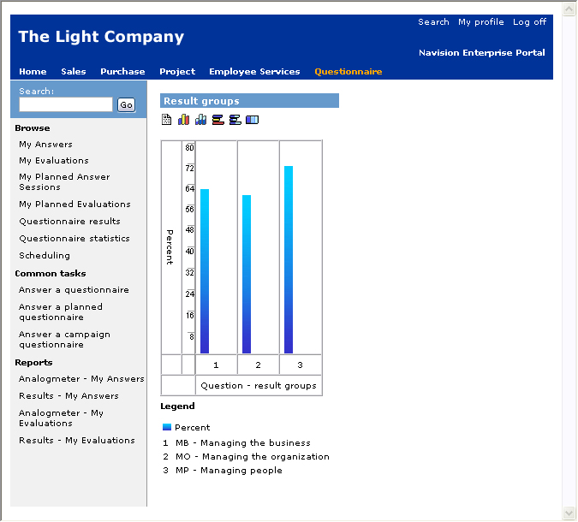
Analyze results from questionnaires immediately
If surveys are repeated, you can compare results, as earlier responses are stored as business transactions in Microsoft Axapta. This makes it easier to compare results and enables variance and development tracking.
Questionnaires can also be used as tracking for management. Whether it is leadership/manager evaluation or business excellence surveys, the results can be easily measured in the Balanced Scorecard module. Data is easy to analyze from within the module or via an On-Line Analytical Processing (OLAP) interface in third party software.

One evaluation tool
The questionnaire system supports all business functions that are represented in Microsoft Axapta, and works closely with modules such as Sales and Marketing, Telemarketing, HRM, Employee Development for Enterprise Portal and Balanced Scorecard.
This means that the module can be used to communicate with your customers, your vendors or your suppliers. You have one evaluation tool across your entire business, and it is ready to cross analyze with your existing business information.

Easy to use
Training is simple and inexpensive. As your employees are already familiar with the user interface and terminology, they only need one training course. At the same time, employees across the organization can share knowledge on how to design and execute surveys.

Microsoft Business Solutions−Axapta Enterprise Portal is a Web solution which seamlessly connects your employees, customers and vendors with your business while reducing information overload and making tasks less complex.
- Anytime, anywhere access to data
- Connect instantly with only Web access
- Intuitive Web layout and browser functionality for walk-up usage
- Greater visibility for everyone
- High ROI - deploy Intranet, Extranet, and Web solution as needed without hassle
- No need to buy third party software

Contact your partner
To learn more about Microsoft Axapta, contact your local Microsoft Certified Business Solutions Partner. They have the expertise necessary to meet your specific business needs.

About Microsoft Business Solutions
Microsoft Business Solutions, a division of Microsoft, offers a wide range of integrated, end-to-end business applications and services designed to help small, midmarket and corporate businesses become more connected with customers, employees, partners and suppliers. Microsoft Business Solutions' applications optimize strategic business processes across financial management, analytics, human resources management, project management, customer relationship management, field service management, supply chain management, e-commerce, manufacturing and retail management. The applications are designed to provide insight to help customers achieve business success. More information about Microsoft Business Solutions can be found at www.microsoft.com/BusinessSolutions.

Address:
Microsoft Business Solutions
Frydenlunds Allé 6
2950 Vedbaek
Denmark
Tel +45 45 67 80 00
Fax +45 45 67 80 01
www.microsoft.com/BusinessSolutions
Key Features | Description
Easy to use | - Intuitive layout and structure  - User-adjustable menu  - User-adjustable layout of master files and journals  - Windows commands incl. ‘copy and paste’ from and to Microsoft Axapta  - Direct access to master files from journals  - Advanced sorting and filter options  - Built-in user help including an integrated manual  - Option to mail and fax directly from Microsoft Axapta  - Application can be run in different languages
Design and Execution | - Rapid design and deployment of surveys  - Individual questions can be accompanied by instructions to advise the user  - Each question is linked to an answer mode identified by text, date, numeric value or an answer collection defined by the questionnaire administrator  - It is possible to enable free-text answers to any type of question.  - Response options can be openly defined  - Multiple choice or data types  - When designing a questionnaire, the questions can be delivered sequentially or in random order  - Possible to show the percentage of questions in a specific questionnaire that need to be answered in order to obtain a valid result  - Questions can be accompanied by rich media (pictures, audio video, etc.)  - Hierarchical questions can be validated  - Response groups can be presented sequentially or randomly  - Management of access control and user profiles
Scheduling | - Management of questionnaire planning  - Easy planning of employees and other individuals in surveys related to applicants, business partners, course participants, networks or organizations  - Mail correspondence with all respondents before, during and after response  - On line tracking of respondents and responses
Reports and Questionnaire Analysis | - Response history by questionnaire and individual  - Advanced statistical analysis tool supporting: SUM, AVG., MIN., MAX. COUNT, variance and standard deviations  - Statistics for % points or number of correct answers  - View statistics on individuals including age, geography, etc.  - Graphical support and use of pivot table and pivot graphics, integrated to Microsoft Excel  - Feedback analysis for 360 degree feedback and other evaluations  - Result report, answer report and ”wrong answers” report
Questionnaire Web Portal | - Web execution  - Viewing and analyzing results online
Questionnaire and ERP in One | - Unique planning and tracking with questionnaires linked to all Microsoft Axapta processes  - Specific integration to Sales and Marketing – Tele-Marketing  - Specific integration to HRM and Employee Development for Enterprise Portal  - Specific integration to Balanced Scorecard

System Requirements
To obtain all of the features mentioned in this fact sheet,  the following modules and technologies are required: | - Microsoft Business Solutions−Axapta 3.0  - Microsoft Business Solutions−Axapta Questionnaire I  - Microsoft Business Solutions−Axapta Questionnaire II  - Microsoft Business Solutions−Axapta Enterprise Portal Framework  - Microsoft Business Solutions−Axapta Employee role  - Microsoft Business Solutions−Axapta Questionnaire for Enterprise Portal
14.04.2003
© 2003 Microsoft Business Solutions ApS, Denmark. All rights reserved. Microsoft, Great Plains, Navision, FRx, *list other trademarks mentioned are either registered trademarks or trademarks of Microsoft Corporation, Great Plains Software, Inc., FRx Software Corporation, or Microsoft Business Solutions ApS or their affiliates in the United States and/or other countries. Great Plains Software, Inc., FRx Software Corporation, and Microsoft Business Solutions ApS are subsidiaries of Microsoft Corporation. The names of actual companies and products mentioned herein may be the trademarks of their respective owners. The example companies, organizations, products, domain names, email addresses, logos, people and events depicted herein are fictitious. No association with any real company, organization, product, domain name, e-mail address, logo, person, or event is intended or should be inferred.

