Microsoft Business Solutions−Axapta Logistics
Microsoft® Business Solutions–Axapta® Logistics connects production, purchasing and sales to help you reduce costs through optimized purchasing and inventory management.

Key Benefits:
- Optimize inventory levels by better matching supply with customer demand.

- Improve your inventory management with detailed insight into your inventory and item tracking.

- Improve your materials requirements planning with flexible options for managing bills of material.

- Create bills of material quickly and easily using the graphical BOM designer.

Microsoft Axapta Logistics gives you the flexibility to manage inventory and purchasing according to your needs, with functionality to support forecasting, classifying and tracking inventory and the efficient creation and management of bills of material.
Microsoft Axapta is an all-in-one solution that gives you real-time connectivity across your business. Logistics exchanges information with many other functional areas in the solution including Production, Master Planning, Trade, Finance and CRM to help ensure a high degree of synergy between logistics and other key areas of your business.

Optimize inventory levels
Microsoft Axapta Logistics offers strong forecasting functionality that supports long-term planning and helps you to optimize inventory levels. You can create sales and purchase forecasts based on items and time periods and use an unlimited number of forecast models to simulate various future scenarios. To quickly project cash flow, you can transfer item forecasts to the general ledger forecast.

Get detailed insight into your inventory
Inventory dimensions are a powerful tool for classifying your inventory according to storage and item characteristics, so that you can get a detailed overview of your inventory whenever you need it. You can track items throughout the system using batch and serial numbers. You can also view documents related to an item using a simple tree-graphic from anywhere in the system. At any time, you have direct access to information telling you where items were used and where they can be found.

Flexible management of bills of material
Microsoft Axapta Logistics gives you an efficient and flexible means of managing bills of material (BOM) to ensure you get the most accurate costing and materials requirements information.
An infinite number of BOM levels can be managed effectively and accurate consumption of raw materials can be calculated using formulas specific to each component. Price calculations, using cost price, can be done for each level of the BOM, giving you accurate and detailed pricing information which is updated throughout the solution. Multiple BOM versions can be created to provide maximum flexibility and the version date can be used to control the validity of particular BOM versions. Previous BOM versions can be accessed and reused at any time.
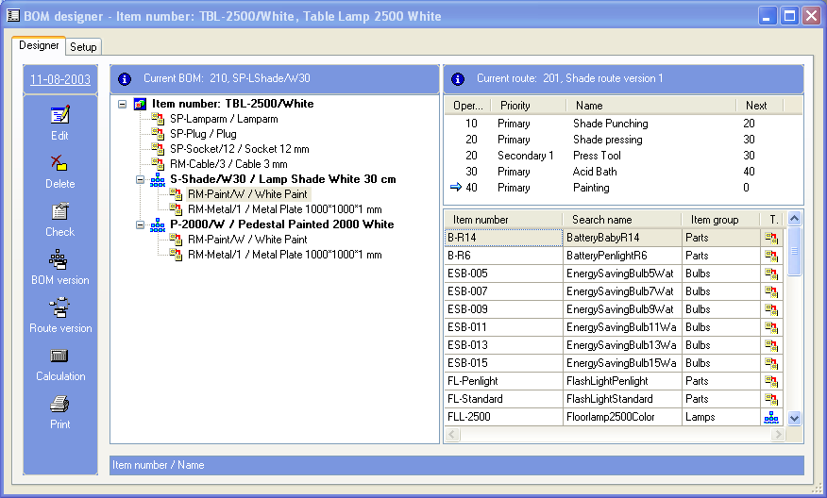
With the Graphical BOM designer, you can create a BOM and get an overview of existing BOMs and routes in the one window

Create bills of material quickly and easily
The Graphical BOM Designer is a graphical suite used to create and manage BOMs based on Microsoft drag-and-drop technology. The familiar and user-friendly environment makes it faster and easier to construct BOMs using a graphical tree-structure. The BOM designer displays all levels and components of the BOM, and you can drag and drop relevant items from the inventory table into the BOM.
The BOM designer also displays the route for the current BOM, allowing you to drag and drop items from the BOM into the operations on the route where they are to be consumed. This helps to achieve more accurate lead time calculations when scheduling production in Microsoft Axapta Master Planning.

For more information about Microsoft Axapta

To learn more about Microsoft Axapta, contact your local Microsoft Business Solutions office, a Microsoft Certified Business Solutions reselling Partner and/or visit www.microsoft.com/BusinessSolutions

About Microsoft Business Solutions
Microsoft Business Solutions, a division of Microsoft, offers a wide range of integrated, end-to-end business applications and services designed to help small, midmarket and corporate businesses become more connected with customers, employees, partners and suppliers. Microsoft Business Solutions' applications optimize strategic business processes across financial management, analytics, human resources management, project management, customer relationship management, field service management, supply chain management, e-commerce, manufacturing and retail management. The applications are designed to provide insight to help customers achieve business success. More information about Microsoft Business Solutions can be found at www.microsoft.com/BusinessSolutions.

Address:
Microsoft Business Solutions
Frydenlunds Allé 6
2950 Vedbaek
Denmark
Tel +45 45 67 80 00
Fax +45 45 67 80 01
www.microsoft.com/BusinessSolutions
Key Features | Description
Forecasting | - Create sales and purchase forecasts  - Use item and period allocation keys to allocate forecasts to individual items and time periods  - Consolidate sales and purchase forecasts into one inventory forecast
item dimensions | - Characterize single item by using up to three item dimensions: configuration, size and color  - Rename the size and color dimensions to suit your purpose  - Maintain valid combinations of item dimensions - can be allocated manually or automatically  - Specify the number of item dimensions used per group of items  - Set up specific prices and discounts per item dimension combination
storage dimensions | - Describe storage by using warehouse, pallets and locations  - Track items using the serial and batch number dimensions
Advanced on-hand tracking | - Get overview of current on-hand inventory per warehouse  - Drill down to current on-hand situation by any item or storage dimension or combination of these  - Tools for tracking batch and serial numbers throughout the system
Quarantine management | - Set aside items in quarantine using quarantine orders, either manually or automatically when receiving items  - Look up quarantine inventory at any stage in the quality control process
ABC analysis | - Calculate ABC analysis using user defined limits  - Calculate the ABC analysis based on: revenue, cost value, margin, and carrying costs
Barcode support | - Maintain multiple barcodes per item  - Read and write the following five different types of bar codes: EAN128/UCC128, Code 39, Interleaved 2 of 5, Code 128.
Bills of material (BOM) Management | - Multi level BOMs  - Version and Date control of multiple BOMs  - Approval routing  - Formulas for calculation of variable or constant consumption  - Supports phantom BOMs  - Variance configurator  - Allowances for scrap can be made in the consumption calculation  - Where used feature  - BOM explosion for materials planning and pricing calculation on all BOM levels
Graphical bom designer | - Graphical suite for designing BOMs and gaining insight into existing BOMs  - Based on Microsoft® drag-and-drop technology  - All levels and sub levels of the BOM are visible in a graphical tree structure  - Drag and drop items from the inventory table to the BOM  - Drag and drop items from the BOM to the route operations  - Circulation check to control which functions can be performed on certain BOMs  - System alerts notify when a BOM is active and should not be modified

System Requirements
To obtain all of the features mentioned in this fact sheet,  the following modules and technologies are required: | - Microsoft Business Solutions−Axapta 3.0  - Microsoft Business Solutions−Axapta Trade Series  - Microsoft Business Solutions−Axapta Logistics Series  - Microsoft Business Solutions−Axapta Master Planning
01 October, 2003
The information contained in this document represents the current view of Microsoft Corporation on the issues discussed as of the date of publication. Because Microsoft must respond to changing market conditions, it should not be interpreted to be a commitment on the part of Microsoft, and Microsoft cannot guarantee the accuracy of any information presented after the date of publication.

This document is for informational purposes only. MICROSOFT MAKES NO WARRANTIES, EXPRESS, IMPLIED OR STATUTORY, AS TO THE INFORMATION IN THIS DOCUMENT.

Complying with all applicable copyright laws is the responsibility of the user. Without limiting the rights under copyright, no part of this document may be reproduced, stored in or introduced into a retrieval system, or transmitted in any form or by any means (electronic, mechanical, photocopying, recording, or otherwise), or for any purpose, without the express written permission of Microsoft Corporation.

Microsoft may have patents, patent applications, trademarks, copyrights, or other intellectual property rights covering subject matter in this document. Except as expressly provided in any written license agreement from Microsoft, the furnishing of this document does not give you any license to these patents, trademarks, copyrights, or other intellectual property.

© 2003 Microsoft Business Solutions ApS, Denmark. All rights reserved. Microsoft and Axapta are either registered trademarks or trademarks of Microsoft Corporation, Great Plains Software, Inc., FRx Software Corporation, or Microsoft Business Solutions ApS or their affiliates in the United States and/or other countries. Great Plains Software, Inc., FRx Software Corporation, and Microsoft Business Solutions ApS are subsidiaries of Microsoft Corporation. The names of actual companies and products mentioned herein may be the trademarks of their respective owners. The example companies, organizations, products, domain names, email addresses, logos, people and events depicted herein are fictitious. No association with any real company, organization, product, domain name, e-mail address, logo, person, or event is intended or should be inferred.

