Microsoft® Business Solutions−Axapta®

Human Resource Management III
Microsoft Business Solutions−Axapta Human Resource Management III supplies you with the overview you need to develop resources for reaching your strategic goals.

Key Benefits:
- Identify skill gaps to determine required employee development
- Initiate and follow up on development plans
- Provide a uniform framework for people managers to reach employee development goals

Key Features:
- Personal development plan with activities and deadlines
- Setup and definition of competencies and competency groups
- Managing and measuring actual skills compared with skill targets
- Graphic tools for skill-gap analysis
- Feedback analysis via online questionnaire and reporting
Assuring attractive and satisfying career planning for your employees is a challenge that demands organized documentation of the agreements made between employer and employee. Microsoft Business Solutions−Axapta Human Resource Management III gives you the tools you need to keep all agreements and development plans in one place, giving you the full overview of each employee’s plans.
Microsoft Axapta Human Resource Management is divided into three modules. This means you can get the functionality you need right now, and implement more modules as your business grows.
HRM I: Core administration for employees and HR professionals
HRM II: Recruitment and absence management
HRM III: Strategic HR

Extended HRM functionality
Building on functionality in Microsoft Axapta Human Resource Management I and II, this module provides additional features to manage personnel and give support for important issues such as professional development for individual employees.

Maximize employee contribution
Microsoft Axapta Human Resource Management III allows HR professionals, as well as personnel managers, to plan thoroughly for employee career development. Foundations for agreements and decisions between managers and employees can be recorded and made easily accessible. You can create professional development plans containing the employee’s goals and the corresponding requirements. These plans can then be linked to specific job profiles and details about employee progress on relevant courses.

Competence management
Managing employee competence means identifying their current competencies as well as the competencies your organization can support them in developing. This includes professional skills and aptitudes as well as attitudes or social and cultural values that your company needs to realize its goals.
Using the system, you can create a competence framework, as well as a dynamic development process. This process involves personal interviews, 360-degree feedback, training curriculums and events to support the employees in bringing the business strategy to life. All of these are collaborative applications that enable follow-up from both your employees and your managers and improve the overall dialog in your organization.

Skill matching and skill-gap analysis
One of the major benefits of a competence management system is that people can be matched with jobs or roles. Whether the company needs to fill a line-organization position, a matrix role or a project role, skill matching is very useful.
For individuals, and for the company as a whole, skill-gap analyses are extremely useful for business planning. It gives employees an opportunity to identify gaps between what a role or a job requires and what they have to offer
Similarly, it is very important for the company to have an overview of the skills needed to bridge the gap between what the company wants to deliver and what it is able to deliver. The system provides graphical support for competency profiles, with several aggregation levels.
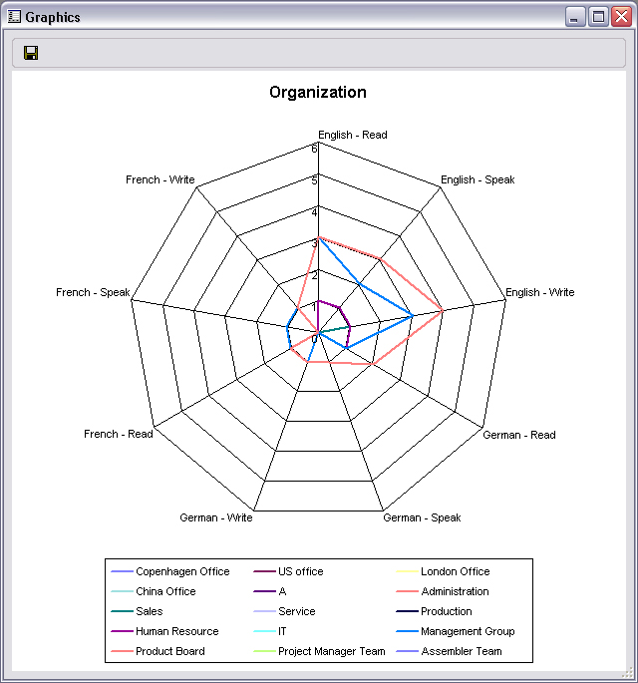
Graphical view of organizational skill-gab analysis

Development plans
Managing employee development is a very broad activity ranging from annual development interviews through skill and leadership training, to career development. The development planning capabilities in Microsoft Axapta Human Resource Management III are an effective leadership tool that helps coordinate individual goals with your company’s investment in employees.

Support for review meetings
The system provides a framework for supporting one-on-one personal development meetings between managers and their employees. The framework supports issues such as salary, personal development, career development, 360-degree feedback, resignations, and so on. With Microsoft Axapta Human Resource Management III, you can easily record the outcome of these meetings. By using the Microsoft Business Solutions–Axapta Questionnaire module together with the Microsoft Axapta HRM modules, performance reviews can be structured to make it easier and quicker to review the history of previous meetings with the employees.

Streamline course administration
Administer training courses with specification of target groups, course identification, location, instructor and participant capacity. Then you can easily register participants and the issue of course certificates. The system ensures an overview of which courses an employee has completed, or plans to take, to help you review his or her skills and competence areas.
The Microsoft Axapta Questionnaire module makes it possible to evaluate the course contents or the instructor, and to test participants to ensure that they have achieved the desired results.

Course overview
In Microsoft Axapta Human Resource Management III, you can create course overviews, containing information such as subjects, instructors, participants, locations, and so
on. This feature will help you keep track of the courses you offer your employees, determine which are in great demand, and which are not.

Contact your partner
To learn more about Microsoft Business Solutions−Axapta, contact your local Microsoft Certified Business Solutions Partner. They have the expertise necessary to meet your specific business needs.

About Microsoft Business Solutions
Microsoft Business Solutions, a division of Microsoft, offers a wide range of integrated, end-to-end business applications and services designed to help small, midmarket and corporate businesses become more connected with customers, employees, partners and suppliers. Microsoft Business Solutions' applications optimize strategic business processes across financial management, analytics, human resources management, project management, customer relationship management, field service management, supply chain management, e-commerce, manufacturing and retail management. The applications are designed to provide insight to help customers achieve business success. More information about Microsoft Business Solutions can be found at www.microsoft.com/BusinessSolutions.

Address:
Microsoft Business Solutions
Frydenlunds Allé 6
2950 Vedbaek
Denmark
Tel +45 45 67 80 00
Fax +45 45 67 80 01
www.microsoft.com/BusinessSolutions

Key Features | Description
Easy to Use | - Intuitive layout and structure  - User-adjustable menus, forms and reports  - User-adjustable layout of main tables and journals  - Windows commands incl. ‘copy and paste’ from and to Microsoft Axapta  - Direct access to main tables from journals  - Advanced sorting and filter options  - Built-in user help including an integrated manual  - Option to mail and fax directly from Microsoft Axapta  - Application can be run in different languages
Employee development | - Personal development plan with activities and deadlines  - Periodic interview management  - Microsoft Outlook integration support for interview administration
Competence Management | - Setup and definition of competencies and competency groups  - Managing and measuring actual skills compared to skill targets  - Registration of skill levels and experience  - Graphic tools for skill-gap analysis  - Skill-gap analysis based on job profiles and skill assessment  - Feedback analysis via online questionnaire and reporting  - Skill search supporting filtering and weighting of skills
Course administration | - Registration of course details, instructor, participants, location  - Managing events supporting setup of agenda, tracks and sessions  - Linking between course completion and skill assessment  - Participant list including participants’ training history  - Reports for waiting list, confirmation and certificates  - Integration with Microsoft Business Solutions–Axapta Enterprise Portal

System Requirements
To obtain all of the features mentioned in this fact sheet,  the following modules and technologies are required: | - Microsoft Business Solutions−Axapta 3.0  - Microsoft Business Solutions−Axapta Human Resource I  - Microsoft Business Solutions−Axapta Human Resource II  - Microsoft Business Solutions−Axapta Human Resource III
14.04.2003
© 2003 Microsoft Business Solutions ApS, Denmark. All rights reserved. Microsoft, Great Plains, Navision, FRx, *list other trademarks mentioned are either registered trademarks or trademarks of Microsoft Corporation, Great Plains Software, Inc., FRx Software Corporation, or Microsoft Business Solutions ApS or their affiliates in the United States and/or other countries. Great Plains Software, Inc., FRx Software Corporation, and Microsoft Business Solutions ApS are subsidiaries of Microsoft Corporation. The names of actual companies and products mentioned herein may be the trademarks of their respective owners. The example companies, organizations, products, domain names, email addresses, logos, people and events depicted herein are fictitious. No association with any real company, organization, product, domain name, e-mail address, logo, person, or event is intended or should be inferred.

