Microsoft® Business Solutions−Axapta®

Human Resource Management II
Microsoft Business Solutions−Axapta Human Resource Management II automates recruitment processes and employee absence analysis.

Key Benefits:
- Implement effective and cost-efficient recruitment processes
- Build up an in-house resource pool
- Monitor the efficiency and well-being of your organization

Key Features:
- Job profiles and role descriptions
- Job profiles and role requirements
- Statistical overviews of the recruiting process
- Employee absence management
- Individual and collective absence registration
Your employees are your most important resource. When striving for higher goals and starting new initiatives, you need to be certain that you have the right people in the right positions.
With Microsoft Business Solutions−Axapta Human Resource Management II, you can set up automatic processes that will take the hassle out of recruitment. You can learn from the experience of previous recruitment campaigns and select the right media and methods for sharper communication. And once the applications start coming in, you have an efficient system to keep track of the status of the applications.
Microsoft Axapta Human Resource Management is divided into three modules. This means you can get the functionality you need right now, and implement more modules as your business grows.
HRM I: Core administration for employees and HR professionals
HRM II: Recruitment and absence management
HRM III: Strategic HR

Extended HRM functionality
Building on functionality in Microsoft Axapta Human Resource Management I, this module gives you additional capabilities for managing job descriptions, automating personnel recruitment and absence management.

Job profiles & descriptions
Your workforce is your biggest asset when driving your business forward towards new goals and territory. Their skills, experience and knowledge are essential. Precise skills and job descriptions make it clearer who to allocate to a specific project or who to hire for an open position.
The job profiles in Microsoft Axapta Human Resource Management II make it simple to manage your workforce. Positions are specified with standard job descriptions, areas of responsibility, work tasks and accomplishments. This gives you the complete picture of the responsibilities and competence areas that an employee must have for any position within your business. Responsibility and reporting hierarchy is also visible within each job description.

Automate personnel recruitment
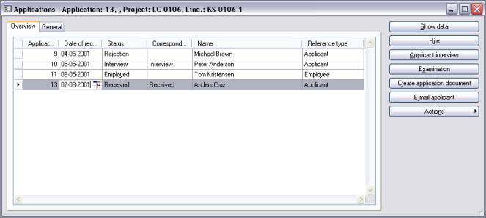
Manage applications in the recruitment process
Recruiting new employees and managing internal job rotations are ongoing processes. The recruitment features in Microsoft Axapta Human Resource Management II give you effective control over these processes.
Creating automated processes will make your business more efficient in a recruitment situation. Set up standard procedures for dealing with job applicants. Categorize and track correspondence, meetings and phone calls. Not only will the entire process be simpler and quicker for you, the signals you send to your applicants will make your business stand out as professional and efficient.

Applicant profiles
Take control of the applications you receive and create applicant profiles that can be updated with contact information and résumé data. With automated personnel recruitment processes, you control the process from when an application is received, through correspondence and interviews with the applicant, to meetings with relevant employees, and up to the point of employment or rejection. All this information is stored in the applicant profile for future reference.
Testing of applicants can be done via the Microsoft Business Solutions–Axapta Questionnaire module. This will give you a unique way to evaluate individual applicants.

Personnel recruitment advertising
Which media give the highest response rate when you’re looking for new employees? Where do you advertise for specific profiles? Knowing this will streamline your recruitment process and enable you to reach the right people. When applications come in, link the applicant profile to the advertisement or campaign that caused the applicant to respond. The results can be shown graphically for a quick overview of where your recruitment advertising budget is best spent.

Job application statistics
Following your applications all the way through the system is easily done with the statistical overviews. You can generate statistical overviews for different phases of the recruitment process to measure the effectiveness of various recruitment activities. See how many applicants for a specific job have been called in for a second interview and how many have already been rejected. With the full overview, you can control the process and ensure an efficient and effective recruitment process.

Absence management
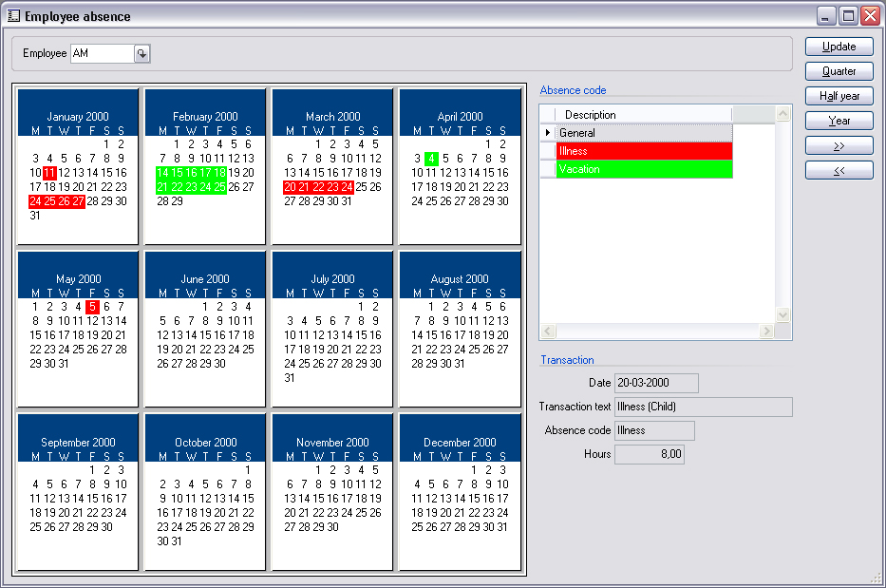
Absence per employee displayed graphically
To leverage the performance of your business, it is critical to ensure a healthy working environment – to monitor employee absence, see if trends are developing and, if so, to deal with the problems before they get out of hand.
In Microsoft Axapta Human Resource Management II, all types of employee absence can be registered and administered. Set up profiles for each type of absence such as vacation, illness, disability, pregnancy and parental leave. The profiles can contain a wide range of variables, such as dates, financial compensation and approvals. When an individual employee is absent, you can link the employee to the appropriate absence profile.
You can display details about absence in a variety of ways. You can easily get an overview of the number of absences and their cause for any given time period. Absence per employee can also be displayed graphically in a calendar.

Contact your partner
To learn more about Microsoft Axapta, contact your local Microsoft Certified Business Solutions Partner. They have the expertise necessary to meet your specific business needs.

About Microsoft Business Solutions
Microsoft Business Solutions, a division of Microsoft, offers a wide range of integrated, end-to-end business applications and services designed to help small, midmarket and corporate businesses become more connected with customers, employees, partners and suppliers. Microsoft Business Solutions' applications optimize strategic business processes across financial management, analytics, human resources management, project management, customer relationship management, field service management, supply chain management, e-commerce, manufacturing and retail management. The applications are designed to provide insight to help customers achieve business success. More information about Microsoft Business Solutions can be found at www.microsoft.com/BusinessSolutions.

Address:
Microsoft Business Solutions
Frydenlunds Allé 6
2950 Vedbaek
Denmark
Tel +45 45 67 80 00
Fax +45 45 67 80 01
www.microsoft.com/BusinessSolutions
Key Features | Description
Easy to Use | - Intuitive layout and structure  - User-adjustable menus, forms and reports  - User-adjustable layout of main tables and journals  - Windows commands incl. ‘copy and paste’ from and to Microsoft Axapta  - Direct access to main tables from journals  - Advanced sorting and filter options  - Built-in user help including an integrated manual  - Option to mail and fax directly from Microsoft Axapta  - Application can be run in different languages
Organization | - Administration of position groups and positions/jobs  - Job profiles and role descriptions  - Job profiles and role requirements
Recruitment | - Recruitment process management  - Automated correspondence via Microsoft Word integration  - Microsoft Outlook integration support for interview administration  - Statistical overviews of the recruitment process  - Applicant matching to job profile requirements.  - Media response measuring
Absence management | - Employee absence administration  - Setup and definition of multiple absence categories  - Individual and collective absence registration  - Statistical and graphical presentation of absence

System Requirements
To obtain all of the features mentioned in this fact sheet,  the following modules and technologies are required: | - Microsoft Business Solutions−Axapta 3.0  - Microsoft Business Solutions−Axapta Human Resource I  - Microsoft Business Solutions−Axapta Human Resource II
14.04.2003
© 2003 Microsoft Business Solutions ApS, Denmark. All rights reserved. Microsoft, Great Plains, Navision, FRx, *list other trademarks mentioned are either registered trademarks or trademarks of Microsoft Corporation, Great Plains Software, Inc., FRx Software Corporation, or Microsoft Business Solutions ApS or their affiliates in the United States and/or other countries. Great Plains Software, Inc., FRx Software Corporation, and Microsoft Business Solutions ApS are subsidiaries of Microsoft Corporation. The names of actual companies and products mentioned herein may be the trademarks of their respective owners. The example companies, organizations, products, domain names, email addresses, logos, people and events depicted herein are fictitious. No association with any real company, organization, product, domain name, e-mail address, logo, person, or event is intended or should be inferred.

