Microsoft® Business Solutions−Axapta®
Fixed Assets
Microsoft Business Solutions−Axapta Fixed Assets helps you forecast, monitor and control your fixed assets throughout their entire life cycle.

Key Benefits:
- Save time and money with streamlined fixed asset management
- Improve decision making with online access to accurate asset information and reports
- Faster monthly and yearly accounting procedures

Key Features:
- Record all types of asset transactions for accounting and tax purposes
- Flexible setup of accounts for connectivity throughout Microsoft Axapta
- Five depreciation methods
- Attach related information to asset records
- Country-specific features
Microsoft Business Solutions−Axapta Fixed Assets expands on the core Microsoft Business Solutions−Axapta Financials module with a sophisticated register specifically for asset management. Since it is connected to the General Ledger, Accounts Receivable, Sales Orders, Accounts Payable, Purchase Orders and Inventory, the Fixed Assets module eliminates any need for duplication. A number of otherwise labor intensive tasks are easily automated. What’s more, the module streamlines tasks such as year-end reporting.

Recording transactions
Fixed assets are set up using asset groups. Through a simple allocation of the new asset to an asset group, the asset inherits a user-defined setup. Setups include, for example, type of asset, depreciation method, bar code allocation and parallel, and independent depreciation setup for tax and other purposes.
Acquisition of the asset can be posted in a number of ways. For example, it is possible to use purchase order processing, to record the vendor invoice directly or to use the invoice approval system. Alternatively, new assets can be entered directly into Microsoft Axapta Fixed Assets either with or without a system-created acquisition proposal. A special inventory journal is available for recording self-assembled assets.

Posting
Microsoft Axapta Fixed Assets is flexible, so you can meet all ledger-posting requirements. You can set up ledger accounts for any type of asset transaction and you can define one posting rule for all assets, different posting rules for different asset groups or a special posting rule for individual assets.

Number series
Your assets can be numbered automatically from one number sequence or you can set up different number sequences for different asset groups. The system automatically assigns numbers to all journals and to all transactions. You can customize the set up of the number allocation. It is also possible to use the allocation of bar codes.

Managing your assets
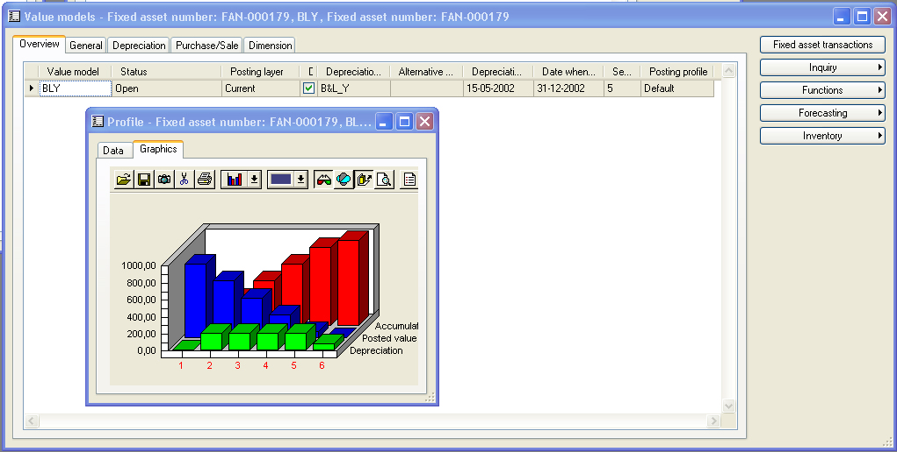
Inquiry on asset profile’ graph is only one of the many options you have to view asset forecasts
You can manage your fixed assets throughout their entire life cycle and simplify your accounting procedures. Your fixed assets can be acquired, depreciated, value adjusted, disposed of or transferred to other assets. Each asset can be set up for several parallel life cycles that can be used for independent recording of asset values for external accounting, tax, management accounting, consolidation and other purposes. Proposals for different types of asset transactions are available.

Depreciation
Fixed assets can be depreciated in a number of ways. Depreciation methods include ‘straight line’, ‘reducing balance’, ‘factor’ (digressive/progressive method), ‘manual’ percentage’ and ‘consumption depreciation’.

Forecasting
Fixed asset forecasting includes all fixed asset transaction types. The user can enter unlimited numbers of parallel fixed assets budgets. These budgets can only be registered in the fixed assets module or included in the ledger budgets. For easy entry of budget lines, the proposals for asset transactions are available in the budget journal.
For potential fixed assets, it is possible to enter details and calculate a hypothetical depreciation. No ledger updates will take place, but the information can be recorded so that you have the information for further analysis and to help with acquisition decisions.

On loan tracking
If an asset is transferred from its permanent location to a temporary location, the movement can be recorded and reported to aid in recall procedures. The lending dates, locations and the responsible user are included in the record.

Disposing of fixed assets
A sales invoice for an asset can be issued using free-text invoicing so that the fixed asset, the customer account and the general ledger are updated. Disposals can also be done from the fixed asset journal or general ledger journal and titled as scrap or sale without producing external documentation. Microsoft Axapta automatically posts the reverse transactions necessary for the update of fixed asset balances.

Accessing information
You have instant access to in-depth information, which you can choose to include in reporting. Extensive inquiry options and a number of standard reports are available in the system.

Using information
You are able to save and attach electronic images of documents, pictures and other records to individual assets. This is a significant time saver that makes it faster and easier to manage assets in a secured environment.

Contact your partner
To learn more about Microsoft Business Solutions−Axapta, contact your local Microsoft Certified Business Solutions Partner. They have the expertise necessary to meet your specific business needs.

About Microsoft Business Solutions
Microsoft Business Solutions, a division of Microsoft, offers a wide range of integrated, end-to-end business applications and services designed to help small, midmarket and corporate businesses become more connected with customers, employees, partners and suppliers. Microsoft Business Solutions' applications optimize strategic business processes across financial management, analytics, human resources management, project management, customer relationship management, field service management, supply chain management, e-commerce, manufacturing and retail management. The applications are designed to provide insight to help customers achieve business success. More information about Microsoft Business Solutions can be found at www.microsoft.com/BusinessSolutions.

Address:
Microsoft Business Solutions
Frydenlunds Allé 6
2950 Vedbaek
Denmark
Tel +45 45 67 80 00
Fax +45 45 67 80 01
www.microsoft.com/BusinessSolutions
Key Features | Description
Easy to use | - Intuitive layout and structure  - User-adjustable menus, forms and reports  - User-adjustable layout of main tables and journals  - Windows commands incl. ‘copy and paste’ from and to Microsoft Axapta  - Direct access to main tables from journals  - Advanced sorting and filter options  - Built-in user help including an integrated manual  - Option to mail and fax directly from Microsoft Axapta  - Application can be run in different languages
Asset Register | - Store information on asset status, financial transactions, technical data, insurance, location, bar codes for tangible, intangible and financial assets  - Display relations between assets  - Assign asset numbers and bar codes to assets  - Attach pictures, files and documents to assets  - Option for recording of lending  - Inquiry options for current and future asset values and transactions  - Easy asset entry based on user-defined standard set up for different asset groups
Asset Acquisition | - Purchase assets using purchase orders and inventory items  - Record purchase invoices directly against assets  - System created acquisition proposals  - Acquisition of self–assembled assets  - Post acquisition manually using journals  - Split assets
Asset Depreciation | - Five different depreciation methods (straight line, reducing balance, factor, manual percentage and consumption)  - User-defined base for straight line depreciation (‘Service life’ or ‘Service life remaining’)  - Option for alternative depreciation and automatic selection of the biggest possible depreciation  - Depreciation proposal
Asset Revaluation | - Write-up and write-down of fixed assets  - Revaluation other than write-up and write-down  - Revaluation proposal based on user-defined indexes
Asset Disposal | - Invoicing external sales of fixed assets  - Recording sales and scrap disposals using fixed asset journal  - User-defined automatic reversing of asset balances at disposal
Value Models | - Option for several independent life cycles for each asset for external accounting, tax, management accounting, consolidation and other purposes  - Independent parallel depreciation proposals  - Options for user-defined sharing of selected transactions (for example acquisitions or disposals) for several value models
Flexible Setup of Accounts for Ledger Integration | - User-defined setup of posting rules for all asset transactions  - Option to set up posting rule on different levels (all assets, group of assets, individual asset)  - Different setup of accounts for different value models (different life cycles) for the same asset

System Requirements
To obtain all of the features mentioned in this fact sheet,  the following modules and technologies are required: | - Microsoft Business Solutions−Axapta 3.0  - Microsoft Business Solutions−Axapta Financials I  - Microsoft Business Solutions−Axapta Fixed Assets
14.04.2003
© 2003 Microsoft Business Solutions ApS, Denmark. All rights reserved. Microsoft, Great Plains, Navision, FRx, *list other trademarks mentioned are either registered trademarks or trademarks of Microsoft Corporation, Great Plains Software, Inc., FRx Software Corporation, or Microsoft Business Solutions ApS or their affiliates in the United States and/or other countries. Great Plains Software, Inc., FRx Software Corporation, and Microsoft Business Solutions ApS are subsidiaries of Microsoft Corporation. The names of actual companies and products mentioned herein may be the trademarks of their respective owners. The example companies, organizations, products, domain names, email addresses, logos, people and events depicted herein are fictitious. No association with any real company, organization, product, domain name, e-mail address, logo, person, or event is intended or should be inferred.

