Microsoft® Business Solutions–Axapta® Financial Management helps you effectively increase your business while maintaining control over your financial management processes.

Key Benefits:
- Helps you increase your business without introducing constraints

- Improves the efficiency of your financial operations enabling strategic planning activities.

- Manages your cash flow effectively

- Helps ensure regulatory compliance

- Provides greater insight of your finances and thereby improves your ability to make the right decisions

Microsoft Business Solutions–Axapta Financial Management provides you with fast, reliable and comprehensive accounting, financial reporting and analysis capabilities. It lets you extend the appropriate information access appropriately within to your business community, so that you can improve the efficiency of your existing accounting processes.
Microsoft Axapta Financial Management is part of Microsoft Business Solutions–Axapta, a customizable, scalable and global Enterprise Resource Planning (ERP) solution that provides you with a fast and powerful way to gain a competitive advantage.
Microsoft Axapta Financial Management consists of several individually packaged offerings:
- Microsoft Axapta Financials I and Financials II
- Electronic Banking
- Fixed Assets
Financials I includes General Ledger, Bank Management, Accounts Receivable and Accounts Payable functionality.
Financials II includes inter-company accounting, multiple company consolidation capabilities, account allocations, cash-flow forecasting, and electronic banking, and an add-on to Bank Management is available that supports the import and export of payment files to financial institutions in several countries.
Fixed Assets allows you to manage the entire lifecycle of your fixed assets.

Increase your business without geographic constraints
Extend your businesses across the globe by running Microsoft Axapta Financial Management in multiple languages. You can use multi-currency functionality to manage currency exchange rates and thereby help ensure the accurate exchange rate adjustments needed to meet accounting requirements in different countries.
With Microsoft Axapta Financial Management, you can purchase and activate additional functionality as the need arises. You can structure your business to maximize tax treatments and favorable business conditions in foreign markets. You can employ the extensive tax module to choose from a wide range of options for tax calculations, posting and reporting. A truly comprehensive solution, Microsoft Axapta Financial Management uniquely provides critical local market functionality to help you do business across borders.

Help ensure legal and regulatory compliance
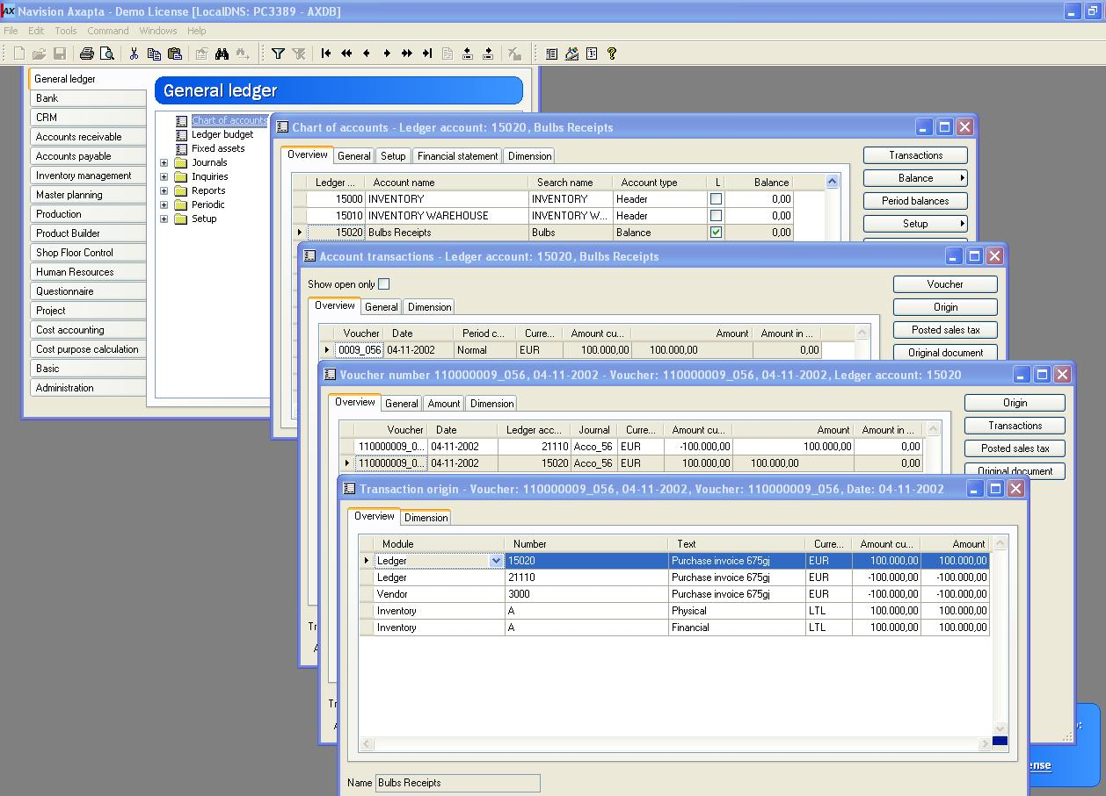
Tracing a transaction from a ledger account to its origin (The transaction can be followed to the original document, for example, a sales invoice.).

Since all Microsoft Axapta modules, such as Logistics, Trade, Production, Project, Fixed Assets and others, are part of one system and database, a transaction in one module is automatically updated in corresponding accounts in the general ledger. This automatic, real-time updating of data helps ensure fast and accurate financial reporting. Connectivity with the general ledger lets you trace each transaction to its origin, so you can verify and analyze transactions immediately or on demand for external or internal audits. You can ensure the security of critical data by allowing information access or approval privileges based on job function or other criteria.

Easily customize your solution for maximum efficiency
Increase user productivity by readily customizing the user interface or online Help features to match your specific business terminology and processes. With customizable Web-based portals, you can control the flow of information and only give users the information they need. Information portals are based on familiar Microsoft standards, which eases training and lowers training costs.

Increase your focus on strategic management
With Microsoft Axapta Financial Management, you can meet demands for faster turnaround of accurate financial results. You can easily consolidate results online across multiple companies. And you can leverage built-in XBRL (Extensible Business Reporting Language, an open standard for exchanging financial reports among users) within or outside your organization in order to eliminate manual reporting activities.
With the help of Microsoft Axapta Financial Management, your financial team can plan and execute from a single corporate database, thereby reducing time-intensive, repetitive administrative tasks and letting them move from strictly tactical activities to more strategic ones.

Effectively manage your cash flow
Microsoft Axapta Financial Management helps provide you with a clear insight of your financial status—at all times. You can analyze your liquidity with cash flow forecasts and optimize the management of your foreign currency. With the Microsoft Axapta Bank Management module, you can reconcile your accounts, set up checks and monitor and report deposits, payments and balances on bank accounts. You can use the electronic payment option to import customer payments automatically into your payment journal or make vendor payments with clear visibility into all your accounts to help you manage your cash flow more effectively.

Enjoy flexible data analysis options
Monitor and analyze transactions with the powerful drill around and drill to detail capabilities of Microsoft Axapta Financial Management. Generate financial reports with flexible advanced reporting tools with multiple output options. Import and export data between Microsoft Office® applications and Microsoft Axapta for easy document handling and creation. You can also analyze actual results against multiple budget assumptions to deal with dynamic market conditions where a single, fixed budget for the fiscal year is not realistic.

Speed data analysis with financial dimensions
Define and work with multiple financial dimensions across various Microsoft Axapta Financial Management modules to track profit, cost centers, departments, regions, products lines or any other measures from any reporting unit. Dimensions deepen analysis capabilities without complicating your chart of accounts.

Extend your solution to suit your needs
Increase the value of your Microsoft Axapta Financial Management solution by purchasing complementary offerings. Monitor and optimize your business performance by establishing Key Performance Indicators (KPI) from Microsoft Business Solutions–Axapta Balanced Scorecard. With Balanced Scorecard, you simply map your accounting and business operating metrics into a framework for strategic analysis.
With Microsoft Axapta Enterprise Portal, your employees—on site or remote—won't waste time looking for information, because the information they need to make accurate and quick business decisions is delivered directly to their Web portals.
With Microsoft Business Solutions–Axapta Business Analysis, you can get advanced multidimensional reporting and analysis features using on-line analytical processing (OLAP). This solution extends your ability to analyze financial data using multiple dimension data cubes and pivot tables.

For more information about Microsoft Axapta
To learn more about Microsoft Axapta, contact your local Microsoft Business Solutions Office or Microsoft Certified Business Solutions Partner at the following Web address. They have the expertise to meet your specific business needs.

About Microsoft Business Solutions
Microsoft Business Solutions, a division of Microsoft, offers a wide range of integrated, end-to-end business applications and services designed to help small, midmarket and corporate businesses become more connected with customers, employees, partners and suppliers. Microsoft Business Solutions' applications optimize strategic business processes across financial management, analytics, human resources management, project management, customer relationship management, field service management, supply chain management, e-commerce, manufacturing and retail management. The applications are designed to provide insight to help customers achieve business success. More information about Microsoft Business Solutions can be found at www.microsoft.com/BusinessSolutions.

Address:
Microsoft Business Solutions
Frydenlunds Allé 6
2950 Vedbaek
Denmark
Tel +45 45 67 80 00
Fax +45 45 67 80 01
www.microsoft.com/BusinessSolutions

 | Module: Financials I
Key Features |  | Description
GeNERAL LEDGER |  | - Flexible setup of accounting periods  - Fast and reliable year-end procedure  - Multiple budgets  - Advanced options for transaction entry  - Journal approval procedures  - Recurring journals  - Validation prior to posting  - Automatic allocation according to predefined setup of accounts, dimensions and percentages??  - Extensive tax module for different types of tax calculation and reporting
Bank Management |  | - Reconcile bank accounts  - Setup of checks  - Monitoring deposits, payments, and bank balances  - Electronic import of bank account statements available for some countries
Accounts Receivable |  | - Credit assessment  - Flexible terms of payment and cash discounts  - Advanced payment schedules  - Prepayments  - Draft handling (bill of exchange)  - Payment proposal  - Free text invoicing (non-stock invoicing)  - Extended options for interest calculation  - Options to setup unlimited number of different collection procedures  - Export and import formats for electronic payments  - Multiple currency handling and exchange rate adjustment
Accounts payable |  | - Export and import formats for electronic payments  - Bridging accounts  - Promissory note handling  - Advanced payment schedules  - Payment proposals  - Option to match invoices to physical deliveries  - Option for separate handling of approved and unapproved invoices
easy to use |  | - Intuitive screen layout and structure  - User-adjustable menus, entry forms and reports  - Advanced sorting and filter options  - Built-in user Help including an integrated manual  - Option to e-mail and fax directly from Microsoft Axapta
global functionalities |  | - Multi-language capabilities  - Comprehensive local market functionality  - Multi-currency and secondary currency handling  - Currency Converter  - Euro conversion  - Exchange rate adjustment handling  - Intrastat and EU sales list  - Country-specific bank formats for electronic payments and import of bank account statements
data analysis |  | - Powerful financial dimensions for data analysis  - Flexible report generator  - XBRL (Extensible Business Reporting Language)  - Drill to detail and drill around capabilities
reliability and security |  | - Strong audit trail capabilities  - System controls and transaction validations  - Transaction approval  - Extended options for setup of access rights
 | Module: Financials II
Key Features |  | Description
Advanced GeNERAL LEDGER |  | - Intercompany accounting  - Global consolidations  - Account allocations based on predefined criteria for actual or budget amounts  - Cash-flow forecasting and currency requirement calculation
 | Module: Fixed Assets
Key Features |  | Description
Asset management |  | - Manages the full life cycle from acquisition, depreciation to disposition  - Maintains asset status information  - Improves control over fixed assets to drive accuracy and timeliness in your accounting results  - Supports five depreciation methods (straight line, declining balance, factor, manual percentage and consumption)  - Forecasts using fixed assets budgets

System Requirements
To obtain all of the features mentioned in this fact sheet,  the following modules and technologies are required: | - Microsoft Business Solutions-Axapta 3.0  - Microsoft Business Solutions-Axapta Financials I  - Microsoft Business Solutions-Axapta Financials II  - Microsoft Business Solutions-Axapta Electronic Banking  - Microsoft Business Solutions-Axapta Fixed Assets  - Microsoft Business Solutions-Axapta Enterprise Portal Framework  - Microsoft Business Solutions-Axapta Business Analysis  - Microsoft Business Analysis Server 2000??  - Microsoft Internet Information Server

07.01.2003
The information contained in this document represents the current view of Microsoft Corporation on the issues discussed as of the date of publication. Because Microsoft must respond to changing market conditions, it should not be interpreted to be a commitment on the part of Microsoft, and Microsoft cannot guarantee the accuracy of any information presented after the date of publication.

This document is for informational purposes only. MICROSOFT MAKES NO WARRANTIES, EXPRESS, IMPLIED OR STATUTORY, AS TO THE INFORMATION IN THIS DOCUMENT.

Complying with all applicable copyright laws is the responsibility of the user. Without limiting the rights under copyright, no part of this document may be reproduced, stored in or introduced into a retrieval system, or transmitted in any form or by any means (electronic, mechanical, photocopying, recording, or otherwise), or for any purpose, without the express written permission of Microsoft Corporation.

Microsoft may have patents, patent applications, trademarks, copyrights, or other intellectual property rights covering subject matter in this document. Except as expressly provided in any written license agreement from Microsoft, the furnishing of this document does not give you any license to these patents, trademarks, copyrights, or other intellectual property.

© 2003 Microsoft Business Solutions ApS, Denmark. All rights reserved. Microsoft, Great Plains, Navision, FRx, *list other trademarks mentioned are either registered trademarks or trademarks of Microsoft Corporation, Great Plains Software, Inc., FRx Software Corporation, or Microsoft Business Solutions ApS or their affiliates in the United States and/or other countries. Great Plains Software, Inc., FRx Software Corporation, and Microsoft Business Solutions ApS are subsidiaries of Microsoft Corporation. The names of actual companies and products mentioned herein may be the trademarks of their respective owners. The example companies, organizations, products, domain names, email addresses, logos, people and events depicted herein are fictitious. No association with any real company, organization, product, domain name, e-mail address, logo, person, or event is intended or should be inferred.

