Microsoft® Business Solutions-Axapta® Sales and Marketing is a Customer Relationship Management (CRM) solution that helps you maximize benefits from all of your business relationships.

Key Benefits:
- Helps increase sales and revenue

- Ensures consistent customer service

- Optimizes sales and marketing activities

Microsoft Business Solutions–Axapta Sales and Marketing gathers all your business information in one place and keeps it structured and readily available. This provides you with the necessary insight to identify your customer’s needs and make optimal sales and marketing decisions. It lets you effectively share information on all aspects of your business relationships, making every employee a customer expert.
Microsoft Axapta Sales and Marketing consist of five modules:
- Sales Force Automation
- Sales Management
- Marketing Automation
- Telemarketing
- CRM for Enterprise portal

The Sales and Marketing modules exchange information with other important functional areas in the solution such as Finance, Supply Chain, Production and Questionnaire, to help improve your overall business performance.

Make more sales and better sales
Know your customer and give them the products and quality service they expect—when they expect it.
Sales and Marketing continuously gathers information about customer purchasing patterns, helping you identify and effectively target cross-selling and up-selling opportunities.
Your sales and marketing professionals will have instant access to all relevant customer information, enabling them to manage relationships more effectively and to predict future behavior with more confidence and accuracy. You can identify and retain the customers that present the highest lifetime value for your company, as well as analyze your marketing activities in order to find new opportunities and react quickly to market changes.

Increase your marketing effectiveness
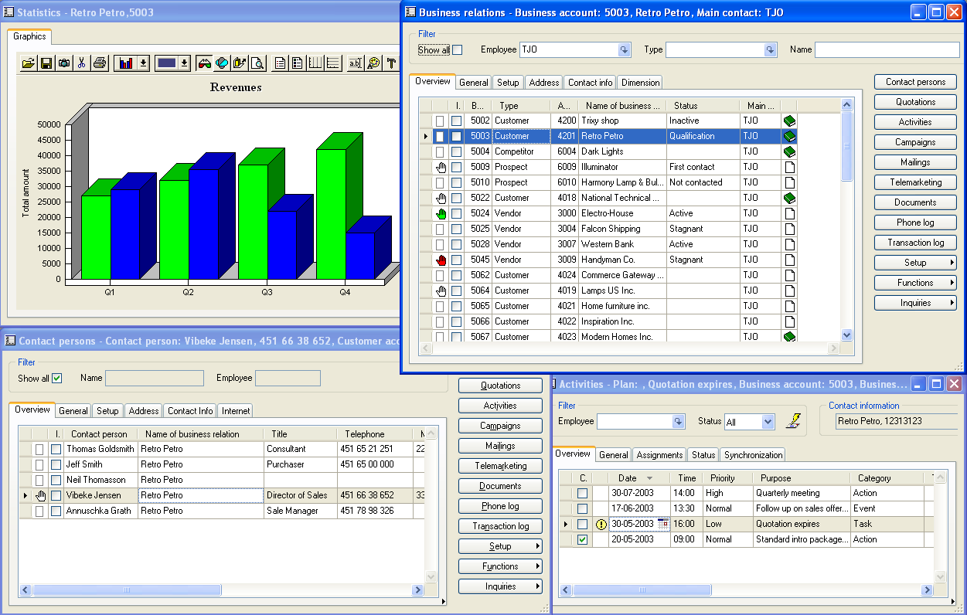

Microsoft Axapta Sales and Marketing helps you identify and qualify new prospects and communicate the right message to your customers—at the right time and through their preferred channel.
Quickly plan and execute personalized campaigns across all communication channels, including direct sales, call centers, e-mail, fax, the Internet and mobile devices. A campaign window consolidates all the information and functionality you need.
Learn from your customers using questionnaires; Web-based functionality lets you design, publish and process questionnaires quickly and easily. Match customer responses with existing customer and market insight, so you can get a head start on planning for future demands.
Manage statistical feedback and measure the success of marketing campaigns by creating market segmentation profiles that track responses and allow accurate follow-up. Monitor return on investment (ROI) in real-time by linking a campaign with a project, and view response rates, revenue, costs and the work put into your marketing efforts.
See all relevant customer information at a glance

Monitor current and past purchasing behavior

Communicate with any type of business relation your company may have

Satisfy customers consistently
Sales and Marketing can give you the customer insight you need to maintain customer satisfaction and increase sales successes. When customer information is updated and shared across teams and departments, employees will have the competence to make accurate, fast and personalized customer service decisions.
Sales representatives who have full insight into customer buying patterns and cost of goods can make personalized offers based on the individual needs of your customers. Complete and up-to-date overview of stocks on hand and delivery schedules, ensure that customers are given the right information every time.
Follow up on generated leads and offers through automated activity generation that is fully integrated with Microsoft Outlook

Even on the road, your sales people will have the full information and analytical support of your organization. You can provide customer information to your sales force over mobile phones, hand-held PCs and/or an Internet browser.

Sales and Marketing and the Web—a perfect fit
You can automate many time-consuming data collection and customer handling routines using the Internet. By streamlining front-office processes, you can exchange information faster and cheaper than before. Because Sales and Marketing connects the front-end and back-end systems, your entire organization can effectively capture the customer information it needs over the Internet—anytime, anywhere.

Optimize sales efficiency
Microsoft Axapta Sales and Marketing gives sales managers on-demand access to all relevant sales information—such as projects, invoices, order history and current revenue— without having to wait for sales representatives to make special reports. This allows more detailed, efficient pipeline management, a better control of the sales force and a stronger focus on the customer. Sales can be analyzed against budgets, and every person, organization and activity can be given a cost/benefit analysis.
You can also monitor and manage the activities of individual sales people, sales teams or the entire sales organization, or run detailed pipeline analyses of sales in the channel. You can associate revenue and expenses to every sales person or activity, at any level of detail. Break down the sales process into its components, and find out what adds to profits and what doesn't.

Make telemarketing more effective
The telemarketing functionality allows you to track opportunities and effectively execute sales and marketing campaigns. You can automatically generate call lists, dial telephones and log call details, as well as flag unsuccessful calls for a second attempt later, and generate call scripts using the questionnaire functionality.

Optimize your business resources
Microsoft Axapta Sales and Marketing uses a single business logic and a single database, making training and maintenance easier. Since all your vital business processes are connected, including sales, customer service, marketing and supply chain management, you have detailed, up-to-date information on current sales offers, making forecasting and production easier and inventory costs fall. You can also drastically cut administrative costs because the system automates many of your customer related transactions.

Microsoft Business Solutions–Axapta
Microsoft Axapta Sales and Marketing is part of Microsoft Business Solutions–Axapta, a customizable, scalable and global Enterprise Resource Planning (ERP) solution that provides you with a fast and powerful way to gain a competitive advantage.

For more information about Microsoft Axapta
To learn more about Microsoft Axapta, contact your local Microsoft Business Solutions Office or Microsoft Certified Business Solutions Partner at the following Web address. They have the expertise to meet your specific business needs.

About Microsoft Business Solutions
Microsoft Business Solutions, a division of Microsoft, offers a wide range of integrated, end-to-end business applications and services designed to help small, midmarket and corporate businesses connect better with their customers, employees, partners and suppliers. Microsoft Business Solutions applications optimize strategic business processes across financial management, analytics, human resources management, project management, customer relationship management, field service management, supply chain management, e-commerce, manufacturing and retail management. These applications are designed to help businesses succeed and achieve their goals. More information about Microsoft Business Solutions can be found at www.microsoft.com/BusinessSolutions.

Address:
Microsoft Business Solutions
Frydenlunds Allé 6
2950 Vedbaek
Denmark
Tel +45 45 67 80 00
Fax +45 45 67 80 01
www.microsoft.com/BusinessSolutions
Key Features | Description
Easy to use | - Intuitive layout and structure  - User-adjustable menu  - “Copy and paste” to and from Microsoft Axapta included in Windows commands  - Advanced sorting and filter options  - Built-in user Help including an integrated manual  - Options to e-mail, fax and phone directly from Axapta  - Application can be run in different languages  - Highly adaptable in order to fulfill specific needs of almost any type of company
ALL-in-one solution | - One business logic, one database, one set of tools and one source code  - Front office and back office function as a single, unified system  - Access to detailed customer information throughout the organization
Sales Force Automation | - Manage all aspects of business relationships, including customers, vendors, leads, partners, members, subscribers, etc.  - Provides instant overview of all financial or logistic information  - Retain customer information for new employees  - Analyze actual sales against budgets  - Evaluate a given activity with a customer against the profitability of that customer  - Give your entire organization access to customer information  - Forecast and plan future revenue  - Forecast and plan future production based on anticipated sales  - Communicate with groups of business relations through any type of mass-generated communication
Sales Management | - Monitor and manage the activities and performance of employees  - Generate graphs or reports from sales activities  - Analyze and report on sales, quotations and all other sales activities  - Perform opportunity management, pipeline analysis, and measure sales forecasts against sales targets  - Budget future activities based on up-to-the-minute information
Marketing Automation | - Create marketing campaigns for any group of business relations dependent on any form of registered information in Microsoft Axapta  - Organize your campaign administration and distribution  - Link campaigns and questionnaires, projects and Web responses  - Automatic creation of follow-up activities with synchronization to Microsoft Outlook  - Monitor ROI by linking the campaign to a project  - Broadcast the campaign via e-mail, Internet, fax, letter and/or call lists
Document Management | - A common document repository where documents are stored and linked  - View a complete record of contacts, sales orders and quotations for all business relationships  - Track and log documents, including e-mails, SMS messages, and phone calls  - Store all collateral in one place  - Access to documents over the Internet
Telemarketing / Telesales | - Daily activities are automatically mapped out  - Calls lists are generated, telephones dial automatically, and call details are logged  - Calls that were not initially successful are identified so that a second attempt can be made  - Call scripts are generated using the questionnaire functionality  - Results from questionnaires are analyzed
E-mail and SMS Integration | - Send emails or notes to employees in the field from within Microsoft Axapta  - Urgent messages are received by your sales force almost instantly  - Time and money can be saved on front-office communication processes
Questionnaires | - Design and generate questionnaires for use in marketing campaigns  - Map responses to knowledge about customers for future planning  - Execution is simplified by Web-based functionality  - Respondents to a questionnaire are automatically created as users  - Respondents’ user ID is automatically logged into the system  - Questionnaires can be grouped by type  - Dependencies between questions in questionnaire are identified

System Requirements
To obtain all of the features mentioned in this fact sheet,  the following modules and technologies are required: | To obtain all of the features mentioned in this fact sheet, the following modules and technologies are required:  - Microsoft Business Solutions−Axapta 3.0  - Microsoft Business Solutions−Axapta Finance 1  - Microsoft Business Solutions−Axapta Trade  - Microsoft Business Solutions−Axapta Logistics  - Microsoft Business Solutions−Axapta Master planning  - Microsoft Business Solutions−Axapta Project 1  - Microsoft Business Solutions−Axapta Sales Force Automation  - Microsoft Business Solutions−Axapta Sales Management  - Microsoft Business Solutions−Axapta Marketing Automation  - Microsoft Business Solutions−Axapta Telemarketing  - Microsoft Business Solutions−Axapta Sales Representative Role  - Microsoft Business Solutions−Axapta CRM for EP  - Microsoft Business Solutions−Axapta Questionnaire I  - Microsoft Business Solutions−Axapta Business Analysis  - Microsoft Business Solutions−Axapta Enterprise Portal
07.01.2003
The information contained in this document represents the current view of Microsoft Corporation on the issues discussed as of the date of publication. Because Microsoft must respond to changing market conditions, it should not be interpreted to be a commitment on the part of Microsoft, and Microsoft cannot guarantee the accuracy of any information presented after the date of publication.

This document is for informational purposes only. MICROSOFT MAKES NO WARRANTIES, EXPRESS, IMPLIED OR STATUTORY, AS TO THE INFORMATION IN THIS DOCUMENT.

Complying with all applicable copyright laws is the responsibility of the user. Without limiting the rights under copyright, no part of this document may be reproduced, stored in or introduced into a retrieval system, or transmitted in any form or by any means (electronic, mechanical, photocopying, recording, or otherwise), or for any purpose, without the express written permission of Microsoft Corporation.

Microsoft may have patents, patent applications, trademarks, copyrights, or other intellectual property rights covering subject matter in this document. Except as expressly provided in any written license agreement from Microsoft, the furnishing of this document does not give you any license to these patents, trademarks, copyrights, or other intellectual property.

© 2003 Microsoft Business Solutions ApS, Denmark. All rights reserved. Microsoft, Great Plains, Navision, FRx, *list other trademarks mentioned are either registered trademarks or trademarks of Microsoft Corporation, Great Plains Software, Inc., FRx Software Corporation, or Microsoft Business Solutions ApS or their affiliates in the United States and/or other countries. Great Plains Software, Inc., FRx Software Corporation, and Microsoft Business Solutions ApS are subsidiaries of Microsoft Corporation. The names of actual companies and products mentioned herein may be the trademarks of their respective owners. The example companies, organizations, products, domain names, email addresses, logos, people and events depicted herein are fictitious. No association with any real company, organization, product, domain name, e-mail address, logo, person, or event is intended or should be inferred.

