Microsoft® Business Solutions−Axapta®
Business Process Management
Microsoft Business Solutions−Axapta Business Process Management helps you develop and manage business processes by identifying and monitoring actions that support your business strategy.

Key Benefits:
- Provides a holistic view of your business processes
- Ensures that employees follow the correct sequence of actions according to their responsibilities
- Tracks the status of all actions and checks that they are followed up appropriately

Key Features:
- Detailed information on responsibilities, time, priorities and status provided
- Structured responses and diverted actions
- Action planning
- Identification of status and end results
- Strategic plans linked to organizational units in Microsoft Business Solutions–Axapta Human Resource I
Setting goals is the first step in implementing your business plan. Following through with a plan of actions comes next. But how do you know if your business is on the right track to achieving its goals?
Microsoft Business Solutions−Axapta Business Process Management helps you monitor your progress to achieve the goals you have set. Functionalities such as strategic planning, best practice action templates, SWOT analysis and action planning will help you leverage experience and human resources, making it easier for you to stay on track and achieve your goals.

Effective planning and action-oriented information
Making a decision and taking the appropriate action is easier when your employees have a goal or strategy in mind. Goals and strategies are often summarized by action-oriented information to make individual and/or business goals clear. Action-oriented information also describes the best method for achieving your goals.
In addition to supporting action management, Microsoft Axapta Business Process Management provides you with an excellent tool that you can use to communicate key strategies and progress to your employees. Microsoft Axapta provides both high-level and detailed views of progress in easy-to-understand terms. All your employees will be able to see, understand and react in accordance with your strategies.

Flexible action management
Microsoft Axapta Business Process Management enables any Microsoft Axapta user to establish and manage actions. When you set up actions, the program automatically ensures that your employees follow a standard structure, with follow-up as a natural part of action planning.
Using the structured and intuitive tools of Microsoft Axapta Business Process Management, all your employees can define personalized actions, set their own priorities and select and sort various types of information such as project status, responsible persons and date intervals.
Analysis and job management is made simple as the manager can easily retrieve the necessary/relevant information from an employee’s personalized system.
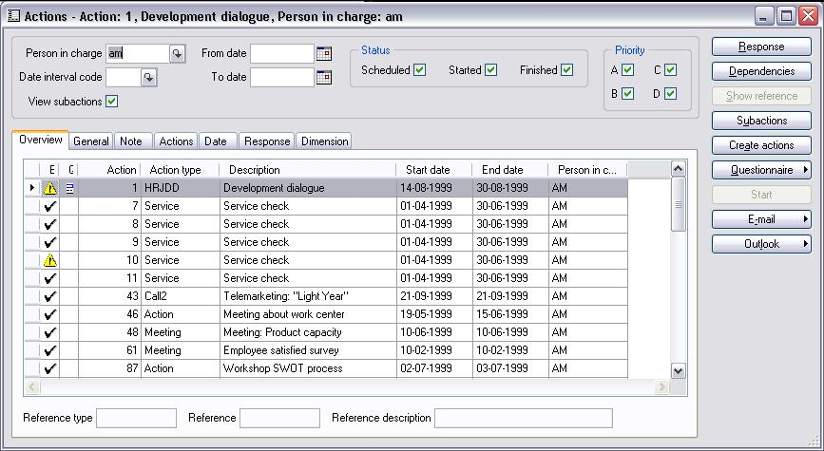
Action Management

Action template
How often have you made your own checklists for reoccurring jobs such as the recruitment of new employees and the preparation of introduction procedures for them? Microsoft Axapta Business Process Management will help you set up standard procedures and free valuable time.
Use Process Design to set up procedures that you regularly use in your daily work, thereby ensuring that a process is optimally supported in accordance with best practice. The action template gives you an unlimited choice in the number of actions that you can simultaneously create and distribute to the responsible people. The process runs automatically, but under your full control as, initially, you set all the definitions.

Response and tracking
With Microsoft Axapta Business Process Management, it is easy to respond to actions, create diverted actions, and require actions between employees. You can set up the system so that a given response automatically suggests a new action. This ensures consistency and gives you the ability to control procedures.

Effective action planning
Action planning helps you to keep your business focused on your goals. You decide which data in Microsoft Axapta should be used to create the foundation for action-oriented efforts such as campaigns, customer satisfaction, employee performance reviews, recruitment tasks, and the administration of other resources, such as machinery.
Easy and flexible planning allows you to control which tasks are delegated to which employees. You can define characteristics, such as qualifications and organizational or physical location, and use the criteria to filter choices for various responsibilities.

Strategic planning
You can use strategic planning to identify, control and monitor the progress of your business’s overall strategy or an employee’s individual development plan. You can either set up the plan as a main plan or a sub-plan with accompanying references. The plan is updated with start and end dates, responsible employees, organizational units and a classification of which type of plan it is. From the initiation of a plan until the end result is achieved, responsibilities must be delegated and tasks fulfilled – all of which can be controlled and monitored by the action management module.
With the strategic planning module, you can ensure that the strategic processes become a natural part of every employee’s daily work. This ensures that you get the most value from your resources. It also creates a shared understanding of the organization’s focus and goals.

Contact your partner
To learn more about Microsoft Axapta, contact your local Microsoft Certified Business Solutions Partner. They have the expertise necessary to meet your specific business needs.

About Microsoft Business Solutions
Microsoft Business Solutions, a division of Microsoft, offers a wide range of integrated, end-to-end business applications and services designed to help small, midmarket and corporate businesses become more connected with customers, employees, partners and suppliers. Microsoft Business Solutions' applications optimize strategic business processes across financial management, analytics, human resources management, project management, customer relationship management, field service management, supply chain management, e-commerce, manufacturing and retail management. The applications are designed to provide insight to help customers achieve business success. More information about Microsoft Business Solutions can be found at www.microsoft.com/BusinessSolutions.

Address:
Microsoft Business Solutions
Frydenlunds Allé 6
2950 Vedbaek
Denmark
Tel +45 45 67 80 00
Fax +45 45 67 80 01
www.microsoft.com/BusinessSolutions

Key Features | Description
Easy to Use | - Intuitive layout and structure  - User-adjustable menus, forms and reports  - User-adjustable layout of main tables and journals  - Windows commands incl. ‘copy and paste’ from and to Microsoft Axapta  - Direct access to main tables from journals  - Advanced sorting and filter options  - Built-in user help including an integrated manual  - Option to mail and fax directly from Microsoft Axapta  - Application can be run in different languages
Action Management | - Detailed information on responsibilities, time, priorities and status  - Register actions  - Tracking and dependencies  - Structure responses and generate diverted actions  - Send actions as email or create as tasks in Microsoft Outlook  - Implement Process Design by using action templates  - Create actions with distribution to the responsible people  - Action Planning
Strategic Planning | - Step-by-step creation of a strategic plan  - Identification of status and end results  - Register SWOT analysis results  - Break-down of visions to define goals and milestones  - Planning and follow-up with actions on initiatives  - Link to Action Management and KPIs in Microsoft Axapta Balanced Scorecard  - Define templates for strategic plans  - Link strategic plans to organizational units in Microsoft Axapta Human Resource I

System Requirements
To obtain all of the features mentioned in this fact sheet,  the following modules and technologies are required: | To obtain all of the features mentioned in this fact sheet, the following modules and technologies are required:  - Microsoft Business Solutions–Axapta 3.0  - Microsoft Business Solutions–Axapta Financials  - Microsoft Business Solutions–Axapta Business Process Management  For full HR and balanced scorecard functionality also:  - Microsoft Business Solutions–Axapta Human Resource Management I  - Microsoft Business Solutions–Axapta Balanced Scorecard
07.04.2003
© 2003 Microsoft Business Solutions ApS, Denmark. All rights reserved. Microsoft, Great Plains, Navision, FRx, *list other trademarks mentioned are either registered trademarks or trademarks of Microsoft Corporation, Great Plains Software, Inc., FRx Software Corporation, or Microsoft Business Solutions ApS or their affiliates in the United States and/or other countries. Great Plains Software, Inc., FRx Software Corporation, and Microsoft Business Solutions ApS are subsidiaries of Microsoft Corporation. The names of actual companies and products mentioned herein may be the trademarks of their respective owners. The example companies, organizations, products, domain names, email addresses, logos, people and events depicted herein are fictitious. No association with any real company, organization, product, domain name, e-mail address, logo, person, or event is intended or should be inferred.

