Microsoft® Business Solutions−Axapta®
Business Analysis
Microsoft Business Solutions−Axapta Business Analysis enables you to quickly transform business data into knowledge and strategic action.

Key Benefits:
- Intuitive views of complex data help identify opportunities, trends and issues
- Improve decision-making power
- Respond quicker to market demands
- Fast implementation
- High return on investment and low cost of ownership

Key Features:
- Multidimensional analysis
- A range of standard cubes supplied
- Full synchronization with Microsoft Analysis Services
- View externally created data cubes
- Create and view cubes in multiple currencies and languages
- No third party add-ons other than Microsoft required to generate cubes
Decision makers in a global marketplace face tough questions everyday. Is the business healthy? Who are my best customers? Which supplier should I choose? Where are we quarter-to-date? Do we deliver products consistently on time? Do we have the right mix of people? To manage your business performance effectively means knowing what questions to ask, and having the facts readily at hand to answer them. Microsoft Business Solutions−Axapta Business Analysis gives you access to the accurate and timely analysis you need to compete successfully.

Information at work
Businesses collect and store a staggering amount of information. Microsoft Axapta Business Analysis puts that information to work. CEOs, CFOs, managers, controllers, accountants and sales and marketing staff can create, view and understand reports that previously were complicated, expensive or time-consuming. You can learn from previous decisions, investigate opportunity and target markets and customers with pinpoint accuracy. You have the answers you need before deadline, before the market has changed and before the competition has moved ahead.

Multidimensional analysis
Microsoft Axapta Business Analysis is based on On-Line Analytical Processing technology (OLAP), which enables multidimensional analysis through the use of the Microsoft Analysis Server. An OLAP server is a high-capacity, multi-user data manipulation engine specifically designed to extract data from a relational database such as Microsoft Axapta and transform it into valuable business insight using predefined views.
A multidimensional analysis performed by the OLAP server is often referred to or visualized as a multi-sided cube. Each side of the cube represents a dimension taken into account during the analysis. Dimensions are distinct categories of business data such as time, products, geographical regions or sales channels. Within every dimension, a hierarchy of data exists. For the category of time, the hierarchy could include year, quarter, month and weekday.

ERP and business analysis in one
With traditional OLAP products, the process of mapping information between the ERP data and the OLAP cube has often been difficult and time-consuming because information needed to be mapped between two separate systems. With Microsoft Axapta, the OLAP functionality in Business Analysis and the ERP data are one. All mappings occur directly in Microsoft Axapta, thus taking full advantage of your business information and making the most of relationships between tables, extended data types and enum labels.
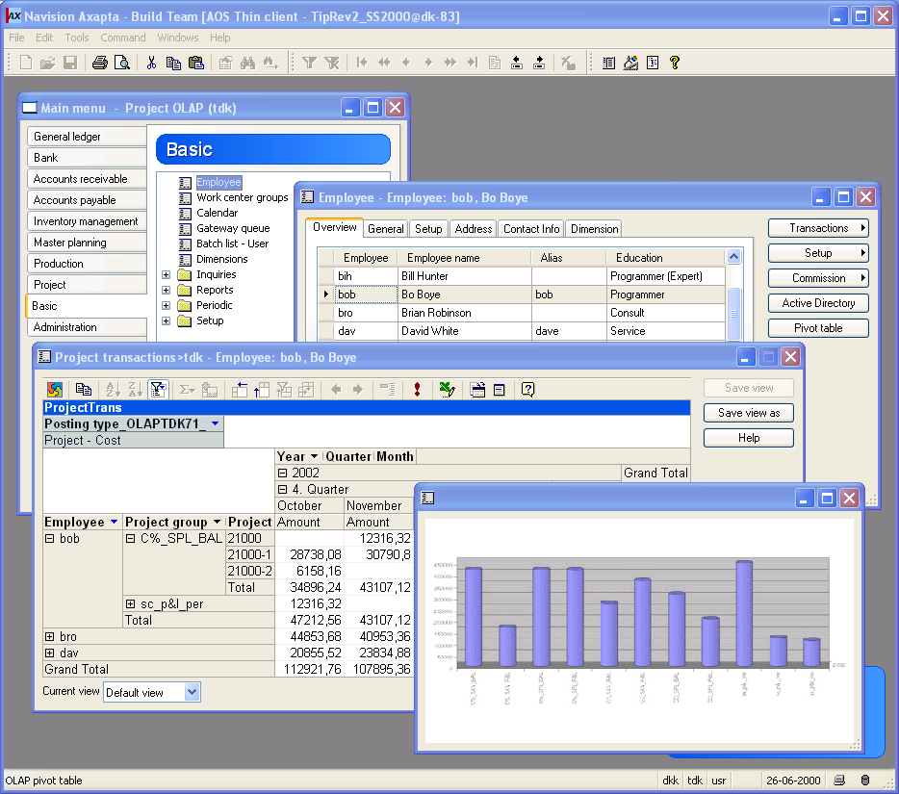
Cost per project for employee Bob Boye

A range of data sources, languages and currencies
You have the ability to centralize data from multiple sources into a single source of business information and analysis. The user creating the query simply selects the data sources when creating a query in Microsoft Axapta. The analysis can then be saved in the language and currency preferred by the user. The time and cost associated with transferring data is reduced as well as the potential for errors.

Precision
Microsoft Axapta Business Analysis consistently delivers reliable results, regardless of the complexity of the query. The business data used during analysis is constantly updated because it includes changes as they occur in Microsoft Axapta or subsequent data sources. You have the option to set the update for every day, every week or every month. There is no duplication or doubling of information sources, or potential for inaccurate numbers.
You also have the ability to look at the overview of your analysis or drill down to the microscopic detail. When making an analysis on buying patterns, for example, you can view information by customer group, by specific customer, specific invoice or by any other level of your choice. By measuring performance continuously, you can ensure that business goals are met and strategies are working effectively. Microsoft Axapta Business Analysis also gives you transparency when looking for the relationship between activities in different departments, locations or subsidiaries.

Cube Definition Manager
One of the barriers to traditional OLAP is the time and expertise required to build and maintain the applications and data. Microsoft Axapta lowers the total cost of ownership for these applications by simplifying the processes of creating and maintaining cubes with the built-in Cube Definition Manager.
The Cube Definition Manager is the administrative interface to the Microsoft Analysis Server. It offers a range of functionality, from cube generation to creating calculated members that give you access to more advanced functionality. With the Cube Definition Manager, you can create, fine-tune and maintain cubes with ease.

Low training costs
With Microsoft Axapta Business Analysis, every user is comfortable with the process of analysis. The intuitive drag and drop environment facilitates learning and knowledge exchange while keeping training costs to a minimum. The queries take place within the familiar Microsoft Axapta environment, so it is not necessary to learn a new layout or switch back and forth between external programs or different computer screens. Microsoft Axapta Business Analysis comes with predefined queries based on best practices to help guide new users.
It reduces internal backlogs and costs associated with reporting. Without a business analysis tool, reports are expensive and time-consuming as they tie up internal resources or are outsourced to external consultants.

Intuitive views
Cubes in traditional OLAP can be a challenge. What if a user does not understand the naming convention from the ERP system, or the user would like to have a different name than the one in the ERP system? With the Cube Definition Manager in Microsoft Axapta Business Analysis, users can select a preferred name – possibly even better related to their specific roles and functions. The name can be personalized at any level - dimension, measure or level. The new name will be transferred to the Microsoft Analysis Server so that it is the name displayed for the user.
For example, a manager would like to have the dimension, customer name, displayed as client name instead. When creating the cube, the manager types in client name in the name field and the change is registered so that it is automatically displayed from that point on. Another common example is currency. If an accountant in France would like to see a monetary value in euro instead of US dollar, he or she selects euro for currency. Euro will be the name and value displayed.

Self-sufficient users
Management can use business analysis to look into business ratios, compare performance against budget or previous years and compare product groups or markets. They can drill down to specific data at the discussion table. Microsoft Axapta Business Analysis is the basis for sound decision-making and strategic action.
Accountants and financial analysts can use Microsoft Axapta Business Analysis to analyze cash flow, actual and budgeted expenses and create performance analysis reviews. Which aspects of the business are most profitable? Which activities deliver the highest rate of return?
Your sales department can use Microsoft Axapta Business Analysis for sales analysis and forecasting. Users can evaluate sales on a specific item in a specific region in a specific month. With the ability to spot opportunities and more accurately predict outcomes, your sales force will increase productivity.
Your marketing department can perform market research analysis, promotions analysis and market/customer segmentation with Microsoft Axapta Business Analysis.

Optimize your relationships
With Microsoft Axapta Business Analysis, you have the opportunity to analyze any factors affecting your bottom line. You can learn as much as possible about your customers – analyze revenue potential, develop strategies to retain preferred customers and attract new customers, create customer profiles and segmentation analysis. You can share up to the minute information such as customer purchasing and supplier inventory, and identify weak spots in your supply chain so that you can make the necessary changes. Answer questions such as “How will profits be affected by switching suppliers?” or “What is my delivery lead time?” You can assess sales and marketing success, identify new markets and make plans based on results. You can also analyze costs and factors associated with employee retention and productivity.

Security
The security is managed centrally, reducing the effect on users and strain on IT. You have full control over which users have access to which models. The user must be registered on the server they select to gain access.

Third party tools
Microsoft Axapta and Microsoft Analysis Server are required to run Business Analysis. There are no third party tools required to create cubes because Microsoft Axapta is based on the latest technology. For optimum performance, Microsoft Axapta Business Analysis saves cubes using the MOLAP model (multidimensional OLAP), which stores aggregations and a copy of the cube’s source data in a multidimensional structure. The reports are published without intervention by IT.

Technology
Microsoft Axapta Business Analysis integrates to Microsoft® SQL Server™ OLAP Services and Microsoft Pivot Table using COM technology. Microsoft Analysis Services are used for saving cube metadata and for building cubes. Microsoft Analysis Services can utilize data from many relational databases that provide connection via ODBC or OLEDB. Microsoft Pivot Table is used for viewing cubes as a pivot table.

Contact your partner
To learn more about Microsoft Axapta, contact your local Microsoft Certified Business Solutions Partner. They have the expertise necessary to meet your specific business needs.

About Microsoft Business Solutions
Microsoft Business Solutions, a division of Microsoft, offers a wide range of integrated, end-to-end business applications and services designed to help small, midmarket and corporate businesses become more connected with customers, employees, partners and suppliers. Microsoft Business Solutions' applications optimize strategic business processes across financial management, analytics, human resources management, project management, customer relationship management, field service management, supply chain management, e-commerce, manufacturing and retail management. The applications are designed to provide insight to help customers achieve business success. More information about Microsoft Business Solutions can be found at www.microsoft.com/BusinessSolutions.

Address:
Microsoft Business Solutions
Frydenlunds Allé 6
2950 Vedbaek
Denmark
Tel +45 45 67 80 00
Fax +45 45 67 80 01
www.microsoft.com/BusinessSolutions

Key Features | Description
Easy to use | - Intuitive layout and structure  - User-adjustable menus, forms and reports  - User-adjustable layout of main tables and journals  - Windows commands incl. ‘copy and paste’ from and to Microsoft Axapta  - Direct access to main tables from journals  - Advanced sorting and filter options  - Built-in user help including an integrated manual  - Option to mail and fax directly from Microsoft Axapta  - Application can be run in different languages
General | - Multidimensional analysis  - Embedded and context adaptable viewing of cubes  - Easy access to manipulation of views in Microsoft Excel  - Full control within Microsoft Axapta
Microsoft Analysis Server | - Available on the Microsoft SQL Server 2000 CD  - Full synchronization with Microsoft Axapta  - Create, maintain and control OLAP databases and cubes  - Cubes stored as MOLAP cubes with no querying drag on legacy database after update (should perhaps be rephrased to be more bullet-like)
Embedded Pivot Table | - Fully integrated with Microsoft Excel 2000 (Microsoft Query)  - Viewing of cube data  - Easy access to manipulation of view in Excel
Cube Definition Manager | - Full use of Microsoft Axapta data model  - Microsoft Axapta forms for easy set-up
Generation of Cubes | - Create cubes in multiple currencies and languages  - Periodic batch update possible for all cubes
Viewing of Cubes | - General overview of available views  - Automatic filtering from Microsoft Axapta base data on Pivot Table
Security and Configuration | - Configuration key control of which cubes to generate  - Security key control of access to cubes and views
Third Party Products | - Any third party product add-on which supports Microsoft Analysis Services can be used for viewing cubes but is not necessary

System Requirements
To obtain all of the features mentioned in this fact sheet,  the following modules and technologies are required: | To obtain all of the features mentioned in this fact sheet, the following modules and technologies are required:  - Microsoft Business Solutions–Axapta 3.0  - Microsoft Business Solutions–Axapta Business Analysis  - Microsoft Analysis Server 2000
07.04.2003
© 2003 Microsoft Business Solutions ApS, Denmark. All rights reserved. Microsoft, Great Plains, Navision, FRx, *list other trademarks mentioned are either registered trademarks or trademarks of Microsoft Corporation, Great Plains Software, Inc., FRx Software Corporation, or Microsoft Business Solutions ApS or their affiliates in the United States and/or other countries. Great Plains Software, Inc., FRx Software Corporation, and Microsoft Business Solutions ApS are subsidiaries of Microsoft Corporation. The names of actual companies and products mentioned herein may be the trademarks of their respective owners. The example companies, organizations, products, domain names, email addresses, logos, people and events depicted herein are fictitious. No association with any real company, organization, product, domain name, e-mail address, logo, person, or event is intended or should be inferred.

