

Service Provisioning Component Overview
White Paper
Published: May 2005
Windows-based Hosting version 3.5 now supports using Windows Server 2003 Service Pack 1 (SP1). Windows Server 2003 SP1 offers better performance and tighter security to help further protect service providers from viruses and malicious code. For the latest information about the Microsoft Solution for Windows-based Hosting,
visit www.microsoft.com/hosting.

Abstract: This white paper provides an overview of the features, benefits, and design recommendations associated with the Service Provisioning component of the Microsoft Solution for Windows-based Hosting. Service Provisioning relies on the Microsoft Provisioning System (MPS) to automate routine administrative service management tasks such as adding new users, updating directory entries, and provisioning applications and services. MPS offers transactional, multi-service provisioning with auditing, rollback, and reporting capabilities that equip your customers with the ability to create and manage their own resources, including databases, e-mail, payment and contact information, and Web sites. Automating provisioning activities frees development resources to work on revenue-generating projects, such as deployment of new value-added services.

Contents
Introduction 1
What Is Service Provisioning? 2
Benefits of Service Provisioning 2
MPS Components and Architecture 3
Applications and Services 3
Service Provisioning Architecture 4
MPS Deployment 4
System Requirements 4
Is Service Provisioning Right for Your Organization? 4
Conclusion 4

Introduction
Building and managing data center environments is growing more complex, with system administrators frequently responsible for managing thousands of servers. As a result, routine administrative tasks that are simple to accomplish in a small multi-server environment are unmanageable across such a large number of servers. Tasks such as adding new users, updating directory entries, and provisioning application services across a large volume of servers are all manual administration tasks that do not scale easily.
In addition, customers of hosted services are demanding service level agreements (SLAs), increased uptime and availability, and the ability to monitor and administer their own services. SLAs often incorporate metrics for service activation, service additions or modifications, user additions, and other similar changes.

What Is Service Provisioning?
The Microsoft Provisioning System (MPS) is at the core of Service Provisioning. MPS is a comprehensive provisioning framework that automates routine administrative service management tasks such as adding new users, updating directory entries, and provisioning applications and services. You can use MPS to automate provisioning tasks for hosted services such as Web, Data, and Windows SharePoint® Services as well as other services through the extension interfaces provided by MPS.
MPS addresses many of the provisioning challenges facing data center environments by enabling service providers to streamline the steps of the provisioning process. Combined with the scripts, tools, and best practices included with Service Provisioning, MPS can improve internal operations and customer satisfaction. MPS does the following:
- Automates many manual, multiple-step provisioning processes while performing comprehensive logging.
- Provides transaction rollback features, a fault tolerant configuration for single point of failure (SPF) protection, a compensation engine to enable rollback in case a failure occurs, and load balancing for provisioning request traffic.
- Provides an infrastructure that supports the delegated administration of basic provisioning tasks to customers. This reduces the management costs normally associated with hosted solutions.
- Translates high-level business logic into specific low-level provisioning tasks. In addition, MPS isolates business logic from underlying platform changes.

Benefits of Service Provisioning
By using MPS to automate provisioning tasks, you can reduce setup time, mitigate administrative costs, and minimize errors. With MPS and its included Providers, you can automate the tasks required to provision and manage services within a data center for a large number of users, and thereby streamline the completion of customer requests. MPS provides the following benefits:
- Improved process management—MPS manages multi-step processes that can be executed asynchronously or synchronously without the need for a system administrator.
- Task automation—The automation of frequent or complex tasks improves accuracy by reducing the amount of human involvement, which reduces the opportunity for human error.
- Time savings—System administrators can spend increased time with new users or customers.
- Lowered administrative burden—Server-to-administrator ratio for Windows-based servers is improved, resulting in lower administration costs.
- Lower costs—Operational costs are lower due to fewer on-site visits.
Through these benefits, service providers can reduce the total cost of ownership in the provisioning environment with MPS.

MPS Components and Architecture
MPS is an extensible Windows-based platform that provides an Extensible Markup Language (XML)-based framework, allowing you to create customized provisioning solutions for Web, data, and application hosting. MPS includes several key components that support provisioning in the service provider environment:
- Namespaces—Namespaces are XML definitions that contain collections of one or more procedures and are stored in the MPS Configuration database.
- Procedures—Procedures are also XML definitions and are used to invoke the functionality of either an underlying Provider or other namespace procedures.
- A Provisioning Engine—The Provisioning Engine acts as a provisioning process coordinator and performs data monitoring and logging services. The Provisioning Engine interprets high-level XML requests and expands them into tasks.
- Providers—MPS uses Providers to invoke the functionality of specific applications, such as Microsoft Active Directory®, a Microsoft SQL Server™ database, and Microsoft Internet Information Services (IIS) Web services. Providers accept XML requests from the Provisioning Engine and execute provisioning tasks against their respective applications.
- Databases—MPS databases include the configuration database, Transaction log, Audit and Recovery Service, and Audit log. In addition, MPS provides a database that allows you to provision predefined customer service plans and track provisioning events to facilitate billing functions.
- Deployment Tool — Provides for the automated deployment and configuration of all MPS components. Eliminates many of the manual deployment and configuration steps to get MPS up and running quickly in the provisioning environment, while minimizing the occurrence of errors.

Applications and Services
Together, these components allow service providers to provision a wide variety of applications and services. For example, service providers can provision:
- Web hosting—MPS provisions IIS services and enables you to create Microsoft FrontPage®-enabled Web sites.
- Data hosting—MPS enables you to provision customer databases on a Microsoft SQL server.
- Hosted Windows SharePoint Services—MPS enables you to provision Windows SharePoint sites for customers and to manipulate sites, users, and groups.
- Directory services—MPS enables you to provision Active Directory tasks such as creating user accounts, groups, and organizational units (OUs).
- DNS—MPS enables you to provision Domain Name System (DNS) tasks such as creating or changing DNS zones and resource records.
- Other services—Other services include the provisioning of installation packages, Microsoft Windows registry and file system configuration, error remapping, and running scripts.
The following figure illustrates how the Microsoft Provisioning System works. A service provider uses a Web-based interface to make a provisioning request, such as signing up a new customer. In turn, MPS processes and expands the incoming XML provisioning request and routes the request to the appropriate Provider, such as the Active Directory Provider. The Provider makes the appropriate changes, and MSP then responds back to the interface to notify the reseller that the provisioning request is complete.
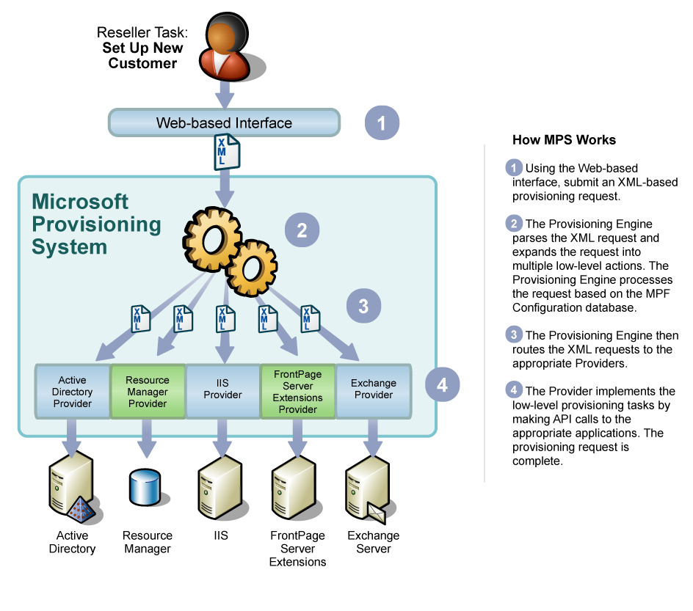
Figure 1: The MPS automates multi-step provisioning processes

Service Provisioning Architecture
Once you submit an XML-based request to MPS that contains a specified procedure, MPS automates all the steps of the provisioning task using Providers. MPS includes Providers for external applications such as Active Directory, DNS, IIS, and SQL Server, where the appropriate provisioning tasks are actually performed.
MPS contains the following components that manage, track, and implement transactional provisioning:
- MPF Client—This client is a Component Object Model (COM) object that receives XML requests containing namespace procedures and forwards them to the MPF Provisioning Engine. After the provisioning system executes the request, an MPF Client method returns the results back to the requester in XML format. The MPF COM Client can also be called by any .NET application that makes use of the MPS .NET Client Wrapper.
- Provisioning Engine—This engine coordinates transactions and executes MPF requests in real time. The Provisioning Engine receives requests from the MPF COM Client or the queue manager and then parses, expands, and routes the request to specific Providers. Provisioning engines process requests using the run-time properties defined in the MPF Configuration database.
- Provisioning Queue Manager—The provisioning queue manager handles all batch and queued requests to enable the submission of requests for later processing.
- Resource Manager—The Resource Manager tracks the availability and usage of resources across all implemented components, including SQL, Web, and Active Directory resources and any additional Provider resources implemented as part of MPS.
- Provisioning Manager—The Provisioning Manager is a Microsoft Management Console (MMC) snap-in for managing most MPS components such as server components, namespaces, procedures, and each of their properties.
- Providers—Providers are COM objects that contain the programmatic procedures for making API calls to external applications to accomplish provisioning tasks. For example, the Active Directory provider implements the provisioning of all directory services. In addition, a DNS Provider is included to enable you to automate complex DNS tasks that otherwise can be error-prone due to manual configuration.
- Provider Namespaces—Provider namespaces are XML components in MPS that invoke the functionality of Providers to handle the performance of low-level provisioning tasks. Each MPS Provider is associated with a corresponding Provider namespace that is registered in the MPF Configuration database when the Provider is installed.
- Non-Provider Namespaces—Non-Provider (managed) namespaces are predefined sets of provisioning actions that come with MPS. These namespaces focus on the implementation of common sets of provisioning tasks that Microsoft customizes for the service provider environment. Managed namespaces are available for Windows-based hosting, SharePoint, data hosting, Web hosting, and others.
- MPS Databases—The databases in MPS provide support for component configurations, transactions, logging, and resource management. For example, MPF uses a SQL database to maintain records of all provisioning servers, credentials, and namespaces (and their procedures) installed with MPF.
- MPS Customer Service Plans—Service plans provide a convenient way to aggregate and package service features into a bundled service plan for your hosted services. The MPS Customer Service Plans database supports the requirements of Windows SharePoint Services hosting, data hosting, and Web hosting.
- ASP.NET Web Service—The ASP.NET Web Service serves as a wrapper for the public methods of various namespaces shipped with MPS. The Web Service provides the means for .NET developers to develop custom provisioning applications for MPS.
- Development tools—MPS includes the Microsoft Provisioning Framework (MPF) Developer Toolkit, which provides MPF development tools for Microsoft Visual Studio® .NET 2003. This enables developers create .NET-based applications that interact with MPS, and allows them to extend MPS by creating new Providers.
- MPS scripts and tools—Scripts and tools are provided with MPS to use in your provisioning environment. For example, several MPS scripts are provided that you can use for support or test purposes.

MPS Deployment
You install and configure the various components with the MPS Deployment Tool, which is a single installation application. The MPS Deployment Tool eliminates all manual deployment and configuration steps to get MPS deployed quickly. Because the deployment and initial configuration of MPS is automated, you can reduce deployment time and minimize configuration errors. After the MPS Deployment Tool installs MPS components on the appropriate servers, it then automates the process of configuring the provisioning environment.
There are two deployment options for MPS:
- Basic MPS configuration—The basic MPS configuration helps you deploy your MPS environment quickly because this configuration requires only a minimal server count for a fully functional provisioning environment. Hosted Windows SharePoint Services and DNS are optional in the basic MPS configuration. In addition, you do not have to learn any advanced MPS capabilities to deploy the basic configuration.
- Advanced MPS configuration—If you have significant experience using MPS, consider deploying the advanced MPS configuration. Deploying the advanced MPS configuration provides a comprehensive provisioning solution that includes Web site, database, directory, and collaboration hosting services while making use of preconfigured customer service plans. The advanced MPS configuration provides fault tolerance and load balancing to ensure high availability and performance.

System Requirements
The minimum hardware and software requirements for your MPS components are:
- MPS hardware requirements—The minimum hardware requirements to install and run the MPF engine are:
- Dual-Pentium III 1-GHz class or higher processors
- 512 MB of memory per processor (1 GB total) or higher
- 30 MB of hard disk space
- Bootable floppy disk drive
- Two 10/100 network interface cards (NICs)
- Integrated Smart Array Controller module
- L2 cache of 256 KB
- CD-ROM drive (recommended)
- MPS Software Requirements—The MPS Deployment Tool enables you to install all the provisioning components including the Provisioning Engine, MPF client, Providers, namespaces, and databases.
- The Provisioning Engine, Providers, and namespaces can only be installed on a computer running Windows 2003 Server SP1.
- The MPS client must be installed on a computer running Windows 2000 Server or Microsoft Windows Server™ 2003.
- The MPS databases must be installed on a computer running Windows Server 2003 SP1 and SQL Server 2000, SP3.

Is Service Provisioning Right for Your Organization?
The Microsoft Solution for Windows-based Hosting is a modular solution architecture that enables service providers to deploy only the technologies they need. Service providers must maintain a competitive advantage by offering services on a stable, scalable infrastructure while keeping their costs low to maximize profitability. MPS can accommodate almost any deployment scenario in your data center, whether you are deploying a new provisioning system, or integrating MPS into an existing provisioning environment.
MPS is appropriate for service providers seeking to automate provisioning services by combining the steps of common tasks into a single, automated transaction. Although you may deploy the Service Provisioning component in a variety of situations, it is commonly implemented in the following hosting scenarios:
- Web hosting providers—Service providers offering Web hosting typically offer shared Web servers or data servers that are updated and maintained by the service provider and are not dedicated to the customer. These service providers can benefit from MPS by centrally managing customer accounts.
- Service aggregators—Service aggregators offer suites of services that they deliver to service providers. MPS enables service aggregators to set up role-based plans for service providers and customers so they can automate the complex administration of these plans.

Conclusion
The Microsoft Solution for Windows-based Hosting offers service providers a packaged set
of tested software tools and scripts with supported architecture guidelines. Each modular component of the solution is designed to help you deliver reliable hosting services with reduced operating costs, increased customer satisfaction, and increased profit margins.
The Service Provisioning component enables you to automate routine administrative server management tasks, thus lowering development costs.
For more information on the Service Provisioning component of the Microsoft Solution
for Windows-based Hosting, including an overview and case studies,
visit www.microsoft.com/hosting. For detailed information on MPS,
visit www.microsoft.com/serviceproviders/mps.

The information contained in this document represents the current view of Microsoft Corporation on the issues discussed as of the date of publication. Because Microsoft must respond to changing market conditions, it should not be interpreted to be a commitment on the part of Microsoft, and Microsoft cannot guarantee the accuracy of any information presented after the date of publication.
This white paper is for informational purposes only. MICROSOFT MAKES NO WARRANTIES, EXPRESS OR IMPLIED, IN THIS
DOCUMENT.
Complying with all applicable copyright laws is the responsibility of the user. Without limiting the rights under copyright, no part of this document may be reproduced, stored in, or introduced into a retrieval system, or transmitted in any form or by any means (electronic, mechanical, photocopying, recording, or otherwise), or for any purpose, without the express written permission of Microsoft Corporation.
Microsoft may have patents, patent applications, trademarks, copyrights, or other intellectual property rights covering subject matter in this document. Except as expressly provided in any written license agreement from Microsoft, the furnishing of this document does not give you any license to these patents, trademarks, copyrights, or other intellectual property.
© 2005 Microsoft Corporation. All rights reserved.
The example companies, organizations, products, domain names, e-mail addresses, logos, people, places, and events depicted herein are fictitious. No association with any real company, organization, product, domain name, e-mail address, logo, person, place, or event is intended or should be inferred.
Microsoft, Active Directory, FrontPage, SharePoint, Visual Studio, Windows, and Windows Server are either registered trademarks or trademarks of Microsoft Corporation in the United States and/or other countries.
The names of actual companies and products mentioned herein may be the trademarks of their respective owners.

