Prayer Times User’s Guide
I. Installation 2
II. Using prayer times 3
Tool bar Buttons 3
Appointments 5
Prayers 7
Location 10
Friday 13

I. Installation
To install Prayer times:

- Double click on the setup icon. Which launches the Prayer Times Installation program.
- Click Next if you wish to continue or Cancel to exit setup.
- Change the directory under which Prayer Times is installed by pressing Browse and clicking on the directory or leave the default which is: “C:\Program Files\ItWorx\ItWorx Prayer Times”. Click Next.
- Choose the type of setup you prefer by clicking on it. The default is: “Prayer times for Outlook 2000”. Click Next.
- Click on the list box. Select a Country/City combination by clicking on it. The default is Cairo, Egypt.
- Click Next.
- The Setup Complete dialog appears, Click Finish to exit.

After installation is complete a Prayer times tab is added to the options section in MS Outlook You can access it by either clicking on the options icon in the tool bar or going to the Tools menu and choosing the Options entry.

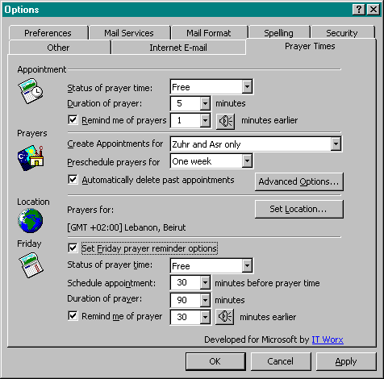
Figure 1:Prayer times tab in property dialog

II. Using prayer times
You can start Generating prayer appointments immediately by using the tool bar buttons or change the default settings of your appointments first. The following is a detailed description of the various sections in prayer times.

To access the Prayer times property page (fig 1 above), simply click on the options icon on the top bar of your outlook then click on the prayer times tab.

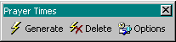

Tool bar Buttons
After installation prayer times inserts three buttons in the top bar in Outlook.

- Generate
Clicking on this button will automatically generate prayer appointments in your calendar.

Each appointment is created according to the settings in the prayer times property page. In addition to the prayer, a Hadith is inserted in the comments section of the appointment. You can view it by double clicking on the prayer entry in the calendar.

- Delete
To delete Prayer time appointment entries click on this button. All entries are removed from the calendar.

- Options
This button is a shortcut to the prayer times property page in the outlook option.

Appointments

You may change the setting of the prayer appointments scheduled in the outlook calendar by going to the appointment section (see fig.2) on the Prayer Times property tab.

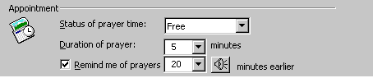
Figure 2: Appointment section

The following attributes of your appointment can be changed:

- Status of prayer time
This determines how others will view the Prayer Times appointment in your calendar. There are four options, including: free, tentative, busy and out of office. The default value is free.

To change the Status of prayer time:  - Click the down arrow on the status of prayer time list box (fig 3)  - Select the desired attribute by clicking on it. | 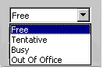  Figure 3: prayer status

- Duration of prayer
This is the number of minutes each prayer takes. The default value is 5 minutes. For example if the Zuhr prayer starts at 12:05pm and the duration of the prayer is 25 minutes then your appointment will be scheduled between 12:05 and 12:30pm.

To change the Duration of prayer:
- Click the down arrow on the Duration of prayer list box.
- Select the number of minutes by clicking on it.
OR:
Simply enter the number of minutes you want the appointment to last for directly in the list box.

- Prayer reminder
This is the amount of time before the prayer appointment when you want to be automatically reminded. The check box is checked by default and the value is set to 1 minute before the prayer.

To change the prayer reminder:
- Check the Remind me of prayers check box if it’s unchecked.
- Click the down arrow on the list box.
- Select the number of minutes by clicking on it.

You can also customize the reminder sound for the prayer appointments. Simply click on the icon and the following dialog appears:
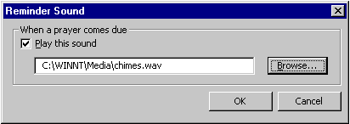

To set the sound of the reminder:
- Check the Play this sound check box if it’s unchecked.
- Click Browse.
- Select the path of the file you’d like to playback.
- Click OK.

Prayers
You may change the prayers for which you want to schedule an appointment. To do so go to the prayer section (see fig.4) on the Prayer Times property tab.

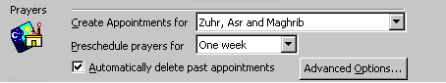
Figure 4: Prayers section

The following are the prayer appointment settings that you can change:

- Create appointment for
This determines which prayers you want to have an appointment for. You can either choose one of the predefined entries or customize them. The default value is “Zuhr and Asr only”.

To change prayer appointments:  - Click the down arrow on the Create appointment for list box (fig 5)  - Select the desired prayer combination by clicking on it. | 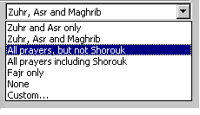  Figure 5: choose prayer times
To Customize your selection:

- Select custom… from Create appointment for list box and the following dialog appears:

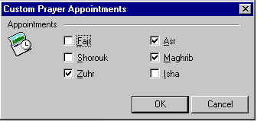
Figure 6: Customize prayers dialog
- Check the box next to the prayer(s) that you want to create an appointment for and uncheck the box if you don’t want an appointment for that prayer.
- Click OK.

- Preschedule prayers for
You can set the time interval for which you want prayer times to generate appointments. The default is a period of one week.

To preschedule prayer appointments:  - Click the down arrow on the Preschedule prayers for list box (fig 7)  - Select the desired attribute by clicking on it. | 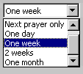  Figure 7

- Automatically delete past appointments
This function enables you to automatically remove past appointments from your calendar. Check the box to activate it or uncheck it to keep all past prayers in your calendar. The default is an unchecked box.

- Advanced options
Prayer times allows you to choose the Mathab you wish to follow. Accordingly the time of the prayer appointment will be set. To do so click on the Advanced Options… button and the following dialog appears:

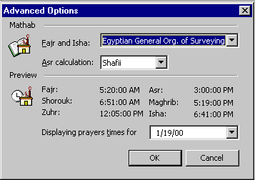
Figure 8:Mathab customization

The default value depends on the location you chose during setup. For example if Cairo was chosen then the value for Fajr and Isha is Egyptian General Org. of Surveying and Shafii for the Asr calculation.

To set the Mathab you wish to follow:
- Click on the Fajr and Isha list box.
- Select an option from the list by clicking on it.
- Click on the Asr calculation list box.
- Select either Shafii or Hanafi.
- Click OK.

You can preview the prayer times by choosing a date from the Display prayer times for list box. They will be automatically displayed.

Location
In order for Prayer times to calculate the correct time for prayer appointments you need to set the geographical location to the correct time zone. The location in initially set to the Country/city you’ve selected during setup.

To make any changes go to the Location section (see fig.9) on the Prayer Times property tab.

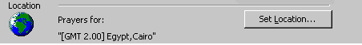
Figure 9:Location section

The following are the Location settings that you can reset:

- Change Location
You can change to a new location from here. You can either choose from a predefined list or add a new location manually.

! The Mathab (see prayers section: advanced options) is automatically changed according to your location, therefore if you had previously changed the Mathab you may need to reset it when you change to a new location.

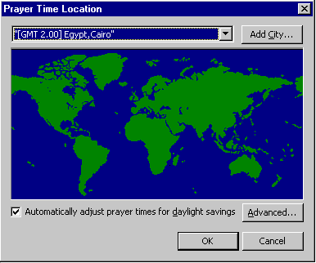
Figure 10: Main location dialog

To change to a PREDEFINED Location:
- Click on Set location… in the location section (fig. 9).
- Click on the list box on top of the dialog that appears (fig 10).
- Select the country/city to which you want to change by clicking on it.
- Click OK.

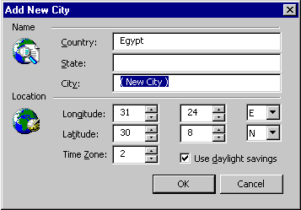
Figure 11: Add new location dialog

To change to a NEW Location:
- Click on Add City… in the location dialog (fig 10).
- Enter the Name information for your new city (fig 11).
- Enter the Location information.
- Check the Use Daylight saving box if you want to automatically switch to daylight savings.
- Click OK.
- Click on the list box on top (fig 10).
- Select the New country/city which you’ve added by clicking on it.
- Click OK

- Setting Daylight savings
If you have checked the automatically adjust prayer times for daylight savings box then you MUST enter the exact dates that daylight savings starts and ends in your new location. The default value is April 1st to October 31st.

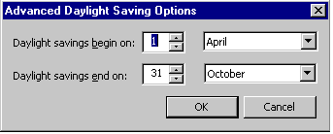
Figure 12:Daylight savings values

To change daylight savings interval:
- Click on Advanced… at the bottom of the location dialog (fig 10).
- Enter the days for the start and end of daylight savings (fig 12).
- To enter the months for the start and end of daylight savings: Click on the months list box and select the month you want.
- Click OK.

Friday
The Friday section refers to appointment attributes related to the Friday prayers only. This is the same as the appointments section with the addition of the option of creating the appointment before the actual prayer time. To make any changes to Juma’a prayers go to the Friday section (see fig.13) on the Prayer Times property tab.

! Friday prayer appointments are added to the calendar only if you have chosen Zuhr (see prayers section: Create appointments for).

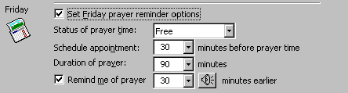
Figure 13:Friday prayers section

In order to edit and/or activate the Friday prayers appointment attributes you must check the Set Friday prayer options individually box. Otherwise, regular appointment settings will apply to the Juma’a prayer since the default is an unchecked box.

You may change the following Friday prayer attributes:

- Status of prayer time
Refer to appointment section, status of prayer time attribute. The default is Free.

- Schedule appointment
This attribute enables you to change the start of the prayer appointment to a time other then the actual prayer time. For example if the Juma’a prayer starts at 12:00pm and Schedule appointment is 30 minutes before then your appointment will be scheduled to start at 11:30. The Default is 30 minutes.

To change the Duration of prayer:
- Click the down arrow on the Schedule appointment list box.
- Select the number of minutes by clicking on it.
OR:
Simply enter the number of minutes you want the appointment to last for directly in the list box.

- Duration of prayer
Refer to appointment section, duration of prayer attribute. The default is 5 minutes after prayer time.

- Prayer reminder
Refer to appointment section, prayer reminder. The default is 1 minute before prayer.

