
Microsoft® COM Transaction Integrator Performance Tuning and Deployment Considerations
White Paper
Published: November 2000

Table of Contents
Table of Contents 1
Introduction 1
Executive Summary 1
What You Will Learn 3
Response Time Budget 3
Host Internal Response Time 4
External Computer Response Time 4
Network Delay 5
True-User Response Time 5
System Tuning 5
COMTI Performance Instrumentation 5
Method Calls Per Second 6
Average Method Call Time 6
Bytes Received Per Second 6
Bytes Sent Per Second 6
Calls Currently Executing 7
Cumulative Calls 7
Host Response Time 7
Errors Per Second 7
Windows 2000 Server Tuning 7
Adjusting Application Priority 7
Reducing Context Switching 8
Streamlining Authentication 8
Optimizing Network Throughput 9
SNA Communication Tuning 10
SNA Server LU 6.2 Contention Winner Limit 10
Pre-Activation of the LU 6.2 Sessions 10
SNA Link Tuning 11
CICS/IMS Host Response Time 11
SNA uplink vs. TCP/IP uplink considerations 12
System Sizing 15
LAN Throughput 15
Windows 2000 Services 17
Transaction Integration Considerations – Web-Based 22
System Configuration Options 22
IIS Keep Session vs. Scalability 26
Load Balancing and Hot Backup 28
SNA Server Load Balancing 28
Web-to-Host Load Balancing 31
COMTI TCP/IP Load Balancing 32
Clustering COMTI 36
Security Implications 38
Performance Costs of Using Security with COMTI 39
Optional Explicit-Level Override Authentication 40
Package-Level Security and User-Level Security 41
Using Host Security Integration 42
Additional Information 44
Transaction Size vs. Transaction Throughput 44
Message Size vs. Data Throughput 45
Long-Running Transactions 46
Scalability and Long-Running Transactions 46
Processing Two-Phase Commit Transactions 47
Microsoft Transaction Server User-thread pool 48
COMTI 2PC Thread Pool 48
SNA Server Parallel Sessions 50
Data Conversion Cost 51
Structured Data (ADO Recordsets vs. UDTs) 53
Remote Environment Selection (Using the SelectionHint Property) 54
Implementing Remote Environment Selection 55
Guidelines for Using Remote Environment Selection 55
Writing Code that Specifies a Remote Environment 55
Cost of Dynamic Remote Environment Selection 56

Microsoft COM Transaction Integrator Performance Tuning and Deployment Considerations
White Paper

Published: November 2000

Introduction
This white paper offers an overview of the integration components provided by Microsoft Host Integration Server 2000. These components enable data integration, application integration, and network integration of host-based systems with applications based on the Microsoft .NET platform. This white paper is not a deployment or administration guide for Host Integration Server 2000. Prior knowledge of host systems and integration strategies is helpful in understanding this white paper.

For the latest information, please see http://www.microsoft.com/hostintserver.

Executive Summary
In Microsoft Host Integration Server (HIS) 2000, transaction response times for Component Object Model Transaction Integrator (COMTI) have proven to be much faster than in SNA Server 4.0. The Microsoft Enterprise Interoperability Group (EIG) has conducted performance tests of COMTI. Test results indicate that Host Integration Server 2000 using COMTI is clearly an enterprise-level performer.

The following table shows a quick summary of the top numbers with some descriptive tests, starting with the numbers achieved with a traditional distributed version of Component Object Model (DCOM) client load.

 | Host Integration Server |  | SNA Server 4.0
Small transaction, 481 bytes in/out | Throughput (TPS) | Response time (ms) | Response time (ms)
Heavy conversion | 622 | 23 | 49
Medium conversion | 798 | 21 | 42
Medium conversion with 500 ms of host UOW time | 737 | 512 | 538
Medium conversion with Selection Hints | 568 | 22 | 47
Medium conversion with TCP/IP (IMS explicit) | 521 | 15 | 89
Light conversion | 1025 | 14 | 45
Light conversion + UDTs | 520 | 15 | 49
Light conversion + ADO record set | 115 | 97 | 260

COMTI and Host Integration Server 2000 on a Quad-Processor, 400-MHz Xeon Pentium II
- Heavy data conversion includes all possible data types.
- Medium data conversion includes 1/3 char, 1/3 float, and 1/3 packed decimals.
- Light data conversion includes character data type only.
- User-defined datatypes (UDTs) and Microsoft ActiveX® Data Objects (ADO) disconnected record sets handle structured data.
- Unit of Work (UOW) time is the time allocated for host transaction processing. (Also referred to as host response time or host processing time.)
- Selection Hints enable the application to select the Customer Information Control System (CICS) Remote Environment (RE) at the time of executing each transaction.

The largest number (1,025 TPS) for character data illustrates the solid internal architecture of COMTI with short and efficient code paths and cache management. The other tests include additional feature efficiencies of COMTI, indicating various other performance factors to take into account.

Note: Due to the difficulty of determining a standard load factor for business logic processing on the COMTI server, none of the tests has this load included in the test results. When sizing the server, you need to take standard load factor into account, if business logic is processed on the server.

The following analysis of COMTI ability to "pump data" was based on the insurance industry’s need to pull customer case histories (up to 1 MB of data) from CICS. The following table shows the COMTI data transfer capabilities. The test was done over a 100BaseT local area network (LAN) segment having a theoretical maximum data transfer rate of 9.5 MB/sec. COMTI managed to load the LAN with 8.5 MB/sec using the synchronous 32-KB input/output (I/O) transactions, demonstrating excellent buffer and memory management.

Small Transaction, 32-KB in/out | Throughput (TPS) |  | Throughput MB/sec |  | Response time (ms)
 | HIS 2000 | SNA Server 4.0 | HIS 2000 | SNA Server 4.0 | HIS 2000 | SNA Server 4.0
Medium conversion | 41 | 37 | 2.6 | 2.4 | 272 | 390
Light conversion | 137 | 136 | 8.8 | 8.5 | 113 | 109

COMTI and SNA Server on a Quad-Processor, 400-MHz Xeon Pentium II

What You Will Learn
As you can observe from the "Executive Summary" section, many performance tests were run in order to determine the performance and scalability of the COMTI server in various deployment situations. This paper provides some guidelines for initially sizing the server, as well as planning for future growth. The focus in these tests, as well as with this paper, is to find the best performance for handling various load conditions and to indicate the system tuning actions needed to improve performance. The paper includes some notes of caution, especially in the "Long-Running Transactions" section. When optimizing for overall end-user performance, a good way to start is to understand the components that contribute to the total user response time—the response time budget.

Response Time Budget
When analyzing the total system response time, dividing the response time into components will help focus on those parts of the system that play a major role in the total response time budget.

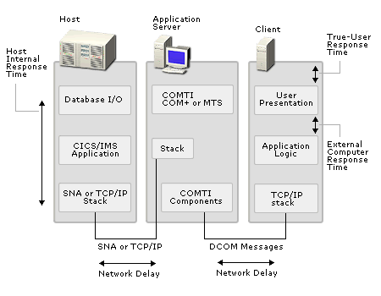
Response Time Budget
When benchmarking the interactive performance of computers executing transactions on the host, several response time and resource figures are of primary value. These include the host internal response time, external computer response time, network delays, CPU use, and transaction rates.

Host Internal Response Time
The host internal response time refers to time that transactions spend inside the host system processing transaction requests from COMTI. These include components that perform actions like processing the business logic, utilizing the disk and database I/O, and handling 2PC processing. One way to determine the performance of the host internal transaction processing is to run the transactions under load without the COMTI and computer components. A typical goal for an interactive transaction is to keep the response time at 500 ms and under one second through most of the range of the daily load conditions. This is a tough goal, and many systems under normal operational loads have hard times maintaining this. The "Long-Running Transactions" section of this paper analyses the impact on the application server when response times get longer.

External Computer Response Time
External computer response time is sometimes called end-user response time or end-to-end response time. External computer response time is the actual response time that the client application running on the computer experiences. When using "fat-client" application architecture, this response time includes all the processing and network delay incurred to the transaction from the time a DCOM call was sent to the COMTI server, until the reply for the transaction returns. For "thin-client" application architecture, additional delays are incurred due to either Microsoft Internet Information Server (IIS) 4.0 or Internet Information Services (IIS) 5.0 converting the Active Server Pages (ASP) requests to DCOM calls and delivering the DCOM replies back to the ASP pages for the client on the intranet or Internet.

Network Delay
Network delay is the difference between what the host computer measures as the host internal response time and what the client computer sees as the external computer response time, excluding the processing time on the application server. On a high-speed LAN deployment, the contribution from the network delay can be miniscule, but when wide area networks (WANs), satellite links, or modems get involved, this can be a major contributor to poor end-user response times.

True-User Response Time
The true-user response time refers to the time required to process the whole transaction. This is measured on the user interface (UI) level. The difference in the true-user response time and the external computer response time for COMTI transactions depends on the amount of processing done on the client itself. For the fat-client approach, the opportunities to have business logic on the client side are greater than with the thin-client approach. Thin-client processing typically involves just screen presentation processing delays.

System Tuning
As noted in the "Executive Summary," the response time for fat-client transactions through COMTI, when the host processing time is virtually zero, is at maximum approximately 23 ms for a small transaction (481-KB I/O). This is measured by the client application (an internal EIG stress application tool). It closely represents the actual end-user response time, missing only the screen-presentation processing time. The amount of data conversion, heavy, medium, or light, as well as the use of Selection Hints and UDTs, did not affect the response time. This response time includes both types of LAN delays, COMTI processing, and back-end host simulation processing, and represents pretty much the optimum possible performance. It is fair to state that for a properly tuned system, the COMTI processing contributes less than 50 ms to the overall user response time. 2PC adds approximately 100 ms to this as a result of the disk I/O for the Microsoft Distributed Transaction Coordinator (MS DTC) logging. The most dramatic contributor to the overall response time is naturally the host, where most of the work is done (business logic and database access). So the area to focus on first in optimizing the performance is the host. To get a better understanding of the response time and transaction volumes, COMTI has some initial instrumentation built in.

COMTI Performance Instrumentation
COMTI has some basic performance counters to help the administrator in analyzing where the performance bottlenecks are in the system. The following performance monitoring counters have been implemented:
- Average method call time
- Bytes received per second for the SNA and TCP transports
- Bytes sent per second for the SNA and TCP transports
- Calls currently executing
- Cumulative calls
- Host response times for the different transports
- Method calls per second for the different transports
- Errors per second

Method Calls Per Second
The counters for method calls per second report the volume of method calls going through the COMTI server. There are actually eight counters implemented:
- Method calls using the CICS link mode
- Method calls using the CICS non-link mode or calls to the Information Management Systems (IMS) mode
- Total method calls
- TCP Concurrent
- TCP MS Link
- TCP IMS Implicit
- TCP IMS Explicit
- TCP OTMA

Assuming that the system is in a somewhat stable condition, that is, the calls are returning at the same rate they are made, these counters represent the Transactions Per Second (TPS) throughput figure for COMTI.

Average Method Call Time
The performance counter for “average method call time” represents the response time the transaction has from the time COMTI receives the method call until it replies to the client. This does not include the LAN/WAN delays between the client and the COMTI server.

Bytes Received Per Second
The counter for “bytes received per second” reports the total bytes per second received from the host. The bytes received together with the bytes sent represent the total data transfer on the communication links between the COMTI server and the host computer.

Bytes Sent Per Second
The performance counter for “bytes sent per second” reports the total data flow in bytes per second from the COMTI server to the host. This becomes a useful counter when COMTI transactions become large, making communication links the bottleneck in the system. The counter for “bytes sent per second” is particularly important when WANs are used.

Calls Currently Executing
This counter displays the number of calls that COMTI is currently processing.

Cumulative Calls
Total number of calls since activating the COM+ Application (MTS Package).

Host Response Time
The host response time is also referred to as the Unit of Work (UOW) or host processing time. Its counter indicates the response time observed by the COMTI transport component, measuring the time from the call to the SNA Server computer, or Transmission Control Protocol/Internet Protocol (TCP/IP) stack, until the reply from the host. This includes some networking overhead. In a typical, well-tuned, high-bandwidth LAN environment, this response time should be very close to the actual host processing time. However, some important tuning issues, especially with SNA Link, must be considered in order to declare host response time to be the representative figure for the host. For additional information, see the "SNA Link Tuning" section. For the host response time, COMTI again separates the CICS link mode and the CICS non-link or Information Management System (IMS) mode into two separate counters.

Errors Per Second
The “total errors per second” counter indicates whether the method calls are failing on errors. Under normal operation, this value should remain at zero, or very close to zero.

Windows 2000 Server Tuning

Adjusting Application Priority
Under normal loads, you need not adjust the Windows 2000 tasking priorities. However, by adjusting the balance between background and foreground applications it is possible to squeeze more server task performance out of the system to cover peak loads. An even balance between the two gives background applications a better response time, but still gives more processor time to the foreground application.

To Adjust the Balance
- On the Start menu, point to Settings, and then click Control Panel.
- In Control Panel, double-click the System icon, and then select the Advanced tab.
- On the Performance button, choose to optimize performance for background services and then click OK.

Reducing Context Switching
Context switching is one of the most common explanations for degraded server performance on any operating system. Windows 2000 is no exception. If a system is doing more than 50,000 context switches per second (unlikely, but nonetheless possible), it does not have time to do actual work. Instead, it is spending all its time switching various code and data pages in and out of its memory to the L2 cache, RAM, or even to the disk drive—in other words, the system is thrashing.

A high total, active thread count on the system is a certain cause of context switching. In the “Long-Running Transactions” section, this paper introduces two registry entries that can increase the thread count for a Microsoft Transaction Server (MTS) package and COMTI 2PC transactions. Care must be taken when the thread counts are adjusted to gain optimum performance.

Note: It is advisable to track context switching / second when these adjustments are made.
In addition to adjusting MTS and COMTI threading, it is possible to adjust the SNA Server asynchronous I/O threading model. These threads only serve the SNA Server client traffic. They are designed to handle the full 30,000 sessions, hitting the SNA Server with over 1,000 TPS. Performance testing in the lab environment has shown no reason for adjusting these values. However, since COMTI represents only one client to the SNA Server, adjustments can be made if you absolutely must minimize the thread count in your system. The thread count is calculated as follows:
- SNA Server I/O thread count = Base thread count + Additional threads x Number of CPUs
- Base thread count is 5
- Default additional threads per CPU is 4
- Adjust by specifying the number of additional threads per CPU by adding a DWORD value NumberofIOthreads to the registry location: HKLM\System\CurrentControlSet\Services\SNAServer\
parameters
- Valid values are: Up to a total of 64 maximum I/O threads per system

Streamlining Authentication
COMTI users are typically authenticated on a transaction-by-transaction basis for both a Windows NT domain and a host domain. Host Integration Server provides the necessary security integration between these systems. The Already verified parameter could be set to streamline the authentication on the host side. Both COMTI and the SNA Server node maintain a cache of verified domain/user names in a secured location. To guarantee fast access to the Windows 2000 authentication, install in the same LAN segment the primary or backup Windows 2000 domain controllers, COMTI, and Host Integration Server. Doing so helps eliminate delays caused by bridging or routing.

Optimizing Network Throughput
Network priority can be adjusted to guarantee the best possible networking throughput. (Basically, you adjust the relationship between memory allocated to network connections and memory allocated to applications running on your computer.)

To Adjust Network Priority in Windows 2000
- On the Start menu, point to Settings, and then click Control Panel.
- In Control Panel, double-click the Network and Dial-up Connections icon.
- Double-click the Local Area Connection that will be handling the Host Integration Server network traffic, then click Properties.
- In the Properties dialog box, select File and Printer Sharing for Microsoft Networks, and then click Properties.
- In the Properties Page for File and Printer Sharing for Microsoft Networks select Maximize Data Throughput for Network Applications, and then click OK.

The Maximize Throughput for Network Applications option optimizes server memory for distributed applications that do their own memory caching. Your network adapter can have a large impact on your overall performance. Some advanced adapters provide setup options for optimizing network I/O performance. The parameters to look for are I/O buffering on the card itself, direct memory access (DMA), adjustable data link control (DLC) maximum frame size, and LAN speed setting.

The following dialog box shows a configuration for optimizing a high file transfer throughput with a Madge token ring card. A smaller frame size (for example 2,048 bytes) is more suitable for a more transaction-oriented configuration.
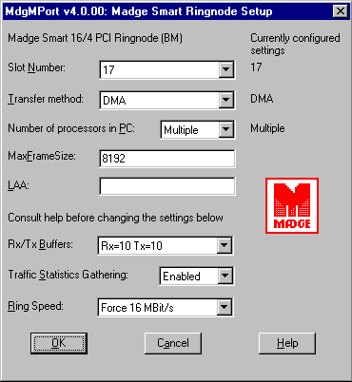

Configuration for a Madge Token Ring Card
DMA and larger transmit-and-receive buffer counts minimize memory access delays and may also minimize interruptions to the CPU.

SNA Communication Tuning
The following major factors affect COMTI throughput over the Advanced Program-to-Program Communications (APPC) Logical Unit (LU) 6.2 SNA Server transport.

SNA Server LU 6.2 Contention Winner Limit
With the release of Host Integration Server, COMTI only requires parallel sessions. Contention winner and loser sessions are automatically used.

Troubleshooting Suggestions
Use this procedure to troubleshoot SNA Server LU 6.2 contention winner sessions. Before starting a connection, enable SNA Server DLC and LU 6.2 message traces of the connection startup and initial COMTI component use. Provide the traces to an SNA Server support engineer. This engineer can decode the DLC trace to determine the parallel session limit. The engineer can also decode contention winner limits negotiated in the Change Number of Sessions (CNOS) exchange for the LU/LU/mode that COMTI is using.

Pre-Activation of the LU 6.2 Sessions
Automatically activating LU 6.2 sessions in advance will prevent a delay in establishing new LU 6.2 sessions as requests are made for COMTI conversation allocation. In addition, by pre-activating sessions, SNA Server will keep these sessions active as long as the connection is active, and they are not affected by the idle session timeout SESTIMEOUT period (approximately 20 seconds).

The SNA Server will honor its APPC mode automatic activation limit setting for any APPC LU-LU partnership defined within the APPC mode when the connection is initially activated. Partnerships are defined within the APPC-mode Partners folder.

For more information about the SNA Server SesTimeout registry parameter, see the SNA Server Reference Guide. This guide is installed with the product and is viewable through the SNA Server online Help, available from the Start menu.

SNA Link Tuning
Investigate DLC tuning if you are using token ring, Ethernet, or fiber distributed data interface (FDDI) to communicate with your host system. The following 802.2 connection default settings should be sufficient:
- Unacknowledged Send Limit defaults to 8.
- Receive ACK Threshold defaults to 2.
- Maximum Basic Transmission Unit (Max BTU) length: 1,929 bytes for token ring, 1,493 bytes for Ethernet. If a 16-megabits-per-second (Mbps) token ring is being used, and the COMTI request or host response will exceed this BTU length, then increase the Max BTU length to 4,105 bytes (or 8,192 bytes for the maximum possible) within the SNA Server connection.

Troubleshooting Suggestions
To troubleshoot SNA Link tuning, capture a network monitor or sniffer trace of the SNA Server computer-to-host traffic, and provide it to an SNA Server support engineer. By examining the logical link connection (LLC) traffic, the engineer can use this trace to observe the Send Window and Receive ACK Thresholds that both ends are using.

CICS/IMS Host Response Time
The host response time for each transaction affects the number of transactions that can be performed, given the number of LU 6.2 sessions being used. If CICS is being used, investigate the CICS region definitions for parallel session limit and contention winner limit. These values are configured in the Maximum parameter in the CICS region SESSION PROPERTIES:

SESSION PROPERTIES Maximum = 100, 000

The first value is the parallel session limit and the second value is the CICS contention winner limit. For COMTI use, SNA Server should be configured as the contention winner for all sessions, so the CICS contention winner limit should be zero. Also, the CICS region maximum tasks value should be sufficient to handle the concurrent client requests. If IMS is being used, ensure that IMS has a sufficient number of message processing regions to handle the expected load.

Troubleshooting Suggestions
To troubleshoot the CICS/IMS host response time, capture an SNA Server DLC message trace of the throughput test and analyze the host response time observed on the LU 6.2 sessions. The response time can be measured for a given LU 6.2 session as follows:

SNA Server Host
----------------- ------------
Start time: FMH-5 Attach (+ data) ->
<- Data Response
End time (*): (<-) Conditional End Bracket (->)

Within an SNA Server DLC message trace, a unique LU 6.2 session is distinguished by the following values: a unique Originating Address Field (OAF), a Destination Address Field (DAF), and an OAF/DAF Assignor Indicator (ODAI). The OAF and DAF specified in an SNA Server session request will alternate on the host response.

Note: Either end may de-allocate the conversation, though COMTI often does this. However, it is possible for the host data response to contain the Conditional End Bracket (CEB).
A simple stress test was devised to obtain a preliminary understanding of the difference in performance for COMTI using TCP/IP as the up-stream-link protocol versus the traditional SNA protocol. In this test, the only change to the setup was the uplink protocol. To make the test compare apples to apples, the SNA test was set to do the selection hint. This is appropriate considering that the TCP/IP uplink is performing the same process. To see the difference between using and not using selection hints, please check the section: Remote Environment Selection (Using the SelectionHint Property).

Analyzing the average response time as a function of transactions performed, we can see that early on, the TCP/IP is as fast as the SNA. In fact, the TCP/IP is faster when the load is below the 100 TPS. For some deployments, that is the normal operating range. With the TCP/IP uplink, response time slows down as load increases. It also limits top performance to 500 TPS. However, the SNA uplink allows stable response times throughout the load range, and achieves higher scalability.

SNA Uplink Versus TCP/IP Uplink Considerations
A simple stress test was devised to obtain a preliminary understanding of the difference in performance for COMTI using TCP/IP as the up stream link protocol versus the traditional SNA protocol. In this test, the only change to the setup was the uplink protocol. To make the test to compare apples to apples, the SNA test was set to do the selection hint. This is appropriate considering that the TCP/IP uplink is performing the same process. To see the difference between using and not using selection hints, please check the section: Remote Environment Selection (Using the SelectionHint Property).

Analyzing the average response time as a function of transactions performed, we can see that early on, the TCP/IP is as fast as the SNA. In fact, the TCP/IP is faster when the load is below the 100 TPS. For some deployments, that is the normal operating range. With the TCP/IP uplink, response time slows down as load increases. It also limits top performance to 500 TPS. However, the SNA uplink allows stable response times throughout the load range, and achieves higher scalability.
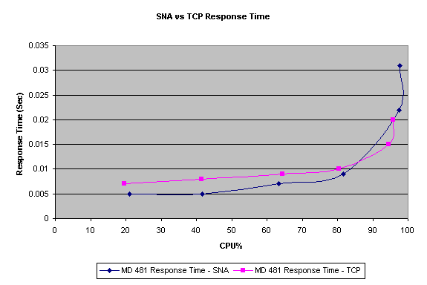
SNA Versus TCP Response Time
Note: The test results here may not be an accurate representation of the results with a real mainframe. Lacking a mainframe that would scale up to the 600-700 TPS, a Host simulator application running on Windows 2000 was used. Therefore, the back-end protocol stacks responding to the COMTI server requests are the Windows NT stacks, not actual mainframe protocol stacks. The results may vary depending on the TCP/IP stack version on your host. IBM is making much progress on the TCP/IP stack, so the end results will be better with a newer version. The Windows 2000 TCP/IP stack is among the fastest, so an additional margin of safety would be prudent when deploying TCP/IP based COMTI.

The following chart can be used to analyze the cause of the superior scalability in this case of an SNA uplink over a TCP/IP uplink. To illustrate the issue, it shows frames per second over the backbone LAN. While the SNA uplink maintains its sessions from transaction to transaction, the TCP/IP uplink will have to establish and destroy the TCP/IP connection for each transaction. As you can see from the chart, the TCP/IP uplink transmits more frames over the uplink than the SNA uplink. In our tests, the 100baseT Ethernet LAN did not become a bottleneck. However, this can become the critical issue if the link is slower between the COMTI server and the host. In any case, the TCP/IP uplink connects and disconnects will generate additional interrupts for both ends.

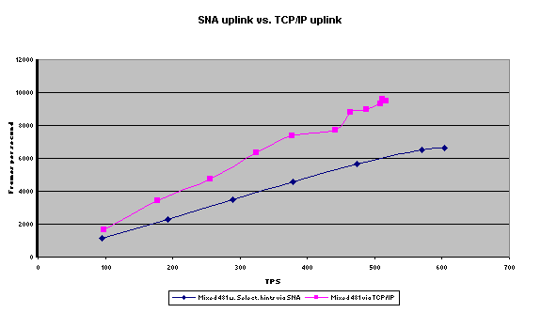

SNA Uplink Versus TCP/IP Uplink – Frames per Second
However, further analysis shows an advantage that the TCP/IP uplink has over the SNA uplink. This advantage might become the deciding factor in a real world deployment, even though it did not show up in our test cases. As you can see, using the SNA uplink, the COMTI server has almost twice the amount of context switching as compared with the TCP/IP uplink. This is due to the fact that with SNA, the messages are passed from COMTI first to the SNA node then to the SNA link service. These are separate processes, thus causing a process-to-process communication and context switching. This does not happen with the TCP/IP test case, and the COMTI is able to pass the messages directly to the NDIS driver. This is the cost of maintaining sessions with another SNA node across the LAN link. On a server where additional processing of business logic occurs, the amount of context switching will affect throughput and scalability.

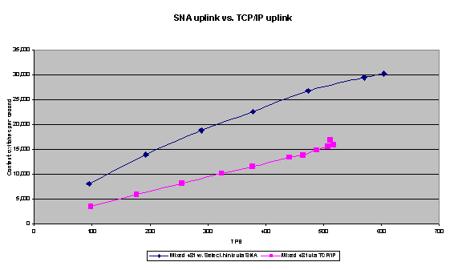

SNA Uplink Versus TCP/IP Uplink – Context Switches per Second

System Sizing

LAN Throughput
The 100BaseT is the most popular, and at this time, the most available alternative to connect the COMTI/SNA Server computer to your host system. Take some time to study the bandwidth it offers and the amount of bandwidth that can be actually put into productive use. The theoretical maximum can be calculated in the following way for the 100BaseT Ethernet.

100BaseT is clocked at 100 MHz, with a 25-MHz crystal multiplied by 4. The coding is 8/10, meaning that one byte is packaged into 10 bits. Therefore, the maximum transfer rate is 100/10=10 million bytes per second. To convert this number to megabytes per second (MBps), we will need to divide it in the following way: 10,000,000 / (1,024 x 1,024) = 9.5 MBps. Regarding efficiency, Ethernet provides up to 90 to 95 percent efficiency (carrier sense multiple access with collision detection [CSMA-CD]). There is a maximum payload of about 1,500 bytes per frame and some minimum interframe spacing. Further, if you use half-duplex cabling, the acknowledgement (ACK) packets must take the bus. This eventually takes some of the bandwidth from the actual data packets.

The frame format for 802.2 over Ethernet is a maximum of 1,487 or 1,484 bytes, depending on which Ethernet standard is used: Institute of Electrical and Electronics Engineers (IEEE) or DEC/Intel/Xerox (DIX).

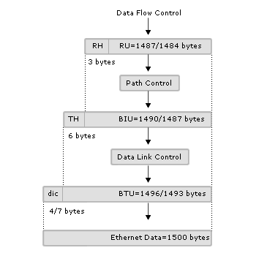
Maximum Request/Response Unit (RU) and Basic Transmission Unit (BTU) Sizes over an Ethernet

The format for TCP/IP over Ethernet is a 14-byte Ethernet layer + 20 IP + 20 TCP + 12 (TCP - timestamp) + 1,448 data. The header overhead is 54/66 bytes for each packet. Of course, one ACK packet is sent for every two packets in TCP/IP. Therefore, the header overhead will be three headers for two data packets, which is seven to eight percent.

For DLC 802.2 traffic, the acknowledgement frequency is controlled by each end negotiating with its partner (see the "SNA Communication Tuning" section). For the 90 to 95 percent efficiency referred to previously, the throughput will be affected by various other factors, such as the size of the broadcast domain, whether the LAN is on a switch or a hub, the number of servers sharing the segment causing possible collisions, and whether your network has other protocols like Internetwork Packet Exchange (IPX), whose broadcasts can consume some of the available bandwidth.

Looking at the LAN utilization levels in our lab tests on an isolated, switched 100BaseT, with only a few servers on the segment, we should be getting close to the theoretical maximum minus the known overhead. The question is whether COMTI can push the LAN to maximum performance.

When sending 32,000 bytes, and receiving 32,001 bytes back, the test results show that COMTI can drive the 100BaseT close to its maximum performance, if only minimal data conversion is required and no other business logic or processing competes with COMTI on the server. This is, of course, with an isolated optimized network. The backbone network in the "real world" will have to endure a lot more overhead without becoming the bottleneck for the system. A prudent design criterion for 100BaseT LAN would be to keep the planned load at:
- Less than 4 MBps for systems that mainly do data movement.
- Less then 3 MBps for systems with short interactive transaction messages.
The reason for designing the interactive LAN load to a lower limit is due to the higher number of frames per MBps. Observing these criteria will set the peak LAN load to a safe 50 percent of LAN capacity.

Windows 2000 Services

Normal Load
To size the Windows 2000 application server, you must review system behavior over the course of a day, as well as over the course of a longer period of time (typically matching the accounting period to capture end-of-the-month processing). Analyzing these load patterns will give a more accurate view of requirements for sizing the system. The attached chart illustrates a hypothetical business system load on a typical business day. If you try to capture the daily load spread, Mondays or Fridays will typically give the most information of the daily swings on the load. The following chart shows an average workload of 60 TPS over 24 hours, and 100 TPS over 12 hours—a business day. If you used the daily averages for system sizing, (peak loads at 8:00 AM, right before lunch, and close of business at 5:00 PM), the end result is system overload and poor performance. This poor performance would be an issue on a daily basis.
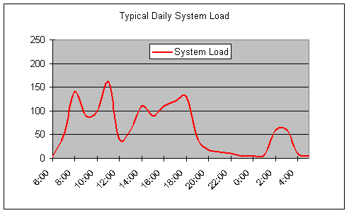

Typical System Load

Additionally, at less frequently occurring high peaks, such as month-end processing, the required peak load handling will increase if the processing overlaps with the daily peak loads. However, no extra capacity is needed if the extra processing can be scheduled to the low load-time periods, for example, 10:00 PM to 1:00 AM.

Preparing for Running in Degrade Mode
Some level of fault tolerance is required because COMTI is a combination of application server and transactional gateway between COM applications and CICS and IMS applications. System uptime is essential for the success of large Online Transactional Processing (OLTP) systems (for example, serving a company’s order entry, shipping, and inventory management). Levels of fault tolerance can be achieved as described in the section "Load Balancing and Hot Backup."

When sizing the system to match throughput requirements, you must provide enough processing power on the remaining servers in case one server in the cluster fails. For load balancing two servers under normal conditions, each server should be able to handle the daily peak loads alone—not necessarily at 60 percent CPU load, but not exceeding the 90 percent limit either. For three-server systems, any two should be able to handle the daily peaks at 60 to 90 percent CPU levels. If you size close to 90 percent CPU on a degraded operation, a slight response time impact can be expected. This is acceptable, as long as failure recovery does not last more than a day or two. This usually means that a spare server must be locally available, and that it can be easily configured for service.

You should also study the excess load caused by the recovery process, its duration, and its impact on system responsiveness during that time.

Taking System Growth into Account
Estimating system growth can be difficult. Careful study of the functional requirements, business plans, market growth, and user community may not provide the exact answers, but it can provide a rough estimate of the growth potential for the system. For a successful company, this growth rate can be as high as 25 percent per year—even as high as 50 percent, usually during the first year after deployment. If our projection for system growth follows these lines, we need to deploy with 50 percent extra capacity at hand, either as larger servers or as additional servers available for load balancing. Looking at a five-year growth path, the plan can include changing to more powerful servers, adding more symmetric multi-processor (SMP) CPUs to the servers, or adding more servers to the cluster. For example, in a system like our previous sample, with daily peaks of 160 TPS, the first growth is 50 percent, with 25 percent growth after that.

Server | TPS at 60 percent | TPS at 90 percent
Dual-processor, 400-MHz Xeon | 110 | 160
Quad-processor, 400-MHz Xeon | 220 | 320

Server Rating at Various CPU Percentages, Based on the Applications Used and Tested
 | First year | Second year | Third year | Fourth year | Fifth year | Sixth year
Growth percentage | 50 | 25 | 25 | 25 | 25
Daily peak TPS | 160 | 240 | 300 | 375 | 468 | 585
Deployment | 2 dual-processor, 400-MHz Xeons in a cluster | 3 dual-processor, 400-MHz Xeons in a cluster | No upgrade | 1 dual-processor and 2 quad-processor, 400-MHz Xeons in a cluster | No upgrade | 3 quad-processor, 400-MHz Xeons in a cluster
Action |  | Add a dual server to the cluster |  | Add 2 CPUs to 2 servers |  | Add 2 CPUs to 1 server
Reason |  | Dual-processor 400-MHz "maxes out" at 160 TPS |  | 2 dual-processor 400-MHz "max out" at 320 TPS |  | A dual-processor and a quad-processor "max out" at 480 TPS
Best practice | 2 quad-processor, 400-MHz Xeons in a cluster | No upgrade | No upgrade | 3 quad-processor, 400-MHz Xeons in a cluster | No upgrade | No upgrade

Growth Projection
Creating a plan for future growth can be a time consuming and difficult task. You can spend enormous amounts of time testing and creating load scenarios for the future. The continuing development of the hardware and software will also affect planning. Future computer systems are likely to outperform the currently available models, many with 100 percent increases in dollars and throughput, thus causing the plan to be less accurate and outdated. To avoid this, a few "rules of thumb" can be helpful:
- Plan at least two growth scenarios with the hardware available today, with easily accessible performance data. Plan one scenario for aggressive growth and one for minimal growth.
- For the initial purchase of the hardware and software, do not confine yourself. Consider such factors as architecture, hardware availability, and networking options.
- Revisit your plan annually, updating your projections and growth scenarios.
- Consider your growth plan in light of future roles of other computing systems in the enterprise, for example: How is inventory control going to evolve? How are customer orders handled and which system is handling them? Are customer orders going to migrate from one system to another?

Estimating the System Load
Following are two sample spreadsheets that can be used to collect the transactional load information for system sizing.

 | Tx. 1 | Tx. 2 | Sample | Comments
Transaction name |  |  | MD481
Input buffer size |  |  | 481 | Data that user/client app. sends to CICS/IMS
Data Conversion; L/M/H |  |  | M | Light= mostly char, Medium= 1/3 char,  1/3 float, 1/3 packed dec.
Structured data; NO/UDT/ADO RS |  |  | No | UDT=user defined data types, ADO RS= disconnected ADO record sets
Reply buffer size |  |  | 481 | Reply buffer size from CICS/IMS
Data conversion; L/M/H |  |  | M | Heavy = No char data, mix of floats, date-times, packed dec.
Structured data; NO/UDT/ADO RS |  |  | No
Transactional; Yes/No |  |  | No | Yes = 2PCs are used with CICS/IMS and other forks
Security; No/User/Pkg. |  |  | No | Type of integrated security in use
Client type; ASP/DCOM |  |  | ASP | ASP = Web-based client, DCOM = client using DCOM to invoke pkg.
Package: Lib/Svr |  |  | Svr | Library = in process COM pkg., Server = COMTI pkg. is on its own process
Number of users |  |  | 3,000
Total average daily load; TPS |  |  | 30
Total daily peak load; TPS |  |  | 70
Minimum Host Unit of Work (UOW) time;ms |  |  | 350 | Milliseconds (ms) spent from processing input to sending user reply
Minimum Host prepare time; ms |  |  |  | 2PC only
Minimum Host commit time; ms |  |  |  | 2PC only
Expected user response time |  |  | 800
Maximum allowed response time |  |  | 1,600 | Maximum acceptable response time

Detailed Spreadsheet
The previous spreadsheet is the more detailed form for storing information on the type of transactions, as well as load levels and acceptable response times. Each column represents one transaction type (such as Order header entry, Order line item, Inventory move, Shipping header, Shipment line). As you can see, this format can become unusable fairly quickly on a large-scale system, with a lot of different transactions. A simpler form might be more practical in these cases, such as the following spreadsheet.

Transaction Name | Bytes In | Bytes Out | Convert L/M/H | Structured UDT/ADO RS | 2PC | Client ASP/DCOM | Number of users | Average total TPS | Peak total TPS
MD481T | 481 | 481 | M |  | Y | ASP | 3,000 | 30 | 120

Less Complex Spreadsheet

In addition to these columns, a system designer could add columns addressing Security Integration types, host response time, and maximum acceptable response times. To complete the estimation, a designer could add columns to illustrate the amount of server, LAN, and host resources. These estimations will remain the real challenge, because each transaction and implementation is unique and cannot be standardized. Thus, none of the test cases illustrated in this document include business logic processing. This remains a task for the system designer to estimate.

Transaction Integration Considerations – Web-Based
Adding a COMTI component to an active server page adds a whole new segment to the system. In a normal COMTI set up, a client talks to a gateway, and the gateway talks to a host. In a Web-based setup, a Web client now talks to a Web server, the Web server to the COMTI gateway and finally the gateway to the host. The system has just gone from four LAN hops, to six LAN hops. (This assumes that your Web client is on a local intranet. If it is on the Internet, two of these LAN hops, from and to the Web client, could be extreme, depending on the client user’s connection.) Of course, the hardware setup is the foremost and biggest concern with Web-based access. Will the Web server and COMTI gateway all be on one machine? Will they be on separate machines? Will there be more than one Web server or COMTI gateway?

System Configuration Options
Looking at the hardware considerations, a few setups are possible for Web-based COMTI access. The Web server and COMTI gateway can be on the same machine. The advantage is that COMTI can run in the same process as your Web server (if you are using IIS and no other business logic needs processing). A big disadvantage is that the two programs are now competing for the same processor time. This might be acceptable if the Web client will not get a lot of use, but if it does, the throughput and response time will suffer for the client users. If the one-machine solution is insufficient, the next logical step is one Web server and one COMTI server. This solution provides a dedicated machine to handle the entire load generated by clients accessing the Web site. This also provides a machine to handle COMTI processing and data load without competing with your Web server for processing power. However, this solution has limitations. It would only be acceptable with a small-to-medium load on the Web server. For a large-scale usage, the recommendation would be for a Web-server farm, clustered together using Windows Load Balancing. This would feature a group of identical Web servers clustered under one IP address, all of which point to the COMTI gateway. The system now has the machine power to handle the client load that will be generated by the numerous users of the Web-based client.

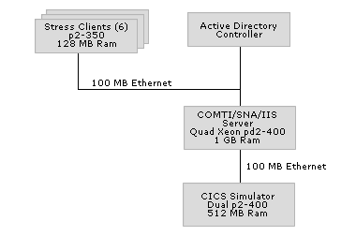
Single Server Configuration

For testing single-system configurations, each COMTI component was placed in a COM+ package using the default settings. Then, using the Microsoft Web Stress Application, the system was placed under stress to 20 percent, 40 percent, 60 percent, 80 percent, 100 percent and pushed past 100 percent of CPU capacity. The tests were run for 5 minutes with 30 second warm ups and 30 second cool downs.

All-in-One Server (Windows 2000 Adv Svr, IIS 5.0, SNA/COMTI)
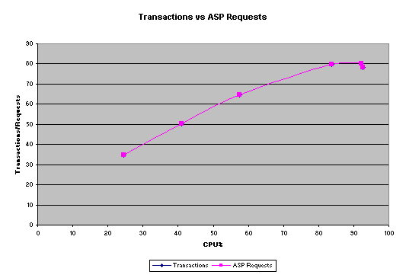
Transactions Versus ASP Requests
In this configuration, the system very quickly reached its maximum level of usage. IIS, COMTI, and the COM+ packages must all fight for processor time—and increased context switching creates an additional burden. This lowers overall system performance.

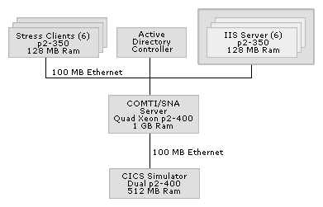
System Configuration Using a Web Cluster
For Web-farm testing, six machines were set up as an IIS Web farm using Windows Load Balancing (WLBS). The COM+ packages were exported as application proxies, and then installed on each of the Web servers. Once again, Microsoft Web Stress Application was used to load the COMTI server to 20 percent, 40 percent, 60 percent, 80 percent, 100 percent, and over 100 percent.

Web Farm (Win2k Adv Svr, SNA/COMTI on Quad Xeon) (Win2k Adv Svr, IIS 5.0 on Web farm)
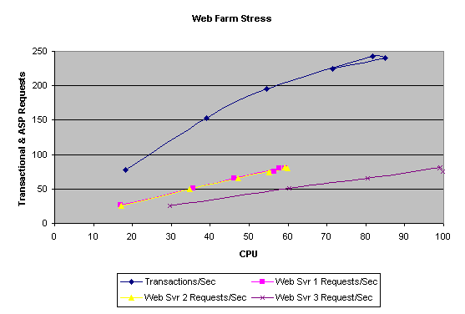
Web-Farm Stress

However, the system again became quickly saturated at a higher rate. Now that it does not have to handle Web access in addition to COMTI and the COM+ packages, the COMTI server CPU has more free cycles to process the data. In addition to the higher TPS, the COMTI machine has cut the number of context switches in use by over half. The addition of the Web-farm servers free the SNA/COMTI machine for more processing. This allows the system to push through more transactions per second. The Web-farm configuration has the added benefit of being able to host static HTML pages without interfering with the SNA/COMTI server.

IIS Keep Session Versus Scalability
The reason for optimizing hardware configuration is as follows. Processing power is required to handle potentially hundreds, even thousands of users creating, using, and destroying COMTI objects on your Web server. In order to get the best performance possible, the system must be able to process all the Web page requests and still have power to create and destroy the COMTI object. Using session objects in the ASP code is one way to do this. When the session objects are not used, objects are created every time users access the page and destroyed every time they leave. This can get expensive if a user makes many queries, or if many users are hitting the system at once. The solution is to use a session object that persists until one of two things happens, the users leave the site, or the object times out. This will reduce the number of COMTI objects created and destroyed, thus lowering the overall overhead required. This configuration has a disadvantage of losing scalability under heavy load. Here is some example code for the session objects.

The “Global.asa” file would contain the following:

<script language=VBScript RUNAT=Server>

Sub Session_OnStart
Set Session("CharOnly0") = Server.CreateObject("PerfTest2.CharOnly0.1")
End Sub

</script>

After the previous code has been defined in the “global.asa” file, the ASP script would then call the Session Object. The following shows how to do this:

<HTML>
<HEAD>
<META NAME="GENERATOR" Content="Microsoft Visual Studio 6.0">
</HEAD>
<BODY>
<%
Dim CharSet

CharSet = "Data Sent and Retrieved!"

set objTest = Session("CharOnly0")
objTest.Char481 CharSet

Response.Write CharSet
%>
<P>&nbsp;</P>
</BODY>
</HTML>

The global.asa file is located in the root of the system Web application directory. The asp file can be located anywhere below the Web application root directory.

Session State (Windows 2000 Adv Svr, SNA/COMTI on Quad Xeon) (Windows 2000 Adv Svr, IIS 5.0 on Web farm)
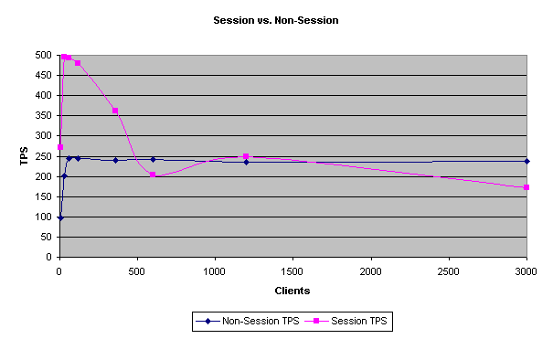
Session Versus Non-Session

#Clients | Trans/Sec | COMTI CPU% | COMTI Mem% | Web CPU% Avg
6 | 273 | 29% | 4.6% | 0.0%
30 | 497 | 52% | 4.7% | 69%
60 | 494 | 51% | 4.7% | 69%
120 | 480 | 50% | 4.8% | 68%
360 | 363 | 40% | 5.6% | 67%
600 | 204 | 25% | 6.5% | 65%
1200 | 248 | 38% | 7.5% | 66%
3000 | 171 | 74% | 10.5% | 40%

Scalability

Initially, this configuration performs extremely well. In the long run though, scalability will suffer when the number of concurrent users increases. At 3,000 clients, the non-session state method has a transaction-per-second rate of almost 60 TPS higher. For a lightly loaded system or a system where the response times are fast, this configuration could be acceptable as long as the number of concurrent users is kept to a reasonable level. However, on a system that will be heavily loaded and under a lot of client stress, scalability starts to suffer.

Load Balancing and Hot Backup
Load balancing and hot backup make applications scalable and increase performance on enterprise systems. Deploying multiple servers increases application throughput by distributing the load based on rules defined by the load-balancing engine. Load balancing services also increase availability by detecting connection failures and providing redundant resources for client applications.

You can deploy COMTI using several load-balancing and hot-backup solutions. The following sections describe the various load balancing and hot backup methods that COMTI supports today.

SNA Server Load Balancing
COMTI can use the load balancing and hot backup capabilities of SNA Server by deploying multiple SNA Server clients and SNA Server computers in a single sub-domain. Redundant APPC session pairs can be configured across multiple SNA Server computers to provide load balancing and hot backup. When a communication failure occurs, hot backup reroutes sessions to alternate host connections.

Two-phase commit (2PC) protocol is not supported when SNA Server is configured for load balancing and hot backup. When a local LU begins a transaction with the host, that local LU is responsible for driving recovery protocols if the transaction does not come to a consistent conclusion (due to system or connectivity failure). To prevent this, the SNA Server configuration utilities enforce a one-to-one correspondence between a local LU name and alias when the SyncPoint check box is selected. However, 2PC requires the knowledge of unique identifiers for each local LU. If a local LU alias represents more than one local LU, the LU 6.2 Resync TP service can not be sure that it was performing recovery using the right local LU. The failed transaction might thus be permanently left in doubt. The following figure illustrates the use of load balancing in SNA Server.

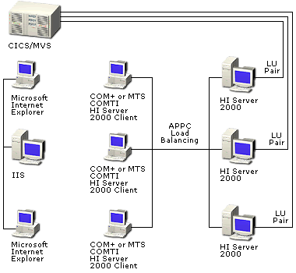
SNA Server Load Balancing

The SNA Server client process (the SnaBase service on Windows 2000) opens a sponsor connection to the SnaBase service on an SNA Server computer in the sub-domain. This sponsor connection remains active while the SNA Server client process is running. When the SNA Server client process first starts, the client receives a list of all SNA Server computers in the sub-domain. Only server changes are sent later.

When an SNA Server application (for example, a COMTI application) requests a session, the underlying SNA Server client software randomly chooses a server from a service list that the sponsor server sends to the client. Each transaction will then use the same SNA-Server-computer connection resources.

To configure an SNA Server for APPC Load Balancing, you must define redundant Local/Remote LU aliases across SNA Server computers using SNA Server Manager. For example:

Server 1
- Local APPC LU alias = COMTI
- Local APPC LU network name = APPN and LU name = SERVER1
- Click to select the Member of default outgoing Local APPC LU pool check box
- Remote APPC LU alias = CICS
- Remote APPC LU network name = APPN and LU name = CICS

Server 2
- Local APPC LU alias = COMTI
- Local APPC LU network name = APPN and LU name = SERVER2
- Click to select the Member of default outgoing Local APPC LU pool check box
- Remote APPC LU alias = CICS
- Remote APPC LU network name = APPN and LU name = CICS

Server 3
- Local APPC LU alias = COMTI
- Local APPC LU network name = APPN and LU name = SERVER3
- Click to select the Member of default outgoing Local APPC LU pool check box
- Remote APPC LU alias = CICS
- Remote APPC LU network name = APPN and LU name = CICS

For load balancing to work across SNA Server computers, the LUWIDSUP parameter must be set to NO in the registry. This parameter causes the SNA Server APPC interface to deactivate support for the logical UOW identifier (luw_id) for APPC programs. This causes the SNA Server client APPC interface to defer its location to an SNA Server computer until the application issues an MC_ALLOCATE request. Otherwise, when specifying the local APPC LU alias in its TP_STARTED request, the SNA Server APPC interface may not choose an SNA Server computer with an available LU 6.2 session, causing an APPC conversation startup request to "hang" until a session becomes available. The following table references the required SNA Server, Virtual Telecommunications Access Method (VTAM), and CICS parameters.

SNA Server | VTAM | CICS
Local Node ID—first 3 digits | IDBLK in physical unit (PU) definition | N/A
Local Node ID—last 5 digits | IDNUM in PU definition | N/A
Control point name | CPNAME in PU definition | N/A
Max BTU length | MAXDATA in the PU | N/A
Local APPC LU name | Name in LU definition | Sessions
APPC mode | DLOGMOD in LU definition | Mode name
Remote APPC LU name | N/A | APPLID

Required Parameters for SNA Server, VTAM, and CICS

Note: Each SNA Server computer must have a unique Local Node ID. This should be configured to make hot backup occur across SNA Server computers to a single host. The local address (LOCADDR) in the VTAM definition must be set to 0 to support independent LU 6.2.
To configure COMTI to use SNA Server load balancing, you will need to configure CICS Link using LU 6.2, CICS using LU 6.2, or IMS using LU 6.2 Remote Environments, for the same local LU alias and remote LU alias defined on the SNA Server computer.

For further instructions on how to configure CICS and IMS hosts, refer to the section on “COMTI TCP/IP Load Balancing”.

Web-to-Host Load Balancing
Microsoft Internet Information Services (IIS) 5.0 can use Microsoft Windows 2000 Load Balancing Service (WLBS) to provide load balancing and failover support for incoming HTTP requests. WLBS is a TCP/IP-based load balancing solution that load balances incoming TCP/IP packets to all nodes in a cluster or to a single node in a cluster. WLBS distributes the load across identical servers. The following figure illustrates WLBS used with IIS and browsing clients accessing Active Server Pages (ASP) to invoke COMTI methods.
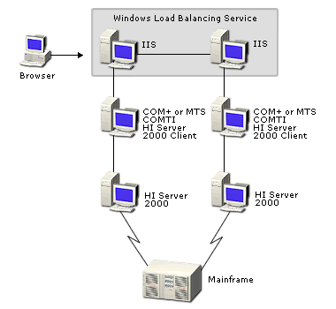
Load Balancing with IIS and WLBS
WLBS provides high availability on enterprise systems. It detects connection failures and automatically redirects requests to other nodes in the server farm. WLBS also improves performance when all incoming packets are load balanced between various nodes in the server farm based on server load.

WLBS can be configured to load balance on multiple servers filtered to use single affinity, no affinity, or Class C. No affinity distributes all incoming TCP/IP requests across any node in the WLBS server farm. Because it incorporates no concept of a session state, this can increase the number of requests that need to be redirected. Using IIS to distribute the HTTP requests configured for single affinity is recommended. When configured for single affinity, all incoming packets using the WLBS virtual IP address will be locked to a specific node in the server farm. Every packet that is sent from the client using the cluster IP address will connect to that node.

Note: WLBS cannot detect whether the server application fails to respond (COMTI). It can only detect if the server fails, for example, if TCP/IP is not responding.

COMTI TCP/IP Load Balancing
COMTI can load balance TCP/IP ports when configured for CICS and IMS TCP/IP REs. This can be achieved by supplying multiple TCP port numbers in the RE to connect to redundant CICS or IMS regions on a single host system. The following figure illustrates the use of a COMTI TCP port load balancing solution.

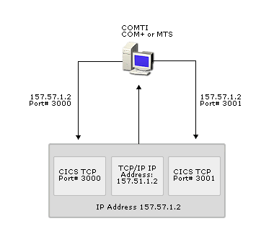
COMTI TCP Port Load Balancing

The first TCP port is used by the first transaction and will "round robin" through all of the configured ports for each transaction that is invoked. The following sections include additional host configuration details for CICS and IMS.

CICS TCP/IP Platform Requirements
The version dependencies for CICS include:
- TCP/IP version 3, release 2 (V3R2)
- CICS version 3.3 (V3.3) or later

Connections to CICS Using TCP/IP
CICS uses the IBM-supplied concurrent listener program (EZACIC02, tranid CSKL) to establish an interaction with TCP/IP. The listener program runs as a CICS task to facilitate the connection process. The listener program is a transaction that automatically starts when CICS TCP/IP is started and enabled. When the listener starts, it obtains a socket on which it can "listen" for connection requests from TCP/IP. The listener binds this socket to a specified port, and then waits for a client request on that port. TCP/IP maintains a relationship of a port number to a CICS job. When a client makes a request on a port associated with CICS, TCP/IP forwards the connection request to the listener program in that CICS job.

TCP/IP to CICS Configuration
A TCP/IP port number is associated with a CICS region in the TCP/IP profile data set (hlq.PROFILE.TCPIP). The port statement is used to define this relationship. The following is an example of a port statement that associates port 3000 with CICS job CICSRG:

3000 TCP CICSRG

CICS to TCP/IP Configuration
The following sample host definition shows configuration parameters for CICS-to-TCP/IP using the EZAC transaction:

EZAC,DEFINE
ENTER ONE OF THE FOLLOWING

CICS ===> yes Enter Yes|No
LISTENER ===> Enter Yes|No

EZAC,DEFINE,CICS
ENTER ALL FIELDS

APPLID ===> CICSRG APPLID of CICS System

EZAC,DEFINE,CICS
OVERTYPE TO ENTER

APPLID ===> CICSRG APPLID of CICS System
TCPADDR ===> TCPIP Name of TCP Address Space
NTASKS ===> 020 Number of Reusable Tasks
DPRTY ===> 000 DPRTY value for ATTACH
CACHMIN ===> 015 Minimum Refresh Time for Cache
CACHMAX ===> 030 Maximum Refresh Time for Cache
CACHRES ===> 010 Maximum number of Resolvers
ERRORTD ===> CSMT TD Queue for Error Messages

The following sample host definition shows configuration parameters for the CICS concurrent listener using the EZAC transaction:

EZAC,DEFINE
ENTER ONE OF THE FOLLOWING

CICS ===> Enter Yes|No
LISTENER ===> yes Enter Yes|No

EZAC,DEFINE,LISTENER
ENTER ALL FIELDS

APPLID ===> CICSRG APPLID of CICS System
NAME ===> xyz TRANSACTION NAME OF LISTENER

EZAC,DEFINE,LISTENER
OVERTYPE TO ENTER

APPLID ===> CICSRG APPLID of CICS System
TRANID ===> XYZ Transaction Name of Listener
PORT ===> 03000 Port Number of Listener
IMMEDIATE ===> YES Immediate Startup Yes|No
BACKLOG ===> 010 Backlog Value for Listener
NUMSOCK ===> 050 Number of Sockets in Listener
MINMSGL ===> 004 Minimum Message Length
ACCTIME ===> 060 Timeout Value for ACCEPT
GIVTIME ===> 030 Timeout Value for GIVESOCKET
REATIME ===> 000 Timeout Value for READ
FASTRD ===> YES Read Immediately Yes|No
TRANTRN ===> YES Translate TRNID Yes|No
TRANUSR ===> YES Translate User Data Yes|No
SECEXIT ===> Name of Security Exit

IMS TCP/IP Platform Requirements
The version dependencies for IMS include:
- TCP/IP V3R2
- IMS version 4 (V4) or later

Connections to IMS Using TCP/IP
IMS uses a listener to establish an interaction with TCP/IP. A listener in an IMS Batch Message Processing (BMP) helps facilitate the connection process. When the listener starts, it obtains a socket on which it can "listen" for connection requests from TCP/IP. The listener binds this socket to a specified port, and then waits for a client request on that port.

TCP/IP maintains a relationship of a port number to an IMS listener BMP. When a client makes a request on a port associated with IMS, TCP/IP forwards the connection request to the listener in that BMP.

Implicit Mode
Implicit mode uses the IMS Assist Module to translate conventional IMS communication into corresponding socket calls. It is dependent on the IBM-supplied default listener (EZAIMSLN) that runs in a BMP region.

This host-server-application model processes input data using the IMS message queue. The listener places the TRANID and the input data into the queue. The IMS control region schedules the transaction in a Message Processing region. The transaction program reads the request from the queue using Get Unique (GU) and Get Next (GN) commands. All response data is delivered to the client by using the Insert (ISRT) command. The IBM-supplied Assist Module delivers the data directly to the client through socket API calls.

Host applications are written using CBLADLI or CBLTDLI APIs. The Assist Module uses the DBLADLI API for Implicit mode. Any existing IMS applications that want to use Implicit mode TCP/IP will have to change to CBLADLI API and recompile the program.

Explicit Mode
The IMS Explicit (TCP/IP) mode requires installation, within IMS, of the IBM-supplied default listener (EZAIMSLN) that runs in a BMP region. This host-server-application model processes data without using the IMS message queue. The listener places only a single segment (the Transaction Initiation message) into the message queue. The IMS control region schedules the execution of the transaction into a Message Processing region. The transaction then communicates directly with the client through socket API calls.

All IMS host-server programs must be administered to IMS as non-response transactions.

TCP/IP to IMS Configuration
A TCP/IP port number is associated with an IMS Batch Processing Region in the TCP/IP profile data set (hlq.PROFILE.TCPIP). The port statement is used to define this relationship. The following is an example of a port statement that associates port 3000 with an IMS batch region with a job name of WNWIBPR1:

3000 TCP WNWIBPR1

IMS to TCP/IP Configuration
An IMS Message Processing Program (MPP) is started specifying the program name ‘EZAIMSLN’ (an IBM-supplied listener program for IMS). This listener reads a configuration file that holds the data sets containing one or more of the following startup parameter statement sets:
- TCPIP statement. This statement identifies the job name for the TCP/IP address space that will manage connection for this listener.
- LISTENER statement. This statement specifies the port number that this listener will be using. The LISTENER statement also specifies other port-related parameters such as backlog and time-out values.
- TRANSACTION statement. This statement defines a list of transactions that this listener can start. In addition, the TRANSACTION statement defines whether the Implicit or Explicit connection mode is used.
The listener uses these three parameter statements to tie the TCP/IP port to the correct transaction.

Here is a sample of an IMS to TCP/IP host definition:

TCPIP ADDRSPC=WNWTCP31
LISTENER PORT=4000 BACKLOG=50
TRANSACTION NAME=TRANIMPL TYPE=IMPLICIT
TRANSACTION NAME=TRANEXPL TYPE=EXPLICIT

Clustering COMTI
COMTI can leverage Microsoft Clustering to provide the ultimate hot backup solution for enterprise systems. Windows 2000 Advanced Server and DataCenter include Microsoft Clustering, which uses small computer system interface (SCSI) and TCP/IP network technologies to detect failures and failover applications when a cluster node fails. The following figure illustrates the benefit of using Microsoft Clustering to provide hot backup support for browser clients accessing COMTI transactions.

Hot backup with Microsoft Clustering

COMTI does not include functionality to take full advantage of Microsoft Clustering features, but by using the following procedure, you can install COMTI in a cluster and gain some of the hot backup benefits of clustering.

To install COMTI in a cluster
- Install the Host Integration Server 2000 client software, including COMTI, on both nodes in the cluster.
- Do not create any REs at this time. If you are replacing an existing COMTI installation, use COMTI Manager to deactivate all REs on both nodes before you install COMTI.
- From the Windows 2000 Control Panel, click Administrative Tools, then click Services and stop the SNA LU62 Resync TP service on both nodes. Change the Startup property to Manual.
- On the SNA Server computer outside the cluster, create the local LU that COMTI will use as an SNA Server client on the cluster. Enable the local LU for Sync Point (do this in SNA Server Manager on the Advanced Properties page for the local LU).
Important: The Client Name must match all the computer names of the individual cluster nodes or clustering will not work.
- Instead of entering a specific computer name, enter a pattern using standard wildcard characters such as an asterisk (*) or a question mark (?).
Important: The pattern must match the computers in the cluster, but should not match any other systems running COMTI, or the system may behave unpredictably.
- In the Cluster Administrator, right-click the cluster resource group where MS DTC is installed. Complete the New Resource wizard to create a resource named COMTI Resync. Click the Resource Type generic service. Specify all nodes in the cluster as possible owners of the resource. Specify a dependency for MS DTC to be brought online before COMTI Resync. In the Generic Service Parameters dialog box, set the Service Name to UN2. No other parameters are required. Click Finish.
- Use the Cluster Administrator to bring the group online. Both MS DTC and COMTI Resync TP should be online.
- Create identical COMTI REs on both nodes, referring to the local LU alias. If the REs already exist, activate them now on both nodes. Within one minute, COMTI Resync TP (running on the node that owns the group) should place event 119 in the log, stating that a successful Exchange Log Name (XLN) has been performed between the local LU and each partner LU specified in the REs.
- If this is not the case, use the events in the log to diagnose the problem before proceeding.
- Simulate failover by moving the group to the other node. Look for event 119 in the log on the other node, stating that a successful XLN can be performed there as well.
- On both nodes, in MTS Explorer, right-click My Computer, click Properties, and then click Options. For Remote Server Name, type the name of the cluster.
- Create identical MTS packages on both nodes. Install components into the packages from a Universal Naming Convention (UNC) name (not a resolved drive letter). Make sure that each component is associated with the intended RE (move it to the correct RE, if necessary).
- On the first node where the package was created, export the package to a UNC path name. This creates an executable program at that location with the name you specify. On the appropriate clients outside the cluster, run the program. This registers the objects from the exported package. Now run the client application.

Security Implications
COMTI for CICS and IMS can provide user ID and password credentials for authentication on the mainframe. They are provided in accordance with existing IBM standards. Mainframe authentication takes place by standard IBM procedures (such as Resource Access Control Facility [RACF] and Top Secret). All this occurs in a manner transparent to the application developer.

When LU 6.2 is used for connectivity, credentials are transmitted to the mainframe in an SNA LU 6.2 Function Management Header Type 5 (FMH-5) ATTACH message. Refer to the IBM manual, Systems Network Architecture Formats, Document Number GA27-3136-16, Section 11.1.5 FM Header 5: Attach (LU 6.2).

When TCP/IP is used for connectivity, credentials are transmitted in the Transaction Request Message (TRM) sent from COMTI to the listener. There are some additional coding requirements on the mainframe for TCP/IP to provide user exits for authentication. For CICS, refer to IBM TCP/IP for MVS CICS TCP/IP Socket Interface Guide and Reference, Document Number SC31-7131-03, Section 6.6.3 Writing Your Own Security Link Module for the Listener. For IMS, refer to IBM TCP/IP for MVS IMS TCP/IP Application Development Guide and Reference, Document Number SC31-7186-03, Section 3.4.4 The IMS Listener Security Exit. Prior to TCP/IP V3R2, the CICS Exit module required the name EZACICSE. However, any name can be chosen when using TCP/IP V3R2. For IMS, the Exit module must be named IMSLSECX.

Three alternative sources are used for mainframe credentials:
- The Microsoft Transaction Server (MTS) identity of the package that contains the COMTI component
- The identity of the Windows 2000 user of the COMTI application
- The optional, explicit security override feature of COMTI

Use of the explicit override feature dissociates mainframe security from Windows 2000 security. Therefore, it is not recommended over the first two alternatives. Using either of the first two alternatives integrates mainframe security with Windows 2000 security by using the SNA Server Host Security Integration (HSI), or single, sign-on functionality. (No software needs to be installed on the mainframe for HSI unless Host Password Synchronization is also wanted.)

By default, passing credentials to the mainframe for authentication is not enabled. You must activate the COMTI RE security properties by selecting the Set security on check box. You must then click either Authenticate with package credentials or Authenticate with user credentials (Windows 2000). You must click one of these options even if you plan to use the explicit security override feature. To select the explicit security override, select the Allow application override check box. This option is the least recommended of the three. If Allow application override is selected, but not implemented by the application, the security mechanism will revert to whichever one of the other two security options you selected. If you select the Use Already Verified authentication option, the mainframe will not authenticate this transaction, and uses the credentials exchanged with the SNA Server during the LU-LU session activation.

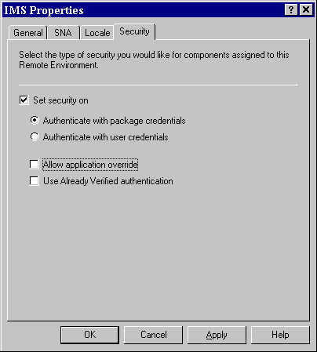
COMTI Remote Environment security settings

Performance Costs of Using Security with COMTI
When security is introduced, the transactions force additional processing by the COMTI/SNA Server computer and the Windows 2000 domain controller. On the host side, similar verification checks are done to authenticate the transactions. Tests conducted in the lab show a performance hit of 25 to 30 percent for a small transaction (481 bytes) with medium data conversion, and a 20 to 25 percent hit for a large transaction (1,921 bytes) with heavy data conversion. Additionally, the tests show that selecting the Allow application override and/or Use Already Verified authentication check boxes did not add to the cost of security verification.
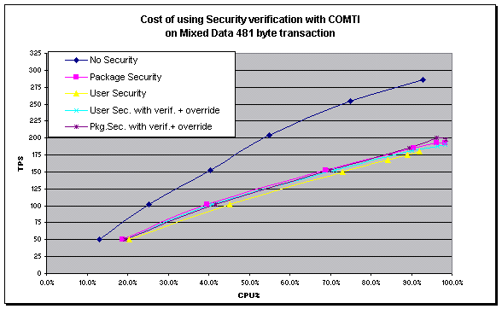
Cost of using security verification with COMTI

Optional Explicit-Level Override Authentication
Selecting the Allow application override check box enables applications to supply credentials at run time through a callback mechanism that COMTI supplies. Using application override does not require the installation and use of HSI. Instead, the client application supplies COMTI with a pointer to a callback object that can be used to request credentials when they are needed at run time. A utility component is provided so that customers can add their callback pointer to the MTS context. Customers can also use this component to create new MTS objects inherited from the modified context. The security callback component is automatically installed in the standard MTS utility package.

The CedarBank tutorial application (included in the CedarBank sample demo provided with COMTI) supplies an example of using this type of authentication.

To use explicit security, the client application must:
- Create an instance of an object that implements IHostSecurityCallback. This object is created in the client application and is implemented by the application developer.
- Create an instance of the COMTI utility object COMTI.HostSecurityContext.
- Call SetCallbackObject on the utility object, passing it the IHostSecurityCallback pointer on the callback object.
- Create instances of the COMTI-created component of the utility object using the CreateInstance method.
When the COMTI component (created in Step 4) establishes a conversation with the host, it will call the ReturnSecurityInfo method on the callback object. COMTI passes to this method the name of the RE being contacted. The output parameters provide the logon and password as clear text.

As an additional aid to developers, COMTI provides the type information for the IHostSecurityCallback interface inside the component library for the COMTI security component. This enables Microsoft Visual Basic® developers to set a reference to this component and then use the Implements keyword to implement the callback class.

Package-Level Security and User-Level Security
Package-level security and user-level security are the preferred means of authentication because they integrate security on the mainframe with Windows 2000 security. The COMTI run-time proxy obtains credentials from either the Windows 2000 identity of the MTS package, or from the identity of the client that invoked the COMTI component.

In both cases, the facilities of SNA Server HSI are required. The Windows 2000 credentials are replicated, unchanged, or mapped to another set of credentials specific to the mainframe. The credentials are then sent to the mainframe for authentication.

Internally, the mechanism is as follows. For MTS package identity credentials, COMTI sets the user ID and password fields in the MC_ALLOCATE verb to MS$SAME, and sets the security field to AP_PGM. This informs HSI to derive host credentials for the owner of the currently executing process.

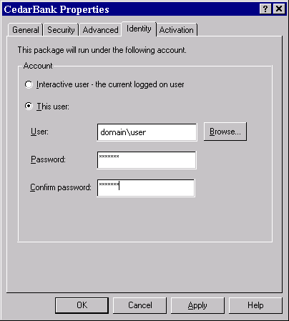

MTS package identity

Package identity defines the MTS computer process that is running. The process can run either as an Interactive User or as a specified Windows 2000 user account. It is typical for server processes to run as Interactive User during development. However, a Windows 2000 user account will typically be used in production deployment scenarios.

For user credentials, COMTI sets the security field in the MC_ALLOCATE verb to AP_PGM OR’ed with AP_PROXY, and fills in the domain and account name fields in the verb control block with the values it obtained from LookupAccountSid (Microsoft Win32® API). This informs HSI to derive host credentials corresponding to that Windows 2000 account, regardless of the running process. In other words, the run process wants to act as a proxy for the real user and pass the real user's credentials.

Using Host Security Integration
When you create an SNA Server Host Security Domain (HSD), two Windows 2000 local user groups are created. For example, if you name the HSD EXAMPLE, the two user groups created are named EXAMPLE and EXAMPLE_PROXY. A Host account cache is also created (see following figure). It is used to maintain user credential mappings. HSI uses these mappings to map (or replicate) the original Windows 2000 credentials to host credentials. The following table lists the credentials that must be specified in a given Windows 2000 user group and the Host account cache when using one of the tabulated options for authentication.

COMTI authentication option | EXAMPLE | EXAMPLE_PROXY | Host account cache
User Credentials | User | Package* | User
MTS Package Credentials | Package | N/A | Package
Application Override | N/A | N/A | N/A

Host Security Integration Settings

*The package identity must be in the EXAMPLE_PROXY user group because you are allowing a process (your COMTI component) to run under an identity other than the identity that Windows 2000 has authenticated. This group assignment specifies that you are allowing the package to run host transaction programs on your behalf.

Host Account Cache
Host Integration Server 2000 maintains the Host account cache. For any Windows 2000 domain user, the Host account configuration specifies whether Windows 2000 credentials are replicated to the mainframe or mapped to other credentials to be sent to the mainframe.

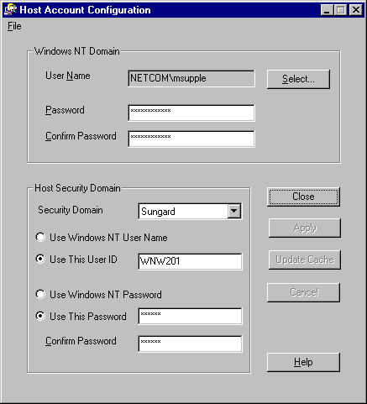

Host Account Cache Configuration

Additional Information

Use Already Verified Authentication
The Use Already Verified authentication option is specified on the Security tab in the IMS Properties (see previous figure). When it is selected, only a user ID is sent to the mainframe. No password is sent if the mainframe partner is set to allow it. The mainframe relies on the assumption that this user ID has already been authenticated and does not require a password. The SNA Server mode on the mainframe must specify this type of authentication. For CICS applications, the mode setting is determined by the ATTACHSEC=IDENTIFY parameter of the Sessions definition used for the connection.

Mainframe Authentication for CICS LINK REs
If a CICS LINK LU 6.2 RE is used, it is necessary to use resource-level authentication. As a result of a restriction in the Distributed Program Link (DPL) protocol, a user ID and password transmitted from the workstation by COMTI are ignored and not used for transaction-level authentication. Under the circumstances, the target CICS region waits for authentication by the application that initiates the DPL call; that is, authentication completed by the COMTI application on the computer. (Traditionally, the application that initiates a DPL is a program in another CICS region.) Instead of using credentials from the FMH-5 ATTACH message for transaction-level authentication, the target CICS region associates the default user ID for the region with the transaction ID of the CICS task (a mirror transaction).

Attempts to secure the mirror transaction using credentials differing from the ones used during the DPL initialization may cause a malfunction of the application because of a failure to authenticate.

Transaction Size Versus Transaction Throughput
When looking at the transactions per second (TPS) rates that the server might be capable of sustaining, you must consider the amount of data moved and processed for each transaction. It is commonly understood that the more data you transfer for each transaction, the lower the transaction rate. This is also true for COMTI. To determine the percentage at which TPS rates decrease as transaction sizes increase, transaction throughput tests were run on the quad-processor, a 400-MHz Xeon test server, which yielded the following results.
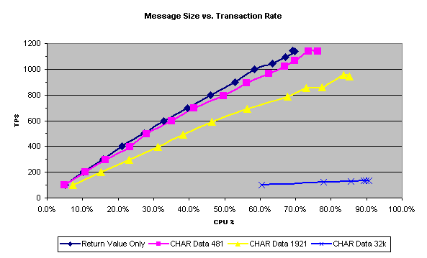
Message Size Versus Transaction Throughput
The test transaction yielded the best TPS rate, which returned only 1 byte of data. This return value sets the high bar to only 1,094 TPS. The CHAR Data of 481 bytes per transaction (simple application screen) can maintain close to the maximum possible rate. The data transfer test of 32 KB, which moves 64,000 bytes of data per transaction, cannot maintain the same TPS rate as the others. In this case, the latencies on the LAN, memory allocations, and copies really begin to show.

Message Size Versus Data Throughput
Results of the transaction throughput tests allow determining the best message size for these transactions. The tests captured the actual user data transferred with the transactions, and allowed an examination of data throughput (in MB/second) versus message size. The following figure shows that where data throughput is optimized, a larger message size yields a higher throughput. Additional considerations can influence the selections of the message size, such as the maximum frame size on the LAN or WAN. For example, Ethernet 802.2 frames can fit 1,484 bytes of user data per frame; token ring frames can fit up to 8,186 bytes.
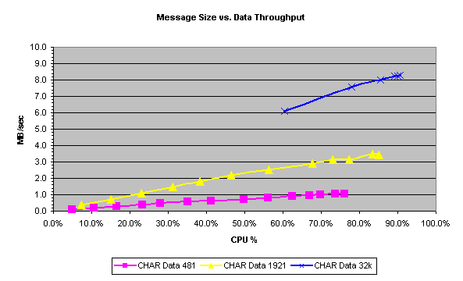
Message Size Versus Data Throughput

Long-Running Transactions

Scalability and Long-Running Transactions
When the transaction processing times (UOW and 2PC times) increase due to the nature of the transactions or an excessive load on the host, the behavior of middle-tier software might change throughput and end-user response time. This is because the number of concurrent active transactions will increase and the middle-tier server is doing some level of "transaction caching." For example, in a system that processes 200 TPS at an average transaction response time of one second, the concurrent active transaction count at any given time is around 200. If the response time grows to five seconds, the concurrent active transaction count will grow to approximately 1,000. When sizing the middle-tier server, you need to consider queries and batch jobs that run from seconds to hours. It is possible to allow more transaction requests in MTS while waiting for the host responses, but excessive transaction caching might not be advantageous. (It increases thread count, context switching, and memory usage.) This burdens the middle-tier server and can cause performance degradation. Because it does not help in the actual transaction processing, and will not improve the response times or throughput, the MTS/COMTI pooling capabilities should be used cautiously.

When transactions run against multiple host systems and databases (multi-forked transactions), the transaction caching in the middle-tier enables each transaction in the fork to start processing immediately. The slowest fork determines the overall response time. If the transaction is not cached, all work is blocked until the prior transactions are completed, thus yielding lower performance. The two thread pools that get taxied when the number of active transactions grows on the middle-tier server are the MTS user-thread pool and the COMTI 2PC thread pool.

Processing Two-Phase Commit Transactions
This section discusses what happens with the two-phase commit (2PC) protocol transaction while being processed by MTS, MS DTC, COMTI, and CICS. The process begins when the application issues a method call to the MTS package. MTS then allocates a thread for the transaction from its user-thread pool, begins the transaction, and passes the method input parameters to the COMTI run time. This thread is blocked for the transaction until the response returns from the CICS host. This is the UOW time. It mostly consists of accessing the database and CICS application processing of the transaction business logic (assuming our transmission speeds are on the level of LAN speeds). When the method output parameters arrive to MTS from the host, the commit message is sent to MS DTC, and the thread is released. The output data is stored waiting for the commit complete message from MS DTC. (If UOW time increases, MTS keeps more transactions active, each one occupying a thread from the MTS user-thread pool.)

MS DTC activates the prepare phase for the transactions, causing COMTI to allocate a thread from its 2PC thread pool, and keeps it blocked until receiving RequestCommit from the host. After all the forks of the transactions are prepared, MS DTC issues CommitComplete for MTS, which then sends the method reply back to the calling client application. This completes the transaction for the user. In this case, the transaction monitors MS DTC. CICS still needs to complete the second phase of the commit. A thread from the COMTI 2PC thread pool is allocated for each transaction during the second phase of the commit.

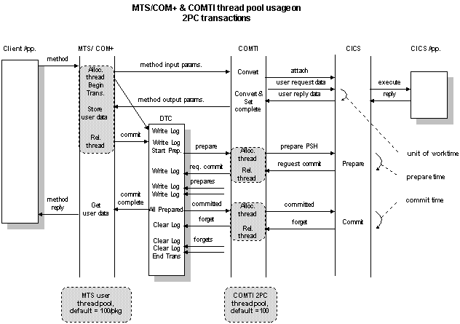
MTS and COMTI Thread Pool Usage on 2PC Transactions

Microsoft Transaction Server User-Thread Pool
A thread from the MTS user-thread pool is allocated to a transaction as long as the host is processing the transaction (UOW time). This happens for both transactional (2PC transactions) and non-transactional processing. If you have a slow host or communication lines, or your transactions take a long time to process, you might have to adjust a registry entry to enable more threads for this pool. The default is 100 threads per MTS package. To enable additional threads for an MTS pool, specify the number of threads by adding a REG_DWORD value named ThreadPoolMax to the package registry key:

HKLM/Software/Microsoft/Transaction Server/Package/{your package GUID}"
Valid values are: 0 to 0x7FFFFFFF

Important: If you adjust the user-thread pool too high, you might enable transactions to use up all the Windows 2000 system resources, such as system page table entries and virtual memory. When tuning your system, keep in mind that each concurrent transaction consumes two or three threads, each with a minimum 1.5 MB of virtual memory space. A system with 1,000 concurrent transactions would thus have more than 2,000 threads and take up over 3 GB of virtual memory space.

Testing the Effects of Increasing UOW Time
Our tests showed that increasing the Unit of Work (UOW) time on the host simulator from 0 ms to a reasonable 1,000 ms did affect transactional throughput.

Testing the Effects of Increasing MTS Thread Pool Size
When testing the throughput of a small transaction (481 bytes of mixed data) with host processing time and UOW time set to 1,000 ms, results indicate no difference in transactional throughput behavior. With 400 threads on the MTS user pool, CPU usage seems to be a bit higher on heavier loads.

COMTI 2PC Thread Pool
Unlike the MTS user-thread pool, this pool is only used for 2PC transactions. The threads are pre-created, and a single process interacts with MS DTC to handle prepare and commit transactions. This improves performance by eliminating thread creation and destruction for every 2PC transaction. Unless huge numbers of 2PC transactions are processed, overburdening this pool will not be a concern. Queuing to interact with MS DTC can only occur when prepare or commit times for the transactions get excessively long.

You can adjust the default amounts by adding a TEXT string value to the registry location:

HKLM\Software\Microsoft\Cedar\Defaults\Threads
- IOPortPoolFactor=20 (20 is the default maximum number of threads per CPU)
- IOPortActive=19 (19 is the default maximum number of active threads per CPU)
- ThreadPoolMax=80 (80 is the default maximum number of threads for the system)
The following rules apply for specifying values:
- All values must be greater than zero.
- IOPortPoolFactor must be >= IOPortActive + 1
- ThreadPoolMax must be >= IOPortPoolFactor
Important: Allocating too many threads can cause Windows 2000 to run out of resources and cause irregular operations in MTS and Windows 2000.

Testing the Effects of Increases in Prepare/Commit Transaction Times
An increase in the prepare time for the 2PC transaction puts pressure on the COMTI 2PC thread pool. Increasing the prepare transaction times to 500 ms and 1,000 ms did not adversely affect the overall transactional throughput. All test runs tracked close to the same performance profile. The 1,000 ms prepare time reached a top number with over 500 simulated clients.
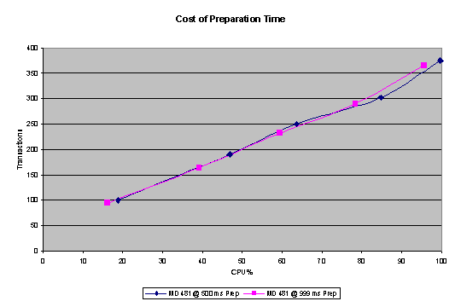
Effects of Prepare and Commit Processing Times on Transactional Throughput

Testing the Effects on End-User Response Time
Any increase in the host response time directly affects end-user response time. Having processing time in UOW phase or prepare phase made no difference. Commit phase would not directly impact user response time since the reply to the user is sent before second commit processing. An interesting observation can be made from the following figure. The point in the curve at which response time starts increasing drastically seems to be a bit earlier when the prepare transaction time is increased.
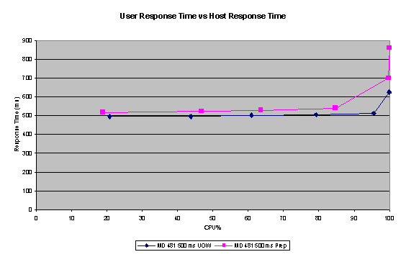
Effects of Host Response Time on End-User Response Time

SNA Server Parallel Sessions
Each active transaction also allocates one parallel session to interact with the host when SNA Server is used instead of TCP/IP. This session is activated when the transaction sends the attach message (allocate conversation) and is released after the forget message (TpEnded). Configuring too few contention-winner parallel sessions for the SNA Server connection used by COMTI can cause queuing of transactions waiting for the active ones to release the sessions. Make sure you configure enough sessions for the worst-case scenario. SNA Server can handle large numbers of parallel sessions. The maximum is 30,000 parallel sessions for each LU-LU pair, after which another LU-LU pair needs to be configured. The CICS system is a bit more sensitive to the amount of parallel sessions configured. Please consult your CICS system experts for the appropriate session count. It is important to note that COMTI can use sessions only where the SNA Server, not the host, is the contention winner. Configure the session counts in the PERFORM properties of your MODE definition.

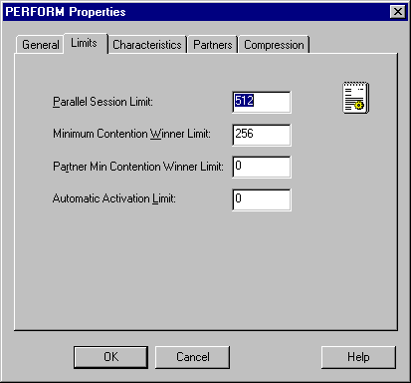

Configuring PERFORM Properties

This configuration provides 512 total parallel sessions, out of which the SNA Server is contention winner for 256. This will guarantee 256 concurrent active transactions. This is the total for all transactional 2PC or non-transactional transactions.

Data Conversion Cost
Data conversion for a middleware product like COMTI represents a significant portion of its overall workload. Therefore, it is important to understand the effects of converting different data types first from EBCDIC to ASCII, and then from the host representative data type to a corresponding valid data type in the computer environment.
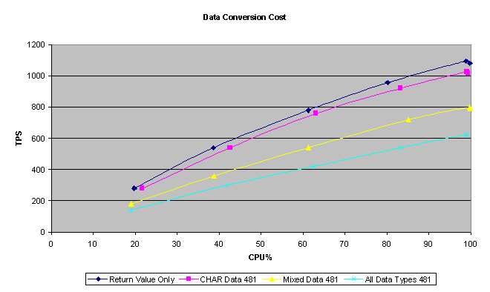
Cost of Data Conversion for a Middleware Product

The tests conducted in the lab with different data types, while maintaining all other aspects of the transactions and setup, illustrate the effects of the data conversion load put on COMTI. As you can see from the preceding figure, the transaction of CHAR 480 bytes tracks closely to the reference transaction (return value is only a 1-byte message). This shows the ease and efficiency of interoperating with CHAR type data. The All Data Type test represents the worst-case scenario of a transaction with a mixture of data types that are the most data-conversion intensive. The Mixed Data Type test features 2/3 of the transaction message as data-conversion-intensive data and 1/3 as character data. This represents a conservative test case for a typical business transaction. For system sizing purposes, some conclusions can be drawn from these test results:
- Most business transactions fall between the Mixed Data 481 and CHAR 481 lines.
- When transferring numeric data (spreadsheets and so forth), the safe assumption is to use the band between test results for All Data Types and Mixed Data.
- When transferring more text-based data (such as user profiles, claims history, and invoice records), the performance will settle close to the CHAR 481 curve.
The following list provides advice on selecting the data types that convert most efficiently between automation and COBOL.
- If the source and destination data types are not strictly dictated, then you can decrease the amount of CPU resource that COMTI consumes by appropriately selecting the data conversions that are performed (that is, thoughtfully selecting the source and destination data types).
- The most efficient way to pass data is to select an automation type of VT_BYTE and a COBOL data type of PIC X untranslated. This involves no conversion and copies the data "as is."
- The automation type VT_BSTR (a UNICODE character string) converts efficiently to COBOL PIC X. Be aware that a BSTR is not the same as a C character data type; it is a Visual Basic string.
- The most efficient numeric data type conversions are VT_I2 (Visual Basic Integer or C short) to COBOL PIC S9(4) COMP, and VT_I4 to PIC S9(8) COMP.
- If the desired data type is COBOL packed decimal, the best choice for data conversion performance is one of the automation integer data types. If fractional parts are required (that is, a COBOL picture like PIC S9(5)V99 COMP-3), the best choice for the automation type is VT_DECIMAL (Decimal) or VT_CY (Currency).
- When the COBOL data type is zoned decimal (that is, a COBOL picture similar to PIC S9(7)V99 DISPLAY), the same considerations apply as for packed decimal. It is slightly more work to convert automation data types to and from zoned decimal than to perform the conversions to packed decimal. If the data is used in calculations on the mainframe system, it is more efficient to use packed decimal than zoned decimal.
- Converting floating-point data types (automation types VT_R4 and VT_R8) is the most expensive in most cases. However, the most efficient data-type conversion involving floating-point numbers is to convert VT_R4 to a COBOL COMP-1, or VT_R8 to a COBOL COMP-2 (a COBOL floating-point number).
- Return Value Only sets the theoretical maximum throughput value. Char 481 represents a very light conversion load. Mixed data (1/3 char, 1/3 float, 1/3 packed decimals) is the most realistic for application sizing. The All Data types setting is the heaviest throughput possible. It is reassuring to observe the small difference in performance degradation between mixed data and all data types.

Structured Data (ADO Record Sets Versus UDTs)
Tests on structured data transfer showed that user-defined types (UDTs) outperformed ActiveX Data Objects (ADO) record sets in CPU usage, transactions per second (TPS), and response time. Tests were conducted using eight Pentium 300-MHz clients, one quad-processor, a 400-MHz Xeon Pentium II system as a gateway, and four SNA Server host server computers to emulate the CICS region of a mainframe. Using an in-house testing tool, four virtual clients on one client accessed the four host emulators through the gateway. When transferring record sets, the clients alone were running almost 100 percent of the CPU and had a very low TPS count. When transferring UDTs, the clients were under less stress and had much better throughput overall. UDTs also put much less stress on the server.
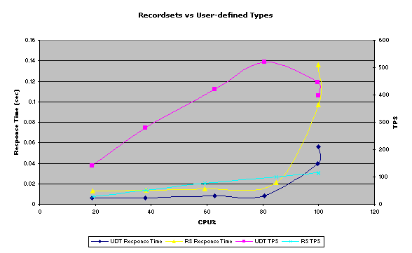
Effects of Using ADO Disconnected Record Sets with Small Transactions

The overall response times for the UDTs are also much less because of the metadata that record sets contain. The metadata inside the record sets increase the amount of data marshaled back and forth across the DCOM connection. In addition to the increased amount, the metadata increase processing overhead.

Remote Environment Selection (Using the SelectionHint Property)
Host Integration Server 2000 provides an alternative means of assigning a COMTI component to a Remote Environment (RE). Use of the SelectionHint property enables developers to specify an RE programmatically.

Remote Environment Selection enables applications to specify which CICS or IMS region is used in servicing COMTI requests. The algorithm used by an application in selecting an RE is determined by the application code. For example, an enterprise can use separate CICS or IMS regions when handling requests from different branches. In this case, the application chooses the RE that identifies the region suitable for the current branch.

To specify an RE, an application uses the SelectionHint property. The Component Builder automatically adds this write-only property to COMTI components. An application sets the SelectionHint property for an object representing a COMTI component by assigning the name of the RE.

Implementing Remote Environment Selection
Before you can use the Remote Environment Selection feature, the following must be in place:
- To use the SelectionHint property, Host Integration Server 2000 must be installed on all computers running the COMTI run time and/or the Component Builder.
- The COMTI component must be assigned to an RE even though Remote Environment Selection is in use. The RE assigned to the component is used when an application with a COMTI component does not explicitly set the SelectionHint property.
To assign a COMTI component to an RE, use COMTI Manager and follow the instructions provided in the COMTI online Help documentation.

Guidelines for Using Remote Environment Selection
Consider these guidelines when using Remote Environment Selection:
- Avoid hard-coding RE names into applications. Instead, load RE names from a file or database.
- Ensure that applications are structured to handle failures when attempting to set the SelectionHint property.
- Ensure that procedures for adding and configuring REs include a mechanism to update REs referenced in the application code.
- Confirm that administrative and operational tasks do not interfere with application code that uses the RE selection. Specifically, review when and how REs are deactivated and deleted.

Writing Code that Specifies a Remote Environment
When using a COMTI component, applications can explicitly specify the RE that the COMTI run time uses. By specifying the RE, the application identifies the CICS or IMS region where transaction programs are carried out when handling calls to the methods of the component.

The following Visual Basic code demonstrates the SelectionHint property:

Dim objExample As Object
Dim Store As String
Set objExample = CreateObject("MyComponent.MyInterface.")
Open "My REList.txt" for Input as #1
Line Input #1, strRE
Close #1

objExample.SelectionHint = strRE
RtrnVal = objExample.method1(parm1, … , parmN) 'Use RE named "MyRemEnvName"

This example shows how the application can explicitly instruct the COMTI run time to use the RE named MyRemEnvName in handling the call to method1. The example assumes that MyRemEnvName is the first string in the file MyREList.txt. Any method calls made after method1 that follow the SelectionHint assignment are handled using the RE assigned to the component by COMTI Manager. In other words, this override of the default RE does not continue past a single method call.

If the application attempts to set the SelectionHint property to a string that does not correspond to the name of an RE, an error is reported and the currently selected RE remains associated with the object. The SelectionHint property can be set to a deactivated RE. However, the next method call to the object will fail because a deactivated RE was selected. The SelectionHint property is optional. If the SelectionHint property does not specify an RE, the COMTI run time uses the RE assigned to the component by COMTI Manager.

Cost of Dynamic Remote Environment Selection
The following graph shows the transaction throughput against the CPU load on the middle tier. Both requests and responses consist of 481 bytes of mixed data (text and numeric).

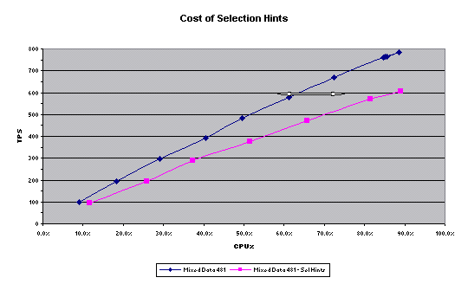
Cost of Selection Hints

The arrow in the figure shows the last level of CPU use at which transactions using SelectionHint and transactions not using SelectionHint ran at a similar number of TPS. Pushing the load beyond this level causes a drop in throughput. Up to the 85 percent CPU load level, you will see the same response time for both types of transactions. Using the SelectionHint property provides additional flexibility, but not without a performance cost (40 percent). On the other hand, when pushing 500 TPS through the server, not using SelectionHint will drop CPU load from above 80 percent to a comfortable 55 percent. These CPU cycles can be used for processing business logic on the middle tier.


This is a preliminary document and may be changed substantially prior to final commercial release. This document is provided for informational purposes only and Microsoft makes no warranties, either express or implied, in this document. Information in this document is subject to change without notice. The entire risk of the use or the results of the use of this document remains with the user. The example companies, organizations, products, people and events depicted herein are fictitious. No association with any real company, organization, product, person or event is intended or should be inferred. Complying with all applicable copyright laws is the responsibility of the user. Without limiting the rights under copyright, no part of this document may be reproduced, stored in or introduced into a retrieval system, or transmitted in any form or by any means (electronic, mechanical, photocopying, recording, or otherwise), or for any purpose, without the express written permission of Microsoft Corporation.
Microsoft may have patents, patent applications, trademarks, copyrights, or other intellectual property rights covering subject matter in this document. Except as expressly provided in any written license agreement from Microsoft, the furnishing of this document does not give you any license to these patents, trademarks, copyrights, or other intellectual property.
Unpublished work. © 2000 Microsoft Corporation. All rights reserved.
Microsoft, ActiveX, Host Integration Server, SNA Server, Windows, and Windows NT are either registered trademarks or trademarks of Microsoft Corporation in the U.S.A. and/or other countries.
The names of actual companies and products mentioned herein may be the trademarks of their respective owners.

