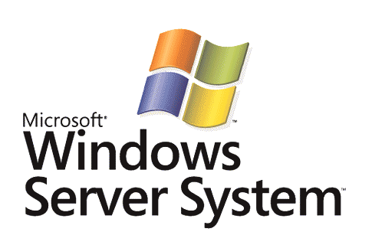

Configuring Network Access Protection Policies in Windows Server "Longhorn"

Microsoft Corporation
Published: February 2006

Abstract
A network administrator configures Network Access Protection (NAP) health policies and enforcement behavior on a computer running Microsoft® Windows Server™ "Longhorn" (now in beta testing) and Network Policy Server (NPS). NAP health policies and enforcement behavior settings consist of authentication policies, authorization policies, and Network Access Protection settings, each of which play a role in determining the health state of a client and limiting the access of noncompliant computers. This white paper describes the configuration of NPS for NAP in the December Community Technology Preview (CTP) and later beta releases of Windows Server "Longhorn" and how the different settings interact to create a customized health determination and enforcement solution.



This is a preliminary document and may be changed substantially prior to final commercial release of the software described herein.
The information contained in this document represents the current view of Microsoft Corporation on the issues discussed as of the date of publication. Because Microsoft must respond to changing market conditions, it should not be interpreted to be a commitment on the part of Microsoft, and Microsoft cannot guarantee the accuracy of any information presented after the date of publication.
This White Paper is for informational purposes only. MICROSOFT MAKES NO WARRANTIES, EXPRESS, IMPLIED OR STATUTORY, AS TO THE INFORMATION IN THIS DOCUMENT.
Complying with all applicable copyright laws is the responsibility of the user. Without limiting the rights under copyright, no part of this document may be reproduced, stored in or introduced into a retrieval system, or transmitted in any form or by any means (electronic, mechanical, photocopying, recording, or otherwise), or for any purpose, without the express written permission of Microsoft Corporation.
Microsoft may have patents, patent applications, trademarks, copyrights, or other intellectual property rights covering subject matter in this document. Except as expressly provided in any written license agreement from Microsoft, the furnishing of this document does not give you any license to these patents, trademarks, copyrights, or other intellectual property.
© 2005 Microsoft Corporation. All rights reserved.
Microsoft, Active Directory, Vista, Windows, and Windows Server are either registered trademarks or trademarks of Microsoft Corporation in the United States and/or other countries.
All other trademarks are property of their respective owners.
Contents
Introduction 1
RADIUS Clients 1
NAP Settings for Health Determination and Enforcement 2
NAP Settings for Health Determination and Enforcement in NPS 3
Authentication Processing 3
Network Access Protection Settings 4
System Health Validators 4
System Health Validator Templates 6
Remediation Server Groups 7
Authorization Policies 7
Authorization Policy Conditions for Network Access Protection 7
Authorization Policy Type for NAP 8
Authorization Policy Settings for NAP 8
How NAP in NPS Works 11
Examples of NPS Processing for NAP 11
NPS Processing for a Compliant NAP Client 12
NPS Processing for a Noncompliant NAP Client 13
NPS Processing for a NAP-ineligible Client 13
Summary 15
Related Links 16

Introduction
Network Access Protection (NAP) is a system health policy enforcement platform built into the Microsoft® Windows Vista™ (now in beta testing) and Windows Server "Longhorn" operating systems that allows you to better protect private network assets by enforcing compliance with system health requirements. With NAP, you can create customized health policies to validate computer health before allowing access or communication, automatically update compliant computers to ensure ongoing compliance, and optionally limit the access of noncompliant computers to a restricted network until they become compliant.
For an overview of NAP, see the Introduction to Network Access Protection white paper at http://www.microsoft.com/technet/itsolutions/network/nap/napoverview.mspx. For additional resources on NAP, see the Network Access Protection Web site at http://www.microsoft.com/nap.
The central server that performs the health determination analysis is a computer running Windows Server "Longhorn" and Network Policy Server (NPS). NPS is the Windows implementation of a Remote Authentication Dial-in User Service (RADIUS) server and proxy. NPS is the replacement for the Internet Authentication Service (IAS) in Windows Server 2003. RADIUS is an Internet Engineering Task Force (IETF) standard specified in Requests for Comments (RFCs) 2865 and 2866. Access devices and NAP servers act as RADIUS clients to an NPS-based RADIUS server. NPS performs authentication and authorization of a network connection attempt and, based on configured system health policies, determines computer health compliance and how to limit a noncompliant computer's network access.
To configure NPS for health determination and enforcement behaviors for NAP servers and access devices, you must configure RADIUS clients and NAP settings.

RADIUS Clients
You must add a RADIUS client for each access device or NAP server that requires NAP health determination. Examples of access devices or NAP servers include IEEE 802.1X-based wireless access points and authenticating switches, virtual private network (VPN) servers running Windows Server "Longhorn," Dynamic Host Configuration Protocol (DHCP) servers running Windows Server "Longhorn," and health registration authorities (HRAs) running Windows Server "Longhorn."
To add a NAP server or access device as a RADIUS client to an NPS server, right-click RADIUS Clients in the tree of the Network Policy Server Microsoft Management Console (MMC) snap-in, and then click New RADIUS Client. The New RADIUS Client wizard guides you through configuring the settings for the RADIUS client. On the Additional Information page for the New RADIUS Client wizard, select the Client is NAP-capable check box. Figure 1 shows an example.
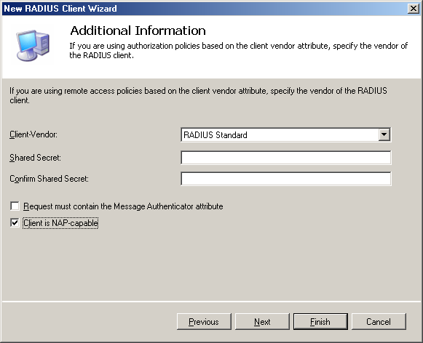
Figure 1 Additional Information page for the New RADIUS Client wizard

NAP Settings for Health Determination and Enforcement
NAP settings for health determination and enforcement consist of the following sets of settings:
- Authentication processing
- Network Access Protection settings
- Authorization policies
The remainder of this white paper describes the details of NAP settings for health determination and enforcement in NPS.
Note Authentication processing in NPS is equivalent to connection request processing in IAS. Authorization policies in NPS are equivalent to remote access policies in IAS.

NAP Settings for Health Determination and Enforcement in NPS
Authentication processing, Network Access Protection, and authorization policy settings correspond to different nodes in the tree of the Network Policy Server MMC snap-in, as Figure 2 shows.
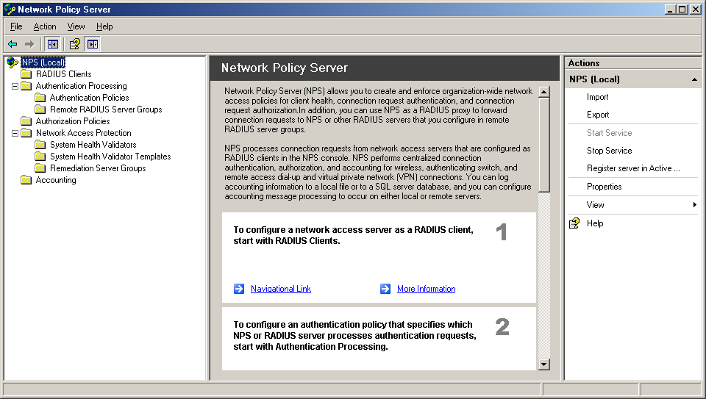
Figure 2 The Network Policy Server MMC snap-in

Authentication Processing
NPS in Windows Server "Longhorn" can be used as either a RADIUS server or a RADIUS proxy. When NPS is used as a RADIUS server:
- RADIUS Access-Request messages are authenticated through the Active Directory® directory service, a Windows NT Server 4.0 domain, or through the local Security Accounts Manager (SAM). They are authorized with the user or computer account properties and authorization policies.
- RADIUS Accounting-Request messages are logged in a local log file or a Microsoft SQL Server 2000 or Microsoft SQL Server 2005 database based on accounting settings.
When NPS is used as a RADIUS proxy:
- Access-Request messages are forwarded to another RADIUS server for authentication and authorization.
- Accounting-Request messages are logged in a local log file or a Microsoft SQL Server 2000 or Microsoft SQL Server 2005 database (based on accounting settings) and forwarded to another RADIUS server for accounting.
To determine whether a specific connection attempt request or an accounting message received from a RADIUS client should be processed locally or forwarded to another RADIUS server, the NPS server uses authentication processing. Authentication processing is a combination of:
- Authentication policies
An ordered set of rules to determine, for any incoming RADIUS request message, whether the message is processed locally or forwarded to another RADIUS server.
- Remote RADIUS server groups
Specify one or more RADIUS servers when forwarding an incoming RADIUS request message.
You can configure authentication policies and remote RADIUS server groups from the Authentication Processing node in the Network Policy Server MMC snap-in. When you are configuring NAP health determination and enforcement settings, NPS is acting as a RADIUS server. Therefore, remote RADIUS server groups are not needed and this white paper does not describe their configuration. However, authentication policies for local processing or RADIUS request messages might need to be configured or customized for NAP clients.

Network Access Protection Settings
Network Access Protection settings consist of the following:
- System Health Validators Specifies the configuration of installed System Health Validators (SHVs) for health requirements and error conditions.
- System Health Validator Templates Specifies the evaluation of health requirements in terms of installed SHVs and whether a NAP client must pass or fail them.
- Remediation Server Groups Specifies the set of servers that are accessible to noncompliant clients with limited network access.
Figure 2 shows the location of the Network Access Protection settings in the Network Policy Server tree.

System Health Validators
The System Health Validators node displays the set of installed SHVs on the NPS server and allows you to configure their settings for health requirements and error conditions. By default, the Microsoft System Health Validator is installed. Figure 3 shows the properties of the Microsoft System Health Validator.
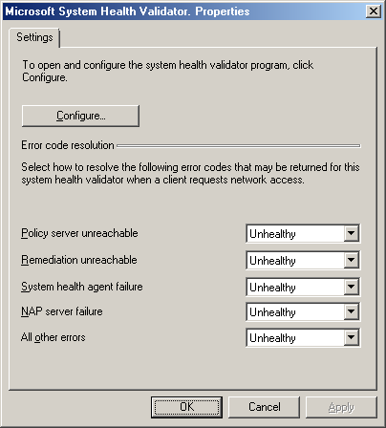
Figure 3 The Microsoft System Health Validator Properties dialog box
From this dialog box, you can configure how NPS interprets various error conditions. To configure the health requirements for the Microsoft System Health Validator SHV, click Configure. Figure 4 shows the Windows Security Health Validator dialog box.
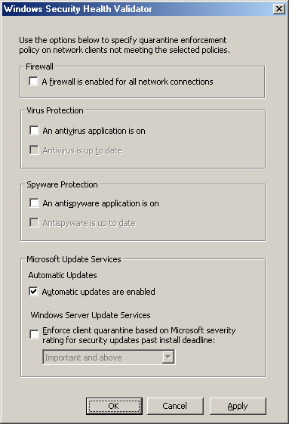
Figure 4 The Windows Security Health Validator dialog box
From this dialog box, you can select the health requirements for NAP clients for built-in Windows services that are monitored by the Windows Security Center.

System Health Validator Templates
System Health Validator Templates allow you to specify health requirements in terms of installed SHVs and whether NAP clients must pass or fail any or all of the selected SHVs. Figure 5 shows an example System Health Validator template.
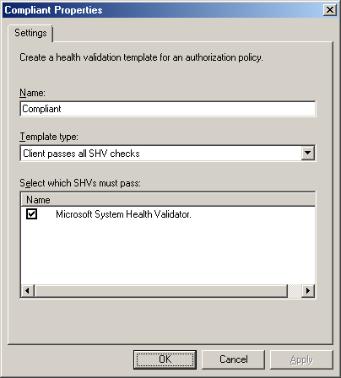
Figure 5 An example System Health Validator template
In Name, type the unique name of the template. In Configuration, specify one of the following:
- Client passes all SHV checks
The client's health status in the connection request must pass the health requirements for all of the SHVs selected in the Select which SHVs must pass list. You might select this option to specify that a compliant NAP client is one that must pass the health requirements for all of the selected SHVs.
- Client fails all SHV checks
The client's health status in the connection request must fail all of the health requirements for all of the SHVs selected in the Select which SHVs must pass list. You might select this option to specify that a noncompliant NAP client is one that fails the health requirements for all of the selected SHVs.
- Client passes one or more SHV checks
The client's health status in the connection request must pass the health requirements of at least one of the SHVs selected in the Select which SHVs must pass list. You might select this option to specify that a compliant NAP client is one that must pass the health requirements of at least one SHV.
- Client fails one or more SHV checks
The client's health status in the connection request must fail the health requirements of at least one of the SHVs selected in the Select which SHVs must pass list. You might select this option to specify that a noncompliant NAP client is one that fails any of the SHVs.
In the Select which SHVs must pass list, select the installed SHVs that apply to the template. By default, the Microsoft System Health Validator is listed.
To create a new template, right-click System Health Validator Templates in the Network Policy Server tree, and then click New.

Remediation Server Groups
A remediation server group is a list of servers on the restricted network that noncompliant NAP clients or NAP-ineligible clients can access. You might have separate groups for noncompliant NAP clients or NAP-ineligible clients or separate groups for different NAP enforcement technologies.
To create a new remediation server group, right-click Remediation Server Groups in the Network Policy Server tree, and then click New. A New Remediation Server Group wizard guides you through the creation of a new group. You can specify remediation servers by Domain Name System (DNS) name, IPv4 address, or IPv6 address.

Authorization Policies
Authorization policies are an ordered set of rules that define how connection attempts are either authorized or rejected. For each rule, there is a policy type that either grants or denies access, one or more conditions, and policy settings. If a connection is authorized, the authorization policy settings can specify a set of connection restrictions. For NAP, authorization policies specify the conditions to check for health requirements and, for noncompliant NAP clients or NAP-ineligible clients, the enforcement behavior.

Authorization Policy Conditions for Network Access Protection
For NAP support, the following conditions have been added to NPS authorization policies:
- SHV Templates
This condition specifies a previously configured System Health Validator template. If the evaluation of the health settings of a connection attempt matches the template, then the connection attempt matches this condition of the policy.
- NAP-capable computers
This condition specifies whether the client is NAP-capable or not.
The following are examples of using these conditions for NAP-based authorization policies:
- For an authorization policy that applies only to compliant NAP-capable clients and pass all of the health requirements of the installed SHVs, specify the following condition:
- Set SHV Templates to the "Compliant" (example name) template, which specifies the Client passes all SHV checks option.
- For an authorization policy that applies only to noncompliant NAP-capable clients that fail any of the health requirements of the installed SHVs, specify the following condition:
- Set SHV Templates to the "Noncompliant" (example name) template, which specifies the Client fails one or more SHV checks option.
- For an authorization policy that applies only to NAP-ineligible clients, specify the following condition:
- Set NAP-capable computers to Only computers that are not NAP-capable.

Authorization Policy Type for NAP
Because NAP health validation is being done for connection attempts that are also authenticated and authorized, you select the Grant access policy type. The connection attempt is authorized, but the network access of noncompliant NAP clients or NAP-ineligible clients is limited to the restricted network. You can create authorization policies to explicitly deny access, however, these authorization policies do not need NAP settings as it is not necessary to validate the system health of a computer that is not allowed access.

Authorization Policy Settings for NAP
Authorization policies in Windows Server "Longhorn" have a set of Network Access Protection settings for NAP Enforcement, Remediation Servers, and Troubleshooting URL. Figure 6 shows an example of NAP Enforcement settings.
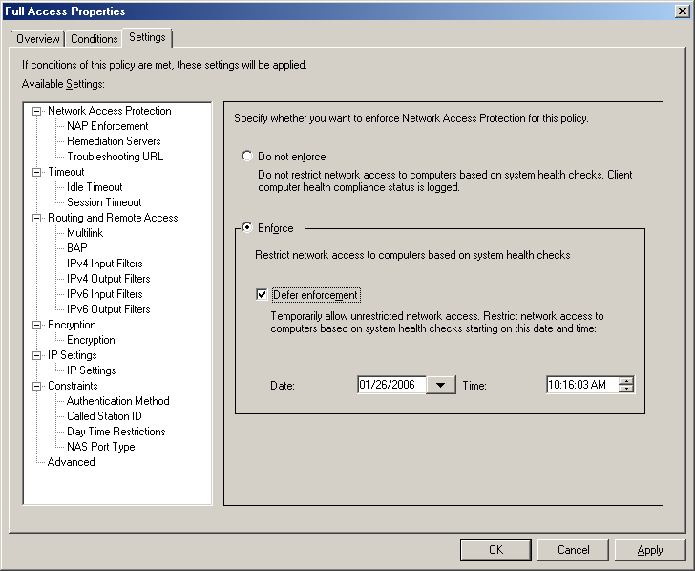
Figure 6 NAP Enforcement settings
For NAP Enforcement settings, you can specify the following:
- Do not enforce Specifies that the connection attempt has unlimited network access. Select this option for authorization policies defined for compliant NAP clients.
- Enforce Specifies that the connection attempt has limited network access. Select this option for authorization policies defined for noncompliant NAP clients or for NAP-ineligible clients.
- Defer Enforcement Specifies whether the connection attempt has unlimited network access until a configured date and time.
Figure 7 shows the Remediation Servers settings.
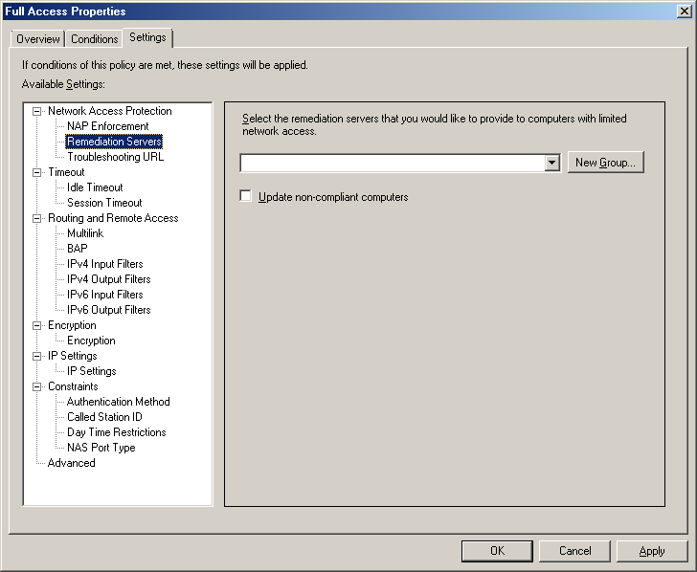
Figure 7 Remediation Servers settings
For Remediation Servers settings, you can specify the following:
- Remediation server group Allows you to select a previously created remediation server group or you can create a new group.
- Update non-compliant computers Specifies whether you want NPS to inform NAP clients to automatically remediate their health state to become compliant.
Figure 8 shows an example of Troubleshooting URL settings.
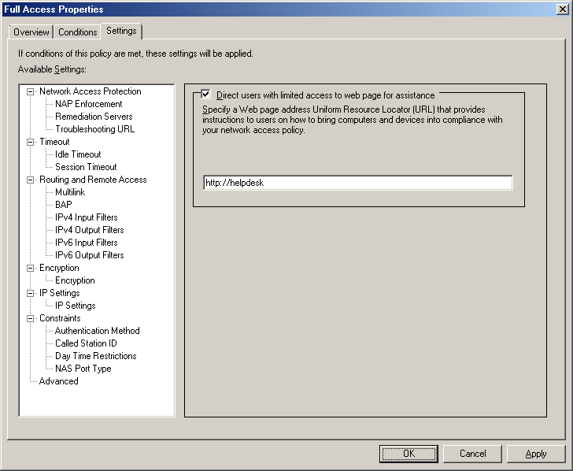
Figure 8 Troubleshooting URL settings
For Troubleshooting URL settings, you can specify the following:
- Direct users with limited access to a web page for assistance Specifies whether you want to send the noncompliant NAP client a Uniform Resource Locator (URL) to a Web page of a server on the restricted network that contains information about how to become compliant.
- URL Provides a space for you to type the URL to a Web page of a remediation server for noncompliant NAP clients. This URL is activated when a user clicks Troubleshoot on the Network Access Protection dialog box that is displayed on noncompliant NAP clients. From the Web page, the user can determine how to update the computer so that it is compliant or perform troubleshooting of network access. This URL is also visible in the display of the netsh nap show state command.

How NAP in NPS Works
The process that NPS uses to determine health status and specify enforcement behavior is the following:
- When NPS receives the RADIUS Access-Request message, it first determines whether the message originated from an address that corresponds to a configured RADIUS client. If not, NPS discards the message. This behavior prevents the NPS server from processing RADIUS messages from RADIUS clients (such as access devices and NAP servers) for which the NPS server has not been configured.
- NPS then compares the Access-Request message to its configured set of authentication policies. For NAP, the Access-Request message should match an authentication policy that specifies that the NPS server perform the authentication and authorization locally.
- NPS evaluates the health information in the Access-Request message, which consists of one or more Statements of Health (SoHs). The NAP Administration Server component on the NPS server validates each SoH using the appropriate SHV. The result of the evaluation is a set of Statement of Health Responses (SoHRs) from the SHVs.
- The Access-Request message and the SoHRs are evaluated against the authorization policies. The SoHRs are compared to the SHV Templates condition of NAP-based authorization policies. Recall that the SHV Templates condition specifies whether the SHVs must either pass or fail. NPS applies the first matching authorization policy to the Access-Request message.
- Based on the first matching policy and the Network Access Protection settings of the policy, NPS creates a System Statement of Health Response (SSoHR) that indicates one of the following:
- The client has unlimited access.
- The client has limited access. In this case, the SSoHR also includes whether the client should automatically attempt to remediate its noncompliant health state.
- NPS sends a RADIUS Access-Accept message with the SSoHR and the list of SoHRs to the RADIUS client (the access device or NAP server) that sent the Access-Request message. If the client has limited access, the Access-Accept message also contains the list of addresses for the remediation servers corresponding to the configured remediation server group.
- The RADIUS client sends the SSoHR and the list of SoHRs to the NAP client.

Examples of NPS Processing for NAP
The following sections describe how NPS processes incoming Access-Request messages for access attempts from three different types of clients (a compliant NAP client, a noncompliant NAP client, and a NAP-ineligible client) based on the following configuration:
- Authentication processing:
NPS uses the default authentication policy Use Windows authentication for all users, which causes NPS to process all RADIUS messages locally, rather than forwarding them to another RADIUS server.
- Network Access Protection settings:
The Microsoft System Health Validator is configured to only require that Windows automatic updates be enabled.
A template named MSSHV_Compliant specifies the use of the Microsoft System Health Validator SHV and the Client passes all SHV checks option.
A template named MSSHV_Noncompliant specifies the use of the Microsoft System Health Validator SHV and the Client fails all SHV checks option.
A remediation server group named REM1 contains a list of the IPv4 addresses for the remediation servers that are located on the restricted network.
- Authorization policies:
An authorization policy named Compliant_NAP_clients is configured for the following:
- Conditions: SHV Templates is set to the MSSHV_Compliant template
- Policy settings: For NAP Enforcement, the Do not enforce option is selected
- Policy Type: The Grant access setting is selected
An authorization policy named Noncompliant_NAP_clients is configured for the following:
- Conditions: SHV Templates is set to the MSSHV_Noncompliant template
- Policy settings: For NAP Enforcement, the Enforce option is selected, and for Remediation Servers, the REM1 remediation server group is selected
- Policy Type: The Grant access setting is selected
An authorization policy named Downlevel_clients is configured for the following:
- Conditions: NAP-capable computers is set to Only computers that are not NAP-capable
- Policy settings: For NAP Enforcement, the Enforce option is selected, and for Remediation Servers, the REM1 remediation server group is selected
- Policy Type: The Grant access setting is selected

NPS Processing for a Compliant NAP Client
When a compliant NAP client (for our example, a client that has Windows automatic updates enabled) attempts to obtain an IP address configuration from a NAP-capable DHCP server, the following process occurs:
- The NAP client sends the DHCP server its list of SoHs. In this case, the list of SoHs consists of a single SoH from the default Windows Security Health Agent indicating that Windows automatic updates are enabled.
- The DHCP server sends the NPS server an Access-Request message containing the SoH.
- The NPS server evaluates the Access-Request message against the authentication policies and matches the Use Windows authentication for all users policy.
- The NPS server evaluates system health by passing the SoH to the Microsoft System Health Validator, which returns an SoHR indicating that the system health requirements passed.
- The NPS server evaluates the Access-Request message and the SoHR against the authorization policies.
- The Access-Request message and the SoHR match the Compliant_NAP_clients authorization policy because the SHV Templates condition, set to the MSSHV_Compliant template, requires that the request pass all the selected SHVs (the Microsoft System Health Validator).
- Based on the Network Access Protection settings of the Compliant_NAP_clients authorization policy (set to Do not enforce), NPS creates an SSoHR indicating unlimited access.
- NPS sends an Access-Accept message to the DHCP server containing the SSoHR and the SoHR from the Microsoft System Health Validator.
- The DHCP server assigns an unlimited access IP address configuration to the NAP client. During the DHCP message exchange, the DHCP server also passes the SSoHR and SoHR to the NAP client.

NPS Processing for a Noncompliant NAP Client
When a noncompliant NAP client (for our example, one that has Windows automatic updates disabled) attempts to obtain an IP address configuration from a NAP-enabled DHCP server, the following process occurs:
- The NAP client sends the DHCP server its SoH from the default Windows Security Health Agent, indicating that Windows automatic updates is disabled.
- The DHCP server sends the NPS server an Access-Request message containing the SoH.
- The NPS server evaluates the Access-Request message against the authentication policies and matches the Use Windows authentication for all users policy.
- The NPS server evaluates system health by passing the SoH to the Microsoft System Health Validator, which returns an SoHR indicating that the system health requirements failed.
- The NPS server evaluates the Access-Request message and the SoHR against the authorization policies.
- The Access-Request message and the SoHR match the Noncompliant_NAP_clients authorization policy because the SHV Templates condition, set to the MSSHV_Noncompliant template, requires that the request fail all the selected SHVs (the Microsoft System Health Validator).
- Based on the Network Access Protection settings of the Noncompliant_NAP_clients authorization policy (set to Enforce with the REM1 remediation servers group), NPS creates an SSoHR indicating limited access.
- NPS sends an Access-Accept message to the DHCP server containing the SSoHR, the SoHR from the Microsoft System Health Validator, and the list of addresses in the REM1 remediation server group.
- Because the SSoHR indicates limited access, the DHCP server assigns a limited IP address configuration to the NAP client. During the DHCP message exchange, the DHCP server also passes the SSoHR and SoHR to the NAP client.

NPS Processing for a NAP-ineligible Client
When a NAP-ineligible client attempts to obtain an IP address configuration from a NAP-enabled DHCP server, the following process occurs:
- The DHCP server sends the NPS server an Access-Request message.
- The NPS server evaluates the Access-Request message against the authentication policies and matches the Use Windows authentication for all users policy.
- The NPS server evaluates the Access-Request message against the authorization policies.
- The Access-Request message matches the Downlevel_clients authorization policy because the Access-Request message is for a NAP-ineligible client.
- Based on the Network Access Protection settings of the Downlevel_clients authorization policy (set to Enforce with the REM1 remediation servers group), NPS creates an SSoHR.
- NPS sends an Access-Accept message to the DHCP server containing the SSoHR and the list of IP addresses in the REM1 remediation server group.
- Because the SSoHR indicates limited access, the DHCP server assigns a limited IP address configuration to the NAP-ineligible client.

Summary
Configuring NPS in Windows Server "Longhorn" for NAP consists of creating RADIUS clients and configuring authentication processing, Network Access Protection settings, and authorization policies. When processing a connection attempt, NPS first uses authentication policies to determine whether to process the connection attempt locally or forward it to another RADIUS server. NPS then matches the connection attempt with an authorization policy. For health validation on connection attempts, authorization policy conditions allow you to specify health requirements and compliance (by referencing a System Health Validator template) and the type of client (NAP-capable or NAP-ineligible). Network Access Protection settings in authorization policies allow you to specify enforcement behavior for noncompliant NAP clients and NAP-ineligible clients.

Related Links
See the following resources for further information:
- Network Access Protection IT Solutions Web site at http://www.microsoft.com/technet/itsolutions/network/nap/default.mspx
- Introduction to Network Access Protection at http://www.microsoft.com/technet/itsolutions/network/nap/napoverview.mspx
- Network Access Protection Platform Architecture at http://www.microsoft.com/technet/itsolutions/network/nap/naparch.mspx
- Network Access Protection Frequently Asked Questions at http://www.microsoft.com/technet/itsolutions/network/nap/napfaq.mspx

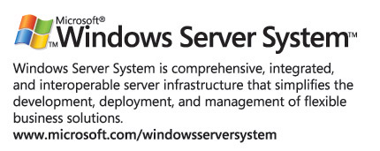
For the latest information about Windows Server System, see the Windows Server System Web site at http://www.microsoft.com/windowsserversystem.

