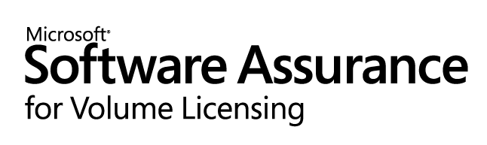

Benefits Entitlement Chart – Academic offerings

Lifecycle Stage | Benefit | Academic Open License | Academic Select License | Academic Select License with Software Assurance Membership (SAM),  Campus and School Agreement
Plan | New Version Rights | Every License covered under Software Assurance may be upgraded to the newest version.
Plan | Spread Payments | Not Available | Payments for License and Software Assurance can be spread into equal annual payments.
Deploy | Windows Preinstallation Environment (WinPE) | Not Available |  | You are entitled to 1 media kit per enrollment.
Use | Windows Vista Enterprise | For every Windows client license covered under Software Assurance, you are entitled to 1 Windows Vista Enterprise upgrade license.
Use | Virtual PC Express | For every Windows Client License covered under Software Assurance, you are entitled to install one copy of Virtual PC Express.
Use | E-Learning | For every Office System application license covered under Software Assurance you are entitled to 1 license for Software Assurance Applications eLearning.  For every Windows Client licenses covered under Software Assurance you are entitled to 1 license for Software Assurance Systems eLearning.  For every Server License covered with Software Assurance you are entitled to 1 license for Software Assurance Servers eLearning.
Maintain | Corporate Error Reporting | Not Available |  | You are entitled to 1 media kit per enrollment.
Maintain | Cold Back Up for Disaster Recovery | For every Server License covered with Software Assurance, you are entitled to run 1 instance of the software on a “cold” server for disaster recovery purposes.
Maintain | TechNet Plus Subscription Media | Not Available |  | You are entitled to 1 kit and user ID per enrollment for use institution-wide. ¹
Maintain | TechNet Managed Newsgroups | Not Available |  | You are entitled to 1 user ID per enrollment for use institution-wide. ¹
Transition | Windows Fundamentals for Legacy PCs | Not Available |  | For every Windows client license covered under Software Assurance, you are entitled to install one copy of Windows Fundamentals for Legacy PCs as the Windows Client license.
Transition | Extended Hotfix Support | SERVER: 90-day enrollment not required. Annual contract fee for Exchange, MOM, SMS, SQL and Windows Server is included as part of the Software Assurance program.
Transition | Extended Hotfix Support | DESKTOP: Not Available |  | DESKTOP: 90 day enrollment not required. Annual contract fees for Windows Client and Office Pro are included as part of Software Assurance.
¹Minimum of 5 server licenses must be acquired to qualify.

