

Connecting Remote Users to Your Network
with Windows Server 2003

Microsoft Corporation
Published: March 2003

Abstract
Business professionals today require access to information on their network from anywhere at any time. Whether they are on the road with customers or working from home, it is critical to provide employees with remote access to the corporate network. This white paper outlines how Windows Server 2003 can provide telecommuters and mobile computing professionals with access to their private organization network resources. With integrated dial-up and virtual private networking services, Windows Server 2003 provides a complete remote access solution for medium-sized networks.

The information contained in this document represents the current view of Microsoft Corporation on the issues discussed as of the date of publication. Because Microsoft must respond to changing market conditions, it should not be interpreted to be a commitment on the part of Microsoft, and Microsoft cannot guarantee the accuracy of any information presented after the date of publication.
This document is for informational purposes only. MICROSOFT MAKES NO WARRANTIES, EXPRESS OR IMPLIED, AS TO THE INFORMATION IN THIS DOCUMENT.
Complying with all applicable copyright laws is the responsibility of the user. Without limiting the rights under copyright, no part of this document may be reproduced, stored in or introduced into a retrieval system, or transmitted in any form or by any means (electronic, mechanical, photocopying, recording, or otherwise), or for any purpose, without the express written permission of Microsoft Corporation.
Microsoft may have patents, patent applications, trademarks, copyrights, or other intellectual property rights covering subject matter in this document. Except as expressly provided in any written license agreement from Microsoft, the furnishing of this document does not give you any license to these patents, trademarks, copyrights, or other intellectual property.
The example companies, organizations, products, people and events depicted herein are fictitious. No association with any real company, organization, product, person or event is intended or should be inferred.
© 2003 Microsoft Corporation. All rights reserved.
Microsoft, Active Directory, Windows, Windows logo, and Windows NT are either registered trademarks or trademarks of Microsoft Corporation in the United States and/or other countries.
The names of actual companies and products mentioned herein may be the trademarks of their respective owners.

Contents
Introduction 1
Scenario Requirements 1
Scenario Tasks 2
Selecting a Remote Access Solution 3
Dial-up Remote Access 3
VPN Remote Access 3
Setup for Dial-Up Remote Access Servers 4
Setup for Virtual Private Networking Servers 6
Configuring Dial-up Remote Access and Virtual Private Networking 7
Enable Remote Access on a Network Address Translation Server 7
Setting Remote Access Permissions and Policies 10
Client Configuration and Deployment 13
Creating a Dial-Up Client Connection 13
Creating a VPN Client Connection 15
Summary 19
Related Links 20

Introduction
Using the remote access services of Windows Server 2003, you can configure remote access servers that provide connectivity to an organization's network for authorized users. This transparent connection allows remote access clients to access resources from remote locations as if they were physically attached to the network.
Windows Server 2003 remote access provides two different types of remote access connectivity:
- Dial-up remote access
To gain access to the network with dial-up remote access, a remote access client uses the public telephone network to create a physical connection to a port on a remote access server that sits on the edge of the private network. This is typically done by using a modem or ISDN adapter to dial into your remote access server. This kind of remote access is also known as a dial-up or direct-dial connection.

- Virtual private network (VPN) remote access
A VPN connection can provide secure remote access through the Internet, rather than through a direct dial-up connection. A VPN client uses an IP internetwork to create an encrypted, virtual, point-to-point connection with a VPN server that exists on the edge of the private network. This is often done by connecting to the Internet first, and then creating the VPN connection. When the initial connection to the Internet is made through dial-up remote access, this kind of VPN connection is known as a double-dial connection. By using the Internet in this way, companies can reduce their long distance phone expenses and rely on existing infrastructure instead of managing their own.

This white paper outlines the steps needed to set up remote access with Windows Server 2003 and to configure remote access clients for dial-up and VPN connections.

Scenario Requirements
This paper builds on the configuration described in the “Connecting Your Network to the Internet with Windows Server 2003” white paper.
Depending on the type of remote access solution, you will need to coordinate with your local telecommunications company or Internet service provider (ISP) to set up remote client connection information. If you are planning to deploy a dial-up solution, your telephone company can set up telephone lines that dial directly to your modem(s). If you are planning to deploy a VPN solution, you need to ask your ISP to assign a public IP address to your VPN server in order for remote clients to connect over the Internet.
To configure the server as a dial-up and VPN server, you will need to configure Routing and Remote Access on Windows Server 2003. You must have network administrator rights to configure Routing and Remote Access.

Scenario Tasks
In this white paper, you can perform the following tasks:
Setup and Management Tasks | - Decide what type of remote access your users will need  - Set up the necessary hardware for a dial-up remote access server  - Set up the necessary hardware for a virtual private networking server  - Configure the dial-up remote access server and VPN server  - Plan for virtual private networking considerations  - Set remote access permissions on user accounts  - Create remote access policies  - Configure and deploy your client

Selecting a Remote Access Solution
When deciding on a remote access solution, you should evaluate your remote access needs and understand the benefits and features of dial-up and VPN remote access. Companies may choose to use a single method for remote access or deploy both as complementing technologies. For example, some companies have deployed VPN as their primary remote access connection and fall back to dial-up connections when Internet access is unavailable.

Dial-up Remote Access
Dial-up remote access will meet the needs of companies that have a small remote user population, that are satisfied with analog or ISDN performance, and that have remote users that stay within the local calling area. Administrators should consider a VPN solution in a company where the remote user population is large, long distance telephone expenses are rapidly increasing, or there is a need for higher bandwidth performance.

VPN Remote Access
Companies that want to lower their remote access cost and increase their network flexibility can take advantage of VPN remote access. Traveling employees can use the same modem they used for long distance dial-up and leverage the Internet by dialing a local ISP for a virtual connection back to the corporate network. This eliminates the long distance charges or toll calls associated with a dial-up connection.
While this minimizes the dial-up cost for traveling employees, all VPN users can benefit from the technology’s flexible connection medium support. VPNs support analog modems and ISDN as well as dedicated broadband connections like cable and DSL.

Setup for Dial-Up Remote Access Servers
In order to support dial-up connections to your network, you will need to have your telephone company install a phone line for each analog modem that accepts incoming calls. Your remote access clients will dial these dedicated phone numbers to connect their computer to the remote access server.
In addition, each server-side modem requires a serial port on the remote access server. If you only want to use one or two modems, you can just use the built-in serial ports on your remote access server or install a few PCI or ISA internal modems.
Note Typically, dial-up connections are made using analog modems or ISDN. If you are going to support ISDN dial-up as well, you will need ISDN lines installed at your company and the same number of ISDN adapters for the number of ISDN lines installed.
If you require more than two modems in your pool, you will need to use a multi-port serial adapter or a high-density combination card. Multi-port serial adapters allow you to connect a large number of analog modems or ISDN modems to one remote access server. A multi-port serial adapter allows you to install one PCI or ISA card in your computer and create a large number of serial ports (4, 8, 16, 64, etc.) for your modems. A high-density combination card combines multiple modems and serial adapters into one device.
For more information on analog modems, ISDN modems and ISDN adapters, and multi-port serial adapters supported in Windows Server 2003, see the Windows Server Catalog at http://www.microsoft.com/windows/catalog/server/.
Analog modems and ISDN Terminal Adapters are normally installed and configured in Control Panel-Phone and Modem Options. Many modems are Plug-and-Play compatible and will be installed automatically after they are connected to a serial port and the computer is either rebooted or the Add New Hardware Wizard is run from Control Panel.
Figure 1 shows how a typical setup might look with multiple modems installed on a multi-port serial adapter with eight ports.
Figure 1 A typical setup with multiple modems installed on a multi-port serial adapter with eight ports
For more information about installing ISDN hardware or analog modems in Windows Server 2003, see Windows Server 2003 Help and Support.

Setup for Virtual Private Networking Servers
To allow VPN clients access to your network, you will need to set up a VPN server that is attached to your internal network as well as to the Internet. This is commonly done by connecting one network adapter in the VPN server to your company network, and connecting another network adapter to the Internet. The Internet connection can be a dedicated line such as a cable modem, DSL, a dial-up connection, or an ISDN link. See the “Connecting Your Network to the Internet with Windows Server 2003” white paper to learn about configuring the external Internet connection.
In this document, for the purposes of setting up a VPN server, we assume the server running a member of the Windows Server 2003 family is connected to the private network and has a dedicated DSL connection to the Internet. We further assume that Routing and Remote Access has been configured for network address translation, as in the “Connecting Your Network to the Internet with Windows Server 2003” white paper.
We also assume the ISP has pre-assigned a static, public IP address that is associated with the external network adapter. The internal network adapter that connects your VPN server to the private network has a statically configured IP address that is excluded from your DHCP address pool.
Windows Server 2003 supports two types of remote access VPN technology: Point-to-Point Tunneling Protocol (PPTP) and Layer Two Tunneling Protocol with IP Security (L2TP/IPSec). This white paper focuses on providing basic VPN remote access with PPTP. L2TP/IPSec requires advanced knowledge of encryption and authentication technologies, including public key infrastructure (PKI), and is not described here. For more information about using L2TP/IPSec, see the Windows VPN Web site at http://www.microsoft.com/vpn/.

Configuring Dial-up Remote Access and Virtual Private Networking
Depending on your remote access needs, you can deploy dial-up and VPN services on the same machine or separate them onto dedicated servers. For the examples in this document, we configure a computer running a member of the Windows Server 2003 family as a combined dial-up remote access server and VPN server.
As a best practice, Microsoft recommends that the domain controller and the server running Routing and Remote Access operate on separate servers. To increase the security of your remote access server, Windows Server 2003 provides configurable filtering options to keep unwanted Internet packets from getting to your server. Additionally, a separate remote access server allows you to expand your usage by supporting more remote access clients or setting up advanced configuration options such as demand-dial routing or LAN routing. If you decide to configure a dial-up or VPN remote access server on the domain controller, Microsoft recommends that you read the Windows Server 2003 Help and Support topics on VPN filters and have a good understanding of IP filtering.

Enable Remote Access on a Network Address Translation Server
The “Connecting Your Network to the Internet with Windows Server 2003” white paper configures Windows Server 2003 Routing and Remote Access as a network address translator (NAT) server, which provides access to the Internet and shares this connection with local area network clients. This NAT server can be further enabled as a remote access server using the following steps:
- Click Start, point to Programs, point to Administrative Tools, and then click Routing and Remote Access.
- In the console tree, right-click the server name, and then click Properties.
- Select the Remote access server check box, and then click OK.
Your network address translation server is now capable of handling dial-up and VPN remote access, with five PPTP and five L2TP/IPSec connections.
Because this server was previously configured for NAT only, all of the modem ports are configured for demand-dial routing rather than remote access. To allow incoming remote access connections, you must set your modems to accept incoming calls only, using the following steps:
- From the console tree of the Routing and Remote Access snap-in, right-click Ports and click Properties. You will see a list of your modems, all of them configured for demand-dial routing (the value of the Used By column is Routing). An example is shown in the following figure.
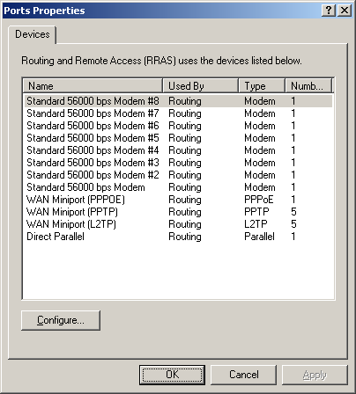
- Click on a modem, and then click Configure.
- Select the Remote access connections (inbound only) check box and clear the Demand-dial routing connections (inbound and outbound) check box. An example is shown in the following figure.
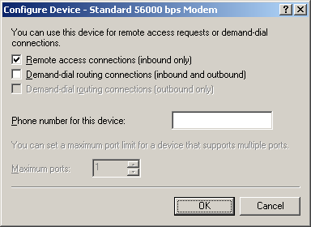
- Click OK.
- Repeat steps 2-4 above for every modem. When you have configured every modem, click Apply.
You have now configured all your modems to be available for remote users to dial in to your network.
Because VPN connections using L2TP require that computer certificates be installed, this particular configuration will not support L2TP connections. For the purposes of this white paper, we are focusing on PPTP-based VPN connections. If you do not plan on using L2TP, it is best to remove support for L2TP using the instructions below.
If you do not plan to support virtual private networking at this time, you can change the default settings and remove support for L2TP and PPTP. Also, you can increase the number of allowed PPTP connections. You can even set certain modems to only be available for dial-in if you want to use some of the modems for other purposes such as accepting faxes. You can select each modem port and click Configure, as described previously. For PPTP or L2TP, you can click on either one and choose Configure. Then you can set the number of allowed connections and enable or disable them completely.
To remove inbound support for L2TP connections as discussed earlier, configure the WAN Miniport (L2TP) properties as shown in the following figure. Note that Maximum ports is set to 0.
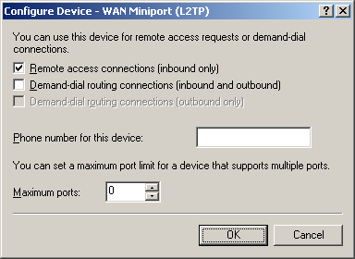
After configuring these options, your server is ready to accept connections from remote access clients using dial-up or virtual private networking. All you have to do now is enable remote access permissions, create a group for remote access users, and create remote access policies.

Setting Remote Access Permissions and Policies
To allow remote users to connect to your network using virtual private networking or dial-up networking, you will need to configure the remote access permission of their user account, using the following steps:
- Click Start, point to Programs, point to Administrative Tools, and then click Active Directory Users and Computers.
- In the console tree, click the Users folder under the domain name.
- Double-click the user account for which you want to enable remote access permissions.
- On the Dial-in tab, click either Allow access or Control access through Remote Access Policy. An example is shown in the following figure.
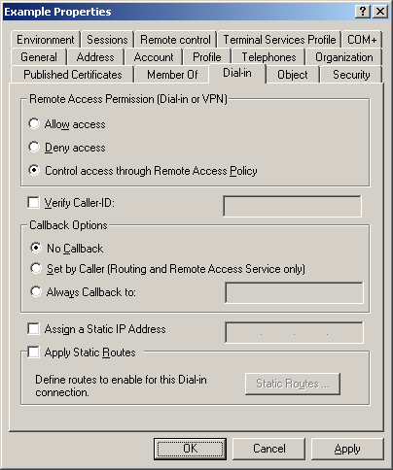
Next, use the Active Directory Users and Computers snap-in to create a new group to contain the user accounts for all your remote access users. For example, create the group RemoteAccessUsers and add as its members all the employees that are allowed to create dial-up or VPN remote access connections.
Once you have created the remote access users group in Active Directory Users and Computers, you must create a remote access policy in Routing and Remote Access that allows these users in this group to connect.
- Click Start, point to Programs, point to Administrative Tools, and then click Routing and Remote Access.
- In the console tree, right-click Remote Access Policies, and then click New Remote Access Policy.
- On the Welcome to the New Remote Access Policy Wizard page, click Next.
- On the Policy Configuration Method page, type the name you want to give this policy, such as Dial-in User Access, in Policy name. This is shown in the following figure.
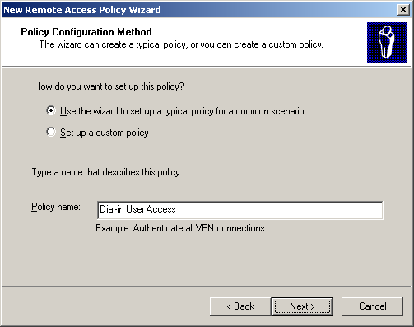
- Click Next. On the Access Method page, select Dial-up. This is shown in the following figure.
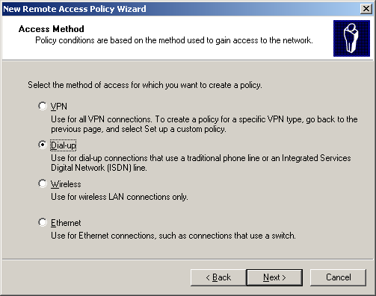
- Click Next. On the User or Group Access page, select Group, and then click Add.
- In the Select Groups dialog box, type the name of the group that contains your remote access users in Enter the object names to select.
- Click OK. The remote access users group is added to the list of groups on the Users or Groups page.
- Click Next. On the Authentication Methods page, the MS-CHAP v2 authentication protocol is selected by default. This is shown in the following figure.
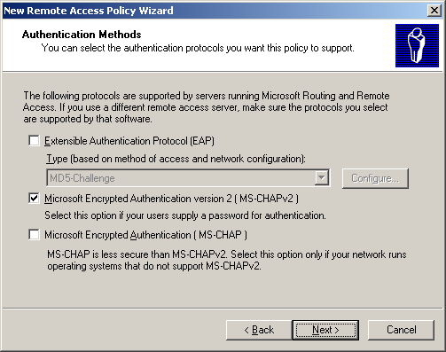
- Click Next. On the Policy Encryption Level page, select the levels of policy encryption you want to support and clear those levels of encryption you do not want to support. Some older operating systems do not support higher levels of encryption. For this white paper, we want to support only the highest level of encryption, so select Strongest encryption (MPPE 128-bit) and clear all the other check boxes. This is shown in the following figure.
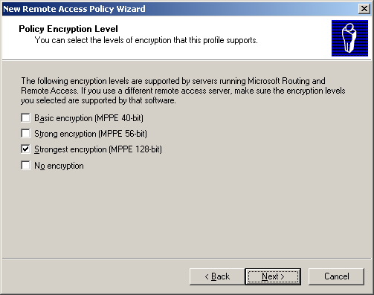
- Click Next. On the Completing the New Remote Access Policy page, click Finish.
You have now created a remote access policy that allows authorized users dial-up access to your corporate network. You must create another remote access policy for VPN users. To do so, follow the steps above, but select VPN instead of Dial-up on the Access Method page of the New Remote Access Policy Wizard.

Client Configuration and Deployment
Windows XP provides users with the flexibility to configure their own dial-up client connection using the New Connection Wizard. You can have your users create their own connections, or you can create a pre-packaged and pre-configured dial-up client connection for installation on your users’ computers. Large remote access deployments can be complex without tools to centrally configure dial-up clients. Windows Server 2003 provides administrators with the Connection Manager Administration Kit (CMAK), which can create pre-configured dial-up clients that can include a phonebook, help files, and custom applications. These pre-configured connections are called service profiles.
This section focuses on helping your users set up an individual dial-up client using the New Connection Wizard on Windows XP Professional. If you plan on having a large number of remote access clients using different versions of Windows, skip this section and refer to the Windows Server 2003 Help and Support about using CMAK to create and distribute service profiles.

Creating a Dial-Up Client Connection
To enable your remote users to connect to your network, they will need to have a dial-up or VPN connection created on their computer. If the computer is running Windows XP Professional and you do not create a pre-configured connection for them using CMAK, your users need to complete the following steps to create a dial-up connection to your remote access server.
- Make sure the appropriate modem or ISDN device is installed properly.
- Open Network Connections from Control Panel.
- In Network Tasks, click Create a new connection.
- On the Welcome to the New Connection Wizard page of the New Connection Wizard, click Next.
- On the Network Connection Type page, click Connect to the network at my workplace. This is shown in the following figure.
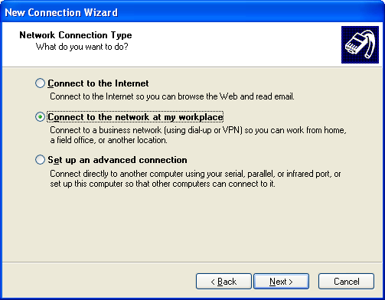
- Click Next. On the Network Connection page, click Dial-up connection. This is shown in the following figure.
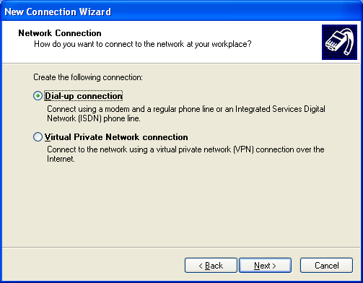
- Click Next. On the Connection Name page, type the name of the dial-up connection in Company Name. In this white paper, we will name this connection Dial-up to Work. This is shown in the following figure.
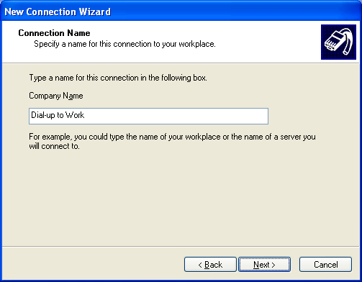
- Click Next. On the Phone Number page, type the phone number of the remote access server in Phone number. An example is shown in the following figure.
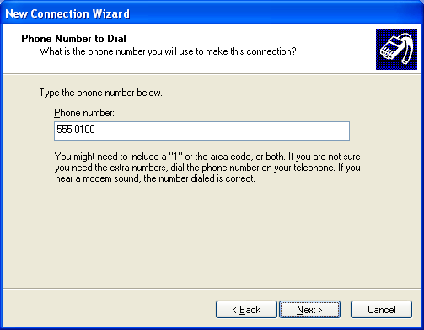
- Click Next. On the Connection Availability page, click My use only. This prevents any other user on that computer from dialing that connection and provides an extra layer of security against accidental misuse of this connection. This is shown in the following figure.
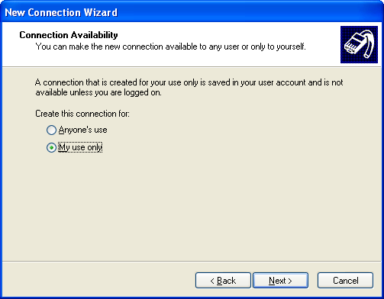
- Click Next. On the Completing the New Connection Wizard page, click Finish.

Creating a VPN Client Connection
Creating a VPN connection requires two steps: connecting to the Internet and connecting to the company VPN gateway. If your users have a dedicated connection such as a DSL, they will only need to configure a VPN connection that connects to the VPN server. If your users have analog modems, they will need to connect to their ISPs before they can connect to the VPN server.
For this white paper, we assume that your users will connect to the Internet through analog modems. We further assume that they all have previously configured connections to the ISP, and that this connection is named Dial-up to ISP.
On Windows XP Professional, in order to create a virtual private networking connection to your remote access server, your users must perform the following steps:
- Make sure the appropriate modem or ISDN device is installed properly.
- Open Network Connections from Control Panel.
- In Network Tasks, click Create a new connection.
- On the Welcome to the New Connection Wizard page of the New Connection Wizard, click Next.
- On the Network Connection Type page, click Connect to the network at my workplace.
- Click Next. On the Network Connection page, click Virtual Private Network connection. This is shown in the following figure.
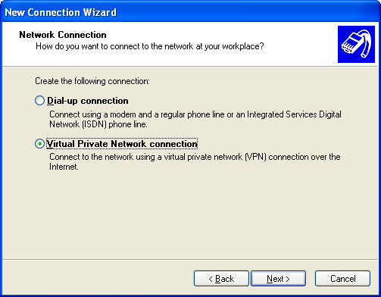
- Click Next. On the Connection Name page, type the name of the dial-up connection in Company Name. In this white paper, we will name this connection VPN to Work. This is shown in the following figure.
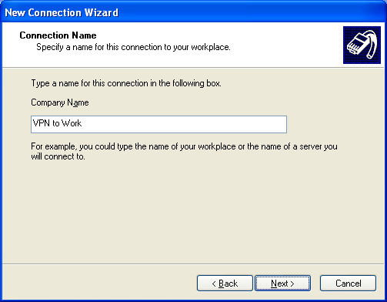
- Click Next. On the Public Network page, select the connection used to connect to the Internet. In this white paper, we select the connection named Dial-up to ISP. This is shown in the following figure.
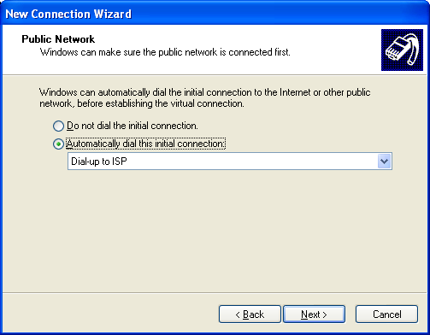
- Click Next. On the VPN Server Selection page, type the IP address or DNS name of the VPN server in Host name or IP address. This is shown in the following figure.
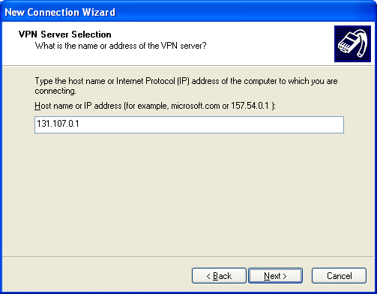
- Click Next. On the Connection Availability page, click Next.
- On the Completing the New Connection Wizard page, click Finish.
Your user should now have a dial-up or VPN connection created that will allow the user to connect to your network remotely. In order to connect, your user should click Start, click Connect To, and select either Dial-up to Work or VPN to Work.
If your users created a VPN connection according to the steps above, they will be automatically prompted to login to their ISPs through the Dial-up ISP connection. Once authenticated with the ISP, your users will then be connected to your VPN server. The users will need to provide their user account names and passwords in order to gain access to your network. Once authenticated with your network, your users will have the same access as the dial-up method.
Note Using the Connection Manager Administration Kit can automate this process and eliminate the need for clients to configure two connections and manage two separate logins. For more information, see Windows Server 2003 Help and Support.
If your users are using Windows 2000, Windows 98, or Windows NT 4.0, follow the procedures documented in Help for those products for creating a dial-up or VPN client connection when helping your users create their connections to your remote access server. In addition, ensure that your users have the appropriate hardware installed and working for creating a dial-up connection. Note that Windows 98 and Windows NT 4.0, unlike Windows Server 2003-based clients, do not automatically install virtual private networking support, so you need to make sure your users have installed the correct components before beginning. Additionally, remember that if your users are using Windows 98 or Windows NT 4.0, you might need to install the latest service packs to use stronger authentication methods.

Summary
This white paper provided an overview to help you set up basic remote access connectivity for your remote clients using Windows Server 2003 and Routing and Remote Access. Routing and Remote Access has many more advanced features that are beyond the scope of this document that will allow you to set up a more advanced configuration if needed. Windows Server 2003 also provides customization services for client connection configuration through the Connection Manager Administration Kit (CMAK), which can simplify support if you provide remote access to more than a few users. For information on advanced configuration options or other concepts you have read about in this document, please see the references listed in the next section.
Windows Server 2003 provides communication and networking solutions that meet the needs of today’s businesses and provides a reliable and scalable platform that grows with your business. Small and growing businesses will find that using Windows Server 2003 makes it easier to set up a network and enable it for remote access connectivity.

Related Links
See the following resources for further information:
- Networking and Communications Services Web site at http://www.microsoft.com/windowsserver2003/technologies/networking/
- Windows VPN Web site at http://www.microsoft.com/vpn/

For the latest information about Windows Server 2003, see the Windows Server 2003 Web site at http://www.microsoft.com/windowsserver2003/.

